Application 1570:
PD-L1 (Programmed Death Ligand 1) immunohistochemistry (IHC) testing for access to atezolizumab as first-line therapy for patients with locally advanced or metastatic triple-negative breast cancer (TNBC)

Ratified PICO Confirmation
(To guide a new application to MSAC)
(Version 1.0)

Summary of PICO criteria to define the questions to be addressed in an Assessment Report to the Medical Services Advisory Committee (MSAC)
Component | Description
Patients | Test: Patients with locally advanced or metastatic triple negative breast cancer (TNBC).  Drug: Patients with locally advanced or metastatic TNBC and who are Programmed Death Ligand 1 (PD-L1) positive (defined as expression on tumour-infiltrating immune cells as a percentage of tumour area ≥1% [PD-L1 ≥1%]).
Prior tests | Routine tests used to determine if the TNBC is locally advanced or metastatic and tests for hormone receptor (oestrogen [ER] progesterone receptor [PgR] and human epidermal growth factor receptor 2 [HER2/neu]) positivity or negativity.
Intervention | Test: The programmed cell death ligand-1 (PD-L1) test involves taking a biopsy of the breast cancer tumour and performing an immunohistochemical (IHC) assay to detect the percentage of PD-L1 expression on immune cells within a tumour.  Drug: First-line treatment with atezolizumab in those with PD-L1 ≥1% expression on tumour-infiltrating immune cells as a percentage of tumour area.
Comparator | No PD-L1 test and the subsequent continuation of standard of care (i.e. anthracyclines and/or taxane and/or platinum-based chemotherapy as initial treatment), with the choice of regimen depending on patient characteristics, previous treatment in the early breast cancer setting and clinician choice.
Outcomes | Safety outcomes: Adverse events of atezolizumab treatment.  Test-related: Efficacy and safety outcomes of atezolizumab with and without prior PD-L1 testing; Re-biopsy rates.  Test outcomes: Trial based (evidentiary standard) PD-L1 IHC assay analytical performance; Comparative performance of PD-L1 testing methods; Clinical utility (test plus drug combination).  Treatment-related: Overall survival; Progression-free survival; Response rate; Duration of response; Quality of life.  Cost-effectiveness: Cost per life year gained; Cost per QALY gained.  Healthcare resources: Cost of testing per case; re-biopsy rates; test turn-around time; estimated number of patients being tested.  Total Australian Government healthcare costs: Total cost to the Medical Benefits Schedule and the Pharmaceutical Benefits Scheme (PBS).

PICO rationale for therapeutic and investigative medical services only

Population
The patient population for whom public funding of the proposed medical service is intended includes patients who express Programmed Death Ligand 1 (PD-L1) and who are being considered for treatment with atezolizumab as first-line therapy for locally advanced or metastatic triple-negative breast cancer (TNBC). This includes patients with unresectable locally advanced or metastatic TNBC, being inclusive of both patients who are diagnosed with de novo metastatic disease and those who have relapsed from the early setting. PASC also recommended that the TNBC population should include men, unless specific reasons are identified not to do so.

Testing Population
Triple-negative breast cancer is characterised by a lack of expression of the hormonal oestrogen receptor (ER) and progesterone receptor (PgR) and lack of overexpression and/or amplification of the human epidermal growth factor 2 (HER2)/neu gene (3). PASC noted that therefore, therapies that target ER and PgR are not applicable to TNBC patients.
Triple-negative breast cancer accounts for between 12-20% of newly diagnosed breast cancer cases and approximately 15-20% of breast cancer cases overall (4, 5). Compared to other breast cancer subtypes, TNBC tumours are generally larger, have poorer differentiation as well as more extensive lymph-node involvement at diagnosis, and they exhibit an invasive phenotype. Patients with TNBC have a higher risk of both local and distant recurrence, and metastases are more likely to occur in visceral organs and the brain rather than bone compared to patients with other breast cancers (6). Of the patient population with breast cancer, patients with TNBC have the worse prognosis (7, 8).
The application states that “triple negative breast cancer patients remain the patient group with the largest unmet need within advanced metastatic breast cancer. Anthracyclines and/or taxane and/or platinum based chemotherapy is recommended as initial treatment. The choice of regimen depends on patient characteristics, previous treatment in the early breast cancer setting and clinician choice.” The nomination of anthracyclines and/or taxane and/or platinum based chemotherapy as initial treatment for TBNC is supported by the European School of Oncology (ESO) and the European Society for Medical Oncology (ESMO) 2018 Guidelines (14). PASC noted that current treatment for TNBC is aggressive and patients have few treatment options.
Estimates for the size of the testing population
Estimates for the size of the testing population provided in the application are detailed in Table 1. The estimated incidence of breast cancer is based on the Australian Institute of Health and Welfare (AIHW) projected figures for 2018 (11).

Table 1. Testing population – incidence of metastatic breast cancer
Population | Parameter | Estimate
A | Projected new cases of breast cancer (2018) ª | 18,235
B | Patients in population A who have metastatic disease (13.4%; 669/4989) ^{b} | 2,443
C | Patients in the metastatic population B who have triple-negative breast cancer (12.8%; 35/273) ^{b, c} | 313
D | Patients in population C who are eligible for testing (100%) ^{d} | 313
E | Population who utilise the testing (uptake rate: 100%) ^{d} | 313
ª from application; AIHW projected cases of breast cancer (11)
^{b} from application and supplementary email dated 27 February 2019, based on Thientosapol 2013 (12)
^{c} of the 669 identified with metastatic breast cancer (MBC), 273 were included in the analysis (396 excluded based on 310 did not receive palliative chemotherapy; 30 started first-line chemotherapy before May 2003 or after January 2011; 43 did not start first-line chemotherapy at one of the three specified cancer centres and 13 patients had insufficient data for analysis). 12.8% may be an underestimate as Thientosapol 2013 (12) report that HER2 status was recorded for only 213 patients, thus the value is reported as 17% (35/213)
^{d} assumption, considered reasonable
The population estimates provided in the application were considered to be underestimated for the following reasons:
- The estimates did not include patients with locally advanced TNBC;
- The percentage of patients with metastatic disease was calculated based on an incident population (new cases). As Thientosapol 2013 (12) stated that most patients were diagnosed with metastatic breast cancer after an initial diagnosis of early breast cancer, this infers that there would be an additional cohort of patients with metastatic disease in the prevalent patient population;
- According Thientosapol 2013 (12), 23% (63/273) of patients had metastatic disease at diagnosis and therefore the percentage in row B should state 23% rather than 13.4%; and
- According to Thientosapol 2013 (12), 17% (35 of 213 with reported HER2 status) were triple negative and therefore the percentage in row C should state 17% rather than 12.8%.
PASC noted that breast cancer staging criteria include different definitions for ‘locally advanced’, ‘metastatic’ and ‘advanced’ disease. PASC queried whether these differences are relevant to the trial populations and, if so, whether the Draft PICO underestimated the numbers of patients and tests, drug access and costs. Additionally, PASC noted that the application specifies that testing is intended for TNBC patients who are ‘previously untreated in the advanced setting’, but patients may have had adjuvant or neoadjuvant therapy for their early disease. PASC queried whether treatment history would have any effect on the model, estimates or outcomes.
PASC noted that, in its response to the Draft PICO, the applicant updated the estimated number of patients likely to receive the test from 313 per year to 1469 per year. PASC noted that the revised estimate only includes patients with metastatic and not locally advanced disease, so is still likely to be an underestimate. It is also likely to be inaccurate, because it is based on incident cases only, and does not consider patients who may have relapsed with advanced disease from earlier-stage disease (i.e. part of the prevalent population).
However, the discussion highlighted that the estimated proportion of newly diagnosed breast cancer cases that are TNBC (12–20% in the application and 49% in the updated estimates) seem high and may need further consideration. PASC noted that ER-positive tumours are those with ER >1%, but expression of ER antigens can be dramatically affected by how tissue is fixed and processed, and the staining platform used. The true rate of ER-negative tumours may therefore be much lower than 20%.
The applicants stated that, because relevant data are scarce, they are conducting quantitative market research to incorporate a more accurate population estimate in the application. Utilisation estimates will be verified during the assessment phase.

Treatment population
Programmed death ligand-1 (PD-L1) is a membrane protein that is expressed on the surface of some types of tumour and tumour-infiltrating immune cells (lymphocytes, macrophages, dendritic cells and granulocytes). In patients with metastatic breast cancer, expression of PD-L1 is mostly observed in tumour-infiltrating immune cells. PD-L1 expression on the surface of these cells helps to promote neoplastic growth by helping the tumour avoid detection and destruction by the body’s immune system (13).
The IMpassion 130 trial reported by Schmid 2018 (13) enrolled patients with metastatic or unresectable locally advanced, histologically documented triple-negative breast cancer (N=902, including n=42 in Australia). Patients were randomised to atezolizumab + nanoparticle albumin-bound paclitaxel (nab-paclitaxel, n=451) or placebo + nab-paclitaxel (n=451). The two primary efficacy end points, investigator-assessed progression-free and overall survival, were evaluated in both the intention-to-treat population (all patients) and a subgroup of patients with PD-L1‒positive tumours (defined as expression on tumour-infiltrating immune cells ≥1% as a percentage of tumour area [PD-L1–positive subgroup]). Of those who had PD-L1 expression in ≥1% of tumour-infiltrating immune cells, 185 (41.0%) and 184 (40.8%) were randomised to atezolizumab + nab-paclitaxel and placebo + nab-paclitaxel, respectively. Results from the IMpassion130 trial are presented in Figure 1.
Likely based on the results of the IMpassion 130 trial, the National Comprehensive Cancer Network (NCCN) 2019 Guidelines (15) includes an update that “For triple negative breast cancer, assess PD-L1 biomarker status on tumor-infiltrating immune cells to identify patients most likely to benefit from atezolizumab plus albumin-bound paclitaxel”.
Rationale
The applicant plans to submit an integrated co-dependent application to the PBAC and MSAC, should the PBAC consider that a positive PD-L1 test should be a requirement for access to atezolizumab for this patient group. The applicants said they plan to lodge a co-dependent MSAC/PBAC submission for March 2020 consideration.
Access to atezolizumab would be based on those who demonstrate that at least 1% of the immune cells express PD-L1 (as a percentage of tumour area). The application indicates that the results of the IMpassion 130 trial will inform the submission. The applicant has advised that updated overall survival data from IMpassion 130 will be provided in the co-dependent application. PASC noted the evidence for the application is largely from the IMpassion 130 trial, a phase III randomised controlled trial evaluating the efficacy, safety and pharmacokinetics of atezolizumab + nanoparticle albumin-bound (nab)-paclitaxel compared with placebo + nab-paclitaxel, for participants with previously untreated metastatic TNBC. PASC noted that other related trials are in progress. Further evidence is available from a recently published open label, phase I trial evaluating long-term clinical outcomes and biomarker analyses of atezolizumab therapy for patients with metastatic TNBC.
A number of co-dependent applications have been submitted for MBS funding of Programmed cell Death protein 1 (PD-1)/PD-L1 testing in non-small cell lung cancer (NSCLC); bladder cancer; mesothelioma; head and neck squamous cell carcinoma (HNSCC); and urothelial cancer (Table 2). Application 1414 was not supported by MSAC; this was resubmitted as Application 1440 / 1440.1. Upon consideration of MSAC 1440.1, MSAC supported a new MBS item for immunohistochemistry testing of programmed cell death ligand 1 (PD-L1) expression in patients with metastatic non-small cell lung cancer (NSCLC) to determine access to pembrolizumab under the Pharmaceutical Benefits Scheme (PBS). Other applications have not yet been considered by MSAC.
Table 2: Current applications for PD-1/PD-L1 testing
Application | Patient group | PD-1/PD-L1 cut-off | Co-dependent medicine | Applicant
1440 / 1440.1 | NSCLC | TPS ≥50% | Pembrolizumab | MSD
1445 | Bladder cancer | CPS ≥1% | Pembrolizumab | MSD
1453 | Mesothelioma | TPS ≥1% | Pembrolizumab | MSD
1457 | Urothelial | Not reported | Pembrolizumab | MSD
1505 | HNSCC | TPS ≥25% (mono)  TPS <25% (combo) | Durvalumab or durvalumab/tremelimumab combination therapy | AZ
1506 | Urothelial | TC ≥25%  ≥1% IC, ≥25%  1% IC, 100% | Durvalumab or durvalumab/tremelimumab combination therapy | AZ
1522 | HNSCC | Not reported | Pembrolizumab | MSD
Source: relevant Public Summary Documents, PICO Confirmations or Application Forms from http://www.msac.gov.au
AZ = AstraZeneca; CPS = combine positive score (tumour + inflammatory cells); HNSCC = head and neck squamous cell carcinoma; IC = immune cells; MSD = Merck, Sharp & Dohme; NSCLC = non-small cell lung cancer; TPS = tumour proportion score (tumour cells)

Prior testing
Prior tests would include tests for advanced breast cancer and tests for hormone receptor (oestrogen receptor [ER], progesterone receptor [PgR] and human epidermal growth factor receptor 2 [HER2/neu]) positivity or negativity. These tests are currently performed routinely.

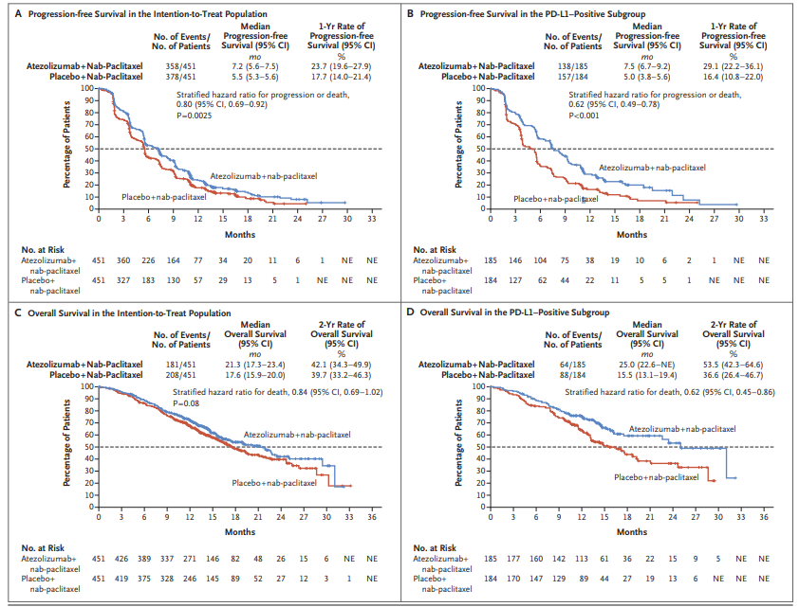
Figure 1: Kaplan–Meier Analysis of Progression-free Survival in (A) the intention-to-treat (ITT) population and (B) PD-L1 positive subgroup and Overall Survival in (C) the ITT population and (D) PD-L1 positive subgroup
PD-L1 positive subgroup = patients whose tumours were positive for programmed death ligand 1 (PD-L1) expression (≥1% PD-L1 expression on tumour-infiltrating immune cells)
Source: Figure 2, p2114 of Schmid 2018 (13)

Intervention
The applicant states the proposed PBS-restriction for atezolizumab will be for first-line treatment of locally advanced or metastatic TNBC. The application to PBAC for PBS listing of atezolizumab will include clinical data in all comer patients and in patients expressing PD-L1. This application to MSAC requests consideration of PD L1 testing in order to access atezolizumab as a contingency for the scenario in which the PBAC recommends PBS listing of atezolizumab in PD-L1 positive patients only. The testing would enable identification of those patients most likely to benefit from treatment with atezolizumab.
All patients who have previously untreated locally advanced or metastatic TNBC are expected to undergo testing for PD-L1 expression (i.e. 100% uptake). The applicant considers that the test will be undertaken using tissue samples taken as part of the standard diagnostic work-up when advanced breast cancer (presumably locally advanced or metastatic) is suspected. The application notes that the IMpassion130 trial utilised PD-L1 testing on both archival and newly obtained biopsy samples. Analysis by type of sample tested would be informative as MSAC noted in the 1414 Public Summary Document that “PD-L1 expression is inducible and may vary during the course of disease”. PASC noted the intention that IHC testing will be done by a pathologist on a biopsy sample, taken as part of standard diagnostic work-up and alongside other routine IHC tests.
PD-L1 testing
A PD-L1 test involves analysing tissue obtained from a tumour biopsy to determine the level of PD-L1 expression. The applicant proposes that the Roche VENTANA SP142 IHC assay be used to assess
PD-L1 expression. The application states that the diagnostic test has yet to be included on the ARTG as a class III IVD with companion diagnostic claims. The applicant noted they will submit an application for the SP142 IHC assay kit (as an in vitro diagnostic [IVD] device) following TGA approval of atezolizumab for the treatment of first-line, locally advanced or metastatic TNBC, see below.
The SP142 assay was specifically developed for atezolizumab to optimise staining of immune cells, in line with the biological hypothesis that PD-L1 expression on immune cells plays a key role for its activity. PD-L1 expression on immune cells is considered to be the biomarker for differentiating the efficacy of atezolizumab plus nab-paclitaxel in patients with TNBC. The assay has been used across the atezolizumab clinical trial program, with the VENTANA SP142 IHC assay specifically being used to assess PD-L1 expression in the key randomised trial (IMpassion130), which is likely to form the major part of the clinical evidence for this test.
The diagnostic hypothesis and definition of PD-L1 positivity in IMpassion130 were based on observations of the potential predictive value of PD-L1 expression on tumour-infiltrating immune cells, and the fact that in breast cancer it appears far more common than on tumour cells, with the majority of cases PD-L1 positive on tumour cells being also positive on immune cells. In IMpassion130 using SP142, prevalence of PD-L1 positivity on immune cells and tumour cells was 41% and 9%, respectively, and the majority of patients who had PD-L1 expression on tumour cells of ≥1% also had PD-L1 expression on immune cells of ≥1%. Patients with PD-L1‒positive tumours (expression on tumour-infiltrating immune cells ≥1% as a percentage of tumour area) represented the PD-L1–positive subgroup in IMpassion 130. PASC noted that the applicants’ rationale for using this definition of PD-L1 positivity was the potential predictive value of PD-L1 expression on tumour-infiltrating immune cells. PASC confirmed that, for atezolizumab access, a score of ≥1% PD-L1 is to be based on the proportion of PD-L1-expressing tumour-infiltrating immune cells as a percentage of tumour area. The applicant states that the results from IMpassion130 have not been validated on any assay other than the VENTANA SP142 assay.
Detailed information on the SP142 IHC assay kit components as well as a comparison of the assay to alternative commercial PD-L1 test kits for TNBC would be presented for MSAC consideration in the co-dependent technology submission along with results from a global concordance study. Data from the same trial will also be presented to help inform both the type of sample required for PD-L1 testing as well as further relevant sample considerations such as biopsy location.
The applicant provided a summary of the type of assay relevant to various PD-1/PD-L1 medicines and the scoring systems used. This is presented in Figure 2. The PD-L1 assay and scoring system proposed for previously untreated, unresectable locally advanced or metastatic TNBC represents a further assay and scoring system to those previously considered by PASC. PASC noted that there are several commercial assay kits and instrumentation platforms available for PD-L1 testing; individual laboratories may also set up their own in-house tests. PASC also noted that the available IHC assays differ in the cell types and cut-offs used to define PD-L1 positivity. PASC expressed concern about the comparability of the different assays, noting that Tecentriq® results had not been validated on other platforms. The applicants stated that they will present a comparison of alternative commercial PD-L1 test kits for TNBC as part of their MSAC application.
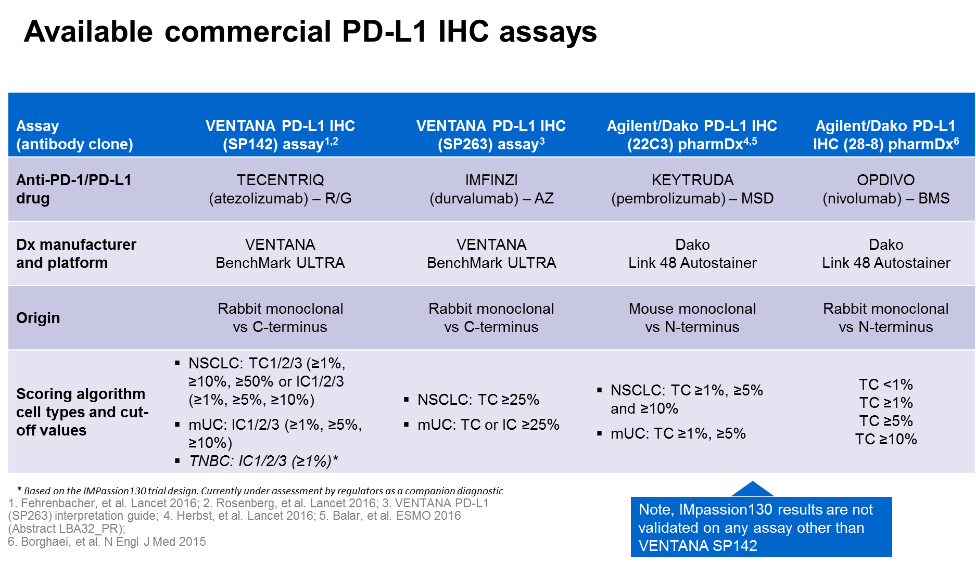
Figure 2: Summary of the type of assay relevant to various PD-1/PD-L1 medicines and the scoring systems used
IC = immune cell; mUC = metastatic urothelial cancer; NSCLC = non-small cell lung cancer; TNBC = triple negative breast cancer; TC = tumour cell
The applicant indicates that only one PD-L1 test would be required throughout the course of a patient’s disease. The applicant states that a certified pathologist would be responsible for conducting the testing and for reporting the results and that PD-L1 testing should be able to be carried out in any pathology laboratory holding the appropriate accreditation to claim pathology services through the MBS. Specialists, including oncologists may provide a referral for PD-L1 testing.
Pathologist training and quality assurance programs are intended to be developed to assist in the interpretation of the test results for PD-L1 positivity specific to the SP142 assay and for other assays that are likely to be available. Further details on these would be useful for MSAC consideration.
There is currently no MBS item for determination of PD-L1 expression in patients with breast cancer. A new MBS item was added on 1 November 2018 for IHC testing of PD-L1 expression to help determine eligibility for PBS-subsidised pembrolizumab in patients diagnosed with non-small cell lung cancer (NSCLC). The MBS item descriptor does not nominate the use of a specific trademarked assay. The applicant states that similarly, it “is not anticipated that a specific trademarked assay would be required to perform PD-L1 IHC testing in TNBC patients (Q29)”. The applicant confirmed that the application is requesting a test-agnostic MBS item descriptor. However, PASC noted that all the evidence is from clinical trials using the SP142 assay on the Ventana platform.
PD-L1 inhibitor: Atezolizumab
Atezolizumab selectively targets PD-L1 to prevent interaction with the receptors PD-1 and B7-1 (a costimulatory cell-surface protein), reversing T-cell suppression.
The applicant advised that atezolizumab [Tecentriq®] is not currently TGA-approved for patients with TNBC; however, is in the process of being considered by the TGA for “First-line, locally advanced or metastatic TNBC”. The applicants stated that regulatory approval of their application for atezolizumab (Tecentriq®) for metastatic TNBC is expected in December 2019.
It is noted that in atezolizumab was used in combination with nanoparticle albumin-bound paclitaxel (nab-paclitaxel) for the treatment of metastatic or unresectable locally advanced, histologically documented triple-negative breast cancer in the IMpassion 130 trial.
The applicant advised the atezolizumab is currently TGA-registered for “the treatment of patients with locally advanced or metastatic non-small cell lung cancer (NSCLC) with progression on or after prior chemotherapy. In patients with tumour EGFR or ALK genomic aberrations, Tecentriq [atezolizumab] should be used after progression on or after targeted therapy”.

Comparator
The applicant proposes that the appropriate comparator for the purposes of this application is no PD-L1 test and current standard of care (i.e. anthracyclines and/or taxane and/or platinum-based chemotherapy as initial treatment), with the choice of regimen depending on patient characteristics, previous treatment in the early breast cancer setting and clinician choice. PASC confirmed that the appropriate comparator is no PD-L1 test and the subsequent continuation of standard of care (i.e. anthracyclines and/or taxane and/or platinum-based chemotherapy as initial treatment).
PASC noted that numerous treatment protocols are used for metastatic TNBC. The applicant confirmed that the choice of chemotherapy regimen depends on patient characteristics (e.g. health status, frailty vs fitness); whether the patient received previous treatment in the early breast cancer setting (and how long ago they had it); if so, what treatment was used and how well was it tolerated; and clinician and patient choice are also relevant. PASC queried whether different protocols imply different patient groups and whether there would be any difference in terms of outcomes or economic considerations. The applicants confirmed that, although TNBC diagnosis groups patients together, current treatment depends on whether the patient has:
• relapsed disease after previous treatment for early disease; or
• unresectable metastatic disease on diagnosis, with no previous treatment.
The applicant confirmed that about one-third of patients in the IMpassion 130 trial were treatment-naïve, and about two-thirds had received previous treatment.
The applicant proposes that PD-L1 testing would be used in addition to current tests (ER, PgR and HER2/neu status and tumour staging/grading) used to confirm the diagnosis of locally advanced or metastatic TNBC. The proposed treatment algorithm (see Figure 4) indicates that atezolizumab based therapy is intended to be used instead of the current standard of care in patients who have PD-L1 expression on tumour-infiltrating immune cells of ≥1% (with scoring based on PD-L1-expressing immune cells as a percentage of tumour area (13)).
The key randomised trial cited in the application (IMpassion130) indicates that the clinical evidence will consist of a comparison of atezolizumab administered with nab-paclitaxel compared to placebo in combination with nab-paclitaxel for patients with locally advanced or metastatic TNBC who have not received prior systemic therapy.

Reference standard
PASC considered that reproducibility of results with different assay kits and platforms may have an impact on treatment decisions. PASC noted the applicants’ commitment to provide comparative analyses in their MSAC/PBAC application. PASC queried whether differences between tests would affect service provision by different laboratories/locations.

Outcomes
PASC accepted the proposed clinical outcomes as follows:
Safety outcomes
• Adverse events of atezolizumab treatment.
Test-related
• Efficacy and safety outcomes of atezolizumab treatment with and without prior PD-L1 testing; and
• Re-biopsy rates.
Test outcomes
- Trial based (evidentiary standard) PD-L1 IHC assay analytical performance;
- Comparative performance of PD-L1 testing methods:
  - Concordance with other commercially available PD L1 assays; and
  - Re-testing rates
- Clinical utility (test plus drug combination).
Treatment-related
• Overall survival;
• Progression-free survival;
- Response rate;
- Duration of response; and
- Quality of life.
PASC accepted the proposed outcomes for use in the economic evaluation as follows:
Healthcare resources
- Cost of testing per case;
- Re-biopsy rates;
- Test turn-around time;
- Estimated number of patients being tested;
Total Australian Government healthcare costs
- Total cost to the Medical Benefits Schedule (MBS); and
- Total cost to the Pharmaceutical Benefits Scheme (PBS).
PASC queried whether the BRCA1/2 status of patients would affect outcomes? The applicant stated that about 15% of patients in the IMpassion 130 trial were BRCA1/2 positive and outcomes did not depend on BRCA1/2 status. PASC indicated that this data needed to be clarified.

Current clinical management algorithm for identified population
The application states that patients with locally advanced or metastatic TNBC undergo no PD-L1 testing and receive anthracyclines and/or a taxane and/or platinum-based chemotherapy. The nomination of anthracyclines and/or taxane and/or platinum based chemotherapy as initial treatment for TBNC is supported by the European School of Oncology (ESO) and the European Society for Medical Oncology (ESMO) 2018 Guidelines (14). The regimen chosen will depend on patient characteristics, previous treatment in the early breast cancer setting and clinician choice.
Figure 3 summarises the current clinical pathway for the first-line treatment of patients with locally advanced or metastatic TNBC. For clarity, the algorithm provided in the application has been amended to specify that inoperable/metastatic breast cancer is determined “at initial diagnosis or progressed from earlier stage disease”.
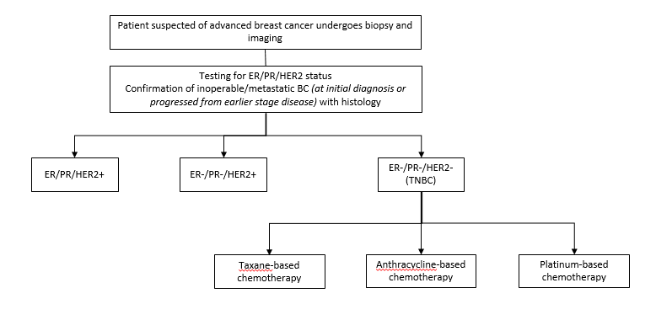
Figure 3: Current clinical treatment algorithm for first-line management of locally advanced or metastatic TNBC
TNBC = triple-negative breast cancer; ER = oestrogen; PgR = progesterone; HER2/neu = human epidermal growth factor receptor; BC = breast cancer

Proposed clinical management algorithm for identified population
Figure 4 summarises the ways in which the applicant predicts that the treatment algorithm for patients with locally advanced or metastatic TNBC is likely to change with the MBS listing of PD-L1 testing for this patient population and with the PBS listing of atezolizumab for this indication. Shaded cells represent the request made in the application. As for the current clinical treatment algorithm and for clarity, the algorithm provided in the application has been amended to specify that inoperable/metastatic breast cancer is determined “at initial diagnosis or progressed from earlier stage disease”. The proposed treatment for those who are determined to be PD-L1 positive (≥1%) may also be better described as “Atezolizumab + nab-paclitaxel” according to its use in the IMpassion 130 trial, rather than “Atezolizumab-based therapy”. Given the key IMpassion 130 trial used atezolizumab + nab-paclitaxel, PASC queried whether that should be specified in the proposed algorithm (rather than ‘atezolizumab-based therapy’). The applicants confirmed that there is no evidence that any particular chemotherapy is better for treating TNBC; nab-paclitaxel was chosen as a reasonable proxy given heterogeneity of treatments in practice.
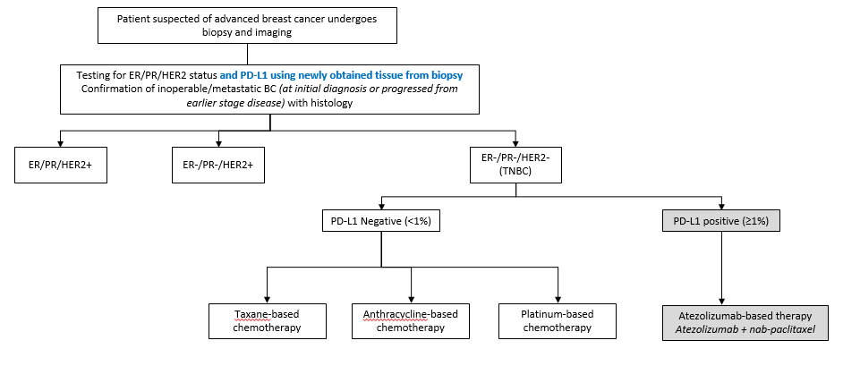
Figure 4: Proposed clinical treatment algorithm for first-line management of locally advanced or metastatic TNBC
TNBC = triple-negative breast cancer; ER = oestrogen; PgR = progesterone; HER2/neu = human epidermal growth factor receptor; BC = breast cancer
PASC noted that the proposed clinical management algorithm specifies that PD-L1 testing should be done on ‘newly obtained tissue from biopsy’. PASC queried whether a new biopsy would be required if the patient has a previous breast cancer diagnosis. The applicants confirmed that, ideally, a biopsy will be done for every patient that relapses to confirm that the tumour is the same as the early disease and not something unexpected. A biopsy will always be done for a patient with metastatic disease to confirm the diagnosis.
Neither the current nor proposed clinical treatment algorithms provided in the application provide any details on the likely subsequent treatments following first-line therapy for locally advanced or metastatic TNBC.

Proposed economic evaluation
The comparative clinical claim is likely to be that PD-L1 testing followed by atezolizumab-based treatment is superior to no testing and current standard of care for patients with locally advanced or metastatic TNBC who are PD-L1 positive. PASC noted the applicants’ claim of superiority; therefore, a cost-effectiveness or cost-utility analysis would be appropriate.
PASC advised that superiority would need to be justified by:
• acceptable safety and analytical performance of the PD-L1 test (MSAC);
• superior efficacy with acceptable safety of atezolizumab-based treatment in PD-L1-positive patients relative to standard of care (without PD-L1 testing) (PBAC); and
• clinical utility of the test plus drug combination (MSAC/PBAC).
PASC advised that the economic evaluation should clearly consider the comparative analytical performance of different test options and platforms, as well as sensitivity and specificity of PD-L1 testing, and the rates of false positives and false negatives. The economic evaluation should specifically analyse the consequences of patients having atezolizumab if they are not PD-L1 positive.

Proposed item descriptor and MBS fee
PASC noted there is currently no MBS funding for PD-L1 testing in breast cancer.
PASC noted the proposed item descriptor (below) is consistent with the descriptor for MBS item 72814 (IHC examination of PD-L1 status in non-small cell lung cancer to determine access to pembrolizumab).
Category 6 – PATHOLOGY SERVICES
Immunohistochemical examination by immunoperoxidase or other labelled antibody techniques using the programmed cell death ligand 1 (PD-L1) antibody of tumour material from a patient diagnosed with triple negative breast cancer, to determine if the requirements relating to (PD-L1) expression status for access to atezolizumab under the Pharmaceutical Benefits Scheme (PBS) are fulfilled

Fee: $74.50

PASC suggested it may be appropriate to include a requester definition: ‘requested by, or on behalf of, specialist or consultant physician’. Scoring of PD-L1 positivity in immune cells has additional logistic complexity compared with scoring done for other cancers, and a specialist should be involved.PASC commented that, because PD-L1 testing can also be claimed under the existing broader IHC MBS items (72846, 72847, 72849 and 72850), even if a new MBS item number is added for PD-L1 testing in breast cancer, rule 13 could prevent it being used.
PASC noted that the proposed fee of $74.50 is consistent with the fee for MBS item 72814.
PASC noted that fees for other IHC test items are driven by the type and number of antibodies per specimen, ranging from $59.60 (for 1–3 antibodies) to $119.20 (for 11 or more antibodies). The fee for IHC using antibodies specific for ER/PgR/HER2/neu is $74.50.

Consultation feedback
PASC noted that Breast Cancer Network Australia (BCNA) supports MSAC consideration of the proposed service, particularly considering the limited treatment options for women with TNBC. BCNA also commented that women who may benefit from treatment with atezolizumab should be able to access PD-L1 testing at an affordable price, and should not be excluded because of out-of-pocket costs.
PASC noted targeted consultation feedback from the Peter MacCallum Cancer Centre supporting the application. Positive comments included: the service will provide improved first-line treatment for patients with advanced disease; PD-L1 testing allows targeted treatment in a patient population with very strong clinical need; and there will be cost savings for patients who otherwise may have to self-fund testing and therapy. The respondent also commented that the addition of immunotherapy (i.e. atezolizumab) will increase the toxicity of the patient’s treatment.

Other issues
PASC noted that a number of other applications for PD-L1 testing are currently progressing through the MSAC process. These applications relate to different cancers and different co-dependent medicines, and include testing on different cell types with different cut-off points. PASC advised that the question of how to deal with funding for PD-L1 testing overall needs to be considered.
PASC queried whether the MBS item descriptor should specify that PD-L1 testing is to be done on the same tissue used to confirm metastases, as done in the trials (i.e. testing at recruitment). The applicants stated that fresh biopsy tissue is preferred, but archival tissue can also be used (which reflects real-world practice). The applicant stated that, in the trials, REDACTED were archival samples. However, the applicant expressed the view that imposing a requirement that the same tissue be used (that confirmed metastases) could lead to some patients being excluded.
PASC noted that quality assurance programs are in place and that the applicant has been conducting training.

Summary of PASC’s discussion
PASC’s focus of concern related to test performance, noting issues in common with other applications for PD-L1 testing. Because the application is test-agnostic, it is important to examine comparability among tests. PD-L1 positivity should be determined on tumour-infiltrating immune cells. PASC advised that false-positive and false-negative rates must be considered, especially in terms of the consequences of a high false-positive rate on economic aspects for the PBAC. Specifically, sensitivity analysis should be performed on the modelled false-positive rate. PASC advised that better population estimates are required, and should include patients with locally advanced disease and patients in the prevalent population. PASC also advised that any effect of previous treatment and age/fitness of the patient on PD-L1 positivity should be assessed and ruled out.

References
1. Ferlay J, Soerjomataram I, Dikshit R, et al. Cancer incidence and mortality worldwide: sources, methods and major patterns in GLOBOCAN 2012. International Journal of Cancer. 2015;136(E359-E386).
2. DeSantis C, Bray F, Ferla J, et al. International variation in female breast cancer incidence and mortality rates. American Association for Cancer Research. 2015;24(10).
3. Dent R, Trudeau M, Pritchard K, et al. Triple-negative breast cancer: clinical features and patterns of recurrence. Clinical Cancer Research. 2007;13(15).
4. Chacon R, Costanzo M. Triple-negative breast cancer. Breast Cancer Research. 2010;12(Suppl. 2).
5. Foulkes W, Smith I, Reis-Filho J. Triple-negative breast cancer. The New England Journal of Medicine. 2010;363.
6. Carey L, Perou C, Livasy C, et al. Race, breast cancer subtypes, and survival in the Carolina Breast Cancer Study. JAMA. 2006;295(21).
7. Urru S, Gallus S, Bosetti C, et al. Clinical and pathological factors influencing survival in a large cohort of triple-negative breast cancer patients. BMC Cancer. 2018;18(56).
8. Press D, Miller M, Liederbach E, et al. De novo metastasis in breast cancer: occurrence and overall survival stratified by molecular subtype. Clinical & Experimental Metastasis. 2017;34:457-165.
9. Bonotto M, Gerratana L, Poletto E, et al. Measures of outcome in metastatic breast cancer: insights from a real-world scenario. The Oncologist. 2014;19:608-15.
10. Seigal R, Miller K, Jemal A. Cancer statistics Surveillance, Epidemiology, and End Results (SEER) Program (www.seer.cancer.gov) SEER*Stat Database: Incidence - SEER 9 Regs Research Data, Nov 2017 Sub (1973-2015) <Katrina/Rita Population Adjustment> - Linked To County Attributes. Total U.S., 1969-2016 Counties, National Cancer Institute, DCCPS, Surveillance Research Program, released April 2018, based on the November 2017 submission. 2018.
11. Australian Institute of Health and Welfare. Cancer in Australia 2017. Cancer Series no 101 Cat No CAN 100. 2017.
12. Thientosapol E, Tran T, Della-Fiorentina S, et al. Survival times of women with metastatic breast cancer starting first-line chemotherapy in routine clinical practice versus contemporary randomised trials. Internal Medicine Journal. 2013:883-8.
13. Schmid P et al. Atezolizumab and nab-paclitaxel in advanced triple-negative breast cancer. N Engl J Med 2018: 379:2108-21.
14. Cardoso E, et al. 4th ESO–ESMO International Consensus Guidelines for Advanced Breast Cancer (ABC 4). Ann Oncol 2018, 29: 1634-57.
15. NCCN Guidelines Version 1.2019 – Breast Cancer. https://www.nccn.org/professionals/physician_gls/pdf/breast.pdf

