Public Summary Document

Report to the Medical Services Advisory Committee on utilisation of

MBS item 73339 and 73340 following Application 1152: Genetic testing for hereditary mutations in the RET gene
Medicare Benefits Schedule (MBS) item considered: 73339 and 73340
Date of MSAC consideration: 29 March 2018
Context for decision: The Medical Services Advisory Committee (MSAC) makes its advice in accordance with its Terms of Reference, see the MSAC Website.

Purpose
The purpose of the report was to inform MSAC of the real world impacts on the outcomes of Application 1152: Genetic testing for hereditary mutations in the RET gene. MSAC uses this information to ensure that the items resulting from this application are being used as intended. The report is not a review of the clinical information covered during the application process.

MSAC’s advice
After considering the real world impacts of the outcomes of Application 1152 for genetic testing of hereditary mutations in the RET gene (MBS items 73339 and 73340), MSAC considered utilisation data and compared it with prior utilisation predictions following MSAC’s support for genetic testing for hereditary mutations in the RET gene. MSAC noted there was lower than expected utilisation of this item and recommended no further action.

Summary of consideration and rationale for MSAC’s advice
MSAC recalled that diagnostic RET mutation testing was estimated to occur in 130–260 patients in 2013, increasing to 147–294 in 2015. MSAC noted that actual utilisation of MBS items 73339 and 73340 is significantly lower than the estimations in Application 1152, amounting to approximately 15% and 4% respectively of predicted utilisation services from 2014-15, 2015-16 and 2016-17.
MSAC noted that testing for germline RET mutation was part of established clinical practice in Australia prior to MSAC consideration, with services provided by the state-territory hospitals system. Prior to MSAC considering this application, there was likely to be little unmet need in the absence of MBS funding. The creation of these MBS items has likely seen some services and associated costs shift to the MBS. The services ‘gap’ in predicted vs actual identified in MBS utilisation data is still likely being met by services in the public hospital system. Public hospital data is not available for pathology services as they are not clinically coded in the Australia Classification of Health Interventions and therefore do not appear in hospital inpatient data.
MSAC noted that the average fee charged for MBS item 73339 had increased from $267.35 in 2015-16 to $370 in 2016-17 (Table 3). Services were typically bulk billed in most states, reaching a 93% rate in 2015-16 and dropping to 88% in 2016-17.
MSAC noted for item 73340, services were 100% bulk billed in Australia, between 2014-15 and 2016-17. MSAC also noted that the majority of both services were claimed in NSW.
MSAC noted that item 73339 is most commonly claimed alone between 25.0-33.3% of the time, and also with item 73939, which is a Patient Episode Initiation (PEI) item. Similarly, item 73340 is most commonly claimed with item 73940 (receipt of specimen) and item 73939.
MSAC noted there was no concern from a clinical perspective as to the MBS items that were co-claimed with these items and agreed there are likely to be legitimate reasons for the MBS items when only utilised occasionally. MSAC recommended no further action is required for MBS items 73339 and 73340.

Methodology
An application is selected for consideration if the resulting new item(s) and/or item amendment(s) have been on the MBS for approximately 24 months or longer or if there were particular concerns about utilisation such that MSAC requested to consider it earlier. The specific applications for each MSAC meeting are selected by the MSAC Executive which is composed of the chairs of MSAC and its sub-committees.
A report on the utilisation is developed by the Department of Health with information on a number of metrics including; state variation, patient demographics, services per patient, practitioner’s providing the service, data on fees and co-claiming of services. The number of metrics included in a report is dependent on the annual service volume for the MBS item(s) under consideration i.e. an item with very low utilisation will have less data to analyse. Where service volumes are too low, information is suppressed to protect patient privacy.
Where possible the report compares data on real world utilisation to the assumptions made during the MSAC assessment. Most of these assumptions are drawn from the assessment report.
Relevant stakeholders are provided an opportunity to comment on the findings in the report before it is presented to the MSAC. It is intended that stakeholders are given at least three weeks to consider the reports.
The stakeholder version of the report does not contain information on assumptions from the MSAC consideration if this information is not already publicly available. This is to protect the commercial in confidence of the original applicants. The same principle is applied to this document.
Once MSAC has considered the report, its advice is made available online at the MSAC Website.

Results

Utilisation
Item 73339 had 24 services claimed in 2014-15, 42 services in 2015-16 and 16 services in 2016-17, constituting about 15% of services estimated for the period. From 2014-15 FY to 2016-17 FY, only three states recorded utilisation of this item, with New South Wales averaging 89% of utilisation across this period.
Utilisation of item 73340 is significantly below that estimated in the submission to MSAC and the MBS costing model. There were 10 services in 2014-15, 14 services in 2015-16 and 4 services in 2016-17, constituting about 4% of services estimated for the period.

Patient breakdown
73339
There were 24 patients in 2014-15, 42 patients in 2015-16 and 16 patients in 2016-17 who claimed item 73339. All were new patients, as this item is limited to one test per patient under rule 25, which limits the item to no more than once in a lifetime.
73340
There were 10 patients in 2014-15, 14 patients in 2015-16 and 4 patients in 2016-17 who claimed item 73340. This item is also limited to one test per patient under rule 25, limiting the item to no more than once in a lifetime.

Utilisation – 73339 (July 2014-September 2017)
Since July 2014, 73339 has predominantly been claimed by patients aged 45-64 (Figure 3).
Figure 3: Demographic profile for MBS item 73339 for July 2014- September 2017
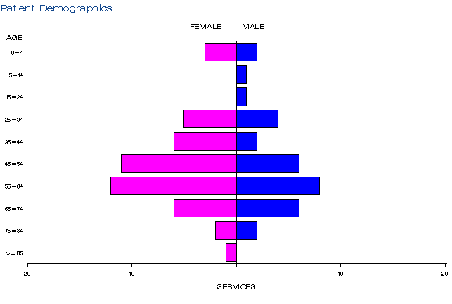
Source: Medicare Statistics, Department of Human Services at
http://medicarestatistics.humanservices.gov.au/statistics/do.jsp?_PROGRAM=%2Fstatistics%2Fmbs_item_standard_report&DRILL=ag&group=73339&VAR=services&STAT=count&RPT_FMT=by+state&PTYPE=finyear&START_DT=201407&END_DT=201711

Utilisation 73340 (July 2014-September 2017)
In the same period, 73340 was predominantly claimed by patients aged 0-24 years (noting the very low utilisation rates) (Figure 4).
Figure 4: Demographic profile for MBS item 73340 for July 2014-September 2017
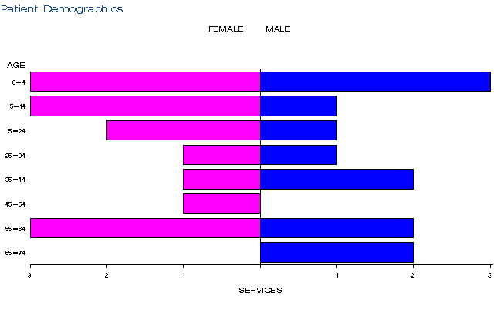
Source: Medicare Statistics, Department of Human Services at
http://medicarestatistics.humanservices.gov.au/statistics/do.jsp?_PROGRAM=%2Fstatistics%2Fmbs_item_standard_report&DRILL=ag&group=73340&VAR=services&STAT=count&RPT_FMT=by+state&PTYPE=finyear&START_DT=201407&END_DT=201711

Co-claiming
MSAC noted that item 73339 is most commonly claimed alone between 25.0-33.3% of the time, and also with item 73939, which is a PEI item. Similarly, item 73340 is most commonly claimed with item 73940 (receipt of specimen) and item 73939.
MSAC noted there was no concern from a clinical perspective as to the MBS items that were co-claimed with these items and agreed there are likely to be legitimate reasons for the MBS items when only utilised occasionally. MSAC recommended no further action is required for MBS items 73339 and 73340.

Data on fee charged
The information provided on fees below is a snapshot of how the item is being claimed in practice. Data has not been printed for states and territories with low service volumes.
The information provided on fees below is a snapshot of how the item is being claimed in practice. Data is only presented as an Australian total because of low service volumes.
The 75% benefit for item 73339 is $300.00. The average fee charged for item 73339 has increased from $267.35 in 2015-16 to $370 in 2016-17 (Table 2). Services typically bulk billed in most states, reaching a 93% rate in 2015-16, dropping to 88% in 2016-17.
Table 2: Statistics on fees charged for MBS item 73339 between 2014-15 and 2016-17 by date of service
Financial year | Fees | AUS total
2014-15 (from 1 Nov 2014) | Bulk Billed Rate | 96.0%
2015-16 | Average Fee Charged ª | $267.35
 | Bulk Billed Rate | 93.0%
2016-17 | Average Fee Charged ª | $370.00
 | Bulk Billed Rate | 88.0%
Source: Department of Health, File: Q20994_1152a Item 73339, 7 NOV 2017.
ª Statistics for Fees Charged are calculated for Patient-billed services only
The 75% benefit for item 73340 is $150.00. Services were 100% bulk billed in Australia, between 2014-15 and 2016-17.

Background
In October 2010, The Pathology Service Table Committee (PSTC) submitted an application requesting an MBS listing of genetic testing for mutations in the RET gene for:
(i) patients with symptoms of multiple endocrine neoplasia type II (MEN2), and
(ii) unaffected relatives of a patient with a documented RET mutation to determine the risk of disease.
The proposal was for two new MBS items to cover the use of diagnostic and predictive testing for mutations in the RET gene. As the application progressed, the PSTC was disbanded and the Royal College of Pathologists of Australasia took over sponsorship for this application.
The intervention is mutation testing for the RET proto-oncogene, whose mutations are associated with multiple endocrine neoplasia type II (MEN2A and B, and familial medullary thyroid cancer, (FMTC) and the seemingly unrelated syndrome of congenital absence of the enteric ganglia (Hirschsprung disease). MEN2 is autosomal dominant, which means that offspring with one affected parent have a 50% chance of having MEN2 themselves. Studies have shown that over 90% of people who have a RET mutation will develop MEN2. Mutation testing of the RET gene is therefore used as a means of diagnosing MEN2 in those with symptoms (distinguishing between those who have MEN2, and those who have the more common sporadic form of MTC), and also as a way of predicting which family members will develop MEN2, based on whether they carry the pathogenic mutation of the RET gene.
MSAC’s role was to assess the safety, effectiveness and efficacy, cost-effectiveness of the tests. MSAC also considered the wording of the MBS item descriptor, the MBS fee and the financial implications of publicly funding the surgical procedure.
On 1 August, 2013, MSAC supported the listing of two new MBS item for genetic testing for hereditary mutations in the RET gene (items 73339 and 73340).
The 2012 MSAC Public Summary document noted that the estimated number of diagnostic RET mutation was estimated to occur in 130-260 patients in 2013, increasing to 147-294 in 2015.
The PSD also estimated the likely number of eligible family members who may elect to have RET mutation screening tests was estimated to be 150-359 in 2013, increasing to 169-406 in 2015.

Item descriptor
MBS Item | Descriptor
73339 | Detection of germline mutations in the RET gene in patients with a suspected clinical diagnosis of multiple endocrine neoplasia type 2 (MEN2) requested by a specialist or consultant physician who manages the treatment of the patient.  One test.(Item is subject to rule 25)  Fee: $400.00 Benefit: 75% = $300.00 85% = $340.00
73340 | Detection of a known mutation in the RET gene in an asymptomatic relative of a patient with a documented pathogenic germline RET mutation requested by a specialist or consultant physician who manages the treatment of the patient.  One test.(Item is subject to rule 25)  Fee: $200.00 Benefit: 75% = $150.00 85% = $170.00

Applicant’s comments on MSAC’s public summary document
No applicant comment was received.

Further information on MSAC
MSAC Terms of Reference and other information are available on the MSAC Website at: www.msac.gov.au.

