Application 1567:
Digital breast tomosynthesis
(DBT or 3D mammography)

Ratified PICO Confirmation
(To guide a new application to MSAC)
(Version 1.3)

Summary of PICO/PPICO criteria to define the question(s) to be addressed in an Assessment Report to the Medical Services Advisory Committee (MSAC)

PICO for clinical effectiveness and safety outcomes using a linked evidence approach
Component | Description
Patients | Population 1: Patients with symptoms or signs of possible breast disease  Population 2: Patients who had a previous personal history of breast cancer, with or without symptoms of breast cancer recurrence  Population 3: Women with a high risk of developing breast cancer due to their family history, with or without symptoms  Population 4: Asymptomatic women with a low-to-moderate increased risk of developing breast cancer due to their family history
Prior tests | Clinical exam  Symptomatic women aged <35 years – ultrasound  Asymptomatic women at high risk aged <50 years – magnetic resonance imaging (MRI)
Interventions | For all four populations:  - Digital breast tomosynthesis (DBT) plus synthesised 2D images  - DBT in conjunction with conventional 2D digital mammography (2D DM)
Comparator(s) | Conventional 2D DM
Outcomes | Safety  - Radiation exposure  Clinical utility  - Percent change in management as a result of earlier detection of cancer by DBT  - change in treatment due to a reduction in false positive or inconclusive results  - risk of ‘over-diagnosis’  Therapeutic effectiveness  - False negative rate  - Overall survival due to earlier detection of breast cancer  - False positive rate  - Avoidance of unnecessary biopsies or surgery  - Proportion of unnecessary workups of benign tumours  - Patient anxiety  - Inconclusive result rate  - Avoidance of unnecessary coned compression views and/or other additional imaging, biopsies and surgeries  - Proportion of unnecessary workups  Cost-effectiveness  Cost, cost per life year gained, cost per quality adjusted life year or disability adjusted life year, incremental cost-effectiveness ratio, cost per case identified, cost per additional diagnosis, cost per case avoided  Total Australian Government healthcare costs  Number of patients tested, number of patients recalled for repeat testing, number of additional patients treated earlier

PICO for diagnostic accuracy
Component | Description
Patients | Population 1: Patients with symptoms or signs of possible breast disease  Population 2: Patients who had a previous personal history of breast cancer, with or without symptoms of breast cancer recurrence  Population 3: Women with a high risk of developing breast cancer due to their family history, with or without symptoms  Population 4: Asymptomatic women with a low-to-moderate increased risk of developing breast cancer due to their family history  Population 5: General breast screening population ª
Prior tests | Clinical exam  Symptomatic women aged <35 years – ultrasound  Asymptomatic women at high risk aged <50 years – magnetic resonance imaging (MRI)
Reference standard | Fine needle aspiration, core biopsy and/or surgical biopsy results
Interventions | For all five populations:  - Digital breast tomosynthesis (DBT) plus synthesised 2D images  - DBT in conjunction with conventional 2D digital mammography (DM)
Comparator(s) | Conventional 2D DM
Outcomes | Diagnostic performance for detection of architectural distortion and focal asymmetries, benign versus malignant cancers (conspicuity), and micro-calcifications as the primary finding, and the effect of breast density  - Diagnostic yield (cancer detection rate)  - Sensitivity and specificity (analytical validity)  - Inter-observer agreement  - Test-retest reliability  - Proportion of inconclusive results  - Recall rate  Clinical validity  - Positive and negative predictive values  - Positive and negative likelihood ratios  - Prognostic value of detecting different types of abnormalities, e.g. architectural distortions, focal asymmetries, micro-calcifications and solid masses
ª Diagnostic performance to be assessed in the general breast screening population only if insufficient literature is identified on the other four populations

PICO rationale for the investigative medical service

Population
The patient population for whom public funding for digital breast tomosynthesis (DBT) is intended includes all patients with: 1) symptoms or signs suggestive of breast cancer, 2) a previous personal history of breast cancer, and 3) women with an increased risk of developing breast cancer due to a family history.
The pathway to mammography may vary for patients with different indications and age. Therefore, the patients who would be eligible for reimbursement under Medicare have been divided into four populations as follows:
Population 1: Patients with symptoms or signs suggestive of breast cancer but without a previous breast cancer diagnosis or a high-risk family history of breast and/or ovarian cancer. This population includes symptomatic women and men from the general population, as well as symptomatic women with a low-to-moderate increased risk of developing breast cancer. These women would be treated the same as those with no increased risk; hence, their inclusion in this population.
Symptoms of breast cancer include:
- A lump or area of thickening in the breast
- Persistent, unusual pain in the breast or armpit not related to the menstrual cycle
- Nipple changes (in shape, crusting, a sore or an ulcer, redness, or a nipple that is inverted when it used to stick out)
- Nipple discharge (with or without blood)
- A change in the size or shape of the breast
- Skin changes (dimpling, unusual redness or other colour changes)
- Swelling or discomfort in the armpit
This population would also include women participating in the BreastScreen Australia program who are identified as having findings suspicious of malignancy who wish to be further assessed in the private health care sector. However, generally very few patients move from the BreastScreen program into the private sector, with the most likely reason being anxiety about a delay in assessment within the BreastScreen program. DBT is currently being used within the BreastScreen program for both screening and further assessment.
Population 2: Patients with a previous personal history of breast cancer, with or without symptoms of breast disease recurrence.
Population 3: Women with a high risk of developing breast cancer due to their family history, with or without symptoms of breast disease. According to the Royal Australian College of General Practitioners (RACGP 2018), women are considered to have a high risk if their family history meets the following criteria:
a. Three or more first- or second-degree relatives, on the same side of the family, who have been diagnosed with breast or ovarian cancer;
b. Two or more first- or second-degree relatives, on the same side of the family, who have been diagnosed with breast or ovarian cancer, if any of the following applies to at least one of the relatives:
• has been diagnosed with bilateral cancer;
• had onset of breast cancer before 40 years of age;
• had onset of ovarian cancer before 50 years of age;
• has been diagnosed with breast and ovarian cancer, at the same time or at different times;
• has Ashkenazi Jewish ancestry;
• is a male relative who has been diagnosed with breast cancer;
c. One first- or second-degree relative diagnosed with breast cancer at 45 years or younger, plus another first- or second-degree relative on the same side of the family with bone or soft tissue sarcoma at age 45 years or younger;
d. Genetic testing has identified the presence of a high-risk breast cancer gene mutation.
PASC noted that BreastScreen Australia is currently looking into risk factors and what studies are required before introducing risk-based screening in Australia. PASC advised that this will provide information about risk categories, which may significantly affect the evaluation.
Population 4: Asymptomatic women with a low-to-moderate increased risk of developing breast cancer due to their family history. According to the RACGP Guidelines (RACGP 2018), these women should be monitored in the same manner as the general asymptomatic population; with screening mammograms (available free of charge from BreastScreen Australia) every two years from the age of 40 years. However, it may be recommended that women with a first-degree relative who was aged <50 years when diagnosed with breast cancer have annual instead of bi-annual screening, starting at least 10 years earlier than the age of the affected relative.
These women would be eligible for MBS-funded screening, instead of through BreastScreen Australia, under the proposed new MBS item numbers. Therefore, this population consists of those women who do not wish to be screened through BreastScreen Australia, but choose to have MBS-funded screening instead. PASC noted that confirmation is required regarding whether Population 4 is in scope. If it is considered outside of scope for MBS-funded DBT, it was noted that it would be necessary to tighten the MBS item descriptors to exclude these women. PASC also noted that similar modification of the descriptor for 2D-DM would also be required.
Women with a low-to-moderate increased risk of developing breast cancer due to their family history who have signs or symptoms suggestive of breast disease would be treated the same as the general population, and are therefore included in Population 1.
Women with a low level of increased risk of developing breast cancer due to their family history are defined as having breast cancer occurring in:
- One first-degree relative at age 50 years or older,
- One second-degree relative at any age,
- Two first- or second-degree relatives over the age of 50 years on different sides of the family,
- Two second-degree relatives on the same side of the family diagnosed at age 50 years or older.
Women with a moderately increased risk have a family history of breast cancer occurring in:
- One first-degree relative before the age of 50 years, or
- Two first-degree relatives on the same side of the family with at least one diagnosed under the age of 50 years
- Two second-degree relatives on the same side of the family with at least one diagnosed under the age of 50 years
Incidence of breast cancer
It is estimated that in 2019, breast cancer will be the fourth most commonly diagnosed cancer in Australia in the general population and the second most common among females, with an expected 19,371 women and 164 males being newly diagnosed with breast cancer. In 2019, breast cancer will account for 13.5% of all cancer cases. The estimated number of deaths from breast cancer in 2019 is 32 males and 3,058 females, representing an age-standardised rate of 10.1%. Population screening through BreastScreen Australia and breast cancer awareness campaigns has resulted in earlier detection, and in combination with better treatment options this has led to an increase in the chance of surviving at least 5 years after diagnosis from 72% in 1982–1987 to 91% in 2010–2014 (Australian Institute of Health and Welfare 2012; Breast Cancer Network Australia 2018).
In 2019, it is estimated that the age-standardised incidence rate will be 67.7 cases per 100,000 persons (1.1 for males and 131 for females). The incidence rate increases with age; around 21% of new cases are diagnosed in women younger than 50 years and 42% in those aged over 65 years. The average age of diagnosis in Australian women is 61 years. In 2019, it is estimated that the risk of an individual being diagnosed with breast cancer by their 85th birthday will be 1 in 675 for males and 1 in 7 for females.
The Department stated that “a more accurate estimate of the four populations” would be required to inform the assessment. Utilisation of the interim MBS item numbers for DBT (see Table 2) indicate that 133,452 claims were processed between 01/11/2018 and 27/03/2019. Of these 88,738 (66.5%) were referred by GPs. According to the Royal Australian and New Zealand College of Radiologists (RANZCR), GPs usually refer symptomatic patients, thus more than half of the DBTs performed under the interim MBS item numbers have been for patients who would most likely be included in Population 1. Specialists usually refer patients with previous cancer or those with a family history. Of the 43,856 (32.9%) patients referred by specialists most would have had cancer previously, patients with a family history would be a minority. PASC queried whether these assumptions can be used to estimate population sizes.
Rationale
Women participating in the BreastScreen Australia program who are identified as having findings suspicious of malignancy and wish to be assessed in the private health care sector would also be eligible for reimbursement for DBT from the MBS if not already undertaken as part of the initial breast screen. These women would be included in Population 1.
Prior to the use of DBT, patients who were investigated with clinical history and examination by their general practitioner or a breast clinical specialist and found to have symptoms or signs suggestive of breast cancer, and/or a family history or previous personal history of breast cancer, were referred for imaging tests, including 2-dimensional (2D) digital mammography (DM), ultrasound and/or magnetic resonance imaging (MRI) to determine the presence of malignant disease. For further details on when these imaging tests are used see the ‘Current and proposed clinical management algorithms’ section below. In recent practice, 2D mammography has largely been replaced by the proposed intervention, DBT, for which interim funding is available through the MBS. However, the extent to which DBT is used in conjunction with 2D imaging is unknown. Although benign conditions are not life threatening, breast imaging of patients with suspected benign disease is required for exclusion of malignancy. Early detection of breast cancer results in reduced mortality and morbidity. Patient management in accordance with clinical guidelines is based on the results of the ‘triple test’, which refers to the combined clinical exam, diagnostic imaging and biopsy results. If there is any inconsistency between the three parts of the triple test, or all three parts are not aligned, further assessment is required. When the triple test is concordant for either benign or malignant breast disease it’s diagnostic accuracy approaches 100% and definitive treatment can be started (Kharkwal, Sameer & Mukherjee 2014).
Of the 15 studies that the applicant identified as providing the key evidence base, and an additional three studies identified in two systematic reviews of DBT for breast cancer screening (Coop, Cowling & Lawson 2016; Hodgson et al. 2016), only one study included a population that matched at least one of the proposed populations eligible for reimbursement for DBT under the proposed MBS listing. The Australian TACT prospective clinical study by Mall et al (2018) included women who were recalled to the screening clinic (n=144). Thus, these women had signs of breast disease but their previous and family histories were not reported. However, patients were selected such that an equal number of normal, benign and cancer cases were included in the analysis, thus the prevalence of positive and inconclusive results for this population cannot be determined from this study.
The study population was much broader in the remaining studies. Twelve studies included all women participating in their local or regional population-based screening programs, thus including a large proportion of women who do not have any indications suggestive of breast cancer or a high risk due to a family or previous personal history and would not be eligible for reimbursement for DBT under the proposed MBS listing. The remaining five studies included only asymptomatic women, with four of the studies also excluding women with any personal or family history of breast cancer. Thus, few, if any of the women in these studies would be eligible for reimbursement at the time of testing.
The method by which patients were assigned to the investigative and control groups also differed greatly between studies (Table 1). Only one key study was a randomised controlled trial comparing DBT plus 2D DM with 2D DM alone (Pattacini et al. 2018). Another study did not include a comparator group (Houssami 2018). A third study selected the imaging procedure based on either clinician preference or radiologists’ choice (based on patient characteristics, such as previous screening, symptoms, breast density, etc) (Giess et al. 2017). Five studies used sequential analysis of both the intervention and control on the same patient cohort (Bernardi et al. 2016; Ciatto et al. 2013; Lång et al. 2016; Mall et al. 2018; Skaane et al. 2019), five studies used a historical control with patients having 2D DM in the 12 months preceding introduction of DBT (Caumo et al. 2018; Friedewald et al. 2014; Lourenco et al. 2015; McDonald et al. 2016; Rose et al. 2013) and in the remaining five studies the imaging procedure was based on patient preference and/or site capability (Conant et al. 2016; Destounis, Arieno & Morgan 2014; Freer et al. 2017; Greenberg et al. 2014; Haas et al. 2013).
If there is a lack of diagnostic accuracy evidence in the proposed populations, as suggested by the evidence base identified by the applicant, it may be necessary to broaden the population to include the general screening population to determine the diagnostic accuracy of the intervention compared with the comparator.
BreastScreen Australia has released its literature reviews of the use of DBT in screening for breast cancer, and its use in the assessment and diagnosis of breast abnormalities. PASC has advised that these reviews will need to be incorporated into the assessment report.
PASC noted that, given there are no long-term efficacy data in terms of reduced cancer mortality, current studies on the rates of interval cancer in screened populations may provide a surrogate measure for reduced mortality. However, these results are not expected until at least 2020.
PASC also expressed concern about applicability of the available (mostly screening) evidence to inform on the clinical validity and clinical utility of DBT in the proposed populations. Therefore, this issue will need to be addressed in the assessment report.
Table 1 Populations included in the studies providing the key evidence base for assessment of DBT with or without 2D DM compared with 2D DM alone
Population | Patient selection/test assignment | Study
Women who were recalled to the BCS clinic | Same patient analysis on equal numbers of normal, benign and cancer cases | Australia: TACT (Mall et al. 2018)
Asymptomatic women who attended BCS | Randomised controlled trial | Italy: Reggio Emilia Tomosynthesis trial (Pattacini et al. 2018)
Most with no prior history of breast cancer | Patient preference | USA: PROSPR breast cancer screening (Conant et al. 2016)
 | Historical control | Italy: Verona BCS (Caumo et al. 2018)  USA: Pennsylvanian BCS (McDonald et al. 2016)
 | Integrated 2D and 3D imaging analysis of same patient | Italy: STORM (Ciatto et al. 2013; Houssami et al. 2014)
Population-based BCS | By clinician or radiologist | USA Boston BCS (Giess et al. 2017)
 | Integrated 2D and 3D imaging analysis of same patient | Italy: STORM-2 (Bernardi et al. 2016)  Norway: Biennial Oslo BCS program (Skaane et al. 2014; Skaane et al. 2013b; Skaane et al. 2013a; Skaane et al. 2019)  Sweden: MBTST (Lång et al. 2016)
 | Historical control | USA: BCS (13 centres) (Friedewald et al. 2014)  Rhode Island BCS (Lourenco et al. 2015)  Texas BCS (Rose et al. 2013)
 | Patient preference and/or site capability | USA: Maryland and Virginia BCS (Greenberg et al. 2014)  New haven BSC (Haas et al. 2013)  New York BCS (Destounis, Arieno & Morgan 2014)  Utah BCS (Freer et al. 2017)
 | Uncontrolled | Australia: BreastScreen Victoria uncontrolled study (Houssami 2017, 2018; Lockie et al. 2018)
2D DM = 2-dimensional digital mammography; BCS =Breast Cancer Screening; DBT = digital breast tomography; MBTST = Malmö Breast Tomosynthesis Screening Trial; PROSPR = Population-based Research Optimizing Screening through Personalised Regimens; STORM = Screening with Tomosynthesis OR standard Mammography; TACT = Tomosynthesis Assessment Clinic Trial

Prior test (investigative services only - if prior tests are to be included)
The National Breast Cancer Centre guidelines ‘Breast imaging: a guide for practice', endorsed by the RANZCR, recommend that ‘diagnostic imaging should only be performed after an adequate medical history has been taken and a thorough clinical breast examination performed’ (NBCC 2002). It is also recommended that where possible, imaging should be performed before a biopsy, such as fine needle aspiration (FNA) or core biopsy, is undertaken. Thus, all patients will have had a clinical exam and their history taken by a medical practitioner prior to undergoing mammography (2D DM or DBT).
Symptomatic women aged under 35 years in Populations 1 and 3 would also have had an ultrasound and possibly a FNA or core biopsy if there were any palpable abnormalities, suspicious or benign findings, prior to mammography. Only those with inconclusive results would then undergo mammography. This scenario is reflected in the usage of the relevant MBS item numbers. In the 2017/2018 financial year 105,064 women aged 15-34 years were reimbursed for an ultrasound of one or both breasts and only 7,494 for a mammogram.
Asymptomatic women aged under 50 years in Population 3 (high-risk) may have had an MRI in the previous 6 months as it is recommended that these women have alternating MRI and mammography (2D DM or DBT) every 6 months as cancer can develop between annual scans in these patients. If there were any suspicious or benign findings by MRI they may also have had a follow-up ultrasound and a FNA or core biopsy if deemed appropriate. During the 2017/2018 financial year, 4,565 women were reimbursed by Medicare (under MBS item numbers 63457 and 63464) for a breast MRI. The number of mammograms conducted in this patient population cannot be determined.
Women identified through the BreastScreen Australia program who wish further assessment to occur in the private health care sector will have had a 2D DM as part of the initial screening process.

Intervention
DBT or 3D mammography is a radiographic procedure using X-rays to create a 3D mammographic image of the breast to be delivered by radiologists or radiographers. DBT requires a DBT-compatible mammography unit with activated DBT software and records between 11 and 25 low-dose angled images of a compressed breast depending on the imaging system used and is reconstructed to create a 3D image. Application training in equipment usage is required prior to taking 3D mammograms. DBT images can be taken in any projection in which a conventional 2D image can be taken, hence, patient positioning remains the same as for 2D mammography. Most commonly, both mediolateral oblique (MLO) and craniocaudal (CC) views are used. Even though two-view DBT is standard practice, PASC recommended that the effectiveness of DBT according to the number of views should be considered in the assessment. The 3D images can be stored and displayed using any radiology picture archiving and communication system with current software.
The DBT images are reviewed on a radiology workstation and displayed as parallel slices (or stacks) to form a 3D image of the breast. This requires high resolution monitors suitable for DM and current display software. Radiologists analyse these images to detect any suspected abnormalities present. However, it does require additional training, as part of the radiologist’s professional development, for 3D image interpretation. Furthermore, additional time (up to two times) is required in the viewing and interpretation of the 3D images compared with 2D interpretation.
The thin cross-sectional images created by DBT reduce the masking effects of breast tissue overlap, which can improve margin visibility and increase lesion conspicuity, providing additional imaging information about the exact location of the abnormality, lesion characteristics and cancer type compared to 2D DM. This increases sensitivity (especially for women with dense/non-fatty breasts) as abnormalities are easier to see, supporting accurate diagnosis and prognosis assessment, and informing the need for other diagnostic procedures (such as biopsy) and treatment planning including surgical management. It may reduce specificity slightly if benign lesions are identified for the first time with DBT. However, DBT can also reduce the need for further procedures (such as additional work-up views or biopsy) by faster dismissal of benign lesions.
Almost universally, the 3D images are reviewed alongside 2D images of the breast – either conventionally acquired 2D images or synthesised 2D images which have been created from the 3D slice information using additional software. In fact, according to the responses received from the manufacturers, 95% of machines capable of DBT in Australia can either take 2D images alongside the 3D images or synthesise them from the 3D images. Thus, the effectiveness of two different imaging procedures should be investigated: DBT in conjunction with synthesised 2D images and DBT in conjunction with acquired 2D mammograms. In addition, PASC has ruled out use of DBT alone as an intervention.
Digital mammography units capable of DBT have been approved for diagnostic use in Australia by the TGA under the product name ‘X-ray system, diagnostic, mammographic, stationary, digital’. Radiology DICOM image processing application software (primarily used for computed tomography and MRI images) has also been approved by the TGA. However, its relevance to DBT needs to be established. If it does not include DBT image processing (both 2D and 3D images), TGA approval for appropriate software must be sought prior to MBS listing of DBT as all X-ray image-processing software must be approved by the TGA.
DBT already plays a role in the assessment of lesions suspicious for breast cancer in Australia. Private radiology providers and some BreastScreen Australia assessment centres use DBT to obtain additional information about suspicious areas on a screening mammogram or for women presenting with symptoms. DBT may also be used as part of a work-up to confirm breast cancer. The applicant proposes that this medical service will be provided in both private and public inpatient and outpatient settings, as most patients requiring mammography are ambulant. PASC noted that there are no issues with patient access to DBT.
Up until November 2018, radiologists would claim a reimbursement for DBT using the MBS item number 60100 for tomography (Table 2) plus the MBS item number for 2D DM (Table 4). However, the extent of DBT usage cannot be determined due to the general nature of the tomography item number. Since November, an interim Medicare rebate for DBT has been available (Table 3) and can be claimed for women with a past occurrence or a family history of breast cancer or who have symptoms or indications of cancer (including from a positive screening 2D mammogram). Current usage of these item numbers indicate that the number of reimbursements for DBT are roughly equivalent to the reduction in the number of reimbursements for 2D DM. This suggests DBT is performed either in conjunction with synthesised 2D imaging or alone; the use of DBT and 2D DM does not appear to be occurring frequently.
Table 2 Current MBS item numbers for tomography
Category 5 – Diagnostic Imaging services
Group I3. Diagnostic Radiology
Subgroup 14. Tomography
MBS item number 60100:

TOMOGRAPHY OF ANY REGION (R) (Anaes.)
(See para IN.0.19 of explanatory notes to this Category)

Fee: $60.75 Benefit: 75% = $45.60 85% = $51.65

Table 3 Interim MBS item numbers for digital breast tomosynthesis
Category 5 – Diagnostic Imaging services
Group I3 - Diagnostic Radiology
Subgroup 10 - Radiographic Examination Of Breasts
Interim MBS item number 59302:

Three dimensional tomosynthesis of both breasts, not being a service associated with item 59300 or 59301, if there is reason to suspect the presence of malignancy because of:
- the past occurrence of breast malignancy in the patient or members of the patient’s family; or
- symptoms or indications of malignancy found on examination of the patient by a medical practitioner (R) (K)

Bulk billing incentive

Fee: $202.00 Benefit: 75% = $151.50 85% = $171.70

Group I3 - Diagnostic Radiology
Subgroup 10 - Radiographic Examination Of Breasts
Interim MBS item number 59305:

Three dimensional tomosynthesis of one breast, not being a service associated with item 59303 or 59304, if there is reason to suspect the presence of malignancy because of:
- the past occurrence of breast malignancy in the patient or members of the patient’s family; or
- symptoms or indications of malignancy found on examination of the patient by a medical practitioner (R) (K)

Bulk billing incentive

Fee: $114.00 Benefit: 75% = $85.50 85% = $96.90

Rationale
The intervention used in the key evidence base was either DBT alone (k=3, n=75,117), DBT with 2D DM (k=14, n=865,611) or DBT with synthesised 2D images (k=5, n=102,041). All except one study used two-view (CC and either mediolateral or MLO) DBT either alone or in combination with two-view acquired or synthesised 2D images; the study by Lång et al (2016) investigated the use of either one-view (MLO) DBT plus one-view (CC) 2D DM or one-view (MLO) DBT alone.
Three breast cancer screening studies (Friedewald et al. 2014; McDonald et al. 2016; Rose et al. 2013), compared DBT plus 2D DM results with the 2D DM results for the 12-month period prior to the introduction of DBT. The ongoing BreastScreen Victoria uncontrolled study (Houssami 2017) is investigating the feasibility of using DBT plus synthesised 2D images in the Australian BreastScreen program.

Comparator
The proposed comparator is 2D DM and this procedure is still used in the clinical setting; there were 409,362 reimbursement claims for the two MBS item numbers for 2D DM (Table 4) during the 2017/2018 financial year. Of these, 1,973 reimbursements (0.48%) were for mammography of males. However, the reason for the procedure (symptomatic, family history or for detection of any recurrent disease) cannot be determined.
2D DM is almost always followed by an ultrasound, as described in the clinical management algorithms discussed below. During this time period, 399,890 women aged 35 years and over were reimbursed for 2D DM and 540,750 were reimbursed for a breast ultrasound under MBS item numbers 55059, 55060, 55061, 55062, 55070, 55073, 55076 and 55079. This suggests that some women may have had more than one ultrasound following 2D DM. There is some evidence in the literature that suggests the number of follow-up ultrasounds will be reduced after DBT compared with 2D DM.
As DBT imaging (almost always in conjunction with 2D imaging) is already being used in clinical practice and appears to be more accurate than 2D DM, it is expected that DBT plus 2D imaging synthesised from the DBT slice information will replace 2D DM. However, if DBT is used in conjunction with 2D DM, it will be an additional test.
Expert opinion indicates that there is anecdotal evidence indicating that 2D synthesis software is widely used in Australian radiology units; however, the extent of DBT being performed in addition to 2D mammography is unknown.
In addition to comparing DBT (plus either synthesised 2D imaging or 2D DM) with 2D DM alone, the diagnostic performance of 2D imaging (compared with 2D DM [with or without DBT] to determine whether synthesising 2D images incurs any loss of resolution compared to ‘true’ 2D-DM images) should be included in the assessment report.
Table 4 Current MBS item numbers for 2D digital mammography
Category 5 – Diagnostic Imaging services
Group I3 - Diagnostic Radiology
Subgroup 10 - Radiographic Examination Of Breasts
MBS item number 59303:

MAMMOGRAPHY OF ONE BREAST, if:
(a) the patient is referred with a specific request for a unilateral mammogram; and
(b) there is reason to suspect the presence of malignancy because of:
(i) the past occurrence of breast malignancy in the patient or members of the patient's family; or
(ii) symptoms or indications of malignancy found on an examination of the patient by a medical practitioner (R)
Bulk billing incentive

Fee: $53.95 Benefit: 75% = $40.50 85% = $45.90
(See para IN.0.19 of explanatory notes to this Category)
Group I3 - Diagnostic Radiology
Subgroup 10 - Radiographic Examination Of Breasts
MBS item number 59300:

(Note: These items are intended for use in the investigation of a clinical abnormality of the breast/s and NOT for individual, group or opportunistic screening of asymptomatic patients)

MAMMOGRAPHY OF BOTH BREASTS, if there is a reason to suspect the presence of malignancy because of:
(i) the past occurrence of breast malignancy in the patient or members of the patient's family; or
(ii) symptoms or indications of malignancy found on an examination of the patient by a medical practitioner. Unless otherwise indicated, mammography includes both breasts (R)
Bulk billing incentive

Fee: $89.50 Benefit: 75% = $67.15 85% = $76.10
(See para IN.0.19 of explanatory notes to this Category)

Additional comparators
PASC advised that, given MRI is only relevant to the high-risk population, which is a small proportion of the total population, MRI is not a comparator for the majority of the DBT population.
PASC noted that MBS data on the use of the interim DBT items show approximately 90% of DBT services are claimed within 6 weeks of a breast ultrasound. Therefore, ultrasound should be an additional test and not a comparator.
Rationale
Seventeen of the eighteen studies providing the key evidence base compared DBT with or without either acquired or synthesised 2D DM imaging to conventional two-view (CC and MLO) 2D DM. The remaining study, the ongoing BreastScreen Victoria trial is uncontrolled. Thus, most of the available evidence uses 2D DM as the comparator to DBT with or with 2D imaging.
However, as the 2D imaging can be either acquired by 2D DM or synthesised from the 3D slice information, a comparison between acquired and synthesised 2D imaging is also warranted. Only two studies provided a comparison between DBT plus synthesised 2D imaging and DBT plus 2D DM (Bernardi et al. 2016; Skaane et al. 2019). The Italian STORM-2 population-based screening study also compared 2D DM with synthesised 2D imaging alone (Bernardi et al. 2016).

Outcomes
As the evidence base does not provide direct evidence (RCTs of testing methodology followed through to clinical outcomes after appropriate treatment), a linked evidence approach will need to be undertaken.
Linked Evidence
Patient-relevant outcomes
Safety Harms from testing (Radiation Mean glandular dose for DBT alone, DBT plus 2D DM and 2D DM alone, and for number of views).
Diagnostic performance For detection of architectural distortion and focal asymmetries, benign versus malignant cancers (conspicuity), and micro-calcifications as the primary finding, and the effect of breast density.
Diagnostic yield (cancer detection rate).
Sensitivity and specificity (analytical validity), inter-observer agreement, test-retest reliability, proportion of inconclusive results, recall rate (number recalled for further testing due to either positive findings or inconclusive results).
The most appropriate reference standard against which the accuracy of 2D and 3D mammography would be measured is the biopsy results (FNA, core or surgical).
Clinical validity Positive and negative predictive values, positive and negative likelihood ratios.
Prognostic value of DBT in detecting different types of abnormalities, e.g. architectural distortions, focal asymmetries, micro-calcifications and solid masses.
Clinical utility Percent change in management plan as a result of earlier detection of cancer by DBT, change in treatment due to a reduction in false positive or inconclusive results, risk of ‘over-diagnosis’ (e.g., benign conditions or ductal carcinoma in situ being misdiagnosed as invasive breast cancer).
It should be noted that some patients already undergo DBT and there may be no change in management outcomes to assess.
Therapeutic effectiveness Overall survival and quality of life due to earlier detection of malignancy (false negative rate), number of biopsies and/or surgeries avoided, number of unnecessary workups of benign tumours and patient anxiety (false positive rate), number of patients avoiding coned compression views and/or other additional imaging tests (inconclusive results).
Healthcare system
Cost-effectiveness Cost, cost per life year gained, cost per quality adjusted life year or disability adjusted life year, incremental cost-effectiveness ratio, cost per case identified, cost per case avoided.
Financial implications Number of patients tested, number of patients recalled for repeat testing, number of additional patients treated earlier.

Current and proposed clinical management algorithm for identified population
These clinical management pathways were constructed based on expert opinion and the Cancer Australia guide titled “'Investigation of a new breast symptom - a guide for general practitioners” (Cancer Australia 2017). The clinical management pathways are based on the ‘triple test’, which takes into account the clinical exam (including personal and family history), the diagnostic imaging (mammography and/or ultrasound or MRI) result and FNA or core biopsy result. The changes in the proposed pathway compared to the current pathway all result from a change in the diagnostic imaging modality from 2D DM to DBT plus 2D imaging.
In the proposed clinical management pathways for all three populations, DBT plus 2D imaging would replace 2D DM alone. The pathway before mammography does not vary between the current and proposed pathways. However, after DBT plus 2D imaging, it is expected that there will be more certainty in the accuracy of benign and normal results and less equivocal results, reducing the need for additional follow-up tests (ultrasound and biopsy). It is also expected that the proportion of patients with normal, benign and malignant results will vary between 2D DM and DBT plus 2D imaging, with more patients being identified with a malignancy.
The separate current and proposed clinical management algorithms for the four defined populations are described below.
Population 1
Women aged 35 years or older and all men with symptoms or signs indicative of possible breast cancer who do not have a previous breast cancer diagnosis or a high-risk family history would initially undergo either 2D DM according to the current pathway (Figure 1) or DBT plus 2D imaging in the proposed pathway (Figure 2). This population also includes symptomatic women with a low-to-moderate increased risk of breast cancer due to their family history. If DBT is used in conjunction with synthesised 2D imaging, it is a replacement test for 2D DM, but if used with 2D DM it is an additional test. Women aged under 35 years, who have denser breast tissue, would initially have an ultrasound. This is not expected to change with DBT, due to concerns about radiation exposure from mammography. Subsequently, only those women with suspicious or inconclusive results would receive a mammogram (Figure 1).
All patients with normal findings are entitled to free biannual breast cancer screening from 40 years of age through BreastScreen Australia. However, those with a low-to-moderate increased risk of breast cancer due to their family history can choose to have MBS-funded biannual screening (or annual if a first-degree relative was diagnosed with breast cancer prior to the age of 50 years) instead (Population 4, see Figure 7 and Figure 8).
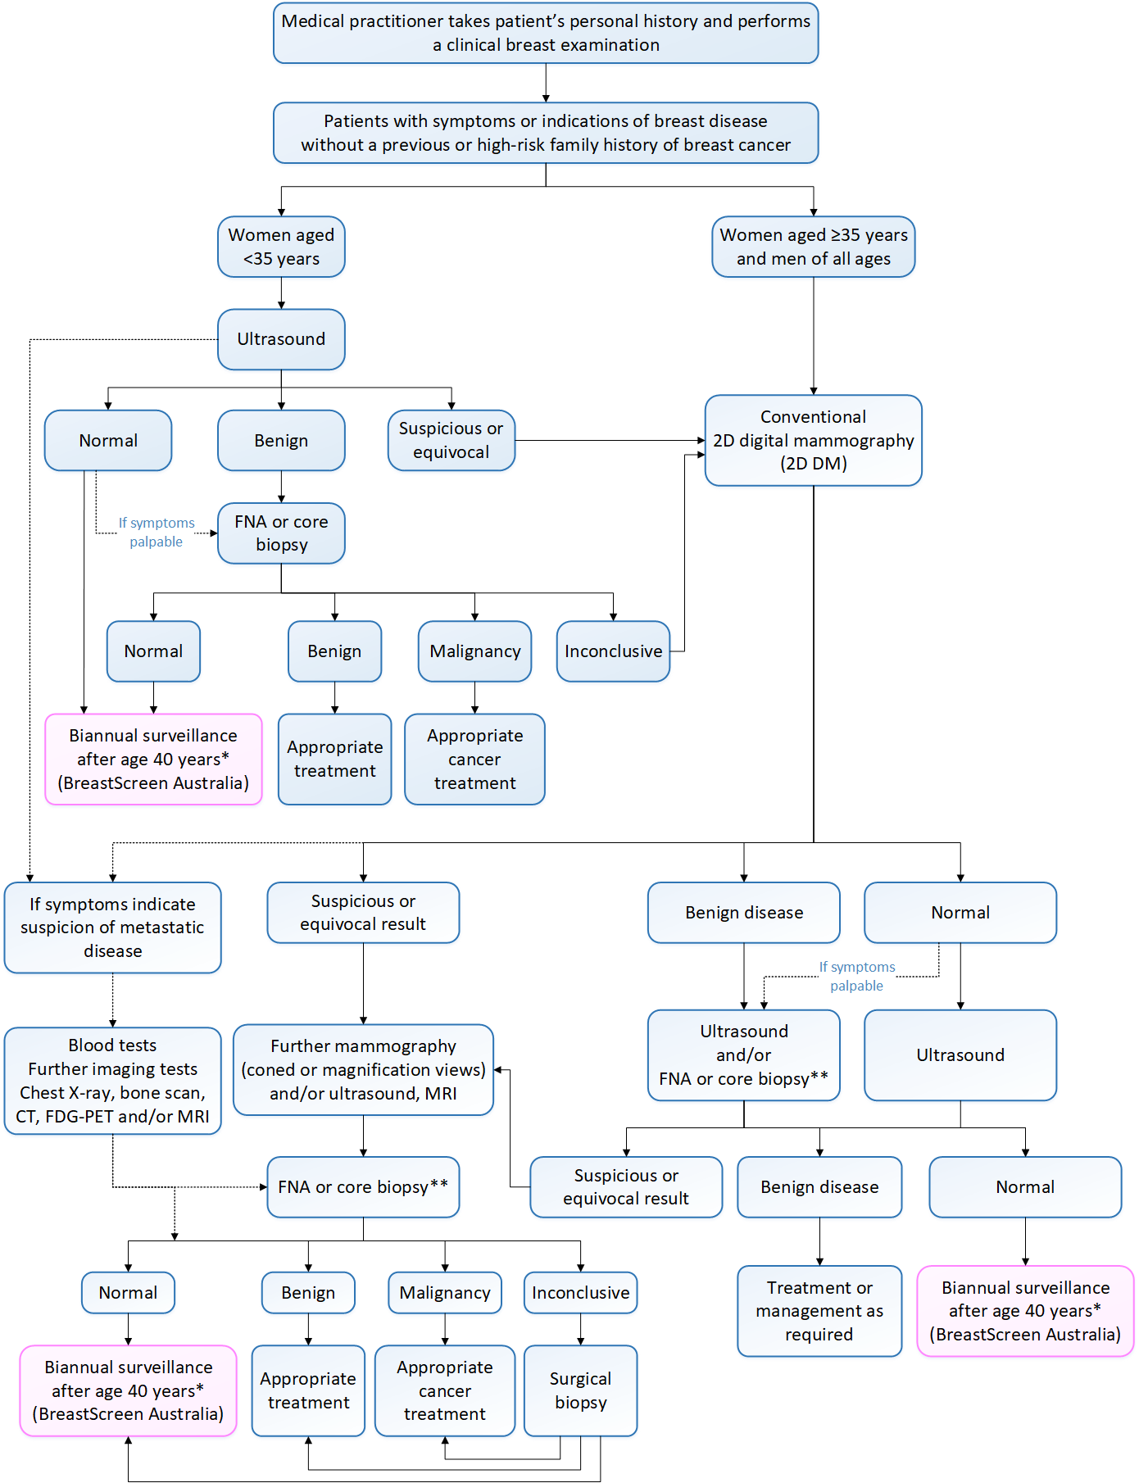
Figure 1 Current clinical management algorithms for patients with symptoms of breast disease
*All patients aged ≥40 years are entitled to free biannual breast cancer screening through BreastScreen Australia, however, those with a low-to-moderate increased risk of breast cancer due to their family history can have MBS-funded biannual screening (or annual if a first-degree relative was diagnosed with breast cancer prior to the age of 50 years) if preferred.
**Patients who have already had an FNA or core biopsy as part of their clinical workup are unlikely to receive another.
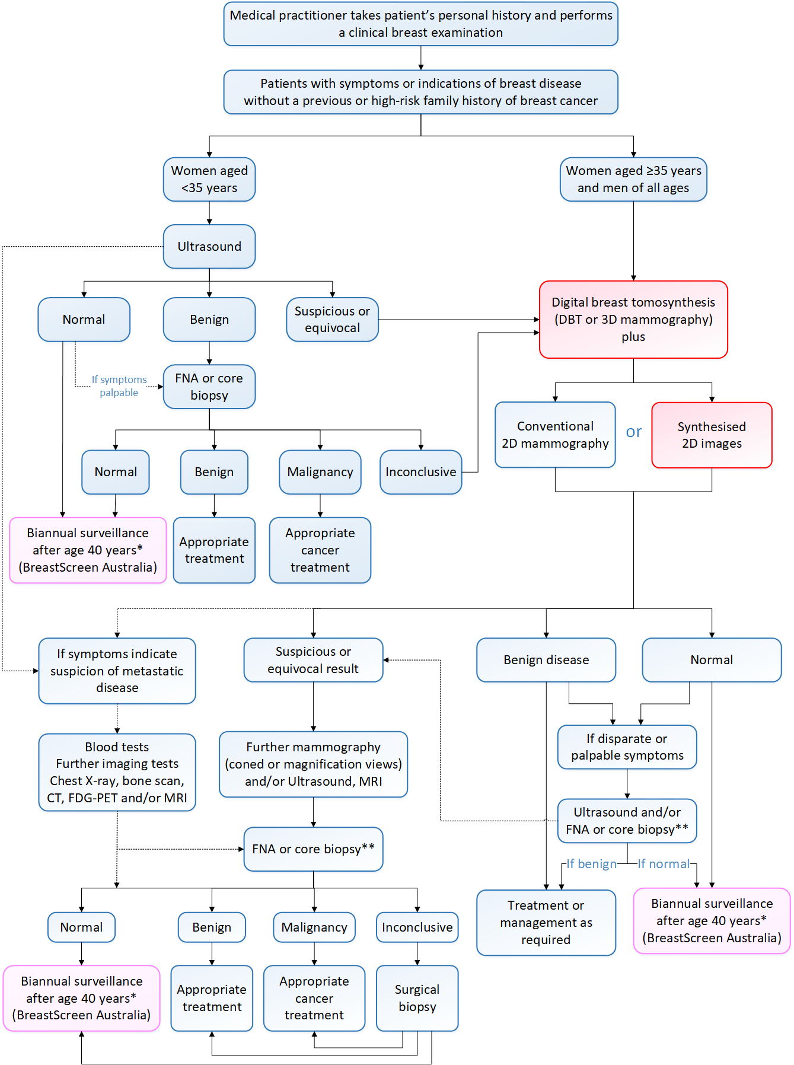
Figure 2 Proposed clinical management algorithms for patients with symptoms of breast disease
*All patients aged ≥40 years are entitled to free biannual breast cancer screening through BreastScreen Australia, however, those with a low-to-moderate increased risk of breast cancer due to their family history can have MBS-funded biannual screening (or annual if a first-degree relative was diagnosed with breast cancer prior to the age of 50 years) if preferred.
**Patients who have already had an FNA or core biopsy as part of their clinical workup are unlikely to receive another.
Population 2
Both patients who had a previous personal history of breast cancer (with or without symptoms of recurrence) would receive either 2D DM according to the current pathway (Figure 3) or DBT plus 2D imaging in the proposed pathway (Figure 4), in the first instance. If DBT is used in conjunction with synthesised 2D imaging, it is a replacement test for 2D DM, but if used with 2D DM it is an additional test. Asymptomatic patients who have previously had breast cancer should have an annual screening mammogram to detect any disease recurrence.
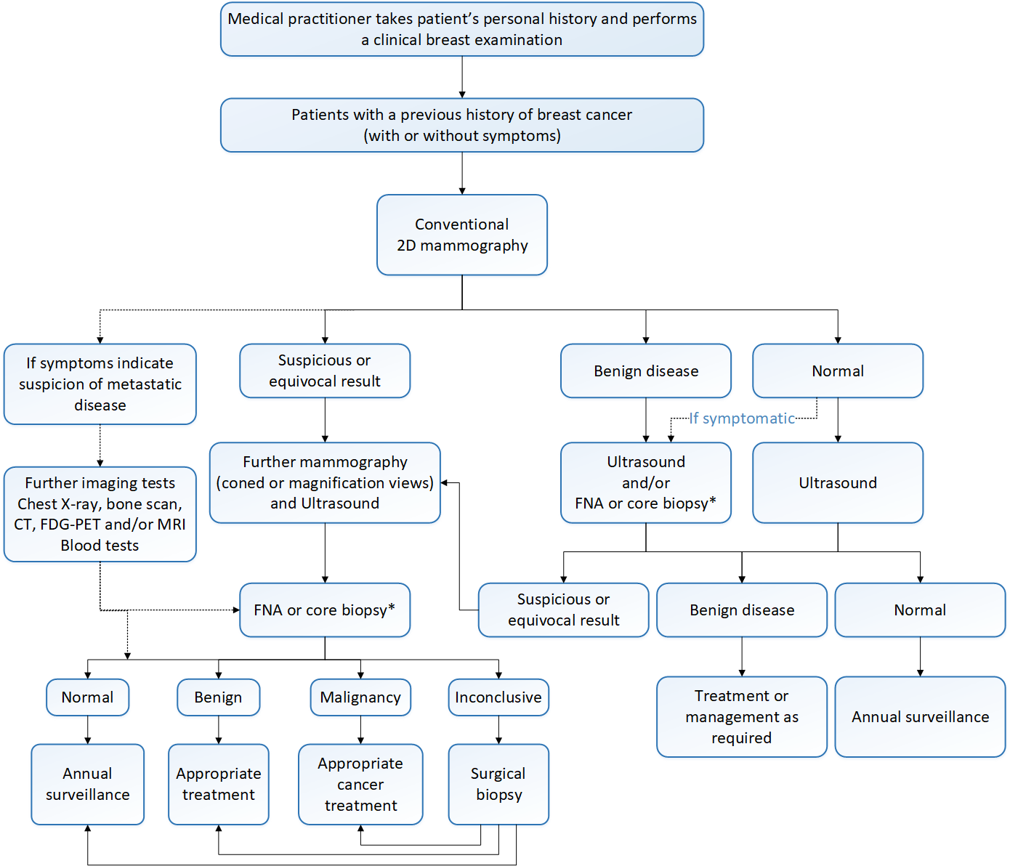
Figure 3 Current clinical management algorithms for patients who have had a previous breast cancer
*Patients who have already had an FNA or core biopsy as part of their clinical workup are unlikely to receive another.
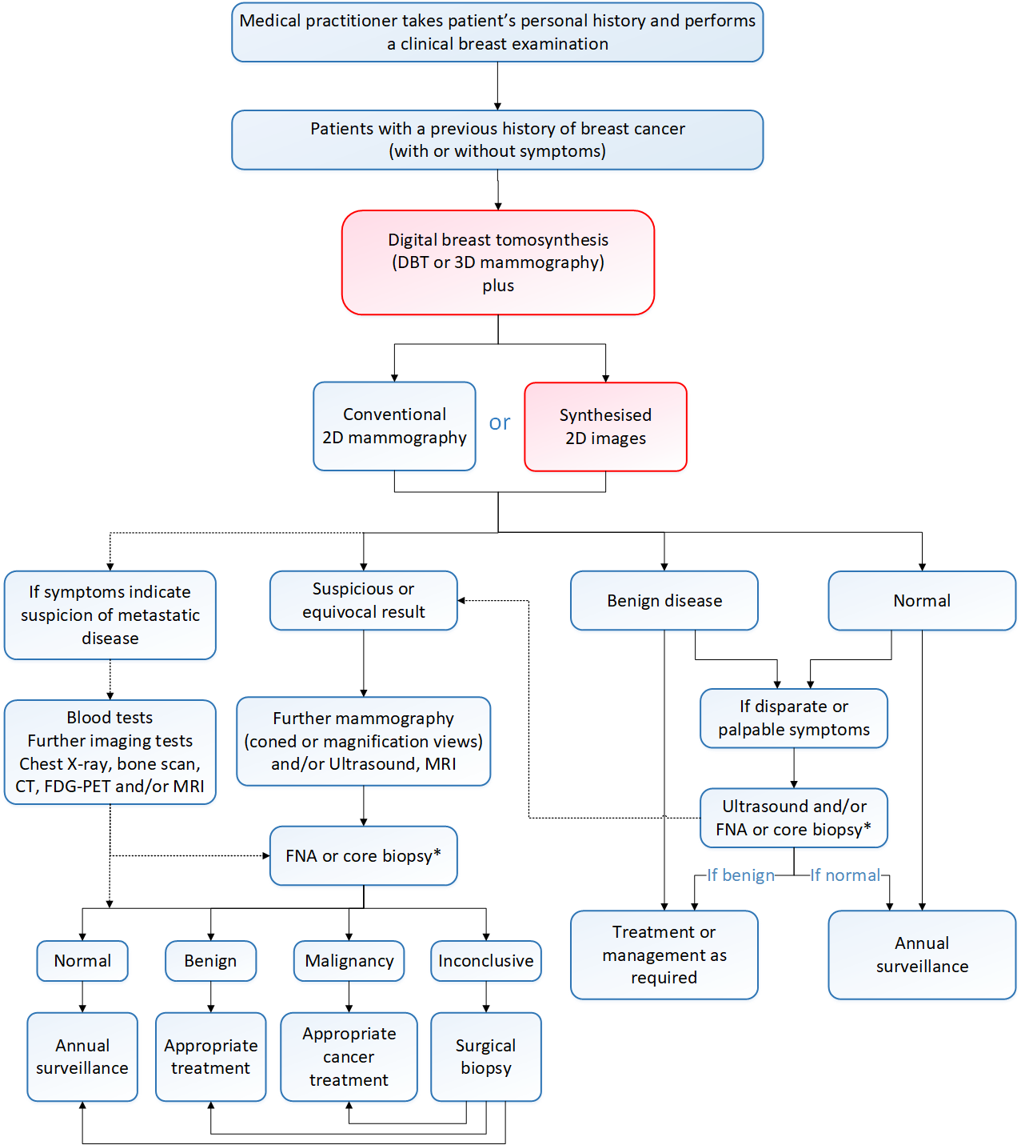
Figure 4 Proposed clinical management algorithms for patients who have had a previous breast cancer
*Patients who have already had an FNA or core biopsy as part of their clinical workup are unlikely to receive another.
Population 3
Women with a high risk of developing breast cancer due to their family history would receive different tests initially, according to the patient’s age and symptoms. Symptomatic women aged under 35 years would receive an ultrasound in the first instance due to their breast density and concerns about radiation exposure. Whereas asymptomatic women aged under 50 years may receive an MRI, or have had one in the previous 6 months. Most screening guidelines for high-risk women recommend both an annual screening mammogram and an annual breast MRI scheduled six months apart. For women in this group who are unable to undergo MRI, a screening ultrasound is recommended as an alternative.
All other high-risk women would receive a mammogram, either 2D DM according to the current pathway (Figure 5) or DBT plus 2D imaging in the proposed pathway (Figure 6). If DBT is used in conjunction with synthesised 2D imaging, it is a replacement test for 2D DM, but if used with 2D DM it is an additional test. Women at high-risk may also undergo genetic testing, and/or prophylactic therapy and/or a mastectomy in addition to having the imaging tests.
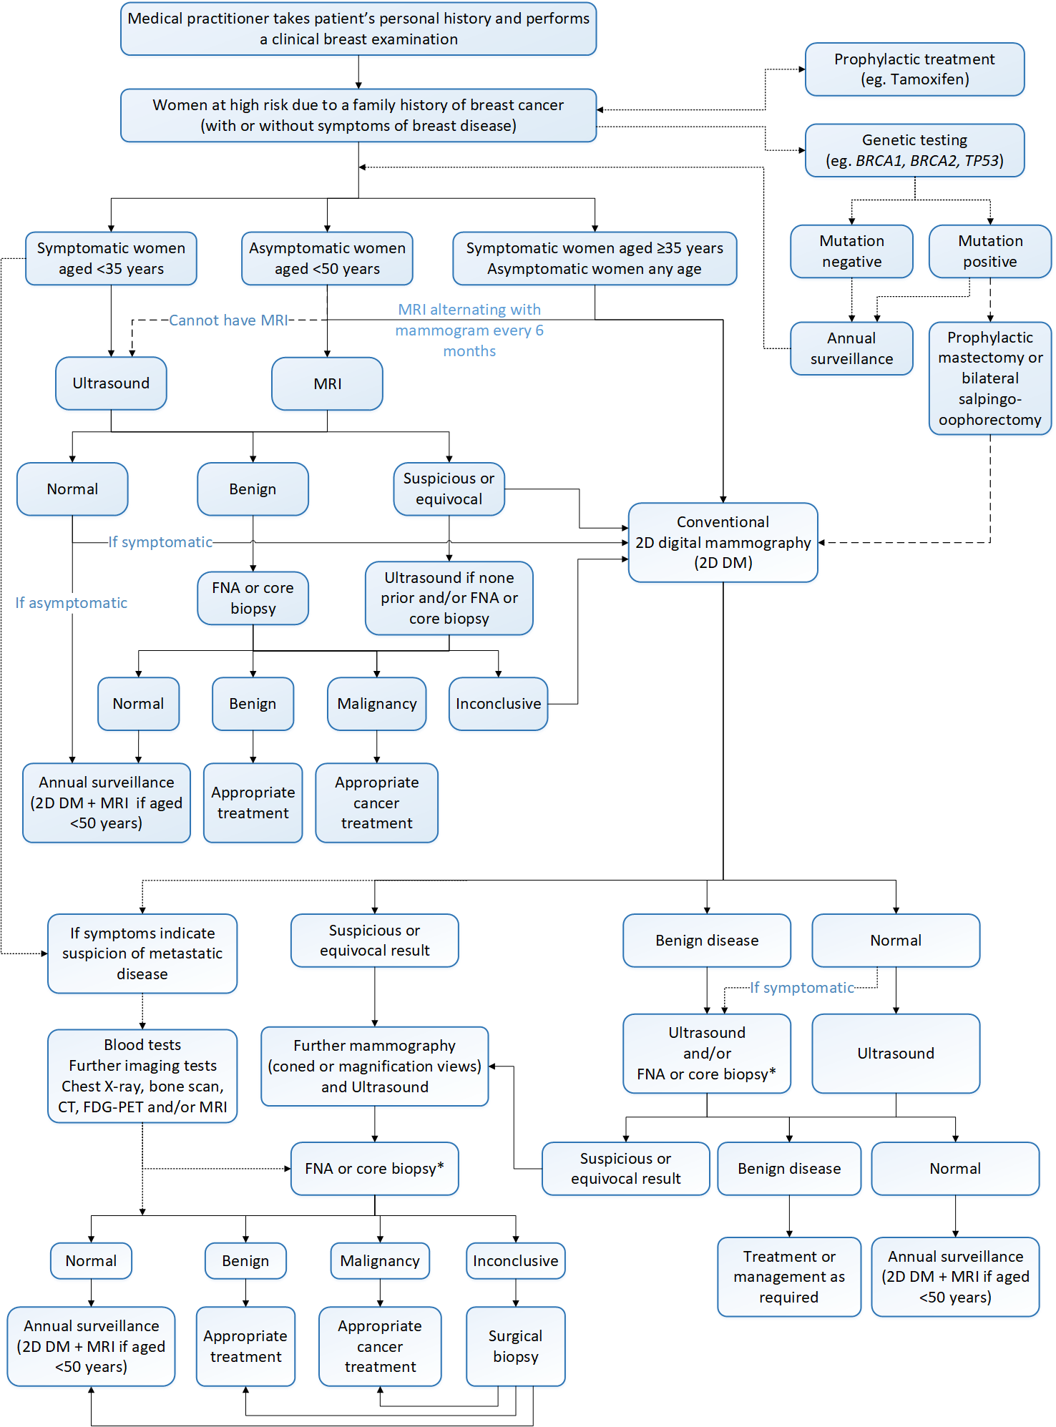
Figure 5 Current clinical management algorithms for women at high risk of developing breast cancer due to a family history
*Patients who have already had an FNA or core biopsy as part of their clinical workup are unlikely to receive another.
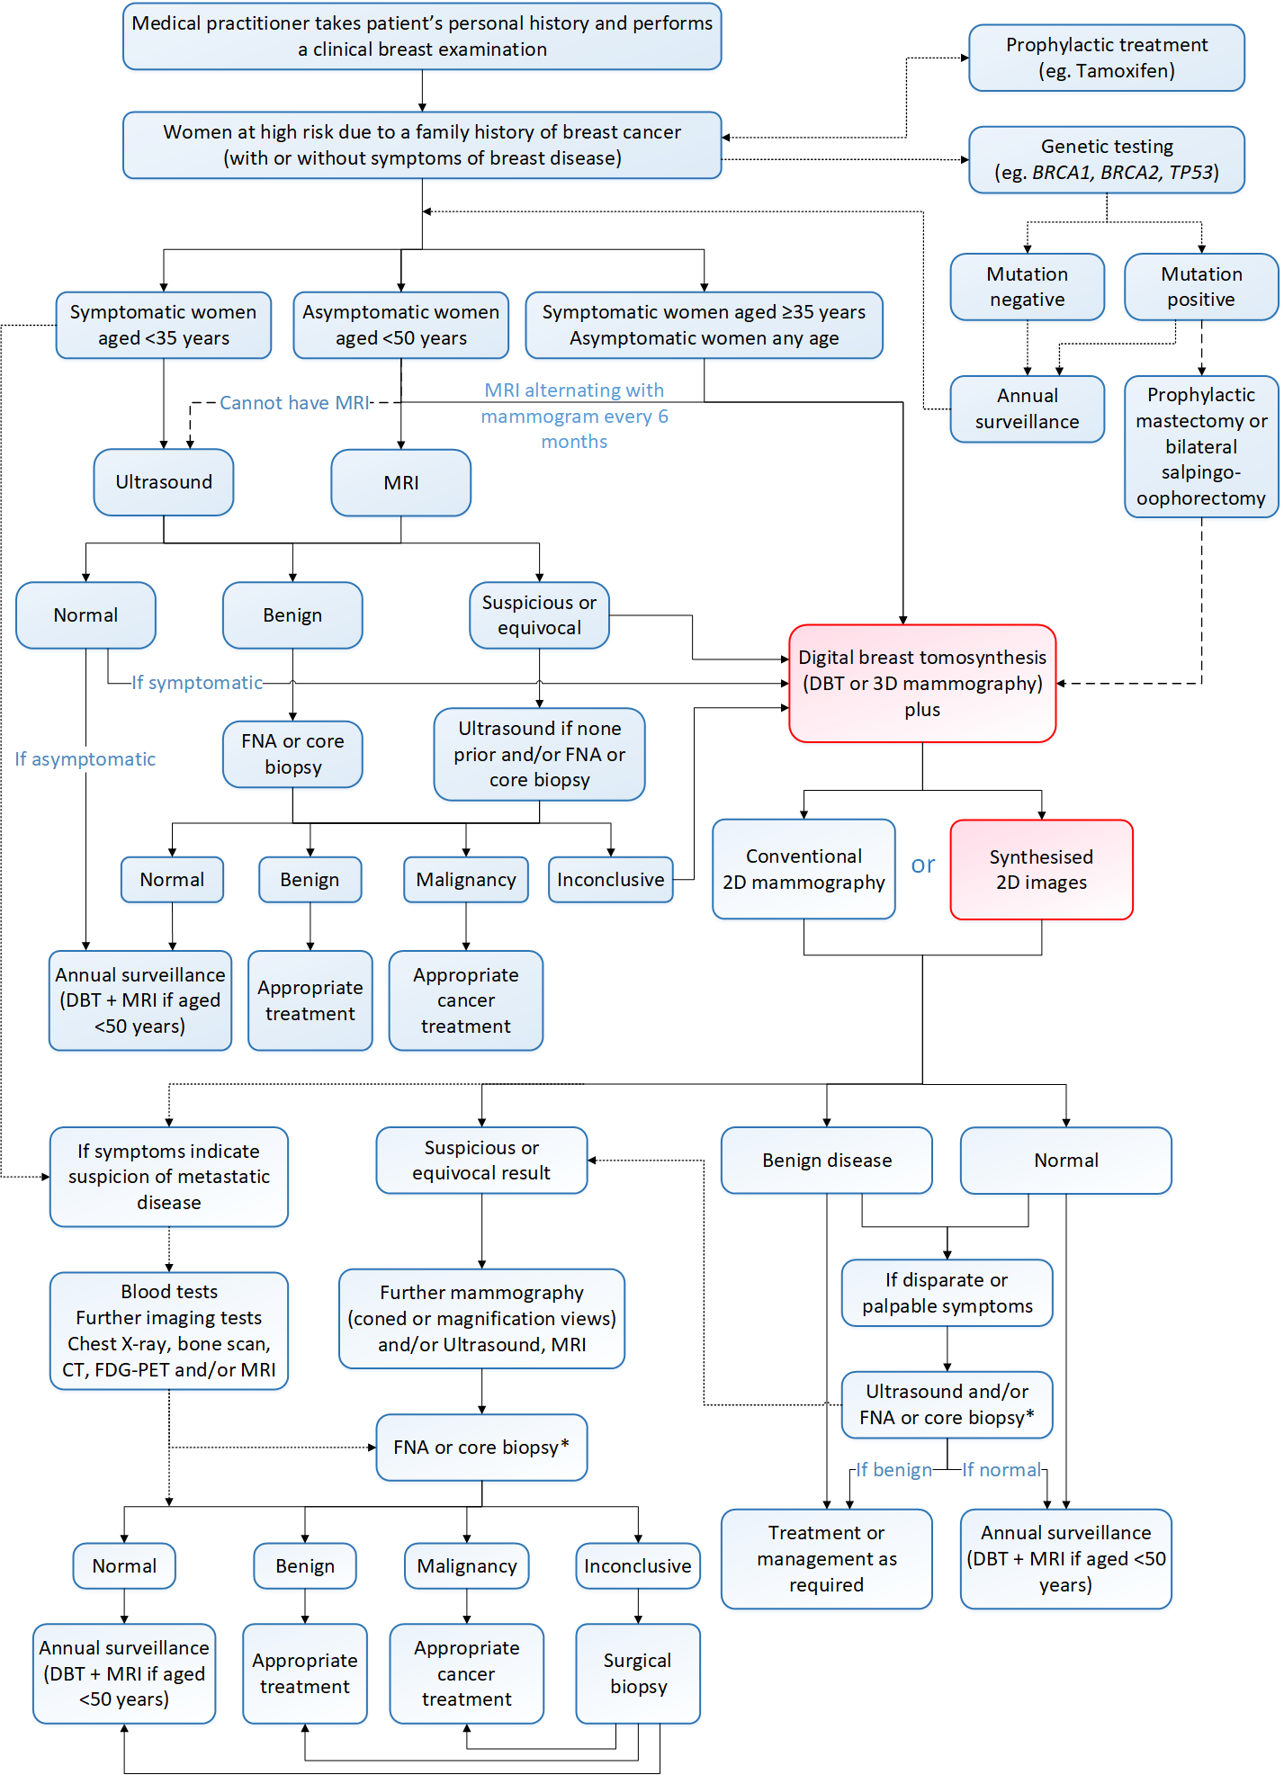
Figure 6 Proposed clinical management algorithms for women at high risk of developing breast cancer due to a family history
*Patients who have already had an FNA or core biopsy as part of their clinical workup are unlikely to receive another.

Population 4
All asymptomatic women in the general population are entitled to free biannual breast cancer screening from 40 years of age through BreastScreen Australia. However, women with a low-to-moderate increased risk of breast cancer due to their family history are eligible for MBS-funded biannual screening (or annual if a first-degree relative was diagnosed with breast cancer prior to the age of 50 years). Population 4 consists of those women with a low-to-moderate increased risk who prefer to have MBS-funded screening instead of using BreastScreen Australia. The current and proposed clinical management algorithms for these patients are shown in Figure 7 and Figure 8.
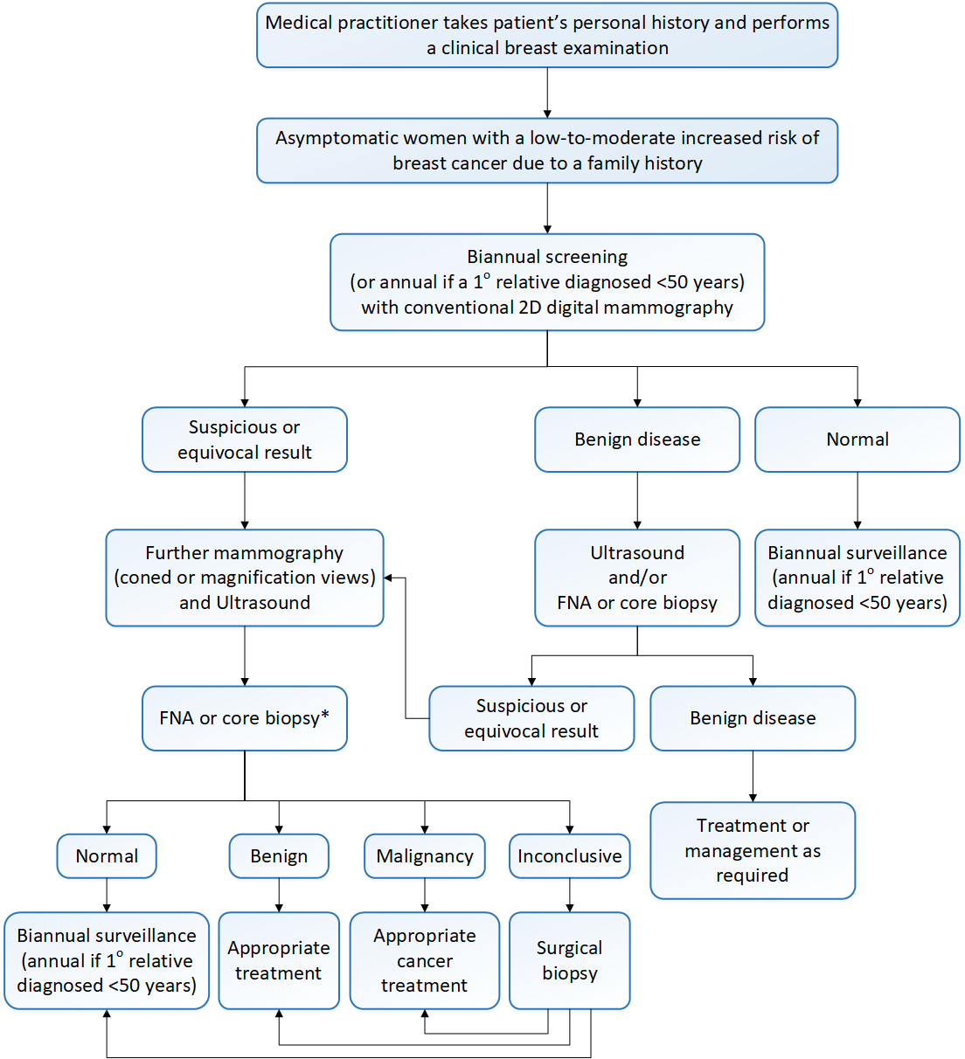
Figure 7 Current clinical management algorithms for asymptomatic women with a low-to-moderate increased risk of developing breast cancer due to their family history
*Patients who have already had an FNA or core biopsy as part of their clinical workup are unlikely to receive another.
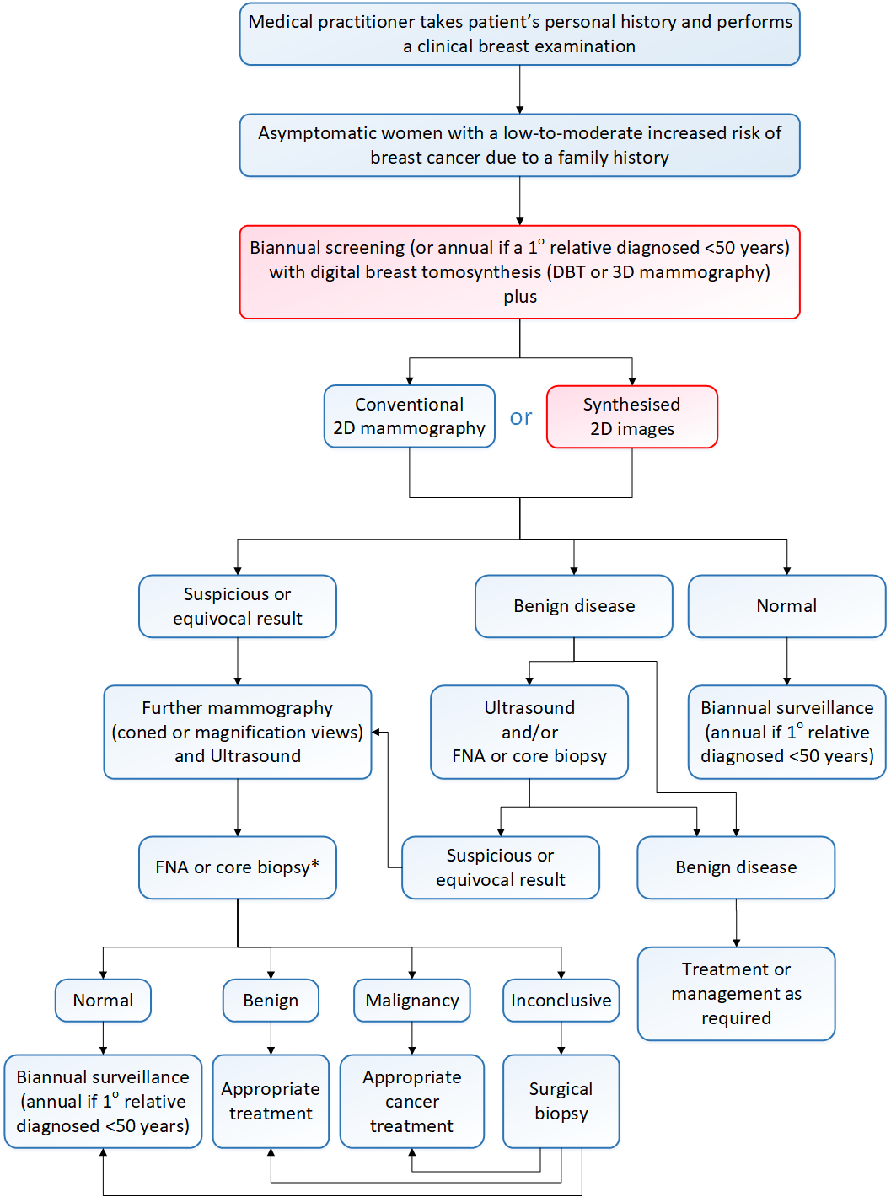
Figure 8 Proposed clinical management algorithms for asymptomatic women with a low-to-moderate increased risk of developing breast cancer due to a family history
*Patients who have already had an FNA or core biopsy as part of their clinical workup are unlikely to receive another.

Proposed economic evaluation
The comparative clinical claim is likely to be superior effectiveness. However, due to a possible increase in the radiation dose from DBT compared to 2D DM, the safety is likely to be either non-inferior or inferior. Therefore, the most appropriate economic evaluation would be either a cost-effectiveness analysis or a cost-utility analysis.
The Department has requested that the contracted assessment include two costing models (using the current interim fee and the RANZCR-requested fee).

Proposed item descriptor
Two interim MBS item numbers for digital 3D tomosynthesis of either one or both breasts have been listed on the MBS since November 2018 (Table 2). The sponsor has suggested slight wording changes for the proposed new item numbers (Table 5, shown in red).
As PASC has ruled out use of DBT alone, a note has been provided in the proposed MBS item descriptor to specify the concomitant use of either synthesised 2D or 2D-DM images. It should be noted that the use of synthesised 2D images would incur only the proposed fee for DBT, whereas the use of 2D DM would incur the fee for 2D DM as well as the fee for DBT. However, in some instances the 2D DM would have occurred prior to DBT, incurring no overall additional fee in this case.
PASC noted that confirmation is needed on whether or not Population 4 should be eligible for the Medicare rebate. If not, the proposed descriptors for DBT (and by extension, the existing descriptors for 2D-DM items) need to be revised.
RANZCR recommends a fee increase from $202 for the interim MBS item number to $225 for the new item number for DBT of both breasts and from $114 to $128 for one breast. The current interim fee was based on the sum of the 2D DM and tomography fees. The sponsor notes that mammography is currently underfunded and has an inadequate Medicare rebate that has been frozen since 1998. It also has the lowest bulk billing rates of all imaging procedures (around 50%), making it very difficult for patients to access this service if they cannot afford to pay the gap. Additionally, the tomography fee is a legacy item and not directly comparable to current breast tomosynthesis technology. Therefore, the sponsor recommends a higher Medicare rebate, and believes that this will improve access to this much needed service.
Table 5 Proposed new MBS items for digital breast tomosynthesis
Category 5 – Diagnostic Imaging services
Group I3 - Diagnostic Radiology
Subgroup 10 - Radiographic Examination Of Breasts
New MBS item descriptor:

Three dimensional tomosynthesis of both breasts, if there is reason to suspect the presence of breast disease or malignancy because of:
a) the past occurrence of breast malignancy in the patient or members of the patient’s family; or
b) symptoms or indications of breast disease or suspected malignancy found on examination of the patient by a medical practitioner

Note: Three dimensional tomosynthesis is to be used in conjunction with two-dimensional images either synthesized from the three-dimensional tomography or obtained by digital mammography.

Fee: $128 Benefit: 75% = $96.00 85% = $108.80
Group I3 - Diagnostic Radiology
Subgroup 10 - Radiographic Examination Of Breasts
New MBS item descriptor:

Three dimensional tomosynthesis of one breast, if there is reason to suspect the presence of breast disease or malignancy because of:
a) the past occurrence of breast malignancy in the patient or members of the patient’s family; or
b) symptoms or indications of breast disease or suspected malignancy found on examination of the patient by a medical practitioner

Note: Three dimensional tomosynthesis is to be used in conjunction with two-dimensional images either synthesized from the three-dimensional tomography or obtained by digital mammography.

Fee: $225 Benefit: 75% = $168.75 85% = $191.25

References
Australian Institute of Health and Welfare 2012, 'Breast cancer in Australia: an overview ', Cancer series no. 71. Cat. no. CAN 67, Canberra: AIHW.
Bernardi, D, Petra Macaskill, P, Pellegrini, M, Valentini, M, Fantò, C, Ostillio, L, Tuttobene, P, Luparia, A & Houssami, N 2016, 'Breast cancer screening with tomosynthesis (3D mammography) with acquired or synthetic 2D mammography compared with 2D mammography alone (STORM-2): A population-based prospective study', The Lancet Oncology, vol. 17, pp. 1105-1113.
Breast Cancer Network Australia 2018, Breast cancer statisitcs in Australia, Canberra, <https://www.bcna.org.au/news/2018/08/the-latest-breast-cancer-stats-from-aihw/>.
Cancer Australia 2017, 'Investigation of a new breast symptom - a guide for general practitioners', Australian Government, Canberra, ACT,<https://nbocc.org.au/publications-and-resources/cancer-australia-publications/investigation-new-breast-symptom-guide-general-practitioners>.
Caumo, F, Zorzi, M, Brunelli, S, Romanucci, G, Rella, R, Cugola, L, Bricolo, P, Fedato, C, Montemezzi, S & Houssami, N 2018, 'Digital Breast Tomosynthesis with Synthesized Two-Dimensional Images versus Full-Field Digital Mammography for Population Screening: Outcomes from the Verona Screening Program', Radiology, vol. 287, no. 1, pp. 37-46.
Ciatto, S, Houssami, N, Bernardi, D, Caumo, F, Pellegrini, M, Brunelli, S, Tuttobene, P, Bricolo, P, Fanto, C, Valentini, M, Montemezzi, S & Macaskill, P 2013, 'Integration of 3D digital mammography with tomosynthesis for population breast-cancer screening (STORM): a prospective comparison study', Lancet Oncol, vol. 14, no. 7, Jun, pp. 583-589.
Conant, EF, Beaber, EF, Sprague, BL, Herschorn, SD, Weaver, DL, Onega, T, Tosteson, ANA, McCarthy, AM, Poplack, SP, Haas, JS, Armstrong, K, Schnall, MD & Barlow, WE 2016, 'Breast cancer screening using tomosynthesis in combination with digital mammography compared to digital mammography alone: a cohort study within the PROSPR consortium', Breast Cancer Research and Treatment, vol. 156, no. 1, February 01, pp. 109-116.
Coop, P, Cowling, C & Lawson, C 2016, 'Tomosynthesis as a screening tool for breast cancer: A systematic review', Radiography, vol. 22, no. 3, 2016/08/01/, pp. e190-e195.
Destounis, S, Arieno, A & Morgan, R 2014, 'Initial Experience with Combination Digital Brea st Tomosynthesis Plus Full Field Digital Mammography or Full Field Digital Mammography Alone in the Screening Environment', Journal of Clinical Imaging Science, vol. 4, no. 1, January 1, 2014, pp. 9-9.
Freer, PE, Riegert, J, Eisenmenger, L, Ose, D, Winkler, N, Stein, MA, Stoddard, GJ & Hess, R 2017, 'Clinical implementation of synthesized mammography with digital breast tomosynthesis in a routine clinical practice', Breast Cancer Research and Treatment, vol. 166, 5 August 2017, pp. 501-509.
Friedewald, SM, Rafferty, EA, Rose, SL, Durand, MA, Plecha, DM, Greenberg, JS, Hayes, MK, Copit, DS, Carlson, KL, Cink, TM, Barke, LD, Greer, LN, Miller, DP & Conant, EF 2014, 'Breast Cancer Screening Using Tomosynthesis in Combination With Digital MammographyTomosynthesis and Mammography for Breast ScreeningTomosynthesis and Mammography for Breast Screening', JAMA, vol. 311, no. 24, pp. 2499-2507.
Giess, CS, Pourjabbar, S, Ip, IK, Lacson, R, Alper, E & Khorasani, R 2017, 'Comparing Diagnostic Performance of Digital Breast Tomosynthesis and Full-Field Digital Mammography in a Hybrid Screening Environment', American Journal of Roentgenology, vol. 209, no. 4, 2017/10/01, pp. 929-934.
Greenberg, JS, Javitt, MC, Katzen, J, Michael, S & Holland, AE 2014, 'Clinical Performance Metrics of 3D Digital Breast Tomosynthesis Compared With 2D Digital Mammography for Breast Cancer Screening in Community Practice', American Journal of Roentgenology, vol. 203, no. 3, 2014/09/01, pp. 687-693.
Haas, BM, Kalra, V, Geisel, J, Raghu, M, Durand, M & Philpotts, LE 2013, 'Comparison of Tomosynthesis Plus Digital Mammography and Digital Mammography Alone for Breast Cancer Screening', Radiology, vol. 269, no. 3, pp. 694-700.
Hodgson, R, Heywang-Köbrunner, SH, Harvey, SC, Edwards, M, Shaikh, J, Arber, M & Glanville, J 2016, 'Systematic review of 3D mammography for breast cancer screening', The Breast, vol. 27, 2016/06/01/, pp. 52-61.
Houssami, N 2017, 'BreastScreen Victoria pilot trial of the feasibility and outcomes of tomosynthesis (3D-mammography) screening at Eastern Health', Australian New Zealand Clinical Trials Registry, Camperdown, NSW,<https://www.anzctr.org.au/Trial/Registration/TrialReview.aspx?id=373203>.
Houssami, N 2018, 'A population-based trial of digital breast tomosynthesis (DBT) screening embedded in the BreastScreenProgram: Interim results', paper presented at Innovations in Cancer Treatment & Care Conference 2018, Sydney, Australia, 13 September 2018.
Houssami, N, Macaskill, P, Bernardi, D, Caumo, F, Pellegrini, M, Brunelli, S, Tuttobene, P, Bricolo, P, Fantò, C, Valentini, M & Ciatto, S 2014, 'Breast screening using 2D-mammography or integrating digital breast tomosynthesis (3D-mammography) for single-reading or double-reading – Evidence to guide future screening strategies', European Journal of Cancer, vol. 50, no. 10, 2014/07/01/, pp. 1799-1807.
Kharkwal, S, Sameer & Mukherjee, A 2014, 'Triple test in carcinoma breast', Journal of clinical and diagnostic research : JCDR, vol. 8, no. 10, pp. NC09-NC11.
Lång, K, Andersson, I, Rosso, A, Tingberg, A, Timberg, P & Zackrisson, S 2016, 'Performance of one-view breast tomosynthesis as a stand-alone breast cancer screening modality: results from the Malmö Breast Tomosynthesis Screening Trial, a population-based study', European Radiology, vol. 26, no. 1, January 01, pp. 184-190.
Lockie, D, Clemson, M, Evans, J, Pridmore, V, Marr, G & Houssami, N 2018, 'BreastScreen Victoria tomosynthesis screening trial, Maroondah pilot: Preliminary Outcomes', paper presented at BreastScreen Australia Conference 2018, Adelaide, Australia, 19-21 April 2018.
Lourenco, AP, Barry-Brooks, M, Baird, GL, Tuttle, A & Mainiero, MB 2015, 'Changes in Recall Type and Patient Treatment Following Implementation of Screening Digital Breast Tomosynthesis', Radiology, vol. 274, no. 2, pp. 337-342.
Mall, S, Noakes, J, Kossoff, M, Lee, W, McKessar, M, Goy, A, Duncombe, J, Roberts, M, Giuffre, B, Miller, A, Bhola, N, Kapoor, C, Shearman, C, DaCosta, G, Choi, S, Sterba, J, Kay, M, Bruderlin, K, Winarta, N, Donohue, K, Macdonell-Scott, B, Klijnsma, F, Suzuki, K, Brennan, P & Mello-Thoms, C 2018, 'Can digital breast tomosynthesis perform better than standard digital mammography work-up in breast cancer assessment clinic?', Eur Radiol, vol. 28, no. 12, Dec, pp. 5182-5194.
McDonald, ES, Oustimov, A, Weinstein, SP, Synnestvedt, MB, Schnall, M & Conant, EF 2016, 'Effectiveness of Digital Breast Tomosynthesis Compared With Digital Mammography: Outcomes Analysis From 3 Years of Breast Cancer ScreeningEffectiveness of Digital Breast Tomosynthesis vs Digital MammographyEffectiveness of Digital Breast Tomosynthesis vs Digital Mammography', JAMA Oncology, vol. 2, no. 6, pp. 737-743.
NBCC 2002, 'Breast imaging: a guide for practice', National Breast Cancer Centre, Camperdown, NSW, pp. 1-114,<https://canceraustralia.gov.au/resources>.
Pattacini, P, Nitrosi, A, Giorgi Rossi, P, Iotti, V, Ginocchi, V, Ravaioli, S, Vacondio, R, Braglia, L, Cavuto, S & Campari, C 2018, 'Digital Mammography versus Digital Mammography Plus Tomosynthesis for Breast Cancer Screening: The Reggio Emilia Tomosynthesis Randomized Trial', Radiology, vol. 288, no. 2, Aug, pp. 375-385.
RACGP 2018, Guidelines for preventive activities in general practice. 9th edition, updated., The Royal Australian College of General Practitioners, East Melbourne, Victoria, <https://www.racgp.org.au/clinical-resources/clinical-guidelines/key-racgp-guidelines/view-all-racgp-guidelines/red-book/early-detection-of-cancers/breast-cancer>.
Rose, SL, Tidwell, AL, Bujnoch, LJ, Kushwaha, AC, Nordmann, AS & Sexton, R, Jr. 2013, 'Implementation of breast tomosynthesis in a routine screening practice: an observational study', AJR Am J Roentgenol, vol. 200, no. 6, Jun, pp. 1401-1408.
Skaane, P, Bandos, AI, Eben, EB, Jebsen, IN, Krager, M, Haakenaasen, U, Ekseth, U, Izadi, M, Hofvind, S & Gullien, R 2014, 'Two-View Digital Breast Tomosynthesis Screening with Synthetically Reconstructed Projection Images: Comparison with Digital Breast Tomosynthesis with Full-Field Digital Mammographic Images', Radiology, vol. 271, no. 3, pp. 655-663.
Skaane, P, Bandos, AI, Gullien, R, Eben, EB, Ekseth, U, Haakenaasen, U, Izadi, M, Jebsen, IN, Jahr, G, Krager, M & Hofvind, S 2013b, 'Prospective trial comparing full-field digital mammography (FFDM) versus combined FFDM and tomosynthesis in a population-based screening programme using independent double reading with arbitration', European Radiology, vol. 23, no. 8, August 01, pp. 2061-2071.
Skaane, P, Bandos, AI, Gullien, R, Eben, EB, Ekseth, U, Haakenaasen, U, Izadi, M, Jebsen, IN, Jahr, G, Krager, M, Niklason, LT, Hofvind, S & Gur, D 2013a, 'Comparison of digital mammography alone and digital mammography plus tomosynthesis in a population-based screening program', Radiology, vol. 267, no. 1, Apr, pp. 47-56.
Skaane, P, Bandos, AI, Niklason, LT, Sebuødegård, S, Østerås, BH, Gullien, R, Gur, D & Hofvind, S 2019, 'Digital Mammography versus Digital Mammography Plus Tomosynthesis in Breast Cancer Screening: The Oslo Tomosynthesis Screening Trial', Radiology, vol. 0, no. 0, p. 182394.

healthdirect Breast cancer symptoms [Last updated July 2018] accessed 20 March 2019, URL: https://www.healthdirect.gov.au/breast-cancer-symptoms
Cancer data in Australia Web report [Last updated 18 December 2018] accessed 7 February 2019, URL: https://www.aihw.gov.au/reports/cancer/cancer-data-in-australia/contents/summary
The two systematic reviews were identified by a horizon scan literature review undertaken by Allen + Clarke for the Department of Health to inform BreastScreen Australia’s position statement on the use of DBT in screening of asymptomatic women and the BreastScreen Australia (BSA) program. Gribble, A & James, S 2018, 'Digital breast tomosynthesis: A literature review to inform BreastScreen Australia’s position statement on the use of tomosynthesis in screening', BreastScreen Australia, Department of Health, Canberra. <www.cancerscreening.gov.au/internet/screening/publishing.nsf/Content/80DD22C5B2C00AA9CA257D85001A04A4/$File/Digital%20breast%20tomosynthesis%20A%20literatur%20-tScreen%20Australia%E2%80%99s%20position%20st.pdf>.
From now on, this will be referred to as DBT plus 2D imaging, unless either acquired or synthesised 2D images are specifically indicated.
Regulation of Software as a Medical Device, TGA website [Last updated 11 December 2018] accessed 12 April 2019, URL: https://www.tga.gov.au/regulation-software-medical-device

