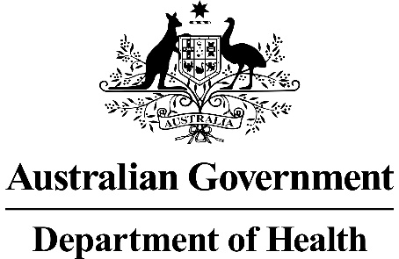
MSAC Application 1657:
Rhenium-188 Brachytherapy for
Non-Melanoma Skin Cancer
Ratified
PICO Confirmation

Summary of PICO/PPICO criteria to define the question(s) to be addressed in an Assessment Report to the Medical Services Advisory Committee (MSAC)
Component | Description
Patients | Patients with basal cell carcinoma (BCC) and cutaneous squamous cell carcinoma (SCC) (depth of ≤3mm, excision diameter of 15-80 mm) where the:  - lesion is located on the nose, eyebrow, lip, ear, digit, genitalia, shin or collarbone, or a contiguous area; and  - patient has comorbidities that prevent surgical excision
Intervention | Dermatological high-dose rate brachytherapy with Rhenium-188 (Re-188)
Comparator | - Radiation therapy  - External beam radiation therapy (EBRT)  - Brachytherapy  - Best supportive care
Outcomes | - Safety, including any potential risk of harm to patient or healthcare providers  - Procedure-related adverse events  - Post-procedure infection rates  - Acute and chronic radiation toxicity  - Secondary cutaneous malignancies  - Radiation protection of staff against β and γ irradiation  - Efficacy / effectiveness, including (but not limited to) patient-relevant outcomes  - Scarring  - Cosmesis  - Health-related quality of life (HRQoL)  - Tumour control  - Progression-free survival  - Disease-free survival  - Overall survival  - Pain  - Functional impairment  - Retreatment rates  - Secondary corrective procedure rates  - Healthcare resources  - Cost of intervention delivery, including cost of Re-188 compound and other proprietary consumables required for intervention delivery  - Cost associated with changes in clinical management (e.g., follow-up, consultations with referring specialist physicians)  - Capital expenditure  - Cost of consultations with referring specialist physicians (dermatologist/plastic surgeon)  - Cost of medical physicist  - Cost-effectiveness  - Cost per life-year gained  - Cost per quality-adjusted life year (QALY) gained  - Total Australian Government healthcare costs:  - Total cost to the Medicare Benefits Schedule (MBS)  - Total cost to other healthcare services.

PICO or PPICO rationale for therapeutic and investigative medical services only

Population
The proposed medical service, high-dose rate brachytherapy with non-sealed Rhenium-188 (Re-188), is intended for patients with keratinocyte cancers. Keratinocyte cancers (formerly called non-melanoma skin cancers) comprise two types of skin cancers: basal cell carcinoma (BCC) and cutaneous squamous cell carcinoma (SCC), as well as other rare subtypes including Bowen’s disease, extramammary Paget’s disease, and erythroplasia of Queyrat.
Keratinocyte carcinomas are assumed to be the most frequently diagnosed cancers in Australia. Although no official Australian statistics are available because keratinocyte cancers are not required to be reported to the cancer registries nationally, the incidence was estimated to be between 1.5%-2.5% per year (Pandeya et al., 2017; Perera et al., 2015). Fransen et al. (2012) estimated that in 2015, close to 940,000 keratinocyte cancer treatments would have been provided in Australia, costing in total over $700 million. The most common cause of BCC and SCC is sun exposure; less than 1% of skin cancers in Australia are attributable to other factors, such as immunosuppression or exposure to ionising radiation (Olsen et al., 2015). Of note, head and neck are the most frequent sites of keratinocyte cancers (Cancer Council Australia Keratinocyte Cancers Working Party).
With prompt detection and effective treatment, BCC and SCC generally have a good prognosis. These tumours are rarely fatal, causing only approximately 560 deaths each year in Australia (Australian Institute of Health and Welfare, 2016).
The proposed medical service is targeted specifically to a small subset of patients with more difficult-to-treat lesions (depth of ≤3mm, excision diameter of 15-80 mm) of the nose, eyebrow, lip, ear, digit, genitalia, shin or collarbone or a contiguous area or with co-morbidities for which a surgical approach or external beam radiation therapy (EBRT) is not indicated.
PASC noted the proposed population was defined as patients with keratinocyte cancers (malignant non-melanoma, depth of ≤3mm, excision diameter of 15-80 mm) where the:
- lesion is located on the nose, eyebrow, lip, ear, digit, genitalia, shin or collarbone, or a contiguous area; and
- patient has comorbidities that prevent surgical excision.
PASC noted that the population should be refined to only include BCCs and SCCs, which represent the majority of keratinocyte cancers. It was noted during a discussion that the term non-melanoma skin cancer, as used in the application, is not interchangeable with keratinocyte cancer. It was also queried whether some less common cancers such as Bowen’s disease and extramammary Paget’s disease should be considered for the indication, and it was considered that Merkel cell carcinoma would not be suitable for the proposed treatment.
PASC agreed that the population was aligned with the Australian Register of Therapeutic Goods (ARTG) listing of the Rhenium-SCT® health technology (class II b medical device for the treatment of skin cancer). PASC queried about providing a more precise definition of the proposed population in terms of the comorbidities that are contraindications for the conventional treatment (surgical or radiation therapy).
In the pre-PASC response, the applicant clarified that comorbidities that may prevent a patient from receiving surgery would be assessed on a case-by-case basis by the treating clinician and/or surgeon and would generally include patients for whom a general anaesthetic may be a risk. The applicant suggested that instead of including a list of “permitted” comorbidities, it could remain a matter of clinical judgement. PASC noted the “case-by-case” indication creates difficulties for defining a PICO and for tightening the proposed MBS descriptor to avoid unintended use outside of the proposed population.
PASC noted that the applicant did not comment on possible contraindications for radiation therapy. The Australian Clinical Practice Guidelines for keratinocyte cancer (2019) list several contraindications for radiation therapy, including young age. PASC considered that this may be in relative conflict with the phase IV multicentric study called EPIC recently launched by the applicant (recruitment in Australia started in November 2021) where the eligibility age limit is “18+ years of age”. The applicant clarified that due to the epidemiology of keratinocyte cancers, most patients would be aged well above 18 years. An applicant’s clinical expert confirmed that the youngest patient they have treated was 25 years old, but that the average age of the 4,000 patients treated with Rhenium-SCT® to date was around 65 years of age. PASC noted that the EPIC trial population was otherwise similar to the population proposed in this application.
PASC noted that the depth limit of tumours eligible for Re-188 brachytherapy should be clarified by the applicant: depth of the lesion as <3mm or ≤3mm. The applicant noted that the depth limit applied specifically to treatments that are intended to be completed within a single session, because beta radiation has a penetration depth limit of 3mm.
The applicant estimates approximately 500 patients would use the proposed medical service during the first full year, growing to 1000, 2000 and 4000 patients in year 2, 3 and 4, respectively. However, the applicant did not provide a basis for this estimate stating that the proportion of patients with keratinocyte cancers that meet the eligibility criteria is unknown. Therefore, the applicant intends to establish (in the second half of 2021) an international registry for keratinocyte cancers, which will include an Australian component to allow a better understanding of disease epidemiology as well the utility of Re-188 brachytherapy in its treatment.
PASC noted that while the population expected to use the proposed service in the first four years was modest considering the high incidence rates of keratinocyte cancers in the Australian population, no basis was provided for these estimates. PASC queried whether a tighter definition of the population with regards to the contraindications to surgery and radiation therapy may better inform these estimates.
In the pre-PASC response, the applicant confirmed that the OncoBeta International Registry was launched in November 2021 and was open to all Australian sites that were willing and able to participate. The Registry is led by an international multi-disciplinary committee including an Australian clinician. PASC enquired further about the Registry, raising a question whether it was a treatment registry or cancer registry. Pathologists were not aware of its existence, and it was not mandatory to report keratinocyte cancers to cancer registries in Australia. The applicant clarified that the registry roll-out will be a staged operation, starting with collecting data for all patients with keratinocyte cancers undergoing surgery, radiation therapy and Rhenium-SCT® brachytherapy. Currently, Rhenium-SCT® brachytherapy is available at one site in Australia only, and this site was participating in the Registry. Patients enrolled in the EPIC clinical trial would also be included in the Registry. The applicant was still assessing and adjusting which data to collect and training participating sites in data entry.
The applicant estimates that the proposed medical service would reach only around 1% of eligible keratinocyte cancer treatments within the first five years of listing on the MBS. This may be due to a combination of the novelty of the procedure, limited current awareness and experience in Australian practice, training and capital equipment requirements, established clinical place, effectiveness and safety of the comparator services, and the highly-restricted eligibility criteria of the proposed MBS item.
Rationale
A range of definitive treatment options for keratinocyte cancers is currently available in Australia. The most common treatment is surgery (either conventional excision or Mohs micrographic surgery), which generally gives the best chance of a cure. Other treatments include cryotherapy, electrodessication and curettage, chemical treatment (e.g., topical creams or gels) and radiation therapy (EBRT or brachytherapy) (Cancer Council Australia Keratinocyte Cancers Working Party).
Most keratinocyte cancers in Australia are diagnosed and managed in primary healthcare settings, and general practitioners can remove most BCCs and SCCs. Referral to a specialist may be needed depending on various factors, including number, size and location of suspicious lesions, clinical and histological assessment of risk (Table 1), relevant comorbidities, and other individual patients’ characteristics. In some cases, patient care may be multidisciplinary, involving different specialties and/or institutions. Lesion-related factors associated with higher risk of recurrence of BCC and SCC are summarised in Table 1 (Cancer Council Australia Keratinocyte Cancers Working Party).
Table 1 Tumour-specific factors associated with recurrence of keratinocyte cancers
Tumour type | Normal risk | High risk
BCC | Nodular subtype | Infiltrative subtype
 | Nodulocystic subtype | Sclerosing (morphoeic) subtype
 | Superficial subtype | Micronodular subtype
 | Fibroepithelioma subtype | Basosquamous carcinoma
 |  | Recurrence
Cutaneous SCC | In situ subtype | Poorly differentiated subtype
 | Well-differentiated subtype | Adenosquamous subtype
 | Moderately well-differentiated subtype | Spindle cell subtype
 | Location on area other than head and neck | Increasing thickness of the primary tumour
 |  | Location on the head and neck especially the lip, ear and genitalia
 |  | Origin in a burn scar
 |  | Recurrence
BCC=basal cell carcinoma; SCC=squamous cell carcinoma
Source: adapted from the Cancer Council Australia Keratinocyte Cancers Working Party

Re-188 brachytherapy would represent an addition to the existing suite of options available in this setting, most suitable for a small subset of patients with difficult-to-treat lesions, uptake of which is expected to be limited by local experience and availability of necessary capital equipment.

Intervention
The proposed medical service is high-dose rate brachytherapy with Re-188 for keratinocyte cancers. The Re-188 isotope is a mixed β-γ emitter with a half-life of 17 hours. The β-particles have a maximum energy of 2.12 MeV and a mean energy of 764 keV, therapeutically effective only at short ranges. Re-188 β particles penetrate human tissue up to 8-10 mm, however, 92% of the doses are deposited with in the first 3 mm. The Re-188 isotype paste is included on the Australian Register of Therapeutic Goods (ARTG; see Table 2) which states that the penetration range of Re-188 β radiation in the human tissue is 2-3 mm. A γ-ray component of 155 keV accounts for 15% of the radiation intensity (Sedda et al., 2008). Γ radiation does not contribute significantly to the therapeutic aspect nor to the radiation burden to the patient and the healthcare professionals. A nanocolloid containing Re-188 particles is homogeneously distributed in a fine dispersion in a viscous polymeric matrix or “compound” applied over the tumour. The Re-188 compound forms a sealed, dry but flexible film, which sets in about 10 minutes. This radioactive mould is kept on the lesion for the time necessary to deliver the predetermined radiation dose (Carrozzo et al., 2013). The Re-188 brachytherapy for keratinocyte cancers is commercialised as Rhenium-SCT® (SCT = skin care therapy).
PASC noted the proposed intervention was high-dose rate brachytherapy with Rhenium-188. The intervention must be performed by a physician with a radiation license for handling unsealed isotopes, in appropriately accredited facilities. PASC noted the discrepancies in the application regarding whether the service may be performed by a nuclear medicine physician or a radiation oncologist. PASC considered that this would eventually depend on the jurisdiction of each State or Territory.
Table 2 Therapeutic goods on the ARTG relevant to the proposed medical service
ARTG # / Product category | Product | Sponsor | Intended purpose | Contraindications
351390  Class IIb medical device | Rhenium Skin Cancer Therapy# (Rhenium-SCT) -Radionuclide system, therapeutic, brachytherapy | Oncobeta Therapeutics Pty Ltd | The Rhenium Skin Cancer Therapy (Rhenium-SCT) is intended to be used to treat skin cancer using the radioisotope Rhenium-188. The main component of the Rhenium-SCT is a radioactive ointment (Rhenium-188-Compount). In order to put the ointment close to the tumour the ointment is applied over a protective foil over the tumour and thus only irradiates diseased tissue. The penetration range of its beta-radiation is very shallow in the human tissue (2-3mm) | Malignant melanoma; skin tumours that involve nerves or bony structures; lesions of the upper lid; lesions which anatomical position does not allow a proper application of the compound; confirmed pregnancy or impossibility to rule out a pregnancy; illnesses which require medication which suppresses significantly wound healing or the immune system; patients under 18 years; or existing major circulatory disorders in the region to be treated
Source: ARTG website (https://www.tga.gov.au/australian-register-therapeutic-goods) accessed 9 November 2021 and application form
Abbreviations: ARTG=Australian Register of Therapeutic Goods
# Specific conditions placed on the ARTG entry state the kind of medical devices identified by the manufacturer as - Rhenium-188 paste for the treatment of skin cancer lesions and skin tumours.

The proposed medical service would be performed by a specialist physician with a radiation licence for handling unsealed isotopes, i.e., most commonly a specialist nuclear medicine physician or specialist radiation oncologist, in an appropriately accredited facility. Referrals for the medical service would be limited to specialist dermatologists or specialist plastic surgeons.
The proprietary components of Rhenium-SCT® include the Re-188 compound, the OncoBeta® Carpoule, the OncoBeta® Applicator, the OncoBeta® Base Station, and OncoBeta® Measurement Station. Additional generic consumables and capital equipment would include the protective foil, personal protective equipment for both medical professionals and patients, and a suitable waste container for radioactive substances. However, the proprietary components could not be identified on the ARTG.
PASC queried whether all proprietary components of Rhenium-SCT® were listed on the ARTG. In the pre-PASC response, the applicant clarified that the Re-188 radionuclide component was registered on the ARTG but that the remaining components of the Rhenium-SCT® system, equipment for handling/using the Re-188 compound, are not included on the ARTG and are currently undergoing conformity assessment by the TGA.
The proposed medical service (skin brachytherapy with an unsealed radioactive source, Re-188) is currently not funded or reimbursed in the private or public setting in Australia for the same or another clinical indication. Brachytherapy with a sealed radioactive source (including iodine, gold, iridium or tantalum) is covered under MBS item 15335.

Re-188 brachytherapy treatment steps
Prior to the intervention, a diagnosis of malignancy and the exclusion of melanoma must be established by histological examination. Determination of suitability for Re-188 therapy and definition of the lesion borders would be performed by a dermatologist or specialist plastic surgeon.
Before the intervention, the lesion to be treated would be prepared by the dermatologist. Crusts and scabs are removed with curettage if necessary, and any bleeding must be stopped. The outlines of the skin area to be treated (i.e., the entire tumour plus an additional margin of a few millimetres) are marked with a dermatological pencil.
In a nuclear medicine facility, a specialist nuclear medicine physician or specialist radiation oncologist would cover the area to be treated with a sterile protective transparent foil to prevent direct contact of radioactive particles and other non-biocompatible ingredients of the Re-188 compound with the patient’s skin. The foil is sterile, waterproof, and durable, consists of a polyurethane film-based dressing with a latex-free acrylic adhesive, and is the only component of the system that has direct contact with the patient’s skin. The area of the lesion is then measured. Radiation protection accessories would be used to cover sensitive body parts as necessary. A technician would load a carpule (OncoBeta® Carpoule, a single use unit comprising a reservoir for the Re-188 compound and a brush for application) into the Oncobeta® applicator for safe handling and measure and record the value of the radioactivity using the OncoBeta® measurement station.
A specialist nuclear medicine physician or specialist radiation oncologist would apply the exact needed amount of the Re-188 compound in a homogeneous layer over the tumour or area needed to treat covered with the protective foil using a specially designed applicator, following the border determined by the dermatologist or specialist plastic surgeon. A timer would be started, and the remaining activity of the compound in the applicator would be measured again in the measurement station. Treatment time to reach the desired target dose at the defined penetration depth would be calculated by a medical physicist based on the radiation activity of the substance being applied and surface area and nature of the tumour, generally ranging between 30 and 180 minutes.
At the elapse of the calculated time, the protective foil including the applied, hardened compound would be removed by a technician and safely disposed of in an appropriate (shielded) waste station.
If radiation protection accessories were used, they may be removed. Radiation activity of the treated site would be measured to ensure no leak of radioactive compound on the skin occurred, and the patient would be discharged. There are no special precautions for the patient or risk to other persons afterwards. The referring dermatologist or plastic surgeon would follow up of the wound healing and later potential remissions at regular intervals as per other methods of treatment for keratinocyte cancers.
The Rhenium-SCT® brochure (Oncobeta, 2019) describes the wound healing as follows: immediately after treatment, a slight reddening is visible. Erythema may occur over the next few days, sometimes a scab or crust is formed and there may be burning or slight bleeding. The erythema fades over a period of 30-120 days. A second scab may occur, as well as wound itching. Wound healing tends to complete within 60-180 days, and at the end of the healing process, the treated skin may appear a little lighter and firmer than the untreated skin.

Retreatment with Re-188 brachytherapy
The applicant claims that most treatments (up to 85%) can be delivered in a single session in outpatient setting, without the need of anaesthesia. The applicant estimated that a very small proportion of patients would receive more than two sessions. A summary of the number of treatment sessions in the published literature is presented in Table 3. Retreatment is a serious concern, as lifetime radiation dose limits may be exceeded if multiple treatments need to be delivered to the same area.
Table 3 Retreatment with Re-188 brachytherapy
Study | Cancer type | 1 session | 2 sessions | 3 sessions | >3 sessions
Sedda et al. (2008) | BCC, SCC | 43/53 (81%) | 8/53 (15%) | 2/53 (4%) | 0/53 (0%)
Carrozzo et al. (2013) | SCC penis | 8/15 (53%) | 2/15 (13%) | 4/15 (27%) | 1/15 (7%)*
Carrozzo et al. (2014) | EMPG | 1/5 (20%) | 4/5 (80%) | 0/5 (0%) | 0/5 (0%)
Cipriani et al. (2017) | KC skin | 37/43 (86%) | 6/43 (14%) | 0/43 (0%) | 0/43 (0%)
Cipriani et al. (2020) | KC skin | 52/52 (100%) | 0/52 (0%) | 0/52 (0%) | 0/52 (0%)
BCC=basal cell carcinoma; EMPG=extramammary Paget’s disease; KC=keratinocyte cancer; SCC=squamous cell carcinoma
*One patient underwent 7 treatment sessions

Re-188 brachytherapy dose, fractionation, exposure
The expected radiation exposure for the patient is 50-100 µSv, with a maximum value of 170 µSv, depending on the tumour location. The exposure of medical staff when wearing protective devices should be below 0.7 µSv per application. According to the Australian Nuclear Science and Technology Organisation (ANSTO), the average natural background radiation per year in Australia is about 1,500 to 2,000 μSv (Australian Nuclear Science & Technology Organisation (ANSTO)). Upon request for further details, the applicant replied that the radiation exposure for the patient cannot be assessed in general terms as it depends on the target dose to be achieved, localisation of the lesion, the underlying tissue, and the possibility of additional shielding measures (e.g., lead rubber mats, lead glass goggles, etc.) The evaluation of the radiation exposure in each individual case is therefore the responsibility of the treating physician. As for the radiation exposure to the healthcare provider, at least 270 treatments per year should be possible to carry out if using the protective measures described in the instructions for use for the Rhenium-SCT® without exceeding legal dose limits (limits employed during testing were the German legal dose limits from 2011).
A request to specify the dose to be administered by Re-188 brachytherapy as well as any potential fractionation schedule was not fully satisfied by the applicant. The applicant also admitted that some problems with distributing the compound evenly may be experienced when covering large lesions, possibly leading to some areas of the lesion receiving either more or less radioactivity. The applicant argued that the safety of the technique was proven over time because no adverse events related to over-irradiation or irradiation of the underlying or surrounding structures have been observed so far, and that recurrence rates were similar to surgical treatment. The safety of the medical service in case of repeated treatments or treatments of adjacent primary tumours, and possible consequences to surgical interventions in the area in the future remain unaddressed. An example of dose distribution curves in three different patients is reproduced in Figure 1.
Figure 1 Example of Re-188 dose distribution curves in three different patients with BCC/SCC (Sedda et al., 2008)
PASC queried about the radiation exposure to the patient and treating personnel and dose limits as well as compliance with Australian regulations and noted the requirement for a medical physicist to be involved in the procedure. The applicant stated that detailed information regarding dosing and radiation exposure would be provided in the assessment report. PASC considered the discussion on the safety of the intervention was insufficient and the applicant should ensure that this is adequately addressed in the ADAR, in particular in the case of retreatment and treatment of adjacent tumours.
PASC noted the training for the intervention is provided by the applicant.
PASC noted the intervention was currently available only through one specialist in Western Australia, which may impact on patient access to services.
PASC noted that the referrals for the proposed medical service would be limited to specialist dermatologists and plastic surgeons.

Comparator
The proposed medical service is expected to partially substitute current practice (i.e., surgery and/or radiation therapy, as discussed below), allowing treatment of patients with lesions which are difficult to treat surgically due to their size and/or location. The applicant expects the substitution to be gradual.
The applicant nominated the following potential comparators for the proposed medical service:
- surgery (conventional excision and Mohs micrographic surgery (MMS));
- external beam radiation therapy (frequently delivered over a number of sessions, usually in an outpatient setting);
- other modes of brachytherapy, including superficial, interstitial and electronic approaches (usually provided in outpatient settings).
Surgery, encompassing conventional excision as well as MMS, is performed in a mix of inpatient and outpatient settings, under local or general anaesthesia. MMS may be performed for treatment of keratinocyte cancers if there is a clear advantage in tumour cure or where tissue sparing is of a significant concern. According to the Cancer Council Australia Keratinocyte Cancers Working Party , MMS may be considered in the following types of BCC:
- poorly defined clinical border
- infiltrating, micronodular, sclerosing, and other aggressive histological subtypes
- residual following previous treatment
- located in the H-zone of the face
- large (>10 mm) in diameter on the face
- if utilising MMS compared to wide excision of the defect size reduction would be of clinical value.
PASC noted the proposed comparators were surgery, encompassing both conventional excision and Mohs micrographic surgery (MMS; preferred by the applicant), and radiation therapy, encompassing both various forms of EBRT and brachytherapy. PASC acknowledged that the choice of comparator would have a direct influence on the outcomes of interest relevant to this PICO confirmation.
PASC considered that because the proposed intervention is intended for patients with contraindications for surgery due to comorbidities, surgery was not an appropriate comparator.
Radiation therapy is an effective treatment modality for keratinocyte cancers. It is used in definitive (curative) treatment, postoperative treatment, in the management of recurrent or metastatic disease, and in palliative treatment. Radiation therapy is usually reserved for the small minority of primary BCCs and SCCs that present particular problems for conventional surgery and for cases of persistent, recurrent or advanced BCC and SCC where surgery can be complemented by radiation therapy to improve control rates (Cancer Council Australia Keratinocyte Cancers Working Party).
PASC noted that radiation therapy is currently used for a small number of primary BCCs and SCCs that are problematic for surgery, and for cases with persistent or advanced cancers. PASC also noted that brachytherapy is currently available for skin cancer treatment but is rarely used at present. PASC noted that radiation therapy may also have some contraindications, but the population with comorbidities that would rule out radiation therapy would likely be very small. PASC therefore considered that radiation therapy was the appropriate main comparator.
Rationale
MBS items for MMS are limited to the anatomical localisations of head, neck, genitalia, hand, digits, leg (below knee) or foot. MMS may be performed, and Medicare items may be claimed by physicians registered by the Australasian College of Dermatologists on the Mohs register. MMS is undertaken in several specialised centres in Australia, in tertiary referral setting (Cancer Council Australia Keratinocyte Cancers Working Party).
Radiation therapy delivery is limited to radiation oncologists and approved sites where radiation oncology services may be performed.
The applicant considered that other treatment options, i.e., cryotherapy, electrodessication and curettage, photodynamic therapy, or topical creams and gels including active agents such as imiquimod, diclofenac, or 5-fluroracil, were generally reserved for smaller and/or lower risk lesions, and therefore were not considered to be directly relevant comparators for the current application, targeted on a population with difficult to treat lesions and specialised secondary treatment setting.
PASC raised the issue whether other additional comparators should be included, i.e., topical treatments such as imiquimod which is listed on the Pharmaceutical Benefits Scheme (PBS) for the treatment of superficial BCC not suitable for surgery. In the pre-PASC response, the applicant argued that imiquimod was not appropriate for larger or higher-risk BCCs that are the objective of this application and is not appropriate for SCCs. PASC agreed with the applicant that best supportive care or watchful waiting may be a relevant comparator in patients with comorbidities that prevent surgical excision or EBRT.

Outcomes
Patient relevant
• Safety, including any potential risk of harm to patient or healthcare providers:
- procedure-related adverse events
- post-procedure infection rates
- acute and chronic radiation toxicity
  - secondary cutaneous malignancies
  - radiation protection of staff against β and γ irradiation.

- Clinical efficacy / effectiveness, including (but not limited to) patient-relevant outcomes:
  - Scarring
  - Cosmesis
  - Health-related quality of life (HRQoL)
  - Tumour control
  - Progression-free survival
  - Disease-free survival
  - Overall survival
  - Pain
  - Functional impairment
  - Retreatment rates
  - Secondary corrective procedures.
PASC considered that the most relevant clinical effectiveness outcomes for the proposed population and intervention may be scarring, cosmesis, and health-related quality of life, with survival outcomes less relevant due to the natural course of the disease.
Healthcare system
- Healthcare resources
  - Cost of intervention delivery, including cost of Re-188 compound and other proprietary consumables required for intervention delivery
  - Cost associated with changes in clinical management (e.g. follow-up)
  - Capital expenditures
  - Cost of consultations with referring specialist physicians (dermatologist/plastic surgeon)
  - Cost of medical physicist
- Cost-effectiveness:
  - Cost per life-year gained
  - Cost per quality-adjusted life year (QALY) gained
- Total Australian Government healthcare costs:
  - Total cost to the Medicare Benefits Schedule (MBS)
  - Total cost to other healthcare services.
PASC considered the proposed outcomes should be revised in light of ruling out surgical treatment as a relevant comparator.
PASC considered that the healthcare resources should include the cost of intervention delivery (including the cost of Re-188 compound and other proprietary consumables) and changes in clinical management, i.e., follow-up. Capital expenditures, consultations with referring specialist physicians (dermatologist/plastic surgeon), and costs of medical physicist should also be included.

Current and proposed clinical management algorithm for identified population
Post-PASC, the HTA group revised the current and proposed clinical management algorithms provided by the applicant; these are represented in Figure 2 and Figure 3 , respectively. The proposal would include the high-dose rate brachytherapy with Re-188 as one of the modalities of brachytherapy. The applicant claims that subsequent follow-up requirements and recurrence rates are expected to be broadly similar across the interventions.
PASC noted the current and proposed clinical management algorithm.
PASC queried whether the proposed medical service was a partial replacement, replacement, or an addition to the current treatment choices for keratinocyte cancers and requested a clarification from the applicant.
PASC noted that while a medical physicist must be involved in the process for calculating the time for the compound to remain in place based on the surface area to be treated and the radioactivity of the substance, this role is not included in the clinical management algorithm.
PASC also enquired whether direct referral to a plastic surgeon as well as to a dermatologist may be relevant in the algorithm.
PASC questioned the role of chemotherapy in the clinical management algorithm. In the pre-PASC response, the applicant clarified that chemotherapy is only for management of patients with metastatic disease, and because the proposed medical service is intended for patients in whom metastatic disease has been excluded. PASC considered that the algorithm required amendment in line with this advice (e.g., chemotherapy should be removed from the comparator intervention box in the algorithm). It remains to be determined whether a contraindication to chemotherapy should be included in the population description (in the algorithm), or whether simply removing chemotherapy from the list of possible treatment options is sufficient.
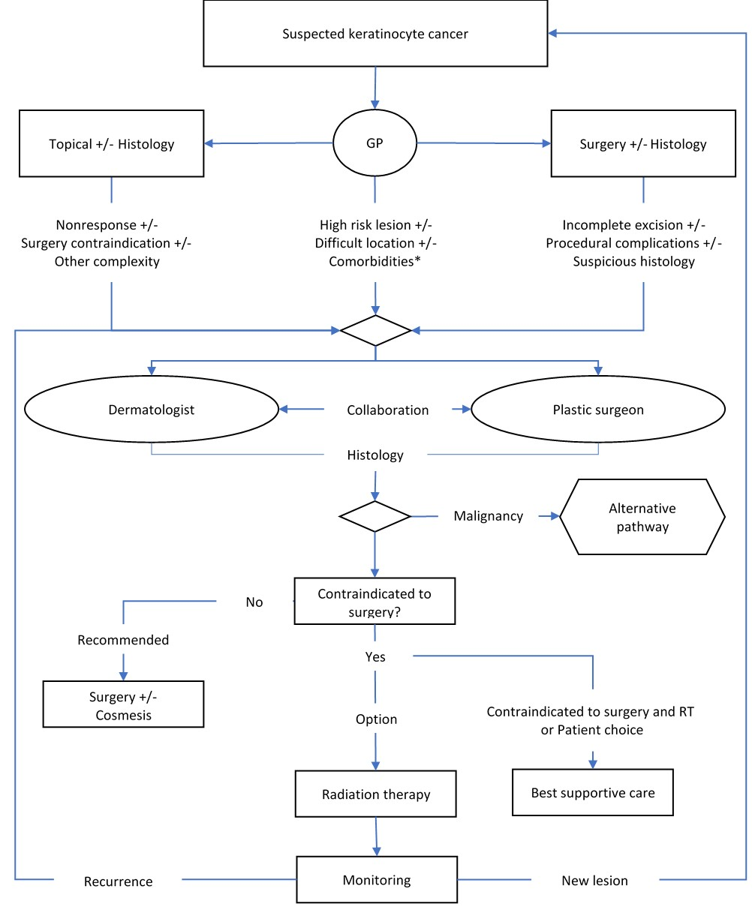
Figure 2 revised current clinical management algorithm
Source: Post-PASC, the HTA group revised the current and proposed clinical management algorithms provided by the applicant

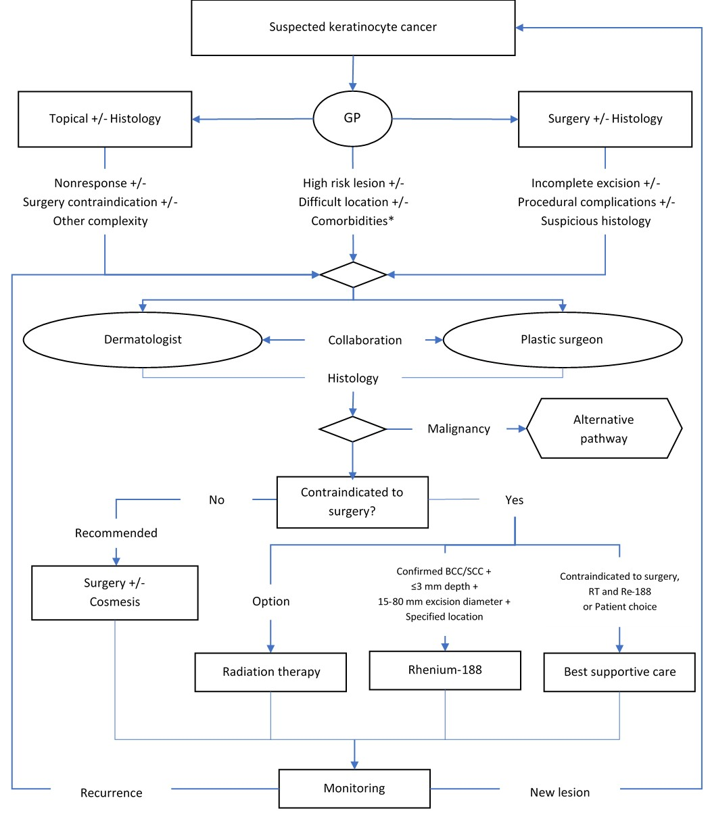
Figure 3 revised proposed clinical management algorithm
Source: Post-PASC, the HTA group revised the current and proposed clinical management algorithms provided by the applicant

Proposed economic evaluation
The clinical claim for the proposed medical service is of superior (patient reported outcomes such as health-related quality of life) and non-inferior (remission and recurrence rates) health outcomes of Re-188 brachytherapy for treatment of keratinocyte cancers compared to the nominated comparators. According to the ‘Technical Guidelines for preparing assessment reports for the Medical Services Advisory Committee’, the appropriate economic evaluation would be cost-effectiveness analysis or cost-utility analysis.
PASC noted that the application claimed superior patient-reported outcomes (HRQoL) and cosmesis, and non-inferior health outcomes. Therefore, the appropriate economic evaluation would be cost-effectiveness or cost-utility analysis.
It should be noted that the application did not include any comparative evidence for the assessment of the clinical claim of Re-188 brachytherapy compared with the nominated comparators. Scoping searches did not identify any relevant comparative evidence either.
PASC also noted that no comparative evidence was provided either for clinical effectiveness or safety in the application, and that the scoping searches during the PICO development also did not identify any comparative evidence. PASC noted assessment of evidence was for MSAC consideration but that the published and ongoing studies are small and provide limited non-comparative (single arm) evidence base that will be a challenging limitation for the application to support the clinical claim.
PASC noted that the ADAR would need to present itemised costing of the whole procedure, i.e., cost of the intervention delivery, of the radiopharmaceutical and of other proprietary consumables in the assessment.

Proposed item descriptors
The applicant has proposed creating three new MBS items with similar descriptor structure but accommodated different lesion diameter: 15-30mm, 30-50mm and 50-80mm.
Category 3 - Therapeutic Procedures – Group T2 - Radiation Oncology; Subgroup 4 - Brachytherapy
Epidermal radioisotope therapy, using rhenium-188, of a cutaneous basal cell carcinoma (BCC) or cutaneous squamous cell carcinoma (SCC) malignant non-melanoma, if:
a) malignancy has been confirmed and other diagnoses excluded by histological examination; and
b) the maximum depth of the lesion is less than or equal to 3 mm; and
c) the necessary excision diameter is at least 15 mm but no more than 30 mm; and
d) the lesion is excised from located on the nose, eyebrow, lip, ear, digit, genitalia, shin or collarbone or a contiguous area; and/ or
e) the patient has comorbidities that prevent surgical excision or external beam radiation therapy; and
g) the service is provided by a suitably trained nuclear medicine physician or radiation oncologist in an approved facility; and
h) the service is referred by a specialist dermatologist or plastic surgeon.

Multiple Operation Rule (the detail of which will need to be confirmed)

Fee: $To be determined subject to clinical consultation and cost effectiveness assessment
Note: edits to the item descriptors (as originally proposed by the applicant in their revised application) have been marked in blue font and are further discussed below.
Category 3 - Therapeutic Procedures – Group T2 - Radiation Oncology; Subgroup 4 - Brachytherapy
Epidermal radioisotope therapy, using rhenium-188, of a cutaneous basal cell carcinoma (BCC) or cutaneous squamous cell carcinoma (SCC) malignant non-melanoma, if:
a) malignancy has been confirmed and other diagnoses excluded by histological examination; and
b) the maximum depth of the lesion is less than or equal to 3 mm; and
c) the necessary excision diameter is at least 31 mm but no more than 50 mm; and
d) the lesion is excised from located on the nose, eyebrow, lip, ear, digit, genitalia, shin or collarbone, or a contiguous area; and/or
e) the patient has comorbidities that prevent surgical excision or external beam radiotherapy; and
g) the service is provided by a suitably trained nuclear medicine physician or radiation oncologist in an approved facility; and
h) the service is referred by a specialist dermatologist or plastic surgeon

Multiple Operation Rule (the detail of which will need to be confirmed)

Fee: $To be determined subject to clinical consultation and cost effectiveness assessment
Note: edits to the item descriptors (as originally proposed by the applicant in their revised application) have been marked in blue font and are further discussed below.
Category 3 - Therapeutic Procedures – Group T2 - Radiation Oncology; Subgroup 4 - Brachytherapy
Epidermal radioisotope therapy, using rhenium-188, of a cutaneous basal cell carcinoma (BCC) or cutaneous squamous cell carcinoma (SCC) malignant non-melanoma skin lesion, if:
a) malignancy has been confirmed and other diagnoses excluded by histological examination; and
b) the maximum depth of the lesion is less than or equal to 3 mm; and
c) the necessary excision diameter is at least 51 mm and no more than 80 mm; and
d) the lesion is excised from located on the nose, eyebrow, lip, ear, digit, genitalia, shin or collarbone, or a contiguous area; and/or
e) the patient has comorbidities that prevent surgical excision or external beam radiotherapy; and
g) the service is provided by a suitably trained nuclear medicine physician or radiation oncologist in an approved facility; and
h) the service is referred by a specialist dermatologist or plastic surgeon

Multiple Operation Rule (the detail of which will need to be confirmed)

Fee: $To be determined subject to clinical consultation and cost effectiveness assessment
Note: edits to the item descriptors (as originally proposed by the applicant in their revised application) have been marked in blue font and are further discussed below.
PASC noted that the three proposed item descriptors were intended to cover the costs of different quantities of Re-188 based on the treated surface. PASC noted an overlap in the lesion size in the three descriptors, and requested corrections be made.
The application form includes the following comments to the proposed item descriptor draft:
- The intent of the draft is to limit eligibility to the target population of patients with more difficult to treat lesions, for which malignancy has been confirmed, melanoma has been excluded, and suitability for treatment with Rhenium-188 is clearly established on the basis of size, location, or comorbidities.
- To limit treatment to appropriately trained nuclear medicine physicians or radiation oncologists, working from accredited facilities, using appropriate equipment, and treating only upon referral from specialist dermatologists and plastic surgeons. However, the applicant-proposed MBS items only refer to nuclear medicine physicians.
- The proposed items describe treatment of a single lesion which the applicant suggested that for multiple lesions the multiple operation rule would apply. However, the multiple operation rule only applies to surgical items under Category 3 Group T8 and therefore would not apply to the proposed items (which are proposed to be listed under Category 2 Group T2) in circumstances where patients have multiple lesions treated in a single session.
- The item will need to encompass both the medical practitioner and single use consumable components of the service, and has not been defined at this stage, pending further consultation. It appears from the application that both the Re-188 compound and other single-use consumables would be included in the fee calculation. It is suggested that a carpule with the Re-188 compound as well as the protective foil could be shared among multiple patients depending on the size and number of their lesions; it is unclear at this stage how this would be incorporated into the fee calculation. As a principle, the MBS subsidises professional components of services only and is not intended to cover other costs such as consumables. A transparent breakdown of the proposed fee that is commensurate to the cost of the professional service only is required.
PASC noted that around 85% of patients require only a single treatment and queried whether the proposed item descriptor should contain a “once per lifetime” limit. PASC also queried whether a limit should be put on the number of lesions that can be treated/billed for in a single session.
PASC noted that that the price of the radiopharmaceutical (Re-188 compound) was the predominant cost of the procedure. One carpule was estimated to cost A$REDACTED and could be used for 4-6 patients on average (total treated area of 25cm²). PASC noted that in Europe, Rhenium-SCT® treatment is estimated to cost € REDACTED for the first lesion treated and €REDACTED for any subsequent lesions treated on a given day within a particular practice (not necessarily subsequent lesions for the same patient, but within the practice setting). The applicant intended to propose the “multiple operation rule” for subsequent treatments on the same patient on the same day but was not aware that this rule may not apply as the MBS group relevant to the proposed intervention/medical service is uncertain.
PASC noted that the proposed item descriptors are in MBS Group T2- Radiation oncology, but Group T3 -Nuclear medicine may be more relevant. It was concluded that this decision would be addressed later in the process, likely closer to the implementation stage.
PASC noted that the applicant had not proposed an MBS item fee(s) but that the applicant intends for the MBS item fee to include the costs of the Re-188 compound and single use consumables. PASC noted that the ADAR would need to include detailed breakdown and justification of the proposed MBS fee along with detailed breakdown of the costs for the Re-188 compound, consumables and any other costs associated with the delivery of the service, and it would have to discuss how the costs would be covered. The applicant sought guidance on options for reimbursing the Re-188 compound and consumables, considering these are ordinarily not covered by the MBS. The Department commented that this would require further discussion once the applicant provided detailed information on the breakdown of the costs of the service and proposed MBS fees.
PASC enquired about the logistics of “batching” several patients in order to make best use of the radiopharmaceutical carpule on a single day. An applicant’s clinical expert agreed that batching of patients was challenging, given the narrow indications for the proposed medical service and the high costs, making patient batching a necessity if the procedure is to be economically viable. At the beginning, patients may need to wait for weeks or even months for a sufficient volume of patients to accumulate.
PASC noted that in comparison, the MBS item 15335 for brachytherapy has a fee of A$704.25.

Consultation feedback
Consultation feedback was received from the following organisations, including three (3) medical specialist colleges, one (1) consumer organisation and one (1) individual specialist physician:
- Royal Australian and New Zealand College of Radiologists (RANZCR)
- Australasian College of Dermatologists (ACD)
- Australian Society of Plastic Surgeons (ASPS)
- Melanoma and Skin Cancer Advocacy Network (MSCAN).
MSCAN was broadly supportive of the application, while RANZCR, ACD and the ASPS were broadly not supportive of the application.
Benefits
MSCAN stated that shorter treatment times equate to less time away from home, family, and work, particularly as the proposed intervention only requires one treatment and can be delivered without anaesthetic in an outpatient setting that appears to have a rapid turnaround from decision to treat to treatment. It also suggested that the proposed intervention is a non-invasive pain-free option where surgery would be disfiguring or too difficult, delivering an unmet need to NMSC patients.
MSCAN further stated that publicly funding the proposed intervention would increase access, while ensuring service delivery at a competitive and fair price and reduce public skin cancer waiting lists.
Disadvantages
The feedback raised concerns in relation to the radiation safety and protection of patients and healthcare providers, risk of exceeding lifetime radiation limits in case of retreatments, and adherence to procedures related to precise documentation of treated areas and administered radiation dose. Feedback considered that the application provides insufficient evidence of safety and efficacy including the durability of treatment, recurrence rates, long-term side effects/risks, and does not appear to provide a benefit over established radiation therapy technology. RANZCR noted the quoted studies are mainly retrospective and very small, with the potential for conflict of interests for clinicians employed or paid by the technology-supplier, and the absence of randomised head-to-head comparison of the proposed treatment with the standard of care. RANZCR considered that the proposed treatment could have technical disadvantages including in regard to its cost.
RANZCR and ACD stated that high dose-rate brachytherapy may cause an acute radiation skin reaction in the weeks following the treatment and that there is potential for significant long-term toxicity to the skin. RANZCR further considered that the proposed intervention does not appear to provide improved radiation dose-distributions or dose-rates compared with current radiation oncology techniques such as standard dual modality linacs, High Dose-Rate (HDR) afterloaders or Superficial X-Rays (SXR). In being such a source of radiation therapy, RANZCR stated that it introduces potential radiation protection hazards to the unfamiliar user and the patient as a result of this.
RANZCR also considered that the proposed treatment delivery in accredited nuclear medicine facilities in specialist hospitals could restrict patient access to treatment, especially as it would be difficult to offer the treatment regularly in regional, rural, and remote locations. This could result in treatment delays and negatively impact patients. MSCAN agreed with this, stating that they were interested to know whether treatment facilities would be limited to metropolitan areas, and that they advocate for equitable access for Australians living in rural and regional Australia.
Comparator
RANZCR clarified that skin cancers are most commonly treated surgically or with established existing radiation therapy modalities if localised, and by systemic chemotherapy if metastatic. RANZCR further stated that this therapy needs to be compared with well-established and understood standards of care, including current external beam radiation therapies.
ACD considered that the main comparator should be radiation therapy (MBS item numbers 15006 and item numbers 15112, 15115, 15224 and 15254). ACD considered that MMS (MBS item numbers 31000, 31001, 31002, 31003, 31004 and 31005) was not a suitable comparator as it is a complex procedure lasting for several hours, requiring special facilities and equipment with histopathology facilities as well as specially trained staff (medical, pathology and nursing). They also considered that the surgical excision (MBS item numbers 31356, 31358, 31359, 31361, 31363, 31365, 31367 and 31369) was not a suitable comparator as it recognised a different process (i.e., surgical excision with requirements for anaesthetics, sutures, and dressings).
The Australian Society of Plastic Surgeons (ASPS) disagreed with surgery being nominated as a comparator, noting that radiation therapy would be more suitable.
Item Descriptor
RANZCR were concerned that the application was inconsistent and unclear about which medical specialist will provide the service. Collectively, concerns were also expressed regarding organisation of the workflow including collaboration with referring dermatologists in terms of delineation of the area to be treated, and possible application of the Re-188 compound by staff other than specialist physicians.
PASC noted the received consultation feedback.
PASC noted that the referrals for the proposed medical service would be limited to specialist dermatologists and plastic surgeons. PASC queried whether this expectation was reasonable, considering that both the ACD and the ASPS were strongly opposed to the application, as per received consultation feedback. PASC considered that the lack of support from nominated referrers would be a difficult challenge that will require further stakeholder engagement by the applicant to address and overcome.

Next Steps
PASC considered that the application required an extensive revision. In the first instance, a revised PICO may be considered out of session, and if some matters remained unresolved, PASC may review it at a subsequent meeting.
Subsequent to resolution of the PICO issues and ratification by PASC, should the applicant decide to proceed with the application, the applicant would develop an ADAR.

Applicant Comments on the Ratified PICO Confirmation
Nil.
References
Australian Institute of Health and Welfare. (2016). Skin cancer in Australia. Cat. no. CAN96. Canberra
Australian Nuclear Science & Technology Organisation (ANSTO). Natural background radiation. Retrieved from https://www.ansto.gov.au/education/nuclear-facts/what-is-radiation#content-natural-background-radiation--2
Cancer Council Australia Keratinocyte Cancers Working Party. Clinical practice guidelines for keratinocyte cancer. Retrieved from https://wiki.cancer.org.au/australia/Guidelines:Keratinocyte_carcinoma
Cancer Council Victoria. Optimal care pathway for people with basal cell carcinoma or squamous cell carcinoma. Retrieved from https://www.cancer.org.au/assets/pdf/basal-cell-carcinoma-or-squamous-cell-carcinoma-optimal-cancer-care-pathway#_ga=2.211716949.1982970825.1616370019-1520682004.1607480919
Carrozzo, A. M., Cipriani, C., Donati, P., Muscardin, L., & Sedda, A. F. (2014). Dermo Beta Brachytherapy with 188Re in extramammary Paget's disease. G Ital Dermatol Venereol, 149(1), 115-121.
Carrozzo, A. M., Sedda, A. F., Muscardin, L., Donati, P., & Cipriani, C. (2013). Dermo beta brachytherapy with 188-Re in squamous cell carcinoma of the penis: a new therapy. Eur J Dermatol, 23(2), 183-188. doi:10.1684/ejd.2013.1927
Cipriani, C., Desantis, M., Dahlhoff, G., Brown, S. D., 3rd, Wendler, T., Olmeda, M., . . . Eberlein, B. (2020). Personalized irradiation therapy for NMSC by rhenium-188 skin cancer therapy: a long-term retrospective study. J Dermatolog Treat, 1-7. doi:10.1080/09546634.2020.1793890
Cipriani, C., Frisch, B., Scheidhauer, K., & Desantis, M. (2017). Personalized high-dose-rate brachytherapy with non-sealed Rhenium-188 in non-melanoma skin cancer. Int J Nucl Med Res, 114-122. doi:10.15379/2408-9788.2017.11
Fransen, M., Karahalios, A., Sharma, N., English, D. R., Giles, G. G., & Sinclair, R. D. (2012). Non-melanoma skin cancer in Australia. Med J Aust, 197(10), 565-568. doi:10.5694/mja12.10654
Olsen, C. M., Wilson, L. F., Green, A. C., Bain, C. J., Fritschi, L., Neale, R. E., & Whiteman, D. C. (2015). Cancers in Australia attributable to exposure to solar ultraviolet radiation and prevented by regular sunscreen use. Aust N Z J Public Health, 39(5), 471-476. doi:10.1111/1753-6405.12470
Oncobeta. (2019). Rhenium-SCT. Questions and answers for physicians and medical personnel. Version D 10.03.2019. Retrieved from https://www.oncobeta.com/for-professionals/
Pandeya, N., Olsen, C. M., & Whiteman, D. C. (2017). The incidence and multiplicity rates of keratinocyte cancers in Australia. Med J Aust, 207(8), 339-343. doi:10.5694/mja17.00284
Perera, E., Gnaneswaran, N., Staines, C., Win, A. K., & Sinclair, R. (2015). Incidence and prevalence of non-melanoma skin cancer in Australia: A systematic review. Australas J Dermatol, 56(4), 258-267. doi:10.1111/ajd.12282
Sedda, A. F., Rossi, G., Cipriani, C., Carrozzo, A. M., & Donati, P. (2008). Dermatological high-dose-rate brachytherapy for the treatment of basal and squamous cell carcinoma. Clin Exp Dermatol, 33(6), 745-749. doi:10.1111/j.1365-2230.2008.02852.x
Therapeutic Goods Administration (TGA). (2020). ARTG ID 351390 - public ARTG summary. Canberra: Australian Government, Retrieved from https://search.tga.gov.au/s/search.html?collection=tga-artg&profile=record&meta_i=351390

