Public Summary Document

Report to the Medical Services Advisory Committee on utilisation of MBS item 48694 following Application 1145: Artificial intervertebral disc replacement (AIDR) in patients with cervical degenerative disc disease
Medicare Benefits Schedule (MBS) item considered: 48694
Date of MSAC consideration: 26-27 July 2017
Context for decision: MSAC makes its advice in accordance with its Terms of Reference, see the MSAC Website.

Purpose
The purpose of the report presented to the Medical Services Advisory Committee (MSAC) was to inform MSAC of the real world impacts on the outcomes of Application 1145. The MSAC uses this information to ensure that the new item resulting from this application is being used as intended.
The report is not intended to be a review of the clinical information covered during the application process.

MSAC’s advice
After consideration of the real world data for MBS item 48694 – cervical artificial intervertebral total disc replacement (AIDR-C), at one level only, including removal of disc – (MSAC Application 1145), MSAC recommended no further action, considering that the actual utilisation data tracked reasonably closely with the utilisation predicted before this MBS listing was implemented, and that the other review variables presented did not raise any other substantive concerns.

Summary of consideration and rationale for MSAC’s advice
MSAC considered the impacts of the outcome of MSAC Application 1145 for cervical artificial intervertebral total disc replacement, at one level only, including removal of disc (MBS item 48694) by examining the actual utilisation data up to December 2017 (the majority up to June 2017). The item was MBS listed in November 2012.
This item is for patients who have not had prior spinal surgery at the same cervical level, are skeletally mature, have symptomatic degenerative disc disease with radiculopathy, do not have vertebral osteoporosis and have failed conservative therapy. MSAC noted that the procedure is performed in-hospital only, by a combination of neurosurgeons and orthopaedic surgeons.
MSAC recalled that for item 48694 there was a predicted uptake of 233 services in the first year of implementation (partial financial year 2012–13) rising to 540 services in year 5 (financial year 2016–17). MSAC noted that actual utilisation was less than predicted in the first 8 months following implementation (152 services), but in the following years actual utilisation surpassed predicted utilisation: 503 actual services compared to 431 predicted services in 2013–14, increasing to 584 actual services compared to the 540 predicted for 2016–17. MSAC noted that, though still above the predicted volumes, services appeared to plateau.
MSAC noted that the highest utilisation was in Queensland, New South Wales, Victoria and Western Australia.
MSAC recalled that the MBS fee for item 48694 is $1082 (75% = $812). MSAC noted that the national average fee for the period 2013–14 to 2016–17 was relatively constant, approximately $2,750 to $2,800. MSAC noted that the fee in the Australian Capital Territory from 2014–15 to 2016–17 was higher than all other states, at approximately $5,800. Nationally, services are rarely bulk billed.
MSAC noted that the service is predominantly claimed by patients aged between 35 and 55, and claimed approximately evenly between males and females. The number of patients claiming the service increased from 152 in 2012–13, to 501 in 2013–14 and averaged 574 per year from 2014–15 to 2016–17.
MSAC noted that the number of practitioners providing this service increased from 47 in 2012–13 to 102 in 2016–17. Approximately 10% of providers perform 40% of the services; this may have drifted down over time.
MSAC noted that item 48694 is rarely claimed alone. It is most commonly (30%) co-claimed with items 40330 (spinal rhizolysis) and 6009 (professional attendance by a specialist in the practice of neurosurgery following referral of the patient to him or her – a minor attendance after the first in a single course of treatment at consulting rooms or hospital).
MSAC noted that the current evaluation is now outdated since MBS items for spinal surgery were recently reviewed by the MBS Review Taskforce. Item 48694 for AIDR-C was recommended to remain a listed service on the MBS, as it was deemed clinically appropriate. The government responded to the taskforce recommendations in the 2018–19 budget. MSAC noted that the new spinal surgery schedule will, however, no longer include item 40330 as a stand-alone service, and that the fee for AIDR-C has been adjusted ($1,560.20) to account for the deletion of item 40330 (modelled on the basis of cost neutrality across the complete restructure of spinal surgery items). MSAC also noted minor changes to the item descriptor made by the taskforce.
MSAC queried whether the price increase for item 48694 will be ratified, and if so whether it will increase patient out-of-pocket costs. MSAC sought advice from the Department on how the effect of outcomes from the MBS Review Taskforce will be monitored.
MSAC recommended no further action, considering that the actual utilisation data tracked reasonably closely with the utilisation predicted before this MBS listing was implemented, and that the other review variables presented did not raise any other substantive concerns. Following clarification on price from the Department, MSAC may recommend continued monitoring depending on the policy framework established to evaluate unintended consequences of the MBS Review.

4. Methodology
An application is selected for consideration if the resulting new item(s) and/or item amendment(s) have been on the MBS for approximately 24 months or longer or if there were particular concerns about utilisation such that MSAC requested to consider it earlier. The specific applications for each MSAC meeting are selected by the MSAC Executive which is composed of the chairs of MSAC and its sub-committees.
A report on the utilisation is developed by the department with information on a number of metrics including; state variation, patient demographics, services per patient, practitioner’s providing the service, data on fees and co-claiming of services. The number of metrics included in a report is dependent on the annual service volume for the MBS item(s) under consideration i.e. an item with very low utilisation will have less data to analyse. Where service volumes are too low, information is suppressed to protect patient privacy.
Where possible the report compares data on real world utilisation to the assumptions made during the MSAC assessment. Most of these assumptions are drawn from the assessment report.
Relevant stakeholders are provided an opportunity to comment on the findings in the report before it is presented to the MSAC. It is intended that stakeholders are given at least three weeks to consider the reports.
The stakeholder version of the report does not contain information on assumptions from the MSAC consideration if this information is not already publicly available. This is to protect the commercial in confidence of the original applicants. The same principle is applied to this document.
Once MSAC has considered the report, its advice is made available online at the MSAC Website.

5. Results

Utilisation
Although actual utilisation of item 48694 was less than predicted in the first eight months following implementation, since 2013-14 actual utilisation has remained greater than what was predicted. In 2012-13 there were 152 actual services which was significantly lower than predicted; in 2013-14 there were 503 actual services which was greater than predicted. Uptake in 2014-15 continued to surpass predicted utilisation. During 2015-16 and 2016-17 though still above the predicted volumes, services appeared to plateau (Figure 1).
From 1 November 2012 to 30 June 2017, Queensland had the highest utilisation with 903 services, accounting for approximately 38 percent of services billed to the item. This compares to New South Wales, which had the second highest utilisation 462 services, accounting for 19 percent of services in this period. After the Northern Territory, South Australia had the lowest utilisation with 10 services claimed during the same period (Table 1).

Figure 1: Predicted versus actual services of MBS item 48694 from 1 November 2012 to
31 December 2017.
° Predicted services in 2012-13 adjusted to reflect partial financial year
Source:Department of Health, File: Q21109B Item 48694 utilisation 31 Jan 2018.xls
Table 1. Service volume of MBS item 48694 between 2012-13 and 2017-18 (date of service)
 | State/Territory |  |  |  |  |  |  |  | Total
 | NSW | VIC | QLD | SA | WA | TAS | NT | ACT
2012-2013 | 28 | 19 | 65 | np | 30 | 10 | - | - | 152
2013-2014 | 109 | 72 | 213 | np | 72 | 31 | - | 10 | 507
2014-2015 | 106 | 87 | 223 | 10 | 103 | 53 | - | 31 | 613
2015-2016 | 99 | 93 | 198 | np | 106 | 57 | - | 53 | 606
2016-2017 | 120 | 94 | 204 | np | 87 | 62 | - | 57 | 624
2017-2018 | 58 | 55 | 116 | np | 60 | 35 | - | 62 | 386
All years | 890 | 420 | 1019 | 33 | 458 | 248 | - | 213 | 3281
*Item implemented 1 November 2012
np = not printed
Source:Department of Health, File: Q21109B Item 48694 utilisation 31 Jan 2018-.xls

Patient breakdown
There were 152 patients who claimed item 48694 in the listing year 2012-13.
In 2013-14 the number of patients who claimed item 48694 increased to 501.
The number of patients claiming item 48694 in the years 2014-15, 2015-16 and
2016-17 averaged 574. For the period 2014-15 to 2016-17 there were 35 repeat
patients (Table 2).
The service is most frequently claimed by patients aged 35-44 and 45-54 (Table 3).
The service is approximately claimed evenly between females and males (Figure 2).
Table 2. Number of new and continuing patients who received MBS item 48694 by financial year
Financial Year | New Patients | Continuing Patients | Total Patients
2012-13* | 152 | 0 | 152
2013-14 | 501 | 0 | 501
2014-15 | 567 | 9 | 576
2015-16 | 559 | 11 | 570
2016-17 | 562 | 15 | 577
Source: Department of Health, MBS Analytics Section File: Q21109B Item 48694 utilisation 31 Jan 2018.xls
* partial financial year
Table 3. Percentage of patients receiving MBS item 48694 per age group by financial year
Age range | Financial Year |  |  |  |  | Total all years
 | 2012-13* | 2013-14 | 2014-15 | 2015-16 | 2016-17
15-24 | 0.8% | 0.4% | 0.9% | 1.0% | 0.7% | 0.8%
25-34 | 6.1% | 8.0% | 7.2% | 7.8% | 7.8% | 7.6%
35-44 | 35.7% | 32.3% | 32.9% | 31.4% | 30.0% | 31.8%
45-54 | 40.95% | 36.5% | 37.9% | 36.5% | 37.1% | 37.2%
55-64 | 13.9% | 17.4% | 16.1% | 17.5% | 19.1% | 17.4%
65-74 | 2.6% | 5.2% | 4.5% | 5.5% | 4.8% | 4.9%
75-84 | 0.0% | 0.2% | 0.4% | 0.3% | 0.5% | 0.3%
+85 | 0.0% | 0.0% | 0.2% | 0.0% | 0.0% | 0.0%
Source: Medicare Statistics Online, accessed 12 April 2018

a)
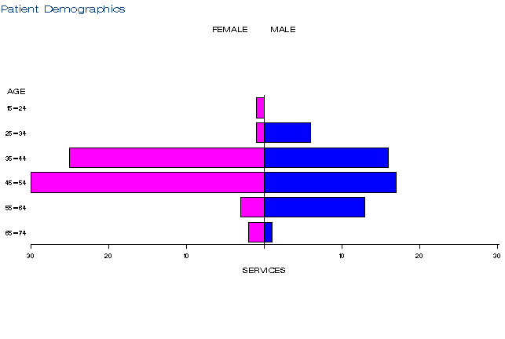
b)
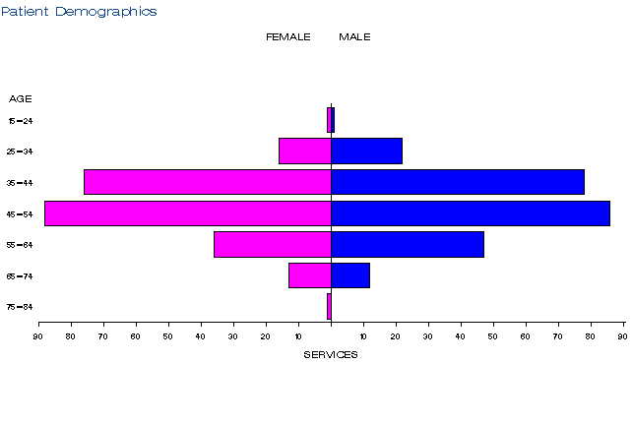
c)
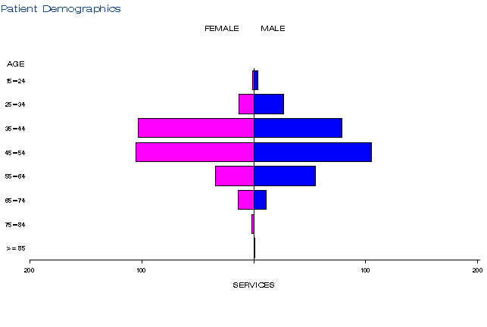
d)
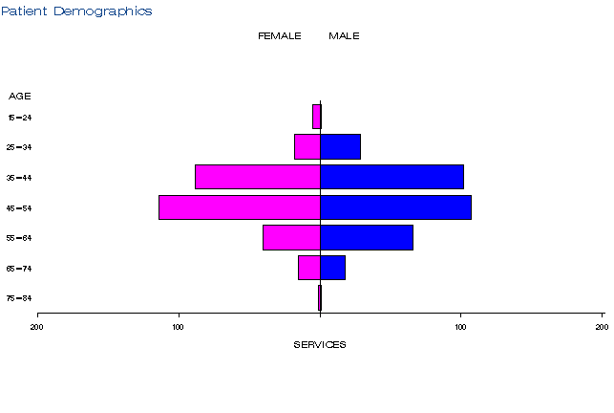
e)
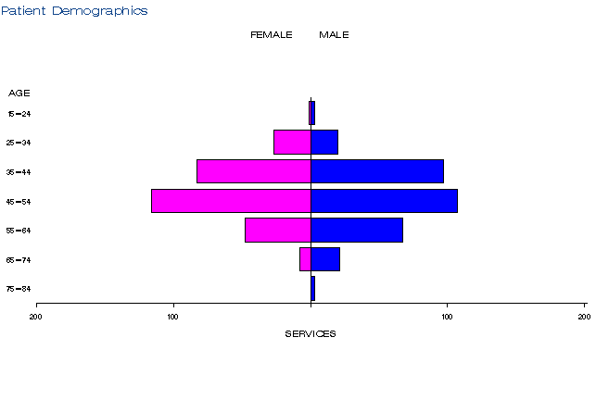
Figure 2: Demographic profile for MBS item 48694 for (a) 2012-13, (b) 2013-14, (c) 2014-15,
(d) 2015-16, and (e) 2016-17
Source: Medicare Statistics Online, accessed 12 April 2018

Practitioner breakdown
There has been an increase in the number of practitioners providing services under item 48694. In 2012-13 there were 47 practitioners providing services, increasing to102 practitioners in 2016-17 (Table 4). Services under item 48694 are provided by spinal surgeons, a combination of neurosurgeons and orthopaedic surgeons. About 60% of practitioners provided 90% of all services (Table 5). Neurosurgeons provided close to 75% of the services (Table 6).
Table 4. Number of practitioners providing services under item 48694 from 2012-13 to 2016-17
Financial year | Practitioners | Services | Average
2012-13* | 47 | 152 | 3.2
2013-14 | 79 | 503 | 6.4
2014-15 | 94 | 579 | 6.2
2015-16 | 92 | 574 | 6.2
2016-17 | 102 | 584 | 5.7
*partial financial year
Source: Department of Health File: Q21109B Item 48694 utilisation 31 Jan 2018.xls
Table 5. Cumulative percentage of medical practitioners providing item 48694 and how many services each percentile accounts for in 2012-13 to 2016-17 financial years
Provider Cumulative % | 2012-13* | 2013-14 | 2014-15 | 2015-16 | 2016-17
10% | 40.3 | 38.3 | 40.7 | 35.6 | 36.1
20% | 55.7 | 59.2 | 60.6 | 56.2 | 56.4
30% | 68.0 | 73.3 | 73.8 | 70.9 | 69.1
40% | 77.9 | 81.9 | 82.3 | 81.4 | 77.8
50% | 84.2 | 88.0 | 87.6 | 88.3 | 84.8
60% | 87.6 | 92.2 | 91.5 | 92.8 | 90.3
70% | 90.7 | 95.3 | 94.7 | 95.2 | 94.1
80% | 93.8 | 96.9 | 96.8 | 96.8 | 96.5
90% | 96.9 | 98.4 | 98.4 | 98.4 | 98.3
99% | 99.7 | 99.8 | 99.8 | 99.8 | 99.8
* partial financial year
Source: Department of Health File: Q21109B Item 48694 utilisation 31 Jan 2018.xls
Table 6. Number of services by provider specialty under item 48694 between 2012-13* and 2016-17 by financial years
Derived Major Specialty | Number of services
Total Combined | 2392
Specialist - Surgery - Neurosurgery | 1784
Specialist - Surgery - Orthopaedic Surgery | 607
*partial financial year
Source: Department of Health File: Q21109B Item 48694 utilisation 31 Jan 2018.xls.

Co-claiming
The service is commonly co-claimed with item 40330 and item 6009 (Tables 7-11).
Source for tables 7-11: Department of Health, Medical Benefits Division, Primary Care and Diagnostics Branch, File: Q21109B Item 48694 utilisation 31 Jan 2018.xls
Table 7. Instances of co-claiming with MBS item 48694 in 2012-13*
# | Items | Episodes | Services | Schedule Fee for combination | Number of patients | % of episodes
1 | 48694,40330 | 29 | 58 | $45,246 | 29 | 19.08%
2 | 48694, 6009,40330 | 16 | 48 | $25,651 | 16 | 10.53%
3 | 48694 | 15 | 15 | $16,241 | 15 | 9.87%
4 | 48694, 6011,40330 | 15 | 45 | $24,686 | 15 | 9.87%
5 | 48694, 48242,48669,48684 | 9 | 36 | $21,501 | 7 | 5.92%
6 | 48694, 6011 | 7 | 14 | $8,178 | 7 | 4.61%
7 | 48694,48242,48660,48684 | 7 | 28 | $14,087 | 5 | 4.61%
8 | 48694,40330,48660,48684 | 5 | 20 | $10,491 | 4 | 3.29%
9 | 48694,6011,40330,48639 | 4 | 21 | $10,911 | 3 | 2.63%
10 | 48694,105,40330,48660,48684 | 3 | 15 | $6,424 | 7 | 1.97%
* partial financial year
Table 8. Instances of co-claiming with MBS item 48694 in 2013-14
# | Items | Episodes | Services | Schedule Fee for combination | Number of patients | % of episodes
1 | 48694,40330 | 119 | 238 | $185,664 | 119 | 23.66%
2 | 48694, 6009,40330 | 38 | 114 | $60,922 | 38 | 7.55%
3 | 48694, 6011,40330 | 35 | 105 | $57,601 | 35 | 6.96%
4 | 48694 | 30 | 30 | $32,481 | 29 | 5.96%
5 | 48694,40330,48660,48684 | 23 | 92 | $48,259 | 23 | 4.57%
6 | 48694,48669,48684 | 23 | 69 | $51,422 | 23 | 4.57%
7 | 48694, 6011,40330,48639 | 19 | 100 | $51,843 | 19 | 3.78%
8 | 48694,48660,48684 | 16 | 48 | $29,751 | 16 | 3.18%
9 | 48694, 6011,40331 | 15 | 45 | $24,686 | 15 | 2.98%
10 | 48694, 6009,40330,40333 | 14 | 56 | $25,235 | 14 | 2.78%

Table 9. Instances of co-claiming with MBS item 48694 in 2014-15
# | Items | Episodes | Services | Schedule Fee for combination | Number of patients | % of episodes
1 | 48694,40330. | 129 | 258 | $201,266 | 129 | 22.28%
2 | 48694,6009,40330. | 71 | 214 | $114,066 | 69 | 12.26%
3 | 48694,6011,40330. | 39 | 118 | $65,139 | 39 | 6.74%
4 | 48694 | 27 | 27 | $29,233 | 26 | 4.66%
5 | 48694,40330,48660,48684. | 26 | 104 | $54,553 | 26 | 4.49%
6 | 48694,48669,48684. | 22 | 67 | $49,650 | 22 | 3.80%
7 | 48694,6009,40330,48660,48684 | 19 | 95 | $42,646 | 19 | 3.28%
8 | 48694,6011,40331. | 15 | 45 | $24,686 | 15 | 2.59%
9 | 48694, 105,40330,48660,48684 | 14 | 70 | $29,977 | 14 | 2.42%
10 | 48694,105,40330. | 14 | 42 | $22,445 | 14 | 2.42%
Table 10. Instances of co-claiming with MBS item 48694 in 2015-16
# | Items | Episodes | Services | Schedule Fee for combination | Number of patients | % of episodes
1 | 48694,40330 | 153 | 306 | $239,188 | 151 | 26.66%
2 | 48694,6009,40330 | 50 | 150 | $80,160 | 50 | 8.71%
3 | 48694,40330,48660,48684 | 34 | 136 | $71,574 | 34 | 5.92%
4 | 48694,6011,40330 | 32 | 96 | $52,664 | 32 | 5.57%
5 | 48694, 105,40330 | 26 | 79 | $41,726 | 26 | 4.53%
6 | 48694 | 23 | 23 | $24,902 | 23 | 4.01%
7 | 48694,48669,48684 | 16 | 48 | $35,775 | 16 | 2.79%
8 | 48694,48660,48684 | 14 | 42 | $26,032 | 14 | 2.44%
9 | 48694, 105,40330,48660,48684 | 12 | 60 | $25,694 | 12 | 2.09%
10 | 48694, 6011,40330,48639 | 12 | 59 | $31,298 | 12 | 2.09%
Table 11. Instances of co-claiming with MBS item 48694 in 2016-17
# | Items | Episodes | Services | Schedule Fee for combination | Number of patients | % of episodes
1 | 48694,40330 | 174 | 348 | $271,475 | 173 | 29.79%
2 | 48694, 6009,40330 | 49 | 147 | $78,557 | 49 | 8.39%
3 | 48694 | 25 | 25 | $27,068 | 25 | 4.28%
4 | 48694,6011,40330 | 24 | 72 | $39,498 | 24 | 4.11%
5 | 48694,40330,48660,48684 | 22 | 88 | $46,160 | 22 | 3.77%
6 | 48694,105,40330 | 18 | 54 | $28,858 | 18 | 3.08%
7 | 48694, 105,40330,48660,48684 | 17 | 86 | $36,639 | 17 | 2.91%
8 | 48694, 40331,40333 | 15 | 45 | $26,393 | 14 | 2.57%
9 | 48694,48669,48684 | 14 | 42 | $31,303 | 14 | 2.40%
10 | 48694,40330,60509 | 13 | 39 | $21,503 | 13 | 2.23%

Data on fee charged
The information provided on fees below is a snapshot of how the item is being claimed in practice. Data has not been printed for states and territories with low service volumes.
The 75% benefit for item 48694 is $812.05.
The national average fee for the period 2013-14 to 2016-17 is relatively constant, around $2,750 to $2,800 (Table 4). There was variation in the fees charged by practitioners, with fees increasing to $6,178 for those practitioners charging at the 95th percentile in 2016-17.
The Australian Capital Territory (ACT) recorded the highest average fees for the years 2014-15, 2015-16 and 2016-17 - $5,848, $5,694 and $5,958 respectively, these fees are approximately $3,000 over the national average. Though the ACT recorded the highest average fees it had only the third highest service volumes (Table 12).
Of the states with the highest utilisation rates - Queensland, New South Wales, Victoria and Western Australia - average fees were higher in New South Wales and Queensland than in Victorian and Western Australia. In Queensland the average fee was above the national average, whereas, in New South Wales, Victoria and Western Australia average fees were below the national average (Table 12).
Nationally, services are rarely bulk billed.

Table 12. Statistics on fees charged for MBS item 48694 for 2013-14 to 2016 -17 by date of service
 |  | Provider State/Territory
 |  | NSW | VIC | QLD | SA | WA | TAS | ACT | AUS
2013-14 | Average Fee | $2,975.03 | $1,789.30 | $3,300.58 | $1,926.40 | $1,636.88 | $3,798.43 | $3,723.35 | $2,798.00
 | Standard Deviation | $1,968.71 | $1,652.25 | $1,726.39 | $1,851.90 | $961.56 | $1,652.25 | $2,901.33 | $1,832.59
 | 25th Percentile Fee | $1,643.65 | $500.05 | $1,756.85 | np | $1,082.70 | $500.05 | np | $1,498.05
 | Median | $1,889.45 | $1,544.85 | $3,142.85 | np | $1,643.65 | $1,544.85 | np | $1,762.00
 | 95th Percentile fee* | $5,999.90 | $5,107.40 | $5,833.75 | np | $4,082.70 | $5,107.40 | np | $6,258.65
 | Bulk Billed rate | 0.0% | 0.0% | 0.0% | 0.0% | 0.0% | 0.0% | 0.0% | 0.0%
2014-15 | Average Fee | $2,361.55 | $1,649.60 | $3,850.78 | $1,599.74 | $1,528.71 | $3,251.99 | $5,848.95 | $2,766.97
 | Standard deviation | $1,799.07 | $1,330.28 | $1,902.75 | $324.65 | $618.17 | $1,808.72 | $104.72 | $1,901.33
 | 25th Percentile Fee | $958.45 | $649.65 | $2,199.30 | np | $872.35 | $1,945.60 | np | $1,586.10
 | Median | $1,734.95 | $1,562.90 | $3,906.85 | np | $1,710.65 | $2,620.35 | np | $1,906.60
 | 95th Percentile fee* | $6,442.40 | $5,107.40 | $5,923.00 | np | $2,143.65 | $6,352.40 | np | $5,923.00
 | Bulk Billed rate | 0.0% | 0.0% | 0.0% | 0.0% | 0.0% | 0.0% | 0.0% | 0.0%
2015-16 | Average Fee | $2,528.27 | $1,841.72 | $3,662.53 | $2,433.72 | $1,584.27 | $3,391.01 | $5,694.40 | $2,779.10
 | Standard deviation | $1,917.47 | $1,546.39 | $1,991.34 | $1,843.98 | $956.67 | $1,880.10 | $750.77 | $1,960.22
 | 25th Percentile Fee | $1,082.70 | $787.60 | $1,719.45 | np | $872.35 | $1,972.00 | np | $1,172.75
 | Median | $1,720.70 | $1,643.65 | $3,906.00 | np | $1,643.65 | $2,295.90 | np | $1,800.20
 | 95th Percentile fee* | $7,000.55 | $5,339.90 | $6,086.00 | np | $3,582.70 | $6,515.30 | np | $6,037.40
 | Bulk Billed rate | 0.0% | 0.0% | 0.0% | 0.0% | 0.0% | 0.0% | 0.0% | 0.0%
2016-17 | Average Fee | $2,694.42 | $1,738.83 | $3,437.17 | $1,367.29 | $1,715.34 | $2,955.09 | $5,958.03 | $2,746.20
 | Standard deviation | $2,694.42 | $1,479.32 | $1,916.66 | $777.08 | $977.24 | $1,764.34 | $604.63 | $1,944.85
 | 25th Percentile Fee | $904.25 | $729.40 | $1,719.45 | np | $946.85 | $1,795.90 | np | $1,250.20
 | Median | $1,720.70 | $1,375.15 | $3,604.60 | np | $1,710.65 | $2,185.30 | np | $1,777.80
 | 95th Percentile fee* | $7,106.90 | $5,339.90 | $6,178.95 | np | $4,082.70 | $6,117.15 | np | $6,178.95
 | Bulk Billed rate | 1.7% | 0.0% | 0.5% | 0.0% | 1.1% | 0.0% | 0.0% | 0.7%
The 95th percentile fee charged represents that 95% of the time the fee is at or below this amount but in 5% of cases, the fee is higher than this.
Source: Department of Health, File: Q21109B Item 48694 utilisation 31 Jan 2018-.xls

Figure 3: Average fee charged and range between 25th percentile and 95th percentile fee charged by state for MBS item 48694 between 2103-14 and 2016-17
Source: Department of Health, File: Q21109B Item 48694 utilisation 31 Jan 2018-.xls

6. Background
In 2006 the Medical Services Advisory Committee (MSAC) considered an application requesting Medicare Benefits Schedule (MBS) listing for artificial intervertebral disc replacement (AIDR), for the treatment of degenerative disc disease in the cervical and lumbar spine (MSAC application 1090). Though MSAC recommended interim listing of AIDR for the lumbar spine (AIDR-L) they did not support listing of AIDR for patients with cervical degenerative disc disease (AIDR-C).
In January 2010 an application (MSAC Application 1145) was received from the Spine Society of Australia requesting MBS listing of AIDR-C. MSAC initially considered the application at its 52nd meeting in April 2011, and deferred a decision pending a request for further information from the applicant and the department.
At its 54th meeting in November 2011, MSAC supported the listing of AIDR-C for patients with symptomatic single level cervical degenerative disc disease in skeletally mature patients with a mechanically stable cervical spine who have not responded to conservative therapy and who have not had prior cervical spine surgery.
Item descriptor
48694 | Cervical artificial intervertebral total disc replacement, at one level only, including removal of disc, for a patient who:  (a) has not had prior spinal surgery at the same cervical level; and  (b) is skeletally mature; and  (c) has symptomatic degenerative disc disease with radiculopathy; and  (d) does not have vertebral osteoporosis; and  (e) has failed conservative therapy;  other than a service associated with item 40300 or 40301  Multiple Services Rule  (Anaes.) (Assist.)  Fee: $1,082.70 Benefit: 75% = $812.05

7. Applicant’s comments on MSAC’s public summary document
The applicant had no comment.

8. Further information on MSAC
MSAC Terms of Reference and other information are available on the MSAC Website at: www.msac.gov.au.

