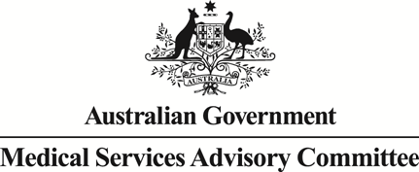

Public Summary Document
Application No. 1435 – Processing and cryopreservation of gonadal tissue and gametes prior to or after gonadotoxic treatment to preserve fertility for the Future (part B)
Applicant: Kids Cancer Centre
Date of MSAC consideration: MSAC 72nd Meeting, 28-29 March 2018
Context for decision: MSAC makes its advice in accordance with its Terms of Reference, visit the MSAC website

Purpose of application
An application requesting two new Medicare Benefits Schedule (MBS) listings for the processing and freezing components of cryopreservation of ovarian tissue was received from the Kids Cancer Centre by the Department of Health.
The proposed medical service is processing and cryopreservation (freezing) of ovarian tissue (complete or partial ovary removal), for fertility preservation either prior to receiving or following completion of gonadotoxic treatment for malignant or non-malignant conditions in female patients aged 0-45 years.

MSAC’s advice to the Minister
After considering the strength of the available evidence in relation to comparative safety, clinical effectiveness and cost-effectiveness, MSAC did not support MBS funding for the processing, analysis and cryopreservation of ovarian tissue (ovarian tissue cryopreservation [OTC]) to preserve fertility in females undergoing potentially gonadotoxic treatment. While MSAC acknowledged the merit of such a service, as it is the only option for fertility preservation in pre-pubertal women, it did not support MBS funding due to uncertain clinical effectiveness and unresolved safety concerns, particularly risk of malignancy.
MSAC advised that any resubmission should include:
- a protocol showing how malignancy in the cryopreserved tissue is ruled out
- evidence of clinical benefits and quality of life information
- further data on utilisation including proportion of females who subsequently use the preserved tissue
- the incremental cost per extra live birth (inclusive of all associated costs).
MSAC advised that any resubmission would need to be considered by ESC.

Summary of consideration and rationale for MSAC’s advice
MSAC noted that the application relates to the processing, analysis and cryopreservation (freezing) of ovarian tissue (ovarian tissue cryopreservation [OTC]) to preserve fertility in females undergoing potentially gonadotoxic treatment. MSAC noted that while the application requests MBS funding for OTC, this is only the first step in fertility preservation. MSAC noted that if OTC is to be helpful in preserving fertility, the frozen tissue must be reimplanted into the body at a later date (ovarian tissue transplant [OTT]).
MSAC noted that the application is Part B of MSAC Application 1435. Part A of Application 1435 relates to the processing and cryopreservation of semen and testicular tissue to preserve future fertility in males undergoing potentially gonadotoxic treatment. MSAC recalled that it had supported MBS funding for the cryopreservation of semen, but not testicular tissue, in post-pubertal men at its November 2017 meeting (MSAC Application 1435A).
MSAC noted that evidence was presented for pre-pubertal and post-pubertal females.
MSAC accepted that OTC with OTT is the only option for fertility preservation in pre-pubertal females as their oocytes are not mature enough for collection. However, MSAC considered the use of OTC with OTT to be experimental in pre-pubertal females, noting that only two live births had been reported among women who had undergone OTC prior to puberty. MSAC noted that a resubmission for the pre-pubertal population should be considered once more evidence becomes available, although it acknowledged that it may be many years before this evidence is available.
MSAC noted that the comparators for OTC with OTT in post-pubertal women included oocyte cryopreservation in conjunction with in vitro fertilisation (IVF), embryo cryopreservation in conjunction with IVF, no fertility preservation, adoption and childlessness.
MSAC considered that the OTC procedure had acceptable safety in post-pubertal women. MSAC noted that one large comparative study reported a complication rate of 0.4% for OTC and 2.9% for oocyte collection, although many of the complications reported for oocyte cryopreservation were technical issues (Lawrenz B et al 2011). MSAC also noted that 13 adverse events were reported when the data on 3097 OTC procedures from 16 non-comparative retrospective studies was combined (0.42%).
MSAC remained concerned about the risk that stored ovarian tissue will contain malignant cells that survive cryopreservation and could potentially be transplanted back into the woman during OTT. MSAC was particularly concerned about contamination among women who had a haematological malignancy, especially leukaemia.
MSAC noted a systematic review of observational studies that used imaging, histology, immunohistochemistry (IHC), and polymerase chain reaction (PCR) of ovarian tissue to test for malignant cells in stored ovarian tissue (Rosendahl M et al 2013). MSAC noted that evidence of malignant cells was found in 7.1% of 422 ovarian tissue samples, all from women diagnosed with haematological cancers (leukaemia or lymphoma). Among the subset of women with leukaemia, PCR identified malignant cells in 31% of 33 women. Among women with any cancer diagnosis, histology and IHC identified malignant cells in one of 367 women and one of 220 women, respectively. MSAC considered that this review suggested there was uncertainty as to the best way to rule out malignancies but that PCR may be one of the better options.
MSAC noted that in another systematic review of observational studies, nine of 230 women with a cancer diagnosis who underwent OTT had a cancer recurrence, although none were considered to be related to the procedure (Gellert SE et al 2018). MSAC considered that although this finding could be interpreted as indicating that there were no cases of reintroduced malignancy related to the procedure in these 230 women, the sample size (especially of the subset with haematological malignancy) was still very small and the possibility of malignant cells being transplanted back into the body could not be ruled out.
MSAC noted that there were no studies directly comparing the effectiveness of OTC with OTT to oocyte cryopreservation or to embryo cryopreservation in post-pubertal women. MSAC noted that two systematic reviews of observational studies reported 73 pregnancies among 131 women (55.7%) who underwent OTC with OTT and 51 live births or ongoing pregnancies among 183 women (27.9%) who underwent OTC with OTT (Bedaiwy MA et al 2008; Pacheco F & Oktay K 2017). However, MSAC considered that this data was at a high risk of bias and could be confounded given there was evidence of restored ovarian function and reports of live births among women who underwent OTC only (Anderson RA 2008; Jadoul P et al 2017; Rosendahl M et al 2008).
MSAC noted that due to the lack of evidence, the economic evaluation was restricted to a cost analysis. MSAC indicated that a scenario based economic model, such as cost per live birth, would have been more helpful for decision making. MSAC noted that in post-pubertal women over a six year time period, OTC was expected to cost in the range of $7326–$37,149 while oocyte cryopreservation and embryo cryopreservation were expected to cost in the range of $20,311–$34,823.
MSAC noted that there was considerable uncertainty with regards to the number of women who would undergo OTC. MSAC noted that the financial estimates in year 1 were based upon 559 women using the service at an MBS cost of approximately $391,000 while in year 5 this rose to 944 women and an MBS cost of approximately $661,000. However, MSAC noted that applicant had estimated that only 40–50 OTC procedures would be undertaken each year in Australia. MSAC noted that this estimate was based upon the number of OTC procedures carried out in a single Australian tertiary centre.
MSAC noted that even if this service was included on the MBS, the out-of-pocket costs for patients are likely to be substantial.
MSAC noted that that tissue storage costs would be an additional ongoing out-of-pocket cost borne by the patient. MSAC also noted that patients would be expected to make regular and ongoing decisions on whether to continue paying for storage and queried whether this would impact upon quality of life, as no information on this had been provided. However, MSAC acknowledged that any such impact needed to be weighed up against the impact the loss of fertility will have upon quality of life.
MSAC noted that the timing of OTT is uncertain as it is dependent upon when a patient is ready to conceive or it may never occur if the woman’s ovarian function recovers, she explores other options for children or if she decides against having children. MSAC noted international data reported that among 4618 women who had undergone OTC, only 3.6% later went on to have OTT. MSAC suggested that such a low uptake presented a large opportunity cost for both the MBS and for the patients paying large out-of-pocket and storage costs to access this service. MSAC indicated that further Australian data on the uptake of OTT following OTC would be helpful for decision making.
MSAC noted that while the applicant had indicated that only women at high risk of ovarian insufficiency would be referred for the procedure, this was not further defined or reflected in the proposed item descriptors or in the proposed clinical algorithms.
MSAC noted that there are ethical issues similar to those seen in MSAC Application 1435A and associated with other assisted reproductive technologies including:
- the existence of equity issues to fertility preservation due to out-of-pocket and storage costs;
- storage, use and disposal of tissue;
- the need for adequate counselling;
- the need for patients to be offered fertility preservation prior to treatment; and
- consent, confidentiality and other ethical and legal issues if the service is offered to pre-pubertal females.
MSAC indicated that any future resubmission would need to be considered by ESC and should provide information on:
- comparative effectiveness data;
- longer term data on uptake rate, number of expected services and number of live births in post-pubertal women (preferably from Australian sources);
- further data on use of OTC in pre-pubertal women;
- further data on rates of OTT following OTC and storage discontinuation rates (preferably from Australian sources);
- Australian data on the lifetime costs of storage;
- longer term safety information for both mothers and babies;
- the quality of life impact of repeated decisions about whether to continue tissue storage;
- information on the best approach for ruling out malignancies prior to OTT; and
- a scenario based economic model, such as the incremental cost per extra live birth.
MSAC acknowledged that it may be many years before adequate data becomes available and encouraged the collection of data on the outcomes of OTC for women and babies in an Australian registry.
MSAC accepted that there was a clinical need for the service and it may provide another choice for women who are undergoing gonadotoxic treatment. However, MSAC reiterated that the evidence base for the service was poor, particularly in pre-pubertal women, and for this reason MSAC did not support MBS funding.
MSAC recommended that a communication plan should be developed to communicate the reasons for not supporting MBS funding for OTC at this time.

Background
For the purpose of the evaluation by ESC and MSAC, Application 1435 was split into two parts:
- Application 1435 – PART A, which seeks to establish MBS listing of processing and cryopreservation of semen, sperm and testicular tissue prior to or after gonadotoxic treatment to preserve future fertility; and
- Application 1435 – PART B, which seeks to establish MBS listing of processing and cryopreservation of ovarian tissue prior to or after gonadotoxic treatment to preserve future fertility.
MSAC considered Application 1435 – PART A at its November 2017 meeting.
A related application, MSAC Application 1434 - Anti-Müllerian hormone testing in female patients for the assessment of ovarian function, including ovarian reserve and ovarian responsiveness before or after gonadotoxic treatment was also considered at the March 2018 MSAC meeting.

Prerequisites to implementation of any funding advice
As at July 2017, there were 34 different assisted reproductive technology (ART) components listed on the ARTG, primarily equipment items, and over 100 culture mediums listed relevant to in vitro fertilisation (IVF), which have relevance to this application.

Proposal for public funding
The proposed MBS item descriptors are summarised in Table 1. The proposal is for new MBS item numbers to cover the processing and freezing components of cryopreservation of ovarian tissue. They differ from what was proposed in the Protocol, as it was thought unnecessary to have different item numbers divided by age. Furthermore, as the proposed fees differ for partial (1/3 of an ovary) and a whole ovary, separate items will be needed for the cryopreservation of these. However, the content of the item descriptors cover the same components and indications as proposed by the applicant. The patient or their family would be required to pay storage fees.
Table 1 Proposed MBS item descriptors for processing and cryopreservation of ovarian tissue, prior to, or following completion of, gonadotoxic treatment
Category 3 – Therapeutic Procedures
Proposed new MBS item 1
Processing and cryopreservation of a partial ovary for fertility preservation treatment for females ≤45 years old, before or after completion of gonadotoxic treatment, at diagnosis or relapse.
Proposed fee: $800, Benefit: 75% = $600
Proposed new MBS item 2
Processing and cryopreservation of a whole ovary for fertility preservation treatment for females ≤45 years old, before or after completion of gonadotoxic treatment, at diagnosis or relapse.
Proposed fee: $1400, Benefit: 75% = $1050
Explanatory notes for all proposed item numbers:
Preparation of the cortical ovarian tissue
The ovarian tissue is prepared prior to freezing by dissecting apart the surface (cortical) tissue containing the follicles, and the inner part, mainly circulation and support tissue. The surface tissue is subsequently dissected into 1mm thick slices to facilitate movement of the cryoprotectants (anti-freeze solutions). This is a manual procedure.
Freezing of the cortical ovarian tissue
The slices of ovarian cortical tissue are exposed to cryoprotectants to remove water from the cells and placed in vials in an automated freezing machine, which gradually reduces temperature at a controlled rate over time to -150 °C. The vials are then stored in a large tank containing liquid nitrogen at a temperature below -150 °C.
This Medicare item number should be used with Medicare item numbers 35638 for surgical collection of ovarian tissue.
Complicated laparoscopic procedure for the complete or partial removal of ovaries (oophorectomy) is covered by item 35638. The transplantation of ovarian tissue occurs under MBS item 14203, in combination with MBS item 35638.

Summary of Public Consultation Feedback/Consumer Issues
Feedback received during the public consultation period of the PICO confirmation was that patients’ fertility preservation is sometimes overlooked or de-prioritised when more critical healthcare is required.
Consumers consider that not having to worry about paying for fertility preservation would mean avoiding an additional concern in a very stressful situation, and increase equity of access. However, some feedback noted that cryopreservation of ovarian tissue was experimental, invasive, and of uncertain fertility benefit.

Proposed intervention’s place in clinical management
For post-pubertal females, the proposed new service would be offered, following fertility assessment and counselling, as an alternative fertility preservation option alongside oocyte cryopreservation in the current clinical pathway. The new service may be offered prior to gonadotoxic treatment (clinical algorithm Figure 1) or after treatment (clinical algorithm Figure 2) depending on the individual circumstances of the patient. Because the new service will be less likely to delay treatment, some women may choose OTC over oocyte collection.
For pre-pubertal patients, rather than undergo no fertility preservation, some girls may choose to take up OTC, and will not bypass the fertility preservation step.
Assessment of risk to fertility for patients undergoing gonadotoxic treatment is current practice. Risk assessment can precipitate fertility counselling for patients either prior to or after treatment and would be a requirement for discussion of fertility preservation options.
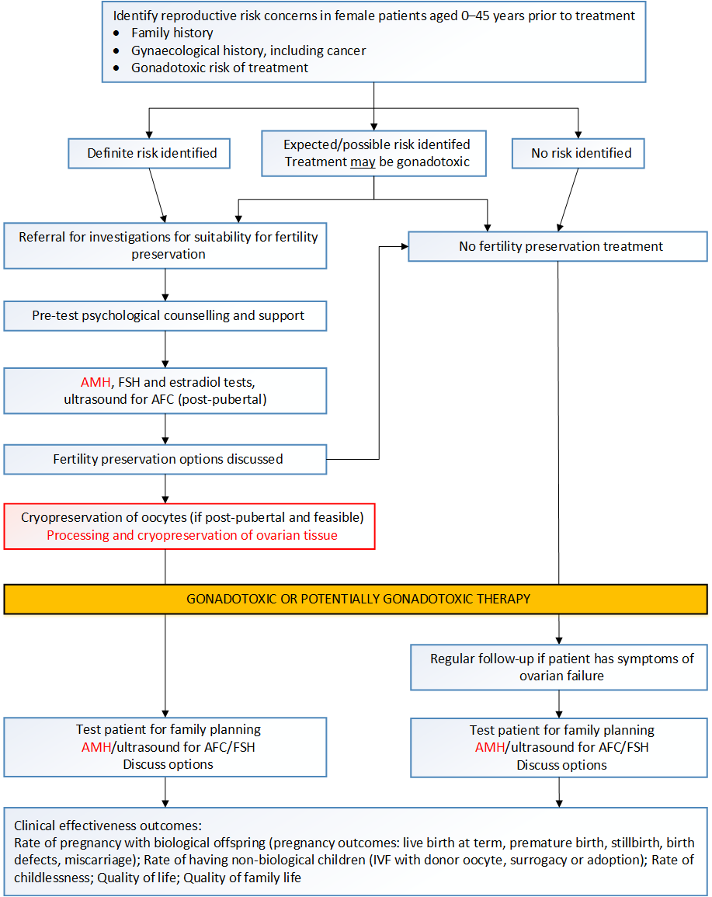
Figure 1 Current and proposed clinical management algorithm for the cryopreservation of ovarian tissue for female patients (aged 0-45 years) prior to receiving gonadotoxic treatment
AFC = antral follicle counts; AMH: Anti-Müllerian hormone; FSH: follicle stimulating hormone
Source: Algorithm 1 from the Final protocol for MSAC application 1435.
The proposed intervention is shown in red, current practice included the cryopreservation of oocytes. The proposed AMH test (MSAC application 1434) is also highlighted in red.
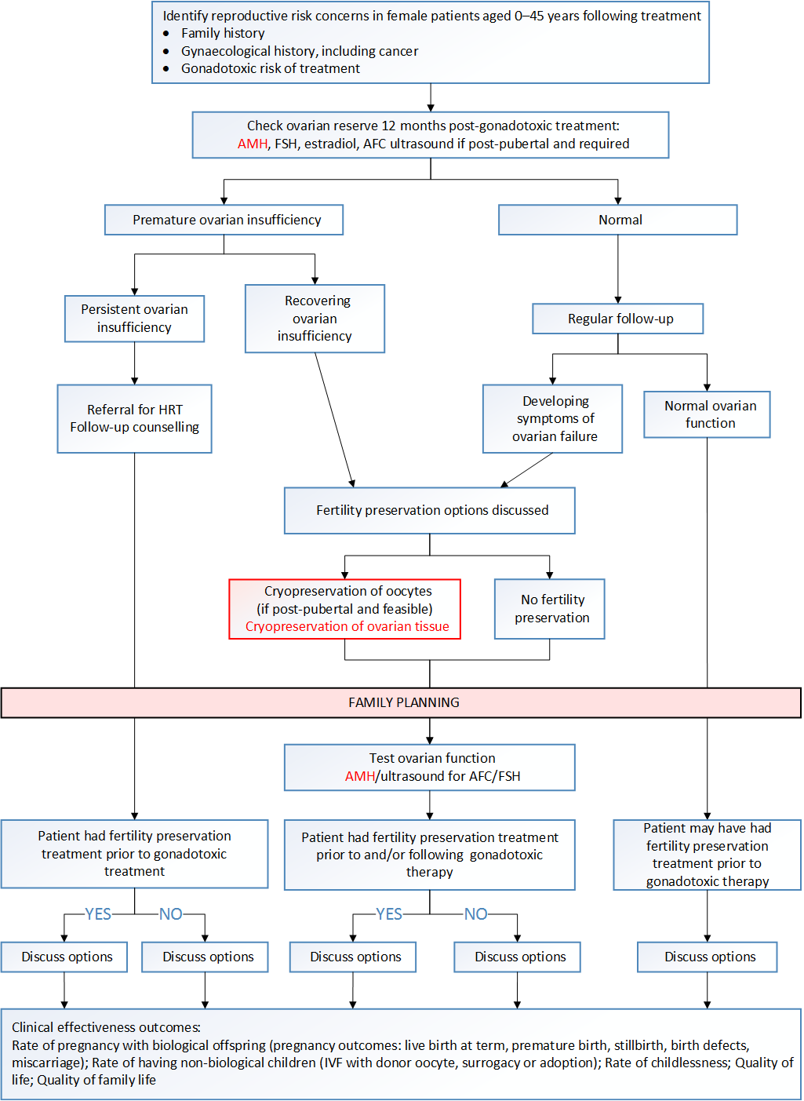
Figure 2 Current and proposed clinical management algorithm for cryopreservation of ovarian tissue for female patients (0–45 years) following completion of gonadotoxic treatment
AFC = antral follicle count; AMH: Anti-Müllerian hormone; FSH: follicle stimulating hormone
Source: Algorithm 4 from the Final protocol for MSAC application 1435.
The proposed intervention is shown in red, current practice included the cryopreservation of oocytes. The proposed AMH test (MSAC application 1434) is also highlighted in red.

Comparator
The Protocol for assessment 1435 listed the comparators for post-pubertal patients as oocyte cryopreservation (egg collection and storage), embryo cryopreservation (fertilisation of an egg with either a partner’s or donor sperm), or no fertility preservation treatment. Both oocyte and embryo cryopreservation would require use of in vitro fertilisation (IVF). No fertility preservation would be the key comparator for those unable to delay treatment or for whom ovarian stimulation is contraindicated. IVF with a surrogate, adoption and childlessness were also listed as comparators.
Fertility preservation options discussed in the Protocol but not listed as comparators include gonadal protection during chemotherapy (using gonadotropin releasing hormone analogues; GnRHa) which is not currently listed on the Pharmaceutical Benefits Scheme; and ovarian transposition (surgical movement of the ovaries), also known as ovarian suspension, oophoropexy, or ovariopexy, to preserve fertility in females receiving pelvic irradiation.
For pre-pubertal patients, the comparators listed in the protocol are no fertility preservation treatment, IVF with patient or donor gametes in adulthood, IVF with surrogate in adulthood, adoption in adulthood and childlessness.
In the pre-MSAC response the applicant noted that OTCP is not an alternative to oocyte cryopreservation as it is a completely different form of fertility preservation. Hundreds and even thousands of oocytes are located in the ovarian tissue in the primordial follicle stage which provides potentially a large resource for future fertility. Oocyte cryopreservation (OC) in contrast usually involves retrieval and storage of only a few oocytes on one attempt which are mature.

Comparative safety
There was no evidence identified that compared the safety of OTC with no fertility preservation or other listed comparators for pre-pubertal patients. OTC should still be considered experimental in this younger population due to the small number of procedures that have been performed. In one study assessing complications for OTC in pre-pubertal females, there was only 1 adverse event out of 169 procedures reported. The patient, who had comorbidities, experienced a serious bleeding event that lead to treatment delay. One technical failure resulting in an incomplete procedure was also reported. Because very few patients in this age group have undergone OTT, it is not possible to provide data on complications for that procedure.
Three studies provided comparative evidence in older patients (aged 18 to 40 years). When compared to oocyte cryopreservation, OTC had fewer reported complications (0.37% versus 3.9%), however despite being comparative, the evidence was of low level and some complications may have been more accurately called technical issues. In particular for oocyte retrieval, a significant proportion of reported complications were actually failure to collect oocytes.
The complication frequency for OTC was supported in 10 case series of patients aged between 2 and 40 years (results not stratified for age). Thirteen adverse events were reported for a total of 3097 OTC procedures giving a frequency of 0.42%.
The frequency of complications for OTT was assessed in one study of adolescent and adult patients. Out of 455 OTT procedures there were 4 adverse events reported (0.88%), one of which required conversion from laparoscopic to open laparotomy procedure.
Transfer of malignant cells is considered a serious risk for OTT, particularly for leukaemia and lymphoma patients, and other with haematological or systemic malignancies. No cases were reported of transferred malignancy leading to recurrence of disease.
While overall the literature points to OTC and OTT being relatively safe procedures, the evidence is weak and primarily found in case series. It should be noted that older patients wishing for children, and pre-pubertal patients requiring puberty induction, would need to go through both OTC and OTT and thereby increase their risk of adverse events. In comparison, patients undergoing oocyte cryopreservation would require only one invasive procedure requiring an anaesthetic for oocyte retrieval and one less invasive procedure for embryo transfer. However oocyte cryopreservation patients are at risk of hyperstimulation syndrome from taking hormonal stimulation therapy, whereas OTC/OTT patients are not.

Comparative effectiveness
The literature search identified no evidence comparing OTC with oocyte cryopreservation or embryo cryopreservation. As the aim of OTC for the purposes of this assessment was to restore fertility, OTT was considered an essential step for patients who are seeking to become pregnant, or in the case of pre-pubertal patients, who seek fertility for the future through induction of puberty. OTC is considered an experimental procedure in pre-pubertal girls, and as yet there is insufficient data available on patients who have achieved pregnancy or live birth following OTT. There is insufficient data to date to make any conclusion about the effectiveness of OTC and OTT for pregnancy, birth and induction of puberty for pre-pubertal patients.
One large systematic review of case series, published in 2017, provided data on pregnancies and births in OTT patients. OTC followed by OTT appears to be successful in some women for achieving pregnancy and live birth with their own biological offspring. However the evidence is not comparative, and therefore not high level evidence, and it remains a supposition (albeit plausible) that without the procedures many of these women would not have had children of their own. Uptake data indicates a preference for OTC over oocyte cryopreservation in many European countries, where there is a trend to focus on fertility preservation counselling in patients who are recommended for gonadotoxic treatment.
One non-randomised study of patients who underwent OTC compared pregnancy and birth outcomes between those who underwent OTT and those who didn’t. OTT versus no OTT was considered a surrogate comparison for this assessment. For post-pubertal patients in the study, those who were recommended for OTT and underwent the procedure were more successful in achieving pregnancy and live birth than those who didn’t have OTT. The result was similar for the pre-pubertal group but the numbers were too small to be able to draw conclusions in this group. However patient confounding and selection bias cannot be excluded.
For a summary of the clinical benefits and harms of OTC compared to no treatment in post-pubertal females and all patients, see Table 2, Table 3 and Table 4.
Table 2 Balance of clinical benefits and harms of OTC and OTT, relative to OTC and no OTTª, or OTC (no comparator) in pre-pubertal females
Outcomes | Participants (studies) | Quality of evidence (GRADE) | Relative effect (95%CI) | Risk with no OTC | Risk or risk difference with OTC | Comments
Live births | K = 2 cohort studiesª  N = 11 | ⨁⨀⨀⨀ | 889 more per 1000 patients  (156, 980) | 1/9 (11.1%) with POF had an ectopic pregnancy, which was aborted | 2/2 (100%) who used OTT for fertility purposes due to POF became mothers | There are too few data to consider OTC and OTT as established treatments
Induction of puberty | K = 1 cohort studyª  N = 24 | ⨁⨀⨀⨀ | 43 more per 1000 patients  (-751, 209) | 22/23 (95.7%) had successful puberty induction with HRT | 1/1 (100%) had successful puberty induction with OTT | -
Complications | K = 5 case series  N = 148 | ⨁⨀⨀⨀ | NA | NA | 2/169 (1.2%) | Patients were aged from 10 months to 20 years
CI = confidence interval; HRT = hormone replacement therapy; K = number of studies; N = number of patients; OTC = ovarian tissue cryopreservation; OTT = ovarian tissue transplantation; POF = premature ovarian failure
ª In the cohort study(s) all patients underwent OTC, so the comparison was between patients who had OTC and OTT versus patients who had only OTC. This comparison is being used as a proxy for OTC versus no OTC.
Table 3 Balance of clinical benefits and harms of OTC or OTT, relative to no OTC (or no comparator) for post-pubertal patients
Outcomes (units)  Follow-up | Participants (studies) | Quality of evidence (GRADE) | Relative effect (95%CI) | Risk with no OTC | Risk or risk difference with OTC | Comments
Live births | K = 1 cohort studyª  N = 30 | ⨁⨀⨀⨀ | 357 more per 1000 patients  (293, 728) | 1/23 (4.3%) women with live births | 2/5 (40%) women with live births | All women had OTC but only 7 out of 30 had OTT (2 were not evaluable)
Pregnancies | K = 1 cohort studyª  N = 30 | ⨁⨀⨀⨀ | 357 more per 1000 patients  (293, 728) | 1/23 (4.3%) pregnancy with donated oocyte | 4 pregnancies in 2 women (40%) with own oocytes | All women had OTC but only 7 out of 30 had OTT (2 were not evaluable)
Live birth rate | K = 1 (SR of case series)  N = 9 | ⨁⨀⨀⨀ | NA | NA | 2/9 (22%) | Data from case series of patients who had OTT (no control group)
Pregnancy rate | K = 1 (SR of case series)  N = 9 | ⨁⨀⨀⨀ | NA | NA | 4/9 (44%) | Data from case series of patients who had OTT (no control group)
Complications  (OTC) | K = 1^{b}  N = 1989 | ⨁⨀⨀⨀ | NA | NA | 15/1898 (0.79%) | Patients were aged between 14 and 39 years.
Complications  (OTT) | K = 1^{b}  N = 455 | ⨁⨀⨀⨀ | NA | NA | 4/455 (0.88%) for OTT procedures | Patients were aged between 14 and 39 years.
CI = confidence interval; K = number of studies; N = number of patients; NA = not applicable; OTC = ovarian tissue cryopreservation; OTT = ovarian tissue transplantation ª In the cohort study (s) all patients underwent OTC, so the comparison was between patients who had OTC and OTT versus patients who had only OTC. This comparison is being used as a proxy for OTC versus no OTC. ^{b} Data from a review of OTC and OTT complications in the literature (Beckmann, Dittrich, Lotz, Oppelt, Findeklee, Hildebrandt, et al. 2017)
Table 4 Balance of clinical benefits and harms of OTC, relative to oocyte cryopreservation (or no comparator), for all patients
Outcomes (units)  Follow-up | Participants (studies) | Quality of evidence (GRADE) | Relative effect (95%CI) | Risk with no OTC | Risk or risk difference with OTC | Comments
Live birth rate | K = 4 (1 SR & 3 case series)  N = 302 | ⨁⨀⨀⨀ | NA | NA | 81/302 (26.8%) | Data from case series of patients who had OTT (no control group)
Pregnancy rate | K = 4 (1 SR & 3 case series)  N = 242 | ⨁⨀⨀⨀ | NA | NA | 109/242 (45.0%) | Data from case series of patients who had OTT (no control group)
Complications | K = 3 (cohort studies)  N = 822 | ⨁⨀⨀⨀ | 35 fewer per 1000 patients  (16, 65) | 11/280 (3.9%) s for oocyte cryopreservation | 2/542 (0.37%) | -
Complications | K = 10 (case series)  N = 3097 | ⨁⨀⨀⨀ | NA | NA | 13/3097 (0.42%) | -
Serious complications | K = 10 (case series)  N = 3097 | ⨁⨀⨀⨀ | NA | NA | 4/3097 (0.13%) | -
CI = confidence interval; K = number of studies; N = number of patients; OTC = ovarian tissue cryopreservation; OTT = ovarian tissue transplantation
GRADE Working Group grades of evidence (Guyatt et al., 2013)
⨁⨁⨁⨁ High quality: We are very confident that the true effect lies close to that of the estimate of effect.
⨁⨁⨁⨀ Moderate quality: We are moderately confident in the effect estimate: The true effect is likely to be close to the estimate of the effect, but there is a possibility that it is substantially different.
⨁⨁⨀⨀ Low quality: Our confidence in the effect estimate is limited: The true effect may be substantially different from the estimate of the effect.
⨁⨀⨀⨀ Very low quality: We have very little confidence in the effect estimate: The true effect is likely to be substantially different from the estimate of effect.

Clinical Claim
No clinical claim was explicit in the Protocol developed by the applicants. However, it may be interpreted that the clinical claim is that greater access to OTC would result in superior rates of live births, increased quality of life, and improved relationships and family life. The applicants stated that “the availability of Medicare item numbers will allow equitable access for all Australians of reproductive age, who are diagnosed with a condition requiring gonadotoxic treatment. Appropriate item numbers will ensure that patients have access to consistent oncofertility referral pathways, consultation with a reproductive specialist and the opportunity to undertake fertility preservation, as well as receiving oncofertility follow-up in the survivorship period.” (Final Protocol MSAC 1435, January 2016).

Economic evaluation
The clinical evidence does not identify the direction of effect of the intervention, much less enable a quantitative estimate of relative effectiveness; hence no evidence-based cost-effectiveness or cost-consequence analyses can be performed. Therefore, cost analyses are presented for the proposed intervention and each of the comparators.
A summary of the key characteristics of the economic evaluation is given in Table 5.
Table 5 Summary of the partial economic evaluation (costs only)
Population | Post-pubertal females | Pre-pubertal females
Perspective | Australian healthcare | Australian healthcare
Comparator(s) | No fertility preservation, oocyte cryopreservation and embryo cryopreservation | No fertility preservation
Type of economic evaluation | Cost-analysis (partial economic analysis only) | Cost-analysis (partial economic analysis only)
Sources of evidence | Systematic review | Systematic review
Time horizon | 6 years | 22 years
Outcomes | Cost per possible clinical pathway | Cost per possible clinical pathway
Cycle length | One year | One year
Discount rate | 5% p.a. (from year 2 onwards) | 5% p.a. (from year 2 onwards)
Methods used to generate results | Modelled costing of decision tree pathways (not able to be weighted or rolled back) | Modelled costing of decision tree pathways (not able to be weighted or rolled back)
Software used | Microsoft Excel 2013® | Microsoft Excel 2013®
The total procedure and downstream costs associated with ovarian tissue cryopreservation and relevant comparators, for post-pubertal and pre-pubertal females, are presented in Table 6 and Table 7, respectively. Downstream costs (e.g. ART and obstetric costs) are based on current pricing but appear lower in the analysis of the pre-pubertal population because they occur further into the future (and consequently are substantially discounted).
Table 6 Average cost or cost range, and overall range of average costs associated with ovarian tissue cryopreservation vs each comparator, in post-pubertal females (over a 6 year time horizon, discounted)
Cost components | Ovarian Tissue cryopreservation | Oocyte cryopreservation | Embryo cryopreservation | No fertility preservation
Cryopreservation | $5,176 | $18,160 | $18,610 | $0
Storage | $2,150 | $2,150 | $2,150 | $0
Conception | from 0$ (if no or natural conception)  to $22,091 (if OTT and full cycle ART) | from $0 (if no or natural conception)  to $6,385 (if ART implantation) | from $0 (no or natural conception)  to $5,833 (if ART implantation) | $0 (if no or natural conception)  to $16,864 (if full cycle ART)
Obstetrics and Delivery | $0 (no pregnancy) – $7,749 (live birth)* | $0 (no pregnancy) – $8,127 (live birth) | $0 (no pregnancy) – $8,127 (live birth) | $0 (no pregnancy) – $8,127 (live birth)
Total Cost range | $7,326 – $37,149 | $20,311 – $34,823 | $20,760 – $34,720 | $0 – $24,979
OTC = ovarian tissue cryopreservation; NA = (pregnancy) not attempted; ART = assisted reproductive technology; NC = natural conception; OTT = ovarian tissue transplant
*All costs (except CP, which happens in year 1) are discounted. Live birth in OTC costs less than for comparators as it is delayed for one year due to expected delay in pregnancy after tissue transplant, therefore costs are further discounted.
Table 7 Average cost or cost range, and overall range of average costs associated with ovarian tissue cryopreservation vs no fertility preservation, in pre-pubertal females (over a 22 year time horizon, discounted)
Cost components | Ovarian Tissue cryopreservation | No fertility preservation
Cryopreservation | $5,176 | $0
Storage | $8,399 | $0
Conception | from 0$ (if no or natural conception)  to $9,926 (if OTT and full cycle ART) | $0 (if no or natural conception)  to $7,577 (if full cycle ART)
Obstetrics and Delivery | $0 (no pregnancy) – $3,482 (live birth)* | $0 (no pregnancy) – $3,652 (live birth)
Total Cost range | $13,575 – $26,975 | $0 – $11,229
OTC = ovarian tissue cryopreservation; NA = (pregnancy) not attempted; ART = assisted reproductive technology; NC = natural conception; OTT = ovarian tissue transplant
*All costs (except CP, which happens in year 1) are discounted. Live birth in OTC costs less than for comparators as it is delayed for one year due to expected delay in pregnancy after tissue transplant, therefore costs are further discounted.
A more detailed summary of total average costs associated with specific clinical outcomes associated with OTC and each comparator, for each population, is shown in Table 8 and Table 9.
Table 8 Average cost or cost range for various clinical outcomes associated with ovarian tissue cryopreservation vs each comparator, in post-pubertal females (over a 6 year time horizon, discounted)
Pregnancy Outcomes | OTC | Oocyte cryopreservation | Embryo cryopreservation | No fertility preservation
No pregnancy | from $7,326 (NA)  to $29,418 (failed ART) | from $20,311 (NA)  to $26,695 (failed ART) | from $20,760 (NA)  to $26,593 (failed ART) | from $0 (NA)  to $16,864 (failed ART)
Miscarriage or stillbirth | from $9,101 (miscarriage after NC)  to $37,134 (still-birth after OTT/ART) | from $22,086 (miscarriage after NC)  to $34,807 (stillbirth after ART) | from $22,535 (miscarriage after NC)  to $34,705 (stillbirth after ART) | from $1,762 (miscarriage after NC)  to $24,963 (stillbirth after ART)
Live birth | from $15,075 (NC),  or $20,728 (OTT then NC)  to $37,149 (OTT then ART) | from $28,060 (NC)  to $34,823 (ART) | from $28,509 (NC)  to $34,720 (ART) | from $7,736 (NC)  to $24,979 (ART)
OTC = ovarian tissue cryopreservation; NA = (pregnancy) not attempted; ART = assisted reproductive technology; NC = natural conception; OTT = ovarian tissue transplant
*All costs (except CP, which happens in year 1) are discounted. Live birth in OTC costs less than for comparators as it is delayed for one year due to expected delay in pregnancy after tissue transplant, therefore costs are further discounted.
Table 9 Average cost or cost range for various clinical outcomes associated with ovarian tissue cryopreservation vs no fertility preservation, in pre-pubertal females (over a 22 year time horizon, discounted)
Pregnancy Outcomes | OTC | No fertility preservation
No pregnancy | from $13,5756 (NA)  to $23,501 (failed ART) | from $0 (NA)  to $7,577 (failed ART)
Miscarriage or stillbirth | from $14,372 (miscarriage after NC)  to $26,968 (still-birth after OTT/ART) | from $798 (miscarriage after NC)  to $11,222 (stillbirth after ART)
Live birth | from $17,057 (NC),  or $19,597 (OTT then NC)  to $26,975 (OTT then ART) | from $3,482 (NC)  to $11,229 (ART)
OTC = ovarian tissue cryopreservation; NA = (pregnancy) not attempted; ART = assisted reproductive technology; NC = natural conception; OTT = ovarian tissue transplant
*All costs (except CP, which happens in year 1) are discounted. Live birth in OTC costs less than for comparators as it is delayed for one year due to expected delay in pregnancy after tissue transplant, therefore costs are further discounted.

Financial/budgetary impacts
A market approach has been used to estimate the financial implications of the introduction of ovarian tissue cryopreservation. It is estimated the listing of OTC, and the associated increase in co-administered services, will cost around $670,000 to the MBS in the fifth year. The financial implications to the MBS resulting from the proposed listing of OTC are summarised in Table 10.
Table 10 Total costs to the MBS associated with ovarian tissue cryopreservation
- | 2018–19 | 2019–20 | 2020–21 | 2021–22 |  | 2022–23
OTC | - | - | - | - |  | -
Number of services | 559 | 637 | 726 | 828 |  | 944
Sub-total cost | $333,082 | $379,714 | $432,874 | $493,476 |  | $562,563
Co-administered services currently MBS listed - MBS items 35638ª, 20706^{b} and 51303^{c} |  |  |  |  | - | - | - | - | -
Number of services | 78 | 89 | 102 | 116 |  | 132
Sub-total cost | $58,248 | $66,402 | $75,698 | $86,296 |  | $98,378
Total cost | $391,330 | $446,116 | $508,572 | $579,772 |  | $660,940
OTC = ovarian tissue cryopreservation; MBS = Medicare Benefits Schedule
ª laparoscopy; ^{b} anaesthesia; ^{c} surgical assistance
Fertility preservation using OTC is a two phase process where ovarian tissue cryopreserved in the first step is transplanted back in the second phase. OTT requires thawing of ovarian tissue (not MBS listed currently and may incur cost similar to embryo/oocyte thawing; MBS item 13218 – $793.55), laparoscopy (MBS item 35638), anaesthesia (MBS item 20706) and surgical assistance (MBS item 51303). Therefore, increase in number of patients undergoing OTC would be expected to result in some increase in OTTs and associated services, however these are downstream costs which may happen years (or even decades) after the OTC services are performed and therefore these are not able to be predicted or included in the financial analysis.

Key issues from ESC for MSAC
This application relates to the processing, analysis and cryopreservation (freezing) of ovarian tissue to preserve fertility in females undergoing potentially gonadotoxic treatment. ESC noted that fertility preservation is a two phase process in which ovarian tissue is firstly removed and frozen (ovarian tissue cryopreservation [OTC]) and then reimplanted back into the body (ovarian tissue transplant [OTT]) at a later date. ESC noted that the timing of OTT is uncertain as it is dependent upon when a patient is ready to conceive or it may never occur if the woman’s ovarian function recovers, she explores other options for children (adoption, surrogacy or oocyte donation) or if she decides against having children.
ESC noted that, unlike oocyte collection, OTC can be done immediately without the need to wait for an ovulation cycle and so it will not delay treatment if urgent gonadotoxic therapy (usually chemotherapy) is recommended. ESC considered that this may be an advantage in women scheduled for gonadotoxic therapy but were unable to see the benefits of OTC with OTT in women who had already undergone gonadotoxic treatment when urgency is no longer an issue.
ESC noted that while OTC with OTT has other purposes, including inducing puberty or preventing premature ovarian failure, these populations are outside the scope of this application.
ESC noted that while the PASC-ratified PICO Confirmation requested information be presented in three age groups (0–14 years, 15–25 years and 26–40 years), the lack of evidence meant results were separated into pre-pubertal and post-pubertal females instead. ESC considered that this was appropriate, noting that in some of the studies used to support use in pre-pubertal females, girls and adolescents up to the age of 20 years were included.
ESC considered the use of OTC with OTT to be experimental in pre-pubertal females. ESC noted that unlike post-pubertal women who can freeze mature oocytes, OTC with OTT is the only option for fertility preservation in pre-pubertal females as their oocytes are not mature enough for collection. Despite this, ESC noted that evidence for OTC with OTT in pre-pubertal girls was very limited with only two live births reported among 60 females with primary ovarian failure who underwent the procedure as girls.
ESC noted that there were many different comparators to OTC with OTT in post-pubertal women including oocyte cryopreservation in conjunction with in vitro fertilisation (IVF), embryo cryopreservation in conjunction with IVF, no fertility preservation, adoption and childlessness. ESC considered that all of these options were relevant at different times and indicated that some women who seek to have a child may use multiple options, either through choice, or as various options fail to result in a live birth.
ESC noted that the evidence base to support the use of OTC with OTT was low level, relying upon retrospective observational studies and case series. Most of the included studies were classified as being at moderate to high risk of bias.
ESC considered OTC to have similar safety to oocyte cryopreservation. ESC noted there were fewer complications reported for OTC than oocyte collection (0.37% vs 3.9%), noting that this relied on three retrospective observational studies and many of the complications reported for oocyte cryopreservation were technical issues. ESC noted the applicant’s statement that among the 250 cases in the Australasian Oncofertility Registry, some of whom underwent OTC, no complications had been recorded.
ESC noted that in the one study which reported rates of complications with OTT separately from those of OTC, the complication rate was 0.88%. ESC considered that reintroduction of malignant tissue during OTT would be rare.
ESC considered that it was not possible to determine the relative effectiveness of OTC with OTT against the comparators in post-pubertal women.
ESC considered that the evidence to support the effectiveness of OTC with OTT in post-pubertal women was very weak. ESC noted that there were no studies directly comparing OTC with OTT to oocyte cryopreservation or to embryo cryopreservation, although they considered that this may be because OTC with OTT is seen as the last resort for most patients. ESC noted there was observational evidence that OTC with OTT resulted in pregnancies and live births, but considered this evidence may be confounded given there were also reports of live births among women who underwent OTC only and who subsequently recovered ovarian function.
ESC noted that there was limited, low-level evidence from a single observational study (n = 20; Meirow D et al 2016) that pregnancy outcomes may be better if OTC occurs prior, rather than after, gonadotoxic treatment. However, ESC noted that this may have been confounded if the women who had chemotherapy prior to OTC were thought to have been less likely to have viable ovarian tissue.
ESC noted that case series evidence found that only 3.6% of women who underwent OTC later went on to have OTT. In studies which reported why women did not undergo OTT, the commonly reported reasons were that OTT was no longer an option, that they had removed their tissue from storage and that their family was already complete.
ESC noted that due to the lack of evidence, the economic evaluation was restricted to a cost analysis. ESC noted that despite this, a ‘proposed model structure’ had been included in the application. ESC flagged that if this model is used in a future economic evaluation it should be used to model two populations separately:
(i) women who do not require urgent treatment and who therefore may be able to consider options such as oocyte cryopreservation and (ii) women who require urgent treatment and hence have more limited options for fertility preservation. ESC also flagged that women often choose a number of options to preserve fertility and the model should reflect this. Finally, ESC flagged that the model was currently open to all women but should exclude (i) women who would not be suitable for OTC with OTT, and (ii) women at low risk of post-treatment ovarian insufficiency who do not require fertility preservation.
ESC noted that even if this service was included on the MBS, the out-of-pocket costs for the service are likely to be substantial. In the estimate of costs, the MBS contribution was ~$800 while the patient costs were ~$5700.
ESC noted that the application had estimated that in year 5, around 950 patients would use the service at an MBS cost of around $670,000. ESC noted that the financial impacts of the service were based upon market share data, rather than epidemiological data.
ESC queried why an epidemiological approach was not considered in this application given it had been provided in the separate, but related, MSAC Application 1434 (Anti-Müllerian hormone testing). ESC noted that if the same patient numbers in MSAC Application 1434 were used for this application, patient numbers and the associated costs could more than double.
ESC considered that while the number of services was based upon MBS item 35638 (complicated operative laparoscopy); this may underestimate patient numbers if there are other MBS items that can be used for ovarian tissue collection. ESC also considered that Australian information on the number of women undergoing gonadotoxic treatment would be helpful.
ESC reaffirmed that, consistent with MSAC Application 1435a (Processing and cryopreservation of male gonadal tissue and gametes - semen, sperm and testicular tissue), storage costs cannot be covered by the MBS. ESC noted that as storage costs will be borne by the patient, this may impose a substantial financial burden.
ESC noted that should this service be recommended, MBS item 13218 for the preparation of frozen or donated embryos or oocytes could be amended to cover the thawing of frozen ovarian tissue.
ESC noted that there are ethical issues similar to those seen in MSAC Application 1435a and associated with other assisted reproductive technologies including:
- the existence of equity issues to fertility preservation due to cost;
- disposal of stored tissue;
- the need for adequate counselling;
- use of tissue after menopause or death of a donor;
- the need for patients to be offered fertility preservation prior to treatment; and
- consent, confidentiality and other ethical and legal issues if the service is offered to pre-pubertal females.
ESC noted that there may be additional equity issues if this service is subsidised for women undergoing gonadotoxic therapies, but not for women with diminished ovarian function for other reasons (e.g. sex chromosome abnormalities).
ESC Key ISSUES | ESC ADVICE
Evidence base | Limited evidence without any good comparator, more evidence required  Experimental in pre-pubertal children
MBS item | Reaffirm storage not covered and consistent with 1435A – Cryopreservation of semen (Dec 2017)  Consider new item number for thawing of frozen tissue (similar to embryo/oocyte thawing MBS item 13218 - $793.55)
Equity | Inequity of OTC for non-cancer patients
Economic evaluation | Uncertain benefit – number needed to treat may be very high for one additional birth  Model not representative of how this would be applied in practice  Adds only a small incremental benefit to the total out of pocket cost – equity issues  Unsure how ovarian function testing relates to choice of fertility preservation – not modelled

Other significant factors
Nil

Applicant’s comments on MSAC’s Public Summary Document
We are very unhappy about the lack of support for this application and feel that based on the comments; we should have an opportunity to provide further evidence answering these comments in a positive manner:
1) PROTOCOL FOR EXCLUDING MALIGNANCY IN CRYOPRESERVED TISSUE
• Protocols are already available for the handling and management of ovarian tissue on collection to ensure that they are not contaminated by tumour cells, the technique varies by tumour type and this includes histology, immunohistochemistry, immunophenotyping, PCR for molecular markers (BCR-ABL) or the creation of xenografting model.
• Ovarian tissue is not reimplanted without an assessment of ovarian contamination being undertaken and with the improvement of minimal disease testing over time the protocol for handing of tissue at re plantation reviews the initial testing especially if this was done a long time before re-implantation.
• Tissue can still be collected from patients who have malignant deposits in the abdomen/pelvis if they are well enough to have an anaesthetic and surgical procedure because newer techniques for lnvitro-maturation allowing for follicles to be removed from the ovarian tissue and this year groups have successful been able to remove immature follicles from pre-pubertal girls and mature them in the laboratory so they can be used for IVF. These options means that patients with malignant contamination will still be able to use this technique.
• In Australia, we have not grafted and are not intending to graft ovarian tissue which has any evidence of contamination and world wide of the 131 published births have not shown a higher relapse rate in the patients who have ovarian tissue re-implanted and no reported cases of recurrence associated with graft although theoretical risk exists hence the protocols for testing and re-implantation.
2) CLINICAL BENEFIT
A number of the clinical benefits have not been considered by the modelling study. This data will increase as the cohort who has had ovarian cryopreservation get to the age that they are considering family planning.
• Resumption of menstrual cyclicity in 95% of patients
• Fertility, pregnancy and livebirth - clinical pregnancy rate per embryo 26%, pregnancies in 29% of patients grafted, miscarriage rate 11%
• Hormone replacement
• Induction of puberty
• Improvements in quality of life of patients having had fertility preservation and who have opportunities for ART
3) UTILISATION
• Relatively recent technology indicating success and requirement of awaiting disease cure mean that there is lag between OTC and OTT (average 5 years in our series)
• 84 OTC in our unit in 5 years 2013-2017, estimate about 30-35 per year nationally
• National data hard to obtain hence our development of the national Australasian Oncofertility Registry
• Expected that 20-30% of patients may ultimately wish to use their tissue
4) INCREMENTAL COST PER LIVE BIRTH
• 50% worldwide births from spontaneous fertility attributed to graft
• IVF cycle numbers to achieve pregnancies are not materially higher than standard IVF
• Reduction of risks of premature menopause including fracture risk, HRT usage, impaired Q of L requiring additional supports
• Alternatives including donor eggs and surrogacy extremely costly and result in significant fertility related distress.
5) PREPUBERTAL OTC
• International experience will take some time to accrue due to the younger age of patients but we are already seeing published cases of successful re-implantation in childhood cancer survivors (now in adulthood)
• No evidence of endocrine dysfunction to suggest any additional concerns
• No evidence of increased complications
• Paediatric centres doing this currently have ethical frameworks (published work) and thorough assessment of risks and benefits. Australasian Oncofertility Registry has no complications in any paediatric patients having this procedure since 2013.
• Only option

Further information on MSAC
MSAC Terms of Reference and other information are available on the MSAC Website:
visit the MSAC website

