Public Summary Document
Application No. 1411.1 – Genetic testing for hereditary mutations predisposing to breast and/or ovarian cancer
Applicant: Royal College of Pathologist of Australasia (RCPA)
Date of MSAC consideration: MSAC 66th Meeting, 30-31 March and 2016
Context for decision: MSAC makes its advice in accordance with its Terms of Reference, see the MSAC Website

Purpose of application and links to other applications
The application was a pilot fit-for-purpose assessment of diagnostic genetic testing for heritable mutations predisposing to breast or ovarian cancer in clinically affected individuals to estimate their relative risk of a new primary cancer, and of predictive genetic testing (or “cascade testing”) of the family members of those affected individuals who are shown to have such a mutation.

MSAC’s advice to the Minister
After considering the strength of the available evidence in relation to the safety, clinical effectiveness and cost-effectiveness, MSAC supported MBS listing of testing of the defined set of breast cancer/ovarian cancer group of genes in affected individuals and for the specific gene mutation identified in their family members.
MSAC advised that further consideration be given to how to take account of marginal costs for subsequent applications for additional tests – given the availability of panel tests.
MSAC endorsed the CUC proforma as useful for future applications to MSAC for genetic tests of affected individuals where an inherited mutation is a likely cause and where knowing the test result is associated with clinical utility for the individual, and also for the family members of those individuals shown to have a relevant mutation.

Summary of consideration and rationale for MSAC’s advice
MSAC noted that it had considered the proposed public funding of genetic testing for hereditary mutations predisposing to breast and/or ovarian cancer in November 2015. Although MSAC had accepted the evidence presented to support the analytical validity, clinical validity and clinical utility of the proposed genetic testing, the application was deferred due to uncertainty regarding the adequacy of the economic analysis for decision-making. In deferring the application, MSAC recommended the establishment of a working group to guide a new economic evaluation.
In the context of its current consideration, MSAC reiterated that this application was also a pilot application to develop a process of applying for public funding for testing groups of genes rather than testing individual genes. MSAC agreed that the Clinical Utility Card (CUC) proforma, modified to reflect sections 6 and 7 (economic evaluation and financial analyses) of the revised application, would be used to guide the approach for future applications for other heritable medical conditions.
MSAC noted that the proposed populations in the resubmission were the same as in the original application, with testing of individuals affected by breast and/or ovarian cancer for genes known to predispose to these conditions and also cascade testing of family members of the subset of individuals who are shown to have a hereditary mutation. MSAC reaffirmed that the current CUC and economic evaluation was focused on genetic testing to identify the “star performer” of BRCA mutations. MSAC clarified that, as defined in the CUC, affected individuals are those “with breast and/or ovarian cancer whose personal or family history of cancer using a mutation prediction score predicts a combined mutation carrier probability of >10%”.
MSAC noted that, at the November 2015 meeting, the committee considered the results of the cost-utility analyses and noted they were high, with an incremental cost-effectiveness ratio (ICER) per quality-adjusted life-year (QALY) gained of $151,837 and $85,598 for affected individuals and family members, respectively. MSAC was concerned that these ICER/QALY estimates may not accurately estimate the cost-utility of publicly funding this testing, noting that they did not match other estimates reported in the literature. MSAC also noted a number of additional concerns with the economic evaluation as highlighted by ESC at the time, including:
- the need for a weighted average approach to modelling to also include the entire eligible population, ie. affected individuals and their family members;
- the model was potentially oversimplified and excluded key benefits including the risk and impact of ovarian cancer;
- the ICERs derived from the model were highly uncertain and likely to be overestimated; and
- the sensitivity analyses indicated the potential for the ICERs to become cost-effective when modelling was based on age-related relative risks, rather than a fixed relative risk across all ages.
In the context of its current consideration, MSAC noted that the Predisposition Genetic Testing Economics Working Group (PGTEWG) was formulated to guide a new economic evaluation addressing these identified limitations with assistance from Griffith University. In determining the appropriateness of utilising an integrated economic model for the resubmission, MSAC noted that PGTEWG considered the concept of ‘joint production’. The working group proposed that performing genetic tests in affected individuals not only impacts their own utility or disutility values, but also those of their family members. In this regard, the cost of testing the affected individuals is incurred for the production of utility and/or disutility values relevant to both the affected individuals and their family members. The working group extended its rationale to note that, if utilities are joint-produced by genetic tests, the cost-utility analysis must also be reframed to include the associated outcomes (whether or not testing of family members is eventually supported in addition to testing affected individuals or not). In turn, MSAC accepted that there was a strong conceptual case to support the use of an integrated model which included the costs and effects of initially testing affected individuals and then also testing their family members according to the results of the tests for the affected individuals.
MSAC acknowledged the use of an integrated model provided in the revised analysis, in addition to several key improvements made to address the concerns raised in relation to the previous analysis. MSAC noted that the revised model accounts for the consequences of BRCA testing for both breast and ovarian cancer prevention and treatment, unlike the previous model which focussed on the consequences for breast cancer only. MSAC also noted that, rather than using the cancer risk associated with BRCA1 only, the revised model considered the lower risk with BRCA2 mutation and applied a weighted average risk based on 54% and 46% prevalence for BRCA1 and BRCA2, respectively as adopted from Collins et al, 2013.
In addition, MSAC noted that the revised analysis applied age-specific (rather than fixed) risks of ovarian and breast cancer, better reflecting the fact that BRCA mutation is likely to increase the risk of these cancers at an earlier age compared to the general population. The age-specific incidence of breast and ovarian cancers were adopted from the findings of Antoniou et al, 2003. MSAC noted that, although there was concern about these estimates not being representative of the Australian population, the cumulative incidence was confirmed in a meta-analysis by Chen and Parmigiani, 2007. In addition to the preventative measure uptake rates proposed by the working group (40% mastectomy with bilateral salpingo-oophorectomy (BSO), 40% BSO alone and 20% surveillance alone), MSAC noted that the revised model also tested the possibility of different uptake rates as reported in the Australian study by Collins et al, 2013 (28% mastectomy alone, 52% BSO alone, 16% mastectomy plus BSO).
MSAC noted that the revised model applied a starting age of 40 years for affected individuals and their female siblings, however female children of the proband were not assumed to undergo testing until 20 years of age or to undertake a preventative measure until 30 years, in line with what would be expected in clinical practice. MSAC also noted that the model assumes the affected individuals and their female siblings would act as defined within one year of learning the test results by undertaking one of the noted preventative measures (or not).
MSAC noted that the impact of genetic testing compared to no testing for affected individuals and their first-degree family members (female siblings and female children of identified probands) was considered as the base case analysis, with their second-degree family members (female children of positively tested male and female siblings of identified probands) considered in a scenario analysis. MSAC noted that the base case ICER generated was less than the ICERs calculated in the previous analysis, with a cost of $18,283 per QALY gained. MSAC noted that this reduction in ICER was primarily driven by the inclusion of ovarian cancer outcomes in the revised model. MSAC also considered that the scenario analyses, incorporating different assumptions about the extent to which family members are tested, did not have a large effect on the ICERs: for affected individuals only ($21,303/QALY), for affected individuals plus identified probands’ female siblings only ($18,241/QALY), for affected individuals plus identified probands’ female children only ($20,987/QALY), and for affected individuals plus identified probands’ first and second-degree family members ($18,752/QALY).
MSAC considered that a better way of interpreting these results was to start with the ICER for affected individuals, and then calculate the further ICER for adding the testing of family members. This was preferred to the above presentation of results which were better interpreted as average cost-effectiveness ratios across the different population definitions. In this case, MSAC noted that the correctly calculated ICERs would show the addition of testing family members would have a more favourable ICER than testing affected individuals only, but this would not necessarily be the case in all diseases where genetic testing might be contemplated.
MSAC noted that the outcomes of the economic analysis not only related to cost per QALY, but also cost per cancer prevented. In the base case, genetic testing reduced breast and ovarian cancer events, with $53,202 per breast cancer event avoided and $79,477 per ovarian cancer avoided, ie. approximately $32,000 per cancer (breast or ovarian) event avoided.
MSAC noted that the presented sensitivity analyses indicated that the ICER generated for the base case was not particularly sensitive to the use of age-specific, as opposed to fixed risk, with the latter leading to a slightly higher ICER of $19,046 per QALY gained. The ICER was more sensitive to the application of the different rates of preventive strategy adoption by probands as noted by Collins et al, 2013. MSAC noted that applying these rates decreased the QALY increment observed in the base case from 0.19 to 0.15, the likely result of the reduced BSO adoption rates (16% in Collins et al, 2013 compared to 40% as proposed by working group), leading to less effective prevention of ovarian cancer and a consequent increase in cost to $22,348 per QALY gained. MSAC also noted that variation in the ICER was observed when the probability of BRCA mutation in affected individuals was decreased to 10%, leading to a higher ICER of $22,828 per QALY. MSAC noted that this illustrated that the lower the chances of identifying a mutation, the less likely it is that testing will be cost-effective and consequently BRCA screening in an unselected population, for example, would not be appropriate.
MSAC also explored the impact of limiting the revised model to genetic testing for the identification of BRCA1 mutations alone and BRCA2 mutations alone on the ICERs generated. MSAC noted that in the base case, limiting the model to BRCA1 testing generated a QALY gain of 0.19 and an ICER of $15,866 per QALY. When the model was limited to BRCA2 testing, this led to a reduced QALY increment of 0.13 and a less favourable ICER of $31,562 per QALY. In turn, MSAC noted that the addition of BRCA2 testing in the primary analysis made the ICER less favourable, while BRCA1 testing, given its association with the detection of early disease and consequent improvements in life expectancy, represented the main driver behind the ICER presented for the base case.
MSAC again cautioned that, although not observed in the current economic analysis, the use of an average cost-effectiveness ratio across genes with different predisposition consequences for the identified disease grouping could also conceal wide variations in cost-effectiveness. MSAC emphasised that future applications would need to pay particular attention to the definition and calculation of relevant ICERs in order to avoid bundling cost effective and non-cost effective options into one package which presents with an attractive overall ICER.
MSAC noted that the revised ICER estimates provided in the resubmission more accurately represent the cost-utility of publicly funding the proposed genetic testing as they are in line with others reported in the literature, which range between approximately $8,600 (Holland et al, 2009) and $49,000 per QALY (Kaldate et al, 2014).
Overall, MSAC concluded that the new economic model demonstrated that the proposed genetic testing arrangement is cost effective for affected individuals alone, and also when extended to include cascade testing of first and second-degree family members.
MSAC noted that residual concerns related to the financial and budgetary impact projections in the revised analysis. MSAC noted that the total expected costs to Government were anticipated to increase from approximately $5.0 million in 2016 ($2.2 million for testing and genetic counselling, $2.8 million for elective surgeries) to $7.0 million in 2020 ($3.1 million for testing and genetic counselling, $3.9 million for elective surgeries). However, MSAC emphasised that these financial projections were likely to depend on a number of implementation issues including the available capacity to conduct genetic testing and counselling, in addition to how requests for the proposed testing arrangements would be regulated. MSAC postulated that if the proposed testing was poorly regulated, this could lead to greater service demand with consequent price inflation and increased out-of-pocket costs.
MSAC noted that genetic counselling resources are limited and expressed concern that increasing workload through the MBS, as a result of the proposed testing, would generate further demand. MSAC reiterated that affected individuals could have their testing ordered by their treating specialist, rather than a geneticist, noting that the consequences of a mutation being identified could be subsequently incorporated into their pre-existing care plans. However, the family members of probands would require a request for testing issued by a clinical geneticist and would require counselling. MSAC anticipated that the Department would need to explore options to facilitate greater access to genetic counselling to meet this increased demand and also recommended a review of testing claims on an annual basis post-listing.
MSAC noted that utilising familial cancer centres and hereditary cancer clinics for cascade testing might result in leakage to wider cascade testing and/or shift costs onto the Commonwealth. MSAC also considered the possibility of laboratories undertaking genetic testing for an expanded panel, including genes which have not been approved in the current application, resulting in detection of other mutations for which there would be pressure to fund cascade testing under the associated MBS item. MSAC noted that this initial testing could be conducted without explicit additional pathology costs, but warned about the potential for downstream impacts associated with additional investigations and/or procedures. Therefore, MSAC also anticipated that the Department would need to consider the use of specific accreditation standards and to limit the definition of the initial set of genes to be tested in laboratories in order to mitigate leakage. In light of these concerns, MSAC advised that the budgetary and financial implications could be considerably greater than foreshadowed.
MSAC noted that a descriptor relating to genetic counselling associated with the proposed testing was not devised for its consideration, as this was out of scope for consideration of this pilot application. However, MSAC indicated that MBS item 132, despite being used in the economic analysis, did not appropriately describe the genetic counselling service to be provided, and therefore should not be used as the basis for the resulting MBS item descriptor.
MSAC also noted that the fee proposed for the testing of affected individuals, as included in the resubmission, was too high and might require revision. MSAC suggested this fee should be aligned to other similar tests. Application 1380, considered by MSAC at the same meeting, was also for a BRCA gene test and the fee for the affected individual was $1,200. MSAC considered this a more appropriate fee for the affected individual.
MSAC agreed to support MBS-listing for the proposed genetic testing arrangements given the evidence provided on its safety and effectiveness considered in November 2015 and the revised cost-effectiveness estimates considered at this meeting. However, MSAC advised that the additional demand placed by this testing would add pressure to the existing capacity of genetic counselling, and that uncontrolled testing of genes not identified for the MBS item descriptor might result in increased financial implications.
MSAC then reiterated that the other intention associated with this application was to develop a proforma that could be made publicly available as guidance for future applications. MSAC confirmed that the current application provided a basis for a modelling approach that the committee is comfortable with, both with regards to the clinical, economic and financial components. However, MSAC stressed the importance of clarifying what is expected of future applicants as part of sections 6 (economic) and 7 (financial) of the extended CUC proforma, including what would be considered as acceptable inputs into the economic model. MSAC recommended that future applications use a modelling approach that aggregates incremental costs to be divided by the aggregated incremental QALYs. However, this modelling approach should then be used to present a base case which starts with affected individuals only and then calculates the further incremental cost-effectiveness of adding cascade testing to at least their first-degree family members. MSAC noted that other sensitivity analyses may be relevant:
- affected individuals and cascade testing to their first-degree siblings alone;
- affected individuals and cascade testing to their first-degree children alone;
- affected individuals and cascade testing to their first- and second-degree family members.
MSAC reiterated that there was a risk that integrated economic models could be used inappropriately to conceal poor ICER results for subsets of the population (for example low prevalence gene mutations). In turn, MSAC emphasised that all integrated models should be constructed in a way which allows results for each of the modelled subgroups to be considered separately.
MSAC recommended that future economic models should start with the most prominent “star performer” genes and the most prominent disease within any grouping of diseases. MSAC considered the impact of including additional diseases in the model noting that, as observed in the current application with the addition of ovarian cancer, this is likely to add greater complexity to the analysis. Therefore, MSAC advised that additional diseases should be added to the model only when required and noted that this could be expected to make the cost-effectiveness more favourable. MSAC also noted that it may be appropriate to test whether including additional genes from the set beyond the “star-performer” genes would substantially alter the cost-effectiveness in incremental terms. MSAC noted that the number of genes to be included for genetic testing in future applications would need to be based on clinical judgement and emphasised that the proposed set of genes must have a minimum level of clinical utility. MSAC noted that rare variants should not generally be included, as they are likely to significantly increase the ICERs generated.
Although the consequences of avoiding births for untreatable conditions were not included in the current application, MSAC noted that future applications may deal with such conditions. In these cases, consideration will need to be given to calculating utilities for a child who would otherwise be born with a condition which cannot be treated (and, possibly, those of the child’s parents). MSAC noted that an option for valuing these consequences is something the committee could develop in the future. MSAC also noted that the revised model in the current application did not capture the testing of parents or male children in scenario analyses and that these should be conducted, if relevant to diseases presented in future applications.
Pending a final review of sections 6 and 7 by ESC, MSAC noted that the CUC proforma (including the economic and financial analyses) for the current application would be made publicly available and should be used to guide future applications related to this type of genetic testing.

Background
MSAC considered Application 1411 at the November 2015 meeting. MSAC considered that the CUC provided strong evidence to support the analytical and clinical validity and clinical utility of the proposed genetic testing in the context of breast and/or ovarian cancer. However, MSAC had concerns regarding the adequacy of the economic analysis for decision-making and deferred public funding for testing so that the outstanding economic issues could be addressed.
The Public Summary Document for Application 1411 is available at MSAC Application 1411

Prerequisites to implementation of any funding advice
Nil.

Proposal for public funding
Affected individuals
“Characterisation of germline gene variants, including at minimum BRCA1 and/or BRCA2 genes, in a patient with breast or ovarian cancer, in whom clinical and family history criteria have been determined by a treating specialist to be strongly suggestive of heritable breast/ovarian cancer predisposition based on the following criteria:
- A patient with breast and/or ovarian cancer whose personal or family history of cancer using a mutation prediction score predicts a combined mutation carrier probability of >10% according to either BOADICEA, BRCAPRO or pathology-adjusted Manchester score (combined score of 16 or greater) OR
- A patient who falls into one or more of the following specific categories:
  - with a triple negative breast cancer and aged ≤40 years
  - with an isolated high grade (Grades 2 & 3) invasive non-mucinous ovarian, fallopian tube or primary peritoneal cancer aged ≤70 years
  - with invasive non-mucinous ovarian, fallopian tube or primary peritoneal cancer at any age and a family history of breast or ovarian cancer
  - with a personal and/or family history of breast and/or ovarian cancer, from a population where a common founder mutation exists.”
Family members
“Request by a specialist familial cancer physician for the detection of a previously identified single gene variant, in a relative of a patient with known breast or ovarian cancer where previous genetic testing has detected a variant causative of hereditary familial cancer predisposition.”
Using this application as a prototype, MSAC proposed the following simplification of the item descriptors for applications using the CUC pro forma to apply for public funding of genetic testing.
- Diagnostic genetic testing of affected individuals
“Characterisation of germline gene variants in one or more of the following genes [BRCA1, BRCA2, STK11, PTEN, CDH1, PALB2, and TP53], in a patient with [breast or ovarian cancer] for whom clinical and family history criteria, as assessed by a treating specialist using a quantitative algorithm, place the patient at [>10%] risk of having a clinically actionable pathogenic mutation identified”.
- Predictive genetic testing of family members
“Request by a clinical geneticist, or a medical specialist providing professional genetic counselling services, for the detection of a clinically actionable pathogenic mutation previously identified in a gene listed in Item XXXX in a relative.”

Summary of Public Consultation Feedback/Consumer Issues
See Application1411 Public Summary Document.

Proposed intervention’s place in clinical management
Genetic testing was proposed to be added to the management of populations selected for being of elevated risk of having an inherited mutation in particular genes, for whom a genetic diagnosis would improve overall subsequent clinical management.

Comparator
No genetic testing of the proposed populations.

Comparative safety
See Application 1411 CUC at MSAC Application 1411

Comparative effectiveness
See Application 1411 CUC at MSAC Application 1411

Economic evaluation
A revised economic evaluation was presented to assess the cost-effectiveness of BRCA1/BRCA2 mutation testing of affected individuals and the family members of the affected individuals who test positive (cascade testing). The model compared the costs and effects of genetic testing versus no genetic testing for the following cohorts:
- Clinically affected individuals (referred to as affected individuals herein). An affected individual was defined in the CUC as “a patient with breast and/or ovarian cancer whose personal or family history of cancer using a mutation prediction score predicts a combined mutation carrier probability of >10%”. An affected individual who tests positive for BRCA1 or BRCA2 mutation (ie., mutation carrier) was referred to as a proband.
- First degree family members of the proband (ie., siblings and children).
Only female affected individuals and their female family members were considered in the model because breast cancer is more common in females. In addition, females have clinical utility from testing; which means they can undertake preventative strategies (e.g., breast and/or ovarian surgery) to reduce their future risk of developing breast and/or ovarian cancer.
The starting age of affected individuals and proband’s female siblings was 40 years, whereas the starting age of proband’s female children was assumed to be 10 years. The model assumed that proband and proband’s siblings would act within one year of learning that they carry a BRCA mutation and undertake a preventative procedure; however, proband’s female children would not be tested until the age of 20 years and they would not undertake a surgical intervention until the age of 30 years.
The model had a cycle length of one year and a lifetime horizon (until the age of 90 years). An annual discount rate of 5% was applied to QALYs, costs and life-years, but not to cancer events. The model estimated the incremental cost per: QALY gained, life-years gained, breast cancer case avoided, and per ovarian cancer case avoided. It also provided Markov traces for key clinical outcomes including survival, cumulative breast cancer risk and cumulative ovarian cancer risk, in each cohort. Sensitivity analyses were performed to test the impact of altering assumptions and input parameters on overall results of the economic evaluation.
Table 1 summarises key structural assumptions in the new model.
Table 1: Summary of the model structure
Model type | Markov cohort
Cohorts | - Female affected individuals  - Proband’s female siblings  - Proband’s female children
Start age | - Female affected individuals : 40 years  - Proband’s female siblings : 40 years  - Proband’s female children :10 years
Time horizon | Lifetime (Age = 90 years)
Cycle length | 1 year
Discount rate | 5% for costs, QALYs, and life-years gained, but not for cancer events
Outcomes | Total cost, QALYs gained, Life-years gained, breast cancer events, ovarian cancer events
QALY = quality-adjusted life-year
The presented model addressed the concerns around the previous economic evaluation in Section 6 of the CUC as follows.
Structural issues
- The new model evaluated the costs and consequences of BRCA mutation testing for both affected individuals and proband’s family members simultaneously (i.e., in one model). This integrated modelling was necessary to reflect the cascading in effects and costs when an affected individual is tested positive for the mutation. The estimated ICER was for the whole model and not a weighted average of ICERs. (NB: The previous model incorrectly calculated a weighted average ICER by weighting each ICER rather than weighting the incremental costs, weighting the incremental QALYs and then calculating the ICER).
- For cascade analysis, the new model considered first degree female family members (children and siblings) of probands in the base-case and the second degree relatives (female children of positively tested male and female siblings) in a scenario analysis.
- The new model included the risk of developing ovarian cancer and captured the costs and outcomes of this condition (including disutility). BRCA mutation carriers have increased risk of ovarian cancer compared with the general population.
- In addition to costs and QALYs, the new model reported clinically relevant outcomes that were useful for model validation and clinical practice such as life-years gained, breast cancer events, and ovarian cancer events. Further, the new model presented Markov traces of the included cohorts for overall survival, cumulative breast cancer risk over age, and cumulative ovarian cancer risk over age.
- The new model considered real-life decision scenarios. For instance, it assumed that probands and their siblings who test positive would make a decision to undertake preventative measures within one year after they learn the results of their test, whereas probands’ children would not undertake genetic testing and preventative measures until the age of 20 and 30 years, respectively.
Input parameters
- The new model used most of the input parameters advised by the working group in terms of probabilities, costs and utilities. However, some inputs were added or modified to improve the model.
- Unlike the previous model, the new model did not use a fixed relative risk to the population incidence because a BRCA mutation is likely to increase the risk of breast and ovarian cancers at an earlier age compared to the general population. The new model used the age-specific incidence of both breast and ovarian cancers reported in Antoniou et al, 2003. Although these estimates represented incidence from England and Wales and may not be representative of the Australian population, the cumulative incidence in that study was confirmed in a meta-analysis by Chen and Parmigiani, 2007. Among carriers of BRCA1 or BRCA2 mutations, the cumulative lifetime risk of developing breast cancer was 50–60% and the equivalent risk of ovarian cancer was 20–40%. The impact of using an age-specific incidence versus a fixed relative risk was tested in a sensitivity analysis.
- Instead of adopting the cancer risk from BRCA1 mutation only, the new model considered the lower risk with BRCA2 mutation and used the weighted average risk based on 54% and 46% prevalence for BRCA1 and BRCA2, respectively (Collins et al, 2013).
- In its base-case, the new model adopted the utilisation of preventative strategies proposed by the working group, which was 40%, 40%, 20% for mastectomy with bilateral salpingo-oophorectomy (BSO), BSO alone, and surveillance, respectively. However, the model tested the possibility of choosing mastectomy alone as well as different uptake rates reported in the Australian study by Collins et al, 2013.
Base-case analysis
The base-case analysis included testing affected individuals and proband’s first degree family members (i.e., female siblings and female children) with the assumptions: start age of 40 years for affected individuals and proband’s siblings, 10 years for proband’s children, discount rate 5% for QALY’s and life-years gained but not for cancer events. Table 2 summarises the incremental costs and effects of genetic testing in the base-case analysis where the affected individuals, proband’s female siblings and female children are included.
Table 2: Results of affected individuals + proband’s female siblings + proband’s female children
 | Genetic testing | No testing | Increment | Incremental cost/effect
Cost | $7,788 | $4,318 | $3,470 | -
QALYs | 22.45 | 22.26 | 0.19 | $18,283/QALY gained
Life-years | 22.56 | 22.41 | 0.14 | $23,971/life-year gained
Breast cancer | 0.28 | 0.35 | -0.07 | $53,202/breast cancer avoided
Ovarian cancer | 0.04 | 0.08 | -0.04 | $79,477/ovarian cancer avoided
Breast cancer+ ovarian cancer | 0.32 | 0.43 | -0.11 | $32,000/cancer avoided
QALY = Quality-adjusted life-year
Genetic testing resulted in an incremental cost of around $3,500 and an additional 0.19 QALYs, with an estimated ICER of around $18,000 per QALYs gained. Further, genetic testing reduced breast cancer and ovarian cancer events with around $53,000 per breast cancer event avoided and $80,000 per ovarian cancer event avoided, which was approximately $32,000 ($3,500/0.11) per cancer (breast or ovarian) event avoided. At a willingness-to-pay threshold of $50,000, genetic testing for BRCA mutation in affected individuals and proband’s first degree female family members was cost-effective compared with no testing.
Scenario analysis
Tables 3 to 6 summarise the results of the economic evaluation when various cohorts were included in the model.
Table 3: Results of affected individuals only
 | Genetic testing | No testing | Increment | Incremental cost/effect
Cost | $6,012 | $3,397 | $2,614 | -
QALYs | 17.42 | 17.29 | 0.12 | $21,303/QALY gained
Life-years | 17.51 | 17.42 | 0.09 | $27,695/life-year gained
Breast cancer | 0.22 | 0.25 | -0.03 | $85,533/breast cancer avoided
Ovarian cancer | 0.03 | 0.05 | -0.03 | $100,160/ovarian cancer avoided
Breast cancer+ ovarian cancer | 0.25 | 0.30 | -0.06 | $44,000/cancer avoided
QALY = Quality-adjusted life-year
Table 4: Results of affected individuals + proband’s female siblings
 | Genetic testing | No testing | increment | Incremental cost/effect
Cost | $7,230 | $4,080 | $3,150 | -
QALYs | 19.50 | 19.33 | 0.17 | $18,241/QALY gained
Life-years | 19.60 | 19.47 | 0.13 | $23,875/life-year gained
Breast cancer | 0.25 | 0.30 | -0.05 | $68,850/breast cancer avoided
Ovarian cancer | 0.03 | 0.07 | -0.03 | $91,950/ovarian cancer avoided
Breast cancer+ ovarian cancer | 0.28 | 0.37 | -0.08 | $39,000/cancer avoided
QALY = Quality-adjusted life-year
Table 5: Results of affected individuals + proband’s female children
 | Genetic testing | No testing | Increment | Incremental cost/effect
Cost | $6,570 | $3,636 | $2,934 | -
QALYs | 20.37 | 20.23 | 0.14 | $20,987/QALY gained
Life-years | 20.47 | 20.36 | 0.11 | $27,368/life-year gained
Breast cancer | 0.26 | 0.31 | -0.05 | $58,641/breast cancer avoided
Ovarian cancer | 0.03 | 0.07 | -0.04 | $82,647/ovarian cancer avoided
Breast cancer+ ovarian cancer | 0.29 | 0.38 | -0.09 | $34,000/cancer avoided
QALY = Quality-adjusted life-year

Table 6: Results of affected individuals + proband’s siblings (male and female)ª + proband’s female children + female children of siblings who test positive (first and second degree family members)
 | Genetic testing | No testing | Increment | Incremental cost/effect
Cost | $8,324 | $4,509 | $3,815 | -
QALYs | 24.81 | 24.61 | 0.20 | $18,752/QALY gained
Life-years | 24.92 | 24.77 | 0.16 | $24,613/life-year gained
Breast cancer | 0.31 | 0.39 | -0.08 | $47,219/breast cancer avoided
Ovarian cancer | 0.05 | 0.1 | -0.05 | $74,545/ovarian cancer avoided
Breast cancer+ ovarian cancer | 0.36 | 0.49 | -0.13 | $29,000/cancer avoided
QALY = Quality-adjusted life-year
ª Proband’s male siblings will not be included in the model but the cost of testing them will be included to inform the need to test their children.
Genetic testing was cost-effective for all groups (scenarios), including affected individuals alone, or with cascading to include first and second degree family members.
Table 7 summarises the incremental costs and effects for the possible testing scenarios by reporting the additional costs, additional QALYs and ICER of adding each step of the cascade to the previous step of the cascade.
Table 7: Incremental costs and effects for testing various groups
 | Cost | QALY | Incremental cost | Incremental effect | ICER/QALY
Affected individuals only | $6,012 | 17.42 | - | - | -
Affected individuals + proband’s female siblings | $7,230 | 19.50 | $1,218 | 2.08 | $586
Affected individuals + proband’s female siblings+ proband’s female children | $7,788 | 22.45 | $558 | 2.95 | $189
Affected individuals + proband’s siblings (male and female) + proband’s female children + female children of siblings who test positive | $8,324 | 24.81 | $536 | 2.36 | $227
QALY = Quality-adjusted life-year; ICER = incremental cost-effectiveness ratio
Genetic testing of affected individuals plus proband’s first and second degree family members was the most cost-effective option since it provided an additional 2.36 QALYs at an incremental cost of $536 (ICER = $227/QALY) compared with testing affected individuals plus proband’s first degree female family members.
Table 8 summarises the results when a fixed relative risk factor of 6.3 was applied to the general female population breast cancer risk, instead of using age-specific estimates.
Table 8: Results of applying fixed relative risk factor of 6.3 to population risk of breast cancer
 | Genetic testing | No testing | Increment | Incremental cost/effect
Cost | $7,691 | $4,140 | $3,552 | -
QALYs | 22.46 | 22.27 | 0.19 | $19,046/QALY gained
Life-years | 22.56 | 22.42 | 0.14 | $24,641/life-year gained
Breast cancer | 0.27 | 0.33 | -0.06 | $61,790/breast cancer avoided
Ovarian cancer | 0.04 | 0.08 | -0.04 | $71,000/ovarian cancer avoided
Breast cancer+ ovarian cancer | 0.31 | 0.42 | -0.11 | $32,000/cancer avoided
QALY = Quality-adjusted life-year
The results of the evaluation were not sensitive to applying a fixed relative risk rate of 6.3 to the risk of breast cancer in the general female population in Australia.

Table 9 presents the results of applying preventative strategies uptake as reported by Collins et al, 2013 (28% mastectomy alone, 52% BSO alone, 16% mastectomy plus BSO, and 4% surveillance) instead of 40% mastectomy plus BSO, 40% BSO alone, 20% surveillance in the base-case analysis.
Table 9: Results of applying preventative strategies uptake as in Collins et al, 2013ª
 | Genetic testing | No testing | Increment | Incremental cost/effect
Cost | $7,725 | $4,318 | $3,450 | -
QALYs | 22.41 | 22.26 | 0.15 | $22,348/QALY gained
Life-years | 22.52 | 22.41 | 0.11 | $31,094/life-year gained
Breast cancer | 0.27 | 0.35 | -0.08 | $44,514/breast cancer avoided
Ovarian cancer | 0.06 | 0.08 | -0.02 | $179,262/ovarian cancer avoided
Breast cancer+ ovarian cancer | 0.33 | 0.43 | -0.10 | $34,500/cancer avoided
QALY = Quality-adjusted life-year
ª28% mastectomy alone, 52% BSO alone, 16% mastectomy plus BSO, and 4% surveillance
Genetic testing remained cost-effective compared with no testing when a different uptake of preventative strategies was applied. The reduction in BSO procedures (with reduced uptake of mastectomy plus BSO) resulted in lower effect on ovarian cancer events avoided (0.02 versus 0.04 in the base-case), and consequently an increased ICER.
Markov traces
Survival
Figure 1 presents the survival curves for probands (genetic testing group) and affected individuals who are BRCA carriers (no testing) compared with the general Australian female population.
Figure 1: Survival curves for probands with and without genetic testing
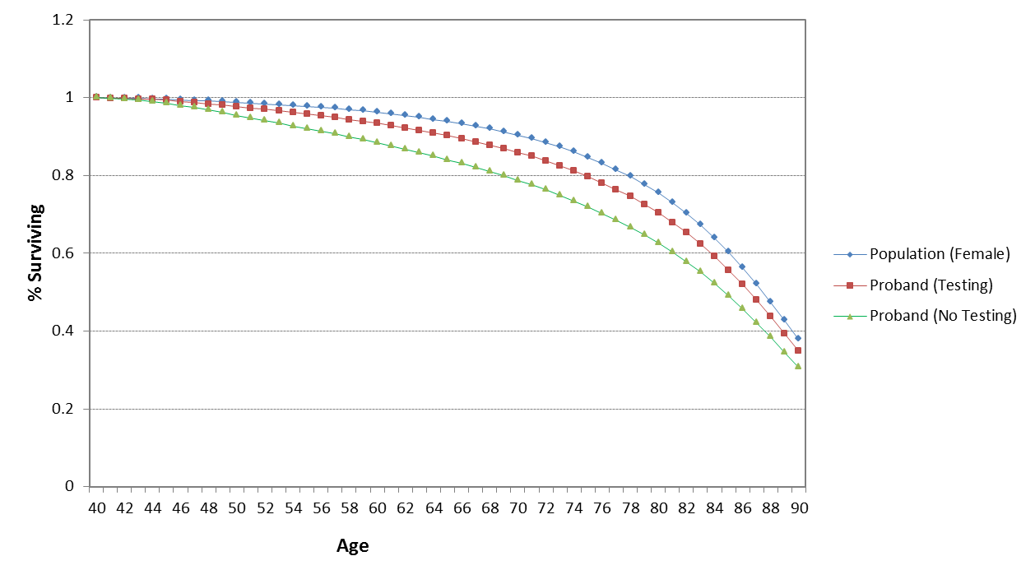

Figure 2 presents the survival curves for proband’s female siblings with and without genetic testing compared with the general population.
Figure 2: Survival curves for proband’s female siblings with and without genetic testing
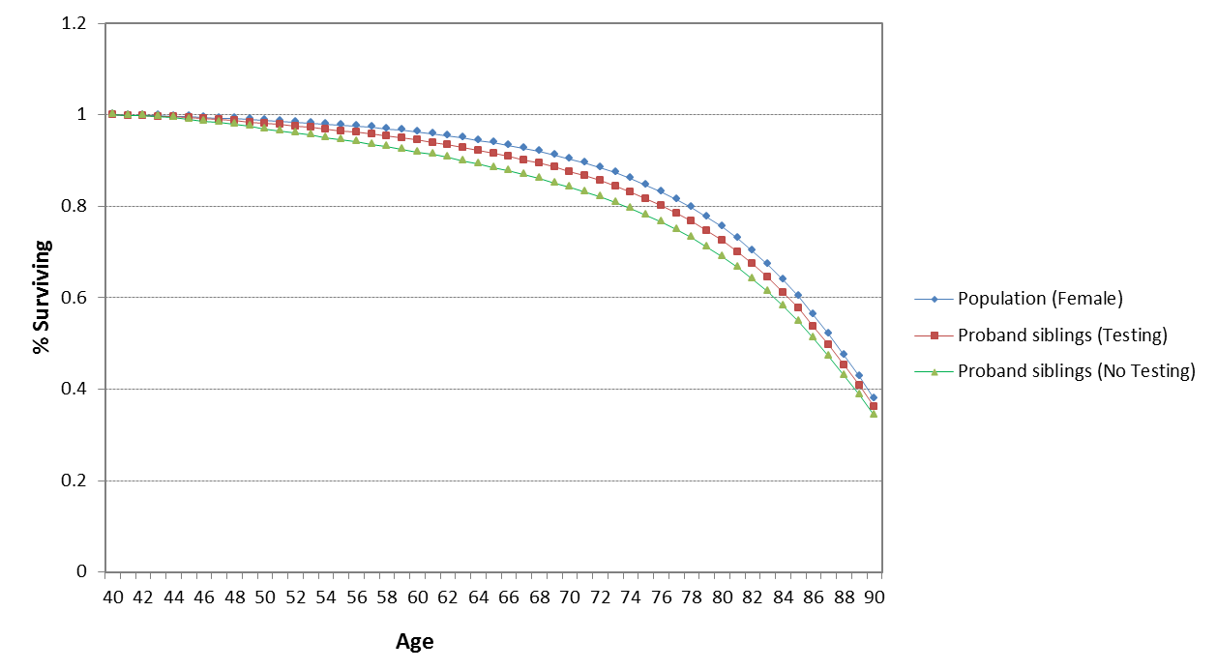
Figure 3 presents the survival curves for proband’s female children with and without genetic testing compared with the general population.
Figure 3: Survival curves for proband’s female children with and without genetic testing
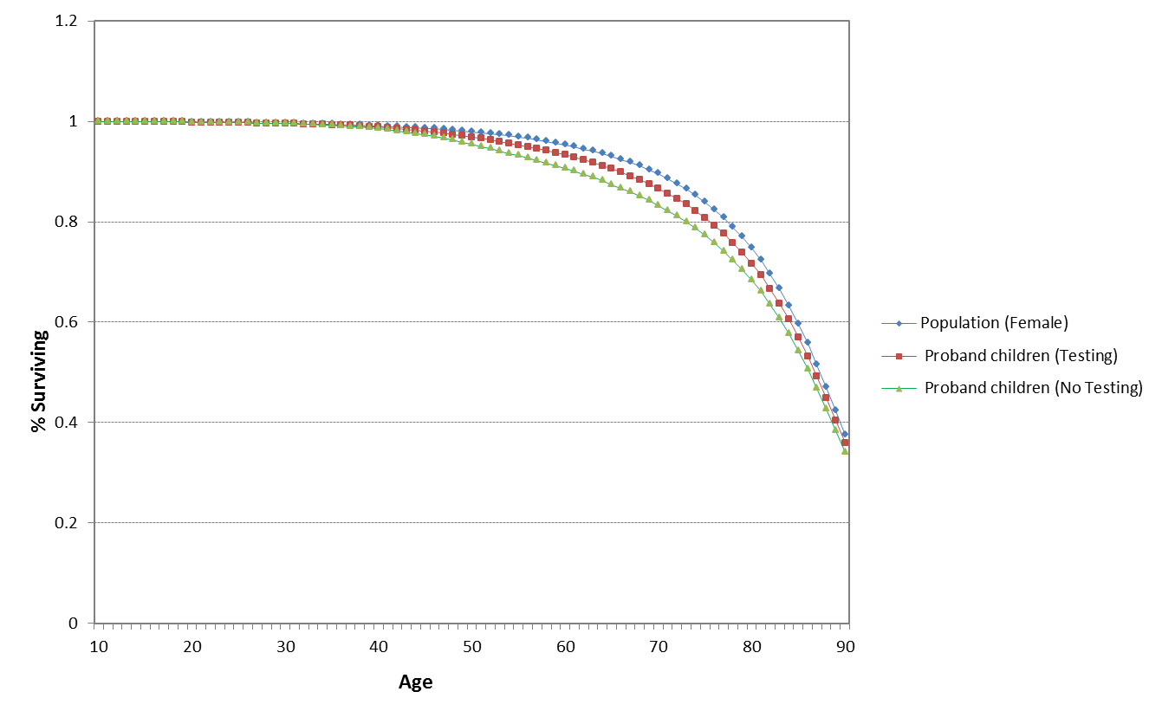
Probands and their family members had reduced survival compared to the general Australian population; however, probands and their family members who undertake genetic testing had improved survival compared with no testing.
Breast cancer
Figure 4 presents the cumulative breast cancer risk in probands with and without genetic testing compared with the cumulative breast cancer risk in the general Australian female population.
Figure 4: Cumulative breast cancer risk in probands with and without genetic testing
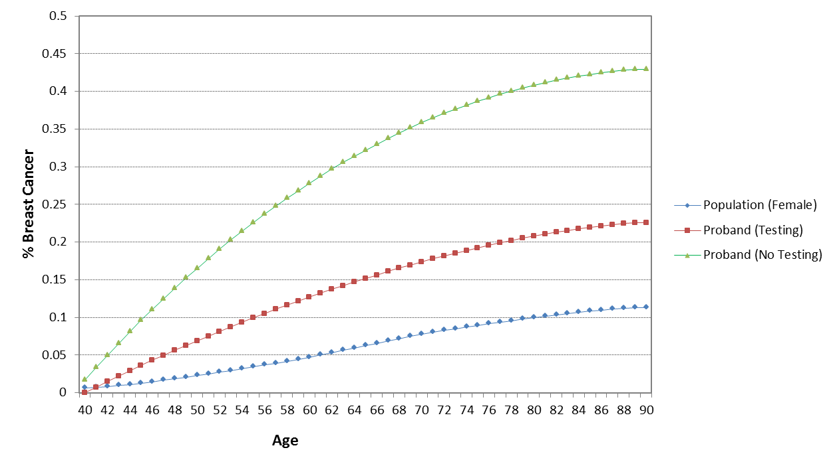
The 15-year cumulative breast cancer risk (Age 55) in probands ranged from 20% to 40%.
Figure 5 presents the cumulative breast cancer risk in proband’s female children (and female siblings) who carry a BRCA mutation with and without genetic testing compared with the cumulative breast cancer risk in the general Australian female population.
Figure 5: Cumulative breast cancer risk in proband’s children who carry BRCA mutation with and without testing
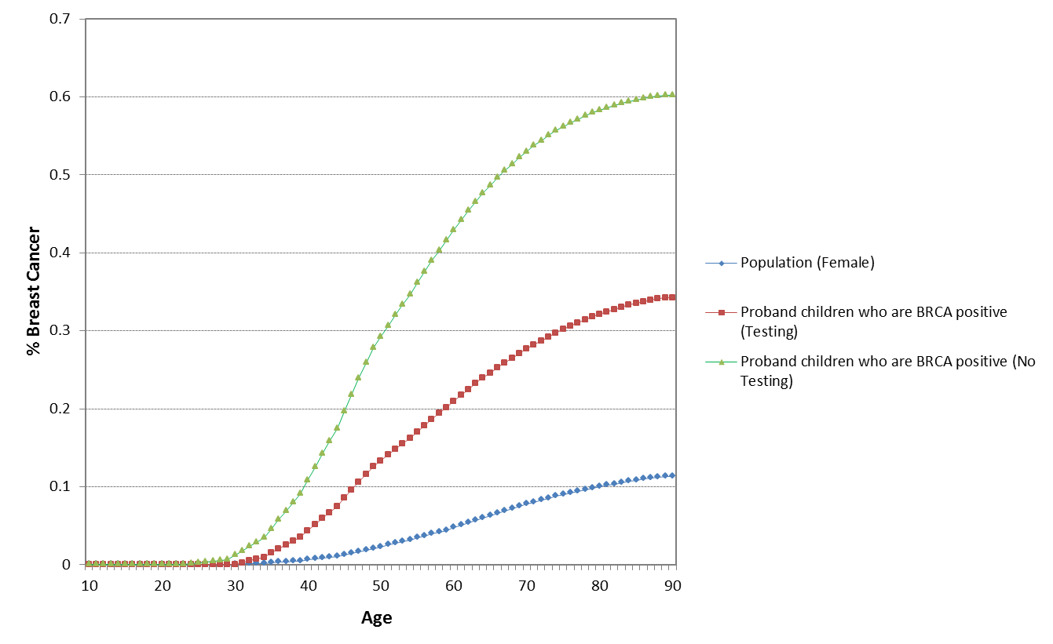
The cumulative risk of breast cancer in BRCA1 or BRCA2 positive proband’s female children (and female siblings) was 55% at the age of 70 years. With genetic testing, the cumulative incidence of breast cancer in this group reduced to 30% at the age of 70 years.
Ovarian cancer
Figure 6 presents the cumulative ovarian cancer risk in probands with and without genetic testing compared with the cumulative ovarian cancer risk in the general Australian female population.
Figure 6: Cumulative ovarian cancer risk in probands with and without genetic testing
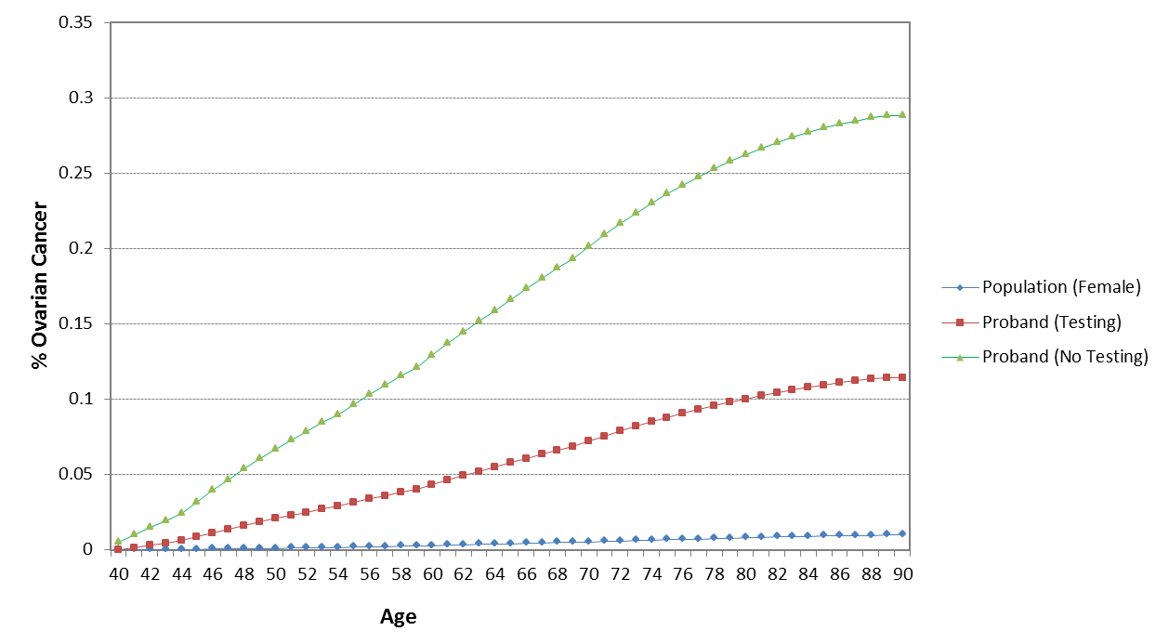
Figure 7 presents the cumulative ovarian cancer risk in proband’s female children (and female siblings) who carry a BRCA mutation with and without genetic testing compared with the cumulative ovarian cancer risk in the general Australian female population.
Figure 7: Cumulative ovarian cancer risk in proband’s children who carry BRCA mutation with and without testing
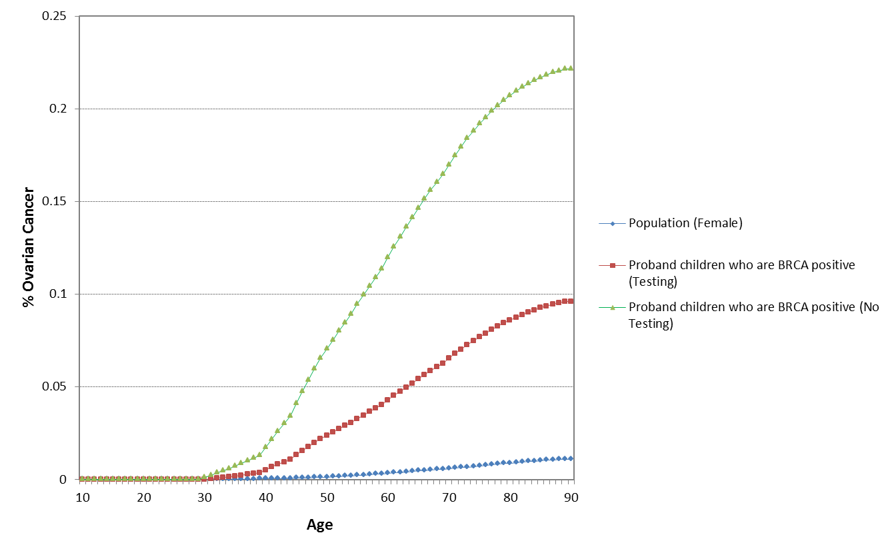
The cumulative risk of ovarian cancer in probands and proband’s family members who carry a BRCA1 or BRCA2 mutation was around 20% at the age of 70 years. Genetic mutation testing resulted in reduced cumulative risk at around 10% for both probands and family members who carry the mutation.
The results of the model were in line with international evaluations. A review of published analyses did not identify any integrated economic model to assess the cost-effectiveness of a genetic testing program for BRCA mutations. Nevertheless, in the economic evaluations of BRCA mutation genetic testing in affected individuals or family members compared with no testing, genetic testing resulted in QALY gains ranging from 0.06 to 0.32 and was cost-effective with ICERs ranging from $9,000 to $50,000 per QALY gained. Table 10 summarises the results of international economic evaluations of BRCA mutation genetic testing with costs and ICERs converted to 2015 Australian dollars.
Table 10: Results of international economic evaluations of BRCA mutation genetic testing
Study | Population | Country | Cost (AUD 2015) | QALY | Life-year | ICER
Balmana et al, 2004 | Affected individuals and women with family history, 30 years old | Spain | Euro 823  (AUD2,096) | - | 0.19 | AUD11,032/LY
Holland et al, 2009 | Women with family risk of breast and/or ovarian cancer, 35 years old | Unites States | USD1,000  (USD1,724) | 0.2 | - | AUD8,620/QALY
Kaldate et al, 2014 | Women at high risk based on family history, 35 years old | Unites States | USD9,844  (AUD15,685) | 0.32 | - | AUD49,016/QALY
NICE, 2013 | Affected individuals, 40-49 years old | United Kingdom | GBP1,086  (AUD 2,580) | 0.062 | 0.09 | AUD43,000/QALY
NICE, 2013 | Women with relatives who tested positive, 40-49 years old | United Kingdom | GBP1,108  (AUD 2,625) | 0.1 | 0.09 | AUD26,250/QALY
AUD = Australian Dollar, USD = United States Dollar, GBP = Great Britain Pound, QALY = quality-adjusted life-year, ICER = incremental cost-effectiveness ratio, NICE = the National Institute for Health and Care Excellence
Figure 8 is a tornado diagram (one-way sensitivity analysis) illustrating the sensitivity of the model to the various model variables for the base-case scenario.
Figure 8: Tornado diagram of the results sensitivity to model variables 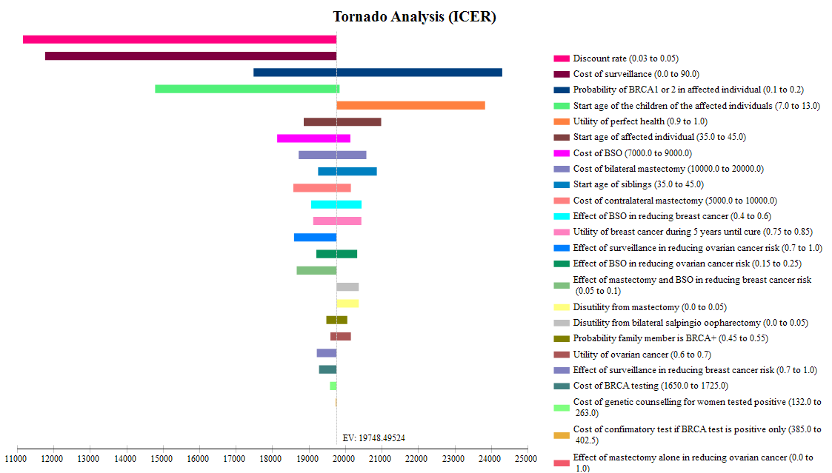
From the tornado diagram, the ICER was most sensitive to discount rate, cost of surveillance and the probability of BRCA mutation positive in affected individuals. Table 11 presents a univariate sensitivity analysis of these key variables.

Table 11: Univariate sensitivity analysis
 | Incremental cost | Incremental QALY | ICER/QALY
Base case | $3,470 | 0.19 | $18,283
Discount rate 3% | $3,216 | 0.32 | $10,192
Applying surveillance cost ($90) to proband’s children who test positive, family members who opt for BSO only in the genetic testing arm, and to family members in the no testing arm | $3,274 | 0.19 | $17,253
Probability BRCA mutation positive in affected individuals 10% | $2,888 | 0.13 | $22,828
Probability BRCA mutation positive in affected individuals 20% | $4,052 | 0.25 | $16,012
QALY = quality-adjusted life-year, ICER = incremental cost-effectiveness ratio, BSO = salpingo-oophorectomy

The sensitivity analysis indicated that genetic testing was cost-effective compared with no testing with an ICER ranging from $10,000/QALY gained to $23,000/QALY gained.

Financial/budgetary impacts
An epidemiological approach was used to estimate the financial implications of testing affected individuals who meet the eligibility criteria specified in Section 1.5 of the CUC and for family members of those individuals who are positive for mutations in BRCA1 or BRCA2.
A summary of the total costs of testing, counselling and preventive surgeries to affected individuals and siblings is presented in Table 12.
Table 12: Summary of net costs to Government
 | 2016 | 2017 | 2018 | 2019 | 2020
Cost Govt (net co-pay) for genetic counselling | $57,540 | $58,694 | $68,398 | $78,432 | $79,916
Total cost Govt (net co-pay) for testing | $2,149,229 | $2,192,337 | $2,554,793 | $2,929,567 | $2,984,991
Total cost of proband surgery | $1,878,349 | $1,916,024 | $2,232,798 | $2,560,337 | $2,608,776
Total cost of sibling surgery | $962,386 | $981,689 | $1,143,990 | $1,311,807 | $1,336,625
Total cost to Govt (net co-pay) | $5,047,513 | $5,148,752 | $5,999,991 | $6,880,155 | $7,010,320

The total expected costs to Government were $5.0 million in year 1 to $7.0 million in year 5.
Compared with the results in the base case, sensitivity analyses showed that the results were most sensitive to the proportion assumed to be eligible for testing at 5% (base case: 10%) which halved the total cost, and the proportion of affected women tested who are BRCA1 or BRCA2 positive at 10% or 20% (base case: 15%) ranging from $4.0 million to $6.1 million in the first year.

Key issues from ESC for MSAC
To enable an expedited MSAC re-consideration, ESC members provided individual comments which were considered by MSAC.

Other significant factors
Nil.

Applicant’s comments on MSAC’s Public Summary Document
The applicant had no comments.

Further information on MSAC
MSAC Terms of Reference and other information are available on the MSAC Website at: www.msac.gov.au.

