**MSAC Application 1802**

**Supervised oral food challenge (OFC) in patients with suspected food allergy**

**PICO Set**

# Population

## Describe the population in which the proposed health technology is intended to be used:

Medically supervised oral food challenges (OFC) are intended to be used in patients (children and adults) with suspected IgE mediated food allergy, where the intention of the clinician is to use the outcome of the OFC to alter or guide management.

**What is IgE mediated food allergy?**

Food allergy is defined as an immune response, triggered by the ingestion of a food allergen, that is either immunoglobulin E (IgE) mediated or non-IgE mediated*. In some cases, it may be a combination of both.[1, 2]

IgE mediated allergic reactions to food are characterised by an acute onset of symptoms[3], usually within 30 minutes to 1 hour of exposure (ingestion) to a trigger food allergen:

* Symptoms of a food-induced allergic reaction vary from mild to moderate such as localised facial angioedema, acute urticaria (hives or welts), tingling mouth, to the most severe type of allergic reaction known as anaphylaxis. A more detailed list of possible signs and symptoms is demonstrated in **Table 1- Examples of symptoms of IgE-mediated food allergy**.[3]
* Anaphylaxis is a potentially life-threatening condition which requires immediate treatment, including the administration of adrenaline (epinephrine). Delayed treatment of anaphylaxis with adrenaline can result in death or disability.

The severity of an IgE mediated allergic reaction to food is difficult to predict and currently the only way to prevent an allergic reaction to food from occurring is to avoid known food allergens. There is no blood or skin test available that is able to confirm which patients with food allergy will have anaphylaxis.

For people with multiple food allergies, avoidance of multiple foods can result in dietary restrictions that significantly impact their nutritional adequacy, growth and development, which can be particularly problematic in children[4]. Dietary restrictions are also known to have an impact on quality of life both for the patient and their family[5-7].

The potential for accidental exposure to food allergens means that people with food allergy and their parents/carers must always be prepared to treat anaphylaxis.

*Patients with non-IgE mediated food allergies such as Food-Protein Induced Enterocolitis Syndrome (FPIES) may need a supervised OFC, however, this indication is not included in this item number.

**What is an oral food challenge?**

Supervised oral food challenges (OFC) are universally considered to be the gold standard for confirming IgE mediated food allergies, resolution of food allergies or tolerance of food allergens.[8]

Supervised OFCs appear in practice guidelines worldwide[9] and are intended to be used for patients of all ages.

An OFC is a standardised procedure where incremental amounts of a particular food are fed to patient at intervals, usually over a period of 2-3 hours. The patient is monitored to determine if the food being tested causes an allergic reaction. They are observed for a minimum of 2 hours after the last dose, or longer if an allergic reaction occurs.

**Table 1- Examples of symptoms of IgE-mediated food allergy**

|  |  |
| --- | --- |
| **Organ or system** | **Symptoms and signs** |
| **Skin** | Urticaria  Angio-oedema  Pruritus  Flushing  Immediate erythema in the predilection sites of eczema  Ear or palm itching |
| **Gastrointestinal** | Oral/pharyngeal pruritus  Oral/pharyngeal swelling  Vomiting  Nausea  Abdominal cramps  Diarrhoea  Abdominal pain |
| **Ocular** | Conjunctival erythema  Pruritus  Lacrimation |
| **Respiratory** | Rhinitis (rhinorrhoea, sneezing, nasal obstruction, pruritus)  Hoarseness  Stridor/laryngeal oedema  Cough  Dyspnoea  Chest tightness  Wheezing  Cyanosis |
| **Cardiovascular** | Pallor  Cold sweats  Heart palpitations  Pre-syncope / Syncope  Tachycardia  Hypotension  Shock |
| **Neurological** | Anxiety  Change in behaviour  Irritability  Apathy  Lethargy  Seizures  Syncope/Loss of consciousness |
| **Other** | Uterine contractions resulting in abdominal pain and bleeding  Shivering |

**How common is IgE mediated food allergy?**

IgE mediated food allergy is common in the Australian population, affecting people of all ages:

* It is most common in infants under 12 months of age with a prevalence of approximately 11%.[10, 11]
* Across other age groups, the prevalence decreases with age. It affects approximately 6.5% of children at 6 and 10 years of age[12] and approximately 5% of 14 year olds[12, 13]
* Although some children will ‘outgrow’ their food allergy[12, 14-16], around 2-4% of adults still have a food allergy[17] including those whose food allergy first occurs in adulthood.[12, 17]
* Whilst we do not have current prevalence data for adult-onset food allergy in Australia, globally the prevalence has been recognised as an issue.[18]

**What is the cost of food allergy to the health care system?**

Supervised OFCs are generally seen as the rate limiting step in the diagnostic process, and the patient (child or adult) is left in a position of ‘presumed allergy’ until such time that this may be either confirmed as a true allergy, or the label removed.[19] The true cost of allergy in Australia is multifaceted, encompassing financial burdens and strain on the healthcare system.

For example, young children with ‘presumed allergy’ which has not been confirmed with an OFC may be incorrectly labelled with long term food allergy which may result in:

* Developing a true allergy due to unnecessary avoidance of food
* Growth and development issues due to dietary restrictions
* Significant impact on quality of life due to dietary restrictions
* Economic burden associated with having to carry and adrenaline device

Anecdotal reports from clinical immunology/allergy specialists initiating new food allergy treatment programs in clinics throughout Australia, suggest that improved access to supervised OFC will reduce the number of young children who are incorrectly labelled with a diagnosis of food allergy by 30-40%. It is expected that this will lead to considerable cost savings for the individuals and the health care system.

The financial burden of managing food allergies, including the purchase of specialised foods and frequent medical consultations, also contributes to decreased quality of life. Children with food allergies incur significantly higher costs for GP visits, specialist visits, tests, and prescriptions[10, 20] compared to families of children without food allergies.

Evidence suggests that feeding disorders like avoidant/restrictive food intake disorder (ARFID) may be more prevalent among people with food allergy, than in the general population with as many as 30% of patients receiving intensive feeding therapy, having a concurrent diagnosis of food allergy.[21]

The “Walking the Allergy Tightrope” report from the Australian Government Inquiry into Allergies and Anaphylaxis in Australia published in May 2020, acknowledged that food allergy has become a significant public health problem with wait lists to see a specialist often over 12 months and the cost of allergies to Australian economy estimated at over $7 billion each year.[22]

In 2020, the total economic burden on Medicare out-of-hospital services caused solely by food allergies among children 0–4 years old was projected to be AUD$26.1 million in Australia.[10]

There are key limitations within the Australian health care system that preclude timely access to an OFC. To setup and safely perform an OFC, the cost is estimated to be around $1100.00.

There are currently no MBS item numbers that provide sufficient remuneration for clinical immunology/allergy specialists to support the delivery of an OFC in private practice.

Therefore, in private practices where they are offered, there is a significant out-of-pocket cost incurred by the patient. This has resulted in inequitable access to OFC in Australia and an increased demand on the public hospital sector to provide these services. Access to OFC in private settings is limited by:

* Unsubsidised cost for families and individuals.
* Private facilities not offering OFC in the absence of an item number.

Improving access to OFC through the provision of an MBS item number will enable equitable access in a timely manner.

**Quality of life and food allergies**

Food allergies have a far-reaching impact on the quality of life, not only for the individual, but also their parents/carers[5-7, 21-23] which extends beyond the immediate physical symptoms of an allergic reaction. Some studies examining the quality of life in individuals with food allergies have found it to be lower than that of those with type 1 diabetes mellitus, primarily due to the fear of accidental exposure and life-threatening reactions.[5, 6] The constant fear and anxiety surrounding potential exposure to allergens can lead to social isolation, as individuals may avoid social gatherings or eating out due to concerns about food contamination:

* Some parents of young children do not access Early Children’s Education and Care services as they are not confident that the service will appropriately manage their child’s allergies[24]
* This can be particularly challenging for children, who may face bullying or exclusion at school due to their dietary restrictions.
* For school aged children, this may have a profoundly harmful effect on social and emotional development.[25]
* Many children with food allergies avoid or exclude themselves from important peer activities such as school excursions and overnight camps due to the difficulty in maintaining strict dietary vigilance[26] and the fear of anaphylaxis.

**How do outcomes of supervised OFC alter clinical management?**

Patients being considered for OFC will usually be avoiding that food. The options for management based on the outcome of an OFC include:

* Reintroduction of the food allergen into the diet
* Commencement of active treatment including oral immunotherapy (OIT) or the introduction of an alternate form of the food e.g. baked milk or baked egg
* Reinforcement of continuing avoidance in appropriate patients

In addition, the outcome of the OFC is likely to influence the social and psychological wellbeing of the patient and will therefore improve their quality of life.[27]

**Examples of how the outcome of an OFC is likely to influence clinical management in two patient scenarios are summarised in Figure 1 and Figure 2.**

**Figure 1 - Scenario 1**

A 12 year old boy, JS, attended his allergist for a routine assessment of his peanut allergy. As a toddler he had reacted to a taste of peanut butter when it was first introduced with widespread hives and lip swelling, he did not have a history of subsequent reactions or anaphylaxis. At the age of 3 he was prescribed an adrenaline device and had successfully avoided peanuts ever since. His skin prick test result was 6 x 4 mm and had decreased from a result 2 years prior that was 15 x 9 mm.

While ongoing allergy is the most likely scenario, it had been many years since JS had last reacted to peanut and there had been a significant decrease in the size of the skin test. JS is given the option of a supervised OFC determine if his peanut allergy has resolved, and if it is safe to reintroduce peanut into his diet.

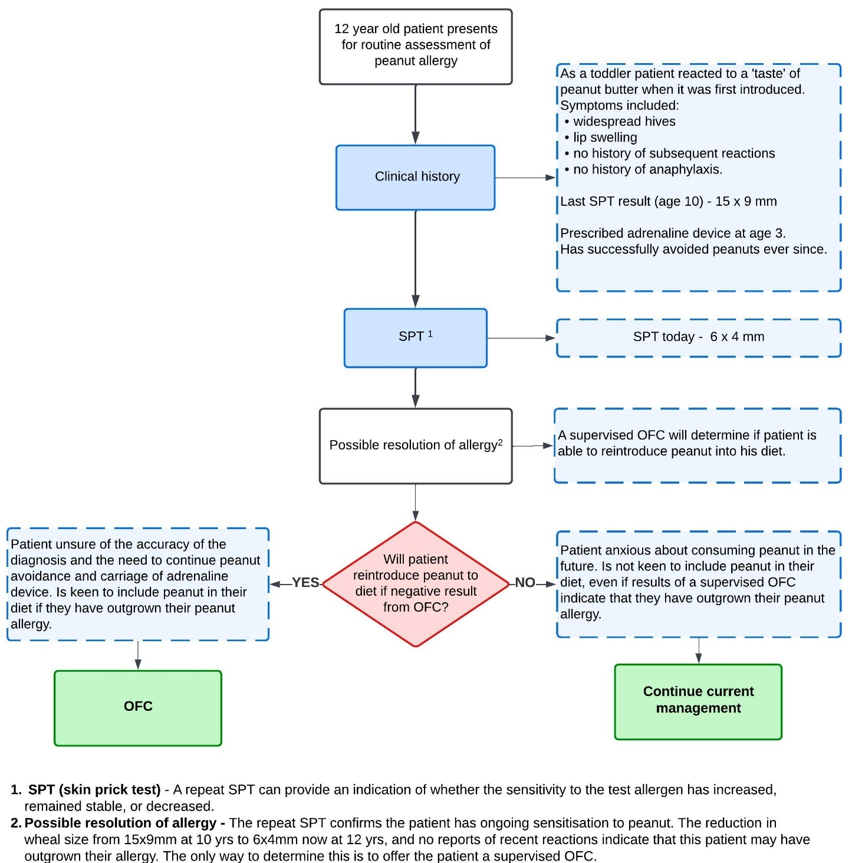

**Figure 2 - Scenario 2**

A 12 year old boy, JS, attended his allergist for a routine assessment of his peanut allergy. As a toddler he had reacted to a taste of peanut butter when it was first introduced with widespread hives and lip swelling. At the age of 3 he was prescribed an adrenaline device and had avoided peanuts ever since, however, 6 months prior to the current review JS had accidentally ingested a small amount of peanut in a chocolate and had developed severe anaphylaxis requiring treatment with adrenaline and a review in the emergency department. The allergist performed a skin prick test for peanut on JS and found that it was 6 x 4 mm and had decreased from a result 2 years prior that was 15 x 9 mm. To reduce the risk of anaphylaxis due to accidental exposure to peanut in the future, JS is given the option of a supervised OFC to determine suitability for a peanut oral immunotherapy (OIT) program.

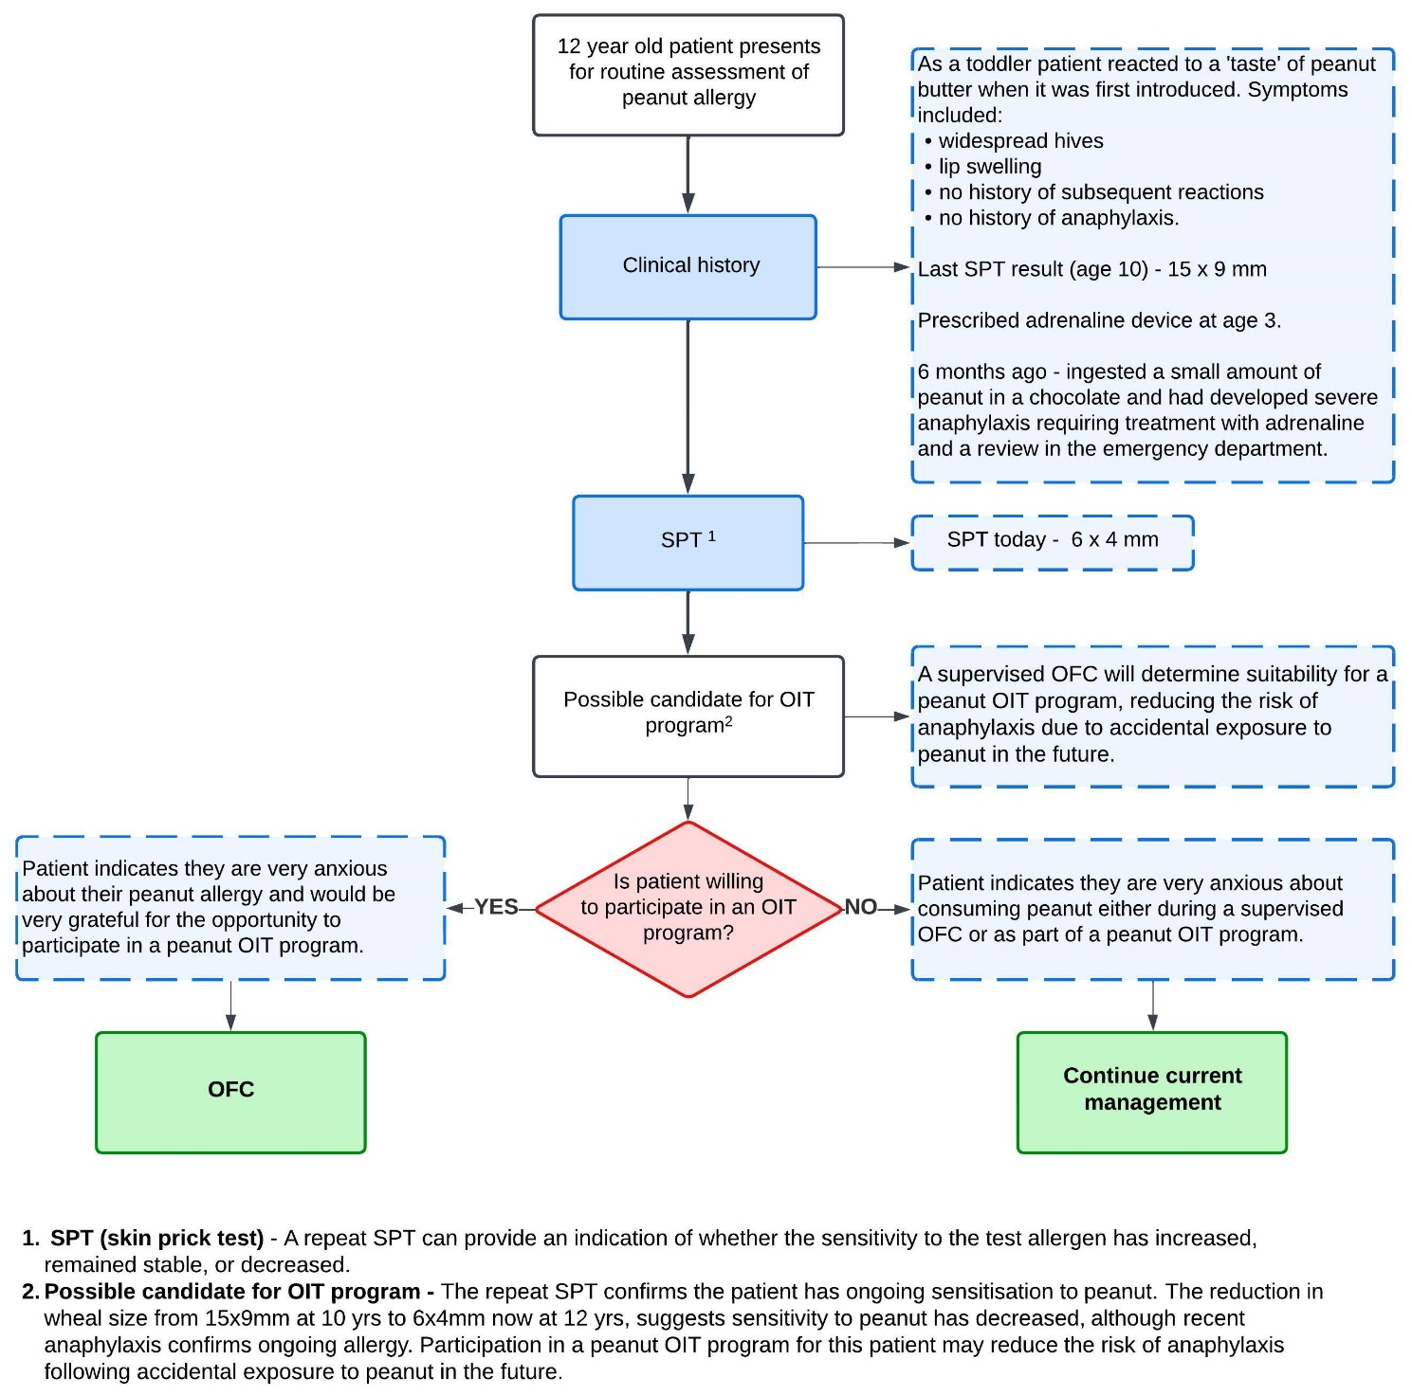

## Specify any characteristics of patients with, or suspected of having, the medical condition, who are proposed to be eligible for the proposed health technology, describing how a patient would be investigated, managed and referred within the Australian healthcare system in the lead up to being considered eligible for the technology:

The decision-making process in terms of patient selection for OFC is made in reference to clinical guidelines, standardised assessment tools as shown in **Figure 3 – Algorithm for patient investigation.**

**Figure 3 - Algorithm for patient investigation**

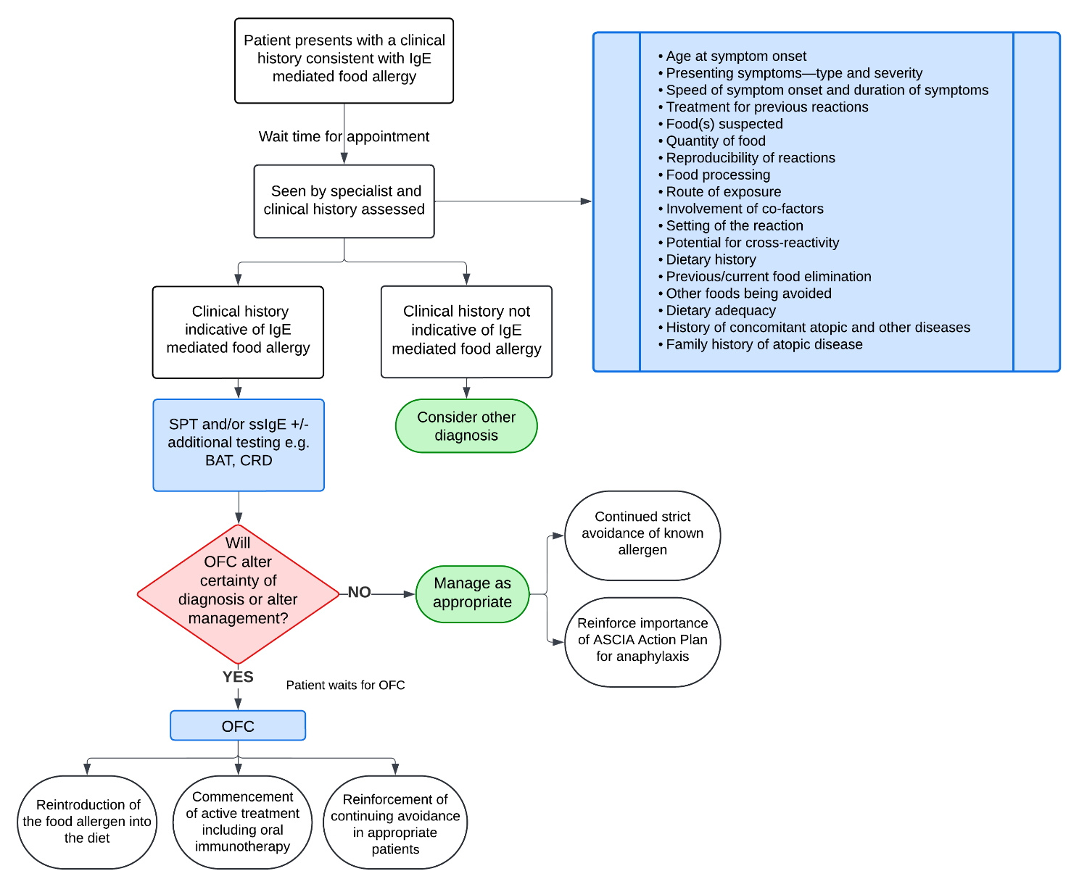

To optimise patient safety and OFC results, the OFC is contraindicated if any of the following exclusion criteria are present:

* Intercurrent illness such as fever, cough, vomiting and/or diarrhoea.
* Active/uncontrolled asthma requiring reliever medication.
* Demonstration of tolerance to the challenge allergen since booking.
* Severe atopic dermatitis (eczema) flare.
* Current urticaria (hives, welts).
* Poorly controlled allergic rhinitis (hay fever).
* Antihistamine taken in the last 72 hrs (excluding nasal sprays used to treat allergic rhinitis).

Criteria for OFC patient selection is based on publications[28] expert consensus and clinical practice. Patients of any age with IgE mediated food allergy should have access to an OFC on the condition that they are considered eligible to proceed by a clinical immunology/allergy specialist.

An OFC is indicated when the outcome is likely to alter or guide current management including:

* Reintroduction of the food allergen into the diet or the introduction of an alternate form of the food e.g. baked milk or baked egg.
* Commencement of active treatment including oral immunotherapy (OIT).
* Reinforcement of continuing avoidance in appropriate patients.

Conversely, a patient is considered ineligible for OFC if, based on the available information from the clinical history and testing, a positive challenge would be unlikely to:

* Lead to management other than strict avoidance of the allergen; and
* Influence the psychosocial management of the patient.

Patient selection for OFC involves careful consideration of additional factors as shown in **Table 2 - Considerations for patient selection for OFC**.

**Table 2 -** **Considerations for patient selection for OFC[29]**

|  |  |
| --- | --- |
| **Medical factors** | **Patient and family factors** |
| * Reaction history (e.g., what food, how much, severity of symptoms) * Time since the most recent the reaction * Presence of cofactors * Nutritional impact of the food to be challenged * Status of other atopic and medical conditions | * Quality of life associated with the inclusion/exclusion of the food * Interest in adding food to the diet * Ability to cooperate with OFC procedures * Anxiety or apprehensions about the procedure/outcomes * Risk-taking behaviour (e.g., intentional ingestion at home if OFC not offered) * Interest in starting treatment for food allergy (e.g., OIT) |

**Food allergen selection**

The nine most common food allergens are egg, milk, peanut, tree nuts, fish, crustacea, soy, sesame, wheat, and these are the most likely to be challenged. Other foods may need to be challenged such as culturally relevant foods in our multicultural population.

For patients with more than one food allergen a triage process will be required, based on nutritional impact (e.g. prioritise staple foods) and risk of accidental exposure.

**Clinical management pathway**

The patient will experience the onset of symptoms suggestive of an allergic reaction and will seek medical attention from either a local healthcare provider such as a GP or through presentation to a hospital emergency department.

Provisional diagnosis of food allergy may be made following an assessment of the patient’s clinical history.

Before a patient leaves a healthcare facility after having an allergic reaction they are advised about the suspected allergen, allergen avoidance strategies and post-discharge care:

* The discharge care plan is tailored to the allergen and includes details of the suspected allergen, the appropriate ASCIA Action Plan, and the need for prompt follow-up with a general practitioner and clinical immunology/allergy specialist review.
* Where there is a risk of re-exposure and anaphylaxis, the patient is prescribed a personal adrenaline device and is trained in its use.
* Details of the allergen, the allergic reaction and discharge care arrangements are documented in the patient’s healthcare record.[30]
* If a referral has been made to a clinical immunology/allergy specialist, an appointment will be allocated. Appointments are prioritised and wait time will vary based on the severity and urgency of the individual clinical circumstances, and whether the appointment is scheduled in a public clinic, or in private practice.

During the initial appointment, the specialist will:

* Obtain a detailed history and conduct relevant testing such as a skin prick test (SPT), serum specific IgE (ssIgE) or other allergy tests as indicated.
* If an OFC will alter certainty of diagnosis or alter management, the specialist will place the patient on a wait list for OFC.

The wait time for the OFC is dependent on various clinical factors including the type of food (e.g., essential or non-essential), the patient's age, the presence of other food allergies, and the rationale for conducting the challenge. Other contributors to wait time include the capacity of services as determined by resource limitations.

The average wait times for an oral food challenge appointment which described in **Table 3 - Wait times (in months) for OFC appointment**

**Table 3 - Wait times (in months) for OFC appointment**

|  |  |  |
| --- | --- | --- |
| **Location** | **Public Hospital** | **Private Practice** |
| **Inpatient** | **Average 9.8 months**  (<1 month ~ 18 months) | **Average 3.9 months**  (<1 month ~ >6 months) |
| **Outpatient** | **Average 8.6 months**  (2 months ~ 12 months) | **Average 5.3 months**  (<1 month ~ >6 months) |

An average wait time of 10 months to be seen in the public hospital system is unacceptable for confirmation of allergy to staple foods. Additionally, a delay in food introduction is associated with an increased risk of developing long term clinical allergy in young infants.[31]

## Provide a rationale for the specifics of the eligible population

Supervised OFCs are intended to be used in children and adults with suspected IgE mediated food allergy where the intention of the clinician is to use the outcome of the challenge to alter management.

Patients being considered for OFC will usually be avoiding that food. The options for management based on the outcome of an OFC include:

1. Reintroduction of the food allergen into the diet or the introduction of an alternate form of the food e.g. baked milk or baked egg.
2. Commencement of active treatment including oral immunotherapy (OIT)
3. Reinforcement of continuing avoidance in appropriate patients

In addition, the outcome of the challenge is likely to influence the social and psychological wellbeing of the patient and will therefore improve their quality of life. This information is fundamental to the decision-making process, allowing the specialist to safely facilitate an OFC for eligible patients.

For example, in the absence of sufficient data suggestive of IgE mediated food allergy in a new patient, an OFC offers limited clinical diagnostic value. Conversely, for patients re-presenting with a known IgE mediated food allergy and data suggestive that this has not resolved, unless the patient is a potential candidate for an OIT program, limited value would be gained through an OFC.

## Are there any prerequisite tests?

The only prerequisite is that a clinical history is taken.

Skin Prick Test (SPT) and/or serum specific IgE (ssIgE) as described in **Table 4** **- MBS funded tests (1 July 2024)**, are often used in conjunction with a clinical history.

**Table 4 - MBS funded tests (1 July 2024)**

|  |  |
| --- | --- |
| 12003 | Skin prick testing for food and latex allergens, including all allergens tested on the same day, not being a service associated with a service to which item 12012, 12017, 12021, 12022 or 12024 applies  (See para DN.1.22 of explanatory notes to this Category)  Fee: $44.35 Benefit: 75% = $33.30 85% = $37.70 |
| 71079 | Detection of specific immunoglobulin E antibodies to single or multiple potential allergens, 1 test  (Item is subject to rule 25)  Fee: $26.80 Benefit: 75% = $20.10 85% = $22.80 |

## Are the prerequisite tests MBS funded?

Yes

## Provide details to fund the prerequisite tests:

Provide a response if you answered 'No' to the question above

# Intervention

## Name of the proposed health technology:

Supervised oral food challenge (OFC)

## Describe the key components and clinical steps involved in delivering the proposed health technology:

The process for an OFC involves repeated consumption of gradually increasing amounts of the suspected food allergen under direct observation in a supervised clinical setting by an appropriately trained health professional (medical doctor, nurse practitioner, registered nurse) at all times.[2, 25]

A summary of the key components and clinical steps involved in OFC is shown in **Figure 4 - Summary of key steps involved in delivering an OFC.**

To optimise patient safety and OFC results, if any of the following exclusion criteria are present, the OFC may need to be cancelled or re-booked:

* Intercurrent illness such as fever, cough, vomiting and/or diarrhoea.
* Active/uncontrolled asthma requiring reliever medication (use of preventer medication should continue in the lead up to the challenge).
* Demonstration of tolerance to the challenge allergen since booking.
* Severe atopic dermatitis (eczema) flare.
* Current urticaria (hives, welts).
* Poorly controlled allergic rhinitis (hay fever).
* Antihistamine taken in the last 72 hrs (excluding nasal sprays used to treat allergic rhinitis).

Once confirmed that the OFC will proceed, written consent is obtained from the patient or parent/carer and a set of baseline vital signs (temperature, pulse, blood pressure, respiratory rate) are recorded. An OFC record will be completed for every patient undergoing a challenge and includes documentation of:

* Pre-determined dose of adrenaline (epinephrine) to be administered IMI in the event of anaphylaxis.
* Preliminary clinical examination including assessment of comorbid disease activity.
* Relevant allergen test results such a SPT (mm).
* Details about the food allergen being challenged including previous reactions and/or exposures.
* Each incremental dose of food protein given to the patient (tsp/mL/mg)
* Presence of any reactions observed**\*** during the challenge at designated intervals corresponding with the dose of food allergen protein. This is usually every 15-20mins but may be subject to alteration as deemed appropriate by the clinical immunology/allergy specialist. Reactions to the allergen (see Table 5), may include but are not limited to:
* Cutaneous (erythema, pruritis, urticaria, angioedema)
* Respiratory (sneeze or itch, cough, wheeze, laryngeal)
* Gastrointestinal (vomiting, diarrhoea)
* Cardiovascular (tachycardia, hypotension, collapse, loss of consciousness)
* Subjective symptoms (nausea, abdominal pain, itchy mouth, itchy throat, mood change, other)
* Details of any treatment given to the patient during the challenge which may include:
* Antihistamine
* IM adrenaline (epinephrine)
* Adrenaline infusion
* Inhaled salbutamol
* Ondansetron
* Oxygen
* IV fluid bolus
* Corticosteroid
* Outcome of the challenge with relevant follow-up anaphylaxis education including update/provision of a relevant ASCIA Action Plan.

**\*** *Observation of the patient continues for at least 2 hours following the last dose of food allergen.*

Protocols developed by the Australasian Society of Clinical Immunology and Allergy (ASCIA) provide a standardised approach to the OFC procedure, are peer reviewed and are based on expert opinion aligning with published OFC protocols that are used worldwide.

Observation following each incremental dose of the allergen and a subsequent post-procedural observation period is required to assess the patient’s immediate and latent tolerance to the allergen once consumed.

Crucially, this also enables appropriately trained clinical staff (nursing and medical) to provide timely intervention in the event of a mild, moderate, or severe allergic reaction in accordance with PRACTALL guidelines and local policies and procedures as shown in **Table 5 - Suggested challenge stopping criteria in accordance with PRACTALL guidelines**.[28] Refer to **Figure 5 – Summary of symptom management in OFC based on PRACTALL guidelines** for an algorithm outlining how the PRACTALL guidelines influence this decision making process.

Most OFCs require approximately two hours to eat the required doses of food, followed by a minimum two hours of observation:

* Where symptoms consistent with an allergic reaction occur, the OFC is stopped and treatment for the allergic reaction is provided by the nursing and medical staff supervising the challenge.
* The OFC may continue if deemed appropriate to do so in accordance with PRACTALL guidelines[32] in which case, a longer time period may then be required to complete the OFC.
* For most foods, symptom-free ingestion of a total cumulative dose relative to the challenge food protein is considered sufficient to rule out a food allergy to that specific food.

**Table 5 - Suggested challenge stopping criteria in accordance with PRACTALL guidelines**.[28]

|  |  |  |
| --- | --- | --- |
| **Suggested challenge stopping criteria:**   * **One red symptom from an organ category** * **Two orange symptoms from two distinct organ categories** | | |
| **I. Skin** | | |
| Rash: erythema | Few areas of faint erythema  ***<50% of body surface area***  ***Generalised (>50% body surface area)*** |  |
| Rash: urticaria | Limited to perioral region or due to contact  ***1–2 lesions (not perioral or due to contact)***  ***≥3 lesions (not perioral or due to contact)*** | Local skin reactions due to contact (including lip contact with challenge dose) excluded |
| Angioedema | ***Prominent lip or ear oedema***  ***Facial edema (and new-onset uvula edema)***  ***Generalised edema*** | Facial (including periocular) swelling should be prominent and **not due to local rubbing or crying**. If crying/rubbing causes local swelling, consider delaying the next OFC dose to see if other symptoms develop |
| Pruritus | Scratching (any) | Not considered a stopping criterion |
| **II. Eyes/Upper respiratory** | | |
| Eyes | Minimal reddening, rubbing of eyes  ***Conjunctival hyperaemia (without prior rubbing)*** | Periocular rubbing or crying is a common cause of conjunctival reddening |
| Nasal | Mild, infrequent rhinitis  ***Persistent*** [***a***](https://onlinelibrary.wiley.com/doi/10.1111/pai.14276#pai14276-note-0005_191)***and significant rhinorrhoea/sneezing/rhinitis*** | Note mild nasal symptoms are common during an OFC and therefore a poor indicator of objective reaction |
| **III. Respiratory** | | |
| Cough [**b**](https://onlinelibrary.wiley.com/doi/10.1111/pai.14276#pai14276-note-0006_192) | Intermittent cough associated with throat clearing  ***Frequent cough without respiratory compromise***  ***Cough with respiratory compromise\****  *Manage as anaphylaxis | If cough is present without evidence of respiratory compromise (e.g., significant tachypnoea, fall in oxygen saturations, use of accessory muscles, wheezing, PEFR decrease >20% with good technique), consider whether to terminate the OFC (which could lead to an equivocal result if no other symptoms develop) or adopt “watchful waiting” (and delay the next OFC dose) |
| Wheezing | ***Any wheeze\****  *Manage as anaphylaxis | Reduced air entry or “added sounds” on auscultation may precede wheeze |
| Chest tightness | Isolated chest tightness  ***Chest tightness with fall in peak flow of ≥20%* (with good technique)***  *Manage as anaphylaxis | Chest tightness is subjective and should not trigger challenge-stop in isolation (but may prompt extending the dosing interval). If peak flow is being assessed, then a decrease of ≥20% from baseline (assuming satisfactory technique) can be considered a stopping criterion |
| **IV. Oropharyngeal** | | |
| Oral cavity | Itchy mouth |  |
| Throat/Laryngeal | Itchy throat, intermittent throat clearing  ***Persistent*** [***a***](https://onlinelibrary.wiley.com/doi/10.1111/pai.14276#pai14276-note-0005_193)***throat tightness or pain***  ***Non-transient hoarseness/stridor*** | Subtle vocal changes are presumably due to mild laryngeal edema and should therefore trigger the OFC to be stopped if non-transient in nature |
| **V. Gastrointestinal** | | |
| Abdominal discomfort | Nausea (any severity/frequency)  Mild abdominal pain  ***Persistent*** [***a***](https://onlinelibrary.wiley.com/doi/10.1111/pai.14276#pai14276-note-0005_194)***non-distractable abdominal pain (usually with a decrease in activity level in children)***  ***Persistent*** [***a***](https://onlinelibrary.wiley.com/doi/10.1111/pai.14276#pai14276-note-0005_191)***severe abdominal pain*** | Abdominal pain is a subjective symptom and should not trigger challenge-stop in isolation. Persistent severe abdominal pain would normally be accompanied by other symptoms. Where this is present, further OFC doses should be deferred to allow additional time for other symptoms to evolve |
| Vomiting | Vomit due to gag or taste aversion  ***1+ episode***  ***(where investigator considers this is due to allergic reaction)*** | If vomiting occurs during or shortly after the OFC dose, then this is more likely to be due to gag or taste aversion. If other symptoms subsequently develop, clinicians should reconsider whether the episode was non-allergic in origin |
| Diarrhea | 1 episode  ***2+ episodes*** |  |
| **VI. Cardiovascular** | | |
| Cardiovascular | Mild tachycardia  ***Clinically significant hypotension***  ***Cardiovascular shock/collapse*** | Hypotension defined as a decrease in systolic blood pressure greater than 30% from that person's baseline, OR   1. <10 yrs: sysBP < (70 mmHg + [2 × age in yrs]) 2. >10 yrs/adults: sysBP <90 mmHg |
| **VII. Neurological** | | |
| Neurological | Feeling weak, tired, upset/agitated  ***Significant change in cognition or Glasgow Coma Score (GCS)***  ***Loss of consciousness\****  *Manage as anaphylaxis | Allergic mediators such as histamine are also neurotransmitters; neurological impairment can occur independently of cardiovascular compromise during allergic reactions |

Note: Objective symptoms are shown in ***bold italics***.

**a** Persistent ongoing symptom (without evidence of resolution) for at least one dosing interval (20–30 min).

**b** Cough may be upper respiratory, laryngeal or lower respiratory in origin, and it can be difficult to determine the source.

**Figure 4 - Summary of key steps involved in delivering an OFC**

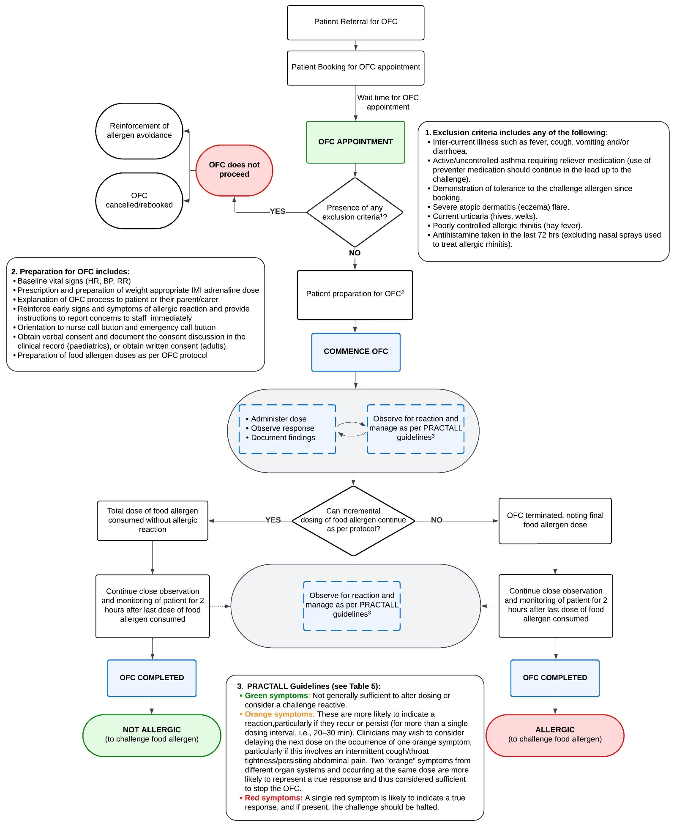

**Figure 5 – Summary of symptom management in OFC based on PRACTALL guidelines**

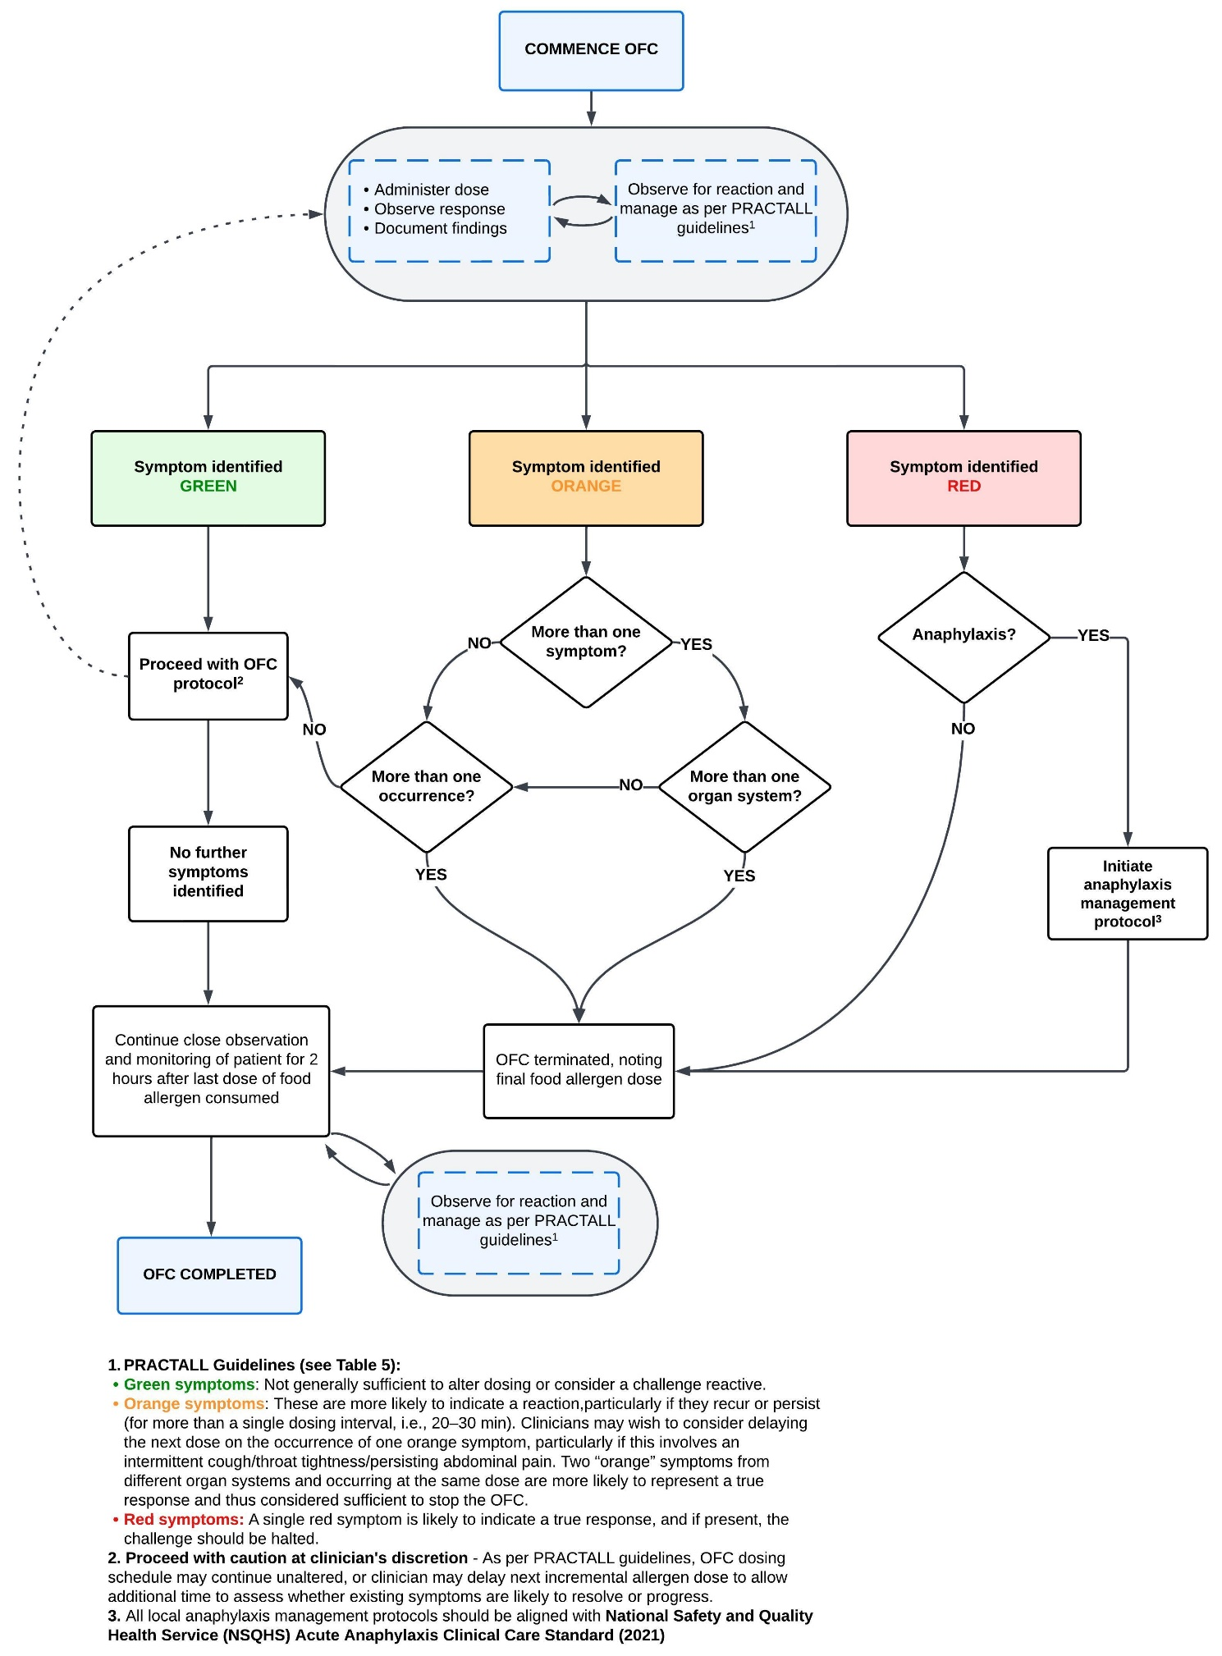

## **Identify how the proposed technology achieves the intended patient outcomes**:

An OFC will alter or guide clinical management based on the results:

* An OFC is deemed **‘negative’** when the amount of food protein ingested is equivalent to a normal serving of the food prepared in the usual manner and has been consumed and tolerated with no adverse symptoms. This indicates that patient does not have or no longer has an IgE mediated food allergy to the challenge food allergen.
* An OFC is deemed **‘positive’** when the patient develops adverse symptoms at any dose of ingested food protein up to and including a normal serving size. This confirms that the patient has a new diagnosis of IgE mediated food allergy, or in the case of a patient with an existing diagnosis of food allergy, that it is persistent or unresolved.

Results of an OFC have the potential to liberate a person’s dietary restrictions and can reduce the burden of the lifelong need for carriage of adrenaline devices.

## Does the proposed health technology include a registered trademark component with characteristics that distinguishes it from other similar health components?

No

## Explain whether it is essential to have this trademark component or whether there would be other components that would be suitable:

N/A

## Are there any proposed limitations on the provision of the proposed health technology delivered to the patient (For example: accessibility, dosage, quantity, duration or frequency):

Yes

## Provide details and explain:

We recommend that suitability and referral for an OFC is assessed by an accredited paediatric or adult specialist in the field of clinical immunology/allergy with specialist recognition as a Fellow of the Royal Australasian College of Physicians (FRACP).

**Proposed accessibility** – Availability of an appropriately qualified and experienced medical practitioner to offer an OFC may limit accessibility for some patients. Access to an OFC may also be limited due to availability of a suitably equipped clinical setting (ready access to appropriate emergency equipment such as oxygen and adrenaline).

**Dosage/Quantity** –It is intended that OFCs will be delivered according to standardised protocols, such as standalone or modified ASCIA OFC protocols.

**Proposed frequency** – Many patients will only require one OFC for a single suspected food allergy. Some patients with multiple suspected food allergies may require additional OFCs for multiple suspected food allergies.

OFCs may occur more than once in a 12-month period, but it is reasonable to limit occasions of service for these procedures, for example, applicable no more than 6 times in a 12-month period, with only one OFC to occur in a 24-hour period for each patient.

## If applicable, advise which health professionals will be needed to provide the proposed health technology:

To ensure appropriate patient selection and safety for an OFC, we propose they are performed by clinical immunology/allergy specialists, also referred to as Consultant Physicians in Clinical Immunology and Allergy. A clinical immunology/allergy specialist refers to an accredited paediatric or adult specialist in the field of clinical immunology and allergy (specialist recognition by RACP).

## If applicable, advise whether delivery of the proposed health technology can be delegated to another health professional:

Following consultation with a clinical immunology/allergy specialist, delivery of the OFC procedure can be delegated to appropriately trained health professionals (medical or nursing) with experience in recognising and treating both mild to moderate and severe allergic reactions (anaphylaxis).

To optimise patient safety, it is expected that the ratio of health professional to patient will not exceed 1:3 for the duration of the OFC procedure. This ensures an appropriate level of patient observation by an adequately trained health professional is undertaken, facilitating prompt clinical intervention should circumstances deem it necessary.

The health professional will ensure:

* Rigorous oversight of the preparation of the challenge food to be administered to ensure no cross contamination of allergens has occurred.
* Incremental administration of the challenge food as per applicable OFC Protocol.
* Completion of an OFC record including patient observation and any necessary intervention.
* Provision of patient education following the OFC to ensure understanding of the outcome of the challenge.

Although the administration of the procedure may be delegated, the OFC will always be conducted:

* Under the immediate supervision of a clinical immunology/allergy specialist located on-site.
* In an appropriately equipped clinical setting with immediate access to emergency equipment including adrenaline, intravenous fluids, and oxygen.

## If applicable, advise if there are any limitations on which health professionals might provide a referral for the proposed health technology:

Any registered medical practitioner can provide a referral to the clinical immunology/allergy specialist who will discern eligibility for the patient to undergo an OFC.

## Is there specific training or qualifications required to provide or deliver the proposed service, and/or any accreditation requirements to support delivery of the health technology?

Yes

## Provide details and explain:

Clinical immunology/allergy specialists (physicians specialised in immunology and allergy) are Fellows of the RACP or hold equivalent specialist physician qualifications from an international body. Many practitioners in the field also hold qualifications in immunopathology, as Fellows of the Royal College of Pathologists of Australasia (FRCPA).

## Indicate the proposed setting(s) in which the proposed health technology will be delivered:

*(Select all relevant settings)*

Consulting rooms

Day surgery centre

Emergency Department

Inpatient private hospital

Inpatient public hospital

Laboratory

Outpatient clinic

Patient’s home

Point of care testing

Residential aged care facility

Other (please specify)

Specify further details here

## Is the proposed health technology intended to be entirely rendered inside Australia?

Yes

## Provide additional details on the proposed health technology to be rendered outside of Australia:

Provide a response if you answered 'No' to the question above

# Comparator

## Nominate the appropriate comparator(s) for the proposed medical service (i.e., how is the proposed population currently managed in the absence of the proposed medical service being available in the Australian healthcare system). This includes identifying healthcare resources that are needed to be delivered at the same time as the comparator service:

A supervised OFC is considered the gold standard diagnostic tool to determine tolerance to suspected food allergen/s for confirmed IgE mediated food allergy.[23, 33] The only identifiable comparator for an OFC is standard medical management, that is, in the absence of an OFC.

Standard medical management of food allergy usually comprises:

* Detailed patient clinical history.
* Skin prick tests* (SPT) and/or serum specific immunoglobulin E** (ssIgE) tests to determine the likelihood of an IgE mediated food allergy – these tests do not have sufficient specificity or reliability to be used as a sole determinant for patient's without a clear history.
* Avoidance of food if available data suggest IgE mediated food allergy or results are inconclusive.
* Prescription of adrenaline device/s if patient is considered at risk of anaphylaxis.

*Skin Prick Test (SPT) – Is the primary mode of testing for immediate IgE-mediated allergy, carrying a very low risk of serious side effects, and provides high quality information when performed optimally and interpreted correctly. For patients with severe eczema, the use of SPT may be limited.

**Serum specific IgE (ssIgE) – Measures the amount of IgE antibodies in the blood, specific to particular allergens. ssIgE results may help inform the decision to proceed with an OFC when interpreted in the context of comprehensive patient history and medical assessment.

Acknowledging that SPT and ssIgE tests are used in conjunction with a clinical history and an OFC, it is important to note that neither of these tests in isolation are a suitable substitute for an OFC due to clinical inaccuracy owing to key differences as described in **Table 6 - Key differences between allergen sensitisation and allergy**

**Table 6 - Key differences between allergen sensitisation and allergy**

|  |  |  |  |  |
| --- | --- | --- | --- | --- |
|  | **SPT/ssIgE result** | **Clinical symptoms** | **Immune response stage** | **Clinical relevance** |
| **Food Allergen Sensitisation** | Positive | Negative | Immune system is prepared to react to the food allergen (initial stage). | Indicates potential for developing a food allergy (allergen sensitisation) but is not conclusive on its own. **Potential for overdiagnosis.** |
| **Food Allergy** | Positive | Positive | Immune system reacts to the food allergen, leading to signs and symptoms of allergic reaction (subsequent stage). | Confirms that the individual has an adverse immune response to the food allergen (food allergy). Potential for resolution. |

The positive predictive value (PPV) of SPT and ssIgE varies between foods, and the level of the test (magnitude of sensitisation) does not correlate with severity of reactions.[29, 34, 35]

* False positives frequently occur, which means that while the SPT or ssIgE test is positive, the person can eat the food without any symptoms. This suggests that the patient is ‘sensitised’ to that allergen rather than allergic which is illustrated in **Figure 6 - Sensitisation versus clinical allergy.**
* False negative SPT and ssIgE are less common with most food allergens than false positive tests.

**Figure 6 - Sensitisation versus clinical allergy**

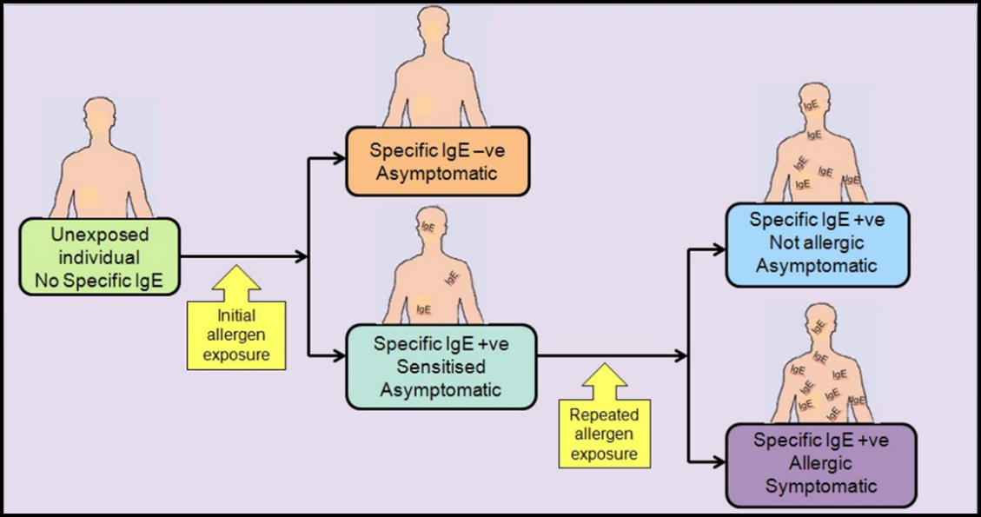

## List any existing MBS item numbers that are relevant for the nominated comparators:

Existing MBS item numbers are unchanged for the nominated comparator as the consultation process leading up to the OFC will not be altered.

## Provide a rationale for why this is a comparator:

The distinguishing factor that identifies standard medical management as the comparator is that standard medical management of a patient with IgE mediated food allergy may not progress to an OFC, even when individual circumstances would warrant this procedure. Accessibility to timely and affordable OFCs are the primary reason standard medical management has been identified as the comparator.

Although other methods of allergy testing are available such as SPT or ssIgE blood tests, neither SPT nor ssIgE is sensitive or specific enough to substitute for a food challenge.[4, 23]

A “positive” food allergy test using SPT or ssIgE indicates that a patient’s immune system has produced an antibody to that food. This is known as being sensitised to an allergen. Positive allergy tests do not correlate well with true clinical reactivity, and false positives frequently occur, which means that the test is positive, yet the person can eat the food without any symptoms.[2, 36, 37] Likewise, there can sometimes be false negative allergy testing, although that is less common with most food allergens than false positive allergy skin or serum testing.

Overall, the positive predictive value of allergy tests varies between foods, and the level of the test (magnitude of the sensitisation) does not correlate well with severity of reactions.[23]

For this reason, it is important to confirm the significance of a positive (or negative) allergy test with an OFC, to prevent unnecessary:

* Avoidance of food/s with associated nutrition and growth implications.
* Prescription of adrenaline devices with associated costs to the Pharmaceutical Benefits Scheme (PBS), and to families.
* Burden of ongoing management of food allergy and associated psychological impacts.

## Pattern of substitution – Will the proposed health technology wholly replace the proposed comparator, partially replace the proposed comparator, displace the proposed comparator or be used in combination with the proposed comparator?

*(Please select your response)*

None (used with the comparator)

Displaced (comparator will likely be used following the proposed technology in some patients)

Partial (in some cases, the proposed technology will replace the use of the comparator, but not all)

Full (subjects who receive the proposed intervention will not receive the comparator)

It is our assessment that an OFC will, in eligible patients, be used as an adjunct to the comparator.

We have selected partial substitution, however, acknowledge that this pattern of substitution may not fully address its intended purpose.

## Outline and explain the extent to which the current comparator is expected to be substituted:

With the availability of an MBS item for OFC, it is expected that clinical immunology/allergy specialists would use this item for all eligible patients. Substitution expectations in private practice are based on the current national annual usage of OFCs in private clinics which is estimated to be:

**Private Practice Outpatient (in rooms)** - 634 patients per month.

**Private Practice Inpatient (day hospital) -** 119 patients per month.

It is expected that funding OFC would result in a 40% - 50% increase in the number of OFCs currently conducted in private clinical immunology/allergy clinics.

# Outcomes

*(Please copy the below questions and complete for each outcome)*

## List the key health outcomes (major and minor – prioritising major key health outcomes first) that will need to be measured in assessing the clinical claim for the proposed medical service/technology (versus the comparator):

*(Please select your response)*

Health benefits

Health harms

Resources

Value of knowing

## Outcome description – include information about whether a change in patient management, or prognosis, occurs as a result of the test information:

OFCs play an important role in confirming the status of food allergies providing diagnostic clarity, empowering both patients and healthcare providers in navigating food allergies more effectively.

The overall outcome of an OFC will be either:

* **Positive\***, when clear objective signs of allergic reaction appear or repetitive (at least three times) or multiple subjective symptoms in several organ systems occur. A positive OFC result confirms an actual food allergy in a person who has never before reacted to or has persisting allergy to that food. This is an expected outcome in a proportion of patients and key clinical steps are embedded in the OFC procedure to ensure that patient safety is well established and maintained throughout the challenge.
* **Negative**, when no symptoms occur. A supervised OFC with a negative result has the potential to exclude food allergy or confirm tolerance, indicating that a patient’s food allergy has resolved. This reduces unnecessary allergen avoidance and associated impacts on quality of life.
* **Inconclusive/Incomplete** if the test is stopped before the required cumulative dose of food is ingested. In young children, 'dose refusal' may occur due to sensory aversion to food texture or taste, despite efforts by staff to modify or disguise the food. In teenagers and young adults, an OFC may be discontinued due to escalating anxiety. At the discretion of the overseeing clinical immunology/allergy specialist, re-testing may be required to yield a conclusive result.

**\*A note on positive results:**

It is expected, for a proportion of patients, that the OFC will provoke an IgE mediated allergic reaction with a challenge food (allergen). All patients who present for an OFC will undergo a pre-challenge assessment which will identify any potential risk factors that would render them unsuitable to proceed with the challenge. Patients deemed suitable to proceed with the OFC will be under close clinical observation for the duration of the procedure with immediate access to emergency equipment such as adrenaline and oxygen and appropriately trained staff using established protocols.

**Summary of benefits as a result of improved access to OFCs (refer to details below)**

Providing an MBS item number for OFC will benefit patients, specifically in relation to:

1. Reduced time to diagnosis
2. Improved nutrition, growth and development
3. Improved quality of life
4. Reduction in other health care costs

**Benefit 1:** **Reduced time to diagnosis**

If OFC is feasible to allow for private clinics to provide the service, this should result in shorter wait times.

* Reducing the time it takes for food allergy to be definitively diagnosed, resolved or ruled out, has immediate flow on effects in terms of better clinical outcomes for the patients.[38]
* A quicker diagnosis allows patients to promptly implement appropriate management strategies, such as avoidance of trigger allergens or initiation of allergy-specific treatments.[39]
* In a national online survey conducted in 2019 by the National Allergy Council of people living with allergies, a delay in diagnosis had the most significant impact on the quality of life of the person with allergies and those who care for them [unpublished data].
* There is also less chance of patients seeking alternate methods of allergy testing (non-evidence-based) which is costly to the patient and their family and can be harmful due to unnecessary allergen avoidance.

**Benefit 2: Improved nutrition, growth and development**.

If OFC is feasible to allow for private clinics to provide the service, this should result in more appropriate management of food allergy:

* With less chance of patients seeking alternate methods of allergy testing (non-evidence-based), which can lead to significant negative health outcomes for patients, placing additional strain on already overburdened health system.
* Reduced need for dietary restriction as dietary restrictions are frequently employed by patients and parents of young children as a means of reducing the risk of allergic reaction prior to an OFC.[4]
* In some cases, diets are unnecessarily restrictive which can significantly impact nutrition, anthropometric development, cognitive development.[4]
* It is important to acknowledge that, although the patient may have undergone OFC to confirm they are not allergic to a particular food, this does not always mean that they are allergy-free. It does however result in a more liberalised diet which may include foods that were previously avoided.

**Benefit 3: Improved quality of life**

Accurate diagnosis of food allergy and identification of trigger allergens significantly improves the quality of life for patients.[37]:

* It reduces food-related anxiety and empowers patients to make informed dietary decisions.
* Confirming trigger allergens reduces the incidence of accidental exposure and subsequent occurrences of anaphylaxis.
* OFCs provide an invaluable opportunity to engage with the patient and provide meaningful education about their allergy, equipping them with essential knowledge about how to recognise signs and symptoms of an allergic reaction and how to correctly administer an adrenaline (epinephrine) device.
* This education helps alleviate anxiety around allergic reactions and fosters a sense of empowerment in managing their condition.[40]

**Benefit 4: Reduction in other health care costs**

Confirming a patient is no longer allergic to a particular food or foods often means that it is no longer necessary for them to carry a prescribed adrenaline (epinephrine) device at all times:

* Patients are provided with a PBS prescription, which means they can purchase adrenaline devices at a cost of $31.60 (for a maximum of 2 devices) in 2025. However, the estimated purchasing pattern for most families of a child with a food allergy, is to ensure one adrenaline device is kept:
  + At the child’s home
  + At the child’s school
  + With staff in out-of-school care facilities
  + With the child during travel between each of these locations

Although adrenaline devices have a 12 month expiry date, it is likely that many devices dispensed to patients and families have an expiration date within 12 months. When considering the individual needs of a school aged child, the potential out-of-pocket expense may include the cost of purchasing up to four additional adrenaline devices to replace expired devices.

* Patients who have had confirmation that their food allergy has resolved no longer require ongoing monitoring, specialised consultations, or allergen-specific treatments, thereby reducing the frequency of healthcare appointments and associated medical costs.
* Confirmation that a diagnosis of food allergy has resolved mitigates the need for patients to pay for other allergy-related medications and special dietary food or supplements.[38]
* There is also less chance of patients seeking alternate methods of allergy testing (non-evidence-based) which is costly to the patient and their family.

# Proposed MBS items

## How is the technology/service funded at present? (e.g., research funding; State-based funding; self-funded by patients; no funding or payments):

Supervised OFCs are currently conducted across Australia within public and private settings without reimbursement. Within the private sector, individuals or their families pay the full cost of the service with no rebate.

Although existing MBS item numbers are available (**Table 4 - MBS funded tests (1 July 2024)**), none provide sufficient remuneration for clinical immunology/allergy specialists to support the delivery of OFCs.

**Appropriate billing of proposed MBS item number – supervised oral food challenge (OFC)**

**Intent**

The intent for OFC item is to provide services through Medicare for private patients undergoing supervised oral food challenge (OFC). Specifically, Medicare benefits will be paid under OFC item where the patient is administered oral food allergens, by or on behalf of a clinical immunology/allergy specialist (consultant physician), where the intention of the clinician is to use the outcome of the challenge to alter management.

For the purpose of claiming benefits under an MBS OFC item, administration of OFC procedure commences with preparing the patient for ingestion of the initial dose of food allergen and ends with the completion of post OFC observation period, regardless of the time expired between the commencement and end.

Medical specialists can only bill an OFC item once each time the patient presents for a procedure.

**Multiple instances of administration in a single day -** There are no clinical instances where this might occur. Medical specialists can only bill OFC item once each time the patient presents for an OFC.

**Professional Attendances -** An appropriate professional attendance item (such as item 116) will only be co-claimed with the item number for OFC, so long as the provisions of the professional attendance are met. For example, in situations where the patient requires ongoing medical specialist oversight, as a result of clinical consequences of the OFC, then the billing of a professional attendance item would be considered appropriate.

**By or on behalf of -** A registered nurse trained in OFC typically performs the administration of OFC allergens, with a clinical immunology/allergy specialist actively supervising and maintaining overall responsibility for the oversight and care of the patient.

The descriptor for OFC item precludes remote or off-site administration of the OFC. This item number is not available where the administration of the OFC occurs at a location other than where a clinical immunology/allergy specialist is on-site.

A clinical immunology/allergy specialist, who is undertaking or supervising the procedure, will bill the service using the provider number associated with the service location.

## Provide at least one proposed item with their descriptor and associated costs, for each Population/Intervention:

## *(Please copy the below questions and complete for each proposed item)*

|  |  |
| --- | --- |
| MBS item number  (where used as a template for the proposed item) |  |
| Category number | **Category 2** – Diagnostic Procedures and Investigations |
| Category description | **D1** (Miscellaneous Diagnostic Procedures and Investigations) **Subgroup 9**. Allergy testing |
| Proposed item descriptor | Supervised oral food challenge (OFC) for the investigation of (IgE mediated) food allergy, usually 4 hours, for a patient if:   1. the necessity for the investigation is determined by a qualified clinical immunology/allergy specialist before the investigation; and 2. there is continuous observation of patient’s allergen tolerance and documentation on an OFC record of the following are made in accordance with current professional guidelines:    1. allergen dose,    2. clinically significant signs of allergic reaction (skin, respiratory, gastrointestinal, cardiovascular/neurological),    3. treatment administered; and 3. medical professional, or registered nurse with OFC training, is in continuous attendance under the supervision of a clinical immunology/allergy specialist; and 4. OFC record and patient is reviewed by clinical immunology/allergy specialist; and 5. for each particular patient—applicable only in relation to each of the first 6 occasions the investigation is performed in any 12-month period. |
| Proposed MBS fee | $392.85 |
| Indicate the overall cost per patient of providing the proposed health technology | $1100.00 |
| Please specify any anticipated out of pocket expenses | $300.00 |
| Provide any further details and explain | There may be out of pocket costs in the form of gap payments to the clinical immunology/allergy specialist which will be at their discretion and cannot be estimated with any certainty. The amount has been estimated to be $300.00 |

Safely conducted OFCs are highly resource-intensive, and are expensive to setup and perform. When taking into consideration the cost of the facility, equipment, nursing and medical staff expertise, OFCs can cost approximately $1100 for a 4-hour procedure, including:

* 2 hours - preparation and delivery of challenge food containing allergen every 15-20 mins over 6 - 8 intervals with concurrent close clinical observation by registered nurse and/or clinical immunology/allergy specialist.
* Up to 2 hours post-challenge clinical observation period by registered nurse and/or clinical immunology/allergy specialist.
* 15 - 30 min – post-challenge patient education by registered nurse and/or clinical immunology/allergy specialist.

Estimated total cost excluding nurse and administrative fees:

|  |  |  |
| --- | --- | --- |
| Item | Unit price ($) | Cost ($) |
| Preparation of and incremental delivery of food containing allergen 15 – 20-minute intervals and concurrent clinical observation for duration of challenge. | 87.30 | 174.60 |
| Post challenge observation period. | 87.30 | 174.60 |
| Post-challenge education. | 87.30 | 43.65 |
| Total estimated cost of OFC - $392.85 | | |

|  |  |
| --- | --- |
| Fee type | Unit price ($)/hr |
| Specialist fee (Item 116) | 87.30 |

# Algorithms

## PREPARATION FOR USING THE HEALTH TECHNOLOGY

## Define and summarise the clinical management algorithm, including any required tests or healthcare resources, before patients would be eligible for the proposed health technology:

Refer to **Figure 3** **- Algorithm for patient investigation.**

Is there any expectation that the clinical management algorithm before the health technology is used will change due to the introduction of the proposed health technology?

No

## Describe and explain any differences in the clinical management algorithm prior to the use of the proposed health technology vs. the comparator health technology:

N/A

## USE OF THE HEALTH TECHNOLOGY

## Explain what other healthcare resources are used in conjunction with delivering the proposed health technology:

**Nursing services:**

* Pre-OFC assessment including SPT, where scope of practice allows.
* OFC appointment scheduling and/or re-scheduling where required.
* Patient education on how to manage food allergy including recognising signs and symptoms of allergic reaction and anaphylaxis and how to administer adrenaline device.
* Post-OFC follow-up phone call.

**Nutrition and dietetics services:**

* Review of dietary needs including assessment of age-appropriate nutritional requirements, particularly for families of young children.
* Provide education on how to identify allergens on food labels.
* Provide education on appropriate food substitutions to ensure age-appropriate nutritional adequacy.
* Provide education on meal preparation, increasing awareness of allergen cross-contamination.

**Pharmaceutical services:**

* Dispensation of prescription medications and infant formulas for the management of food allergy.
* Provide education on how to administer adrenaline device.

**Psychology services:**

* Assessment and management of psychological impact of food allergies including mental, emotional and social considerations (e.g. avoidant/restrictive food intake disorder (ARFID) anxiety, fear, isolation).[21, 41, 42]

## Explain what other healthcare resources are used in conjunction with the comparator health technology:

Healthcare resources used in conjunction with the comparator are the same for an OFC.

## Describe and explain any differences in the healthcare resources used in conjunction with the proposed health technology vs. the comparator health technology:

There are no differences in the healthcare resources used on conjunction with the proposed health technology vs the comparator health technology.

## CLINICAL MANAGEMENT AFTER THE USE OF HEALTH TECHNOLOGY

## Define and summarise the clinical management algorithm, including any required tests or healthcare resources, *after* the use of the proposed health technology:

It is an expected outcome that although the requirements of healthcare resources will be mostly unchanged, the introduction of an MBS funded item number for an OFC will enable more efficient use of these resources for patients and families. Access to a timely OFC will facilitate the appropriate use of other healthcare resources

## Define and summarise the clinical management algorithm, including any required tests or healthcare resources, *after* the use of the comparator health technology:

As previously stated, the clinical management algorithm after the use of the comparator is unlikely to change. However, in the absence of a timely OFC, management of unconfirmed food allergy often involves:

* Unnecessary elimination of core foods, leading to poor nutrition, poor growth and development.
* Development of food anxiety and hesitation leading to disordered eating, and increased potential for social isolation.
* Increase in cost to families for adrenaline devices, doctors’ appointments and purchasing of food and formula substitutions unnecessarily.
* Increase in risk of allergic reactions to food, with potential for increase in presentations to hospital due to anaphylaxis.

## Describe and explain any differences in the healthcare resources used *after* the proposed health technology vs. the comparator health technology:

After an OFC, a definitive diagnosis can be made regarding a patient’s condition. Once certainty about a patient’s food allergy diagnosis has been established, it is then possible for the clinical immunology/allergy specialist to tailor clinical management according to the patient’s needs.

## Insert diagrams demonstrating the clinical management algorithm with and without the proposed health technology:

**Figure 7 -** **Algorithm for clinical management without OFC**

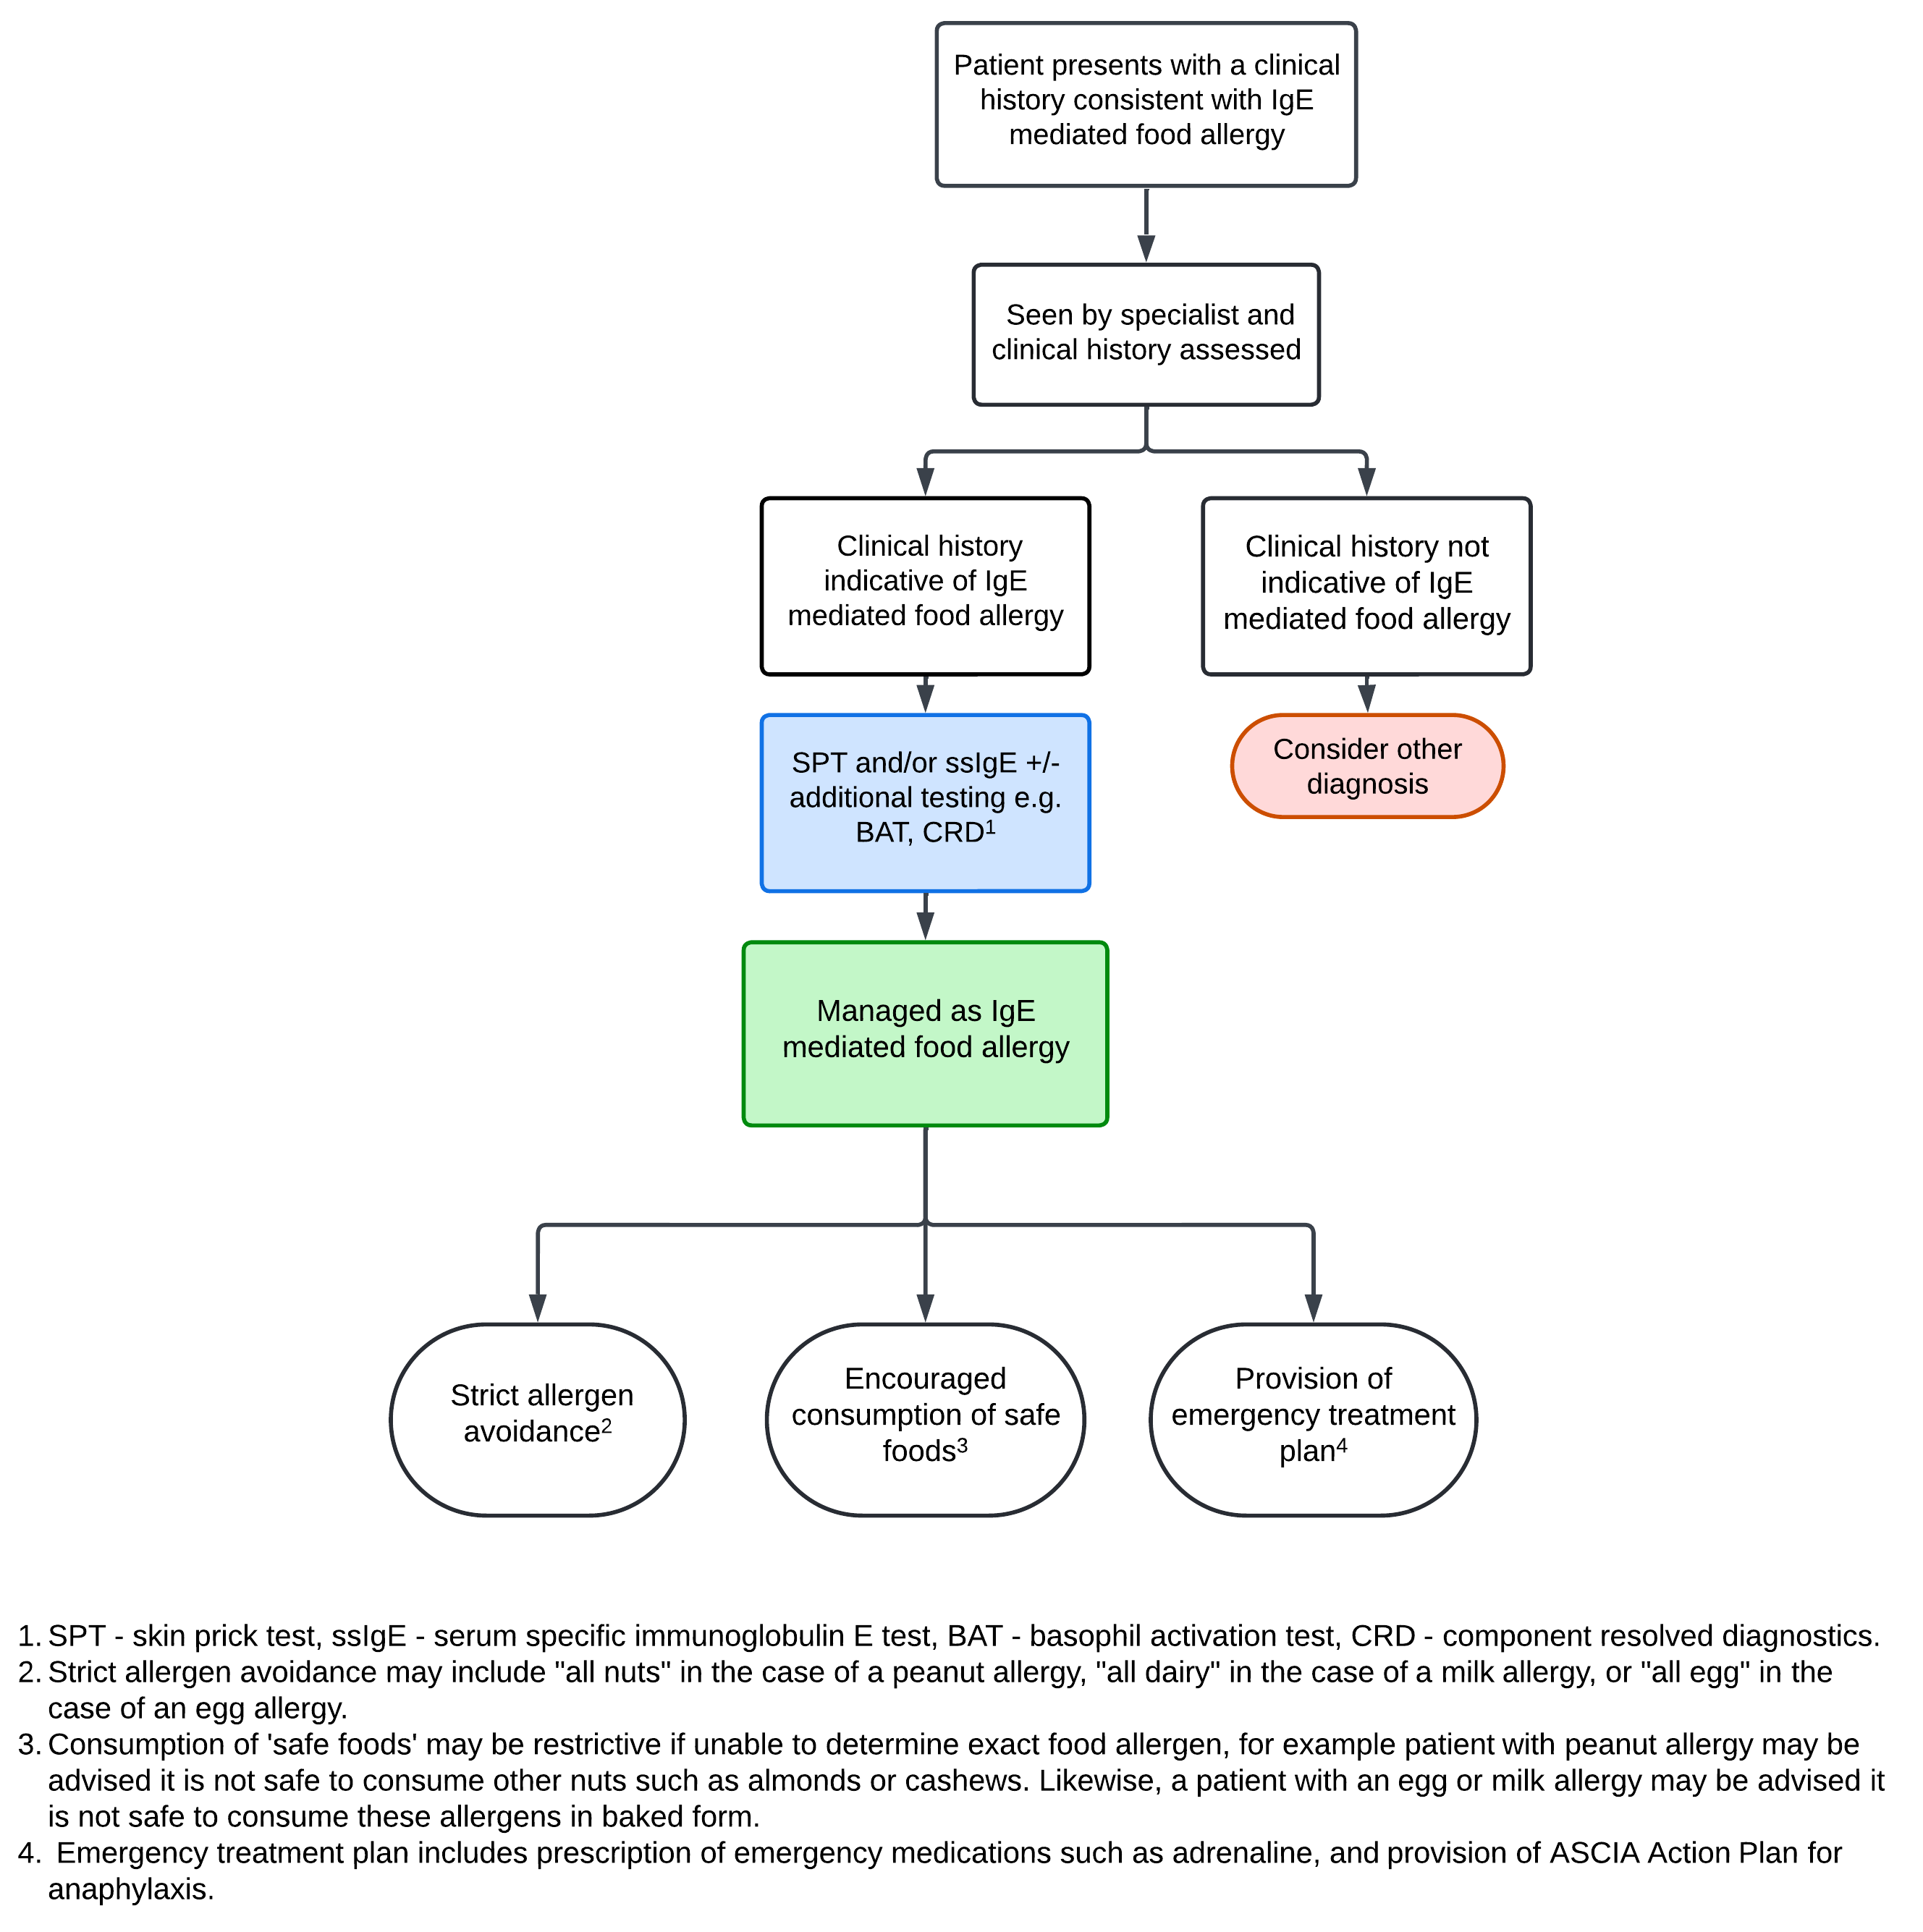

**Figure 8** **- Algorithm for clinical management with OFC**

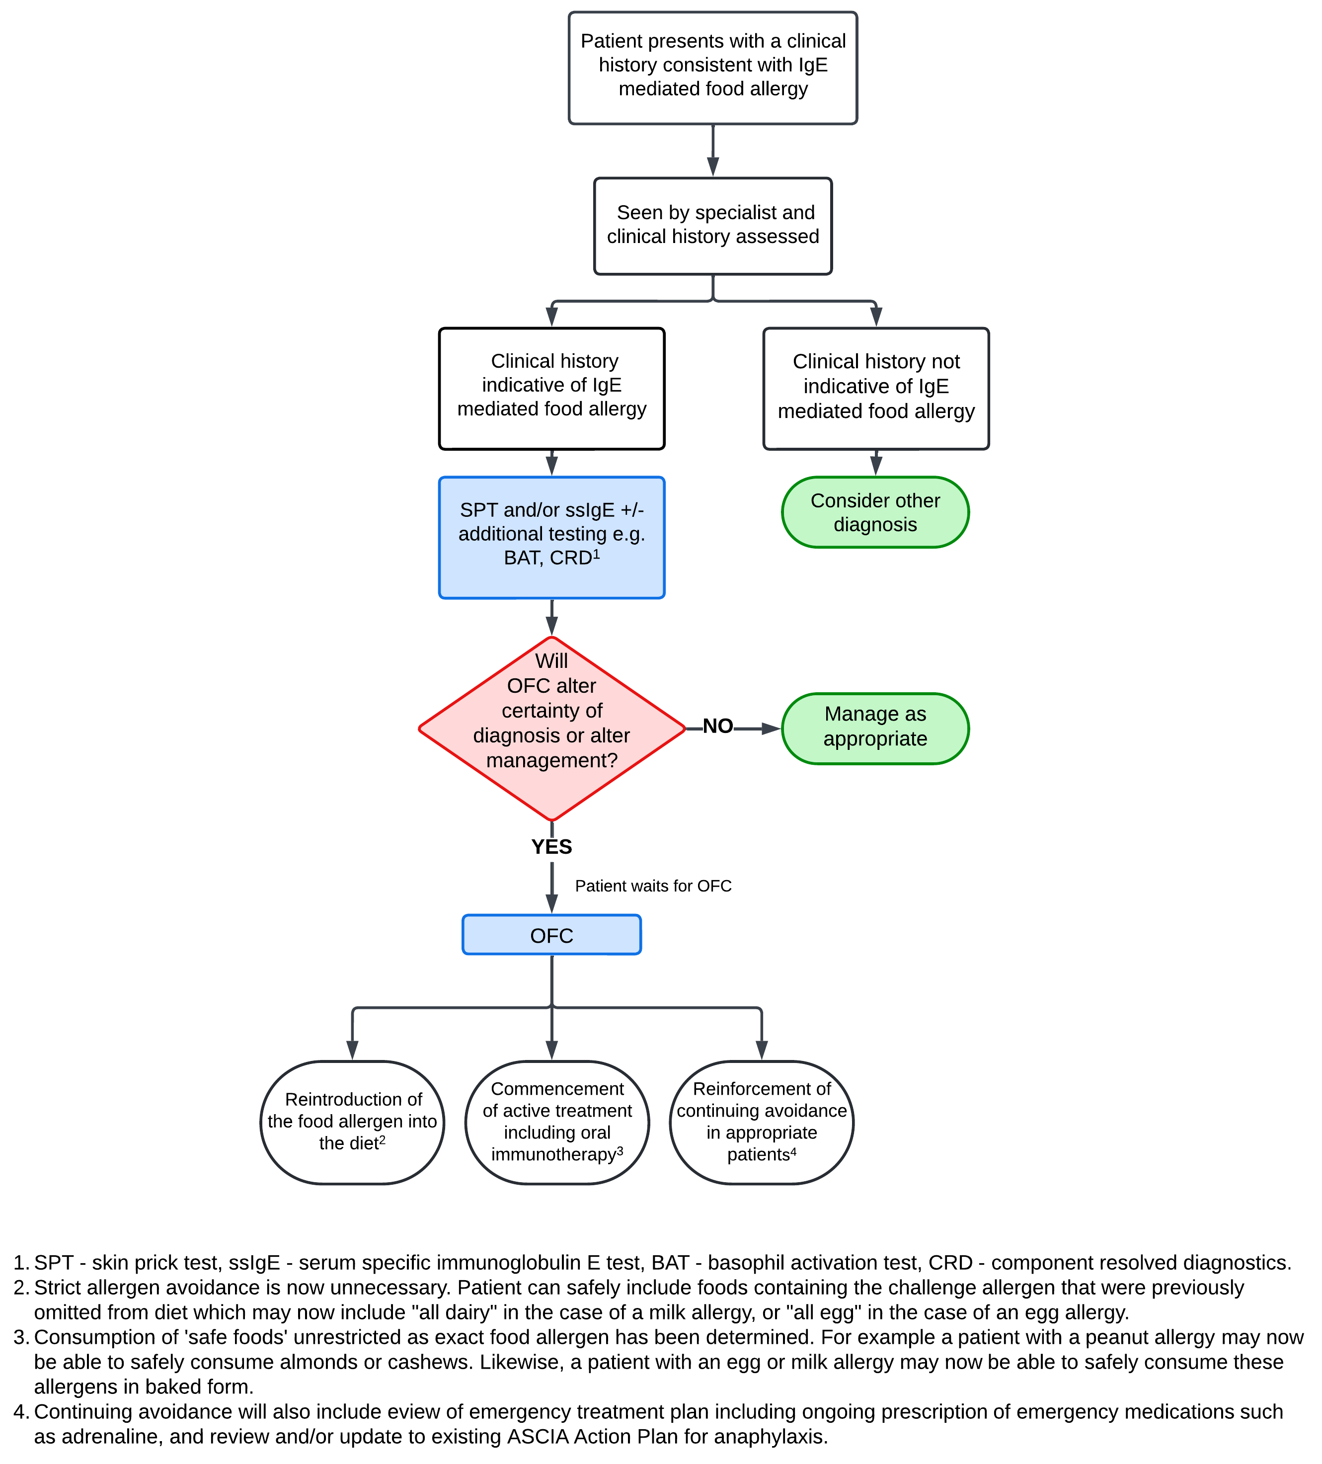

# Claims

## In terms of health outcomes (comparative benefits and harms), is the proposed technology claimed to be superior, non-inferior or inferior to the comparator(s)?

*(Please select your response)*

Superior

Non-inferior

Inferior

## Please state what the overall claim is, and provide a rationale:

The overall claim for an OFC is that it results in superior health outcomes compared to the comparator which, for the purposes of this application, has been identified as standard medical management without an OFC.

## Why would the requestor seek to use the proposed investigative technology rather than the comparator(s)?

The comparator (standard medical management without OFC) relies on the results of allergy testing that does not offer sufficient specificity or reliability to be used as a sole determinant for a patient when the clinical presentation is inconclusive.

The requestor would seek to use a supervised OFC rather than the comparator as an OFC is the most reliable method of determining severity of a patient’s IgE mediated food allergy. An OFC provides the most definitive assessment of their tolerance to certain allergenic foods. It is also the only reliable and safe way to ascertain a patient’s tolerance to different forms of allergenic foods, such as baked milk or baked egg.

## Identify how the proposed technology achieves the intended patient outcomes:

Intended patient outcomes are achieved as a result of the diagnostic certainty that can only be achieved through a supervised OFC. A summary of how the how the results of an OFC achieve intended patient outcomes can be seen in **Table 7 - Benefits of OFC results.**

**Table 7 - Benefits of OFC results**

|  |  |
| --- | --- |
| **Benefits of OFC results** | |
| **Negative (without an allergic reaction)** | **Positive (with an allergic reaction)** |
| One of the main purposes of an OFC is to ‘de-label’ patients by confirming that they no longer have a food allergy.  This has significant impact on quality of life for the patient, their family and other carers, developmental implications, and cost savings.  Benefits include:   * Improved quality of life for patients, their families and other carers, due to patients no longer having to restrict that food in their diet, and elimination of anxiety around the risk of accidental ingestion of that food. * Cost savings due to patients no longer needing to carry an adrenaline (epinephrine) device. This is particularly significant when OFCs are performed in children prior to starting school, thus avoiding years of prescriptions and associated health care visits. * Improved nutritional outcomes, especially in children avoiding staple foods such as milk.   Note - After a negative result for an OFC, the challenge food/s needs to be regularly included in the diet (at least once a week) to maintain tolerance.  Some people who do not eat the food for long periods may become sensitised to the food and have allergic reactions again when they consume the food.  Therefore, an OFC should not be conducted if a patient or their family does not intend to include the food regularly in the diet following a negative OFC result. | If an allergic reaction occurs during the OFC, it will be treated with medications (including adrenaline if indicated), and any other medical measures as needed.  Confirming a suspected food allergy is important for the following reasons:   * To educate about avoidance and preparedness for anaphylaxis. This can be important for teenagers and adults who have avoided a particular food since early infancy with no ongoing inadvertent reactions, as they may have difficulty appreciating the seriousness of their food allergy. * It improves the preparedness of patients with a food allergy (and their family and school or children’s education/care service) to treat anaphylaxis. Preparedness is important as the severity of severe reactions over time is unpredictable, and timely treatment of anaphylaxis substantially reduces the risk of fatality. * Studies have shown improvement in quality of life for patients with a positive challenge result, possibly due to decreased ‘fear of the unknown’ and improved understanding of management. * It establishes that an allergy exists in those where the diagnosis is in question, allowing for appropriate clinical management options to be discussed. |

## For some people, compared with the comparator(s), does the test information result in:

*(Please answer either Yes or No, deleting text as required)*

**A change in clinical management?** Yes

**A change in health outcome?** Yes

**Other benefits?**  Yes

## Please provide a rationale, and information on other benefits if relevant:

In addition to change in clinical management and health outcomes, the results of an OFC will also impact the quality of life of not only the individual, but also their parent/carer:

* Patients may no longer having to restrict food in their diet eliminating anxiety around the risk of accidental ingestion of that food.
* Where a result confirms tolerance to a food allergen, liberation of dietary restrictions can be particularly impactful for children who may face bullying or exclusion at school due to their dietary restrictions.
* It improves the preparedness of patients with a food allergy (and their family and school or children’s education/care service) to treat anaphylaxis. Studies have shown improvement in quality of life for patients with a positive challenge result, possibly due to decreased ‘fear of the unknown’ and improved understanding of management.

## In terms of the immediate costs of the proposed technology (and immediate cost consequences, such as procedural costs, testing costs etc.), is the proposed technology claimed to be more costly, the same cost or less costly than the comparator?

*(Please select your response)*

More costly

Same cost

Less costly

## Provide a brief rationale for the claim:

The cost of providing supervised OFCs is estimated to be around $1100.00. There would be an understandable increase in cost to the provider in order to setup this service, however, the introduction of an MBS item number will enable an increase in the number of OFCs being conducted in private practice, more efficiently once the service has been established. It is also expected that with more equitable access to OFCs for eligible patients, diagnostic certainty will lead to a reduction in associated healthcare costs to the patient and to the health system.

OFCs offer greater diagnostic certainty for patients, enabling more effective lifestyle management plans and better health outcomes. This approach can also result in reduced long-term costs for people with food allergies:

* If a food allergy with a risk of anaphylaxis cannot be excluded without an OFC, the standard practice would require prescribing at least two adrenaline devices annually, at a cost of $159.69 per device. This equates to an expense of up to $319.38 per year. Over 20 years, the total cost to the healthcare system per patient would amount to $6,387.60 (excluding inflation and other factors).
* In contrast, the estimated cost of providing a supervised OFC is approximately $1,100.00 per patient. While there is an initial investment required to establish the infrastructure for offering supervised OFCs, the introduction of an MBS item number would enable private practices to conduct these tests more efficiently. Once the service is established, it is expected to significantly enhance access to OFCs for eligible patients.
* With broader and more equitable access to OFCs, diagnostic certainty can reduce unnecessary long-term healthcare expenses for both patients and the healthcare system.
* By shifting from reliance on emergency medication (adrenaline) to accurate diagnosis and tailored management, this approach not only improves patient outcomes but also optimises resource allocation.

# Summary of Evidence

**Provide one or more recent (published) high quality clinical studies that support use of the proposed health service/technology.**

Identify yet-to-be-published research that may have results available in the near future (that could be relevant to your application).

|  | **Type of study design\*** | **Title of journal article or research project (including any trial identifier or study lead if relevant)** | **Short description of research (max 50 words)\*\*** | **Website link to journal article or research (if available)** | **Date of publication\*\*\*** |
| --- | --- | --- | --- | --- | --- |
|  | Systematic review | Feeding difficulties in children with food allergies: An EAACI Task Force Report | Feeding difficulties are prevalent among children with food allergies, more so among those that have multiple allergies. Consensus guidelines and further research is needed to enable the appropriate management of these patients. | https://onlinelibrary.wiley.com/doi/epdf/10.1111/pai.14119 | 2024 |
|  | Guidelines | EAACI guidelines on the diagnosis of IgE-mediated food allergy | European Academy of Allergy and Clinical Immunology (EEACI) guidelines have been developed on immediate food allergy diagnosis, providing recommendations and best practice with supporting evidence. It is aimed at health professionals that see patients with food allergy. | <https://hub.eaaci.org/resources_guidelines/eaaci-guidelines-on-the-diagnosis-of-ige-mediated-food-allergy/> | 2023 |
|  | Discussion | Will Oral Food Challenges Still Be Part of Allergy Care in 10 Years' Time? | Oral food challenges can help patients manage their symptoms appropriately and can provide some reassurance among non- reactive cases. It is likely that oral food challenges will still be undertaken in 10 years, however there is hope that alternative tests will be developed that carry less risk of anaphylaxis. Oral food challenges will still be the best test in some cases however. | <https://pubmed.ncbi.nlm.nih.gov/36822320/> | 2023 |
|  | Review article | The future of food allergy: Challenging existing paradigms of clinical practice | Self-reported food allergies are overestimated – a review found that milk allergy symptoms reported by parents are 15 to 20 times more frequent than confirmed test results. The oral food challenge is the gold standard test for food allergy, and further diagnostic methods are emerging. | <https://onlinelibrary.wiley.com/doi/full/10.1111/all.15757> | 2023 |
|  | Review article | Food allergy, mechanisms, diagnosis and treatment: Innovation through a multi-targeted approach | Food allergy impacts negatively on quality of life and the economy, impacting approximately 10% of infants and 4-5% of children and young adolescents. Australian-based studies identified oral food challenges as the gold standard for food allergy diagnosis, although there have been advancements in other diagnostic tests. | <https://onlinelibrary.wiley.com/doi/full/10.1111/all.15418> | 2022 |
|  | Population-­based longitudinal study | Out-of-hospital health care costs of childhood food allergy in Australia: A population-based longitudinal study | Food allergy in children 4 years and under is associated with significant Medicare costs, which is approximately $26 million annually. Costs are substantially lower than the US, which may be due to GPs playing a greater role in allergy management in Australia, avoiding expensive emergency department presentations and hospital admissions. | <https://pubmed.ncbi.nlm.nih.gov/36433856/> | 2022 |
|  | Literature review | The dilemma of open or double-blind food challenges in diagnosing food allergy in children: Design of the ALDORADO trial | Self-reported food allergies are increasing. Appropriate testing is important to remove parent hesitancy to provide a varied diet for their child, to improve quality of life, and avoid life-threatening reactions. Oral food challenges are the gold standard, and can confirm diagnosis, determine threshold dose, and identify possible tolerance. | <https://www.ncbi.nlm.nih.gov/pubmed/34435396> | 2022 |
|  | Commentary | Separating Fact from Fiction in the Diagnosis and Management of Food Allergy | It has been found that quality of life is worse for children with peanut allergy compared with other chronic childhood diseases including type 1 diabetes mellitus. A study found that foods avoided due to positive skin prick or food-specific IgE tests, could be reintroduced after an oral food challenge. | <https://www.ncbi.nlm.nih.gov/pubmed/34678246> | 2022 |
|  | Research letter | Suitability of low-dose, open food challenge data to supplement double-blind, placebo-controlled data in generation of food allergen threshold dose distributions | Food allergy data from double-blind, placebo-controlled food challenges can assist in research and risk management decision-making. Although as there is a lack of this data, open food challenges can fill gaps around priority foods (e.g. tree nuts, shellfish) and foods that less commonly cause allergy (e.g. corn, lentil). | <https://www.ncbi.nlm.nih.gov/pubmed/33030225> | 2021 |
|  | Review article | Update on food allergy | Diagnosing food allergies is critical to mitigate risk of allergic reactions and promote dietary liberation (which also prevents food allergies). Food allergies are costly on the healthcare system and families. Food avoidance impacts on restaurants, manufacturers, schools and other public spaces. Diagnosis can minimise impacts through education and management strategies. | <https://www.ncbi.nlm.nih.gov/pubmed/33370488> | 2021 |
|  | Systematic literature review | ImmunoCAP ISAC in food allergy diagnosis: a systematic review of diagnostic test accuracy | There is insufficient evidence to replace the gold standard oral food challenge with ImmunoCAP ISAC, and further evidence is required to support its replacement. | <https://www.ncbi.nlm.nih.gov/pubmed/33847011> | 2021 |
|  | Retrospective data collection | Predicting food allergy: The value of patient history reinforced | Patient history is important for determining presence of food allergy, and should include symptoms, timing, reproducibility and co-existing allergic diseases. It can aid in the clinician’s decision-making and potentially avoid unnecessary testing. | <https://www.ncbi.nlm.nih.gov/pubmed/32894581> | 2021 |
|  | Pragmatic, parallel-group, multi-centre, assessor-blind, randomized-controlled trial | An algorithm for diagnosing IgE-mediated food allergy in study participants who do not undergo food challenge | Food allergy has a significant health and economic impact. The double-blind, placebo-controlled oral food challenge is the diagnostic gold standard; however can be unpleasant, time-consuming and risky. An algorithm can be used if the challenge cannot be done, however should not replace the gold standard due to its moderate specificity. | <https://www.ncbi.nlm.nih.gov/pubmed/31999862> | 2020 |
|  | Clinical communication | Differences in the evaluation of skin prick testing results for food allergy diagnosis between US and UK physicians | There are inconsistences between US and UK, around how skin prick tests are interpreted, leading to conflicting diagnoses. Standardisation across countries around measurement and interpretation is important to evaluate food allergy consistently. | <https://www.ncbi.nlm.nih.gov/pubmed/32531480> | 2020 |
|  | Systematic literature review | Quality Of Life in Patients with Food Allergy: A Systematic Review and Meta-Analysis of interventions Food Allergy Diagnosis and Immunotherapy Studies | Food allergy impacts negatively on quality of life due to anxiety, and also has social and economic impacts. Oral food challenges and oral immunotherapy can improve quality of life. | <https://www.jacionline.org/article/S0091-6749(19)31856-1/fulltext> | 2020 |
|  | Review article | Food allergy: an updated review on pathogenesis, diagnosis, prevention and management | Food allergy diagnosis is based on diagnostic testing (skin prick test and allergen-specific IgE levels in the serum), clinical history, oral food challenge and elimination diet. Diagnostic tests and clinical history may provide sufficient information to make an accurate diagnosis, however an oral food challenge is required in some cases. | <https://www.ncbi.nlm.nih.gov/pubmed/33004782> | 2020 |
|  | World Allergy Organisation position paper | IgE allergy diagnostics and other relevant tests in allergy, a World Allergy Organization position paper | Skin prick testing is a commonly used diagnostic test for food allergy due to its low cost, simplicity and rapidity. It must be carried out by an experienced and knowledgeable clinician. Other tests include Serum IgE and Basophil Activation Test. Standardisation will achieve more accuracy that will improve health outcomes. | <https://www.ncbi.nlm.nih.gov/pubmed/32128023> | 2020 |
|  | Review article | Diagnosis and Management of Food Allergy | Food allergy diagnosis is critical to address dietary restrictions and poor quality of life due to food allergy. Diagnosis can include clinical history, skin prick testing, allergen-specific serum immunoglobulin E test and oral food challenge. There are other diagnostic measures that are emerging and show some promise. | <https://www.ncbi.nlm.nih.gov/pubmed/31466683> | 2019 |
|  | Review article | Oral Food Challenge | Oral food challenges are the gold standard for IgE-mediated and non-IgE mediated food allergy diagnosis. Although sometimes clinical history and other diagnostic tests can be sufficient, oral food challenges are required for in other cases. They should be carried out by experienced health professionals in an environment equipped for emergencies. | <https://www.ncbi.nlm.nih.gov/pubmed/31569825> | 2019 |
|  | Review article | IgE-Mediated Food Allergy | Prevalence of food allergy is significantly higher than the proportion of people that believe they have a food allergy. Food allergy is costly for families, which includes cost of special foods. Oral food challenges can confirm food allergy, and enable appropriate management through dietary advice. | <https://www.ncbi.nlm.nih.gov/pubmed/30370459> | 2019 |
|  | Review article | Food allergy: A review and update on epidemiology, pathogenesis, diagnosis, prevention, and management | Food allergy prevalence is increasing, particularly in Australia. Oral food challenges (OFC) are an appropriate diagnostic method for some patients, and counselling can address patient fear. OFCs are safe if carried out by an experienced health professional. Quality of life improves after an OFC, even if an allergic reaction occurs. | <https://www.ncbi.nlm.nih.gov/pubmed/29157945> | 2018 |
|  | Review article | Advances in the approach to the patient with food allergy | Food allergies have significant adverse medical, economic and psychosocial effects on families. Engagement with the right health professional can ensure accurate diagnosis and can support patients to safely engage in activities and promote community awareness. Improved standardisation of oral food challenges in clinical settings is necessary. | <https://www.ncbi.nlm.nih.gov/pubmed/29524535> | 2018 |
|  | Review article | Cross-Reactive Aeroallergens: Which Need to Cross Our Mind in Food Allergy Diagnosis? | Diagnosis of secondary food allergies (between food allergen and inhalant) is a significant public health issue. Diagnosis is often not straightforward, and oral provocations are required for inconclusive cases, so that correct dietary advice can be provided, avoiding unnecessary restrictive diets. | <https://www.ncbi.nlm.nih.gov/pubmed/30172018> | 2018 |
|  | Review article | Do we still need oral food challenges for the diagnosis of food allergy? | The demand for accurate food allergy diagnoses is increasing, and oral food challenges (OFC) are the gold standard. They can also be used to follow-up patients who may have outgrown their allergy. Solutions can address the complexity of OFCs, such as skilled health professionals, correct management and safe settings. | <https://www.ncbi.nlm.nih.gov/pubmed/29240247> | 2018 |
|  | Review article | Road map for the clinical application of the basophil activation test in food allergy | Oral food challenges (OFCs) are often required to confirm diagnosis of food allergy. Although safe in qualified settings, severe reactions do occur, and a significant amount of resource and experience is required. The basophil activation test is an emerging practice that is being assessed as a possible alternative to OFCs. | <https://www.ncbi.nlm.nih.gov/pubmed/28618090> | 2017 |
|  | Review article | Food Allergy: What We Know Now | Self-reported food allergy symptoms are a poor predictor of disease, and testing is required to confirm. Skin prick testing is accessible and low-cost, however oral food challenges (OFCs) are gold standard. Open OFCs can be done in a clinic, and patient can undergo further blinded testing if symptoms are questionable. | <https://www.ncbi.nlm.nih.gov/pubmed/28317623> | 2017 |
|  | Multi-centre prospective cohort study | Peanut Allergen Threshold Study (PATS): Novel single-dose oral food challenge study to validate eliciting doses in children with peanut allergy | A single-dose oral food challenge was found to be safe and acceptable to families. It can identify the most highly-sensitive people with food allergy and improves quality of life. It is easier to perform than current oral food challenges. This method once validated, could improve public health approaches to allergy. | <https://www.ncbi.nlm.nih.gov/pubmed/28238744> | 2017 |
|  | Review article | Food allergy: immune mechanisms, diagnosis and immunotherapy | Oral food challenges are the only definitive method to diagnose food allergy, however should only be undertaken in properly equipped centres with specialist staff. New treatments are emerging, and reliable, inexpensive tests with no risk of anaphylaxis are required to enable these treatments to become part of standard care. | <https://www.ncbi.nlm.nih.gov/pubmed/27795547> | 2016 |
|  | Review article | Pearls and Pitfalls in Diagnosing IgE-Mediated Food Allergy | Obtaining an accurate diagnosis is critical for patients to manage their allergy, including having access to an adrenalin auto-injector in case they ingest the allergen. It is also important that false positives do not occur, as food avoidance can cause nutritional deficits and impact on quality of life. | <https://www.ncbi.nlm.nih.gov/pubmed/27039392> | 2016 |
|  | Review article | Current concepts: diagnosis and management of food allergy in children | A food challenge by the right health professional is required to confirm a suspected food allergy. Skin prick and serum IgE tests can be useful as they can predict an oral food challenge reaction and can confirm clear history of allergy. Where there is uncertainty, a food challenge is required. | <https://www.ncbi.nlm.nih.gov/pubmed/26982622> | 2016 |
|  | Multi-centre prospective cohort study | Prevalence of sensitization to food allergens and challenge proven food allergy in patients visiting allergy centres in Rawalpindi and Islamabad, Pakistan | Food allergy prevalence is increasing. It impacts on quality of life and adds to the economic burden. Standardisation of methodologies is needed to support epidemiological studies to measure true prevalence. In this study, oral food challenges found that wheat allergy was most prevalent, followed by egg, chicken, beef and fish. | <https://www.ncbi.nlm.nih.gov/pubmed/27563525> | 2016 |
|  | Retrospective cross-sectional study | Failure of introduction of food allergens after negative oral food challenge tests in children | Oral food challenges can avoid the unnecessary elimination of foods, although dietary advice is needed immediately following the challenge to promote re-introduction of foods. Long-term avoidance of an allergen may also increase the risk of developing an allergy. Families need assurance that result is negative to remove fear of re-introduction. | <https://www.ncbi.nlm.nih.gov/pubmed/25762026> | 2015 |
|  | Review article | Food Allergy: Common Causes, Diagnosis, and Treatment | Accurate prevalence of food allergy is difficult to predict to imprecise diagnoses. A positive skin prick test or serum IgE result will suggest sensitisation, however a clinical history or positive oral food challenge result is needed to confirm allergy. | <https://www.ncbi.nlm.nih.gov/pubmed/26434966> | 2015 |
|  | Review article | Optimizing the diagnosis of food allergy | Accurate food allergy diagnoses are crucial to identify patients with severe allergy and avoid unnecessary diet restrictions. Skin prick testing and serum IgE measures can detect sensitisation but lack clinical relevance. Oral food challenges can confirm food allergy, however clinicians need to weigh the risks and benefits prior to commencement. | https://www.ncbi.nlm.nih.gov/pubmed/25459577 | 2015 |
|  | Report of results of a retrospective chart review | Pitfalls in food allergy diagnosis: serum IgE testing | Food allergy misdiagnosis can lead to nutritional deficiencies, increased anxiety, reduced quality of life, and economic impacts due to additional testing, unnecessary prescriptions, further medical evaluations and purchasing special foods. Allergists can conduct skin testing and oral food challenges to confirm food allergy, and should work in collaboration with GPs. | <https://www.ncbi.nlm.nih.gov/pubmed/25449218> | 2015 |
|  | Literature review | Diagnosis and treatment of paediatric food allergy: an update | Oral food challenges will confirm allergy and hence provide a better indication of prevalence and avoid unnecessary food elimination. Food avoidance in children can lead to malnutrition, poor growth, social restrictions and decreased quality of life. Most food allergies resolve in the first years, and re-evaluation is therefore fundamental. | <https://www.ncbi.nlm.nih.gov/pubmed/25880827> | 2015 |
|  | Review article | Diagnosis of Food Allergy | Although clinical history is the most important component of food allergy diagnosis, blood and skin tests and food challenges can provide confirmation where required, with oral food challenges being the gold standard. Specialists play an important role in food allergy diagnosis and management, however a multidisciplinary approach is required. | <https://www.ncbi.nlm.nih.gov/pubmed/26456439> | 2015 |
|  | Systematic review and meta-analysis | The diagnosis of food allergy: a systematic review and meta-analysis | Clinical history is the fundamental step of food allergy diagnosis. Skin prick and ssIgE tests are sensitive but lack specificity. Oral food challenges are the gold standard however are costly and time and resource intensive. Clinicians need to consider accuracy, safety, availability and cost when determining the patient’s diagnostic pathway. | https://www.ncbi.nlm.nih.gov/pubmed/24329961 | 2014 |
|  | Position paper | EAACI food allergy and anaphylaxis guidelines: diagnosis and management of food allergy | Oral food challenges (preferably double-blind, placebo-controlled) are the gold standard, although facilities and reimbursements are lacking. Food allergy diagnosis and management needs to be multidisciplinary between allergists, GPs and Centres of Excellence, and education tools are required to support this model. National healthcare system reimbursement is necessary to enable this. | <https://www.ncbi.nlm.nih.gov/pubmed/24909706> | 2014 – updated in 2023, see reference 2. |
|  | Retrospective cohort study. | Predicting outcomes of oral food challenges by using the allergen-specific IgE-total IgE ratio | Food allergy impacts on a parent’s and child’s quality of life. Enabling allergists to conduct more oral food challenges (OFCs) on children as early as possible can diminish this impact. Specific IgE to total IgE Ratios is a tool that may help better predict OFC outcomes, and therefore increase uptake. | https://www.ncbi.nlm.nih.gov/pubmed/24811021 | 2014 |
|  | Population-based, longitudinal study | Skin prick test responses and allergen-specific IgE levels as predictors of peanut, egg, and sesame allergy in infants | Positive predictive values (PPVs) have been developed to predict likelihood of food allergy in young children, based on clinic population data, from skin prick test results, serum allergen-specific IgE (sIgE) levels, and oral food challenge (OFC) results. PPVs can potentially avoid the resource-intensive and stressful OFCs. | <https://www.ncbi.nlm.nih.gov/pubmed/23891354> | 2013 |
|  | Review article | The value of mucosal allergen challenge for the diagnosis of food allergy | Food allergy has increased, affecting 1-4% of adults and 6-8% of children. They can be life threatening however if misdiagnosed, they can cause unnecessary fear, social exclusion and economic burden. Food challenges will provide the correct diagnosis, however are often not performed. Mucosal provocation tests may be an appropriate alternative. | <https://www.ncbi.nlm.nih.gov/pubmed/23571410> | 2013 |
|  | Review article | The regulatory challenge of food allergens | Food allergy is a world-wide public health issue, and people with an allergy must avoid eating foods that may provoke a life-threatening reaction. Regulatory agencies need to work in an integrated way to protect people with food allergies. Clear information about food ingredients must be provided. | https://www.ncbi.nlm.nih.gov/pubmed/22866605 | 2013 |
|  | Review article | Food allergen profiling: A big challenge | Food allergy is a growing public health concern, and appropriate management is necessary to reduce impact to quality of life. An accurate food allergy diagnosis is necessary to avoid foods that may cause reaction, avoid unnecessary food restrictions, and enable possible immunotherapy treatments. | <https://www.sciencedirect.com/science/article/abs/pii/S0963996913001762> | 2013 |
|  | Consensus report | Standardizing double-blind, placebo-controlled oral food challenges: American Academy of Allergy, Asthma & Immunology-European Academy of Allergy and Clinical Immunology PRACTALL consensus report | Food challenges are important as they can confirm whether or not a patient has a food allergy, can establish the minimal threshold before clinical symptoms appear, and can provide research benefit. Carrying out food challenges can help researchers to further understand food allergy mechanisms and develop new therapies. | <https://www.ncbi.nlm.nih.gov/pubmed/23195525> | 2012 |
|  | Perspective report | ICON: food allergy | Studies show that over half of self-reported allergies are not true allergies, and accurate diagnosis is therefore critical to avoid unnecessary food restrictions. Physical examination and Clinical history is not enough to confirm food allergy, and additional testing is required. Food challenge procedures need to be standardised and promoted. | <https://www.ncbi.nlm.nih.gov/pubmed/22365653> | 2012 |
|  | Retrospective chart review | Oral food challenges in children with a diagnosis of food allergy | Oral food challenge (OFC) results have demonstrated that many people are on unnecessary dietary restrictions. The uptake of food elimination diets and reliance on inaccurate indicators of food allergy is concerning. The lack of practices that can conduct OFCs (possibly due to safety or cost) adds to this problem. | <https://www.ncbi.nlm.nih.gov/pubmed/21030035> | 2011 |
|  | Guidelines | Guidelines for the diagnosis and management of food allergy in the United States: summary of the NIAID-sponsored expert panel report | An expert panel representing scientific, clinical and public health domains recommend oral food challenges to be used to diagnose food allergy. Other tests such as skin prick, intradermal and sIgE are not reliable on their own, however can support diagnosis. Risk of evaluations should be assessed on an individual basis. | <https://www.ncbi.nlm.nih.gov/pubmed/21310308> | 2011 |
|  | Prospective multi-centre cohort study | Exhaled nitric oxide decreases after positive food-allergen challenge | Food challenges are considered the gold standard for food allergy diagnosis. This study identified changes in nitric oxide exhalation levels after positive challenges, but further studies are needed to explore this further. | <https://www.ncbi.nlm.nih.gov/pubmed/22409969> | 2011 |
|  | Guidelines | Guidelines for the diagnosis and management of food allergy in the United States: report of the NIAID-sponsored expert panel | Diagnosing food allergy and identifying culprit foods can improve quality of life and prevent life-threatening reactions. Appropriate evaluations can reduce the risk of misdiagnoses, leading to unnecessary dietary restrictions which impacts on social and nutritional well-being. Delays can lead to harm and the possibility of death. | <https://www.ncbi.nlm.nih.gov/pubmed/21134576> | 2010 |
|  | Review article | Diagnosis of food allergy based on oral food challenge test | Oral food challenges are the most reliable procedure for food allergy diagnosis and food allergy tolerance. Few clinics offer the challenge and there is no standardised protocol. Rather than following one universal procedure, the process needs to be based on the patient needs and available resources. | <https://www.ncbi.nlm.nih.gov/pubmed/19847093> | 2009 |
|  | Review article | Food allergen detection methods and the challenge to protect food-allergic consumers | Methods are being developed for detection of allergens in foods, which is an ongoing effort. It is important to know how much of an allergenic food can cause an allergic reaction. Oral food challenges are the gold standard to determining reactivity of allergens at low concentrations in individuals. | <https://www.ncbi.nlm.nih.gov/pubmed/17530230> | 2007 |
|  | Comparative study | Reducing the need for food allergen challenges in young children: a comparison of in vitro with in vivo tests | The double-blind placebo-controlled food challenge is the gold standard for food allergy diagnosis. It is however risky and time-consuming. Standardised skin test methodologies could improve clinical relevance of skin-prick testing and reduce the need for food challenges. | <https://www.ncbi.nlm.nih.gov/pubmed/11467993> | 2001 |

*\* Categorise study design, for example meta-analysis, randomised trials, non-randomised trial or observational study, study of diagnostic accuracy, etc.*

*\*\*Provide high level information including population numbers and whether patients are being recruited or in post-recruitment, including providing the trial registration number to allow for tracking purposes. For yet to be published research, provide high level information including population numbers and whether patients are being recruited or in post-recruitment.*

*\*\*\* If the publication is a follow-up to an initial publication, please advise. For yet to be published research, include the date of when results will be made available (to the best of your knowledge).*

# References

1. Calvani, M., et al., *Food allergy: an updated review on pathogenesis, diagnosis, prevention and management.* Acta Bio-Medica: Atenei Parmensis, 2020. **91**(11-S): p. e2020012.

2. Anvari, S., et al., *IgE-Mediated Food Allergy.* Clinical Reviews in Allergy and Immunology, 2019. **57**(2): p. 244-260.

3. Santos, A.F., et al., *EAACI guidelines on the diagnosis of IgE-mediated food allergy.* Allergy, 2023. **78**(12): p. 3057-3076.

4. Peters, R.L., et al., *Update on food allergy.* Pediatric Allergy and Immunology, 2021. **32**(4): p. 647-657.

5. Nguyen, D.I., et al., *Quality of life is lower in food allergic adolescents compared to young children at a community educational symposium.* Allergy, Asthma and Clinical Immunology, 2023. **19**(1): p. 99.

6. Miller, J., et al., *Quality of life in food allergic children: Results from 174 quality-of-life patient questionnaires.* Annals of Allergy, Asthma and Immunology, 2020. **124**(4): p. 379-384.

7. Abrams, E.M., et al., *Qualitative analysis of perceived impacts on childhood food allergy on caregiver mental health and lifestyle.* Annals of Allergy, Asthma & Immunology, 2020. **124**(6): p. 594-599.

8. Santos, A.F., et al., *EAACI guidelines on the management of IgE-mediated food allergy.* Allergy, 2025. **80**(1): p. 14-36.

9. de Weger, W.W., et al., *The dilemma of open or double-blind food challenges in diagnosing food allergy in children: Design of the ALDORADO trial.* Pediatric Allergy and Immunology, 2022. **33**(1): p. e13654.

10. Hua, X., et al., *Out-of-hospital health care costs of childhood food allergy in Australia: A population-based longitudinal study.* Pediatric Allergy and Immunology, 2022. **33**(11): p. e13883.

11. Osborne, N.J., et al., *The HealthNuts population-based study of paediatric food allergy: validity, safety and acceptability.* Clinical and Experimental Allergy, 2010. **40**(10): p. 1516-1522.

12. Peters RL, S.V., Allen KJ, Tang MLK, Perrett KP, Lowe AJ, Wijesuriya R, Parker KM, Loke P, Dharmage SC, Koplin JJ, *The Prevalence of IgE-Mediated Food Allergy and Other Allergic Diseases in the First 10 Years: The Population-Based, Longitudinal HealthNuts Study.* The Journal of Allergy and Clinical Immunology in Practice, 2024.

13. Sasaki, M., et al., *Prevalence of clinic-defined food allergy in early adolescence: The SchoolNuts study.* Journal of Allergy and Clinical Immunology 2018. **141**(1): p. 391-398.e4.

14. Fleischer, D.M., et al., *The natural progression of peanut allergy: Resolution and the possibility of recurrence.* Journal of Allergy and Clinical Immunology, 2003. **112**(1): p. 183-189.

15. Al-Muhsen, S., A.E. Clarke, and R.S. Kagan, *Peanut allergy: an overview.* Canadian Medical Association Journal, 2003. **168**(10): p. 1279-85.

16. Savage, J., S. Sicherer, and R. Wood, *The Natural History of Food Allergy.* The Journal of Allergy and Clinical Immunology in Practice, 2016. **4**(2): p. 196-203; quiz 204.

17. Tang, M.L.K. and R.J. Mullins, *Food allergy: is prevalence increasing?* Internal Medicine Journal, 2017. **47**(3): p. 256-261.

18. Gupta, R., et al., *Global distribution of physician-diagnosed adult-onset food allergy: results from the international, cross-sectional prevalence and severity study of pediatric and adult IgE-mediated food allergies (ASSESS FA).* Journal of Allergy and Clinical Immunology, 2024. **153**(2): p. AB45.

19. Verhoeven, D.H.J., et al., *Successful Introduction of Peanut in Sensitized Infants With Reported Reactions at Home.* The Journal of Allergy and Clinical Immunology in Practice, 2024. **12**(12): p. 3363-3369.

20. Fong, A.T., et al., *The Economic Burden of Food Allergy: What We Know and What We Need to Learn.* Current Treatment Options in Allergy, 2022. **9**(3): p. 169-186.

21. Patrawala, M.M., et al., *Avoidant-restrictive food intake disorder (ARFID): A treatable complication of food allergy.* The Journal of Allergy and Clinical Immunology in Practice, 2022. **10**(1): p. 326-328 e2.

22. House of Representatives Standing Committee on Health Aged Care and Sport, *Walking the allergy tightrope Addressing the rise of allergies and anaphylaxis in Australia*. 2020: Canberra

23. Patel, N., et al., *Will Oral Food Challenges Still Be Part of Allergy Care in 10 Years' Time?* The Journal of Allergy and Clinical Immunology in Practice, 2023. **11**(4): p. 988-996.

24. Hua, T., et al., *Food allergy management in Early Childhood Education and Care Services in Australia.* Journal of Paediatrics and Child Health, 2020. **56**(3): p. 394-399.

25. Proctor, K.B., A.M. Ramos, and L.J. Herbert, *"The peanut butter didn't attack me": Food allergen proximity challenges to improve quality of life.* Annals of Allergy, Asthma & Immunology, 2023. **131**(1): p. 9-10.

26. Stockhammer, D., et al., *Parent perceptions in managing children with food allergy: An Australian perspective.* World Allergy Organization Journal, 2020. **13**(10).

27. Cao, S., et al., *Improvement in Health-Related Quality of Life in Food-Allergic Patients: A Meta-Analysis.* The Journal of Allergy and Clinical Immunology in Practice, 2021. **9**(10): p. 3705-3714.

28. Sampson, H.A., et al., *AAAAI-EAACI PRACTALL: Standardizing oral food challenges-2024 Update.* Pediatric Allergy and Immunology, 2024. **35**(11): p. e14276.

29. Wang, J., *Food challenges: Patient selection, predictors, component testing, and decision points.* Journal of Food Allergy, 2023. **5**(2): p. 38-42.

30. Australian Commission on Safety and Quality in Health Care, *Acute Anaphylaxis Clinical Care Standard*. 2021.

31. Jones, S.M., et al., *Efficacy and safety of oral immunotherapy in children aged 1-3 years with peanut allergy (the Immune Tolerance Network IMPACT trial): a randomised placebo-controlled study.* Lancet, 2022. **399**(10322): p. 359-371.

32. Sampson, H.A., et al., *Standardizing double-blind, placebo-controlled oral food challenges: American Academy of Allergy, Asthma & Immunology-European Academy of Allergy and Clinical Immunology PRACTALL consensus report.* Journal of Allergy and Clinical Immunology 2012. **130**(6): p. 1260-74.

33. Anagnostou, A., et al., *The future of food allergy: Challenging existing paradigms of clinical practice.* Allergy, 2023. **78**(7): p. 1847-1865.

34. Foong, R.X., et al., *Improving Diagnostic Accuracy in Food Allergy.* The Journal of Allergy and Clinical Immunology in Practice, 2021. **9**(1): p. 71-80.

35. Turner, P.J., et al., *Risk factors for severe reactions in food allergy: Rapid evidence review with meta-analysis.* Allergy, 2022. **77**(9): p. 2634-2652.

36. Abrams, E.M., et al., *Separating Fact from Fiction in the Diagnosis and Management of Food Allergy.* Journal of Pediatrics, 2022. **241**: p. 221-228.

37. Calvani, M., et al., *Oral Food Challenge.* Medicina (Kaunas, Lithuania), 2019. **55**(10).

38. Couch, C., T. Franxman, and M. Greenhawt, *The economic effect and outcome of delaying oral food challenges.* Annals of Allergy, Asthma & Immunology, 2016. **116**(5): p. 420-424.

39. Cha, L.M.-J., et al., *The Timely Administration of Epinephrine and Related Factors in Children with Anaphylaxis.* Journal of Clinical Medicine, 2022. **11**(19): p. 5494.

40. Scurlock, A.M. and S.M. Jones, *Advances in the approach to the patient with food allergy.* Journal of Allergy and Clinical Immunology, 2018. **141**(6): p. 2002-2014.

41. Casale, T.B., et al., *The mental health burden of food allergies: Insights from patients and their caregivers from the Food Allergy Research & Education (FARE) Patient Registry.* World Allergy Organization Journal, 2024. **17**(4).

42. Ciciulla, D., et al., *Systematic Review of the Incidence and/or Prevalence of Eating Disorders in Individuals With Food Allergies.* The Journal of Allergy and Clinical Immunology in Practice, 2023. **11**(7): p. 2196-2207 e13.