**MSAC Application 1803**

**Implantation of an active middle ear implant (Vibroplasty) for treatment of mixed and conductive hearing loss**

**PICO Set**

# Population

## Describe the population in which the proposed health technology is intended to be used:

Patients above the age of 5 years with conductive (CHL) or mixed (MHL), mild to moderate hearing loss who cannot achieve success or adequate benefit from surgical therapy or bone-conduction devices or cannot wear traditional hearing aids due to medical reasons.

## Specify any characteristics of patients with, or suspected of having, the medical condition, who are proposed to be eligible for the proposed health technology, describing how a patient would be investigated, managed, and referred within the Australian healthcare system in the lead up to being considered eligible for the technology:

In most cases, the indication for an active middle ear implant (aMEI) arises from the presence and/or the management of an underlying pathology in the middle or outer ear. Medical conditions in typical aMEI candidates include:

* Chronic otitis media (COM):

COM includes a range of suppurative or nonsuppurative ear conditions characterized by inflammation of the middle ear. It is commonly associated with mild to moderate CHL caused by accumulated fluid in the middle ear, ruptured ear drum or erosion of middle ear ossicles. COM may lead to more severe CHL or MHL (Bluestone, 1998; DeAntonio et al., 2016; Klein, 2000; Monasta et al., 2012; Schilder et al., 2016; World Health Organization, 2004). Worldwide, an estimated 98.7 million people or more are affected by hearing loss (mild or greater) because of acute and chronic suppurative otitis media (Institute for Health Metrics and Evaluation, 2015).

* Cholesteatoma:

Cholesteatoma is a serious but less common ear disease. Acquired cholesteatoma has an annual incidence of approximately 9 to 12.6 cases per 100,000 adults and 3 to 15 cases per 100,000 in children (Kuo et al., 2015). It describes a destructive and expanding growth consisting of keratinizing squamous epithelium in the middle ear and/or mastoid process. Cholesteatoma is not cancerous as the name may suggest but can cause significant problems because of its erosive and expansile properties. This can result in the destruction of middle ear ossicles as well as growth through the base of the skull into the brain. Treatment almost always consists of surgical removal (Sooriyamoorthy & Jesus, 2023) which often leads to permanent CHL or MHL.

* Otosclerosis:

Otosclerosis, is an abnormal bone growth inside the ear of unknown cause, with possible genetic and environmental influences and is a disease characterized by lesions of the endochondral bone of the otic capsule. The abnormal bone growth commonly affects the stapes ossicle, but in some cases also extends to the cochlea. It can therefore cause CHL, MHL or sensorineural hearing loss (SNHL) (Cureoglu et al., 2010; Rudic et al., 2015).

* Congenital malformations in the outer and middle ear:

Aural atresia is a congenital condition in which the external auditory ear canal is absent or closed. When aural atresia is diagnosed, the ossicles (incus, stapes, and malleus) may be malformed, thus narrowing the ear canal, which is also called canal stenosis (Attaway et al., 2015). Pathologies like external auditory atresia, oval window atresia, ossicular anomalies (e.g., malleoincudal fixation, stapes fixation, and incudo-stapedial dislocation), congenital cholesteatoma (10 % of the CHL cases), dysmorphic ossicular chain with fused or rotated ossicles, and fenestral otosclerosis are responsible for various degrees of CHL and sometimes MHL (Shah & Wiggins, 2009).

* In some cases, indication for an aMEI may also arise secondary to cancer treatment, e.g. when anatomical structures of either outer or middle ear have been damaged because of the cancer treatment.

Patients with these pathologies often show both conductive and sensorineural hearing loss components (i.e., MHL), which is identified via audiometric standard tests. In all cases it is crucial to manage the pathology before unilateral or bilateral aMEIs can be placed. An interdisciplinary team of healthcare professionals needs to determine aMEI candidacy and ideal timepoint for implantation based on the patient’s history, the management plan for the pathology, severity of hearing loss and potential expectations of the patient.

## Provide a rationale for the specifics of the eligible population:

## In Australia, treatment with an aMEI is currently limited to patients with sensorineural hearing loss (SNHL; MBS item 41618). The first-line treatment for the target population subject of the current application is either a surgical intervention (MHL) or a bone-conduction hearing solution (CHL). If first-line treatments are not feasible or cannot provide adequate hearing restoration, the new medical service emerges as a second-line treatment.

## Because the actuator (Floating Mass Transducer (FMT)) of an aMEI is located closer to the cochlea compared to bone conduction implants (BCIs), aMEIs can provide amplification more effectively and specifically to only one cochlea (BCIs always stimulate the better cochlea, independent of side of implantation), resulting in better audiological rehabilitation. Also, treatment with aMEI can restore true binaural hearing, which cannot be achieved with BCIs. Patients with CHL or MHL currently do not have access to this technology in Australia.

## Are there any prerequisite tests?

Audiometry testing AC and BC thresholds and speech recognition

Computed-tomographic scan of the head (recommended)

## Are the prerequisite tests MBS funded?

Yes.

MBS codes relevant to Audiometric testing:

11306 Non determinate audiometry, if a service to which item 82306 applies has not been performed on the patient on the same day.

11309 Audiogram, air conduction, if a service to which item 82309 applies has not been performed on the patient on the same day.

11312 Audiogram, air and bone conduction or air conduction and speech discrimination, if a service to which item 82312 applies has not been performed on the patient on the same day.

11315 Audiogram, air and bone conduction and speech, if a service to which item 82315 applies has not been performed on the patient on the same day

11318 Audiogram, air and bone conduction and speech, with other cochlear tests, if a service to which item 82318 applies has not been performed on the patient on the same day.

11324 Impedance audiogram involving tympanometry and measurement of static compliance and acoustic reflex performed by, or on behalf of, a medical practitioner, if a service to which item 82324 applies has not been performed on the patient on the same day

MBS codes relevant to computer tomography (CT):

56001 - Computed tomography - scan of brain without intravenous contrast medium, not being a service to which item 57001 applies;

56007 - Computed tomography—scan of brain with intravenous contrast medium and with any scans of the brain before intravenous contrast injection, when performed, not being a service to which item 57007 applies;

57001 - Computed tomography—scan of brain and chest with or without scans of upper abdomen without intravenous contrast medium, not including a study performed to exclude coronary artery calcification or image the coronary arteries;

57007 - Computed tomography—scan of brain and chest with or without scans of upper abdomen with intravenous contrast medium and with any scans of brain and chest and upper abdomen before intravenous contrast injection, when performed, not including a study performed to exclude coronary artery calcification or image the coronary arteries

## Provide details to fund the prerequisite tests:

Provide a response if you answered 'No' to the question above

# Intervention

## Name of the proposed health technology:

Implantation of an active middle ear implant via Vibroplasty

## Describe the key components and clinical steps involved in delivering the proposed health technology:

Active middle ear implants have been developed in the 1990s. Since then, most competitor devices were retrieved from the market. Currently, only the VIBRANT SOUNDBRIDGE is available in Australia.

The VIBRANT SOUNDBRIDGE system consists of two major components:

1. The implant, called Vibrating Ossicular Prosthesis (VORP 503)

The VORP 503 (Figure 1) consists of the Floating Mass Transducer (FMT), a conductor link, the electronics (demodulator), fixation wings and a magnet surrounded by a receiver coil. The FMT is coupled to one of several vibratory structures of the middle ear (single-point fixation) in a procedure named Vibroplasty. Different vibroplasty couplers can be used to affix the FMT to different middle ear structures. The middle ear is accessed either via a posterior epitympanotomy (also called attico-antrotomy) or via the facial recess route (mastoidectomy and posterior tympanotomy).

1. The external audio processor (AP)

The system is operated via the externally worn audio processor (Figure 1). The SAMBA 2 AP contains a microphone, processing electronics, a battery, and an exchangeable magnet. It is held to the patient’s head via magnetic attraction to the implant magnet. The implant is activated when placing the external AP on the patient’s head over the receiver coil. The AP is adjusted by an audiologist, or other trained healthcare professional, so that its output properly drives the FMT.

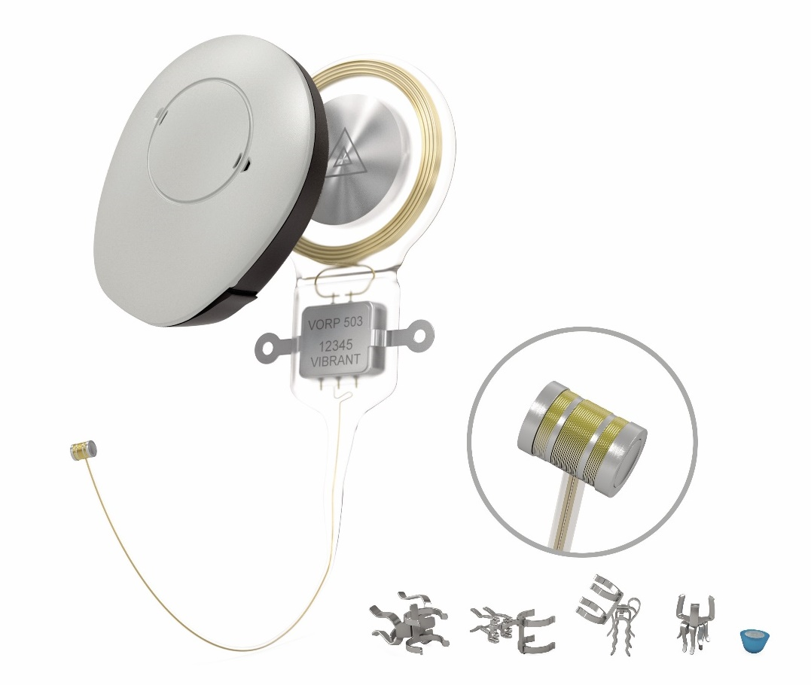

Figure 1: Rendering of the VIBRANT SOUNDBRIDGE system, including VORP 503 implant, SAMBA 2 audio processor and five different Vibroplasty couplers. The inlet shows an enlarged view of the floating mass transducer (FMT).

## **Identify how the proposed technology achieves the intended patient outcomes**:

The dual microphones of the SAMBA 2 audio processor pick up sounds like speech or environmental noise. At this point the SAMBA 2 uses directional speech enhancement, speech and noise management and wind-noise reduction to optimize the patient’s hearing experience. The implant receives this information via near-field magnetic induction technology and translates it to mechanical vibrations, which are then transduced to the cochlea by the FMT. The VIBRANT SOUNDBRIDGE system thus restores the natural hearing pathway. A set of available vibroplasty couplers allow for a precise and long-term stable coupling of the FMT to one of several target structures along the ossicular chain, including the round window membrane. This flexibility helps surgeons find the ideal coupling strategy for each single patient.

Compared to surgical therapy with passive middle ear implants (pMEIs), aMEIs provide signal amplification and are therefore much more effective in hearing restoration. Because the FMT is located close to the target cochlea, there is no risk of cross stimulating the contralateral cochlea. This is a huge advantage over BCIs, which cannot selectively stimulate one single cochlea. Selective stimulation is, however, crucial for true binaural hearing.

## Does the proposed health technology include a registered trademark component with characteristics that distinguishes it from other similar health components?

Yes.

## Explain whether it is essential to have this trademark component or whether there would be other components that would be suitable:

The VIBRANT SOUNDBRIDGE trademark is the only active middle ear implant available on the Australian market.

## Are there any proposed limitations on the provision of the proposed health technology delivered to the patient (For example: accessibility, dosage, quantity, duration or frequency):

No.

## Provide details and explain:

There are no such limitations, except to the maximum provision of two implants per patient if hearing restoration in both ears is indicated.

## If applicable, advise which health professionals will be needed to provide the proposed health technology:

Audiologist

ENT surgeon

Radiologist (recommended)

## If applicable, advise whether delivery of the proposed health technology can be delegated to another health professional:

Not applicable

## If applicable, advise if there are any limitations on which health professionals might provide a referral for the proposed health technology:

ENT surgeon or Otologist

## Is there specific training or qualifications required to provide or deliver the proposed service, and/or any accreditation requirements to support delivery of the health technology?

Yes

## Provide details and explain:

No accreditation is required. The ENT surgeon performing Vibroplasty needs to be a qualified medical practitioner and otology specialist.

In addition, the manufacturer offers the following specialized trainings to professionals (audiologist and surgeons), but these are not mandatory:

* Surgical training labs for surgeons.
* Clinical/Product experts may be requested for personalized trainings (if required).
* There is a surgical guide for the VIBRANT SOUNDBRIDGE system (which is not part of the product labelling).
* Videos of implantation surgeries are published on MED-ELs professionals’ website.
* Live surgeries are streamed with the opportunity to ask questions to the performing surgeons in unregular intervals.

## Indicate the proposed setting(s) in which the proposed health technology will be delivered:

*(Select all relevant settings)*

Consulting rooms

Day surgery centre

Emergency Department

Inpatient private hospital

Inpatient public hospital

Laboratory

Outpatient clinic

Patient’s home

Point of care testing

Residential aged care facility

Other (please specify)

Implantation is typically performed as an inpatient procedure but fitting of the audio processor and follow-up appointments may take place in an outpatient setting.

## Is the proposed health technology intended to be entirely rendered inside Australia?

Yes

## Provide additional details on the proposed health technology to be rendered outside of Australia:

Not applicable

# Comparator

## Nominate the appropriate comparator(s) for the proposed medical service (i.e., how is the proposed population currently managed in the absence of the proposed medical service being available in the Australian healthcare system). This includes identifying healthcare resources that are needed to be delivered at the same time as the comparator service:

1. Prescribed List (PL) group 02.01.09 - Implantable Piezoelectric Bone Conduction Hearing System (all components), i.e.

Active transcutaneous BCIs:

Cochlear Osia system, including other healthcare resources:

Audiometry testing AC and BC thresholds and speech recognition

Programming of the audio processor (first fitting)

Aftercare and re-fitting (if necessary)

1. Other bone-conduction systems listed under PL group 02.01.04 - Implantable Bone Conduction Hearing System, i.e.

Active transcutaneous BCIs:

BONEBRIDGE System (BCI 602 kit + SAMBA 2 BONEBRIDGE audio processor)

Audiometry testing AC and BC thresholds and speech recognition

Programming of the audio processor (first fitting)

Aftercare and re-fitting (if necessary)

## List any existing MBS item numbers that are relevant for the nominated comparators:

41603 (Osseo-integration procedure-implantation of bone conduction hearing system device)

45794 (Osseo‑integration procedure, first stage, implantation of fixture, following congenital absence, tumour or trauma, other than a service associated with a service to which item 41603 applies)

45797 (Osseo‑integration procedure, second stage, fixation of transcutaneous abutment, following congenital absence, tumour or trauma, other than a service associated with a service to which item 41603 applies)

## Provide a rationale for why this is a comparator:

Due to the reasons outlined below, we consider only active bone conduction implants (aBCIs) as direct comparators for the proposed medical service:

1. In MHL patients where the ossicular chain is non-functional, surgical reconstruction of the ossicular chain to re-establish the natural hearing pathway is considered first-line treatment (Prescribed List (PL) group 02.01.05; MBS items 41539 – 41542). Because treatment with the proposed medical service is considered second-line treatment (see Figure 2), reconstructive surgery is not a direct comparator. But see summary of evidence n°5 for a discussion on lifecycle costs of reconstructive surgery vs. the new medical service.
2. BCIs listed on the Prescribed List (i.e., those included under product groups 02.01.04 and 02.01.09) are used for the treatment of conductive (CHL) and mild to moderate cases of mixed hearing loss (MHL) and are implanted via procedures of MBS items 41603, 45794 or 45797. However, the following BCI sub-groups should not be considered as direct comparators for the proposed medical service:
   1. Non-implantable bone conduction devices (BCDs) used for bone conduction trials. These are typically used as temporary solutions until a permanent, implantable solution becomes feasible.
   2. Passive BCIs (BAHAs): there is a general trend away from passive implants (both percutaneous and transcutaneous) since the availability of active transcutaneous bone conduction implants (aBCIs), which are currently state-of-the-art.

## Pattern of substitution – Will the proposed health technology wholly replace the proposed comparator, partially replace the proposed comparator, displace the proposed comparator ­­­

*(Please select your response)*

None (used with the comparator)

Displaced (comparator will likely be used following the proposed technology in some patients)

Partial (in some cases, the proposed technology will replace the use of the comparator, but not all)

Full (subjects who receive the proposed intervention will not receive the comparator)

## Outline and explain the extent to which the current comparator is expected to be substituted:

The proposed health technology will likely substitute comparators in cases when the comparator devices cannot deliver sufficient benefit, i.e.,

* when comparator devices cannot deliver enough amplification, or
* when stimulation of one single cochlea is sought and overstimulation of a contralateral cochlea is to be avoided, or
* if restoration of true binaural hearing is sought, or
* when implantation of a comparator device (aBCI) is not feasible due to anatomical reasons (e.g., radical cavity, insufficient bone thickness) or skin quality.

# Outcomes

*(Please copy the below questions and complete for each outcome)*

## List the key health outcomes (major and minor – prioritising major key health outcomes first) that will need to be measured in assessing the clinical claim for the proposed medical service/technology (versus the comparator):

1. Functional Gain

*(Please select your response)*

Health benefits

Health harms

Resources

Value of knowing

## Outcome description – include information about whether a change in patient management, or prognosis, occurs as a result of the test information:

Assessment of unaided and aided sound-field hearing thresholds at single frequencies. The functional gain is defined as the difference, or the benefit from unaided to aided condition at specific frequencies.

Patient management or prognosis are not expected to change as a result of the test information.

1. Effective Gain

*(Please select your response)*

Health benefits

Health harms

Resources

Value of knowing

## Outcome description – include information about whether a change in patient management, or prognosis, occurs as a result of the test information:

Assessment of bone conduction (BC) thresholds and aided sound-field hearing thresholds at single frequencies. The functional gain is defined as the difference, or the benefit from diagnostic BC thresholds at specific frequencies to aided sound-field (SF) hearing thresholds at the same frequency. Negative values indicate no closure of the air-bone gap (ABG). Positive values indicate overclosure of the ABG.

Patient management or prognosis are not expected to change as a result of the test information.

1. Word Recognition Score

*(Please select your response)*

Health benefits

Health harms

Resources

Value of knowing

## Outcome description – include information about whether a change in patient management, or prognosis, occurs as a result of the test information:

Assessment of word recognition score (WRS) at stimulation level of 65 dB SPL. Using a closed list of words, numbers, or sentences, the WRS indicates the percentage of correctly understood words, numbers, or sentences.

Patient management or prognosis are not expected to change because of the test information.

1. Speech Reception Threshold in Noise

*(Please select your response)*

Health benefits

Health harms

Resources

Value of knowing

## Outcome description – include information about whether a change in patient management, or prognosis, occurs as a result of the test information:

Assessment of speech reception threshold (SRT 50), which is defined as the level of stimulation (in dB SPL) at which the patients understood 50 % of the stimuli (words, numbers, or sentences) correctly. To assess the SRT 50 in noise, the noise signal is fixed at a specific level (in dB SPL), while the speech signal is adaptively changed over repeating test cycles, effectively measuring speech understanding (in %) at different signal-to-noise-ratios (SNR). The test result is the one SNR at which the patient understood 50 % of the speech material correctly.

Patient management or prognosis are not expected to change because of the test information.

# Proposed MBS items

## How is the technology/service funded at present? (e.g., research funding; State-based funding; self-funded by patients; no funding or payments):

no funding; occasionally state-base funding via hospital or self-funded by patients

## Provide at least one proposed item with their descriptor and associated costs, for each Population/Intervention:

## *(Please copy the below questions and complete for each proposed item)*

|  |  |
| --- | --- |
| MBS item number  (where used as a template for the proposed item) | 41618 (MEI for SNHL used as template) |
| Category number | 3 |
| Category description | Therapeutic Procedures |
| Proposed item descriptor | Active middle ear implant, partially implantable, insertion of, via Vibroplasty, for patients with:   1. mixed or conductive hearing loss; and 2. no success or adequate benefit from surgical therapy or bone conduction devices; or 3. can not wear traditional hearing aids. |
| Proposed MBS fee | $2,138.30 |
| Indicate the overall cost per patient of providing the proposed health technology | Audiology testing:  $ 38.10 air and bone conduction and speech discrimination audiogram (MBS 82315 85 % fee)  $15.50 impedance audiogram (MBS 82324 85 % fee) or  $19.25 (MBS 11324 85 % fee)  Audiology programming/fitting:  $149.10 programming an auditory implant or the sound processor of an auditory implant (MBS 82301 85 % fee) or  $186.45 (MBS 11302 85 % fee)  $ 270.90 CT scan (MBS 56016 85 % fee)  $ 2138.30 proposed MBS fee for surgical implantation  $ 350 Vibroplasty coupler  $7,166 SAMBA 2 audio processor  $7,470 VORP 503 implant |
| Please specify any anticipated out of pocket expenses | $56/year batteries for audio processor (estimation based on 8 cards of batteries per year at $7/card) |
| Provide any further details and explain | anticipated out of pocket expenses are per year for batteries for the audio processor (estimation based on 8 cards of batteries per year at $7/card) |

# Algorithms

## PREPARATION FOR USING THE HEALTH TECHNOLOGY

## Define and summarise the clinical management algorithm, including any required tests or healthcare resources, before patients would be eligible for the proposed health technology:

Patients presenting with hearing problems typically undergo a standard ENT visit including audiometric screening first. Depending on the type of hearing loss and/or comorbidities, more advanced audiological tests (speech audiometry, impedance audiometry) may be required. First-line treatments for patients diagnosed with C/MHL include reconstructive surgery (combined with traditional hearing aids) or bone conduction solutions. If these are not feasible or not effective, the proposed treatment (Vibroplasty/aMEI) emerges as second-line treatment. An interdisciplinary team of healthcare professionals needs to determine aMEI candidacy and ideal timepoint for implantation based on the patient’s history, the management plan for the pathology, severity of hearing loss and potential expectations of the patient. A CT scan is recommended before deciding for a specific surgical strategy.

Is there any expectation that the clinical management algorithm before the health technology is used will change due to the introduction of the proposed health technology?

No. The same management algorithm is currently used for aBCIs (under MBS item 41603) and aMEI for SNHL (MBS item 41618).

## Describe and explain any differences in the clinical management algorithm prior to the use of the proposed health technology vs. the comparator health technology:

No difference.

## USE OF THE HEALTH TECHNOLOGY

## Explain what other healthcare resources are used in conjunction with delivering the proposed health technology:

None.

## Explain what other healthcare resources are used in conjunction with the comparator health technology:

None.

## Describe and explain any differences in the healthcare resources used in conjunction with the proposed health technology vs. the comparator health technology:

No differences.

## CLINICAL MANAGEMENT AFTER THE USE OF HEALTH TECHNOLOGY

## Define and summarise the clinical management algorithm, including any required tests or healthcare resources, *after* the use of the proposed health technology:

Patients typically need the following:

1. Wound care in the direct post-operative phase (approximately within first week)
2. Activation and fitting of audio processor (approximately 4 weeks post-op)
3. Additional fitting appointments as needed (within the first 6 months)
4. Additional fitting appointment as needed

## Define and summarise the clinical management algorithm, including any required tests or healthcare resources, *after* the use of the comparator health technology:

Patients treated with the comparator health technology need the same management algorithm:

1. Wound care in the direct post-operative phase (approximately within first week)
2. Activation and fitting of audio processor (approximately 4 weeks post-op)
3. Additional fitting appointments as needed (within the first 6 months)
4. Additional fitting appointment as needed

## Describe and explain any differences in the healthcare resources used *after* the proposed health technology vs. the comparator health technology:

No difference.

## Insert diagrams demonstrating the clinical management algorithm with and without the proposed health technology:

*(Please ensure that the diagrams provided do not contain information under copyright)*

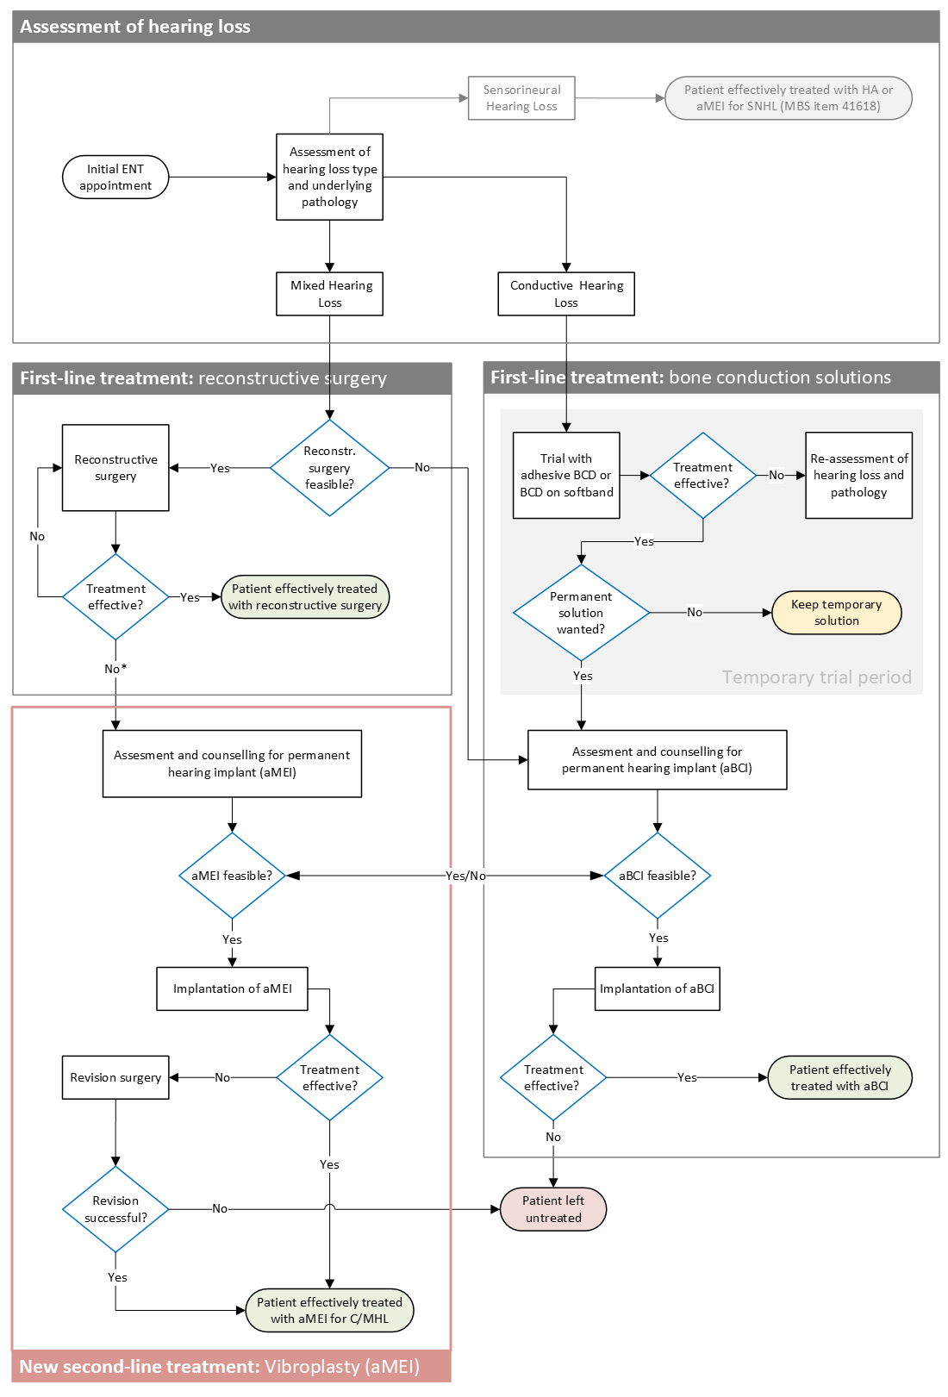

Figure 2: Clinical management algorithm **including the proposed health technology** (red frame).

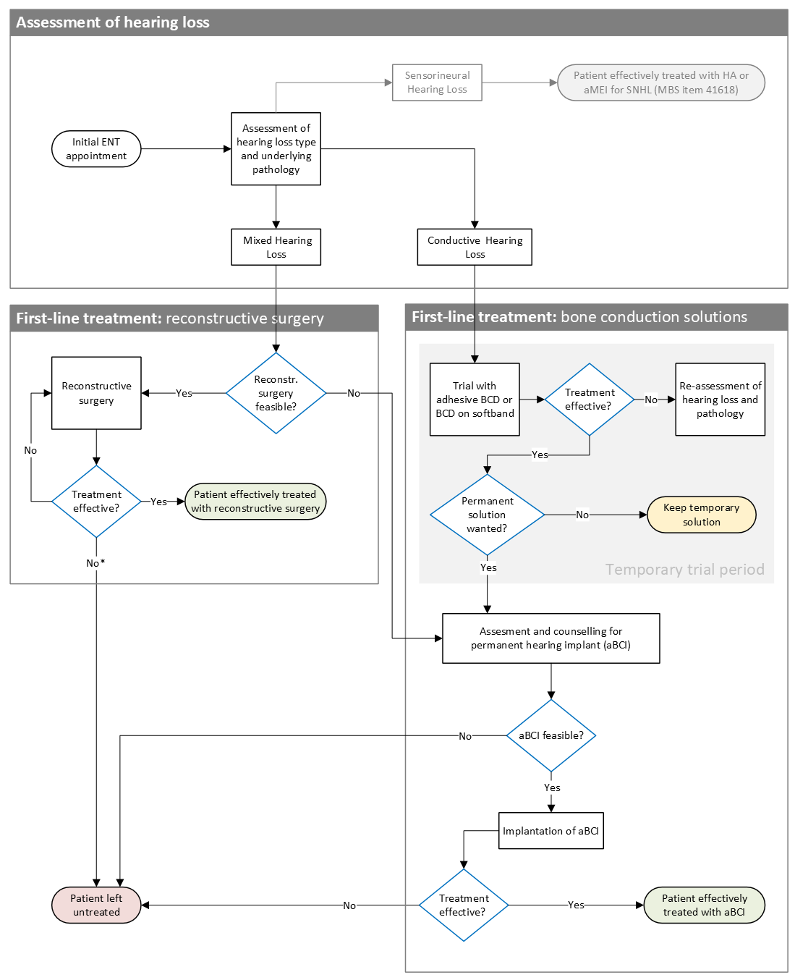

Figure 3: Clinical management algorithm **without the proposed health technology**.

# Claims

## In terms of health outcomes (comparative benefits and harms), is the proposed technology claimed to be superior, non-inferior or inferior to the comparator(s)?

*(Please select your response)*

Superior

Non-inferior

Inferior

## Please state what the overall claim is, and provide a rationale:

Claim: aMEIs can provide true binaural hearing.

Rationale: Because the FMT of the proposed health technology is located close to the target cochlea, it can provide selective stimulation of one single cochlea. There is no risk of cross stimulating the contralateral side. This is a huge advantage over BCIs, which cannot selectively stimulate one single cochlea. Selective stimulation is paramount for true binaural hearing and improved localization abilities.

## Why would the requestor seek to use the proposed investigative technology rather than the comparator(s)?

Requestors may choose the proposed technology:

1. In cases where true binaural hearing (improved sound localization) is key.
2. In cases where overclosure of the air-bone gap in speech-relevant frequencies is key.
3. If comparator devices can not deliver enough amplification.
4. In cases where implantation of comparator devices (aBCIs) is not feasible due to anatomical reasons (e.g., radical cavity, insufficient bone thickness) or skin quality.

## Identify how the proposed technology achieves the intended patient outcomes:

1. Better localization abilities in bilateral implanted patients compared to bilateral BCI.

A recent publication by Agterberg et al. (2024) calculated mean angular error (MAE) in patients with bilateral aMEI and compared their results to another cohort of patients who had received bilateral BCIs (Den Besten et al., 2020). The difference in MAE was significant (p < .005), with an average MAE of 16° (SD=7°) for aMEI and 37° (SD=11°) for BCI.

1. Better effective gain (ABG overclosure) in mid-frequencies compared to BCIs.

A recent retrospective analysis in the Australian setting (Tavora-Vieira et al., 2023) showed that the average ABG (as evidenced by a positive effective gain) was over-closed at 2 kHz and 3 kHz in patients who had received an aMEI, while no full closure of the average ABG was achieved in patients who had received a BCI.

## For some people, compared with the comparator(s), does the test information result in:

*(Please answer either Yes or No, deleting text as required)*

**A change in clinical management?**

No.

**A change in health outcome?**

Yes.

**Other benefits?**

No.

## Please provide a rationale, and information on other benefits if relevant:

## In terms of the immediate costs of the proposed technology (and immediate cost consequences, such as procedural costs, testing costs etc.), is the proposed technology claimed to be more costly, the same cost or less costly than the comparator?

*(Please select your response)*

More costly

Same cost

Less costly

## Provide a brief rationale for the claim:

The new procedure will be more costly than aBCIs under PL group 02.01.04 and equally costly compared to aBCIs under PL group 02.01.09. Overall, the cost of the new procedure will be comparable to item 41618, which is not a comparator due to a different target population.

# Summary of Evidence

Provide one or more recent (published) high quality clinical studies that support use of the proposed health service/technology.

|  | **Type of study design\*** | **Title of journal article or research project (including any trial identifier or study lead if relevant)** | **Short description of research (max 50 words)\*\*** | **Website link to journal article or research (if available)** | **Date of publication\*\*\*** |
| --- | --- | --- | --- | --- | --- |
| 1. | Observational study | Decision making in bone conduction and active middle ear implants – hearing outcomes and experiences over a 10-year period | Retrospective data analysis of 89 patients comparing audiological outcomes across pre-assigned patient groups – effectively comparing treatment with aMEI vs. BCI. The aMEI group was shown to reach significantly better effective gain compared to the BCI group. | <https://www.tandfonline.com/doi/full/10.1080/14670100.2023.2267900> | 17 Oct 2023 |
| 2. | Observational study | Middle Ear Active Implant Indications, Comparative Audiometric Results from Different Approaches, and Coupling with the Vibrant Soundbridge®: A Single Center Experience over More Than 20 Years | This is a retrospective analysis of data from 55 patients in a single centre. Benefit in hearing thresholds and speech understanding are compared among subgroups, e.g., SNHL and CMHL or different coupling locations. Patients with CMHL are shown to have more benefit from the treatment when compared to patients with SNHL. | <https://www.mdpi.com/2039-4349/14/4/61> | 21 Aug 2024 |
| 3. | Observational study | Health-related quality of life in Vibrant Soundbridge patients: Generic and specific measures, short-term and long-term outcomes | This is a retrospective analysis of Health-related Quality of Life (HR-QoL) data that was collected during clinical routine. The results of 21 patients from 2 centres show an immediate, clinically relevant benefit 3 months after treatment and stable benefit at 24 months post-intervention. | <https://link.springer.com/article/10.1007/s00405-024-08889-2> | 23 Aug 2024 |
| 4. | Systematic Review | Efficacy of vibrant sound bridge in congenital aural atresia: an updated systematic review | This Systematic Review summarizes evidence on effectiveness, safety and patient-reported outcomes with VIBRANT SOUNDBRIDGE in patients with congenital aural atresia (CAA). Twenty-seven studies were included in the final dataset. The authors conclude that the VIBRANT SOUNDBRIDGE provided significant benefits to individuals with hearing loss owing to CAA, with excellent subjective outcomes and a low risk of complications. | <https://link.springer.com/article/10.1007/s00405-024-08629-6> | 22 Apr 2024 |
| 5. | Health-Economic Analysis | Expensive today but cheaper tomorrow: lifetime costs of an active middle ear implant compared to alternative treatment options | Lifetime costs were calculated for three different patient groups at a single ENT centre (Hannover Medical School). Direct treatment with aMEI (group 1) resulted in lowest lifetime costs. Treatment with aMEI after an avg. of 2.5 middle ear surgeries (group 2) was most expensive. Treatment with middle ear surgeries alone resulted in similar lifetime costs as in group 1, but over 25 % of the population remained effectively untreated after an avg. lifetime of 26.7 years and a maximum of 15 repeated surgeries. | https://link.springer.com/article/10.1007/s10198-024-01743-6 | 06 Dec 2024 |

* Categorise study design, for example meta-analysis, randomised trials, non-randomised trial or observational study, study of diagnostic accuracy, etc.

**Provide high level information including population numbers and whether patients are being recruited or in post-recruitment, including providing the trial registration number to allow for tracking purposes. For yet to be published research, provide high level information including population numbers and whether patients are being recruited or in post-recruitment.

*** If the publication is a follow-up to an initial publication, please advise. For yet to be published research, include the date of when results will be made available (to the best of your knowledge).

**Identify yet-to-be-published research that may have results available in the near future (that could be relevant to your application).**

|  | **Type of study design\*** | **Title of journal article or research project (including any trial identifier or study lead if relevant)** | **Short description of research (max 50 words)\*\*** | **Website link to journal article or research (if available)** | **Date of publication\*\*\*** |
| --- | --- | --- | --- | --- | --- |
| 1. | Non-randomised trial | The Vibrant Soundbridge VORP 503 Post-Market clinical follow up study | This is the final report of the post-market follow up study sponsored by the manufacturer. Sixtyseven patients were included prospectively across 9 participating centres. Data on audiological benefit, safety and QoL were analysed over the full cohort and over subgroups by type of hearing loss and FMT-couplers. |  | Data from this report will likely be published beginning of 2025 |

* Categorise study design, for example meta-analysis, randomised trials, non-randomised trial or observational study, study of diagnostic accuracy, etc.

**Provide high level information including population numbers and whether patients are being recruited or in post-recruitment, including providing the trial registration number to allow for tracking purposes. For yet to be published research, provide high level information including population numbers and whether patients are being recruited or in post-recruitment.

*** If the publication is a follow-up to an initial publication, please advise. For yet to be published research, include the date of when results will be made available (to the best of your knowledge).

**Citations**

Agterberg M.J.H., Straatman L., Bruchhage K.-L., Jürgens T., Hollfelder D., Leichtle A. (2024). The Merits of Bilateral Application of Middle Ear Implants in Patients With Bilateral Conductive and/or Mixed Hearing Loss. *Trends in Hearing,* 28. DOI:10.1177/23312165241264466

Attaway, J., Stone, C., Sendor, C. & Rosario, E. (2015). Effect of Amplification on Speech and Language in Children With Aural Atresia. *Am J Audiol*, *24*(3), 354–359. <https://doi.org/10.1044/2015_aja-15-0021>

Bluestone, C. D. (1998). Epidemiology and pathogenesis of chronic suppurative otitis media: implications for prevention and treatment. *Int J Pediatr Otorhinolaryngol*, *42*(3), 207–223. <https://doi.org/10.1016/s0165-5876(97)00147-x>

Cureoglu, S., Baylan, M. Y. & Paparella, M. M. (2010). Cochlear otosclerosis. *Curr Opin Otolaryngol Head Neck Surg*, *18*(5), 357–362. <https://doi.org/10.1097/moo.0b013e32833d11d9>

DeAntonio, R., Yarzabal, J. P., Cruz, J. P., Schmidt, J. E. & Kleijnen, J. (2016). Epidemiology of otitis media in children from developing countries: A systematic review. Int J Pediatr Otorhinolaryngol, 85, 65–74. <https://doi.org/10.1016/j.ijporl.2016.03.032>

Den Besten C. A., Vogt K., Bosman A. J., Snik A. F. M., Hol M. K. S., Agterberg M. J. H. (2020). The merits of bilateral application of bone-conduction devices in children with bilateral conductive hearing loss. *Ear & Hearing*, 41, 1327–1332. <https://doi.org/10.1097/AUD.0000000000000853>

Institute for Health Metrics and Evaluation. (2015). *EPI Visualization*. <http://vizhub.healthdata.org/epi/>

Klein, J. O. (2000). The burden of otitis media. *Vaccine*, 19 Suppl 1, S2-8. <https://doi.org/10.1016/s0264-410x(00)00271-1>

Kuo, C. L., Shiao, A. S., Yung, M., Sakagami, M., Sudhoff, H., Wang, C. H., Hsu, C. H. & Lien, C. F. (2015). Updates and knowledge gaps in cholesteatoma research. *Biomed Res Int*, *2015*, 854024. <https://doi.org/10.1155/2015/854024>

Monasta, L., Ronfani, L., Marchetti, F., Montico, M., Brumatti, L. V., Bavcar, A., Grasso, D., Barbiero, C. & Tamburlini, G. (2012). Burden of disease caused by otitis media: systematic review and global estimates. *PLoS One*, *7*(4), e36226. <https://doi.org/10.1371/journal.pone.0036226>

Olaison, S., Berglund, M., Taj, T., Knutsson, J., Westman, E., Eriksson, P. and Bonnard, Å. (2024), Hearing Outcomes After Ossiculoplasty With Bone or Titanium Prostheses—A Nationwide Register-Based Study. Clinical Otolaryngology, 49: 660-669. <https://doi.org/10.1111/coa.14191>

Rudic, M., Keogh, I., Wagner, R., Wilkinson, E., Kiros, N., Ferrary, E., Sterkers, O., Grayeli, A. B., Zarkovic, K. & Zarkovic, N. (2015). The pathophysiology of otosclerosis: Review of current research. *Hear Res*, *330*(Pt A), 51–56. <https://doi.org/10.1016/j.heares.2015.07.014>

Schilder, A. G., Chonmaitree, T., Cripps, A. W., Rosenfeld, R. M., Casselbrant, M. L., Haggard, M. P. & Venekamp, R. P. (2016). Otitis media. *Nat Rev Dis Primers*, *2*(1), 16063. <https://doi.org/10.1038/nrdp.2016.63>

Shah, L. M. & H., 3rd Wiggins, R. (2009). Imaging of hearing loss. *Neuroimaging Clin N Am*, *19*(3), 287–306. <https://doi.org/10.1016/j.nic.2009.06.010>

Sooriyamoorthy, T. & Jesus, O. D. (2023). Conductive Hearing Loss. [Updated 2023 Aug 23]. In: StatPearls [Internet]. Treasure Island (FL): StatPearls Publishing; 2024 Jan-. Available from: https://www.ncbi.nlm.nih.gov/books/NBK563267/

Távora-Vieira, D., Marino, R., Kuthubutheen, J., Broadbent, C., & Acharya, A. (2023). Decision making in bone conduction and active middle ear implants – hearing outcomes and experiences over a 10-year period. *Cochlear Implants International*, *25*(1), 16–22. <https://doi.org/10.1080/14670100.2023.2267900>

World Health Organization. (2004). *Chronic suppurative otitis media : burden of illness and management options*. World Health Organization. <https://apps.who.int/iris/handle/10665/42941>