**MSAC Application 1806**

**Marstacimab for routine prophylaxis to prevent bleeding in patients with haemophilia**

**PICO Set 2**

**Severe haemophilia B (FIX < 1%)**

# **Population**

**Describe the population in which the proposed health technology is intended to be used:**

Marstacimab is intended to treat children and adults aged 12 years and over with Haemophilia A (HMA) or Haemophilia B (HMB), without inhibitors. Haemophilia is an X-linked congenital bleeding disorder caused by deficiency of coagulation factor VIII (FVIII; HMA) or coagulation factor IX (FIX; HMB). The deficiency is the result of mutations of the respective clotting factor genes, F8 and F9.

Haemophilia is a rare disease. The best estimates of the prevalence of haemophilia, based on the most reliable national patient registry data and recent World Federation of Hemophilia (WFH) annual global surveys, indicate that there are an expected 1,125,000 males with haemophilia worldwide, of whom the majority are undiagnosed. There are an estimated 418,000 males with severe haemophilia (Srivastava, Santagostino, & Dougall, 2020). In Australia, there are more than 3,000 people diagnosed with haemophilia. Approximately 1 in 6,000 males has HMA and 1 in 25,000 to 30,000 males has HMB (Haemophilia Foundation Australia, 2023).

Haemophilia generally affects males on the maternal side; however, women who carry a genetic mutation in a clotting factor gene may also have reduced factor levels and be classified as having haemophilia. Both F8 and F9 genes are prone to new mutations, and as many as one-third of all cases are the result of spontaneous mutation where there is no prior family history (Srivastava, Santagostino, & Dougall, 2020).

The characteristic phenotype in haemophilia is the tendency to bleed due to reduced levels of factor concentrate. The normal clotting process is compared to the clotting process in haemophilia in **Figure 1**. In the normal clotting process, when a capillary is injured, it tightens to slow the bleeding. Platelets then make a plug to patch the hole, and clotting factors in the plasma knit together to form a clot over the plug. This works to stop the bleeding. In haemophilia, there is not enough factor for the clot to stay together, so bleeding continues for longer than usual (Haemophilia Foundation Australia, 2023).

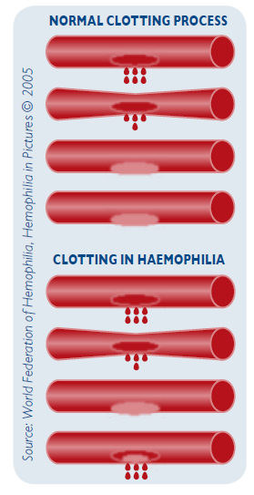 

Figure 1 Clotting process in people with and without haemophilia

Source: (Haemophilia Foundation Australia, 2013)

The severity of bleeding is generally correlated with clotting factor level, as shown in **Table 1**. A person with haemophilia will have the same level of severity over their lifetime. Within a family, males with haemophilia will also have the same level of severity, i.e., if a grandfather has severe haemophilia and his grandson has inherited haemophilia, the grandson will also have severe haemophilia. However, females with haemophilia may not have the same severity as other females within the same family (Haemophilia Foundation Australia, 2023).

Table 1 Relationship of bleeding severity to clotting factor level

| Severity | Clotting factor level | Bleeding episodes |
| --- | --- | --- |
| Severe | <1 IU/dl (<0.01 IU/ml) or  <1% of normal | Spontaneous bleeding into joints or muscles, predominantly in the absence of identifiable haemostatic challenge |
| Moderate | 1– 5 IU/dl (0.01– 0.05 IU/ml) or  1–5% of normal | Occasional spontaneous bleeding; prolonged bleeding with minor trauma or surgery |
| Mild | 5–40 IU/dl (0.05–0.40 IU/ml) or  5% to <40% of normal | Severe bleeding with major trauma or surgery; spontaneous bleeding is rare |

Source: (Srivastava, Santagostino, & Dougall, 2020)

Internal bleeding episodes or “bleeds” are the main problem for most people with haemophilia. Bleeds are most commonly into the joints (70–80% of all bleeds) or muscles (10–20%) (Srivastava, Santagostino, & Dougall, 2020). They can occur without an obvious cause (“spontaneous”) or as a result of injury. If internal bleeding is not treated quickly it will result in pain and swelling which, if repeated over time, can cause permanent damage such as arthritis, chronic pain and loss of mobility (Haemophilia Foundation Australia, 2023). Up to 70% of people with haemophilia report limitations on their ability to do daily activities (Buckner, et al., 2018).

Some bleeds can be life-threatening, for example those which occur intracranially, in the neck or throat, or in the gastrointestinal tract (Srivastava, Santagostino, & Dougall, 2020). The mortality rate for people with severe haemophilia is 2.4 times that of the general population (**Table 2**).

Table 2 Severity of haemophilia and associated health outcomes

| Outcome | Mild | Moderate | Severe |
| --- | --- | --- | --- |
| Factor level (activity % in blood) | 5 to <40% | 1 to <5% | <1% |
| Risk for inhibitor development | Very rare | 1-2% | HMA: 30%  HMB: 2-3% |
| Mortality rate (vs general population)1 | 1.0 | 1.1 | 2.4 |
| Nosebleeds or gum bleeds | 🗸 | 🗸 | 🗸 |
| Bleeding after injury, trauma or surgery | 🗸 | 🗸 | 🗸 |
| Easy or excessive bruising | - | 🗸 | 🗸 |
| Spontaneous internal bleeding | - | 🗸2 | 🗸 |
| Haemophilic arthropathy (joint damage) | - | 🗸3 | 🗸 |

1 Standardised mortality ratio (observed deaths / expected deaths) for age- and calendar year-specific mortality rate

2 Rare in moderate haemophilia A; can occur occasionally in moderate haemophilia B

3 Common in patients with moderate disease who are not on prophylaxis

Source: (National Blood Authority, 2016; NORD, 2015; NORD, 2018; Kizilocak & Young, 2019; Hassan, Monahan, & Mauser-Bunschoten, 2021; Srivastava, Santagostino, & Dougall, 2020)

There is a substantial clinical and humanistic burden of disease associated with haemophilia. The key driver of disease burden is chronic arthropathy and pain resulting from repeated bleeding into joints which can limit activities of daily living and independence (O'Hara, et al., 2018). If haemophilia is inadequately treated, this can become apparent in the first one to two decades of life (Srivastava, Santagostino, & Dougall, 2020). It is thus unsurprising that a high frequency of disease-related anxiety and depression is reported for haemophilia in the literature. The impact of haemophilia on health-related quality of life (HRQoL) is reported to be similar to other chronic diseases such as rheumatoid arthritis and diabetes (D'Angiolella, 2018), with those with more severe disease generally the most impacted (Carroll, et al., 2019).

In addition to the humanistic burden, haemophilia is associated with an increased risk for numerous other acute and chronic conditions including arthritis, osteoporosis, obesity, anaemia, kidney disease and haemorrhagic stroke (National Hemophilia Foundation, 2019).

**Specify any characteristics of patients with the medical condition, or suspected of, who are proposed to be eligible for the proposed health technology, describing how a patient would be investigated, managed and referred within the Australian health care system in the lead up to being considered eligible for the technology:**

Patients proposed to be eligible for reimbursed treatment with marstacimab are children and adults aged 12 years and over with severe HMA (FVIII < 1%) or severe HMB (FIX < 1%), without inhibitors to FVIII or FIX. This population aligns with the approved Product Information for marstacimab (2025).

Severe haemophilia is usually diagnosed at a young age when unusual bruising or bleeding is noticed, or if there is a family history of haemophilia. Haemophilia may be suspected if babies have internal bleeding or unusual swelling or bruising after delivery, continue to bleed after a heel prick or circumcision, or have excessive bruising after immunisation. Generally though, bleeding is first suspected when a child starts crawling or walking and bruising becomes more apparent. A blood test is used to assess a child’s underlying factor levels and confirm whether haemophilia is present, including the severity of disease (Haemophilia Foundation Australia, 2023). As such, patients proposed to be eligible for treatment with marstacimab are already expected to have had their disease diagnosed, including the level of severity.

The current haemophilia population is well known to the Australian healthcare system via the Haemophilia Treatment Centres (HTCs). Patients with severe disease receive comprehensive care from a multidisciplinary team of healthcare professionals, including a haematologist, specialised nurse coordinator, musculoskeletal experts (e.g., physiotherapist, orthopaedic specialist and/or rheumatologist), coagulation medical scientist and psychosocial expert (e.g., social worker or psychologist) (National Blood Authority, 2025).

The treating haematologist would be responsible for assessing a patient’s suitability for treatment with marstacimab, including their inhibitor status. Inhibitor development occurs in approximately 30% of people with severe HMA. In contrast, only about 2-3% of people with HMB develop inhibitors (Srivastava, Santagostino, & Dougall, 2020). Inhibitors may be suspected, and a test performed, if the patient’s clinical response to factor is not as expected. It would be rare for inhibitors to go undetected in a patient undergoing factor prophylaxis.

**Provide a rationale for the specifics of the eligible population:**

Marstacimab will fill an important unmet clinical need in the HMB non-inhibitor population where there is no subcutaneous treatment option. The majority (92%) of children and adults aged 12 years and older with severe HMB receive intravenous (IV) factor replacement therapy, with 86% on a prophylaxis treatment regimen (National Blood Authority, 2023b). Infusions twice per week are common (Mason, Parikh, Rowell, & McRae, 2018). The following quotes about treatment experience are taken from recent Australian research involving patients with moderate to severe HMA or HMB (IQVIA, August 2023):

* *“IV treatment is invasive and difficult to do. Makes travelling and planning the future more troublesome.” – HMB, 15-17 years*
* *“Currently takes about 15+ minutes for each treatment. The routine requires making sure everything is sterile, unpacking everything, draw it all up and then administering treatment.” – HMB, age not provided*
* *“It’s much easier to only have one injection a week instead of multiple.” – HMB, 18-24 years*
* *“Since starting Hemlibra, my quality of life has improved dramatically in terms of treatment burden. Various iterations of treatments prior to Hemlibra (factor replacement via IV or port-a-cath) were very burdensome and difficult to manage i.e., infections, vein health.” – HMA, 35-44 years*
* *“Hemlibra doesn’t require IV infusions which makes the treatment process extremely easy.” – HMA, 25-34 years*

Marstacimab will alleviate a significant treatment burden for patients with HMB by allowing for a once-weekly, self-administered, subcutaneous injection.

Marstacimab has a flat weekly dose of 150 mg for all patients and is easily administered via a pen device. This will simplify treatment, even for patients with severe HMA currently receiving treatment with emicizumab which requires weight-based dosing and delivery via a syringe. The flat dosing of marstacimab will be particularly valuable for adolescents where body weight is frequently changing. Adherence to therapy is an important determinant of the long-term sequelae of haemophilia such as chronic pain and arthropathy (Thornburg & Duncan, 2017; Khanji, Nuabor, & Gould, 2025), and it is reasonable to assume that a simple, subcutaneous treatment option would lead to greater adherence in the real-world setting.

The severity of the requested populations for reimbursement aligns with the approved Product Information for marstacimab (2025).

**Are there any prerequisite tests?** (please highlight your response)

Yes **No**

**Are the prerequisite tests MBS funded?** (please highlight your response)

Not applicable.

**Please provide details to fund the prerequisite tests:**

Not applicable.

# **Intervention**

**Name of the proposed health technology:**

Marstacimab is a human monoclonal antibody (immunoglobulin G isotype, subclass 1 [IgG1]) for children and adults aged 12 years and over with severe HMA or severe HMB, without inhibitors. It is administered prophylactically as a once-weekly subcutaneous injection, eliminating the need for regular infusions of factor concentrate.

Marstacimab was registered on the ARTG on 29/01/2025 with the brand name HYMPAVZI (ARTG #438990).

**Describe the key components and clinical steps involved in delivering the proposed health technology:**

Marstacimab is delivered as a subcutaneous injection using a pen device at a loading dose of 300 mg (2x 150 mg injections), followed by once-weekly injections of 150 mg. A dose adjustment to 300 mg weekly can be considered in patients weighing ≥50 kg when control of bleeding events is judged to be inadequate by the healthcare professional.

Marstacimab can be self-administered by the patient or by a parent or guardian for younger children.

**Identify how the proposed technology achieves the intended patient outcomes:**

In the human body, blood coagulation is achieved via a highly regulated cascade of plasma proteins. The coagulation cascade is activated upon injury to stop bleeding, and shut down when bleeding has stopped to prevent thrombosis. Regulation is achieved by two overlapping pathways: the extrinsic (initiation) pathway and the intrinsic (amplification) pathway. Patients with haemophilia have some ability to stop bleeding through their extrinsic pathway; however, this is not sufficient to control major bleeds or prevent spontaneous bleeds from occurring as the pathway is rapidly shut down by the tissue factor pathway inhibitor (TFPI) (Smith, Travers, & Morrissey, 2015).

TFPI is a multiple kunitz domain protease inhibitor which inactivates both Factor Xa (FXa) and Factor VIIa (FVIIa). Thus, neutralising the activity of TFPI in haemophilia may serve to enhance the extrinsic pathway and bypass the need to replace FVIII or FIX (Smith, Travers, & Morrissey, 2015). This was the approach taken when developing marstacimab.

Marstacimab binds and inhibits TFPI, thus enhancing the extrinsic coagulation pathway and reducing the frequency of bleeds in people with haemophilia. Over the long term, this is expected to prevent the chronic pain and joint damage associated with haemophilia. As a monoclonal antibody, marstacimab has the advantage of a long circulating half-life which allows for once-weekly administration.

**Does the proposed health technology include a registered trademark component with characteristics that distinguishes it from other similar health components?** (please highlight your response)

**Yes** No

**Explain whether it is essential to have this trademark component or whether there would be other components that would be suitable:**

Marstacimab has a registered trademark of HYMPAVZI in Australia.

**Are there any proposed limitations on the provision of the proposed health technology delivered to the patient (For example: accessibility, dosage, quantity, duration or frequency):** (please highlight your response)

**Yes** No

**Provide details and explain:**

Reimbursement will be sought for children and adults aged 12 years and older with severe HMA (FVIII < 1%) or severe HMB (FIX < 1%) without inhibitors, in line with the approved Product Information (2025). Marstacimab is designed as an ongoing therapy and has the same dosing schedule for all patients (300 mg loading dose followed by 150 mg once per week). Patients should follow the advice of their treating haematologist.

**If applicable, advise which health professionals will be needed to provide the proposed health technology:**

The Product Information for marstacimab states that “Treatment should be initiated under the supervision of a physician/healthcare professional experienced in the treatment of haemophilia.” Haematologists, or specialist clinicians at a recognised HTC, are proposed to be the main prescribers.

Marstacimab can be self-administered by the patient or by a parent or guardian for younger children.

**If applicable, advise whether delivery of the proposed health technology can be delegated to another health professional:**

Not applicable (see above).

**If applicable, advise if there are any limitations on which health professionals might provide a referral for the proposed health technology:**

Not applicable.

**Is there specific training or qualifications required to provide or deliver the proposed service, and/or any accreditation requirements to support delivery of the health technology?** (please highlight your response)

Yes **No**

**Provide details and explain:**

Provide a response if you answered 'Yes' to the question above

**Indicate the proposed setting(s) in which the proposed health technology will be delivered:** (select all relevant settings)

Consulting rooms

Day surgery centre

Emergency Department

Inpatient private hospital

Inpatient public hospital

Laboratory

Outpatient clinic

Patient’s home

Point of care testing

Residential aged care facility

Other (please specify)

Specify further details here

**Is the proposed health technology intended to be entirely rendered inside Australia?** (please highlight your response)

Yes **No**

**Please provide additional details on the proposed health technology to be rendered outside of Australia:**

The drug substance for marstacimab will be from Andover, US and the finished drug product will be from Puurs, Belgium.

# **Comparator**

**Nominate the appropriate comparator(s) for the proposed medical service (i.e. how is the proposed population currently managed in the absence of the proposed medical service being available in the Australian health care system). This includes identifying health care resources that are needed to be delivered at the same time as the comparator service:**

**Haemophilia B**

For patients with severe HMB, the nominated comparator is factor replacement therapy in the form of FIX prophylaxis.

In haemophilia, prophylaxis involves the regular IV infusion of the missing clotting factor (FVIII in HMA and FIX in HMB), given to increase factor levels and reduce bleeding frequency. The focus of prophylaxis is primarily to prevent joint bleeds and maintain musculoskeletal health (Srivastava, Santagostino, & Dougall, 2020).

FIX prophylaxis is the standard of care for the majority of patients with severe HMB (FIX < 1%) in Australia. Data from the Australian Bleeding Disorders Registry (ABDR) for 2021-22 found that 92% of patients aged 12 years and older with severe HMB were receiving factor product, with 86% on a prophylaxis regimen (National Blood Authority, 2023b). The remaining 14% received factor product “on-demand,” i.e., in response to bleeding rather than as a preventative measure. On-demand factor therapy could be considered as a secondary comparator for marstacimab.

Recombinant factor is the most widely used type of concentrate in Australia as it contains little to no material from human blood or animals. In HMB it is the product used by 99% of patients, while the remaining 1% use plasma-derived factor product (Mason, Parikh, Rowell, & McRae, 2018). Both recombinant and plasma products are listed on the National Products List (NPL), managed by the National Blood Authority (NBA).

There are two types of recombinant factor product available in Australia: standard half-life (SHL) and extended half-life (EHL). **Table 3** shows conventional dosing regimens for factor prophylaxis with SHL products. It is not yet determined what constitutes high-, intermediate-, and low-dose prophylaxis with EHL products, but overall, EHLs allow people with haemophilia to reduce the number of infusions needed to achieve levels of protection similar to SHLs, or to increase levels of bleed protection with a similar number of infusions, or a combination of both. Dosing regimens with either product type should be adjusted based on patient response (Srivastava, Santagostino, & Dougall, 2020).

Table 3 Conventional factor prophylaxis regimens with SHLs, by intensity

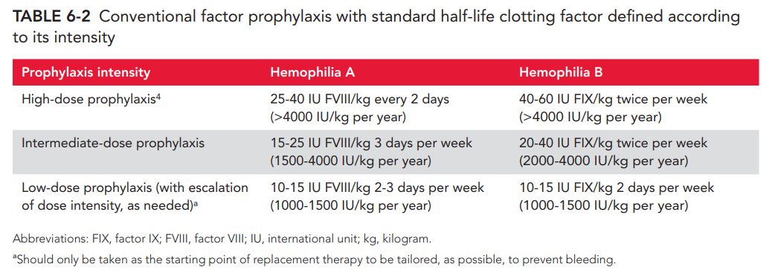

The ABDR report for 2022-23 (Table 7) found that average yearly FIX consumption for patients with severe HMB (n=114) was 2,952 IU/kg (National Blood Authority, Dec 2023). The amount of product consumed varies between patients due to age, physical activity level, type of factor product used (SHL vs EHL) and healthcare professional (HCP) practices.

The FIX product used by the majority of HMB patients for prophylaxis in 2021-22 was Alprolix, an EHL product (n=103 [80.5%]), followed by BeneFIX, an SHL product (n=25 [19.5%]). No other FIX products were used by Australian HMB patients for prophylaxis in 2021-22 (National Blood Authority, 2023) or 2022-23 (National Blood Authority, Dec 2023).

**Haemophilia A**

For patients with severe HMA, the nominated comparators are emicizumab (Hemlibra) and factor replacement therapy in the form of FVIII prophylaxis.

Like marstacimab, emicizumab is a humanised antibody delivered prophylactically as a subcutaneous injection, eliminating the need for factor prophylaxis. It was the treatment used by 52% of children and adults aged 12 years and older with severe HMA in 2021-22 (National Blood Authority, 2023b). The same ABDR analyses reported that 63% of this population were receiving FVIII prophylaxis in 2021-22, and 10% were receiving FVIII on-demand (in response to bleeding). Totals do not sum to 100% as some patients were treated under multiple regimens (i.e., a proportion of patients with severe HMA receiving factor product were also receiving emicizumab). Based on utilisation reported for emicizumab, the maximum size of the severe HMA population aged 12 years and older receiving factor product only (without emicizumab) was 48%.

The ABDR report for 2022-23 (Table 6) found that average yearly FVIII consumption for patients with severe HMA (n=758) was 1,753 IU/kg (National Blood Authority, Dec 2023). Similar to HMB, both SHL and EHL factor products are available for HMA. In 2021-22, the majority (n=225 [39.9%]) of adults with HMA on a prophylaxis regimen were using Eloctate, a recombinant EHL product (National Blood Authority, 2023). Other recombinant FVIII products used for prophylaxis included Xyntha (SHL; n=113 [20.0%]), Adynovate (EHL; n=111 [19.7%]) and Advate (SHL; n=104 [18.4%]). Overall, 59.5% of adults were using an EHL product and 38.5% were using an SHL product. A small proportion of HMA patients (n=11 [2.0%]) were using Biostate, a plasma-derived FVIII product, for prophylaxis.

**List any existing MBS item numbers that are relevant for the nominated comparators:**

Not applicable. Factor products and emicizumab are listed on the NPL managed by the NBA.

**Please provide a rationale for why this is a comparator:**

See above.

**Pattern of substitution – Will the proposed health technology wholly replace the proposed comparator, partially replace the proposed comparator, displace the proposed comparator or be used in combination with the proposed comparator?** (please select your response)

None – used with the comparator

Displaced – comparator will likely be used following the proposed technology in some patients

Partial – in some cases, the proposed technology will replace the use of the comparator, but not in all cases

Full – subjects who receive the proposed intervention will not receive the comparator

**Please outline and explain the extent to which the current comparator is expected to be substituted:**

In HMB, marstacimab is expected to replace use of FIX prophylaxis in some patients, and a small number of patients treated with FIX on-demand. In HMA, marstacimab is expected to replace use of FVIII prophylaxis in some patients, and a small number of patients treated with either emicizumab or FVIII on-demand.

Utilisation will be estimated by calculating the expected uptake among newly eligible patients with severe HMA or HMB without inhibitors (i.e., those turning 12 years of age) and those who would already be eligible for marstacimab at the time of listing. The uptake rate is expected to be higher among younger, newly eligible patients than older, established patients, based on the utilisation experience in emicizumab (National Blood Authority, 2023b). Uptake is also expected to be higher in HMB relative to HMA due to the availability of emicizumab in HMA.

Initial estimates of marstacimab utilisation are based on the annual ABDR reports, physician input and local patient interviews. In HMA, 33 patients are estimated to use marstacimab in the first year of listing, increasing to 187 patients in the fourth year of listing. In HMB, 21 patients are estimated to use marstacimab in the first year of listing, increasing to 64 patients in the fourth year of listing. In total, 54 patients with HMA or HMB are estimated to use marstacimab in the first year of listing, increasing to 251 patients in Year 4.

The utilisation estimates will be refined ahead of the full MSAC submission.

# **Outcomes**

(Please copy the below questions and complete for each outcome)

**List the key health outcomes (major and minor – prioritising major key health outcomes first) that will need to be measured in assessing the clinical claim for the proposed medical service/technology (versus the comparator):** (please select your response)

Health benefits

Health harms

Resources

Value of knowing

The Phase 3 “BASIS” clinical trial (B7841005) is the pivotal trial which will inform the clinical claims for marstacimab (described in further detail in **Section 7** and **Section 8**). Endpoints of BASIS related to efficacy, HRQoL and resource use (factor products and bypassing agents) will inform health benefits, while safety endpoints will inform any health harms.

The primary efficacy endpoint of BASIS, and key health outcome which will inform the clinical efficacy claims, is annualised bleeding rate (ABR) of treated bleeding events. This was derived for each subject using the following formula: ABR = number of bleeds requiring treatments / (days on treatment period/365.25). The trial was powered in the non-inhibitor cohort to detect both superiority of marstacimab prophylaxis over on-demand treatment with FVIII or FIX replacement, and non-inferiority and superiority of marstacimab prophylaxis over FVIII or FIX prophylaxis, using within-subject comparison.

Secondary efficacy endpoints of BASIS included incidence of joint bleeds, target joint bleeds, spontaneous bleeds, and total bleeds; change in joint health, and HRQoL measures. Data for these endpoints will support the clinical efficacy claims.

Safety endpoints of BASIS included adverse events (AEs) and serious adverse events (SAEs), thrombotic events, injection site reactions, and development of anti-drug antibodies. Data for safety endpoints will inform the clinical safety claims for marstacimab. A summary of outcomes and claims is presented in **Table 4.**

The BASIS trial made its assessment of efficacy and safety for marstacimab versus factor therapy (each patient acted as his or her own control). As such, evidence will be directly applicable to the clinical claims in HMA and HMB where factor prophylaxis is the comparator.

An indirect treatment comparison (ITC) will be required to establish clinical claims for marstacimab versus emicizumab in HMA. The primary efficacy endpoint of BASIS (ABR of treated bleeds) was also the primary efficacy endpoint of the HAVEN clinical trials of emicizumab. This endpoint will be used in the main ITC, with secondary efficacy and safety endpoints indirectly compared between the trials when clinically and statistically appropriate.

Table 4 Summary of outcomes supporting the clinical claims for marstacimab

| **Type** | **Outcome (BASIS trial endpoint)** | **Outcome claim vs emicizumab (HMA)** | **Outcome claim vs factor prophylaxis (HMA & HMB)** |
| --- | --- | --- | --- |
| Health benefit | Annualised bleeding rate | Marstacimab is expected to achieve a similar ABR as emicizumab | Marstacimab is expected to reduce ABR relative to factor prophylaxis |
| Health benefit | Total factor and/or BPA consumption | Patients treated with marstacimab are expected to have a similar level of factor and/or BPA consumption as patients treated with emicizumab | Marstacimab is expected to reduce total factor and/or BPA consumption relative to factor prophylaxis |
| Health benefit | Bleeds (joint, target joint, spontaneous, total) | Patients treated with marstacimab are expected to have a similar incidence of bleeds as patients treated with emicizumab | Some* patients treated with marstacimab are expected to have a lower incidence of bleeds than patients treated with factor prophylaxis |
| Health benefit | Joint health | Patients treated with marstacimab are expected to maintain similar joint health as patients treated with emicizumab | Some* patients treated with marstacimab are expected to have better joint health than patients treated with factor prophylaxis |
| Health benefit | Quality of life | Patients treated with marstacimab are expected to have similar QoL as patients treated with emicizumab | Patients treated with marstacimab are expected to have better QoL than patients treated with factor prophylaxis |
| Health harm | Adverse events and serious adverse events | Patients treated with marstacimab are expected to have a similar incidence of AEs and SAEs as patients treated with emicizumab | Patients treated with marstacimab are expected to have a similar incidence of AEs and SAEs as patients treated with factor prophylaxis |
| Health harm | Thrombotic events | Patients treated with marstacimab are expected to have a similar incidence of thrombotic events as patients treated with emicizumab | Patients treated with marstacimab are expected to have a similar incidence of thrombotic events as patients treated with factor prophylaxis |
| Health harm | Immunogenicity | Marstacimab and emicizumab are expected to have similar immunogenicity | Marstacimab and factor prophylaxis are expected to have similar immunogenicity |
| Health harm | Injection site reactions | Patients treated with marstacimab are expected to have a similar incidence of injection site reactions as patients treated with emicizumab | NA (injection site reactions were not measured during the factor prophylaxis phase of BASIS) |

ABR = annualised bleeding rate; ADA = anti-drug antibody; AE = adverse event; BPA = bypass agent; FIX = factor IX; NA = not applicable; QoL = quality of life

* Those with a relatively high ABR on factor prophylaxis are expected to see improvement with marstacimab. Those with a relatively low ABR are expected to have similar efficacy vs. marstacimab.

**Outcome description – please include information about whether a change in patient management, or prognosis, occurs as a result of the test information:**

Not applicable.

# **Proposed MBS items**

**How is the technology/service funded at present? (for example: research funding; State-based funding; self-funded by patients; no funding or payments):**

Marstacimab is not currently funded.

**Please provide at least one proposed item with their descriptor and associated costs, for each population/Intervention:** (please copy the below questions and complete for each proposed item)

Pfizer seeks listing for marstacimab on the National Products List (NPL), funded by the National Blood Authority (NBA), similar to emicizumab (Hemlibra). Thus, no MBS item number is proposed.

**Proposed item details**

|  |  |
| --- | --- |
| MBS item number (where used as a template for the proposed item) | Specify MBS item number here |
| Category number | Insert category number here |
| Category description | Insert category description here |
| Proposed item descriptor | Specify the proposed descriptor here |
| Proposed MBS fee | Insert proposed fee here |
| Indicate the overall cost per patient of providing the proposed health technology | Insert overall cost per patient amount here |
| Please specify any anticipated out of pocket expenses | Specify anticipated out of pocket costs here |
| Provide any further details and explain | Provide further details here |

# **Algorithms**

## Preparation for using the health technology

**Define and summarise the clinical management algorithm, including any required tests or healthcare resources, before patients would be eligible for the proposed health technology:**

Severe haemophilia is usually diagnosed at a young age when unusual bruising or bleeding is noticed, or if there is a family history of haemophilia. A blood test is used to assess a child’s underlying factor levels and confirm whether haemophilia is present, including the severity of disease (Haemophilia Foundation Australia, 2023). As such, patients proposed to be eligible for treatment with marstacimab are already expected to have had their disease diagnosed, including the level of severity.

Patients with severe haemophilia receive comprehensive care from a multidisciplinary team of HCPs, including a haematologist, specialised nurse coordinator, musculoskeletal experts (e.g., physiotherapist, orthopaedic specialist and/or rheumatologist), coagulation medical scientist and psychosocial expert (e.g., social worker or psychologist) (National Blood Authority, 2025).

The treating haematologist would be responsible for assessing a patient’s suitability for treatment with marstacimab, including their inhibitor status. Inhibitor development occurs in approximately 30% of people with severe HMA and 2-3% of people with HMB receiving factor replacement therapy (Srivastava, Santagostino, & Dougall, 2020). Inhibitors may be suspected, and a test performed, if the patient’s clinical response to factor is not as expected. It would be rare for inhibitors to go undetected in a patient undergoing factor prophylaxis.

**Is there any expectation that the clinical management algorithm *before* the health technology is used will change due to the introduction of the proposed health technology?** (please highlight your response)

Yes **No**

**Describe and explain any differences in the clinical management algorithm prior to the use of the proposed health technology vs. the comparator health technology:**

None.

## Use of the health technology

**Explain what other healthcare resources are used in conjunction with delivering the proposed health technology:**

No other healthcare resources are required to be used in conjunction with marstacimab.

**Explain what other healthcare resources are used in conjunction with the comparator health technology:**

Factor replacement therapy may be administered at an HTC or in the patient’s home. As an intravenous infusion, it requires syringes, swabs and sharps containers to administer and dispose of the product. Factor therapy may be administered by a haemophilia nurse at an HTC or by the patient themselves in the home setting. If administration occurs at an HTC, additional healthcare resources are consumed in the form of HCP time (a factor infusion takes approximately 30 minutes when considering preparation of a sterile injection and administration) and building overheads. Patients on a prophylaxis regimen can receive infusions 1–3 times per week.

Emicizumab (in HMA) is self-administered by the patient in the home setting and thus does not have the same level of healthcare resource utilisation as factor replacement therapy administered at an HTC. As emicizumab is delivered via a syringe, it still requires syringes, swabs and sharps containers to administer and dispose of the product; however, as the frequency of injection is fortnightly or monthly for the majority of patients, overall resource utilisation is lower when compared to factor therapy.

**Describe and explain any differences in the healthcare resources used in conjunction with the proposed health technology vs. the comparator health technology:**

As marstacimab is self-administered via a pen device, fewer healthcare resources will be used versus factor replacement therapy, particularly when considering patients who receive their infusions at an HTC. No significant change in healthcare resource utilisation is expected between patients who use marstacimab and those with HMA currently using emicizumab.

## Clinical management after the use of health technology

**Define and summarise the clinical management algorithm, including any required tests or healthcare resources, *after* the use of the proposed health technology:**

No healthcare resources are required to be used after marstacimab. Given development of neutralising antibodies (nAbs) to marstacimab is uncommon (approximately 5% of study participants in the pivotal BASIS trial developed nAbs – all were transient – and no participants in the BASIS LTE developed nAbs), routine testing of nAbs is not advised.

**Define and summarise the clinical management algorithm, including any required tests or healthcare resources, *after* the use of the comparator health technology:**

Patients receiving factor prophylaxis may be tested for inhibitors (via a blood test) if the clinical response is not as expected, after intensive therapy, or before surgery. Inhibitor testing usually occurs at an HTC but may be done at certain pathology clinics. Quantification of the titre is performed in the laboratory.

Inhibitor testing is not required for patients receiving emicizumab (only), and no other healthcare resources are required to be used after therapy.

**Describe and explain any differences in the healthcare resources used *after* the proposed health technology vs. the comparator health technology:**

Healthcare resource utilisation after treatment with marstacimab is expected to be lower than for patients currently receiving factor prophylaxis, given patients will no longer be required to undergo inhibitor testing.

Healthcare resource utilisation after marstacimab and emicizumab is expected to be similar.

**Algorithms**

**Insert diagrams demonstrating the clinical management algorithm with and without the proposed health technology:**

The clinical treatment algorithms presented in this section are based on the WFH Guidelines for the Management of Hemophilia (3rd edition) (Srivastava, Santagostino, & Dougall, 2020), the Position Statement by the Australian Haemophilia Centre Director’s Organisation (AHCDO, 2024), the Framework for the Management of Bleeding Disorders in Australia by the NBA (National Blood Authority, 2025), and the Public Summary Document for emicizumab (Application No. 1579, MSAC 76th Meeting, 1-2 August 2019).

**HMB**

The current treatment algorithm for HMB is shown below in **Figure 4**. Potential candidates for reimbursed treatment with marstacimab (FIX < 1%) are highlighted in green. The current standard of care for the majority of patients is prophylactic infusions of FIX concentrate 1–2 times per week (see **Comparator** Section for details). These patients still receive FIX concentrate on-demand as required, for example to treat breakthrough bleeds or prior to surgery.

Patients receiving FIX prophylaxis are screened for inhibitors if the clinical response is not as expected, after intensive therapy or before surgery. Inhibitors are not common in HMB, with only 2-3% of individuals affected. If high titres are observed, immune tolerisation induction (ITI) may be attempted; however, due to the higher risk of allergic reactions, kidney disease and decreased success rate relative to ITI in HMA, this is not frequently performed in HMB. For patients with inhibitors and no tolerisation, treatment options include second-line ITI with a different regimen or factor concentrate or the addition of an immunosuppressant, or on-demand or prophylactic use of bypass agents (BPAs).

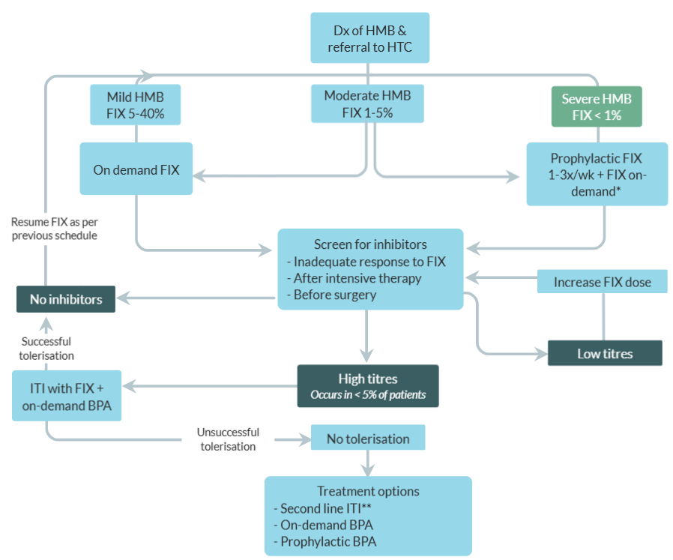

Figure 4 Current clinical algorithm for the treatment of Haemophilia B

BPA = bypass agents (e.g., FVIIa, aPCC, FEIBA); HMB = haemophilia B; HTC = haemophilia treatment centre; FIX = factor IX concentrate; ITI = immune tolerance induction

* To treat breakthrough bleeds / surgical cover

** Different treatment regimen (e.g., higher factor dose or twice-daily regimen), different factor concentrate, or the addition of an immunosuppressant

The future treatment algorithm for HMB following the availability of marstacimab is shown below in **Figure 5**, with the eligible population proposed for reimbursement highlighted in green. For eligible patients who choose to switch from factor therapy to marstacimab, screening for inhibitors (and any subsequent ITI or FIX dose adjustment) will no longer be required.

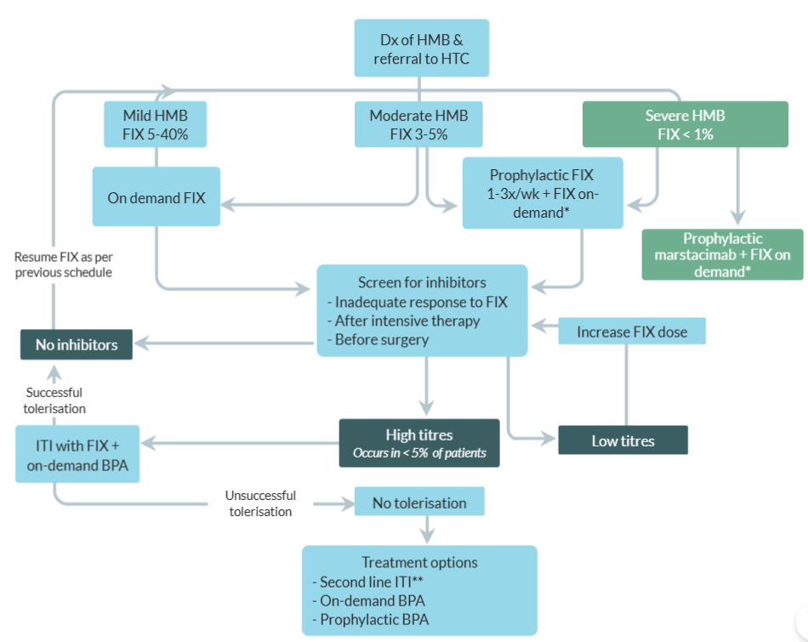

Figure 5 Future clinical algorithm for the treatment of Haemophilia B

BPA = bypass agents (e.g., FVIIa, aPCC, FEIBA); HMB = haemophilia B; HTC = haemophilia treatment centre; FIX = factor IX concentrate; ITI = immune tolerance induction

* To treat breakthrough bleeds / surgical cover

** Different treatment regimen (e.g., higher factor dose or twice-daily regimen), different factor concentrate, or the addition of an immunosuppressant

**HMA**

The current treatment algorithm for HMA is shown below in **Figure 6.** Potential candidates for reimbursed treatment with marstacimab (FVIII < 1%) are highlighted in green. The current standard of care for these patients involves either prophylactic subcutaneous injections of emicizumab (1–4x per month) or prophylactic infusions of FVIII concentrate (1–3x per week), as the most common treatment regimens (see **Comparator** Section for details). Patients on a prophylactic regimen with either emicizumab or FVIII concentrate still receive FVIII concentrate on-demand as required, for example to treat breakthrough bleeds or prior to surgery.

Similar to HMB, patients with HMA receiving FVIII prophylaxis are screened for inhibitors if the clinical response is not as expected, after intensive therapy or before surgery. Inhibitor development is more common in HMA, occurring in approximately 30% of individuals with severe disease (Srivastava, Santagostino, & Dougall, 2020). If high titres are observed, ITI with FVIII is performed in the first instance, with on-demand BPA as required. If tolerisation is unsuccessful, treatment options include on-demand or prophylactic BPAs, or prophylactic emicizumab with a BPA.

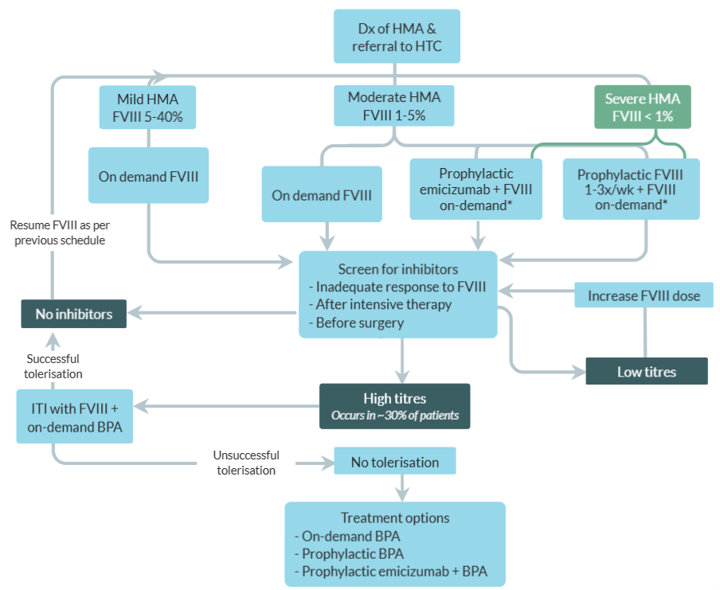

Figure 6 Current clinical algorithm for the treatment of Haemophilia A

BPA = bypass agents; HMA = haemophilia A; HTC = haemophilia treatment centre; FVIII = factor VIII concentrate; ITI = immune tolerance induction

* To treat breakthrough bleeds / surgical cover

Source: <https://my.visme.co/editor/aEpkc1JDZVFHVVh4UU5sb1JNVmdpQT09OjpbG7KWToQgWccH-dN5xnID/graphics>

The future treatment algorithm for HMA following the availability of marstacimab is shown in **Figure 7,** with the eligible population proposed for reimbursement highlighted in green. Marstacimab will represent an alternative to emicizumab and factor replacement therapy for children and adults aged 12 years and older with severe HMA.

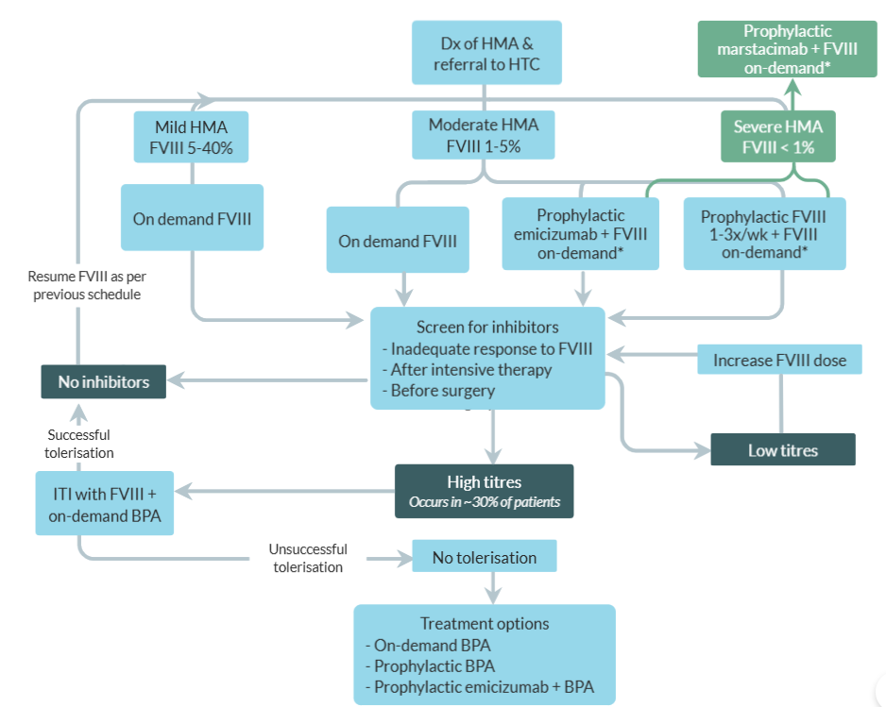

Figure 7 Future clinical algorithm for the treatment of Haemophilia A

BPA = bypass agents; HMA = haemophilia A; HTC = haemophilia treatment centre; FVIII = factor VIII concentrate; ITI = immune tolerance induction

* To treat breakthrough bleeds / surgical cover

Source: <https://my.visme.co/editor/aEpkc1JDZVFHVVh4UU5sb1JNVmdpQT09OjpbG7KWToQgWccH-dN5xnID/graphics>

# **Claims**

**In terms of health outcomes (comparative benefits and harms), is the proposed technology claimed to be superior, non-inferior or inferior to the comparator(s)?** (please select your response)

Superior (versus factor prophylaxis in HMA and HMB)

Non-inferior (versus emicizumab in HMA)

Inferior

**Please state what the overall claim is, and provide a rationale:**

**HMA**

Among children and adults aged 12 years and older with severe HMA (FVIII < 1%) without inhibitors:

* Marstacimab has superior efficacy to FVIII prophylaxis and non-inferior efficacy to emicizumab in terms of annualised bleeding rate of treated bleeds; and
* Marstacimab has a non-inferior safety profile to FVIII prophylaxis and emicizumab in terms of adverse events.

**HMB**

Among children and adults aged 12 years and older with severe HMB (FIX < 1%) without inhibitors:

* Marstacimab has superior efficacy to FIX prophylaxis in terms of annualised bleeding rate of treated bleeds; and
* Marstacimab has a non-inferior safety profile to FIX prophylaxis in terms of adverse events.

**Why would the requestor seek to use the proposed investigative technology rather than the comparator(s)?**

In HMB, marstacimab offers superior efficacy to factor replacement therapy while significantly reducing the treatment burden by allowing for a once-weekly, self-administered, subcutaneous injection. Marstacimab represents the first subcutaneous treatment option for patients with HMB without inhibitors, and will be particularly valuable for patients who struggle with vascular access.

In HMA, marstacimab offers similar efficacy and safety to emicizumab while simplifying therapy by offering a once-weekly, subcutaneous injection delivered via a pen-device with flat dosing. The flat dosing of marstacimab will be particularly valuable for children and adolescents where body weight is frequently changing. Patients with severe HMA choosing to switch from intravenous factor replacement therapy to marstacimab will have a significantly reduced treatment burden due to the subcutaneous route of administration.

**Identify how the proposed technology achieves the intended patient outcomes:**

See **Section 2** (Intervention) for details.

**For some people, compared with the comparator(s), does the test information result in:** (please highlight your response)

**A change in clinical management?** Yes No

**A change in health outcome?** Yes No

**Other benefits?** Yes No

Not applicable.

**Please provide a rationale, and information on other benefits if relevant:**

Besides the tangible medical and economic costs, haemophilia also incurs tremendous intangible costs, including the emotional and physical toll on patients and their caregivers/loved ones (Chen S. , 2016; Cassis, A., & Forsyth, 2014). Part of this toll can be attributed to treatment burden.

Of the 299 adults with HMB who participated in the US-based Bridging Hemophilia B Experiences, Results and Opportunities Into Solutions (B-HERO-S) study, 94% reported that the condition had a negative effect on their ability to complete a formal education, largely attributed to the inability to attend or concentrate in school as a result of bleeding or pain (Cutter, Molter, & Dunn, 2017). Nearly all the adults (95%) reported a negative impact on their ability to work, but current routine infusion therapy allowed 27% of respondents to work in most situations. The study also reported that 98% of adults experienced a negative impact on their participation in recreational activities due to haemophilia‐related issues, and 90% of caregivers of children with HMB (n=150) said that HMB had a negative impact on their child's engagement in recreation (Baumann, Hernandez, & Witkop, 2017).

Additional studies have shown that patients with HMB are up to 4 times more likely to be unemployed than non-haemophilia controls (among people of working age) (Hartl, et al., 2008), and are less likely to be in full-time work if their haemophilia is severe compared with patients with mild or moderate haemophilia (Chen, Baker, & Nichol, 2017; Plug, Peters, & Mauser-Bunschoten, 2008).

As marstacimab is expected to reduce the ABR of treated bleeds in HMB compared to factor prophylaxis, as well as simplifying treatment, there may be a flow-on positive impact on to participation in work, education and recreational activities among these patients.

Many people with haemophilia feel that using their treatment product interferes with their ability to travel. In a multinational survey of 200 patients with moderate or severe HMA, 47% of respondents said they were dissatisfied with the need to take all of their treatment items with them when travelling and 41% were dissatisfied with storing the product with them when they’re away from home (Tischer, Marino, & Napolitano, 2018). As a once-weekly subcutaneous injection, marstacimab will help to alleviate this burden.

**In terms of the immediate costs of the proposed technology (and immediate cost consequences, such as procedural costs, testing costs etc.), is the proposed technology claimed to be more costly, the same cost or less costly than the comparator?** (please select your response)

More costly (than factor replacement therapy in HMA and HMB)

Same cost (as emicizumab in HMA)

Less costly

**Provide a brief rationale for the claim:**

The clinical data for marstacimab will support a clinical claim of superior efficacy versus factor prophylaxis in HMA and HMB, and non-inferior efficacy versus emicizumab in HMA. As such, cost-effectiveness analyses will be performed to establish the value-based price of marstacimab versus factor prophylaxis in HMA and HMB, and a cost-minimisation analysis will be performed versus emicizumab in HMA.

# **Summary of Evidence**

**Provide one or more recent (published) high quality clinical studies that support use of the proposed health service/technology. At ‘Application Form lodgement’, please do not attach full text articles; just provide a summary (repeat columns as required).**

**Identify yet-to-be-published research that may have results available in the near future (that could be relevant to your application). Do not attach full text articles; this is just a summary (repeat columns as required).**

An overview of the marstacimab clinical development program is shown in **Figure 8,** with details for individual trials provided in **Table 5.**

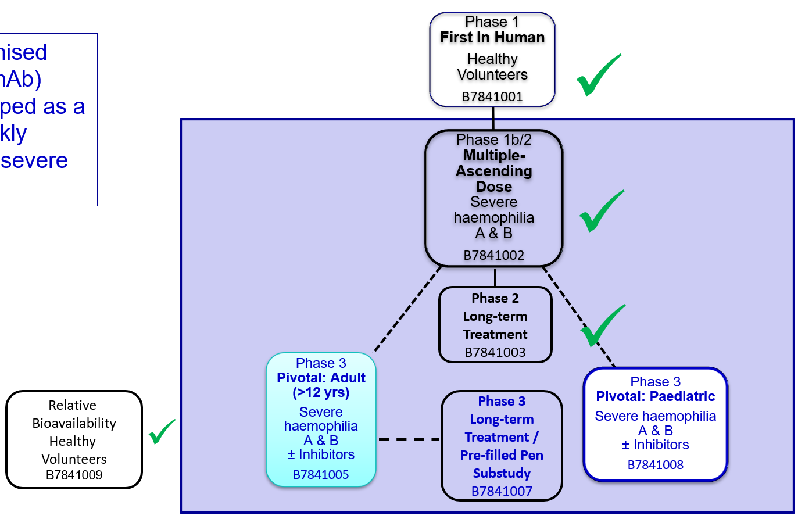

Figure 8 Overview of marstacimab clinical trial program

Table 5 Summary of trials and publications in marstacimab clinical program

| **Type of study design\*** | **Title of journal article or research project (including any trial identifier or study lead if relevant)** | **Short description of research (max 50 words)\*\*** | **Website link to journal article or research (if available)** | **Date of publication** |
| --- | --- | --- | --- | --- |
| Phase I first-in-human, dose escalation study | NCT02531815 / B7841001  A Randomized, Double-blind, Sponsor-open, Placebo-controlled, Single Intravenous Or Subcutaneous Dose Escalation Study To Evaluate The Safety, Tolerability, Pharmacokinetics, And Pharmacodynamics Of Pf-06741086 In Healthy Subjects And An Open-label Evaluation In Healthy Japanese Subjects | A Phase I study of 41 healthy volunteers to assess the safety, tolerability, pharmacokinetics and immunogenicity of single SC doses of marstacimab 30, 100 or 300 mg, or IV doses of marstacimab 150, 300, 1000 or 440 mg, or placebo. | <https://clinicaltrials.gov/ct2/show/>  NCT02531815  Cardinal M, et al. J Thromb Haemost 2018;16:1722–31 | 2018 |
| Phase Ib/II multiple ascending dose study | NCT02974855 / B7841002  A multicenter, open-label, multiple ascending dose study to evaluate the safety, tolerability, pharmacokinetics, pharmacodynamics, and efficacy of subcutaneous or intravenous Pf-06741086 in subjects with severe haemophilia | A Phase Ib/II study of 27 patients with severe haemophilia to assess the safety, tolerability, pharmacokinetics and efficacy of SC marstacimab 150, 300 or 450 mg once weekly over a period of 78 days. | <https://clinicaltrials.gov/ct2/show/>  NCT02974855  Mahlangu et al Br J Haematol. 2022;00:1–9 | 2022 |
| Phase II long-term follow-up study | NCT03363321 / B7841003  A multicenter, open-label study to evaluate the long-term safety, tolerability and efficacy of subcutaneous Pf-06741086 in subjects with severe haemophilia | A Phase II follow-up study of 20 patients with severe haemophilia who participated in Study B7841002, to assess the safety, tolerability and efficacy of long-term treatment with SC marstacimab. | <https://clinicaltrials.gov/ct2/show/>  NCT03363321  Mahlangu J. et al. Br J Haematol. 2023; 200(2):229-239 | 2023 |
| Phase III one-way, cross-over study **(pivotal efficacy trial)** | **BASIS** (NCT03938792 / B7841005)  An Open-Label Study in Adolescent and Adult Severe (Coagulation Factor Activity <1%) Hemophilia A Participants With or Without Inhibitors or Moderately Severe to Severe Hemophilia B Participants (Coagulation Factor Activity ≤2%) With or Without Inhibitors Comparing Standard Treatment to PF-06741086 Prophylaxis | A Phase III study of 145 patients with severe HMA or moderately severe to severe HMB assessing the efficacy and safety of a 300 mg loading dose of marstacimab followed by weekly dosing of 150 mg. | [www.clinicaltrials.gov/ct2/show/](http://www.clinicaltrials.gov/ct2/show/)  NCT03938792 | NA |
| Phase III paediatric study | **BASIS KIDS** (NCT05611801 / B7841008)  An open-label study in pediatric (<18 years of age), severe haemophilia participants (coagulation factor activity <1%) with or without inhibitors, or moderately severe to severe haemophilia B participants (coagulation factor activity ≤2%) with or without inhibitors, comparing 12 months of historical standard treatment to marstacimab prophylaxis. | A Phase III study of 100 paediatric patients with severe HMA or moderately severe to severe HMB assessing the efficacy and safety of SC marstacimab once weekly. | <https://clinicaltrials.gov/ct2/show/>  NCT05611801 | NA |
| Phase III long-term extension study | **BASIS LTE** (NCT05145127 / B7841007)  An Open-Label Extension Study to Evaluate the Long-term Safety, Tolerability, and Efficacy of Marstacimab Prophylaxis in Participants with Severe Hemophilia A and B With or Without Inhibitors. | Open-label extension study to assess the long-term safety, tolerability, and efficacy of marstacimab in participants who did not require "Early Termination" from the Phase 3 “BASIS” Study, and participants in the first age group (12 to <18 years) from the Phase 3 “BASIS KIDS” Study. | <https://clinicaltrials.gov/study/>  NCT05145127?term=B7841007&rank=1  Matino D. et al. Blood. 2023; 142(S1):285  [https://www.sciencedirect.com/ science/](https://www.sciencedirect.com/%20science/)article/pii/S0006497123048899 | NA  2 Nov 2023 |

IV = intravenous; LTE = long-term extension; SC = subcutaneous

* Categorise study design, for example meta-analysis, randomised trials, non-randomised trial or observational study, study of diagnostic accuracy, etc.

**Provide high level information including population numbers and whether patients are being recruited or in post-recruitment, including providing the trial registration number to allow for tracking purposes. For yet to be published research, provide high level information including population numbers and whether patients are being recruited or in post-recruitment.

**BASIS**

The Phase 3 “BASIS” clinical trial (B7841005) provides the pivotal evidence to inform the clinical efficacy and safety claims for marstacimab in children and adults aged 12 years and older with severe HMA or severe HMB, without inhibitors. BASIS was the clinical trial included in the Category 1 application to the TGA, submitted on 31 January 2024. Marstacimab was approved on the ARTG on 29 January 2025 (ARTG #438990) for the following indications:

*HYMPAVZI is indicated for routine prophylaxis of bleeding episodes in patients 12 years of age and older with:*

* *severe haemophilia A (congenital factor VIII deficiency, FVIII <1%) without factor VIII inhibitors, or*
* *severe haemophilia B (congenital factor IX deficiency, FIX <1%) without factor IX inhibitors.*

BASIS was an open-label, one-way, cross-over, prevention study in which 145 planned participants (≥ 100 without inhibitors) were to be administered a 300 mg loading dose of marstacimab, followed by 150 mg once-weekly dosing for 12 months. Participants began the trial in a 6-month observation phase (OP) in which they continued their current factor replacement treatment regimen (prophylaxis or on-demand) before entering the active treatment phase (ATP) with marstacimab. The primary efficacy endpoint was ABR of treated bleeding events.

Participants who completed the ATP of BASIS were eligible to enrol in the long-term extension (LTE) study (B7841007).

A summary of results for the non-inhibitor population of BASIS with prior prophylaxis are presented below. Results for the inhibitor population of BASIS are still being collected, and the BASIS LTE is ongoing.

**Efficacy**

Once-weekly dosing of marstacimab demonstrated non-inferiority and superiority (2-sided p-value = 0.0376) over routine factor prophylaxis for ABR of treated bleeding events in haemophilia patients without inhibitors. The mean estimated ABR was 5.08 (95% CI: 3.40, 6.77) for marstacimab prophylaxis during the ATP compared to 7.85 (95% CI: 5.09, 10.61) for routine factor prophylaxis during the OP, with a resulting estimated ABR difference of -2.77 (95% CI: -5.37, -0.16). The reduction in ABR of treated bleeds from the OP was 35.2% (95% CI: 5.6, 55.6). With the upper bound of the 95% CI for the ABR difference less than 0, results achieved the predetermined criterion for establishing the non-inferiority and superiority of marstacimab compared to routine factor prophylaxis in haemophilia patients without inhibitors.

A summary of results for the primary analysis is presented in **Table 6**.

Table 6 Primary analysis of the ABR for treated bleeds in BASIS, non-inhibitor cohort with prophylaxis at OP, mITT set

|  |  |  |
| --- | --- | --- |
|  | **Factor Prophylaxis OP**  **N=83** | **Marstacimab ATP**  **N=83** |
| Completed the phase, n (%) | 83 (100) | 78 (94.0) |
| **Descriptive summary** | | |
| Mean ABR (SD) | 7.88 (12.91) | 5.17 (8.04) |
| Min, Max ABR | 0.00, 9.87 | 0.00, 6.09 |
| 0 bleeds, n (%) | 33 (39.8) | 29 (34.9) |
| 1 bleed, n (%) | 9 (10.8) | 7 (8.4) |
| 2 bleeds, n (%) | 11 (13.3) | 9 (10.8) |
| ≥ 3 bleeds, n (%) | 30 (36.1) | 33 (39.8) |
| **Model-based summary1** | | |
| Mean ABR (95% CI) | 7.85 (5.09, 10.61) | 5.08 (3.40, 6.77) |
| **Treatment comparison: marstacimab vs factor prophylaxis** | | |
| Difference estimate (95% CI) | -2.77 (-5.37, -0.16) | |
| p-value | 0.0376 | |
| % reduction from OP (95% CI) | 35.2 (5.6, 55.6) | |

ABR = annualised bleeding rate; ATP = active treatment phase; CI = confidence interval; mITT = modified intent-to-treat; OP = observational phase; SD = standard deviation

Note: “mITT set” defined as participants who completed the OP and received at least 1 dose of marstacimab in the ATP. Participants who changed from the non-inhibitor cohort to the inhibitor cohort on or before ATP Day -7 testing were excluded.

1 Based on a repeated measure negative binomial regression model via generalized estimating equation approach with

identity link function, the working correlation was set as unstructured. The model used the number of bleeds as a response variable, and duration (in years) and the interaction by treatment (marstacimab prophylaxis or routine prophylaxis) and duration as factors without intercept.

Source: BASIS CSR interim report body Table 24

**Long-term efficacy**

Participants who completed the ATP of BASIS were eligible to enrol in the LTE study. There were 88 participants who had entered the LTE at the time of the interim study report (1 Sept 2023), of whom 58 had received routine prophylaxis during the OP (n=45 with HMA and n=13 with HMB). Bleed rates for an additional 16 months of follow-up in the LTE (mean 6.9 months) were consistent with those observed during the first 12 months of marstacimab prophylaxis in BASIS, with mean ABR further decreasing to 2.27 (95% CI 1.40, 3.67) (**Table 7**). Results support the long-term efficacy of marstacimab.

Table 7 Mean ABR for treated bleeds in the OP, ATP and LTE of BASIS, non-inhibitor cohort with prophylaxis at OP

|  |  |  |  |
| --- | --- | --- | --- |
|  | **Factor Prophylaxis OP**  **N=83** | **Marstacimab ATP**  **N=83** | **Marstacimab LTE**  **N=58** |
| Mean ABR (95% CI) | 7.85 (5.09, 10.61) | 5.08 (3.40, 6.77) | 2.27 (1.40, 3.67) |

ABR = annualised bleeding rate; ATP = active treatment phase; CI = confidence interval; LTE = long-term extension; OP = observational phase

Mean duration of follow-up in the LTE: 6.9 months

Source: (Matino, et al., 2023)

More recent data from the LTE was presented at the European Hematology Association (EHA) Congress in 2024 (Kazani, Gould, & Sun, 2024). After a mean duration of 12.5 months in the LTE (range 1 to 23.1 months), 107 of 116 (92.2%) non-inhibitor participants from the BASIS ATP had enrolled in the LTE, including 89 adults (83%) and 18 adolescents (17%). Seventy-five of these participants had received routine prophylaxis during the OP (n=58 with HMA and n=17 with HMB).

Overall compliance with marstacimab prophylaxis was high at 98.9%. The mean estimated ABR for treated bleeds was 2.79 (95% CI 1.95, 3.98) in the prior routine prophylaxis group after a mean 12.5 months (**Table 8**). Findings were similar in the HMA (2.94; 95% CI 2.01, 4.31) and HMB (2.24; 95% CI 0.88, 5.74) subgroups.

Results demonstrate the sustained long-term efficacy of marstacimab in HMA and HMB patients without inhibitors.

Table 8 Mean ABR for treated bleeds in the OP, ATP and LTE of BASIS, non-inhibitor cohort with prophylaxis at OP

|  |  |  |  |
| --- | --- | --- | --- |
|  | **Factor Prophylaxis OP**  **N=83** | **Marstacimab ATP**  **N=83** | **Marstacimab LTE**  **N=75** |
| Mean ABR (95% CI) | 7.85 (5.09, 10.61) | 5.08 (3.40, 6.77) | 2.79 (1.95, 3.98) |

ABR = annualised bleeding rate; ATP = active treatment phase; CI = confidence interval; LTE = long-term extension; OP = observational phase

Mean duration of follow-up in the LTE: 12.5 months

Source: (Kazani, Gould, & Sun, 2024)

**Safety**

The other primary objective of BASIS was to demonstrate the safety of marstacimab. Safety measures included adverse events (AEs), serious adverse events (SAEs), incidence and severity of thrombotic events and injection site reactions, and development of anti-drug antibodies (ADAs).

In the non-inhibitor cohort, once-weekly marstacimab prophylaxis was well tolerated with no notable safety findings. During screening and the 6-month OP (where participants continued their current factor therapy), AEs were collected during 2 clinic visits and 3 phone calls whereas, for the ATP (where participants received marstacimab), AEs were collected during 9 clinic visits and 5 phone calls over a 12-month period. With consideration to these differences in duration of study phase, frequency in study visits, and opportunities to record AEs, and external factors such as COVID-19, marstacimab exhibited an acceptable safety profile versus factor prophylaxis. No thrombotic or embolic events were reported with marstacimab use during the ATP.

A summary of treatment-emergent AEs (TEAEs; all causalities) in the non-inhibitor, prior prophylaxis cohort, is presented in **Table 9.**

The total incidence of TEAEs during the 6-month OP was 27.5% (25 participants with 44 TEAEs), compared with 79.5% (66 participants with 262 TEAEs) during the 12-month marstacimab ATP. The most frequently reported TEAE in the OP and ATP was COVID-19, occurring in 3 (3.3%) participants and 19 (22.9%) participants, respectively. TEAEs were generally mild or moderate in severity. There were 19 (22.9%) participants who experienced treatment-related TEAEs. The most frequently reported treatment-related TEAEs in the marstacimab ATP were injection site pruritis (4 [4.8%] participants), injection site erythema (3 [3.6%] participants), and prothrombin fragment 1.2 increased (3 [3.6%] participants). All treatment-related TEAEs were mild or moderate in severity.

There were no deaths during the study and no SAEs related to thromboembolism. Two (2.2%) SAEs were reported during the OP and seven (8.4%) SAEs were reported during the ATP. One SAE of Grade 1 peripheral swelling (calf swelling) was considered to be treatment-related by the investigator. Five (6.0%) medication errors were reported during the ATP. No participants were permanently discontinued from the study due to AEs during the OP; one (1.2%) participant permanently discontinued during the ATP due to an SAE of meningioma not related to study intervention.

Of the 116 ADA-evaluable participants, 23 participants (19.8%) were ADA positive (treatment-induced). Of the 23 ADA-positive participants, 21 participants were adults (21/97 [21.6%]) and 2 participants were adolescents (2/19 [10.5%]). For the majority of the participants who developed ADAs, titers were low and seen by the first post-dose visit. ADAs were transient (positivity for <16 weeks) in the majority (14/23 [61%]) of participants and had resolved in 95.7% (22/23) of participants by the end of the study.

Six of 116 ADA-evaluable participants (5.2%) developed nAbs. All were transient in nature and no participants were nAb positive at the end of the study.

Table 9 Summary of all-causality AEs in BASIS by age group, non-inhibitor cohort with prophylaxis at OP, all safety set

|  |  |  |  |  |  |  |
| --- | --- | --- | --- | --- | --- | --- |
| **n (%)** | **18 to <75 years** | | **12 to <18 years** | | **All** | |
| **OP**  **N=73** | **ATP**  **N=66** | **OP**  **N=18** | **ATP**  **N=17** | **OP**  **N=91** | **ATP**  **N=83** |
| AEs, n | 33 | 226 | 11 | 36 | 44 | 262 |
| Participants with AEs | 18 (24.7) | 52 (78.8) | 7 (38.9) | 14 (82.4) | 25 (27.5) | 66 (79.5) |
| Participants with SAEs | 1 (1.4) | 6 (9.1) | 1 (5.6) | 1 (5.9) | 2 (2.2) | 7 (8.4) |
| Participants with max Grade 3 AEs | 1 (1.4) | 5 (7.6) | 0 | 1 (5.9) | 1 (1.1) | 6 (7.2) |
| Participants with max Grade 4 AEs | 0 | 0 | 0 | 0 | 0 | 0 |
| Participants with max Grade 5 AEs | 0 | 0 | 0 | 0 | 0 | 0 |
| Participants with related AEs | - | 15 (22.7) | - | 4 (23.5) | - | 19 (22.9) |
| Discontinuations due to AEs | 0 | 1 (1.5) | 0 | 0 | 0 | 1 (1.2) |
| Dose reductions or temporary discontinuations due to AEs | 0 | 12 (18.2) | 0 | 2 (11.8) | 0 | 14 (16.9) |
| Deaths | 0 | 0 | 0 | 0 | 0 | 0 |

AEs = adverse events; ATP = active treatment phase; OP = observational phase; SAEs = serious adverse events

Note: “all safety set” defined as all participants who received at least one treatment during the OP, and all participants who received at least one dose of marstacimab during the ATP

Source: BASIS CSR interim report body Table 42 (all except treatment-related) and Table 45 (treatment-related)

**Long-term safety**

At the time of the interim report of the BASIS LTE (1 Sept 2023), after an additional mean 6.9 months of marstacimab prophylaxis, no thromboembolic, thrombotic microangiopathy, or disseminated intravascular coagulopathy adverse events of special interest (AESIs) were reported. There were no deaths or discontinuations from treatment or the study due to AEs. Two (2.3%) SAEs were reported: one participant had a contusion of the head and one participant had haemarthrosis of the hip. Both events resolved and the participants continued treatment with marstacimab. Neither event was considered to be treatment-related.

The majority of TEAEs were mild; one (1.1%) Grade 2 treatment-related injection site reaction (swelling) was reported in one participant. This event resolved in 6 days without sequalae. There were three other TEAEs reported in two participants which were considered to be treatment-related. All were Grade 1 injection-site reactions (2 events of bruising and 1 event of induration). No injection-site reactions of pain were reported.

At the time of the interim report of the BASIS LTE, one adult participant was persistently positive for anti-drug antibodies (ADAs; incidence 1/44 [2.3%]). This participant had a negative ADA titer prior to receiving marstacimab in the parent study, with a positive ADA titer at the end of the parent study and a positive ADA titre at Day 180 in the LTE. The participant was negative for nAbs at both time points. No other participants tested positive for ADAs in the LTE.

No new safety signals had emerged for marstacimab at the time of the EHA presentation in 2024 after a mean additional treatment duration of 12.5 months in the BASIS LTE (Kazani, Gould, & Sun, 2024).

Full results of the BASIS clinical trial, including relevant subgroup and sensitivity analyses, will be presented in the full MSAC application.

# **References**

AHCDO. (2024). *Position Statement: Guidelines for the Management of Haemophilia in Australia.* Malvern East, VIC: AHCDO.

Baumann, K., Hernandez, G., & Witkop, M. (2017). Impact of mild to severe hemophilia on engagement in recreational activities by US men, women, and children with hemophilia B: The Bridging Hemophilia B Experiences, Results and Opportunities into Solutions (B-HERO-S) study. *European Journal of Haematology, 98*(Suppl 86), 25-34.

Buckner, T., Batt, K., Quon, D., Witkop, M., Recht, M., & Kessler, C. (2018). Assessments of pain, functional impairment, anxiety, and depression in US adults with hemophilia across patient-reported outcome instruments in the Pain, Functional Impairment, and Quality of Life (P-FiQ) study. *Eur J Haematol, 100*(Suupl 1), 5-13.

Carroll, L., Benson, G., Lambert, J., Benmedjahed, K., Zak, M., & Lee, X. (2019). Real-world utilities and health-related quality-of-life data in hemophilia patients in France and the United Kingdom. *Patient Prefer Adherence, 13*, 941-57.

Cassis, F., A., B., & Forsyth, A. (2014). Haemophilia Experiences, Results and Opportunities (HERO) Study: influence of haemophilia on interpersonal relationships as reported by adults with haemophilia and parents of children with haemophilia. *Haemophilia, 20*(4), e287-e295.

Chen, C., Baker, J., & Nichol, M. (2017). Economic burden of illness among persons with hemophilia B from HUGS Vb: examining the association of severity and treatment regimens with costs and annual bleed rates. *Value in Health, 20*(8), 1074-1082.

Chen, S. (2016). Economic costs of hemophilia and the impact of prophylactic treatment on patient management. *The American Journal of Managed Care, 22*(5 Suppl), S126-S133.

Cutter, S., Molter, D., & Dunn, S. (2017). Impact of mild to severe hemophilia on education and work by US men, women, and caregivers of children with hemophilia B: The Bridging Hemophilia B Experiences, Results and Opportunities into Solutions (B-HERO-S) study. *European Journal of Haematology, 98*(Suppl 86), 18-24.

D'Angiolella, L. (2018). The socioeconomic burden of patients affected by hemophilia with inhibitors. *Eur J Haematol, 101*(4), 435-56.

Haemophilia Foundation Australia. (2013). *Haemophilia.* Malvern East, VIC: Haemophilia Foundation Australia.

Haemophilia Foundation Australia. (2023). *Haemophilia.* Darling, VIC: HFA.

Hartl, H., Reitter, S., Eider, U., Ramschak, H., Ay, C., & Pabinger, I. (2008). The impact of severe haemophilia on the social status and quality of life among Austrian haemophiliacs. *Haemophilia, 14*(4), 703-8.

Hassan, S., Monahan, R., & Mauser-Bunschoten, E. (2021). Mortality, life expectancy, and causes of death of persons with hemophilia in the Netherlands 2001-2018. *J Thromb Haemost, 19*(3), 645-653.

IQVIA. (August 2023). *Understanding experiences of patients with haemophilia A & B.* Sydney: IQVIA.

Kazani, S., Gould, T., & Sun, P. (2024). Abstract S320: Sustained efficacy of marstacimab in adults and adolescents with severe hemophilia A or B without inhibitors. *EHA Congress*.

Khanji, C., Nuabor, W., & Gould, T. (2025). Systematic Literature Review of Outcomes Associated With Adherenece to Haemophilia Drug Therapy. *Haemophilia*, 1-20.

Kizilocak, H., & Young, G. (2019). Diagnosis and treatment of hemophilia. *Clin Adv Hematol Oncol, 17*(6), 344-351.

Mason, J., Parikh, S., Rowell, J., & McRae, S. (2018). Australian multicentre study of current real-world prophylaxis practice in severe and moderate haemophilia A and B. *Haemophilia, 24*, 253-60.

Matino, D., Acharya, S., Palladino, A., Hwang, E., McDonald, R., Taylor, C., & Teeter, J. (2023). Efficacy and Safety of the Anti-Tissue Factor Pathway Inhibitor Marstacimab in Participants with Severe Hemophilia without Inhibitors: Results from the Phase 3 Basis Trial. *Blood, 142*, 285-87.

NA. (2025). *Australian Product Information - HYMPAVZI (marstacimab).* Unpublished.

National Blood Authority. (2016). *Guidelines for the managment of haemophilia in Australia.* Malvern East, VIC: Australian Haemophilia Centre Directros' Organisation.

National Blood Authority. (2020). *Australian Bleeding Disorders Registry Annual Report 2019-20.* Canberra: National Blood Authority.

National Blood Authority. (2021). *Australian Bleeding Disorders Registry Annual Report 2020-21.* Canberra: National Blood Authority.

National Blood Authority. (2023). *Australian Bleeding Disorders Registry Annual Report 2021-22.* Canberra: National Blood Authority.

National Blood Authority. (2023b). *Analyses requested by Pfizer from the ABDR.* Canberra: NBA.

National Blood Authority. (2025). *The framework for the management of bleeding disorders in Australia.* Canberra: NBA.

National Blood Authority. (Dec 2023). *Australian Bleeding Disorders Registry Annual Report 2022-23.* Canberra: NBA.

NORD. (2015). *Hemophilia A: Rare Disease Database.* National Organization for Rare Disorders.

NORD. (2018). *Hemophilia B: Rare Disease Database.* National Organization for Rare Disorders.

O'Hara, J., Walsh, S., Camp, C., Mazza, G., Carroll, L., & Hoxer, C. (2018). The impact of severe haemophilia and the presence of target joints on health-related quality-of-life. *Health Qual Life OUtcomes, 16*(1), 84.

Plug, I., Peters, M., & Mauser-Bunschoten, E. (2008). Social participation of patients with hemophilia in the Netherlands. *Blood, 111*(4), 1811-15.

Smith, S., Travers, R., & Morrissey, J. (2015). How it all starts: initiation of the clotting cascade. *Crit Rev Biochem Mol Biol, 50*(4), 326-336.

Srivastava, A., Santagostino, E., & Dougall, A. (2020). WFH Guidelines for the Management of Hemophilia, 3rd edition. *Haemophilia, 26*(Suppl 6), 1-158.

Thornburg, C., & Duncan, N. (2017). Treatment adherence in hemophilia. *Patient Preference and Adherence, 11*, 1677-86.

Tischer, B., Marino, R., & Napolitano, M. (2018). Patient preferences in the treatment of hemophilia A: impact of storage conditions on product choice. *Patient preference and adherence, 12*, 431-441.