MSAC Application 1790

*POLE* genotyping for the molecular classification of endometrial cancer

Applicant: The Royal College of Pathologists of Australasia

# PICO Confirmation

## Summary of PICO/PPICO criteria to define question(s) to be addressed in an Assessment Report to the Medical Services Advisory Committee (MSAC)

Table 1 PICO for *POLE* genotyping in patients with endometrial carcinoma

| **Component** | **Description** |
| --- | --- |
| Population | Patients diagnosed with endometrial carcinoma. |
| Prior tests | Pelvic ultrasonography with or without transvaginal ultrasonography to measure endometrial thickness, endometrial biopsy, and/or dilatation and curettage with or without hysteroscopy. |
| Intervention | *POLE* genotyping (method agnostic) in the exonuclease domain (targeting exons 9, 11, 13 and 14 as a minimum) where pathogenic variants have been detected |
| Comparator/s | No *POLE* testing. |
| Reference standard | Next generation sequencing |
| Outcomes | *Safety*   * Harm associated with absence of testing. * Harm associated with false positive or false negative results.   *Clinical effectiveness*  Test performance   * Prognostic accuracy: Sensitivity, specificity, positive predictive value, and negative predictive value of *POLE* genotyping to predict avoidance of adjuvant therapy. * Any differences in prognostic accuracy by patient characteristics (e.g., age, ancestry) and underlying condition (e.g., type of endometrial carcinoma).   Patient management outcomes   * Change in patient management (e.g., modification of therapy, monitoring, fertility-sparing treatment). * Any differences in patient management by patient characteristics. * Change in patient health outcomes: mortality, morbidity, quality of life   Non-health outcome   * Value of knowing (for patients with group 2 (Low-grade (G1/G2; Endometrioid; Stage IA; no/focal LVSI; ER positive) or group 4 (Stage III/IV or locally advanced) endometrial carcinoma).   *Healthcare resource use*   * costs associated with the intervention including cost of appointments, cost of test processing and out-of-pocket costs * cost-effectiveness of *POLE* genotyping * total Australian Government healthcare costs * uptake of *POLE* genotyping |
| Assessment questions | What is the safety, effectiveness and cost-effectiveness of *POLE* genotyping versus no *POLE* testing in patients with endometrial carcinoma? |

Abbreviations: *POLE*= Polymerase ε exonuclease; LVSi=Lymph-vascular space invasion; ER=oestrogen receptor

## Purpose of application

An application requesting Medicare Benefits Schedule (MBS) listing of *POLE* genotyping for the molecular classification of endometrial carcinoma was received from The Royal College of Pathologists of Australasia by the Department of Health and Aged Care.

The claim is that the proposed technology results in superior health outcomes compared to the comparator/standard practice.

## PICO criteria

### Population

The PICO population is patients diagnosed with endometrial carcinoma (EC).

Uterine cancer is the most common gynaecological cancer diagnosed in Australian women, with 90-95% being endometrial carcinomas, which originate from the inner epithelial lining of the uterus (ANZGOG, 2024 ). Most patients diagnosed with endometrial carcinomas are postmenopausal, with a median age at diagnosis of 60 years. However, the incidence of EC is steadily increasing, especially among younger, premenopausal women, potentially due to increasing risk factors such as rising rates of obesity and changes in reproductive trends, including women having fewer children and delaying childbirth. In 2020, there were 2,652 women in Australia diagnosed with EC and this is expected to rise to approximately 3,019 in 2024, equivalent to an age-standardised rate of 17.8 per 100,000 females (AIHW, 2025). EC rates steadily increase in women over 35 years, peaking between ages 65 and 75. Survival rates are generally very good, with 84.4% of women surviving 5 years after diagnosis (95% CI [83.6, 85.2]). However, cases of EC have been identified in patients as young as 14 years of age (Lee et al., 2006).

Endometrial carcinomas are traditionally classified according to histopathological subtypes (Type I and II) and tumour grades (Grade I-III). Type I, which has a favourable prognosis, primarily consists of grade I or grade II endometrioid adenocarcinomas, while Type II, which has an unfavourable prognosis, includes grade III endometrioid adenocarcinomas, serous clear cell, undifferentiated, and carcinosarcomas. Although histological classification helps determine further surgical and adjuvant therapy, decision-making can be complicated by overlaps between tumour subtypes and grades, as well as interobserver variability in classification (WHO, 2020). Incorporating molecular classification into the standard histologic classification of EC will precisely define subtypes and guide therapeutic decision-making (WHO, 2020). A diagnostic algorithm may include the use of three immunohistochemical markers (Tumour protein P53 (p53), mutS homolog 6 (MSH6), and Postmeiotic Segregation homolog 2 (PMS2)) along with variant analysis of the *POLE* gene. Approximately 7-10% of all ECs have a *POLE* variant known as a *POLE* hotspot mutation (*POLEmut*), characterized by a high tumour mutational burden (Berek et al., 2023, Naveena Singh, 2022, Sznurkowski et al., 2023, WHO, 2020).

Patients with *POLEmut* have an excellent prognosis, with comparable recurrence-free and overall survival rates regardless of post-surgical adjuvant therapy (Nero et al., 2025). Therefore, de-escalation to no adjuvant treatment is recommended for patients with low-risk, stage I-II *POLEmut* endometrial carcinoma (WHO, 2020). However, it is recommended by the applicant that all women with EC undergo risk stratification with *POLE* variant analysis regardless of histological classification. During the pre-PASC meeting, the applicant confirmed that all EC patients would be eligible for testing. However, in practice, testing is unlikely to be clinically necessary for women with low-stage, low-grade disease, as it typically does not influence clinical management. While the applicant is requesting testing in patients with endometrial carcinoma, there are some discrepancies among guidelines and how *POLE* genotyping should be applied. The International Federation of Gynaecology and Obstetrics (FIGO) staging of endometrial carcinoma (Jonathan S. Berek, 2023) states that “if available and feasible, molecular classification testing (*POLEmut*, mismatch Repair deficiency (dMMR), No Specific Molecular Profile (NSMP), p53 protein mutated or abnormally expressed (p53abn)) is encouraged in all patients with endometrial carcinoma for prognostic risk-group stratification” (Berek et al., 2023). Polish guidelines suggest that if endometrial carcinoma is diagnosed on the initial histology, then molecular classification can also be conducted at this point (Sznurkowski et al., 2023). The British Association of Gynaecological Pathologists (BAGP) recommend that only Group 1 and Group 3 endometrial carcinomas should undergo *POLE* genotyping to limit resource use (Figure 1; Naveena Singh, 2022). During the pre-PASC meeting the applicant confirmed that the proposed placement of *POLE* testing follows BAGP guideline and occurs after MMR testing, rather than before, as suggested in the National Comprehensive Cancer Network (NCCN) guideline (Abu-Rustum, 2023). The reason given was that this sequence aligns with the usual workflow in laboratories.

*PASC noted inconsistencies in international guidelines in regard to the test population, which has implication for the size of test population. PASC noted that FIGO encourages* POLE *genotyping in all patients with EC if available and feasible, whereas BAGP recommends* POLE *genotyping only for selected cases of EC to optimize resource utilization. PASC noted that the MSAC executive recommended a full evaluation of the current application due to the inconsistency with respect to best practice and current clinical guidelines in using* POLE *testing, which has implications on the total financial impact.*

*PASC noted that 3-5% of EC tumours may have more than one molecular feature (multiple classifiers) with tumours with both* POLE *and p53 variants behaving like* POLE*mut tumours. Furthermore, PASC noted that tumours with pathogenic* POLE *exonuclease domain variants and MMRd are classified as* POLEmut*. Therefore, PASC considered that* POLE *testing cannot be excluded based on positive MMR or p53 immunohistochemistry (IHC).*

*PASC noted that the BAGP guidelines recommend* POLE *testing for Group 1 EC (MMR abnormal and/or p53 abnormal) at the initial biopsy stage and Group 3 EC (Stage I/II non-endometrioid; G3 endometrioid, stage IA with no or focal LVSI; or endometrioid with any of the following: ER negative, stage IA with substantial LVSI, or stage IB/II) after hysterectomy. PASC noted that BAGP guidelines do not recommend* POLE *testing for Group 4 EC (Stage III and IV or locally advanced EC) unless requested by a multidisciplinary team, as these advanced tumours would typically receive adjuvant treatment regardless. PASC considered that there may be utility in testing these advanced tumours. For instance, tumours with* POLE *variants may be considered for less aggressive adjuvant therapy. PASC noted that BAGP guidelines do not recommend* POLE *testing in Group 2 EC (low grade, endometriod stage IA, no/focal LVSI, ER positive) citing the recently validated selective ProMisE testing protocol (ProMisE-S, Talhouk et al 2023). The ProMisE-S defined “very low risk” EC (Grade 1/2, endometrioid, MMR and p53 normal, stage 1A, no LVI) with excellent prognosis (no adjuvant therapy required) and POLE testing was not tested in this subgroup as* POLE *testing would not alter clinical management. PASC noted that using ProMisE-S approach* POLE *testing would not be required in the “very low risk” EC which accounted for 55% of biopsies and 38% of all ECs after evaluation of hysterectomy specimens in the population in (Talhouk A, 2023) study.*

*PASC noted the applicant’s pre-PASC response on the issues of selecting patients for testing as per BAGP guidelines. For Group 3 patients with stage I/II EC (these patients are not considered to be low risk), delaying* POLE *testing until after definitive surgery and staging would hinder timely treatment options. Furthermore, immune checkpoint therapy remains unavailable for rare recurrences in Group 2 (low risk), and fertility-sparing approaches for young patients with* POLE*-variants are not accommodated under the current BAGP guidelines (as only Group 1 EC is tested prior to hysterectomy). Additionally, the pathway does not fully address complex pathological cases such as uncertain lymphovascular invasion or isolated tumour cells in lymph nodes which could influence decisions of adjuvant treatment. In addition,* POLE *testing can provide reassurance for Group 2 patients by confirming a low relapse risk, allowing them to avoid unnecessary adjuvant therapies. Results of* POLE *testing can also provide guiding immunotherapy considerations for Group 4 (Stage III/IV) and potentially de-escalate therapy in frail patients with advanced disease.*

*PASC noted that the initial application was for all patients diagnosed with EC, and that the applicant noted during the pre-PASC PICO development that in practice, testing is unlikely to be needed for low stage low-grade disease. However, PASC noted the advice provided by the applicant’s clinical expert that there are multiple potential benefits in testing all EC patients, including obtaining timely information on the* POLE *status to plan for treatments (i.e. adjuvant therapy and extent of surgery, if required) and benefits related to the workflow in the lab and in handling multiple classifiers (as discussed above). PASC noted from the applicant that some patients may prefer fertility sparing options over hysterectomy and therefore knowing the* POLE *status from the initial biopsy may provide valuable information/assurance on whether a hysterectomy can be avoided or delayed. Taking all this into consideration, PASC considered that all EC patients should be eligible for testing (preferably on the initial biopsy at the diagnosis stage).*

*PASC noted that while the current application is for somatic testing, some* POLE *variants may be hereditary (particularly in patients with family history of colon or EC), and considered whether costing for germline testing in applicable patients should also be included in the current application. PASC noted from the applicant that only a very small proportion of patients will require germline testing and that this would not lead to any significant impact on costs.*

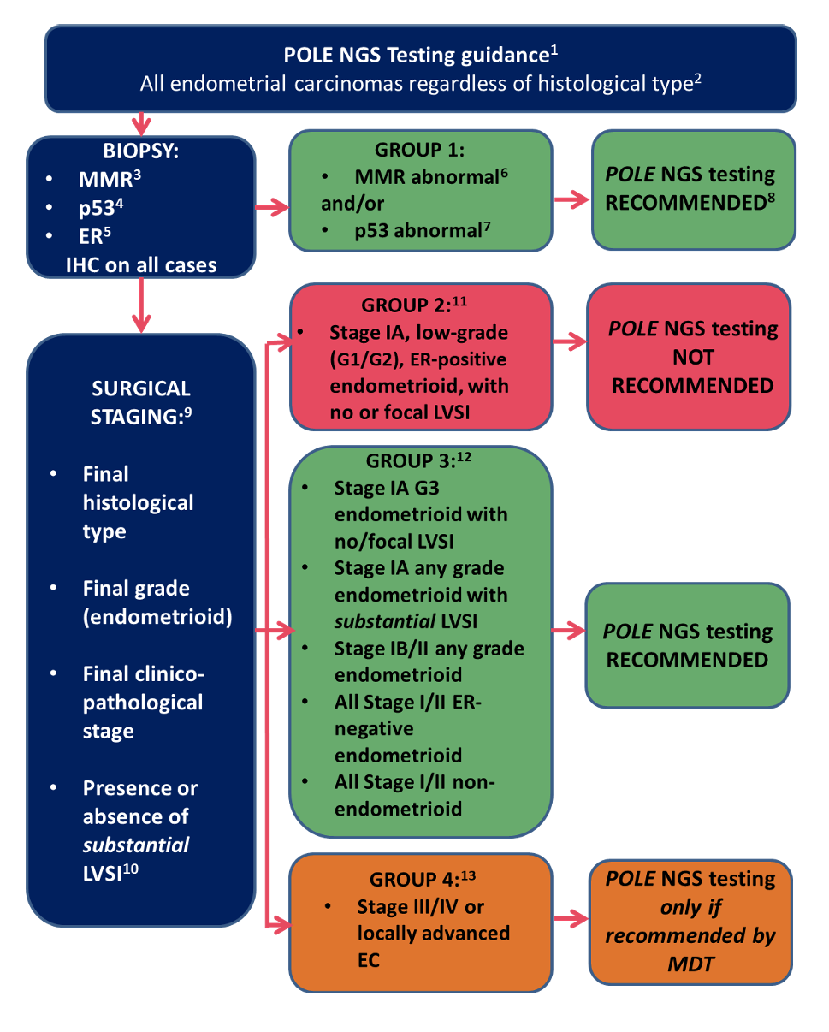

Figure 1 Algorithm provided to limit *POLE* testing to those cases where it is essential for patient care

Source: adapted from BAGP POLE NGS testing guidance, v1.1, dated 8 April 2022  
Abbreviations: EC=endometrial carcinoma; ER=estrogen receptor; IHC=immunohistochemistry; LVSI=lymphovascular space invasion; MMR=mismatch repair deficiency; MDT=multi-disciplinary team; NGS=next generation sequencing, p53=tumour protein P53

### Intervention

*POLE* genotyping is a molecular diagnostic test used to identify variants in the *POLE* gene, specifically in its exonuclease domain. The *POLE* gene encodes DNA polymerase epsilon, an enzyme involved in DNA replication and repair. Variants in this gene, particularly in the exonuclease domain, lead to an ultramutated (>100 mutations/megabase) phenotype, which is associated with certain cancers, such as endometrial carcinoma (Li et al., 2019). Different test methodologies are available for *POLE* genotyping (e.g. NGS, Multiplex Genotyping Quantitative PCR, Sanger sequencing). The applicant requested the proposed MBS item descriptor to be method agnostic. NGS would be considered the reference standard for *POLE* genotyping and is considered the preferred method due to its high sensitivity, ability to detect rare pathogenic variants, and lower limit of detection. During the pre-PASC meeting the applicant noted that they were not aware of any laboratory in Australia using PCR for *POLE* genotyping.

NGS is particularly effective for identifying variants in the exonuclease domain of the *POLE* gene, which are crucial for molecular classification and risk stratification in endometrial carcinoma and the following clinical outcomes:

* Risk Stratification: *POLE* variants are linked to a subtype of endometrial carcinoma (*POLEmut*) that has a high mutation rate but is generally associated with excellent prognosis. Identifying these variants helps classify patients into appropriate risk categories. This has been demonstrated by two systematic reviews (He et al., 2020, Jumaah et al., 2022).
* Treatment Guidance: Patients with *POLEmut* tumours may benefit from less aggressive treatments, as these tumours typically respond well to therapy and have favourable outcomes (Orellana et al., 2022).
* Integration in Molecular Subtyping: *POLE* genotyping is part of the molecular classification of endometrial carcinoma, alongside markers like p53 and mismatch repair (MMR) proteins and oestrogen receptor protein, to guide personalized treatment strategies.

Endometrial malignancies should be molecularly characterized according to the World Health Organisation (WHO) diagnostic criteria in Female Genital Tumours, WHO Classification of Tumours, 5th Edition (WHO, 2020) to establish pathologic risk stratification for guiding treatment decisions. EC should only be classified as *POLEmut* when pathogenic variants of the *POLE* gene are identified in the exonuclease domain (exons 9, 11, 13, and 14) using an unbiased technique.

There are three ongoing trials that will provide direct test to outcomes for *POLE* genotyping (Li et al., 2023, RAINBO Research Consortium, 2023, van den Heerik et al., 2020). One trial (van den Heerik et al., 2020) was expected to be completed by December 2024; however, no clinical results have been published yet.

*PASC noted that the intervention is variant analysis of* POLE *performed on a routine formalin fixed paraffin embedded tissue block and includes at least the 4 exons (9, 11, 13, and 14) in the exonuclease domain where pathogenic variants have been detected. While PASC agreed with the applicant that the proposed intervention should be method agnostic, PASC considered next generation sequencing (NGS) to be the preferred method due to its high sensitivity, ability to detect rare pathogenic variants and lower limit of detection. PASC noted that while Sanger sequencing or PCR could also be used, it's not clear if any laboratories in Australia are still using these methodologies for* POLE *testing. PASC considered that other genes (e.g*. P53, MLH1, PMS2, MSH2, MSH6, CTNNB1, ERBB2 *and* PIK3CA *genes as a minimum and* *consideration for* BRCA1, BRCA2 *and* CHEK2*) would likely also be included in an NGS panel approach, adding further potentially useful information on the tumour.*

*PASC raised concerns about the timing of* POLE *genotyping. PASC considered that* POLE *genotyping should be allowed to be performed on the biopsy sample at the point of diagnosis together with immunohistochemistry testing for ER, p53 and MMR enzymes to more accurately classify EC and to plan treatment. PASC noted that in most cases, the biopsy sample is preferred owing to the optimal preservation of tissue (whereas hysterectomy specimens may show poor endometrial fixation if suboptimally handled); however, noted from the applicant that in some instances the biopsy specimen may not be of high quality or testing on the biopsy sample may fail. Therefore, PASC considered that testing on the hysterectomy sample should not be excluded, in such instances.*

### Comparator

The nominated comparator is the absence of *POLE* variant analysis. Following surgery, the hysterectomy specimen would undergo MMR, p53, and ER immunohistochemistry. Without *POLE* variant analysis, treatment adjustments based on variant analysis would not be made. Patients would be treated solely on their histological findings, which may include observation, radiation, chemotherapy, or a combination of these treatments.

*PASC noted that no* POLE *variant analysis is the comparator.*

*PASC agreed that current standard of care includes MMR, p53, and ER immunohistochemistry testing with adjuvant therapy based on age, stage, grade, LVI and other histological findings. PASC noted that patients can currently access* POLE *testing but are privately billed as there is no MBS rebate (this results in out of pocket costs for patients).*

### Reference standard (for investigative technologies only)

*POLE* genotyping using NGS is the reference standard.

*PASC agreed that NGS is the reference standard.*

### Outcomes

Safety Outcomes

* Harm (or avoided harm) associated with absence of testing.
* Harm associated with false positive or false negative results.

Test performance:

* Prognostic accuracy: Sensitivity, specificity, positive predictive value, and negative predictive value of *POLE* genotyping to predict avoidance of adjuvant therapy.
* Any differences in prognostic accuracy by patient characteristics (e.g., age, ancestry) and underlying condition (e.g., type of endometrial carcinoma).

Change in management:

* Change in patient management (e.g., modification of therapy, monitoring, fertility-sparing treatment).
* Any differences in patient management by patient characteristics.
* Change in patient health outcomes: mortality, morbidity, quality of life.

Non-health outcome

* Value of knowing (for patients with group 2 (Low-grade (G1/G2; Endometrioid; Stage IA; no/focal LVSI; ER positive) or group 4 (Stage III/IV or locally advanced) endometrial carcinoma).

Clinical Effectiveness Outcomes

* Direct evidence
  + Change in patient health outcomes: mortality, morbidity, quality of life.
  + Any differences in patient management by patient characteristics (e.g., age, ancestry) and underlying condition (e.g., type of endometrial carcinoma).
  + Clinical utility: change in patient management/treatment resulting in change in patient outcomes: mortality, morbidity, quality of life: comparing patients who *POLE* genotyping versus those who did not receive *POLE* genotyping.
* Indirect evidence
  + Clinical utility: change in patient management/treatment resulting in change in patient outcomes: mortality, morbidity, quality of life.
  + Clinical validity: prognostic value: assessment of diagnostic/test accuracy: sensitivity, specificity, number of false positives, number of false negatives, number of inconclusive results.

Healthcare resource use

* Costs associated with the intervention including cost of appointments, cost of test processing and out-of-pocket costs.
* Cost offsets due to change in management based on *POLE* genotyping
* Total Australian Government healthcare costs.
* Uptake of *POLE* genotyping.

Cost-effectiveness outcomes:

* Cost per patient with positive genotyping result identified.
* Incremental cost per quality-adjusted life year (QALY) gained.
* Any differential results by patient characteristics (e.g., age, ancestry), and carcinoma characteristics (e.g., location, stage).

*PASC considered that the safety outcome “Harm arising from sampling (e.g. physical discomfort, pain, bleeding)” should be removed as the testing would be done using biopsy samples already being collected to confirm diagnosis. PASC also considered that the outcomes of differential results by patient characteristics of sex should be removed as EC is a gynaecological cancer that only occurs in biological females.*

*PASC considered that the main benefit of testing very low risk patients is value of knowing since these patients are not candidates for adjuvant therapy, however it may enable planning of fertility-sparing treatment in a subgroup of patients.*

*PASC noted that even though patients with stage III/IV EC will get adjuvant therapy regardless of* POLE *status, PASC considered that there is a benefit in testing these patients to know further information about the tumour. For instance, if the advanced tumour has a* POLE *variant, less aggressive treatment may be considered. Therefore, PASC considered that there is utility in addition to value of knowing in testing patients with stage III/IV EC.*

*PASC noted that the test performance outcomes are likely to lead to avoidance of therapy rather than predicting a response to therapy.*

*PASC noted that* POLE *testing would likely be performed on a gene panel in practice and therefore considered that this may provide additional potentially useful information on other relevant genes.*

## Assessment framework (for investigative technologies)

Figure 2 provides the assessment framework for *POLE* genotyping for the molecular classification of endometrial carcinoma.

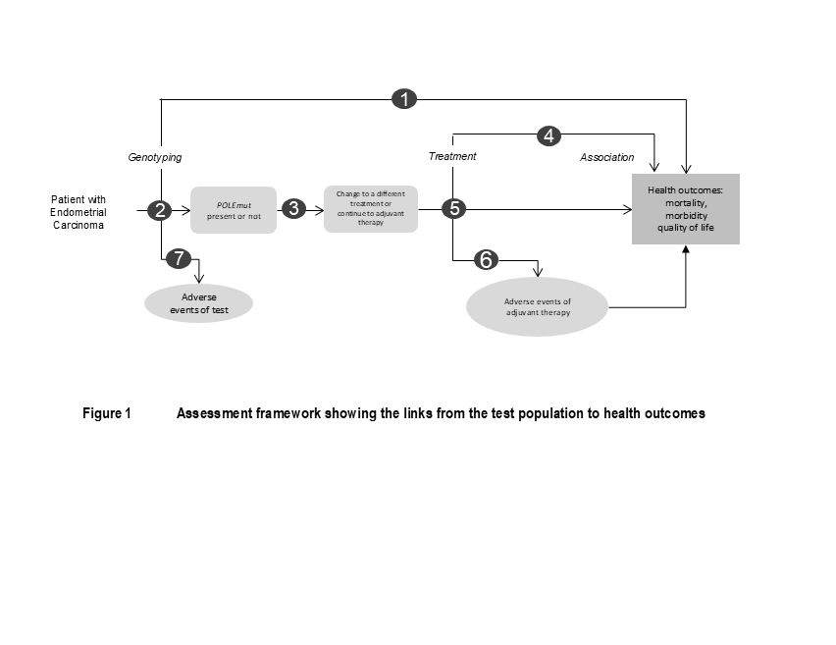

Figure 2 Assessment framework showing the links from the test population to health outcomes

Figure notes: 1: direct from test to health outcomes evidence; 2: test accuracy; 3: change in treatment/management; 4: influence of the change in management on health outcomes; 5: influence of the change in management on intermediate outcomes; 6: adverse events due to treatment; 7: adverse events due to testing.

*POLEmut* = Polymerase ε exonuclease mutation

Assessment questions mapped to the assessment framework:

1. What is the comparative safety and effectiveness of *POLE* genotyping versus no *POLE* genotyping in patients with endometrial carcinoma?
2. What is the diagnostic yield of *POLE* genotyping in patients with EC? What is the test accuracy of the proposed genotype test in predicting safe avoidance of adjuvant therapy.
3. How do the proposed genotyping results affect downstream clinical treatment/management (e.g., treatment de-escalation) and what is the evidence base of the impact?
4. What is the impact of the change in therapy vs no change in therapy on health outcomes such as mortality, morbidities, underlying condition control, and quality of life?
5. What are the effects on safety in de-escalating therapy where appropriate regarding drug adverse events?
6. How do adverse events of treatment impact on health outcomes (e.g., morbidity, mortality, quality of life)?
7. What is the comparative safety of *POLE* genotyping (pre-treatment or at treatment commencement) vs no genotyping including but not limited to e.g., impact of false negative results and potential delay in commencing or stopping treatment due to test turn-around time?

*PASC noted and accepted the assessment framework.*

## Clinical management algorithms

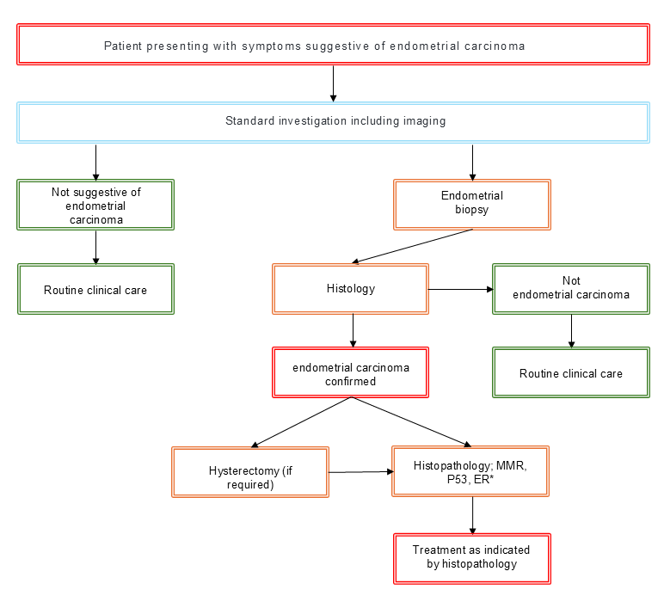

Figure 3 Current clinical algorithm (no routine *POLE* genotyping)

Source: MSAC Application 1790 PICO Set, Figure 3, p 11, modified during PICO development

*Histopathology and molecular testing may be carried out on either the hysterectomy or biopsy sample.

ER=estrogen receptor; MMR=mismatch repairdeficiency; p53=Tumour protein P53.

As presented, there is currently no routine *POLE* genotyping or any phenotypic testing. Patients would commence treatment with a therapy that is indicated by histopathology (including adjuvant therapy).

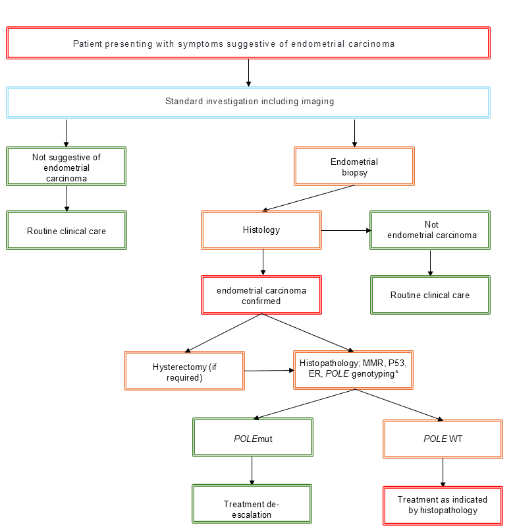

Figure 4 Proposed clinical management algorithm after introducing *POLE* genotyping.

Source: MSAC Application 1790 PICO Set, Figure 4, p 13, modified during PICO development.

*Histopathology and molecular testing may be carried out on either the hysterectomy or biopsy sample.

ER=estrogen receptor; MMR=mismatch repair deficiency; *POLEmut* = Polymerase ε exonuclease mutation; POLEWT = Polymerase ε exonuclease wild type; p53=Tumour protein P53.

Figure 4 illustrates that post listing of *POLE* genotyping, all women diagnosed with EC should undergo MMR, p53, and ER immunohistochemistry with *POLE* genotyping. International guidelines indicate that post-surgical treatment is guided by the level of risk determined through molecular testing. For women with *POLEmut* -variant endometrial carcinoma, treatment following surgery can be de-escalated. Conversely, in cases without *POLEmut* variants, post-surgical treatment options may include adjuvant brachytherapy, chemotherapy, external beam radiation therapy, or a combination of these modalities.

The updated algorithm noted that molecular testing (which includes *POLE* genotyping) could be included in the initial histology of an endometrial biopsy.

*PASC suggested the need for revision of the proposed algorithm as not all patients would be treated with a hysterectomy (for instance, very low risk patients may be managed with hormonal treatments instead). PASC advised that* POLE *testing should be performed on all patients diagnosed with EC, and that this testing will likely be on the biopsy sample, although in some instances this may be performed on the hysterectomy sample if no prior biopsy is undertaken, if the biopsy sample is not suitable or if testing on the biopsy sample fails.*

*PASC also noted that a patient would not be diagnosed as not having EC until post histology testing and that the clinical management algorithm needed to be changed to reflect this.*

## Proposed economic evaluation

The application claimed that *POLE* genotyping in patients with endometrial carcinoma to determine treatment de-escalation has superior health outcomes compared to routine clinical care (i.e., no testing). The clinical claim in the application leads to a cost-effectiveness analysis (CEA) or a cost-utility analysis (CUA) for the economic evaluation Table 2.

Table 2 Classification of comparative effectiveness and safety of the proposed intervention, compared with its main comparator, and guide to the suitable type of economic evaluation

| Comparative safety |  | Comparative effectiveness |  |  |
| --- | --- | --- | --- | --- |
| Inferior | Uncertaina | Noninferiorb | Superior |
| Inferior | Health forgone: need other supportive factors | Health forgone possible: need other supportive factors | Health forgone: need other supportive factors | ? Likely CUA |
| Uncertaina | Health forgone possible: need other supportive factors | ? | ? | ? Likely CEA/CUA |
| Noninferiorb | Health forgone: need other supportive factors | ? | CMA | CEA/CUA |
| Superior | ? Likely CUA | ? Likely CEA/CUA | CEA/CUA | CEA/CUA |

CEA=cost-effectiveness analysis; CMA=cost-minimisation analysis; CUA=cost-utility analysis

? = reflect uncertainties and any identified health trade-offs in the economic evaluation, as a minimum in a cost-consequences analysis

a ‘Uncertainty’ covers concepts such as inadequate minimisation of important sources of bias, lack of statistical significance in an underpowered trial, detecting clinically unimportant therapeutic differences, inconsistent results across trials, and trade-offs within the comparative effectiveness and/or the comparative safety considerations

b An adequate assessment of ‘noninferiority’ is the preferred basis for demonstrating equivalence

*Given the applicant’s claim of superior health outcomes, PASC agreed that the economic evaluation should be a cost effectiveness or a cost utility analysis.*

*While PASC considered that all patients with EC should undergo* POLE *testing, PASC considered that the assessment should also include a sensitivity analysis of the financial impact of only testing the sub-populations as outlined in the BAGP guidelines (i.e. only testing Group 1, Group 3 and MDT recommended Group 4 patients) and another sensitivity analysis of excluding testing in the “very low risk” patients as defined by the PROMISE-S protocol.*

## Proposal for public funding

The application proposed a new MBS item for *POLE* genotyping of endometrial carcinoma samples that would be funded under the MBS. There are no other associated applications relating to the proposed health technology that are in progress. It may be considered appropriate to add information limiting the MBS item to NGS testing.

| Category 6 – PATHOLOGY SERVICES – P7 Genetics |
| --- |
| MBS item AAAA  Characterisation of variants in the exonuclease domain (targeting exons 9, 11 13 and 14 as a minimum) of the *POLE* gene, requested by a specialist or consultant physician in a patient diagnosed with endometrial carcinoma  Applicable once per ~~lifetime~~ primary tumour diagnosis |
| Fee: ~~$500~~TBC Benefit: 75% ~~$415.50~~TBC 85% ~~$467.50~~ TBC |

Source: MSAC Application 1790 PICO Set, p 9.

Abbreviations: *POLE* = Polymerase ε exonuclease, TBC = to be confirmed.

Strikethrough and red font indicate PASC advice

The applicant noted that costings vary from laboratory to laboratory due to multiple variables in NGS testing, which include the number of samples tested in each run. The applicant noted that the cost of a small to medium NGS assay would typically be around $500 to $550 (when an error margin is included) and provided a breakdown of costs associated with *POLE* genotyping from one laboratory to support this (the laboratory was not identified in the application). The breakdown of costs is presented in Table 3.

Table 3 A breakdown of costs associated with *POLE* genotyping from one laboratory provided by the applicant

|  |  |
| --- | --- |
| **Item** | **Cost** |
| Anatomical pathology: H&E and unstained slides | $18 |
| DNA extraction/sample processing | $30 |
| Magnis SureSelect™ XT HS2 DNA (No Probe) (96 reactions) | $102 |
| SureSelect™ Custom Probes – Tier 1 (96 reactions) | $65 |
| Magnis™ Automation tips | $1 |
| Magnis ™ Service cost | $4.60 |
| NextSeq ™ P1 | $150.48 |
| NextSeq ™ Service cost | $6.38 |
| Scientist time (Magnis / MiSeq™) | $6.67 |
| Analysis, Curation & Validation Scientist/Clinician Time | $88 |
| Genomic analysis | $25 |
| **Total** | **$497.13** |
| **Error of margin** | **$550** |

Source: MSAC Application 1790 PICO Set, Text, pp 9 and 10.

DNA=deoxyribonucleic acid; H&E= haematoxylin and eosin.

There are a number of cancer related NGS test that are listed/included in MBS items; however, none of these are similar to the proposed test as they are for different tumour types and tend to be more complex testing e.g.:

* Item 73433 – next generation sequencing (NGS) test for neurotrophic receptor tyrosine kinase (*NTRK*1, *NTRK*2, *NTRK3*) fusions by RNA or DNA in tumour tissue from a patient with locally advanced or metastatic solid tumour; Fee: $1,000.
* Item 73437 – A nucleic acid-based multi-gene panel test of tumour tissue from a patient with a new diagnosis of non-small cell lung cancer; Fee: $1,247.
* Item 73310 – Measurable residual disease (MRD) testing by next-generation sequencing, performed on bone marrow (or a peripheral blood sample if bone marrow cannot be collected) from a patient diagnosed with acute lymphoblastic leukaemia, for the purpose of determining baseline MRD; Fee: $1,550.

*PASC considered restricting the proposed testing only to patients with EC who are being considered for adjuvant therapy. However, PASC considered that even if the MBS descriptor wording is limited to “patients being considered for adjuvant therapy” testing will likely be requested in most patients anyway and would not result in any significant reduction in the number of tests. Therefore, PASC considered such wording to be unnecessary in the item descriptor.*

*PASC considered whether the exon list should be included in the item descriptor or an explanatory note. PASC recommended for the exon list to be included in the item descriptor.*

*PASC acknowledged that the current wording of the item descriptor allows testing at any stage of EC, which PASC considered to be appropriate. PASC considered that testing should be pathologist determinable given that PASC advice is for testing to be performed on all patients diagnosed with EC and because staging information is not required to perform the test.*

*PASC considered the appropriate MBS fee for the proposed method agnostic item. PASC noted that while the applicant proposed an MBS fee of $550, commercial pathology providers were offering privately-billed services for* POLE *genotyping by NGS using multigene panel for a lower fee (in the range of $375 - $450) and other single gene (excluding* POLE*) testing by NGS from $337.75 to $350. PASC also noted that the schedule fee for existing MBS items for single gene analysis (items 73337, 73436) has a schedule fee of $397.35. PASC advised the applicant to provide an appropriately justified test fee in their assessment report.*

*PASC considered whether the item description should be updated to include Tier 1 variants (underlined words demonstrate additions considered by PASC). “Characterisation of tier 1 variants in the exonuclease domain (targeting exons 9, 11 13 and 14 as a minimum) of the* POLE *gene, requested by a specialist or consultant physician in a patient diagnosed with endometrial carcinoma.” PASC determined the item descriptor should not be updated to include Tier 1 variants as this prevent the item being used to characterise other variants found and unnecessarily restrict patient access to this diagnostic item.*

*PASC proposed that the item should be restricted to “once per primary tumour diagnosis” rather than “Once per lifetime”. PASC noted that although rare, EC can occur in adolescents and therefore considered that the testing should not be restricted to adults (i.e. the MBS descriptor should not include an age limit).*

## Summary of public consultation input

PASC noted and welcomed consultation input from 8 organisations and 2 individuals, both of whom were health professionals. The 8 organisations that submitted input were:

* Royal Australian and New Zealand College of Radiologists (RANZCR)
* National Gynae-Oncology Registry (NGOR)
* Victorian Integrated Cancer Services (VICS)
* Institute for Health Transformation (IHT) at Deakin University
* Human Genetics Society of Australasia (HGSA)
* Rare Cancers Australia (RCA)
* Australia New Zealand Gynaecological Oncology Group (ANZGOG)
* Cancer Australia

The consultation input received was all supportive of public funding for *POLE* genotyping for the molecular classification of endometrial cancer.

**Benefits and Disadvantages**

The main benefits of public funding received in the consultation input included that *POLE* genotyping can identify *POLE* variants in women with endometrial cancer who have an excellent prognosis and allow clinicians to safely de-escalate treatment. The input stated that *POLE* genotyping improves prognostic accuracy, may lead to patients avoiding unnecessary toxic treatments and reduce inequity in the management of endometrial cancer by allowing low-risk patients from rural and regional areas to avoid travelling for intensive follow-up care. Organisational input stated that public funding of *POLE* genotyping would allow Australia to follow international guidelines and provide access to all patients, not just those who could afford to privately fund *POLE* testing. ANZGOG stated that international guidelines recommend routine testing of endometrial tumours for *POLE* variants. RCA and HGSA stated that the World Health Organization Classification of Female Genital Tumours categorises endometrial cancer based on molecular testing and that *POLE* genotyping would assist in fulfilling the WHO recommendations.

The main disadvantages of public funding received in the consultation input included the high cost of the test and a lack of widespread implementation in clinical settings, with *POLE* testing currently available only through private testing or clinical trials.

**Population, Comparator (current management) and Delivery**

The consultation input agreed with the proposed population. RANZCR recommended limiting *POLE* testing to patients intending to undergo adjuvant therapy and to consider the placement of testing to prevent delays in treatment decisions.

The consultation input agreed with the proposed comparator of standard histopathological classification without *POLE* testing.

Consultation input stated the proposed delivery appears to be suitable overall but noted there are important considerations to ensure equitable access, including ensuring that testing is available across rural and remote areas and that telehealth is considered. RCA stated additional support services, such as counselling, dietary advice, and pain management, should be included to address the complex needs of patients undergoing testing and subsequent treatments.

**MBS Item Descriptor and Fee**

The consultation input agreed with the item descriptor and the proposed fee, with IHT stating that *POLE* testing should be available at no cost to patients.

*PASC welcomed consultation input from 8 organisations and 2 individual health professionals, noting that all were supportive of public funding for* POLE *genotyping for the molecular classification of endometrial cancer.*

*PASC noted that several inputs suggested that* POLE *testing should be provided as a reflex test. PASC noted the input from RANZCR that testing should be limited to patients being considered for adjuvant therapies. However, PASC considered that restricting the test to only ‘patients being considered for adjuvant therapy’ through the MBS descriptor is unlikely to result in any significant reduction in the number of tests requested.*

*PASC noted from the consultation input concerns around equity of access to testing and extended wait times for patients in rural and remote areas. PASC noted that while there may be access issues with obtaining a sample for testing (e.g. access to a gynaecologist to perform the biopsy), PASC considered that this is not restricted to* POLE *testing. PASC considered that once a sample is collected, the only extended times in obtaining the results of the test were due to the time associated with transporting samples to the testing laboratories (currently testing is centralised), which PASC considered to be negligible.*

## Next steps

*PASC noted that the applicant has elected to progress the application as a Department Contracted Assessment Report (DCAR).*

## Applicant Comments on Ratified PICO

The RCPA are grateful for the careful consideration of this PICO Confirmation by PASC. In response to the committee’s deliberations, we have the following minor comments.

* We recommend the proposed MBS descriptor not be limited to "Tier 1" variants, as the Association for Molecular Pathology (AMP) Tier classification does not assist in defining whether a variant is oncogenic/pathogenic based on functional evidence, which is of particular importance when encountering the rarer POLE variants.
* We recommend that the sensitivity analyses of patient subgroups to be conducted in the economic modelling be based on the 2023 FIGO staging system, and not the 2018 BAGP criteria. Some cases previously called stage 3 in the old staging system are now called stage 1A3, and it would be desirable to do POLE testing in this group.

## References

Abu-Rustum, N. Y. (2023). Uterine Neoplasms, Version 1.2023, NCCN Clinical Practice Guidelines in Oncology. *Journal of the National Comprehensive Cancer Network, 21*(2), 181-209.

AIHW. 2025. *Cancer data in Australia; Cancer summary data visualisation* [Online]. Australian Institute of Health and Welfare. Available: <https://www.aihw.gov.au/reports/cancer/cancer-data-in-australia/contents/summary-dashboard> [Accessed].

ANZGOG. 2024 *The Rise of Endometrial Cancer* [Online]. Australia New Zealand Gynaecological Oncology Group. Available: <https://www.anzgog.org.au/the-rise-of-endometrial-cancer/> [Accessed 03/03/2025].

Berek, J. S., Matias-Guiu, X., Creutzberg, C., Fotopoulou, C., Gaffney, D., Kehoe, S., Lindemann, K., Mutch, D., Concin, N. & Endometrial Cancer Staging Subcommittee, F. W. s. C. C. 2023. FIGO staging of endometrial cancer: 2023. *International Journal of Gynecology & Obstetrics,* 162**,** 383-394.

He, Y., Wang, T., Li, N., Yang, B. & Hu, Y. 2020. Clinicopathological characteristics and prognostic value of POLE mutations in endometrial cancer: A systematic review and meta-analysis. *Medicine (Baltimore),* 99**,** e19281.

Jonathan S. Berek, X. M.-G. (2023). FIGO staging of endometrial cancer: 2023. *International Journal of Gynecology & Obstetrics, 162*(2), 383-394. doi:https://doi.org/10.1002/ijgo.14923

Jumaah, A. S., Al-Haddad, H. S., McAllister, K. A. & Yasseen, A. A. 2022. The clinicopathology and survival characteristics of patients with POLE proofreading mutations in endometrial carcinoma: A systematic review and meta-analysis. *PLoS One,* 17**,** e0263585.

Lee, C. M., Szabo, A., Shrieve, D. C., Macdonald, O. K. & Gaffney, D. K. 2006. Frequency and Effect of Adjuvant Radiation Therapy Among Women With Stage I Endometrial Adenocarcinoma. *JAMA,* 295**,** 389-397.

Li, Y., Bian, Y., Wang, K. & Wan, X.-P. 2019. POLE mutations improve the prognosis of endometrial cancer via regulating cellular metabolism through AMF/AMFR signal transduction. *BMC Medical Genetics,* 20**,** 202.

Li, Y., Zhu, C., Xie, H., Chen, Y., Lv, W., Xie, X. & Wang, X. 2023. Molecular profile-based recommendations for postoperative adjuvant therapy in early endometrial cancer with high-intermediate or intermediate risk: a Chinese randomized phase III trial (PROBEAT). *J Gynecol Oncol,* 34.

Naveena Singh, A. J., Jo Morrison, Alexandra Taylor, Raji Ganesan. 2022. *BAGP guidance on POLE NGS testing in endometrial carcinoma* [Online]. The British Gynaecological Cancer Society (BGCS). Available: <https://www.bgcs.org.uk/wp-content/uploads/2022/04/BAGP-POLE-testing-in-Endometrial-cancer-v1.1-2022-04-08.pdf> [Accessed 03/03/2025].

Nero, C., Trozzi, R., Persiani, F., Rossi, S., Mastrantoni, L., Duranti, S., Camarda, F., Marino, I., Giacò, L., Pasciuto, T., De Bonis, M., Rinelli, M., Perrone, E., Giacomini, F., Lorusso, D., Piermattei, A., Zannoni, G., Fanfani, F., Scambia, G. & Minucci, A. 2025. POLE mutations in endometrial carcinoma: Clinical and genomic landscape from a large prospective single-center cohort. *Cancer,* 131**,** e35731.

Orellana, T. J., Kim, H., Beriwal, S., Bhargava, R., Berger, J., Buckanovich, R. J., Coffman, L. G., Courtney-Brooks, M., Mahdi, H., Olawaiye, A. B., Sukumvanich, P., Taylor, S. E., Smith, K. J. & Lesnock, J. L. 2022. Cost-effectiveness analysis of tumor molecular classification in high-risk early-stage endometrial cancer. *Gynecol Oncol,* 164**,** 129-135.

RAINBO Research Consortium 2023. Refining adjuvant treatment in endometrial cancer based on molecular features: the RAINBO clinical trial program. *Int J Gynecol Cancer,* 33**,** 109-117.

Sznurkowski, J. J., Rys, J., Kowalik, A., Zolciak-Siwinska, A., Bodnar, L., Chudecka-Glaz, A., Blecharz, P., Zielinska, A., Marszalek, A., Bidzinski, M. & Sawicki, W. 2023. The Polish Society of Gynecological Oncology Guidelines for the Diagnosis and Treatment of Endometrial Carcinoma (2023). *J Clin Med,* 12.

van den Heerik, A., Horeweg, N., Nout, R. A., Lutgens, L., van der Steen-Banasik, E. M., Westerveld, G. H., van den Berg, H. A., Slot, A., Koppe, F. L. A., Kommoss, S., Mens, J. W. M., Nowee, M. E., Bijmolt, S., Cibula, D., Stam, T. C., Jurgenliemk-Schulz, I. M., Snyers, A., Hamann, M., Zwanenburg, A. G., Coen, V., Vandecasteele, K., Gillham, C., Chargari, C., Verhoeven-Adema, K. W., Putter, H., van den Hout, W. B., Wortman, B. G., Nijman, H. W., Bosse, T. & Creutzberg, C. L. 2020. PORTEC-4a: international randomized trial of molecular profile-based adjuvant treatment for women with high-intermediate risk endometrial cancer. *Int J Gynecol Cancer,* 30**,** 2002-2007.

Van den Heerik, A. S. V. M., Ter Haar, N. T., Vermij, L., Jobsen, J. J., Brinkhuis, M., Roothaan, S. M., Leon-Castillo, A., Ortoft, G., Hogdall, E., Hogdall, C., Van Wezel, T., Lutgens, L. C. H. W., Haverkort, M. A. D., Khattra, J., McAlpine, J. N., Creutzberg, C. L., Smit, V. T. H. B. M., Gilks, C. B., Horeweg, N. & Bosse, T. 2023. QPOLE: A Quick, Simple, and Cheap Alternative for POLE Sequencing in Endometrial Cancer by Multiplex Genotyping Quantitative Polymerase Chain Reaction. *JCO Global Oncology***,** e2200384.

WHO 2020. *Female genital tumours,* Lyon, IARC Press.