MSAC Application 1796

ADAMTS13 testing for the diagnosis of thrombotic thrombocytopenic purpura (TTP)

Applicant: The Royal College of Pathologists of Australasia (RCPA)

# PICO Confirmation

## Summary of PICO/PPICO criteria to define question(s) to be addressed in an Assessment Report to the Medical Services Advisory Committee (MSAC)

Table 1 PICO Set 1: ADAMTS13 testing in patients with symptoms and signs suggestive of thrombotic microangiopathy (TMA) for the differential diagnosis of thrombotic thrombocytopenic purpura (TTP) vs. non-TTP and immune-mediated TTP vs. congenital TTP

| **Component** | **Description** |
| --- | --- |
| Population | Patients with symptoms and signs suggestive of TMA (such as thrombocytopenia, microangiopathic haemolytic anaemia and neurological symptoms ranging from headache to coma), and a PLASMIC score >4a |
| Prior tests | Standard tests: full blood count; peripheral blood film (schistocytes); elevated reticulocyte (immature red blood cells) count; elevated lactate dehydrogenase; reduced haptoglobin; urea and electrolytes; troponin T/troponin I; bilirubin; direct antiglobulin (Coombs’); coagulation profile (APTT, INR, fibrinogen); glucose  PLASMIC scorea |
| Intervention | **Sequential testing with:**   * ADAMTS13 activity testb * Anti-ADAMTS13 autoantibody test in patients with ADAMTS13 activity <10% b * *ADAMTS13* genetic test in patients with absence of anti-ADAMTS13 antibodies |
| Comparator | Standard investigations and management with no ADAMTS13 tests |
| Clinical utility standard | ADAMTS13 fluorescence resonance energy transfer assay (FRETS-VWF73), or ELISA-based detection (for ADAMTS13 activity test) |
| Reference standard | Full diagnostic workup / consensus clinical diagnosis based on all available information |
| Outcomes | **Safety outcomes**   * harms from obtaining a blood sample for testing * harms associated with false positive or false negative results * psychological harms due to testing (positive result, negative result or variant of uncertain significance) or no genetic testing   **Clinical effectiveness outcomes**  Test performance   * diagnostic accuracy (sensitivity & specificity) of each test methodology * concordance * diagnostic yield of each test methodology * rate of repeat testing   Predictive clinical utility of the proposed tests in guiding change in clinical management  Change in management outcomes   * change in treatment (treatment ceased, treatment initiated, treatment avoided) * time to correct diagnosis * time to appropriate treatment * duration of plasma exchange therapy (PEX)   Patient health outcomes   * mortality * morbidity * time to clinical response to therapy * relapse rate; hospital admission rate * health-related quality of life * adverse events avoided   **Health care resources**   * cost of ADAMTS13 activity testing and anti-ADAMTS13 autoantibody testing * cost of *ADAMTS13* genetic testing * cost of therapies (e.g. PEX, monoclonal antibody therapies) * cost of adverse events (including impact from false positives or false negatives) * cost per proband identified   **Cost-effectiveness**  **Total Australian Government health care costs** |
| Assessment questions | In patients presenting with symptoms and signs of TMA and a PLASMIC score >4, what is the comparative safety, effectiveness and cost-effectiveness of ADAMTS13 activity testing, followed by anti-ADAMTS13 autoantibody testing, followed by testing for *ADAMTS13* genetic variants versus none of the three ADAMTS13 test methods, for the differential diagnosis of (a) TTP vs. non-TTP and (b) iTTP vs. cTTP?  Direct evidence   1. In patients with suspected TTP (i.e. presenting with symptoms and signs of TMA and a PLASMIC score >4), does the use of ADAMTS13 activity testing, anti-ADAMTS13 autoantibody testing and *ADAMTS13* genetic testing instead of no testing result in improved health outcomes?   Indirect evidence   1. **(a)** In a symptomatic population, how does the information from ADAMTS13 activity testing differ from the information obtained from prior tests alone?   **(b)** How does the information from ADAMTS13 activity testing (using chemiluminescence immunoassay (CLIA) using a commercial kit (AcuStar)) differ from the information obtained from the clinical utility standards (FRETS-VWF73 or ELISA-based detection)?  **(c)** In a symptomatic population with <10% ADAMTS13 activity, how does the information from anti-ADAMTS13 autoantibody testing differ from the information obtained from prior tests alone?  **(d)** In a symptomatic population, with <10% ADAMTS13 activity and no anti-ADAMTS13 autoantibodies, what is the diagnostic, prognostic and predictive yield of *ADAMTS13* genetic testing compared to prior tests alone?   1. **(a)** Does the availability of new information from ADAMTS13 activity testing lead to a change in patient management compared to no ADAMTS13 activity testing?   **(b)** Does the availability of new information from anti-ADAMTS13 autoantibody testing lead to a change in patient management compared to no anti-ADAMTS13 autoantibody testing?  **(c)** Does the availability of new information from *ADAMTS13* genetic testing lead to a change in patient management compared to no *ADAMTS13* genetic testing?   1. Do the differences in management derived from the tests (e.g. eculizumab, plasma infusion for aHUS, PEX, rituximab ± caplacizumab for iTTP, plasma infusions for cTTP) lead to improved health outcomes compared to treatment based on prior tests alone? 2. What are the (direct) adverse events associated with ADAMTS13 activity testing, anti-ADAMTS13 autoantibody testing and *ADAMTS13* genetic testing? 3. What are the adverse events associated with the treatments/interventions that lead from the management decisions informed by the tests and by the comparator? |

aHUS = atypical haemolytic uraemic syndrome; APTT = activated partial thromboplastin time; CLIA = chemiluminescence immunoassay; cTTP = congenital TTP; ELISA = enzyme-linked immunosorbent assay; FRETS-VWF73 = ADAMTS13 fluorescence resonance energy transfer assay; INR = international normalized ratio; iTTP = immune-mediated TTP; PEX = Plasma exchange therapy; PICO = Population, Intervention, Comparator, Outcomes; TMA = thrombotic microangiopathy; TTP = thrombotic thrombocytopenic purpura.

a PLASMIC score calculated using one point for any of the following: (1) platelet count <30 x 109/L; (2) haemolysis variables (reticulocyte count >2.5%, undetectable haptoglobin, or indirect bilirubin >2 mg/dL); (3) no active cancer; (4) no history of solid or haematopoietic progenitor cell transplant; (5) mean corpuscular volume of <90 fL; (6) international normalized ratio <1.5; (7) creatinine level <2 mg/dL.

b Test to be performed using blood sample taken prior to commencing PEX.

Table 2 PICO Set 2: cascade testing of first-degree biological siblings of a patient with *ADAMTS13* pathogenic variants

| **Component** | **Description** |
| --- | --- |
| Population | First-degree biological sibling of an individual with pathogenic *ADAMTS13* gene variants |
| Prior tests | Not applicable |
| Intervention | Variant-specific testing to determine the presence of a pathogenic variant that is causative for cTTP in biological siblings |
| Comparator | No variant-specific testing in first-degree biological siblings |
| Reference standard | N/A |
| Outcomes | **Safety outcomes**   * harms from obtaining a sample for testing * psychological harms from genetic testing (positive result, negative result) or no genetic testing   **Test information**   * test uptake rate * diagnostic yield * prognostic and predictive value * rate of repeat testing * rate of repeat data analysis   **Health outcomes**   * impact on clinical management   + earlier treatment   + monitoring and prophylactic treatment * health-related quality of life   **Other utility outcomes**   * value of knowing   **Healthcare resources**   * cost of variant-specific test * number of, and cost associated with, obtaining an appropriate sample * additional medical practitioner consultations * cost of re-testing and/or data reanalysis   **Cost-effectiveness**   * cost per sibling identified with pathogenic variant(s)   **Total Australian Government health care costs** |
| Assessment questions | 1. What is the diagnostic yield of variant-specific testing to determine the presence of pathogenic *ADAMTS13* gene variant(s) that are causative for cTTP in a first-degree biological sibling of a patient with identified pathogenic variant(s) (homozygous or compound heterozygous)? 2. Is there a change in management in individuals who undergo variant-specific testing? 3. Does earlier treatment of siblings who are non-symptomatic or do not have overt symptoms and have inherited *ADAMTS13* gene variants (homozygous or compound heterozygous) lead to better health outcomes compared to delaying treatment until the onset of symptoms? 4. Will the information generated as a result of variant-specific testing be of additional value to siblings with inherited pathogenic *ADAMTS13* gene variant(s) even if there are not changes in management i.e. value of knowing? 5. Are there any safety concerns with variant specific testing of first-degree siblings at risk of having cTTP? 6. Are there any psychological harms from variant specific testing of first-degree siblings at risk of having cTTP? 7. Are there any safety concerns with targeted therapies compared to symptom-based therapies?   Note that under a refined assessment approach for genomic testing, questions 3 and 7 do not need to be addressed. |

cTTP = congenital thrombotic thrombocytopenic purpura; N/A = not applicable; PICO = Population, Intervention, Comparator, Outcomes.

Table 3 PICO Set 3: ADAMTS13 activity testing for monitoring patients diagnosed with TTP

| **Component** | **Description** |
| --- | --- |
| Population | Patients with a confirmed diagnosis of TTP |
| Prior tests | Confirmation of TTP via ADAMTS13 activity test |
| Intervention | ADAMTS13 activity testing for patient monitoring |
| Comparator | No ADAMTS13 activity testing for patient monitoring and clinical management based on symptoms and platelet count |
| Reference standard | Ability to predict exacerbation and recurrence |
| Clinical utility standard | ADAMTS13 fluorescence resonance energy transfer assay (FRETS-VWF73), or ELISA-based detection |
| Outcomes | **Safety outcomes**   * harms from obtaining a sample for testing * harms associated with false positive or false negative results   **Clinical effectiveness outcomes**  Test performance   * accuracy, concordance * prognostic and predictive value * rate of test failure/repeat testing   Change in management   * change in treatment (treatment ceased, treatment initiated, treatment avoided) * adherence to monitoring   Patient health outcomes   * mortality * morbidity * time to exacerbation/relapse * health-related quality of life   **Health care resources**   * cost of testing/monitoring   **Cost-effectiveness**  **Total Australian Government health care costs** |
| Assessment questions | What is the comparative safety, effectiveness and cost-effectiveness of repeat ADAMTS13 activity testing versus no repeat ADAMTS13 activity testing for predicting exacerbation and relapse in patients diagnosed with TTP?  Direct evidence   1. In patients with a confirmed diagnosis of TTP does the use of ADAMTS13 activity testing to predict exacerbation and relapse result in improved health outcomes compared to no ADAMTS13 activity testing?   Indirect evidence   1. In patients with a confirmed diagnosis of TTP, how does the information from ADAMTS13 activity testing differ from the information obtained without ADAMTS13 activity testing? 2. What is the prognostic value of ADAMTS13 activity testing for predicting TTP exacerbation? 3. What is the prognostic value of ADAMTS13 activity testing for predicting TTP relapse? 4. Does the information from ADAMTS13 activity testing lead to a change of management compared to no ADAMTS13 activity testing? 5. Do the differences in management derived from the test (e.g. initiation of treatment to prevent exacerbation/relapse) lead to improved health outcomes compared to treatment based on symptoms alone? 6. What are the (direct) adverse events associated with ADAMTS13 activity testing for monitoring? 7. What are the adverse events associated with the treatments/interventions that lead from the management decisions informed by the test? |

ELISA = enzyme-linked immunosorbent assay; FRETS-VWF73 = ADAMTS13 fluorescence resonance energy transfer assay; PICO = Population, Intervention, Comparator, Outcomes; TTP = thrombotic thrombocytopenic purpura

## Purpose of application

An application requesting Medicare Benefits Schedule (MBS) listing of ADAMTS13 testing for the diagnosis of thrombotic thrombocytopenic purpura (TTP) was received from the Royal College of Pathologists of Australasia by the Department of Health and Aged Care.

The term ‘ADAMTS13 testing’ is used in this document as a collective term referring to three test types. The application notes these tests are used to target patients to appropriate treatments and subsequent management, and requests MBS listings for each of the three tests for the following purposes:

* ADAMTS13 activity testing – for a differential diagnosis of TTP from other types of thrombotic microangiopathy (TMA) and subsequent monitoring of ADAMTS13 activity levels for patients with immune-mediated TTP (iTTP)
* Anti-ADAMTS13 autoantibody testing – to differentiate between immune-mediated (iTTP) and congenital forms of TTP (cTTP) (also known as Upshaw-Schulman syndrome)
* *ADAMTS13* genetic testing – to confirm a molecular cTTP diagnosis in the index patient, and to identify first-degree siblings carrying the same genetic variants, noting cTTP generally requires biallelic variants in *ADAMTS13* to cause disease (usually autosomal recessive).

The clinical claim in the application is that ADAMTS13 testing (collectively) results in superior health outcomes compared to no ADAMTS13 testing for patients with suspected TTP.

## PICO criteria

### Population

Three populations are relevant to the application:

* PICO Set 1 – ADAMTS13 activity testing, anti-ADAMTS13 autoantibody testing and *ADAMTS13* genetic testing for the differential diagnosis of iTTP and cTTP at initial presentation
  + patients presenting with symptoms suggestive of TMA and a PLASMIC score >4
* PICO Set 2 – cascade testing
  + first-degree biological siblings of an individual with cTTP confirmed by *ADAMTS13* genetic testing
* PICO Set 3 – ADAMTS13 activity testing for monitoring during the post-acute or chronic phase
  + patients with a confirmed diagnosis of TTP.

#### Thrombotic microangiopathy (TMA)

TMAs are a collection of conditions that result in endothelial injury in the microcirculation. The aetiology of TMAs is varied, but all pathologies involve platelet aggregation and thrombus formation in small blood vessels, leading to luminal narrowing or occlusion and end-organ ischaemia and infarction. The most affected organs are the kidneys, brain, heart, and gastrointestinal tract. TMA is characterised by:

1. thrombocytopenia;
2. microangiopathic haemolytic anaemia with red cell fragments (schistocytes); and
3. the clinical and laboratory abnormalities attributable to organ-specific dysfunction.

TTP is a rare type of TMA caused by markedly reduced ADAMTS13 activity. The ADAMTS13 protein, coded by the *ADAMTS13* gene, is a plasma protease that cleaves von Willebrand factor (VWF). When ADAMTS13 activity is severely impaired, highly adhesive, ultra-large VWF multimers accumulate in the microcirculation, spontaneously binding platelets and causing widespread microvascular occlusion resulting in TTP. While autoantibodies to the ADAMTS13 protein are typically the cause of low ADAMTS13 activity (iTTP), a small proportion of patients with TTP carry homozygous or compound heterozygous pathogenic variant(s) of the *ADAMTS13* gene (cTTP), resulting in either low levels of expression or a dysfunctional enzyme. As a result, the appropriate treatments for these two types of TTP are different.

Other types of TMA include haemolytic uraemic syndrome (HUS) induced by Shiga toxin from *Escherichia coli*-contaminated food (STEC-HUS), systemic infection with *Streptococcus pneumoniae* (pneumococcal HUS) and atypical HUS (aHUS), all of which are associated with renal involvement. TMAs can also be precipitated by conditions such as infection, pregnancy, some auto-immune conditions, organ or stem cell transplantation, and malignancies.

#### Clinical significance of thrombotic thrombocytopenic purpura (TTP)

TTP is a relapsing TMA that typically manifests as an abrupt-onset illness with symptoms and signs such as thrombocytopenia, microangiopathic haemolytic anaemia and neurological symptoms ranging from headache to coma. As the clinical symptoms and laboratory abnormalities seen in TTP are relatively non-specific, a definitive diagnosis is not possible from initial presentation.

TTP has the potential for rapid clinical deterioration and, left untreated, has a 90% mortality rate due to sudden neurological and cardiac dysfunction (Scully et al. 2023). Optimal treatment of an acute episode of TTP decreases mortality rates to around 10% (Fox et al. 2018). Therefore, patients presenting with TMA symptoms and certain clinical signs may have TTP and require urgent empiric therapy that should not be delayed awaiting confirmation of diagnosis.

#### Diagnosis and management of TTP

The PLASMIC scoring system, based on both clinical and basic laboratory findings, has been demonstrated to have some efficacy in identifying patients with a likelihood of having TTP (Table 4). If the score is 4 or less, the patient is less likely to have severe deficiency of ADAMTS13.

Table 4 PLASMIC Score

| Parameter | Points |
| --- | --- |
| Platelet count <30 x 109/L | 1 |
| Haemolysis variables (reticulocyte count >2.5%, undetectable haptoglobin, or indirect bilirubin >2 mg/dL) | 1 |
| No active cancer | 1 |
| No history of solid or hematopoietic progenitor cell transplant | 1 |
| Mean corpuscular volume of <90 fL | 1 |
| International normalized ratio <1.5 | 1 |
| Creatinine level <2 mg/dL | 1 |

Source: adapted from Application 1796 for ADAMTS13 testing for TTP, p 3.

As noted earlier, since TTP is considered a medical emergency due to high mortality when untreated, the suspicion of TTP requires immediate empiric therapy with plasma exchange (PEX), which increases ADAMTS13 activity and removes the anti-ADAMTS13 antibodies that mediate TTP in the majority of cases (iTTP). Where no ADAMTS13 testing occurs, PEX is continued until clinical response.

##### PICO Set 1 population

The population for PICO Set 1 is patients presenting with symptoms and signs suggestive of TMA and a PLASMIC score >4. However, as 3 ADAMTS13 tests are proposed to be undertaken sequentially, the populations that are tested with the second and third tests are a subset of the starting population. This is illustrated in Figure 1 that shows the testing pathway. Clinical management decisions are excluded from this pathway.

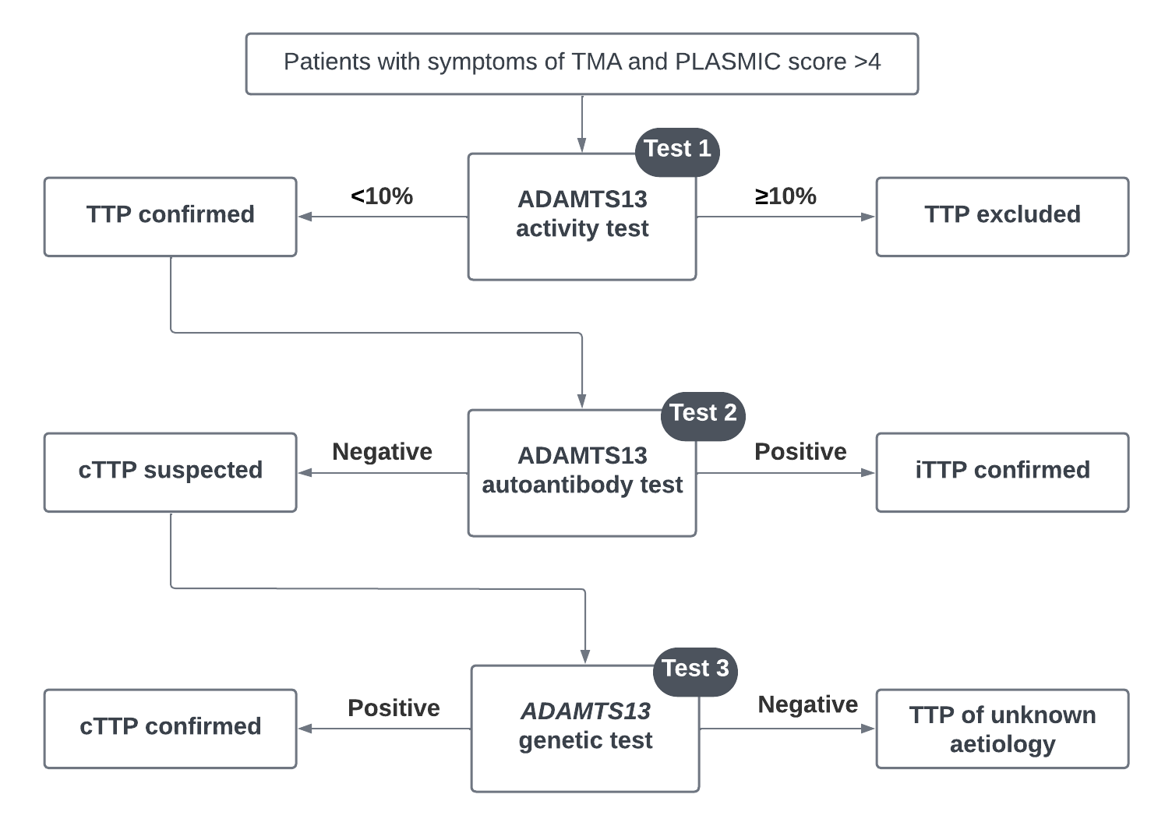

Figure 1 Testing algorithm for the differential diagnosis of iTTP and cTTP

Source: adapted from Sukamar et al. (2021), Figure 2, by the assessment group.

aHUS = atypical haemolytic uraemic syndrome; cTTP = congenital TTP; iTTP = immune-mediated TTP; TMA = thrombotic microangiopathy; TTP = thrombotic thrombocytopenic purpura.

The population for the second test, anti-ADAMTS13 autoantibody testing, is only those patients with an ADAMTS13 activity level <10% (i.e. TTP was confirmed). The population for the third test, *ADAMTS13* genetic testing, is only those patients who also tested negative for anti-ADAMTS13 autoantibodies. This is a very small proportion of the starting population.

Symptoms and signs suggestive of TMA include thrombocytopenia, microangiopathic haemolytic anaemia and neurological symptoms ranging from headache to coma. Where a PLASMIC score is >4, severe thrombocytopenia and milder renal impairment may suggest TTP rather than aHUS but ADAMTS13 activity testing is required to definitively differentiate TTP from aHUS. Patients commence urgent PEX therapy and ADAMTS13 activity testing (**Test 1**) is performed.

An ADAMTS13 activity level of <10% confirms a diagnosis of TTP and these patients remain on PEX (<10% supports a diagnosis of TTP, although 1% is more typically observed in these patients[1]). An ADAMTS13 activity level ≥10% excludes a diagnosis of TTP and these patients can safely cease PEX; further testing may be needed to establish an alternative diagnosis, but exclusion of TTP in this population is likely to confirm a diagnosis of aHUS, and these patients would be considered for PBS-listed complement inhibitors (eculizumab or ravulizumab).

Patients with confirmed TTP are the population who undergo anti-ADAMTS13 autoantibody testing (**Test 2**) to distinguish those with iTTP from suspected cTTP. This is important because PEX is continued for iTTP to reduce anti-ADAMTS13 antibodies but discontinued for suspected cTTP because the pathology is not immune-mediated so removal of anti-ADAMTS13 antibodies is not required in these patients. Instead, these patients receive plasma infusions to increase levels of ADAMTS13 activity without the risks associated with PEX.

Only those patients with suspected cTTP would be eligible for *ADAMTS13* genetic testing (**Test 3**). Unlike the earlier tests in the diagnostic pathway, *ADAMTS13* genetic testing occurs once a clinical response has been achieved and where ADAMTS13 activity levels remain persistently low (i.e. following initial monitoring, PICO Set 3). Identification of homozygous or compound heterozygous pathogenic genetic variant(s) confirms a diagnosis of cTTP, which can inform management decisions (e.g. prophylactic plasma infusions). If a known pathogenic variant is not identified, the patient is considered to have TTP of unknown aetiology.

*For PICO Set 1, PASC considered that the population eligible for ADAMTS13 activity testing should be expanded from the applicant’s proposed population of patients with suspected TTP to patients with suspected TMA. The rationale was to allow access for MBS-funded testing in patients who may require the test to access PBS-listed treatments (e.g., eculizumab) for aHUS. PASC noted that PBAC considered the ADAMTS13 activity test as part of the diagnostic work-up for aHUS and therefore not a co-dependent test. Furthermore, the diagnostic work-up was typically undertaken in patients admitted to public hospitals, in which case the test did not require an MBS item.*

*The applicant noted that a very small proportion of ADAMTS13 activity tests are positive for TTP so clinicians are already ordering tests for suspected TMA. The applicant did not anticipate a significant change in the estimated population size if the wording of the PICO was expanded to include investigation of suspected TMA.*

*As for the economic evaluation, PASC advised that the assessment should focus on the cost-effectiveness of testing for the diagnosis of TTP (as per the original application) while the financial estimates should consider the broader costs of investigation of suspected TMA.*

##### PICO Set 2 population

PICO Set 2 is for *ADAMTS13* genetic testing beyond the index case. Cascade testing has been proposed for first-degree biological siblings of individuals with confirmed cTTP. For siblings identified with the same class 4/5 homozygous or compound heterozygous *ADAMTS13* variants as the index case, cascade testing allows for the option for prophylactic treatment during high-risk periods (e.g. pregnancy) and symptom relief for individuals who may experience non-overt cTTP (headaches, lethargy, or abdominal pain; Alwyn et al. 2019).

*For PICO Set 2 (cascade testing), PASC noted that cTTP is an autosomal recessive condition and the target population for testing is siblings, although the proposed MBS item is for first-degree relatives. PASC noted that testing of parents may be required for variant phasing and, if required, this would be part of the diagnostic testing in PICO Set 1 and should be included in the cost of variant testing to identify the proband. PASC noted the pre-PASC response stating that the applicant does not support routine reproductive partner screening in the absence of a family history as TTP is a rare condition. The applicant also pointed out that the utility of prenatal screening has not been established. PASC confirmed that the population for PICO Set 2 should be limited to siblings and should exclude reproductive partners and fetal testing.*

##### PICO Set 3 population

The population for PICO Set 3 is patients with a confirmed diagnosis of TTP. It is proposed that they undergo monitoring during the post-acute and chronic phase. This is most relevant to iTTP as prophylactic interventions may prevent relapses in these patients if a declining trend of ADAMTS13 activity is detected.

As patients with cTTP have lifelong persistently low ADAMTS13 activity, they will not require regular monitoring. There are rare circumstances, however, where someone with cTTP may be suitable for ADAMTS13 activity monitoring. Some individuals may produce ADAMTS13 enzyme with a degree of functionality and may experience fluctuations in ADAMTS13 activity levels influenced by external triggers (e.g. pregnancy, viral infections). Therefore, the population for PICO Set 3 is not restricted to iTTP although it is expected that most utilisation will be in the iTTP population.

*PASC considered that the population for PICO Set 3 was appropriate.*

#### TMA therapies

Urgent first-line treatment for iTTP is PEX to remove anti-ADAMTS13 autoantibody and replace ADAMTS13. As delays in PEX administration are associated with increased mortality, all adults presenting with TMA should receive urgent PEX as empiric therapy within 4 to 8 hours (Fox et al. 2018). It is undertaken daily until platelet count recovers (i.e. >150 x 109/L for at least 2 days), lactate dehydrogenase (LDH) decreases, and clinical status improves (or iTTP is excluded). In the past, after complete response, PEX was gradually tapered over 3 weeks to prevent exacerbations of disease. However, due to the introduction of other therapies (e.g. rituximab and caplacizumab), it is now more commonly abruptly stopped (Picod et al. 2019). According to Australian guidance, patients with iTTP should be treated with high-dose steroids in addition to PEX, and ‘off-label’ use of rituximab for iTTP may be appropriate, ‘especially in severe or relapsing cases’ (Fox et al. 2018).

Caplacizumab is a humanised nanobody that inhibits the interaction between ultra-large VWF and platelets. It was assessed by the Pharmaceutical Benefits Advisory Committee (PBAC) in July 2020 and not recommended for listing for the treatment of iTTP. According to the [Public Summary Document](https://www.pbs.gov.au/industry/listing/elements/pbac-meetings/psd/2020-07/files/caplacizumab-psd-july-2020.pdf) (PSD) for caplacizumab, the PBAC considered the clinical place of the therapy was uncertain and had low confidence in the trial data. In the caplacizumab PBAC application, eligibility for ongoing treatment was dependent on ADAMTS13 activity testing results <10%.

Caplacizumab is recommended for treatment of iTTP in British Guidelines for TTP/TMA diagnosis and treatment (Scully et al. 2023) and has been reimbursed for iTTP in the UK (NICE, 2020) but not in Canada (CADTH, 2023). For patients with cTTP, recombinant ADAMTS13 phase 3 trial results have been published, and this treatment could replace plasma infusions for prophylaxis in the future (Scully et al. 2023).

For patients where ADAMTS13 activity testing excludes TTP and they are ultimately diagnosed with aHUS, there are two PBS-listed therapeutics; eculizumab and ravulizumab. These are both complement 5 inhibitors and were approved by the PBAC in March 2014 and July 2023, respectively. Eligibility for both requires ADAMTS13 activity of greater than or equal to 10% on a blood sample taken prior to PEX or infusion. If a blood sample for an ADAMTS13 activity test is not taken prior to PEX or infusion, then it must be taken 7-10 days after cessation of PEX or infusion for continued access. The PSD for ravulizumab (July 2023) makes the following observations with respect to the availability of ADAMTS13 testing:

“Two key issues with respect to the listing and use of eculizumab have been the availability of ADAMTS-13 test results at the time of treatment initiation, and the duration of treatment.”

“The submission stated that, ‘[r]esults from the ADAMTS-13 assay are typically available within 24 hours in current practice (particularly in public metropolitan centres; there may be delays in regional or private settings). While this result is also contingent on sampling taking place prior to administration of plasma therapy (otherwise measurement of ADAMTS-13 activity will be delayed by 1-2 weeks following the last plasma therapy), obtaining a plasma sample prior to onset of empiric therapy is now considered standard practice.”

These statements suggest availability of ADAMTS13 activity testing for patients wishing to access PBS-funded therapies may be limited.

#### Regulatory requirements

According to the applicant, ADAMTS13 testing does not need to be included in the Australian Register of Therapeutic Goods (ARTG). An accredited laboratory that intends to provide ADAMTS13 activity testing can apply to the National Association of Testing Authorities (NATA) for approval to start performing the test if the equipment is already in place.[2]

#### Expected size of the population to be tested

The incidence of TTP is estimated at 2 to 6 people per million per year with cTTP accounting for 2-10% of all diagnosed cases of TTP (Alwyn et al. 2019). The application projected, based on pathology data from a single service, that ADAMTS13 activity testing would be undertaken in 2,562 patients with suspected TTP in the first year of listing. Of these patients, 141 would have ADAMTS13 autoantibody testing due to ADAMTS13 activity levels ≤10% and 54 would go on to *ADAMTS13* genetic testing. No estimates of the number of biological siblings who would undertake cascade testing were provided. Monitoring would occur in the estimated 141 patients with ADAMTS13 activity ≤10%. It is proposed to be undertaken weekly for 1 month, every 3 months for the first year, and every 3-6 months after that, estimated at approximately 1,048 tests per year in the application.

*PASC noted that the confirmed TTP population, at about 2 per million people in Australia, is small and even smaller for those with cTTP. PASC noted the population undergoing ADAMTS13 activity testing would be larger than the confirmed TTP population as it would also include patients with alternative diagnoses such as aHUS.*

### Intervention

The interventions are 3 investigative technologies; ADAMTS13 activity testing (diagnostic and monitoring), anti-ADAMTS13 autoantibody testing (diagnostic) and *ADAMTS13* genetic testing (diagnostic and cascade testing).

#### ADAMTS13 activity tests

Blood samples for testing ADAMTS13 activity ought to be taken prior to commencing empiric therapy. A number of test methodologies have been developed, but in Australian laboratories, one of the following 3 tests is typically used:

* enzyme-linked immunosorbent assay (ELISA)
* fluorescence resonance energy transfer assay (FRETS-VWF73)
* chemiluminescence immunoassay (CLIA).

Each test quantifies ADAMTS13 enzymatic activity by detecting cleavage of a substrate – either VWF multimers (ELISA) or a VWF-based, 73 amino acid, synthetic peptide (FRETS-VWF73, CLIA). The CLIA test is typically performed with HemosIL AcuStar instrumentation[3] and is supplied as a fully automated commercial kit. CLIA testing of ADAMTS13 activity with AcuStar typically has a more rapid turn-around time compared to the ELISA or FRETS-VWF73 tests, which are likely to involve batch runs with other tests in pathology laboratories (Singh et al. 2023; Favaloro et al. 2023). According to the applicant’s clinical expert, same-day results are possible where the automated AcuStar instrumentation is available on site.[4] This may not always translate to same-day results where the sample is sent off site, and potentially interstate. Although the application states that AcuStar is used to triage patients at presentation in some Australian laboratories, the applicant’s clinical expert advised that, in Australia, ADAMTS13 activity is almost exclusively tested using AcuStar. The application does not request MBS funding for a specific type of ADAMTS13 activity test and it is anticipated that there will be ongoing development of commercial assays.

The Therapeutic Goods Administration (TGA) issued notifications for HemosIL AcuStar ADAMTS13 activity testing in February 2022 and again in August 2024,[5] following findings that AcuStar ADAMTS13 activity testing produced a relatively high rate of false positives around the diagnostic threshold compared to the FRETS-VWF73 test (i.e. returning values <10% when other tests found >10%) (Singh et al. 2023).

The TGA stated that:

* results should be interpreted in conjunction with other clinical and laboratory findings
* the use of the assay to guide patient therapy plan (e.g. plasma exchange, rituximab and caplacizumab) has not been evaluated
* the assay has not been validated for use in the paediatric population and claims in the Instructions For Use are not applicable to this population
* the test has not been validated for evaluating TTP relapse or recurrence.

In an acute episode when a patient is being diagnosed, the risk of false positives means some patients continue PEX when they do not have TTP. However, the advantage of a rapid test, with potentially a same day result, is that some patients without TTP may avoid initiating PEX altogether.

The application states that where AcuStar is used to triage patients with the intention of identifying patients with normal ADAMTS13 activity levels who can safely avoid PEX, subsequent confirmatory testing by ELISA is performed on samples with low ADAMTS13 levels (Application 1796, p5). However, the applicant’s clinical expert advised that such confirmatory testing is highly unusual, and decisions not to initiate or continue PEX rely on results well below the diagnostic threshold where AcuStar has less specificity. It was also noted that it is unusual for patients experiencing an acute episode of TTP to have ADAMTS13 activity levels as high as 10% (more likely to be around 1%), which again is not close to the diagnostic threshold of 10%.4

The applicant’s clinical expert advised that AcuStar is also used in Australia for monitoring ADAMTS13 activity, noting that monitoring relies on observation of a trend and that the treatment threshold is higher than the 10% diagnostic threshold, where AcuStar was found to misclassify some patients.[6] The application proposes monitoring weekly for 1 month after achieving clinical response, every 3 months for the first year, and every 3-6 months after that.

*PASC noted that the CLIA assay for ADAMTS13 activity is the test most commonly used in practice (PICO Set 1, test 1 and PICO Set 3) and that it can be confirmed with FRETS-* *VWF73 or ELISA. PASC noted the pre-PASC response acknowledged that the choice of activity assay varies among states and laboratories. The applicant informed that all assays correlate well at severely deficient levels (i.e., ADAMTS13 activity <5%) and that diagnostic uncertainties tend to arise closer to the 10% threshold. In practice, most severely deficient patients present with activity levels closer to 1% than 10%.*

*PASC noted a lack of established validity for this test in the paediatric population. The applicant stated that testing in paediatric patients is extremely rare and estimated one paediatric patient every 4-5 years in NSW.*

*PASC noted that the frequency of monitoring (PICO Set 3) is not well described in the PICO and that this may present challenges for the assessment, particularly for the cost analysis. The applicant stated that although there is good evidence for monitoring, evidence supporting the frequency is lacking and that the application relies on the British Guidelines (Scully et al. 2023). In practice, the frequency of monitoring is individualised.*

#### Anti-ADAMTS13 autoantibody tests

Anti-ADAMTS13 autoantibodies are typically detected using a Bethesda-like assay, adapted from the Bethesda assay used to identify FVIII inhibitors. This is a functional test that measures the level of inhibitory activity of anti-ADAMTS13 neutralising antibodies. However, this test does not detect anti-ADAMTS13 autoantibodies that do not impede ADAMTS13 activity, although in vivo these antibodies will reduce the amount of circulating enzyme. An ELISA assay measures both inhibitory and non-inhibitory anti-ADAMTS13 autoantibodies (anti-ADAMTS13 IgG levels). If patients have general auto-immune conditions, however, there is a risk the ELISA will detect non-anti-ADAMTS13 autoantibodies (i.e. false positives), especially where antibody levels are high (Favaloro et al. 2021). Anti-ADAMTS13 autoantibody testing occurs infrequently in Australia (16% of patients) (Fox et al. 2018).

The application does not request MBS funding for a specific type of anti-ADAMTS13 autoantibody test and therefore the intervention includes all available assays.

*PASC considered the intervention of the Bethesda-like assay for anti-ADAMTS13 autoantibody testing (PICO Set 1, test 2) to be appropriate.*

#### ADAMTS13 genetic tests

All pathogenic *ADAMTS13* variants are autosomal recessive, meaning patients with cTTP carry pathogenic variants on both alleles, either homozygous for the one variant or heterozygous for two variants (compound heterozygous). The latter is more common, with 64% of a UK cohort of 73 cases of cTTP found to be compound heterozygous (Alwyn et al. 2019). Pathogenic mutations occur throughout the *ADAMTS13* gene and are mostly missense (55%) or frameshift (28%) mutations (Scully et al. 2023). Over 200 pathogenic variants have been described (Sukumar et al. 2021), and the gene variant can determine the level of ADAMTS13 activity, or the conformation, and therefore functionality, of the ADAMTS13 enzyme (Scully et al. 2023). However, a correlation between most genotypes and cTTP phenotypes has not been established (Alwyn et al. 2019).

The application states that *ADAMTS13* gene testing would normally be included in a panel for other TMAs of genetic origin, but no further information is provided. Genetic disorders of complement regulation can be a cause of aHUS, and the Australia and New Zealand Renal Gene Panels (ANZRGP) service performs targeted exome sequencing for multigene panels (over 230 genes, including aHUS) associated with more than 22 kidney disease categories (Tanudisastro et al. 2021).

However, the application proposes that genetic testing for suspected cTTP requires confirmation of persistently, severely low levels of ADAMTS13 activity in the post-acute phase. By this stage, aHUS would have been excluded as a diagnosis, so it would not be appropriate to test for variants in both the *ADAMTS13* gene and complement regulatory genes. Furthermore, it is not necessary to test for variants in any other genes to confirm cTTP, as no other mechanism of reduced ADAMTS13 activity has been described other than inhibition by autoantibodies (i.e. iTTP).

Most pathogenic *ADAMTS13* gene variants are private and confined to single families (Sukumar et al. 2021), so testing for specific variants in index patients is not appropriate. Variants in the introns of the *ADAMTS13* gene have been shown to cause aberrant mRNA splicing, and have been implicated in the pathology of cTTP (Lv et al. 2020; Kimchi-Sarfaty et al. 2008). For these reasons, whole gene sequencing (i.e. including introns) would appear to be the appropriate test for index patients suspected of cTTP. *PASC discussed the intervention of* ADAMTS13 *gene sequencing (PICO Set 1, test 3), noting a lack of clarity regarding this test; in particular, which type of sequencing test is appropriate and whether it should be performed as part of a panel. PASC noted the cited literature (Sukumar et al. 2021) reported that missense mutations are most common (59%), followed by nonsense mutations (13%), deletions (13%), splice site mutations (9%), and insertions (6%). PASC noted that splice site variants are detected by standard Sanger sequencing or NGS targeted sequencing that cover intron-exon boundaries and therefore, considered that whole gene sequencing including full intronic sequencing is not necessary. PASC noted wide variation in the cost that is charged for testing ($780-$1,800) and turnaround time (4 weeks to 4 months), due to public molecular laboratories increasingly only offering sequencing through an exome capture.*

Variant-specific testing is sufficient for cascade testing of first-degree biological siblings of identified index cases.

*PASC discussed whether the MBS item descriptor for proband testing would need to include the costs of cascade testing the biological parents for the purpose of variant phasing. PASC advised that the appropriate type of genetic testing will need to be described with the proposed fee justified in the assessment report.*

*PASC noted the consumer representative stressed the importance of oversight by a clinical genetic service for PICO Set 2.*

*PASC considered the intervention of the variant-specific cascade genetic testing (PICO Set 2) to be appropriate.*

### Comparator(s)

In all PICO Sets, the comparator is no ADAMTS13 testing and standard investigative and medical management. None of the three tests in the interventions are proposed as replacements to currently available investigative technology and therefore they are additional tests in the clinical management of TTP.

Currently there are many tests that should be conducted when a patient presents with suspected TTP (prior tests in PICO Set 1, summarised alongside the clinical management algorithms in Table 8), however the application states that while these are necessary, they are not sufficient for a diagnosis of TTP.

*PASC confirmed that the comparator for all PICOs is no ADAMTS13 testing and standard investigations. PASC noted that during the acute phase, standard tests (e.g. low platelets, markers of haemolysis etc.) would be routinely done in public hospitals where there is suspicion of TTP.*

*PASC noted that testing of first-degree relatives is not currently offered but that clinical assessment may be used if symptoms are present.*

*PASC noted that monitoring is currently undertaken using clinical history and laboratory testing to identify acute flares.*

### Reference standard

#### PICO Set 1

The application proposes a testing strategy to differentially diagnose iTTP and cTTP in patients presenting with acute symptoms and signs suggestive of TMA. As the diagnosis of iTTP and cTTP are defined by the outcomes of ADAMTS13 testing, the intervention tests, in combination with a full clinical workup and consensus diagnosis based on all available information, are the reference standard.

As the tests are part of the reference standard, the MSAC guidelines note that ‘the accuracy of the proposed test itself will need to be demonstrated by direct from test to health outcomes evidence showing a health benefit resulting from use of the test, or by comparison against a suitable clinical utility standard.’

No reference standard is necessary for the assessment of the *ADAMTS13* genetic test in patients with an absence of anti-ADAMTS13 antibodies.

#### PICO Set 2

No reference standard is necessary for the assessment of the *ADAMTS13* genetic test in first-degree siblings of an individual with a pathogenic *ADAMTS13* gene variant.

#### PICO Set 3

Monitoring is used to predict exacerbations and recurrence; therefore, longitudinal accuracy will be sought, and the reference standard is the clinical outcome (ability to predict exacerbation of TTP, ability to predict recurrence of TTP).

*PASC stated that longitudinal accuracy with reference to clinical outcomes was appropriate for monitoring.*

### Clinical utility standard

Although the application is not a codependent assessment, there are trials of treatments for aHUS and TTP and given that the proposed tests are the reference standard, additional consideration of a clinical utility standard is appropriate. This is not applicable to genetic testing.

#### PICO Set 1

The reference standard for the diagnosis of TTP due to ADAMTS13 deficiency is described in the literature as in-house ELISA using full-length VWF or FRETS-VWF73, ideally calibrated against the World Health Organisation International Standard ADAMTS13 plasma (Roose and Joly, 2020). In Australian practice, the chemiluminescence immunoassay (CLIA), a two-step immunoassay that quantifies plasma ADAMTS13 activity using magnetic particles as solid phase and a chemiluminescent detection system that requires specific instrumentation (AcuStar), is commonly used due to the ability to rapidly obtain results.

Clinical trials of treatments for aHUS and TTP have not all required ADAMTS13 activity testing as an inclusion criterion and have rarely reported the assay used for diagnosis of TTP (Table 5). For the TTP trials, although ADAMTS13 activity testing was not part of the inclusion criteria it was measured at baseline and during follow-up after PEX treatment. As many of these studies were conducted across multiple international sites (92 sites in Hercules and 56 sites in Titan) it may have been difficult to prescribe the assay used. However, given the MBS item is requested to be technology agnostic, the FRETS-VWF73 or ELISA assays should be considered the clinical utility standard for reference to the more widely used CLIA (AcuStar) assay.

No clinical utility standard is identified for anti-ADAMTS13 autoantibody testing.

Table 5 Key trials for PBAC-assessed TMA treatments and their inclusion criteria with respect to ADAMTS13 activity testing

| Therapy | Population | Trial | ADAMTS13 activity eligibility criteria | Method of testing |
| --- | --- | --- | --- | --- |
| Eculizumab | aHUS | Trial 1 & 2 (Legendre 2013) | ≥ 5% (both trials) | FRETS-VWF73 |
| Ravulizumab | aHUS | Study 311 (Barbour 2021) | > 5% | Not specified |
| Ravulizumab | aHUS | Study 312 (Takana 2021) | > 5% | Not specified |
| Caplacizumab | TTP | Hercules (Scully 2019) | Not an eligibility criterion | Not specified |
| Caplacizumab | TTP | Titan (Peyvandi 2016) | Not an eligibility criterion (known diagnosis of iTTP was an eligibility criterion) | Not specified |

Source: prepared by the Assessment Group during PICO Confirmation development.

aHUS = atypical haemolytic uraemic syndrome; TMA = thrombotic microangiopathy; TTP = thrombotic thrombocytopenic purpura.

*PASC stated that the accuracy of the CLIA assay can be assessed using FRETS-VWF73 or ELISA as a reference standard.*

*PASC noted that no reference standard was necessary for ADAMTS13 genetic testing.*

#### PICO Set 3

As monitoring is most likely to be undertaken with a CLIA assay, the clinical utility standard is ADAMTS13 fluorescence resonance energy transfer assay (FRETS-VWF73), or ELISA-based detection.

### Outcomes

The application provided a list of outcomes for assessing the clinical safety and effectiveness of ADAMTS13 testing in patients with symptoms of TMA (MSAC 1796 PICO Set p.9). These have been reviewed and edited to align with the proposed PICO Sets and assessment framework.

#### PICO Set 1

As TTP is potentially fatal, patients who present with symptoms require urgent treatment and therefore treatment is initiated on suspicion of TTP and not diagnosis. Treatment is daily PEX therapy and this reduces the mortality rate from approximately 90% to 10% (Fox et al. 2018; Martin et al. 2021). However, PEX therapy carries a high risk of complications (Table 6). If patients do not have TTP, then ceasing PEX treatment has the potential to reduce the risk of these complications and improve health outcomes. It may also facilitate faster access to a correct diagnosis and enable initiation of complement inhibitors in aHUS patients. These are the main change of management outcomes of the proposed testing.

Table 6 Complications of PEX

|  |  |
| --- | --- |
| Catheter-related complications | PEX procedure related complications |
| * Catheter related bleeding   + Hemothorax   + Retroperitoneal haemorrhage   + Insertion site haemorrhage * Catheter related thrombosis * Catheter related local or systemic infection * Catheter dysfunction | * Hypotension * Arrhythmia * Hypocalcaemia * Hypokalaemia * Filter clotting (filtration) * Reactions to plasma   + Anaphylaxis   + Serum sickness   + Transfusion-related acute lung injury |

Source: adapted from Picod et al. 2019, Table 1.

PEX = plasma exchange therapy

Further change in management may occur following anti-ADAMTS13 autoantibody testing as PEX is also contraindicated in cTTP. Therefore, patients with no anti-ADAMTS13 autoantibodies in whom cTTP is suspected may cease PEX and initiate plasma infusions and cease immune modulators such as rituximab if started.

If cTTP is confirmed via genetic testing, then ongoing management will reflect the final diagnosis and may include prophylactic use of plasma infusions to reduce risk of relapse. It is anticipated that future treatment with recombinant ADAMTS13 will also become available to these patients. The proposed outcomes for this PICO Set are listed below.

Safety outcomes

* harms from obtaining a blood sample for testing
* harms associated with false positive or false negative results
* psychological harms due to testing (positive result, negative result or variant of uncertain significance) or no genetic testing

Test performance

* diagnostic accuracy (sensitivity and specificity) of each test methodology
* concordance
* diagnostic yield of each test methodology
* rate of repeat testing

Change in management outcomes

* change in treatment (treatment ceased, treatment initiated, treatment avoided)
* time to correct diagnosis
* time to appropriate treatment
* duration of PEX

Patient health outcomes

* mortality
* morbidity
* time to clinical response to therapy
* relapse rate; hospital admission rate
* health-related quality of life
* adverse events avoided

Health care resources (all ADAMTS13 tests)

* cost of ADAMTS13 activity testing and anti-ADAMTS13 autoantibody testing
* cost of *ADAMTS13* genetic testing
* cost of therapies (e.g. PEX, monoclonal antibody therapies)
* cost of adverse events (including impact from false positives or false negatives)
* cost per proband identified

#### PICO Set 2

PICO Set 2 is cascade testing of first-degree biological siblings of a patient with a suspected pathogenic variant of *ADAMTS13*. Genetic testing of the proband is included in PICO Set 1. Identification of pathogenic variant(s) in the *ADAMTS13* gene may have clinical consequences in asymptomatic first-degree siblings including the initiation of monitoring, prophylactic treatment and earlier appropriate treatment in the event of an acute event. For this PICO Set, value of knowing is also listed as an outcome. The proposed outcomes for this PICO Set are listed below.

Safety

* harms from obtaining a sample for testing
* psychological harms from genetic testing (positive result, negative result or variant of uncertain significance) or no genetic testing

Test information

* test uptake rate
* diagnostic yield
* prognostic and predictive value
* rate of repeat testing
* rate of repeat data analysis

Health outcomes

* impact on clinical management
  + earlier treatment
  + monitoring and prophylactic treatment
* health-related quality of life

Other utility outcomes

* value of knowing

Healthcare resources

* cost of variant-specific test
* number of, and cost associated with, obtaining an appropriate sample
* additional medical practitioner consultations
* cost of re-testing and/or data reanalysis.

Cost effectiveness

* cost per sibling identified with pathogenic variant(s)

#### PICO Set 3

PICO Set 3 is monitoring, once PEX treatment has ceased, to predict disease exacerbation and relapse. These are defined in the Hercules trial as:

* Recurrence – new decrease in the platelet count that necessitates the reinitiation of PEX after normalisation of the platelet count had occurred.
* Exacerbation – a recurrence that occurs within 30 days after the last PEX.
* Relapse – a recurrence that occurs more than 30 days after cessation of PEX (Scully et al. 2019).

The main treatment change is the initiation of immune suppressive therapy to increase ADAMTS13 activity levels and prevent exacerbation or relapse (Masias and Cataland 2018). The proposed outcomes for this PICO set are listed below.

Safety outcomes

* harms from obtaining a sample for testing
* harms associated with false positive or false negative results

Test performance

* accuracy, concordance
* prognostic and predictive value
* rate of test failure/repeat testing

Change in management

* change in treatment (treatment ceased, treatment initiated, treatment avoided)
* adherence to monitoring

Patient health outcomes

* mortality
* morbidity
* time to exacerbation/relapse
* health related quality of life

Health care resources

* cost of testing/monitoring.

Note that suspected cTTP patients will undergo initial monitoring with ADAMTS13 activity testing following PEX treatment. Where activity remains low and cTTP remains suspected, genetic testing is undertaken. The clinical role of repeat ADAMTS13 activity testing in the diagnosis of cTTP is acknowledged but not considered in the assessment.

*PASC noted the outcomes and that they were appropriate.*

## Assessment framework

#### PICO Set 1

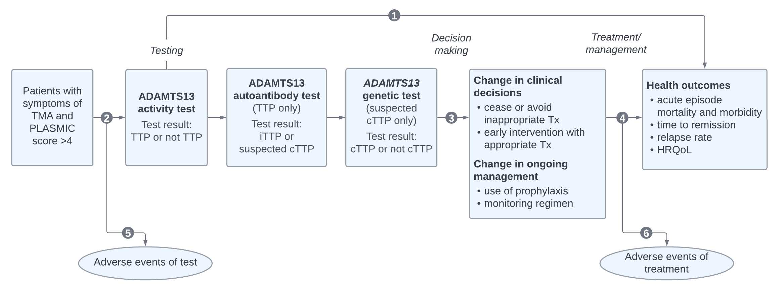

Figure 2 Assessment framework for PICO Set 1: Differential diagnosis of TTP vs not TTP and iTTP vs cTTP

Source: prepared by the assessment group.

cTTP = congenital TTP; HRQoL = health-related quality of life; iTTP = immune-mediated TTP; PICO = Population, Intervention, Comparator, Outcomes; TMA = thrombotic microangiopathy; TTP = thrombotic thrombocytopenic purpura.

Figure notes: 1: direct from test to health outcomes evidence; 2: test accuracy; 3: change in diagnosis/management; 4: influence of the change in management on health outcomes; 5: adverse events due to testing; 6: adverse events due to treatment.

The assessment questions related to the assessment framework for PICO set 1 are listed below.

##### Direct evidence

* 1. In patients with suspected TTP (i.e. presenting with symptoms and signs of TMA and a PLASMIC score >4), does the use of ADAMTS13 activity testing, anti-ADAMTS13 autoantibody testing and *ADAMTS13* genetic testing instead of no ADAMTS13 testing result in improved health outcomes?

##### Indirect evidence

* 1. (a) In a symptomatic population, how does the information from ADAMTS13 activity testing differ from the information obtained from prior tests alone?

(b) How does the information from ADAMTS13 activity testing (CLIA using a commercial kit (AcuStar)) differ from the information obtained from the clinical utility standards (FRETS-VWF73 or ELISA-based detection)?

(c) In a symptomatic population with <10% ADAMTS13 activity, how does the information from anti-ADAMTS13 autoantibody testing differ from the information obtained from prior tests alone?

(d) In a symptomatic population, with <10% ADAMTS13 activity and no anti-ADAMTS13 antibodies, what is the diagnostic, prognostic and predictive yield of ADAMTS13 genetic testing compared to prior tests alone?

* 1. (a) Does the availability of new information from ADAMTS13 activity testing lead to a change in patient management compared to no ADAMTS13 testing?

(b) Does the availability of new information from anti-ADAMTS13 autoantibody testing lead to a change in patient management compared to no ADAMTS13 testing?

(c) Does the availability of new information from *ADAMTS13* genetic testing lead to a change in patient management compared to no *ADAMTS13* testing?

* 1. Do the differences in management derived from the tests (e.g. eculizumab, plasma infusion for aHUS, PEX, rituximab ± caplacizumab for iTTP, plasma infusions for cTTP) lead to improved health outcomes compared to treatment based on prior tests alone?
  2. What are the (direct) adverse events associated with ADAMTS13 activity testing, anti-ADAMTS13 autoantibody testing and *ADAMTS13* genetic testing?
  3. What are the adverse events associated with the treatments/interventions that lead from the management decisions informed by the tests and by the comparator?

*PASC discussed that PICO Set 1 includes 3 sequential tests undertaken at different points in care in decreasing population subgroups and that this may present challenges for evidence evaluation. PASC discussed whether the PICO should be split up to consider each test individually or to remove genetic testing from this PICO Set; however, the sequential approach was considered appropriate.*

#### PICO Set 2

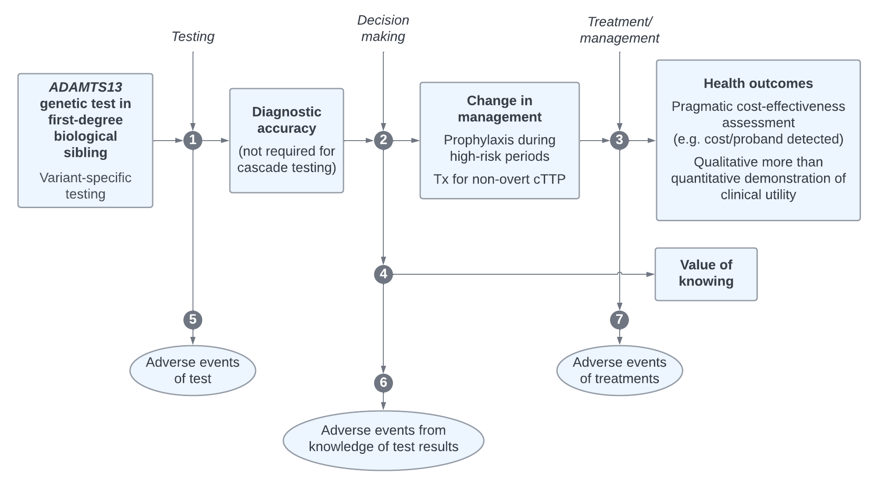

Figure 3 Assessment framework for PICO Set 2: Cascade testing for first-degree biological siblings

Source: prepared by the assessment group adapted from Figure 2 of MSAC Application 1675 PICO Confirmation.

cTTP = congenital TTP; PICO = Population, Intervention, Comparator, Outcomes; Tx = treatment.

Figure notes: 1: diagnostic yield; 2: change in management; 3: health outcomes; 4: value of knowing; 5: adverse events due to testing; 6: harms from knowing; 7: adverse events due to treatment.

A refined assessment approach has been used and accepted by MSAC for the assessment of genomic tests in certain situations, particularly large gene panels (detailed in Figure 2 of the PICO Confirmation [1675](https://www.msac.gov.au/sites/default/files/documents/1675%2520Ratified%2520PICO.pdf)). The assessment questions for PICO Set 2 are presented based on this pragmatic approach. It is noted that this approach may also apply to aspects of Test 3 (*ADAMTS13* genetic testing) for PICO Set 1. Although not a gene panel, the approach may be suitable given the context within an assessment of a sequential testing strategy and given the small population likely to be tested. Based on this approach, questions related to health outcomes do not need to be addressed (questions 3 and 7) as the acceptable outcome of the assessment is a cost per proband identified rather than cost per health outcomes. Health outcomes will still need to be addressed for the overall testing strategy for PICO Set 1.

1. What is the diagnostic yield of variant-specific testing to determine the presence of pathogenic *ADAMTS13* gene variant(s) that are causative for cTTP in a first-degree biological sibling of a patient with identified pathogenic variant(s) (homozygous or compound heterozygous)?
2. Is there a change in management in individuals who undergo variant-specific testing?
3. Does earlier treatment of siblings who are non-symptomatic or do not have overt symptoms and have inherited *ADAMTS13* gene variants (homozygous or compound heterozygous) lead to better health outcomes compared to delaying treatment until the onset of symptoms?
4. Will the information generated as a result of variant-specific testing be of additional value to siblings with inherited pathogenic *ADAMTS13* gene variant(s) even if there are not changes in management i.e. value of knowing?
5. Are there any safety concerns with variant specific testing of first-degree siblings at risk of having cTTP?
6. Are there any psychological harms from variant specific testing of first-degree siblings at risk of having cTTP?
7. Are there any safety concerns with targeted therapies compared to symptom-based therapies?

#### PICO Set 3

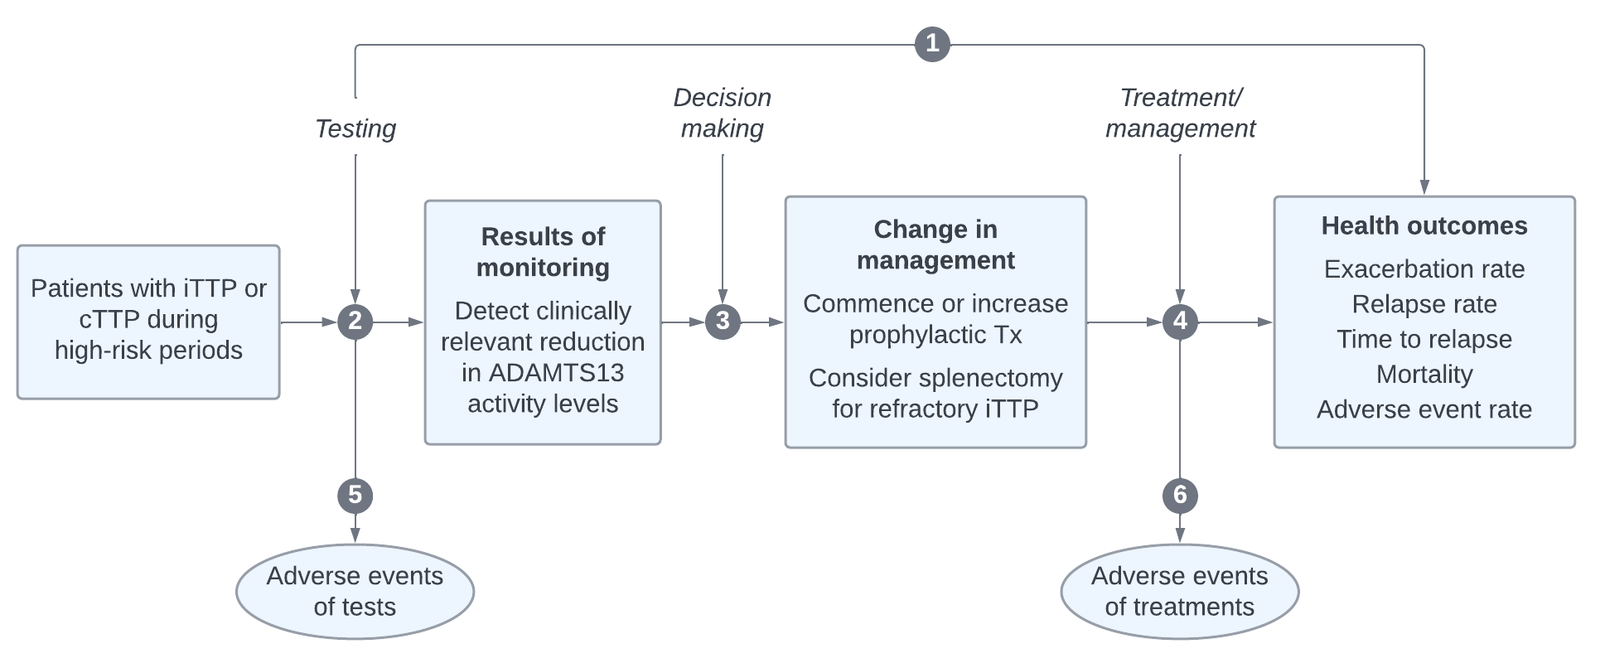

Figure 4 Assessment framework for PICO Set 3: Monitoring ADAMTS13 activity in TTP patients during the post-acute and remission phases

Source: prepared by the assessment group.

cTTP = congenital TTP; iTTP = immune-mediated TTP; PICO = Population, Intervention, Comparator, Outcomes; TTP = thrombotic thrombocytopenic purpura; Tx = treatment.

Figure notes: 1: direct from test to health outcomes evidence; 2: test accuracy; 3: change in management; 4: health outcomes; 5: adverse events due to testing; 6: adverse events due to treatment.

##### Direct evidence

1. In patients with a confirmed diagnosis of TTP does the use of ADAMTS13 activity testing to predict exacerbation and relapse result in improved health outcomes compared to no ADAMTS13 activity testing?

##### Indirect evidence

1. In patients with a confirmed diagnosis of TTP how does the information from ADAMTS13 activity testing differ from the information obtained without ADAMTS13 activity testing?
   1. What is the prognostic value of ADAMTS13 activity testing for predicting TTP exacerbation?
   2. What is the prognostic value of ADAMTS13 activity testing for predicting TTP relapse?
2. Does the information from ADAMTS13 activity testing lead to a change of management compared to no ADAMTS13 activity testing?
3. Do the differences in management derived from the test (e.g. initiation of treatment to prevent exacerbation/relapse) lead to improved health outcomes compared to treatment based on symptoms alone?
4. What are the (direct) adverse events associated with ADAMTS13 activity testing for monitoring?
5. What are the adverse events associated with the treatments/interventions that lead from the management decisions informed by the test?

## Clinical management algorithms

#### Current clinical management

TMA is defined by:

1. thrombocytopenia
2. microangiopathic haemolytic anaemia (MAHA) with red cell fragments (schistocytes)
3. the clinical and laboratory abnormalities attributable to organ-specific dysfunction (Fox et al. 2018).

Patients with TMA are likely to present with an abrupt onset of symptoms (Table 7) caused by the pathological process of platelet aggregation and thrombus formation in small blood vessels.

Table 7 Presenting clinical features and signs in acute TTP

|  |
| --- |
| **Clinical features and signs** |
| **Thrombocytopenia:** epistaxis, bruising, petechiae, gingival bleeding, haematuria, heavy menstrual bleeding, gastrointestinal bleeding, retinal haemorrhage and haemoptysis |
| **Central neurological:** (often flitting and variable 70%–80%): confusion, headache, paresis, seizures, aphasia, dysarthria, visual abnormalities, encephalopathy, coma (10%) |
| **Fever:** (>37.5°C) |
| **Non-specific symptoms:** pallor, jaundice, fatigue, arthralgia, myalgia |
| **Jaundice:** unconjugated hyperbilirubinaemia, resulting from haemolysis |
| **Renal impairment:** proteinuria, microhaematuria |
| **Cardiac:** chest pain, heart failure, hypotension, myocardial infarction, acute cardiac arrest |
| **Gastrointestinal tract:** abdominal pain, pancreatitis, gut ischaemia |

Source: adapted from Table 2 of Scully et al. 2023, p547

TTP = thrombotic thrombocytopenic purpura.

Historically, TMA was divided into two syndromes: TTP and HUS on the basis of clinical and laboratory features. However, this has evolved with the discovery of underlying genetic and molecular mechanisms.

Patients presenting with symptoms undergo a series of tests to rule out alternative pathologies and to assess the probability of TTP (Table 8). PEX is commenced immediately on suspicion of TTP. Where ADAMTS13 testing is not available, the diagnosis of TTP relies on these tests, captured in the PLASMIC score (Table 4) and clinical response to treatment (Figure 5). Without molecular testing, clinical response to treatment is based on a platelet count.

Table 8 Routine testing for the diagnosis of TTP

| Essential investigation | Expected results in TTP |
| --- | --- |
| Full blood count | Platelets <150 × 109/L or >25% fall from baseline Haemoglobin <100 g/L |
| Peripheral blood film | Fragments/schistocytes on blood film |
| Reticulocyte count | Raised |
| Lactate dehydrogenase | Raised due to haemolysis |
| Haptoglobin | Reduced |
| Urea and electrolytes | Renal impairment |
| Troponin T/Troponin I | Cardiac involvement |
| Bilirubin | Raised |
| Direct antiglobulin (Coombs) | Negative (with few exceptions) |
| Coagulation profile | Normal |
| Glucose | Exclude diabetes |

Source: adapted from Application 1796 for ADAMTS13 testing for TTP, p 3.

TTP = thrombotic thrombocytopenic purpura.

Although a management pathway without ADAMTS13 testing is presented (Figure 5), it is noted that ADAMTS13 testing is in routine use and is a requirement for access to the PBS-listed drugs eculizumab and ravulizumab for the treatment of aHUS.

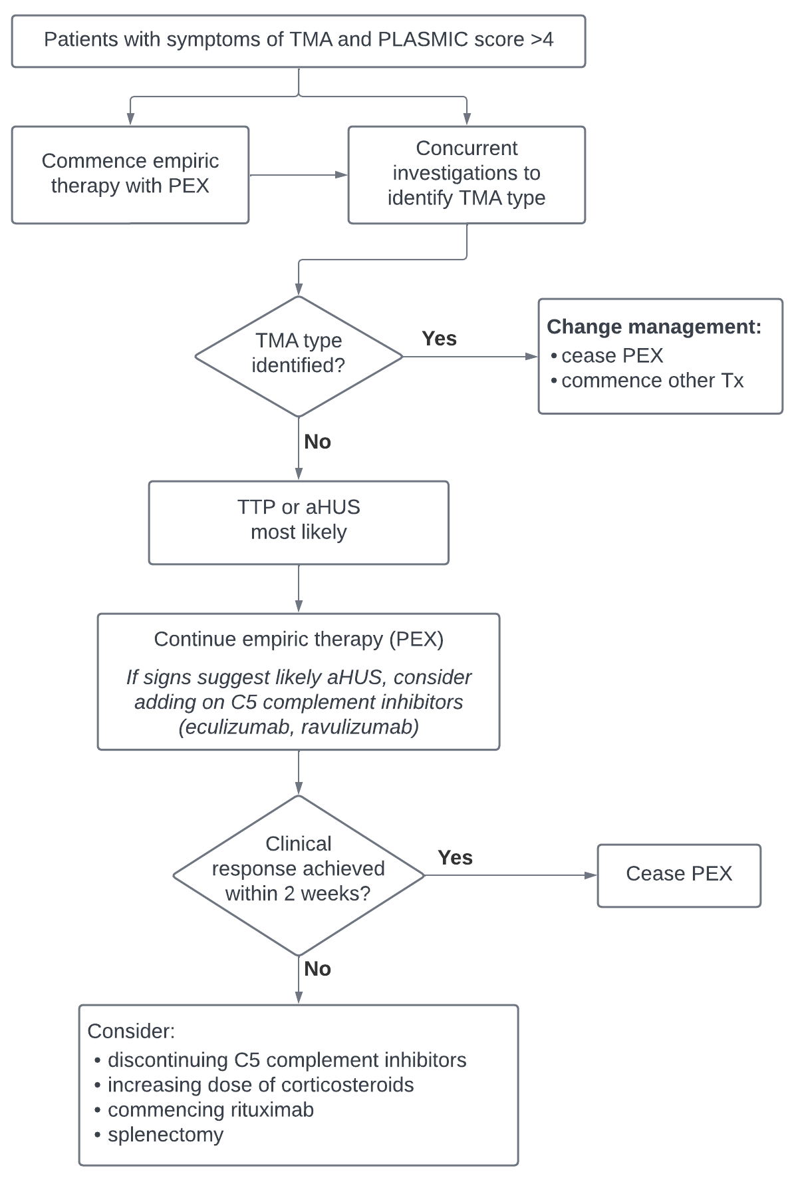

Figure 5 Current clinical management pathway for a patient with suspected TTP

Source: prepared by the assessment group based on Application 1796 and information from the applicant and clinical guidelines (Scully et al. 2023, Fox et al., 2018).

aHUS = atypical haemolytic uraemic syndrome; PEX = Plasma exchange therapy; TMA = thrombotic microangiopathy; TTP = thrombotic thrombocytopenic purpura; Tx = treatment.

#### Proposed clinical management – PICO Set 1

The intervention (ADAMTS13 testing) is additional to the current diagnosis and management of TTP. Therefore, all testing described for current clinical management will also be undertaken with the introduction of ADAMTS13 testing.

In the proposed pathway, blood samples for ADAMTS13 testing are taken prior to the initiation of PEX therapy; however, treatment is not delayed while awaiting the results. The application notes that rapid turnaround using AcuStar may enable PEX to be avoided altogether, however the clinical algorithm shows all patients with suspected TTP receive PEX, which is discontinued if ADAMTS13 activity is later found to be >10% (i.e. TTP is excluded). This is consistent with the algorithm presented in the application and clinical guidelines (Scully et al. 2023; Fox et al. 2018). Duration of PEX is an outcome measure for the assessment. The exclusion of TTP may also lead to uptake of treatments specific to aHUS, such as eculizumab or ravulizumab.

For both ADAMTS13 activity testing and anti-ADAMTS13 autoantibody testing, blood samples should be taken prior to PEX initiation; however, only activity testing is undertaken initially. If ADAMTS13 activity is <10% (i.e. diagnostic of TTP) then ADAMTS13 autoantibody testing is undertaken to distinguish iTTP from suspected cTTP. ADAMTS13 autoantibody testing is currently occurring infrequently in Australia (16% of TTP patients) (Fox et al. 2018). A suspected diagnosis of cTTP changes management to plasma infusions rather than PEX and the avoidance of immunosuppressive therapy.

Confirmation of cTTP requires the final test in the diagnostic pathway; *ADAMTS13* genetic testing. This occurs after a clinical response has been achieved (i.e. >150 x 109/L for at least 2 days) and after patients have commenced a period of monitoring to confirm persistently low ADAMTS13 activity (i.e. PICO Set 3). ADAMTS13 activity testing is repeated upon withdrawal of PEX or plasma infusion and if activity levels remain low, then genetic testing can be undertaken to confirm cTTP. This may lead to prophylactic plasma infusions and is anticipated to be treated with recombinant ADAMTS13 in the future (Scully et al. 2024).

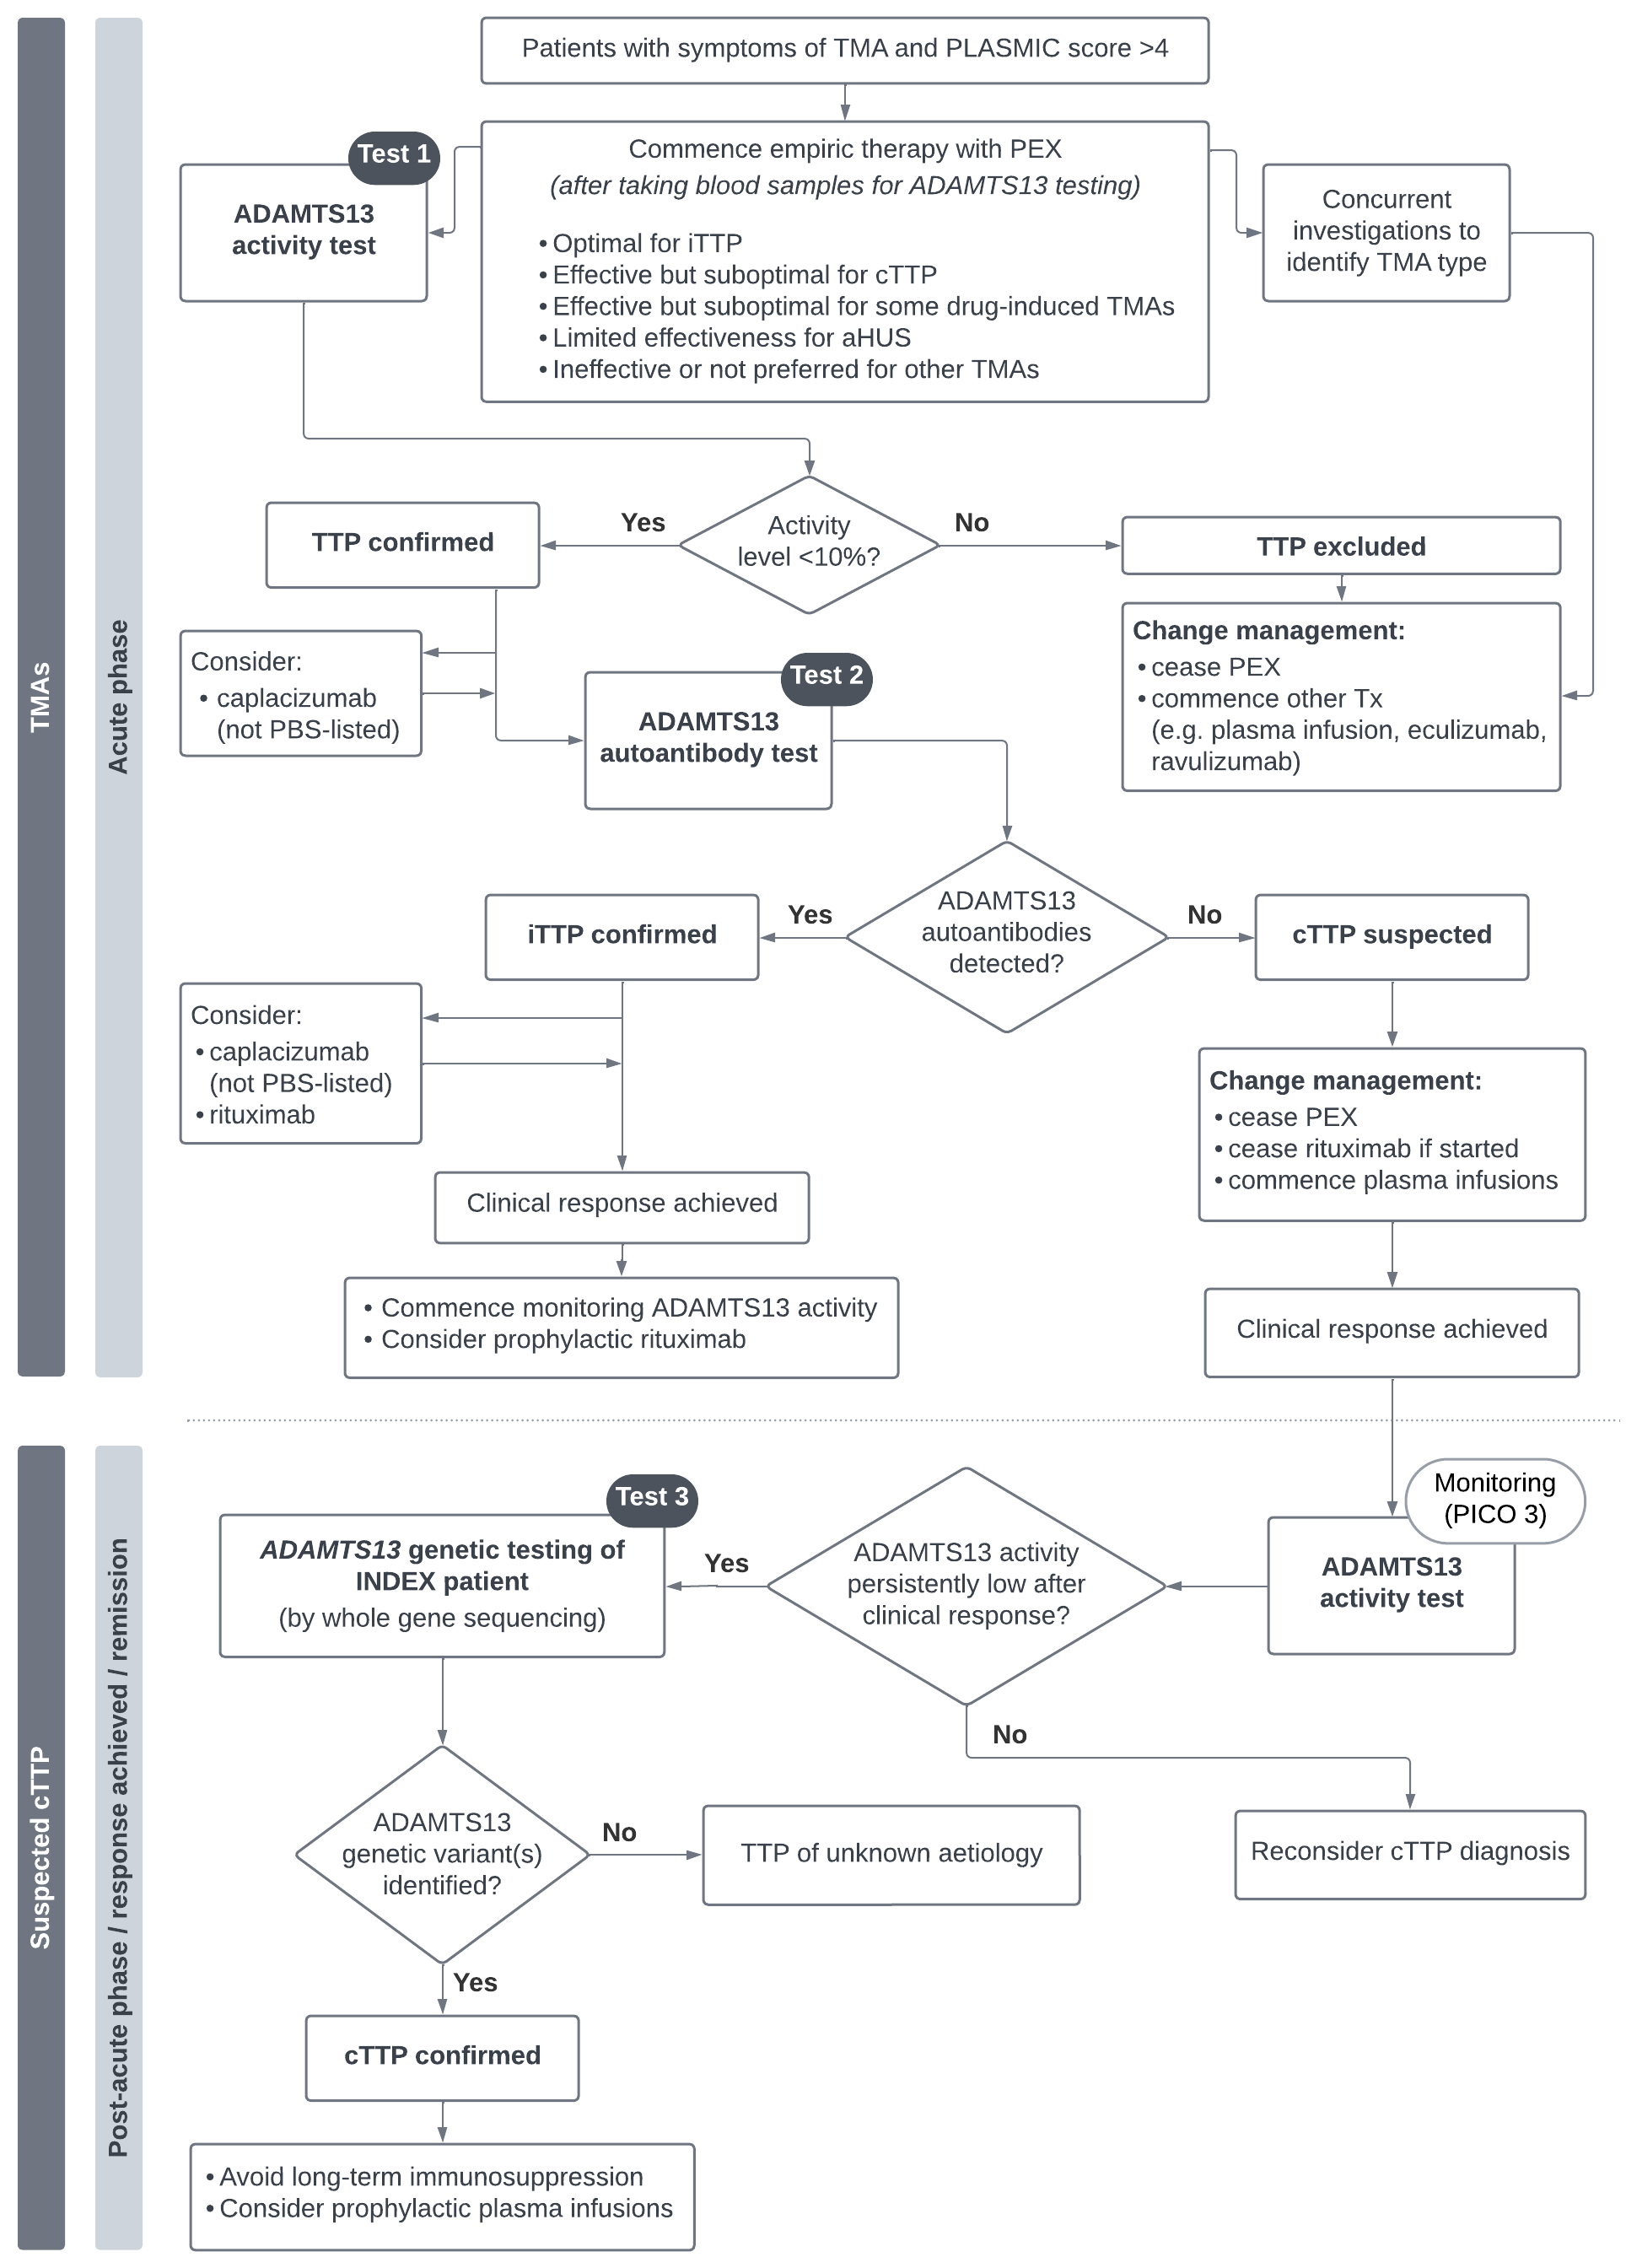

Figure 6 PICO Set 1: Differential diagnosis of TTP vs not TTP and iTTP vs cTTP

Source: prepared by the assessment group based on Application 1796 and information from the applicant and clinical guidelines (Scully et al. 2023, Fox et al., 2018).

aHUS = atypical haemolytic uraemic syndrome; cTTP = congenital TTP; iTTP = immune-mediated TTP; PBS = Pharmaceutical Benefits Scheme; PEX = Plasma exchange therapy; PICO = Population, Intervention, Comparator, Outcomes; TMA = thrombotic microangiopathy; TTP = thrombotic thrombocytopenic purpura; Tx = treatment.

#### Proposed clinical management – PICO Set 2

cTTP is estimated to account for 2-10% of all TTP cases. A UK cohort study found the majority of cases (62%) are diagnosed in adulthood (Scully et al. 2023) as patients can be asymptomatic until precipitated by an acute event (e.g. by viral infection, vaccination or pregnancy). Late recognition can lead to other medical co-morbidities such as stroke and obstetric complications.

Without access to *ADAMTS13* genetic testing, first-degree siblings of patients diagnosed with cTTP who are overtly symptomatic may be assumed to also have cTTP and those without overt symptoms are less likely to be identified.

If the proposed intervention, *ADAMTS13* cascade testing, is available, then first-degree siblings, including those with non-overt symptoms and no symptoms, can also be tested (Figure 7). Confirmation of pathogenic variants (homozygous or compound heterozygous) can lead to improved clinical management. Patients without overt symptoms may have symptoms such as headaches, lethargy and abdominal pain that are responsive to prophylactic treatment with plasma infusions (Alwyn et al. 2019). This may also prevent acute episodes and other medical co-morbidities. If the siblings are found to be homozygous or compound heterozygous for pathogenic variants and are asymptomatic, then additional treatment or monitoring can be initiated during high-risk periods such as pregnancy.

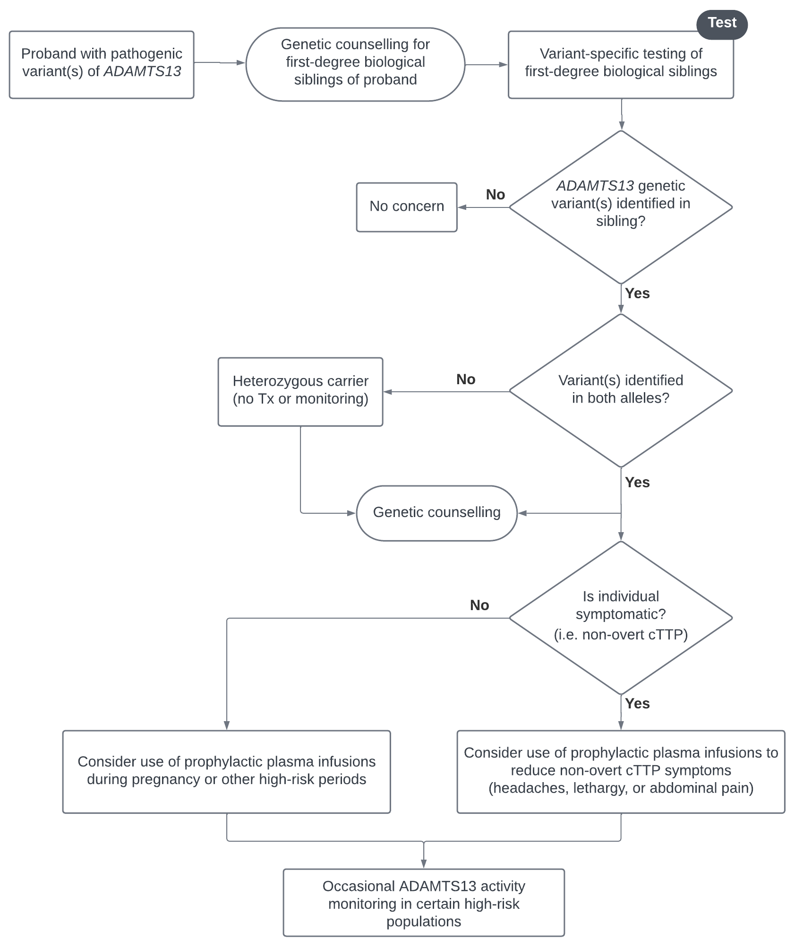

Figure 7 PICO Set 2: Cascade testing for first-degree biological siblings

Source: prepared by the assessment group based on Application 1796 and information from the applicant and clinical guidelines (Scully et al. 2023, Fox et al., 2018).

cTTP = congenital TTP; PICO = Population, Intervention, Comparator, Outcomes; Tx = treatment.

#### Proposed clinical management – PICO Set 3

Once a clinical response has been achieved with PEX treatment (or plasma infusions for suspected cTTP), patients require long-term follow-up. This includes monitoring of end-organ damage (brain, heart and renal function) and anxiety and depression (Scully et al. 2023). Ongoing management of organ damage and psychological impacts is not included in the clinical management algorithm and would not be altered by the introduction of ADAMTS13 testing.

In the absence of ADAMTS13 activity testing, ongoing monitoring of disease activity is undertaken via repeated measures of platelet count and LDH levels (Cuker et al. 2021). ADAMTS13 activity testing is proposed as an additional test for monitoring ongoing disease activity, as changes in ADAMSTS13 activity precede a drop in platelet count.

Monitoring frequency is proposed to alter over time (Figure 8). For patients in the first month post-PEX, (i.e. in clinical response), monitoring occurs weekly and is directed at identifying and preventing disease exacerbations. If no exacerbations occur over this time, the patient is in remission and monitoring frequency is reduced and aimed at identifying and preventing recurrence. In both cases, low levels of ADAMTS13 activity may trigger changes in treatment, particularly resumption or changes in immunomodulatory therapies and potentially resumption of PEX. Levels of ADAMTS13 activity that trigger changes in treatment may be higher than those that are used for diagnosis with a level of 20% selected in consensus guidelines as defining ADAMTS13 relapse (Cuker et al. 2021).

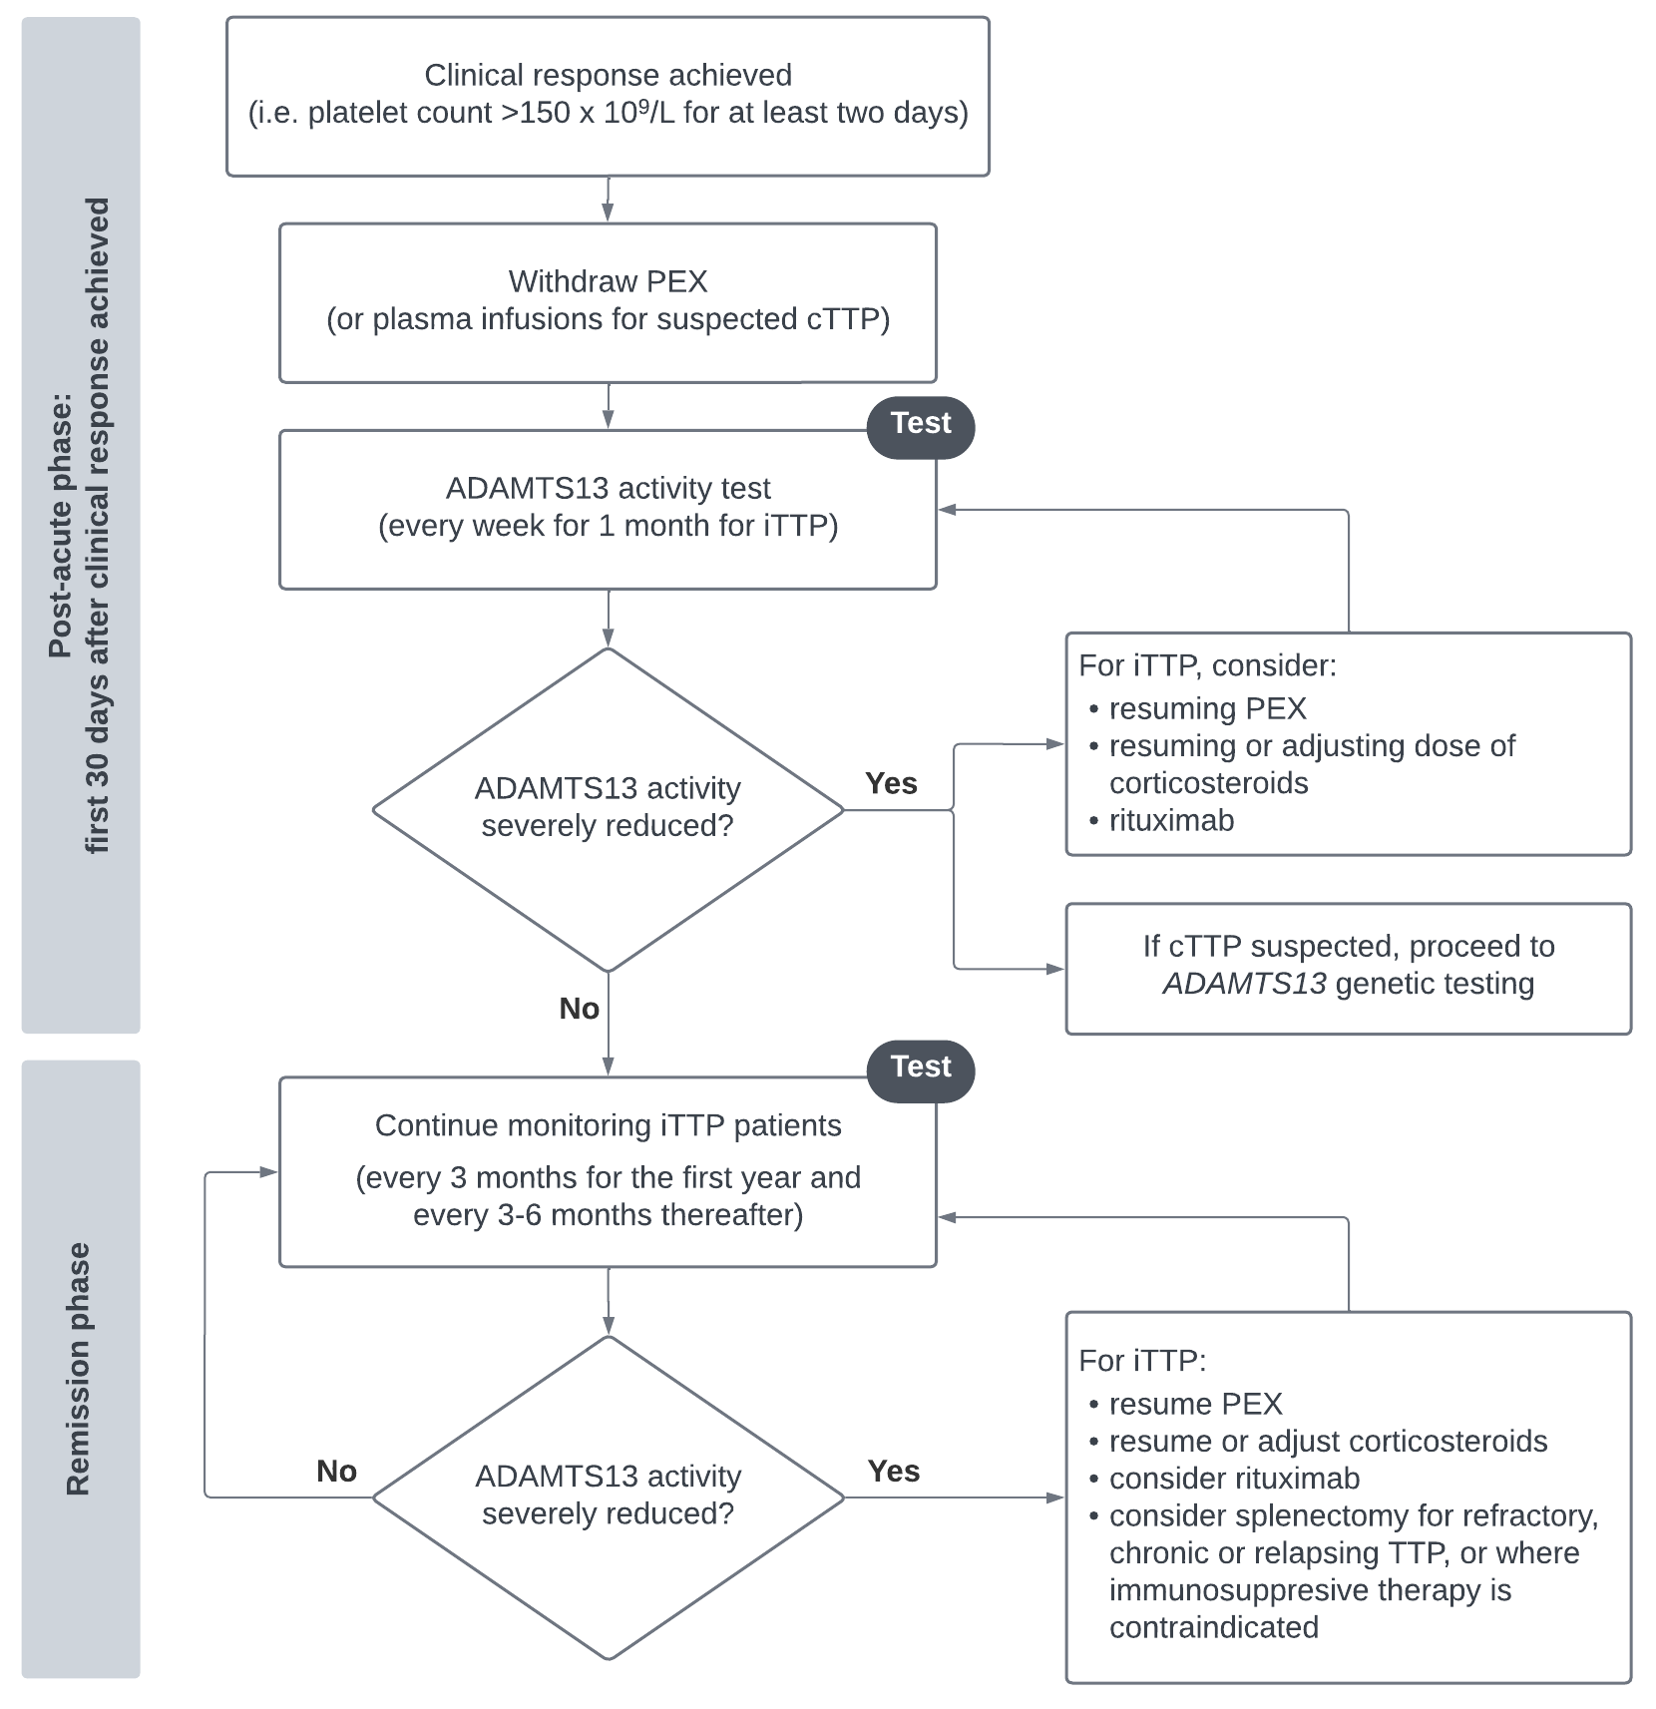

Figure 8 PICO Set 3: Monitoring ADAMTS13 activity in TTP patients during the post-acute and remission phases

Source: prepared by the assessment group based on Application 1796 and information from the applicant and clinical guidelines (Scully et al. 2023, Fox et al., 2018).

cTTP = congenital TTP; iTTP = immune-mediated TTP; PEX = Plasma exchange therapy; PICO = Population, Intervention, Comparator, Outcomes; TTP = thrombotic thrombocytopenic purpura.

*PASC accepted the clinical management algorithms.*

## Proposed economic evaluation

#### PICO Set 1

The clinical claim in the application is that ADAMTS13 testing results in superior health outcomes compared to no ADAMTS13 testing for patients with suspected TTP. The main clinical benefit of ADAMTS13 testing is for patients who test negative for TTP via ADAMTS13 activity testing as they can cease PEX early and avoid the associated complications and cost of this therapy.

The clinical claim in the application leads to a cost-effectiveness analysis (CEA) or a cost-utility analysis (CUA) for the economic evaluation (Table 9). The comparative cost-effectiveness assessment should incorporate the comparative costs and benefits of ADAMTS13 testing strategy as an additional testing strategy to current best practice in the differential diagnosis of TTP versus non-TTP and iTTP versus cTTP, including considerations of AEs from testing (e.g., false positives, false negatives) and downstream treatment.

*The PASC discussed whether the 3 sequential tests in PICO Set 1 could be considered in a single economic evaluation or whether they should be split out. It was agreed that since the activity and antibody testing are both performed during an acute presentation, they can be considered in a single economic evaluation. A cost-utility analysis was considered appropriate.*

*PASC requested that the financial analysis for PICO Set 1 should consider the costs of testing patients for investigation of suspected TMA (as per the revised item descriptor). An economic evaluation of this broader testing is not required.*

#### PICO Set 2

The application suggested that cascade testing of first-degree siblings is superior in effectiveness and safety compared to no genetic testing for the proposed population. A CEA or CUA can be used for this claim; however, MSAC has previously recommended a refined approach to the assessment of genetic testing with a CEA focus on the proportion of patients who received prognostic or predictive information (for example, PICO Confirmation [1675](https://www.msac.gov.au/sites/default/files/documents/1675%2520Ratified%2520PICO.pdf)). The appropriate economic evaluation using this approach is an analysis of the cost per proband detected and/or cost per pathogenic variant detected. This approach does not require an assessment of health outcomes.

*For PICO Set 2 (cascade testing), PASC considered a cost-per-diagnosis approach acceptable.*

#### PICO Set 3

The clinical claim in the application for PICO Set 3 is that ADAMTS13 activity testing for monitoring results in superior health outcomes compared to no ADAMTS13 activity testing in the monitoring of patients with TTP. Testing predicts disease exacerbations and relapse, and treatment can be commenced before symptoms begin. Therefore, the clinical claim leads to a CEA or a CUA for the economic evaluation.

*PASC stated the appropriate economic analysis for PICO Set 3 (monitoring) is a cost-utility analysis. PASC noted that uncertainty in the frequency of monitoring will present a challenge for the economic evaluation.*

Table 9 Classification of comparative effectiveness and safety of the proposed intervention, compared with its main comparator, and guide to the suitable type of economic evaluation

| Comparative safety- |  | Comparative effectiveness |  |  |
| --- | --- | --- | --- | --- |
| Inferior | Uncertaina | Noninferiorb | Superior |
| Inferior | Health forgone: need other supportive factors | Health forgone possible: need other supportive factors | Health forgone: need other supportive factors | ? Likely CUA |
| Uncertaina | Health forgone possible: need other supportive factors | ? | ? | ? Likely CEA/CUA |
| Noninferiorb | Health forgone: need other supportive factors | ? | CMA | CEA/CUA |
| Superior | ? Likely CUA | ? Likely CEA/CUA | CEA/CUA | CEA/CUA |

CEA = cost-effectiveness analysis; CMA = cost-minimisation analysis; CUA = cost-utility analysis

? = reflect uncertainties and any identified health trade-offs in the economic evaluation, as a minimum in a cost-consequences analysis

a ‘Uncertainty’ covers concepts such as inadequate minimisation of important sources of bias, lack of statistical significance in an underpowered trial, detecting clinically unimportant therapeutic differences, inconsistent results across trials, and trade-offs within the comparative effectiveness and/or the comparative safety considerations

b An adequate assessment of ‘noninferiority’ is the preferred basis for demonstrating equivalence

## Proposal for public funding

The application requested 5 new MBS items for ADAMTS13 testing; 2 for ADAMTS13 activity testing (diagnosis and monitoring), one for anti-ADAMTS13 antibody testing and 2 for *ADAMTS13* genetic testing (diagnosis and cascade testing). The MBS descriptors proposed in the application are presented in Table 10.

Table 10 MBS item descriptors proposed in the application for ADAMTS13 testing

|  |
| --- |
| **Category 6 – PATHOLOGY SERVICES** |
| **Group P1 Haematology**  MBS item AAAA  ADAMTS13 activity testing in patients presenting with suspected thrombotic thrombocytopenic purpura (TTP) to be conducted concurrently with BBBB  Once per episode |
| Proposed fee: $700 Benefit: 75% = $525.00 85% = $597.60 |
| **Group P1 Haematology**  MBS item BBBB  Anti-ADAMTS13 antibody testing in patients presenting with suspected thrombotic thrombocytopenic purpura (TTP) to be conducted concurrently with AAAA  Once per episode |
| Proposed fee: $1,050 Benefit: 75% = 787.50 85% = $947.60 |
| **Group P7 Genetics**  MBS item CCCC  Characterisation of variant(s) in the *ADAMTS13* gene in a patient with symptoms suggestive of thrombotic thrombocytopenic purpura, where testing with AAAA has indicated reduced ADAMTS13 activity and testing with BBBB indicates an absence of anti-ADAMTS13 antibodies, requested by a specialist or consultant physician  Available once per lifetime |
| Proposed fee: $1,200 Benefit: 75% = $900 85% = $1,097.60 |
| **Group P7 Genetics**  MBS item DDDD  Characterisation of variants in the *ADAMTS13* gene in a patient in a first-degree biological relative of a patient found to have a likely pathogenic variant(s) identified by item CCCC, requested by or on behalf of a specialist or consultant physician who manages the treatment of the patient  Available once per lifetime |
| Proposed fee: $1,200 Benefit: 75% = $900 85% = $1,097.60 |
| **Group P1 Haematology**  MBS item EEEE  Monitoring ADAMTS13 activity levels in patients with confirmed acquired thrombotic thrombocytopenic purpura (TTP) by item AAAA and BBBB  Weekly for first month after diagnosis, every 3-months for next 12-months, every 3-6 months thereafter |
| Proposed fee: $700 Benefit: 75% = $525.00 85% = $597.60 |

Source: adapted from Application 1796 for ADAMTS13 testing for TTP, with 75% and 85% Benefits calculated by the assessment group.

Note: The application assumed the Greatest Permissible Gap would apply to each of these items, but it is noted some services will be for inpatients.

There are no associated applications currently related to the proposed health technologies but access to PBS-funded eculizumab and ravulizumab for treatment of aHUS requires ADAMTS13 testing[7] to exclude TTP. The PBAC did not recommend the proposed listing of caplacizumab for the treatment of iTTP (July 2020 PBAC meeting).

The applicant’s proposed item descriptors do not align with the clinical management algorithm for PICO Set 1. Blood samples should be taken prior to PEX initiation for both ADAMTS13 activity testing and anti-ADAMTS13 antibody testing, although the tests are not undertaken concurrently, and the latter is only performed where the former indicates TTP. According to the applicant’s clinical expert, a practice note to specify this is not considered to be necessary.

In the pre-PASC meeting, the department queried whether there needed to be separate MBS items for diagnosis and monitoring and whether the proposed item AAAA required a higher fee due to urgency. The application has requested the same fee for both the diagnostic and monitoring indications and therefore agreed that these proposed items could be combined. The assessment group has proposed 4 new MBS items for ADAMTS13 testing based on discussion at the pre-PASC meeting and existing MBS item descriptors (Table 11).

Table 11 New MBS item descriptors proposed by the assessment group for ADAMTS13 testing

|  |
| --- |
| **Category 6 – PATHOLOGY SERVICES** |
| **Group P1 Haematology**  MBS item AAAA (combined with EEEE)  Quantitation of ADAMTS13 activity for the investigation of suspected thrombotic microangiopathy (TMA) or monitoring of diagnosed thrombotic thrombocytopenic purpura (TTP)  Rule 3 exemption applies |
| Proposed fee: $700 Benefit: 75% = $525.00 85% = $597.60 |
| **Group P1 Haematology**  MBS item BBBB  Anti-ADAMTS13 autoantibody testing in patients presenting with suspected thrombotic thrombocytopenic purpura (TTP) where testing has indicated reduced ADAMTS13 activity  Once per episode |
| Proposed fee: $1,050 Benefit: 75% = 787.50 85% = $947.60 |
| **Group P7 Genetics**  MBS item CCCC  Characterisation of variant(s) in the *ADAMTS13* gene in a patient who:   1. has symptoms suggestive of thrombotic thrombocytopenic purpura (TTP) where testing has indicated reduced ADAMTS13 activity and an absence of anti-ADAMTS13 antibodies, and 2. has not previously received a service to which item DDDD applies.   requested by a specialist or consultant physician.  Available once per lifetime |
| Proposed fee: $1,200 Benefit: 75% = $900 85% = $1,097.60 |

|  |
| --- |
| **Group P7 Genetics**  MBS item DDDD  Characterisation of variant(s) in the *ADAMTS13* gene in a person who:   1. is a first-degree biological relative of a patient found to have a likely pathogenic variant(s) in the *ADAMTS13* gene 2. has not previously received a service to which item CCCC applies   requested by or on behalf of a specialist or consultant physician.  Available once per lifetime |
| Proposed fee: $1,200 Benefit: 75% = $900 85% = $1,097.60 |

Source: prepared by the assessment group, adapted from Application 1796 for ADAMTS13 testing for TTP.

TTP = thrombotic thrombocytopenic purpura.

85% benefit reflects the 1 November 2024 Greatest Permissible Gap (GPG) of $102.40. All out-of-hospital Medicare services that have an MBS fee of $683.00 or more will attract a benefit that is greater than 85% of the MBS fee – being the schedule fee less the GPG amount. The GPG amount is indexed annually on 1 November in line with the Consumer Price Index (CPI) (June quarter).

*PASC noted that the MBS item descriptors for ADAMTS13 activity testing for diagnosis and monitoring had been combined and considered this appropriate. A Rule 3 exemption was supported by the applicant.*

*PASC considered if the PLASMIC score should be included in the MBS item descriptor. The applicant stated that there are other scores that are also used and, furthermore, the scores are often being calculated simultaneously with the sample being sent off for ADAMTS13 testing. Therefore, the applicant was of the opinion that inclusion of the PLASMIC score in the item descriptor would disadvantage the clinical end users. It was also noted that the PLASMIC score is neither validated in pregnant patients nor in children, so it is not applicable for all populations. Therefore, PASC agreed with the applicant that it was not required in the item descriptor.*

*PASC considered that the item descriptor should be broadened to TMA in order to also include patients with aHUS seeking treatment with PBS-listed medications. PASC supported advice from policy that item number AAAA be changed to include TMA instead of limiting it to TTP, but that monitoring use be limited to patients with TTP.*

*For item number BBBB, PASC requested that the requirement for a claim against item number AAAA be removed as in practice this may not have occurred.*

*PASC stated that both item numbers CCCC and DDDD should be once per lifetime and that item number DDDD should specify that it is applicable to biological first-degree relatives (i.e. not spouses).*

#### Proposed fees

The application did not state how the proposed fees were derived other than to note that in ‘patients in the community, private ED/private hospital with a TMA that requires ADAMTS13 testing, the public hospital will currently bill them approximately $800 out of pocket expense for testing‘. It is assumed this refers to monitoring ADAMTS13 activity, although this is not explicit. Lower fees for similar types of antibody and genetic tests can be identified on the MBS and at least one laboratory charges lower fees for ADAMTS13 activity testing, so the fees will need to be justified in the assessment.

The proposed fee for *ADAMTS13* genetic testing of index patients aligns with that for MBS items for characterisation of germline variants for specific conditions, but these involve multiple genes, including copy number variation (e.g. MBS items 73354, 73355, and 73356), so may not be an appropriate comparative fee.

The proposed fee for cascade testing does not align with that for MBS services to identify single gene variants in family members (i.e. variant-specific cascade testing) for other conditions; these tend to be around $400 (e.g. MBS item 73361).

*For all item numbers, PASC questioned the appropriateness of the proposed fees and noted that there were examples of laboratories undertaking these tests at lower costs. The applicant state*d *that for ADAMTS13 activity testing, the test can sometimes be an urgent request and therefore cannot be undertaken during standard hours as batch testing. Urgent requests would therefore be associated with higher costs, but the proposed fee for MBS item AAAA reflects an averaged-out cost rather than requesting two separate items.*

*PASC discussed the genetic testing and associated proposed fees, with members noting that there were different approaches to testing and that the applicant had not specified what approach would be taken. The assessment will need to specify the approach and, based on this, justify the proposed fees.*

*PASC considered the proposed fees to be high and unsupported, and instead should reflect publicly available costs. PASC stated that if the fees remain higher, this needs to be justified in the assessment.*

*Post-PASC, it was considered that a fee of $400 would be more appropriate for cascade testing than the applicant’s proposed fee of $1200 as $400 better aligned with existing MBS fees for variant-specific cascade testing for other conditions (e.g. item 73299 COL4A, 73361 monogenic, 73393 cardiomyopathy and 73443 hearing loss).*

The proposed fees can be associated with high out-of-pocket costs, especially for patients diagnosed with iTTP. Table 12 shows the proposed fee and benefits payable for each of the tests in the settings the tests are most likely to be used. It is assumed the ADAMTS13 activity testing and anti-ADAMTS13 autoantibody testing performed during acute episodes (Test 1 and Test 2 of PICO 1) would be performed on inpatients, so the 75% Benefit would apply. The 85% Benefit would apply to genetic testing (PICO 1 for index patient, PICO 2 for cascade testing) and monitoring of ADAMTS13 activity (PICO 3). The Greatest Permissible Gap (GPG) would apply to all test conducted on out-patients, which is $102.40 (as of 01 November 2024).

Table 12 Out-of-pocket costs per test based on proposed MBS benefits for ADAMTS13 testing

|  |  |  |  |  |  |
| --- | --- | --- | --- | --- | --- |
| **Setting, test and PICO** | **In-patient** ADAMTS13 activity test (PICO 1) | **In-patient**  Anti-ADAMTS13 autoantibody test (PICO 1) | **Out-patient** genetic test of index patient (PICO 1) | **Out-patient** cascade testing (PICO 2) | **Out-patient** ADAMTS13 activity monitoring  (PICO 3) |
| Proposed Fee | $700.00 | $1,050.00 | $1,200.00 | $1,200.00 | $700.00 |
| Benefit payable in setting per test | $525.00 | $787.50 | *GPG applies* | *GPG applies* | *GPG applies* |
| OOP costs per test | $175.00 | $262.50 | $102.40 | $102.40 | $102.40 |

Source: prepared by the assessment group from benefits proposed in Application 1796 for ADAMTS13 testing for TTP.

GPG = Greatest Permissible Gap; OOP = out-of-pocket; PICO = Population, Intervention, Comparator, Outcomes.

Note: GPG is $102.40 as of 01 November 2024.

The total out-of-pocket costs would differ between populations. Table 13 shows an estimate of likely out-of-pocket costs for 4 populations – patients excluded from having TTP, patients with confirmed iTTP, patients with confirmed or excluded cTTP, and cascade testing. For patients with confirmed iTTP, where monitoring of ADAMTS13 activity levels is expected to be ongoing, total costs are shown for the first two years, with ongoing annual costs ranging from $204.80 to $409.60. It is noted, however, that patient out-of-pocket costs may be impacted by other factors such as the level of practitioners’ fees and potential rebates from private health insurance.

Table 13 Likely out-of-pocket costs of ADAMTS13 testing for 4 populations

|  |  |  |  |  |
| --- | --- | --- | --- | --- |
| **Testing** | **TTP excluded** (PICO 1) | **iTTP confirmed** (PICO 1 & PICO 3) | **cTTP confirmed or excluded** (PICO 1) | **Cascade test  (per sibling)** (PICO 2) |
| In-patient ADAMTS13 activity tests | $175.00 | $175.00 | $175.00 | – |
| In-patient anti-ADAMTS13 autoantibody tests | – | $262.50 | $262.50 | – |
| Out-patient | – | Year 1 (8 tests) $819.20 | $204.80a | – |
| ADAMTS13 activity tests | – | Per year thereafter (2 – 4 tests) $204.80 – $409.60 |  |  |
| Genetic test of index patient | – | – | $102.40 | – |
| Cascade testing | – | – | – | $102.40 |
| **Total likely OOP costs** | **$175.00** | After 2 years: **$1,461.50 – $1,666.30** | **$744.70** | **$102.40** |

Source: prepared by the assessment group from information in Application 1796 for ADAMTS13 testing for TTP.

cTTP = congenital TTP; iTTP = immune-mediated TTP; OOP = out-of-pocket; PICO = Population, Intervention, Comparator, Outcomes; TTP = thrombotic thrombocytopenic purpura.

a Assumes 2 ADAMTS13 activity tests after clinical response achieved to establish persistently low ADAMTS13 activity levels prior to genetic testing.

## Summary of public consultation input

*PASC noted that there was no consultation feedback received by the Department for consideration by PASC.*

## Next steps

*PASC noted that the application will proceed as a department-contracted assessment report (DCAR).*

## Applicant Comments on Ratified PICO

The College is grateful for the careful consideration of this PICO Confirmation by PASC. In response to the committee’s deliberations, we have the following minor comments:

* For added clarity, we recommend genetic testing in **Table 1** be defined as “*ADAMTS13* genetic test in patients with ADAMTS13 activity <10% and absence of anti-ADAMTS13 antibodies”. This is already implied as testing is noted as being sequential, this change is simply intended to remove any ambiguity from the indicated population for genetic testing.
* Diagnostic testing for patients with signs and symptoms suggestive of TMAs is certainly undertaken in private and community settings, albeit less commonly than in public hospitals. The conditions are not common, so the absolute numbers of tests undertaken would be relatively small. The College is happy to provide the assessment group with updated estimates for uptake during the assessment phase.

## References

Alwan F, Vendramin C, Liesner R, et al. (2019) Characterization and treatment of congenital thrombotic thrombocytopenic purpura. *Blood*. 133(15):1644-1651. doi:10.1182/blood-2018-11-884700

Barbour T, Scully M, Ariceta G, et al. (2021) Long-Term Efficacy and Safety of the Long-Acting Complement C5 Inhibitor Ravulizumab for the Treatment of Atypical Hemolytic Uremic Syndrome in Adults. *Kidney Int Rep*.;6(6):1603-1613. doi:10.1016/j.ekir.2021.03.884

CADTH (Canadian Agency for Drugs and Technology in Healthcare) (2023) [CADTH Reimbursement Recommendation - Caplacizumab (Cablivi)](https://www.cda-amc.ca/sites/default/files/DRR/2023/SR0736%20Cablivi%20Resubmission%20-%20Final%20CADTH%20Recommendation%20Final.pdf) Accessed 10 March 2025

Cuker A, Cataland SR, Coppo P, et al. (2021) Redefining outcomes in immune TTP: an international working group consensus report. *Blood.* 137(14):1855-1861. doi:10.1182/blood.2020009150

Favaloro EJ, Pasalic L, Henry B, Lippi G. (2021) Laboratory testing for ADAMTS13: Utility for TTP diagnosis/exclusion and beyond. *Am J Hematol*. 96(8):1049-1055. doi:10.1002/ajh.26241

Favaloro, E. J., Chapman, K. et al. (2023) Automated and Rapid ADAMTS13 Testing Using Chemiluminescence: Utility for Identification or Exclusion of TTP and Beyond. *Methods Mol Biol.* 2663: 487-504

Fox LC, Cohney SJ, Kausman JY, et al. (2018) Consensus opinion on diagnosis and management of thrombotic microangiopathy in Australia and New Zealand. *Intern Med J*. 48(6):624-636. doi:10.1111/imj.13804

Kimchi-Sarfaty, C, Blaisdell, A, et al. (2008) Human Hepatic Stellate Cells Carry a New Splice Variant of the Human ADAMTS13. *Blood*, 112, 4085-4085. <https://doi.org/10.1182/BLOOD.V112.11.4085.4085>.

Legendre CM, Licht C, Muus P, et al. (2013) Terminal complement inhibitor eculizumab in atypical hemolytic-uremic syndrome. *N Engl J Med*. 368(23):2169-2181. doi:10.1056/NEJMoa1208981

Lv H, Wang Z, Yang L, et al. (2020) Neonate with Congenital Thrombotic Thrombocytopenic Purpura: a Case Report of a de novo Compound Heterozygote Mutation in ADAMTS13 Gene and Review of Literature. *Clin Lab*. Apr 1;66(4). doi: 10.7754/Clin.Lab.2019.190715. PMID: 32255295.

Martin SD, McGinnis E, Smith TW. (2021) Indicators Differentiating Thrombotic Thrombocytopenic Purpura From Other Thrombotic Microangiopathies in a Canadian Apheresis Referral Center. *Am J Clin Pathol*. Nov 8;156(6):1103-1112. doi: 10.1093/ajcp/aqab078. PMID: 34160013.

Masias C, Cataland SR. (2018) The role of ADAMTS13 testing in the diagnosis and management of thrombotic microangiopathies and thrombosis. *Blood.* 132(9):903-910. doi:10.1182/blood-2018-02-791533

NICE (National Institute for Health and Care Excellence) (2020) [Caplacizumab with plasma exchange and immunosuppression for treating acute acquired thrombotic thrombocytopenic purpura](https://www.nice.org.uk/guidance/ta667/resources/caplacizumab-with-plasma-exchange-and-immunosuppression-for-treating-acute-acquired-thrombotic-thrombocytopenic-purpura-pdf-82609264160197) (TA667). Accessed 10 March 2025.

Peyvandi F, Scully M, Kremer Hovinga JA, et al. (2016) Caplacizumab for Acquired Thrombotic Thrombocytopenic Purpura. *N Engl J Med.* 374(6):511-522. doi:10.1056/NEJMoa1505533

Picod A, Provôt F, Coppo P. (2019) Therapeutic plasma exchange in thrombotic thrombocytopenic purpura. *Presse Med*. 48(11 Pt 2):319-327. doi:10.1016/j.lpm.2019.08.024

Roose E, Joly BS. (2020) Current and Future Perspectives on ADAMTS13 and Thrombotic Thrombocytopenic Purpura. *Hamostaseologie*. 40(3):322-336. doi:10.1055/a-1171-0473

Scully M, Antun A, Cataland SR, et al. (2024) Recombinant ADAMTS13 in Congenital Thrombotic Thrombocytopenic Purpura. *N Engl J Med*. 390(17):1584-1596. doi:10.1056/NEJMoa2314793

Scully M, Cataland SR, Peyvandi F, et al. (2019) Caplacizumab Treatment for Acquired Thrombotic Thrombocytopenic Purpura. *N Engl J Med.* 380(4):335-346. doi:10.1056/NEJMoa1806311

Scully M, Rayment R, Clark A, et al. (2023) A British Society for Haematology Guideline: Diagnosis and management of thrombotic thrombocytopenic purpura and thrombotic microangiopathies. *Br J Haematol*. 203(4):546-563. doi:10.1111/bjh.19026

Singh D, Subhan MO, de Groot R, et al. (2023) ADAMTS13 activity testing: evaluation of commercial platforms for diagnosis and monitoring of thrombotic thrombocytopenic purpura. *Res Pract Thromb Haemost*. 2023;7(2): doi:10.1016/j.rpth.2023.100108

Sukumar S, Lämmle B, Cataland SR. (2021) Thrombotic Thrombocytopenic Purpura: Pathophysiology, Diagnosis, and Management. *J Clin Med*. Feb 2;10(3):536. doi: 10.3390/jcm10030536. PMID: 33540569; PMCID: PMC7867179.

Tanaka K, Adams B, Aris AM, et al. (2021) The long-acting C5 inhibitor, ravulizumab, is efficacious and safe in pediatric patients with atypical hemolytic uremic syndrome previously treated with eculizumab. *Pediatr Nephrol*. 36(4):889-898. doi:10.1007/s00467-020-04774-2

Tanudisastro HA, Holman K, Ho G, *et al.* (2021) Australia and New Zealand renal gene panel testing in routine clinical practice of 542 families. *npj Genom. Med.* **6**, 20.

1. Pre-PASC meeting with Department and applicant, 26 February 2025.
2. Pre-PASC meeting with Department and applicant, 26 February 2025.
3. The ACL AcuStar automated system (Werfen) uses a HemosIL kit to assay ADAMTS13 activity.
4. Pre-PASC meeting with Department and applicant, 26 February 2025.
5. TGA Recall Reference RC-2024-RN-00633-1; 12 August 2024.
6. Pre-PASC meeting with Department and applicant, 26 February 2025.
7. To initiate treatment, patients must have ADAMTS13 activity of greater than or equal to 10% on a blood sample taken prior to plasma exchange or infusion; or, if ADAMTS13 activity was not collected prior to plasma exchange or infusion, patient must have platelet counts of greater than 30x109/L and a serum creatinine of greater than 150 mol/L.