MSAC Application 1798

Liquid biopsy genetic testing in patients with non-small cell lung cancer

Applicant: AstraZeneca, Daiichi Sankyo Australia, Illumina, SOPHiA Genetics, Thermo Fisher Scientific

# PICO Confirmation

## Summary of PICO/PPICO criteria to define question(s) to be addressed in an Assessment Report to the Medical Services Advisory Committee (MSAC)

Table 1 PICO for liquid biopsy-based genetic testing using next generation sequencing (NGS)-based genotyping of circulating tumour DNA (ctDNA) to detect oncogenic biomarkers among patients with non-small cell lung carcinoma (NSCLC)

| **Component** | **Description** |
| --- | --- |
| **Population** | Population 1:  Patients with suspected NSCLC for whom tissue biopsy is not available. PASC recommended that population 1 be excluded from the PICO.  Population 2:  Patients newly clinically diagnosed with unresectable or metastatic lung cancer and histologically or cytologically confirmed NSCLC whose initial tissue biopsy was insufficient for tissue-based genetic testing or failed tissue-based genetic testing.  Population 3:  Patients with recurrence or progression of NSCLC disease on first-line (1L) treatment with targeted therapy, e.g. epidermal growth factor receptor tyrosine kinase inhibitors(*EGFR* TKIs). |
| **Prior tests** | Population 1:  Tests to evaluate for lung pathology including possible lung malignancy, e.g. X-ray, Computed Tomography (CT) of the chest.  Population 2:  Tests to confirm lung cancer, e.g. X-ray, CT of the chest and tissue biopsy for genetic testing to confirm NSCLC, fludeoxyglucose-18 (FDG) positron emission tomography (PET) scan, histopathology of biopsy samples obtained via methods such as ultrasound-guided biopsy or ultrasound-guided fine needle aspiration biopsy and bronchoscopy.  Population 3:  Tests to detect disease progression and spread of NSCLC to other tissues, e.g. Magnetic Resonance Imaging (MRI), CT scan, bone scan. |
| **Intervention** | Population 1:  Testing for actionable variants and gene fusions using liquid biopsy sample.  Population 2:  Testing actionable variants and gene fusions using liquid biopsy sample as second line test if re-biopsy and tissue-based genetic testing fails or is not possible.  Population 3:  Testing for actionable variants and gene fusions using liquid biopsy sample if biopsy post progression fails or not feasible |
| **Comparator** | Population 1:  Standard of care: no genotyping using liquid biopsy.  Population 2:  Standard of care: tissue-based genetic testing where tissue rebiopsy was feasible, and no molecular testing where tissue rebiopsy was not feasible.  Population 3:  Standard of care: either tissue biopsy post progression and tissue-based genetic testing, or no molecular testing. |
| **Reference standard** | Population 1:  Confirmation of lung cancer diagnosis, specifically histopathology demonstrating NSCLC and tissue-based genetic testing.  Population 2 and 3:  Tissue-based genetic testing. |
| **Outcomes** | Safety outcomes:   * Adverse events (AEs) related to liquid biopsy-based genetic testing (e.g. sampling related). * AEs (or avoided AEs) from any change in patient management (e.g., targeted treatment).   Test performance:   * Prognostic accuracy: Sensitivity, specificity, positive predictive value, and negative predictive value of liquid biopsy-based genetic testing to predict response to therapy. * Any differences in prognostic accuracy by patient characteristics (e.g., age), and cancer characteristics (e.g., subtype, stage). * Any harm from liquid biopsy-based genetic testing (e.g., false positive and negative results, test turn-around time resulting in a potential delay in commencing treatment, test failure rate).   Change in management:   * Change in patient management (e.g., treatment modifications, monitoring). * Any differences in patient management by patient characteristics (e.g., age), and cancer characteristics (e.g., type, stage).   Clinical effectiveness outcomes:   * Direct: Change in patient-relevant health outcomes (e.g., the effectiveness of targeted treatment, progression-free survival, mortality, morbidity, quality of life) when comparing the following groups:   + Patients receiving targeted therapy following positive identification of biomarker(s) on liquid biopsy-based genetic testing Patients not receiving targeted therapy (due to failed/negative liquid biopsy-based genetic testing or negative tissue-based genetic testing or rebiopsy not feasible).   + Patients who were identified as biomarker positive following rebiopsy and tissue-based genetic testing.   + Patients receiving targeted therapy based on original test results despite post progression biopsy and tissue test failure and failed/negative liquid biopsy-based genetic testing.   + Patients receiving targeted therapy following positive identification of additional biomarker(s) on liquid biopsy-based genetic testing.   + Patients receiving a targeted therapy following positive identification of additional biomarker(s) on post progression biopsy and tissue-based genetic testing. * Indirect: Change in patient-relevant health outcomes (e.g., progression-free survival, mortality, morbidity, quality of life, rate of rebiopsy, tumour recurrence) when comparing the following groups:   + Patients receiving targeted therapy following positive identification of biomarker(s) on liquid biopsy-based genetic testing.   + Patients not receiving targeted therapy (due to failed/negative liquid biopsy-based genetic testing or negative tissue-based genetic testing or rebiopsy not feasible).   + Patients who were identified as biomarker positive following rebiopsy and tissue-based genetic testing.   + Patients receiving targeted therapy based on original test results despite post progression biopsy and tissue test failure and failed/negative liquid biopsy-based genetic testing.   + Patients receiving targeted therapy following positive identification of additional biomarker(s) on liquid biopsy-based genetic testing.   + Patients receiving a targeted therapy following positive identification of additional biomarker(s) on post progression biopsy and tissue-based genetic testing. * Any differential clinical effectiveness outcomes by patient characteristics (e.g., age, ethnicity), and cancer characteristics (e.g., type, stage).   Cost-effectiveness outcomes:   * Cost per patient with a targetable oncogenic biomarker identified allowing access to Pharmaceutical Benefits Scheme (PBS)-listed therapies. * Cost per patient experiencing disease progression avoided. * Cost per quality-adjusted life year (QALY) gained. * Any differential results by patient characteristics (e.g., age, sex), and cancer characteristics (e.g., location, stage).   Health system resources:   * Cost of liquid biopsy-based genetic testing including NGS-based genotyping of ctDNA. * Change in the costs associated with the investigation, monitoring, and management of NSCLC (e.g., drugs, hospitalisation) and other AEs if applicable. * Change in the cost of treatment because of a change in clinical management (e.g., targeted therapy, alternative therapy after relapse). * Cost-effectiveness of liquid biopsy-based genetic testing * Total Australian Government healthcare costs.   Other relevant considerations   * Value of knowing. |
| **Assessment questions** | Population 1  What is the safety, effectiveness and cost-effectiveness of liquid biopsy-based genetic testing versus standard of care without testing in patients with suspected NSCLC for whom tissue biopsy is not available?  Population 2  What is the safety, effectiveness and cost-effectiveness of liquid biopsy-based genetic testing versus standard of care in patients newly clinically diagnosed with unresectable or metastatic lung cancer, and histologically or cytologically confirmed NSCLC whose initial tissue biopsy was insufficient for tissue-based genetic testing or failed tissue-based genetic testing?  Population 3  What is the safety, effectiveness and cost-effectiveness of liquid biopsy-based genetic testing versus standard of care in patients with recurrence or progression of NSCLC disease on first-line (1L) treatment with targeted therapy? |

CT= computed tomography; MRI= magnetic resonance imaging; NGS= next-generation sequencing; NSCLC= non-small cell lung carcinoma.

## Purpose of application

An application requesting Medicare Benefits Schedule (MBS) listing of liquid biopsy-based genetic testing to identify oncogenic biomarkers for treatment prediction of non-small cell lung carcinoma (NSCLC) was received from Health Technology Analysts by the Department of Health and Aged Care.

While the application proposed liquid biopsy-based genetic testing to detect oncogenic biomarkers to determine eligibility for targeted Pharmaceutical Benefits Scheme (PBS)-subsidised medicines, the application also anticipated that the testing would allow access to targeted treatments that may become available in the future but are not yet PBS listed (p9 of the PICO Set document). Therefore, the application provided two (2) options for MBS item descriptors (Section ‘Proposal for public funding’).

### Clinical claim

The clinical claims leading up to the PASC meeting were revised from the original clinical claim in the application. The revised population definitions and clinical management algorithms provided by the applicant in the pre-PASC meeting on 28 February 2025, are described by the assessment group as below:

1. For patients with suspected NSCLC for whom tissue biopsy is not available (population 1), liquid biopsy-based genetic testing offers superior effectiveness and superior safety compared to no molecular testing.
2. For patients newly clinically diagnosed with unresectable or metastatic lung cancer and histologically or cytologically confirmed NSCLC who have either insufficient tissue for tissue-based genetic testing or have failed tissue-based genetic testing (population 2) liquid biopsy-based genetic testing offers superior effectiveness and superior safety compared to no molecular testing.
3. For relapsed patients with progressed NSCLC disease on first-line (1L) treatment with first or second generation targeted therapy, and who are eligible for tissue-based genetic testing to detect resistant oncogenic biomarkers (population 3), liquid biopsy-based genetic testing offers superior effectiveness and superior safety compared to no molecular testing.

## PICO criteria

### Population

The application proposed 3 populations (pre-PASC meeting, 28 February 2025):

#### Population 1

Patients with suspected NSCLC for whom tissue biopsy is not available.

#### Population 2

Patients newly clinically diagnosed with unresectable or metastatic lung cancer and histologically or cytologically confirmed NSCLC who have either insufficient tissue for tissue-based genetic testing or have failed tissue-based genetic testing.

*PASC suggested adding ‘unresectable or metastatic’ to the population 2 definition, as it was most likely that surgical resection would not be feasible in patients at this disease stage and therefore tumour tissue would be more difficult to access.*

*PASC noted that liquid biopsy would be a second line test for all patients with advanced and metastatic disease who have had an initial biopsy and either tissue- based testing has failed or biopsy tissue was insufficient and rebiopsy is not possible.*

*PASC further noted Population 2 does not include patients who cannot have a first/initial biopsy or are unfit to have a first/initial biopsy (but have been diagnosed on cytology).*

#### Population 3

Patients with recurrence or progression of NSCLC disease on first-line (1L) treatment with targeted therapy, e.g. *EGFR* TKIs.

The population definitions described above departed from the original description in the application document which described the populations as patients with non-small cell lung carcinoma (NSCLC) who cannot receive or have failed tissue-based testing, and patients unfit to undergo rebiopsy or who have insufficient tissue for genetic testing or failed tissue-based testing and require a rebiopsy (p1 of the PICO Set document).

The application proposed eligible population 3 as those with recurrence or progression of NSCLC disease in whom tissue biopsy was not feasible, while the draft PICO proposed population 3 as all patients with recurrence or progression of NSCLC disease. This change followed the revised clinical management algorithm received from the applicant after the pre-PASC meeting. Expanding the population to include all patients with recurrence or progression will potentially increase the uptake of liquid biopsy-based genetic testing.

*PASC noted that the definition of population 3 was amended by the applicant. The original definition of population 3 included patients who had progressed on first line (1L) treatment with first- or second-generation targeted therapy (e.g.* EGFR *TKIs). PASC noted the applicant’s proposal to include patients who have progressed with NSCLC on 1L targeted therapy irrespective of the generation or type of the first line targeted therapy. PASC noted that there was substantial uncertainty and heterogeneity in this population, as it now includes patients on any 1L targeted treatment who have progressed. PASC noted that NCCN 2024 guidelines* *(Riely et al. 2024)* i*ndicate that treatment decisions for patients in this heterogenous group comprising population 3 are complex and individualised and dependent on factors such as site of disease progression, presence or absence of symptoms, original genotype and prior treatment.*

In the pre-PASC meeting the applicant, the department and the assessment group agreed to include 3 separate populations based on the updated clinical algorithms presented by the applicant (Document titled “Updated clinical algorithms_Feb2025”, Pre-PASC meeting, 28 Feb 2025). While the application proposes liquid biopsy-based genetic testing for patients with NSCLC, PASC advice was sought regarding the inclusion of population 1 who do not have a histologically or cytologically confirmed diagnosis of NSCLC. The applicant’s clinical experts noted that tissue biopsy may not be possible in these patients due to it being unsafe, expensive and complex, and may lead to adverse events leading to hospitalisation for the patient. Published research indicates that the reasons for not undergoing a biopsy primarily include older age (≥ 75 years) and poor performance status (PS) score, (i.e. poor health decreasing the patient’s ability to perform daily activities independently). On the other hand, the stage of the disease is not associated with the likelihood of pathology (Khakwani et al. 2013). The clinical experts described this population as particularly vulnerable to undertreatment given that they might not have accessible or available lung tumour tissue for tissue-based genetic testing. The applicant’s clinical experts indicated that the exclusion of this population from accessing liquid biopsy-based genetic testing might introduce inequity as these patients were likely to be undertreated without any molecular testing. The clinical experts estimated that such patients would comprise 10% of all lung cancer patients, and 80% of these may have NSCLC who in turn might have oncogenic biomarkers targetable by PBS-listed therapies. In an Australian study of 841 lung cancer cases, 85/841 (approx. 10%) were diagnosed clinically, without pathological confirmation of NSCLC or SCLC (Mitchell et al. 2013). The clinical experts also indicated that currently most of these patients are prescribed immunotherapy, which is an expensive and non-targeted therapy and is associated with substantial adverse effects. Providing liquid biopsy-based genetic testing as an option for these patients would decrease the adverse events associated with immunotherapy and allow these patients to receive targeted therapy (Pre-PASC Meeting, 28 February 2025).

*PASC recommended that population 1 be excluded from the PICO.*

*PASC highlighted the key issue with population 1 was the diagnostic uncertainty in this population due to the lack of a histological or cytological diagnosis of NSCLC. PASC noted the proposed population would be highly heterogenous due to lack of a confirmed diagnosis. Further, PASC noted that there were limited clinical trials that provided evidence to support the inclusion of this population. Therefore, PASC considered that undertaking an HTA would be very difficult in the absence of a defined diagnosis and evidence of clear health outcomes. The possibility of disease misclassification would be compounded by test misclassification.*

*PASC noted that an optimal care pathway for diagnosing lung cancer in Australia requires a specialist diagnostic work-up which often includes CT scans, bronchoscopy, excision biopsy, sputum cytology and ultrasound-guided or CT-guided aspiration biopsy.*

#### Lung cancer

Lung cancer is the fifth most commonly-diagnosed cancer, with an estimated 15,122 new cases in 2024 in Australia (AIHW 2024). The age-standardised incidence rate for lung cancer was estimated at 56 cases per 100,000 in 2024. It is the most common cause of cancer-related deaths in Australia. Of the 5 most common cancers in Australia, survival rates in people with lung cancer are the lowest (5-year survival rate of 26% in 2016–2020 for lung cancer) (AIHW 2024).

There are 2 main histological types of lung cancer: small-cell lung cancer, and non-small cell lung cancer. Small-cell lung cancer tends to grow and spread quickly, and it has usually spread to other parts of the body before it is detected.

#### Diagnosis of lung cancer

Lung cancer diagnosis typically includes several tests required for cancer management (American Cancer Society (ACS) 2024; Cancer Council Australia 2024):

* The initial or clinical diagnosis is made by:
  + Medical history and physical examination by the physician.
  + Imaging tests to look for suspected cancer, including chest X-ray, and computed tomography (CT) scan.
* The tests to confirm the type of lung cancer diagnosis (e.g. NSCLC) include:
  + Magnetic resonance imaging (MRI) scan, positron emission tomography (PET) scan.
  + Biopsy including CT-guided lung biopsy, bronchoscopy, Endobronchial ultrasound (EBUS)-guided biopsy, endoscopic ultrasound (EUS) guided biopsy, mediastinoscopy, thoracoscopy, needle biopsy to get a small sample from a suspicious area, including fine needle aspiration (FNA) biopsy.
  + Other tests: Sputum cytology, where a sample of sputum (mucus coughed up from the lungs) is examined under a microscope to look for cancer cells (cytological testing); Pleural tap (also called pleurocentesis) to sample fluid from around the lungs
* Tests to detect specific genetic variants or biomarkers are called ‘molecular tests’. These tests require a biopsy.
* Tests to check spread of cancer to other areas: e.g., bone scan, CT or MRI of brain, etc.

#### Non-small cell lung carcinoma (NSCLC)

NSCLC is the most common type of lung cancer, accounting for around 85-90% of lung cancers (Cancer Australia 2025). The most common risk factor associated with NSCLC is cigarette smoking (American Cancer Society (ACS) 2024). NSCLC patients generally have a poor prognosis, with 55–70% diagnosed with metastatic disease at the time of presentation (de Jager et al. 2024). The 5-year survival rate of NSCLC in Australia for Stage 3 disease is 24%, reducing to 10% for Stage 4 disease (Denton et al. 2016).

NSCLC is divided into 6 clinical stages based on spread to other parts of the body: 1) Occult (hidden) stage – cancer cells are found in sputum or other fluids from the lungs, but the cancer is not seen in other tests. 2) Stage 0 (carcinoma in situ) – the cancer is in the top layers of cells lining the air passages. It has not spread to lymph nodes or distant areas of the body. 3) Stage I: minimally invasive tumour < 3 cm (stage IA) in size or 3-4 cm (stage IB) in size but not spread to the lymph nodes or distant parts of the body. 4) Stage II: could be 4-5 cm that has grown into the bronchus and clogged airways without spreading to the lymph nodes or other body parts (Stage IIA), or 3-7 cm in size with spread to nearby lymph nodes but not to other body parts. 5) Stage III (divided into IIIA, IIIB and IIIC) – these involve the cancer increasing in size and spreading to nearby lymph nodes but not to other parts of the body. 6) Stage IV (divided into IVA and IVB)– the cancer may have spread to the opposite lung, space around the lungs or heart, or other organs, such as bone, liver and brain (American Cancer Society (ACS) 2025).

#### NSCLC subtypes and treatment strategies

The most common subtypes of NSCLC, based on histology are adenocarcinomas, squamous cell carcinoma and large cell carcinomas. Of these, the commonest is adenocarcinoma which is more likely to occur in non-smokers and younger people than other types of carcinomas (American Cancer Society (ACS) 2024).

Most of these treatments are directed at late-stage NSCLC as the condition is detected in late stages.

While traditionally the treatment of NSCLC was based on histological subtypes, more recently, the treatment strategy has been driven by clinically relevant molecular subsets. Molecular subsets are classified based on specific ‘driver variants’ or oncogenic biomarkers, which are complex genetic lesions that can be systematically identified and exploited with specific targeted agents (Pao and Girard 2011). The presence of oncogenic biomarkers, which are specific genetic variants associated with a tumour, indicates how effective treatment with targeted therapies will be. E.g. tumours with *EGFR* gene variants on exons 18–21 and in exons 18, 19 and 21 indicate suitability for treatment with *EGFR* tyrosine kinase inhibitors (*EGFR*‑TKIs). As a result, gene panel testing for these oncogenic biomarkers also called “actionable targets” or “actionable genetic alteration” is useful for oncologists in deciding personalised treatment options.

It is estimated that more than 65% of patients with advanced NSCLC have a targetable genomic alteration (Cheng et al. 2021), and the commonest in NSCLC is the KRAS proto-oncogene, GTPase (*KRAS)* and epidermal growth factor receptor (*EGFR)* variants.

Table 2 outlines the oncogenic drivers in NSCLC that are included in the application and can be therapeutically targeted with treatments currently available in Australia. Of these, erb-b2 receptor tyrosine kinase 2 (*ERBB2)/* human epidermal growth factor 2 *(HER2) (*ERBB2 (HER2) is not included in any current MBS-listed gene panel tests and not included in the proposed item descriptors.

Table 2 Targetable oncogenic biomarkers and PBS and ARTG registration status of therapies

|  |  |  |  |  |  |
| --- | --- | --- | --- | --- | --- |
| Actionable biomarkers | *Common Subtypes* | Frequency in Different Populations | Targeted Therapies | PBS listed | Registered on ARTG |
| *KRAS* | *G12C, G12V, G12D* | Caucasian: 13–15%  East Asian: 3.6%  Indian: 3.9% | Sotorasib | No | Provisional |
| Adagrasib | No | No |
| *EGFR* | Deletion 19, *L858R* | Caucasian: 12–15%  East Asian: 47–64%  Indian: 22% | *EGFR* inhibitors:  erlotinib, gefitinib, afatinib, osimertiniba | Yes | Yes |

|  |  |  |  |  |  |
| --- | --- | --- | --- | --- | --- |
| *ALK* | *EML-ALK* fusion | Caucasian: 7%  East Asian: 5%  Indian: 3% | *ALK* inhibitors: crizotinib, ceritinib, alectinib, brigatinib, lorlatinib | Yes | Yes |
| *ALK, ROS1,* and pan-*TRK* inhibitor: Entrectinib | Yes | Yes |
| *MET* | *Exon 14* skipping variant | Caucasian: 2.1–4.5%  East Asian: 0.9–4% | *MET* inhibitors: tepotinib | Yes | Yes |
| *MET* inhibitors: capmatinib | No | No |
| *MET* amplification | *MET, ALK, and ROS1* inhibitor: crizotinib | Yes | Yes |
| *BRAF* variants | *V600E* | Caucasian: 2.6%  East Asian: 1.7%  Indian: 1.5–3.5% | *BRAF & MEK* inhibitors: dabrafenib, trametinib | No | Yes |
| *RET* | *RET-KIF5B* | Caucasian: 1–2%  East Asian: 1% | RET inhibitors: selpercatinib, pralsetinib | Recommended by PBAC | Provisional |
| *ROS1* | Variable fusion partners | Caucasian: 0.7–1.7%  East Asian: 0.8%  Indian: 2.8% | Crizotinib, entrectinib | Yes | Yes |
| Repotrectinib, taletrectinib | No | No |
| *NTRK* | *NTRK 1, 2, 3* with different fusion partners | Caucasian: 0.2%  East Asian: 0.3%  Indian: 0.7% | *Pan-TRK, ALK, and ROS1* inhibitor: entrectinib | Yes | Yes |
| *Pan-TRK* inhibitor: larotrectinib | Yes | Provisional |
| *HER2* | *HER2* amplification | Caucasian: 2–4%  East Asian: 1.3%  Indian: 1.5% | Antibody-drug conjugates: ado-trastuzumab emtansine, trastuzumab deruxtecan  *HER2* Exon 20 inhibitors: mobocertinib, poziotinib | No | Not for NSCLC |
| *HER2* Exon 20 variant |

Table adapted from Majeed et al. (2021) and the application.  
a Osimertinib is PBS listed and ARTG registered for advanced stage NSCLC patients with *EGFR T790M* variant of *EGFR* gene detected in the tumour material (tissue) after progression on first-line *EGFR*-TKI treatment.   
*ALK*= ALK receptor tyrosine kinase; ARTG= Australian Register of Therapeutic Goods; *BRAF*= B-Raf proto-oncogene, serine/threonine kinase; *EGFR*= Epidermal growth factor receptor; *HER2*= human epidermal growth factor 2*/* erb-b2 receptor tyrosine kinase 2 (*ERBB2))*; *KIF5B*= Kinesin family member 5B gene; *KRAS*=KRAS proto-oncogene, GTPase; *MET*= MET proto-oncogene, receptor tyrosine kinase; NSCLC= non-small cell lung carcinoma; *NTRK*= Neurotrophic receptor tyrosine kinase; PBAC= Pharmaceutical Benefits Advisory Committee; PBS= Pharmaceutical benefits Scheme; *RET*= ret proto-oncogene; *ROS1*= ROS proto-oncogene 1 receptor tyrosine kinase.

#### Clonal evolution and tumour plasticity

Clonal evolution of NSCLC may make it necessary to take multiple samples and perform repeat biopsies to decide on the treatment strategy. Clonal evolution refers to the process by which cancer cells accumulate genetic variations and diversify over time, leading to tumour heterogeneity, drug resistance, and disease progression. Clonal evolution could explain intratumour heterogeneity, where the same tumour harbours multiple genetic variants. Further, the metastasised tumour at a different site might present with different oncogenic biomarkers compared to the initial tumour (Nicoś and Krawczyk 2022).

#### NSCLC stage and histopathology in proposed populations.

The application described the utility of liquid biopsy-based genetic testing in all NSCLC patients agnostic of the disease stage and histological type of the tumour. Because of the evolving landscape of newly identified oncogenic biomarkers, the presence of oncogenic biomarkers in other types of lung cancer, and the detection of NSCLC in early-stage disease, the applicant’s clinical experts suggested that the MBS item descriptor be agnostic to the disease stage and histopathology, e.g. squamous cell carcinoma, adenocarcinoma, histology not otherwise specified (Pre-PASC meeting, 28 February 2025).

#### Prerequisite-tests

##### Population 1

Tests to evaluate for lung pathology including possible lung malignancy, e.g. X-Ray, Computed tomography (CT) of the chest.

##### Population 2

Tests to confirm lung cancer, e.g. X-ray, CT of the chest and tissue biopsy for genetic testing to confirm NSCLC, fludeoxyglucose-18 (FDG) positron emission tomography (PET) scan, histopathology of biopsy samples obtained via methods such as ultrasound-guided biopsy or ultrasound-guided fine needle aspiration biopsy and bronchoscopy. The MBS items associated with these prerequisite tests are described in Table 3.

Table 3 MBS items for prerequisite tests

|  |  |
| --- | --- |
| **MBS item** | **Procedure** |
| 61529 | Whole body FDG PET study, performed for the staging of proven non-small cell lung cancer, where curative surgery or radiotherapy is planned (R). |
| 38417 | Endobronchial ultrasound guided biopsy or biopsies (bronchoscopy with ultrasound imaging, with or without associated fluoroscopic imaging) to obtain one or more specimens by:  a) transbronchial biopsy or biopsies of peripheral lung lesions; or  b) fine needle aspirations of one or more mediastinal masses; or  c) fine needle aspirations of locoregional nodes to stage non-small cell lung carcinoma;  other than a service associated with a service to which an item in Subgroup 1 of this Group, item 38416, 38420 or 38423, or an item in Subgroup I5 of Group I3, applies |
| 38416 | Endoscopic ultrasound guided fine needle aspiration biopsy or biopsies (endoscopy with ultrasound imaging) to obtain one or more specimens from either or both of the following:  a) mediastinal masses;  b) locoregional nodes to stage non-small cell lung carcinoma;  other than a service associated with a service to which an item in Subgroup 1 of this Group, or item 38417 or 55054, applies. |
| *56307* | *Computed tomography—scan of chest, including lungs, mediastinum, chest wall and pleura, with or without scans of the upper abdomen, with intravenous contrast medium and with any scans of the chest, including lungs, mediastinum, chest wall or pleura and upper abdomen before intravenous contrast injection, when undertaken, not being a service to which item 56807 or 57007 applies and not including a study performed to exclude coronary artery calcification or image the coronary arteries (R) (Anaes.).* |
| *63301* | *MRI—scan of musculoskeletal system for tumour arising in bone or musculoskeletal system, excluding tumours arising in breast, prostate or rectum (R) (Anaes.) (Contrast)* |
| 38800 | THORACIC CAVITY, aspiration of, for diagnostic purposes, not being a service associated with a service to which item 38803 applies |
| 38812 | PERCUTANEOUS NEEDLE BIOPSY of lung |
| 56301 | Computed tomography—scan of chest, including lungs, mediastinum, chest wall and pleura, with or without scans of the upper abdomen, without intravenous contrast medium, not being a service to which item 56801 or 57001 applies and not including a study performed to exclude coronary artery calcification or image the coronary arteries (R) (Anaes. |
| 57341 | Computed tomography, in conjunction with a surgical procedure using interventional techniques (R) |

Source: MBS online [www.mbsonline.gov.au](http://www.mbsonline.gov.au), p6 of the PICO Set document   
FDG= Fludeoxyglucose; PET= Positron emission tomography.

Italics indicate changes made by the assessment group

Blue font indicates changes by department

##### Population 3

Tests to detect disease progression and spread of NSCLC to other tissues, e.g. Magnetic Resonance Imaging (MRI), CT scan, bone scan.

#### Number of eligible patients

##### Population 1

The application did not provide an estimate for the number of patients eligible for liquid biopsy-based genetic testing who are suspected NSCLC for whom tissue biopsy is not available. The assessment group estimated that, using the numbers of total newly diagnosed lung cancer patients provided in the application, and assuming 10% will not undergo tissue biopsy, approximately 1,573 patients will be eligible for liquid biopsy-based genetic testing in the first year (Table 4).

Table 4 Estimated size of population 1 eligible for liquid biopsy-based genetic testing

|  |  |  |  |  |  |  |
| --- | --- | --- | --- | --- | --- | --- |
| **NEWLY DIAGNOSED** | **2026** | **2027** | **2028** | **2029** | **2030** | **2031** |
| Lung cancer incident cases a | 15,727 | 16,080 | 16,415 | 16,736 | 17,051 | 17,360 |
| **Unconfirmed NSCLC patients who are eligible for liquid biopsy-based genetic testing (10%) b** | **1,573** | **1,608** | **1,642** | **1,674** | **1,705** | **1,736** |

Source: Developed during the PICO development, with data derived from the table provided in the application attachment “Liquid biopsy population for sequential testing”.  
a Lung cancer incidence cases in 2026[Data tables: CDIA 2023: Book 1e- Long term cancer incidence projections]  
b Clinical expert opinion, Pre-PASC meeting, 28 February 2025.

##### Population 2

The estimated number of population 2 patients eligible for liquid biopsy-based genetic testing is described in Table 5.

Table 5 Estimated size of population 2 eligible for liquid biopsy-based genetic testing

| **Newly diagnosed NSCLC with insufficient tissue or tissue failure** | **Calculations** | **2026** | **2027** | **2028** | **2029** | **2030** | **2031** |
| --- | --- | --- | --- | --- | --- | --- | --- |
| Lung cancer incident cases a | A | 15,727 | 16,080 | 16,415 | 16,736 | 17,051 | 17,360 |
| NSCLC b | B= [A] x 87% | 13,682 | 13,990 | 14,281 | 14,560 | 14,834 | 15,103 |
| Tissue biopsy feasible c,d | C= [B] x 80% | 10,946 | 11,192 | 11,425 | 11,648 | 11,867 | 12,083 |
| Number of patients with insufficient tissue from initial biopsy for genetic testing or failed tissue test e | D= [C] x 26% | 2,846 | 2,910 | 2,970 | 3,029 | 3,086 | 3,141 |
| **Eligible population 2 for liquid biopsy-based genetic testing** | **Total = [D]** | **2,846** | **2,910** | **2,970** | **3,029** | **3,086** | **3,141** |

Source: Based on the table provided in the application attachment “Liquid biopsy population for sequential testing”, developed during the development of the PICO.  
NGS= Next generation sequencing; NSCLC= non-small cell lung carcinoma.  
a Lung cancer incidence cases in 2026 [AIHW Data tables: Cancer Data in Australia (CDIA) 2023: Book 1e- Long term cancer incidence projections]  
b Mitchell et al 2013, 'Lung cancer in Victoria: are we making progress?', Med J Aust, vol. 199, no. 10, Nov 18, pp. 674-679.  
c Proportion based on: Bosc et al (2015). Rebiopsy during disease progression in patients treated by TKI for oncogene-addicted NSCLC. Targeted Oncology, 10(2), 247-253; Chouaid C. et al. (2014). Feasibility and clinical impact of re-biopsy in advanced non-small-cell lung cancer: A prospective multicenter study in a real-world setting (GFPC study 12-01). Lung Cancer, 86(2), 170-173; Murray S. et al. (2012). Molecular predictors of response to tyrosine kinase inhibitors in patients with non-small-cell lung cancer. J Exp Clin Cancer Res, 31(1), 77.; Trédan O., et al (2019). Molecular screening program to select molecular-based recommended therapies for metastatic cancer patients: Analysis from the profiler trial. Annals of Oncology, 30(5), 757-765. And key opinion leader input.  
d Assumption that all those with feasible tissue tests receive tissue biopsy for molecular testing.  
e About 8% to 43% of NSCLC patients can fail tissue tests (average 26%). Malapelle et al (2021). "Liquid Biopsy for Biomarker Testing in Non-Small Cell Lung Cancer: A European Perspective." Journal of Molecular Pathology 2(3): 255-273.

##### Population 3

The estimated number of population 3 patients eligible for liquid biopsy-based genetic testing are described in Table 6Table 5.

Table 6 Estimated size of population 3 eligible for liquid biopsy-based genetic testing

| **NSCLC patients with recurrence or progression on 1L targeted therapy** | **Calculation** | **2026** | **2027** | **2028** | **2029** | **2030** | **2031** |
| --- | --- | --- | --- | --- | --- | --- | --- |
| Projected Australian population a | A | 28,372,315 | 28,765,734 | 29,157,085 | 29,545,877 | 29,931,725 | 30,314,335 |
| Number of people living with lung cancer b | B= [A] x 0.10% | 28,372 | 28,766 | 29,157 | 29,546 | 29,932 | 30,314 |
| Number of people living with NSCLC c | C= [B]x 86.6% | 24,570 | 24,911 | 25,250 | 25,587 | 25,921 | 26,252 |
| The proportion of patients on 1L targeted therapy d | D= [C]x 16% | 3,931 | 3,986 | 4,040 | 4,094 | 4,147 | 4,200 |
| Proportion of patients progressed on 1L targeted therapy e | E= [D] x 30% | 1,179 | 1,196 | 1,212 | 1,228 | 1,244 | 1,260 |
| **Eligible population 3 for liquid biopsy-based genetic testing** | **Total=[E]** | **1,179** | **1,196** | **1,212** | **1,228** | **1,244** | **1,260** |

Source: Table provided in the application attachment “Liquid biopsy population for sequential testing” with edits by the assessment group during the development of the PICO.  
1L= first line; NGS= Next generation sequencing; NSCLC= non-small cell lung carcinoma.  
a Australian Bureau of Statistics (ABS) (https://www.abs.gov.au/articles/australias-population-reach-30-million-11-15-years).  
b Prevalence rate of 0.15% calculated by the application; the prevalence of lung cancer in 2020 was 26,356 people and the population in 2020 was 25,687,041 (<https://www.canceraustralia.gov.au/cancer-types/lung-cancer/lung-cancer-australia-statistics#prevalence>); crude prevalence rate was approximately 0.10%.   
c Mitchell et al 2013, 'Lung cancer in Victoria: are we making progress?', Med J Aust, vol. 199, no. 10, Nov 18, pp. 674-679.  
d Carroll NM et al 2023. "Uptake of novel systemic therapy: Real-world patterns among adults with advanced non-small cell lung cancer." Cancer Treatment and Research Communications 36: 100730.  
e MSAC application 1721 PSD small gene panel testing.

### ***Intervention***

The application proposed liquid biopsy-based genetic testing as an intervention to detect oncogenic biomarkers, using next-generation sequencing (NGS) techniques. The liquid biopsy-based genetic testing will be performed through the collection and analysis of circulating tumour DNA (ctDNA) from plasma isolated from whole blood samples (p1 of the PICO Set Document).

Tissue-based genetic testing is already listed on the MBS to detect oncogenic biomarkers in NSCLC patients (described in section “Comparator” in Table 7). The application proposes to add liquid biopsy-based genetic testing to the current treatment pathways.

#### Population 1

*PASC noted that the intervention for population 1 is testing for actionable variants and gene fusions using liquid biopsy sample*.

#### Population 2

*PASC noted that the intervention for population 2 is testing for actionable variants and gene fusions using liquid biopsy sample as second line test if re-biopsy and tissue-based genetic testing fails or is not possible.*

#### Population 3

*PASC noted that**the intervention for population 3 is testing for variants and gene fusions using liquid biopsy sample if biopsy post progression fails or not feasible.*

Gene panel or molecular testing is used to detect targetable oncogenic biomarkers, among patients already diagnosed with NSCLC. Testing to identify patients suitable for treatment with targeted therapies, e.g. *EGFR*‑TKIs is performed *in vitro*. Such gene panel testing is typically done on a tumour sample obtained by tissue biopsy. Several methods are used to detect potential targetable oncogenic alterations, each affecting the amount of required material, sensitivity, completeness of evaluated biomarkers, turnaround time, and costs (Steeghs et al. 2022). The choice of biopsy or cytology depends on the nature of the lesion (e.g., size, location), underlying disease (e.g., emphysema), approach of biopsy (i.e., anterior vs posterior), age of the patient, suspicion of malignancy and/or preference and experience of the pathologist (Coley et al. 2015).

Of the available sampling methods, testing based on tissue biopsy is considered the gold standard test to confirm NSCLC and for determining the presence of targetable genetic biomarkers. Tissue-based genetic testing is recommended in treatment-naïve patients with advanced or metastatic non-squamous NSCLC, and squamous NSCLC from small biopsies if they are never or light smokers and younger age, or if there is a non-squamous component in the tissue sample, the clinicopathological features that are associated with a higher probability of having a targetable oncogenic biomarker (Liam et al. 2020).

The acquisition of adequate tissue biopsies in NSCLC can be particularly challenging, as tumour sites in patients with advanced NSCLC are often difficult to access, and invasive biopsies are associated with risks, such as bleeding and pneumothorax—about 20% of transthoracic needle biopsy result in pneumothorax (Malapelle et al. 2021).

Tissue biopsy may not be feasible in approximately 20% of patients (Chouaid et al. 2014; Malapelle et al. 2021), and when a biopsy is feasible, samples may be inadequate for testing (molecular diagnoses and/or histological diagnosis) in up to a quarter of cases— overall biopsy failure rates vary from 8% to 43% (Malapelle et al. 2021).

*PASC noted the overall test failure rate for biopsy, which was quoted as up to 43% in Malapelle et al. 2021, includes patients in whom biopsy was not possible and/or not carried out. PASC noted that if these patients are excluded, the biopsy failure rate would be ~8-26%.*

Failure of tissue-based testing can be classified into the following categories (Li et al. 2021):

* Failed samples owing to insufficient tissue: samples with scant tissue (e.g. tissue < 2 mm in greatest dimension) or less than 10% tumour cell content or poor quality of DNA (Liam et al. 2020). Insufficient tissue material often results from small biopsies and minimally invasive procedures such as fine-needle aspirations. Up to 10–20% of tissue biopsies have insufficient tissue or inadequate DNA (Liam et al. 2020).
* Failed samples owing to insufficient DNA: samples with a poor quantity
* Failed library: poor polymerase chain reaction (PCR) product (size < 280 or >400 base pair or quantity < 4.5 ng).
* Failed samples owing to low-quality sequences: i.e. sequencing data that did not meet the laboratory quality control metrics.

#### Circulating tumour DNA and cell-free DNA

More recently, gene panel tests that use free circulating tumour DNA (ctDNA) have been developed as an alternative to tissue biopsy. Only a blood sample is needed for plasma gene panel testing, so it is sometimes called a 'liquid biopsy' (Hofman 2024).

Circulating cell-free DNA (cfDNA) can be found in various body fluids, such as blood, urine, or cerebrospinal fluid, and can originate from apoptosis, neutrophil extracellular traps (NETs), and erythroblast enucleation. The cfDNA can be increased in normal physiological processes, such as physical exercise, or in pathological processes that increase cell death, such as inflammation, sepsis, or myocardial infarction (Dao et al. 2023). Therefore, cfDNA is not commonly used for prognosis and monitoring of cancers. Further, there is a lack of consensus on levels of cfDNA during treatment, and there is an overall lack of standardization in methodology (Dao et al. 2023).

ctDNA is a component of cfDNA and is released into the blood stream either through shedding by tumour cells or during apoptosis, encoding the genes of the tumour cell. While cfDNA can be increased in healthy patients for various reasons, ctDNA detection is more specific to tumours. ctDNA is made up of fragments of tumour DNA, representing DNA from all tumour foci and mirrors genomic alterations present in primary and metastatic sites (Thierry et al. 2016; Ren et al. 2024).

Some of the drawbacks of ctDNA testing for detecting oncogenic biomarkers include: a lack of published standards and guidelines for plasma ctDNA testing for somatic variants, up to a 30% false-negative rate, and detection of variants that are not related to the tumour (e.g., clonal haematopoiesis of indeterminate potential [CHIP])(Riely et al. 2024)

##### CHIP (clonal haematopoiesis of indeterminate potential) and false positives with ctDNA testing

CHIP is described as the presence of known somatic genetic variants usually associated with myeloid haematological disorders such as leukaemia but can be present in otherwise healthy people (Groarke and Young 2019). CHIP has been shown to be associated with the development of both haematological malignancies (lymphoid and myeloid) and atherosclerosis (cardiovascular and cerebrovascular disease) (Groarke and Young 2019). Normal haematopoietic cells (the source of all blood cells in the body) accumulate these somatic genetic variants which can drive clonal expansions of haematopoietic cells in the absence of cancer. CHIP has been associated with ageing with the phenomenon affecting at least 10% of people over 70 years old and nearly 20% of people over the age of 90 years(Reed et al. 2023).

The majority of cfDNA (over 80% in healthy individuals) arises from haematopoietic cells— also responsible for CHIP. Therefore, the presence of CHIP can be a confounding factor in cancer diagnosis and genetic testing that is dependent on the characterisation of cfDNA as ctDNA testing is based on somatic variant detection (Abbosh et al. 2019). Such test results can be false positive for the presence of a targetable oncogenic biomarker. While some CHIP-related genes are common, e.g. tumour protein p53 *(TP53)* and ATM serine/threonine kinase *(ATM)*, many gene alterations are unlikely to be false positive associated with CHIP, e.g. *EGFR* and *KRAS* (Pascual et al. 2022). Studies are currently available that list all plausible variants associated with CHIP (Niroula et al. 2021). Therefore, consideration should be given to ctDNA test results that contain CHIP-related oncogenic biomarkers for NSCLC.

#### Liquid biopsy-based genetic testing

Liquid biopsy-based genetic testing does not need a tissue sample to be taken and is less invasive compared to tissue-based gene variant tests. Therefore, it could provide testing in people who are unable to or do not wish to have a tissue biopsy and whose disease otherwise would remain untested. People may have a lack of available tumour tissue, limited tumour cellularity in small biopsy samples, low-quality tissue samples or because the patients are too ill to undergo tissue biopsy, leading to tissue testing failure (as described in ‘subsection’ Testing to detect oncogenic biomarkers— tissue-based testing’).

The proposed liquid biopsy-based genetic testing is a minimally invasive procedure that uses standard venous blood sampling for sample collection. On average, only 4-10ml of blood will be required (Lockwood et al. 2023) and specialised collection tubes with additives that stabilise blood cells and prevent lysis should be used to prevent interference with the analysis (Hasenleithner and Speicher 2022). Following the collection of a blood sample, the plasma is isolated by centrifugation followed by extraction of cfDNA by isolation methods (such as silica membrane-based spin columns, and magnetic bead-based). The ctDNA is then ready to be sequenced and analysed (Hasenleithner and Speicher 2022; Lopez-Rios et al. 2023).

#### Testing technology

The application proposes the use of NGS technology to detect multiple genetic alterations in parallel against a specified gene panel. NGS-based tests efficiently utilise limited biopsy tissue while maximizing diagnostic genomic information. Guidelines recommend tissue-based genetic testing via a broad, panel-based approach like NGS where feasible (Riely et al. 2024). NGS-based genotyping of ctDNA from liquid biopsy samples is available in 4 National Association of Testing Authorities (NATA)-accredited laboratories in Australia (Attachment “Liquid biopsy sites in Australia” with the application).

Commonly used methods to detect oncogenic alterations comprise next generation sequencing (NGS) approaches or single gene tests (e.g. Sanger sequencing). NGS-based techniques allow simultaneous testing of multiple variants and potentially spare valuable tumour tissue, which is a common limiting factor for molecular diagnostics in NSCLC. In routine diagnostics, these DNA-based analyses are mostly not performed in one comprehensive test that also includes RNA-based gene fusion detection assays. Gene fusions were traditionally analysed using fluorescence *in situ* hybridization (FISH), but also immunohistochemistry (IHC) of e.g. ALK receptor tyrosine kinase *(ALK)* rearrangementscould be part of “molecular” treatment decision-making (Steeghs et al. 2022).

The 2024 National Comprehensive Cancer Network (NCCN) Clinical Practice Guidelines for NSCLC recommend initial PD-L1 expression testing in patients with metastatic NSCLC to assess whether patients are candidates for immune checkpoint inhibitors (ICIs), as well as molecular testing for actionable genetic variants including *ALK* rearrangements,B-Raf proto-oncogene, serine/threonine kinase *(BRAF)* variants, *EGFR, ERBB2 (HER2)* variants*, KRAS* variants,MET proto-oncogene, receptor tyrosine kinase (*MET*) variants*,* neurotrophic receptor tyrosine kinase 1/2/3 (*NTRK1, NTRK2, NTRK3)* fusions,ret proto-oncogene *(RET)* rearrangements*,* and *ROS* proto-oncogene 1, receptor tyrosine kinase (*ROS1)* rearrangements (Riely et al. 2024). The guidelines further stipulate that when molecular testing results are unknown or pending, then patients are treated as though they do not have driver oncogenes (Riely et al. 2024).

*PASC requested clarification as to what the liquid biopsy entails, whether genotyping or identifying actionable variants and gene fusions would be performed on one platform.*

### Comparator

#### Population 1

The comparator for population 1 is no genotyping using liquid biopsy*.*

Population 1 was first described by the applicant in the pre-PASC meeting (pre-PASC meeting, 28 Feb 2025). The applicant described that currently, no testing options are available for this population. As described under the subheading ‘Population’, population 1 comprises patients with suspected NSCLC and do not have available or accessible lung tumour tissue from tissue biopsy. Therefore, at the pre-PASC stage it was considered that a valid comparator for population 1 is ‘no molecular testing’.

*PASC noted that standard of care with no genotyping using liquid biopsy is the comparator for population 1.*

#### Population 2

The comparator for population 2 is standard of care comprising tissue-based genetic testing where tissue re-biopsy was feasible, and no molecular testing where tissue re-biopsy was not feasible. The applicant proposed the comparator for population 2 to be rebiopsy followed by tissue-based multi-gene panel testing or no molecular testing.

The applicant described that this population is eligible for tissue-based genetic testing after rebiopsy so that those with targetable biomarkers can access PBS-subsidised drugs. The application also provided a list of related tests that are currently publicly funded (Table 7).

The application proposed sequential liquid biopsy-based genetic testing followed by tissue-based testing in those who fail liquid biopsy-based genetic testing. Therefore, at the pre-PASC stage it was considered that a valid comparator for population 2 is no molecular testing.

*Based on the standard of care discussed in the PASC meeting, PASC suggested the comparator should be tissue-based genetic testing where tissue rebiopsy is feasible, and no molecular testing where tissue rebiopsy is not feasible.* *PASC noted that the inclusion of both comparators will allow MSAC to examine the relative outcomes between the groups and the incremental benefit of liquid biopsy.*

#### Population 3

The comparator for population 3 is standard of care comprising either tissue biopsy post progression and tissue-based genetic testing, or no molecular testing if post progression tissue biopsy is not feasible. The application proposed the comparator for population 3 to be no molecular testing (p27 of the PICO Set document).

In the updated clinical algorithm, the applicant assumed that patients who relapsed on targeted therapy did not receive any molecular testing before a change in treatment (Document titled “Updated clinical algorithms_Feb2025”, Pre-PASC meeting, 28 Feb 2025). However, there is an opportunity for NSCLC patients on targeted therapy who have disease progression to undergo tissue biopsy, when feasible, to identify resistant variants or other biomarkers so that targeted therapy can be initiated/changed/discontinued. This pathway is evident by the currently listed MBS item 73351 for tissue-based testing, albeit for a singular oncogenic biomarker (*EGFR* variant) to access PBS-listed drugs (Table 7). Because liquid biopsy-based genetic testing will be provided after disease recurrence or progression, followed by tissue-based testing in those who fail liquid biopsy-based genetic testing, at the pre-PASC stage it was considered that a valid comparator for population 3 is no molecular testing.

*PASC noted that there was only one MBS item number to accommodate this approach to tumour testing at disease progression. This item (73437) relates only to osimertinib, which is a third generation* EGFR*, and is now PBS listed for 1L treatment, as well as for patients with locally advanced or metastatic NSCLC who have progressed while on or after prior* EGFR *tyrosine kinase inhibitor therapy. PASC suggested that the comparator for population 3 should include standard of care which consists of either tissue biopsy post progression and tissue-based genetic testing, or no molecular testing which is similar to the comparator for Population 2.*

The related tests listed on the MBS are described in Table 7.

Table 7 Related MBS items for genetic testing in NSCLC

| **MBS item number** | **Description** | **Fee** |
| --- | --- | --- |
| 73437 | A nucleic acid-based multi-gene panel test of tumour tissue from a patient with a new diagnosis of non-small cell lung cancer requested by, or on behalf of, a specialist or consultant physician, if the test is:  (a) to detect variants in at least *EGFR, BRAF, KRAS* and *MET* exon 14 to determine access to specific therapies relevant to these variants listed on the Pharmaceutical Benefits Scheme (PBS); and  (b) to detect the fusion status of at least *ALK, ROS1, RET, NTRK1, NTRK2 and NTRK3*; and  (i) to determine access to specific therapies relevant to these variants listed on the PBS; or  (ii) determine if the requirements relating to *EGFR, ALK and ROS1* status for access immunotherapies listed on the PBS are fulfilled; and  (c) not associated with a service to which item 73438, 73439, 73337, 73341, 73344, 73436 or 73351 applies | $1,247.0 |
| 73438 | A DNA-based multi-gene panel test of tumour tissue from a patient with a new diagnosis of non-small cell lung cancer requested by, or on behalf of, a specialist or consultant physician, if the test is:   1. to detect variants in at least *EGFR, BRAF, KRAS* and *MET* exon 14; and 2. to determine access to specific therapies relevant to these variants listed on the Pharmaceutical Benefits Scheme (PBS); or 3. to determine if the requirements relating to *EGFR* status for access to immunotherapies listed on the PBS are fulfilled; and 4. not associated with a service to which item 73437, 73337, 73436 or 73351 applies | $682.35 |
| 73439 | A nucleic acid-based multi-gene panel test of tumour tissue from a patient with a new diagnosis of non-small cell lung cancer and with documented absence of activating variants of the *EGFR* gene, KRAS, BRAF and MET exon14, requested by, or on behalf of, a specialist or consultant physician, if the test is:   1. to determine the fusion status of at least *ALK, ROS1, RET, NTRK1, NTRK2*, and *NTRK3* to determine access to specific therapies relevant to these variants listed on the Pharmaceutical Benefits Scheme (PBS) are fulfilled; or 2. to determine if the requirements relating to *ALK* and *ROS1* status for access to immunotherapies listed on the PBS are fulfilled; and 3. not associated with a service to which item 73437, 73341, 73344 or 73351 applies | $682.35 |
| 73341 | Fluorescence in situ hybridisation (FISH) test of tumour tissue from a patient with a new diagnosis of locally advanced or metastatic non-small cell lung cancer, which is of non-squamous histology or histology not otherwise specified, with documented evidence of anaplastic lymphoma kinase (ALK) immunoreactivity by immunohistochemical (IHC) examination giving a staining intensity score > 0, and with documented absence of activating mutations of the epidermal growth factor receptor (EGFR) gene, requested by a specialist or consultant physician, if the test is:   1. to determine if requirements relating to *ALK* gene rearrangement status for access to an immunotherapy listed under the Pharmaceutical Benefits Scheme (PBS) are fulfilled; and 2. not associated with a service to which item 73437 or 73439 applies | $400.0 |
| 73344 | Fluorescence in situ hybridization (FISH) test of tumour tissue from a patient with a new diagnosis of locally advanced or metastatic non-small cell lung cancer, which is of non-squamous histology or histology not otherwise specified, with documented evidence of *ROS* proto-oncogene 1 (*ROS1*) immunoreactivity by immunohistochemical (IHC) examination giving a staining intensity score of 2+ or 3+; and with documented absence of both activating mutations of the epidermal growth factor receptor (*EGFR*) gene and anaplastic lymphoma kinase *(ALK*) immunoreactivity by IHC, requested by a specialist or consultant physician, if the test is:   1. to determine if requirements relating to *ROS1* gene arrangement status for access to an immunotherapy listed under the Pharmaceutical Benefits Scheme (PBS) are fulfilled: and 2. not associated with a service to which item 73437 or 73439 applies | $400.00 |
| 73351 | A test of tumour tissue that is derived from a new sample from a patient with locally advanced (Stage IIIb) or metastatic (Stage IV) non-small cell lung cancer (NSCLC), who has progressed on or after treatment with an epidermal growth factor receptor tyrosine kinase inhibitor (*EGFR* TKI). The test is to be requested by a specialist or consultant physician, to determine if the requirements relating to *EGFR T790M* gene status for access to osimertinib under the Pharmaceutical Benefits Scheme are fulfilled. | $397.35 |

Source: MBS online [www.mbsonline.gov.au](http://www.mbsonline.gov.au).

### Reference standard

The reference standard for population 1 is confirmation of lung cancer diagnosis, specifically histopathology demonstrating NSCLC and tissue-based genetic testing.

The reference standard for population 2 and population 3 will be tissue-based genetic testing using a polymerase chain reaction (PCR) based sequencing technique (including NGS) to detect oncogenic biomarkers.

The application did not specify any non-clinical, clinical reference or clinical utility standard for the comparative analytical performance of the proposed liquid biopsy-based genetic testing. The accuracy of NGS testing in detecting the oncogenic biomarkers is well studied, and the guidelines suggest a robust functional significance of the proposed variants (Riely et al. 2024). Furthermore, tissue-based NGS panel testing is the current standard of care for genetic testing at diagnosis (p13 of the PICO Set document).

#### Population 1

*PASC noted that the reference standard for population 1 is confirmation of lung cancer diagnosis, specifically histopathology demonstrating NSCLS and tissue-based genetic testing.*

#### Population 2

*PASC agreed that the reference standard for population 2 is tissue-based genetic testing.*

#### Population 3

*PASC agreed that the reference standard for population 3 is tissue-based genetic testing.*

#### Outcomes

Safety outcomes:

* Adverse events (AEs) related to liquid biopsy-based genetic testing (e.g. sampling related).
* AEs (or avoided AEs) from any change in patient management (e.g., targeted treatment).

Test performance:

* Prognostic accuracy: Sensitivity, specificity, positive predictive value, and negative predictive value of liquid biopsy-based genetic testing to predict response to therapy.
* Any differences in prognostic accuracy by patient characteristics (e.g., age), and cancer characteristics (e.g., type, stage).
* Any harm from liquid biopsy-based genetic testing (e.g., false negatives, test turn-around time resulting in a potential delay in commencing treatment).

Change in management:

* Change in patient management (e.g., treatment modifications, monitoring).
* Any differences in patient management by patient characteristics (e.g., age), and cancer characteristics (e.g., type, stage).

Clinical effectiveness outcomes:

* Direct: Change in patient-relevant health outcomes (e.g., the effectiveness of targeted treatment, progression-free survival, mortality, morbidity, quality of life) comparing patients who were diagnosed on liquid biopsy-based genetic testing and received targeted therapy versus:
  + Patients not receiving targeted therapy (due to failed/negative liquid biopsy genetic testing or negative tissue-based genetic testing or rebiopsy not feasible).
  + Patients who were identified as biomarker positive following rebiopsy and tissue-based genetic testing.
* Indirect: Change in patient-relevant health outcomes (e.g., progression-free survival, mortality, morbidity, quality of life, rate of rebiopsy) in patients diagnosed on liquid biopsy-based genetic testing and received targeted therapy compared to:
  + Patients not receiving targeted therapy (due to failed/negative liquid biopsy-based genetic testing or negative tissue-based genetic testing or rebiopsy not feasible).
  + Patients who were identified as biomarker positive following rebiopsy and tissue-based genetic testing.
* Any differential clinical effectiveness outcomes by patient characteristics (e.g., age, ethnicity), and cancer characteristics (e.g., type, stage).

Cost-effectiveness outcomes:

* Cost per patient with a targetable oncogenic biomarker identified allowing access to PBS-listed therapies.
* Cost per patient experiencing progression avoided.
* Cost per quality-adjusted life year (QALY) gained.
* Any differential results by patient characteristics (e.g., age, sex), and cancer characteristics (e.g., location, stage).

Health system resources:

* Cost of liquid biopsy-based genetic testing including NGS-based genotyping of ctDNA.
* Change in the costs associated with the investigation, monitoring, and management of NSCLC (e.g., drugs, hospitalisation) and other AEs if applicable.
* Change in the cost of treatment because of a change in clinical management (e.g., targeted therapy, alternative therapy after relapse).
* Total Australian Government healthcare costs.

#### Value of knowing

The potential value of knowing information about genetic biomarkers using liquid biopsy-based genetic testing primarily would comprise of 2 elements:

1. Shortening the diagnostic odyssey with the aim of accessing PBS-subsidised targeted therapy early in the disease.
2. Increase in uptake of liquid biopsy-based genetic testing over time.

*PASC noted the applicant’s pre-PASC response that proposed a cost effectiveness analysis up to the point of treatment decision including a cost per actionable mutation and cost-consequences analysis to capture other benefits of liquid biopsy testing. To this end, the applicant proposed the removal of the cost-effectiveness outcomes of cost per patient experiencing progression avoided and cost per quality-adjusted life year (QALY) gained. PASC reiterated that the aim of testing was to determine eligibility for PBS-listed targeted therapies. Therefore, the outcomes of the application should demonstrate the incremental diagnostic yield of an actionable variant that is directly linked to a PBS-funded therapy, while demonstrating that it is superior to current standard treatment-based guidelines.*

#### Population 1

*PASC noted that it is not possible to determine some outcomes such as the test performance and clinical effectiveness due to population 1 lacking a confirmed diagnosis of NSCLC. Therefore, PASC considered that this population should be excluded from the PICO.*

#### Population 2

*PASC acknowledged the cost-effectiveness analysis which was proposed by the applicant. PASC noted that direct and indirect clinical effectiveness outcomes should include comparisons between the following groups:*

*a) patients receiving targeted therapy following positive identification of biomarker(s) on liquid biopsy-based genetic testing,*

*b) patients not receiving targeted therapy (due to failed/negative liquid biopsy-based genetic testing or negative tissue-based genetic testing or rebiopsy not feasible),*

*c) patients who were identified as biomarker positive following rebiopsy and tissue-based genetic testing.*

*PASC also noted that the aim of testing was to determine eligibility for PBS-listed targeted therapies and therefore cost per patient with a targetable oncogenic biomarker identified should be analysed for allowing access to PBS treatment.*

#### Population 3

*PASC acknowledged the cost-effectiveness analysis which was proposed by the applicant. PASC noted that direct and indirect clinical effectiveness outcomes should include comparisons between the following groups:*

*a) patients receiving targeted therapy following positive identification of additional biomarker(s) on liquid biopsy-based genetic testing,*

*b) patients receiving targeted therapy based on original test results despite post progression biopsy and tissue test failure and failed/negative liquid biopsy-based genetic testing*

*c) patients receiving a targeted therapy following positive identification of additional biomarker(s) on post progression biopsy and tissue-based genetic testing.*

*d) patients not receiving targeted therapy (due to failed/negative liquid biopsy-based genetic testing or negative tissue-based genetic testing or rebiopsy not feasible),*

*PASC also noted that the aim of testing was to determine eligibility for PBS-listed targeted therapies. Therefore, the cost per patient with a targetable oncogenic biomarker identified that is linked to a related and funded PBS therapy should be presented.*

## Assessment framework (for investigative technologies)

### Population 1

The assessment framework for population 1 is presented in **Error! Reference source not found.**.

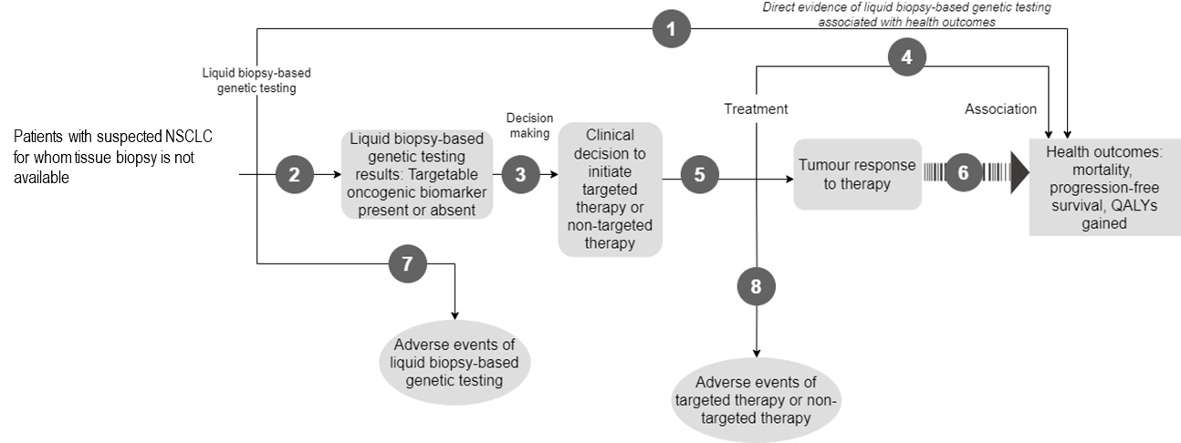Figure 1 Generic assessment framework showing the links from the test population 1 to health outcomes

Figure notes: 1: direct from test (liquid biopsy-based genetic testing) to health outcomes evidence; 2: test accuracy; 3: change in diagnosis/treatment/management including initiating targeted therapy based on targetable oncogenic biomarker detected; 4: influence of the change in management on health outcomes; 5: influence of the change in management on intermediate outcomes, e.g. response of tumour to targeted therapy so there is no progression of disease; 6: association of intermediate outcomes with health outcomes such as increased progression-free survival and increased overall survival; 7: adverse events due to liquid biopsy-based genetic testing; 8: adverse events due to targeted or non-targeted therapy.  
NSCLC= non-small cell lung carcinoma; QALY= quality-adjust life years.

Assessment questions mapped to the assessment framework for population 1 (**Error! Reference source not found.**):

1. What is the safety and effectiveness of liquid biopsy-based genetic testing versus standard of care in patients with suspected NSCLC for whom tissue-based genetic testing is not available? (Direct evidence).
2. What is the diagnostic yield of liquid biopsy-based genetic testing in patients with suspected NSCLC for whom tissue-based genetic testing is not available?
3. What is the proportion of patients among population 1 with a targetable oncogenic biomarker who receive relevant targeted treatments under the pharmaceutical benefits scheme (PBS) or non-targeted therapy, compared to standard of care?
4. What is the effectiveness of the targeted therapy vs non-targeted therapy for health outcomes such as overall survival, progression-free survival, and quality of life?
5. What is the effectiveness of targeted therapy vs no targeted therapy for intermediate health outcomes such as tumour response?
6. How valid is the link between intermediate health outcomes such as tumour response, and incidence of progression-free survival and mortality?
7. What is the safety of liquid biopsy-based genetic testing vs no molecular testing for adverse events related to sampling?
8. What is the safety of targeted treatment vs non-targeted?

### Population 2

The assessment framework for population 2 is presented in **Error! Reference source not found.**.

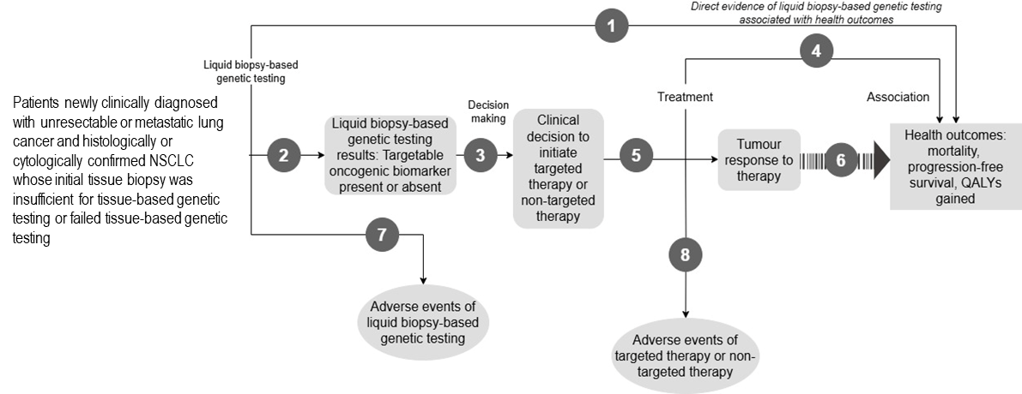Figure 2 Generic assessment framework showing the links from the test population 2 to health outcomes

Figure notes: 1: direct from test (liquid biopsy-based genetic testing) to health outcomes evidence; 2: test accuracy; 3: change in diagnosis/treatment/management including initiating targeted therapy based on targetable oncogenic biomarker detected; 4: influence of the change in management on health outcomes; 5: influence of the change in management on intermediate outcomes, e.g. response of tumour to targeted therapy; 6: association of intermediate outcomes with health outcomes such as increased progression-free survival and increased overall survival; 7: adverse events due to liquid biopsy-based genetic testing; 8: adverse events due to targeted therapy.  
NSCLC= non-small cell lung carcinoma; QALY= quality-adjust life years.

Assessment questions mapped to the assessment framework for population 2 (**Error! Reference source not found.**):

1. What is the safety and effectiveness of liquid biopsy-based genetic testing versus standard of care in patients newly clinically diagnosed with unresectable or metastatic lung cancer and histologically or cytologically confirmed NSCLC whose initial tissue biopsy was insufficient for tissue-based testing or failed tissue-based testing? (Direct evidence).
2. What is the diagnostic yield of liquid biopsy-based genetic testing in patients newly clinically diagnosed with unresectable or metastatic lung cancer and histologically or cytologically confirmed NSCLC whose initial tissue biopsy was insufficient for tissue-based genetic testing or failed tissue-based genetic testing, compared to standard of care?
3. What is the proportion of patients among population 2 with a targetable oncogenic biomarker who receive relevant targeted treatments under the pharmaceutical benefits scheme (PBS) or non-targeted therapy, compared to standard of care?
4. to 8.: Same as Population 1.

### Population 3

The assessment framework for population 3 is presented in

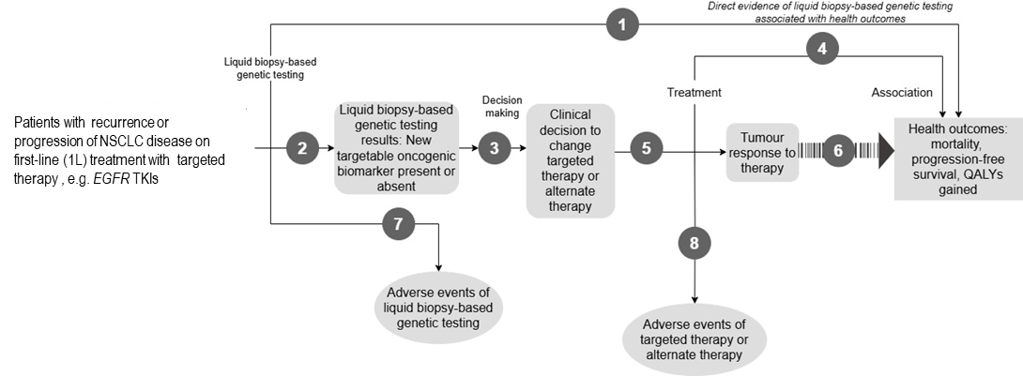

Figure 3.



Figure 3 Generic assessment framework showing the links from the test population 3 to health outcomes

Figure notes: 1: direct from test (liquid biopsy-based genetic testing) to health outcomes evidence; 2: test accuracy; 3: change in diagnosis/treatment/management including initiating targeted therapy based on targetable oncogenic biomarker detected; 4: influence of the change in management on health outcomes; 5: influence of the change in management on intermediate outcomes, e.g. response of tumour to targeted therapy so there is no progression of disease; 6: association of intermediate outcomes with health outcomes such as increased progression-free survival and increased overall survival; 7: adverse events due to liquid biopsy-based genetic testing; 8: adverse events due to targeted therapy.  
1L= First line; *EGFR* TKIs= epidermal growth factor receptor tyrosine kinase inhibitors; NSCLC= non-small cell lung carcinoma; QALY= quality-adjust life years.

Assessment questions mapped to the assessment framework for population 3 (



Figure 3):

1. What is the safety and effectiveness of liquid biopsy-based genetic testing versus standard of care in patients with recurrence or progression of NSCLC disease on first-line (1L) treatment with targeted therapy? (Direct evidence).
2. What is the diagnostic yield of liquid biopsy-based genetic testing in patients with progressed NSCLC disease on first-line (1L) treatment with targeted therapy, compared to standard of care?
3. What is the proportion of patients among population 3 with a targetable oncogenic biomarker who receive relevant targeted treatments under the pharmaceutical benefits scheme (PBS) or non-targeted therapy, compared to standard of care?
4. to 8.: Same as Population 1.

*PASC suggested changing the population definitions in the assessment framework diagrams based on the discussion under ‘Population’. Population 2 should include patients with ‘unresectable or metastatic’ patients. Population 3 should be changed to patients on all first-line targeted therapies.*

*Further, PASC suggested changing the comparator in the assessment questions to ‘standard of care’ as discussed in the ‘Comparator’ section.*

## Clinical management algorithms

### Population 1

The current clinical management algorithm for population 1 is described in 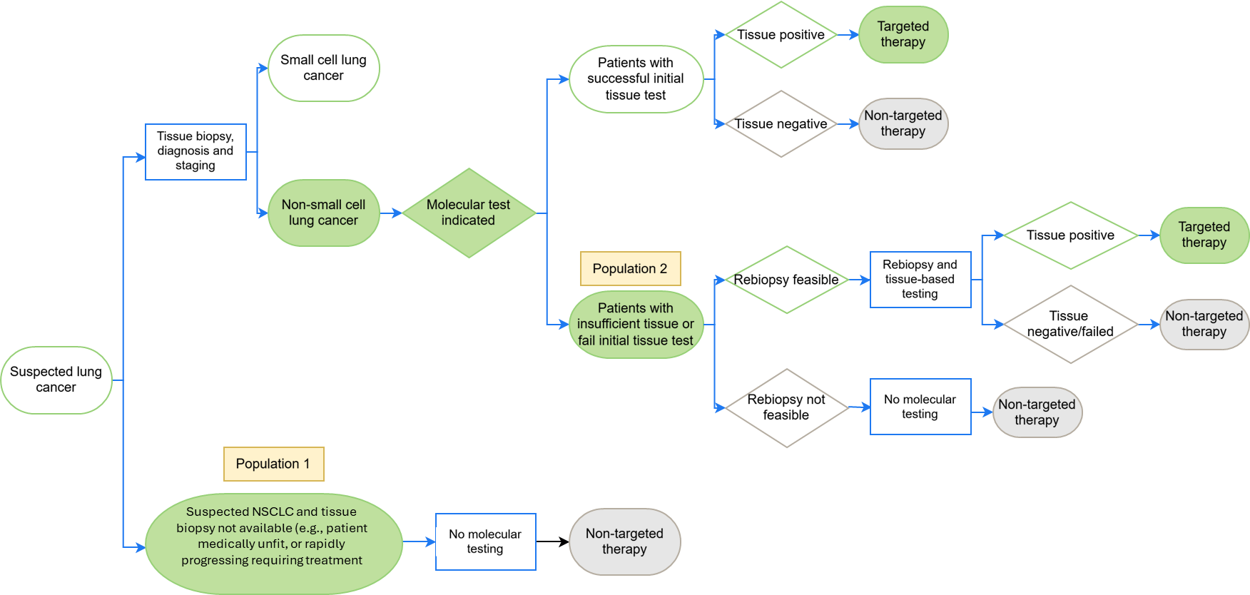

Figure 4. The proposed clinical management algorithm for population 1 is described in **Error! Reference source not found.**.

The proposed liquid biopsy-based genetic testing aims to detect oncogenic biomarkers in patients with suspected NSCLC, who cannot undergo tissue biopsy. The difference between the current and proposed clinical management algorithms is liquid biopsy-based genetic testing after lung cancer diagnosis without confirmed NSCLC. Such patients would, under current clinical management pathways do not undergo any molecular testing. The clinical algorithms are presented assuming that these patients will be unfit to undergo tissue rebiopsy in the future (Applicant’s clinical expert view, pre-PASC meeting 25 February 2025).

*PASC noted that the diagnosis of NSCLC is not confirmed in population 1 due to the lack of a histological or cytological diagnosis. PASC noted that there are currently PBS restrictions for targeted therapies requiring a confirmed diagnosis of NSCLC to access the targeted treatments. PASC also noted that the current standard of care was unclear in this population, making it difficult to propose a clinical treatment algorithm for population 1.*



Figure 4 Current treatment algorithm for testing in NSCLC for population 1 and population 2

Source: Algorithm received from the applicant in the document titled “Updated clinical algorithms_Feb2025”, and reproduced by the assessment group.  
Population 1: Patients with suspected non-small cell carcinoma (NSCLC) for whom tissue biopsy is not available.  
Population 2: Patients newly clinically diagnosed with unresectable or metastatic lung cancer and histologically or cytologically confirmed NSCLC who have either insufficient tissue for tissue based genetic testing or have failed tissue-based genetic testing.  
The oval shape indicates the start or end of the process; diamonds indicate the clinical step which would govern the clinical decision; green shaded areas indicate receipt of therapy, and blue rectangles indicate if tissue-based genetic testing occurred.

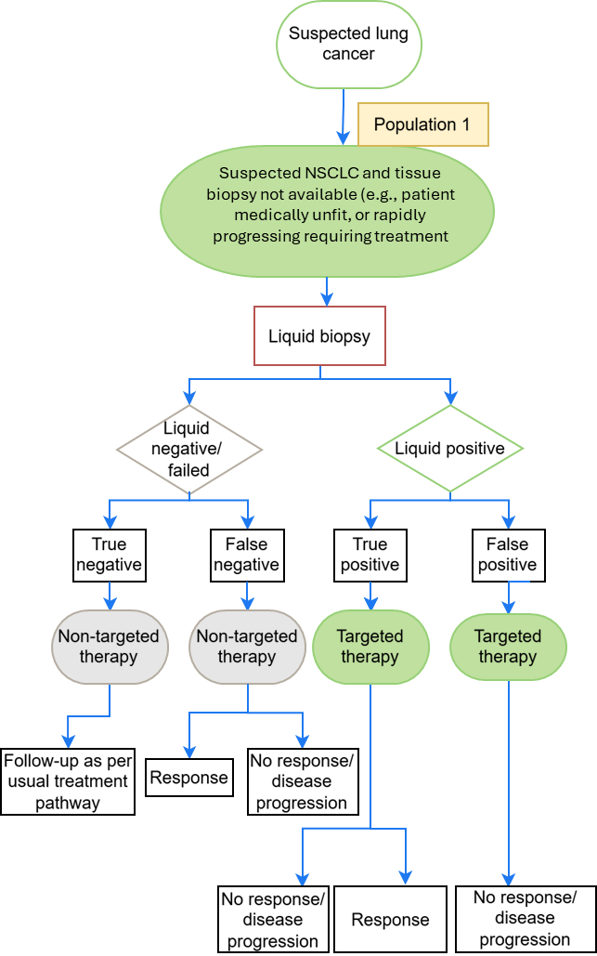

Figure 5 Proposed clinical management algorithm for oncogenic biomarker testing in population 1.

Source: Based on the algorithm received from the applicant in the document titled “Updated clinical algorithms_Feb2025”, reproduced by the assessment group.  
The oval shape indicates the start or end of the process; diamonds indicate the clinical step which would govern the clinical decision; green shaded areas indicate receipt of therapy; blue rectangles indicate if tissue-based genetic testing occurred; red rectangle indicates liquid biopsy-based genetic testing.

### Population 2

The current clinical management algorithm for population 2 is described in 

Figure 4. The proposed clinical management algorithm for population 2 is described in Figure 6.

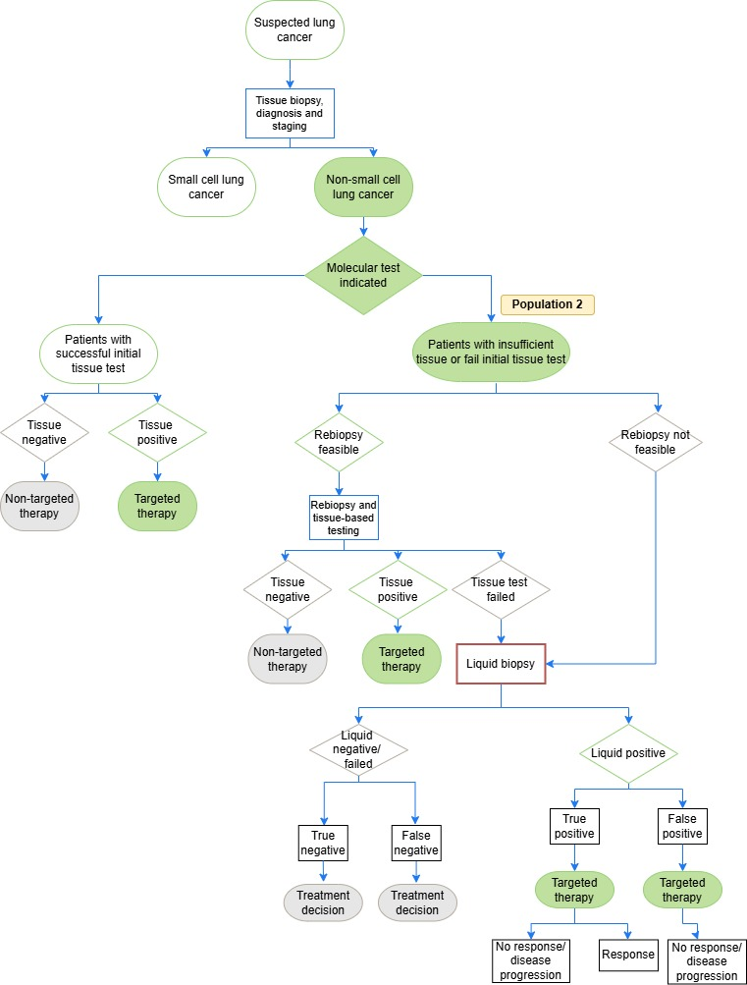

Figure 6 Proposed clinical management algorithm for oncogenic biomarker testing in Population 2.

Source: Based on the algorithm received from the applicant in the document titled “Updated clinical algorithms_Feb2025”, and discussion in the PASC meeting, reproduced by the assessment group.  
The oval shape indicates the start or end of the process; diamonds indicate the clinical step which would govern the clinical decision; green shaded areas indicate receipt of therapy; blue rectangles indicate if tissue-based genetic testing occurred; red rectangle indicates liquid biopsy-based genetic testing.

The proposed liquid biopsy-based genetic testing aims to detect oncogenic biomarkers in patients with confirmed NSCLC who cannot undergo tissue-based testing because of either insufficient tissue for tissue based genetic testing or failed tissue-based genetic testing. The difference between the current and proposed clinical management algorithms is a liquid biopsy-based genetic testing after patients fail rebiopsy or when tissue biopsy is not feasible.

*PASC noted the standard of care for population 2 would be tissue testing where the first biopsy was insufficient or failed tissue based genetic testing, and a second biopsy is possible; while the standard of care will be no testing where the first biopsy was insufficient, and tissue based genetic testing failed and a second biopsy is not possible. PASC suggested that the assessment should distinguish between these 2 pathways.*

### Population 3

The current clinical management algorithm for population 3 is described in Figure 7. The proposed clinical management algorithm for population 3 is described in Figure 8.

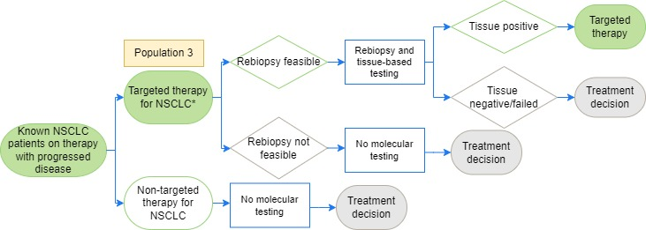

Figure 7 Current clinical management algorithm for oncogenic biomarker testing in population 3

Source: Based on the algorithm received from the applicant in the document titled “Updated clinical algorithms_Feb2025”, reproduced by the assessment group.  
NSCLC=non-small cell lung carcinoma.  
*Tissue-based testing after progression on first- or second-generation targeted therapies is available to identify resistant variations such as *EGFR T790M* (MBS item 73351), to determine eligibility for PBS-listed drugs e.g. osimertinib.   
The Figure presented here is different from the current management algorithm presented in the PICO set document and the updated clinical algorithms sent by the applicant after the pre-PASC meeting on 28 February 2025. The updated clinical algorithm stipulated that most patients are now treated upfront with newer generation targeted therapies and tissue-based testing for the resistant variants is not required (Fig “relapse-current algorithm” in PDF titled “Updated clinical algorithms_Feb2025”. However, the Figure above is based on the assumption that all patients on targeted therapy who experience disease progression will be tested using tissue biopsy to identify resistant variants or other biomarkers so targeted therapy can be initiated/changed/discontinued as indicated by the MBS item 73351.  
The oval shape indicates the start or end of the process; diamonds indicate the clinical step which would govern the clinical decision; green shaded areas indicate receipt of therapy; blue rectangles indicate if tissue-based genetic testing occurred.

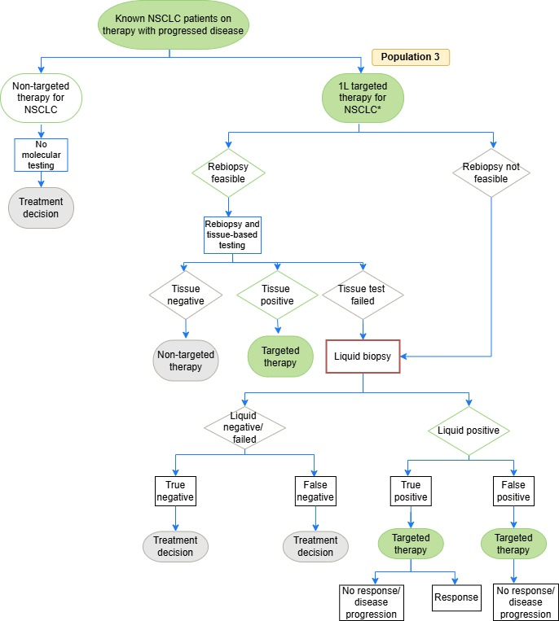

Figure 8 Proposed clinical management algorithm for oncogenic biomarker testing in population 3

Source: Based on the algorithm received from the applicant in the document titled “Updated clinical algorithms_Feb2025”, and changes discussed in the PASC meeting on 16 April 2025, reproduced by the assessment group.  
NSCLC=non-small cell lung carcinoma.  
*Tissue-based genetic testing after progression on first- or second-generation targeted therapies is available to identify resistant variations such as *EGFR T790M* (MBS item 73351), to determine eligibility for PBS-listed drugs, e.g. osimertinib. The application stipulated that most patients are now treated upfront with newer generation targeted therapies and tissue-based genetic testing for the resistant variants is not required (Fig “relapse-proposed algorithm” in PDF titled “Updated clinical algorithms_Feb2025”.  
The oval shape indicates the start or end of the process; diamonds indicate the clinical step which would govern the clinical decision; green shaded areas indicate receipt of therapy; blue rectangles indicate if tissue-based genetic testing occurred; red rectangle indicates liquid biopsy-based genetic testing.

The proposed liquid biopsy-based genetic testing aims to detect oncogenic biomarkers in patients with disease progression after receiving targeted therapy and being offered rebiopsy. The difference between the current and proposed clinical management algorithms in population 3, is the liquid biopsy-based genetic testing after failing a rebiopsy or when rebiopsy was not feasible.

*PASC noted that in population 3 there was no evidence base to support liquid biopsy-based testing as the first diagnostic test at progression without first offering tumour tissue testing where applicable. PASC agreed that this was an evolving field, and although the applicant’s clinical experts suggested that liquid biopsy should be offered in the first instance, the algorithms should follow published guidelines. For example, the NCCN guidelines for non-small cell lung cancer, version 4.2024 (Riely, 2024) recommends rebiopsy (using tissue biopsy) in patients who have progressed on an* EGFR *targeted treatment, to determine tumour transformation, which occurs in about 5% of cases. PASC recommended that the assessment should explore direct tumour testing when possible as a first line investigation for population 3 rather than liquid biopsy.*

## Proposed economic evaluation

### Population 1

*PASC acknowledged the claim of superior effectiveness and superior safety compared to no molecular testing for population 1 up to the point of treatment decision as the testing was aimed at accessing PBS listed drugs. However, PASC noted that due to the lack of a confirmed diagnosis of NSCLC, targeted therapies are not PBS approved for population 1 (as confirmed diagnosis of NSCLC is required) and therefore this approach is limited. PASC noted that not all targeted treatments are listed on the PBS, therefore, not all targeted treatments would have been assessed by the PBAC as cost-effective. If the economic evaluation in the current assessment is limited at the treatment decision step, the cost of a genetic variation/fusion would only be based on access to relevant treatments currently funded under the PBS, rather than including non-PBS listed treatments as well.*

### Population 2

Based on the claim of superior effectiveness and safety of liquid biopsy-based genetic testing compared to standard of care (either tissue rebiopsy and tissue-based genetic testing, or no molecular testing), the economic evaluation will be a cost-effectiveness analysis (cost per patient with an oncogenic biomarker identified), and cost-utility analysis (cost per QALY gained) (Table 8).

### Population 3

Based on the claim of superior effectiveness and safety of liquid biopsy-based genetic testing compared to standard of care (either tissue rebiopsy and tissue-based genetic testing, or no molecular testing), the economic evaluation will be a cost-effectiveness analysis (cost per patient with an oncogenic biomarker identified), and cost-utility analysis (cost per QALY gained) (Table 8).

The economic evaluation will include modelling cost per QALY taking into account changes in clinical management and health outcomes (progression-free survival and overall survival).

*PASC acknowledged the claim of superior effectiveness and superior safety compared to no molecular testing for population 2 and 3 up to the point of treatment decision, as the testing was aimed at accessing PBS listed drugs.*

*PASC noted that in relation to populations 2 and 3, the applicant in its pre-PASC response proposed a cost effectiveness analysis including a cost per actionable mutation and cost-consequences analysis to capture other benefits of liquid biopsy testing. To this end, the applicant proposed the removal of the cost-effectiveness outcomes of cost per patient experiencing progression avoided and cost per quality-adjusted life year (QALY) gained. Overall, PASC suggested that a cost utility analysis was preferable. PASC noted that a cost-effectiveness analysis including health outcomes was preferable as opposed to limiting the cost-effectiveness analysis up to the point of test outcome. As for a cost consequence analysis, while the applicant had proposed to capture other benefits of the testing, PASC suggested that such an analysis should capture all test-related issues, such as false positive and negative results, and all the consequences of those to health and not limited to testing outcomes only.*

Table 8 Classification of comparative effectiveness and safety of the proposed intervention, compared with its main comparator, and guide to the suitable type of economic evaluation

| Comparative safety- |  | Comparative effectiveness |  |  |
| --- | --- | --- | --- | --- |
| Inferior | Uncertaina | Noninferiorb | Superior |
| Inferior | Health forgone: need other supportive factors | Health forgone possible: need other supportive factors | Health forgone: need other supportive factors | ? Likely CUA |
| Uncertaina | Health forgone possible: need other supportive factors | ? | ? | ? Likely CEA/CUA |
| Noninferiorb | Health forgone: need other supportive factors | ? | CMA | CEA/CUA |
| Superior | ? Likely CUA | ? Likely CEA/CUA | CEA/CUA | CEA/CUA |

CEA=cost-effectiveness analysis; CMA=cost-minimisation analysis; CUA=cost-utility analysis  
? = reflect uncertainties and any identified health trade-offs in the economic evaluation, as a minimum in a cost-consequences analysis   
a ‘Uncertainty’ covers concepts such as inadequate minimisation of important sources of bias, lack of statistical significance in an underpowered trial, detecting clinically unimportant therapeutic differences, inconsistent results across trials, and trade-offs within the comparative effectiveness and/or the comparative safety considerations  
b An adequate assessment of ‘noninferiority’ is the preferred basis for demonstrating equivalence

## Proposal for public funding

The application proposed listing of a new MBS item for liquid biopsy-based genetic testing in patients with NSCLC for whom tissue-based genetic testing is not an option or has failed.

While the application proposed liquid biopsy-based genetic testing to detect oncogenic biomarkers to access targeted PBS-subsidised medicines, the application also anticipated that the testing would allow access to targeted treatments that may become available in the future but are not yet PBS listed (p9 of the PICO Set document). Therefore, the proposed MBS items were described to allow scope for additional genes to be added as more targeted therapies become available on the PBS.

There are 2 options of proposed MBS item descriptors:

* MBS items AAAA, CCCC and EEEE to detect the oncogenic biomarkers but not to determine eligibility for PBS-funded targeted treatment.
* MBS items BBBB, DDDD and FFFF to detect the oncogenic biomarkers specifically to determine eligibility for PBS-funded targeted treatment.

*PASC considered that testing should only be performed to determine eligibility for PBS-funded targeted treatment. PASC considered that testing to provide prognostic information alone was outside the scope of MBS funding. Therefore, proposed MBS items AAAA, CCCC and EEEE would not be applicable to the assessment and were removed from the PICO draft.*

The application proposed item BBBB to detect the oncogenic biomarkers specifically to access specific PBS-listed therapies (p18-20 of the PICO Set document). This proposed MBS item BBBB would likely encompass population 2 only (item BBBB was provided in the application). Item DDDD is described as for population 1 and item FFFF is described for population 3 (items DDDD and FFFF were developed during the PICO).

### MBS item descriptor for population 1

MBS item to encompass population 1 is presented in item descriptor DDDD to detect the oncogenic biomarkers specifically to access specific PBS-listed therapies.

Table 9. MBS item descriptor for population 1

| Category 6 – Pathology services – P7 Genetics |
| --- |
| MBS item DDDD  Characterisation of a variant or variants in a multi-gene panel using a circulating tumour, nucleic acid-based test on a plasma sample, from a patient with suspected NSCLC for whom tissue biopsy is not available, as requested by, or on behalf of, a specialist or consultant physician, if the test is:   1. to detect variants in at least, *EGFR, BRAF, KRAS,* and *METexon14,* to determine eligibility for relevant treatments under the Pharmaceutical Benefits Scheme (PBS); and 2. to detect fusion status of at least *ALK, ROS1, RET, NTRK1, NTRK2* and *NTRK3;* to determine eligibility for relevant treatments under the Pharmaceutical Benefits Scheme (PBS); and 3. not associated with a service to which item 73437, 73438, 72439, 73337, 73341, 73344, 73436 or 73351 applies. |
| Fee: to be determined |

Source: MBS descriptor developed during the PICO development and changes suggested during the PASC meeting.

*PASC noted that the current PBS restrictions on targeted therapy for NSCLC stipulate a confirmed diagnosis of NSCLC. Including population 1 in the assessment could induce a marked shift in many layers in policy and clinical care. PASC did not support the inclusion of Population 1. However, it considered that if population 1 is considered in the assessment, the test should be restricted to identify relevant gene variants and fusions to determine eligibility to PBS-funded targeted therapies only.*

*PASC noted that if population 1 were included in the assessment the relevant gene variants and fusions would not be aligned with the existing MBS items on tumour testing services. PASC also noted that the PBS restrictions for targeted therapy currently restrict access to those who have confirmed NSCLC. PASC suggested that the fee will be decided at a later date.*

### MBS item descriptor for population 2

The MBS descriptor BBBB was proposed in the application and is likely to encompass population 2.

Table 10. MBS item descriptor for population 2

| Category 6 – Pathology services – P7 Genetics |
| --- |
| MBS item BBBB  Characterisation of a variant or variants in a multi-gene panel using a circulating tumour, nucleic acid-based test on a plasma sample, from a patient with newly diagnosed unresectable or metastatic non-small cell lung cancer whose initial tissue biopsy is insufficient for tissue-based genetic testing or failed tissue-based genetic testing ~~for whom tissue testing is not an option or has failed~~, as requested by, or on behalf of, a specialist or consultant physician, if the test is:   1. to detect variants in at least, *EGFR, BRAF, KRAS,* and *METexon14,* to determine eligibility for relevant treatments under the Pharmaceutical Benefits Scheme (PBS); and 2. to detect fusion status of at least *ALK, ROS1, RET, NTRK1, NTRK2* and *NTRK3*; to determine eligibility for relevant treatments under the Pharmaceutical Benefits Scheme (PBS); and 3. not associated with a service to which item 73437, 73438, 72439, 73337, 73341, 73344, 73436 or 73351 applies. |
| Fee: to be determined |

Source: Based on Table on p19 of the PICO Set document and changes suggested during the PASC meeting.

Strikethrough and red font indicate deletion and additions, respectively, during the PASC meeting

*PASC considered that the MBS item descriptor BBBB should include characterisations of the multi-gene panel, examining variants through sequencing in the associated* EGFR*,* BRAF*,* KRAS*, and* METexon14sk*, and detect fusion status in those genes in which fusions are the oncogenic drivers.*

*PASC also noted the applicant’s proposal to add on* ERRB2 (HER2) *testing to the proposed MBS item descriptor. PASC noted that the eligibility for current PBS restrictions for targeted therapy were restricted to patients who have confirmed NSCLC. The* ERRB2 (HER2) *test will be covered by the phrasing of the item descriptor which stipulates testing for “at least” the listed genes, potentially also future proofing the descriptor going forward. PASC noted that the new MBS item had the potential to increase the uptake of PBS-subsidised targeted treatments.*

### MBS item descriptor for population 3

Proposed MBS item FFFF would encompass population 3 to detect the oncogenic biomarkers specifically to access specific PBS-listed therapies.

Table 11. MBS item descriptor for population 3

| Category 6 – Pathology services – P7 Genetics |
| --- |
| MBS item FFFF  Characterisation of a variant or variants in a multi-gene panel using a circulating tumour, nucleic acid-based test on a plasma sample, from a patient with non-small cell lung cancer who is on targeted therapy and has evidence of progressed disease, as requested by, or on behalf of, a specialist or consultant physician, if the test is:   1. to detect variants in at least, *EGFR, BRAF, KRAS,* and *METexon14,* to determine eligibility for relevant treatments under the Pharmaceutical Benefits Scheme (PBS); and 2. to detect fusion status of at least *ALK, ROS1, RET, NTRK1, NTRK2* and *NTRK3;* to determine eligibility for relevant treatments under the Pharmaceutical Benefits Scheme (PBS); and 3. not associated with a service to which item 73437, 73438, 72439, 73337, 73341, 73344, 73436 or 73351 applies. |
| Fee: to be determined |

Source: MBS descriptor developed during the PICO development and changes suggested during the PASC meeting.

PASC was requested to note that there might be flow-on effects to PBS restrictions for access to specific targeted therapies if liquid biopsy-based genetic testing is publicly funded. The wording of PBS restrictions for targeted therapies currently listed for NSCLC treatment that require tissue-based testing results will need to be amended. The wording will need to also allow patients with test results from liquid biopsy-based genetic testing to access these therapies.

*PASC noted that there was no proposed item descriptor for population 3 because of the change in population that was made by the applicant during the pre-PASC teleconference. PASC suggested that the proposed MBS item descriptor would be similar to the item descriptor for population 2. This included specialists or consultant physician as requestors, the aim being to identify the variants as stated and align with the tumour testing items. In addition, PASC considered that the item should be restricted to determining eligibility for relevant PBS listed therapies.*

*PASC also suggested the need for the development of regulatory and quality assurance programs for liquid biopsy testing in Australia, acknowledging the potential increase in the use of relevant PBS-listed targeted therapies for eligible patients and the need to modify PBS restrictions. Additionally, PASC noted that as further progression of disease is possible and therefore a frequency limit for the test should apply. However, these recommendations would not hinder this application.*

### Cost of testing

The application stated that the proposed fee of $3,000 was higher than the reimbursement currently offered for tissue-based testing (p17 of the PICO Set document). The application described that in general, the ctDNA fraction in the blood of patients with cancer was low, which would require NGS-based methods, as opposed to traditional PCR techniques for a high sensitivity in detecting targetable oncogenic biomarkers. Furthermore, the clinical experts of the applicant argued that NGS techniques in liquid biopsy-based genetic testing required higher sequencing depth compared to tissue biopsy to achieve such sensitivity. Sequencing depth refers to the number of sequencing reads covering a specific position in the genome, which can reveal known mutations occurring at a low frequency or even uncover new driver mutations (Brockley et al. 2023). The application justified the proposed fee of $3,000 as follows (p19-20 of the PICO Set document):

* Accounts for the costs of specialised collection tubes, nucleic acid extraction, library preparation and sequencing, bioinformatics analysis, pathologist interpretation and reporting and pathology laboratory overheads, including the maintenance and service of instruments, data storage, quality assurance programmes, validation, rental and staffing.
* Covers the characterisation of the 11 genes specified in the proposed MBS items and provides scope for additional genes to be added as more targeted therapies become available on the PBS.
* Covers the necessary sequencing depth for a sufficiently high-sensitivity assay.
* Factors in the potential need for the assay to be run below maximum capacity.
* Ensures minimal or no out-of-pocket costs to the patient.
* Is benchmarked against the cost of homologous recombination deficiency (HRD) status testing, reimbursed at $3,000.00 (MBS item 73307) for the level of sequencing and resources required.

Further, the application provided a breakdown of the fee in Table 12.

Table 12. Breakdown of cost of liquid biopsy-based genetic testing

| **Cost component** | **Cost** |
| --- | --- |
| Specialised collection tubes and nucleic acid extraction | $50 |
| Library preparation | $700 |
| Sequencing | $1,250 |
| Bioinformatics analysis | $100 |
| Interpretation and reporting | $100 |
| Pathology overheads | $800 |
| Total Cost | $3,000 |

Source: Application attachment workbook “Liquid biopsy cost breakdown for proposed MBS fee”.

The department noted that laboratory overheads are not funded by the MBS. Potentially “pathology overheads” include items which are reimbursable, however this cannot be ascertained without more explicit details of what is included in these overheads.

The costs were anticipated to increase over time given the increase in labour costs and reagent costs. However, the application argued that costs could be alleviated by batch-testing (batching) multiple specimens at the same time. But the feasibility of such an exercise was not discussed at the pre-PASC meeting (pre-PASC meeting, 28 Feb 2025).

*PASC noted that the proposed fee of $3,000 is substantial and needs further justification.*

*PASC noted that the cost of the proposed liquid biopsy test was significant with the major reason being the need for increased coverage because of the low quantity of DNA or RNA found in the blood— the testing medium for liquid biopsy. When circulating tumour DNA (ctDNA) is scarce, sequencing efforts may result in low coverage, meaning that some ctDNA fragments may be missed, which may be related to NSCLC. To overcome this, a larger number of sequencing reads may be required to detect the variants. PASC noted that such issues should be linked to the quality assurance programs. PASC inquired about the extent of coverage expected to conclude that the final test result is valid. PASC suggested adding further explanation of these factors into the justification for costs.*

## Summary of public consultation input

PASC noted and welcomed consultation input from 9 organisations and 2 individuals, both of whom were consumers. The 9 organisations that submitted input were:

* Lung Foundation Australia (LFA)
* Thoracic Oncology Group of Australasia (TOGA)
* Medical Oncology Group of Australia (MOGA)
* Thoracic Society of Australia and New Zealand (TSANZ)
* Australian Genomics
* Human Genetics Society of Australasia (HGSA) Cancer Special Interest Group
* Roche Diagnostics Australia
* InGeNA Ltd
* Rare Cancers Australia (RCA)

The consultation input received was all supportive of public funding for liquid biopsy genetic testing in patients with NSCLC.

**Consumer Input**

Consumer consultation input, LFA and RCA input advocated for the public funding of liquid biopsy due to the substantial benefits of the sample collection process, potentially avoiding a tissue biopsy which can be invasive, painful and have a high risk of complications. Input noted patients may require multiple diagnostic procedures to obtain tissue, incurring higher expenses, including travel, which can be even higher for people living in rural and remote regions. LFA stated that people unable to receive tissue testing due to geographical barriers should be eligible for liquid biopsy testing. A consumer stated that the scarring around the pleural cavity from a tissue biopsy had resulted in restricted movement and prevented them doing sports or exercises, and that some patients are too scared to undergo a biopsy due to the side effects of the procedure.

Consumer consultation input noted the high financial, physical and emotional burden for patients with lung cancer, and stated that the benefits of liquid biopsy would help to address this as it has less out of pocket costs and no recovery time or side effects.

**Benefits and Disadvantages**

The main benefit of public funding received in the consultation input was detection of genetic alterations in patients with NSCLC who are unable to receive tissue-based testing, enabling access to targeted therapies including PBS listed therapies. Consultation input stated that the simplicity of liquid biopsy may be an advantage for patients with co-morbidities or at less well-resourced hospitals and will be of particular benefit to populations that are affected by distance from their diagnostic centre. Organisational input stated that liquid biopsy has the benefit of faster results and the potential to capture the heterogeneity in the tumour, potentially detecting more variants than a tissue sample.

The main disadvantage of public funding received in the consultation input included variability in the capability of NGS of liquid biopsies in laboratories around Australia, with the cost of acquiring equipment and training staff potentially effecting the implementation nationally.

**Population, Comparator (current management) and Delivery**

The consultation input largely agreed with the proposed population. MOGA noted that actionable events can be detected on ctDNA when not found in tissue, and that patients in whom no actionable events from tissue samples are found, may also benefit from liquid biopsy testing. Roche Diagnostics Australia stated that patients who are not clinically suitable for tissue biopsy but are suspected or likely to have NSCLC, should have access to liquid biopsy testing to enable access to eligible PBS listed therapies.

The consultation input agreed with the proposed comparators.

**MBS Item Descriptor and Fee**

The consultation input from organisations partly agreed with the proposed service descriptors, with all input agreeing that flexibility in the genes tested was important to future-proof the item. Australian Genomics supported the proposed lack of restriction by stage of disease for the eligible population and noted that the item should specify diagnosis and/or relapse, depending on the eligible population. Australian Genomics also noted that a brand-agnostic descriptor may improve access and availability of testing across laboratories but could also impact standardisation of testing. TOGA stated that it would be appropriate to include a restriction to ensure patients have the best available sample rather than the most convenient sample tested. MOGA stated that the test should be limited to diagnosis and restricted to once per lifetime.

The consultation input from organisations agreed with the proposed service fee. TOGA, InGeNA and Roche Diagnostics Australia stated the proposed fee is appropriate, and Australian Genomics stated the fee should take into consideration the required sequencing depth and estimation of how often labs will be running the assay below capacity.

*PASC noted that the consultation feedback was positive and supportive of liquid biopsy-based genetic testing.*

*PASC noted that the consultation feedback indicated that the cost of liquid biopsy is reasonable. PASC noted comments received during consultation feedback that the cost of liquid biopsy would decrease over time, but the applicant indicated that it is likely to increase over time.*

*PASC noted that turnaround time is not directly discussed in the application but will need to be a consideration of the service, including costing of the service.*

## Next steps

*PASC noted that the applicant confirmed that an applicant developed assessment report (ADAR) will be prepared.*

## Applicant Comments on Ratified PICO

The applicant highlights a key distinction between the proposed clinical algorithms for population 2 presented by the applicant in the original application and during the pre-PASC meeting, and the proposed algorithm shown in the ratified PICO confirmation. In the ratified PICO, the proposed algorithm for population 2 shows that liquid biopsy is performed as a second line test after rebiopsy, and tissue-based genetic testing is attempted or if a rebiopsy is not feasible. However, the applicant maintains that in patients with insufficient tissue on the diagnostic biopsy or who fail the initial tissue test, liquid biopsy should be offered upfront whether or not a rebiopsy is feasible. A rebiopsy and tissue test should only be attempted if the liquid biopsy test yields a negative result. This aligns with consensus best practice recommendations for molecular testing of lung cancer in Australia from the RCPA and TOGA. The applicant clinical experts views are that leaving liquid biopsy as a second line option leads to unnecessary and harmful treatment delays, as well as exposing patients to biopsy risks.

PASC also recommended the exclusion of patients with suspected NSCLC for whom tissue biopsy is not available (population 1), citing concerns related to the diagnostic uncertainty in this population due to the lack of a histological or cytological diagnosis of NSCLC, limited clinical evidence and complex interactions with current PBS eligibility, and clinical care. The applicant emphasises that these concerns should not detract from the high clinical need in a population that would otherwise have no forthcoming options to allow access to optimal treatment. Consultation input has highlighted the need for a molecular testing option in these patients, supporting the use of liquid biopsy testing for this purpose and noting the clinical utility of plasma-based testing in practice.

## References

Abbosh C, Swanton C and Birkbak NJ (2019). "Clonal haematopoiesis: a source of biological noise in cell-free DNA analyses." Ann Oncol **30**(3): 358-359.

AIHW (2024). Cancer data in Australia: Cancer rankings data visualisation, Australian Institute of Health and Welfare.

American Cancer Society (ACS). (2024, 24/06/2024). "What is lung cancer?" Retrieved 14 Feb, 2025, from <https://www.cancer.org/cancer/types/lung-cancer/about/what-is.html>.

American Cancer Society (ACS). (2025). "Non-Small Cell Lung Cancer Stages." Lung Cancer- Early Deetction, Diagnosis and Staging Retrieved 4 Feb, 2025, from <https://www.cancer.org/cancer/types/lung-cancer/detection-diagnosis-staging/staging-nsclc.html>.

Brockley LJ, Souza VGP, Forder A, Pewarchuk ME, Erkan M, Telkar N, Benard K, Trejo J, Stewart MD, Stewart GL, Reis PP, Lam WL and Martinez VD (2023). "Sequence-Based Platforms for Discovering Biomarkers in Liquid Biopsy of Non-Small-Cell Lung Cancer." Cancers (Basel) **15**(8).

Cancer Australia. (2025). "What is lung cancer?" Retrieved 4 Feb, 2025, from <https://www.canceraustralia.gov.au/cancer-types/lung-cancer>.

Cancer Council Australia. (2024). "Understanding Lung Cancer." Retrieved 20 March, 2025, from <https://www.cancercouncil.com.au/wp-content/uploads/2024/10/Understanding-Lung-Cancer-2024.pdf>.

Cheng Y, Zhang T and Xu Q (2021). "Therapeutic advances in non-small cell lung cancer: Focus on clinical development of targeted therapy and immunotherapy." MedComm (2020) **2**(4): 692-729.

Chouaid C, Dujon C, Do P, Monnet I, Madroszyk A, Le Caer H, Auliac JB, Berard H, Thomas P, Lena H, Robinet G, Baize N, Bizieux-Thaminy A, Fraboulet G, Locher C, Le Treut J, Hominal S and Vergnenegre A (2014). "Feasibility and clinical impact of re-biopsy in advanced non small-cell lung cancer: a prospective multicenter study in a real-world setting (GFPC study 12-01)." Lung Cancer **86**(2): 170-173.

Coley SM, Crapanzano JP and Saqi A (2015). "FNA, core biopsy, or both for the diagnosis of lung carcinoma: Obtaining sufficient tissue for a specific diagnosis and molecular testing." Cancer Cytopathology **123**(5): 318-326.

Dao J, Conway PJ, Subramani B, Meyyappan D, Russell S and Mahadevan D (2023). "Using cfDNA and ctDNA as Oncologic Markers: A Path to Clinical Validation." Int J Mol Sci **24**(17).

de Jager VD, Timens W, Bayle A, Botling J, Brcic L, Büttner R, Fernandes MGO, Havel L, Hochmair MJ, Hofman P, Janssens A, Johansson M, van Kempen L, Kern I, Lopez-Rios F, Lüchtenborg M, Machado JC, Mohorcic K, Paz-Ares L, Popat S, Ryška A, Taniere P, Wolf J, Schuuring E and van der Wekken AJ (2024). "Developments in predictive biomarker testing and targeted therapy in advanced stage non-small cell lung cancer and their application across European countries." The Lancet Regional Health - Europe **38**: 100838.

Groarke EM and Young NS (2019). "Aging and Hematopoiesis." Clin Geriatr Med **35**(3): 285-293.

Hasenleithner SO and Speicher MR (2022). "A clinician's handbook for using ctDNA throughout the patient journey." Mol Cancer **21**(1): 81.

Hofman P (2024). "Liquid and Tissue Biopsies for Lung Cancer: Algorithms and Perspectives." Cancers **16**(19): 3340.

Khakwani A, Rich AL, Tata LJ, Powell HA, Stanley RA, Baldwin DR and Hubbard RB (2013). "The pathological confirmation rate of lung cancer in England using the NLCA database." Lung Cancer **79**(2): 125-131.

Li W, Li Y, Guo L, Liu Y, Yang L and Ying J (2021). "Metastatic NSCLCs With Limited Tissues: How to Effectively Identify Driver Alterations to Guide Targeted Therapy in Chinese Patients." JTO Clinical and Research Reports **2**(5).

Liam C-K, Mallawathantri S and Fong KM (2020). "Is tissue still the issue in detecting molecular alterations in lung cancer?" Respirology **25**(9): 933-943.

Lockwood CM, Borsu L, Cankovic M, Earle JSL, Gocke CD, Hameed M, Jordan D, Lopategui JR, Pullambhatla M, Reuther J, Rumilla KM, Tafe LJ, Temple-Smolkin RL, Terraf P and Tsimberidou AM (2023). "Recommendations for Cell-Free DNA Assay Validations: A Joint Consensus Recommendation of the Association for Molecular Pathology and College of American Pathologists." J Mol Diagn **25**(12): 876-897.

Lopez-Rios F, Arcila ME and Rolfo C (2023). Liquid Biopsy: Specimen Acquisition, Testing Strategies, and Clinical Roles. IASLC ATLAS of Molecular Testing for Targeted Therapy in Lung Cancer. L. M. Sholl, W. A. Cooper, K. M. Kerr et al. Denver, Colorado, IASLC

Majeed U, Manochakian R, Zhao Y and Lou Y (2021). "Targeted therapy in advanced non-small cell lung cancer: current advances and future trends." Journal of Hematology & Oncology **14**(1): 108.

Malapelle U, Tiseo M, Vivancos A, Kapp J, Serrano MJ and Tiemann M (2021). "Liquid Biopsy for Biomarker Testing in Non-Small Cell Lung Cancer: A European Perspective." Journal of Molecular Pathology **2**(3): 255-273.

Mitchell PLR, Thursfield VJ, Ball DL, Richardson GE, Irving LB, Torn-Broers Y, Giles GG and Wright GM (2013). "Lung cancer in Victoria: are we making progress?" Medical Journal of Australia **199**(10): 674-679.

Nicoś M and Krawczyk P (2022). "Genetic Clonality as the Hallmark Driving Evolution of Non-Small Cell Lung Cancer." Cancers (Basel) **14**(7).

Niroula A, Sekar A, Murakami MA, Trinder M, Agrawal M, Wong WJ, Bick AG, Uddin MM, Gibson CJ, Griffin GK, Honigberg MC, Zekavat SM, Paruchuri K, Natarajan P and Ebert BL (2021). "Distinction of lymphoid and myeloid clonal hematopoiesis." Nature Medicine **27**(11): 1921-1927.

Pao W and Girard N (2011). "New driver mutations in non-small-cell lung cancer." The Lancet Oncology **12**(2): 175-180.

Pascual J, Attard G, Bidard FC, Curigliano G, De Mattos-Arruda L, Diehn M, Italiano A, Lindberg J, Merker JD, Montagut C, Normanno N, Pantel K, Pentheroudakis G, Popat S, Reis-Filho JS, Tie J, Seoane J, Tarazona N, Yoshino T and Turner NC (2022). "ESMO recommendations on the use of circulating tumour DNA assays for patients with cancer: a report from the ESMO Precision Medicine Working Group." Ann Oncol **33**(8): 750-768.

Reed SC, Croessmann S and Park BH (2023). "CHIP Happens: Clonal Hematopoiesis of Indeterminate Potential and Its Relationship to Solid Tumors." Clin Cancer Res **29**(8): 1403-1411.

Ren F, Fei Q, Qiu K, Zhang Y, Zhang H and Sun L (2024). "Liquid biopsy techniques and lung cancer: diagnosis, monitoring and evaluation." Journal of Experimental & Clinical Cancer Research **43**(1): 96.

Riely GJ, Wood DE, Ettinger DS, Aisner DL, Akerley W, Bauman JR, Bharat A, Bruno DS, Chang JY, Chirieac LR, DeCamp M, Desai AP, Dilling TJ, Dowell J, Durm GA, Gettinger S, Grotz TE, Gubens MA, Juloori A, Lackner RP, Lanuti M, Lin J, Loo BW, Lovly CM, Maldonado F, Massarelli E, Morgensztern D, Mullikin TC, Ng T, Owen D, Owen DH, Patel SP, Patil T, Polanco PM, Riess J, Shapiro TA, Singh AP, Stevenson J, Tam A, Tanvetyanon T, Yanagawa J, Yang SC, Yau E, Gregory KM and Hang L (2024). "Non-Small Cell Lung Cancer, Version 4.2024, NCCN Clinical Practice Guidelines in Oncology." J Natl Compr Canc Netw **22**(4): 249-274.

Steeghs EMP, Groen HJM, Schuuring E, Aarts MJ, Damhuis RAM, Voorham QJM, Ligtenberg MJL and Grünberg K (2022). "Mutation-tailored treatment selection in non-small cell lung cancer patients in daily clinical practice." Lung Cancer **167**: 87-97.

Thierry AR, El Messaoudi S, Gahan PB, Anker P and Stroun M (2016). "Origins, structures, and functions of circulating DNA in oncology." Cancer and Metastasis Reviews **35**(3): 347-376.