**How to submit a completed Reapplication Template   
via the Health Products Portal**

Download a copy of the MSAC Reapplication Template from the ‘Resources’ tab on the MSAC website. Complete the template and read and sign the declaration.

If you have included in-confidence information in the [Reapplication Template](https://www.msac.gov.au/resources/msac-reapplication-template), highlight this to bring it to the attention of the department. Provide an explanation for why you consider the information confidential. This can be done by

* inserting comments next to the relevant (highlighted) text in the word document or
* providing an explanation in the free text field in the ‘Publication’ section of the template.

Submit the completed Reapplication Template to the department when you lodge your Notice of Intent (NOI) to submit an Applicant Developed Assessment Report (ADAR).

**Uploading the template when lodging a Notice of Intent (NOI)**

1. Log into the Health Products Portal (HPP). If you are not yet registered to use the HPP you must set up your Digital Identity, such as myGovID, and link it to an organisation using Relationship Authorisation Manager (RAM) before completing the remaining tasks. Further information is available at [Home Health Products Portal](https://hpp.health.gov.au/).
2. Within the Services page of the HPP, select the Applications tile.

1. On the ‘Applications’ page, locate the ‘New application’ field. From the drop-down menu on the ‘New application’ field, select ‘Medical services and health technologies’ and then ‘Notice of intent’.

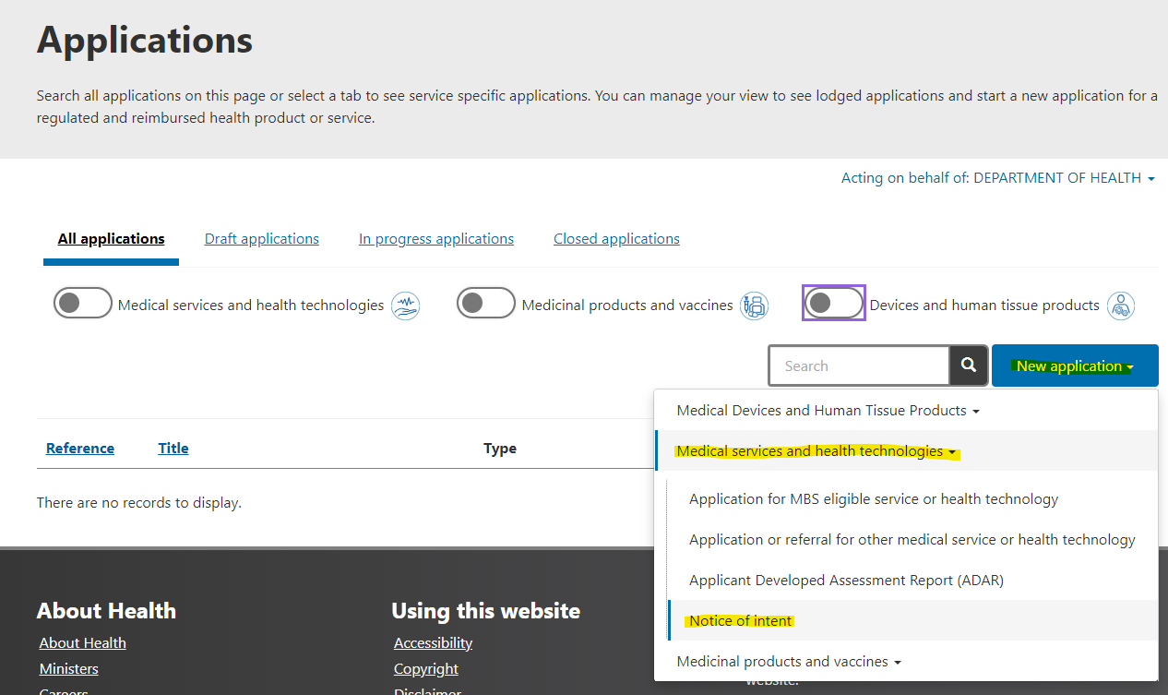

1. On the ‘About’ screen, select the radio button for ‘Medical Services Advisory Committee (MSAC) – ADAR or, if the NOI relates to a codependent application, select the radio button for ‘PBAC and MSAC (codependent submission)’.
2. On the ‘Details’ screen, in response to the question ‘Did you lodge your MSAC application via the HPP?’, select:
   1. YES, if you lodged the previous related application via the HPP.

* Use the look up function to locate the relevant application
* Nominate the MSAC meeting that you want your ADAR considered at.
  1. NO, if you lodged the previous related application outside of the HPP.
* Write the application number and title of the previous application in the free text fields.
* Nominate the MSAC meeting that you want your ADAR considered at.

1. In response to the question ‘Is the selected MSAC application related to a resubmission?’ select YES.
   1. Enter the details for the previous application into the required fields. While this is duplicative, it is a work around to support the revised MSAC reapplication process in the HPP.
2. At the bottom of the ‘Details’ screen you will see a ‘Supporting Evidence’ section. You can use this to upload your completed Reapplication Template.

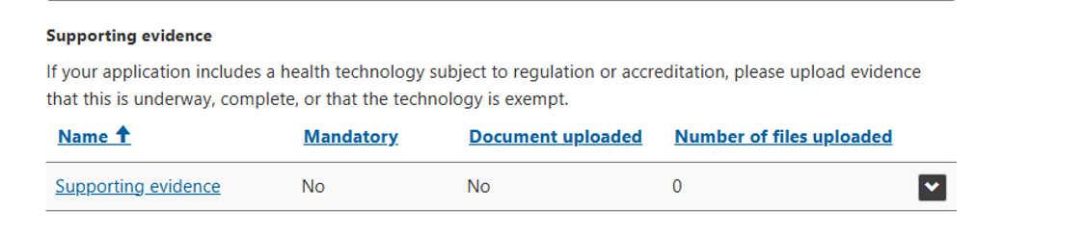

1. Click on the blue ‘supporting evidence’ link. This will take you to a screen where you can select and upload files from your computer.

1. Click on the ‘Add files’ button, then click on the ‘Choose files’ button and select the completed   
   Reapplication Template that you want to upload. Press open. The file name will appear next to the ‘Choose files’ button.

1. Press ‘Add Files’. The ‘Supporting Evidence’ page will re-appear listing the files that you have uploaded.

1. Select the ‘add files’ button if you need to upload additional documents. For example, regulatory information, references to evidence not included in your original application etc.

1. If you upload the wrong file, you can delete it by selecting the down arrow next to the document on the supporting evidence page.

1. Once you are satisfied that you have uploaded all required documents, press ‘save and close’.
2. Complete the other fields in the NOI as applicable, check the box at the bottom of the declaration and lodge your NOI.
3. Once you lodge your NOI, you will receive a reference number. If you need to correspond with the department about your NOI, you can quote this reference number.