**MSAC Application**

**Genomic testing in cancer of unknown primary (CUP) and diagnostically challenging cancers**

**PICO Set**

# Population

# *The testing population*

The proposed testing population are patients diagnosed with cancer of unknown primary (CUP) where a diagnostic work-up, including imaging studies and conventional pathological review of tumour tissue (including a second pathology opinion), are unable to determine a primary site or tissue of origin. Without identification of a tissue of origin, patients with CUP are limited to empiric chemotherapy treatment and cannot access site-specific or targeted treatments that are only available to patients with a specific known cancer diagnosis. Resolving the diagnosis at the molecular level can improve clinical outcomes by enabling access to precision treatments, as well as disease-specific clinical trials, support services and multi-disciplinary care.

CUP incorporates ICD-10 cancer codes:

* incidence C80 (malignant neoplasm without specification of site);
* mortality C77-C80
  + C77 (secondary and unspecified malignant neoplasm of lymph nodes),
  + C78 (secondary malignant neoplasm of respiratory and digestive organs),
  + C79 (secondary malignant neoplasm of other and unspecified sites),
  + C80 (malignant neoplasm without specification of site);
* C97 (malignant neoplasms of independent primary multiple sites).

***Overview of CUP***

CUP is a metastatic cancer where tumour cells detach from a primary tumour site and disseminate to surrounding tissues and distant secondary anatomical locations. A patient presenting with symptoms of disease at these secondary sites will undergo standardised clinical and pathological investigations to determine the primary cancer site of origin. When these invesigations fail to detect the primary cancer the patient receives a diagnosis of CUP.

The exact pathogenesis of CUP remains unknown but a leading hypothesis suggests that CUP may arise from a small, dormant, or later regressed primary tumour that is not detected by cancer imaging (1). Many CUPs are thought to metastasise early, are aggressive and have an unpredicable metastatic spread (2). The natural history of disease is commonly progressive with median survival times of less than 12 months, but can be much longer in a minority of patients presenting with favourable risk CUP (described below).

Due to the heterogeneity of CUP, patients may exhibit a wide range of symptoms depending on the location of malignant involvement (2). Patients frequently present with metastases across multiple organs, most commonly the liver, followed by the respiratory system, lymph nodes, abdominal cavity, bone, and brain (3). Worldwide, CUP incidence rates have declined over time as diagnostic modalities have become more sophisticated, however, patient survival outcomes have not significantly improved (4).

Current standard pathology evaluation of CUP involves histology and immunohistochemistry (IHC) performed on formalin-fixed paraffin-embedded (FFPE) sections obtained on biopsy. CUP can be categorised based on their histological subtypes. Approximately 50% of cases are well-to-moderately differentiated adenocarcinomas, ~30% as poorly or undifferentiated adenocarcinomas, ~15% as squamous cell carcinomas and ~5% as undifferentiated neoplasms (3, 5). Following lineage classification, additional IHC markers are tested for, guided by clinical work-up results (3). The essential clinical work-up, according to the European Society for Medical Oncology (ESMO) clinical practice guidelines and the Australian Optimal Care Pathway, includes a comprehensive patient history, physical examination, basic blood tests, and computerised tomographic (CT) scans or magnetic resonance imaging (MRI) imaging of the neck, thorax, abdomen, and pelvis for all patients, with additional mammography for females (3, 6). Additional tests may be warranted based on the clinical and pathological findings, including FDG-positron emission tomography (PET), gastroscopy and colonoscopy.

CUP usually presents as advanced disease when the cancer has spread to distant anatomical locations requiring systemic treatment and typically has a poor prognosis. Patients with CUP are classified into two prognostic subgroups based on their clinicopathologic characteristics (7). About 80-85% of patients belong to unfavourable subsets with limited sensitivity to platinum-based chemotherapy and a median overall survival (OS) of approximately 6-10 months (7). The remaining 15-20% of patients have a favourable outcome according to clinicopathological features that resemble known cancer types, and may respond well to standard treatment for these tumour types (7). However, as they still have a CUP diagnosis they may be unable to access relevant clinical trials and/or molecularly-targeted therapies for the likely tissue of origin. The following favourable subtypes are recognised:

1. Single metastatic deposit or oligometastatic disease amenable to local ablative treatment (single-site or oligometastatic CUP).
2. Women with isolated axillary lymph node metastases (breast-like CUP).
3. Women with peritoneal carcinomatosis of a serous papillary adenocarcinoma (ovary-like CUP).
4. Squamous-cell carcinoma involving non-supraclavicular cervical lymph nodes (head and neck-like CUP).
5. Men with blastic bone metastases and/or IHC or serum PSA expression (prostate-like CUP).
6. Adenocarcinoma with colorectal IHC (CK7-negative, CK20-positive, CDX2-positive) or molecular profile (colon-like CUP).
7. Carcinoma with renal-cell histological and IHC profile (renal-like CUP).

**Specify any characteristics of patients with, or suspected of having, the medical condition, who are proposed to be eligible for the proposed health technology, describing how a patient would be investigated, managed and referred within the Australian healthcare system in the lead up to being considered eligible for the technology:**

***Population characteristics***

CUP is considered a rare or less common cancer, constituting 1.6% of all cancer cases diagnosed in Australia in 2021 (8), representing the 14th most common cancer diagnosis but the sixth most common cause of cancer-related deaths (8). In Australia, rates of CUP are marginally higher in males than females, as are rates of mortality (Table 1) (8). CUP is the fifth and sixth most common cause of cancer death in 2021 among females and males in Australia, with 1,166 and 1,390 deaths, respectively (Table 1) (8).

**Table 1: Incidence and mortality rates of CUP in Australia, by sex, 2021**

|  |  |  |  |  |  |  |  |
| --- | --- | --- | --- | --- | --- | --- | --- |
| **Rate** | **Cancer type (ICD-10 code)** | **Males** | | **Females** | | **Total** | |
| **Cases/ deaths** | **ASR (per 100,000)** | **Cases/ deaths** | **ASR (per 100,000)** | **Cases/ deaths** | **ASR (per 100,000)** |
| **Incidence** | Cancer of unknown primary site (C80) | 1,305 | 8.7 | 1,048 | 5.5 | 2,353 | 7.0 |
| **Mortality** | Cancer of unknown primary site (C77-C80, C97) | 1,390 | 9.2 | 1,166 | 6.1 | 2,556 | 7.5 |

Source: Australian Institute of Health and Welfare (AIHW), 2021

ASR=age standardised rate

Patients with CUP have a 5-year survival rate of just 13% (16% for males and 10% for females), one of the lowest among all cancers in Australia during 2014-2018 (Figure 1) (8). Between 1989–1993 and 2014–2018, the 5-year relative survival rate for CUP increased from 6.2% to 13% (Figure 1) (8). Although survival prospects at time of diagnosis are poor, conditional survival increases with additional years survived (8). The age-standardised incidence and mortality rates have decreased since 1982 (Figure 2 & 3) due to several key factors including advances in diagnostic techniques, better cancer screening and early detection, enhanced pathology and molecular testing, and improved cancer treatment and management. However, outcomes remain very poor for those patients who continue to have a CUP diagnosis at completion of the diagnostic work-up.

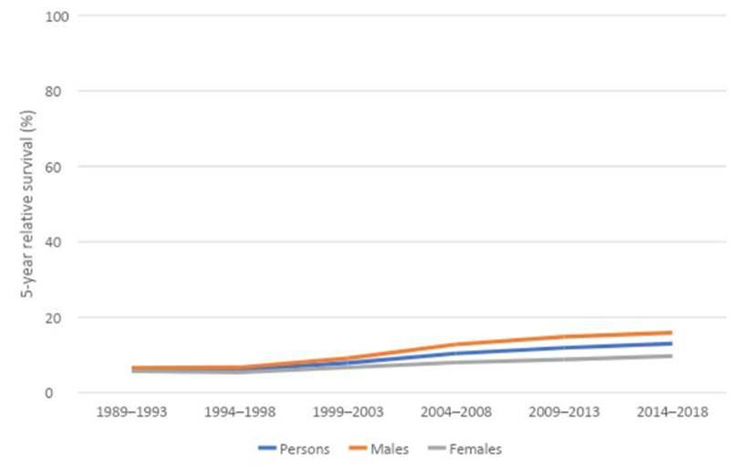

Source: Australian Institute of Health and Welfare (AIHW), 2022

**Figure 1. 5-year relative survival for CUP, 1989–1993 to 2014–2018, by sex**

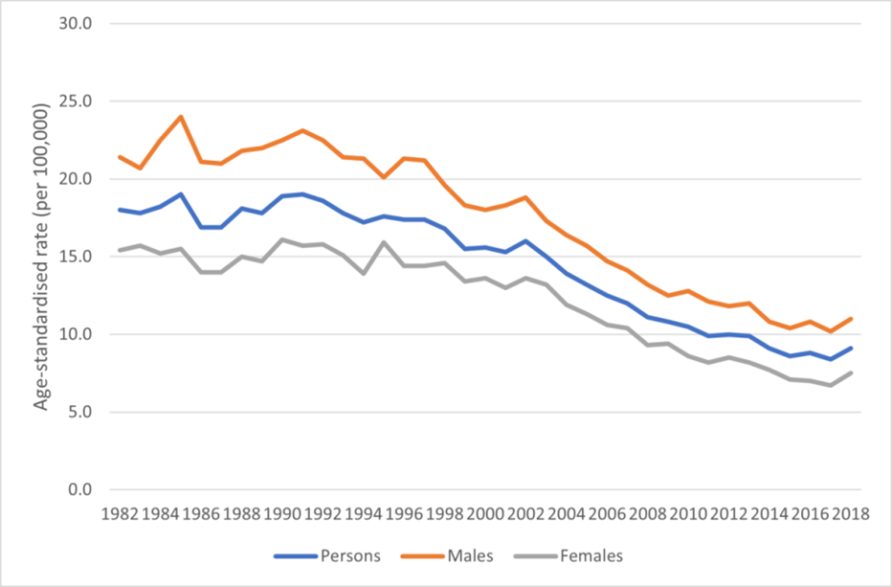

Source: Australian Institute of Health and Welfare (AIHW), 2022

**Figure 2: Age-standardised incidence rates for CUP, 1982 to 2018, by sex**

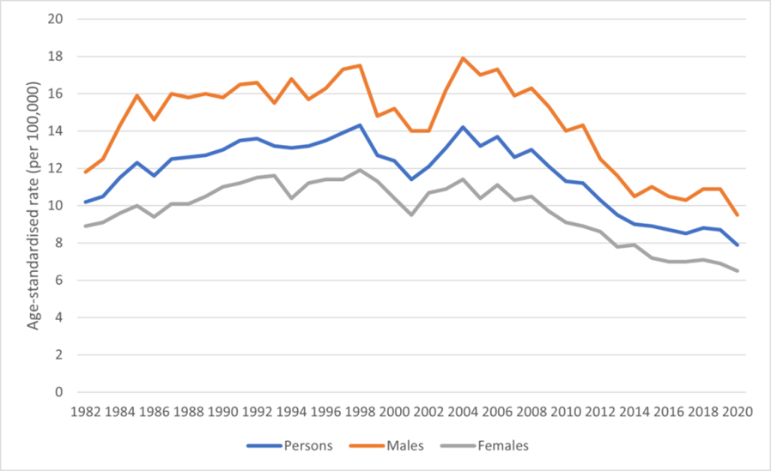

Source: Australian Institute of Health and Welfare (AIHW), 2022

**Figure 3. Age-standardised mortality rates for CUP, 1982 to 2020, by sex**

The median age of CUP diagnosis is 65 years (5), reaching a projected peak of 1,126 cases, or 105.2 cases per 100,000 persons in 2021 for those aged 80+ in Australia (8). Furthermore, mortality rates increase exponentially with age, reaching a predicted peak of 1,233 deaths in persons aged 80+ in 2021 in Australia (Table 2) (8). It should be noted that age-specific mortality rates are estimated to have decreased across all age groups in Australia over the last 20 years (Table 2) (8).

**Table 2: Estimated age-specific mortality rates of CUP in Australia, 2001 and 2021**

|  |  |  |  |  |  |  |  |
| --- | --- | --- | --- | --- | --- | --- | --- |
| **Persons aged** | **Cancer type (ICD-10 code)** | **2001** | | | **2021** | | |
| **Deaths** | **Rate** | **Ranking** | **Deaths** | **Rate** | **Ranking** |
| 20-39 | Cancer of unknown primary site (C77-C80, C97) | 32 | 0.6 | 7 | 25 | 0.3 | 8 |
| 40-59 | Cancer of unknown primary site (C77-C80, C97) | 259 | 5.1 | 7 | 242 | 3.8 | 7 |
| 60-79 | Cancer of unknown primary site (C77-C80, C97) | 1,126 | 42.6 | 4 | 1,055 | 22.7 | 7 |
| 80+ | Cancer of unknown primary site (C77-C80, C97) | 773 | 130.7 | 4 | 1,233 | 115.2 | 4 |

Source: Australian Institute of Health and Welfare (AIHW), 2021

Age-specific rates are expressed per 100,000 population

Ranked on cancer site/ type

2001 rates are based on actual data and 2021 data are projections based on 2010-2019 mortality data

Remote and very remote areas had the highest age-standardised incidence rates for CUP. (8). After adjusting for age, Indigenous Australians in very remote areas were more than twice as likely to be diagnosed with CUP compared to those in major cities, with incidence rates of 28 and 13 cases per 100,000 people, respectively (8).

Additionally, Indigenous Australians have significantly lower 5-year relative survival rates compared to non-Indigenous Australians (5% compared with 13%) (8). Those living in remote and very remote areas and Indigenous Australians face barriers such as limited access to healthcare services, lower participation in cancer screening programs, socioeconomic disadvantage, and a higher prevalence of cancer risk factors (tobacco use, poor diet, HPV infection).

Disparities in access to genomic services are a concern for regionally dispersed populations as well as Indigenous Australians, as most clinical genomic services are in metropolitan centres (9, 10). Extended travel distances, gaps in cancer services and specialists, and later detection results in late presentation and diagnostic delays. To ensure equitable access for all Australians genomic testing for CUP can be implemented in regional and remote settings through centralised genomic laboratories and metropolitan tumour advisory boards supporting regional oncology teams via virtual multidisciplinary case reviews. This model has been successfully demonstrated by the Molecular Screening and Therapeutics (MoST) program nationally, where regional patients with CUP were able to access comprehensive genomic profiling (CGP) and be matched to targeted therapies through virtual consultations and remote sample logistics.

***Current investigations for CUP***

CUP diagnostics according to current guidelines involve a comprehensive and systematic approach to detecting the elusive origin of the primary cancer. Patients presenting with clinical features suspicious for malignancy typically undergo initial assessment by their primary healthcare provider including a complete history and physical exam, and basic laboratory blood tests including tumour markers (e.g. CEA, CA-125, PSA) (5). Imaging studies are performed to identify potential sites of disease. Computerised tomographic (CT) scans (chest, abdomen, and pelvis) and/or ultrasound of the area of concern are standard first-line imaging.

If the results of these investigations are consistent with likely malignancy, patients are referred to a specialist such as a medical oncologist for further investigations. MRI may be considered for head and neck tumours, brain, spinal, or liver metastases. Mammography should be performed on women. PET scans may be used if CT is inconclusive or if specific primary sites are suspected (3). Gastroscopy and colonoscopy are typically advised when a gastrointestinal primary cancer is suspected.

Histology on a good quality tissue specimen (obtained through biopsy) is needed to differentiate cell morphology and to identify the pattern of tissue organisation (3). The specimen undergoes initial IHC staining for cell type specific protein markers to help classify tumour origin (3). The aim of these investigations is to identify the primary site, guide treatment decisions, enable access to government-funded treatments or clinical trials and determine prognosis.

Treatment is tailored to the patient's clinical presentation, pathology findings, and overall health status. Management is coordinated through multidisciplinary teams (MDT) comprising oncologists, radiologists, pathologists, and palliative care specialists. Patients with favourable CUP are recommended to receive site-specific treatment tailored to the presumed primary site. e.g. a female patient presenting with adenocarcinoma in an isolated axillary node without a demonstrable breast primary on imaging is treated as breast cancer.

Common treatment strategies for unfavourable CUP include:

* empiric platinum-doublet chemotherapies (3);
* radiotherapy - considered for symptom control or localised disease; or
* surgical intervention - rarely used unless a single site of metastasis is operable.

CT follow-up may be conducted every three months if the patient is considered suitable for further treatment.

**Provide a rationale for the specifics of the eligible population:**

The 2023 revision of the ESMO clinical practice guidelines emphasises the importance of thorough diagnostic workup and the potential role of genomic testing in the management of CUP patients. According to the guidelines, integrating genomic testing into the diagnostic pathway for CUP should be considered when standard diagnostic procedures do not reveal the primary tissue of origin (TOO). In some cases, by identifying specific molecular alterations, genomic profiling may suggest the TOO or reveal actionable mutations (Figure 4), thereby guiding targeted therapies and potentially improving patient outcomes. However, molecular tests to inform a diagnosis in CUP are not currently reimbursed by the MBS in Australia.

Molecular profiling can detect molecular alterations that may indicate a putative primary, allowing for more precise diagnosis and hence the most appropriate tumour-specific treatment. Targeted therapies may also be recommended when the identified genetic alteration indicates a likely primary cancer type for which approved targeted treatments are available and represent the standard of care (11). For example, EGFR mutations or *ALK* and *ROS1* fusions strongly suggest NSCLC and support the use of tyrosine kinase inhibitors (TKIs) as first-line treatment. In addition, genomic signatures reflecting ultraviolet light or tobacco exposure can provide further clues about the tumour's origin (3,9). Other examples of molecular alterations that may indicate a TOO include:

* Intrahepatic cholangiocarcinoma: *FGFR2* fusions
* Salivary gland carcinoma: *ETV6-NTRK3, MYB, MYBL2, EWSR1-ATF1, MAML2, PLAG1, HMG2* fusions, *PRKD1* mutations
* NUT carcinoma: *NUTM1* fusions
* Prostate cancer: *TMPRSS2-ERG* fusions
* Sarcomas and mesenchymal tumours: fusions involving *EWSR1-FLI1, EWSR1-ERG, EWSR1-WT1, EWSR1-POU5F1, HEY1-NCOA2, COL1A1-PDGFB, DDIT3, CREB3L2/CREB3L1, TFE3, NAB2-STAT6, SS18(SYT), NR4A3*; mutations in *SMARCB1, BCOR*, and *KIT*
* Hepatocellular carcinoma: *PRKACA* fusions
* Renal cell carcinoma: *TFE3* fusions
* Breast cancer: *ETV3* fusions (11)

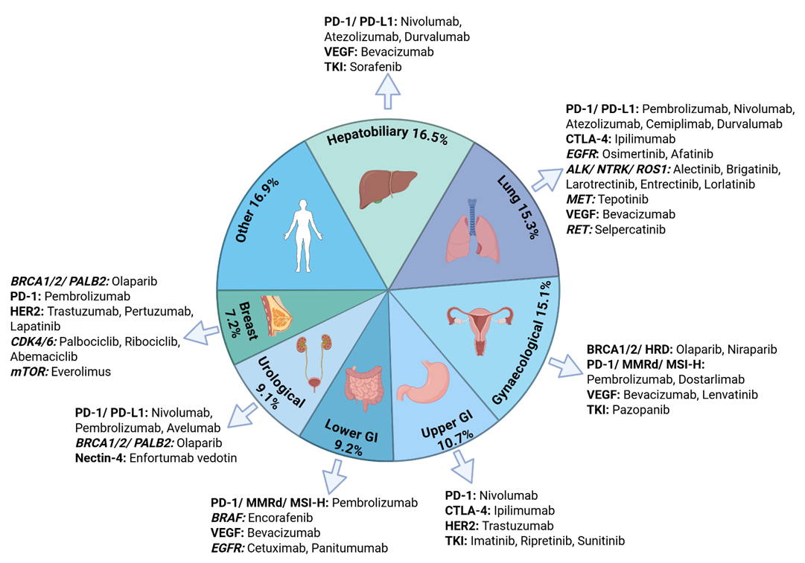

**Figure 4. Proportion of predicted tumour types within large CUP cohorts and corresponding PBS-subsidised immunotherapies and targeted therapies**

*Other – sarcoma, lymphoma, skin/melanoma, squamous-cell carcinoma, prostate, appendix, anal.

** Proportions represent the combined TOO classifier primary site predictions from 11 studies.

*** Created in BioRender: <https://BioRender.com>

Several CUP research studies support the role of comprehensive genomic testing to inform TOO diagnosis. A retrospective Australian study involving the analysis of 201 CUP patients using CGP testing found that DNA alterations in tumours, including tumour type enriched gene mutations and mutational signatures, helped inform a TOO diagnosis in 31% of CUP patients, where clinicopathological review was otherwise unable to resolve the TOO (12). A study from the same Australian group in 2025 now involving whole genome and transcriptome sequencing (WGTS), found that 54% of CUP could be assigned a likely TOO, whereas only 34% of the same cases were resolved using CGP (13). The proportion of CUP cases with a resolved diagnosis using WGTS was increased to 71% when using an algorithm called CUPPA (CUP Prediction Algorithm), which is trained on the whole genome DNA and RNA profiles of thousands of cancers of known origin (13). Application of the same CUPPA method (DNA-only) was also reported in an independent CUP series involving 72 patients in the Netherlands, showing 68% of cases could be assigned a single site diagnosis by whole genome sequencing (WGS) testing (14). CGP therefore appears to inform TOO in approximately a third of CUP cases, whereas WGS can increase the proportion resolved to two thirds of cases.

A major impact of resolving the TOO cancer diagnosis in CUP is access to standard of care (SOC) treatments as well as clinical trials. In the Australian CUP study, utilising WGTS combined with centralised clinciopathology review, 71% of CUP patients were eligble for a SOC site-specific treatment, which included PBS-funded molecularly targeted therapies (based on mutation features detected and resolved TOO) of immunotherapy. This was compared to just 42% patients eligible for SOC treatments if using a CGP approach. Furthermore, clinical trial access would have increased from 41% using CGP to 54% using WGTS. In total, 79% of CUP patients would have had access to treatments other than empirical chemotherapy when using WGTS, compared with 62% when employing CGP. Both WGTS and CGP tests can therefore improve access to SOC and clinical trials, with WGS clearly being superior.

The clinical benefits of molecular guided therapy in CUP have become evident in recent years. The CUPISCO trial demonstrated a significant improvement in progression-free survival (PFS) for patients with unfavourable CUP and actionable genomic alterations, when treated with targeted therapy (6.1 months) compared to standard chemotherapy (4.4 months), (HR 0.72; 95% CI 0.56–0.92; P = 0.0079) (15). This highlights the importance of integrating CGP into routine clinical practice. The proven benefits of targeted therapies and the ability of next-generation sequencing (NGS) to identify actionable mutations and potential TOO has led to the ESMO Precision Medicine Working Group recommending tumour NGS testing for all patients with unfavourable CUP (11).

**Are there any prerequisite tests?**

Yes: People presenting with these symptoms would undergo standard investigations for work-up for CUP including basic laboratory blood tests and relevant tumour markers, tissue biopsy and initial IHC panels, CT chest/abdomen/pelvis and mammogram if the patient is female. As per the Optimal Care Pathway CUP guidelines (6), MRI and PET scans, gastroscopy and colonoscopy or other investigations may be suggested depending on the clinical picture. In addition, second opinion pathology review should be performed to confirm the diagnosis of CUP.

**Are the prerequisite tests MBS funded?**

Yes

# Intervention

**Name of the proposed health technology:**

Tumour and matched blood genomic testing using WGTS or tumour-only CGP testing to identify molecular signatures that inform a TOO. Tumour genomic profiling can be used to diagnose cancers that elude standard diagnostic investigations as well as identify molecular features guiding PBS-funded treatments for some cancer types.

**Describe the key components and clinical steps involved in delivering the proposed health technology:**

People with symptoms suggestive of metastatic malignancy will undergo standard clinical investigations, including blood tests and imaging. If cancer is suspected, a biopsy will be taken, with histology performed to confirm malignancy and histological subtype. If following completion of the diagnostic work-up, including a second opinion pathology review, a CUP diagnosis is confirmed then genomic testing will be requested. Whenever possible and clinically relevant a fresh tissue specimen from a second biopsy is prefered for WGTS, but is not a pre-requisite as WGTS can be done on a FFPE biopsy. However, fresh samples typically have superior DNA and RNA quality, leading to more accurate and reliable results.

The decision to proceed with CGP or WGTS is primarily guided by the quality and quantity of the available tissue or nucleic acid sample. CGP generally requires less input material and is more tolerant of FFPE tissue, making it suitable for samples with limited quantity or suboptimal preservation. In contrast, WGTS requires higher quality RNA and DNA and larger input volumes to ensure reliable and comprehensive sequencing across the entire genome and transcriptome. DNA and RNA yields are typically quantified using fluorometric methods such as the Qubit™ Fluorometer, which provides sensitive and accurate concentration measurements. To assess purity, UV spectrophotometry using instruments like the NanoDrop™ is employed, evaluating 260/280 and 260/230 absorbance ratios. Therefore, sample assessment is essential to determine the most appropriate testing method.

**Identify how the proposed technology achieves the intended patient outcomes:**

Genomic testing allows for more precise classification of tumours, providing a tissue of origin diagnosis to guide clinical management and access to the full range of SOC treatments, patient support services +/- clinical trial eligibility. In addition, having a confirmed specific diagnosis will reduce the significant distress and uncertainty for patients and carers that comes with a CUP diagnosis (16).

**Does the proposed health technology include a registered trademark component with characteristics that distinguishes it from other similar health components?**

No

**Are there any proposed limitations on the provision of the proposed health technology delivered to the patient (For example: accessibility, dosage, quantity, duration or frequency):**

Yes: a good quality adequate tissue specimen is needed for tumour genomic testing. A blood sample is required for whole genome testing.

**Provide details and explain:**

Not applicable

**If applicable, advise which health professionals will be needed to provide the proposed health technology:**

Testing would be requested by the treating oncologist, consultant physician or approved practising pathologists in line with other tests on the MBS Pathology Services Table.

**If applicable, advise whether delivery of the proposed health technology can be delegated to another health professional:**

Not applicable

**If applicable, advise if there are any limitations on which health professionals might provide a referral for the proposed health technology:**

Patients should be referred by an oncologist, consultant physician or pathologist.

**Is there specific training or qualifications required to provide or deliver the proposed service, and/or any accreditation requirements to support delivery of the health technology?**

Yes

**Provide details and explain:**

Testing would be delivered only by approved practising pathologists with appropriate scope of practice in NATA accredited pathology laboratories (as defined in MBS pathology Table) by referral only by registered medical practitioners (non-pathologists) in line with other tests in the MBS Pathology Table.

**Indicate the proposed setting(s) in which the proposed health technology will be delivered:**

Consulting rooms

Day surgery centre

Emergency Department

Inpatient private hospital

Inpatient public hospital

Laboratory

Outpatient clinic

Patient’s home

Point of care testing

Residential aged care facility

Other (please specify)

**Is the proposed health technology intended to be entirely rendered inside Australia?**

Yes

**Provide additional details on the proposed health technology to be rendered outside of Australia:**

Not applicable

# Comparator

**Nominate the appropriate comparator(s) for the proposed medical service (i.e., how is the proposed population currently managed in the absence of the proposed medical service being available in the Australian healthcare system). This includes identifying healthcare resources that are needed to be delivered at the same time as the comparator service:**

The nominated comparator is no tumour genomic testing. The pre-requisite for testing is standard investigations for CUP, including blood tests, imaging (CT, +/-MRI, US, PET-CT), and histopathology review of biopsy material.

The introduction of genomic testing for CUP patients using WGTS or CGP would be additional to the currently listed MBS funded items used for the diagnostic work-up of patients with a malignant diagnosis of unknown origin. These MBS items for diagnostic tests are performed to provide initial characterisation of a malignancy and uncover a primary site of origin (Table 4).

**List any existing MBS item numbers that are relevant for the nominated comparators:**

**Table 4: Existing MBS items for investigations and diagnostic tests to identify a primary site**

| **Investigative technology** | **Item number** | **Description and fee** |
| --- | --- | --- |
| Blood Examination | 65070 (Group P1 – Haematology) | Erythrocyte count, haematocrit, haemoglobin, calculation or measurement of red cell index or indices, platelet count, leucocyte count and manual or instrument generated differential count - not being a service where haemoglobin only is requested - one or more instrument generated sets of results from a single sample; and (if performed)  (a) a morphological assessment of a blood film;  (b) any service in item 65060 or 65072  Fee: $16.95 Benefit: 75% = $12.75 85% = $14.45 |
| 66650 (Group P2 – Chemical) | Alpha-fetoprotein, CA-15.3 antigen (CA15.3), CA-125 antigen (CA125), CA-19.9 antigen (CA19.9), cancer associated serum antigen (CASA), carcinoembryonic antigen (CEA), human chorionic gonadotrophin (HCG), neuron specific enolase (NSE), thyroglobulin in serum or other body fluid, in the monitoring of malignancy or in the detection or monitoring of hepatic tumours, gestational trophoblastic disease or germ cell tumour - quantitation - 1 test  (Item is subject to rule 6)  Fee: $24.35 Benefit: 75% = $18.30 85% = $20.70 |
| Diagnostic Imaging | 56807 (Group I2 - Computed Tomography, Subgroup  8 - Chest, abdomen, pelvis and neck) | Computed tomography-scan of chest, abdomen and pelvis with or without scans of soft tissues of neck with intravenous contrast medium and with any scans of chest, abdomen and pelvis with or without scans of soft tissue of neck before intravenous contrast injection, when performed, not including a study performed to exclude coronary artery calcification or image the coronary arteries (R) (Anaes.)  Fee: $615.40 Benefit: 75% = $461.55 85% = $523.10 |
| 63001 (Group I5 – Magnetic Resonance Imaging, Subgroup 1 – Scan of Head – for specified conditions) | MRI-scan of head (including MRA, if performed) for tumour of the brain or meninges (R) (Anaes.) (Contrast)  Fee: $441.45 Benefit: 75% = $331.10 85% = $375.25 |
| 63271 (Group I5 – Magnetic Resonance Imaging, Subgroup 10 – Scan of Cervical Spine and Brachial Plexus - For Specified Conditions | MRI—scan of cervical spine and brachial plexus for tumour (R) (Anaes.) (Contrast)  Fee: $539.60 Benefit: 75% = $404.70 85% = $458.70 |
| 61612 (Group I4 – Nuclear Medicine Imaging, Subgroup 2 – PET) | Whole body FDG PET study for the initial staging of eligible cancer types, for a patient who is considered suitable for active therapy, if:  (a) the eligible cancer type is:  (i) a rare or uncommon cancer (less than 12 cases per 100,000 persons per year); and  (ii) a typically FDG‑avid cancer; and  (b) there is at least a 10% likelihood that the PET study result will inform a significant change in management for the patient  Applicable once per cancer diagnosis (R)  Fee: $953.00 Benefit: 75% = $714.75 85% = $850.60 |
| 55036 (Group I1 – Ultrasound, Subgroup 1 – General) | Abdomen, ultrasound scan of (including scan of urinary tract when performed), for morphological assessment, if:  (a) the service is not solely a transrectal ultrasonic examination of any of the following:  (i) prostate gland;  (ii) bladder base;  (iii) urethra; and  (b) within 24 hours of the service, a service mentioned in item 55038 is not performed on the same patient by the providing practitioner (R)  Fee: $124.70 Benefit: 75% = $93.55 85% = $106.00 |
| 55065 (Group I1 – Ultrasound, Subgroup 1 – General) | Pelvis, ultrasound scan of, by any or all approaches, if:  (a) the service is not solely a service to which an item (other than item 55736 or 55739) in Subgroup 5 of this Group applies or a transrectal ultrasonic examination of any of the following:  (i) prostate gland;  (ii) bladder base;  (iii) urethra; and  (b) within 24 hours of the service, a service mentioned in item 55038 is not performed on the same patient by the providing practitioner (R)  Fee: $110.20 Benefit: 75% = $82.65 85% = $93.70 |
| 30473 (Group T8 – Surgical Operations, Subgroup 1 – General) | Oesophagoscopy (not being a service associated with a service to which item 41822 applies), gastroscopy, duodenoscopy or panendoscopy (1 or more such procedures), with or without biopsy, not being a service associated with a service to which item 30478 or 30479 applies.  (Anaes.)  Fee: $201.75 Benefit: 75% = $151.35 85% = $171.50 |
| 32222 (Group T8 – Surgical Operations, Subgroup 2 – Colorectal) | Endoscopic examination of the colon to the caecum by colonoscopy, for a patient:  (a) following a positive faecal occult blood test; or  (b) who has symptoms consistent with pathology of the colonic mucosa; or  (c) who has anaemia or iron deficiency; or  (d) for whom diagnostic imaging has shown an abnormality of the colon; or  (e) who is undergoing the first examination following surgery for colorectal cancer; or  (f) who is undergoing pre‑operative evaluation; or  (g) for whom a repeat colonoscopy is required due to inadequate bowel preparation for the patient’s previous colonoscopy; or  (h) for the management of inflammatory bowel disease;  other than a service associated with a service to which item 32230 applies  Applicable once on a day under a single episode of anaesthesia or other sedation (H)  (Anaes.)  Fee: $380.90 Benefit: 75% = $285.70 |
| 59300 (Group I3 – Diagnostic Radiology, Subgroup 10 – Radiographic Examination of Breasts) | Mammography of both breasts if there is reason to suspect the presence of malignancy because of:  (a) the past occurrence of breast malignancy in the patient; or  (b) significant history of breast or ovarian malignancy in the patient’s family; or  (c) symptoms or indications of breast disease found on examination of the patient by a medical practitioner (R)  Fee: $100.35 Benefit: 75% = $75.30 85% = $85.30 |
| Biopsy | 30071 (Group T8 – Surgical Operations, Subgroup 1 – General) | Diagnostic biopsy of skin, as an independent procedure, if the biopsy specimen is sent for pathological examination  (Anaes.)  Fee: $59.50 Benefit: 75% = $44.65 85% = $50.60 |
| 30072 (Group T8 – Surgical Operations, Subgroup 1 – General) | Diagnostic biopsy of mucous membrane, as an independent procedure, if the biopsy specimen is sent for pathological examination  (Anaes.)  Fee: $59.50 Benefit: 75% = $44.65 85% = $50.60 |
| 30075 (Group T8 – Surgical Operations, Subgroup 1 – General) | DIAGNOSTIC BIOPSY OF LYMPH NODE, MUSCLE OR OTHER DEEP TISSUE OR ORGAN, as an independent procedure, if the biopsy specimen is sent for pathological examination  (Anaes.)  Fee: $170.60 Benefit: 75% = $127.95 85% = $145.05 |
| 30078 (Group T8 – Surgical Operations, Subgroup 1 – General) | DIAGNOSTIC DRILL BIOPSY OF LYMPH NODE, DEEP TISSUE OR ORGAN, as an independent procedure, where the biopsy specimen is sent for pathological examination  (Anaes.)  Fee: $55.20 Benefit: 75% = $41.40 85% = $46.95 |
| Histology | 72849 (Group P5 – Tissue Pathology) | Immunohistochemical examination of biopsy material by immunofluorescence, immunoperoxidase or other labelled antibody techniques with multiple antigenic specificities per specimen - 7-10 antibodies  Fee: $104.30 Benefit: 75% = $78.25 85% = $88.70 |
|  | 72859 (Group P5 – Tissue Pathology) | A second opinion, provided in a written report, where the opinion and report together require more than 30 minutes to complete, on a patient specimen, requested by a treating practitioner, where further information is needed for accurate diagnosis and appropriate patient management.  Fee: $370.00 Benefit: 75% = $277.50 85% = $314.50 |

**Provide a rationale for why this is a comparator:**

The nominated comparator - no tumour genomic testing - accurately reflects the current SOC for patients diagnosed with CUP. Currently, the diagnostic workup for CUP includes blood tests, imaging (CT, MRI, or PET-CT), and histopathology review, all of which are funded under the MBS. These investigations are aimed at characterising the malignancy and identifying a potential primary tumour site. While most patients go on to receive empiric treatment based on clinical and pathological findings, this approach is limited by the absence of tumour specific genomic information. Without genomic testing, treatments are often non-specific and poorly targeted, leading to suboptimal outcomes. Genomic testing (such as WGTS or CGP) is not routinely performed or funded at present, except when accessed through research initiatives or paid for privately by patients.

The comparator captures the incremental value of genomic testing by comparing to a setting where genomic testing is not undertaken, the analysis isolates and highlights the incremental clinical and economic value of introducing tumour genomic profiling. This includes:

* improved diagnostic precision,
* access to site-specific or targeted therapies,
* eligibility for clinical trials, and
* better prognostic stratification.

**Pattern of substitution – Will the proposed health technology wholly replace the proposed comparator, partially replace the proposed comparator, displace the proposed comparator or be used in combination with the proposed comparator?**

None (used with the comparator)

Displaced (comparator will likely be used following the proposed technology in some patients)

Partial (in some cases, the proposed technology will replace the use of the comparator, but not all)

Full (subjects who receive the proposed intervention will not receive the comparator)

**Outline and explain the extent to which the current comparator is expected to be substituted:**

Standard of care clinical management (in the absence of genomic testing) is the comparator.

# Outcomes

**List the key health outcomes (major and minor – prioritising major key health outcomes first) that will need to be measured in assessing the clinical claim for the proposed medical service/technology (versus the comparator):**

Health benefits

Health harms

Resources

Value of knowing

**Outcome description – include information about whether a change in patient management, or prognosis, occurs as a result of the test information:**

***Clinical Effectiveness Outcomes***

Direct evidence

* Change in patient health outcomes: mortality, morbidity, quality of life
* Number of cases with a resolved diagnosis

Indirect evidence

* Cumulative diagnostic yield (informative result)
* Cumulative prognostic yield (from those with an informative result)
* Change in management/treatment resulting in change in patient outcomes: mortality, morbidity, quality of life (indirect evidence)
* Proportion of patients gaining access to standard of care treatments and referral to clinical trials
* Reduced toxicity (associated with empirical and inappropriate therapy)

***Health system resources***

* Cost of WGTS or CGP
* Reduced number of individual genetic tests
* Reduced number of unnecessary imaging tests or other investigations trying to continue to search for a primary site
* Cost of targeted therapies
* Cost per quality-adjusted life year and/or cost-effectiveness
* Total Australian Government healthcare costs

***Value of knowing***

* Identifying previously unknown Germline findings (leading to referral to Familial Cancer Centre)
* Psychosocial impact – illness uncertainty leading to distress and anxiety

***Health harms***

* Test related adverse events
* Over investigation

# Proposed MBS items

**How is the technology/service funded at present? (e.g., research funding; State-based funding; self-funded by patients; no funding or payments):**

Currently genomic testing for CUP patients is funded by research funding or self-funded by the patient.

**Provide at least one proposed item with their descriptor and associated costs, for each Population/Intervention:**

|  |  |
| --- | --- |
| MBS item number  (where used as a template for the proposed item) | AAAAA |
| Category number | **Category 6** |
| Category description | **Group P7 Genetics** |
| Proposed item descriptor | Characterisation of gene variants and tissue of origin algorithm by whole genome and transcriptome sequencing, requested by a specialist or consultant physician or pathologist in a patient diagnosed with cancer of unknown primary.  Applicable once per diagnostic episode at initial diagnosis or at disease relapse. |
| Proposed MBS fee | Fee: $5500 Benefit: 75% = $4125 85% = $5397.60 |
| Indicate the overall cost per patient of providing the proposed health technology | $5500 |
| Please specify any anticipated out of pocket expenses | Nil |
| Provide any further details and explain | See cost breakdown attachment for more information. |

|  |  |
| --- | --- |
| MBS item number  (where used as a template for the proposed item) | BBBBB |
| Category number | **Category 6** |
| Category description | **Group P7 Genetics** |
| Proposed item descriptor | Characterisation of gene variants by a comprehensive gene panel, tissue of origin algorithm requested by a specialist or consultant physician or pathologist in a patient diagnosed with cancer of unknown primary.  Applicable once per diagnostic episode at initial diagnosis or at disease relapse. |
| Proposed MBS fee | Fee: $3300 Benefit: 75% = $2475 85% = $3197.60 |
| Indicate the overall cost per patient of providing the proposed health technology | $3300 |
| Please specify any anticipated out of pocket expenses | Nil |
| Provide any further details and explain | See cost breakdown attachment for more information. |

# Algorithms

## PREPARATION FOR USING THE HEALTH TECHNOLOGY

**Define and summarise the clinical management algorithm, including any required tests or healthcare resources, before patients would be eligible for the proposed health technology:**

The clinical management algorithm for the comparator is depicted in Figure 5. Patients with diagnosis or CUP (in the absence of molecular testing) currently commence general anti-cancer treatment.

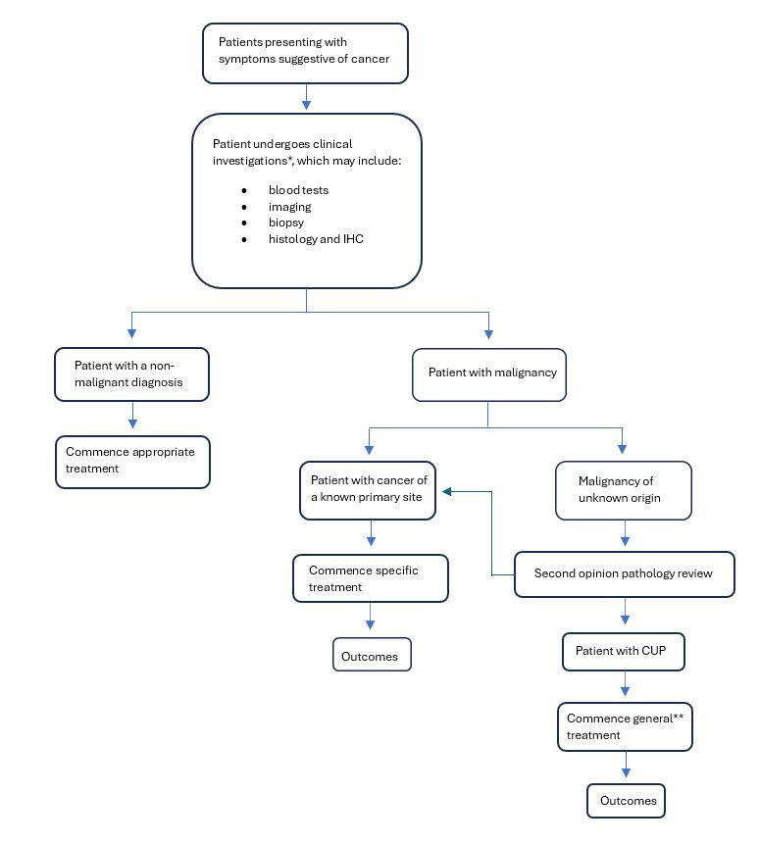

**Figure 5. Clinical management algorithm for CUP without genomic testing**

*Investigations will depend on symptoms, clinical presentation and results of the investigations.

**Treatment for CUP patients will rely on empiric chemotherapy regimens.

**Is there any expectation that the clinical management algorithm before the health technology is used will change due to the introduction of the proposed health technology?**

No

**Describe and explain any differences in the clinical management algorithm prior to the use of the proposed health technology vs. the comparator health technology:**

There is no difference in clinical management prior to genomic testing as complete clinical workup (including second opinion pathology review) is required before a diagnosis of CUP can be given.

## USE OF THE HEALTH TECHNOLOGY

**Explain what other healthcare resources are used in conjunction with delivering the proposed health technology:**

None, the intervention is a genomic test. Delivery of the tests requires a NATA accredited laboratory and associated overheads (consumables and labour).

**Explain what other healthcare resources are used in conjunction with the comparator health technology:**

None in addition to standard CUP work-up as described above, the comparator is no genomic test.

**Describe and explain any differences in the healthcare resources used in conjunction with the proposed health technology vs. the comparator health technology:**

The only difference is the requirement of a NATA accredited laboratory and associated overheads (consumables and labour).

## CLINICAL MANAGEMENT AFTER THE USE OF HEALTH TECHNOLOGY

**Define and summarise the clinical management algorithm, including any required tests or healthcare resources, after the use of the proposed health technology:**

The proposed clinical management algorithm is depicted in Figure 6. Genomic testing is an additional service provided to patients with a cancer diagnosis post clinical investigations and second opinion pathology review. Patients with a diagnosis of CUP are currently directed to receive generalised treatment, whereas the proposed management algorithm suggests the introduction of genomic testing and thereafter specific treatment. The introduction of genomic testing for these patients can increase the success of treatment and improve health outcomes by delivering a specific diagnosis that informs prognosis and allows use of precision medicine through the identification of tumour variants.

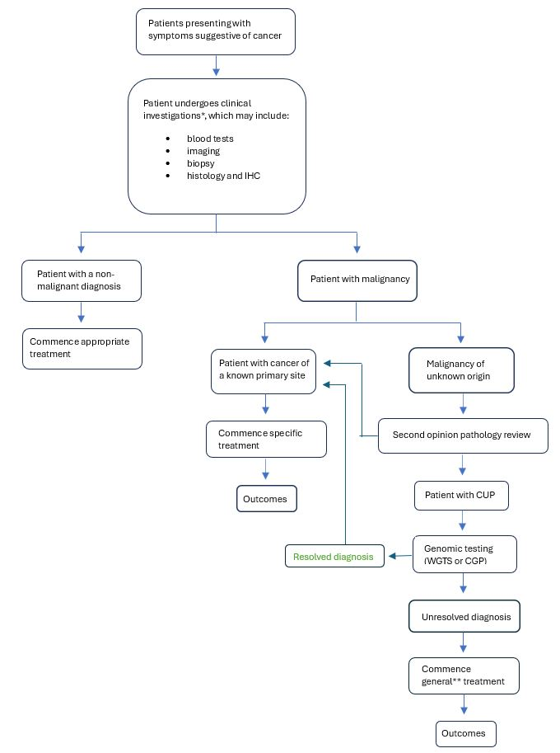

**Figure 6. Clinical management algorithm for CUP with genomic testing**

*Investigations will depend on symptoms, clinical presentation and results of the investigations.

**Treatment for CUP patients will rely on empiric chemotherapy regimens.

**Describe and explain any differences in the healthcare resources used after the proposed health technology vs. the comparator health technology:**

In patients with a resolved diagnosis, site specific treatment will commence, which may include chemotherapy, immunotherapy and/or targeted therapy. It is also anticipated that there will be a reduction in subsequent ongoing investigations to try and determine a tissue of origin in patients with a resolved diagnosis. Recently published Australian data from Gordon et al, has highlighted ongoing healthcare costs for the 6 months after a diagnosis of CUP that are much higher than for ovarian cancer, and partly driven by ongoing increased imaging and procedure costs (17). Patients with an unresolved CUP diagnosis after genomic testing, will commence empiric chemotherapy regimens as per the existing SOC.

# Claims

**In terms of health outcomes (comparative benefits and harms), is the proposed technology claimed to be superior, non-inferior or inferior to the comparator(s)?**

**Superior**

Non-inferior

Inferior

**Please state what the overall claim is, and provide a rationale:**

The overall claim is that genomic testing in patients with CUP results in superior health outcomes compared to no genomic testing. Currently, there are no MBS item numbers that cover this testing, testing is either being performed at cost to the patient, covered by research funding, or not performed. Public funding of these molecular tests would align Australian clinical practice with ESMO’s precision medicine working group recommendations for patients with a CUP diagnosis, as well as the ESMO guidelines for CUP management, and with publicly funded WGS available under the National Health Service (NHS) in the UK as well as in the Netherlands. Access to genomic testing will allow more patients to resolve a diagnosis, access site-specific treatment and clinical trials, provide prognostic information, resulting in better patient management and improved outcomes.

**Why would the requestor seek to use the proposed investigative technology rather than the comparator(s)?**

Without genomic testing, CUP patients tend to start treatment later than patients with cancers of known primaries contributing to significantly higher pretreatment costs (18). Identification of a primary site allows patients to commence site-specific treatment, improving health outcomes and HRQoL.

**Identify how the proposed technology achieves the intended patient outcomes:**

Implementing genomic testing in the routine diagnostic work-up for CUP patients will increase the number of patients with a resolved diagnosis resulting in a change in management, treatment and patient outcomes (mortality, morbidity, HRQoL). Additionally, the proportion of patients gaining access to SOC treatments and referral to clinical trials will increase.

**For some people, compared with the comparator(s), does the test information result in:**

**A change in clinical management?** Yes

**A change in health outcome?** Yes

**Other benefits?**  Yes

**Please provide a rationale, and information on other benefits if relevant:**

Certain genetic alterations can provide insight into prognosis for CUP patients. Mutations in *KRAS* or *NRAS*, as well as loss of the *CDKN2A* gene, are associated with poorer outcomes (19). Likewise, *TP53* mutations, chromosomal copy number losses, or deletion of chromosome *17p* are linked to worse prognosis, particularly in patients with limited metastatic disease who may be eligible for localised treatment (20). Other markers can predict response to targeted therapies regardless of the tumour’s tissue of origin. *NTRK* rearrangements predict response to NTRK inhibitors (3). High tumour mutational burden (TMB) and microsatellite instability (MSI) are reliable indicators for likely benefit from immunotherapy. In CUP, high PD-L1 expression and TMB have been associated with better treatment response and longer survival in patients receiving nivolumab. In a prospective phase II study, nivolumab plus ipilimumab demonstrated antitumor activity in patients who had progressed after platinum-based chemotherapy (21). Notably, patients with TMB-high tumours had a significantly higher objective response rate (ORR) of 60% (95% CI 15–95) compared to 7.7% (95% CI 1–25) in the TMB-low group (21). TMB-high status was also associated with better median PFS (HR 0.32; 95% CI 0.09–1.10; P = 0.056) and overall survival (OS) (HR 0.32; 95% CI 0.09–1.09; P = 0.056) (21). Comprehensive genomic testing at diagnosis can determine MSI, PD-L1 and TMB status which is recommended when ICI treatment is considered, in alignment with the ESMO guidelines (3).

CUP patients are impacted by higher levels of psychological distress and lower quality of life compared to patients with metastatic cancer of known origin. In CUP the existential dread of receiving a cancer diagnosis is compounded by the uncertainty regarding the diagnosis, treatment options and prognosis (16). A large national study of cancer patients in the UK found that CUP patients were less likely to have understood explanations of their illness compared to non-CUP patients (22). Furthermore, higher levels of anxiety and depression were found to be positively correlated with greater illness uncertainty (16). A better understanding of a patient’s cancer diagnosis could provide a sense of empowerment and lessen uncertainty and psychological distress (16). Confirming a TOO through genomic testing ends the diagnostic odyssey, thereby minimising further unnecessary investigations and offering substantial psychological benefits that enhance overall quality of life.

**In terms of the immediate costs of the proposed technology (and immediate cost consequences, such as procedural costs, testing costs etc.), is the proposed technology claimed to be more costly, the same cost or less costly than the comparator?**

**More costly**

Same cost

Less costly

**Provide a brief rationale for the claim:**

Genomic testing is more costly than no genomic testing.

# Summary of Evidence

**Provide one or more recent (published) high quality clinical studies that support use of the proposed health service/technology. At ‘Application Form lodgement’,**

| **#** | **Design** | **Title** | **Description** | **Link** | **Date** |
| --- | --- | --- | --- | --- | --- |
| 1. | Observational, non-randomised | Complete genomic characterization in patients with cancer of unknown primary origin in routine diagnostics | This study investigated the clinical value of whole genome sequencing (WGS) in terms of primary tumor identification and detection of actionable events, in the routine diagnostic work-up of CUP patients. A WGS-based tumor type 'cancer of unknown primary prediction algorithm' (CUPPA) was developed and applied to 72 CUP patients. CUPPA identified a primary tumor type for 49/72 patients (68%). Actionable events with matched therapy options in clinical trials were identified in 47% of patients. | <https://www.ncbi.nlm.nih.gov/pubmed/36463731> | 01 December 2022 |
| 2. | Observational, non-randomised | Comprehensive genomic and epigenomic analysis in cancer of unknown primary guides molecularly-informed therapies despite heterogeneity | Comprehensive molecular characterization by whole genome/exome, transcriptome and methylome analysis of 70 CUP patients. 56/70 (80%) patients receive genomics-based treatment recommendations which are applied in 20/56 (36%) cases. Genomics data provide evidence for the underlying entity in 62/70 (89%) cases. Germline analysis reveals five (likely) pathogenic mutations in five patients. Recommended off-label therapies translate into a mean PFS ratio of 3.6 with a median PFS1 of 2.9 months (17 patients) and a median PFS2 of 7.8 months (20 patients). | https://pmc.ncbi.nlm.nih.gov/articles/PMC9346116/ | 02 August 2022 |
| 3. | Observational, non-randomised | Machine learning-based tissue of origin classification for cancer of unknown primary diagnostics using genome-wide mutation features | A tissue-of-origin prediction algorithm (CUPLR) was developed based on WGS data employing 511 features based on simple and complex somatic driver and passenger mutations. CUPLR distinguishes 35 cancer (sub)types with approximately 90% recall and approximately 90% precision based on cross-validation and test set predictions. CUPLR could determine the TOO for 82/141 (58%) of CUP patients. | <https://www.ncbi.nlm.nih.gov/pubmed/35817764> | 11 July 2022 |
| 4. | Observational, non-randomised | A deep learning system accurately classifies primary and metastatic cancers using passenger mutation patterns | A deep learning classifier to predict cancer type based on patterns of somatic passenger mutations detected in whole genome sequencing (WGS) of 2606 tumours representing 24 common cancer types produced by the PCAWG Consortium. Our classifier achieves an accuracy of 91% on held-out tumour samples and 88% and 83% respectively on independent primary and metastatic samples, roughly double the accuracy of trained pathologists when presented with a metastatic tumour without knowledge of the primary. | <https://www.ncbi.nlm.nih.gov/pubmed/32024849> | 05 February 2020 |
| 5. | Observational, non-randomised | A comparison of DNA sequencing and gene expression profiling to assist tissue of origin diagnosis in cancer of unknown primary | The diagnostic utility of comprehensive DNA panel and RNA gene-expression testing was assessed in 215 CUP patients in a prospective Australian study. Diagnostic DNA features were interrogated in 201 CUP tumours guided by the cancer type specificity of mutations observed across 22 cancer types from the AACR Project GENIE database (77,058 tumours) as well as mutational signatures (e.g. tobacco smoking). Among CUP cases unresolved following pathology review, mutations and mutational signatures provided additional diagnostic evidence to support a likely tissue-of-origin in 31% of CUP cases. | <https://www.ncbi.nlm.nih.gov/pubmed/36287571> | 26 October 2022 |
| 6. | Clinical practice guideline | Cancer of unknown primary: ESMO Clinical Practice Guideline for diagnosis, treatment and follow-up | The ESMO guideline for cancer of unknown primary (CUP) outlines a structured approach to diagnosis, treatment, and follow-up, emphasising thorough clinical evaluation, targeted investigations, molecular profiling, and personalised therapy to improve outcomes. It supports multidisciplinary management and evidence-based care tailored to CUP subtypes and patient-specific factors. | https://pubmed.ncbi.nlm.nih.gov/36563965/ | March 2023 |
| 7. | Clinical practice guideline | Recommendations for the use of next-generation sequencing (NGS) for patients with advanced cancer in 2024: a report from the ESMO Precision Medicine Working Group | ESMO updated its guidelines to expand tumour NGS use in advanced cancers, now including breast, rare cancers, and CUP. NGS is recommended where matched therapies are accessible, aiming to improve precision medicine’s impact. Recommendations consider clinical actionability, cost-effectiveness, and patient discussion in research or specific settings. | https://pubmed.ncbi.nlm.nih.gov/38834388/ | July 2024 |
| 8. | Clinical practice guideline | Optimal care pathway for people with cancer of unknown primary | Optimal Care Pathways (OCPs) ensure consistent, high-quality, evidence-based care for all cancer patients. For cancer of unknown primary (CUP), OCPs guide timely, coordinated diagnosis and treatment to improve outcomes, promoting equitable access to best-practice care regardless of location or background. | https://www.cancer.org.au/assets/pdf/cancer-of-unknown-primary-january-2020 | January 2020 |
| 9. | Observational, non-randomised | Healthcare Costs Before and After Diagnosis of Cancer of Unknown Primary Versus Ovarian Cancer in Australia | Patients with cancer of unknown primary (CUP) incur significantly higher healthcare costs than those with ovarian cancer, both before and after diagnosis. Costs are driven by imaging, procedures, and medicines, highlighting the diagnostic complexity and treatment challenges of CUP in the Australian healthcare setting. | https://pubmed.ncbi.nlm.nih.gov/36253664/ | January 2023 |
| 10. | Interventional, phase II, randomised, clinical trial | Molecularly guided therapy versus chemotherapy after disease control in unfavourable cancer of unknown primary (CUPISCO): an open-label, randomised, phase 2 study | The CUPISCO trial found that in patients with unfavourable non-squamous cancer of unknown primary, molecularly guided therapy (MGT) based on comprehensive genomic profiling (CGP) significantly improved progression-free survival compared to standard chemotherapy. CGP at diagnosis is recommended to guide treatment and improve outcomes. | https://pubmed.ncbi.nlm.nih.gov/39096924/ | 10 August 2024 |
| 11. | Interventional, phase II, randomised, clinical trial | A Challenging Task: Identifying Patients with Cancer of Unknown Primary (CUP) According to ESMO Guidelines: The CUPISCO Trial Experience | Effective therapeutic regimens are lacking for patients with cancers of unknown primary (CUP). This article reports the clinic‐pathological challenges associated with diagnosis of unfavourable CUP in the CUPSICO trial and suggests refinements for diagnostic algorithms. | https://pmc.ncbi.nlm.nih.gov/articles/PMC8100559/ | 25 March 2021 |
| 12. | Interventional, prospective cohort study | Impact of whole genome sequencing on the care pathway for patients with cancer of unknown primary | Whole genome sequencing (WGS) significantly improved primary tumour diagnosis and identified actionable mutations in cancer of unknown primary (CUP) patients, enabling tailored treatments. Compared to a historical control group, WGS increased diagnostic yield and treatment recommendations, though overall survival improvement was not statistically significant. | https://pubmed.ncbi.nlm.nih.gov/40345055/ | 8 May 2025 |
| 13 | Observational, non-randomised | Whole genome sequencing improves tissue of origin diagnosis and treatment options for cancer of unknown primary | Whole genome and transcriptome sequencing (WGTS) outperforms panel testing in cancer of unknown primary (CUP) by identifying more clinically relevant mutations, predicting tissue of origin in 77% of cases, and suggesting treatment options for 79% of patients, demonstrating its diagnostic and therapeutic value using routine samples. | https://www.nature.com/articles/s41467-025-59661-x | 20 May 2025 |

**References**

1. Conway AM, Mitchell C, Kilgour E, Brady G, Dive C, Cook N. Molecular characterisation and liquid biomarkers in Carcinoma of Unknown Primary (CUP): taking the 'U' out of 'CUP'. Br J Cancer. 2019;120(2):141-53.

2. Lee MS, Sanoff HK. Cancer of unknown primary. BMJ. 2020;371:m4050.

3. Kramer A, Bochtler T, Pauli C, Baciarello G, Delorme S, Hemminki K, et al. Cancer of unknown primary: ESMO Clinical Practice Guideline for diagnosis, treatment and follow-up. Ann Oncol. 2023;34(3):228-46.

4. Rassy E, Pavlidis N. The currently declining incidence of cancer of unknown primary. Cancer Epidemiol. 2019;61:139-41.

5. Kato S, Alsafar A, Walavalkar V, Hainsworth J, Kurzrock R. Cancer of Unknown Primary in the Molecular Era. Trends Cancer. 2021;7(5):465-77.

6. Cancer Council Victoria. Optimal care pathway for people with cancer of unknown primary. Melbourne: Department of Health; 2020.

7. Rassy E, Bakouny Z, Choueiri TK, Van Allen EM, Fizazi K, Greco FA, et al. The role of site-specific therapy for cancers of unknown of primary: A meta-analysis. Eur J Cancer. 2020;127:118-22.

8. Australian Institute of Health and Welfare. Cancer in Australia 2021. Canberra: AIHW; 2021. Report No.: CAN 144.

9. Luke J DP, Tuer L, Savarirayan R, Ferdinand A, McGaughran J, Kowal E, Massey L, Garvey G, Dawkins H, Jenkins M, Paradies Y, Pearson G, Stutterd CA, Baynam G, Kelaher M. . Investigating disparity in access to Australian clinical genetic health services for Aboriginal and Torres Strait Islander people. Nat Commun. 2022;13(1):4966.

10. Mordaunt DA DK, Goranitis I, Stark Z. Uptake of funded genomic testing for syndromic and non-syndromic intellectual disability in Australia. Eur J Hum Genet. 2023;31(9):977-79.

11. Mosele MF, Westphalen CB, Stenzinger A, Barlesi F, Bayle A, Bieche I, et al. Recommendations for the use of next-generation sequencing (NGS) for patients with advanced cancer in 2024: a report from the ESMO Precision Medicine Working Group. Ann Oncol. 2024;35(7):588-606.

12. Posner A, Prall OW, Sivakumaran T, Etemadamoghadam D, Thio N, Pattison A, et al. A comparison of DNA sequencing and gene expression profiling to assist tissue of origin diagnosis in cancer of unknown primary. J Pathol. 2023;259(1):81-92.

13. Rebello RJ, Posner A, Dong R, Prall OWJ, Sivakumaran T, Mitchell CB, et al. Whole genome sequencing improves tissue of origin diagnosis and treatment options for cancer of unknown primary. Nat Commun. 2025;16(1):4422.

14. Schipper LJ, Samsom KG, Snaebjornsson P, Battaglia T, Bosch LJW, Lalezari F, et al. Complete genomic characterization in patients with cancer of unknown primary origin in routine diagnostics. ESMO Open. 2022;7(6):100611.

15. Krämer A, Bochtler T, Pauli C, Shiu KK, Cook N, de Menezes JJ, et al. Molecularly guided therapy versus chemotherapy after disease control in unfavourable cancer of unknown primary (CUPISCO): an open-label, randomised, phase 2 study. Lancet. 2024;404(10452):527-39.

16. Wolyniec K, Sharp J, Fisher K, Tothill RW, Bowtell D, Mileshkin L, et al. Psychological distress, understanding of cancer and illness uncertainty in patients with Cancer of Unknown Primary. Psychooncology. 2022;31(11):1869-76.

17. Gordon LG, Wood C, Tothill RW, Webb PM, Schofield P, Mileshkin L, et al. Healthcare Costs Before and After Diagnosis of Cancer of Unknown Primary Versus Ovarian Cancer in Australia. Pharmacoecon Open. 2023;7(1):111-20.

18. Walker MS, Weinstein L, Luo R, Marino I. Pretreatment costs of care and time to initial treatment for patients with cancer of unknown primary. J Comp Eff Res. 2018;7(6):523-33

19. Bochtler T, Reiling A, Endris V, Hielscher T, Volckmar AL, Neumann O, et al. Integrated clinicomolecular characterization identifies RAS activation and CDKN2A deletion as independent adverse prognostic factors in cancer of unknown primary. Int J Cancer. 2020;146(11):3053-64.

20. Bochtler T, Wohlfromm T, Hielscher T, Stichel D, Pouyiourou M, Kraft B, et al. Prognostic impact of copy number alterations and tumor mutational burden in carcinoma of unknown primary. Genes Chromosomes Cancer. 2022;61(9):551-60.

21. Pouyiourou M, Kraft BN, Wohlfromm T, Stahl M, Kubuschok B, Loffler H, et al. Nivolumab and ipilimumab in recurrent or refractory cancer of unknown primary: a phase II trial. Nat Commun. 2023;14(1):6761.

22. Wagland R, Bracher M, Drosdowsky A, Richardson A, Symons J, Mileshkin L, et al. Differences in experiences of care between patients diagnosed with metastatic cancer of known and unknown primaries: mixed-method findings from the 2013 cancer patient experience survey in England. BMJ Open. 2017;7(9):e017881.