MSAC Application 1804
Genetic testing to detect RET variants in patients with medullary thyroid cancer to determine eligibility for PBS subsidised selpercatinib treatment
Applicant: Eli Lilly Australia Pty Ltd

PICO Confirmation

Summary of PICO/PPICO criteria to define questions to be addressed in an Assessment Report to the Medical Services Advisory Committee (MSAC)
Table 1 PICO for RET variant testing in patients with medullary thyroid cancer to determine eligibility for PBS subsidised selpercatinib treatment
Component | Description
 | Option 1: tumour testing at stage III/IV MTC | Option 2: tumour testing at diagnosis of MTC
Population | Test: Patients with a confirmed histological diagnosis of medullary thyroid cancer (MTC)
Population | Treatment: Patients with locally advanced or metastatic MTC and a clinically significant activating ret proto-oncogene (RET) variant
Prior tests | Surgical resection of the thyroid (if possible) or biopsy (if resection is not feasible); and immunohistochemistry diagnosis  Laboratory tests, including serum calcitonin and carcinoembryonic antigen (CEA)  Ultrasound of the neck  Positron Emission Tomography (PET)/Computed Tomography (CT) scan to detect metastatic disease
Intervention | Test: Diagnosed with stage I/II MTC: Germline RET variant testing for suspected multiple endocrine neoplasia 2 (MEN2). If patient progresses to stage III/IV MTC, and germline was RET wildtype, then tumour tissue testing for clinically significant activating somatic RET variants (see definition in note below).  Diagnosed with stage III/IV MTC: Tumour tissue testing for clinically significant activating RET variants. If activating RET variant detected, then germline RET variant testing for MEN2. |  | Test: Tumour tissue testing for clinically significant activating RET variants. If activating RET variant detected, then germline RET variant testing for MEN2.
Intervention | Treatment: oral doses of selpercatinib (120-160 mg twice daily) until disease progression or unacceptable toxicity (in those with a clinically significant activating RET variant) and pharmacological interventions to treat symptoms.
Comparators | Test:  - germline RET variant testing (as MEN2 is suspected in patients with MTC), with  - no RET variant testing of tumour tissue  For financial analysis only: RET variant testing of tumour tissue performed within public hospitals (without MBS item)  Treatment: The current standard of care for advanced or metastatic MTC
Clinical utility standard | RET variant testing using next generation sequencing (NGS) or polymerase chain reaction (PCR) based methods, such as Sanger sequencing, on either tumour tissue or blood sample.
Outcomes | Test-related considerations:  - Number of tumours estimated to be tested and impact on number of germline tests performed  - Number of tumours needed to test (to identify one additional eligible case for selpercatinib)  - Test turn-around time  - Rate of re-biopsy (including test failure and inadequate sample rate)  - Safety of re-biopsy  Clinical utility of test:  - Treatment effect modification for selpercatinib in MTC patients with/without a clinically significant activating RET variant (predictive validity)  Change in management:  - Proportion of cases eligible for selpercatinib who would actually receive it  Treatment-related outcomes  - Safety (including treatment-emergent adverse events [AEs])  - Overall survival (OS), progression free survival (PFS), overall response rate (ORR), comparative tolerability  - Health-related quality of life (HR-QoL)  Healthcare resources  - Cost of testing per patient (including costs of associated re-biopsies, test failure, inadequate sampling)  - Cost of treatments  - Cost of treating adverse events  - Financial implications (including the number of patients tested and treated)
Assessment questions | What is the safety, effectiveness and cost-effectiveness of RET variant testing of tumour tissue versus no RET testing of tumour tissue in patients with locally advanced or metastatic MTC to determine eligibility for treatment with Pharmaceutical Benefits Scheme (PBS) subsidised selpercatinib versus treatment with standard of care in those who have a clinically significant activating RET variants and advanced or metastatic MTC? |  | What is the safety, effectiveness and cost-effectiveness of RET variant testing of tumour tissue versus no RET testing of tumour tissue in patients with MTC to determine eligibility for treatment with Pharmaceutical Benefits Scheme (PBS) subsidised selpercatinib in the advanced or metastatic MTC setting versus treatment with standard of care in those who have a clinically significant activating RET variants and advanced or metastatic MTC?
Assessment questions | Is there a treatment effect modification for selpercatinib based on activating RET variant status in people with locally advanced or metastatic MTC?

Note: The term ‘clinically significant activating RET variants’ is used throughout the PICO Confirmation document and is defined as:
- Tier 1 somatic RET variants that are oncogenic drivers in MTC (Horne et al. 2019)
- Pathogenic or likely pathogenic germline RET variants that are causative of the inherited genetic condition, MEN2 (Richards et al. 2015)
The same RET variants that have been identified as being causative in multiple endocrine neoplasia 2 (MEN2) have been identified as tier 1 RET variants in MTC. Patients with either type of RET variant would be eligible for selpercatinib (if they meet other criteria such as having locally advanced or metastatic MTC).
Therefore, testing of both tumour tissue (for somatic or germline RET variants) and blood/buccal swab/saliva for germline RET variants are both included in the PICO confirmation, although germline RET gene testing already has an MBS item (73339) that the target population are currently eligible to use for MEN2 diagnostic purposes, rather than predictive purposes (predicting response to treatment).

Purpose of application
The codependent application requested:
- Medicare Benefits Schedule (MBS) listing of ret proto-oncogene (RET) variant testing of tumour tissue for the determination of patient eligibility for treatment with selpercatinib (Retevmo®); and
- Pharmaceutical Benefits Scheme (PBS) Authority Required listing of selpercatinib (Retevmo®) for the treatment of locally advanced or metastatic medullary thyroid cancer (MTC).
The clinical claim made in the application form was that the use of RET variant testing, followed by treatment with selpercatinib in eligible patients, results in superior health outcomes compared to no RET variant testing and treatment with the current standard of care. The applicant also claimed that selpercatinib had an acceptable safety profile compared to multikinase inhibitors (MKIs; cabozantinib or vandetanib).

PICO criteria

Population

Population for testing
The target population for RET variant testing in tumour tissue are those with a confirmed histological diagnosis of MTC, who have not already undergone testing of tumour tissue for clinically significant RET variants and do not have a known germline RET variant.
PASC noted that the population eligible for testing could either be restricted to those with locally advanced (stage III) or metastatic (stage IV) MTC (consistent with eligibility for selpercatinib) (Option 1), or it could be expanded to include any patient with a confirmed histological diagnosis of MTC, regardless of stage (Option 2).
PASC noted that testing at the point of diagnosis regardless of stage (Option 2) avoids tissue block and previous germline molecular report retrieval, and means clinicians and patients would know ahead of time about selpercatinib eligibility, prior to the point of disease progression (if not locally advanced or metastatic at the time of diagnosis). PASC considered it would not be unreasonable to test all patients with MTC, regardless of stage, and advised that the assessment report should include models of both Options 1 and 2 for MSAC ESC and MSAC consideration.
Thyroid cancer was diagnosed in 2.5% of all new cancer patients in Australia in 2022. Of the patients diagnosed with thyroid cancer, only 4% had MTC. It arises from C cells (or parafollicular cells) within the thyroid, which are of neural crest origin and function in secretion of the hormone, calcitonin (Hazard 1977). Thus, MTC is a neuroendocrine tumour (Gild et al. 2023). Calcitonin functions in the regulation of plasma calcium by a feedback mechanism which inhibits bone resorption, thus reducing the amount of circulating calcium (Hazard 1977). Additionally, because C cells do not lose their secretory capacity when becoming neoplastic, they continue to secrete calcitonin often in a dysregulated way leading to excessive secretion of calcitonin. Therefore, elevated calcitonin levels in the blood are a highly sensitive and specific tumour marker for the diagnosis and follow-up of MTC (Gild et al. 2023). Unlike differentiated thyroid cancer, thyroid-stimulating hormone (TSH) is not a key marker MTCs (Boucai, Zafereo & Cabanillas 2024). MTC commonly presents with a thyroid nodule in the upper portion of the gland, where C cells are primarily located, and has a 5-year survival rates of 83–89%. However, in patients with distant metastases on presentation the survival rate decreases to 36–51% (Kesby et al. 2022). It is expected that 15-20% of patients will present with distant metastatic disease (Angelousi et al. 2022).
MTCs are either sporadic (approximately 75% of cases) or hereditary (approximately 25% of cases) (Gild et al. 2023). Hereditary MTC is due to multiple endocrine neoplasia type 2 (MEN2), a condition that can cause tumours affecting the endocrine glands. MEN2 consists of three related disorders: MEN2A, MEN2B, and familial medullary thyroid carcinoma (FMTC) (Santoro & Carlomagno 2013; Walker & Mulligan 2025). These will be collectively referred to as MEN2. MTC is usually the first tumour to develop in MEN2 and is the only tumour type in FMTC. Patients with hereditary MTC typically present with bilateral tumours. MEN2A causes 23% of MTC, usually in the 3rd decade of life and MEN2B causes <2% of MTC in the 1st decade of life, with FMTC causing <1% of cases and occurs in middle-age (Raue, Friedhelm & Frank-Raue 2015; Santoro & Carlomagno 2013). Patients with sporadic MTC generally present with unilateral tumours and no other endocrine involvement with average age at diagnosis being in the 5th decade of life (Block et al. 1980; Raue, Friedhelm & Frank-Raue 2015).

The role of calcitonin levels on the management of locally advanced or metastatic MTC
Calcitonin level is an important factor used in the diagnosis, assessment and follow-up of MTC (other factors include, but are not limited to, biomarkers, tumour size and grade, and lymph node involvement). Preoperative levels correlate with the degree of metastatic disease (Gild et al. 2023). Levels below 53 pg/mL reflect a low likelihood of lymph node metastases, whereas levels above 1000 pg/mL are highly indicative of distant metastatic disease. Preoperative calcitonin levels may also guide surgical management; in patients with levels above 200 pg/mL, contralateral neck dissection should be considered in addition to total thyroidectomy. This involves the surgical removal of lymph nodes on the side of the neck opposite to the primary tumour site.
Postoperative calcitonin levels also aid in management of advanced or recurrent disease (Raue, F. & Frank-Raue 2025). Persistent or recurrent disease with levels less than 150 pg/ml following thyroidectomy is usually confined to lymph nodes in the neck. If levels exceed 150 pg/ml, patients should be evaluated by multiple imaging procedures, including computed tomography (CT), magnetic resonance imaging (MRI), ultrasound of the liver, bone scintigraphy, and positron emission tomography (PET) (Raue, F. & Frank-Raue 2025).
Patients with persistent or recurrent MTC localised to the neck and slightly elevated calcitonin levels following thyroidectomy might be candidates for neck reoperations depending on the extent of the tumour (Raue, F. & Frank-Raue 2025). Once metastases appear MTC becomes incurable, and the management goals are to provide locoregional disease control, palliate symptoms such as diarrhoea, palliate symptomatic metastases causing pain or bone fractures, and control metastases that threaten life through bronchial obstruction or spinal cord compression. This can be achieved by palliative surgery or systemic therapy using non-selective MKIs that inhibit multiple tyrosine kinases including RET, such as cabozantinib, lenvatinib, and vandetanib. RET-specific inhibitors such as selpercatinib have also been used in patients with a clinically significant activating RET variant in their tumour tissue (Raue, F. & Frank-Raue 2025).

The role of RET in MTC
Clinically significant activating RET variants are genetic alterations found in 70% of patients with MTC and play a critical role in tumour development and progression (Wirth et al. 2020). RET is a transmembrane tyrosine kinase receptor encoded by the RET gene, which plays an important role in the development and maintenance of the enteric nervous and genitourinary systems in neonates such as kidney induction, spermatogonial stem cell maintenance, neural crest cell migration, central nervous system (CNS) and peripheral nervous system (PNS) neuron maintenance (Walker & Mulligan 2025).
RET is normally activated by binding a group of neurotrophic growth factors that belong to the glial cell line-derived neurotrophic factor (GDNF) family, which leads to RET kinase activation and stimulates signalling through the mitogen-activated protein kinases (RAS-MAPK) and phosphatidyl inositol 3 kinase (PI3K-AKT) pathways (Santoro & Carlomagno 2013; Walker & Mulligan 2025). The role of RET signalling in normal C-cell function is not known, although calcitonin gene transcription appears to be sensitive to RET activation (Bagheri-Yarmand, Grubbs & Hofmann 2025).
The three hereditary MEN2 subtypes differ in tumour aggressiveness and are caused by distinct patterns of RET variants (Figure 1) (Santoro & Carlomagno 2013; Walker & Mulligan 2025). RET variants causing MEN2A and FMTC mostly involve substitution of an extracellular cysteine (C) residue involved in ligand-independent dimerization via disulphide bonds. MEN2A is most frequently (85% of cases) associated with variants that substitute C634, particularly the substitution C634R, whereas FMTC variants are evenly distributed among the codons encoding the various Cs (Figure 1). These RET-variant kinases form covalently linked dimers in the absence of neurotrophic growth factors, leading to constitutive activation of the RET kinase and activation of the downstream signalling RAS-MAPK and PI3K-AKT pathways (Walker & Mulligan 2025).
Rare RET variants causing MEN2A or FMTC target areas of the extracellular domain other than the cysteine-rich domain. FMTC can also be associated with changes in the RET kinase domain (Figure 1). MEN2B is caused by a single amino acid change in the RET tyrosine kinase domain, M918T occurs in >95% of cases but some harbour an A883F substitution (Figure 1). These changes promote autophosphorylation and produce a more active RET kinase that can promote signalling as monomers or dimers in the absence of a ligand (Santoro & Carlomagno 2013; Walker & Mulligan 2025).
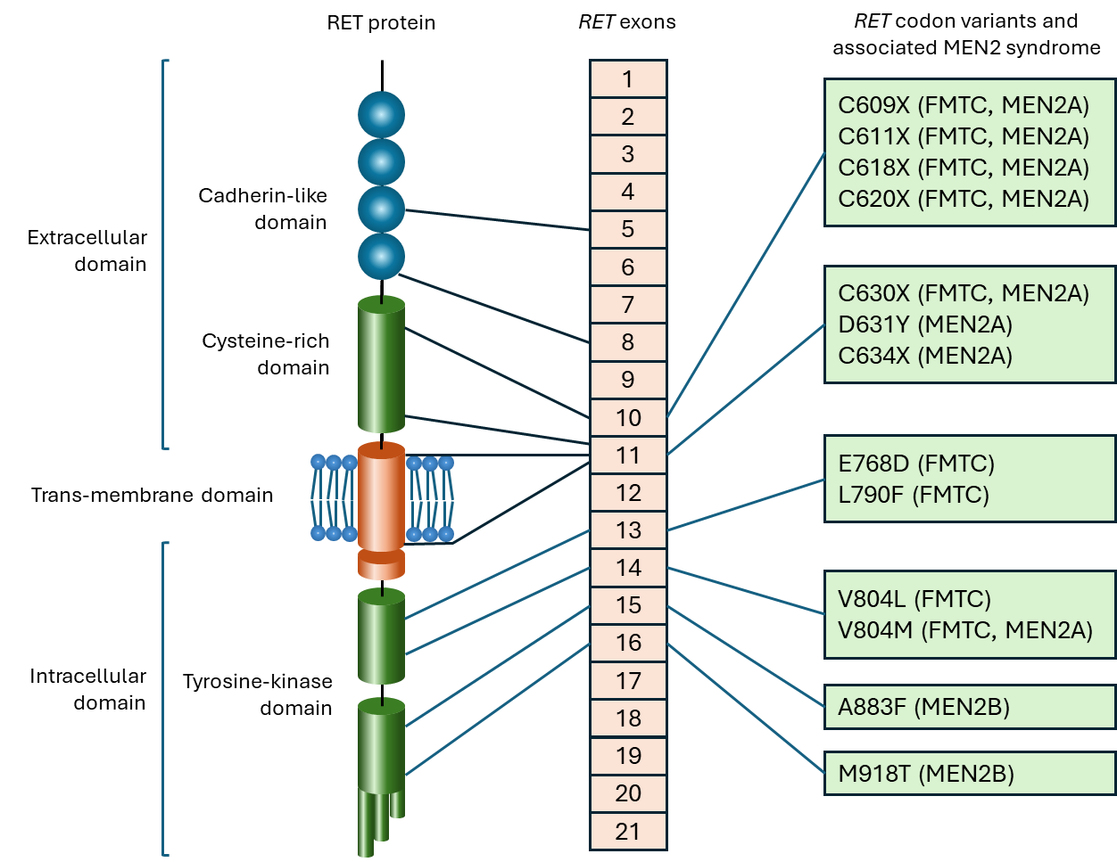
Figure 1 The most common germline missense variants in the RET gene found in MEN2.
Adapted from Santoro and Carlomagno (2013)
FMTC = familial medullary thyroid cancer; MEN2A = Multiple Endocrine Neoplasia type 2A; MEN2B = Multiple Endocrine Neoplasia type 2B; RET = ret proto-oncogene
Of the MTC patients with a suspected clinical diagnosis of MEN2, 75% have no prior family history. Detection of germline clinically significant variants in the RET gene and cascade testing for that variant in close relatives of patients with MEN2 is standard practice. Gild et al. (2023) noted that testing all patients with MTC for germline RET variants on exons 8, 10, 11, 13-16, even in the absence of a family history, results in a diagnosis of MEN2 in an additional 6% of cases.
Sporadic MTC is driven by somatic clinically significant activating variants, most commonly in the RET gene (50-60% of cases), with the most common tier 1 variant being M918T, which is associated with a more aggressive disease course and poor prognosis with increased risk of lymph node metastases, advanced tumour stage, and recurrence (Gild et al. 2023; Santoro & Carlomagno 2013; Scurini et al. 1998). Other clinically significant variants in the RET gene associated with sporadic MTC include variants in multiple other codons located on the same exons where the common MEN2 variants are found (exons 10, 11, 13, 14, 15 and 16; Figure 1), as well as small insertions/deletions, especially in exons 11 and 15 (Bai et al. 2020; Gild et al. 2023; Scurini et al. 1998).

Other biomarkers associated with MTC
In sporadic MTC with a wild-type RET gene, mutagenesis is driven by tier 1 variants in the genes encoding the Ras type GTPase family (RAS) in approximately 70% of cases (Gild et al. 2023; Parimi et al. 2023). These variants predominantly involve the HRas proto-oncogene, GTPase (HRAS; especially Q61R), followed by less frequent KRAS proto-oncogene, GTPase (KRAS) variants, and with NRAS proto-oncogene, GTPase (NRAS) variants being quite uncommon (Walker & Mulligan 2025). Clinically significant RAS variants are generally associated with less aggressive tumour behaviour than those with clinically significant RET variants (Gild et al. 2023). Interestingly, both RET and Ras act on the RAS-MAPK and phosphoinositide 3-kinase (PI3K)-AKT pathways, which are implicated in both initiation and progression of MTC (Bagheri-Yarmand, Grubbs & Hofmann 2025).
Ras proteins (K-Ras, H-Ras, N-Ras) are a family of small GTPases that play a crucial role in cell signalling and regulation of cellular pathways involved in cell growth, differentiation, and apoptosis. They play a central role in preventing uncontrolled cell division and tumour development. The Ras GTPases also play a role in and inactivation of the retinoblastoma (RB1) tumour suppressor pathway through the RAS-MAPK pathway (Bagheri-Yarmand, Grubbs & Hofmann 2025). H-Ras inactivation of RB1 leads to uncontrolled cell proliferation and cancer development. Cells lacking a functional RB1 protein are less susceptible to the oncogenic actions of H-Ras (Williams et al. 2006).

Population for treatment
The target population for treatment with selpercatinib (as per the proposed Product Information to the Therapeutic Goods Administration (TGA) for listing on the Australian Register of Therapeutic Goods (ARTG)) is adult and adolescent (12 years of age and older) patients with advanced or metastatic RET-mutant MTC. RET variant status in incident cases is expected to be derived from testing via the proposed MBS item for testing of tumour tissue, or using the existing MBS item for germline RET variant testing. Conversely, RET variant status in prevalent cases would have been determined by testing in the public hospital system (or paid for by the clinic or patient in the private setting, as per the applicant’s clinical advice provided at the pre-PASC meeting) or from the existing MBS item 73339 for germline RET variant testing.

Mechanisms of treatment resistance
Resistance to targeted RET treatments can occur via various mechanisms. In some cases, resistance can be present before treatment begins (primary resistance). For example, some patients may have pre-existing subpopulations of tumour cells with additional (on-target) variants that do not respond to RET inhibition and become dominant under the selective pressure of the treatment (Clifton-Bligh 2025). Alternatively, after a period of successful treatment, off-target or bypass variants may arise that either block the effect of the targeted treatment or activate bypass pathways (Angelousi et al. 2022; Gild et al. 2023).
On-target variants in the RET gene that confer resistance to treatment with targeted kinase inhibitors have been identified. A well characterised on-target variant that blocks the targeted treatment by MKIs is the ‘gatekeeper’ RET V804M resistance variant. It lies at the entrance to the RET ATP binding cleft, and results in steric inhibition of MKI binding, especially to vandetanib (Angelousi et al. 2022; Gild et al. 2023). However, the selective RET inhibitors selpercatinib and pralsetinib, were designed to avoid the ‘gate’ via wrap-around access to the binding cleft, and therefore, their effectiveness is not affected by the presence of the V804M variant (Clifton-Bligh 2025). On-target variants that block the effect of RET-specific kinase inhibitors can be acquired at the solvent front (G810S/R/C), hinge region (Y806C/N), roof (L730V/I) or β2 strand (V738A) of the ATP-binding pocket, hindering the binding of the targeted therapeutics (Clifton-Bligh 2025; Hamidi & Hu 2024).
Off-target or bypass alterations that activate parallel or downstream signalling pathways can occur, effectively bypassing the inhibited RET pathway. This occurs when subclones within the tumour that are driven by alterations in other oncogenic drivers emerge (Gild et al. 2023). Acquired KRAS, HRAS, NRAS and BRAF variants, as well as MET proto-oncogene, receptor tyrosine kinase (MET)and fibroblast growth factor receptor 1 (FGFR1) amplifications were identified in patients who developed resistance to selpercatinib and pralsetinib. Additional alterations have been observed in different tumour types treated with RET-specific kinase inhibitors. These alterations reactivate the MAPK and PI3K-AKT signalling pathways via oncogene gain by amplification (MET, KRAS, FGFR1 or erb-b2 receptor tyrosine kinase 2 (ERBB2 also known as HER2)), activating variants (KRAS, HRAS, NRAS, BRAF or mitogen-activated protein kinase kinase (MAP2K)), fusion events (neurotrophic receptor tyrosine kinase (NTRK) or ALK) or tumour suppressor loss (cyclin-dependent kinase inhibitor 2 (CDKN2)) (Clifton-Bligh 2025; Hamidi & Hu 2024).
Hadoux et al. (2023) reported that of 46 patients treated with the RET inhibitors, selpercatinib or pralsetinib, 16 (35%) discontinued treatment due to disease progression. The authors evaluated the patterns of treatment failure in 12 of these patients. Acquired resistance via a bypass mechanism occurred in 9 (75%) of the patients with treatment failure including RAS gene variants (50%), FGFR2 and ALK fusions, BRAF variant and MYCN p.P44L. On-target resistance RET variants in the solvent front and hinge region were identified in remaining 25% of the cases. (Hadoux et al. 2023).

Prevalence of MTC / Estimated size of target population (for testing)
Kesby et al. (2022) reported that the age-standardised incidence rate of thyroid cancer in Australia was 13 per 100,000 population in 2019. They also reported that less than 5% of thyroid cancer cases were diagnosed as MTC, and had a 5-year survival rates of 83–89%, which falls to 36–51% in patients who present with metastatic disease.
The Australian Institute of Health and Welfare (AIHW) estimated that 4,335 new cases of thyroid cancer were diagnosed in 2024. Cancer Australia estimated that MTC makes up about 4% of thyroid cancer cases. Thus, 173 cases (4% of 4,335) of MTC were diagnosed in 2024. The applicant calculated that the average growth rate of MTC incidence from the last five years (2020-2024) was 4.35%. Thus, an estimated 189 cases are expected in 2026, increasing to 224 in 2030 (Table 2).
If RET variant testing of tumour tissue is to occur for all patients, regardless of MTC stage, the number of tests that would be conducted per year would be equivalent to the number of MTC cases diagnosed. Thus, an estimated 189 tests would be conducted in 2026, increasing to 224 in 2030.
If tumour tissue testing is to occur at diagnosis of or progression to stage III/IV disease, as per current practice, only the incident cases diagnosed with stage III/IV disease would be eligible for testing. Papachristos et al. (2023) found that 54% of Australian cases of MTC treated between 1986 to 2022 at a tertiary institution had locally advanced or metastatic disease. Thus, it is estimated that of the 189 cases of MTC diagnosed in 2026, 102 cases will have locally advanced or metastatic MTC and be eligible for RET variant testing at diagnosis, increasing to 121 cases in 2030.
However, a proportion of patients presenting with early stage MTC will progress to stage III/IV over time. These patients would likely be referred for germline RET testing, and 25% of these patients are assumed to have a germline variant. The remaining patients would be recommended to have their tumour tissue tested for somatic activating variants in the RET gene. Papachristos et al. (2023) estimated that distant recurrence occurred in 21% of patients who were M0 at first presentation, at a median time of 72 months (range 3-317 months). Papachristos et al. (2023) also estimated that local irresectable mediastinal nodal disease occurred in 12% of patients with stage I/II disease at presentation, at a median time of 25 months (range 3-192). These estimates were used to calculate the number of cases that progressed to locally advanced or metastatic MTC over a period of 2 years for locally advanced and 6 years for metastatic disease, as shown in Table 3. The total number of patients with stage III/IV MTC to be tested each year is shown in Table 2.
If tumour tissue testing, regardless of initial stage of MTC is recommended, some patients that will progress to stage III/IV disease (and diagnosed prior to 2026) will not have been tested previously, as per current practice. Thus, in the first few years the number of patients requiring testing will be greater than the number of incident cases, as shown in Table 2 and Table 3.
The estimate of 33% of patients progressing from stage I/II to III/IV after surgery is consistent with the estimate of 30-40% given by the applicant’s clinical experts during the pre-PASC teleconference.
Table 2 Number of patients with MTC who would be eligible for RET variant testing per year over five years.
 | 2026 | 2027 | 2028 | 2029 | 2030
RET variant testing of tumour tissue at diagnosis of or progression to stage III/IV MTC
No. with stage III/IV MTC (54% of incident cases) | 102 | 106 | 111 | 116 | 121
Number of prevalent stage I/II MTC cases that will progress to stage III/IV (33% over a median of 2-6 years) ª | 68 | 71 | 74 | 79 | 81
Total number of tests required | 170 | 178 | 185 | 195 | 202
RET variant testing of tumour tissue after surgery (or on biopsy sample if unresectable), regardless of stage
No. of incident MTC cases (annual increase at 4.35%) | 189 | 197 | 206 | 215 | 224
Number of prevalent stage I/II MTC cases that will progress to stage III/IV and have not yet had their tumour tissue tested ª | 40 | 22 | 15 | 9 | 4
Number of prevalent stage I/II MTC cases that will progress to stage III/IV, who have not had a germline variant identified (if all patients have had germline testing, and assuming 25% have germline variants) | 30 | 17 | 11 | 7 | 3
Total number of tests required (with/without prior germline testing in prevalent cases) | 219 - 229 | 214 - 219 | 217 -221 | 222 - 224 | 227 - 228
ª see Table 3 for the derivation of these numbers.
Table 3 Calculating the number of patients with stage I/II MTC who will progress to stage III/IV MTC per year over ten years.
 | 2021 | 2022 | 2023 | 2024 | 2025 | 2026 | 2027 | 2028 | 2029 | 2030
No. of patients with MTC | 152 | 159 | 166 | 173 | 181 | 189 | 197 | 206 | 215 | 224
No. with stage I/II MTC (46%) | 70 | 73 | 76 | 80 | 83 | 87 | 91 | 95 | 99 | 103
Progression to stage III in year 1 (12%) | 8 | 9 | 9 | 10 | 10 | 10 | 11 | 11 | 12 | 12
Progression to stage IV in year 1 (21%) | 15 | 15 | 16 | 17 | 17 | 18 | 19 | 20 | 21 | 22
Remaining patients with stage I/II MTC | 47 | 49 | 51 | 53 | 56 | 59 | 61 | 64 | 66 | 69
Progression to stage III in year 2 (12%) | 6 | 6 | 6 | 6 | 7 | 7 | 7 | 8 | 8
Progression to stage IV in year 2 (21%) | 10 | 10 | 11 | 11 | 12 | 12 | 13 | 13 | 14
Remaining No. with stage I/II MTC | 31 | 33 | 34 | 36 | 37 | 40 | 41 | 43 | 44
Progression to stage IV in year 3 (21%) | 7 | 7 | 7 | 8 | 8 | 8 | 9 | 9
Remaining No. with stage I/II MTC | 24 | 26 | 27 | 28 | 29 | 32 | 32 | 34
Progression to stage IV in year 4 (21%) | 5 | 5 | 6 | 6 | 6 | 7 | 7
Remaining No. with stage I/II MTC | 19 | 21 | 21 | 22 | 23 | 25 | 25
Progression to stage IV in year 5 (21%) | 4 | 4 | 4 | 5 | 5 | 5
Remaining No. with stage I/II MTC | 15 | 17 | 17 | 17 | 18 | 20
Progression to stage IV in year 6 (21%) | 3 | 4 | 4 | 4 | 4
Remaining No. with stage I/II MTC | 12 | 13 | 13 | 13 | 14
Total number of stage I/II cases progressing to stage IV disease 2030 |  |  |  |  | 81 (2025-2030)
over a 6-year period 2029 |  |  |  | 79 (2024-2029)
2028 |  |  | 74 (2023-2028)
2027 |  | 71 (2022-2027)
2026 | 68 (2021-2026)
Total number of stage I/II cases who had not been tested at diagnosis 2030 |  |  |  |  | 4 (diagnosed in 2025)
and progressed to stage IV disease over a 6-year period 2029 |  |  |  | 9 (diagnosed in 2024-2025)
(diagnosed prior to 2026) 2028 |  |  | 15 (diagnosed in 2023-2025)
2027 |  | 22 (diagnosed in 2022-2025)
2026 | 40 (diagnosed in 2021-2025)
The number of patients who have progressed for each year was calculated by adding the number of progressed patients for that year and for the previous years as shown in boldface for 2030.

Intervention

Test
The codependent intervention proposed for new MBS listing is testing of tumour tissue for clinically significant activating RET variants (either somatic or germline), to determine eligibility for selpercatinib (Retevmo®). However, the assessment will also be required to consider germline RET testing, performed under existing MBS item 73339, which would also be used to determine eligibility for selpercatinib (i.e. no changes to the existing MBS item are proposed for germline testing, but it may also be considered codependent with selpercatinib). A codependency is to be determined following anticipated outcomes of the TGA consideration of the product submission to the TGA.
Tumour tissue should be available from surgical dissection of the tumour, or if the tumour is unresectable, from a biopsy (possibly the fine needle aspirate (FNA) biopsy conducted for diagnostic purposes). Thus, an additional biopsy to obtain material for RET variant testing may not be required if the initial resection specimen is still available and sufficient. A small cohort of patients would need rebiopsy (those patients where a suitable specimen is no longer available).
The RET gene is well characterised and clinically significant RET variants are tightly clustered; hence, genetic analysis can be confined to specific exons. Numerous variants have been identified in multiple exons (10, 11, 13, 14, 15, 16, and rarely 1, 5, 8; Figure 1) (Gild et al. 2023). The RET variants that have been identified as being causative in MEN2 have also been identified as being clinically significant in MTC.
The methods used to perform the RET variant test in patients with MTC would be conventional DNA-based methods such as Polymerase Chain Reaction (PCR)-based Sanger sequencing and targeted next generation sequencing (NGS). The test would be performed on formalin-fixed paraffin-embedded (FFPE) tumour tissue.
If a clinically significant activating RET variant is identified in tumour tissue, it is unknown whether the variant is somatic (an acquired variant that is present only in tumour tissue) or a germline inherited variant present in all cells in the body. Patients with either type of variant would be eligible for selpercatinib (if they meet other criteria such as having advanced or metastatic MTC). However, for the purposes of determining whether the patient has MEN2 disease, they should be referred to a genetic service for germline testing, if not previously tested (noting familial cancer centres also coordinate cascade testing of family members). If a patient has already received germline testing, then they would only require testing of tumour tissue if no likely pathogenic or pathogenic RET variant was identified, for the purpose of eligibility for targeted therapy.
The interpretation of the results from somatic and germline RET variant testing are summarised in Table 4.
Table 4 Tumour tissue and germline testing for clinically significant RET variants and the implications of the results
Testing of: | Tumour tissue | Blood, buccal sample or saliva
Clinically significant activating RET variant identified | Tier 1 RET variant  Unknown if variant is somatic or germline  Eligible for selpercatinib if stage III/IV MTC | Germline pathogenic or likely pathogenic RET variant  Diagnosed with MEN2  The RET variant will also be present in the tumour and testing of tumour tissue is not required.  Eligible for selpercatinib if stage III/IV MTC
Wild type RET identified | No somatic or germline clinically significant RET variant  Unlikely to be MEN2ª  MTC is driven by another biomarker (most likely RAS) without a specific targeted treatment available  Treat with MKIs if stage III/IV MTC  Not eligible for selpercatinib | No germline pathogenic or likely pathogenic RET variant  Unlikely to be MEN2ª  Unknown if a somatic tier 1 RET variant is present in the tumour  Not eligible for selpercatinib unless testing of tumour tissue indicates a tier 1 RET variant
ª 2% of patients diagnosed with MEN2 do not have an identifiable pathogenic or likely pathogenic RET variant.
RET = ret proto-oncogene; MEN2 = multiple endocrine neoplasia 2; MKIs = multikinase inhibitors; RAS = Ras type GTPase family.

PASC noted that the intervention was tumour testing of the RET gene for activating variants and/or germline testing of the RET gene. Tumour testing could occur either at stage III or IV (Option 1) or at diagnosis (Option 2).
PASC noted advice from the applicant’s clinical experts that confirmation of MTC would only occur after surgical resection (if feasible), so RET testing (either somatic or germline) would occur after this.
PASC supported the inclusion of ‘germline RET testing’ in both the intervention and comparator arms, so that the incremental value of testing of tumour tissue for activating RET variants could be assessed.
PASC noted that the application had been silent on the type of RET variants that would be relevant to test and clarified that testing should search for RET activating variants.
PASC noted that if testing occurs at the point of diagnosis, rather than when the patient has stage III/IV disease, then the clinician can decide whether germline or tumour testing would be most appropriate to perform first. If a patient has a family history of MTC or MEN2, then germline testing may be appropriate to test first or may already have occurred prior to MTC diagnosis. However, if a patient has no family history of MEN2, then testing of the tumour tissue first may be more appropriate.
PASC noted advice from the applicant’s clinical experts that it can take 8-12 weeks for germline testing results to be available as patients usually require genetic counselling prior to testing, and there is a shortage of genetic counsellors. If testing of tumour tissue is possible for an individual patient, then results from this testing would be available faster than germline testing. PASC noted that if testing of tumour tissue occurs first, this would result in fewer patients being required to undergo germline testing. PASC considered this would be beneficial at reducing the number of patients who would require genetic counsellors (as those with wildtype RET genes in tumour tissue would not require genetic counselling or germline testing). This may therefore help triage the use of genetic counsellors to those most likely to need this service.
PASC noted that there are two different reasons to test for RET activating variants: to determine familial risk of MEN2, and to determine eligibility for selpercatinib. Patients would be interested in testing for both purposes, although testing of tumour tissue influences their own treatment faster.

Treatment
In those with clinically significant activating RET variants (either germline, somatic, or unknown, i.e. based on tumour tissue testing without germline testing), the proposed treatment is oral doses of selpercatinib (120-160 mg twice daily) until disease progression or unacceptable toxicity.
Selpercatinib is a novel, ATP-competitive, highly selective, central nervous system (CNS)-penetrant, small-molecule RET kinase inhibitor. It has been shown to be effective against diverse RET alterations, including the ‘gatekeeper’ resistance variant, V804 (Morgenstern et al. 2024; Wirth et al. 2020).
This treatment would be used in addition to pharmacological management of symptoms. It would replace standard of care treatment, such as the use of MKIs.

Comparators

Test
The comparator is:
- germline RET variant testing (as MEN2 is suspected in patients with MTC), with
- no RET variant testing of tumour tissue
Most patients with stage III/IV MTC currently receive tumour tissue RET variant testing under state and territory hospital funding arrangements, at a loss to the clinic if tested privately (as per advice provided by the applicant’s clinical experts in the pre-PASC meeting), or the patient may pay an out-of-pocket fee in a private clinical setting. However, the MSAC guidelines state that “In situations where the health technology proposed for public funding is already established practice (i.e. it has already ‘diffused’), the comparator should be what was used before the introduction of the health technology”. Therefore, for the assessment of the safety and effectiveness of MBS-reimbursed RET testing of tumour tissue, current non-MBS-reimbursed testing should be excluded.
However, the MSAC guidelines also state the “The comparator for the budget impact analysis (Section 4) should always be current practice, regardless of the comparator used to determine the safety, effectiveness and cost-effectiveness of the health technology (i.e. if the intervention has already diffused, the budget impact analysis would assess the impact of cost-shifting from the current funding source to the proposed funding source, and any impact of an increase in utilisation).” The application stated that 100% of the population diagnosed with or progressed to stage III/IV MTC would be expected to receive RET variant testing on tumour tissue under the proposed MBS item, if publicly funded on the MBS, which may result in a cost-shift away from the states and territories public hospital funding for performing the test. As such, RET variant testing of tumour tissue performed in public hospitals in Australia could be considered a comparator for the financial analysis.
PASC noted that the comparator was germline RET testing. PASC considered it reasonable for the assessment report to assume that 100% of patients would currently receive germline testing, although data from the Victorian Cancer Registry suggested that only 66% of patients with MTC have been receiving germline testing. PASC noted that the PICO confirmation had not been explicit regarding when germline testing is performed. The applicant’s clinical experts clarified that germline testing would currently occur after an MTC is confirmed (i.e. after a thyroidectomy is performed).
PASC noted that RET testing of tumour tissue may currently be occurring, covered financially by non-MBS means including funding from state/territory sources. However, PASC noted that the number of patients who have received selpercatinib thus far is very low, so suggested that it is likely that only a small number of patients have been receiving RET testing of their tumour tissue, to determine eligibility for selpercatinib. Therefore, PASC considered that if state and territory hospital funding arrangements are currently in place for RET testing, it would be appropriate to take cost-shifting into consideration in the financial analysis.

Treatment
There are currently no active treatments, reimbursed through the PBS, that are available for patients with advanced or metastatic MTC, and in this situation, the Pharmaceutical Benefits Advisory Committee (PBAC) guidelines state that “In the absence of a PBS-listed medicine, standard medical management may be to use a medicine that is not PBS listed. In this circumstance, this medicine may be the appropriate comparator” (section 1.1.3 Intervention and comparator). Non-selective targeted systematic therapies such as the MKIs cabozantinib, lenvatinib, and vandetanib have been used to treat patients with MTC in Australia, despite not having PBS-listing for these indications (Kesby et al. 2022). The comparator is therefore current standard care for patients with a clinical diagnosis of MTC, which includes surgical interventions, pharmacological interventions to treat symptoms, and treatment with MKIs for locally advanced and metastatic disease.
MKIs are small-molecule tyrosine kinase inhibitors that inhibit multiple receptor tyrosine kinases:
- Cabozantinib targets MET, AXL, KIT proto-oncogene, receptor tyrosine kinase (KIT), Fms-like Tyrosine Kinase 3 (FLT3), vascular endothelial growth factor receptor 2 (VEGFR2), and RET.
- Lenvatinib, targets vascular endothelial growth factor receptor 1-3 (VEGFR1-3), FGFR1-4, platelet-derived growth factor receptor alpha (PDGFR-α), KIT, and RET.
- Vandetanib targets EGFR, VEGFR1-3, and RET.
Figure 2 shows the tyrosine kinase receptors that are often involved in tumorigenesis and the MKIs that will inhibit them. During tumorigenesis, there are several signalling pathways that are upregulated, promoting disease growth and progression. Inhibition of these receptors interferes with this process. The primary therapeutic target of MKIs is VEGFR2 to inhibit angiogenesis, limiting tumour growth. Thus, MKIs are used to treat MTC regardless of RET variant status (Jara & Castroneves 2025).
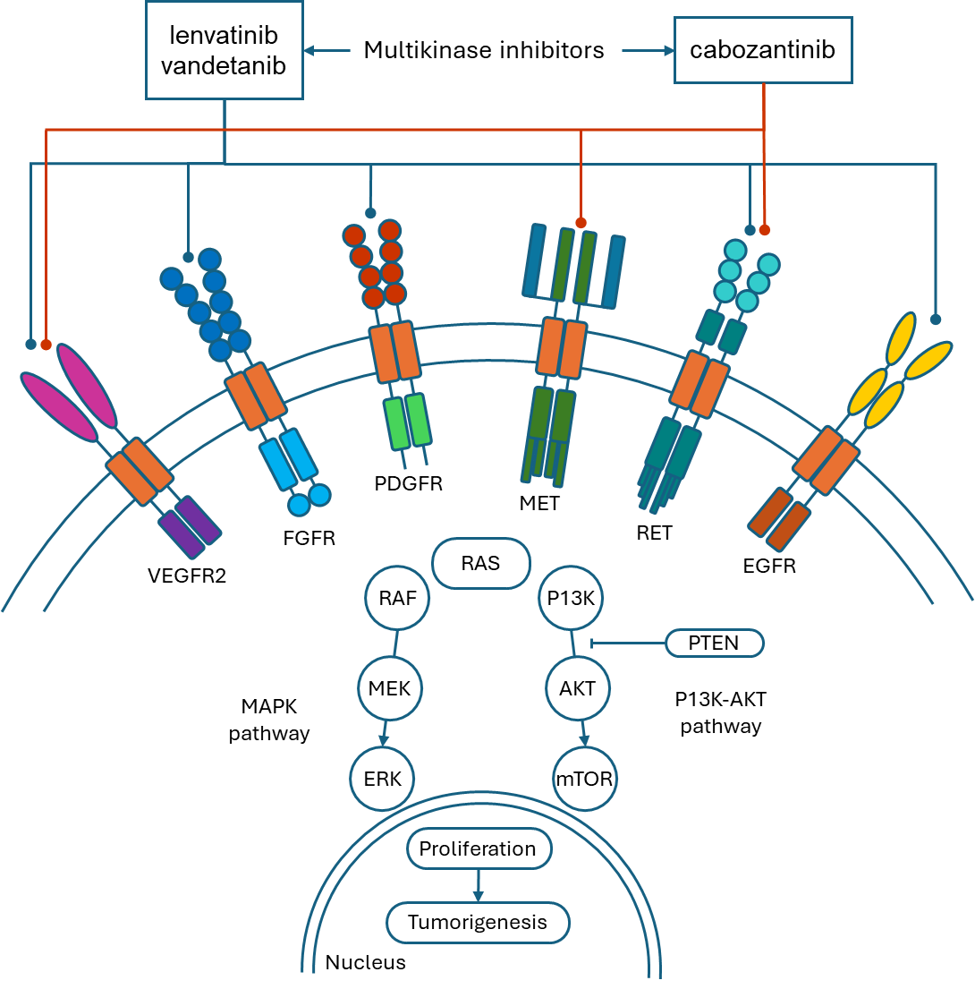
Figure 2 The inhibitor actions of MKIs
Adapted from Jara & Castroneves (2025)
EGFR = epidermal growth factor receptor; ERK = extracellular signal-regulated kinase; FGFR = fibroblast growth factor receptor; MEK = mitogen-activated protein kinase kinase; MET = MET proto-oncogene, receptor tyrosine kinase; mTOR = mechanistic target of rapamycin ; P13K = Phosphoinositide 3-Kinase; PDGFR = platelet-derived growth factor receptor; PTEN = phosphatase and tensin homolog; RAF = rapidly accelerated fibrosarcoma; RAS = rat sarcoma viral oncogene homolog; RET = ret proto-oncogene; VEGFR2 = vascular endothelial growth factor receptor 2
The comparative data provided by the key trial providing clinical effectiveness data (LIBRETTO-531) compares the effectiveness of selpercatinib versus the MKIs cabozantinib or vandetanib.
PASC noted that further consideration of the treatment comparator for the target population would be required, such as whether best supportive care is only relevant but acknowledged that confirming the appropriate comparator/s for the treatment is a matter for PBAC.

Clinical utility standard
In the key trial, LIBRETTO-531, RET variant status was determined by either PCR or NGS of tumour tissue or a blood sample (the same tests expected to be used in the Australian setting).
PASC noted that the clinical utility standard was the same as what is currently used in Australia for testing of activating RET variants (NGS or Sanger sequencing, which are well-established methods). PASC advised that a reference standard was not required, and that analytical validity was not required to be assessed.
PASC noted that a quality assurance program (QAP) would be required to be assessed and established by the Royal College of Pathologists of Australasia Quality Assurance Programs (RCPAQAP) for use in laboratories in Australia. PASC considered that a QAP should include training, standardisation and accuracy of RET variant testing, and the appropriate curation of activating RET variants (as in silico modelling is better validated for curation of loss of function variants).
PASC noted that the vast majority of RET activating variants are missense variants and not copy number variants.

Outcomes

Test-related outcomes

The applicant has enquired whether they would need to assess the analytical validity of RET variant testing. The department advised that in some circumstances analytical validity was not required to be presented as part of an integrated codependent submission, and that this question could be posed to PASC. The applicant advised that “Selpercatinib is not used in addition to total thyroidectomy. The treatment algorithms reflect that it should be used after thyroidectomy unless contraindicated which is in line with the LIBRETTO-531 trial design”.

Test-related considerations:
- Number of tumours estimated to be tested and impact on number of germline tests performed
- Number of tumours needed to test (to identify one additional eligible case for selpercatinib)
- Test turn-around time
- Rate of re-biopsy (including test failure and inadequate sample rate)
- Safety of re-biopsy

Clinical utility of test
- Treatment effect modification for selpercatinib in MTC patients with/without a clinically significant activating RET variant (predictive validity)

Change in management
- Proportion of cases eligible for selpercatinib who would actually receive it

Treatment-related outcomes
- Safety (including treatment-emergent adverse events)
- Overall survival (OS), progression free survival (PFS), overall response rate (ORR), comparative tolerability
- Health-related quality of life (HR-QoL)

Healthcare resources
- Cost of testing per patient (including costs of associated re-biopsies, test failure, inadequate sampling)
- Cost of treatments
- Cost of treating adverse events
- Financial implications (including the number of patients tested and treated)

PASC noted that the outcomes proposed were reasonable.
PASC suggested that the incremental benefit of testing tumour tissue in addition to germline testing, over germline testing alone should be made clear. For example, number needed to test to identify one additional eligible case for selpercatinib, as this number would differ depending on whether tumour tissue testing occurs prior to germline testing, in parallel with germline testing, or after germline testing.
PASC noted that the assessment report would need to demonstrate codependency between the proposed service and proposed treatment (i.e. between patient response to selpercatinib and having an activating RET variant), as the key trial (LIBRETTO-531) used to support the proposal does not address this since all patients had RET variants and patients without RET variants were excluded from the study.
PASC noted that most of the patients in the LIBRETTO-531 trial were positive for the RET codon M918T variant and requested further information on the frequency, distribution and curation of RET non-M918T variants across the study population.

Assessment framework (for investigative technologies)
The aim of the codependent application will be to demonstrate that testing for clinically significant activating RET variants and targeted treatment with selpercatinib results in superior health outcomes compared to no tumour variant testing and treatment with MKIs in patients with locally advanced or metastatic MTC. The key trial, LIBRETTO-531, is a randomised trial comparing selpercatinib versus MKIs in patients with clinically significant RET variants. This provides incomplete direct evidence (i.e. health outcomes only for those whose results identify a clinically significant RET variant) and does not make the relationship between the biomarker and medicine explicit. Further evidence will be required to supplement the key trial, in order to demonstrate that the medicine interacts with the biomarker (either directly through clinical evidence, or from in vitro studies, or by inference (e.g. if there is a biologically plausible basis to differentiate between those with and without clinically significant RET variants and response to the medicine)), as per Product type 4 of the PBAC guidelines.
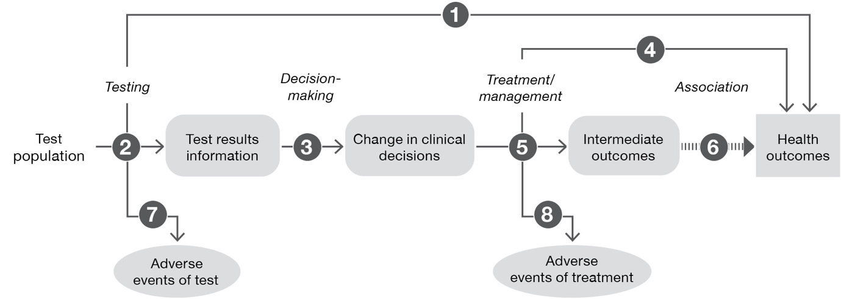
Figure 3 Generic assessment framework showing the links from the test population to health outcomes
Figure notes: 1: direct from test to health outcomes evidence; 2: test accuracy; 3: change in diagnosis/treatment/management; 4: influence of the change in management on health outcomes; 5: influence of the change in management on intermediate outcomes; 6: association of intermediate outcomes with health outcomes; 7: adverse events due to testing; 8: adverse events due to treatment
Research questions mapped to the assessment framework:
- What is the safety and effectiveness of RET variant testing of tumour tissue versus no RET testing of tumour tissue in patients with MTC to determine eligibility for treatment with Pharmaceutical Benefits Scheme (PBS) subsidised selpercatinib versus treatment with standard of care in those who have a clinically significant activating RET variants and advanced or metastatic MTC? (Direct evidence)?
- What is the diagnostic yield of RET variant testing of tumour tissue in patients with MTC compared to germline testing alone? (or the number needed to test to find one patient additional eligible for selpercatinib)?
Do results from RET variant testing predict a treatment effect modification with selpercatinib?
- What proportion of patients eligible for selpercatinib based on RET activating variant status, meet all other eligibility criteria and receive the treatment? (note, evidence that patients are treated consistent with test results may be assumed for a codependent biomarker and medicine)
- What is the effectiveness of selpercatinib vs MKIs for overall survival in those with locally advanced or metastatic MTC and have a clinically significant activating RET variant?
- What is the effectiveness of selpercatinib versus MKIs on the outcomes of progression-free survival and objective response rate in those with locally advanced or metastatic MTC and have a clinically significant activating RET variant? (if required)
- How valid is the link between progression-free survival or objective response rate and overall survival in patients with MTC? (if claim is based on these outcomes rather than overall survival)
- What is the rate of rebiopsy required due to insufficient tissue available for testing, and are there any adverse events associated with rebiopsy?
- What is the safety of selpercatinib vs MKIs in those locally advanced or metastatic MTC who have a clinically significant activating RET variant?

PASC noted and accepted the assessment framework.

Clinical management algorithms

Current clinical management algorithm
Currently patients with a clinical diagnosis of MTC, hereditary or sporadic, are treated with standard of care, which includes surgery as the primary treatment. In cases of locally advanced or metastatic disease following surgery, patients are treated with MKIs, and/or pharmacological interventions such as systemic therapies to manage symptoms. Patients with MTC are suspected of having MEN2, and currently undergo germline RET variant testing under MBS item 73339. There are no MBS-funded means of testing tumour tissue for RET variants (so although current standard of care includes this testing through the state funded hospital system, it is excluded from the current clinical management algorithm).

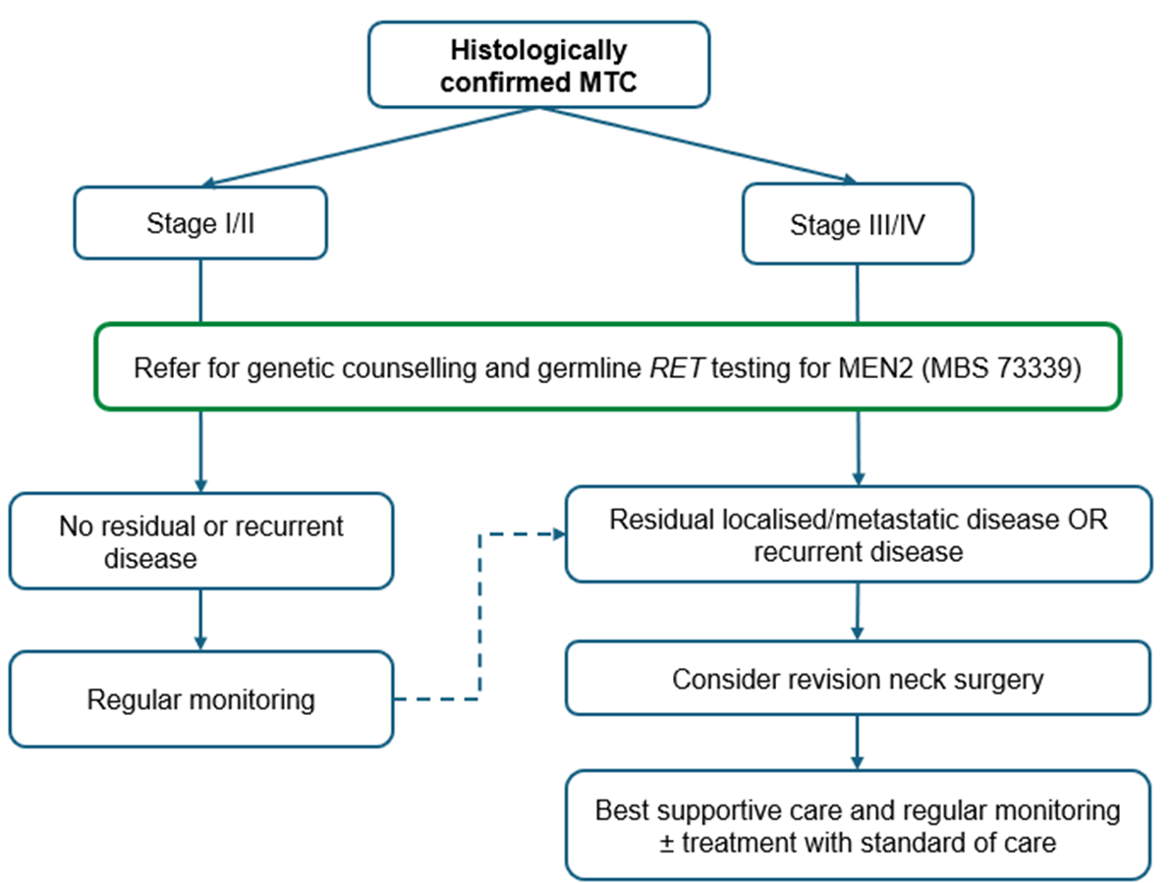
Figure 4 Current clinical management algorithm showing germline RET variant testing for MEN2, but no RET variant testing of tumour tissue
MBS = Medicare Benefits Schedule; MEN2 = multiple endocrine neoplasia 2; MTC = medullary thyroid cancer; RET = ret proto-oncogene

Proposed clinical management algorithm
The proposal is that patients accessing the proposed health technology, RET variant testing of tumour tissue, will continue to be treated with best supportive care and monitoring with the replacement of standard of care with selpercatinib in those with either a somatic or germline activating RET variant (or those with variants in tumour tissue whose origin is unknown. RET variant testing will enable identification of eligible patients for PBS-subsidised selpercatinib. Healthcare resources used in conjunction with the proposed health technology (e.g., tumour biopsy, surgical resection, pathology assessment, specialist consultations) are already part of routine MTC management.
The applicant’s clinical experts suggested that there are two main ways in which the germline and tumour tissue testing may occur, with some patients being tested via option 1, while others will be tested via option 2:
Note: This section includes the estimated number of patients to be tested for the various scenarios and these numbers were estimated using the data in the section titled ‘Prevalence of MTC / Estimated size of target population (for testing)’ found in Tables 2 and 3. Note that these estimated numbers are approximate only.
Option 1: (tumour testing at the point of progression)
- Patients with stage I or II MTC (87 in 2026, increasing to 103 in 2030) are referred for germline RET variant testing (using existing MBS item 73339) at the point of diagnosis:
  - 25% would have a clinically significant germline RET variant (assuming prognostic factors and disease progression do not differ between those with or without RET variants). These patients would not require tumour testing.
  - If wildtype, then testing of tumour tissue would be indicated at the point of progression to stage III/IV. There would be an estimated 68 patients progressing in 2026, increasing to 81 in 2030. Of these, 75% would require RET variant testing of tumour tissue (51-61 patients per year).
- When stage III or IV disease is diagnosed in incident cases (102-121 per year), then testing of tumour tissue for a RET variant is indicated (proposed MBS item, Tables 6 and 7).
  - Those with activating RET variants would be referred for germline testing (under existing MBS item 73339). 70% of all MTC cases have a clinically significant RET variant, so 71-85 patients would be referred for germline RET testing for the purposes of determining if they have MEN2.
- Thus, there would be a total of 153 tumour tissue tests using proposed MBS item in 2026 (51 who have progressed to stage III/IV and are germline RET negative, and 102 diagnosed at stage III/IV), increasing to 182 tests in 2030 (61 who progressed to stage III/IV and are germline RET negative, and 121 newly diagnosed stage III/IV cases). In addition, there would be 158 (87 stage I/II +71 stage III/IV) germline tests performed in 2026, increasing to 188 (103+85) by 2030.
Option 2: (tumour testing irrespective of stage)
- Patients with MTC undergo RET testing on tumour tissue (proposed MBS item).
  - This would result in all incident cases being tested, resulting in 189 tests in 2026, increasing to 224 tests in 2030.
  - A few additional patients, diagnosed in previous years, progressing to stage III/IV who have not yet been tested will also require testing in the first few years (30 in 2026, decreasing to 3 in 2030)
  - Thus, there would be a total of 219 tests using proposed MBS item 1 in 2026, and 227 tests in 2030.
- Patients positive for a RET variant on tumour tissue are referred for germline RET testing for the identified variant.
  - As 70% of all MTC cases have a clinically significant RET variant, approximately 160 patients per year would require germline RET testing for a known variant between 2026 and 2030.
- Patients negative for RET variants on tumour tissue have neither somatic or germline RET variants, and therefore do not need germline RET testing.
If testing for germline RET variant status is required, patients are referred to a genetic service for this test. If a germline pathogenic or likely pathogenic variant is identified, cascade testing of their close relatives (MBS 73340) should also be undertaken. Two different proposed clinical management algorithms for RET variant testing of tumour tissue either in advanced or metastatic MTC (Option 1, Figure 5) or after surgery for all MTC patients (Option 2, Figure 6) are shown.
Patients with MTC harbouring a wild type RET gene will still be treated with a MKI if they have locally advanced or metastatic disease even though MKIs are not active against RAS variants (the most common oncogenic driver in the absence of RET variants). This is because the primary therapeutic target of MKIs is VEGFR2 to inhibit angiogenesis, which will interfere with the tumour’s ability to grow.
PASC noted that the applicant’s clinical expert suggested that MTC is only confirmed after surgical resection of the MTC and germline RET testing would occur after that.
PASC advised that best supportive care for patients who cannot tolerate standard of care should be added. The clinical management algorithms have been updated accordingly.
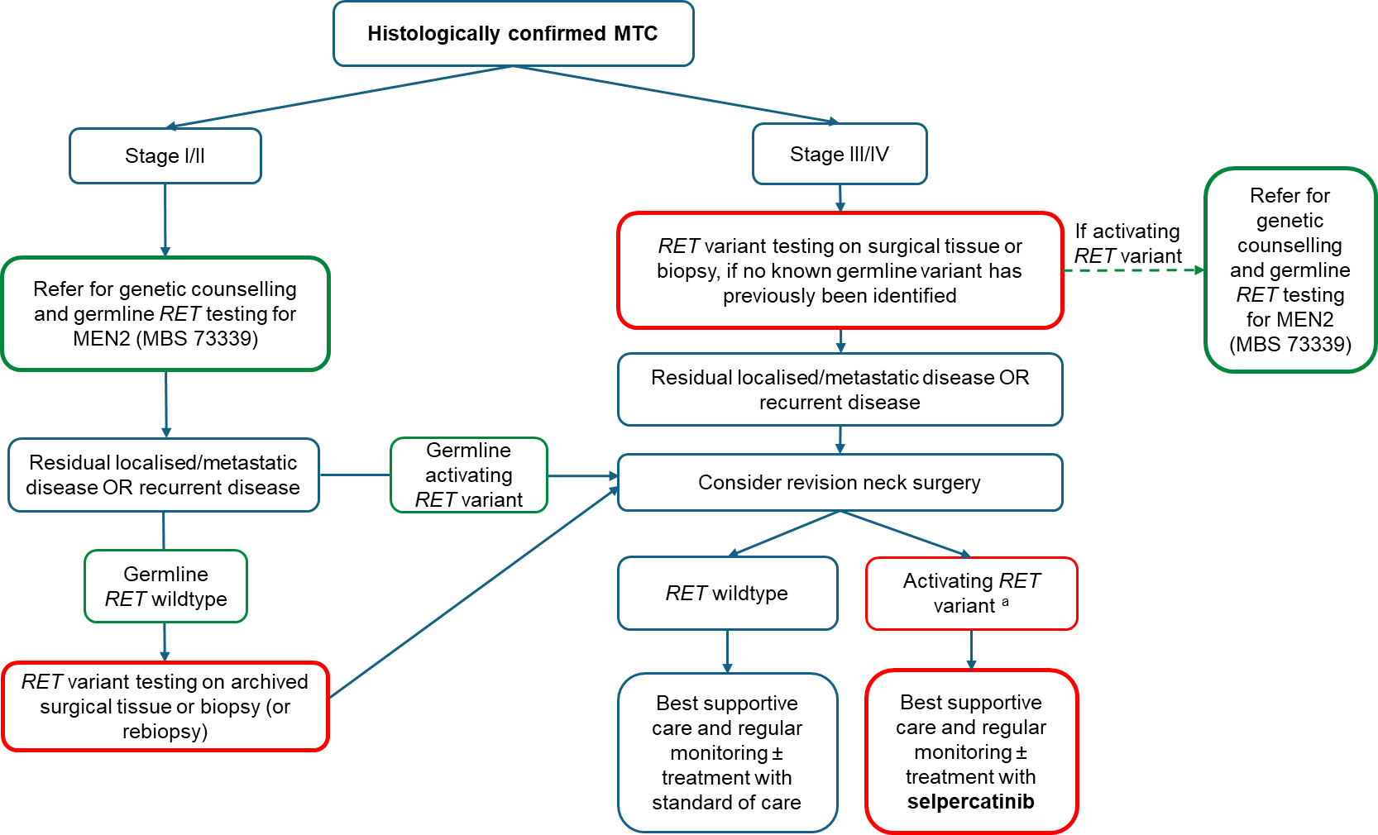

Figure 5 Proposed clinical management algorithm showing RET variant testing of tumour tissue in advanced or metastatic MTC (Option 1- tumour testing at point of progression)
MBS = Medicare Benefits Schedule; MEN2 = multiple endocrine neoplasia 2; MTC = medullary thyroid cancer; RET = ret proto-oncogene
ª On either testing of tumour tissue or germline testing
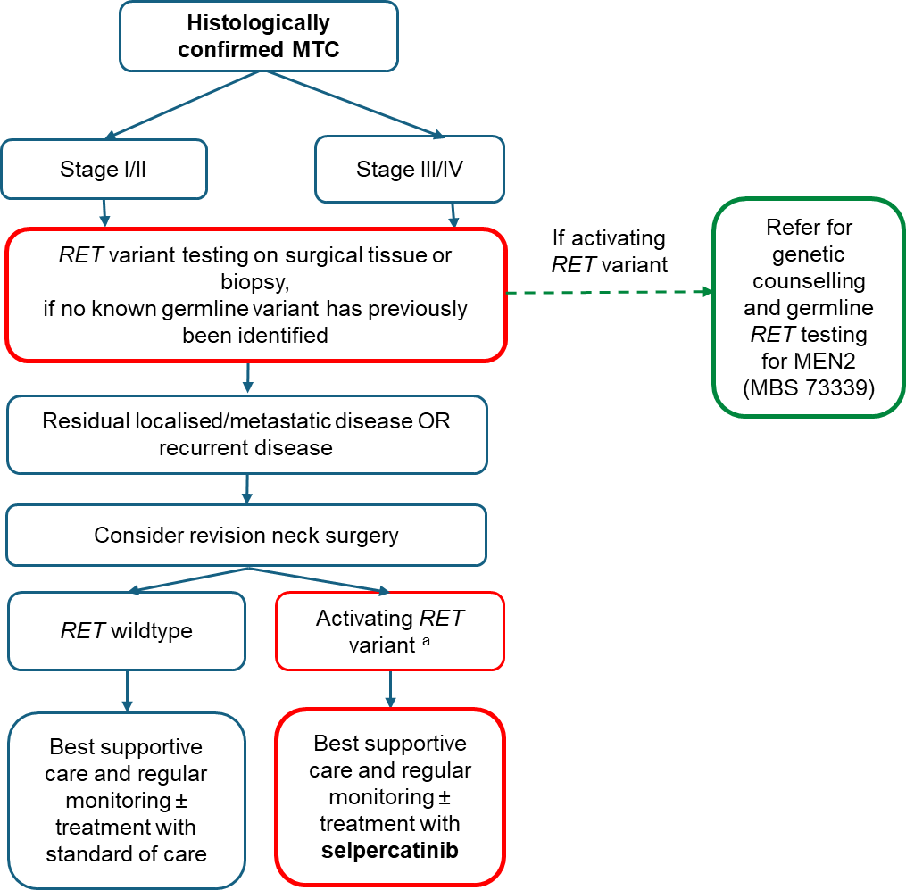

Figure 6 Proposed clinical management algorithm showing RET variant testing of tumour tissue after surgical resection of MTC (Option 2 -tumour testing irrespective of stage)
MBS = Medicare Benefits Schedule; MEN2 = multiple endocrine neoplasia 2; MTC = medullary thyroid cancer; RET = ret proto-oncogene
ª On either testing of tumour tissue or germline testing

Proposed economic evaluation
The anticipated clinical claim is that the proposed codependent technologies (RET variant testing and in patients with advanced or metastatic MTC and a clinically significant RET variant, selpercatinib as targeted therapy) are superior in effectiveness and has an acceptable safety profile, compared to no RET variant testing and standard of care including MKIs (cabozantinib or vandetanib) in patients with advanced or metastatic MTC. The appropriate type of economic evaluation in the assessment report would either be a cost-effective analysis (CEA) or a cost-utility analysis (CUA), as indicated in Table 5.
The main clinical evidence for the effectiveness of the treatment is from a global, multicentre randomised, open-label (sponsor blinded), controlled, phase III trial (LIBRETTO-531). This trial provides evidence of the efficacy and safety of selpercatinib versus physician’s choice of cabozantinib or vandetanib in treatment-naïve, advanced or metastatic MTC patients with a clinically significant activating RET variant. Evidence from this trial demonstrated treatment with selpercatinib produced clinically meaningful improvement across multiple endpoints, including disease progression and survival. There were also fewer adverse events with selpercatinib compared with cabozantinib or vandetanib.
PASC noted the anticipated clinical claim is that the proposed codependent technologies (RET variant testing and in patients with advanced or metastatic MTC and a clinically significant RET variant, selpercatinib as targeted therapy) are superior in effectiveness and has a non-inferior safety profile, compared to no RET variant testing and standard of care in patients with advanced or metastatic MTC.
Table 5 Classification of comparative effectiveness and safety of the proposed intervention, compared with its main comparator, and guide to the suitable type of economic evaluation
Comparative safety |  | Comparative effectiveness
Comparative safety | Inferior | Uncertainª | Noninferior^{b} | Superior
Inferior | Health forgone: need other supportive factors | Health forgone possible: need other supportive factors | Health forgone: need other supportive factors | ? Likely CUA
Uncertainª | Health forgone possible: need other supportive factors | ? | ? | ? Likely CEA/CUA
Noninferior^{b} | Health forgone: need other supportive factors | ? | CMA | CEA/CUA
Superior | ? Likely CUA | ? Likely CEA/CUA | CEA/CUA | CEA/CUA
CEA=cost-effectiveness analysis; CMA=cost-minimisation analysis; CUA=cost-utility analysis
? = reflect uncertainties and any identified health trade-offs in the economic evaluation, as a minimum in a cost-consequences analysis
a ‘Uncertainty’ covers concepts such as inadequate minimisation of important sources of bias, lack of statistical significance in an underpowered trial, detecting clinically unimportant therapeutic differences, inconsistent results across trials, and trade-offs within the comparative effectiveness and/or the comparative safety considerations
b An adequate assessment of ‘noninferiority’ is the preferred basis for demonstrating equivalence

Proposal for public funding
Currently, germline RET variant testing is standard practice in Australia and is MBS-funded for patients with a suspected clinical diagnosis of MEN2. There is no MBS funding for RET variant testing of tumour tissue, however, RET variant testing services are provided in public hospitals funded under state and territory hospital funding arrangements, or may occur in a private setting (funded privately by the patient or the clinic).
Table 6 provides a proposed MBS item for RET variant testing of tumour tissue suggested by PASC.
If testing is restricted to patients with advanced or metastatic MTC (as per the original application), the MSAC may wish to consider whether the item should include the stage of disease in the item descriptor.
Table 6 Proposed MBS item for RET variant testing of tumour tissue (suggested by PASC)
Category 6 – Pathology Services​
MBS item *YYYY Group P7 – Genetics ​
Detection in tumour tissue of rearranged during transfection ret proto-oncogene (RET) gene likely pathogenic or pathogenic activating variant status in a patient with histologically confirmed medullary thyroid cancer requested by, or on behalf of a specialist or consultant physician to determine eligibility for a relevant treatment listed under the Pharmaceutical Benefits Scheme (PBS). ​

Applicable once per lifetime. ​
Fee: $400.00 Benefit 75% $300.00 85% $340.00 ​
Strikethrough indicates deletions and green text indicates additions suggested by PASC
The proposed MBS fee of $400 is consistent with other MBS listed pathology services for mutation testing in a single gene for a test of tumour tissue (e.g. item 73338 for RAS mutation testing) and is consistent with the fee for MBS item 73339 for detection of germline clinically significant variants in the RET gene.
If testing of tumour tissue identifies a clinically significant activating RET variant, germline testing would still be warranted if the patient is suspected of having MEN2 and has not already undergone germline testing. Patients would be referred to a familial cancer centre, who would order the germline test. Patients would be eligible for germline testing under the existing MBS item 73339.
PASC noted that the MBS item would likely be used once per lifetime, but suggested omitting this restriction, as in the future, there may be resistant variants that would be worthwhile identifying after treatment.
PASC considered the proposed fee to be reasonable and comparable to other single gene tests listed on the MBS.
PASC considered that somatic RET test may have familial consequences and that testing should be discussed and ordered by the patient’s treating clinician only and therefore the proposed item should not be pathologist determinable.
PASC advised against the creation of an additional MBS item for variant specific germline testing, which was proposed for use following a positive tumour test to identify whether a variant is somatic or germline. The reasoning for this, was that the proposed item would likely be redundant, as all patients with MTC are currently able to access the existing MBS item for germline testing. PASC considered that there would be a small cost benefit from the proposed less expensive item, but it was uncertain whether the proposed item would be used or not.

Summary of public consultation input
PASC noted and welcomed consultation input from 5 organisations, the organisations that submitted input were:
- NeuroEndocrine Cancer Australia (NECA)
- Omico
- Public Pathology Australia (PPA)
- Rare Cancers Australia (RCA)
- Royal College of Pathologists of Australasia (RCPA).
Consultation input was supportive of public funding for testing options to detect RET variants in patients with MTC to determine eligibility for PBS subsidised selpercatinib treatment.
Consumer Input
RCA and NECA input included individuals experiences with MTC and RET testing. Input stated that treatment options for MTC remain limited and included radiation therapy, theranostics, non-targeted therapies, and extensive surgeries, which can have significant side effects and uncertain outcomes. Both inputs stated that much of the testing and treatment for MTC was self-funded and was a financial burden in addition to the physical and emotional burden of having cancer. RCA input also included a patient’s experience of accessing RET-targeted therapy, which lead to a significantly improved quality of life compared to conventional therapies.
Benefits and Disadvantages
The main benefits of public funding reported in the consultation input included refining the diagnosis of MTC, guiding treatment decisions, and providing access to more targeted and better-tolerated treatment. The RCPA stated that public funding of RET testing would align MTC management in Australia with current clinical practice guidelines. NECA stated that RET testing provided information that allowed individuals to be confident in their care and could significantly reduce emotional distress and uncertainty.
A disadvantage of public funding reported in the consultation input was the stress associated with the chance of identifying a heritable variant.
Population, Comparator (current management) and Delivery
The consultation input agreed with the proposed population and comparator, noting that individuals with rare cancers such as MTC are an underserved population with limited treatment options.
Other services identified in the consultation input as being needed to be delivered before or after the intervention included the need for counselling services for individuals with a heritable variant identified.
MBS Item Descriptor and Fee
The consultation input partially agreed with the proposed service descriptor. RCPA recommended the wording refer to “pathological diagnosis” rather than “clinical diagnosis” and specify somatic testing. The RCPA also supported the item being pathologist determinable.
The consultation input ranged from agreeing to disagreeing with the proposed service fee. PPA stated that at least one laboratory could adapt an existing small solid tumour NGS panel for RET testing in MTC and that the proposed fee of $400 was adequate. NECA stated the fee was appropriate and in line with comparable genetic tests. The RCPA stated that the true cost of testing via NGS was more closely aligned with MBS item 73438, which is priced at $682.35 for a small gene panel, and strongly recommended aligning the RET testing fee with the small panel fee to avoid potential out of pocket costs for patients.
Additional Comments
NECA noted that selpercatinib is an oral therapy, and that not having to travel to attend intravenous therapy can make a meaningful difference, particularly for patients living in rural or remote areas.
PASC noted that public consultation responses from 5 organisations were supportive of creating an MBS item for testing of tumour tissue for patients with MTCs to determine eligibility for relevant treatment on the PBS.
PASC noted that the RCPA were supportive of the application and somatic test being pathologist determinable. PASC noted that the RCPA considered the fee was too low and had suggested that a fee of $682 was more appropriate, and were concerned that some laboratories would not be able to provide the testing at a fee of $400. PASC noted that testing of a single gene should not cost the same as a small gene panel, and considered that every laboratory would not need to be able to test for RET variants, given the small number of patients expected to be tested.

Next steps
PASC noted the applicant confirmed that an applicant developed assessment report (ADAR) will be prepared.

Applicant Comments on Ratified PICO
The applicant had no comment.

References
Angelousi, A, Hayes, AR, Chatzellis, E, Kaltsas, GA & Grossman, AB 2022, 'Metastatic medullary thyroid carcinoma: a new way forward', Endocr Relat Cancer, vol. 29, no. 7, May 31, pp. R85-r103 10.1530/erc-21-0368.
Bagheri-Yarmand, R, Grubbs, EG & Hofmann, MC 2025, 'Thyroid C-Cell Biology and Oncogenic Transformation', Recent Results Cancer Res, vol. 223, pp. 51-91 10.1007/978-3-031-80396-3_3.
Bai, Y, Niu, D, Yao, Q, Lin, D & Kakudo, K 2020, 'Updates in the advances of sporadic medullary thyroid carcinoma: from the molecules to the clinic', Gland Surg, vol. 9, no. 5, Oct, pp. 1847-1856 10.21037/gs-2019-catp-21.
Block, M, Jackson, C, Greenawald, K, Yott, J & Tashjian, A 1980, 'Clinical Characteristics Distinguishing Hereditary From Sporadic Medullary Thyroid Carcinoma: Treatment Implications', Archives of Surgery vol. 115, no. 2, pp. 142-148
Boucai, L, Zafereo, M & Cabanillas, ME 2024, 'Thyroid Cancer: A Review', Jama, vol. 331, no. 5, Feb 6, pp. 425-435 10.1001/jama.2023.26348.
Clifton-Bligh, RJ 2025, 'Mechanisms of resistance to RET-directed therapies', Endocr Relat Cancer, vol. 32, no. 2, Feb 1, 10.1530/erc-24-0224.
Gild, ML, Clifton-Bligh, RJ, Wirth, LJ & Robinson, BG 2023, 'Medullary Thyroid Cancer: Updates and Challenges', Endocr Rev, vol. 44, no. 5, Sep 15, pp. 934-946 10.1210/endrev/bnad013.
Hadoux, J, Al Ghuzlan, A, Lamartina, L, Bani, MA, Moog, S, Attard, M, Scoazec, JY, Hartl, D, Aldea, M, Friboulet, L, Jules-Clement, G, Italiano, A, Besse, B, Lacroix, L & Baudin, E 2023, 'Patterns of Treatment Failure After Selective Rearranged During Transfection (RET) Inhibitors in Patients With Metastatic Medullary Thyroid Carcinoma', JCO Precis Oncol, vol. 7, Sep, p. e2300053 10.1200/po.23.00053.
Hamidi, S & Hu, MI 2024, 'RET kinase inhibitors for the treatment of RET-altered thyroid cancers: Current knowledge and future directions', Annales d'Endocrinologie, vol. 85, no. 2, 2024/04/01/, pp. 118-126 https://doi.org/10.1016/j.ando.2024.02.001.
Hazard, JB 1977, 'The C cells (parafollicular cells) of the thyroid gland and medullary thyroid carcinoma. A review', Am J Pathol, vol. 88, no. 1, Jul, pp. 213-250
Horne, HN, Roscoe, D, Litwack, ED, Pathak, A, Pandey, JP, Gallagher, PS, Koontz, LM, Schuck, RN, Lee, EY, Hu, YF, Beaver, JA, Blumenthal, GM & Philip, R 2019, 'Weighing the Evidence: Variant Classification and Interpretation in Precision Oncology, US Food and Drug Administration Public Workshop-Workshop Proceedings', JCO Precis Oncol, vol. 3, 10.1200/po.18.00314.
Jara, MA & Castroneves, LA 2025, 'Overview of management and therapeutic advances in medullary thyroid cancer', Endocr Oncol, vol. 5, no. 1, Jan, p. e240077 10.1530/eo-24-0077.
Kesby, NL, Papachristos, AJ, Gild, M, Aniss, A, Sywak, MS, Clifton-Bligh, R, Sidhu, SB & Glover, AR 2022, 'Outcomes of Advanced Medullary Thyroid Carcinoma in the Era of Targeted Therapy', Ann Surg Oncol, vol. 29, no. 1, Jan, pp. 64-71 10.1245/s10434-021-10980-5.
Morgenstern, DA, Casanova, M, van Tilburg, CM, Ziegler, DS, Campbell, M, Watt, TC, Pappo, AS, Laetsch, TW, Liu, D, Liming, K, Kang, S, Wright, J & Kang, HJ 2024, 'Safety and efficacy of selpercatinib in pediatric patients with RET-altered solid tumors: Updated results from LIBRETTO-121', Journal of Clinical Oncology, vol. 42, no. 16_suppl, pp. 10022-10022 10.1200/JCO.2024.42.16_suppl.10022.
Papachristos, AJ, Nicholls, LE, Mechera, R, Aniss, AM, Robinson, B, Clifton-Bligh, R, Gill, AJ, Learoyd, D, Sidhu, SB, Glover, A, Delbridge, L & Sywak, M 2023, 'Management of Medullary Thyroid Cancer: Patterns of Recurrence and Outcomes of Reoperative Surgery', Oncologist, vol. 28, no. 12, Dec 11, pp. 1064-1071 10.1093/oncolo/oyad232.
Parimi, V, Tolba, K, Danziger, N, Kuang, Z, Sun, D, Lin, DI, Hiemenz, MC, Schrock, AB, Ross, JS, Oxnard, GR & Huang, RSP 2023, 'Genomic landscape of 891 RET fusions detected across diverse solid tumor types', NPJ Precis Oncol, vol. 7, no. 1, Jan 23, p. 10 10.1038/s41698-023-00347-2.
Raue, F & Frank-Raue, K 2015, 'Epidemiology and Clinical Presentation of Medullary Thyroid Carcinoma', in F Raue (ed.), Medullary Thyroid Carcinoma: Biology – Management – Treatment, Springer International Publishing, Cham, pp. 61-90.
Raue, F & Frank-Raue, K 2025, 'Long-Term Follow-Up in Medullary Thyroid Carcinoma Patients', Recent Results Cancer Res, vol. 223, pp. 267-291 10.1007/978-3-031-80396-3_11.
Richards, S, Aziz, N, Bale, S, Bick, D, Das, S, Gastier-Foster, J, Grody, WW, Hegde, M, Lyon, E, Spector, E, Voelkerding, K & Rehm, HL 2015, 'Standards and guidelines for the interpretation of sequence variants: a joint consensus recommendation of the American College of Medical Genetics and Genomics and the Association for Molecular Pathology', Genet Med, vol. 17, no. 5, May, pp. 405-424 10.1038/gim.2015.30.
Santoro, M & Carlomagno, F 2013, 'Central role of RET in thyroid cancer', Cold Spring Harb Perspect Biol, vol. 5, no. 12, Dec 1, p. a009233 10.1101/cshperspect.a009233.
Scurini, C, Quadro, L, Fattoruso, O, Verga, U, Libroia, A, Lupoli, G, Cascone, E, Marzano, L, Paracchi, S, Busnardo, B, Girelli, ME, Bellastella, A & Colantuoni, V 1998, 'Germline and somatic mutations of the RET proto-oncogene in apparently sporadic medullary thyroid carcinomas', Molecular and Cellular Endocrinology, vol. 137, no. 1, 1998/02/13/, pp. 51-57 https://doi.org/10.1016/S0303-7207(97)00234-7.
Walker, TJ & Mulligan, LM 2025, 'Cellular mechanisms of RET receptor dysfunction in multiple endocrine neoplasia 2', Endocr Relat Cancer, vol. 32, no. 1, Jan 1, 10.1530/erc-24-0187.
Williams, JP, Stewart, T, Li, B, Mulloy, R, Dimova, D & Classon, M 2006, 'The retinoblastoma protein is required for Ras-induced oncogenic transformation', Mol Cell Biol, vol. 26, no. 4, Feb, pp. 1170-1182 10.1128/mcb.26.4.1170-1182.2006.
Wirth, LJ, Sherman, E, Robinson, B, Solomon, B, Kang, H, Lorch, J, Worden, F, Brose, M, Patel, J, Leboulleux, S, Godbert, Y, Barlesi, F, Morris, JC, Owonikoko, TK, Tan, DSW, Gautschi, O, Weiss, J, de la Fouchardiere, C, Burkard, ME, Laskin, J, Taylor, MH, Kroiss, M, Medioni, J, Goldman, JW, Bauer, TM, Levy, B, Zhu, VW, Lakhani, N, Moreno, V, Ebata, K, Nguyen, M, Heirich, D, Zhu, EY, Huang, X, Yang, L, Kherani, J, Rothenberg, SM, Drilon, A, Subbiah, V, Shah, MH & Cabanillas, ME 2020, 'Efficacy of Selpercatinib in RET-Altered Thyroid Cancers', N Engl J Med, vol. 383, no. 9, Aug 27, pp. 825-835 10.1056/NEJMoa2005651.

Cancer Australia. Thyroid cancer in Australia statistics. URRL: https://www.canceraustralia.gov.au/cancer-types/thyroid-cancer/thyroid-cancer-australia-statistics. Accessed 17 June 2025, last updated 8 October 2024.
Provided pre-PASC by the applicants
Australian Institute of Health and Welfare (AIHW) https://www.aihw.gov.au/reports/cancer/cancer-data-in-australia/contents/overview Accessed 24 June 2025, Last updated 15 August 2024.
Cancer Australia, Types of thyroid cancer https://www.canceraustralia.gov.au/cancer-types/thyroid-cancer/types-thyroid-cancer Accessed 24 June 2025, Last updated 8 October 2024.
Somatic variants are spontaneous and present only in tumour tissue, whereas germline variants are present in all calls in the body, including those in tumour tissue.
https://pbac.pbs.gov.au/section-1/1-1-clinical-issue-addressed_by-the-submission.html
Note that there has been a shift in preferred language since the items that mention ‘mutation’ were added. The preferred term is now ‘variant’.

