MSAC Application 1806

Marstacimab for routine prophylaxis to prevent bleeding in patients with haemophilia

Applicant: Pfizer Australia Pty Ltd

PICO Confirmation

Summary of PICO criteria to define questions to be addressed in an Assessment Report to the Medical Services Advisory Committee (MSAC)
Table 1 PICO for Marstacimab in patients with Haemophilia A (PICO Set 1) and Haemophilia B (PICO Set 2)
Component | Description
Population | PICO Set 1  Children and adults aged 12 years and older with severe haemophilia A (congenital factor VIII deficiency, FVIII < 1%) without Factor VIII inhibitors | PICO Set 2  Children and adults aged 12 years and older with severe haemophilia B (congenital factor IX deficiency, FIX <1%) without Factor IX inhibitors
Intervention | Marstacimab (for prophylaxis)
Comparators | 1. Emicizumab (for prophylaxis)  2. Extended half-life (EHL) factor VIII products (for prophylaxis) | 1. EHL factor IX products (for prophylaxis)
Outcomes | Safety  - Adverse events (e.g. injection site reactions)  - Serious adverse events (including thrombotic events)  - Immunogenicity (antidrug antibodies, neutralising antibodies)  Effectiveness  - Annualised bleeding rates (overall, categorised bleed severity, surgical/non-surgical, and site/type specific)  - Volume of factor (FVIII/FIX) replacement required for breakthrough bleeds  - Joint health outcomes  - Health-related quality of life  - Number of missed days of work/activity/school  Cost and cost-effectiveness  - Financial implications (costs and cost-offsets including total factor and/or monoclonal antibody consumption (incorporating increase in dose), costs of delivering the intervention, costs of managing adverse events or breakthrough bleeding)  - Cost-effectiveness  Other relevant considerations  - Patient preference  - Treatment burden e.g. administration time, impact on lifestyle, ability to travel  - Adherence to treatment
Assessment questions | 1. What is the safety, effectiveness and cost-effectiveness of marstacimab prophylaxis versus emicizumab prophylaxis in the severe Haemophilia A without factor VIII inhibitor population?  2. What is the safety, effectiveness and cost-effectiveness of marstacimab prophylaxis versus EHL factor VIII prophylaxis in the severe Haemophilia A without factor VIII inhibitor population? | 1. What is the safety, effectiveness and cost-effectiveness of marstacimab prophylaxis versus EHL factor IX prophylaxis in the severe Haemophilia B without factor IX inhibitor population?

Purpose of application
An application requesting listing of marstacimab for severe haemophilia A or B on the National Products Price List (NPPL), managed by the National Blood Authority (NBA), was received from Pfizer by the Department of Health, Disability and Ageing.
Public funding for blood and blood-related products is facilitated through the national blood arrangements outlined in the National Blood Agreement and managed by the NBA on behalf of all governments. Blood and blood related products included in the national blood arrangements are agreed to by Australian governments and listed on the NPPL. Schedule 4 of the National Blood Agreement provides for evidence-based evaluation and advice to governments to support decisions regarding changes to products funded under the National Blood Agreement, including assessment by MSAC where required.
Clinical claim
In children and adults aged 12 years and older with severe haemophilia A (HMA), without factor eight (FVIII) inhibitors:
- Use of marstacimab results in superior efficacy in comparison to FVIII prophylaxis; and non-inferior efficacy to emicizumab; in terms of annualised bleeding rate (ABR).
- Use of marstacimab results in non-inferior safety in comparison to FVIII prophylaxis and emicizumab in terms of adverse events.
In children and adults aged 12 years and older with severe haemophilia B (HMB), without factor nine (FIX) inhibitors:
- Use of marstacimab results in superior efficacy in comparison to FIX prophylaxis in terms of ABR.
- Use of marstacimab results in non-inferior safety in comparison to FIX prophylaxis in terms of adverse events.

PICO criteria

Population
Patients proposed to be eligible for treatment with marstacimab include children and adults aged 12 years and over with severe HMA (congenital factor VIII deficiency, FVIII < 1%) or severe HMB (congenital factor IX deficiency, FIX <1%) without inhibitors to FVIII or FIX. This population aligns with the registered indication for marstacimab listed in the Australian Register of Therapeutic Goods (ARTG) in 2025 (ID 438990).
In the pre-PASC meeting, the applicant specified that an absence of inhibitors refers to active inhibitors and that individuals who have had a history of inhibitors (but do not currently have active inhibitors) will still be eligible for marstacimab.
Haemophilia is an X-linked congenital bleeding disorder, caused by a deficiency in a coagulation FVIII in HMA or coagulation FIX in HMB. This deficiency arises from the variants in the F8 or F9 genes, which encode the respective clotting factors. As illustrated in Figure 1, the clotting cascade involves a complex interaction of the coagulation factors. In HMA and HMB, the disruption of FVIII and FIX impairs the cascade, resulting in prolonged bleeding.
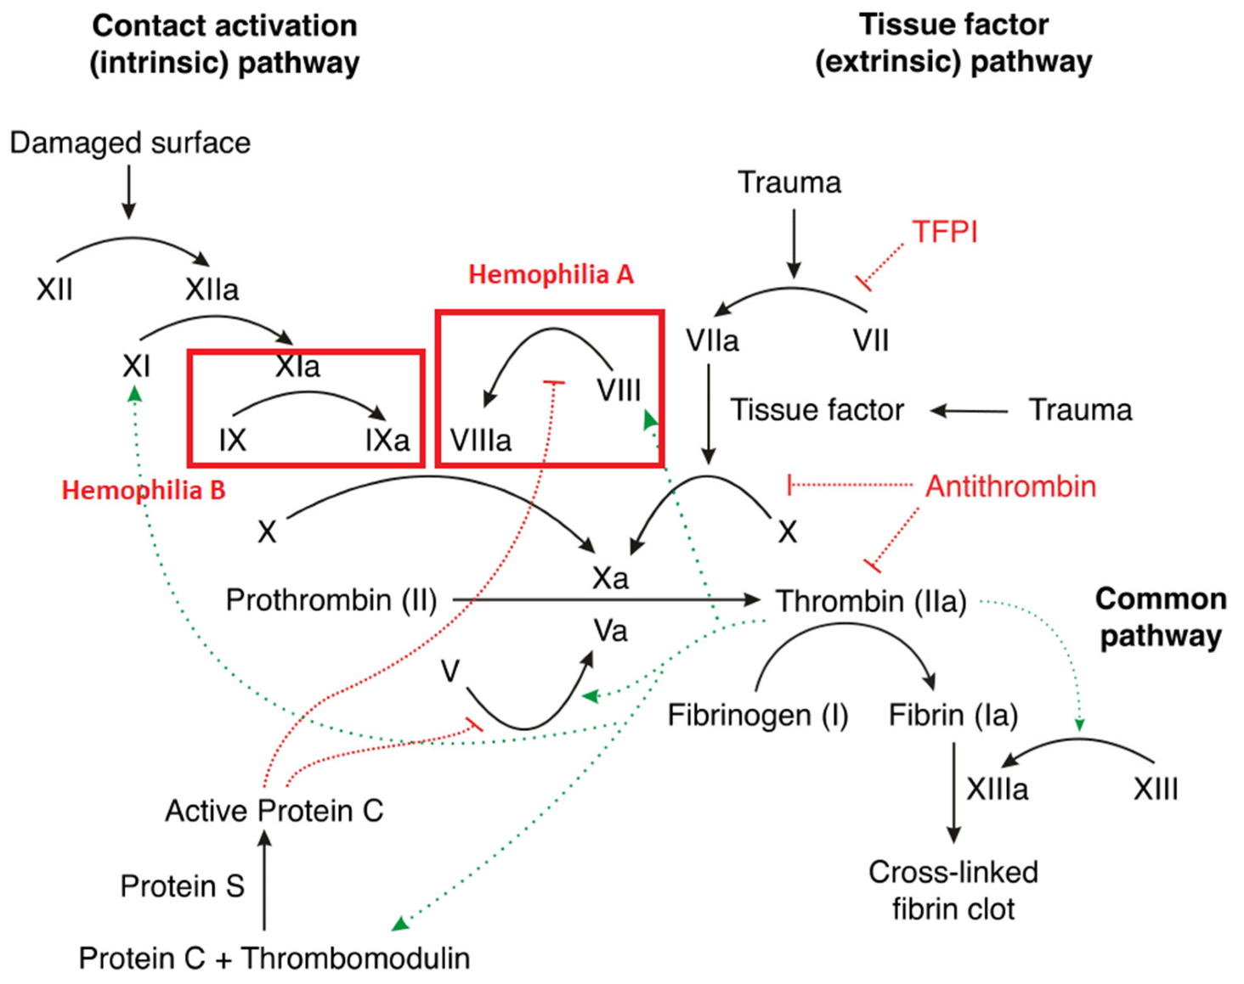
Figure 1 The clotting cascade
Source: Figure 1 Badulescu et al. (2024) Licensed under Creative Commons Attribution (CC BY) license (https://creativecommons.org/licenses/by/4.0/)
TFPI = tissue factor pathway inhibitor.
Note: the factors affected by marstacimab (IX and VIII) are highlighted in red boxes.
Haemophilia typically affects males and is inherited through the maternal line due to being X-linked. However, females who carry a variant in a clotting factor gene can also have reduced levels of clotting factor and may be diagnosed with haemophilia. Additionally, both F8 and F9 genes are susceptible to de novo variants, and up to one-third of haemophilia cases arise from spontaneous variants with no prior family history (Srivastava et al. 2020).
There are three levels of haemophilia: mild, moderate and severe. The level of severity depends on the amount of clotting factor activity in the person’s blood as shown in Table 2. A person with haemophilia will usually have the same level of severity over their lifetime. Within a family, males with haemophilia will also nearly always have the same level of severity, e.g. if a grandfather has severe haemophilia and his grandson inherited haemophilia, his grandson will also have severe haemophilia. However, factor levels in females with haemophilia are unpredictable, and severity can vary between females within the same family (Haemophilia Foundation Australia 2023).
Table 2 Relationship of bleeding severity to clotting factor
Severity | Clotting factor level activity (%) | Bleeding episodes
Severe | <1 IU/dl (<0.01 IU/ml) or  <1% of normal | Spontaneous bleeding into joints or muscles, predominantly in the absence of identifiable haemostatic challenge
Moderate | 1– 5 IU/dl (0.01– 0.05 IU/ml) or  1–5% of normal | Occasional spontaneous bleeding; prolonged bleeding with minor trauma or surgery
Mild | 5 – 40 IU/dl (0.05–0.40 IU/ml) or  5% to <40% of normal | Severe bleeding with major trauma or surgery; spontaneous bleeding is rare
Source: Table 1, MBS Application PICO set document_Pfizer_marstacimab_March 2025
IU = international units
Severe haemophilia is typically identified early in life, especially when unusual bruising or bleeding occurs, or if there is a known family history of the condition. It may be suspected in newborns who experience internal bleeding, swelling, or persistent bleeding following procedures such as heel pricks, circumcision, or immunisation. More often, signs become noticeable when a child begins to crawl or walk, and bruising becomes more visible. Individuals with severe haemophilia most commonly experience internal bleeding into the joints (70-80%), muscles (10-20%) and the internal organs (5-10%) (Srivastava et al. 2020). These bleeds can occur without an obvious cause (“spontaneous”), or they may result from an injury. If not promptly treated, internal bleeding can lead to pain and swelling. Over time, recurrent bleeding into joints and muscles can cause permanent damage such as arthritis, chronic pain and loss of mobility (Haemophilia Foundation Australia 2023). Up to 70% of individuals with haemophilia reported experiencing limitations in their ability to perform daily activities (Buckner et al. 2018). Diagnosis is confirmed through a blood test that measures clotting factor levels and determines disease severity (Haemophilia Foundation Australia 2023).
Bleeding in critical areas such as the brain, neck or throat, and gastrointestinal tract is considered as life-threatening in individuals with haemophilia (Srivastava et al. 2020). As given in Table 3, the standardised mortality ratio (SMR) for individuals with severe haemophilia is 2.4-fold higher than that of the general male population (Hassan et al. 2021).
Table 3 Severity of haemophilia and associated health outcomes
Outcome | Mild | Moderate | Severe
Factor level (activity % in blood) | 5 to <40% | 1 to <5% | <1%
Risk for inhibitor development | Very rare | 1-2% | HMA: 30%⁴  HMB: 2-3%⁴
Mortality rate (vs general male population)¹ | 1.0 | 1.1 | 2.4
Nosebleeds or gum bleeds | 🗸 | 🗸 | 🗸
Bleeding after injury, trauma or surgery | 🗸 | 🗸 | 🗸
Easy or excessive bruising | - | 🗸 | 🗸
Spontaneous internal bleeding | - | 🗸² | 🗸
Haemophilic arthropathy (joint damage) | - | 🗸³ | 🗸
Source: Table 2, MBS Application PICO set document_Pfizer_marstacimab_March 2025
HMA = haemophilia A; HMB = haemophilia B.
1 Standardised mortality ratio (observed deaths / expected deaths) for age- and calendar year-specific mortality rate
2 Rare in moderate haemophilia A; can occur occasionally in moderate haemophilia B
3 Common in patients with moderate disease who are not on prophylaxis
4 Lifetime risk
Haemophilia places a significant burden on both clinical outcomes and health-related quality of life (HRQoL). The key contributor to this disease burden is chronic arthropathy (joint disease) and pain resulting from recurrent bleeding into joints, which can impair daily functioning and personal independence (O'Hara et al. 2018). If haemophilia is inadequately treated, the consequences can become evident within the first one to two decades of life (e.g. chronic synovitis, haemophilic arthropathy, muscle contractures, compartment syndrome, and pseudotumours) (Srivastava et al. 2020). It is thus unsurprising that the literature frequently reports high levels of anxiety and depression associated with haemophilia. The impact of haemophilia on HRQoL is reported to be similar to other chronic diseases such as rheumatoid arthritis, diabetes, and multiple sclerosis (D'Angiolella et al. 2018), with those with more severe forms of the disease experiencing the greatest impact (Carroll et al. 2019).
Beyond its impact on quality of life, haemophilia is associated to a heightened risk of several acute and chronic health conditions, such as arthritis, osteoporosis, obesity, anaemia, kidney disease and haemorrhagic stroke (Srivastava et al. 2020).
Managing this condition involves frequent healthcare visits, blood tests, imaging and costly treatments such as bypassing agents (BPAs) or immune tolerance therapy if patients develop inhibitors. Australian data indicate that people with severe HMA face higher levels of absenteeism (often missing 20 days of work per year, or more if they have inhibitors), early retirement, and dependence on informal care than those without haemophilia, contributing to lost productivity and financial strain on households. Children with HMA may miss 5 to 40 school days annually, and caregivers, usually family members, face emotional and financial stress, with many reducing their working hours or leaving the workforce altogether. Although support services such as National Disability Insurance Scheme (NDIS) are available in Australia, they are not widely accessed by this group (Brown et al. 2020). The economic burden of HMA in Australia has been explored in various studies which highlight the substantial societal cost associated with the disease (Johnson & Zhou 2011).

Size of the target population
In Australia, approximately one in 6,000 males has HMA and one in 25,000-30,000 males has HMB, resulting in over 3,000 individuals currently diagnosed across the two conditions (Haemophilia Foundation Australia 2023). The Australian Bleeding Disorders Registry (ABDR) had 561 severe HMA cases and 90 severe HMB cases in people aged 12 years or over in 2021-22, who may potentially receive marstacimab if they do not have active inhibitors. Table 4 shows an estimate of the number of people who may receive marstacimab, if added to the NPPL.
Table 4 Estimated size of target population
Row | Sample description | Haemophilia A | Haemophilia B | Source
A | Number of people in Australia with condition | 2681 | 621 | ABDR data 2022–2023 (National Blood Authority 2023c)
B | Number of severe cases | 758 | 114 | ABDR data 2022–2023 (National Blood Authority 2023c)
C | Number of people aged 12+ with severe disease | 561 | 90 | ABDR data up to 30 June 2022 (National Blood Authority 2023a)
D | Number of people aged 12+ with severe disease receiving emicizumab | 298 | N/A | ABDR data up to 30 June 2022 (National Blood Authority 2023a)
E | Number of people aged 12+ with severe disease without inhibitors | 539  (96% of row C) | 89  (99% of row C) | ABDR data 2019–2020 (National Blood Authority 2020)
F | Market share  HMA: 10% amongst established individuals (>12 years and with access to emicizumab) and <25% amongst newly eligible patients (turning 12 years of age without yet having access to emicizumab)ª  HMB: 25% amongst established individuals (>12 years) and 45% of newly eligible individuals (turning 12 years of age) | Established:  54 in year 1  (10% of row E)  Newly eligible: not calculated | Established:  22 in year 1  (25% of row E)  Newly eligible: not calculated | Preliminary estimates of market share provided by applicant
ABDR= Australia Bleeding Disorder Registry; HMA = haemophilia A; HMB = haemophilia B; N/A = not applicable
ª In their pre-PASC response the applicant stated that “patients aged < 12 years are eligible to receive emicizumab so the uptake rate of marstacimab among “newly eligible patients” (turning 12 years of age) is likely to be lower than 25%.

PASC noted that the proposed population is patients aged 12 years and over with severe HMA or HMB without factor VIII or IX inhibitors, respectively. Within the proposed population, PASC considered that patients with HMB have the highest unmet clinical need due to the lack of a currently available subcutaneous treatment option.
PASC noted that in addition to the proposed population, the key BASIS trial also included patients with moderately severe HMB (factor IX 1-2%). While PASC noted that the proposed population is not fully aligned with the key trial informing this application, PASC did not consider this to be a significant issue. PASC noted from the BASIS trial interim clinical study report provided by the applicant that only one patient (out of the 128 patients who entered the observational phase of the trial) had moderately severe HMB.
PASC noted that although the overall clinical claim versus factor replacement was for HMA and HMB combined, the comparators are different for the two populations (FVIII and FIX replacement, respectively). PASC therefore advised that the results for HMA and HMB would need to be presented separately for the purposes of the health technology assessment. PASC noted that whilst the BASIS trial was not powered for analysis by haemophilia type, presenting the results by haemophilia type will allow the committees (ESC and MSAC) to determine whether any observed differences are likely to be clinically important (even if underpowered for statistical comparisons).
PASC queried whether individuals with haemophilia and inhibitors to FVIII/FIX should be eligible for marstacimab. PASC noted from the applicant that data are currently being collected for marstacimab treatment in this population. The applicant further stated that the use of marstacimab in this population has not yet been considered by the TGA for registration on the ARTG.
PASC noted that there is an ongoing phase 3 clinical trial for the treatment of marstacimab in paediatric patients (<18 years of age) with haemophilia (BASIS KIDS; NCT05611801). PASC noted that marstacimab is currently only registered on the ARTG for patients aged 12 and over.

Intervention
The proposed intervention is marstacimab for the prevention of bleeding in HMA and HMB. Marstacimab is a human monoclonal antibody (immunoglobulin G isotype, subclass 1 [IgG1]). Marstacimab is delivered prophylactically as a subcutaneous injection using a pen device, which may be self-administered, or by a parent or guardian for younger children.
The applicant claims that marstacimab has a long circulating half-life, which allows for once-weekly administration. The loading dose is 300mg (2 x 150mg injections), followed by once-weekly injections of 150mg. In patients weighing ≥50kg, the treating physician may increase the dose to 300mg should control of bleeding events be insufficient. The dosing regimen is the same, regardless of whether the individual has HMA or HMB.
The proposed TGA product information for marstacimab provided in the application does not recommend dose adjustment in individuals who are ≥65 years; have renal and/or hepatic impairment as these patient populations have not been studied. Marstacimab may also be used for the purpose of treating breakthrough bleeds, although this is outside the proposed indications (NA 2025).
Marstacimab is listed on the ARTG (ID: 438990) and indicated for the routine prophylaxis of bleeding episodes in patients 12 years of age and older with:
- severe haemophilia A (congenital factor VIII deficiency, FVIII <1% activity) without factor VIII inhibitors, or
- severe haemophilia B (congenital factor IX deficiency, FIX <1% activity) without factor IX inhibitors
Marstacimab is included in the Black Triangle Scheme for additional monitoring, so any new safety information may be quickly identified, as per the ARTG entry.

Rationale for prevention of bleeds with marstacimab
In haemophilia, individuals retain some ability to control bleeding via the extrinsic pathway. However, this is not sufficient to control major or spontaneous bleeds as this pathway is shut down by the tissue factor pathway inhibitor (TFPI). TFPI is a multiple Kunitz domain protease inhibitor which inactivates both Factor Xa (FXa) and Factor VIIa (FVIIa), thereby stopping the clotting cascade (Smith, Travers & Morrissey 2015).
Marstacimab binds and inhibits TFPI, thereby enhancing the extrinsic pathway, and bypassing the requirement to replace FVIII or FIX (Figure 2). The application claims that marstacimab is expected to reduce the frequency of bleeds, and prevent chronic pain and joint damage associated with haemophilia in the longer term.
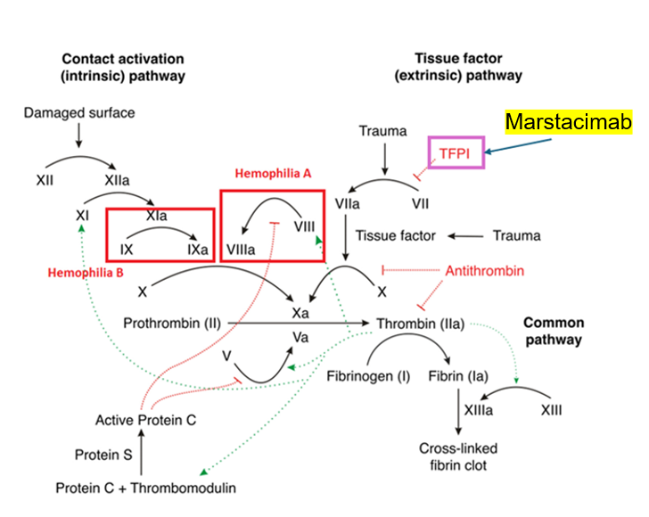
Figure 2 Mechanism of action of marstacimab
Source: adapted from Figure 1, Badulescu et al. (2024); Licensed under Creative Commons Attribution (CC BY) license (https://creativecommons.org/licenses/by/4.0/)
TFPI = tissue factor pathway inhibitor
Note: the factor targeted by marstacimab (TFPI) is highlighted in a purple box.

Key evidence for marstacimab
The BASIS trial (NCT03938792) is the pivotal trial for the application. It is a before-and-after case series of 128 individuals with severe HMA or moderately severe to severe HMB, with or without inhibitors. The applicant has presented data from the non-inhibitor cohort. The trial consisted of 2 parts: observational phase (OP), and active treatment phase (ATP). In the OP, participants were followed up for 6 months on their existing regimen (either on-demand or prophylaxis). In the ATP, participants received a 300mg loading dose of marstacimab followed by a prophylactic regimen of marstacimab of 150mg dose once a week, and followed up for 12 months. Participants were permitted to escalate their dose if required after 180 days. A total of 14 participants required dose escalation. Three participants with prior on-demand treatment (HMA: 1; HMB: 2); and 11 with prior prophylaxis (HMA: 5; HMB: 6) had their marstacimab dose increased from 150 mg to 300 mg weekly.
PASC noted that in the key trial, individuals who had 2 bleeding episodes in a 6-month period while on 150 mg marstacimab per week, were eligible for a dose increase, to 300 mg per week. PASC noted from the applicant’s pre-PASC response that across the key trial and the subsequent open label extension study (NCT05145127), 23 participants (21%) had their dose escalated from 150mg to 300mg weekly. PASC considered that the proportion of individuals who required a dose increase (from 150mg to 300mg weekly) should be reported in the assessment report, as this will have implications for the economic assessment and financial analysis.
PASC noted that the flat dosing of marstacimab (rather than weight-based dosing) is a benefit as it results in less product wastage.
Results from the BASIS trial interim study report for the non-inhibitor cohort established that once-weekly prophylaxis of marstacimab was superior to factor prophylaxis in individuals with HMA and HMB. The mean estimated ABR was 5.08 (95% CI: 3.40, 6.77) for marstacimab prophylaxis during the ATP compared to 7.85 (95% CI: 5.09, 10.61) for routine factor prophylaxis during the OP, with a resulting estimated ABR difference of -2.77 (95% CI: -5.37, -0.16) (Pfizer (2023), Table 24 and 38).
The assessment group considered it was not appropriate to pool results across populations (i.e. HMA and HMB). The assessment group considered it more appropriate that data for each population be presented separately in the assessment report.
The assessment group has extracted these results from the subgroup analysis in the BASIS trial interim study report and presented them in Table 5 below. Efficacy favoured marstacimab compared to on-demand factor replacement for both HMA and HMB. Similarly, efficacy favoured marstacimab compared to prophylactic factor replacement for HMA only. In contrast, superior efficacy was not established for marstacimab in HMB when compared to prophylactic factor replacement. The report states that this is likely due to small participant numbers in the HMB arm. This is reasonable; however, this evidence alone is insufficient to establish the claim of superiority for this population.
Table 5 ABR subgroup analysis, by haemophilia type and treatment mode, non-inhibitor cohort
 | On-Demand cohort |  |  |  | Prophylaxis cohort
 | N | OP  (FR, On-D) | AT  (Mars, PPX) | Ratio  (95%CI) | N | OP  (FR, PPX) | AT  (Mars, PPX) | Difference  (95%CI)
HMA | 26 | 40.57 | 3.61 | 0.089  (0.062, 0.130) | 65 | 9.16 | 5.3 | -3.91  (-7.1, -0.73)
HMB | 7 | 28.67 | 1.65 | 0.036  (0.012, 0.111) | 18 | 3.26 | 4.71 | 1.35  (-1.44, 4.13)
Source: Section 5.1.1.1.1 and 5.1.2.1.1 Interim Study Report Pfizer (2023)
AT = active treatment; CI = confidence interval; FR = factor replacement; HMA = haemophilia A; HMB = haemophilia B; Mars = marstacimab;
On-D = on-demand; OP = observation phase; PPX = prophylaxis
After the 12 months of follow up in the ATP, 107 (83.5%) individuals from BASIS (non-inhibitor cohort) were enrolled in an Open-Label Extension study (NCT05145127), and followed up for a mean 12.5 months. At the end of study follow up, efficacy favoured marstacimab compared to on-demand factor replacement for both HMA and HMB. Similarly, efficacy favoured marstacimab compared to prophylactic factor replacement for HMA and HMB (Table 6).

Table 6 Modelled ABR estimates for treated and total bleeds during the Open-Label Extension study phase, non-inhibitor cohort
 | On-Demand cohort | Prophylaxis cohort
Observational phase ABR summary
HMA | 40.57 | 9.16
HMB | 28.67 | 3.26
Model-basedª ABR summary, treated bleeds [Estimate (95%CI)]
HMA | 4.25 (2.43, 7.42) | 2.94 (2.01, 4.31)
HMB | 1.77 (0.45, 6.93) | 2.24 (0.88, 5.74)
Model-basedª ABR summary, total bleeds [Estimate (95%CI)]
HMA | 5.08 (3.17, 8.14) | 3.40 (2.33, 4.96)
HMB | 5.16 (2.96, 8.98) | 2.39 (1.01, 5.69)
Source : Adapted from Section 5.1.1.1.1 and 5.1.2.1.1 Interim Study Report Pfizer (2023), Kazani et al. (2025)
ABR = annualised bleeding rate; HMA = haemophilia A; HMB = haemophilia B
- Based on a negative binomial regression model without treatment and a log-link function. The model uses the number of bleeds as a response variable and log time on treatment as an offset variable to account for different duration on treatment.
Note: study cohorts are defined by what the participant historically received.
The assessment group also noted that the BASIS trial does not describe the type of factor replacement (e.g. EHL or SHL) used by participants in the OP of the trial. This has implications as efficacy may differ across these factor replacement types. Secondly, this has implications on the applicability of evidence to the Australian population in terms of EHL and SHL usage. This is pertinent for the HMB population, the vast majority (80%) of which use EHL rather than SHL in Australia (National Blood Authority 2023a).
The majority of treatment emergent adverse events in the ATP were injection site pruritis (4 [4.8%] participants), injection site erythema (3 [3.6%] participants), and prothrombin fragment 1.2 increased (3 [3.6%] participants). All events were mild-moderate in severity.
There were no deaths, and no serious adverse events (SAEs) related to thromboembolism. One SAE was related to the treatment: one incident of Grade 1 peripheral swelling (calf swelling) occurred during the ATP. Five (6.0%) medication errors were reported during the ATP.
Anti-drug antibodies (ADAs) developed in 19.8% of evaluable patients (23/116). Most instances of ADAs (61%, 14/23) were judged to be transient (defined as positivity for <16 weeks). By the end of the ATP study period, 95.7% (22/23) had resolved. Neutralising antibodies (nAb) developed in 5.2% of the study cohort (6/116). All were transient and resolved by the end of the ATP study period.
The assessment group raised the issue of developing marstacimab ADAs after commencement of marstacimab treatment. Specifically, whether it would be monitored by antibody testing as per factor replacement, and its flow-on effects in condition management. In the pre-PASC meeting, the applicant stated that 23 (19.8%) of participants in the BASIS trial developed ADAs, of which the vast majority (n=22) were transient. It was also stated that management of ADAs would be left up to the treating clinician’s judgement. The Food and Drug Administration (FDA) prescribing information for marstacimab does not recommend any clinical course of management, stating "There was no identified clinically significant effect of ADAs, including nAbs, on safety or efficacy of marstacimab-hncq over the treatment duration of 12 months." The applicant stated that similar wording has been included in the proposed TGA product information for marstacimab. The applicant has confirmed that data on ADA development will be provided in the assessment report.
The assessment group considered that the evidence from the BASIS trial does not preclude the possibility of clinically-relevant ADAs to marstacimab as ADAs to other monoclonal antibody-based haemophilia treatments (e.g. emicizumab) have been observed in the real world (Kizilocak, Guerrera & Young 2023). Therefore, information regarding the requirements and provisions for testing ADAs to marstacimab in Australia would be informative.
PASC noted from the applicant’s clinical expert that there is no strong justification from the available evidence for the need for regular ADA testing and that this testing, if performed, should be driven by clinical requirements.

Comparators

Haemophilia A
The primary comparator for people with HMA is emicizumab (Hemlibra), which is a bispecific, humanised monoclonal antibody. Emicizumab is delivered subcutaneously as a prophylactic treatment for HMA. The treatment brings together activated Factor IX and Factor X in the clotting cascade, thereby replacing FVIII (Mahlangu, Iorio & Kenet 2022). Emicizumab is available under the National Blood Agreement for treatment of HMA with or without inhibitors, based on a positive recommendation by the MSAC (Applications 1579 and 1510.1) and was added to the NPPL in November 2020. NBA data from 2021-22 reported that 298/561 (53%) individuals with severe HMA aged ≥12 years were receiving emicizumab (National Blood Authority 2023b). This includes those with HMA with inhibitors to FVIII, who would not be eligible for marstacimab. Between 2021-22 and 2022-23, the demand for emicizumab increased by 13.8% (National Blood Authority 2023c).
An additional comparator is FVIII replacement prophylaxis via intravenous infusion. FVIII may be sourced from human plasma, or manufactured as a recombinant product. Recombinant products may be classified as standard-half-life (SHL) or extended half-life (EHL). SHL products are administered every 2 days whilst EHL products require less-frequent infusion (2-3 times per week).
It was reported that 356/561 (63.5%) patients aged 12 years and older with severe HMA in Australia were on a prophylactic regimen of FVIII at some point in 2021-2022 (National Blood Authority 2023a) although it is likely that at least some of these swapped to prophylaxis with emicizumab (given the sum of those who received emicizumab and prophylactic FVIII summed to more than 100%). NBA usage estimates for 2021-2022 report that: 59.5% of individuals with severe HMA use an EHL; 38.5% use an SHL; and 2% were using a plasma-derived FVIII product (National Blood Authority 2023b).
In 2021-2022, there were 49 adults and <5 adolescents (aged 12-17) with severe HMA receiving FVIII product as an on-demand regimen (National Blood Authority 2023a).

Haemophilia B
The nominated primary comparator for people with HMB is FIX replacement prophylaxis via intravenous infusion. As with HMA, FIX products are available as blood plasma products, and recombinant products (including SHL and EHL). NBA usage estimates for 2021-2022: 80.5% of severe HMB patients use an EHL (Alprolix) versus 19.5% of patients use a SHL (Benefix) for prophylactic regimens (National Blood Authority 2023b). Data from the ABDR estimate that 78.9% of individuals with severe HMB are on a prophylactic regimen (National Blood Authority 2023a). Dosing regimens are twice a week for SHL products and up to once per 2-3 weeks for EHL.
The secondary comparator is FIX replacement on-demand via intravenous infusion. The products available for FIX on-demand are identical to those available for prophylaxis, except that the individual receives infusion only when required (i.e. for the treatment of bleeds). Whilst prophylaxis is recommended as the gold standard of treatment for severe haemophilia, reasons for on-demand regimens include inconvenience and frequency of intravenous delivery, and the cost of factor replacement (Makris 2012). Data from the ABDR estimate that 18.9% of individuals with severe HMB are on an on-demand regimen (National Blood Authority 2023a).
PASC noted from the published results of the key BASIS trial (Matino et al. 2025) that while marstacimab led to fewer bleeding events compared to previous factor replacement therapy, the reduction was significantly greater in patients who had previously received on-demand treatment (a 92% reduction) than in those who had been on prior prophylaxis (a 35.5% reduction). PASC noted that in the Australian setting, the majority of patients with severe haemophilia treated with factor replacement are on a prophylactic regimen as opposed to on demand therapy. PASC noted that the prophylactic treatment is the current standard of care for patients with severe haemophilia treated with factor replacement therapy. PASC noted from the applicant’s clinical expert that the minority of patients who do not undergo prophylaxis, are those with difficulty self-administering regular infusions intravenously. PASC noted that some patients may also choose to opt out of regular prophylaxis due to treatment fatigue. Given that the majority of patients undergo prophylaxis factor replacement therapy, PASC advised that on-demand factor replacement therapy should not be considered a comparator for either HMA or HMB populations.
PASC noted that EHL factor replacement products are only marginally superior to SHL products in regard to bleeding rates, but are associated with improved convenience due to reduced dosing frequency (which may improve quality of life). PASC noted that although there are SHL factor replacement products available on the NPPL, the vast majority of patients receiving factor replacement are on EHL products, and the clinical expert also advised that SHL is rarely used now. Therefore, SHL was considered to not be a valid comparator.
PASC noted that the results from the BASIS trial were pooled across prior treatment (i.e. SHL or EHL). PASC considered input from the applicant’s clinical expert that the BASIS trial recruited a significant proportion of participants from several low-middle income countries where, due to availability, the proportion of SHL use is greater than in Australia. PASC advised that the assessment report should clearly outline the proportion of patients on prior EHL and SHL treatment in the key trial and assess the applicability of this to the Australian setting.
Haemophilia A
PASC noted from the applicant’s clinical expert that the majority of patients with HMA are treated with emicizumab (approximately 80%) with, the remainder being treated with FVIII replacement using EHL products. PASC noted that the most widely used treatment regimen for FVIII replacement in severe HMA is prophylaxis rather than on-demand, including in the paediatric setting where newborns may be given prophylactic treatment. Therefore, PASC considered emicizumab to be the main comparator in the HMA population and EHL factor VIII products (for prophylaxis) to be the secondary comparator.
PASC noted that there is no evidence directly comparing marstacimab with emicizumab, so an indirect comparison of the two treatments will be required.
Haemophilia B
PASC noted that on demand treatment should not be included as a comparator, as the vast majority of individuals with severe HMB receive prophylactic treatment. PASC further noted that the majority of patients in the severe HMB population use EHL products. PASC therefore considered that EHL factor IX products (for prophylaxis) to be the main comparator for the HMB population.

Near-market comparators
The assessment group noted two additional near market comparators.
Concizumab (MSAC 1805) is currently undergoing assessment for prophylaxis in patients with HMB with inhibitors. Whilst the patient population does not match the population for marstacimab, there is an ongoing trial of concizumab in individuals with HMA or HMB without inhibitors (explorer8; NCT04082429). Therefore, concizumab may be considered a near-market comparator for both PICO set 1 and 2.
PASC noted that concizumab has been registered on the ARTG for patients at least 12 years of age who have HMA or HMB. PASC noted that an application for concizumab has been submitted for consideration by MSAC for patients with HMB with factor IX inhibitors. PASC noted this was not the same targeted population as marstacimab and did not consider that concizumab was a relevant near-market comparator. However, if the proposal for public funding of concizumab is expanded to include patients with HMA or HMB without inhibitors, it would be a relevant near-market comparator against marstacimab for the HMA and HMB patient populations proposed in the current application.
Etranacogene dezaparvovec (Hemgenix) (MSAC application 1728.1) is currently undergoing assessment for adult patients (≥18 years) with severe or moderately severe (≤2%) congenital haemophilia B (cHMB), currently receiving stable FIX prophylactic therapy, who also meet the following criteria:
- Anti-AAV5 NAb titre < 1:900 using 9-point assay as determined by the AAV5 NAb assay
- No active infections, either acute or uncontrolled chronic
- No known advanced hepatic fibrosis, or cirrhosis
- No FIX inhibitors
Therefore, etranacogene dezaparvovec may be considered a near-market comparator for PICO set 2.
PASC noted that etranacogene dezaparvovec gene therapy (ED; trade name - Hemgenix) has been provisionally registered on the ARTG for adults with HMB without a history of factor IX inhibitors. ED was considered by MSAC in August 2024 and July 2025 for adults with HMB without a history of factor IX inhibitors. In accordance with the MSAC Guidelines, PASC considered ED to be a relevant near-market comparator for the HMB population.

Outcomes

Safety
- Adverse events (e.g. injection site reactions)
- Serious adverse events (including thrombotic events)
- Immunogenicity (antidrug antibodies, neutralising antibodies)

Efficacy
- Annualised bleeding rates (overall, categorised bleed severity, surgical/non-surgical, and site/type specific)
- Volume of FVIII/FIX replacement required for breakthrough bleeds
- Joint health outcomes
- Health-related quality of life
- Number of missed days of work/activity/school

Cost and cost-effectiveness
- Financial implications (costs and cost-offsets including total factor and/or monoclonal antibody consumption (including increase in dose), costs of delivering the intervention, costs of managing adverse events or breakthrough bleeding)
- Cost-effectiveness

Other relevant considerations
- Patient preference
- Treatment burden e.g. administration time, impact on lifestyle, ability to travel
- Adherence to treatment
PASC largely agreed that the outcomes were appropriate.
PASC advised that the annualised bleeding rate be presented as an overall rate and also categorised according to bleed severity, surgical/non-surgical and site/type specific. PASC recommended that perioperative bleeding rates also be captured as part of the outcomes.
PASC considered that routine monitoring of ADAs would not be required as data provided showed a very low incidence of these, and they tend not to influence the efficacy of marstacimab. PASC recommended that the assessment report include the information on ADAs collected in the BASIS trial, but further information would not be required on this outcome.
PASC noted from the applicant’s pre-PASC response the high compliance to treatment in the key BASIS trial (attrition rate <5%) and the open label extension study where 80% of participants had opted to continue treatment with marstacimab at the time of interim analysis.

Clinical management algorithms
Patients with haemophilia receive specialist care coordinated through Haemophilia Treatment Centres (HTCs). Individuals with severe haemophilia receive coordinated, multidisciplinary care involving a haematologist, specialised haemophilia nurse, musculoskeletal specialists such as physiotherapists, orthopaedic surgeons or rheumatologists, coagulation scientists, and psychosocial professionals including social workers or psychologists (National Blood Authority 2025).
The treating haematologist would be responsible for determining a patient’s eligibility for marstacimab treatment, including evaluating the presence of clotting factor inhibitors. Inhibitor development occurs far more frequently in HMA compared to HMB, with inhibitory antibodies developing in approximately 30% of previously untreated patients with HMA, whereas inhibitor formation in HMB occurs infrequently, with a cumulative incidence of up to 5% (Srivastava et al. 2020). If a patient does not clinically respond to factor as expected, the presence of inhibitors may be suspected and tested. It is rare for inhibitors to remain undetected in a patient undergoing factor prophylaxis. The clinical treatment algorithms outlined in this section are based on the World Federation of Haemophilia (WFH) Guidelines for the Management of Haemophilia (3rdedition) (Srivastava et al. 2020) ,the Position Statement by the Australian Haemophilia Centre Director’s Organisation (AHCDO 2024), the Framework for the Management of Bleeding Disorders in Australia by the NBA (National Blood Authority 2025), and the Public Summary Document for emicizumab (MSAC 1579).
The assessment group noted that clinical treatment algorithms should reflect current practice, specific to the claimed population and nominated comparators, which may differ from best practice outlined in the guidelines. The assessment group has amended the algorithms provided in the application to reflect these requirements Figure 5 and Figure 6.

Haemophilia A
The current treatment algorithm for HMA is illustrated in Figure 3. The current standard of care for people with severe HMA involves either prophylactic subcutaneous injections of emicizumab (administered 1-4 times per month) or prophylactic infusions of FVIII concentrate (administered 1-2 times per week for EHL products). Patients receiving prophylactic treatment with either emicizumab or FVIII concentrate may still require on-demand FVIII concentrate, such as for managing breakthrough bleeding episodes or as surgical cover prior to procedures (surgical prophylaxis).
In patients with HMA receiving FVIII prophylaxis, screening for inhibitors is conducted if the clinical response is not as expected, after intensive therapy or prior to surgery. Inhibitor development is more common in HMA, occurring in approximately 30% of individuals with severe disease at some point in their lifetime (Srivastava et al. 2020). If high inhibitor titres are detected, immune tolerance induction (ITI) with FVIII is typically initiated, alongside on-demand use of BPAs as needed. If tolerisation is unsuccessful, subsequent treatment options include on-demand or prophylactic BPAs, or prophylactic emicizumab in combination with a BPA.
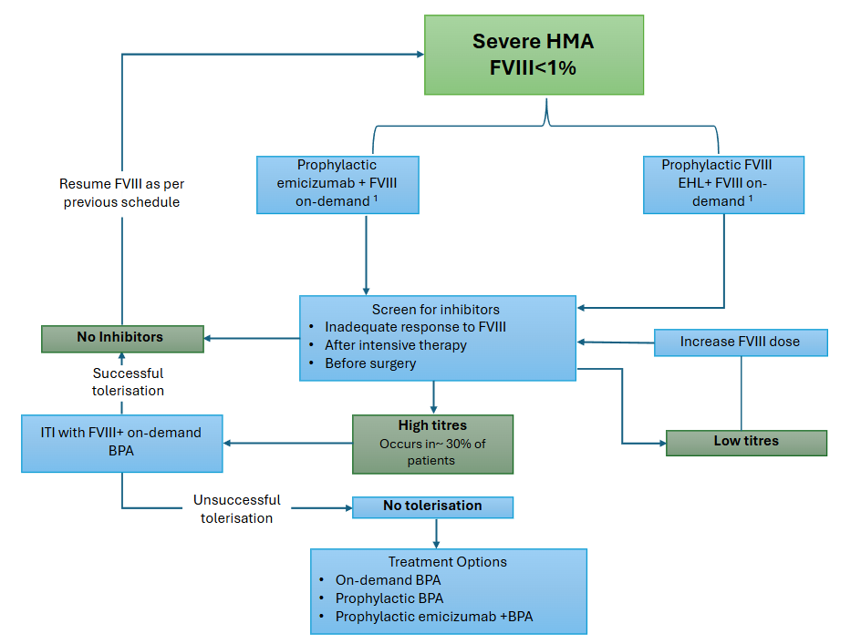
Figure 3 Current clinical algorithm for the treatment of Haemophilia A
Source: Adapted from Figure 6, MBS Application PICO set document_Pfizer_marstacimab_March 2025
BPA = bypassing agents; EHL= Extended half-life; HMA = haemophilia A; FVIII = factor VIII concentrate; ITI = immune tolerance induction;
¹ To treat breakthrough bleeds / surgical cover
Figure 4 illustrates the proposed algorithm for the management of patients with severe HMA, incorporating the anticipated availability of marstacimab. Marstacimab is proposed as an alternative to both emicizumab and EHL factor VIII replacement for individuals aged 12 years and older.
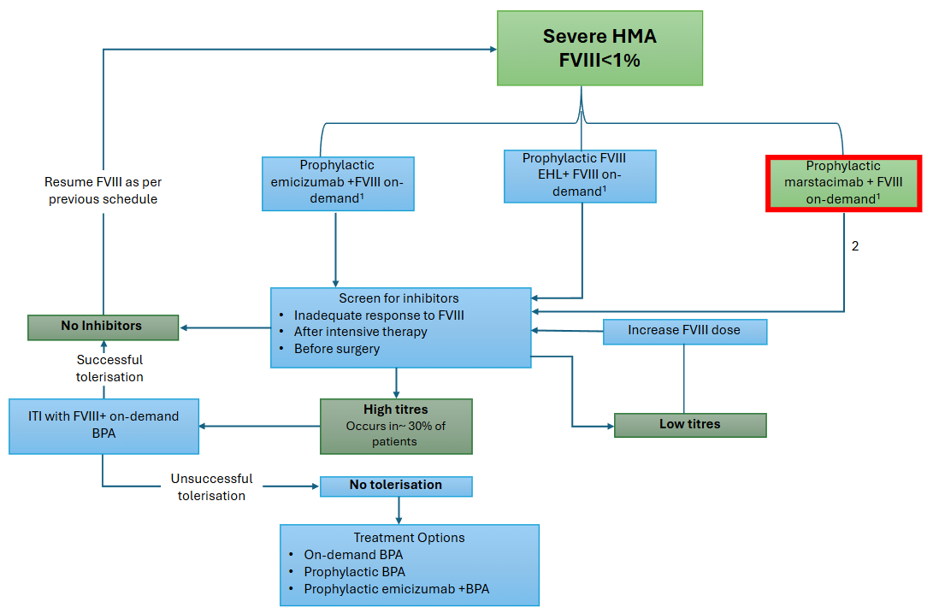
Figure 4 Proposed clinical algorithm for the treatment of Haemophilia A
Source: Adapted from Figure 7, MBS Application PICO set document_Pfizer_marstacimab_March 2025
BPA = bypassing agents; EHL= Extended half-life; HMA = haemophilia A; FVIII = factor VIII concentrate; ITI = immune tolerance induction;
¹ To treat breakthrough bleeds / surgical cover
² Individuals to be screened for inhibitors to FVIII only
Intervention subject to this assessment outlined in red

Haemophilia B
The current treatment algorithm for individuals with severe HMB is illustrated below in Figure 5. The current standard of care for the majority of these patients involves prophylactic infusions of EHL FIX concentrate (administered once per 2-3 weeks). In addition, FIX concentrate is also used on-demand to manage breakthrough bleeds or as cover prior to surgical procedures. Patients receiving FIX prophylaxis are typically screened for inhibitor development if they exhibit an unexpected clinical response, have undergone intensive FIX treatment, or are scheduled for surgical procedures. Although developing inhibitors in HMB is relatively rare—affecting approximately 1–4% of patients with severe HMB—it poses significant clinical challenges (National Blood Authority, A 2022).
If high-titre inhibitors are detected, ITI may be considered; however, ITI is infrequently used in HMB due to its lower success rate and a higher risk of complications such as allergic reactions and nephrotic syndrome, compared to ITI in HMA.
For patients with HMB with inhibitors who do not achieve tolerisation, alternative management options include:
- Second-line ITI using a modified protocol or alternative FIX product,
- The addition of immunosuppressive therapy, or
- The use of BPAs, either on-demand or as prophylaxis.
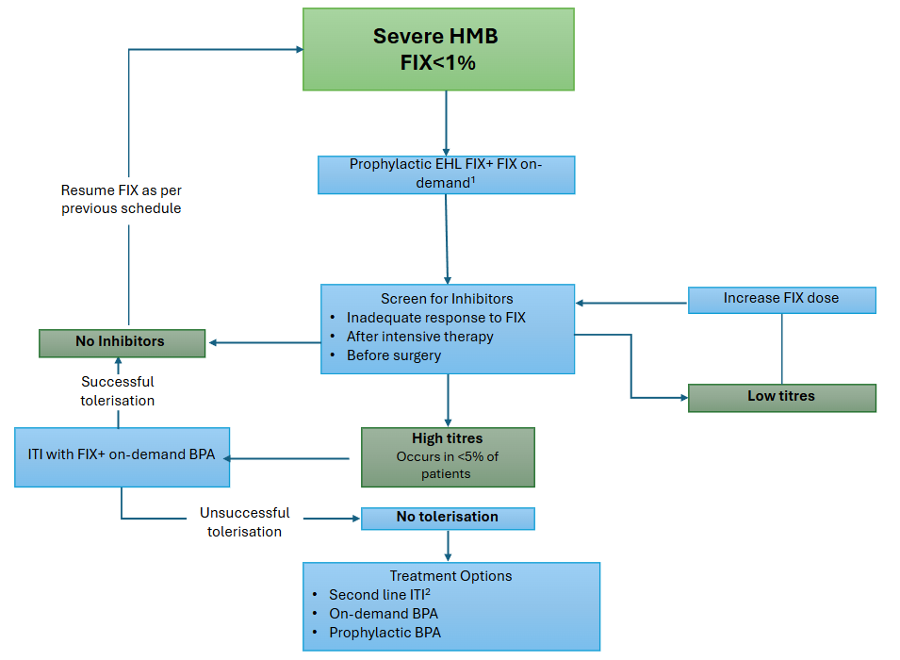
Figure 5 Current clinical algorithm for the treatment of Haemophilia B
Source: Adapted from Figure 4, MBS Application PICO set document_Pfizer_marstacimab_March 2025
BPA = bypassing agents (e.g., FVIIa, aPCC, FEIBA); EHL= Extended half-life; HMB = haemophilia B; FIX = factor IX concentrate; ITI = immune tolerance induction;
¹To treat breakthrough bleeds / surgical cover
²Different treatment regimen (e.g., higher factor dose or twice-daily regimen), different factor concentrate, or the addition of an immunosuppressant

The proposed treatment algorithm for the management of individuals with severe HMB following the introduction of marstacimab is illustrated in Figure 6. For eligible patients who opt to transition from FIX replacement therapy to marstacimab, the need for routine inhibitor screening, ITI or FIX dose adjustments is eliminated, due to the non-factor mechanism action of marstacimab.

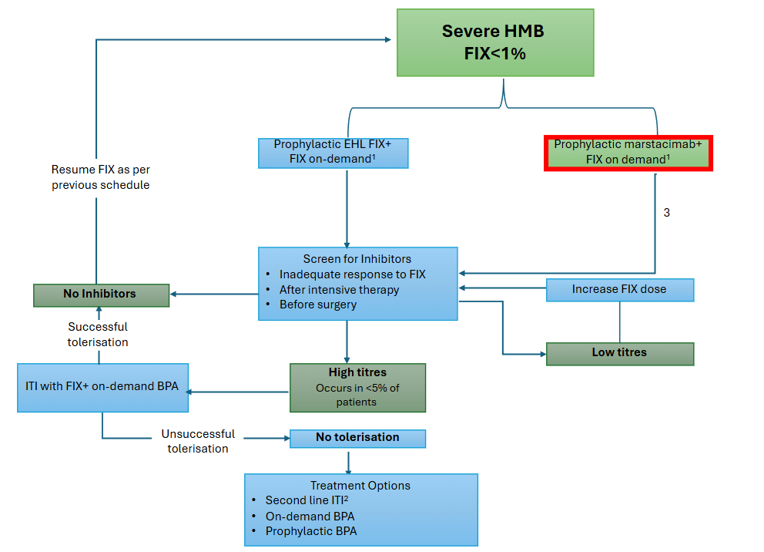
Figure 6 Proposed clinical algorithm for the treatment of Haemophilia B
Source: Adapted from Figure 5, MBS Application PICO set document_Pfizer_marstacimab_March 2025
BPA = bypassing agents (e.g., FVIIa, aPCC, FEIBA); EHL= Extended half-life; HMB = haemophilia B; FIX = factor IX concentrate; ITI = immune tolerance induction;
¹To treat breakthrough bleeds / surgical cover
² Different treatment regimen (e.g., higher factor dose or twice-daily regimen), different factor concentrate, or the addition of an immunosuppressant
intervention subject to this assessment outlined in red
³ Individuals to be screened for inhibitors to FIX only.

As noted above, PASC considered that on-demand treatment regimens and SHL products are not applicable to severe HMA and HMB within the Australian clinical context. The clinical management algorithms have been updated accordingly.

Proposed economic evaluation

Haemophilia A
A claim of non-inferiority of efficacy and safety was made for marstacimab compared to emicizumab. The appropriate type of economic evaluation in the assessment report would be a cost-minimisation analysis (CMA) (Table 7).
A claim of superior efficacy and non-inferior safety was made for marstacimab compared to FVIII prophylaxis. The appropriate type of economic evaluation in the assessment report would either be a cost-effective analysis (CEA) or a cost-utility analysis (CUA).

Haemophilia B
A claim of superior efficacy and non-inferior safety was made for FIX prophylaxis. The appropriate type of economic evaluation in the assessment report would either be a CEA or a CUA (Table 7).
Table 7 Classification of comparative effectiveness and safety of the proposed intervention, compared with its main comparator, and guide to the suitable type of economic evaluation
Comparative safety |  | Comparative effectiveness
Comparative safety | Inferior | Uncertainª | Noninferior^{b} | Superior
Inferior | Health forgone: need other supportive factors | Health forgone possible: need other supportive factors | Health forgone: need other supportive factors | ? Likely CUA
Uncertainª | Health forgone possible: need other supportive factors | ? | ? | ? Likely CEA/CUA
Noninferior^{b} | Health forgone: need other supportive factors | ? | CMA | CEA/CUA
Superior | ? Likely CUA | ? Likely CEA/CUA | CEA/CUA | CEA/CUA
CEA=cost-effectiveness analysis; CMA=cost-minimisation analysis; CUA=cost-utility analysis
? = reflect uncertainties and any identified health trade-offs in the economic evaluation, as a minimum in a cost-consequences analysis
ª ‘Uncertainty’ covers concepts such as inadequate minimisation of important sources of bias, lack of statistical significance in an underpowered trial, detecting clinically unimportant therapeutic differences, inconsistent results across trials, and trade-offs within the comparative effectiveness and/or the comparative safety considerations
^{b} An adequate assessment of ‘noninferiority’ is the preferred basis for demonstrating equivalence
PASC advised that the economic evaluations for the HMA and HMB populations will need to be separated given that each population has different comparators.
PASC advised that a CMA against emicizumab would be the most appropriate economic evaluation for the HMA population.
PASC considered that if the claim of superiority is met for marstacimab versus EHL prophylaxis for the HMB population, then a CUA or CEA would be appropriate.
PASC considered that if superiority cannot be demonstrated for the comparison of marstacimab versus EHL FIX prophylaxis, then a CMA would be the most appropriate economic evaluation for the HMB population.

Proposal for public funding
The applicant has sought listing of marstacimab on the NPPL, managed by the NBA. Prescription of funded marstacimab would be limited to haematologists working in HTCs.
The price for marstacimab is not yet available, but will be included in the assessment report.
PASC noted that the proposal for public funding was via the National Blood Agreement.

Summary of public consultation input
PASC noted and welcomed consultation input from 4 organisations:
- Australian Haemophilia Centre Directors’ Organisation (AHCDO)
- Haemophilia Foundation Australia (HFA)
- Public Pathology Australia (PPA)
- Thrombosis and Haemostasis Society of Australia and New Zealand (THANZ).
Consultation input was supportive of public funding for marstacimab for routine prophylaxis to prevent bleeding in patients with haemophilia.
Consumer Input
HFA input included consumer experiences, stating that people with haemophilia who do not have prophylactic treatment can have abnormal bleeding that is disruptive for both the person and their immediate family and can affect work, study, relationships, participating in social activities, recreation and travel. Consultation input stated that the effects of haemophilia can lead to poor mental health, and that non-compliance with intravenous prophylactic treatment during adolescence is a known problem that can lead to permanent joint damage.
Benefits and Disadvantages
The main benefits of public funding reported in the consultation input included a subcutaneous prophylactic treatment option for people with severe haemophilia who are currently on intravenous prophylactic treatment, convenient pen device for weekly delivery with a fixed dose and improved quality of life. All consultation input stated that access to a subcutaneous prophylactic treatment for people with severe haemophilia who are not able to receive emicizumab would be a big advance, reduce the burden of care and reduce symptoms allowing individuals to participate in activities.
The main disadvantages of public funding reported in the consultation input included the lack of direct evidence to demonstrate marstacimab is non-inferior to the comparator emicizumab. AHCDO input noted the ABR for patients using marstacimab in the BASIS trial was higher than many would consider acceptable in the era of aiming for zero bleeds. Further, there are a high percentage of patients with HMA on emicizumab that experience zero bleeds and the ABR is typically <1.
Population, Comparator (current management) and Delivery
The consultation input ranged from agreeing to disagreeing with the proposed population. AHCDO and HFA stated that the population was too narrow and should be expanded to include people with moderate haemophilia without inhibitors where a severe phenotype is present, as these patients are candidates for prophylactic therapy.
The consultation input broadly agreed with the proposed comparators. AHCDO and HFA noted the proportion of people with severe HMA on emicizumab is likely higher than the 2023 annual report.
The consultation input stated that people with haemophilia can access expert medical care, nursing, counselling, physiotherapy, data management and laboratory services through the HTC comprehensive care team.
Additional Comments
Consultation input noted that there would be no out of pocket costs for patients, as approved products are funded through the National Blood Authority.
PPA noted that marstacimab targets the tissue factor pathway in ways that cannot currently be monitored and that should monitoring of TFPI inhibitors become required, new assays may need to be set up.
PASC noted the consultation feedback from AHCDO, HFA, PPA and THANZ and noted that all feedback was supportive of public funding of marstacimab.
PASC noted that marstacimab is administered as a subcutaneous injection via a pen device and that this method of delivery is not available for any other currently existing treatment for HMB. PASC noted from the results of the 2024 Haemophilia Treatment Preferences Survey provided by HFA that subcutaneous injections are preferred by patients and carers. While a subcutaneous mode of delivery may improve adherence compared to intravenous prophylaxis in the real-world setting, PASC emphasised the importance of support from families and multidisciplinary teams in HTCs to increase adherence, especially in adolescents and young adults where this can be an issue.
PASC noted from AHCDO input that marstacimab does not eliminate the need for factor inhibitor testing as factor replacement may be required for breakthrough bleeds and surgical prophylaxis.

Next steps
PASC noted that the applicant stated they would submit an applicant developed assessment report (ADAR).

Applicant Comments on Ratified PICO
The applicant had no comment.

References
AHCDO 2024, 'Position Statement: Guidelines for the Management of Haemophilia in Australia', Malvern East, VIC.

Badulescu, OV, Badescu, MC, Bojan, IB, Vladeanu, M, Filip, N, Dobreanu, S, Tudor, R, Ciuntu, B-M, Tanevski, A & Ciocoiu, M 2024, 'Thrombotic Disease in Hemophilic Patients: Is This a Paradox in a State of Hypocoagulability?', Diagnostics, vol. 14, no. 3, p. 286,

Brown, LJ, La, HA, Li, J, Brunner, M, Snoke, M & Kerr, AM 2020, 'The societal burden of haemophilia A. I – A snapshot of haemophilia A in Australia and beyond', Haemophilia, vol. 26, no. S5, 2020/08/01, pp. 3-10, https://doi.org/10.1111/hae.14102.

Buckner, TW, Batt, K, Quon, D, Witkop, M, Recht, M, Kessler, C, Baumann, K, Hernandez, G, Wang, M, Cooper, DL & Kempton, CL 2018, 'Assessments of pain, functional impairment, anxiety, and depression in US adults with hemophilia across patient-reported outcome instruments in the Pain, Functional Impairment, and Quality of Life (P-FiQ) study', Eur J Haematol, vol. 100 Suppl 1, Apr, pp. 5-13, 10.1111/ejh.13027.

Carroll, L, Benson, G, Lambert, J, Benmedjahed, K, Zak, M & Lee, XY 2019, 'Real-world utilities and health-related quality-of-life data in hemophilia patients in France and the United Kingdom', Patient Prefer Adherence, vol. 13, pp. 941-957, 10.2147/PPA.S202773.

D'Angiolella, LS, Cortesi, PA, Rocino, A, Coppola, A, Hassan, HJ, Giampaolo, A, Solimeno, LP, Lafranconi, A, Micale, M, Mangano, S, Crotti, G, Pagliarin, F, Cesana, G & Mantovani, LG 2018, 'The socioeconomic burden of patients affected by hemophilia with inhibitors', Eur J Haematol, vol. 101, no. 4, Oct, pp. 435-456, 10.1111/ejh.13108.

Haemophilia Foundation Australia 2023, Haemophilia.

Hassan, S, Monahan, RC, Mauser-Bunschoten, EP, van Vulpen, LFD, Eikenboom, J, Beckers, EAM, Hooimeijer, L, Ypma, PF, Nieuwenhuizen, L, Coppens, M, Schols, SEM, Leebeek, FWG, Smit, C, Driessens, MH, le Cessie, S, van Balen, EC, Rosendaal, FR, van der Bom, JG & Gouw, SC 2021, 'Mortality, life expectancy, and causes of death of persons with hemophilia in the Netherlands 2001-2018', J Thromb Haemost, vol. 19, no. 3, Mar, pp. 645-653, 10.1111/jth.15182.

Johnson, KA & Zhou, ZY 2011, 'Costs of care in hemophilia and possible implications of health care reform', Hematology Am Soc Hematol Educ Program, vol. 2011, pp. 413-418, 10.1182/asheducation-2011.1.413.

Kazani, S, Gould, T, Sun, P, McComb, B, Taylor, CT, McDonald, R, Teeter, J, Hwang, E & Palladino, A 2025, 'Sustained Efficacy of Marstacimab in Adults and Adolescents with Severe Hemophilia A or B without Inhibitors', Hämostaseologie, vol. 45, no. S 01, pp. T-07-05,

Kizilocak, H, Guerrera, MF & Young, G 2023, 'Neutralizing antidrug antibody to emicizumab in patients with severe hemophilia A: Case report of a first noninhibitor patient and review of the literature', Res Pract Thromb Haemost, vol. 7, no. 6, Aug, p. 102194, 10.1016/j.rpth.2023.102194.

Mahlangu, J, Iorio, A & Kenet, G 2022, 'Emicizumab state-of-the-art update', Haemophilia, vol. 28, no. S4, 2022/05/01, pp. 103-110, https://doi.org/10.1111/hae.14524.

Makris, M 2012, 'Prophylaxis in haemophilia should be life-long', Blood Transfus, vol. 10, no. 2, Apr, pp. 165-168, 10.2450/2012.0147-11.

Matino, D, Palladino, A, Taylor, CT, Hwang, E, Raje, S, Nayak, S, McDonald, R, Acharya, S, Mahlangu, J, Jiménez-Yuste, V, Choraria, NGD, Yang, R, Li, C-k, Al-Khabori, M, Wali, YAMS, Morales-Adrian, JDJ, Park, Y-S, Zülfikar, OB & Teeter, J 2025, 'Marstacimab Prophylaxis in Hemophilia A/B Without Inhibitors: Results from the Phase 3 BASIS Trial', Blood, p. blood.2024027468, 10.1182/blood.2024027468.

NA 2025, Australian Product Information HYMPAVZI™ (MARSTACIMAB).

National Blood Authority 2020, Australian Blood Disorders Registry Annual Report 2019-20, NB Authority, <http://www.blood.gov.au/data-analysis-reporting>.

National Blood Authority 2023a, 'Analyses requested by Pfizer from the ABDR', NBA.

National Blood Authority 2023b, Australian Blood Disorders Registry Annual Report 2021-22, NB Authority, <http://www.blood.gov.au/data-analysis-reporting>.

National Blood Authority 2023c, Australian Blood Disorders Registry Annual Report 2022-23, NB Authority, <https://www.blood.gov.au/australian-bleeding-disorders-registryannual-report>.

National Blood Authority 2025, The framework for the management of bleeding disorders in Australia.

National Blood Authority, A 2022, NOVOSEVEN RT
EPTACOG ALFA
<https://www.blood.gov.au/sites/default/files/documents/2024-07/Eptacog%20alfa%20%28NovoSeven%20RT%29%20Utilisation%20Review.pdf>.

O'Hara, J, Walsh, S, Camp, C, Mazza, G, Carroll, L, Hoxer, C & Wilkinson, L 2018, 'The impact of severe haemophilia and the presence of target joints on health-related quality-of-life', Health Qual Life Outcomes, vol. 16, no. 1, May 2, p. 84, 10.1186/s12955-018-0908-9.

Pfizer 2023, BASIS (B7841005) Interim Study Report Body.

Smith, SA, Travers, RJ & Morrissey, JH 2015, 'How it all starts: Initiation of the clotting cascade', Crit Rev Biochem Mol Biol, vol. 50, no. 4, pp. 326-336, 10.3109/10409238.2015.1050550.

Srivastava, A, Santagostino, E, Dougall, A, Kitchen, S, Sutherland, M, Pipe, SW, Carcao, M, Mahlangu, J, Ragni, MV, Windyga, J, Llinas, A, Goddard, NJ, Mohan, R, Poonnoose, PM, Feldman, BM, Lewis, SZ, van den Berg, HM, Pierce, GF, panelists, WFHGftMoH & co, a 2020, 'WFH Guidelines for the Management of Hemophilia, 3rd edition', Haemophilia, vol. 26 Suppl 6, Aug, pp. 1-158, 10.1111/hae.14046.

Note, there is another form of the disorder, known as acquired haemophilia that is not caused by inherited gene variants. However, acquired haemophilia is not considered part of the target population.
https://www.tga.gov.au/resources/artg/438990
Medical Services Advisory Committee – Guidelines for preparing assessments for the Medical Services Advisory Committee

