MSAC Application 1813

  - Measurable residual disease (MRD) for acute myeloid leukaemia (AML)

  - PICO Set

Population
Describe the population in which the proposed health technology is intended to be used:
The intended population for the proposed medical service (Measurable residual disease [MRD] testing) includes patients with acute myeloid leukaemia (AML) in morphological remission (<5% bone marrow blasts) following intensive induction therapy or, in selected cases, after less-intensive therapy when further treatment decisions are being contemplated.^{1, 2}
AML is an aggressive cancer of the blood and bone marrow that arises from the clonal proliferation of immature myeloid cells, called blasts. This uncontrolled proliferation leads to the replacement of normal haematopoietic cells, resulting in the common symptoms of anaemia (fatigue, dyspnoea, pallor), neutropenia (recurrent infections and fever), thrombocytopenia (easy bruising, petechiae, mucosal bleeding), and bone pain (due to marrow expansion).³ High circulating blast counts can also lead to leukostasis, producing respiratory or neurologic compromise. Constitutional features such as weight loss, night sweats, and fever may also be present.
In Australia, AML predominantly affects older adults, with a median age at diagnosis of 69 years, but can occur at any age.⁴ Overall survival has remained stagnant since 2007, with a reported five-year relative survival of around 26%, reflecting the aggressive nature of the disease and the high frequency of relapse.^{1, 4}
AML is a highly heterogeneous disease with respect to morphology, immunophenotype (cell-surface marker patterns), and genetic abnormalities, as well as treatment response and health outcomes.^{1, 2} Diagnosis requires ≥20% myeloid blasts in bone marrow or blood, unless specific defining genetic lesions such as t(8;21) or inv(16) are present. Molecular testing is used to classify AML into favourable, intermediate, or adverse risk groups according to the 2022 European LeukemiaNet (ELN) risk classification, which guide therapy (Table 1).¹
MRD testing is particularly important for patients in the ELN intermediate-risk group, which constitutes the largest single category within this prognostic classification.⁵ Currently, international and Australian clinical practice guidelines suggest that intermediate- and adverse-risk AML patients who are fit should receive an allogeneic haematopoietic stem cell transplantation (allo-HSCT) in first complete remission.^{1, 5, 6} However, the intermediate-risk group is recognised to be highly heterogeneous in terms of clinical outcomes. MRD testing enables more refined risk stratification within this cohort: for example, patients who are MRD-positive may be directed to allo-HSCT, while MRD-negative patients may avoid allo-HSCT and its attendant risks. This is particularly relevant because allo-HSCT is an intensive procedure associated with appreciable transplant-related mortality (approximately 15%). Avoiding allo-HSCT in lower-risk patients is also of significant financial benefit to the Australian health system, since allo-HSCT is a high-cost procedure (approximately $246,855 per patient; unpublished data available upon request).

Table 1 2022 ELN risk classification by genetics at initial diagnosis, for patients treated with intensive chemotherapy
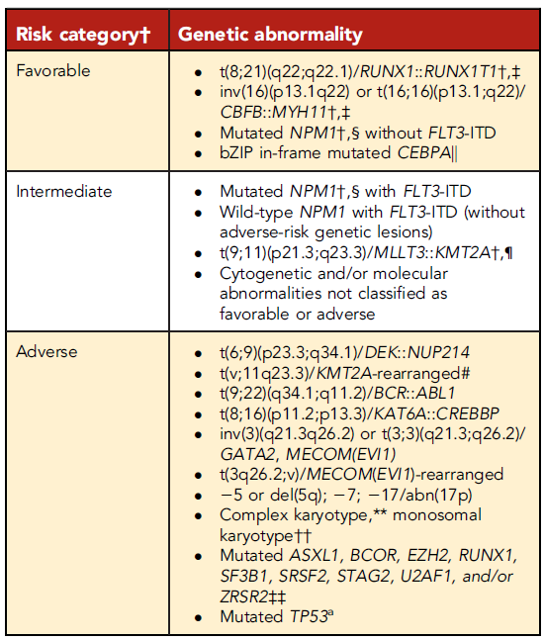
Source: Döhner et al 2022¹

Specify any characteristics of patients with, or suspected of having, the medical condition, who are proposed to be eligible for the proposed health technology, describing how a patient would be investigated, managed and referred within the Australian healthcare system in the lead up to being considered eligible for the technology:
People with suspected AML typically present via GP or emergency departments with cytopenias, infection, bleeding or constitutional symptoms and are urgently referred to a haematologist at a tertiary/metropolitan centre. Diagnostic work-up includes complete blood count and differential count, bone marrow aspirate/trephine, immunophenotyping by flow cytometry, cytogenetics (karyotype ± FISH), and molecular testing (targeted NGS for Tier 1 AML genes; and urgent single-gene assays such as FLT3 and NPM1 where rapid impact on choice of induction therapy is expected).^{1, 6} Baseline cytogenetic and molecular assessments are recommended for all newly diagnosed patients to aid in risk stratification, treatment selection and identification of a traceable MRD marker.^{1, 2}
Following a confirmed diagnosis of AML, patients are evaluated for suitability for active treatment. Newly diagnosed patients that are suitable will receive intensive chemotherapy as a first-line treatment option (e.g. “7+3” cytarabine + anthracycline [idarubicin or daunorubicin], with regimen adaptations such as the addition of gemtuzumab ozogamicin for core binding factor [CBF] AML or midostaurin for FLT3-mutated disease), followed by consolidation therapy and consideration of either maintenance therapy or allo-HSCT according to ELN risk and patient fitness.^{6, 7} Patients not fit for intensive chemotherapy are recommended lower-intensity treatments (azacitidine + venetoclax), or best supportive care;⁶ MRD testing is most established after intensive induction/consolidation. MRD monitoring is not routinely performed in most elderly patients receiving low-intensity therapy without a treatment alternative, however there is emerging evidence of utility and prognostic value.¹
The intended population for MRD testing includes:
- Patients with confirmed AML in morphologic remission following intensive chemotherapy (usually after two cycles of induction/consolidation);
- Patients who are potential candidates for further consolidation chemotherapy, allo-HSCT, or maintenance therapy;
- Patients for whom early identification of molecular or immunophenotypic relapse would inform treatment modification or pre-emptive therapy.
Provide a rationale for the specifics of the eligible population:
MRD is most useful in patients that achieve morphological remission, with trackable molecular markers (e.g. NPM1, FLT3-ITD, CBF AML etc.) or where leukaemia-associated immunophenotypes (LAIPs) can be reliably defined for MFC monitoring (Table 2). Approximately 80-90% of adult AML patients have identifiable MRD markers suitable for either MFC or molecular assessment.^{1, 5} In addition, approximately 65% of patients that are candidates for induction therapy will achieve remission, with rates varying by age and other prognostic factors.⁸ In patients that meet these criteria, MRD monitoring provides a more sensitive marker of disease activity than morphological assessment, and can inform treatment decisions regarding earlier intensification or de-escalation of therapy, including the suitability or avoidance of allo-HSCT.
Table 2 MRD markers by primary testing method
MRD Marker | Primary Testing Method | Notes
NPM1  CBFB::MYH11  RUNX1::RUNX1T1 | Real-time quantitative PCR | Highest sensitivity; preferred whenever validated assay exists
FLT3-ITD  IDH1/2 | NGS (targeted deep sequencing) | Recommended for MRD detection to ≤10⁻⁵; not to be used as sole MRD marker
IDH1/2 | MFC | IDH1/2 mutations often persist in remission
No molecular marker identifiable (LAIP/DfN) | MFC | MFC using leukaemia-associated immunophenotypes
Source: Adapted from Döhner et al. 2022¹, Heuser et al. 2021⁵ and NCCN 2025²
Are there any prerequisite tests?
Yes. Tests to diagnose AML: Bone marrow morphological assessment, full blood count, immunophenotyping, and cytogenetic and molecular studies.
Are the prerequisite tests MBS funded?
Yes.
Provide details to fund the prerequisite tests:
N/A

Intervention
Name of the proposed health technology:
MRD-AML testing using multiparametric flow cytometry (MFC), next generation sequencing (NGS) or polymerase chain reaction (PCR) assays.
Describe the key components and clinical steps involved in delivering the proposed health technology:
Delivery of MRD testing in AML involves coordinated diagnostic, laboratory, and clinical processes to detect measurable disease following therapy. Testing is performed in accredited pathology laboratories using high-sensitivity techniques such as MFC, PCR, or NGS. Bone marrow aspirate is the preferred specimen, particularly at defined time points such as post-induction, post-consolidation, and pre- or post-transplant. Peripheral blood may be used for surveillance in selected molecular assays (e.g., NPM1, CBF AML), though its sensitivity is lower than bone marrow–based testing. Strict sample handling, such as prioritising the first marrow pull and ensuring prompt processing, is critical to maintain assay sensitivity and reproducibility.^{1, 2}
Routine implementation of MRD testing requires supporting clinical infrastructure, including coordination between haematologists, pathologists, and transplant teams. Samples are collected in outpatient or inpatient haematology settings, processed by specialised laboratory personnel, and integrated into electronic reporting systems to inform clinical review.^{1, 2}
Identify how the proposed technology achieves the intended patient outcomes:
High-sensitivity MRD assays, including MFC and molecular techniques such as qPCR and NGS, are essential for refining post-remission risk and guiding allo-HSCT decisions. These assays:
- provide a quantitative means of establishing the depth of remission;
- refine post-remission relapse risk assessment;
- detect impending relapse to enable early intervention; and
- serve as a surrogate endpoint to accelerate drug development and regulatory approval.¹
MRD analysis quantifies residual leukaemic cells below the threshold of conventional morphology (typically 5% leukaemia blasts on bone marrow aspirate), providing a far more precise measure of remission depth and treatment response.⁹ Results are classified as MRD-negative, low-level positive, or MRD-positive according to validated thresholds for each assay. Interpretation is multidisciplinary, combining laboratory and clinical expertise to guide patient management. Confirmed MRD positivity after treatment, or re-emergence during surveillance, triggers review and may prompt treatment intensification, introduction of targeted therapy, or referral for allo-HSCT. MRD negativity across both molecular and flow platforms represents the strongest predictor of durable remission and improved survival outcomes.^{1, 5, 10}
Parallel MFC and molecular testing offer complementary prognostic value: While molecular assays generally have superior sensitivity, MFC can detect immunophenotypic aberrancies even when molecular targets are undetectable at relapse due to leukaemic clonal evolution,^{11, 12} while concurrent negativity across both methods provides the most powerful predictor of durable remission.^{13, 14} Collectively, these findings underpin modern MRD-directed treatment strategies and the shift toward response-adapted therapy and transplant decision-making guided by MRD status.^{1, 2}
MRD testing is incorporated into optimal care pathways for AML per the AML Australian Clinical Guidelines⁶ as part of the National Strategic Action Plan for Blood Cancer (September 2020).¹⁵
Does the proposed health technology include a registered trademark component with characteristics that distinguishes it from other similar health components?
No
Explain whether it is essential to have this trademark component or whether there would be other components that would be suitable:
N/A
Are there any proposed limitations on the provision of the proposed health technology delivered to the patient (For example: accessibility, dosage, quantity, duration or frequency):
No
Provide details and explain:
No limitation should be placed on the number of services that each patient can receive, due to the heterogeneity in AML biology and patient response to treatment. While most patients will require 4 or fewer tests per year, in accordance with the ELN recommended MRD testing algorithm (Figure 1),¹ patients with CBF-AML, and those who respond poorly to treatments may require additional testing. Importantly, patients who relapse with AML will require ongoing MRD testing to determine the effectiveness of their next line of therapy, necessitating restarting of the MRD assessment algorithm.
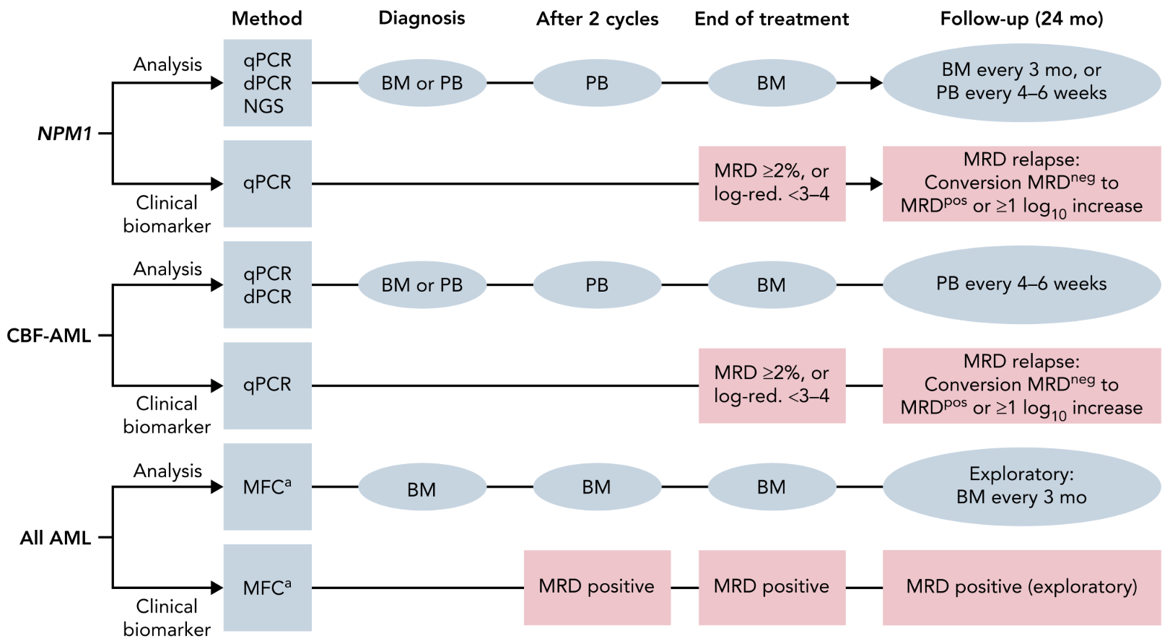
Figure 1 Algorithm of MRD assessment and time points at which MRD is considered a clinically relevant biomarker
“Blue squares indicate timepoints of assessment and source of material; pink squares indicate timepoints for treatment modification based on a clinically relevant biomarker: for example, if the level of molecular MRD as assessed by qPCR is ≥2% or if there is failure to reduce mutant transcript levels by 3 to 4 log after completion of consolidation chemotherapy, treatment modifications (e.g., allogeneic hematopoietic stem cell transplantation) may be considered; similarly, if patients are still MRD positive by MFC after 2 cycles of intensive chemotherapy or at end of treatment. For patients receiving less intensive therapy, timepoints for assessment and clinical decision making are not yet established. Modified from 2021 ELN MRD recommendations” Source: Döhner et al. 2022¹
ªMFC as assessed by LAIP or the DfN method.
AML = acute myeloid leukaemia; BM = bone marrow; CBF = core-binding factor; PB = peripheral blood; q/dPCR = quantitative/digital polymerase chain reaction.
NOTE: About half of patients with FLT3-ITD mutations will also have NPM1; however, there is value to doing FLT3 MRD in these patients in addition to NPM1 (especially post induction and end of treatment). At the time the ELN guideline was written FLT3 MRD testing wasn't as well established, hence it wasn't included. An updated guidelines from ELN will be published soon which will more strongly emphasise FLT3 MRD testing.
If applicable, advise which health professionals will be needed to provide the proposed health technology:
MRD testing would be provided by Approved Practising Pathologists in line with other tests on the MBS Pathology Table.
If applicable, advise whether delivery of the proposed health technology can be delegated to another health professional:
N/A
If applicable, advise if there are any limitations on which health professionals might provide a referral for the proposed health technology:
Yes. The proposed services should only be referred by a specialist oncologist, haematologist or consultant physician.
Is there specific training or qualifications required to provide or deliver the proposed service, and/or any accreditation requirements to support delivery of the health technology?
Yes
Provide details and explain:
Testing would be delivered only by Approved Practising Pathologists in NATA Accredited Pathology Laboratories (as defined in MBS Pathology table) by referral only by registered Medical Practitioners (haematologists, oncologists and consultant physicians) in line with other tests in the MBS Pathology Table. NPAAC qualifications in genomic testing.
Indicate the proposed setting(s) in which the proposed health technology will be delivered:
Consulting rooms
Day surgery centre
Emergency Department
Inpatient private hospital
Inpatient public hospital
Laboratory
Outpatient clinic
Patient’s home
Point of care testing
Residential aged care facility
Other (please specify)
All MRD assays, including MFC, PCR, and NGS, are performed in accredited pathology laboratories. Testing requires the collection of bone marrow or peripheral blood samples. Samples are typically collected in outpatient clinics or during inpatient care and then processed in the laboratory. Routine follow-up involves scheduled peripheral blood draws, bone marrow procedures conducted in day oncology or haematology units. In inpatient settings, bone marrow sampling may occur during hospital admission for induction or consolidation therapy, or when patients are otherwise clinically unwell.
Is the proposed health technology intended to be entirely rendered inside Australia?
Yes
Provide additional details on the proposed health technology to be rendered outside of Australia:
N/A

Comparator
Nominate the appropriate comparator(s) for the proposed medical service (i.e., how is the proposed population currently managed in the absence of the proposed medical service being available in the Australian healthcare system). This includes identifying healthcare resources that are needed to be delivered at the same time as the comparator service:
Following induction therapy, patients who achieve complete remission are monitored for relapse risk. Without MRD testing, this surveillance relies on full blood examination and periodic bone marrow biopsy to detect morphological relapse (morphological assessment ± cytogenetic analysis), which becomes apparent once bone marrow blasts exceed 5%. However, molecular or immunophenotypic relapse typically precedes morphologic relapse by several weeks to months.^{10, 16}
Typically, morphology can detect down to approximately five blasts (AML cells) in 100 white cells.¹⁷ This is insensitive with poor specificity and a wide coefficient of variation for residual leukaemia after treatment, and indeed NCCN guidelines define MRD-AML as the presence of leukaemic cells below the threshold of detection by conventional morphologic assessment.² To better define the residual leukaemic burden, immunophenotyping by MFC and/or molecular studies is required.^{1, 9, 17}
Cytogenetic analysis is also frequently performed on bone marrow aspirates. This genetic technology will allow leukaemia cell burden to be measured to approximately 5 in 100 cells if a clonal cytogenetic marker is identified.
Figure 2 Bone marrow smear. A) shows the smears of healthy bone marrow consisting of different functional cell types and B) an AML patient with predominantly leukaemic blasts.¹⁷

List any existing MBS item numbers that are relevant for the nominated comparators:
MBS items relevant to morphological assessment and cytogenetic analysis are described in Table 3.
Table 3 MBS items for morphological assessment and cytogenetic analysis
MBS items relevant to comparator
MBS item 65087
Bone marrow - examination of aspirated material (including clot sections where necessary), including (if performed): any test described in item 65060, 65066 or 65070
Fee: $83.10 Benefit: 75% = $62.35 85% = $70.65
MBS item 73290
The study of the whole of each chromosome by cytogenetic or other techniques, performed on blood or bone marrow, in the diagnosis and monitoring of haematological malignancy (including a service in items 73287 or 73289, if performed). - 1 or more tests.
Fee: $394.55 Benefit: 75% = $295.95 85% = $335.40
MBS item 73314
Characterisation of gene rearrangement or the identification of mutations within a known gene rearrangement, in the diagnosis and monitoring of patients with laboratory evidence of:
(a) acute myeloid leukaemia; or
(b) acute promyelocytic leukaemia; or
(c) acute lymphoid leukaemia; or
(d) chronic myeloid leukaemia;
Fee: $230.95 Benefit: 75% = $173.25 85% = $196.35
MBS item 73315
A test described in item 73314, if rendered by a receiving APP - 1 or more tests
(Item is subject to rule 18)
Fee: $230.95 Benefit: 75% = $173.25 85% = $196.35
MBS item numbers used for services performed to obtain the bone marrow sample
MBS item 20440
INITIATION OF MANAGEMENT OF ANAESTHESIA for percutaneous bone marrow biopsy of the sternum (4 basic units)
Fee: $82.40 Benefit: 75% = $61.80 85% = $70.05
MBS item 21112
INITIATION OF MANAGEMENT OF ANAESTHESIA for percutaneous bone marrow biopsy of the anterior iliac crest (4 basic units)
Fee: $82.40 Benefit: 75% = $61.80 85% = $70.05
MBS item 21114
INITIATION OF MANAGEMENT OF ANAESTHESIA for percutaneous bone marrow biopsy of the posterior iliac crest (5 basic units)
Fee: $103.00 Benefit: 75% = $77.25 85% = $87.55
MBS item 30081
DIAGNOSTIC BIOPSY OF BONE MARROW by trephine using open approach, where the biopsy specimen is sent for pathological examination
(Anaes.)
Fee: $114.30 Benefit: 75% = $85.75 85% = $97.20
MBS item 30084
DIAGNOSTIC BIOPSY OF BONE MARROW by trephine using percutaneous approach where the biopsy is sent for pathological examination
(Anaes.)
Fee: $61.20 Benefit: 75% = $45.90 85% = $52.05
MBS item 30087
DIAGNOSTIC BIOPSY OF BONE MARROW by aspiration or PUNCH BIOPSY OF SYNOVIAL MEMBRANE, where the biopsy is sent for pathological examination
(Anaes.)
Fee: $30.60 Benefit: 75% = $22.95 85% = $26.05
Provide a rationale for why this is a comparator:
Prior to the introduction of MRD assessment, risk stratification and treatment decisions in AML were largely determined by diagnostic clinical and laboratory factors (age, white cell count, and cytogenetics). These offer limited capacity to tailor therapy based on treatment response, as most patients achieve morphological complete remission.
MRD monitoring enables clinicians to identify patients that can safely receive less intensive, less toxic therapy (those with undetectable MRD) and those who would benefit from more aggressive treatment (patients with detectable MRD). This approach ensures therapy intensity is matched to individual relapse risk, optimising both efficacy and tolerability. This is particularly relevant for selection of AML patients for allo-HSCT as this procedure should be reserved for higher risk patients as it is associated with a significant procedure-related mortality risk.
Pattern of substitution – Will the proposed health technology wholly replace the proposed comparator, partially replace the proposed comparator, displace the proposed comparator or be used in combination with the proposed comparator?
None (used with the comparator)
Displaced (comparator will likely be used following the proposed technology in some patients)
Partial (in some cases, the proposed technology will replace the use of the comparator, but not all)
Full (subjects who receive the proposed intervention will not receive the comparator)
Outline and explain the extent to which the current comparator is expected to be substituted:
MRD-AML testing by flow or molecular methods represents clinical best practice as recommended by the National Comprehensive Cancer Network (NCCN) and ELN clinical practice guidelines.^{2, 5} In Australia, MRD testing has been considered standard of care for more than 20 years;. However, as MRD-AML is not currently funded by the MBS, some patients may still undergo residual disease testing by morphology alone, particularly where out-of-pocket costs apply. If recommended for public funding, it would be expected that MRD testing would partially replace residual disease monitoring by morphology, noting that bone marrow biopsy will often still need to be performed (see Figure 1). Morphology may still be performed on bone marrow aspirates as interpretation of the MRD test is enhanced by a full assessment of haematopoiesis, including assessments of cellularity, dysplasia, fibrosis and other features. However for monitoring in remission, MRD is often conducted on peripheral blood (avoiding bone marrow aspirates), in which case there is a potential substitution for morphology.

Outcomes
List the key health outcomes (major and minor – prioritising major key health outcomes first) that will need to be measured in assessing the clinical claim for the proposed medical service/technology (versus the comparator):
Health benefits
Health harms
Resources
Value of knowing
Health benefits
Prognostic value (i.e. informing safe avoidance of allo-HSCT)
Predictive value (i.e. response to allo-HSCT)
Change in management/treatment (informed by prognostic value) resulting in change in patient health outcomes: Mortality, Morbidity, Quality of life
Health harms
Test adverse events
Adverse events from subsequent treatment
Adverse events from change in patient management
Health resources:
Costs of test and treatments (avoidance of allo-HSCT)

Proposed MBS items
How is the technology/service funded at present? (e.g., research funding; State-based funding; self-funded by patients; no funding or payments):
Despite being routinely performed, funding for MRD services is highly inconsistent across service providers. Hospitals rely on a mix of internal budgets (run at-cost or at a loss) and charitable support, with some centres asking patients for co-payments. Some patients access MRD-AML through clinical trials (e.g. AMLM26 Intercept).
Provide at least one proposed item with their descriptor and associated costs, for each Population/Intervention:
There are three draft items for the proposed services, related to MRD-NGS (Table 4), MRD-qPCR (
Table 5), and MRD-MFC (Table 6).
Table 4 Proposed item AAAAA, NGS
MBS item number  (where used as a template for the proposed item) | 73310
Category number | 6
Category description | Pathology services
Proposed item descriptor | Measurable residual disease (MRD) testing by next-generation sequencing, performed on bone marrow (or a peripheral blood sample if bone marrow cannot be collected) from a patient diagnosed with acute myeloid leukaemia, requested by a specialist or consultant physician practising as a haematologist or oncologist
Proposed MBS fee | Fee: $950.00 Benefit: 75% = $712.50 85% = $845.50*
Indicate the overall cost per patient of providing the proposed health technology | $950
Please specify any anticipated out of pocket expenses | $0.00
Provide any further details and explain | *Greatest Permissible Gap (GPG) applies  PN.0.35 applies: The number of measurable residual disease (MRD) tests per patient, per episode of disease or per relapse is not expected to exceed 12, inclusive of a baseline assessment.  See cost breakdown attachment for more details.

Table 5 Proposed item BBBBB, qPCR
MBS item number  (where used as a template for the proposed item) | 73316
Category number | 6
Category description | Pathology services
Proposed item descriptor | Measurable residual disease (MRD) testing by a quantitative molecular assay performed on bone marrow or peripheral blood collected from a patient diagnosed with acute myeloid leukaemia, requested by a specialist or consultant physician practising as a haematologist or oncologist
Proposed MBS fee | Fee: $430.00 Benefit: 75%=$322.50 85%=$365.50
Indicate the overall cost per patient of providing the proposed health technology | $430
Please specify any anticipated out of pocket expenses | $0.00
Provide any further details and explain | PN.0.35 Applies: The number of measurable residual disease (MRD) tests per patient, per episode of disease or per relapse is not expected to exceed 12, inclusive of a baseline assessment.  See cost breakdown attachment for more details.

Table 6 Proposed item CCCCC, MFC
MBS item number  (where used as a template for the proposed item) | 71202
Category number | 6
Category description | Pathology services
Proposed item descriptor | Measurable residual disease (MRD) testing by flow cytometry using a panel containing a minimum of 20 antibodies, performed on bone marrow from a patient diagnosed with acute myeloid leukaemia, requested by a specialist or consultant physician practising as a haematologist or oncologist
Proposed MBS fee | Fee: $857.00 Benefit: 75%=$642.75 85%=$753.6
Indicate the overall cost per patient of providing the proposed health technology | $857.00
Please specify any anticipated out of pocket expenses | $0.00
Provide any further details and explain | PN.0.35 applies: The number of measurable residual disease (MRD) tests per patient, per episode of disease or per relapse is not expected to exceed 12, inclusive of a baseline assessment.  See cost breakdown attachment for more details.

Algorithms

PREPARATION FOR USING THE HEALTH TECHNOLOGY
Define and summarise the clinical management algorithm, including any required tests or healthcare resources, before patients would be eligible for the proposed health technology:
As noted previously, the diagnostic work-up of suspected AML includes complete blood count and differential count, bone marrow aspirate/trephine, immunophenotyping by flow cytometry, cytogenetics, and molecular testing.^{1, 6} Baseline cytogenetic and molecular assessments are recommended for all newly diagnosed patients to aid in the identification of a traceable MRD marker.^{1, 2} A summary of the classification of AML is provided in Figure 3.
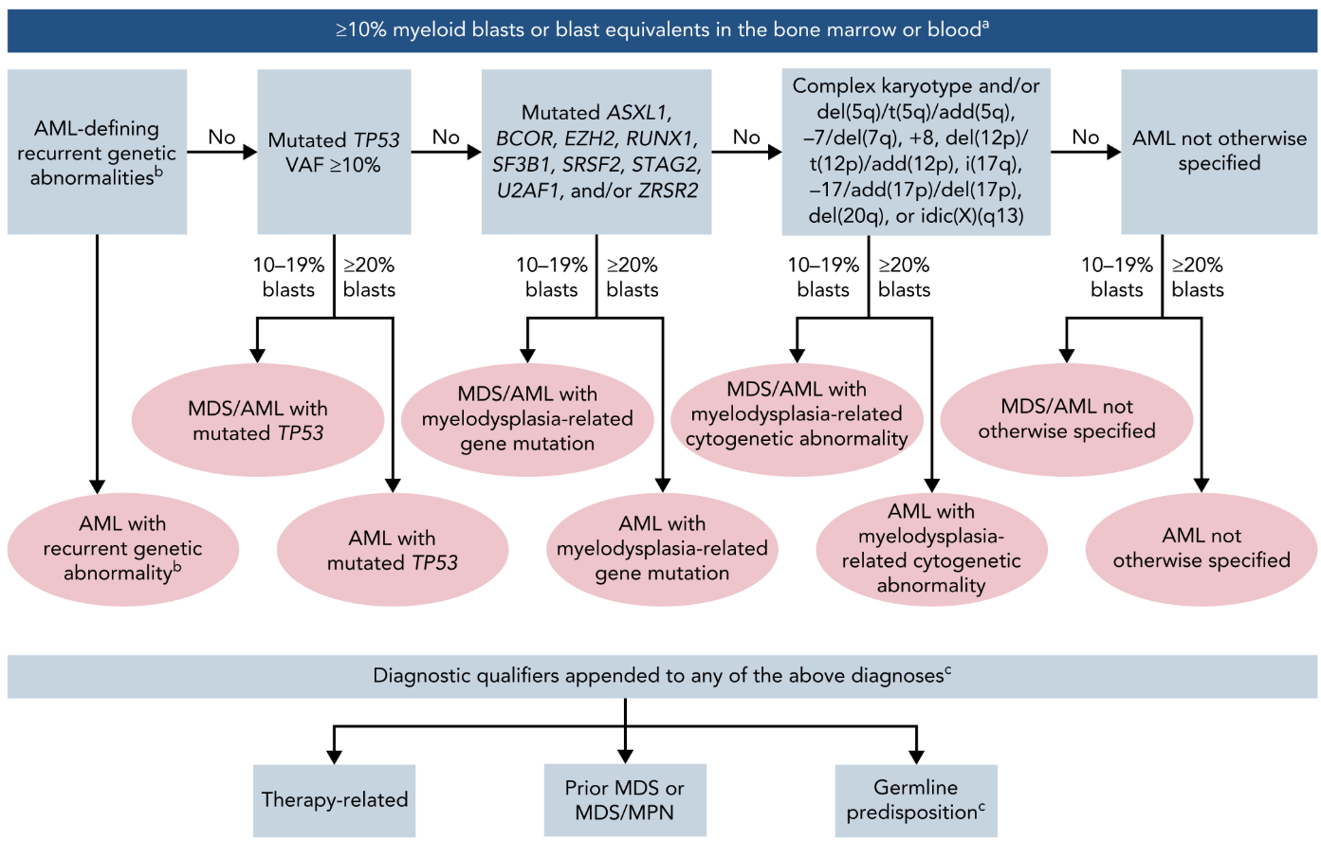
Figure 3 Hierarchical classification of the International Consensus Classification of AML
Source: Döhner et al. 2022¹
Is there any expectation that the clinical management algorithm before the health technology is used will change due to the introduction of the proposed health technology?
Yes.
Describe and explain any differences in the clinical management algorithm prior to the use of the proposed health technology vs. the comparator health technology:
MRD monitoring requires a trackable MRD marker to be identified at diagnosis via cytogenetic or FISH testing for the detection of fusion genes (e.g. PML::RARA), or rapid screening (e.g. capillary electrophoresis) to identify patients with FLT3-ITD or NPM1 mutations.¹

USE OF THE HEALTH TECHNOLOGY
Explain what other healthcare resources are used in conjunction with delivering the proposed health technology:
The handling of AML patient bone marrow and peripheral blood samples in pathology laboratories is required as part of the preparation of AML blood and bone marrow specimens for histopathological review and for sample archiving purposes.¹ These services are outlined in the Comparator section, relating to services performed to obtain the bone marrow sample. No additional healthcare resources are required when MRD testing is performed using NGS, PCR or MFC-based assays.

Explain what other healthcare resources are used in conjunction with the comparator health technology:
All resources related to morphological assessment with or without cytogenetics are outlined in the Comparator section, including services performed to obtain the bone marrow sample. No additional resources are used in conjunction with the comparator health technology.
Describe and explain any differences in the healthcare resources used in conjunction with the proposed health technology vs. the comparator health technology:
N/A

CLINICAL MANAGEMENT AFTER THE USE OF HEALTH TECHNOLOGY
Define and summarise the clinical management algorithm, including any required tests or healthcare resources, after the use of the proposed health technology:
Following diagnosis and induction therapy, patients who achieve complete remission are monitored for relapse risk using MRD. MRD-negative patients continue standard consolidation and routine blood or marrow surveillance, while MRD-positive patients, who face higher relapse risk, may be considered for allo-HSCT or targeted/clinical trial therapies.^{1, 2} The intensity of the preparatory chemotherapy and/or radiation treatment prior to the allo-HSCT procedure (called “conditioning therapy”) may be intensified from reduced intensity conditioning to myeloablative conditioning based on factors including MRD status. In addition, MRD charts are presented at weekly MDT meetings based on individual patient needs.
Define and summarise the clinical management algorithm, including any required tests or healthcare resources, after the use of the comparator health technology:
Without MRD testing, this surveillance relies on full blood examination (FBE) and periodic bone marrow biopsy to detect morphological relapse, which becomes apparent once bone marrow blasts exceed 5%. However, molecular or immunophenotypic relapse typically precedes morphologic relapse by several weeks to months, enabling earlier intervention to prevent overt AML relapse (necessitating reinduction chemotherapy) and potentially allows targeted treatments.^{10, 16}
Describe and explain any differences in the healthcare resources used after the proposed health technology vs. the comparator health technology:
MRD status is used to inform treatment decisions, particularly around the suitability of allo-HSCT. MRD-positive individuals are more often referred earlier to allo-HSCT, or receive augmented consolidation therapy. MRD-negative patients may de-escalate (e.g. chemotherapy-only consolidation, omitting transplant in more favourable-risk patients). The ELN 2022 guideline embeds MRD into these decisions.¹ As a result, MRD-AML is likely to shift resource use rather than uniformly increase it, by increasing costs related to allo-HSCT workups in MRD-positive intermediate/adverse-risk, while decreasing costs related to transplants and high-intensity consolidation in sustained MRD-negative, favourable-risk patients.¹
Earlier detection enables pre-emptive outpatient therapy, which is associated with fewer presentations with clinically unstable overt relapse. Morphology-only comparators relapse later and are typically sicker, often needing unplanned admissions, urgent cytoreduction and increased supportive care.

Insert diagrams demonstrating the clinical management algorithm with and without the proposed health technology:
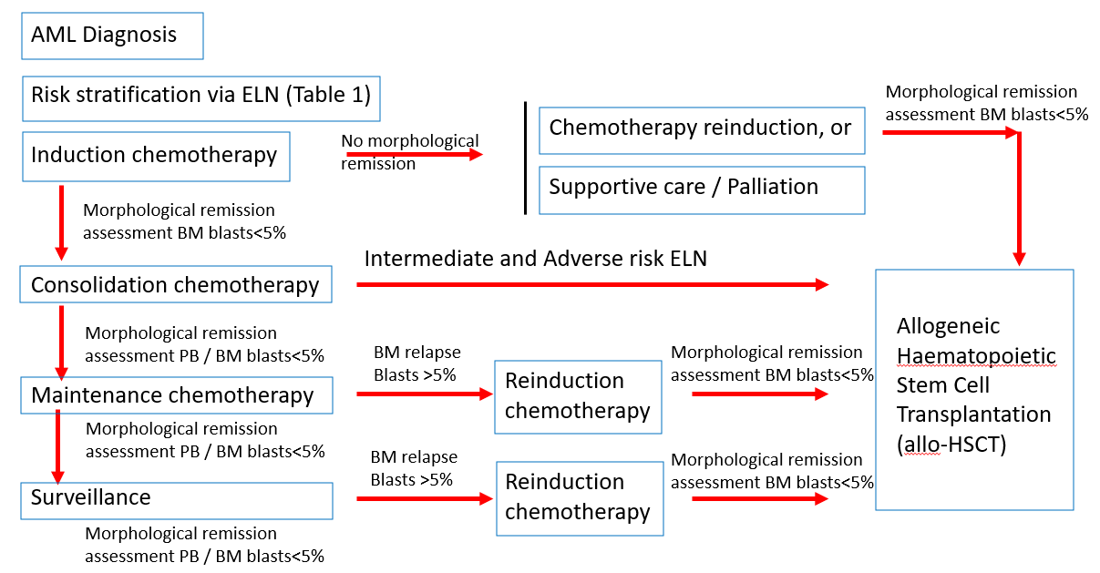
Figure 4 AML clinical management algorithm without proposed health technology
AML = acute myeloid leukaemia; BM = bone marrow; ELN = European LeukemiaNet; PB = peripheral blood.
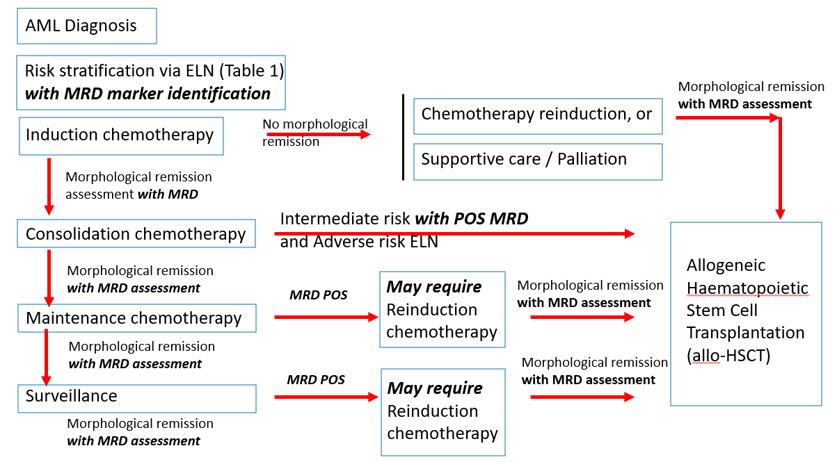
Figure 5 AML clinical management algorithm with proposed health technology
AML = acute myeloid leukaemia; ELN = European LeukemiaNet; MRD = measurable residual disease; POS = positive.

Claims
In terms of health outcomes (comparative benefits and harms), is the proposed technology claimed to be superior, non-inferior or inferior to the comparator(s)?
Superior
Non-inferior
Inferior
Please state what the overall claim is, and provide a rationale:
Relative to disease surveillance with morphological examination ± cytogenetic testing, MRD testing is claimed to result in superior health outcomes, principally by enabling timely, risk-adapted interventions that improve relapse-free survival (with growing evidence for overall survival in defined subgroups).
MRD positivity is the strongest prognostic indicator in AML.¹⁰ Relative to morphology ± cytogenetic testing without MRD testing, MRD testing enables treating clinicians to better determine which patients will benefit from allo-HSCT and which can safely avoid allo-HSCT (i.e. lower risk patients). Further, MRD monitoring of patients in remission informs sub-morphological relapse, enabling earlier intervention with fewer associated complications.
Why would the requestor seek to use the proposed investigative technology rather than the comparator(s)?
As noted above, MRD testing is contemporary best practice for the monitoring of AML remission,^{1, 2} as a supplement to the comparator. MRD provides additional information compared to morphological examination ± cytogenetic testing by providing a quantitative methodology to establish a deeper remission status, refine post remission relapse risk assessment, and identify impending relapse to enable early intervention.¹
Identify how the proposed technology achieves the intended patient outcomes:
See previous response in the Intervention section.
For some people, compared with the comparator(s), does the test information result in:
A change in clinical management? Yes
A change in health outcome? Yes
Other benefits? No
Please provide a rationale, and information on other benefits if relevant:
MRD detection in patients achieving complete remission (CR or CRi) has clear prognostic value across both intensive and less-intensive treatment settings. Numerous studies and meta-analyses confirm its association with relapse risk and overall survival.^{10, 16, 18} Detectable MRD before allo-HSCT predicts poorer post-transplant outcomes, but additional chemotherapy before transplant has not been shown to improve prognosis; such patients may instead benefit from more intensive myeloablative treatment conditioning or early immunosuppression tapering.¹ The strong prognostic information provided by MRD can be used to inform treatment decisions, particularly the avoidance of allo-HSCT in lower risk patients.

A key treatment decision informed by AML-MRD is the avoidance of allo-HSCT. Based on national cancer registry data, approximately 1,280 new AML cases are diagnosed annually in Australia, with a median age of 70 years.⁴ Of these, approximately half (n=640) are patients under 70 who are likely to be fit for intensive chemotherapy,⁴ and of whom around 200 (27–34%) have NPM1-mutated AML.^{19, 20}
Under a non-MRD-guided approach, about 103 patients would undergo allo-HSCT: 78 with FLT3-ITD co-mutation and an estimated 25 additional patients receiving transplant in second remission after relapse.^{19, 21}
Using an MRD-guided approach would result in around 76 transplants, with roughly 25% (50 patients) being MRD-positive after second chemotherapy and an estimated further 26 MRD-negative patients relapsing and later proceeding to transplant in CR2.¹⁰ These patients will avoid the high risk of severe adverse events associated with allo-HSCT,²² as well as the significant costs associated with allo-HSCT shared between hospital budgets and out-of-pocket copayments (mean $246,855 per patient or ~$6.67m total; unpublished data available upon request).
In terms of the immediate costs of the proposed technology (and immediate cost consequences, such as procedural costs, testing costs etc.), is the proposed technology claimed to be more costly, the same cost or less costly than the comparator?
More costly
Same cost
Less costly
Provide a brief rationale for the claim:
Immediate costs associated with the proposed services will be higher than the comparator in the short term, as the proposed testing methods are intended to only partially offset morphology with or without cytogenetic analysis. However, the primary driver of cost-savings associated with MRD-AML testing relates to significant downstream offsets realised through the avoidance of allo-HSCT (total estimated cost savings of ~$6.67m), and associated side effects, as noted above.²³⁻²⁵
If your application is in relation to a specific radiopharmaceutical(s) or a set of radiopharmaceuticals, identify whether your clinical claim is dependent on the evidence base of the radiopharmaceutical(s) for which MBS funding is being requested. If your clinical claim is dependent on the evidence base of another radiopharmaceutical product(s), a claim of clinical noninferiority between the radiopharmaceutical products is also required.
N/A

Summary of Evidence
Provide one or more recent (published) high quality clinical studies that support use of the proposed health service/technology. At ‘Application Form lodgement’,
# | Study, design | Title of journal article or research project | Short description of research | Link
Clinical practice guidelines
1 | Döhner et al. 2022 ¹  Clinical practice guideline | Diagnosis and management of AML in adults: 2022 recommendations from an international expert panel on behalf of the ELN | The updated 2022 European LeukemiaNet (ELN) recommendations integrate advances in AML genomics, MRD assessment, and targeted therapies. Revisions include an updated genetic risk classification, refined MRD response definitions, and modernised treatment recommendations reflect evolving molecular and therapeutic understanding. | PMID: 35797463
2 | Heuser et al 2021 ⁵  Clinical practice guideline | 2021 Update on MRD in acute myeloid leukemia: a consensus document from the European LeukemiaNet MRD Working Party | The 2021 ELN MRD Working Party consensus statement updates the prior 2018 MRD recommendations for AML, reflecting major advances in flow cytometry and NGS technologies. It standardises MRD thresholds, timing, reporting, and integration across methods, emphasising harmonised application for prognosis, response assessment, and regulatory drug evaluation. | PMCID: PMC8718623
3 | NCCN 2025 ²  Clinical practice guideline | NCCN Clinical Practice Guidelines in Oncology: Acute Myeloid Leukaemia Version 2.2025 | The 2025 NCCN AML guidelines emphasise MRD as a critical prognostic tool guiding post-remission therapy. Flow cytometry and qPCR are recommended, with bone marrow as the preferred sample. Persistent MRD (particularly NPM1, CBFB::MYH11, or RUNX1::RUNX1T1 positivity) indicates high relapse risk and may warrant clinical trial enrolment or allogeneic transplantation. | NCCN Guidelines
Using MRD to improve selection of patients for transplant
4 | Venditti et al. 2019 ³⁰  Prospective trial with historical controls | GIMEMA AML1310 trial of risk-adapted, MRD-directed therapy for young adults with newly diagnosed acute myeloid leukemia  NCT01452646 / EudraCT 2010-023809-36 | In this trial, post-remission (n=361) therapy in de novo AML was assigned by genetic risk and post-consolidation MRD. Favourable-risk and MRD-negative intermediate-risk patients received autologous SCT, while poor-risk and MRD-positive intermediate-risk patients received allogeneic SCT. MRD-guided allocation improved outcomes, equating survival between MRD-positive intermediate and favourable-risk groups. | PMID: 31395600
5 | Tettero et al. 2023 ³¹  Propensity-score matched historical control | Measurable residual disease-guided therapy in intermediate-risk acute myeloid leukemia patients is a valuable strategy in reducing allogeneic transplantation without negatively affecting survival  NTR4376 | In the HO132 trial (n=153 ELN intermediate-risk AML patients in complete remission with incomplete hematologic recovery), MRD after cycle 2 guided consolidation with or without allogeneic HSCT. MRD negativity (72%) predicted similar event-free and overall survival whether treated with allo- or auto-HSCT. Historical comparison confirmed MRD-guided therapy safely reduced transplants without compromising survival. | PMID: 37021540
6 | Fenwarth et al. 2021 ³²  Retrospective cohort study | A personalized approach to guide allogeneic stem cell transplantation in younger adults with acute myeloid leukemia  NCT00932412 | In the ALFA-0702 trial (n=656 AML patients <60 years), a knowledge bank (KB) algorithm integrating molecular data improved survival prediction versus ELN 2017. HSCT in CR1 was detrimental for favourable-risk or NPM1 MRD-negative patients, but beneficial for poor-prognosis groups per KB modelling. Integrating KB predictions with ELN 2017 and MRD may thus represent a promising approach to optimise HSCT timing in younger AML patients. | PMID: 32871585
8 | Othman et al. 2024 ³³  Retrospective cohort study | Postinduction molecular MRD identifies patients with NPM1 AML who benefit from allogeneic transplant in first remission  ISRCTN55675535 and ISRCTN78449203 | In 737 patients with NPM1-mutated AML in remission after induction, 19% were MRD positive. Allogeneic transplant in first remission significantly improved 3-year survival for MRD+ patients (61% vs 24%; HR 0.39), but not for MRD− patients (79% vs 82%). Benefits were consistent in FLT3-ITD–mutated subgroups. | PMID: 38364112
9 | Zhu et al. 2013 ³⁴  Prospective cohort study | MRD-directed risk stratification treatment may improve outcomes of t(8;21) AML in the first complete remission: results from the AML05 multicenter trial  ChiCTR-OCH-12002406 | In 116 patients with t(8;21) AML in complete remission 1, MRD testing was used to direct HSCT (allo-HST for high-risk; chemo/autologous HSCT for low-risk). Allo-HSCT reduced relapse (22% vs 79%) and improved DFS (62% vs 20%) in high-risk patients, while chemotherapy or auto-HSCT achieved excellent DFS (95%) in low-risk cases, supporting MRD-guided post-remission therapy. | PMID: 23535063
10 | Balsat et al. 2017 ³⁵  RCT (Phase II) | Postinduction Minimal Residual Disease Predicts Outcome and Benefit From Allogeneic Stem Cell Transplantation in Acute Myeloid Leukemia With NPM1 Mutation: A Study by the Acute Leukemia French Association Group  NCT00932412 | In the ALFA-0702 trial (n=229 NPM1-mutated AML), postinduction MRD was evaluable in 152 patients. Failure to achieve a ≥4-log NPM1 MRD reduction predicted higher relapse (SHR 5.83, P<0.001) and worse OS (HR 10.99, P<0.001). Allogeneic SCT improved survival only in MRD-poor responders, confirming NPM1 MRD as a predictive marker for transplant benefit. | PMID: 28056203
Monitoring MRD and treating at molecular relapse
11 | Potter et al 2025 ³⁶  RCT (Phase III) | Molecular monitoring versus standard clinical care in younger adults with acute myeloid leukaemia: results from the UK NCRI AML17 and AML19 randomised, controlled, phase 3 trials  ISRCTN55675535, ISRCTN78449203 | In the NCRI AML17 and AML19 phase III trials (n=637), patients with molecularly trackable AML were randomised to MRD monitoring or standard care. Overall survival at 3 years was similar (70% vs 73%; HR 1.11), but patients with baseline NPM1 and FLT3-ITD mutations demonstrated a survival benefit from MRD-guided management (69% vs 58%; HR 0.53, p=0.021). | PMID: 40306832
12 | Tiong et al. 2024 ³⁷  Phase II; Historical control | Targeting Molecular Measurable Residual Disease and Low-Blast Relapse in AML With Venetoclax and Low-Dose Cytarabine: A Prospective Phase II Study (VALDAC)  ACTRN12619000746134 | In this prospective phase II study (n=48 adults, median age 67), venetoclax plus low-dose cytarabine was evaluated in AML patients with MRD or oligoblastic relapse. MRD reduction occurred in 69%, with 46% achieving MRD-negative remission; 73% attained CR/CRh/CRi. Estimated 2-year OS was 67% (95% CI, 50 to 89) in the MRD and 53% (95% CI, 34 to 84) in the oligoblastic relapse cohorts. | PMID: 38427924
13 | Jimenez-Chillon et al. 2024 ³⁸  Retrospective case series | Venetoclax-based low intensity therapy in molecular failure of NPM1-mutated AML | In an international cohort of 79 patients with NPM1-mutated AML treated with venetoclax plus low-dose cytarabine or azacitidine for molecular relapse, 84% achieved ≥1-log MRD reduction and 71% became MRD negative. Two-year overall survival was 67%. Outcomes were inferior in FLT3-ITD–mutated cases, confirming venetoclax efficacy for molecular failure. | PMID: 38039513
14 | Platzbecker et al 2018 ³⁹  Prospective case series | Measurable residual disease-guided treatment with azacitidine to prevent haematological relapse in patients with myelodysplastic syndrome and acute myeloid leukaemia (RELAZA2): an open-label, multicentre, phase 2 trial  NCT01462578 | In the RELAZA2 phase II trial (n=198 screened, 60 MRD positive), MRD-guided azacitidine was initiated upon molecular relapse detected by PCR or donor chimaerism. Six months after treatment, 58% of MRD-positive patients remained relapse-free. Persistent MRD negativity strongly correlated with favourable outcomes, confirming MRD as a prognostic and therapeutic marker. | PMID: 30442503
15 | Bataller et al 2020 ⁴⁰  Cohort study | Acute myeloid leukemia with NPM1 mutation and favorable European LeukemiaNet category: outcome after preemptive intervention based on measurable residual disease | In the CETLAM-12 study (n=110 ELN-favourable NPM1-mutated AML), MRD monitoring identified molecular failure in 33 patients prompting pre-emptive therapy. An NPM1/ABL1 ratio ≥0.05 after first consolidation predicted inferior 2-year molecular leukaemia-free survival (40% vs 77%). MRD-guided intervention improved outcomes, supporting its role in early relapse detection and treatment stratification. | PMID: 32510599
16 | Othman et al 2023 ⁴¹  Retrospective cohort study | FLT3 inhibitors as MRD-guided salvage treatment for molecular failure in FLT3 mutated AML | In 56 patients with FLT3-mutated AML treated for molecular failure, FLT3 inhibitor therapy (mainly gilteritinib) achieved molecular responses in 60% and MRD negativity in 45%. High-sensitivity NGS FLT3-ITD testing identified responders, supporting MRD-guided, pre-emptive FLT3 inhibition as an effective bridge-to-transplant or disease control strategy. | PMID: 37558736
Prognostic and predictive value
17 | Othman et al. 2024 ⁴²  Retrospective cohort study | Molecular MRD is strongly prognostic in patients with NPM1-mutated AML receiving venetoclax-based nonintensive therapy | Among patients with NPM1-mutated AML treated with venetoclax combinations (n=76), those achieving MRD negativity by cycle 4 had markedly superior outcomes, with 2-year overall survival of 84% versus 46% in MRD-positive patients. MRD negativity in the first 4 cycles was the strongest prognostic factor, predicting durable, treatment-free remission (HR 0.21, 95% CI 0.08-0.55). | PMID: 37647641
18 | Ivey et al. 2016 ¹⁰  Prospective cohort study | Assessment of Minimal Residual Disease in Standard-Risk AML  ISRCTN55675535 | In the NCRI AML17 trial (post-recruitment), 346 patients with NPM1-mutated AML received intensive chemotherapy. After two cycles, 15% had persistent NPM1 transcripts, predicting higher relapse (82% vs 30%) and lower 3-year survival (24% vs 75%). MRD positivity independently predicted death and reliably signalled relapse during remission. | PMID: 26789727
19 | Short et al. 2020 ¹⁶  Meta-analysis | Association of Measurable Residual Disease With Survival Outcomes in Patients With Acute Myeloid Leukemia: A Systematic Review and Meta-analysis | This meta-analysis (81 studies, 11,151 patients with AML) found MRD negativity strongly associated with improved survival. Five-year DFS was 64% vs 25% and OS 68% vs 34% for MRD-negative versus MRD-positive patients (HR ≈0.36). Benefits were consistent across age, subtype, and detection method, supporting MRD as a validated prognostic endpoint. | PMCID: PMC7545346
20 | McCarthy et al. 2024 ⁴³  Study of diagnostic accuracy | Pre-emptive detection and evolution of relapse in acute myeloid leukemia by flow cytometric measurable residual disease surveillance | In a retrospective cohort of 291 bone marrow samples from AML patients, flow cytometric MRD surveillance predicted relapse with 74% sensitivity and 87% specificity at an optimal diagnostic threshold of 0.04%. Flow MRD surveillance can detect MRD relapse in high risk AML and its evaluation may be enhanced by computational analysis. | PMID: 38890448
21 | Loo et al 2022 ⁴⁴  Cohort study | Pretransplant FLT3-ITD MRD assessed by high-sensitivity PCR-NGS determines posttransplant clinical outcome | In 104 adults with FLT3-ITD AML undergoing first allogeneic transplant in remission, pretransplant FLT3-ITD MRD was assessed by high-sensitivity PCR-NGS. MRD positivity (≥0.001%) predicted markedly worse outcomes: relapse 67–100% and 4-year survival ≤26%, versus 16% relapse and 74% survival in MRD-negative patients (<0.001%). | PMCID: 10653044
22 | Loo et al. 2024 ⁴⁵  Cohort study | Pretransplant MRD detection of fusion transcripts is strongly prognostic in KMT2A-rearranged acute myeloid leukemia | Pretransplant detection of KMT2Ar measurable residual disease ≥0.001% by quantitative polymerase chain reaction was associated with significantly inferior posttransplant survival (2-year relapse-free survival 17% vs 59%; P = .001) and increased 2-year cumulative incidence of relapse (75% vs 25%, P = .0004). | PMID: 39316646
23 | Tiong et al. 2024 ³⁷  Case series (phase II trial) | Targeting Molecular Measurable Residual Disease and Low-Blast Relapse in AML With Venetoclax and Low-Dose Cytarabine: A Prospective Phase II Study (VALDAC)  ACTRN12619000746134 | A phase II study evaluated venetoclax plus low-dose cytarabine in AML patients with MRD or oligoblastic relapse. Among 48 participants (median age 67), treatment was well tolerated and effective: 69% achieved MRD reduction, 73% CR/CRh/CRi, and 44% proceeded to transplant. Two-year overall survival exceeded 50% in both cohorts. | PMID: 38427924
24 | Tettero et al. 2022 ⁴⁶  Meta-analysis and cost-analysis | Concordance in measurable residual disease result after first and second induction cycle in acute myeloid leukemia: An outcome- and cost-analysis | In a pooled analysis of HOVON-SAKK trials (n=273; post-recruitment), MRD-AML by flow cytometry was assessed after one and two induction cycles. MRD negativity (<0.1%) at either point predicted significantly lower relapse and improved survival. Early MRD testing after cycle 1 showed strong concordance, safely reducing allogenic donor searches and halving search costs. | PMCID: PMC9589259
25 | Dillon et al. 2023 ⁴⁷  Retrospective cohort study | DNA Sequencing to Detect Residual Disease in Adults With Acute Myeloid Leukemia Prior to Hematopoietic Cell Transplant | In a study of 822 adults with FLT3-ITD or NPM1-mutated AML undergoing first allogeneic transplant, pretransplant DNA sequencing detected residual variants in 17% of cases. MRD positivity (≥0.01%) predicted higher relapse (68% vs 21%) and lower 3-year survival (39% vs 63%), confirming the prognostic power of molecular MRD detection. | PMID: 36881031
26 | Croese et al 2025 ⁴⁸  Review article | Measurable residual disease monitoring in acute myeloid leukaemia: Techniques, timing and therapeutic implications | MRD detection in AML is now recognised as a key prognostic and therapeutic biomarker across treatment settings. Techniques such as flow cytometry, qPCR, and NGS enable sensitive disease quantification, guiding post-remission therapy, transplant decisions, and early intervention. Emerging applications include MRD-directed treatment cessation and integration into precision, response-adapted AML management. | PMID: 40617703

Identify yet-to-be-published research that may have results available in the near future (that could be relevant to your application).
 | Type of study design | Title of journal article or research project | Short description of research | Source
1. | AMLM26 INTERCEPT platform trial  Prospective case series | Investigating Novel Therapy to target Early Relapse and Clonal Evolution as Pre-emptive Therapy in AML  ACTRN12621000439842 | The INTERCEPT study is an adaptive, multi-arm platform trial enrolling patients with AML in first or second remission who have measurable residual disease (MRD) markers. It evaluates sequential, biomarker-guided therapeutic combinations, rotating patients between arms upon MRD progression to demonstrate sustained anti-leukaemic activity across evolving treatment domains. | AMLM26 INTERCEPT* platform trial
*Early results presented at https://doi.org/10.1182/blood-2024-202895

References
1.Döhner H, Wei AH, Appelbaum FR, Craddock C, DiNardo CD, Dombret H, et al. Diagnosis and management of AML in adults: 2022 recommendations from an international expert panel on behalf of the ELN. Blood. 2022;140(12):1345–77.
2.NCCN. NCCN Clinical Practice Guidelines in Oncology: Acute Myeloid Leukaemia Version 2.2025. 2025.
3.Döhner H, Estey E, Grimwade D, Amadori S, Appelbaum FR, Büchner T, et al. Diagnosis and management of AML in adults: 2017 ELN recommendations from an international expert panel. Blood. 2017;129(4):424–47.
4.AIHW. Cancer Data in Australia 2025. Canberra: AIHW; 2025.
5.Heuser M, Freeman SD, Ossenkoppele GJ, Buccisano F, Hourigan CS, Ngai LL, et al. 2021 Update on MRD in acute myeloid leukemia: a consensus document from the European LeukemiaNet MRD Working Party. Blood. 2021;138(26):2753–67.
6.Blood Cancer Taskforce, Leukaemia Foundation, Haematology Society of Australia and New Zealand. Australian treatment guidelines for adults with acute myeloid leukaemia: Clinical guidelines (Version 1.0, February 2025). 2025.
7.eviQ. Acute myeloid leukaemia induction 7-3 (cytarabine and DAUNOrubicin) 2025 [Available from: https://www.eviq.org.au/haematology-and-bmt/leukaemias/acute-myeloid-leukaemia/2043-induction-7-3-cytarabine-and-daunorubicin?utm_source=chatgpt.com#clinical-information.
8.Clinic C. Acute Myeloid Leukemia (AML) 2023 [Available from: https://my.clevelandclinic.org/health/diseases/6212-acute-myeloid-leukemia-aml.
9.Wang SA, Arenillas L, Buccisano F, Bruggemann M, Kern W, Menes M, et al. Reporting blast percentage for response assessment in acute leukemias: recommendations from an EHA/ELN expert panel. Haematologica. 2025.
10.Ivey A, Hills RK, Simpson MA, Jovanovic JV, Gilkes A, Grech A, et al. Assessment of Minimal Residual Disease in Standard-Risk AML. N Engl J Med. 2016;374(5):422–33.
11.Kronke J, Schlenk RF, Jensen KO, Tschurtz F, Corbacioglu A, Gaidzik VI, et al. Monitoring of minimal residual disease in NPM1-mutated acute myeloid leukemia: a study from the German-Austrian acute myeloid leukemia study group. J Clin Oncol. 2011;29(19):2709–16.
12.Höllein A, Meggendorfer M, Dicker F, Jeromin S, Nadarajah N, Kern W, et al. NPM1 mutated AML can relapse with wild-type NPM1: persistent clonal hematopoiesis can drive relapse. Blood Advances. 2018;2(22):3118–25.
13.Jongen-Lavrencic M, Grob T, Hanekamp D, Kavelaars FG, Al Hinai A, Zeilemaker A, et al. Molecular Minimal Residual Disease in Acute Myeloid Leukemia. N Engl J Med. 2018;378(13):1189–99.
14.Patkar N, Kakirde C, Shaikh AF, Salve R, Bhanshe P, Chatterjee G, et al. Clinical impact of panel-based error-corrected next generation sequencing versus flow cytometry to detect measurable residual disease (MRD) in acute myeloid leukemia (AML). Leukemia. 2021;35(5):1392–404.
15.Australian Government. National Strategic Action Plan for Blood Cancer. 2020.
16.Short NJ, Zhou S, Fu C, Berry DA, Walter RB, Freeman SD, et al. Association of Measurable Residual Disease With Survival Outcomes in Patients With Acute Myeloid Leukemia: A Systematic Review and Meta-analysis. JAMA Oncol. 2020;6(12):1890–9.
17.Cloos J, Harris JR, Janssen J, Kelder A, Huang F, Sijm G, et al. Comprehensive Protocol to Sample and Process Bone Marrow for Measuring Measurable Residual Disease and Leukemic Stem Cells in Acute Myeloid Leukemia. J Vis Exp. 2018(133).
18.Terwijn M, van Putten WL, Kelder A, van der Velden VH, Brooimans RA, Pabst T, et al. High prognostic impact of flow cytometric minimal residual disease detection in acute myeloid leukemia: data from the HOVON/SAKK AML 42A study. J Clin Oncol. 2013;31(31):3889–97.
19.Papaemmanuil E, Gerstung M, Bullinger L, Gaidzik VI, Paschka P, Roberts ND, et al. Genomic Classification and Prognosis in Acute Myeloid Leukemia. N Engl J Med. 2016;374(23):2209–21.
20.Metzeler KH, Herold T, Rothenberg-Thurley M, Amler S, Sauerland MC, Görlich D, et al. Spectrum and prognostic relevance of driver gene mutations in acute myeloid leukemia. Blood. 2016;128(5):686–98.
21.Othman J, Potter N, Ivey A, Tazi Y, Papaemmanuil E, Jovanovic J, et al. Molecular, clinical, and therapeutic determinants of outcome in NPM1-mutated AML. Blood. 2024;144(7):714–28.
22.Chen YF, Li J, Xu LL, Găman MA, Zou ZY. Allogeneic stem cell transplantation in the treatment of acute myeloid leukemia: An overview of obstacles and opportunities. World J Clin Cases. 2023;11(2):268–91.
23.Walter RB, Gyurkocza B, Storer BE, Godwin CD, Pagel JM, Buckley SA, et al. Comparison of minimal residual disease as outcome predictor for AML patients in first complete remission undergoing myeloablative or nonmyeloablative allogeneic hematopoietic cell transplantation. Leukemia. 2015;29(1):137–44.
24.Craddock C, Jackson A, Loke J, Siddique S, Hodgkinson A, Mason J, et al. Augmented Reduced-Intensity Regimen Does Not Improve Postallogeneic Transplant Outcomes in Acute Myeloid Leukemia. J Clin Oncol. 2021;39(7):768–78.
25.Paras G, Morsink LM, Othus M, Milano F, Sandmaier BM, Zarling LC, et al. Conditioning intensity and peritransplant flow cytometric MRD dynamics in adult AML. Blood. 2022;139(11):1694–706.
26.Stirewalt DL, Radich JP. The role of FLT3 in haematopoietic malignancies. Nat Rev Cancer. 2003;3(9):650–65.
27.Chang P, Kang M, Xiao A, Chang J, Feusner J, Buffler P, et al. FLT3mutation incidence and timing of origin in a population case series of pediatric leukemia. BMC Cancer. 2010;10(1):513.
28.Duployez N, Willekens C, Marceau-Renaut A, Boudry-Labis E, Preudhomme C. Prognosis and monitoring of core-binding factor acute myeloid leukemia: current and emerging factors. Expert Rev Hematol. 2015;8(1):43–56.
29.K L, A L, R DK, D P. An audit of molecular measurable residual disease testing for cases of acute myeloid leukaemia in the western australia public health system 2019-2022. 2024.
30.Venditti A, Piciocchi A, Candoni A, Melillo L, Calafiore V, Cairoli R, et al. GIMEMA AML1310 trial of risk-adapted, MRD-directed therapy for young adults with newly diagnosed acute myeloid leukemia. Blood. 2019;134(12):935–45.
31.Tettero JM, Ngai LL, Bachas C, Breems DA, Fischer T, Gjertsen BT, et al. Measurable residual disease-guided therapy in intermediate-risk acute myeloid leukemia patients is a valuable strategy in reducing allogeneic transplantation without negatively affecting survival. Haematologica. 2023;108(10):2794–8.
32.Fenwarth L, Thomas X, de Botton S, Duployez N, Bourhis JH, Lesieur A, et al. A personalized approach to guide allogeneic stem cell transplantation in younger adults with acute myeloid leukemia. Blood. 2021;137(4):524–32.
33.Othman J, Potter N, Ivey A, Jovanovic J, Runglall M, Freeman SD, et al. Postinduction molecular MRD identifies patients with NPM1 AML who benefit from allogeneic transplant in first remission. Blood. 2024;143(19):1931–6.
34.Zhu HH, Zhang XH, Qin YZ, Liu DH, Jiang H, Chen H, et al. MRD-directed risk stratification treatment may improve outcomes of t(8;21) AML in the first complete remission: results from the AML05 multicenter trial. Blood. 2013;121(20):4056–62.
35.Balsat M, Renneville A, Thomas X, de Botton S, Caillot D, Marceau A, et al. Postinduction Minimal Residual Disease Predicts Outcome and Benefit From Allogeneic Stem Cell Transplantation in Acute Myeloid Leukemia With NPM1 Mutation: A Study by the Acute Leukemia French Association Group. J Clin Oncol. 2017;35(2):185–93.
36.Potter N, Jovanovic J, Ivey A, Othman J, Thomas A, Gilkes A, et al. Molecular monitoring versus standard clinical care in younger adults with acute myeloid leukaemia: results from the UK NCRI AML17 and AML19 randomised, controlled, phase 3 trials. Lancet Haematol. 2025;12(5):e346–e56.
37.Tiong IS, Hiwase DK, Abro E, Bajel A, Palfreyman E, Beligaswatte A, et al. Targeting Molecular Measurable Residual Disease and Low-Blast Relapse in AML With Venetoclax and Low-Dose Cytarabine: A Prospective Phase II Study (VALDAC). J Clin Oncol. 2024;42(18):2161–73.
38.Jimenez-Chillon C, Othman J, Taussig D, Jimenez-Vicente C, Martinez-Roca A, Tiong IS, et al. Venetoclax-based low intensity therapy in molecular failure of NPM1-mutated AML. Blood Adv. 2024;8(2):343–52.
39.Platzbecker U, Middeke JM, Sockel K, Herbst R, Wolf D, Baldus CD, et al. Measurable residual disease-guided treatment with azacitidine to prevent haematological relapse in patients with myelodysplastic syndrome and acute myeloid leukaemia (RELAZA2): an open-label, multicentre, phase 2 trial. Lancet Oncol. 2018;19(12):1668–79.
40.Bataller A, Onate G, Diaz-Beya M, Guijarro F, Garrido A, Vives S, et al. Acute myeloid leukemia with NPM1 mutation and favorable European LeukemiaNet category: outcome after preemptive intervention based on measurable residual disease. Br J Haematol. 2020;191(1):52–61.
41.Othman J, Potter N, Mokretar K, Taussig D, Khan A, Krishnamurthy P, et al. FLT3 inhibitors as MRD-guided salvage treatment for molecular failure in FLT3 mutated AML. Leukemia. 2023;37(10):2066–72.
42.Othman J, Tiong IS, O'Nions J, Dennis M, Mokretar K, Ivey A, et al. Molecular MRD is strongly prognostic in patients with NPM1-mutated AML receiving venetoclax-based nonintensive therapy. Blood. 2024;143(4):336–41.
43.McCarthy N, Gui G, Dumezy F, Roumier C, Andrew G, Green S, et al. Pre-emptive detection and evolution of relapse in acute myeloid leukemia by flow cytometric measurable residual disease surveillance. Leukemia. 2024;38(8):1667–73.
44.Loo S, Dillon R, Ivey A, Anstee NS, Othman J, Tiong IS, et al. Pretransplant FLT3-ITD MRD assessed by high-sensitivity PCR-NGS determines posttransplant clinical outcome. Blood. 2022;140(22):2407–11.
45.Loo S, Potter N, Ivey A, O'Nions J, Moon R, Jovanovic J, et al. Pretransplant MRD detection of fusion transcripts is strongly prognostic in KMT2A-rearranged acute myeloid leukemia. Blood. 2024;144(24):2554–7.
46.Tettero JM, Al-Badri WKW, Ngai LL, Bachas C, Breems DA, van Elssen C, et al. Concordance in measurable residual disease result after first and second induction cycle in acute myeloid leukemia: An outcome- and cost-analysis. Front Oncol. 2022;12:999822.
47.Dillon LW, Gui G, Page KM, Ravindra N, Wong ZC, Andrew G, et al. DNA Sequencing to Detect Residual Disease in Adults With Acute Myeloid Leukemia Prior to Hematopoietic Cell Transplant. JAMA. 2023;329(9):745–55.
48.Croese KJ, Cloos J, Tettero JM. Measurable residual disease monitoring in acute myeloid leukaemia: Techniques, timing and therapeutic implications. Seminars in Hematology. 2025.

