MSAC Application 1738.1

  - Investigations to support the use of PBS subsidised lecanemab in people with mild cognitive impairment and mild dementia due to Alzheimer’s disease.

  - PICO Set

Population
Describe the population in which the proposed health technology is intended to be used:
This is a co-dependent technology application where biomarker testing is used to inform eligibility to access lecanemab through the PBS. The biomarkers that need to be assessed are amyloid beta (Aβ) pathology and apoliprotein E ε4 (ApoE ε4) genotype.
The outcome of biomarker testing determines eligibility to access lecanemab. Thus, the proposed health technologies are intended to be used in two distinct populations:
- Biomarker testing: people with mild cognitive impairment and mild dementia due to Alzheimer’s disease
- Lecanemab treatment: people with mild cognitive impairment and mild dementia due to Alzheimer’s disease with evidence of Aβ pathology that are ApoE ε4 non-carriers or heterozygous
The lecanemab TGA Product Information outlines that a recent (within 6 months) magnetic resonance imaging (MRI) scan of the brain should be available prior to initiating lecanemab treatment. Follow-up MRI scans are also recommended before the 3rd , 5th, 7th and 14th infusions of lecanemab. These MRI scans investigate for the presence amyloid-related imaging abnormalities (ARIA) and other pathologies that would contraindicate lecanemab treatment.
This application also requests the creation of MBS items supporting MRI scans of the brain in people intended to be treated with lecanemab and for monitoring people during the early stages of treatment.
Specify any characteristics of patients with, or suspected of having, the medical condition, who are proposed to be eligible for the proposed health technology, describing how a patient would be investigated, managed and referred within the Australian healthcare system in the lead up to being considered eligible for the technology:
Biomarker testing
It is proposed that people with mild cognitive impairment and mild dementia due to Alzheimer’s disease would be eligible to undergo biomarker testing associated with determining eligibility to access lecanemab through the PBS.
Principles of care and investigations associated with establishing a diagnosis of mild cognitive impairment and mild dementia due to Alzheimer’s disease in Australia are outlined in ‘Clinical Practice Guidelines and Principles of Care for People with Dementia’ (Guideline Adaption Committee 2016).
This document outlines that a diagnosis of dementia should be made after a comprehensive assessment of:
- History taking from the person
- History taking from a person who knows the person well, if possible
- Cognitive and mental state examination with a validated instrument
- Physical examination
- A review of medication in order to identify and minimise use of medications, including over-the-counter products, that may adversely affect cognitive functioning and to simplify medication dosing
- Consideration of other causes (including delirium or depression)
These assessments can take place as part of consultation(s) with a general practitioner or specialist (e.g. neurologist, geriatrician or psychiatrist).
The following blood tests are recommended as part of a basic dementia screen:
- Routine haematology
- Biochemistry tests (including electrolytes, calcium, glucose, renal and liver function)
- Thyroid function tests
- Serum vitamin B12 and folate levels
A request for blood testing can be made by the medical practitioner during the consultation(s) where clinical history and other assessments are performed. Testing would be performed in a pathology laboratory on plasma samples collected from the person with suspected dementia.
Structural imaging with CT or MRI is also described as part of the assessment of people with dementia to exclude other cerebral pathologies (Guideline Adaption Committee 2016). A request for imaging can be made by the medical practitioner during the consultation(s) where clinical history and other assessments are performed. Imaging would be performed at a radiology clinic.
Lecanemab treatment
It is proposed that people with mild cognitive impairment and mild dementia due to Alzheimer’s disease with evidence of Aβ pathology that are ApoE ε4 non-carriers or heterozygous would be eligible to access lecanemab through the PBS.
This is a subgroup of the population eligible for biomarker testing that would be identified based on results of Aβ pathology testing (Aβ positive) and ApoE ε4 genotype testing (non-carriers or heterozygous).
Provide a rationale for the specifics of the eligible population:
The therapeutic indication for lecanemab approved by the TGA is provided below.
LEQEMBI [lecanemab] is indicated in adult patients with a diagnosis of mild cognitive impairment and mild dementia due to Alzheimer’s disease (Early Alzheimer’s disease) that are apolipoprotein E ε4 (ApoE ε4) non-carriers or heterozygotes.
Beta amyloid evidence consistent with Alzheimer’s disease (AD) should be confirmed using a validated test prior to initiating treatment.
Biomarker testing
The population proposed to be eligible for biomarker testing is people with mild cognitive impairment and mild dementia due to Alzheimer’s disease. This population aligns with the clinical diagnosis of people potentially eligible for lecanemab treatment as per the therapeutic indication approved by the TGA.
Lecanemab treatment
The population proposed to be eligible for lecanemab treatment is people with mild cognitive impairment and mild dementia due to Alzheimer’s disease with evidence of Aβ pathology that are ApoE ε4 non-carriers or heterozygous. This is consistent with the population eligible for lecanemab through the therapeutic indication approved by the TGA.
The rationale for lecanemab to be used in people with evidence of Aβ pathology reflects its mechanism of action. Lecanemab is a monoclonal antibody which targets amyloid protofibrils and plaques (anti-amyloid therapy). Accumulation of amyloid plaques in the brain is a pathophysiological feature of Alzheimer’s disease (Jack et al. 2024). Establishing that a person has evidence of amyloid pathology is essential. If amyloid plaques are not present lecanemab has no biological target and no therapeutic benefit is expected.
People were required to undergo Aβ pathology testing as part of the screening for enrolment in the clinical trial supporting TGA approval of lecanemab (CLARITY AD). A positive biomarker for Aβ pathology was an inclusion criteria establishing eligibility to enrol in CLARITY AD. Therefore, the safety and efficacy of lecanemab has been assessed in an Aβ pathology positive population only.
The rationale for lecanemab to be used in people that are ApoE ε4 non-carriers or heterozygous reflects the lower risk of ARIA for this subgroup.
People were required to undergo ApoE ε4 genotyping as part of the CLARITY AD trial, however people were eligible to enrol regardless of ApoE ε4 genotype. In the CLARITY AD trial approximately 84% of people enrolled were ApoE ε4 non-carriers or heterozygous.
Details of ARIA events reported in the lecanemab arm by ApoE ε4 genotype at the primary analysis of CLARITY AD are outlined in Table 1.
Table 1: ARIA events by ApoE ε4 genotype reported at primary analysis of CLARITY AD: safety population
 | Lecanemab (N=898)
 | ApoE ε4 non-carrier | ApoE ε4 heterozygote | ApoE ε4 homozygote
Patients in safety population, n (%) | 278 (31%) | 479 (53%) | 141 (16%)
ARIA-E, n (%) | 15 (5%) | 52 (11%) | 46 (33%)
ARIA-H, n (%) | 33 (12%) | 67 (14%) | 55 (39%)
Source: Adapted from Table 3 (pp. 18-19) of (Van Dyck et al. 2023)
Abbreviations: ARIA-E=Amyloid-related imaging abnormalities with edema or effusions; ARIA-E=Amyloid-related imaging abnormalities with hemosiderin deposits
As seen from the data presented in Table 1 ARIA events were reported in a higher proportion of ApoE ε4 homozygotes than non-carriers or heterozygous. In consideration of this, and the potential for ARIA events to be fatal in a small number of people, the therapeutic indication for lecanemab approved by the TGA is restricted to people that are ApoE ε4 non-carriers or heterozygous. This restriction enhances the overall safety profile of lecanemab.
It is foreshadowed that the PBS restriction for lecanemab will specifying that a person must meet specific criteria regarding episodic impairment assessed using the Wechsler Memory Scale-IV Logical Memory (subscale) II instrument, Clinical Dementia Rating score and Clinical Dementia Rating Memory Box score (Table 2). These criteria were applied to determine eligibility to enrol in the CLARITY AD trial and are being proposed to ensure alignment between the clinical trial population and the population eligible for lecanemab treatment through the PBS.
Table 2: Foreshadowed clinical criteria establishing eligibility for lecanemab through the PBS
Clinical criteria: | Patient must have objective impairment in episodic memory as indicated by at least 1 standard deviation below age-adjusted mean in the Wechsler Memory Scale-IV Logical Memory (subscale) II, as follows:  - ≤15 for age 50 to 64 years  - ≤12 for age 65 to 69 years  - ≤11 for age 70 to 74 years  - ≤9 for age 75 to 79 years  - ≤7 for age 80 to 90 years  AND  Patient must have mild cognitive impairment due to Alzheimer’s disease-intermediate likelihood, as follows:  - Meet the National Institute of Aging-Alzheimer’s Association core clinical criteria for mild cognitive impairment due to Alzheimer’s disease-intermediate likelihood  - Have a global Clinical Dementia Rating score of 0.5 and a Clinical Dementia Rating Memory Box score of ≥0.5  OR  Patient must have mild Alzheimer’s disease dementia, as follows:  - Meet the National Institute of Aging-Alzheimer’s Association core clinical criteria for probable Alzheimer’s disease dementia  - Have a global Clinical Dementia Rating score of 0.5 to 1.0 and a Clinical Dementia Rating Memory Box score of ≥0.5  AND  Patient must be apolipoprotein E ε4 (APOE ε4) non-carrier or heterozygote  AND  The condition must be positive for brain amyloid pathology as indicated by a validated test  AND  Patient must not be contraindicated to treatment on the basis of magnetic resonance imaging scanning, as follows:  - Evidence of clinically significant lesions on the brain at screening that could indicate a dementia diagnosis other than Alzheimer’s disease  - Significant pathological findings on the brain at screening
Definitions | Significant pathological findings on the brain at screening include but are not limited to: more than 4 microhemorrhages (defined as 10 mm or less at the greatest diameter); a single microhaemorrhage greater than 10 mm at greatest diameter; an area of superficial siderosis; evidence of vasogenic oedema; evidence of cerebral contusion, encephalomalacia, aneurysms, vascular malformations or infective lesions; evidence of multiple lacunar infarcts or stroke involving a major vascular territory, severe small vessel or white matter disease; space occupying lesions; or brain tumours (however, lesions diagnosed as meningiomas or arachnoid cysts and less than 1 cm at their greatest diameter need not be exclusionary).

Are there any prerequisite tests?
Yes
Biomarker testing
Blood tests and structural imaging are required as part of the investigations supporting a diagnosis of mild cognitive impairment and mild dementia due to Alzheimer’s disease.
Lecanemab treatment
Aβ pathology and ApoE ε4 genotype testing are required to establish eligibility for lecanemab. A recent (within 6 months) MRI scan of the brain should be available prior to initiating treatment with lecanemab. Most people would receive this MRI scan as part of the investigations supporting a diagnosis of mild cognitive impairment and mild dementia due to Alzheimer’s disease. If a recent MRI scan of the brain was not available this would be a prerequisite test to establish the lecanemab treatment population.
Are the prerequisite tests MBS funded?
Biomarker testing: Yes
Lecanemab treatment:
- Aβ pathology testing: No
- ApoE ε4 genotype testing: No
- MRI scan of the brain (if not performed as part of diagnostic work-up): Yes

Provide details to fund the prerequisite tests:
This application seeks that funding of prerequisite tests establishing the lecanemab treatment population be funded through the MBS, specifically:
- Aβ pathology testing using any of the following methodologies
  - Amyloid Positron Emission Tomography (amyloid PET) of the brain
  - Immunoassay assessment of t-tau/Aβ[1-42] in cerebrospinal fluid (CSF)
  - Immunoassay assessment of pTau217 in plasma
- ApoE ε4 genotype testing by assessment of DNA isolated from plasma
This application requests the creation of new MBS items supporting MRI scans of the brain associated with lecanemab treatment. Eisai Australia Pty Ltd considers that MRI scans of the brain at baseline and for ARIA monitoring would be supported through the existing MBS item 63004. However, the Public Summary Document for MSAC’s assessment of MSAC Application 1784 (donanemab) outlines that the Department proposed that MRI items specific to baseline scanning and ARIA monitoring are required (p. 14). The request for new MBS items for MRI scanning reflects the proposal from the Department on this matter.

Intervention
Name of the proposed health technology:
Biomarker testing
Aβ pathology testing using any of the following methodologies
- Amyloid PET of the brain
- Immunoassay assessment of t-tau/Aβ[1-42] in CSF
- Immunoassay assessment of pTau217 in plasma
ApoE ε4 genotype testing by assessment of DNA isolated from plasma
Lecanemab treatment
Lecanemab (Leqembi®)
Describe the key components and clinical steps involved in delivering the proposed health technology:
Biomarker testing
Amyloid PET of the brain is performed in a radiology clinic. The process involves a short preparation period, tracer injection and an imaging session. An intravenous line is placed to administer a tiny amount of radioactive tracer that binds to amyloid plaques in the brain. People rest quietly for 20–60 minutes while the tracer circulates and attaches to any amyloid deposits. Once ready, people lie on a padded table that moves slowly into the PET scanner. Images are collected over a time period of 10 - 20 minutes. Results of the amyloid PET scan are interpreted by the imaging physician and communicated to the referring practitioner.
Immunoassay assessment of t-tau/Aβ[1-42] is performed in a pathology laboratory. A sample of CSF is obtained from a person by lumbar puncture. A person may choose to receive local anaesthesia or sedation during the lumbar puncture procedure. The CSF sample is collected in low bind sample collection tubes and sent to a pathology laboratory for analysis. In the laboratory the CSF sample is analysed using an immunoassay platform quantifying the concentration of total tau (t-tau) and Aβ[1-42]. Analysis of these concentrations are typically expressed as a t-tau/Aβ₁₋₄₂ ratio. Results of the assessment of t-tau/Aβ[1-42] are interpreted by a pathologist and communicated to the referring practitioner.
Immunoassay assessment of pTau217 in plasma is performed in a pathology laboratory. A sample of plasma is obtained from a person through routine blood draw. The sample is usually collected in an EDTA (lavender top) sample collection tube and sent to a laboratory for analysis. In the laboratory, pTau217 concentration is measured using an immunoassay platform. The pTau217 assay uses antibodies specific to the phosphorylated tau-217 protein. Calibrators and control samples are run in parallel to ensure assay performance. Results of the assessment of pTau217 value from the persons sample are interpreted by a pathologist and communicated to the referring practitioner.
ApoE ε4 genotype testing is performed in a pathology laboratory. A sample of plasma is obtained from a person through routine blood draw. The sample is usually collected in an EDTA (lavender top) sample collection tube and sent to a laboratory for analysis. In the laboratory DNA is extracted from cells in the sample. Isolated DNA is analysed, typically using PCR-based or SNP-array assays to identify which APOE alleles (ε2, ε3, ε4) are present. Controls samples are run alongside the persons sample to ensure assay performance. The resulting genotype is reported as a pair of alleles inherited from each parent, such as ε3/ε3 or ε3/ε4. Results of the assessment of ApoE ε4 genotype testing from the persons sample are interpreted by a pathologist and communicated to the referring practitioner.
Lecanemab treatment
People must be assessed as being eligible for lecanemab treatment prior to initiating treatment. This requires the use of Aβ pathology testing and ApoE ε4 genotype testing. Only people assessed has having positive Aβ pathology test and ApoE ε4 non-carrier or heterozygous are indicated for lecanemab treatment.
People should also have no evidence of clinically significant lesions based on an MRI scan of the brain performed within 6 months of initiating lecanemab treatment.
Treatment with lecanemab should be provided in specialist centres under the supervision of a multidisciplinary team trained in the detection, monitoring and management of ARIA and infusion related reactions.
After a person initiates lecanemab they are monitored for ARIA in the early phases of treatment by MRI scan of the brain. The lecanemab Product Information outlines that monitoring for ARIA should be performed prior to 3rd, 5th, 7th and 14th infusion of lecanemab (Months 1, 2, 3 and 6). Recommendations for treatment suspension in people that develop an ARIA while receiving lecanemab are described in the lecanemab Product Information (pp. 3-4).
People receiving treatment with lecanemab are monitored for Alzheimer's disease symptoms and adverse events. The benefit-risk of continued treatment is re-assessed by the managing clinician at regular intervals. If a person is assessed as having progressed to moderate Alzheimer’s disease while on treatment they should discontinue lecanemab. If a person has not progressed to moderate Alzheimer's disease and the benefit-risk of continued treatment is favourable than people would continue to receive lecanemab.
Identify how the proposed technology achieves the intended patient outcomes:
Aβ pathology testing and ApoE ε4 genotyping play an indirect role in improving health outcomes by identifying people for whom treatment with lecanemab is indicated.
Lecanemab is a monoclonal antibody which targets amyloid protofibrils and plaques. Accumulation of amyloid plaques in the brain is a pathophysiological feature of Alzheimer’s disease.
By clearing amyloid plaques in the brain and slowing the formation of new amyloid deposits lecanemab may slow the rate of symptom progression for people with mild cognitive impairment and mild dementia due to Alzheimer’s disease with evidence of Aβ pathology.
Does the proposed health technology include a registered trademark component with characteristics that distinguishes it from other similar health components?
Biomarker testing: No
The application is not requesting that Aβ pathology testing or ApoE ε4 genotype testing be performed using a PET tracer or biomarker assay with a specific trademark.
Lecanemab treatment: Yes
Lecanemab is also referred to as the brand name Leqembi®, a registered trademark owned by Eisai R&D Management Co., Ltd.
Explain whether it is essential to have this trademark component or whether there would be other components that would be suitable:
Lecanemab treatment
Donanemab is an alternate anti-amyloid treatment that has been approved by the TGA. There is consistency between the therapeutic indications of lecanemab and donanemab approved by the TGA. Thus, donanemab may also be suitable for the treatment of people with mild cognitive impairment and mild dementia due to Alzheimer’s disease with evidence of Aβ pathology that are ApoE ε4 non-carriers or heterozygous.
Lecanemab and donanemab have distinct structural properties. Further, these medications have different dosing and treatment frequencies. As such, donanemab and lecanemab are not directly interchangeable.
Are there any proposed limitations on the provision of the proposed health technology delivered to the patient (For example: accessibility, dosage, quantity, duration or frequency):
Biomarker testing: Yes
Lecanemab treatment: Yes
Provide details and explain:
Provide a response if you answered 'No' to the question above
If applicable, advise which health professionals will be needed to provide the proposed health technology:
Biomarker testing
Amyloid PET would be performed under the supervision of a specialist with training in nuclear medicine.
Assessment of t-tau/Aβ[1-42] in CSF, pTau217 in plasma and ApoE ε4 genotype testing would be performed under the supervision of a specialist with training in pathology. The collection of blood samples for pTau217 in plasma and ApoE ε4 genotype testing can be performed by a medical practitioner or other healthcare workers trained in blood sample collection procedures. The collection of CSF samples for t-tau/Aβ[1-42] testing through lumbar puncture can be performed by a medical practitioner or nurse.
Lecanemab treatment
It is foreshadowed that lecanemab would be subsidised through the PBS through the Section 100 Highly Specialised Drugs Program. It is also foreshadowed that there will be a criteria specifying that a person must be treated by a neurologist, geriatrician or psychiatrist to be eligible for lecanemab funded through the PBS. These practitioners would be responsible for prescribing lecanemab and making ongoing assessments of the benefit-risk of continued treatment.
The current presentations of lecanemab (500 mg/5 mL and 200 mg/2 mL vials) are administered by intravenous infusion. This is expected to be performed by a nurse working under the supervision of medical practitioners in a hospital or infusion clinic.
The MRI scanning of the brain indicated prior to initiating treatment with lecanemab and for the monitoring or ARIA early in the course of treatment would be performed under the supervision of a specialist with training in radiology.
If applicable, advise whether delivery of the proposed health technology can be delegated to another health professional:
Not applicable
If applicable, advise if there are any limitations on which health professionals might provide a referral for the proposed health technology:
Biomarker testing
The proposed MBS item descriptors would limit requesting of Aβ pathology and ApoE ε4 genotype testing to specialists or consulting physicians.
Lecanemab treatment
It is foreshadowed that a criteria in the PBS restriction will specify that a person must be treated by a neurologist, geriatrician or psychiatrist to be eligible for lecanemab funded through the PBS.
Is there specific training or qualifications required to provide or deliver the proposed service, and/or any accreditation requirements to support delivery of the health technology?
Yes
Provide details and explain:
Biomarker testing
Pathology tests: The existing qualification and accreditation requirements applicable to receiving Medicare benefits for pathology services would apply.
Testing must be performed by, or under supervision of, an Approved Pathology Practitioners. An Approved Pathology Practitioner would be a medical practitioner registered with the Australian Health Practitioner Regulation Agency, typically a Fellow of the Royal College of Pathologists of Australasia.
Biomarker testing must be performed in an Accredited Pathology Laboratory. Inspection of the laboratory by an approved agency such as the National Association of Testing Authorities (NATA) is a key step to becoming an Accredited Pathology Laboratory.
These qualification and accreditation requirements apply for all pathology services funded through the MBS. They are not unique to ApoE ε4 genotype, t-tau/Aβ[1-42] in CSF and pTau217 in plasma testing for the purpose of determining eligibility for lecanemab.
Amyloid PET: The existing qualification and accreditation requirements applicable to receiving Medicare benefits for PET services would apply.
PET must be performed by, or under supervision of, a PET credentialled specialist, defined in the Medicare Benefits Schedule Book Operating from March 2026 as:
- A specialist or consultant physician who is credentialled under the Joint Nuclear Medicine Specialist Credentialling Program for the Recognition of the Credentials of Nuclear Medicine Specialists for Positron Emission Tomography overseen by the JNMCAC [Joint Nuclear Medicine Credentialling and Accreditation Committee]; or
- A specialist or consultant physician who:
  - is a Fellow of the RACP [Royal Australian College of Physicians] or RANZCR [Royal Australian and New Zealand College of Radiologists]; and
  - has reported 400 or more studies forming part of PET services for which a Medicare benefit was payable; and
  - is authorised under State or Territory law to prescribe and administer to humans the PET radiopharmaceuticals that are to be administered to a person; and
  - met these requirements before 1 November 2011.
Amyloid PET must be performed in a facility that is accredited under the Diagnostic Imaging Accreditation Scheme, been allocated a Location Specific Practice Number and approved as a Medicare-eligible PET unit.
These qualification and accreditation requirements apply for all PET services funded through the MBS. They are not unique to amyloid PET for the purpose of determining eligibility for lecanemab.
Lecanemab treatment
It is foreshadowed that lecanemab would be subsidised through the PBS through the Section 100 Highly Specialised Drugs Program. The existing qualification and accreditation requirements applicable to becoming a Highly Specialised Drugs prescriber would apply.
MRI scan of the brain: The existing qualification and accreditation requirements applicable to receiving Medicare benefits for diagnostic imaging services would apply.
MRI scans must be performed by, or under supervision of, a medical practitioner to be eligible to receive a Medicare benefit.
MRI scans must be performed in a facility that is accredited under the Diagnostic Imaging Accreditation Scheme, been allocated a Location Specific Practice Number and approved as a Medicare-eligible MRI unit.
These qualification and accreditation requirements apply for all MRI services funded through the MBS. They are not unique to MRI scans of the brain for the purpose of determining eligibility for initial and ongoing treatment with lecanemab.
Indicate the proposed setting(s) in which the proposed health technology will be delivered:
Consulting rooms
Day surgery centre
Emergency Department
Inpatient private hospital
Inpatient public hospital
Laboratory
Outpatient clinic
Patient’s home
Point of care testing
Residential aged care facility
Other (pathology collection centre)
Biomarker testing
ApoE ε4 genotype, t-tau/Aβ[1-42] in CSF and pTau217 in plasma testing would take place in a laboratory. Blood sample collection for ApoE ε4 genotype and pTau217 in plasma testing would take place in consulting rooms or a pathology collection centre.
Sample collection for t-tau/Aβ[1-42] in CSF testing would take place in consulting rooms. Some people may have local anaesthesia or mild sedation prior to CSF sample collection, with the procedure performed within an outpatient clinic.
Amyloid PET would take place in an outpatient radiology clinic.
Lecanemab treatment
Intravenous infusion of lecanemab is expected to take place at an infusion centre operating as an outpatient clinic.
MRI scans of the brain would take place in an outpatient radiology clinic.
Is the proposed health technology intended to be entirely rendered inside Australia?
Yes
Provide additional details on the proposed health technology to be rendered outside of Australia:
Not applicable

Comparator
Nominate the appropriate comparator(s) for the proposed medical service (i.e., how is the proposed population currently managed in the absence of the proposed medical service being available in the Australian healthcare system). This includes identifying healthcare resources that are needed to be delivered at the same time as the comparator service:
Biomarker testing
- ApoE ε4 genotype testing: No testing and standard medical management
- Amyloid PET: No amyloid PET and standard medical management
- t-tau/Aβ[1-42] in CSF testing: Amyloid PET
- pTau217 in plasma testing: Amyloid PET
Other investigations
- MRI scan of the brain: MRI scanning performed through existing MBS items
Lecanemab treatment
- Main comparator: Standard medical management
- Near market comparator: Donanemab
List any existing MBS item numbers that are relevant for the nominated comparators:
Biomarker testing
- ApoE ε4 genotype testing: None
- t-tau/Aβ[1-42] in CSF testing: None
- pTau217 in plasma testing: None
- Amyloid PET: None
Other investigations
- MRI scan of the brain: MBS item 63004

Provide a rationale for why this is a comparator:
Health technology | Nominated comparator(s) | Rationale
Investigations
ApoE ε4 genotype testing | No testing and standard medical management | ApoE ε4 genotype testing and amyloid PET are not funded through the MBS. Per MSAC Guidelines for comparator selection of investigative technologies “if the proposed test does not replace a current investigative technology, the comparator would usually be standard medical management and no testing” (p. 36)
Amyloid PET | No amyloid PET and standard medical management
t-tau/Aβ[1-42] in CSF testing | Amyloid PET | Amyloid PET was used as a reference standard supporting approval of CSF assay by regulatory agencies. Amyloid PET was also used as the reference standard in the analysis of blood biomarker markers by (BBM) the BBM Workgroup convened by the Global CEO Initiative on Alzheimer’s Disease (Schindler et al. 2024).  Comparisons of t-tau/Aβ[1-42] in CSF and pTau217 in plasma testing with amyloid PET support an assessment of amyloid pathology using CSF and plasma testing vs an accepted reference standard.
pTau217 in plasma testing | Amyloid PET
MRI scan of the brain | MRI scanning performed through existing MBS items | MRI scans of the brain suitable for the assessment of ARIA events are facilitated through MBS item 63004. Per MSAC Guidelines for comparator selection of investigative technologies “if the proposed test is likely to replace an existing MBS-listed test, the relevant comparator would be the existing test.” (p. 36)
Lecanemab treatment
Lecanemab | Standard medical management (Main comparator) | Current PBS listed treatments for Alzheimer’s disease include acetylcholinesterase inhibitors (mild to moderately severe disease) and memantine (moderately severe disease). Some people treated with lecanemab are expected to receive concomitant treatment with acetylcholinesterase inhibitors or memantine. Per PBAC Guidelines for comparator selection “if the proposed medicine is for a target population for which there are no currently listed PBS medicines, or the proposed medicine will be used in addition to – rather than replace – a medicine, the comparator would usually be standard medical management “(p. 13).
Lecanemab | Donanemab (Near market comparator) | Donanemab is an anti-amyloid treatment with TGA approval in a population highly consistent with the lecanemab population. Donanemab was considered by the PBAC at the July 2025. Per PBAC Guidelines “if there is a reasonable expectation that another medicine will enter the Australian market for the targeted Australian population, and that it might be considered at the same or an adjacent PBAC meeting, then it would be prudent to regard this other medicine as an additional contingency comparator to inform a PBAC consideration across the new competing medicines” (p. 14)

Pattern of substitution – Will the proposed health technology wholly replace the proposed comparator, partially replace the proposed comparator, displace the proposed comparator or be used in combination with the proposed comparator?
None (used with the comparator)
Displaced (comparator will likely be used following the proposed technology in some patients)
Partial (in some cases, the proposed technology will replace the use of the comparator, but not all)
Full (subjects who receive the proposed intervention will not receive the comparator)
Outline and explain the extent to which the current comparator is expected to be substituted:
Biomarker testing and MRI scan of the brain
Some people diagnosed with mild cognitive impairment and mild dementia due to Alzheimer’s disease would be contraindicated for, or elect not to pursue, treatment with lecanemab. For these people there is no clinical rationale to request ApoE ε4 genotyping or Aβ pathology testing (any methodology) to determine eligibility for lecanemab and ‘no testing plus standard medical management’ would continue to represent the management approach.
It is foreshadowed that there will be variable uptake of Aβ pathology testing across the amyloid PET, t-tau/Aβ[1-42] in CSF and pTau217 in plasma testing methodologies. In most cases t-tau/Aβ[1-42] in CSF or pTau217 in plasma testing is expected to be used as an alternative/replacement for amyloid PET. However, some people with indeterminate results from t-tau/Aβ[1-42] in CSF or pTau217 in plasma testing may go on to receive follow-on amyloid PET as a confirmatory test.
MRI scanning of the brain through MBS items specific to people on anti-amyloid treatment is expected to partially replace MRI scanning of the brain through existing MBS items. The rationale for this is that the item descriptor for MBS item 63004 would not preclude its continued use in performing MRI for the purpose of investigating for ARIA events in people receiving anti-amyloid treatment. Thus, radiology clinics could reasonably claim MRI scans of the brain for the purpose of investigating ARIA events through MBS item 63004 or MBS items specific to people receiving anti-amyloid treatment.

Outcomes
List the key health outcomes (major and minor – prioritising major key health outcomes first) that will need to be measured in assessing the clinical claim for the proposed medical service/technology (versus the comparator):
Health benefits
Health harms
Resources
Value of knowing
Outcome description – include information about whether a change in patient management, or prognosis, occurs as a result of the test information:
Change in patient management as a result information from investigations
A change is management is expected to occur as a result of the information provided by ApoE ε4 genotyping and Aβ pathology testing. Specifically, a change in management to consider initiating lecanemab is expected in people reported has having evidence of Aβ pathology and ApoE ε4 non-carriers or heterozygous.
A change in management may occur as a result of the information provided by MRI scanning of the brain prior to initiating lecanemab. People with evidence of clinically significant lesions that could indicate a dementia diagnosis other than Alzheimer’s disease or people with significant pathological findings on the brain at screening would be contraindicated for lecanemab. In this context, the information provided by the MRI scan would inform a decision to not initiate lecanemab even if a person was eligible based on the outcome of Aβ pathology and ApoE ε4 genotype testing.
A change in management in terms on suspending lecanemab dosing is expected to occur for some people assessed as experiencing an ARIA event based on the information provided by MRI scanning of the brain after initiating lecanemab. The dosing recommendations for people assessed as experiencing an ARIA event set out in the TGA approved Product Information are provided below.
 | ARIA-E and ARIA-H Severity on MRI
Clinical Symptom | Mild | Moderate | Severe
Asymptomatic | Consider suspending dosing | Suspend dosing | Suspend dosing
Symptomatic | Suspend dosing
Source: p.3 of lecanemab Product Information
Abbreviations: ARIA-E=Amyloid-related imaging abnormalities with edema or effusions; ARIA-E=Amyloid-related imaging abnormalities with hemosiderin deposits
Outcomes: ApoE ε4 genotype testing vs No testing and standard medical management
MSAC have assessed the safety and accuracy/test performance of ApoE ε4 genotype testing as part of MSAC Application 1784 (donanemab). The PSD from this assessment outlines that “MSAC reviewed the safety and effectiveness of the proposed APOE4 genotyping. MSAC noted that APOE4 genetic testing would be straightforward and that many laboratories in Australia could perform the test. MSAC considered the proposed MBS fee ($154.00) for APOE4 genotyping to be appropriate, accounting for a relatively small proportion of the overall costs of diagnostics, monitoring and treatment. MSAC had no concerns regarding the performance of the test” (p. 5 of PSD, emphasis added).
It is proposed that a reimbursement submission for lecanemab can reasonably omit presenting an assessment of the safety and accuracy/test performance of ApoE ε4 genotype testing. Such an assessment would effectively duplicate the presentation of clinical studies previously considered by MSAC and is unlikely to have an impact on the MSAC’s position that it has no concerns regarding the performance of the test.
The cost of ApoE ε4 genotype testing will influence the cost-effectiveness of lecanemab and represents a cost to government if funded through the MBS. Thus, it is proposed that a reimbursement submission for lecanemab is streamlined to consideration of ApoE ε4 genotype testing costs in the economic evaluation and budget impact assessment.
Outcomes: Amyloid PET vs No amyloid PET and standard medical management
Amyloid PET was a permitted method for the assessment of Aβ pathology as part of screening for enrolment to the CLARITY AD trial. Amyloid PET tracers approved for use in the CLARITY AD trial were florbetaben, florbetapir or flutemetamol.
The role of amyloid PET in the diagnostic work-up of people with suspected Alzheimer's disease is widely accepted. Specifically, revised criteria for the diagnosis and staging of Alzheimer’s disease published by the National Institute on Aging and the Alzheimer's Association (Jack et al. 2024) categorise amyloid PET as a ‘Core 1’ biomarker. These revised criteria outline that “an abnormal Core 1 biomarker result is sufficient to establish a diagnosis of AD [Alzheimer’s disease] and to inform clinical decision making throughout the disease continuum” (p. 5,144).
The clinical utility of amyloid PET is accepted for the purpose of assisting establishing a diagnosis of Alzheimer's disease. With the availability of anti-amyloid treatments such as lecanemab the clinical utility of amyloid PET is further enhanced. This is because it identifies the presence of the biological target of anti-amyloid treatments in people with Alzheimer’s disease.
For the purposes of MSAC decision-making an assessment of the diagnostic accuracy of amyloid PET compared with vs no amyloid PET and standard medical management is proposed. For this comparison, no amyloid PET and standard medical management is defined as establishing a diagnosis of Alzheimer’s disease based on assessment of clinical signs and symptoms only.
Test accuracy outcomes proposed for the assessment of the diagnostic accuracy of amyloid PET compared with vs no amyloid PET and standard medical management are: sensitivity, specificity, positive likelihood ratio, negative likelihood ratio and diagnostic odds ratio. Test safety outcomes proposed for the assessment of amyloid PET are levels of radiation exposure during the PET scan and the rate and nature of adverse events associated with amyloid tracers and PET scanning.
Outcomes: t-tau/Aβ[1-42] in CSF testing vs Amyloid PET
Assessment of t-tau/Aβ[1-42] in CSF was a permitted method for the assessment of Aβ pathology as part of screening for enrolment to the CLARITY AD trial. Results of the assessment of other CSF biomarkers such as p-tau181/Aβ[1-42] and Aβ42/40 were not permitted to determine eligibility for enrolment in CLARITY AD and are not within the scope of this application.
The role of t-tau/Aβ[1-42] in CSF testing in the diagnostic work-up of people with suspected Alzheimer's disease is widely accepted. Specifically, revised criteria for the diagnosis and staging of Alzheimer’s disease published by the National Institute on Aging and the Alzheimer's Association (Jack et al. 2024) report intended uses of t-tau/Aβ[1-42] in CSF testing for the purpose of diagnosis and as an indicator of biological treatment effect (Table 2, p. 5,147).
Amyloid PET was used as a reference standard supporting approval of CSF assays by regulatory agencies. For the purposes of MSAC decision-making an assessment of the concordance of Aβ pathology outcomes reported by t-tau/Aβ[1-42] in CSF vs amyloid PET is proposed.
Outcomes proposed for the assessment of the concordance of Aβ pathology outcomes reported by t-tau/Aβ[1-42] in CSF vs amyloid PET are: positive percent agreement, negative percent agreement and overall percent agreement. Test safety outcomes proposed for the assessment of t-tau/Aβ[1-42] in CSF are the rate and nature of adverse events associated with the lumbar puncture procedure to obtain the CSF sample.
Outcomes: pTau217 in plasma testing vs Amyloid PET
Aβ pathology testing using pTau217 in plasma testing was not used as part of screening people for eligibility to enrol on the CLARITY AD trial. However, the role of pTau217 in plasma testing is increasingly accepted as having a role in the diagnostic work-up of people with suspected Alzheimer's disease. Specifically, revised criteria for the diagnosis and staging of Alzheimer’s disease published by the National Institute on Aging and the Alzheimer's Association (Jack et al. 2024) report intended uses of pTau217 in plasma testing for the purpose of diagnosis and as an indicator of biological treatment effect (Table 2, p. 5,147).
Amyloid PET was used as the reference standard in the analysis of blood biomarker markers by (BBM) by a workgroup convened by the Global CEO Initiative on Alzheimer’s Disease (Schindler et al. 2024). For the purposes of MSAC decision-making an assessment of the concordance of Aβ pathology outcomes reported pTau217 in plasma vs amyloid PET is proposed. Outcomes proposed for the assessment of the concordance of Aβ pathology outcomes reported by pTau217 in plasma vs amyloid PET are: positive percent agreement, negative percent agreement and overall percent agreement. No incremental safety issues are anticipated with pTau217 in plasma testing. People would require collection of a blood sample for ApoE ε4 genotype testing. The assessment of pTau217 in plasma may be performed on the sample blood sample, or a separate blood sample from the same collection episode. Therefore, no additional/incremental safety issues are expected for pTau217 in plasma testing.
Outcomes: MRI scan of the brain using anti-amyloid MBS items vs current MBS items
MBS item 63004 would support MRI scans of the brain associated with lecanemab treatment. However, it is acknowledged that as part of the assessment of MSAC Application 1784 (donanemab) the Department proposed the creation of new MRI items specific to baseline screening and ARIA monitoring (p. 14 of PSD).
It is proposed that a reimbursement submission for lecanemab can reasonably omit presenting an assessment of the safety and diagnostic performance of MRI scans of the brain. The safety and diagnostic performance of MRI has been accepted as part of the creation of current MBS items for MRI scan, including item 63004 facilitating MRI scans of the brain. Further, there is no clinical uncertainty regarding the role of MRI scans of the brain as part of the diagnostic workup of people with suspected Alzheimer’s disease, nor the requirement for people to receive MRI scans as part of a course of lecanemab treatment.
The cost of MRI scans of the brain will influence the cost-effectiveness of lecanemab and represents a cost to government if funded through the MBS. Thus, it is proposed that a reimbursement submission for lecanemab is streamlined to consideration of MRI scan of the brain to costs in the economic evaluation and budget impact assessment.
Outcomes: lecanemab treatment
Primary effectiveness outcome: Change from baseline in Clinical Dementia Rating-Sum of Boxes (CDR-SB)
The CDR-SB is a quantitative measure of cognitive and functional impairment. It sums scores across 6 domains: memory, orientation, judgement/problem solving, community affairs, home/hobbies and personal care. The total range of score is from 0 (normal) to 18 (severe dementia).
The CDR-SB score has a role in staging people with dementia (Table 3). The effectiveness of treatments for people with Alzheimer’s disease can be evaluated by assessing the change in baseline CDR-SB over time. Lower follow-up CDR-SB scores for an intervention (e.g. lecanemab) vs standard medical management is supportive that an intervention is more effective in delaying the rate of clinical deterioration.
Table 3: Sum of Boxes staging category
CDR-SB Range | Staging category
0 | Normal
0.5-4.0 | Questionable cognitive impairment
0.5-2.5 | Questionable impairment
3.0-4.0 | Very mild dementia
4.5-9.0 | Mild dementia
9.5-15.5 | Moderate dementia
16.0-18.0 | Severe dementia
Abbreviation: CDR-SB=Clinical Dementia Rating-Sum of Boxes
Source: Table 3 (p. 1,094) of (O’Bryant et al. 2008)
Secondary effectiveness outcomes: The secondary outcomes proposed for the assessment of clinical effectiveness are outlined in Table 4.
These outcomes allow for the assessment of changes in person-relevant outcomes such cognitive function, real-world functional performance and quality of life. The outcome of brain amyloid levels by PET allows for the assessment of the ability of lecanemab to clear amyloid deposits from the brain.
Table 4: Secondary effectiveness outcomes for assessment of lecanemab
Outcome | Short description
Alzheimer Disease Assessment Scale-Cognitive subscale 14 item Version (ADAS-Cog14) | The ADAS-Cog14 is an instrument designed to assess cognitive function in people with Alzheimer’s disease. Domains assessed are memory, language, praxis, orientation and executive type functions.  The ADAS-Cog14 uses scoring system ranging from 0 to 90, with lower scores representing better cognitive function.
Alzheimer’s Disease Cooperative Study-Activities of Daily Living Scale for Mild Cognitive Impairment (ADCS MCI-ADL) | The ADCS MCI-ADL is an instrument designed to assess real-world functional performance in people with mild cognitive impairment. Domains assessed relate to cognitive complex daily tasks such as shopping, navigating out of the home and using household appliances.  The ADCS MCI-ADL uses a scoring system ranging from 0 to 53, with lower scores representing greater impairment.
Alzheimer’s Disease Composite Score (ADCOMS) | The ADCOMS is a composite measure that combines items from the ADAS-Cog (4 items), Mini-Mental State Examination (2 items) and CDR-SB (6 items) instruments. The composite measure consists of cognitive and functional components from the included instruments.  The ADCOMS uses a scoring system ranging from 0 to 1.97, with lower scores representing lower impairment.
European Quality of Life-5 Dimensions 5 Level (EQ-5D-5L) | The EQ-5D-5L is a universal health-related quality of life instrument. It includes 5 dimensions: mobility, self-care, usual activities, pain/discomfort and anxiety/depression. Each dimension is scored based on 5 levels (1 to 5).  The 5-digit health state reported from the EQ-5D-5L instrument may be converted to a summary (utility) value using various country-specific value sets. The utility value uses a scoring system ranging from 0 to 1, with lower scores representing poorer quality of life.
Quality of Life in Alzheimer’s Disease (QOL-AD) | The QOL-AD is a health-related quality of life instrument specific to Alzheimer’s disease. It was designed to be used by people with Alzheimer’s disease and their caregivers. The instrument contains 13 domains each rated on a 4-point Likert scale.  The QOL-AD instrument uses a scoring system ranging from 13 to 52, with lower scores representing poorer quality of life
Zarit Burden Interview (ZBI) | The ZBI is an instrument designed to assess caregiver burden. It was completed by caregivers of people enrolled in the CLARITY AD trial. The revised version of the ZBI includes 22 items each rated on a 5 point scale (0-4).  The 22 item ZBI uses a scoring system ranging from 0 to 88, with lower scores representing lower caregiver burden.
Brain amyloid levels measured by amyloid PET centiloids | The centiloid scale is a standardised metric allowing PET results from difference tracers, scanners and analysis methods to be expressed on a common scale.  The amyloid PET centiloids scale uses two anchor points: 0 and 100. Higher centiloid levels represent higher amyloid burden.

Safety outcomes: Per PBAC Guidelines the safety outcomes to be reported in a reimbursement submission for lecanemab are:
- Any adverse event
- Any adverse event resulting in discontinuation of the randomised treatment
- Any serious adverse event
- Any adverse event resulting in death
- Each and every other type of adverse event where the frequency or severity differs across groups, e.g. ARIA events and infusion-related reactions

Proposed MBS items
How is the technology/service funded at present? (e.g., research funding; State-based funding; self-funded by patients; no funding or payments):
Since obtaining TGA approval lecanemab treatment and the investigations supporting its use are being self-funded.
Provide at least one proposed item with their descriptor and associated costs, for each Population/Intervention:
The MBS item descriptors outlined in the PSD for MSAC Application 1784 (donanemab) are considered suitable to fund the investigations associated with the use of lecanemab treatment.
The MBS items descriptors provided below are based on the MBS item descriptors (with suggested amendments by the Department) outlined in the PSD for MSAC Application 1784, with minor amendments to ensure consistency in terminology used across the item descriptors.
ApoE ε4 genotype testing
Category number | 6
Category description | Pathology services
Proposed item descriptor | Genetic testing to determine apolipoprotein E ԑ4 (APOE ԑ4) genotype as requested by a specialist or consultant physician for patients with a clinical diagnosis of Mild Cognitive Impairment (MCI) due to Alzheimer disease or Mild Alzheimer dementia to determine eligibility for a relevant treatment under the Pharmaceutical Benefits Scheme.
Proposed MBS fee | $154.00

Amyloid pathology testing: t-tau/Aβ[1-42] in CSF testing
Category number | 6
Category description | Pathology services
Proposed item descriptor | Analysis of amyloid and tau proteins in cerebrospinal fluid, requested by a specialist or consultant physician, from a patient with a clinical diagnosis of Mild Cognitive Impairment (MCI) due to Alzheimer disease or Mild Alzheimer dementia, to determine eligibility for a relevant treatment under the Pharmaceutical Benefits Scheme
Proposed MBS fee | $400.00

Amyloid pathology testing: pTau217 in plasma testing
Category number | 6
Category description | Pathology services
Proposed item descriptor | Quantitation of phosphorylated at threonine 217 (pTau217) in blood, requested by a specialist or consultant physician, from a patient with a clinical diagnosis of Mild Cognitive Impairment (MCI) due to Alzheimer disease or Mild Alzheimer dementia, to determine eligibility for a relevant treatment under the Pharmaceutical Benefits Scheme
Proposed MBS fee | $TBC  Consultation with laboratories specialising in pathology testing of Alzheimer’s disease biomarkers revealed that commercial availability of pTau217 in plasma assays is expected in the second half 2026. An MBS will be proposed once the pricing of pTau217 in plasma assays becomes available.

Amyloid pathology testing: amyloid PET
Category number | 5
Category description | Diagnostic imaging services
Proposed item descriptor | Beta-amyloid positron emission tomography (PET) study of the brain, requested by a specialist or consultant physician, for the evaluation of patients with a clinical diagnosis of Mild Cognitive Impairment (MCI) due to Alzheimer disease or Mild Alzheimer dementia, to determine eligibility for treatment with an anti-amyloid monoclonal antibody agent to treat Alzheimer disease under the Pharmaceutical Benefits Scheme, if:  - the patient considered for this service also meets specific PBS eligibility criteria; and  - the patient has not previously been treated and is not currently undergoing treatment with the pharmaceutical.
Proposed MBS fee | $1,800

MRI scan of the brain: prior to initiating treatment
Category number | 5
Category description | Diagnostic imaging services
Proposed item descriptor | Magnetic resonance imaging (MRI) scan of the head (including MRA, if performed) for the baseline assessment of patients who will be treated with an anti-amyloid monoclonal antibody agent intended to treat Alzheimer disease under the Pharmaceutical Benefits Scheme (PBS), to ensure the patient does not have pathology which would preclude treatment with this agent.  One scan per patient
Proposed MBS fee | $452.05

MRI scan of the brain: for evaluation of people during treatment
Category number | 5
Category description | Diagnostic imaging services
Proposed item descriptor | Magnetic resonance imaging (MRI) scan of the head (including MRA, if performed) for the evaluation of patients currently receiving treatment with an anti-amyloid monoclonal antibody agent intended to treat Alzheimer disease under the Pharmaceutical Benefits Scheme (PBS) to ensure the patient does not have pathology which would preclude further treatment with this agent.  The assessment will be performed to determine the continuing safety of treatment.  Applicable not more than four times in a 12-month period
Proposed MBS fee | $452.05

Algorithms

PREPARATION FOR USING THE HEALTH TECHNOLOGY
Define and summarise the clinical management algorithm, including any required tests or healthcare resources, before patients would be eligible for the proposed health technology:
Biomarker testing
Prior to being eligible for Aβ pathology and ApoE ε4 genotype testing people would undergo investigations to establish a diagnosis of mild cognitive impairment and mild dementia due to Alzheimer’s disease. The clinical assessments and tests associated with establishing this diagnosis were described previously under the ‘Population’ heading.
Lecanemab treatment
Prior to being eligible for lecanemab people must have a diagnosis of mild cognitive impairment and mild dementia due to Alzheimer’s disease and be assessed as having as being ApoE ε4 non-carriers or heterozygous with evidence of Aβ pathology. They must also be assessed as not having pathology which would preclude treatment based on an MRI scan of the brain performed within 6 months of initiating treatment.
Is there any expectation that the clinical management algorithm before the health technology is used will change due to the introduction of the proposed health technology?
Biomarker testing: No
Lecanemab treatment: Yes
Describe and explain any differences in the clinical management algorithm prior to the use of the proposed health technology vs. the comparator health technology:
Lecanemab treatment
People would be required to undergo ApoE ε4 genotype testing and Aβ pathology testing before using lecanemab. These investigations are not required before using the comparator treatment of Standard medical management.

USE OF THE HEALTH TECHNOLOGY
Explain what other healthcare resources are used in conjunction with delivering the proposed health technology:
Biomarker testing
ApoE ε4 genotype and pTau217 in plasma testing are performed on blood samples. Collection of the blood sample may take place as part of a consultation with the persons managing clinician. Alternatively, the blood sample may be collected at an approved collection centre.
Assessment of t-tau/Aβ[1-42] in CSF requires the collection of a sample by lumbar puncture. The is a short procedure which may be performed as part of a consultation with the persons managing clinician. Alternatively, the lumbar puncture procedure could take place in an outpatient clinic. For some lumbar puncture procedures image guided fluoroscopy or computed tomography (CT) may be used to improve needle placement accuracy. A person may choose to receive local anaesthesia or sedation during the lumbar puncture procedure.
Amyloid PET is performed with CT or MRI imaging for the purpose of attenuation correction and anatomical localisation. In clinical practice the use of CT is more established that MRI due to CT being a more direct and widely available approach.
Lecanemab treatment
MRI scans of the brain are required to support the safe use of lecanemab treatment. A recent (within 6 months) MRI scan of the brain should be available prior to initiating treatment. Follow-up MRI scans are also recommended before the 3rd, 5th, 7th and 14th infusions of lecanemab. These MRI scans investigate for the presence of ARIA and other pathologies which may contraindicate treatment with lecanemab.
The current presentations of lecanemab (500 mg/5 mL and 200 mg/2 mL vials) are administered by intravenous infusion. This is expected to take place at an infusion centre operating as an outpatient clinic.
Explain what other healthcare resources are used in conjunction with the comparator health technology:
For people diagnosed with mild cognitive impairment and mild dementia due to Alzheimer’s disease standard medical management involves pharmaceutical and non-pharmaceutical interventions.
Pharmaceutical interventions for the treatment of Alzheimer’s disease include acetylcholinesterase inhibitors or memantine. Both of these treatments are listed on the PBS listed for the treatment of Alzheimer’s disease. Acetylcholinesterase inhibitors are PBS listed for people with mild to moderately severe disease. Memantine is PBS listed for people with moderately severe disease. The PBS restrictions for acetylcholinesterase inhibitors and memantine do not include criteria relating to Aβ pathology and ApoE ε4 genotype status.
Describe and explain any differences in the healthcare resources used in conjunction with the proposed health technology vs. the comparator health technology:
At the discretion of the investigator people in either arm of the CLARITY AD trial were eligible to receive approved treatments for Alzheimer’s disease, e.g. acetylcholinesterase inhibitors or memantine. In this context, people accessing ApoE ε4 genotype and Aβ pathology testing, and subsequent treatment with lecanemab, may also be treated with standard medical management.

CLINICAL MANAGEMENT AFTER THE USE OF HEALTH TECHNOLOGY
Define and summarise the clinical management algorithm, including any required tests or healthcare resources, after the use of the proposed health technology:
Biomarker testing
People assessed as being ApoE ε4 non-carriers or heterozygous with evidence of Aβ pathology would be eligible for lecanemab. Healthcare resources associated with the use of lecanemab are MRI scans of the brain and treatment administration by intravenous infusion.
People assessed as being ApoE ε4 homozygous or without evidence of Aβ pathology would not be eligible for lecanemab treatment. They would continue to be managed using standard medical management.
Lecanemab treatment
There is no protocol-defined approach to managing people after discontinuation of lecanemab treatment. People would continue to be managed using standard medical management.
Define and summarise the clinical management algorithm, including any required tests or healthcare resources, after the use of the comparator health technology:
There is no protocol-defined approach to managing people after standard medical management. People diagnosed with mild to moderately severe disease that received treatment with acetylcholinesterase inhibitors may go on to receive memantine upon progression to moderately severe disease.
Describe and explain any differences in the healthcare resources used after the proposed health technology vs. the comparator health technology:
Described previously. In short, people assessed as being ApoE ε4 non-carriers or heterozygous with evidence of Aβ pathology after the use of biomarker testing will be eligible for treatment with lecanemab in addition to standard medical management. For the comparator scenario ‘no testing and standard medical management’ all people would be managed with standard medical management.
Insert diagrams demonstrating the clinical management algorithm with and without the proposed health technology:
Clinical management algorithms depicting a high-level summary of people diagnosed with mild cognitive impairment and mild dementia due to Alzheimer’s disease are provided in Figure 1 (without biomarker testing and lecanemab) and Figure 2 (with biomarker testing and lecanemab).
No change in the investigations undertaken as part of establishing a diagnosis with mild cognitive impairment and mild dementia due to Alzheimer’s disease is expected with the availability of lecanemab. Thus, the clinical management algorithms focus on the downstream investigations proposed to determine eligibility for treatment with lecanemab through the PBS.
Figure 1: Clinical management algorithm without biomarker testing and lecanemab
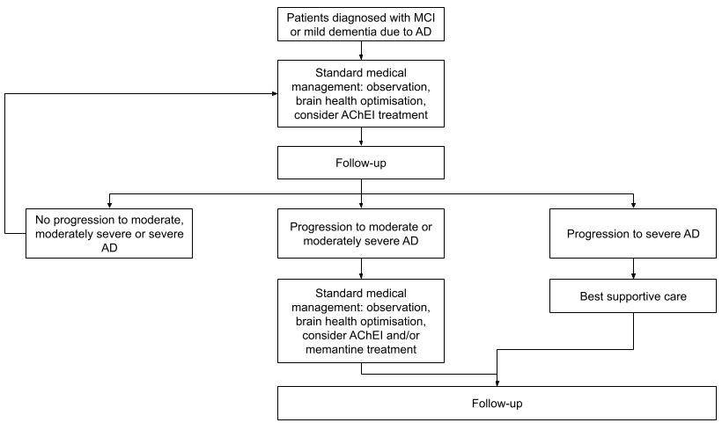
Abbreviations: AchEl=Acetylcholinesterase inhibitor; AD=Alzheimer’s disease; MCI=Mild cognitive impairment

Figure 2: Clinical management algorithm with biomarker testing and lecanemab
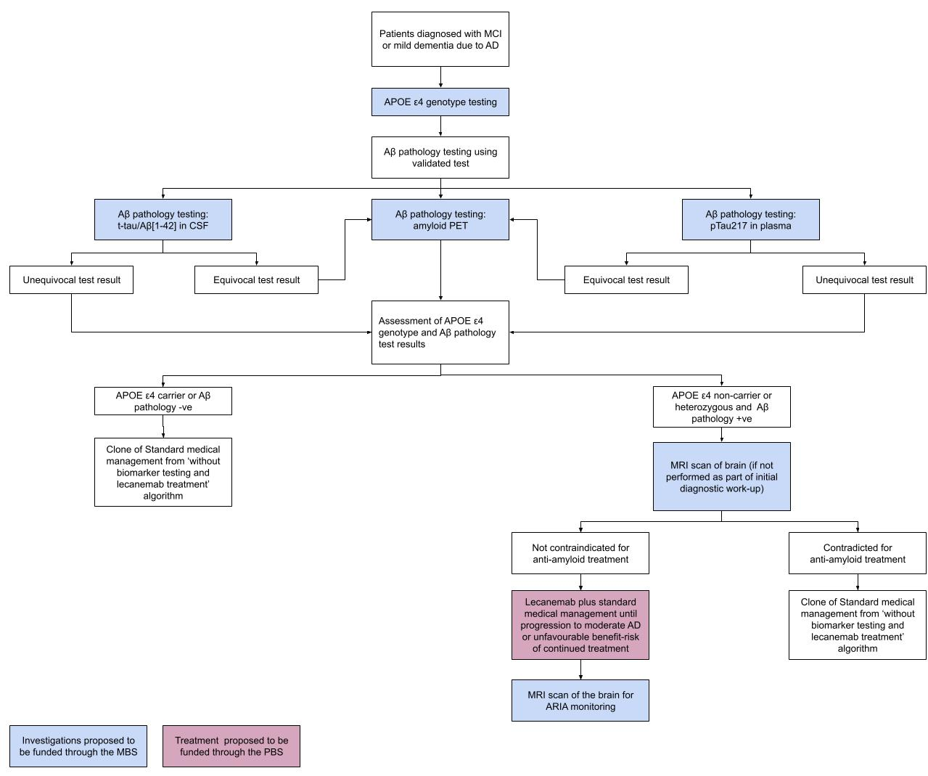
Abbreviations: AD=Alzheimer’s disease; APOE= apoliprotein E; CSF=cerebrospinal fluid; MCI=Mild cognitive impairment; MRI=magnetic resonance imaging

Claims
In terms of health outcomes (comparative benefits and harms), is the proposed technology claimed to be superior, non-inferior or inferior to the comparator(s)?
Superior
Non-inferior
Inferior
Please state what the overall claim is, and provide a rationale:
It is claimed that Aβ pathology and ApoE ε4 genotype testing, followed by lecanemab treatment in people assessed as being ApoE ε4 non-carriers or heterozygous with evidence of Aβ pathology, is superior to no testing plus standard medical management in terms of effectiveness and inferior in terms of safety.
Evidence from the primary analysis CLARITY AD trial and the associated open label extension study provide the rationale for the overall clinical claim.
Results from the assessment of the primary efficacy outcome (CDR-SB) from the CLARITY AD program assessed at 18 months (primary analysis of core study) and 48 months (open label extension) demonstrate that people treated with lecanemab derive a clinical benefit from lecanemab. Specifically, the claim of superior effectiveness is based on the increasing adjusted mean difference in CDR-SB reported for lecanemab vs standard medical management over time (Figure 1).
Figure 3: Clinical Dementia Rating—Sum of Boxes through 48 months: lecanemab vs Standard of Care
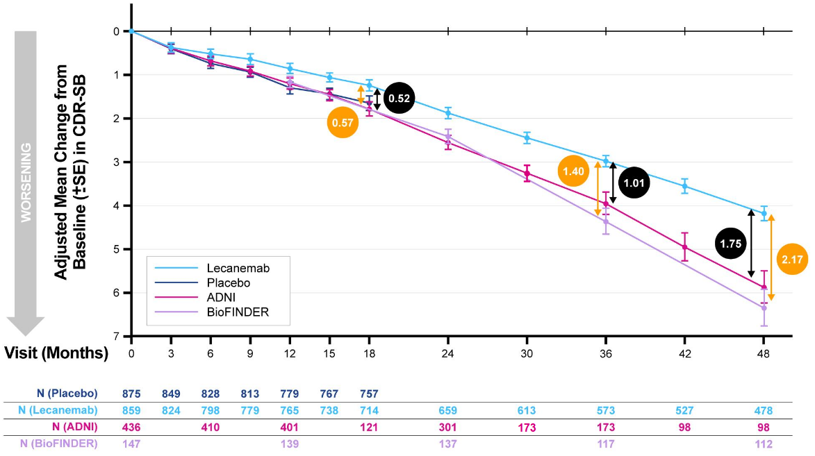
Note: Lower CDR-SB lower scores represent less severe staging of Alzheimer’s disease.
Source: Slide 4 of Presentation by (van Dyck et al. 2025)
Compared with outcomes for standard medical management collected from the ADNI cohort, lecanemab has also been assessed as delaying progression to the next stage of Alzheimer’s disease through 48 months (Figure 2). These findings support a conclusion that the difference in change from baseline in CDR-SB over time reported in people treated with lecanemab vs standard medical management translates to a significant difference in the rate of progression to increasingly more severe stages of Alzheimer's disease in favour of lecanemab.
Figure 4: Time to worsening stage of Alzheimer's disease through 48 months: lecanemab vs Standard of Care
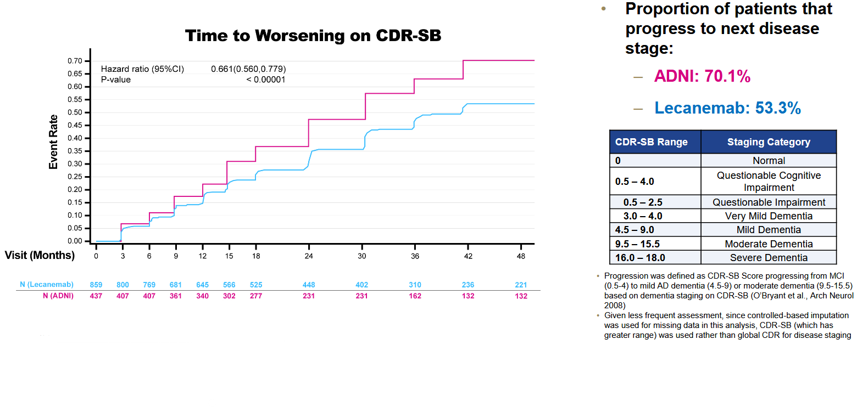Source: Slide 6 of presentation by (van Dyck et al. 2025)
A comprehensive assessment of evidence reported for secondary effectiveness outcomes will be provided in the reimbursement submission for lecanemab as further evidence to further support the clinical claim of superior effectiveness.
Why would the requestor seek to use the proposed investigative technology rather than the comparator(s)?
Alzheimer's disease is progressive condition. The cognitive and functional capacity of people diagnosed with earlier stages of disease is expected to decline over time. Standard medical management, including existing pharmaceutical agents, may provide symptomatic relieve, however they do not modify the progression trajectory of Alzheimer’s disease (Breijyeh et al. 2020).
Lecanemab is a TGA-approved treatment for people diagnosed with mild cognitive impairment and mild dementia due to Alzheimer’s disease with evidence of Aβ pathology that are ApoE ε4 non-carriers or heterozygous. The results from the CLARITY AD trial, and associated open label extension study, provide evidence that treatment with lecanemab delays the rate of Alzheimer’s progression. While not a curative treatment, lecanemab has demonstrated an ability to preserve the cognitive and functional capacity of people compared with standard medical management.
Identify how the proposed technology achieves the intended patient outcomes:
This is a repeat of a question in the ‘Intervention’ section. Please refer to the response provided previously.
For some people, compared with the comparator(s), does the test information result in:
A change in clinical management? Yes
A change in health outcome? Yes
Other benefits? No
Please provide a rationale, and information on other benefits if relevant:
Not applicable
In terms of the immediate costs of the proposed technology (and immediate cost consequences, such as procedural costs, testing costs etc.), is the proposed technology claimed to be more costly, the same cost or less costly than the comparator?
More costly
Same cost
Less costly
Provide a brief rationale for the claim:
Biomarker testing
Aβ pathology and ApoE ε4 genotype testing would represent additional investigations performed as part of the diagnostic work-up of people with Alzheimer’s disease. If funded through the MBS, these tests would represent additional costs.
MRI scanning of the brain is frequently performed as part of the diagnostic work-up of people with Alzheimer’s disease. However, MRI scans of the brain are not required for to monitor for ARIA events in people managed with standard medical management. Thus, MRI scans of the brain performed on people undergoing lecanemab treatment would represent an additional cost.
Lecanemab treatment
Lecanemab is anticipated to have a higher price than existing treatments for Alzheimer's disease listed on the PBS. Further, in some people lecanemab would be provided in addition to standard medical management that includes use of pharmaceutical treatments. If funded through the PBS lecanemab would represent an additional cost.
If your application is in relation to a specific radiopharmaceutical(s) or a set of radiopharmaceuticals, identify whether your clinical claim is dependent on the evidence base of the radiopharmaceutical(s) for which MBS funding is being requested. If your clinical claim is dependent on the evidence base of another radiopharmaceutical product(s), a claim of clinical noninferiority between the radiopharmaceutical products is also required.
Not applicable.

Summary of Evidence
Provide one or more recent (published) high quality clinical studies that support use of the proposed health service/technology. At ‘Application Form lodgement’,
 | Type of study design* | Title of journal article or research project | Short description of research | Website link to journal article or research | Date of publication***
1. | Phase 3 randomised trial: Core CLARITY AD study | Lecanemab in Early Alzheimer’s Disease (Van Dyck et al. 2023)  NCT: 03887455 | 1,795 people enrolled in the study, 898 randomised to lecanemab arm and 897 randomised to placebo arm. People must have been assessed as Aβ pathology positive by amyloid PET or CSF testing.  The primary efficacy assessment was CDR-SB score assessed at 18 months. The adjusted least-squares mean change from baseline at 18 months was 1.21 with lecanemab and 1.66 with placebo (difference, −0.45 (95% CI: −0.67 to −0.23), P<0.001.  ARIA-E events: 12.6% in lecanemab arm vs 1.7% in placebo arm. ARIA-H events: 17.3% in lecanemab arm vs 9.0% in placebo arm | 10.1056/NEJMoa2212948 | 2023
2. | Open-label extension to CLARITY AD | Long-term safety and efficacy of lecanemab in early Alzheimer’s disease: Results from the clarity AD open-label extension study (Van Dyck et al. 2025) | All people enrolled in the open label extension study must have completed the Core CLARITY AD study. People randomised to the placebo arm that completed the Core CLARITY AD study were eligible to enrol and receive lecanemab (delayed start cohort).  At 36 months lecanemab treated people continued to accrue benefit assessed per the CDR-SB. The delayed start cohort does not catch-up to the early start cohort (lecanemab arm in Core CLARITY AD Study), reflecting the importance of early treatment initiation.  ARIA rates were low after 6 months (1.7%). | 10.1002/alz.70905 | 2025 (follow-up to primary assessment of CLARITY AD)
3. | Open-label extension to CLARITY AD | The Lecanemab Clarity AD Open-Label Extension in Early Alzheimer’s Disease: Initial Findings From the 48-Month Analysis (van Dyck et al. 2025) | At 48 months lecanemab treated people continued to accrue benefit assessed per the CDR-SB.  A comparison of outcomes with people treated with standard medical management in a population-matched observational cohort (ADNI, N=436) reports that lecanemab reduces the relative risk of progression to next stage of disease by 34% (P<0.00001).  No new safety signals for lecanemab reported | https://www.eisaimedicalinformation.com/-/media/Files/EisaiMedicalInformation/Neurology/Congress-Materials/AAIC-2025/Van-Dyck-OLE---2025-AAIC---28July2025rev2FINAL.pdf?hash=da827667-3b0b-484c-a3ca-6fc5ba002581 | 2025 (follow-up to primary assessment of CLARITY AD)
4. | Diagnostic accuracy study | Detection and staging of Alzheimer’s disease by plasma pTau217 on a high throughput immunoassay platform (Feizpour et al. 2024) | 388 people with Aβ PET, tau PET and pTau217 in plasma outcomes were assessed. Of these, 232 people had mild cognitive impairment or Alzheimer’s disease,  In the cognitive impairment group pTau217 discriminated between AB- and Aβ+ by PET with an AUC of 0.94 (95% CI: 0.90, 0.98).  Applying two thresholds to classify participants in the entire cohort into Low, Indeterminate, and High zones, 17.8% had Indeterminate results and among Low/High zone participants, 92% were correctly classiﬁed as Aβ or Aβ+ by PET. | 10.1016/j.ebiom.2024.105405 | 2024
5. | Diagnostic accuracy study | Diagnostic Accuracy of a Plasma Phosphorylated Tau 217 Immunoassay for Alzheimer Disease Pathology (Ashton et al. 2024) | Outcomes from 3 cohorts were assessed: WRAP (N=323), TRIAD (N=268) and SPIN (N=195).  pTau217 discriminated between AB- and Aβ+ by PET with an AUC of 0.92 (95% CI: 0.92, 0.96) in the TRIAD cohort and an AUC of 0.93 (95% CI: 0. 90, 0.97) in the WRAP cohort. | 10.1001/jamaneurol.2023.5319 | 2024

References
Ashton, NJ, Brum, WS, et al. (2024). "Diagnostic accuracy of a plasma phosphorylated tau 217 immunoassay for Alzheimer disease pathology." JAMA neurology 81(3): 255-263.

Breijyeh, Z and Karaman, R (2020). "Comprehensive review on Alzheimer’s disease: causes and treatment." Molecules 25(24): 5789.

Feizpour, A, Doecke, JD, et al. (2024). "Detection and staging of Alzheimer's disease by plasma pTau217 on a high throughput immunoassay platform." EBioMedicine 109.

Guideline Adaption Committee (2016). Clinical Practice Guidelines and Principles of Care for People with Dementia. C. D. P. Centre. Sydney.

Jack, CR, Andrews, JS, et al. (2024). "Revised criteria for diagnosis and staging of Alzheimer's disease: Alzheimer's Association Workgroup." Alzheimer's & Dementia 20(8): 5143-5169.

O’Bryant, SE, Waring, SC, et al. (2008). "Staging dementia using Clinical Dementia Rating Scale Sum of Boxes scores: a Texas Alzheimer's research consortium study." Archives of neurology 65(8): 1091-1095.

Schindler, SE, Galasko, D, et al. (2024). "Acceptable performance of blood biomarker tests of amyloid pathology—recommendations from the Global CEO Initiative on Alzheimer’s Disease." Nature Reviews Neurology 20(7): 426-439.

van Dyck, CH, Li, D, et al. (2025). "The Lecanemab Clarity AD Open‐Label Extension in Early Alzheimer’s Disease: Initial Findings From the 48‐Month Analysis." Alzheimer's & Dementia 21(Suppl 7): e108905.

Van Dyck, CH, Sperling, R, et al. (2025). "Long‐term safety and efficacy of lecanemab in early Alzheimer's disease: Results from the clarity AD open‐label extension study." Alzheimer's & Dementia 21(12): e70905.

Van Dyck, CH, Swanson, CJ, et al. (2023). "Lecanemab in early Alzheimer’s disease." New England Journal of Medicine 388(1): 9-21.

