MSAC Application
Lisocabtagene maraleucel (Breyanzi®) for treatment of relapsed or refractory large B-cell lymphoma (R/R LBCL) in the second-line (2L) setting

  - PICO Set 1 of 2

Population
Describe the population in which the proposed health technology is intended to be used:
Patients with confirmed relapsed/refractory large B-cell lymphoma (LBCL).

Specify any characteristics of patients with the medical condition, or suspected of, who are proposed to be eligible for the proposed health technology, describing how a patient would be investigated, managed and referred within the Australian health care system in the lead up to being considered eligible for the technology:
It is proposed that lisocabtagene maraleucel be funded for the treatment of patients with large B-cell lymphoma in the second-line setting. Specifically, this includes:
- Diffuse Large B-Cell Lymphoma (DLBCL, not otherwise specified)
- DLBCL (transformed from FL, CLL, MZL, or other)
- High-Grade B-Cell Lymphoma (HGBCL, double/triple hit)
- Primary Mediastinal B-Cell Lymphoma (PMBCL)
- Follicular Lymphoma Grade 3B (FL3B)
The treatment pathway for patients with LBCL is well-described in Cancer Australia’s optimal care pathway (Cancer Australia, 2021).
Patients may present with an abnormal lump or mass, lymphadenopathy, or persistent unexplained fever, drenching sweats, unintentional weight loss, persistent severe itch and frequent infections.
Upon recognition of such symptoms, appropriate investigations include:
- full blood examination
- imaging of the affected areas using ultrasound, x-ray and CT, as appropriate
- biopsy, as appropriate
- a period of observation of up to 4 weeks for patients without significant or progressive symptoms.
If malignancy is suspected, patients are referred to an oncologist for diagnosis, staging and treatment planning.

Provide a rationale for the specifics of the eligible population:
The proposed population is aligned to the existing eligibility criteria for axicabtagene ciloleucel in the 2L LBCL setting (per MSAC recommendation 1722.1, April 2024). This population is also aligned to the clinical trial population from TRANSFORM (NCT03483103), the pivotal trial upon which regulatory approval is based.

Intervention
Name of the proposed health technology:
Lisocabtagene maraleucel (Breyanzi®).

Describe the key components and clinical steps involved in delivering the proposed health technology:
Lisocabtagene maraleucel is chimeric antigen receptor T-cell (CAR-T) therapy.
CAR-T therapy is an immunocellular therapy that is individualised to each patient. It involves the leukapheresis of autologous T-cells from a blood sample taken from a patient. The T-cells are then genetically modified via transduction of a viral vector into T-cell DNA (creating a CAR-T). Following transduction, CAR-T cells are expanded to a therapeutic dose, formulated, and cryopreserved. The manufactured CAR-T cells are primed to target antigens on tumours and destroy cancer cells after reinfusion into the patient.
An overview of the CAR-T process is summarised in Figure 1.
Figure 1: CAR-T process
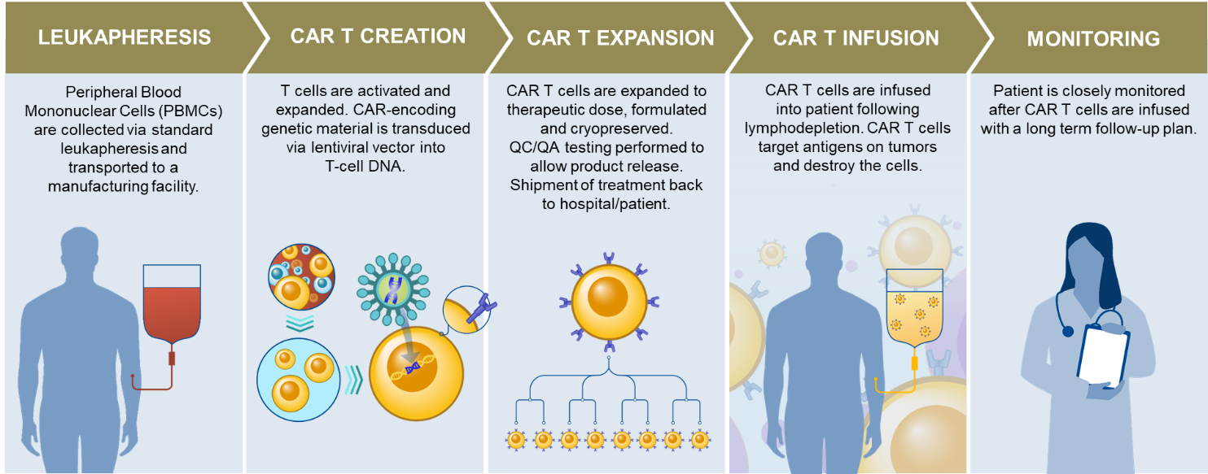
Source: Adapted from Mato A, et al. Blood. 2015;126:478-485. Davila ML, et al. Oncoimmunology. 2012;1:1577-1583. Davila ML, et al. Int J Hematol. 2014;99:361-371. Tumaini B, et al. Cytotherapy. 2013;15:1406-1415.

CAR-T therapy is unique in a number of ways, as it is a truly personalised treatment with specific requirements for preparation, transport, manufacturing, and monitoring.

Identify how the proposed technology achieves the intended patient outcomes:
In the TRANSFORM clinical trial, lisocabtagene maraleucel demonstrated a statistically significant improvement in terms of event free survival (EFS) and progression free survival (PFS) compared to standard of care chemotherapy. Lisocabtagene maraleucel also demonstrated higher complete response rates (CRRs) and numerically improved overall survival (OS) versus standard of care chemotherapy.
Does the proposed health technology include a registered trademark component with characteristics that distinguishes it from other similar health components?
Yes.

Explain whether it is essential to have this trademark component or whether there would be other components that would be suitable:
Breyanzi is manufactured by Bristol Myers Squibb under patent protection and cannot be substituted for another product.

Are there any proposed limitations on the provision of the proposed health technology delivered to the patient (For example: accessibility, dosage, quantity, duration or frequency):
Yes.

Provide details and explain:
Lisocabtagene maraleucel is proposed to be offered in the tertiary public setting by qualified treatment centres.

If applicable, advise which health professionals will be needed to provide the proposed health technology:
Haematologist or haematologist-oncologist.

If applicable, advise whether delivery of the proposed health technology can be delegated to another health professional:
Not applicable.

If applicable, advise if there are any limitations on which health professionals might provide a referral for the proposed health technology:
As noted above, treatment is proposed to be limited to qualified treatment centres.

Is there specific training or qualifications required to provide or deliver the proposed service, and/or any accreditation requirements to support delivery of the health technology?
Yes.

Provide details and explain:
Treatment centres must have appropriate training and qualification in the management and administration related to lisocabtagene maraleucel for patients with LCBL.

Indicate the proposed setting(s) in which the proposed health technology will be delivered:
Consulting rooms
Day surgery centre
Emergency Department
Inpatient private hospital
Inpatient public hospital
Laboratory
Outpatient clinic
Patient’s home
Point of care testing
Residential aged care facility
Other (please specify)
The proposed eligibility criteria for lisocabtagene maraleucel mandates that a patient “must be treated in a tertiary public hospital with appropriate credentials”.

Is the proposed health technology intended to be entirely rendered inside Australia?
Yes

Comparator
Nominate the appropriate comparator(s) for the proposed medical service (i.e. how is the proposed population currently managed in the absence of the proposed medical service being available in the Australian health care system). This includes identifying health care resources that are needed to be delivered at the same time as the comparator service:
Provide a name for your comparator:
Axicabtagene ciloleucel (Yescarta®)

Provide an identifying number for your comparator (if applicable):
Not applicable.

Provide a rationale for why this is a comparator:
Axicabtagene ciloleucel is a currently available CAR-T therapy that has been recommended for funding in the same population as sought for lisocabtagene maraleucel.

Pattern of substitution – Will the proposed health technology wholly replace the proposed comparator, partially replace the proposed comparator, displace the proposed comparator or be used in combination with the proposed comparator?
None (used with the comparator)
Displaced (comparator will likely be used following the proposed technology in some patients)
Partial (in some cases, the proposed technology will replace the use of the comparator, but not all)
Full (subjects who receive the proposed intervention will not receive the comparator)
Outline and explain the extent to which the current comparator is expected to be substituted:
Lisocabtagene maraleucel is anticipated to replace axicabtagene ciloleucel for a proportion of patients with LBCL being treated in the second line setting.

Outcomes
List the key health outcomes (major and minor – prioritising major key health outcomes first) that will need to be measured in assessing the clinical claim for the proposed medical service/technology (versus the comparator):
Health benefits
Health harms
Resources
Outcome description – please include information about whether a change in patient management, or prognosis, occurs as a result of the test information:
Key efficacy outcomes anticipated to be presented in the ADAR that are informed by the TRANSFORM clinical trial include:
- Primary efficacy endpoint: event-free survival (EFS)
- Key secondary efficacy endpoints:
  - Complete response rate (CRR)
  - Progression-free survival (PFS)
  - Overall survival (OS)
  - Duration of response (DOR)
  - Objective response rate (ORR)
  - Progression-free survival 2 (PFS-2)
  - Health related quality of life (HRQoL)
Key efficacy outcomes anticipated to be presented in the ADAR that are informed by the PILOT clinical trial include:
- Primary efficacy endpoint: overall response rate (ORR)
- Key secondary efficacy endpoints:
  - Complete response rate (CRR)
  - Progression-free survival (PFS)
  - Overall survival (OS)
  - Event-free survival (EFS)
  - Duration of response (DOR)
  - Health related quality of life (HRQoL)

Note that the proposed therapy is not a test.

List the key health outcomes (major and minor – prioritising major key health outcomes first) that will need to be measured in assessing the clinical claim for the proposed medical service/technology (versus the comparator):
Health benefits
Health harms
Resources
Outcome description – please include information about whether a change in patient management, or prognosis, occurs as a result of the test information:
Key safety outcomes anticipated to be presented in the ADAR are informed by the TRANSFORM clinical trial include the type, frequency, and severity of adverse events (AEs), serious adverse events (SAEs), and laboratory abnormalities.
Key safety outcomes anticipated to be presented in the ADAR are informed by the PILOT clinical trial include the type, frequency, and severity of adverse events (AEs), and laboratory abnormalities.
Note that the proposed therapy is not a test.

List the key health outcomes (major and minor – prioritising major key health outcomes first) that will need to be measured in assessing the clinical claim for the proposed medical service/technology (versus the comparator):
Health benefits
Health harms
Resources
Outcome description – please include information about whether a change in patient management, or prognosis, occurs as a result of the test information:
Key resource related outcomes anticipated to be presented in the ADAR are informed by the TRANSFORM clinical trial, and include:
- Number of and duration of hospitalisations
- Reasons for hospitalisation
- Unit of admission
- ICU and non-ICU inpatient stays
- Number of outpatient visits

Key resource related outcomes anticipated to be presented in the ADAR are informed by the PILOT clinical trial, include numbers of intensive care unit (ICU) inpatient days and non-ICU inpatient days and reasons for hospitalisation.

Claims
In terms of health outcomes (comparative benefits and harms), is the proposed technology claimed to be superior, non-inferior or inferior to the comparator(s)?
Superior
Non-inferior
Inferior
Please state what the overall claim is, and provide a rationale:
Claim of non-inferiority is based on the totality of evidence available for lisocabtagene maraleucel in comparison to the nominated comparator, axicabtagene ciloleucel.
Why would the requestor seek to use the proposed investigative technology rather than the comparator(s)?
Based on preference for the clinical profile of the therapy versus the comparator.
Identify how the proposed technology achieves the intended patient outcomes:
Lisocabtagene maraleucel has demonstrated efficacy and safety in a randomised Phase III clinical trial, extending EFS, PFS, and OS, with higher CR rates than standard of care chemoimmunotherapy.
For some people, compared with the comparator(s), does the test information result in:
A change in clinical management? N/A (not a test)
A change in health outcome? N/A (not a test)
Other benefits? N/A (not a test)
Provide a rationale, and information on other benefits if relevant:
Lisocabtagene maraleucel is not a test. It is anticipated that lisocabtagene maraleucel will result in similar health outcomes to the currently available standard of care in the 2L DLBCL setting.
In terms of the immediate costs of the proposed technology (and immediate cost consequences, such as procedural costs, testing costs etc.), is the proposed technology claimed to be more costly, the same cost or less costly than the comparator?
More costly
Same cost
Less costly
Provide a brief rationale for the claim:
Proposed claim of non-inferiority resulting in a price per patient in line with currently available axicabtagene ciloleucel.

Algorithms

PREPARATION FOR USING THE HEALTH TECHNOLOGY
Define and summarise the clinical management algorithm, including any required tests or healthcare resources, before patients would be eligible for the proposed health technology:
Presently, patients diagnosed with large B-cell lymphoma (LBCL) are treated in the first line setting with the chemotherapy regimen RCHOP. Depending on fitness for stem cell transplant and time to relapse, patients may subsequently be treated with immunochemotherapy, platinum-based salvage chemotherapy following by high-dose chemotherapy and autologous stem cell transplant, or allogeneic stem cell transplant. Today, patients can access axicabtagene ciloleucel in the 2L and 3L+ setting, and tisagenlecleucel in the 3L+ setting. The bispecific antibody agent epcoritamab is reimbursed for patients in the 3L+ setting. See Figure 2 for a diagram of the current and proposed treatment algorithm.
Is there any expectation that the clinical management algorithm before the health technology is used will change due to the introduction of the proposed health technology?
No. It is anticipated that lisocabtagene maraleucel will provide another CAR-T therapy option to patients with 2L DLBCL but will not change the algorithm for patients with this condition.

USE OF THE HEALTH TECHNOLOGY
Explain what other healthcare resources are used in conjunction with delivering the proposed health technology:
Management of patients receiving CAR-T therapy often includes lymphodepleting chemotherapy, and may include adverse event management with tocilizumab or other blood products.
Explain what other healthcare resources are used in conjunction with the comparator health technology:
As above.
Describe and explain any differences in the healthcare resources used in conjunction with the proposed health technology vs. the comparator health technology:
Based on the available clinical data, lisocabtagene maraleucel is associated with fewer adverse events in comparison to axicabtagene ciloleucel. This may result in a reduction in healthcare resource utilisation associated with the management of patients with LBCL undergoing CAR-T treatment.

CLINICAL MANAGEMENT AFTER THE USE OF HEALTH TECHNOLOGY
Define and summarise the clinical management algorithm, including any required tests or healthcare resources, after the use of the proposed health technology:
Immediately following infusion with CAR-T therapy, patient monitoring is essential to ensure fast response to any adverse events from treatment. In the proposed Product Information for lisocabtagene maraleucel, this period is two weeks.
Beyond this point, ongoing monitoring and check ups are required, and patients may continue through the treatment algorithm presented in Figure 2 if disease progression occurs.

Define and summarise the clinical management algorithm, including any required tests or healthcare resources, after the use of the comparator health technology:
There are no differences between the treatment algorithm for the use of lisocabtagene maraleucel or axicabtagene ciloleucel aside from the potential magnitude of resources used in the management of adverse events.
Describe and explain any differences in the healthcare resources used after the proposed health technology vs. the comparator health technology:
As noted above, the key anticipated difference is the resource use associated with the management of adverse events.
Insert diagrams demonstrating the clinical management algorithm with and without the proposed health technology:
A visual representation of the clinical management algorithm for patients with LBCL is presented in Figure 2.
Figure 2: LBCL clinical management algorithm
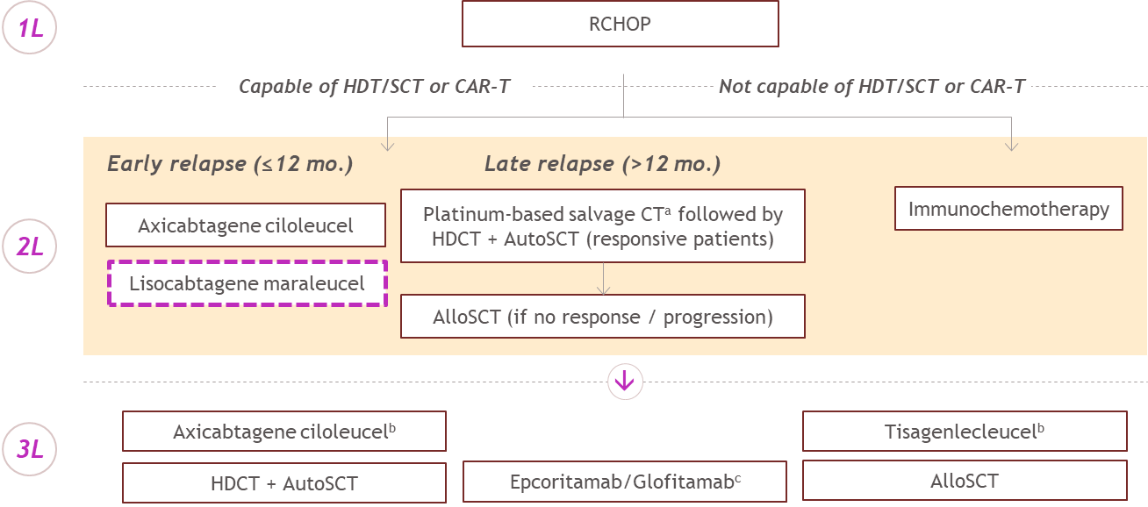

ª R-ICE, R-ESHAP, R-GDP, R-DHAP
^{b} Patient ineligible for CAR-T in the 3L setting if they have received CAR-T in the 2L setting
^{c} Glofitamab has been recommended by the PBAC, not yet PBS listed
Abbreviations: BSC = best supportive care; CAR = chimeric antigen receptor; HDCT = high-dose chemotherapy; R-CHOP = rituximab, cyclophosphamide, doxorubicin, vincristine, and prednisone; R-DHAP = rituximab plus dexamethasone, high-dose cytarabine and cisplatin/oxaliplatin; R-ESHAP = rituximab plus etoposide, methylprednisolone, cytarabine and cisplatin; R-GDP = rituximab plus gemcitabine, dexamethasone and cisplatin/carboplatin; R-ICE = rituximab plus ifosfamide, carboplatin and etoposide; SCT = stem cell transplant.

Lisocabtagene maraleucel is presented in the above figure in the pink dotted box, indicating the proposed population for use (aligned to axicabtagene ciloleucel).

Summary of Evidence
Provide one or more recent (published) high quality clinical studies that support use of the proposed health service/technology. At ‘Application Form lodgement’,
 | Type of study design | Title of journal article or research project | Short description of research | Website link to journal article or research | Date of publication
1. | Phase III, randomized, open-label, parallel group, multi-centre clinical trial | Lisocabtagene maraleucel as second-line therapy for large B-cell lymphoma: primary analysis of the phase 3 TRANSFORM study (NCT03575351)  Abramson et. al. | Lisocabtagene maraleucel demonstrated a significant improvement in the outcomes of EFS, CR rate, and PFS vs salvage chemotherapy in the treatment of 2L TNE DLBCL patients at the time of primary analysis (n=184) | Blood. 2023;141(14):1675-1684. doi:10.1182/blood.2022018730 | 6 April 2023
2. | Phase II, single-arm, open-label, multi-centre clinical trial | Lisocabtagene maraleucel for R/R LBCL in patients not intended for HSCT: final results of the phase 2 PILOT study (NCT03483103)  Sehgal et. al. | Lisocabtagene maraleucel demonstrated durable efficacy and a favourable safety profile among patients with 2L DLCBL not intended for HSCT (n=61) | Blood Adv. 2025;9(15):3694-3705. doi:10.1182/bloodadvances.2024015262 | 23 July 2025
3. | Phase II, multi-centre, open-label clinical trial | OUTREACH: phase 2 study of lisocabtagene maraleucel as outpatient or inpatient treatment at community sites for R/R LBCL (NCT03744676)  Linhares et. al. | A study evaluating the safety and efficacy of outpatient monitoring after lisocabtagene maraleucel at community sites in the United States. Adults with DLBCL after at least 2 lines of therapy received lisocabtagene maraleucel.  82 patients received therapy (70% outpatient, 30% inpatient).  Data support the feasibility of liso-cel administration at community sites with outpatient monitoring. | Blood Adv. 2024;8(23):6114-6126. doi:10.1182/bloodadvances.2024013254 | 3 December 2024

