MSAC Application 1823

  - ¹⁷⁷Lutetium PSMA-617 for prostate specific membrane antigen (PSMA)-positive, taxane-naïve patients with metastatic castrate resistant prostate cancer (mCRPC)

  - PICO Set

Population

Describe the population in which the proposed health technology is intended to be used:
The proposed population are adult patients with metastatic castration-resistant prostate cancer (mCRPC), who are confirmed prostate specific membrane antigen (PSMA)-positive, have progressive disease following treatment with an androgen receptor inhibitor pathway inhibitor (ARPI) and are untreated with taxane-based chemotherapy in the hormone-sensitive or castration-resistant setting.
Prostate cancer is the most diagnosed cancer in Australia, accounting for approximately 30% of all male cancer diagnoses in 2025. Figure 1 illustrates the natural history of prostate cancer. Approximately 1 in 6 men will be diagnosed with prostate cancer in their lifetime (ACP, 2026). Most men (82%) will be diagnosed in the early stages of disease (i.e., Stage I and II) where prognosis is generally good (AIHW, 2025). Despite treatment, approximately 10% to 20% will progress to castration-resistant disease and studies suggest that most of these patients will have metastases at the time of developing castration resistant disease (i.e., mCRPC) (Kirby et al., 2011). Approximately 60% of non-metastatic castration-resistant disease will develop mCRPC (Malone et al., 2022). Only a small proportion (4.2%) of men will be diagnosed with de novo metastatic disease (AIHW, 2025).
mCRPC is generally associated with the poorest prognosis, with real-world studies reporting median survival of less than 4 years and Australian data reporting median survival of 3 years (Francini 2019, Chowdhury 2020, Westgeest 2021; Williams et al., 2025). mCRPC significantly affects patient wellbeing due to persistent symptoms and impairment from both cancer and treatments. Australian men with mCRPC experience lower quality of life, greater severity of symptoms, more psychological distress, increased suicide risk, and greater unmet care needs than those with localised disease (Chambers et al., 2018; Holmstrom et al., 2019).
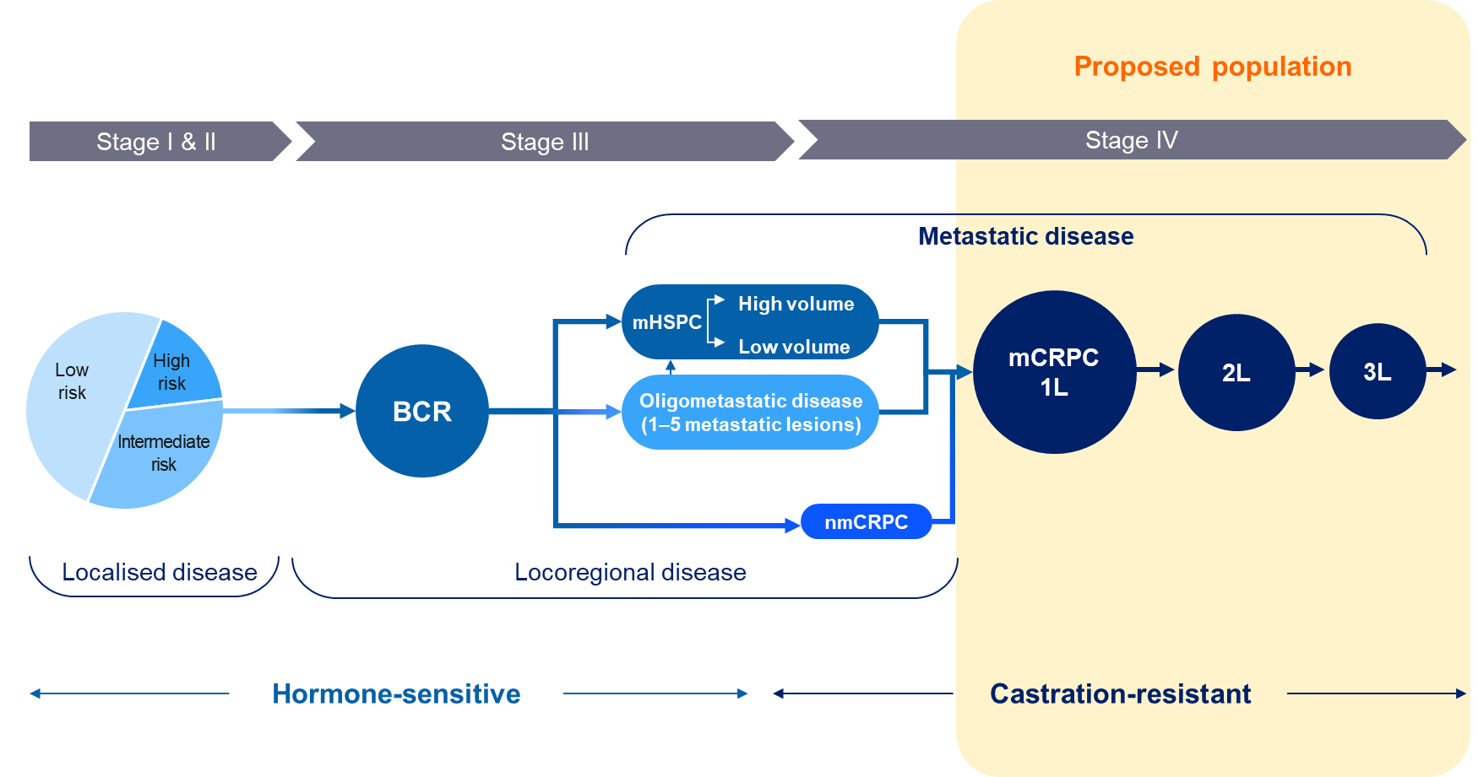
Figure 1 Overview of prostate cancer
Abbreviations: 1L, first line; 2L, second line; 3L, third line; BCR, biochemical recurrence; mHSPC, metastatic hormone-sensitive prostate cancer; mCRPC, metastatic castration-resistant prostate cancer; nmCRPC, non-metastatic castration-resistant prostate cancer.
Source: Novartis Data on File, 2026.

Specify any characteristics of patients with, or suspected of having, the medical condition, who are proposed to be eligible for the proposed health technology, describing how a patient would be investigated, managed and referred within the Australian healthcare system in the lead up to being considered eligible for the technology:
The proposed population will be required to be confirmed PSMA-positive by PSMA positron emission tomography (PET) scan, have progressive disease following treatment with an ARPI and have not received taxane-based chemotherapy in the hormone-sensitive or castration-resistant setting.
Patients with prostate cancer are managed by a lead physician (e.g., urologist, medical oncologist) and, where possible, a comprehensive multidisciplinary team (MDT). mCRPC patients will have undergone extensive pathology and imaging testing to confirm diagnosis as well as the stage and extent of disease. Such tests may include physical examination, digital rectal examination, prostate-specific antigen (PSA) levels, biopsy, bone scans, and PET/computed tomography (CT) scan. Evidence of biochemical or radiographic recurrence despite castrate levels of testosterone in the setting of existing metastatic disease confirms a diagnosis of mCRPC
The treatment pathway is varied depending on patient risk factors and disease characteristics. In mCRPC, treatment options are limited to ARPI, docetaxel, ¹⁷⁷Lu-PSMA-617, cabazitaxel or palliative care and treatment decisions are dependent upon prior therapies received. For mCRPC patients with progressive disease following ARPI who have not yet received chemotherapy, treatment options in Australia are docetaxel or palliative care. Literature suggests that patients may forego treatment with docetaxel due to the toxicity profile and impact on quality of life (Al-Batran et al., 2015; Singer & Srinivasan, 2012). The Drug Utilisation Sub-Committee (DUSC) analysis indicates that most patients (71%) receive palliative care following an ARPI and only a small proportion (14%) receive docetaxel (olaparib PSD, para 5.2, March 2021 PBAC Meeting). This highlights a significant unmet need for new effective treatment options for the proposed patient population.
To be considered for treatment with ¹⁷⁷Lu-PSMA-617, a patient will need to have confirmed disease progression based on pathology and/or imaging following treatment with an ARPI and be confirmed PSMA-positive based on PSMA PET scan. mCRPC patients considered appropriate candidates for treatment will be referred by their lead specialist for a PSMA PET scan to determine eligibility and suitability for treatment. For eligible patients, ¹⁷⁷Lu-PSMA-617 will be administered by an accredited nuclear medicine specialist in an accredited facility.

Provide a rationale for the specifics of the eligible population:
MSAC has previously noted the high clinical unmet need for new, effective therapies for mCRPC for the following reasons: (1) mCRPC patients experience significant morbidity due to bone metastases and skeletal related events, (2) many mCRPC patients opt to forego chemotherapy and elect for palliative care, and (3) 3,000 Australian men die each year from mCRPC. MSAC has also acknowledged equity issues and barriers to accessing treatments in remote and regional areas (MSAC 1681.1 PSD April 2024 Meeting).
Radiopharmaceuticals offer an innovative treatment alternative in cancer care. ¹⁷⁷Lu-PSMA-617 is now standard of care for PSMA-positive mCRPC patients who have progressive disease following at least one ARPI and at least one taxane therapy based on the phase III study VISION. The National Comprehensive Cancer Network (NCCN) and the European Society for Medical Oncology (ESMO) guidelines recommend the use of ¹⁷⁷Lu-PSMA-617 for patients who are taxane-naïve (the proposed patient population), based on the pivotal randomised controlled trial, PSMAfore.

Are there any prerequisite tests?
Yes.

Are the prerequisite tests MBS funded?
No, seeking amendment to existing MBS item.

Provide details to fund the prerequisite tests:
This application requests an amendment to the MBS item 61528 to include the proposed patient population. MSAC supported the MBS listing of PSMA PET/CT scan at their July 2021 meeting to assess eligibility for treatment with ¹⁷⁷Lu-PSMA therapy in mCRPC patients with progressive disease who have had at least one ARPI and at least one taxane-based chemotherapy. MSAC considered PSMA PET/CT to have superior effectiveness in terms of diagnostic accuracy and clinical utility, and acceptable cost-effectiveness (MSAC 1632 PSD July 2021 Meeting). The proposed patient population are required to undergo a PSMA PET scan to determine eligibility for treatment.

Intervention

Name of the proposed health technology:
Lutetium-177 vipivotide tetraxetan (¹⁷⁷Lu-PSMA-617) (Pluvicto®).
Radioligand therapy in Australia
Currently, Pluvicto® and Lutathera® are the only Therapeutic Goods Administration (TGA) approved radioligand therapies (RLTs) available for eligible mCRPC and neuroendocrine tumour patients, respectively. Patients may be eligible for a partial subsidy via the MBS; however, in practice this funding mechanism is reportedly challenging for clinicians and patients with several access barries including complex billing, multiple pathways to claim, payment of full cost upfront, and wait time for reimbursement.
RLT, a specific radiopharmaceutical, has a healthy future locally and internationally with several pharmaceutical companies exploring treatment options for various diseases

This application requests the following:
- An amendment to the existing PSMA PET MBS item to determine eligibility for treatment,
- Reimbursement of ¹⁷⁷Lu-PSMA-617 through the broader Medicare program.,
- Associated administrative costs subsided separately to treatment costs.

Describe the key components and clinical steps involved in delivering the proposed health technology:
¹⁷⁷Lu-PSMA-617 is a novel RLT consisting of a PSMA-targeting vector that binds with high affinity and specificity to PSMA expressing tumours. Patients with higher PSMA expression may have a greater magnitude of benefit (Beltran, et al., 2025). As such, treatment with ¹⁷⁷Lu-PSMA-617 is only effective against tumours with sufficient PSMA expression. PSMA PET scan is used to determine the level of PSMA expression and assess suitability for treatment with ¹⁷⁷Lu-PSMA-617.
Figure 2 illustrates the typical steps involved to deliver ¹⁷⁷Lu-PSMA-617.
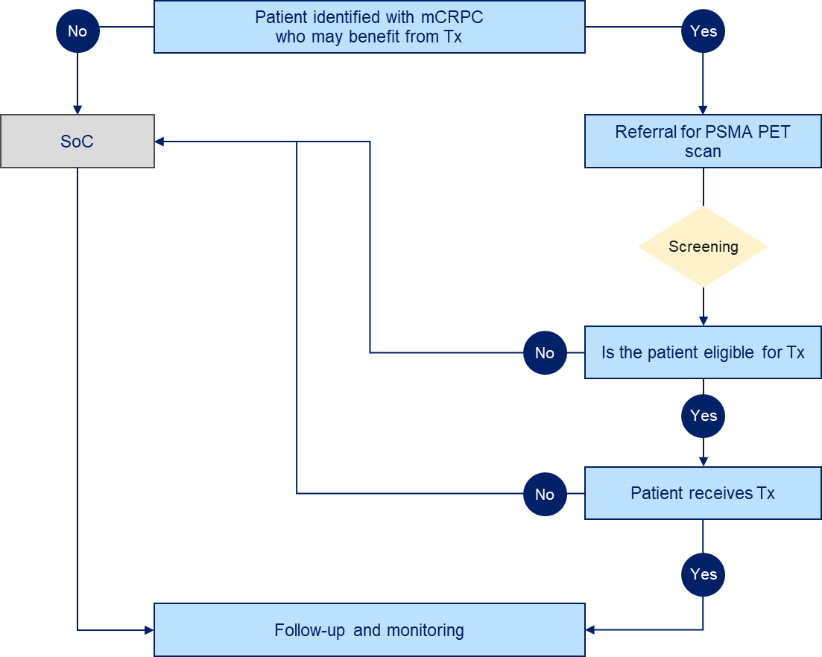
Figure 2 Flow diagram of the steps required to receive ¹⁷⁷Lu-PSMA-617
Abbreviations: mCRPC, metastatic castration-resistant prostate cancer; PET, positron emission tomography; PSMA, prostate-specific membrane antigen; SoC, standard of care; Tx, treatment

- Referral
Patients living with mCRPC are managed by a lead physician (e.g., urologist, medical oncologist) and where possible a comprehensive MDT. The lead physician will confirm disease progression and identify if the patient may benefit from, and could be considered appropriate for, treatment with ¹⁷⁷Lu-PSMA-617. The physician will refer the patient for a PSMA PET scan at an accredited facility. The request is verified and, if valid, an appointment will be made, and the patient will be provided with the relevant preparation details in line with the Product Information.
- Screening
The patient will undergo a whole-body PSMA PET scan performed by a trained nuclear medicine specialist at a certified facility.
PSMA PET is a non-invasive imaging procedure that involves the administration of one of several radiopharmaceutical tracers that share the characteristics of highly specific binding to PSMA (MSAC 1632 PSD July 2021 Meeting, p7). PET imaging measures the biodistribution of an intravenously injected biological tracer labelled with a positron-emitting radionuclide (Scott, 2001). This technique can detect and quantify biological processes within the body.
PET imaging is commonly combined with CT, with scans collected using a single, hybrid PET/CT scanner (MSAC 1632 PICO Confirmation, p14). There are several hybrid PET/CT devices listed on the Australian Register of Therapeutic Goods (ARTG) (ARTG numbers: 343270, 324191, 296394, 292543, 271560, 144218 and 118077).
In Australian clinical practice, gallium-68-PSMA-11 (⁶⁸Ga-PSMA-11) is the most widely used radiopharmaceutical tracer. ⁶⁸Ga-PSMA-11 is TGA approved for patient selection for PSMA-targeted therapy. Such radiopharmaceuticals are produced extemporaneously in a facility holding a Good Manufacturing Practice license.
Proposed diagnostic test
In 2024, MSAC evaluated and recommended PSMA PET to determine a patient’s eligibility for PSMA-targeted therapy (MSAC 1686.1 PSD April 2024 Meeting). The MBS item 61528 was listed on 1 July 2025 to assess suitability for ¹⁷⁷Lu-PSMA therapy in a patient with mCRPC after progressive disease has developed while undergoing prior treatment with at least one taxane chemotherapy and at least one ARPI.
The current MBS item number excludes the population under consideration in this application which means that these patients are unable to access the same test that was supported by MSAC. This test is necessary to determine eligibility for treatment. The proposed patient population are required to undergo a PSMA PET scan to determine eligibility for treatment. As such this application requests an amendment to the MBS item 61528 to include the proposed patient population.
- Eligibility
Screening with whole body PSMA PET assesses whether the patient has sufficient PSMA expression at sites of measurable disease to indicate eligibility for treatment. A nuclear medicine specialist will evaluate the results to determine the patient’s PSMA expression levels and their suitability for treatment with ¹⁷⁷Lu-PSMA-617.
PSMA-positive
PMSA is often highly expressed in patients with mCRPC and studies suggest that higher maximum or mean standard uptake volume (SUV) rates may be predictive of a greater likelihood of favourable treatment response (Beltran, et al., 2025). MBS item 16050 defines PSMA-positive as SUV_{max} > 15 at a single site of disease and SUV_{max} > 10 at all sites of measurable disease. This application requests the same definition to determine eligibility for treatment.
- Treatment
The decision to treat will be made by the lead physician and/or the nuclear medicine specialist in collaboration with the patient. Several factors will be taken into consideration including PET imaging characteristics, stage in the patient journey, and haematologic and biochemical results. Despite being deemed eligible for treatment these factors may lead to a decision not to treat. Treatment will be scheduled for patients deemed eligible and appropriate for treatment. Patients will be monitored regularly by their treating physician to ensure they are medically and physically fit for treatment.
In preparation for the procedure, patients are encouraged to increase oral fluids and void as often as possible to reduce bladder radiation. Laboratory tests are recommended before and during treatment as per the Product Information (PLUVICTO® PI, Attachment B).
The procedure is performed within an accredited nuclear medicine facility by an accredited nuclear medicine specialist. Patients are treated in an outpatient setting. A cannula is placed in a vein, and ¹⁷⁷Lu-PSMA-617 is administered as a slow intravenous injection. An oral dose of 8 mg dexamethasone is also administered at the time of injection to minimise the chance of nausea or transient increase in pain.
The patient will stay isolated in the nuclear medicine facility, encouraged to drink water, until radiation levels reduce to the safe government limit for discharge (25uSv /hour at one metre). The patient is given full radiation safety education on limiting radiation dose to the public, family and caregivers.
- Follow-up and monitoring
Following treatment, the patient will be routinely monitored for response to treatment, side effects and disease progression to determine suitability for subsequent doses. As per the Product Information, ¹⁷⁷Lu-PSMA-617 can be delivered every 6 weeks up to a maximum of 6 doses or until toxicity or disease progression based on clinician assessment (PLUVICTO® PI, Attachment B). To date, no large-scale clinical trials have assessed more than 6 doses, and limited data is available to support more than 6 doses of ¹⁷⁷Lu-PSMA-617 (Rosar et al., 2024).
The decision to deliver each subsequent dose(s) of ¹⁷⁷Lu-PSMA-617 will be made by the nuclear medicine specialist. Management of severe or intolerable adverse reactions may require temporary dose interruption, dose reduction or permanent discontinuation. If a treatment delay due to adverse reaction persists for 4 or more weeks, treatment discontinuation may be considered. The dose may be reduced by 20% once but should not be re-escalated. If a patient has further adverse reactions that would require additional dose reduction, treatment with ¹⁷⁷Lu-PMSA-617 must be discontinued. Upon cessation of ¹⁷⁷Lu-PSMA-617, the patient’s lead physician will determine the next appropriate course of treatment with the patient.

Identify how the proposed technology achieves the intended patient outcomes:
¹⁷⁷Lu-PSMA-617 is a minimally invasive treatment targeting PSMA-positive prostate cancer cells which can lead to improved clinical outcomes and better quality of life compared to current standard of care. PSMA is often overexpressed on prostate cancer cells but has limited expression in most normal tissues. This selective expression allows ¹⁷⁷Lu-PSMA-617 to deliver β-particle radiation directly to prostate cancer cells and their tumour microenvironment, thereby minimising off-target effects (Morris et al., 2024).

Does the proposed health technology include a registered trademark component with characteristics that distinguishes it from other similar health components?
Yes.

Explain whether it is essential to have this trademark component or whether there would be other components that would be suitable:
Maintaining the trademark component is essential to ensure the safe delivery of treatment to patients. ¹⁷⁷Lu-PSMA-617 has undergone extensive testing, controlled clinical trials and rigorous regulatory evaluations and is the only RLT approved by the TGA and listed on the ARTG for the treatment of patients with mCRPC. The trademark gives providers, patients and the community security that the treatment they are receiving is safe, effective and of a high quality.
In the past, compounded therapies made from various sources have enabled patients to access unapproved versions of similar technologies. Alternative ¹⁷⁷Lu-PSMA components are not produced following Good Manufacturing Practice standards, which ensures product quality, have not been reviewed by the TGA for safety or effectiveness, and are not listed on the ARTG.
Today, RLTs and other radiopharmaceuticals are rapidly evolving. Australia’s health technology assessment system is a recognised way of safeguarding patients and the community, wherein products must be approved by the TGA before potential reimbursement. Companies seeking to include therapeutic goods on the ARTG are required to provide certification of patent or declaration that their application is not infringing on any patent (existing or pending). Reimbursement for treatments that have not been assessed by the TGA contradicts this and places patients at risk. ¹⁷⁷Lu-PSMA-617 is a Novartis trademarked and patent protected product, and as such all relevant clinical trial data is the property of Novartis.

Are there any proposed limitations on the provision of the proposed health technology delivered to the patient (For example: accessibility, dosage, quantity, duration or frequency):
Yes.

Provide details and explain:
The recommended dose of ¹⁷⁷Lu-PSMA-617 is 7,400 MBq intravenously every six weeks (± 1 week) for up to a total of 6 doses or until disease progression (based on clinician assessment), or unacceptable toxicity (PLUVICTO PI®, Attachment B). To date, no large- scale clinical trials have explored higher doses, and limited data is available to support more than 6 doses of ¹⁷⁷Lu-PSMA-617 (Rosar et al., 2024).
One mL of solution contains 1,000 MBq of ¹⁷⁷Lu-PSMA-617 at the date and time of calibration. The total amount of radioactivity per single-dose vial is 7,400 MBq ± 10% at the date and time of administration. Given the fixed volumetric activity of 1,000 MBq/mL at the date and time of calibration, the volume of the solution in the vial can range from 7.5 mL to 12.5 mL in order to provide the required amount of radioactivity at the date and time of administration.
Management of severe or intolerable adverse reactions may require temporary dose interruption, dose reduction or permanent discontinuation of treatment with ¹⁷⁷Lu-PSMA-617. If a treatment delay due to an adverse reaction persists for more than 4 weeks, treatment discontinuation may be considered. The dose may be reduced by 20% once (to a dose of 5,900 MBq); the dose should not be re-escalated. If a patient has further adverse reactions that would require an additional dose reduction, treatment with ¹⁷⁷Lu-PSMA-617 must be discontinued.

If applicable, advise which health professionals will be needed to provide the proposed health technology:
¹⁷⁷Lu-PSMA-617 may only be received and administered by recognised nuclear medicine specialists (i.e., full membership with Australasian Association of Nuclear Medicine Specialists) in designated facilities. In Australia, nuclear medicine is an advanced speciality that requires specific training.

If applicable, advise whether delivery of the proposed health technology can be delegated to another health professional:
Administration and delivery of ¹⁷⁷Lu-PSMA-617 cannot be delegated to another health professional. ¹⁷⁷Lu-PSMA-617 is a RLT and should only be used by or under the control of healthcare professionals who are specifically qualified and experienced in the safe use and handling of radiopharmaceuticals, and whose experience and training have been approved by the appropriate governmental agency authorised to license the use of radiopharmaceuticals.

If applicable, advise if there are any limitations on which health professionals might provide a referral for the proposed health technology:
A referral for treatment with ¹⁷⁷Lu-PSMA-617 will come from the patient’s lead physician such as their medical oncologist, urologist, or other oncology specialist. Treatment with ¹⁷⁷Lu-PSMA-617 can only be administered by an appropriately registered and licenced nuclear medicine specialist.
A patient cannot access MBS item numbers in the public hospital setting, they can only access MBS item numbers as an in-patient or out-patient in the private setting (i.e., private hospital or private clinic). ¹⁷⁷Lu-PSMA-617 is administered in the outpatient setting which means that access for patients considered suitable for treatment with ¹⁷⁷Lu-PSMA-617 is currently limited to the private market (i.e., out-of-hospital private patients in the private setting). This impacts referral and access pathways for most patients given the majority of outpatient treatments are delivered within the public setting. Discussion with the Department of Health suggest that the listing in a RLT fund may mean availability in public hospitals but that needs to be confirmed and as such is not discussed.

Is there specific training or qualifications required to provide or deliver the proposed service, and/or any accreditation requirements to support delivery of the health technology?
Yes.

Provide details and explain:
Nuclear medicine is an advanced speciality provided by recognised specialists. Healthcare professionals must have successfully completed advanced training (in addition to their medical practitioner qualification) and have national registration and accreditation as a practicing nuclear medicine specialist. In Australia, the Australasian Association of Nuclear Medicine Specialists outlines relevant training standards. Guidelines for the safe delivery of RLT in practice have been developed by the Society of Nuclear Medicine and Molecular Imaging and the European Association of Nuclear Medicine (Kratochwil et al., 2023).

Indicate the proposed setting(s) in which the proposed health technology will be delivered:
Consulting rooms
Day surgery centre
Emergency Department
Inpatient private hospital
Inpatient public hospital
Laboratory
Outpatient clinic
Patient’s home
Point of care testing
Residential aged care facility
Other (please specify):
¹⁷⁷Lu-PSMA-617 will be administered in appropriately accredited facilities. At present, this only includes private facilities across Australia. Reimbursement of ¹⁷⁷Lu-PSMA-617 via a radiopharmaceutical fund will expand access to accredited facilities in the public and private outpatient setting.

Is the proposed health technology intended to be entirely rendered inside Australia?
No.

Provide additional details on the proposed health technology to be rendered outside of Australia:
Manufacturing of ¹⁷⁷Lu-PSMA-617 occurs only once a patient is scheduled and confirmed for treatment. The process is carried out internationally and shipped to the nominated facility within a specific timeframe to ensure the patient receives the correct dose. There is an existing and stable supply chain for ¹⁷⁷Lu-PSMA-617 in Australia.

Comparator

Nominate the appropriate comparator(s) for the proposed medical service (i.e., how is the proposed population currently managed in the absence of the proposed medical service being available in the Australian healthcare system). This includes identifying healthcare resources that are needed to be delivered at the same time as the comparator service:
Docetaxel or palliative care are the current standard of care for taxane-naïve mCRPC patients that progress following ARPI, making them the most appropriate comparators. ¹⁷⁷Lu-PSMA is currently subsidised for patients that have had at least one ARPI and one taxane-based chemotherapy. Patients who meet the criteria for ¹⁷⁷Lu-PSMA are more progressed, later line patients and are not the same population as the proposed patient population in this application. As such, ¹⁷⁷Lu-PSMA therapy is not an appropriate comparator.
Figure 5 illustrates the current clinical algorithm for patients with mCRPC. This reflects Australian evidence-based treatment protocols and international guidelines. In Australia, treatment with ARPIs is restricted to once per lifetime under the Pharmaceutical Benefits Scheme (PBS) criteria. Subsequently, treatment options for mCRPC patients who progress following an ARPI and are taxane-naive are limited to either docetaxel or palliative care. The DUSC data indicates that following treatment with a novel hormone therapy, 14% of patients receive docetaxel and 71% do not receive any subsequent treatment within 18-24 months of follow-up (olaparib PSD, para 5.2, March 2021 PBAC Meeting).
Docetaxel, a taxane-based chemotherapy, is TGA approved and PBS-listed for use in various cancers including mCRPC. Docetaxel is administered as a one-hour infusion every three weeks in the outpatient setting. Oral prednisone or prednisolone is administered twice daily, continuously, commencing day 1 and continuing through each cycle. In addition, patients should be pre-treated with oral dexamethasone 12 hours, 3 hours and 1 hour before infusion. Docetaxel is a cytotoxic drug with specific requirements for safe handling and waste management. Relevant outpatient healthcare resources are required to delivery treatment. There are no prerequisite diagnostic tests required for docetaxel.
Palliative care for mCRPC patients involves a holistic MDT focused on maintaining the patient’s quality of life while meeting their health and supportive care needs. This includes access to specially trained palliative care staff, medical and allied professionals, hospital-related services and medicines such as opioids.

List any existing MBS item numbers that are relevant for the nominated comparators:
None.

Provide a rationale for why this is a comparator:
The nominated comparators are informed by a pragmatic search of national and international clinical management resources (Table 1).
Table 1 List of relevant materials and guidelines for mCRPC
 | Reference
eviQ | eviQ: Cancer Treatments Online: https://www.eviq.org.au/medical-oncology/urogenital/prostate.
NCCN | National Comprehensive Cancer Network (NCCN). Prostate Cancer. Version 2.2026 – September 15, 2025.
AUA | Lowrance, W., Dreicer, R., Jarrard, D. F., Scarpato, K. R., Kim, S. K., Kirkby, E., ... & Cookson, M. S. (2023). Updates to advanced prostate cancer: AUA/SUO guideline (2023). The Journal of Urology, 209(6), 1082-1090.
EAU | European Association of Urology (EAU). Guidelines on Urological Infections. Edn. presented at the EAU Annual Congress Madrid 2025. ISBN 978-94-92671-29-5.
EAU | European Association of Urology (EAU). Guidelines on Prostate Cancer (2025). https://uroweb.org/guidelines/prostate-cancer.
ESMO | Fizazi, K., Attard, G., Azad, A. A., et al. on behalf of the ESMO Guidelines Committee. (2026). Advanced and metastatic prostate cancer: ESMO Clinical Practice Guideline for diagnosis, treatment and follow-up. Annals of Oncology.
ESMO | Fizazi, K. & Gillessen, S. on behalf of the ESMO Guidelines Committee. (2023). Updated treatment recommendations for prostate cancer from the ESMO Clinical Practice Guideline considering treatment intensification and use of novel systemic agents. Annals of Oncology, 34(6), 557-563.
ESMO | Parker, C., Castro, E., Fizazi, K., Heidenreich, A., Ost, P., Procopio, G., & Gillessen, S. (2020). Prostate cancer: ESMO Clinical Practice Guidelines for diagnosis, treatment and follow-up. Annals of Oncology, 31(9), 1119-1134.
Abbreviations: AUA, American Urological Association; EAU, European Association of Urology; ESMO, European Society for Medical Oncology; NCCN, National Comprehensive Cancer Network.
Source: Comparator selection for mCRPC Attachment B

Briefly, five therapies are consistently recommended for mCRPC patients in various settings:
- Abiraterone (plus prednisolone / prednisone)
- Enzalutamide
- ¹⁷⁷Lu-PSMA-617
- Docetaxel
- Cabazitaxel
Therapy choices and sequencing depend on factors such as patient preferences, prior treatments, health conditions, performance status, visceral metastases, symptoms, side effects, cross-resistance among ARPIs, and genetic changes like BRCA2 or ATM. PBS restrictions may further limit medication use.
All clinical practice guidelines recommend ARPI as the preferred treatment option prior to chemotherapy, given the more favourable safety profiles. Docetaxel is recommended across all clinical practice guidelines for mCRPC patients that progress following abiraterone or enzalutamide but are taxane naïve. NCCN and ESMO guidelines recommend ¹⁷⁷Lu-PSMA-617 for PSMA-positive mCRPC patients in the pre- and post-taxane setting based on the PSMAfore and VISION clinical trials.
In Australia, current PBS criteria restrict the use of ARPIs to once per lifetime, meaning ARPI switching is not a treatment option for the proposed patient population. DUSC data indicate that following treatment with a novel hormone therapy, 14% of patients receive docetaxel and 71% do not receive any subsequent treatment within 18-24 months of follow-up (olaparib PSD, para 5.2, March 2021 PBAC Meeting). As such, docetaxel or palliative care are the most appropriate comparators.

Pattern of substitution – Will the proposed health technology wholly replace the proposed comparator, partially replace the proposed comparator, displace the proposed comparator or be used in combination with the proposed comparator?
None (used with the comparator)
Displaced (comparator will likely be used following the proposed technology in some patients)
Partial (in some cases, the proposed technology will replace the use of the comparator, but not all)
Full (subjects who receive the proposed intervention will not receive the comparator)

Outline and explain the extent to which the current comparator is expected to be substituted:
The funding of ¹⁷⁷Lu-PSMA-617 for PSMA-positive mCRPC patients who progress following ARPI but are taxane-naïve will provide patients with an alternative treatment option to docetaxel or palliative care. DUSC data indicates that only 14% of patients receive docetaxel in the 18-24 months following treatment with a novel hormone therapy (olaparib PSD, para 5.2, March 2021 PBAC Meeting). This suggests that most patients forgo subsequent treatment leaving them without any other treatment options.
It is likely that clinicians and patients will prefer ¹⁷⁷Lu-PSMA-617 over docetaxel (or no further treatment) following ARPI due to favourable quality of life and a different but manageable safety profile. As a result, docetaxel will likely be a subsequent treatment option for patients who may progress following treatment with ¹⁷⁷Lu-PSMA-617.

Outcomes

List the key health outcomes (major and minor – prioritising major key health outcomes first) that will need to be measured in assessing the clinical claim for the proposed medical service/technology (versus the comparator):
The clinical claim will be assessed on radiographic progression-free survival (rPFS) as the primary outcome for effectiveness, and adverse events for safety.
Additional secondary and exploratory outcomes for effectiveness include overall survival (OS), progression-free survival (PFS), PSA50 response, time to symptomatic skeletal events (TTSSE), time to soft tissue progression, time to chemotherapy, and patient-related outcomes (PROs).
The diagnostic test PSMA PET has been assessed and considered clinically superior and cost-effective by MSAC. As such, effectiveness outcomes for the test (e.g., diagnostic accuracy) are not relevant.
Health benefits
Health harms
Resources
Value of knowing

Outcome description – include information about whether a change in patient management, or prognosis, occurs as a result of the test information:
Prevalence of PSMA expression is high in prostate tumours. ¹⁷⁷Lu-PSMA-617, a PSMA-targeted RLT, has been shown to improve survival outcomes and quality of life in mCRPC patients previously treated with at least one ARPI and one taxane-based chemotherapy (Hofman et al., 2024). PSMAfore is an international, phase III randomised clinical trial enrolling adults with PSMA-positive mCRPC who were treated with an ARPI as their last treatment, are taxane naïve and are considered appropriate to delay taxane-based chemotherapy. PSMAfore represents the clinical data for ¹⁷⁷Lu-PSMA-617 in the proposed population.
There are no head-to-head trials comparing the effectiveness of ¹⁷⁷Lu-PSMA-617 to docetaxel or palliative care in the proposed patient population. Based on DUSC analysis, most patients (71%) do not receive any subsequent treatment in the 18-24 months following novel hormone therapy. Therefore, in the absence of direct evidence comparing the proposed treatment to standard of care in the proposed population, the comparator arm of PSMAfore will be presented as a proxy for standard of care.

Clinical effectiveness
The outcome measurements in PSMAfore are common endpoints for prostate cancer and standard based on the Prostate Cancer Working Group 3 (PCWG3)-modified Response Evaluation Criteria in Solid Tumours (RECIST) v1.1. The PCWG3 is an international working group of clinical and translational experts in prostate cancer who developed internally recognised recommendations.
Radiographic progression-free survival (primary outcome)
rPFS was the primary outcome and defined as the time from the date of randomisation to the date of first documented radiographic disease progression as assessed by blinded independent central review (BICR) and as outlined in PCWG3 Guidelines (Scher et al., 2016) or death due to any cause.
The Pharmaceutical Benefits Advisory Committee (PBAC) has previously accepted clinical claims based on rPFS as the primary outcome in mCRPC (olaparib PSD March PBAC Meeting 2021; talazoparib PSD March Meeting 2024; talazoparib PSD July Meeting 2024). The MSAC has previously accepted clinical claims based on rPFS in mCRPC (MSAC 1681.1 PSD April 2024 Meeting).
Radiographic progression was determined by radiologic assessment following PCWG3-modified RECIST v1.1 Guidelines. Periodic radiographic imaging including CT/MRI imaging and bone scans. Patients who were alive without radiographic progression at analysis data cut-off (DCO), or who were lost to follow-up, were censored at the time of their last radiographic assessment. Clinical deterioration without objective radiographic evidence was not considered as documented radiographic progression. Primary rPFS analysis was based on the full analysis set (FAS) and distribution was estimated using the Kaplan-Meier (KM) method. Updated rPFS analysis was conducted as an exploratory analysis with a nominal p-value and provides supportive results for a more robust estimate of the median rPFS.
Results
At primary DCO of 2 October 2022, patients treated with ¹⁷⁷Lu-PSMA-617 had a statistically significant 59% reduced risk of radiographic progression or death based on BICR compared to ARPI (hazard ratio [HR] 0.41; 95% CI: 0.29, 0.56; p <0.0001). Overall, fewer people experienced an rPFS event or death when treated with ¹⁷⁷Lu-PSMA-617 compared to ARPI (25.8% and 45.3%, respectively). The median follow-up time for rPFS was 4.09 months and 2.37 months for ¹⁷⁷Lu-PSMA-617 and ARPI, respectively.
Results at updated analysis DCO (27 February 2024) were consistent with primary analysis; patients treated with ¹⁷⁷Lu-PSMA-617 had an estimated 51% reduction in the risk of radiographic progression or death compared to ARPI (HR 0.49; 95% CI: 0.39, 0.61). The median follow-up time for rPFS was 9.3 months and 4.3 months for ¹⁷⁷Lu-PSMA-617 and ARPI, respectively.
Figure 3 shows the KM rPFS curves diverged after approximately 8 weeks, corresponding to the time of the first tumour assessment, with the radiographic progression-free probability remaining higher for the ¹⁷⁷Lu-PSMA-617 arm than for ARPI arm, indicating an early and sustained advantage for ¹⁷⁷Lu-PSMA-617 treatment.
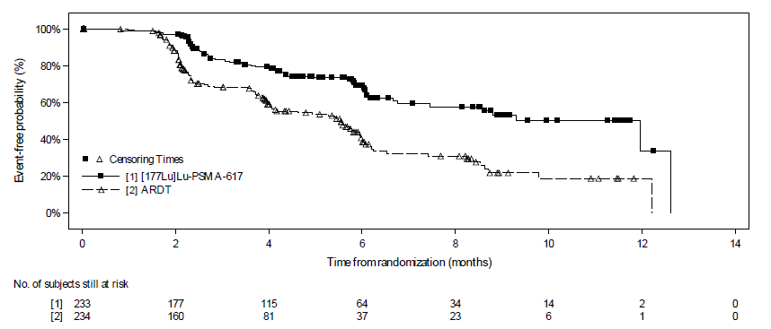
Figure 3 KM plot of rPFS based on BICR (FAS)
DCO data: 2 October 2022
Abbreviations: ARDT, androgen-receptor deprivation therapy; BICR, blinded independent central review; FAS, full analysis set; KM, Kaplan-Meier, rPFS, radiographic progression-free survival.
Source: PSMAfore CSR, Figure 11-1, Attachment B

Overall survival
OS was defined as the time from randomisation to death due to any cause. OS was assessed using the KM method to estimate survival distribution. Since patients assigned to the ARPI arm were allowed to crossover to ¹⁷⁷Lu-PSMA-617 upon confirmed radiographic progression, adjustment for the effect of crossover on OS may be performed based on recognised methods (e.g., Rank Preserving Structural Failure Time).
Progression-free survival
PFS was defined as the time from the date of randomisation to the first documented progression by investigator’s assessment (radiographic, clinical or PSA progression) or death due to any cause.
Radiographic progression-free survival 2
rPFS2 was defined as the time from the date of crossover (ARPI to ¹⁷⁷Lu-PSMA-617) to the date of radiographic disease progression as assessed by BICR or death due to any cause on the next line of therapy based on the Crossover Analysis Set, whichever occurred first. Distribution was estimated using the KM method.
Time to symptomatic skeletal event
TTSSE was defined as date of randomisation to the date of first new symptomatic pathological bone fracture, spinal cord compression, tumour-related orthopaedic surgical intervention, requirement of radiation therapy to relieve bone pain, or death from any cause (whichever occurred first). TTSSE was analysed in the FAS and distribution was estimated using the KM method.
Results
At third data DCO of 27 February 2024, TTSSE analysis provided clinically meaningful result in favour of ¹⁷⁷Lu-PSMA-617 arm with an estimated 59% risk reduction of symptomatic skeletal event (SSE) or death (HR: 0.41; 95% CI: 0.26, 0.63). The median time to SSE was 17.97 months (95% CI: 14.26, not estimable) in the ARPI arm and not reached in the ¹⁷⁷Lu-PSMA-617 arm.
PSA50 response
PSA50 response was defined as proportion of patients who achieved a ≥ 50% decrease from baseline confirmed by a second PSA measurement ≥ 4 weeks (as per laboratory testing). Baseline PSA was obtained at screening and could be as long as 6 weeks prior to the date of treatment start for ¹⁷⁷Lu-PSMA-617 arm given the allowed screening window and lead time to order and administer the treatment after randomisation. Since PSA could rise over this interval, the PSA50 response observed could be underestimated in the ¹⁷⁷Lu-PSMA-617 arm. PSA50 response was calculated at 12, 24 and 48 weeks based on the FAS and according to the intent-to-treat principle. Response will be presented by treatment group.
Patient-reported outcomes
A PRO is a measurement that captures the person’s perception of their own health condition without interpretation by a healthcare physician or anyone else. Symptoms or other unobservable concepts known only to the patient (e.g., pain, fatigue) can only be assessed using PRO measures. All PROs were collected on an electronic tablet device at the clinic at the scheduled visit prior to any clinical assessments.
Pain score
The Brief Pain Inventory – Short Form (BPI-SF) was used to assess the severity and impact of pain on daily functions. The BPI was initially developed to assess pain related to cancer and is a widely used measurement tool for assessing clinical pain. The BPI-SF measures pain intensity and interference using a scale of 0 to 10 (no pain/interference to worst pain/complete interference). Change in scores from baseline were assessed using linear mixed effect model.
Results
While on-treatment, patients treated with ¹⁷⁷Lu-PSMA-617 appeared to be more stable with less pain compared to ARPI. Time to worsening was delayed in the ¹⁷⁷Lu-PSMA-617 arm compared to the ARPI arm (HR 0.72; 95% CI: 0.59, 0.88).
Time to improvement after worsening was faster in the ¹⁷⁷Lu-PSMA-617 arm compared to ARPI arm. The mean time to improvement after worsening in BPI-SF scales was 6.70 months for patients treated with ¹⁷⁷Lu-PSMA-617 compared to 14.05 months for patients treated with ARPI.
Health-related quality of life
The EuroQoL-5 Dimension-5 Level (EQ-5D-5L), a generic instrument for describing and valuing health, was administered to assess health-related quality of life. EQ-5D is an international, validated, standardised, generic questionnaire for describing and valuing HRQoL (Rabin & de Charro 2001). EQ-5D was developed by the EuroQoL Group in order to provide a simple, generic measure of health for clinical and economic appraisal (EuroQoL, 1990). EQ-5D-5L is the most recent version developed to improve the instrument’s sensitivity and to reduce ceiling effects.
Functional Assessment of Cancer Therapy-Prostate
The Functional Assessment of Cancer Therapy-Prostate (FACT-P) was administered to assess the prostate cancer specific HRQoL with higher scores representing better the quality of life. The FACT-P comprises 2 parts: general (G) and Prostate Cancer Subscale (PCS). FACT-G is one of the most widely used HRQoL instruments measuring four domains – physical, functional, emotional and social/family wellbeing. FACT-PCS is designed to specifically measure prostate cancer-specific quality of life. Each item of the FACT-G and -PCS is rated on a 0 to 4 Likert-type scale and combined to produce subscale scores for each domain as well a global QoL score.
Results
While on-treatment, patients in the ¹⁷⁷Lu-PSMA-617 arm reported higher FACT-P total score compared to the ARPI arm. Time to worsening (≥ 10-point decrease) was delayed in the ¹⁷⁷Lu-PSMA-617 arm (HR 0.61; 95% CI: 0.50, 0.75). The median time to deterioration was 7.46 months (95% CI: 6.08, 8.54) in the ¹⁷⁷Lu-PSMA-617 arm vs. 4.27 months (95% CI: 3.45, 4.50) in ARPI arm.

Safety
¹⁷⁷Lu-PSMA-617 has been assessed as safe and tolerable based on the VISION trial (MSAC 1686.1 PSD April 2024 Meeting). PSMAfore provides safety and tolerability data for the proposed population. Adverse events were classified according to the Common Toxicity Criteria Adverse Even (CTCAE) version 5.0 and severity was characterised as Grade 1 to 5. Adverse event monitoring continued for at least 30 days following the end of treatment visit (or End of Treatment 2 visit if crossover occurred).
Safety outcomes were analysed in all randomised patients who received at least one dose of study treatment. The Safety Set included all patients who received at least one dose to study treatment. The ¹⁷⁷Lu-PSMA-617 Safety Set included all patients who received at least one dose of ¹⁷⁷Lu-PSMA-617, during the randomised part of the protocol or after crossover.
At the final DCO (1 January 2025), the Safety Set consisted of 227 patients (97.0% of the FAS) in the ¹⁷⁷Lu-PSMA-617 arm and 232 patients (99.1% of the FAS) in the ARPI arm. The ¹⁷⁷Lu-PSMA-617 Set consisted of 134 patients (57.3%) who crossed over from the ARPI arm.
Change in clinical management
mCRPC is an incurable disease associated with high morbidity and mortality. Natural progression often involves worsening symptoms such as fatigue and bone pain which can have negative impacts on quality of life. Improving survival and preserving quality of life are key treatment goals for patients living with mCRPC (Kulasegaran & Oliveira, 2024). Treatment decisions can be impacted by various factors. Up to 90% of patients develop bone metastases leading to severe bone pain from skeletal events like fractures and spinal cord compression (Leaning et al., 2023). Studies have found that controlling or reducing bone pain is an important factor for mCRPC patients when considering their treatment options (George et al., 2022).
In Australia, current treatment options for the proposed mCRCP patient population are docetaxel or palliative care. Taxane-based chemotherapy may be deferred or avoided due to concerns from either the patient or physician about severe side effects that reduce quality of life, an assessment that the therapeutic benefits do not outweigh the risk, or because the patient's health makes taxanes unsuitable (Al-Batran et al., 2015; Singer & Srinivasan, 2012). This is supported by DUSC data that indicates only 14% of patients receive docetaxel in the 18-24 months following treatment with an ARPI (olaparib PSD, para 5.2, March 2021 PBAC Meeting).
Overall, PSMAfore demonstrates improved outcomes for taxane naïve mCRPC patients who have been treated with an ARPI compared to current standard of care. The results show that patients treated with ¹⁷⁷Lu-PSMA-617 may experience improved survival through a significantly reduced risk of radiographic progression compared to standard of care. In addition, patients treated with ¹⁷⁷Lu-PSMA-617 may experience better quality of life while on treatment due to delayed worsening and longer time to deterioration compared to current standard of care.
Prolonging time to progression and symptomatic skeletal event (SSE) while maintaining quality of life are important considerations for mCRPC patients. ¹⁷⁷Lu-PSMA-617 provides clinicians and patients with an alternative effective and safe treatment option to docetaxel or palliative care in the first line mCRPC setting following treatment with an ARPI.

Proposed MBS items

How is the technology/service funded at present? (e.g., research funding; State-based funding; self-funded by patients; no funding or payments):
¹⁷⁷Lu-PSMA-617 is not currently funded for patients with mCRPC who are taxane naïve. TGA registration for the proposed population is expected mid-2026 and without public funding will only be available via private pay (i.e., self-funded by the patient). ¹⁷⁷Lu-PSMA-617 is currently subsidised on the MBS for patients with mCRPC who have progressive disease following treatment with at least one ARPI and at least once taxane-based therapy.

Provide at least one proposed item with their descriptor and associated costs, for each Population/Intervention:
This application requests the following:
- An amendment to the existing PSMA PET MBS item to determine eligibility for treatment,
- ¹⁷⁷Lu-PSMA-617 reimbursed via the broader Medicare program.,
- Associated administrative costs subsided separately to treatment costs.

Amendment to the existing PSMA PET MBS item
MBS item 61528 is currently available for mCRPC patients who have progressed following treatment with at least one ARPI and at least one taxane-based chemotherapy. This application requests an amendment to expand the patient population under the existing item to include the proposed patient population to determine eligibility for treatment with ¹⁷⁷Lu-PSMA-617 in the proposed patient population (Table 2).
Table 2 Proposed amendment to MBS item 61528 to include the proposed patient population
MBS item number | 61528
Category number | 5
Category description | Diagnostic Imaging Services
Proposed item descriptor | Whole body PSMA PET study, performed for the assessment of suitability for Lutetium 177 PSMA therapy in a patient with metastatic castrate resistant prostate cancer,  - after progressive disease has developed while undergoing prior treatment with at least one androgen receptor signalling inhibitor but no prior taxane chemotherapy, or  - after progressive disease has developed while undergoing prior treatment with at least one taxane chemotherapy and at least one androgen receptor signalling inhibitor
Proposed MBS fee | $1,300
Indicate the overall cost per patient of providing the proposed health technology | 75% = $975.00 85% = $1,195.50
Please specify any anticipated out of pocket expenses | 75% = $325.00 85% = $104.50
Provide any further details and explain | Amendment to existing MBS item to include the proposed population.
Proposed changes in bold italics

Reimbursement via Medicare
This application requests reimbursement via the broader Medicare program. that will enable mCRPC patients to access and receive treatment with ¹⁷⁷Lu-PSMA-617
The Applicant recommends that patients must meet specific criteria to qualify for treatment. It is recommended that the criteria are met before receiving treatment to ensure the right patient receives treatment, minimise unnecessary treatment and appropriately manage government expenditure. It is recommended that prescribers obtain authority to confirm the patient meets the criteria to receive treatment and minimise unnecessary and incorrect use. Authority could be obtained via Services Australia or an equivalent process.
Recommended criteria are presented in Table 3 and are guided by the clinical trial for ¹⁷⁷Lu-PSMA-617. Patients must have PSMA-positive mCRPC, progressive disease following treatment with ARPI, and have not been exposed to taxane-based chemotherapy in the hormone-sensitive or castration-resistant setting. It is recommended PSMA-positive is defined in alignment with current MBS item 16050: SUV_{max} > 15 at a single site of disease and SUV_{max} > 10 at all sites of measurable disease.
Disease progression is defined as:
- a rise in PSA of > 2 ng/mL confirmed by two tests a minimum of two weeks apart, and/or
- evidence of new soft tissue or bone metastases on diagnostic imaging computed tomography as per established guidelines (such as the RECIST criteria, as published by the European Organisation for Research and Treatment of Cancer, or the Response Evaluation Criteria in PSMA-Imaging Criteria).
This is aligned with the current MBS definition of disease progression for the continuation of ¹⁷⁷Lu-PSMA therapy (MBS Item 16055). The current MBS item descriptor includes follow-up SPECT scan within 36 hours. This was not a requirement in the pivotal clinical trials for ¹⁷⁷Lu-PSMA-617 (PSMAfore and VISION) and is therefore not included in the proposed restriction criteria. The requirement for post-treatment imaging should be based on clinical practice, need and feasibility.
Table 3 Proposed criteria for treatment with ¹⁷⁷Lu-PSMA-617 for mCRPC, taxane-naïve patients
Category | Therapeutic medicine
Restriction | Authority required
Clinical criteria | Patient must have confirmed metastatic castration-resistant prostate cancer.  Patient must be confirmed prostate-specific membrane antigen (PSMA)-positive based on PSMA PET scan (defined as SUV_{max} >15 at a single site of disease and SUV_{max} >10 at all sites of measurable disease).  Patient must have progressive disease following a) treatment with at least one ARPI, and b) have not been exposed to taxane-based chemotherapy in the hormone-sensitive or castration-resistant setting.  Patient must not have received treatment with 177Lu-PSMA-617 for prostate cancer.  Treatment is applicable once per cycle and must not be subsidised beyond whichever comes first: i) up to a maximum of 6 cycles, ii) disease recurrence/progression.

Associated administration services
This application seeks advice on the requirement for a separate MBS item number for the associated services required to deliver ¹⁷⁷Lu-PSMA-617. ¹⁷⁷Lu-PSMA-617 is administered intravenously every 6 weeks for up to 6 doses. Figure 4 outlines relevant administration services required for the proposed patient population receiving ¹⁷⁷Lu-PSMA-617 and docetaxel.
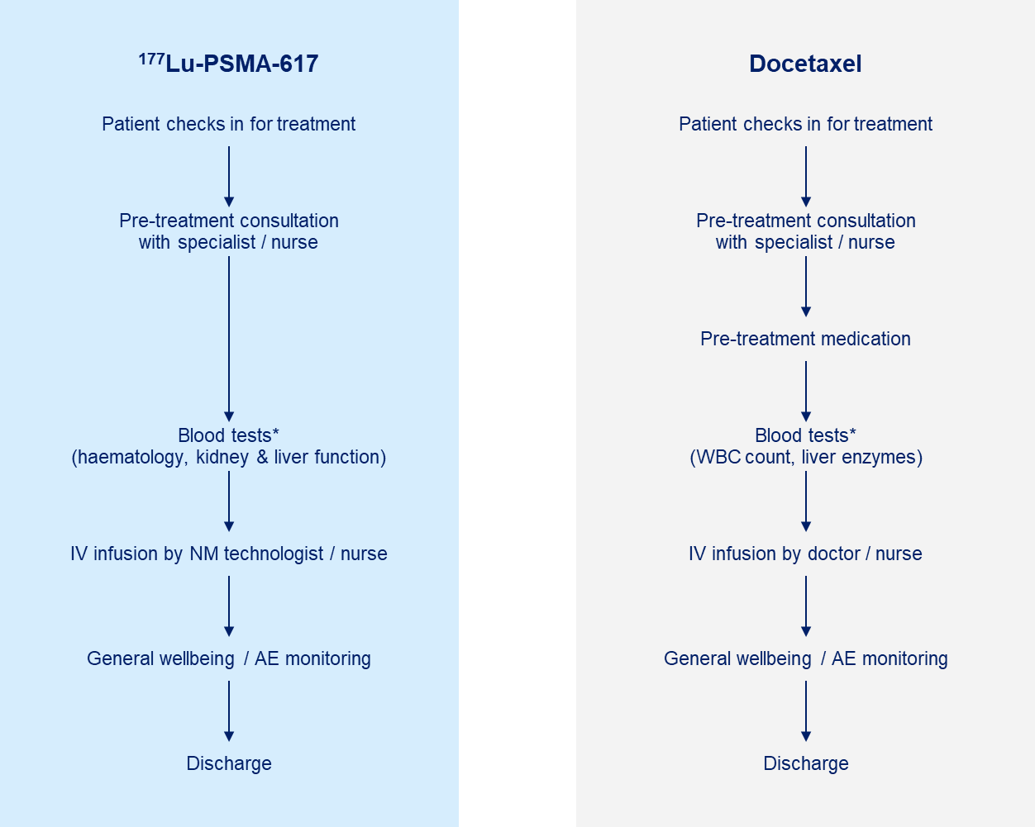
Figure 4 Relevant administrative services required for the delivery of ¹⁷⁷Lu-PSMA-617 and docetaxel
*Blood tests are performed in the days or week prior to treatment. Results are reviewed on the day of infusion.
Abbreviations: AE, adverse event; IV, intravenous; NM, nuclear medicine; WBC, white blood cell

As illustrated, there is very little difference between the administration of antineoplastic therapies such as PBS-listed docetaxel and ¹⁷⁷Lu-PSMA-617. Patients treated with ¹⁷⁷Lu-PSMA-617 will have a consultation with their specialist prior to receiving treatment; review blood tests to confirm they are medically and physically fit to receive treatment; intravenous infusion of treatment; and general monitoring following treatment before being discharged to go home. These are all standard administrative services required for delivery of antineoplastic treatment.
Following treatment infusion, patients will remain isolated in the nuclear medicine facility until radiation levels reduce to the safe government limit for discharge (25uSv /hour at one metre). Radiation levels are monitored using small devices. Such devices are stocked in facilities where radiation levels are required to be monitored and are not claimable MBS services.
The Applicant notes that there are already MBS item numbers for relevant administration services for ¹⁷⁷Lu-PSMA-617. Table 4 outlines the administrative services required to deliver treatment with ¹⁷⁷Lu-PSMA-617 an existing MBS item numbers.
Table 4 Required administrative services for treatment with ¹⁷⁷Lu-PSMA-617
Resource | MBS item(s) | Fee
Specialist consultation | MBS 110: Professional attendance at consulting rooms or hospital, by a consultant physician in the practice of the consultant physician's specialty (other than psychiatry) following referral of the patient to the consultant physician by a referring practitioner-initial attendance in a single course of treatment | $178.70
Specialist consultation | MBS 116: Professional attendance at consulting rooms or hospital, by a consultant physician in the practice of the consultant physician's specialty. | $89.40
Blood tests (haematology, kidney function, liver function) | MBS 65070: Full blood examination | $17.35
Blood tests (haematology, kidney function, liver function) | MBS 12524: Renal function test (without imaging procedure) | $184.75
Blood tests (haematology, kidney function, liver function) | MBS 66512: Liver function test | $17.70
IV infusion of treatment | MBS 13950: Parenteral administration of one or more antineoplastic agents | $126.00
Abbreviations: IV, intravenous; MBS, Medicare Benefits Schedule
Source: www.mbs.gov.au

This application requests that associated administrative services necessary for the administration of ¹⁷⁷Lu-PSMA-617 are subsided separately utilising existing MBS items. This aligns with the administration of other antineoplastic treatments delivered in the outpatient setting (e.g., chemotherapy) and would reduce the risk of duplicated claims for services.

Algorithms

PREPARATION FOR USING THE HEALTH TECHNOLOGY

Define and summarise the clinical management algorithm, including any required tests or healthcare resources, before patients would be eligible for the proposed health technology:
A prostate cancer diagnosis is made following thorough work-up including patient history, physical examination, digital rectal examination, PSA testing, biopsy, and genomic testing. Where appropriate, a clinician may request diagnostic and staging PSMA PET/CT scan(s) which may inform appropriate clinical management.
Figure 5 illustrates the current clinical management algorithm for mCRPC patients in Australia, which aligns with international guidelines and Australian evidence-based protocols. For patients with mCRPC who have progressive disease following an ARPI and have had no prior taxane therapy, the NCCN Guidelines recommend continued ADT to maintain castrate levels of serum testosterone (< 50 ng/dL) and systemic treatment with docetaxel, or olaparib / rucaparib if presence of BRCA mutation. Similarly, the ESMO Guidelines recommend docetaxel for patients with progressive mCRPC following ARPI. PBS restricts the use of ARPIs to once per lifetime.
The NCCN Guidelines recommend metastatic lesion biopsy, somatic testing and tumour mutational burden, if considered appropriate. Routine testing of PSA levels may be required to monitor disease progression.

Is there any expectation that the clinical management algorithm before the health technology is used will change due to the introduction of the proposed health technology?
Yes.

Describe and explain any differences in the clinical management algorithm prior to the use of the proposed health technology vs. the comparator health technology:
Currently, mCRPC patients who have progressive disease following treatment with an ARPI will receive either taxane-based chemotherapy or palliative care. Following reimbursement of ¹⁷⁷Lu-PSMA-617 in the patient population, physicians will refer patients they consider potential candidates for treatment for a PSMA PET scan at an accredited site. Patients determined PSMA-positive and suitable for treatment will be given the option to receive ¹⁷⁷Lu-PSMA-617. Docetaxel will become a subsequent treatment option for patients who progress following treatment with ¹⁷⁷Lu-PSMA-617. Docetaxel or palliative care will remain standard of care for patients who are not PSMA-positive. The current and proposed clinical management algorithms are presented in Figure 5 and Figure 6, respectively.

USE OF THE HEALTH TECHNOLOGY

Explain what other healthcare resources are used in conjunction with delivering the proposed health technology:
All potential candidates will undergo PSMA PET imaging to assess eligibility for treatment with ¹⁷⁷Lu-PSMA-617. Access to PSMA PET imaging is well established in Australia and is already being utilised by mCRPC patients.
PSMA-positive mCRPC patients who have progressive disease following an ARPI, are taxane-naïve and are considered suitable for treatment with ¹⁷⁷Lu-PSMA-617 will be treated with ¹⁷⁷Lu-PSMA-617 as standard of care. This will decrease the number of patients treated with docetaxel in the first line setting by providing an alternative treatment option to patients who choose not to receive docetaxel.
Access to, and delivery of, ¹⁷⁷Lu-PSMA-617 is established in Australia with mCRPC patients meeting specific criteria receiving treatment in the second line setting in accredited facilities. Expanding reimbursement of ¹⁷⁷Lu-PSMA-617 to include the first-line setting will change clinical management and outcomes for more mCRPC patients.

Explain what other healthcare resources are used in conjunction with the comparator health technology:
Patients who are not PSMA-positive or are not considered suitable for treatment with ¹⁷⁷Lu-PSMA-617 will continue to receive docetaxel or palliative care.
Docetaxel is a cytotoxic drug administered in the outpatient setting. Associated healthcare services are required including, but is not limited to, appropriately trained medical professionals to deliver treatment, infusion chair and post-treatment monitoring.
Palliative care involves a wide range of services delivered in the hospital and community setting. Significant healthcare resources are required to deliver palliative care including hospital admission, pharmaceuticals, and a palliative care workforce.

Describe and explain any differences in the healthcare resources used in conjunction with the proposed health technology vs. the comparator health technology:
As illustrated in Figure 6, PSMA PET will be performed for all potential candidates following progression on an ARPI. Those patients with mCRPC considered suitable will receive ¹⁷⁷Lu-PSMA-617 as standard of care. Those who are not PSMA-positive or are not considered suitable for treatment will receive docetaxel or palliative care.
Both ¹⁷⁷Lu-PSMA-617 and docetaxel are administered in the outpatient setting, however, administration of ¹⁷⁷Lu-PSMA-617 takes longer compared to docetaxel and patients are required to remain isolated until radiation levels reach safe levels. Both treatments require appropriate safe handling and waste management. Palliative care is resource heavy, requiring in-patient and/or out-patient support from a diverse workforce.
Table 5 summarises key differences in healthcare resources between ¹⁷⁷Lu-PSMA-617, docetaxel and palliative care.
Table 5 Healthcare resources required for ¹⁷⁷Lu-PSMA-617, docetaxel and palliative care
 | ¹⁷⁷Lu-PSMA-617 |  | Docetaxel | Palliative care
Referral | Written referral from managing physicians for all mCRPC patients considered potential candidates for treatment.
Diagnostic | Amendment to existing MBS item 61528 to include proposed patient population to assess eligibility for treatment.
Diagnostic | mCRPC patients confirmed PSMA-positive and suitable to receive ¹⁷⁷Lu-PSMA-617. | mCRPC patients who are not PSMA-positive or suitable for ¹⁷⁷Lu-PSMA-617 receive docetaxel or palliative care.
Treatment | ¹⁷⁷Lu-PSMA-617 reimbursed via a radiopharmaceutical fund that is independent of MBS. | No change to existing MBS/PBS funded access for docetaxel or palliative care.
Treatment | An increased number of mCRPC patients treated with ¹⁷⁷Lu-PSMA-617 in the first line setting. | Fewer patients treated with docetaxel in the first line. |  |  | Fewer patients receive palliative care in the first line.

CLINICAL MANAGEMENT AFTER THE USE OF HEALTH TECHNOLOGY

Define and summarise the clinical management algorithm, including any required tests or healthcare resources, after the use of the proposed health technology:
Patients will be informed about the necessary precautions to take following treatment with ¹⁷⁷Lu-PSMA-617 in line with the Product Information. The patient’s managing physicians(s) will closely monitor and follow-up with the patient to assess toxicity and disease progression. This may include imaging and laboratory testing to assess PSA levels or radiographic progression. Quantitative post-treatment imaging (e.g., PET/CT, single-photon emission computed tomography [SPECT]) may be used by clinicians to assess response to treatment. The current MBS item descriptors for treatment with ¹⁷⁷Lu-PSMA-617 include follow-up SPECT scan within 36 hours (16050 and 16055). This was not a requirement in the pivotal clinical trials for ¹⁷⁷Lu-PSMA-617 (PSMAfore and VISION). The requirement for post-treatment imaging should be based on clinical practice, need and feasibility.
Disease progression is defined as a rise in PSA of > 2 ng/mL confirmed by two tests a minimum of two weeks apart, and/or evidence of new soft tissue or bone metastases on diagnostic imaging as per established guidelines. As such, pathology and/or imaging would be required to determine eligibility for subsequent treatment with ¹⁷⁷Lu-PSMA-617.

Define and summarise the clinical management algorithm, including any required tests or healthcare resources, after the use of the comparator health technology:
Patients treated with docetaxel will be informed about the necessary precautions that must be taken following treatment, in line with chemotherapy safety and Product Information. The patient’s managing physician(s) will closely monitor and follow-up with the patient to assess toxicity and disease progression. This may include laboratory testing to monitor blood cell count and PSA levels.
Patients receiving palliative care will be supported by a MDT of professionals including but not limited to medical professionals, support workers and volunteers.

Describe and explain any differences in the healthcare resources used after the proposed health technology vs. the comparator health technology:
¹⁷⁷Lu-PSMA-617, docetaxel and palliative care require routine follow-up and monitoring from various healthcare professionals (e.g., laboratory tests, follow-up appointments, imaging, pain management, wellbeing support, etc.). Patients treated with ¹⁷⁷Lu-PSMA-617 may also have quantitative post-treatment imaging (e.g., SPECT/CT) to evaluate response to treatment.

Insert diagrams demonstrating the clinical management algorithm with and without the proposed health technology:
Figure 5 illustrates the current clinical management algorithm for patients with mCRPC without the proposed treatment. Figure 6 illustrates the proposed clinical management algorithm for patients with mCRPC with the proposed treatment.

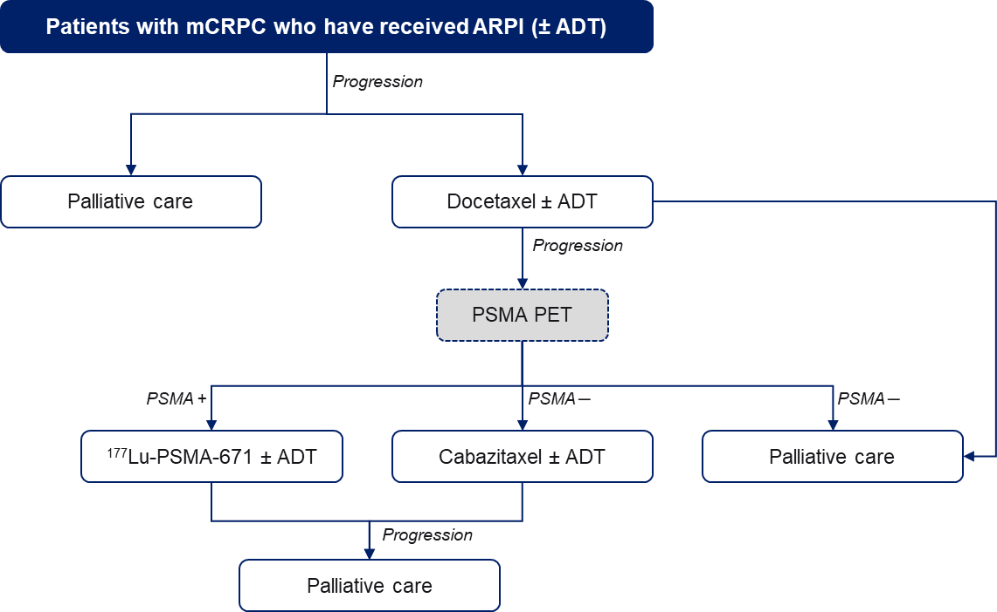
Figure 5 Current treatment algorithm for mCRPC
Abbreviations: ADT, androgen deprivation therapy; ARPI, androgen receptor pathway inhibitor; mCRPC, metastatic castration-resistant prostate cancer; PSMA, prostate-specific membrane antigen; PET, positron emission tomography

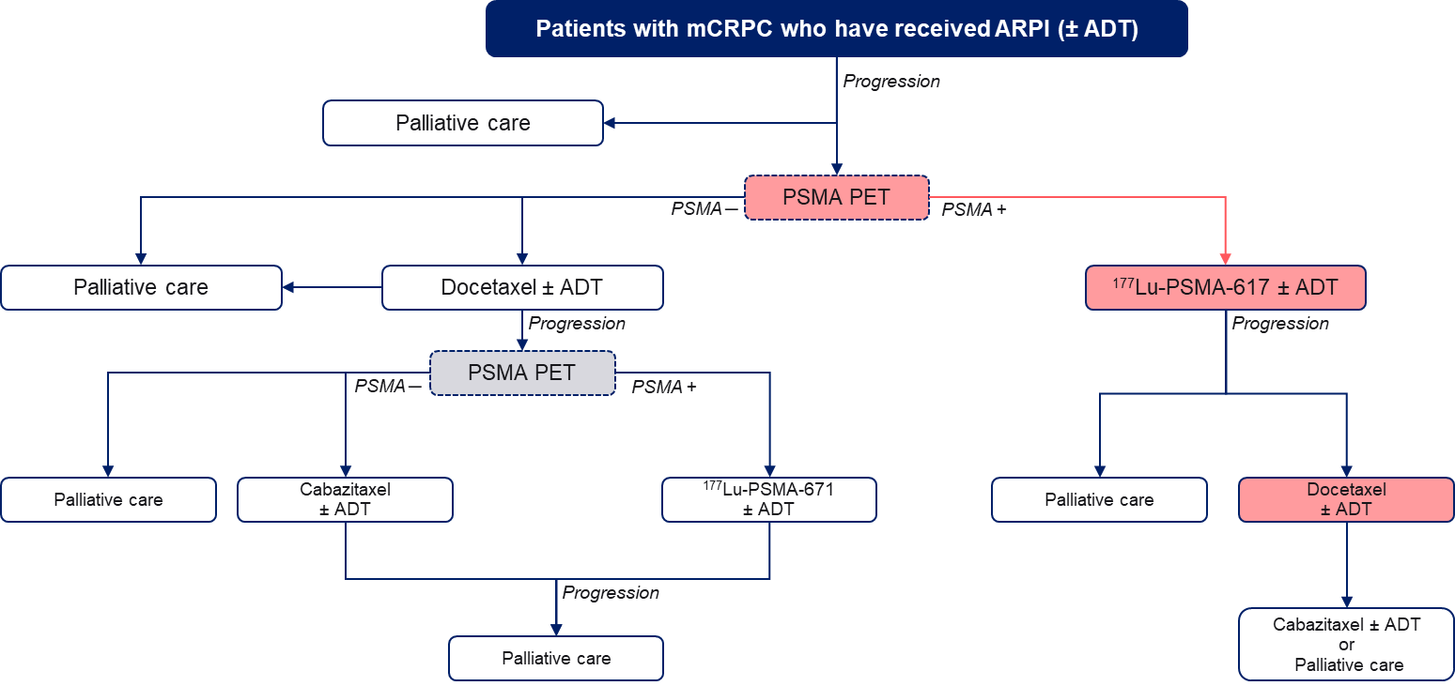
Figure 6 Proposed treatment algorithm for mCRPC
Abbreviations: ADT, androgen deprivation therapy; ARPI, androgen receptor pathway inhibitor; mCRPC, metastatic castration-resistant prostate cancer; PSMA, prostate-specific membrane antigen; PET, positron emission tomography

Claims

In terms of health outcomes (comparative benefits and harms), is the proposed technology claimed to be superior, non-inferior or inferior to the comparator(s)?
Efficacy:
Superior
Non-inferior
Inferior
Safety:
Superior
Non-inferior
Inferior

Please state what the overall claim is, and provide a rationale:
The therapeutic conclusion is that ¹⁷⁷Lu-PSMA-617 is superior to current standard of care in terms of clinical efficacy, and non-inferior in terms of safety.
Currently, patients with mCRPC who have progressed following treatment with an ARPI and are taxane-naïve have limited treatment options, highlighting an unmet need for this population. The pivotal trial, PSMAfore, assessed the efficacy of ¹⁷⁷Lu-PSMA-617 compared to ARPI. In Australia, PBS criteria restrict treatment with an ARPI to once per lifetime, leaving docetaxel or palliative care as the only available treatment options for patients (i.e., current standard of care). There are no head-to-head studies comparing ¹⁷⁷Lu-PSMA-617 to docetaxel or palliative care. Data indicates that most patients (71%) do not receive any subsequent treatment following an ARPI (olaparib PSD, para 5.2, March 2021 PBAC Meeting). Given this, the clinical data from the PSMAfore ARPI arm is used as a proxy for current standard of care.
The clinical claim is based on rPFS, the primary outcome of PSMAfore, supported by secondary outcomes including TTSSE and PROs, and adverse events. The clinical data demonstrates that ¹⁷⁷Lu-PSMA-617 improves outcomes for taxane naïve mCRPC patients who have been treated with an ARPI compared to current standard of care:
- Reduced risk of progression
Patients treated with ¹⁷⁷Lu-PSMA-617 had a statistically significant 59% reduced risk of radiographic progression or death compared to ARPI (HR 0.41; 95% CI: 0.29, 0.56; p <0.0001).
- Reduced risk of symptomatic skeletal events
Patients treated with ¹⁷⁷Lu-PSMA-617 had a 59% risk reduction of SSE or death compared to ARPI (HR: 0.41; 95% CI: 0.26, 0.63).
- Delayed worsening of pain
While on-treatment, patients treated with ¹⁷⁷Lu-PSMA-617 appeared to be more stable with less pain compared to ARPI. Time to worsening of pain was delayed in the ¹⁷⁷Lu-PSMA-617 arm compared to the ARPI arm (HR 0.72; 95% CI: 0.59, 0.88).
- Improvement in quality of life
While on-treatment, patients treated with ¹⁷⁷Lu-PSMA-617 experienced a higher quality of life and delayed time to deterioration compared to ARPI.
- Favourable safety profile
There was fewer grade 3 or higher treatment-related adverse events reported among patients receiving ¹⁷⁷Lu-PSMA-617 compared to ARPI (36% and 48%, respectively). ¹⁷⁷Lu-PSMA-617 exhibits high PSMA binding affinity and internalisation, prolonged tumour retention and rapid kidney clearance (Benesova et al., 2015). To date, nephrotoxicity has not been notable in any safety series and there are no reports of Grade 3 or 4 nephrotoxicity in the literature. The exposure to normal bone marrow tissue is predictably low as it does not express PSMA and corresponds with normal plasma clearance.
The results show that patients treated with ¹⁷⁷Lu-PSMA-617 may experience improved survival through a significantly reduced risk of radiographic progression and a reduced risk of experiencing SSEs compared to standard of care. In addition, patients treated with ¹⁷⁷Lu-PSMA-617 experienced favourable quality of life compared to ARPI (proxy for current standard of care). In addition, patients treated with ¹⁷⁷Lu-PSMA-617 may experience better quality of life while on treatment due to delayed worsening and longer time to deterioration compared to current standard of care.
Prolonging time to progression and SSE while maintaining quality of life are important considerations for mCRPC patients. ¹⁷⁷Lu-PSMA-617 provides clinicians and patients with an alternative effective and safe treatment option to docetaxel or palliative care in the first line mCRPC setting following treatment with an ARPI.

Why would the requestor seek to use the proposed investigative technology rather than the comparator(s)?
The key treatment goals for patients with mCRPC is extended survival and improved quality of life, particularly pain, and treatment decisions are influenced by various factors. For mCRPC patients who have progressed following treatment with an ARPI and are taxane naïve, current treatment options are limited to docetaxel or palliative care. However, taxane-based chemotherapy comes with significant side effects and impact on quality of life, including haematological toxicity that almost always requires hospitalisation (Crombag et al., 2019; Peltekian et al., 2023). The preference of alternative therapies over docetaxel is consistently observed in prostate cancer, including no further treatment.
¹⁷⁷Lu-PSMA-617 provides clinicians and patients with an alternative effective and safe treatment option to current standard of care. Clinical data demonstrates that patients treated with ¹⁷⁷Lu-PSMA-617 may experience reduced risk of radiographic progression and reduced risk of SSE, outcomes which indicate longer survival. Given this is a key treatment goal, some clinicians and patients would prefer treatment with ¹⁷⁷Lu-PSMA-617 over current standard of care if it meant better patient outcomes.
Patients treated with ¹⁷⁷Lu-PSMA-617 may experience delayed worsening and delayed time to deterioration, indicating an improved overall quality of life while on-treatment. Up to 90% of patients develop bone metastases, leading to significant morbidity and severe bone pain, either from the metastases themselves or from skeletal events like fractures and spinal cord compression (Leaning et al., 2023). Studies have found that controlling or reducing bone pain is an important factor for mCRPC patients (George et al., 2022). Data shows that patients treated with ¹⁷⁷Lu-PSMA-617 may experience delayed worsening of pain compared to standard of care. mCRPC is a life-limiting disease and maximising quality of life is a key factor when considering treatment options. It is likely that patients, and clinicians, would favour a treatment option that has a less of an impact daily activity.
The safety profile of ¹⁷⁷Lu-PSMA-617 is manageable and patients treated with ¹⁷⁷Lu-PSMA-617 may experience less grade 3 or higher treatment-related adverse events compared to standard of care. Studies suggest that patients may forego treatment with taxane-based chemotherapy due to its toxicity profile (Al-Batran et al., 2015; Singer & Srinivasan, 2012). As such, ¹⁷⁷Lu-PSMA-617 gives clinicians and patients a safe and effective treatment option.

Identify how the proposed technology achieves the intended patient outcomes:
High PSMA-expression correlates with disease progression and is an independent prognostic biomarker of poorer clinical outcomes (Hupe et al., 2018; Nagaya et al., 2020; Paschalis et al., 2019). ¹⁷⁷Lu-PSMA-617 is a novel treatment that binds with high affinity to PSMA. The radioactive atom ¹⁷⁷Lu delivers cytotoxic radiation specifically to prostate cancer lesions expressing PSMA, maximising the therapeutic effect while minimising off-target effects. Treatment with ¹⁷⁷Lu-PSMA-617 improves survival and patient outcomes by significantly reducing risk of radiographic progression, reducing risk of TTSSE and improving quality of life.

For some people, compared with the comparator(s), does the test information result in:
A change in clinical management? Yes
A change in health outcome? Yes
Other benefits? No

Please provide a rationale, and information on other benefits if relevant:
None.

In terms of the immediate costs of the proposed technology (and immediate cost consequences, such as procedural costs, testing costs etc.), is the proposed technology claimed to be more costly, the same cost or less costly than the comparator?
More costly
Same cost
Less costly

Provide a brief rationale for the claim:
¹⁷⁷Lu-PSMA-617 is an innovative radiopharmaceutical and as such will result in higher costs than currently available treatments for mCRPC. There are significant risks and investment from industry to develop innovative pharmaceuticals, with development times ranging from 5 to 20 years across multiple indications. Yet without investment from government to ensure reimbursement, we miss the opportunity to secure timely and equitable access for patients and risk future investments for innovation.

If your application is in relation to a specific radiopharmaceutical(s) or a set of radiopharmaceuticals, identify whether your clinical claim is dependent on the evidence base of the radiopharmaceutical(s) for which MBS funding is being requested. If your clinical claim is dependent on the evidence base of another radiopharmaceutical product(s), a claim of clinical noninferiority between the radiopharmaceutical products is also required.
This application is in relation to a radiopharmaceutical product that is listed on the ARTG. As such, this application is not required to provide any additional information. The clinical claim in this application is not dependent upon another radiopharmaceutical product(s).

Summary of Evidence
Provide one or more recent (published) high quality clinical studies that support use of the proposed health service/technology. At ‘Application Form lodgement’,
 | Type of study design | Title of journal article or research project | Short description of research | Website link to journal article or research | Date of publication
1. | Phase III RCT | Morris et al., 2024  177Lu-PSMA-617 versus a change of androgen receptor pathway inhibitor therapy for taxane-naive patients with progressive metastatic castration-resistant prostate cancer (PSMAfore): a phase 3, randomised, controlled trial. | 468 taxane-naïve, PSMA-positive mCRPC patients with progressive disease following ARPI were randomly allocated to 177Lu-PSMA-617 or change in ARPI. rPFS was the primary endpoint.  Primary analysis showed a statistically significant reduced risk of radiographic progression or death in the 177Lu-PSMA-617 arm (HR 0.41; 95% CI: 0.29, 0.56; p <0.0001). | https://doi.org/10.1016/S0140-6736(24)01653-2 | 2024
2. | Phase III RCT | Fizazi et al., 2025  Health-related quality of life, pain, and symptomatic skeletal events with [177Lu]Lu-PSMA-617 in patients with progressive metastatic castration-resistant prostate cancer (PSMAfore): an open-label, randomised, phase 3 trial. | 468 taxane-naïve, PSMA-positive mCRPC patients with progressive disease following ARPI were randomly allocated to 177Lu-PSMA-617 or change in ARPI. Patient-relevant outcomes were secondary endpoints.  177Lu-PSMA-617 delayed time to worsening in all assessed FACT-P, EQ-5D-5L and BPI-SF scales and subscales compared to change in ARPI. | https://doi.org/10.1016/S1470-2045(25)00189-5 | 2025
3. | Phase III RCT | Fizazi et al., 2025  Final overall survival and safety analyses of the phase III PSMAfore trial of [177Lu]Lu-PSMA-617 versus change of androgen receptor pathway inhibitor in taxane-naive patients with metastatic castration-resistant prostate cancer. | 468 taxane-naïve, PSMA-positive mCRPC patients with progressive disease following ARPI were randomly allocated to 177Lu-PSMA-617 or change in ARPI. Crossover from ARPI to 177Lu-PSMA-617 was allowed after confirmed progression. The key secondary endpoint was OS.  Median OS was 24.48 months with 177Lu-PSMA-617 versus 23.13 months with ARPI (HR 0.91, P = 0.20) based on the ITT principle. Crossover-adjusted OS HR by inverse probability of censoring weighting modelling was 0.59. | https://doi.org/10.1016/j.annonc.2025.07.003 | 2025

Identify yet-to-be-published research that may have results available in the near future (that could be relevant to your application).
None.

References
AIHW 2025. Cancer data in Australia. https://www.aihw.gov.au/reports/cancer/cancer-data-in-australia/contents/summary-dashboard.
Al-Batran S. E., Hozaeel W., Tauchert F. K., Hofheinz R. D., Hinke A., Windemuth-Kieselback C., et al. 2015. The impact of docetaxel-related toxicities on health-related quality of life in patients with metastatic cancer (QoliTax). Annals of Oncology 26, 1244-1248. doi:10.1093/annonc/mdv129
Beltran H., Calais J., Emmett L., Kuo P. H. and Logothetis C. J. 2025. Biomarkers to optimize PSMA-targeted radioligand therapy for metastatic castration-resistant prostate cancer. Frontiers in Oncology 15:1583168. doi: 10.3389/fonc.2025.1583168
Benesova M., Schafer M., Bauder-Wust U., Afshar-Oromieh A., Kratochwil C., Meir W., Haberkorn U., et al. 2015. Preclinical evaluation of a tailor-made DOTA-conjugated PSMA inhibitor with optimized linker moiety for imaging and endoradiotherapy of prostate cancer. Journal of Nuclear Medicine 56, 914-920. doi: 10.2967/jnumed.114.147413
Chambers S. K., Hyde M. K., Laurie K., Legg M., Frydenberg M., Davis I. D., et al. 2018. Experiences of Australian men diagnosed with advanced prostate cancer: a qualitative study. BMJ Open 8:e019917. doi:10.1136/bmjopen-2017-019917
Chowdhury S., Bjartell A., Lumen N., Maroto P., Paiss T., Gomez-Veiga F., et al. 2020. Real-world outcomes in first-line treatment of metastatic castration-resistant prostate cancer: the prostate cancer registry. Targeted Oncology 15, 301-315. doi.org/10.1007/s11523-020-00720-2
Crombag MR. B. S., de Vries Scheultink A. H. M., van Doremalen J. G. C., Otten HM., Bergman A.M, Schellens J. H. M., et al. 2019. Age-associated hematological toxicity in patients with metastatic castration-resistant prostate cancer treated with docetaxel in clinical practice. Drugs & Aging 36, 379-385. doi.org/10.1007/s40266-019-00643-2
European Association of Urology (EAU). Guidelines on Prostate Cancer (2025). https://uroweb.org/guidelines/prostate-cancer.
EuroQol Group 1990. EuroQol – a new facility for the measurement of health-related quality of life. Health Policy 16, 199-208.
Fizazi K. & Gillessen S. on behalf of the ESMO Guidelines Committee. (2023). Updated treatment recommendations for prostate cancer from the ESMO Clinical Practice Guideline considering treatment intensification and use of novel systemic agents. Annals of Oncology, 34(6), 557-563.
Fizazi K., Chi K. N., Shore N. D., Hermann K., de Bono J. S., Castellano D., et al. 2025. Final overall survival and safety analyses of the phase III PSMAfore trial of [ 177 Lu]Lu-PSMA-617 versus change of androgen receptor pathway inhibitor in taxane-naive patients with metastatic castration-resistant prostate cancer. Annals of Oncology 36(11), 1319-1330. doi.org/10.1016/j.annonc.2025.07.003
Fizazi K., Morris M. J., Shore N. D., Chi K. N., Crosby M., de Bono J. S., et al. 2025 Health-related quality of life, pain, and symptomatic skeletal events with [177Lu]Lu-PSMA-617 in patients with progressive metastatic castration-resistant prostate cancer (PSMAfore): an open-label, randomised, phase 3 trial. Lancet Oncology. doi.org/10.1016/S1470-2045(25)00189-5
Fizazi K., Attard G., Azad A. A., et al. on behalf of the ESMO Guidelines Committee. (2026). Advanced and metastatic prostate cancer: ESMO Clinical Practice Guideline for diagnosis, treatment and follow-up. Annals of Oncology.
Francini E., Gray K. P., Shaw G. K., Evan C. P., Hamid A. A., Perry C. E., et al. 2019. Impact of new systemic therapies on overall survival of patients with metastatic castration resistant prostate cancer in a hospital-based registry. Prostate Cancer Prostiatic Dis. 22(3), 420-427. doi:10.1038/s41391-018-0121-2
George D. J., Mohamed A. F., Tsai JH., Karimi M., Ning N., Jayade S., et al. 2022. Understanding what matters to metastatic castration-resistant prostate cancer (mCRPC) patients when considering treatment options: A US patient preference survey. Cancer Medicine 12:6040–6055. doi: 10.1002/cam4.5313
Hofman M. S., Emmett L., Sandhu S., Iravani A., Buteau J. P., Joshua A. M., et al. 2024. Overall survival with [¹77Lu]Lu-PSMA-617 versus cabazitaxel in metastatic castration-resistant prostate cancer (TheraP): secondary outcomes of a randomised, open-label, phase 2 trial. Lancet Oncology 25, 99-107. doi.org/10.1016/S1470-2045(23)00529-6
Holstrom S., Naidoo S., Turnbull J., Hawryluk E., Paty J. and Morlock R. 2018. Symptoms and impacts in metastatic castration-resistant prostate cancer: qualitative findings from patient and physician interviews. The Patient – Patient-Centered Outcomes Research 12, 57-67. doi.org/10.1007/s40271-018-0349-x
Hupe M. C., Philippi C., Roth D., Kumpers C., Ribbat-Idel J., Becker F., et al. 2018. Expression of prostate-specific membrane antigen (PSMA) on biopsies is an independent risk stratifier of prostate cancer patients at time of initial diagnosis. Frontiers in Oncology 8:623. doi: 10.3389/fonc.2018.00623
Kirby M., Hirst C. and Crawford E. D. 2011. Characterising the castration resistant prostate cancer population: a systematic review. The International Journal of Clinical Practice 65, 11, 1180–1192. 1180 doi: 10.1111/j.1742-1241.2011.02799.x
Kratochwil C., Fendler W. P., Eiber M., Hofman M. S., Emmett L., Calais J., et al. 2023. Joint EANM/SNMMI procedure guideline for the use of 177Lu-labeled PSMA-targeted radioligand-therapy (177Lu-PSMA-RLT). European Journal of Nuclear Medicine and Molecular Imaging 50, 2830-2845. doi.org/10.1007/s00259-023-06255-8
Kulasegaran T. and Oliveira N. 2024. Metastatic castration-resistant prostate cancer: advances in treatment and symptom management. Current Treatment Options in Oncology 25, 914-931. doi 10.1007/s11864-024-01215-2
Leaning D., Kaur G., Morgans A. K., Ghouse R., Mirante O. and Chowdhury S. 2023. Treatment landscape and burden of disease in metastatic castration-resistant prostate cancer: systematic and structured literature reviews. Frontiers in Oncology 13:1240864. doi: 10.3389/fonc.2023.1240864
Lowrance W., Dreicer R., Jarrard D. F., Scarpato K. R., Kim S. K., Kirkby E., et al. 2023. Updates to Advanced Prostate Cancer: AUA/SUO Guideline (2023). The Journal of Urology, 209(6), 1082-1090. doi.org/10.1097/JU.0000000000003452
Malone S., Wallis C. J. D., Lee-Ying R., Basappa N. S., Cagiannos I., Hamilton R. J., et al. 2022. Patterns of care for non-metastatic castration-resistant prostate cancer: A population-based study. BJUI Compass 3, 383-391. doi: 10.1002/bco2.158
Morris M. J., Castellano D., Hermann K., de Bono J. S., Shore N. D., Chi K. N., et al. 2024. 177Lu-PSMA-617 versus a change of androgen receptor pathway inhibitor therapy for taxane-naive patients with progressive metastatic castration-resistant prostate cancer (PSMAfore): a phase 3, randomised, controlled trial. Lancet 404, 1227-1239. https://doi.org/10.1016/S0140-6736(24)01653-2
MSAC 1632. PSD. July 2021 Meeting.
MSAC 1686.1. PSD. April 2024 Meeting.
Nagaya N., Nagata M., Lu Y., Kanayama M., Hou Q., Hotta Z., et al. 2020. Prostate-specific membrane antigen in circulating tumor cells is a new poor prognostic marker for castration-resistant prostate cancer. PLoS ONE 15(1), e0226219. doi.org/10.1371/journal.pone.0226219
National Comprehensive Cancer Network (NCCN). Prostate Cancer. Version 2.2026 – September 15, 2025
Olaparib PSD, March 2021 PBAC Meeting.
Parker, C., Castro, E., Fizazi, K., Heidenreich, A., Ost, P., Procopio, G., & Gillessen, S. (2020). Prostate cancer: ESMO Clinical Practice Guidelines for diagnosis, treatment and follow-up. Annals of Oncology, 31(9), 1119-1134.
Paschalis A., Sheehan B., Riisnaes R.a, Rodrigues D. N., Gurel B., Bertan C., et al. 2019. Prostate-specific membrane antigen heterogeneity and DNA repair defects in prostate cancer. European Urology 76, 469-478. doi.org/10.1016/j.eururo.2019.06.030
Peltekian S., Sajwani S., Wang X. and Kanji S. 2023. Incidence, predictors, and outcomes of febrile neutropenia and neutropenia in patients with metastatic castrate‑resistant prostate cancer receiving docetaxel. Supportive Care in Cancer 31, 311. doi.org/10.1007/s00520-023-07776-6
Rabin R. and de Charro F. 2001. EQ-SD: a measure of health status from the EuroQol Group. Annals of Medicine 33(5), 337-343. doi: 10.3109/07853890109002087
Rosar F., Schuler J., Burgard C., Blickle A., Bartholomä M., Maus S., et al. 2024. Efficacy and safety of rechallenge [177Lu]Lu-PSMA-617 RLT after initial partial remission in patients with mCRPC: evaluation of a prospective registry (REALITY study). European Journal of Nuclear Medicine and Molecular Imaging 51, 4151-4162. doi.org/10.1007/s00259-024-06825-4
Scher H., Morris M. J., Stadler W. M., Higano C., Basch E., Fizazi K., et al. 2016. Trial design and objectives for castration-resistant prostate cancer: updated recommendations from the Prostate Cancer Clinical Trials Working Group 3. Journal of Clinical Oncology 34(12), 1402-1418. doi: 10.1200/JCO.2015.64.2702
Scott A.M. 2001. Current status of positron emission tomography in oncology. Internal Medicine Journal, 31: 27-36. https://doi.org/10.1046/j.1445-5994.2001.00015.x
Singer E. A. and Srnivasan R. 2012. Intravenous therapies for castration-resistant prostate cancer: toxicities and adverse events. Urologic Oncology: Seminars and Original Investigations 30, S15-S19. doi: 10.1016/j.urolonc.2011.09.003
Westgeest H. M., Kuppen M. C. P., van den Eertwegh A. J. M., de Wit R., Bergman A. M., van Moorselaar R. J. A., et al. 2021. The effects of new life-prolonging drugs for metastatic castration-resistant prostate cancer (mCRPC) patients in a real-world population. Prostate Cancer and Prostatic Diseases. doi.org/10.1038/s41391-021-00344-1
Williams C., Inderjeeth AJ., Hong W., McKenzie J., Anton A., Weickhardt A., et al. 2025. Treatment patterns and outcomes for younger patients with metastatic castration-resistant prostate cancer (mCRPC); An Australian prospective registry study. Clinical Genitourinary Cancer 23(3), 102345. doi.org/10.1016/j.clgc.2025.102345

