MSAC Application 1826
N-Terminal-pro Brain Natriuretic Peptide (NT-proBNP) testing as an aid for the management of patients with heart failure.
PICO Set

Population

Describe the population in which the proposed health technology is intended to be used:

The population for whom this proposed health technology is intended to be used is best described with reference to the patient journey for heart failure. Within this description, specific clinical findings and objective measures which identify patients who are likely to benefit from NT-pro BNP testing to optimise treatment for heart failure are detailed in the next section relating to patient characteristics.
Heart failure is a complex clinical syndrome which is characterised by the failure of the heart to pump sufficient blood to supply an individual’s metabolic needs, and / or the ability to do so only with abnormally high filling pressure within the heart. A diagnosis of heart failure is made by an appropriately qualified clinician on the basis of symptoms (typically including dyspnea, persistent cough or wheeze, or fatigue), clinical signs (fluid retention / oedema, elevated jugular venous pressure, or crackles in the lungs), and objective measures (structural or functional cardiac abnormalities, or elevated natriuretic peptides [BNP / NT-pro BNP] detected in blood). Heart failure can be described with reference to the percentage of blood ejected from the left ventricle in each cardiac contraction (reduced, mildly reduced or preserved ejection fraction), and impact on daily activities (the New York Heart Association / NYHA severity scale, ranging from I, no limitations, to IV, inability to carry out any physical tasks or activities). Heart failure that either occurs suddenly or is a sudden worsening of existing heart failure is referred to as “acute heart failure”. Heart failure which develops gradually or which has been successfully managed following hospitalisation is referred to as “chronic heart failure”. Heart failure can be a critical condition that can result in death, restrictions in daily activities, reduced quality of life, and increased risk of unplanned readmission to hospital for emergency care after initial treatment.
People with heart failure may require unplanned and immediate admission to hospital for treatment of heart failure. This may be because they are experiencing acute or sudden onset heart failure, or because previously-diagnosed chronic heart failure has suddenly worsened. Hospital admission is required because acute heart failure is a life-threatening condition, and requires immediate medical intervention. As part of individual patient treatment decisions, patients are likely to be initiated on or have doses of current medications adjusted in line with clinical guidelines for the management of heart failure. NT-pro BNP testing is proposed to be used for patients who have specific clinical characteristics (detailed below) as an aid for rapid optimisation (titration) of guideline-directed medical therapies.
The population for this proposed health technology is therefore identified as part of this initial hospitalisation for heart failure. Noting, however, that NT-pro BNP testing can be performed as part of emergency department admission for heart failure, for the purposes of the proposed Medicare Benefits Schedule item within this application, the relevant population are those patients who are in the immediate post-hospitalisation or post-discharge phase, also referred to as the vulnerable phase (Greene et al. 2015). This is a critical period for managing heart failure, as reducing mortality and morbidity depends on ensuring that a patient is on the right dose of each of the four pillars of guideline-directed medical therapy (GDMT), referred to as rapid optimisation. The use of NT-pro BNP testing in this population supports clinical decision-making during this vulnerable period.

Specify any characteristics of patients with, or suspected of having, the medical condition, who are proposed to be eligible for the proposed health technology, describing how a patient would be investigated, managed and referred within the Australian healthcare system in the lead up to being considered eligible for the technology:

Patients who have acute or acute-on-chronic (worsening) heart failure are admitted to hospital for treatment, and are readily identified through current clinical practice which includes evaluation and diagnosis by specialist cardiologists. Patients who are proposed to be eligible for additional NT-pro BNP testing in the immediate post-hospitalisation period have additional objective clinical criteria. These are based on the inclusion criteria for the STRONG-HF trial, and therefore identify patients in which there is a likelihood that NT-proBNP testing supports optimisation of GDMT, and therefore reduced mortality, improved quality of life, and a lower likelihood of unplanned or emergency re-admission to hospital following an initial or index admission.
Key population characteristics are:
- Diagnosed with heart failure as part of a hospital admission, and/or admitted to hospital for treatment for heart failure.
- Intended to be treated or managed with at least three of the four classes of guideline directed medical therapy, including an angiotensin-converting enzyme inhibitor (ACEi), beta blocker, mineralocorticoid receptor antagonist (MRA), and / or sodium-glucose cotransporter 2 inhibitors (SGLT2i)
- An initial NT-pro BNP measurement either during or immediately prior to hospital admission of more than 2500 pg / mL
- Not currently treated with greater than 50% of maximum doses of GDMT (ACEi, MRA, beta blocker)
These population specifics assume that a cardiologist with responsibility for the care of a patient recommends the use of NT-pro BNP testing as part of titration of GDMT. This assumption emphasises that NT-pro BNP testing as described in this application is for the purposes of supporting specific clinical decisions that lead to rapid optimisation of treatment, in comparison to optimisation relying on current standard of care (clinical observations and standard laboratory measurements). Based on current Australian clinical practices and expert feedback sought in relation to this application, cardiologists are the most appropriate specialist practitioners to have overall responsibility for patients in this setting. Other clinicians, such as General Practitioners or nurse practitioners, are likely to be working in a collaborative model (e.g. in a multidisciplinary hospital clinic or as part of continuing care between hospital and community settings).

Provide a rationale for the specifics of the eligible population:
These specifics are proposed as they align to the population identified in the STRONG-HF trial. The STRONG-HF trial demonstrate that changes in NT-pro BNP can change clinical decision-making and lead to improved outcomes for patients in whom heart failure is associated with pathological changes in cardiac tissue which leads to the release of NT-pro BNP (leading to high levels of NT-pro BNP detected in an initial or diagnostic blood test). In addition, the benefit of using NT-pro BNP testing to guide treatment optimisation is limited to initial titration of doses, meaning that patients who are already at or close to maximum tolerated doses of GDMT are unlikely to experience additional benefit from NT-pro BNP testing.
Although ejection fraction (EF) is a common clinical feature that can be used to describe heart failure, available data in the Australian health system does not provide sufficient granularity to estimate the number of patients who are admitted to hospital for heart failure stratified by ejection fraction thresholds. Additionally, there are some variations between guidelines and available clinical evidence for treatment approaches in terms of ejection fraction thresholds to define preserved vs reduced ejection fraction. For this reason, the proposed population specifics emphasise the use of objective measurement of NT-pro BNP and the associated threshold used in the STRONG-HF trial to identify the proposed population, noting that this may result in the estimated patient population (discussed in the appropriate section of this application) being greater than the true patient population.

Are there any prerequisite tests?
Yes

Are the prerequisite tests MBS funded?
Yes

Provide details to fund the prerequisite tests:
Provide a response if you answered 'No' to the question above

Intervention

Name of the proposed health technology:

NT-proBNP testing as an aid for the management of heart failure

Describe the key components and clinical steps involved in delivering the proposed health technology:

NT-pro BNP testing is an established technology within the Australian health system. It is currently used:
- In hospital settings, as a single test during the initial diagnosis / emergency admission of a patient with heart failure
- In community settings, as a diagnostic test for the monitoring of specific cardiac disease under the care of a specialist cardiologist, or as an aid for determining whether to refer a patient for echocardiography for the diagnosis of heart failure.
The use of NT-proBNP testing as an aid in the management of heart failure relies on the value of NT-proBNP as a biomarker associated with specific cardiac pathophysiology. The precursor protein (proBNP) is synthesised by cardiomyocytes in response to increased mechanical stretch in the heart. As this process is both unique to cardiomyocytes and associated with specific physical conditions within the heart, measurement of the cleavage product (NT-proBNP) allows for an objective quantitative measure of cardiomyocyte activity. Importantly, as NT-proBNP levels vary both with age and across individuals, increases or decreases in NT-proBNP levels over time indicate biomechanical stress within the heart and cellular response to such biomechanical stress (Yoo 2014).
The aim of medication in treating heart failure is to improve cardiac output and reduce biomechanical stress within the heart. This reduces the risk of mortality and improves everyday quality of life through restoring the heart’s capacity to meet everyday metabolic demands. However, the off-target effects of beta blockers and diuretic agents used in treating heart failure can, if not tolerated, lead to worse outcomes. Measuring changes in NT-proBNP increases information about cardiac response to treatment, and can allow more effective decision-making in increasing or stabilising doses of GDMT agents.
For the eligible population, the proposed intervention may also suggest that clinicians alter the frequency and timing of visits for dose escalation. Under usual care, patients generally complete full dose escalation over approximately 12 weeks, according to guidelines, if not longer. With NT-proBNP testing for treatment optimisation, this period is expected to decrease to just 6 weeks, reflecting a more intensive and timely titration schedule facilitated by biomarker-based monitoring.

NT-proBNP testing as an aid in the management of heart failure provides additional information for clinician decision-making during the vulnerable phase of heart failure following hospital admission. This assumes that:
- An initial NT-proBNP test is performed associated with the index or initial hospital admission
- A cardiologist determines that a patient is likely to receive benefit from GDMT and that optimisation of GDMT using NT-proBNP testing would be appropriate
- Additional NT-proBNP testing is initiated in line with clinical decision-making and available evidence, with up to 5 additional NT-proBNP tests within 6 weeks from the index or initial hospital admission (as demonstrated in the STRONG-HF trial).
As supported by the Australian consensus statement and the STRONG-HF trial, the use of NT-proBNP to guide treatment decisions is based on relative variation in individual NT-proBNP levels (pg/mL). Specifically, an increase of more than 10% from pre-discharge concentrations may prompt treatment modification, including consideration of not up-titrating beta blockers and, where clinically appropriate, up-titrating diuretics. Conversely, a reduction in NT-proBNP levels may provide reassurance to support the safe up-titration of guideline-directed medical therapy, including beta blockers.
Serial monitoring of NT-proBNP may commence prior to hospital discharge, depending on local care pathways and the integration of emerging clinical evidence (including STRONG-HF) into practice. Critically, the proposed health technology aims to enhance the availability of objective information on cardiac stress during the vulnerable post-discharge period following acute heart failure, a time associated with a high risk of mortality.

Identify how the proposed technology achieves the intended patient outcomes:

NT-proBNP testing enables clinical decisions to rapidly optimise patient treatment. The STRONG-HF study demonstrated that NT-proBNP testing for optimising GDMT leads to improved outcomes - chiefly reduced mortality and reduced hospitalisation, as well as improved quality of life. In this study, patients were randomised to either GDMT with NT-proBNP guidance or usual care. Importantly, usual care in this study included the same treatment agents (e.g. the same medication options) but without the dose adjustment guidance provided by NT-proBNP levels. This study showed that NT-proBNP guidance supports more effective use of GDMT treatments. Notably, the STRONG-HF study was halted early by the independent monitoring board due to the significant positive survival benefit, meaning that all patients (e.g. including the control group) had to be offered NT-proBNP testing for rapid optimisation of GDMT.
The use of NT-proBNP in this setting is supported by the Australian consensus statement, published in 2025, which shows that Australian clinicians interpret this study to indicate that NT-proBNP is an appropriate and effective clinical option for optimising therapy during the immediate post-discharge period for appropriate patients (i.e. those for whom the treatment goal is to get to maximum doses of GDMT).

Does the proposed health technology include a registered trademark component with characteristics that distinguishes it from other similar health components?
No

Explain whether it is essential to have this trademark component or whether there would be other components that would be suitable:
Not applicable

Are there any proposed limitations on the provision of the proposed health technology delivered to the patient (For example: accessibility, dosage, quantity, duration or frequency):
Yes

Provide details and explain:
Following the evidence demonstrated in the STRONG-HF trial, there is no evidence for benefit of >5 NT-proBNP tests following a hospital admission. Patients who are rapidly optimised on GDMT with NT-proBNP testing and who remain on maximum tolerated dose treatment for heart failure would not require additional testing, even if subsequently readmitted to hospital for heart failure in a future year. There may be some exceptional cases in which patients who have a second lifetime admission to hospital for heart failure and who have ceased treatment with GDMT or who are (at the point of admission) on lower doses of GDMT, and therefore require a second titration process. In order to ensure that treating clinicians have discretion in selecting patients who will benefit from NT-proBNP-guided rapid optimisation, an annual limit rather than lifetime limit has been proposed. This aligns with the approach taken to estimating the number of patients, which relies on hospitalisation data rather than prevalence or incidence of disease.

If applicable, advise which health professionals will be needed to provide the proposed health technology:
A referral request for NT-proBNP testing would come from a cardiologist with responsibility for managing the care of the patient. NT-proBNP assays should be conducted in laboratories with the appropriate accreditation and registration for the diagnostic procedure and performed and interpreted by qualified and trained pathologists and laboratory technicians.

If applicable, advise whether delivery of the proposed health technology can be delegated to another health professional:
In line with existing item(s) for NT-proBNP testing, MSAC may wish to consider allowing general practitioners to request NT-proBNP tests for patients who are also under the care of a cardiologist to support shared care models and/or telehealth. This would also enable equity of access, such as in rural or remote areas in which General Practitioners or other clinicians may be the most appropriate person to provide care for heart failure in collaboration with a cardiologist.

Indicate the proposed setting(s) in which the proposed health technology will be delivered:
☑ Emergency Department
☑ Inpatient private hospital
☑ Inpatient public hospital
☑ Laboratory
☑ Outpatient clinic

Is the proposed health technology intended to be entirely rendered inside Australia?
Yes

Provide additional details on the proposed health technology to be rendered outside of Australia:

National Association of Testing Authorities (NATA) accreditation for laboratories to report NT-proBNP results is established in Australia; no additional accreditation is required. No additional training is required for cardiologists to utilise NT-proBNP testing as an aid to decision-making for patients with AHF.

Comparator

Nominate the appropriate comparator(s) for the proposed medical service (i.e., how is the proposed population currently managed in the absence of the proposed medical service being available in the Australian healthcare system). This includes identifying healthcare resources that are needed to be delivered at the same time as the comparator service:

The comparator in this analysis is treatment of heart failure without NT-proBNP as an aid for the optimisation or titration of GDMT. NT-proBNP is intended to be used (in line with the STRONG-HF trial) in addition to usual care, which includes the measurement of biomarkers and clinical observation detailed in the below table.
Usual care in Australia for heart failure treatment is based on the Cardiac Society of Australia and New Zealand (CSANZ) Heart Failure Guidelines 2018. Table 1 summarises usual care / standard of care tests associated with GDMT optimisation.
Table 1: Nominated comparators
Comparator | Recommended Use: CSANZ HF Guidelines 2018
Blood Biochemistry | For each dose escalation of ACEi, diuretics and mineralocorticoid receptor antagonists (MRA), blood biochemistry is recommended to monitor renal function and potassium levels.
Observations (i.e. bradycardia, congestion, cough and angioedema) | For ACEi escalation, it is recommended to monitor for ACEi cough and angioedema.  Monitoring for bradycardia and congestion is recommended when escalating beta blockers.  Signs of congestion typically reflect symptoms of HF, therefore worsening congestion would suggest dose escalation of diuretic.
Vitals (i.e. blood pressure and heart rate) | Blood pressure, heart rate and clinical evaluation of volume status are important vitals for beta blocker escalation. Blood pressure is also essential when escalating ACEi and MRAs.
Source: p. 1156 - 1158 CSANZ Heart Failure Guidelines 2018

List any existing MBS item numbers that are relevant for the nominated comparators:
Table 2: MBS items for comparators
Comparator | MBS item | Description
Blood Biochemistry | 66500 | Quantitative measurement of specified analytes in serum (e.g. creatinine, potassium), per test.
Blood Biochemistry | 66503 | Quantitative measurement of 2 tests described under 66500.
Blood Biochemistry | 66506 | 3 tests described in item 66500
Blood Biochemistry | 66509 | 4 tests described in item 66500
Blood Biochemistry | 66512 | 5 or more tests described in item 66500
Observations & Vitals | 3 | Simple GP consultation with examination
Observations & Vitals | 23 | GP consultation with examination, between 6 - 20 minutes
Observations & Vitals | 36 | GP consultation with examination, lasting at least 20 minutes
Observations & Vitals | 44 | GP consultation with examination, lasting at least 40 minutes
Observations & Vitals | 104 | Initial specialist consultation
Observations & Vitals | 105 | Follow-up specialist consultation

Provide a rationale for why this is a comparator:

MSAC Guidelines stipulate to “select the comparator(s) in the context of the Australian population with the targeted condition, the current alternative health technologies for that condition in Australia, and the technologies most likely to be replaced (or added to) in clinical practice” (Medical Services Advisory Committee 2021, p. 35).
The selection of the tests outlined in the previous section as comparators is consistent with MSAC Guidelines, based on the following rationale:
- The nominated comparators, as listed in the 2018 CSANZ Guidelines, are recommended during dose escalation in the pharmacological management of chronic heart failure. Monitoring blood biochemistry, clinical observations, and vital signs helps identify when it is unsafe to increase treatment doses.

Pattern of substitution – Will the proposed health technology wholly replace the proposed comparator, partially replace the proposed comparator, displace the proposed comparator or be used in combination with the proposed comparator?
☑ None (used with the comparator)

Outline and explain the extent to which the current comparator is expected to be substituted:

NT-proBNP is intended to be used in addition to standard of care tests, including those which are currently used in Australia. As outlined in the intervention section, variation in NT-proBNP is associated with cardiomyocyte response to biomechanical stress, and therefore NT-proBNP provides additional and unique clinical information to aid in decision-making in relation to pharmacological management of heart failure.
Standard blood biochemistry testing will remain essential for monitoring treatment safety, particularly renal function and electrolyte levels for ACEi and MRAs. According to current guidelines, blood biochemistry, clinical observations, and vital signs help determine when it is not safe to escalate treatment doses; however, they offer limited guidance on when dose escalation should occur.

Outcomes

List the key health outcomes (major and minor – prioritising major key health outcomes first) that will need to be measured in assessing the clinical claim for the proposed medical service/technology (versus the comparator):
☑ Health benefits
Major outcome: Reduction in HF admissions and reduced risk of 180-day all-cause death
Minor outcome: Reduced HF symptoms and improved quality of life

☑ Resources
Major outcome: Increased cost of the use of NT-proBNP to the MBS, increased utilisation of associated health-care resources such as specialist and/or general practitioner attendance items.
Minor outcome: Cost savings to the overall healthcare budget impact due to reduced HF readmission rate, higher proportion of HF patients on optimal doses of GDMT

Outcome description – include information about whether a change in patient management, or prognosis, occurs as a result of the test information:

As described above, NT-proBNP testing for treatment optimisation should be used alongside existing tests, such as blood biochemistry and physicals (observations and vital signs), when considering dose escalation. While usual care primarily informs clinicians when not to escalate treatment, NT-proBNP levels provide additional guidance by indicating when it is appropriate to up-titrate or pause therapies. This is facilitated through a traffic light system, as shown in Figure 1 under the algorithms section, which gives clinicians greater confidence in making timely and appropriate treatment decisions.
NT-proBNP provides objective information on biomechanical stress within the heart and therefore persistent congestion, offering insight beyond routine clinical assessments (Pastore et al. 2023). This information is particularly important when adjusting beta-blocker therapy, as up-titration during periods of haemodynamic stress may worsen heart failure (Haydock and Flett 2022). On the other hand, NT-proBNP levels linked to biomechanical stress within the heart often indicate congestion, signaling the need for an increased diuretic dose. This adjustment can relieve symptoms and lead to improved patient outcomes.
Crucially, the STRONG‑HF trial demonstrated that these outcomes depend directly on NT‑proBNP-guided therapy: without the traffic light system to guide dose adjustments, full up-titration of guideline-directed medical therapy (GDMT) within 6 weeks post-discharge would not have been reliably achieved. In a post-hoc analysis of the STRONG-HF trial, 80.3% of patients in the intervention arm who achieved a >30% reduction in NT-proBNP were receiving optimal doses of therapy, compared with 44.1% in the usual-care arm (Adamo et al. 2023). This is particularly relevant given that utilisation of all four pillars of heart failure therapy can be as low as 11.1% in some areas of Australia. Therefore, NT‑proBNP testing for treatment optimisation leads to:
- A change in patient management, providing clinicians with guidance on when to up-titrate or pause treatment - particularly beta blockers for cardiac remodelling and diuretics used for symptomatic relief - with full dose up-titration occurring within 6 weeks post-discharge;
- Reduced risk of 180-day HF readmission, due to the intensified regime of NT-proNBP testing for treatment optimisation; and therefore
- Reduced risk of 180-day all-cause death.
- Higher proportion of HF patients on optimal doses of GDMT.
A randomised trial of 482 participants (Logeart et al., 2022) demonstrated that intensive follow-up alone did not lead to improved outcomes in patients with heart failure. Although participants in the intervention arm received more frequent post-discharge visits and protocolised up-titration of guideline-directed medical therapy over a defined follow-up period, NT-proBNP was measured but not used to guide clinical decision-making. Consequently, there was no significant difference in mortality or hospitalisation between the intensified follow-up group and those receiving usual care.
Importantly, while the study population and post-discharge setting are broadly comparable to those in the STRONG-HF trial, the absence of NT-proBNP–guided treatment adjustment represents a key distinction. These findings therefore suggest that intensified follow-up and up-titration alone are insufficient to improve outcomes, and support the conclusion that the benefits observed in STRONG-HF are specifically attributable to biomarker-guided treatment optimisation, rather than to increased clinical contact or aggressive dose escalation in isolation.

Proposed MBS items

How is the technology/service funded at present? (e.g., research funding; State-based funding; self-funded by patients; no funding or payments):

BNP and NT-proBNP testing are currently funded under the MBS for specific indications, including scleroderma, monitoring of pulmonary arterial hypertension, and the diagnosis of HF in emergency departments and non-hospital settings.
NT-proBNP testing is not MBS listed for treatment optimisation in heart failure patients. However, access and uptake are limited, with availability confined to a small number of public hospitals, such as Blacktown Hospital using local health district funding.

Provide at least one proposed item with their descriptor and associated costs, for each Population/Intervention:

MBS item number  (where used as a template for the proposed item) | Not applicable
Category number | 6
Category description | PATHOLOGY SERVICES
Proposed item descriptor | Quantitation of NT-proBNP levels in patients with heart failure:  - where a patient has an NT-proBNP level of greater 2,500 pg/ml; and  - patients not currently on optimal treatment; and  - to guide the optimisation of heart failure therapy.  Applicable to a maximum of 5 tests per patient in any 12 month period.
Proposed MBS fee | Fee: $58.50 Benefit: 75% = $43.90 85% = $49.75
Indicate the overall cost per patient of providing the proposed health technology | Similar to existing NT-proBNP MBS listed items, the intention is that the MBS fee covers the entire cost of using the assay.
Please specify any anticipated out of pocket expenses | $0
Provide any further details and explain | In conjunction with the proposed item descriptor, a practice note is proposed to ensure multidisciplinary care is under specialist supervision, similar to that of PN.2.5 for scleroderma. See below for proposed practice note:  PN.X.X  Where MBS item XXXX is requested by a medical practitioner (other than a specialist or consultant physician), the request should be made in consultation with a specialist or consultant physician who manages the treatment of the patient.

Algorithms

PREPARATION FOR USING THE HEALTH TECHNOLOGY

Define and summarise the clinical management algorithm, including any required tests or healthcare resources, before patients would be eligible for the proposed health technology:
As previously outlined, the full NT-proBNP testing regimen for treatment optimisation involves six tests: one at diagnosis in the hospital, one pre-discharge from hospital, and four in the outpatient setting during the vulnerable phase. Since NT-proBNP testing is already reimbursed for diagnostic purposes, this application seeks reimbursement for the five additional tests conducted after diagnosis.
In order to access the five additional tests for NT-proBNP, eligibility would require a clinical diagnosis of acute failure that is not currently managed by medication or is a new diagnosis, including NT-proBNP eligibility thresholds. Five tests represent the maximum allowance, but actual usage may be lower depending on the number of tests provided.

Is there any expectation that the clinical management algorithm before the health technology is used will change due to the introduction of the proposed health technology?
No

Describe and explain any differences in the clinical management algorithm prior to the use of the proposed health technology vs. the comparator health technology:

No change to the clinical management algorithm before the use of the proposed health technology.

USE OF THE HEALTH TECHNOLOGY

Explain what other healthcare resources are used in conjunction with delivering the proposed health technology:

In conjunction with NT-proBNP levels, blood biochemistry and physicals are essential for monitoring treatment safety. Blood biochemistry can indicate the risk of hyperkalaemia - which is associated with arrhythmias - and elevated serum creatinine levels, which reflect impaired renal function. Both findings may warrant pausing dose up-titration or discontinuing ACEi and MRAs. Furthermore, physical observations are typically assessed during the same clinical consultation to identify treatment intolerances, such as bradycardia associated with beta blockers or a persistent cough linked to ACEi.
For the proposed health technology, these monitoring touchpoints would typically occur within a six-week period and may be delivered through a combination of primary care consultations, cardiology specialist review, telehealth follow-ups, public hospital outpatient services, and heart failure nurse-led management programs.

Explain what other healthcare resources are used in conjunction with the comparator health technology:

Together with blood biochemistry, patients typically receive a consultation with their managing clinician, during which physical observations and vital signs are assessed to monitor treatment safety and guide dose escalation, for similar reasons as outlined in the previous question.
Based on the CSANZ Heart Failure Guidelines 2018, patients should be offered four outpatient visits, which can be completed at the earliest within 12 weeks. However, based on clinician feedback, full dose titration in usual care can take more than six months post-discharge.

Describe and explain any differences in the healthcare resources used in conjunction with the proposed health technology vs. the comparator health technology:

Regarding clinician visits, NT-proBNP testing for treatment optimisation is an additional test alongside standard blood biochemistry, observations, and vital signs.
However, significant resource savings are evident when comparing the number of clinical visits between usual care and the intervention. Patients under the intervention see their treating physician fewer times over a shorter period, resulting in at least one fewer appointment with the cardiologist.
Furthermore, in a multidisciplinary team model where a GP or nurse practitioner can order tests directly, this may further reduce cardiologist appointments, improving time efficiency.
Lastly, according to the STRONG-HF trial, NT-proBNP testing for treatment optimisation led to a higher proportion of patients on optimised GDMT compared to that of standard of care, which resulted in fewer readmissions at 180 days compared to usual care, meaning the substantial health resource costs associated with hospital readmissions should also be considered.

CLINICAL MANAGEMENT AFTER THE USE OF HEALTH TECHNOLOGY

Define and summarise the clinical management algorithm, including any required tests or healthcare resources, after the use of the proposed health technology:

The STRONG-HF trial recommends using NT-proBNP testing to guide the up-titration of heart failure therapies to the maximally tolerated dose within six weeks following hospital discharge. NT-proBNP levels are assessed at scheduled intervals, with loop diuretic therapy adjusted at each testing point to manage treatment-related side effects and optimise the safety and tolerability of guideline-directed medical therapy. These decisions are supported by a “traffic light” system” to guide treatment adjustments (Figure 1).
Figure 1: NT-proBNP testing for treatment optimisation traffic light system
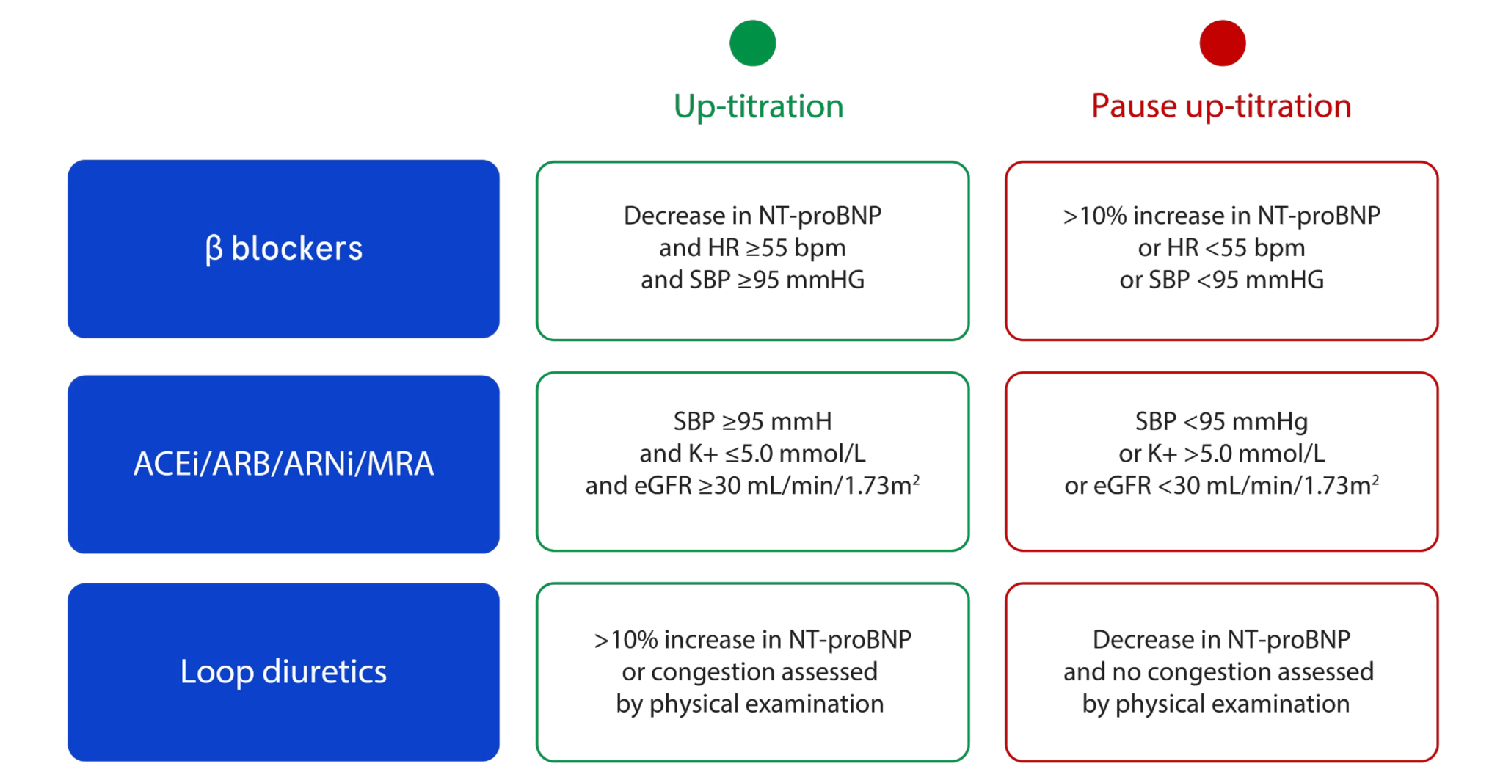
Source: Roche Diagnostics Australia
A recently published consensus statement on the optimisation of patient care after hospitalisation for acute heart failure outlines how NT-proBNP, and the findings of the STRONG-HF trial, should be applied to guide dose titration in the Australian healthcare setting (Sindone et al., 2026). While the statement does not specify an exact number of NT-proBNP tests, it states that serial measurements of B-type natriuretic peptides may be considered to optimise GDMT and to assess response to treatment. In line with the “traffic light” system presented in Figure 1, the consensus statement advises that if B-type natriuretic peptide levels are more than 10% higher than the pre-discharge concentration, clinicians should consider not up-titrating beta-blockers and instead consider increasing diuretic therapy.
These levels help guide whether it is appropriate to up-titrate or pause escalation of treatment and inform adjustments to loop diuretics for managing congestion symptoms. Specifically for beta blockers - a decrease in NT-proBNP, combined with physical examination findings and biochemical tests, indicates it is safe to increase the medication dose.
Conversely, an increase in NT-proBNP suggests worsening hemodynamic stress, signaling that beta blockers should be paused and the dose of loop diuretics increased to alleviate symptoms of congestion. Again, it is well established that increasing the dose of beta-blockers during haemodynamic stress in acute heart failure is hazardous and may lead to worsening heart failure, including congestion or cardiogenic shock (Schurtz et al. 2023).
Additionally, ACEi and MRAs should not be up-titrated if systolic blood pressure is below 95 mmHg, serum potassium exceeds 5.0 mmol/L, or eGFR is less than 30 mL/min/1.73 m². Beta blockers should not be up-titrated if the patient’s heart rate is below 55 beats per minute or systolic blood pressure is below 95 mmHg.
The traffic light system, along with blood biochemistry and physical assessments at each clinician visit, is used to guide clinical management starting at pre-discharge and continuing into the outpatient setting through to six weeks post-discharge.
Pre-Discharge Clinical Management
After the diagnosis of AHF patients are initiated on low dose cardiac remodelling treatment. This is followed by the second NT-proBNP test in the clinical management algorithm which provides guidance whether a patient is able to be up-titrated to 50% of optimal dose prior to discharge.
Outpatient (Vulnerable Phase) Clinical Management
After discharge, patients will have four scheduled visits with their treating clinician over a six-week period. These visits take place at weeks 1, 2, 3, and 6, respectively. By the second visit, clinicians should aim to have patients on optimal doses of therapy, guided by NT-proBNP levels, biochemistry and physical assessments. However, if patients are not up-titrated to the required doses, attempts at up-titration should occur at subsequent visits.

Define and summarise the clinical management algorithm, including any required tests or healthcare resources, after the use of the comparator health technology:

The usual care clinical management algorithm has been adapted by integrating relevant guidance from the sections on AHF and the pharmacological management of chronic HF within the guidelines (NHFA CSANZ Heart Failure Guidelines Working Group 2018) in addition to the consensus statement (Sindone et al. 2022). It is important to note that the guidelines define chronic HF as HF diagnosed for a period of time, arbitrarily set as a minimum of three months. This may suggest that some patients are initiated on appropriate HF therapies only after living with the condition for three months.
Similar to the proposed intervention, NT-proBNP is required to support the diagnosis of AHF in emergency departments. In usual care, treatment adjustments such as up-titration or pausing of medications are typically guided by safety concerns - for example, a drop in eGFR of more than 30% following initiation of an ACEi or MRA, serum potassium exceeding 5.5 mmol/L, or a heart rate below 50 bpm. Notably, usual care lacks a clear marker indicating when it is safe to up-titrate; instead, clinical decisions are based on identifying when it is unsafe to proceed, using biochemical and physical assessments.

Treatment adjustments typically occur at a clinician visit as follows.
Pre-Discharge Clinical Management
Following AHF diagnosis and stabilisation of acute symptoms, patients are initiated on low dose cardiac remodelling treatment, followed by discharge.
Outpatient Clinical Management
In hospital outpatient or community based care, patients are monitored during clinician visits for vitals, observations and biochemistry, which informs whether it is inappropriate to up-titrate treatment doses. Clinician visits are based on the recommended titration schedule provided in the CSANZ HF Guidelines 2018, as detailed below:
- ACE: Double dose every 2 weeks, until target or maximum tolerate dose
- Beta Blockers: Double dose every 2-4 weeks, until target or maximum tolerate dose
- MRAs: Double dose every 4-8 weeks, until target or maximum tolerate dose
Based on the above schedule the earliest a patient is able to reach full or maximum tolerable dose is 12 weeks. One explanation for the inefficient use of these treatments-sometimes coined “prescribing inertia”-is overcautious, subtherapeutic dosing to avoid adverse effects seen in the management of real-world comorbid, elderly patients, where there is no clear guidance from biochemical markers or physical examination on when dose escalation is appropriate. Despite the availability of guidelines, it should be noted that Australia has poor adherence to GDMT (Sindone et al. 2026).

Describe and explain any differences in the healthcare resources used after the proposed health technology vs. the comparator health technology:

Pre-Discharge Clinical Management
Despite the CSANZ Heart Failure Guidelines 2018 recommending the initiation of treatment prior to hospital discharge, they provide limited guidance on the timing of therapy initiation and how to manage dose escalation following an episode of AHF. In the absence of specific direction on pharmacological management of AHF prior to discharge, it is assumed that clinicians would rely on the Pharmacological Management of Chronic Heart Failure section of the guidelines, meaning that under usual care, patients would be started on low-dose therapy prior to discharge.
In the proposed health intervention, NT-proNBP would guide the clinicians to up-titrating treatment to 50% of optimal doses prior to discharge.
Outpatient Clinical Management
Referencing the CSANZ Heart Failure Guidelines 2018, patients would typically up-titrate their treatment to full optimal dose over a 12 week period; ACEi every 2 weeks, Beta Blockers every 2-4 weeks and MRAs every 4-8 weeks.
In contrast, the proposed health technology enables full titration to the optimal dose within two weeks of discharge, with ongoing safety assessments and diuretic adjustments continuing for up to six weeks post-discharge. Overall the change in clinical management would result in full dose titration timelines from 12+ weeks to 2. By the end of week 6, it is anticipated that a greater number of patients would be on optimal doses of GDMT compared to that of standard of care.

Insert diagrams demonstrating the clinical management algorithm with and without the proposed health technology:
(Please ensure that the diagrams provided do not contain information under copyright)
Figure 2: Clinical management of heart failure patients in usual care
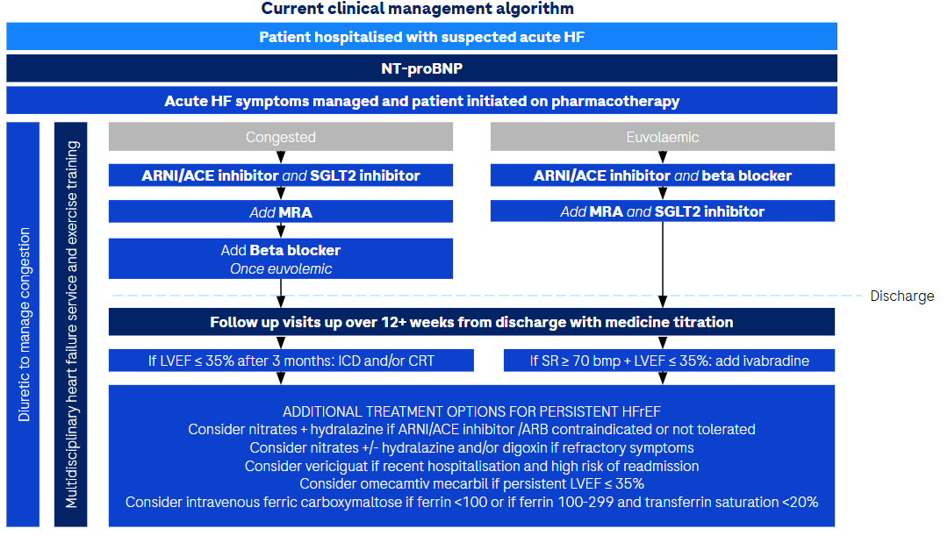
Source: Adapted from CSANZ HF Guidelines 2018 and Consensus Statement 2022
Figure 3: Clinical management with NT-proBNP testing for treatment optimisation, used as part of HF pharmacomanagement
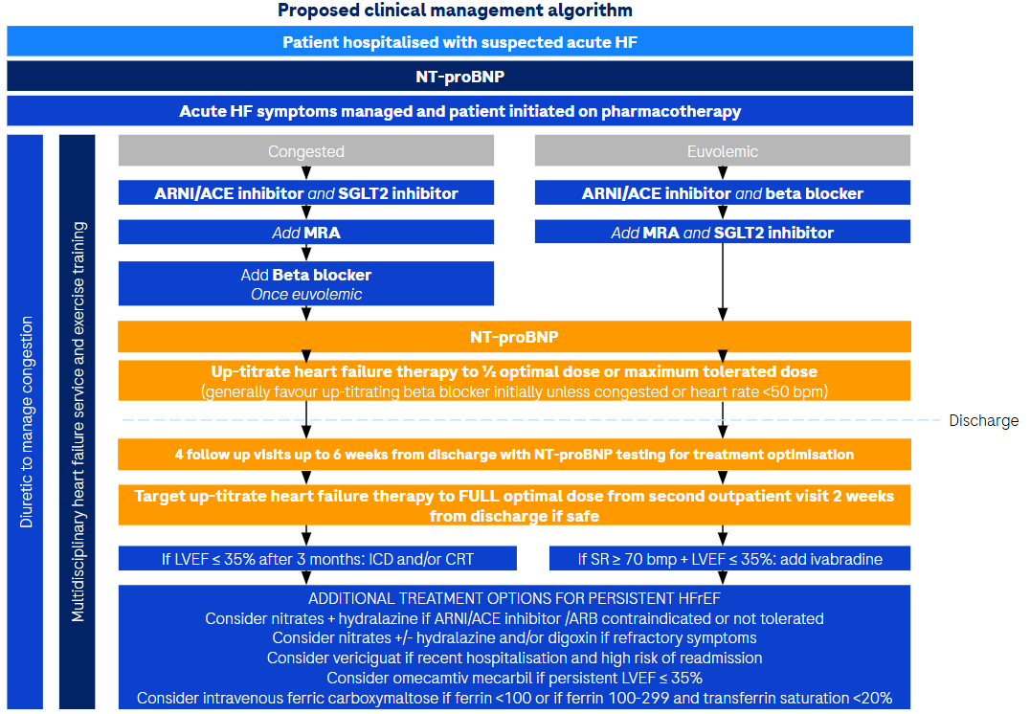

Claims

In terms of health outcomes (comparative benefits and harms), is the proposed technology claimed to be superior, non-inferior or inferior to the comparator(s)?
☑ Superior
☐ Non-inferior
☐ Inferior

Please state what the overall claim is, and provide a rationale:
As previously discussed, NT-proBNP provides insights into biomechanical stress, and therefore persistent congestion in heart failure, guiding clinical decisions for optimising beta-blockers and diuretics as part of guideline-directed medical therapy (GDMT). Evidence will support this claim with improved GDMT uptake, reduced readmissions, and better survival outcomes.
Our claim is that the use of NT-proBNP testing to guide treatment optimisation will be superior to usual care consisting of biochemistry tests, vital signs, and clinical observations alone.

Why would the requestor seek to use the proposed investigative technology rather than the comparator(s)?
Based on the STRONG-HF study, a NT-proBNP level has influence on the clinical management of AHF, which has downstream implications on GDMT uptake, rehospitalisation rates and survival.
Supporting this, the 2018 NICE Guidelines (NG106) recommended considering the measurement of NT-proBNP as part of a treatment optimisation protocol (National Institute for Health and Care Excellence (NICE) 2018).

Identify how the proposed technology achieves the intended patient outcomes:

NT-proBNP ensures patients are initiated on GDMT while they are in hospital and that GDMT is up-titrated to optimal tolerated doses rapidly after discharge (Mebazaa et al. 2022). This is especially critical because rapid optimisation of HF therapies and close follow-up in the early period after HF hospitalisation has been found to decrease all-cause mortality and reduce the risk of HF readmission.

For some people, compared with the comparator(s), does the test information result in:
A change in clinical management? Yes
A change in health outcome? Yes
Other benefits? Yes

Please provide a rationale, and information on other benefits if relevant:

At a system level, the use of NT-proBNP to guide therapy optimisation can contribute to more efficient use of healthcare resources by supporting earlier stabilisation of patients and potentially reducing avoidable hospital presentations through improved outpatient monitoring and follow-up.

In terms of the immediate costs of the proposed technology (and immediate cost consequences, such as procedural costs, testing costs etc.), is the proposed technology claimed to be more costly, the same cost or less costly than the comparator?
(Please select your response)
☑ More costly
☐ Same cost
☐ Less costly

Provide a brief rationale for the claim:

The cost of investigations for HF management would increase marginally to the MBS with the use of NT-proBNP testing for treatment optimisation in conjunction with usual care investigations.
However, when considering the budget impact to the health system, the proposed health technology is likely to be cost saving whilst providing better health outcomes. This is largely predicated on the proposed health technology shown to reduce rehospitalisation rates and improve survival and quality of life.

If your application is in relation to a specific radiopharmaceutical(s) or a set of radiopharmaceuticals, identify whether your clinical claim is dependent on the evidence base of the radiopharmaceutical(s) for which MBS funding is being requested. If your clinical claim is dependent on the evidence base of another radiopharmaceutical product(s), a claim of clinical noninferiority between the radiopharmaceutical products is also required.
Not applicable

Summary of Evidence

Provide one or more recent (published) high quality clinical studies that support use of the proposed health service/technology. At ‘Application Form lodgement’,
 | Type of study design* | Title of journal article or research project | Short description of research | Website link to journal article or research | Date of publication
1. | Multinational, open-label, randomised, prospective  clinical trial | Safety, tolerability and efficacy of up-titration of guideline-directed medical therapies for AHF (STRONG-HF): a multinational, open-label, randomised, trial | 1641 patients were screened and 1078 were successfully randomly assigned to high-intensity care (n=542) or usual care (n=536). The study was stopped early per the data and safety monitoring board’s recommendation because of greater than expected between-group differences. Heart failure readmission or all-cause death up to day 180 occurred in 74 (15·2% down-weighted adjusted Kaplan- Meier estimate) of 506 patients in the high-intensity care group and 109 (23·3%) of 502 patients in the usual care group (adjusted risk difference 8·1% [95% CI 2·9–13·2]; p=0·0021; risk ratio 0·66 [95% CI 0·50–0·86]). | https://www.thelancet.com/journals/lancet/article/PIIS0140-6736(22)02076-1/fulltext | December 2022
2. | Secondary analysis of a multinational, open-label, randomised controlled trial (STRONG-HF) | NT-proBNP and high intensity care for acute heart failure: the STRONG-HF trial | Secondary analysis of the STRONG-HF trial evaluating NT-proBNP-guided optimisation of guideline-directed medical therapy following hospitalisation for acute heart failure. Demonstrated that serial NT-proBNP monitoring supported rapid up-titration of therapy and was associated with improved clinical outcomes compared with usual care. | DOI: 10.1093/eurheartj/ehad335 | August 2023
3. | Randomised control trial | Natriuretic Peptide-guided Therapy for HF (STARS-BNP) | In a study of 220 patients, BNP-guided therapy led to more frequent medication adjustments and higher doses of ACE inhibitors and beta-blockers (p < 0.05), with similar furosemide use across groups. Over 15 months, fewer patients in the BNP group reached the combined endpoint (24% vs. 52%, p < 0.001). | Doi: 10.1016/j.jacc.2006.10.081 | April 2007
4. | Prospective, randomised controlled trial | Heart failure outcomes and benefits of NT-proBNP-guided management in the elderly: results from the prospective, randomized ProBNP outpatient tailored chronic heart failure therapy (PROTECT) study | A study of 151 patients with heart failure due to LVSD compared standard-of-care (SOC) treatment to NT-proBNP-guided care (target ≤1000 pg/mL) over 10 months. In patients aged ≥75 (n=38), NT-proBNP levels rose with SOC but fell significantly with guided care. Elderly patients on SOC had the highest cardiovascular event rate, while those on NT-proBNP-guided care had the lowest (1.76 vs 0.71 events per patient, P=0.03). NT-proBNP-guided care significantly reduced event risk in the elderly (OR 0.24, P=0.008), with a non-significant trend in younger patients (OR 0.61, P=0.10). | Doi: 10.1016/j.cardfail.2012.05.00 | February 2011
5. | Randomised control trial | N-terminal pro-B-type natriuretic peptide-guided treatment for chronic heart failure: results from the BATTLESCARRED (NT-proBNP-Assisted Treatment To Lessen Serial Cardiac Readmissions and Death) trial | This study compared NT-proBNP–guided therapy, intensive clinical management, and usual care (UC) in 364 patients with chronic heart failure over a 3-year period. One-year mortality was significantly lower in both NT-proBNP and clinically guided groups (9.1%) compared to UC (18.9%; p = 0.03). At three years, NT-proBNP–guided therapy further reduced mortality in patients ≤75 years (15.5%) versus clinically guided (30.9%; p = 0.048) and UC (31.3%; p = 0.021). NT-proBNP–guided therapy offers a selective long-term mortality benefit in younger patients. | https://pubmed.ncbi.nlm.nih.gov/20117364/ | December 2009
6. | Multicentre prospective study | Nurse-Led, Remote Optimisation of Guideline-Directed Medical Therapy in Patients with Heart Failure and Reduced Ejection Fraction Across Australia | Australian multicentre study evaluating a nurse-led remote programme to optimise guideline-directed medical therapy in patients with HFrEF. Among 2004 patients, uptake of four-pillar heart failure therapy increased from 11.1% to 49.8%, with significant increases across all medication classes and improved left ventricular ejection fraction following medication optimisation. | https://doi.org/10.3390/jcm14155371 | July 2025
7. | Guidelines | National Heart Foundation of Australia and Cardiac Society of Australia and New Zealand: Guidelines for the Prevention, Detection, and Management of Heart Failure in Australia 2018 | An Australian guideline that addresses the use of medicines in adults with acute and chronic heart failure. It aims to provide structured guidance on the safe and effective use of therapies, supporting optimal treatment decisions and promoting the quality use of medicines in the management of heart failure. | DOI: 10.1016/j.hlc.2018.06.1042 | October 2018
8. | Guidelines | 2023 Focused Update of the 2021 ESC Guidelines for the diagnosis and treatment of acute and chronic heart failure: Developed by the task force for the diagnosis and treatment of acute and chronic heart failure of the European Society of Cardiology (ESC) With the special contribution of the Heart Failure Association (HFA) of the ESC | European guidelines which cover the diagnosis and management of acute and chronic heart failure in adults. It provides information on the use of NT-proBNP for diagnosis, prognosis, and monitoring, and how it can support considerations around treatment. | https://doi.org/10.1093/eurheartj/ehad195 | October 2023
9. | Consensus Statement | Consensus Statement on Optimisation of Patient Care After Hospitalisation for Acute Heart Failure | Consensus statement outlining strategies to improve care following hospitalisation for acute heart failure, focusing on early follow-up, optimisation of guideline-directed medical therapy, and monitoring to reduce rehospitalisation and mortality. | DOI: 10.1016/j.hlc.2025.09.019 | February 2026
10. | Expert Consensus | Beta-blocker management in patients admitted for acute heart failure and reduced ejection fraction: a review and expert consensus opinion | Expert consensus reviewing evidence on beta-blocker use during acute heart failure hospitalisation, providing recommendations on continuation, initiation and up-titration of beta-blockers in patients with reduced ejection fraction. | DOI: 10.3389/fcvm.2023.1263482 | November 2023
11. | Narrative review | The vulnerable phase after hospitalization for heart failure. | Highlights the high-risk “vulnerable phase” following heart failure hospitalisation, supporting the need for early, intensive follow-up and optimisation of guideline-directed medical therapy. | https://doi.org/10.1038/nrcardio.2015.14 | February 2015

