Medical Services Advisory Committee (MSAC)

Public Summary Document
Application No. 1790 – POLE genotyping for the molecular classification of endometrial cancer
Applicant: The Royal College of Pathologists of Australasia
Date of MSAC consideration: 1 April 2026
Context for decision: MSAC makes its advice in accordance with its Terms of Reference, visit the MSAC website

Purpose of application
An application requesting Medicare Benefits Schedule (MBS) listing of DNA polymerase epsilon, catalytic subunit POLE genotyping for the molecular classification of endometrial cancer (EC) was received from the Royal College of Pathologists of Australasia (RCPA) by the Department of Health, Disability and Ageing.

MSAC’s advice to the Minister
After considering the strength of the available evidence in relation to comparative safety, clinical effectiveness, cost-effectiveness and total cost, MSAC supported the creation of a new Medicare Benefits Schedule (MBS) item for POLE genotyping for the molecular classification of endometrial cancer. MSAC considered endometrial cancer with POLE variants has an excellent prognosis and a very low risk of recurrence. Some patients with POLE variants can safely avoid or reduce the use of adjuvant treatments without compromising the clinical outcome and avoid the adverse events from these treatments. MSAC considered the use of POLE genotyping to inform de‑escalation of adjuvant treatment is likely to lead to superior outcomes and would not introduce any additional safety concerns. MSAC noted that POLE testing is standard of care for patients with endometrial cancer in Australia. MSAC considered it appropriate to test all patients with newly diagnosed endometrial cancer.
MSAC considered that POLE testing is cost-effective with the potential to be cost saving depending on the proportion of patients with POLE variant endometrial cancer who undergo treatment de-escalation. MSAC considered that the overall financial impact to the government would be acceptable, with likely cost offsets to the Pharmaceutical Benefits Scheme (PBS) and MBS as a result of treatment de-escalation due to the avoidance of chemotherapy and reduction in radiotherapy use. MSAC advised that the MBS item descriptor should restrict requesting of the test to specialist or consultant physicians and that the test should be pathologist determinable. MSAC advised a fee of $400 would be appropriate for the proposed single gene test. MSAC considered MBS listing of POLE genotyping would improve access to testing and reduce out‑of‑pocket costs for individuals who currently self‑fund this test.
Table 1 MSAC’s supported MBS item descriptor
Category 6 – PATHOLOGY SERVICES Group P7 – Genetics
MBS item AAAAA
Characterisation of variants on the exonuclease domain (targeting exons 9, 11, 13 and 14 as a minimum) of the POLE gene, requested by a specialist or consultant physician, in a patient diagnosed with endometrial carcinoma.

Applicable once per primary tumour diagnosis.
Fee: $400.00 Benefit 75%: $300.00 85%: $340.00
Consumer summary

This application from the Royal College of Pathologists of Australasia requested Medicare Benefits Schedule (MBS) listing of genetic testing for DNA polymerase epsilon, catalytic subunit (known as POLE gene) alterations, also called POLE genotyping, for people newly diagnosed with endometrial cancer.

Endometrial cancer is becoming more common, with over 3,000 people in Australia expected to be diagnosed in 2025. About 84% of people with endometrial cancer are still alive 5 years after diagnosis.

Surgery is usually the main treatment for endometrial cancer. However, it is not always easy to tell which people need additional treatments after surgery, such as radiotherapy or chemotherapy. After being diagnosed with endometrial cancer, the tumour sample may have several genetic tests performed to check for problems with several genes or proteins that will help doctors better understand the cancer and guide treatment decisions. These genes or proteins include the POLE gene, mismatch repair genes, estrogen receptor and a gene called p53.

Some people may have a very high number of genetic changes in their POLE gene which is known as ultramutated (POLEmut). These people will most likely have a good outcome. Because of this, some people with POLEmut may be able to safely avoid or have lower doses of treatments after surgery, such as chemotherapy and radiotherapy. This is called therapy de-escalation that avoids unnecessary treatments and the side effects they can cause.

MSAC considered the test to be safe because POLE genotyping is performed on a piece of tissue already taken for a biopsy at diagnosis or during surgery– so there is no need for more tissue to be taken for the test. Although MSAC was unsure of the exact number of people who would be able to safely de-escalate treatment, the evidence showed some people would be able to.

MSAC noted that POLE testing is already part of standard care in Australia and is recommended internationally, including by the World Health Organization and the European Society of Gynaecological Oncology. At the moment some people fund the test privately (out of pocket). Adding it to the MBS would make the test available for everyone. Although POLEmut is most often found in people with early-stage endometrial cancer, MSAC considered it appropriate for everyone diagnosed with endometrial cancer, including people with late-stage disease, to have access to the test. This helps ensure fair access for all and means people with endometrial cancer are fully tested after diagnosis.

MSAC also considered the test to be good value for money, and noted it would have only modest impact on the MBS budget. There would also be some cost savings for the MBS because of fewer radiotherapy services and specialist consultations, and cost savings for the Pharmaceutical Benefits Scheme (PBS) because of avoided chemotherapy treatments.

MSAC’s advice to the Commonwealth Minister for Health, Disability and Ageing

MSAC supported listing POLE testing on the MBS. MSAC recommended that all patients newly diagnosed with endometrial cancer have access to the test. The test is safe, effective, currently standard of care in Australia and good value for money. The listing will have a modest impact on health budgets, and will result in modest cost savings to both the MBS and PBS.

Summary of consideration and rationale for MSAC’s advice
MSAC noted that this application from the Royal College of Pathologists of Australasia (RCPA) requested Medicare Benefits Schedule (MBS) listing of DNA polymerase epsilon, catalytic subunit (POLE) genotyping for the molecular classification of endometrial cancer (EC). This was the first time MSAC considered POLE testing for the molecular classification of EC.
MSAC noted that the public consultation input was supportive of the application.
The applicant was granted a hearing at the April 2026 MSAC meeting to support its proposal.
MSAC noted EC is increasingly common with an estimated 3,153 Australian cases diagnosed in 2025. EC has a favourable prognosis with a 5-year survival rate of 84.4%. Accurately identifying which patients require additional treatment after surgical excision is difficult. MSAC noted that there are different subtypes of EC and several approaches for molecularly classifying EC, including testing POLE gene, mismatch repair (MMR) genes, p53 and estrogen receptor (ER). MSAC noted approximately 7–10% of the EC population harbours POLE variants. Patients found to have a POLE ultramutation (POLEmut) have an excellent prognosis. As a result, these patients may safely reduce the intensity of, or avoid entirely, adjuvant therapy.
MSAC noted the proposed population for testing, as well as lack of consensus across international guidelines or Australian clinical practice on the recommended test population. MSAC agreed with ESC that POLE testing should be available to all patients newly diagnosed with EC, regardless of cancer stage. MSAC emphasised the importance of equity and supporting access to molecular characterisation for all patients, regardless of EC stage and or setting. MSAC considered an MBS item that allows for all patients to be tested would help to futureproof the item.
MSAC noted POLE genotyping would be used in addition to current histopathological investigations and conducted alongside tests used in current practice. MSAC noted that POLE testing aligns with the current edition of the World Health Organization (WHO) Classification of Tumours, which recommends staging criteria and integration of molecular classification (including POLE genotyping). MSAC noted the applicant’s pre‑MSAC response, which stated that there is precedent for MSAC supporting applications informed by recommendations from the WHO Classification of Tumours. MSAC also noted that recent changes to the ESGO-ESTRO-ESP 2025 guidelines incorporate molecular EC classification into adjuvant treatment recommendations. MSAC acknowledged that POLE testing is standard of care in Australia and noted that some patients are currently paying for the test privately (out of pocket).
Although the application was for single-gene testing, MSAC acknowledged that many laboratories will use panel tests that include POLE, including commercially available kits for testing in Australia. Therefore, MSAC considered it appropriate for the MBS item descriptor to be method agnostic.
MSAC noted that the proposed fee in the application was $550, but that ESC recommended a lower fee of $397.35. MSAC also noted the fee advice of $400 for the proposed single-gene method-agnostic test received from Genomics Australia (GA). MSAC agreed with GA that a fee of $400 was appropriate and consistent with current MBS rebates for single gene tests.
MSAC supported the test being pathologist determinable, to streamline the testing and ensure faster test turnaround times. MSAC supported the test to be requested from a specialist or consultant physician. MSAC agreed with the department that retaining the need for a specialist or consultant physician in the item descriptor is important to ensure that the test is requested by clinicians with appropriate expertise. MSAC advised the department and the RCPA to advise pathologists that the test is also pathologist determinable. MSAC noted that several laboratories in Australia are NATA-accredited to conduct POLE testing.
MSAC considered the clinical management algorithm to be appropriate. POLE testing will be conducted after EC is confirmed and at the same time as MMR, p53 and ER testing.
MSAC agreed with ESC that there were no safety concerns because the testing would be conducted on the original biopsy used for EC diagnosis. MSAC considered that, for people with POLEmut, treatment may be de-escalated and they may avoid side effects from adjuvant therapy, which suggests superior safety for some patients.
MSAC noted the clinical evidence supporting POLE testing. MSAC noted the majority of participants in the studies presented were stage I-II POLEmut EC. The evidence demonstrated that people with POLEmut had a better prognosis than people with wildtype POLE, which supported treatment de-escalation for POLEmut. However, as also noted in the consultation feedback, more evidence on this is emerging (in particular, from the EN10 clinical trial, as described in the pre-MSAC response) and the evidence base is expected to strengthen in the future. MSAC acknowledged that, currently, evidence of predictive utility in stage III/IV EC is limited.
MSAC noted that the economic evaluation in the department contracted assessment report (DCAR) was sensitive to an immunotherapy de-escalation rate. MSAC considered that the de-escalation rate of 46% observed in the PORTEC-4a trial was more reasonable; however, noted that de-escalation rate was not used as an input in the economic model. MSAC further noted during the hearing, the applicant confirmed that most people with POLEmut have early-stage EC and are not treated with immunotherapy. The applicant also stated that most treatment de-escalation will be due to avoidance of chemotherapy and/or radiotherapy, but the exact proportion of patients who will be able to de-escalate treatment is unknown because Australian registries do not collect the appropriate data to determine this. MSAC accepted that, although the exact proportion is unknown, it is certain that some patients will benefit from de-escalation of chemotherapy and/or radiotherapy as a direct result of POLE testing.
The base case incremental cost-effectiveness ratio (ICER) was calculated with immunotherapy as a treatment option, which the applicant acknowledged was unlikely. When immunotherapy is excluded as a treatment option, the ICER increased to $30,509 per quality-adjusted life year (QALY). MSAC noted using a 0% de-escalation rate for immunotherapy in patients with stage III-Iva EC increases the ICER further to $37,958/QALY. Although these ICERs are higher than the base case, MSAC considered them to be acceptable. MSAC noted the re-specified base case using the test fee of $397.35 and the mapped utilities indicated that POLE genotyping was dominant. MSAC noted the QALY gains described in the DCAR were also uncertain; however, MSAC suggested that the cost per POLEmut identified ($4,080.42) would be acceptable to use as a measure of cost-effectiveness. MSAC noted the cost per diagnostic yield was within the range of ICERs based on diagnostic yield that MSAC had previously supported for other genotyping applications.
MSAC noted the financial impact to the MBS using the lower fee of $397.35 was $588,565 in Year 1 increasing to ~$1.15 million in Year 6. MSAC acknowledged there will be some cost savings to the MBS and Pharmaceutical Benefits Scheme (PBS) in Year 6 from reductions in radiotherapy services (MBS), chemotherapy (PBS) and specialist consultations (MBS). MSAC accepted that the cost offsets from immunotherapy de-escalation were unlikely to be realised in practice and therefore did not consider these in its decision‑making.
MSAC queried the pre-MSAC response that noted the financial impact to the MBS may be overestimated because some testing will occur privately. MSAC considered this to be possible but noted that, historically, once a service is available on the MBS, any services previously billed privately tend to shift to the MBS over time. During the hearing, the applicant acknowledged that the percentage of patients accessing the testing privately was approximately 40%.
Given the relatively modest financial impact and that POLE testing is established clinical practice in Australia, MSAC considered that a utilisation review would not be warranted. MSAC advised that correspondence be sent to PBAC to inform it of the MSAC outcome.

Background
MSAC has not previously considered POLE genotyping for the molecular classification of EC.

Prerequisites to implementation of any funding advice
Should POLE genotyping be publicly funded, laboratories providing this service would require accreditation by the National Association of Testing Authorities (NATA). No Therapeutic Goods Administration (TGA) approval or other prerequisites are required for this application as there are laboratories accredited by NATA to perform this test.

Proposal for public funding
The application proposed a new MBS item for POLE genotyping of EC samples (Table 2). No other associated applications relating to the proposed health technology are in progress. The applicant requests that the MBS item descriptor for POLE genotyping be method agnostic.
Table 2 Proposed MBS item descriptor for POLE genotyping
Category 6 – PATHOLOGY SERVICES – P7 Genetics
MBS item AAAA
Characterisation of variants in the exonuclease domain (targeting exons 9, 11, 13 and 14 as a minimum) of the POLE gene, requested by a specialist or consultant physician in a patient diagnosed with endometrial carcinoma
Applicable once per primary tumour diagnosis
Fee: $TBC Benefit: 75% $TBC, 85% $TBC
Abbreviations: POLE = DNA polymerase epsilon, catalytic subunit, TBC = to be confirmed
Source: MSAC Application 1790 PICO Confirmation, p 14.
The applicant noted that costings vary between laboratories due to multiple variables in next generation sequencing (NGS) testing, which include the number of samples tested in each run. The applicant advised that the cost of a small to medium NGS assay would typically be around $500–$550 (when an error margin is included) and provided a breakdown of costs associated with POLE genotyping from one laboratory to support this (the laboratory was not identified in the application). The breakdown of costs is presented in Table 3.
Table 3 Costs associated with POLE genotyping from one laboratory provided by the applicant
Item | Cost
Anatomical pathology: H&E and unstained slides | $18.00
DNA extraction/sample processing | $30.00
Magnis SureSelect™ XT HS2 DNA (no probe) (96 reactions) | $102.00
SureSelect™ custom probes – tier 1 (96 reactions) | $65.00
Magnis™ automation tips | $1.00
Magnis ™ service cost | $4.60
NextSeq ™ P1 | $150.48
NextSeq ™ service cost | $6.38
Scientist time (Magnis/MiSeq™) | $6.67
Analysis, curation & validation scientist/clinician time | $88.00
Genomic analysis | $25.00
Total | $497.13
Margin of error | $550.00
Abbreviations: DNA = deoxyribonucleic acid; H&E = haematoxylin and eosin; POLE = DNA polymerase epsilon, catalytic subunit
Source: MSAC Application 1790 PICO Set, Text, pp 9 and 10

Population
One PICO set was defined for this application. The target population is patients diagnosed with EC. Approximately 7–10% of the EC population harbours the POLE mutation (POLEmut). Most POLEmut ECs are of endometrioid histology and are classed as stage I–II. A substantial proportion of POLEmut ECs are of high grade (grade 3: 21–60%).
The proposed technology would be used in addition to current histopathological investigations and conducted alongside tests used in current practice (mismatch repair [MMR], p53, oestrogen receptor [ER]). While the proposed technology is available for patients if paid for privately (by patients out of pocket, or by clinical trial sponsors), it is currently not publicly funded.
International guidelines for POLE genotyping are inconsistent, which has implications for the size of the test population. The International Federation of Gynaecology and Obstetrics (FIGO) recommends POLE genotyping in all EC patients. In contrast, the 2022 British Association of Gynaecological Pathologists (BAGP) recommends POLE genotyping only for specific groups, where the results have the potential to influence decisions regarding adjuvant treatment. The BAGP guidelines recommend POLE genotyping in groups such as patients with abnormal MMR or p53 results and stage III or IV or locally advanced EC, if recommended by a multi-disciplinary team (MDT). The BAGP did not recommend POLE genotyping in patients with low-grade, endometrioid, stage IA, no/focal lymphovascular space invasion (LVSI) and ER+ EC, and those with stage III/IV or locally advanced EC.
PASC considered that all EC patients should be eligible for testing (preferably on the initial biopsy at the diagnosis stage). In the post-PASC period, targeted consultation by the department with key groups and organisations indicated there is no single approach in Australia regarding patient eligibility for POLE genotyping.
An independent Australian clinical expert advised the assessment group that management of EC in Australia generally follows guidelines from the European Society of Gynaecological Oncology, European Society for Radiotherapy and Oncology and European Society of Pathology (ESGO-ESTRO-ESP); the European Society for Medical Oncology (ESMO) and the American Society for Radiation Oncology (ASTRO) (personal communication, gynaecological surgeon, October 2025). ESMO recommends POLE genotyping is performed sequentially in the following order: POLE, MMR and then p53. The ESGO-ESTRO-ESP guidelines follow no particular sequence. The sequence of testing in Australian laboratories is unknown. As the targeted consultation of key groups and organisations indicated there is no single approach in Australian practice for testing sequence or methodologies used, this supports the request for a method agnostic restriction.
The applicant’s proposal for public funding described the following proposed clinical management. Patients presenting with EC symptoms will undergo standard investigation and imaging. If EC is suspected following these investigations, patients will receive an endometrial biopsy followed by histology of the biopsy sample. If histology is positive for EC, patients will either have a hysterectomy and histopathology with POLE genotyping conducted on the hysterectomy sample, or if hysterectomy is not required, histopathology and POLE genotyping conducted on the initial endometrial biopsy sample. In cases where patients test positive for POLEmut, de-escalation of adjuvant treatment would be considered based on individual case factors and expert opinion. If the patient does not test positive for POLEmut, adjuvant treatment will proceed according to current management guidelines.
If patient management post-POLE genotyping does not change, there is no meaningful change in resource utilisation. If the presence of POLE variant results in adjuvant treatment de-escalation for some patients, then resource use will decrease.
The assessment report addresses the requirements of the PICO confirmation.

Comparator
The comparator specified by the applicant in the post-PASC period was no POLE genotyping. After hysterectomy, the sample would undergo standard investigations including MMR, p53 and ER immunochemistry without POLE variant analysis. Patients would be treated based on the histological findings and the results of the MMR, p53 and ER tests, which may include a combination of observation, radiation and/or chemotherapy.
The proposed comparator is no POLE genotyping. The comparator identified by the applicant in the post-PASC period is appropriate.
No MBS item number is currently available for POLE genotyping.

Summary of public consultation input
Consultation input was welcomed from:
1790 – POLE genotyping for the molecular classification of endometrial cancer | No. of Inputs Received
Organisations (14)
I am providing input on behalf of a consumer group or organisation. Consumer organisations are not-for-profit organisations representing the interests of healthcare consumers, their families and carers. | 1
I am providing input on behalf of a medical, health, or other (non-consumer) organisation. For example, input on behalf of a group of clinicians, research organisation, professional college, or from an organisation that produces a similar service or technology. | 13
Health Professionals (3)
I am a health professional or health academic working in the area. | 3
Consumers (2)
I have the health condition that this health service or technology is for and have experience with the proposed health service or technology. | 1
I am an interested individual who does not fall into any of the above categories. | 1
Grand Total | 19
MSAC received consultation input from 11 organisations and 5 individuals. The organisations that provided input were:
- The Royal Australian and New Zealand College of Radiologists (RANZCR) (2 inputs)
- National Gynae-Oncology Registry (NGOR) (2 inputs)
- Victorian Integrated Cancer Services (VICS)
- Institute of Health Transformation (IHT) at Deakin University
- Human Genetics Society of Australasia Ltd (HGSA) (2 inputs)
- Rare Cancers Australia (RCA)
- Australia New Zealand Gynaecological Oncology Group (ANZGOG)
- Cancer Australia (CA)
- Public Pathology Australia (PPA)
- Australian Pathology
- Royal Australian and New Zealand College of Obstetricians and Gynaecologists (RANZCOG)
Level of support for public funding
Consultation input was supportive of public funding for POLE genotyping for the molecular classification of endometrial cancer, with several noting that this would align Australia with global standards and ensure all patients receive the best possible treatment. RANZCOG noted, however, that the evidence base is still evolving.
Comments on the PICO
Most consultation input agreed with the proposed population. RANZCR recommended limiting POLE testing to patients intending to undergo adjuvant therapy and to consider the placement of testing to prevent delays in treatment decisions.
In response to specific questions relating to clinical management algorithms and testing protocols, several organisations (RANZCR, NGOR, PPA) provided specific advice on positioning of POLE genotyping in routine clinical practice in Australia. There were mixed views about universal testing vs a targeted approach.
Perceived Advantages
The main benefits of public funding articulated in the consultation input included:
- determining POLE variant status enables safe de-escalation of treatment in multiple clinical scenarios. It provides information that would guide management decisions for clinicians and may potentially avoid side effects of treatments for patients. Without access to POLE testing, patients may be exposed to unnecessary adjuvant therapy, such as vaginal brachytherapy, external beam radiotherapy, or chemotherapy.
- Avoiding the use of less effective therapies that may be associated with additional health issues can decrease healthcare system costs.
- POLE genotyping improves prognostic accuracy, may lead to patients avoiding unnecessary toxic treatments and reduce inequity in the management of endometrial cancer by allowing low-risk patients from rural and regional areas to avoid travelling for intensive follow-up care.
- Organisational input stated that public funding of POLE genotyping would allow Australia to follow international guidelines and provide access to all patients, not just those who could afford to privately fund POLE testing. ANZGOG stated that international guidelines recommend routine testing of endometrial tumours for POLE variants. RCA and HGSA stated that the World Health Organization Classification of Female Genital Tumours categorises endometrial cancer based on molecular testing and that POLE genotyping would assist in fulfilling the WHO recommendations.
- A consumer with experience with POLE genotyping described it as ‘life-changing’, noting that it helped her mental health immensely and allowed her to opt out of radiotherapy, which made her recovery easier. She also noted that public funding would result in equal treatment for all women regardless of financial circumstances or geographic location.
Perceived Disadvantages
The consultation input did not identify any perceived disadvantages of public funding. Input did, however, note that a major disadvantage at present is the high cost of the test (paid by the consumer) and a lack of widespread implementation in clinical settings, with POLE testing currently available only through private testing or clinical trials.
Support for Implementation and Issues
Consultation input was supportive of implementation of public funding for POLE testing with the proposed approach seen as broadly suitable. However, the input raised some issues for considerations and potential challenges to successful implementation:
- Several submissions (e.g., RCA, IHT, VICS) emphasised the importance of equitable access, including for people in rural and remote settings. RCA noted that integrating the testing process with local pathology services could reduce the need for travel and improve access.
- VICS suggested the provision of funding for initial infrastructure upgrades, training programs for clinicians and pathologists, and public awareness campaigns to ensure patients understand the value of molecular testing. Others also stressed the importance of training.
- RANZCR recommended a protocol-driven approach for initiation of POLE testing to mitigate delays in treatment decision and additional workload for laboratory staff. It expressed concerns about potential limited resourcing (i.e., staffing issues), particularly in rural and regional areas, which may contribute to extended turnaround times for test results.
- RANZCR also noted that genetic counselling capacity and continuing medical education (CME) for clinicians remain key barriers to full implementation of molecular-guided practice in endometrial cancer management.
- RCA stated additional support services, such as counselling, dietary advice, and pain management, are important to address the complex needs of patients undergoing testing and subsequent treatments.
- PPA indicated that POLE testing should be able to be pathologist initiated, with the understanding that for public patients, the hospital will bear the cost. It also indicated the need for clear guidance about when POLE testing should occur (i.e., on biopsy [preferred if adequate tissue as better fixation] or post-operatively).
- AP noted that there is currently no RCPA Quality Assurance Programs (QAP) available for POLE, but there are overseas QA programs (e.g. GenQA).
- RANZCOG indicated that, if supported, guidance about whether POLE testing should be considered in cases of recurrent endometrial cancer would be needed.

Characteristics of the evidence base
A systematic literature review (SLR) was conducted to answer the following research question: What is the safety, effectiveness and cost-effectiveness of POLE genotyping versus no POLE genotyping in patients with EC? The SLR was conducted on 20 August 2025 across multiple databases. A total of 10 publications met the inclusion criteria for assessing POLE mutations in patients with EC.
As the SLR found no studies providing direct evidence, a linked evidence approach was undertaken. This approach integrated the 3 key domains of the assessment framework: the diagnostic accuracy of POLE genotyping methods, the impact of POLEmut status on clinical management, and the effect of adjuvant treatments on patient outcomes. Note that following the SLR, a conference abstract was published for PORTEC-4a, providing preliminary results on direct health outcomes for adjuvant treatment of EC based on molecular profile.
Four studies identified in the SLR provided data on the test accuracy of POLE genotyping across various genotyping methodologies, including polymerase chain reaction (PCR), quantitative PCR (qPCR), droplet digital PCR (ddPCR), Sanger sequencing and NGS (Table 4). No studies were retrieved that directly evaluated change in clinical management resulting from POLE genotyping. Instead, this component was informed indirectly through 3 studies comparing the prognosis of POLEmut EC versus other molecular subtypes (POLE wild type [POLEwt], MMR deficient [MMRd] and no specific molecular profile [NSMP]). Three studies were identified that assessed the impact of adjuvant therapy in patients with POLEmut EC.
The studies contributing to each component of the assessment framework were heterogeneous in study designs, comparator groups and reported outcomes. Thus, meta-analysis or pooling of the study results was not feasible. Instead, the evidence was evaluated independently, with findings appraised at the individual study level.
Table 4 Key features of the included evidence for POLE genotyping in EC
Study | Type of evidence supplied | Sample size  No. of studies | Overall risk of bias | GRADE assessment
Test accuracy
Chen 2024 | - Cohort study  - PCR vs NGS | n=365  k=1 | Unclear | ⨁⨁⨁⨀  Moderate
Van den Heerik 2023 | - Cross-sectional study  - qPCR vs NGS | n=282  k=1 | Unclear | ⨁⨁⨁⨀  Moderate
Kim 2022 | - Cohort study  - ddPCR vs Sanger sequencing | n=240  k=1 | Unclear | ⨁⨁⨁⨀  Moderate
Talhouk 2016 | - Cohort study  - Ultradeep MiSeq sequencing (NGS) or Sanger sequencing on pre-surgical specimen vs post-surgical specimen | n=57  k=1 | Unclear | ⨁⨁⨁⨀  Moderate
Prognosis (inferred from indirect evidence)
PORTEC-3, | - Post-hoc analysis of RCT (phase 3, open-label)  - Stage I–III, high-risk EC  - POLEmut (n = 51) vs MMRd (n = 137) | n=410  k=1 | High | ⨁⨁⨁⨁  High
PORTEC-1/2 + EC series (Church 2015) | - Post-hoc analysis of 2 RCTs (PORTEC-1 and -2) plus 3 EC series (Leuven, Zurich/Basel, TCGA)  - Stage I–II EC  - POLEmut (n = 48) vs POLEwt (n = 740) | n=788  k=1 | High | ⨁⨁⨁⨁  High  ⨁⨁⨁⨀  Moderate
PORTEC-1/2 (Stelloo 2016) | - Post-hoc analysis of 2 RCTs (PORTEC-1 and -2)  - Stage I–II EC  - POLEmut (n = 49) vs NSMP (n = 492) | n=834  k=1 | High | ⨁⨁⨀⨀  Low
Health outcomes
PORTEC-3^{10,11} | - RCT of stage I–III, high-risk EC  - Assessed CTRT vs RT alone  - Survival outcomes reported as post-hoc analysis for POLEmut subgroup (n = 51)  - Safety outcomes reported for overall EC population (n = 410) | n=410  k=1 | High | ⨁⨁⨀⨀  Low
PORTEC-1 and 2 | - PORTEC-1  - RCT of stage I, intermediate-risk EC  - Assessed pelvic RT vs no adjuvant therapy  - Locoregional recurrence as post-hoc analysis for POLEmut subgroup (n = 42)  - PORTEC-2  - RCT of stage I–II, high-intermediate risk EC  - Assessed EBRT vs VBT  - Locoregional recurrence, pelvic recurrence as post-hoc analysis for POLEmut EC (n = 24) | N=880  k=2 | High | NA*
McAlpine 2021 | - IPD meta-analysis of POLEmut EC  - Assessed any adjuvant therapy vs no adjuvant therapy | n=359  k=1 | Serious | ⨁⨁⨀⨀  Low
Abbreviations: CTRT = chemoradiation therapy; ddPCR = droplet digital polymerase chain reaction; EBRT = external beam radiation therapy; EC = endometrial cancer; GRADE = Grading of Recommendations, Assessment, Development and Evaluations; IPD = individual patient data; k = number of studies; MMRd = mismatch repair deficient; n = number of patients; NGS = next generation sequencing; NSMP = no specific molecular profile; PCR = polymerase chain reaction; POLEmut = DNA polymerase epsilon, catalytic subunit mutation; POLEwt = DNA polymerase epsilon, catalytic subunit wild type; qPCR = quantitative polymerase chain reaction; RCT = randomised controlled trial; RT = radiation therapy; TCGA = The Cancer Genome Atlas; VBT = vaginal brachytherapy
* GRADE assessments were not performed for PORTEC-1 and 2 as summary statistics were not available because no events were reported in all treatment arms in patients with POLEmut EC

Comparative safety
The POLE genotyping test is unlikely to introduce additional safety concerns for patients with EC. The genotyping test is typically performed on tissues obtained during routine diagnostic, staging or grading procedures (e.g. biopsy or hysterectomy), meaning no extra intervention is required to obtain a tissue sample for analysis. Moreover, the diagnostic performance of various genotyping methods is high. Chen et al. 20246 and Talhouk et al. 20169 both demonstrated positive and negative predictive values of at least 90% with PCR and NGS. As a result, the likelihood of incorrect molecular classification and consequent inappropriate decisions regarding adjuvant therapy that lead to adverse outcomes is considered low. Nevertheless, should a patient be incorrectly identified as POLEmut positive, inappropriate de-escalation of adjuvant treatment may potentially result in serious adverse outcomes of disease progression or death. Other safety effects of POLE genotyping are due to the subsequent changes in clinical management of patients with POLEmut EC.
In the identified studies, safety outcomes related to adjuvant treatments used in EC were not reported for the POLEmut subgroup but for the broader EC population. Nevertheless, there is no evidence to suggest that safety outcomes would differ for patients with POLEmut EC. Safety outcomes for the broader EC population were informed by PORTEC-3, PORTEC-2 and PORTEC-1. As open-label RCTs, the PORTEC trials carry a higher risk of differential reporting of adverse events (AEs), since clinicians and patients were aware of allocation of adjuvant treatment. This may have influenced the reporting of safety data. Consequently, the risk of bias was judged to be high. Nevertheless, safety data reported in PORTEC-3 demonstrated that more intensive adjuvant therapy (i.e. chemoradiation therapy [CTRT]) was associated with at least numerically greater AEs compared with less intensive adjuvant therapy (i.e. radiation therapy [RT] alone) (Table 5). Any grade 2 AEs and any grade 3–4 AEs were statistically significantly greater for CTRT than RT. Grade 3–4 gastrointestinal, haematological and neuropathic AEs, and pain were also statistically significantly greater for CTRT than RT. For PORTEC-2, external beam radiation therapy (EBRT) was associated with higher gastrointestinal AEs and lower mucous membrane AEs than vaginal brachytherapy (VBT). In PORTEC-1, late treatment complications were more common in patients treated with RT than in the no adjuvant therapy arm.
Overall, the efficacy and safety results support the de-escalation of adjuvant treatment for patients with POLEmut EC. Therefore, de-escalation of adjuvant treatment due to POLE genotyping is likely to lead to superior safety outcomes for patients with POLEmut EC.
Table 5 Summary of comparative safety of adjuvant treatment
Trial  (Treatment comparison) | Outcome | p-value
PORTEC-3  (CTRT vs RT alone) | Any grade 2 AE | 34% vs 31%; p <0.0001
PORTEC-3  (CTRT vs RT alone) | Any grade 3–4 AE | 61% vs 13%; p <0.0001
PORTEC-3  (CTRT vs RT alone) | auditory/hearing | <1% vs <1%; p = 1
PORTEC-3  (CTRT vs RT alone) | fatigue | 3% vs 0%; p = 0.0018
PORTEC-3  (CTRT vs RT alone) | any gastrointestinal | 14% vs 6%; p = 0.0002
PORTEC-3  (CTRT vs RT alone) | any haematological | 45% vs 6%; p <0.0001
PORTEC-3  (CTRT vs RT alone) | any neuropathy | 7% vs 0%; p <0.0001
PORTEC-3  (CTRT vs RT alone) | any pain | 9% vs 1%; p <0.0001
PORTEC-3  (CTRT vs RT alone) | genitourinary incontinence | <1% vs 0%; p = 1
PORTEC-3  (CTRT vs RT alone) | genitourinary urinary frequency | 1% vs 1%; p = 1
PORTEC-3  (CTRT vs RT alone) | thrombosis or embolism | 1% vs 0%; p = 0.12
Abbreviations: AE = adverse event; CTRT = chemoradiation therapy; RT = radiation therapy
Source: de Boer et al. (2016) Table 2 pp 7

Comparative effectiveness

Direct evidence: PORTEC-4a
PORTEC-4a is an RCT that provides direct evidence for molecular profile-based adjuvant treatment. The interim results were presented at the ESTRO 2025 conference. PORTEC-4a is an international randomised trial comparing adjuvant treatment based on the molecular integrated profile to standard vaginal brachytherapy (VBT) in high-intermediate risk EC (Stage IA, IB, or II who meet certain criteria). Patients were randomised to adjuvant treatment or VBT based on risk profile (Figure 1A). After randomisation, the tumour tissues were molecularly profiled (Figure 1B). The primary efficacy outcome was the first event of vaginal recurrence (recurrence of endometrial cancer in the vaginal region). Key secondary outcomes included cumulative incidence of pelvic recurrence, locoregional recurrence, distant metastases, recurrence-free survival (RFS) and overall survival (OS).
The full details and results from the PORTEC-4a trial are not yet available. Therefore, a linked evidence approach is also undertaken.
Figure 1 PORTEC-4a study design (A) and decision tree of molecular integrated risk profile (B)
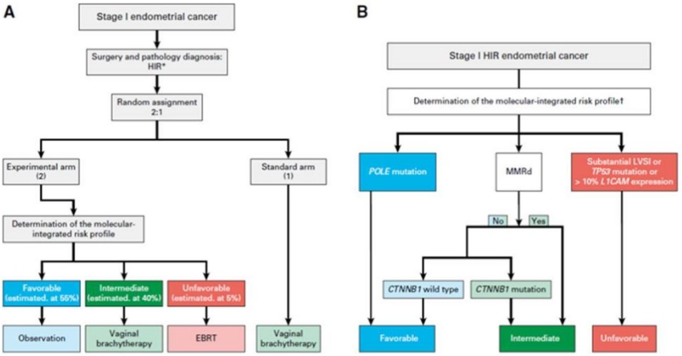
Abbreviations: CTNNB1 = catenin beta 1; EBRT = external beam radiation therapy; HIR = high-intermediate risk; L1CAM = L1 cell adhesion molecule; LVSI = lymphovascular space invasion; MMRd = mismatch repair deficient; POLE = DNA polymerase epsilon, catalytic subunit
* HIR includes 1) stage IA (with invasion), grade 3 (any age, with or without LVSI); 2) stage IB, grade 1 or 2 and age ≥ 60 years; 3) stage IB, grade 1 or 2 with documented LVSI; 4) stage IB, grade 3 without LVSI; 5) stage II (microscopic), grade 1
Source: van den Heerik, ASVM et al. (2025)
Interim results from the prospective trial PORTEC-4a showed that the 5-year cumulative incidence of vaginal recurrence (Figure 2) was 4.5% in the molecular profile arm versus 1.6% in the VBT arm (HR 2.72; 95% CI: 0.37-9.36). The difference of the one-sided 95% CI between arms was estimated at 5.3%, below the predefined equivalence margin of 7% (p_{non-inferiority}=0.005). Pelvic recurrences were less frequent in the molecular profile arm (3.2%) than the VBT arm (5.2%) (p=0.32). Locoregional recurrence was 8.8% versus 7.5% in the molecular profile and VBT arms, respectively (p=0.62).
There were no statistically significant differences between treatment arms for recurrence-free survival (RFS) (p=0.36) and overall survival (OS) (p=0.34) (Figure 2). The proportion of RFS events was 81.7% versus 85.1% in the molecular profile and VBT arms, respectively. OS events occurred in 88.0% of patients in the molecular profile arm and 90.9% in the VBT arm. These preliminary results support the rationale for modifying management approaches for EC based on molecular class. The full trial results are expected to be published in the near future (personal communication, study authors, 28 August 2025).
Figure 2 5-year cumulative incidence of vaginal recurrence and recurrence-free survival
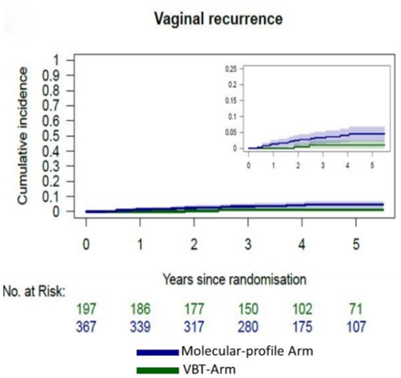 | 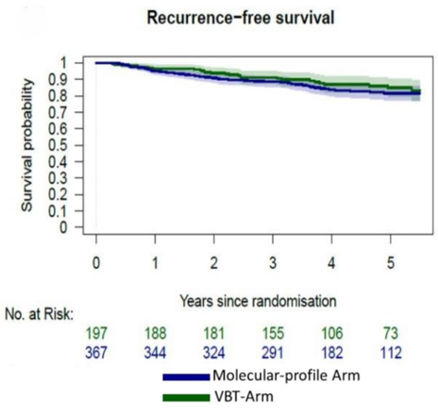
Abbreviations: VBT = vaginal brachytherapy
Source: van den Heerik, ASVM et al. (2025) Figure A and B p4430
Based on the RCTs, patients with EC harbouring pathogenic POLE variants were consistently shown to have a more favourable prognosis compared with other molecular classes. Coupled with recent updates to the ESGO-ESTRO-ESP 2025 guidelines,5 it is reasonable to consider that the presence of POLEmut in EC supports de-escalation of adjuvant treatment. Adjuvant treatment recommendations from other guidelines align with this, in that adjuvant therapy is generally not recommended for low-risk EC, a category that includes most POLEmut cases.4, An independently sourced clinical expert indicated that Australian practice is guided by the ESGO-ESTRO-ESP, ESMO and ASTRO guidelines (personal communication, gynaecological surgeon, October 2025), suggesting that changes in the ESGO-ESTRO-ESP guidelines would also influence Australian clinical practice.

Linked evidence: Test accuracy
All test accuracy studies enrolled patients with EC irrespective of stage and grade. The study designs differed, with 3 retrospective cohort studies and 1 cross sectional study. The studies assessed different PCR methods versus NGS or Sanger sequencing, or differences between pre-surgical (biopsy or curettage) and post-surgical (hysterectomy) samples. The studies interrogated different regions of the POLE gene but consistently included the exonuclease domain, which is associated with pathogenic POLE variants.
Across the test accuracy studies, the heterogeneity in methodologies and the consistently high sensitivity and specificity of the genotyping methods studied (Table 6) support a method-agnostic approach to the proposed MBS item.
Risk of bias was generally judged to be low across the Quality Assessment of Diagnostic Accuracy Studies (QUADAS)-2 domains. Where unclear risk of bias was identified, it was primarily due to insufficient reporting within the publications, resulting in an unclear risk of bias overall. As a result, the overall certainty of evidence was rated as moderate using the Grading of Recommendations, Assessment, Development and Evaluations (GRADE) framework. Despite addressing the research question, the applicability of these studies to the Australian context remains uncertain, as PCR-based POLE genotyping methods may not be routinely implemented in local laboratories. This may limit the transferability of the findings from Chen et al. (2024), Van den Heerik, A et al. (2023) and Kim et al. (2022). Nevertheless, a targeted consultation with key groups and organisations about the position of POLE genotyping and methodologies used in Australia indicated there is no single approach regarding the use of POLE genotyping or the methodologies used.
Table 6 Quality of evidence for diagnostic accuracy studies
Study | Index/reference tests | Results | Quality of evidence using GRADE
Chen 20246 | PCR/NGS | Specificity: 0.993 (95% CI: 0.9761, 0.9982)ª  Sensitivity: 1.000 (95% CI: 0.9434, 1.0000)ª  NPV: 1.000  PPV: 0.970 | ⨁⨁⨁⨀  Moderate
Van den Heerik 2023⁷ | qPCR/NGS  Equivocal results were sequenced by NGS or Sanger | Accuracy: 0.986 (95% CI: 0.972, 0.999)  Specificity: 1.000  Sensitivity: 0.952 (95% CI: 0.907, 0.998) | ⨁⨁⨁⨀  Moderate
Kim 2022⁸ | ddPCR/Sanger sequencing  Discordant results were retested using NGS | Approximately 30% of samples were discordant between ddPCR and Sanger | ⨁⨁⨁⨀  Moderate
Talhouk 20169 | Ultradeep MiSeq sequencing (NGS) or Sanger sequencing using diagnostic and hysterectomy samples | Accuracy: 0.95 (95% CI: 0.89, 1.00)  Specificity: 0.98 (95% CI: 0.89, 1.00)  Sensitivity: 0.82 (95% CI: 0.52, 0.95)  NPV: 0.96 (95% CI: 0.86, 0.99)  PPV: 0.90 (95% CI: 0.60, 0.99) | ⨁⨁⨁⨀  Moderate
Abbreviations: CI = confidence interval; ddPCR = droplet digital polymerase chain reaction; GRADE = Grading of Recommendations, Assessment, Development and Evaluations; NGS = next generation sequencing; NPV = negative predictive value; PCR = polymerase chain reaction; PPV = positive predictive value; qPCR = quantitative polymerase chain reaction
ª Confidence intervals were not reported in the publication and were calculated using the Wilson score method for this DCAR (Newcombe 1998).
Source: Chen et al. (2024); Van den Heerik, A et al. (2023); Kim et al. (2022); Talhouk, A. et al. (2016)

Linked evidence: Clinical benefit of POLE genotyping

Prognostic value of POLE testing in EC
For the linked evidence approach, clinical benefit of POLE genotyping is indirectly informed by post-hoc analyses of RCTs PORTEC-1,12,13 PORTEC-212,13 and PORTEC-3.10,11 PORTEC-3 was an RCT that evaluated adjuvant CTRT versus RT alone in patients with stage I–III high risk EC. Molecular classification was determined post-hoc by NGS, which was performed blinded to patient outcomes. Key outcomes were RFS and OS reported at 5 years (León-Castillo, de Boer, et al. 2020) and 10 years (Post et al. 2025).
Church et al. (2015) and Stelloo et al. (2016) conducted post-hoc molecular analyses using the PORTEC-1 and PORTEC-2 trials, which enrolled patients with stage I intermediate-risk EC and stage I–II high–intermediate-risk EC, respectively. Church et al. (2015) also incorporated 3 independent EC cohorts. PORTEC-1 randomised patients to pelvic radiotherapy or no adjuvant treatment, while PORTEC-2 randomised patients to EBRT or VBT. Outcomes included RFS, cancer-specific survival/disease-specific survival (CSS/DSS) and OS. The comparisons of survival outcomes between POLEmut and other molecular subgroups were not reported by treatment arm. Due to differences in the comparative molecular subgroups across studies, a meta-analysis was not feasible and each study was appraised independently.
Analysis of the quality of evidence using the GRADE framework showed a moderate to high certainty of evidence, with the exception of Stelloo et al. (2016), which was rated as low certainty of evidence, primarily due to serious imprecision stemming from wide confidence intervals in the reported outcomes. ESC noted the reported risk of bias assessment conducted by the assessment group assessed the bias of the study-intended randomised comparison of treatments rather than the post-hoc nonrandomised comparison of prognosis by genotype status. Therefore, ESC did not agree with the assessment group’s conclusion of the strength of evidence presented. Post-ESC the assessment group clarified that there is no established consensus regarding the application of the risk of bias tools to post-hoc analyses of RCTs, the DCAR’s risk of bias evaluation was undertaken using the ROB2 tool for the post-hoc analyses presented. A systematic review of the whole trial for PORTEC-1 to -3 reported an overall low to unclear risk of bias using the ROB2 tool, whereas the DCAR assessed the post-hoc analyses as having a high risk of bias. In context of the uncertainty regarding the use of assessment tools, a supplementary assessment using the ROBINS-I tool identified an overall serious risk of bias, aligning with the ROB2 conclusions presented in the DCAR.
Results from the studies are presented in Table 7, showing a largely favourable prognostic effect observed in POLEmut EC relative to other molecular subtypes. Statistical significance was reached for RFS in PORTEC-3 and Church et al. 2015, with a hazard ratio (HR) between 0.07 and 0.33. OS reported in PORTEC-3 was also statistically significant in favour of POLEmut at the 5-year follow-up (HR 0.12; 95% CI: 0.02, 0.87; p = 0.036) and 10-year follow-up (HR 0.07; 95% CI: 0.01, 0.54; p = 0.009), but did not reach statistical significance in PORTEC-1/2 as reported by Stelloo et al. 2016 (HR 1.105; 95% CI: 0.394, 3.101; p = 0.850). Overall, the favourable prognosis associated with POLEmut EC supports the clinical utility of POLE genotyping in guiding decisions for adjuvant treatment. However, note that POLE status was not obtained until the post-hoc period, after randomisation of treatment, and therefore treatment received may be a potential confounder. Although multivariable Cox models adjusted for clinicopathologic features, to account for treatment differences, this may not have completely eliminated the effects of confounding.
Table 7 Prognostic value of POLE testing in EC
Study | Participants | Comparison | Results, HR (95% CI) | Quality of evidence using GRADE
PORTEC-3  (Leon-Castillo 202010; Post 202511) | Stage I–III, high-risk EC | POLEmut vs MMRd | 5-year follow-up  RFS: 0.08 (0.01, 0.58); p = 0.012  OS: 0.12 (0.02, 0.87); p = 0.036  10-year follow-up  RFS: 0.07 (0.01, 0.53); p = 0.009  OS: 0.07 (0.01, 0.54); p = 0.009 | ⨁⨁⨁⨁  High
PORTEC-1/2 + EC series  (Church 2015¹²) | Stage I–II, intermediate- to high–intermediate- risk EC | POLEmut vs POLEwt | RFS: 0.33 (0.12, 0.91); p = 0.03 | ⨁⨁⨁⨁  High
PORTEC-1/2 + EC series  (Church 2015¹²) | Stage I–II, intermediate- to high–intermediate- risk EC | POLEmut vs POLEwt | CSS: 0.26 (0.06, 1.08); p = 0.06 | ⨁⨁⨁⨀  Moderate
PORTEC-1/2  (Stelloo 2016¹³) | Stage I–II, intermediate- to high–intermediate-risk EC | POLEmut vs NSMP | OS: 1.105 (0.394, 3.101); p = 0.850 | ⨁⨁⨀⨀  Low
Abbreviations: CI = confidence interval; CSS = cancer specific survival; CTRT = combined adjuvant chemotherapy and radiotherapy; HR = hazard ratio; MMRd = mismatch repair deficient; NSMP = no specific molecular profile; OS = overall survival; PFS = progression free survival; POLEmut = DNA polymerase epsilon, catalytic subunit mutation; POLEwt = DNA polymerase epsilon, catalytic subunit wild type; RFS = recurrence free survival; RT = external beam radiotherapy alone; VBT = vaginal brachytherapy
Note: Bolded results indicate statistically significant difference
Note that in Church et al. and Stelloo et al., comparisons of survival outcomes between POLEmut and other molecular subgroups were not reported by treatment arm.
Of note, the assessment group noted long term data from PORTEC-3 showed that over 10 years of follow-up, the favourable prognosis of POLEmut EC was sustained compared with other molecular classes, irrespective of the adjuvant therapy received (Figure 3).
Figure 3 PORTEC-3: OS over 10 years
Overall survival by molecular class
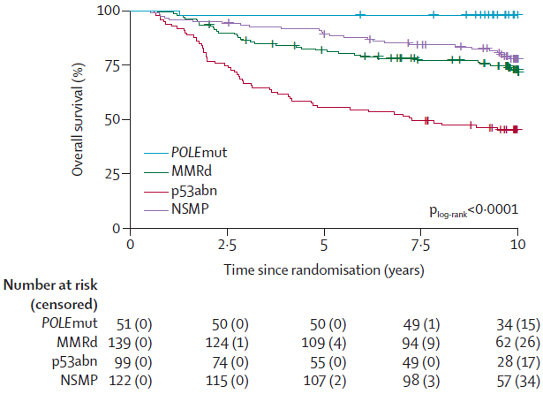
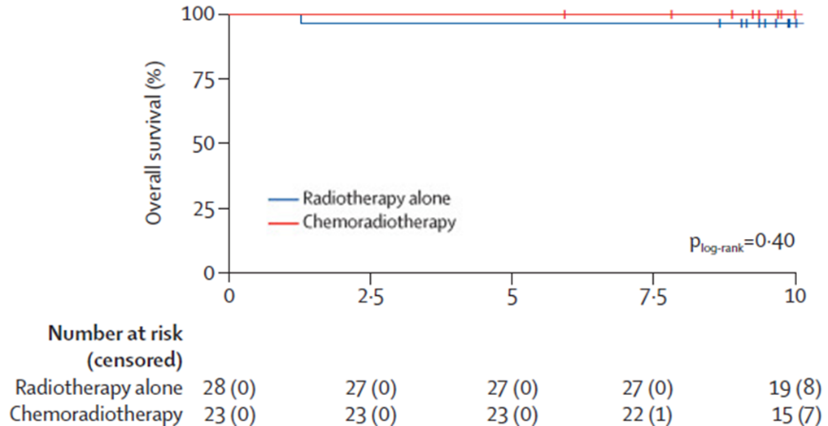
Overall survival for POLEmut EC

Abbreviations: EC = endometrial cancer; MMRd = mismatch repair deficient; NSMP = no specific molecular profile; OS = overall survival; POLEmut = DNA polymerase epsilon, catalytic subunit mutation
Source: Post et al. (2025) Figure 1C p5 and 3C p8
Following the ESC meeting the assessment group provided an overview of the effect of CTRT versus RT on OS and RFS by molecular class in PORTEC 3, as presented below (Figure 4). The assessment group observed a statistically significant benefit of CTRT for patients with p53abn EC, with improvements in both OS and RFS. For patients with MMRd or NSMP EC, slight divergence of the survival curves was noted. However, these differences were not statistically significant. Unlike the other molecular classes, where events accumulated in both treatment arms over 10 years, POLEmut EC demonstrated very few overall events, with only one event occurring in the RT arm during the 10-year follow-up.
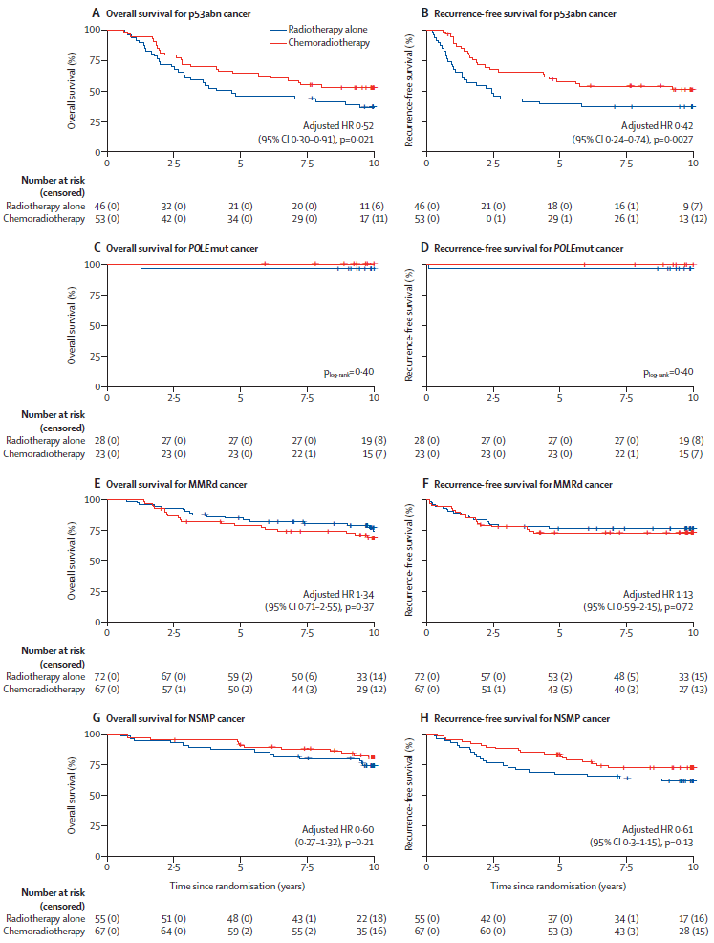
Figure 4 OS and RFS by molecular class for PORTEC 3

Abbreviations: CI = confidence interval; HR = hazard ratio; MMRd = mismatch repair deficient; NSMP = no specific molecular profile; OS = overall survival; p53abn = p53 abnormal; RFS = recurrence-free survival; POLEmut = DNA polymerase epsilon, catalytic subunit mutation
Source: Post et al. (2025) Figure 3 p 8

Change in clinical management
Studies investigating the change in clinical management from knowledge of POLEmut status in EC is lacking and is based on RCTs reporting survival according to EC molecular classes (Table 7). As demonstrated, patients with EC harbouring the POLE mutation have a favourable prognosis compared with other molecular classes. The favourable prognosis lends confidence to treatment de-escalation in patients with POLEmut EC. This is further supported by recent changes in the ESGO-ESTRO-ESP 2025 guidelines (Concin et al. 2025), which incorporate molecular classification into adjuvant treatment recommendations.

Linked evidence: Impact on patient outcomes
The SLR identified 2 studies—PORTEC-3 and McAlpine et al. (2021)—that evaluated the impact of adjuvant therapy in patients with POLEmut EC. A targeted search also identified a post-hoc analysis of PORTEC-1 and 2 by molecular class.
In PORTEC-3, molecular classification was applied post-hoc, and subgroup analyses in the POLEmut cohort were informed by follow-up publications^{10,11,}. These analyses compared outcomes between patients treated with CTRT and RT alone. However, the randomisation process was for the overall population and was not stratified by molecular class. Furthermore, the open-label design of the trials may influence clinical management, resulting in an overall risk of bias that was judged to be high. In addition to the high risk of bias, the small sample size for the POLEmut cohort (n=51) and low event rates resulted in very wide confidence intervals, contributing to serious imprecision. Overall, the certainty of evidence was rated as low using the GRADE framework.
Horeweg et al., 2023 reported results comparing pelvic RT with no adjuvant therapy in early-stage intermediate-risk EC (PORTEC-1) and VBT versus EBRT in early-stage high-intermediate-risk EC (PORTEC-2). The randomisation process was for the overall population and was not stratified by molecular class. PORTEC-1 and 2 were open-label trials. The assessment of recurrence may be affected by the open-label design of the trial. Furthermore, not all patients from the trials underwent molecular classification. Therefore, the risk of bias was judged to be high. No summary statistics were reported for the outcomes of recurrence rates. Therefore, a GRADE assessment was not possible.
McAlpine et al. (2021) conducted an individual patient data (IPD) meta-analysis to assess whether the favourable prognosis observed in POLEmut EC was attributable to adjuvant therapy. Data were pooled from 35 publications and consolidated into 15 unique cohorts, with IPD available for 13 cohorts, resulting in a final data set of 359 patients with POLEmut EC. The analysis compared any adjuvant therapy versus no adjuvant therapy, reporting PFS and/or DSS as adverse outcomes. While McAlpine et al. (2021) was judged to have a low risk of bias across most domains, limited reporting on data availability and missing data handling led to an overall judgement of serious risk of bias.
McAlpine et al. (2021) and Horeweg et al. (2023) did not report safety outcomes. PORTEC-3, PORTEC-2 and PORTEC-1 did not report safety outcomes specifically for the POLEmut subgroup, but safety data were available for the overall cohort. In the absence of molecular-specific safety data, outcomes were based on the broader EC populations of these trials.
PORTEC-3 and McAlpine et al. (2021) evaluated the impact of adjuvant therapy in patients with POLEmut EC. Across both studies, no significant differences in survival outcomes were observed between treatment arms for patients with POLEmut (Table 8). However, the small sample size and low event rates resulted in very wide confidence intervals, contributing to serious imprecision. When combined with the serious risk of bias, the certainty of evidence was rated as low using the GRADE framework. Nevertheless, the absence of recurrence or death in the POLEmut subgroup of PORTEC-3 over a 10-year follow-up period supports the de-escalation of adjuvant treatment in these patients. The proportion of patients with stage III–IV disease across both studies was low, limiting the generalisability of the results to stage III and IV disease. These results also align with treatment guidelines (Concin et al. 2025) where no adjuvant therapy is recommended for patients with stage I–II disease POLEmut EC. No firm recommendations were made for stage III–IV disease.
Table 8 Quality of evidence for comparative therapies
Study | Outcome | Comparison | Participants | Results, HR (95% CI) | Quality of evidence using GRADE
McAlpine 202115 | PFS and/or DSS | Any adjuvant therapy vs no adjuvant therapy | POLEmut EC | 1.53 (0.27, 8.50); p = 0.626 | ⨁⨁⨀⨀  Low
PORTEC-310,11 | RFS (5-year follow-up) | CTRT vs RT alone | Stage I–III, high-risk EC | 0.02 (<0.01, >10⁵); p = 0.637 | ⨁⨁⨀⨀  Low
 | OS (5-year follow-up) | CTRT vs RT alone | Stage I–III, high-risk EC | 0.02 (<0.01, >10⁵); p = 0.637 | ⨁⨁⨀⨀  Low
 | RFS (10-year follow-up) | CTRT vs RT alone | Stage I–III, POLEmut EC | p = 0.40 | ⨁⨁⨀⨀  Low
 | OS (10-year follow-up) | CTRT vs RT alone | Stage I–III, POLEmut EC | p = 0.40 | ⨁⨁⨀⨀  Low
Abbreviations: CI = confidence interval; CTRT = chemoradiation therapy; DSS = disease-specific survival; EC = endometrial cancer; HR = hazard ratio; OS = overall survival; PFS = progression-free survival; RFS = recurrence-free survival; POLEmut = DNA polymerase epsilon, catalytic subunit mutation; RT = radiotherapy
Source: McAlpine et al. (2021); León-Castillo, de Boer, et al. (2020); Post et al. (2025)
Italics indicates post-ESC updates by assessment group
In PORTEC-1 and 2,14 no recurrence events were reported in the POLEmut subgroup irrespective of adjuvant treatment received (Figure 5). This supports the conclusion POLEmut EC is associated with a favourable prognosis, irrespective of adjuvant therapy administered.
Figure 5 Time to recurrence in POLEmut EC
Locoregional recurrence  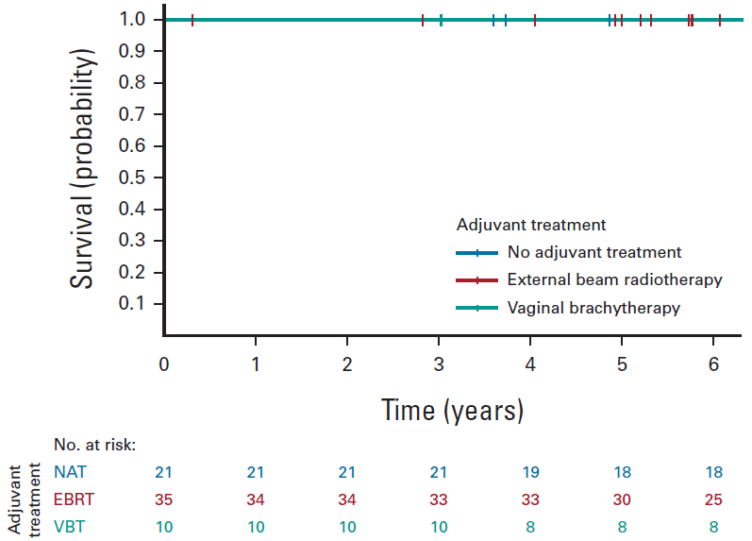 | Pelvic recurrence  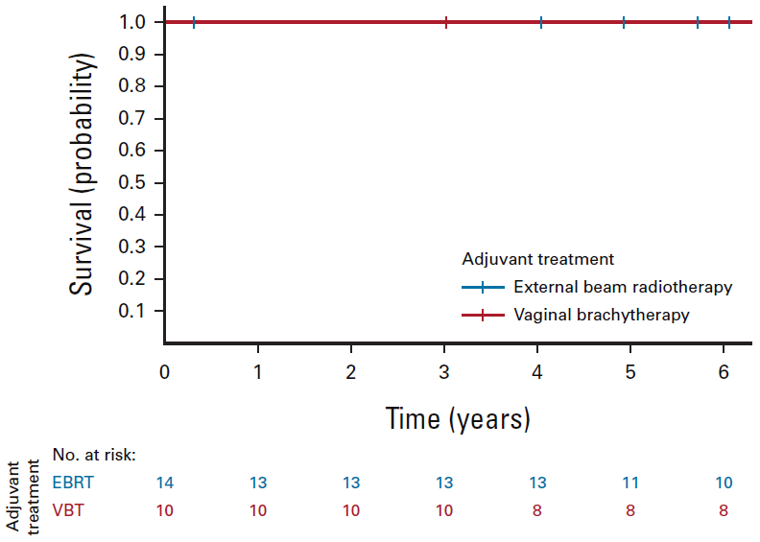
Abbreviations: EBRT = external beam radiation therapy; EC = endometrial cancer; POLEmut = DNA polymerase epsilon, catalytic subunit mutation; NAT = no adjuvant therapy; VBT = vaginal brachytherapy
Source: Horeweg et al. (2023)Fig 5A p9, Fig 4A p8
In the POLEmut subgroup in PORTEC- 3, one event occurred in the RT arm. This patient had stage III disease and experienced a recurrence and ultimately died (León-Castillo, de Boer, et al. (2020), p 3). Over the 5- and 10-year follow-up periods, no other events were reported in patients with POLEmut EC from either treatment arm (León-Castillo, de Boer, et al. 2020; Post et al. 2025). No statistically significant differences were observed between CTRT and RT alone in terms of RFS or OS (Figure 6). HRs for both outcomes were 0.02 (95% CI: <0.01, >10⁵; p = 0.637). The wide confidence intervals and lack of statistical significance likely reflect the small sample size and very low event rate within this molecular subgroup. The assessment group considered despite these limitations, the absence of additional recurrences and deaths, over the 10-year follow-up period underscores the favourable prognosis associated with pathogenic POLEmut EC.
Figure 6 Kaplan-Meier curves for RFS and OS at 5-year and 10-year follow-up for the POLEmut EC subgroup
A) RFS for POLEmut EC (5-year follow-up)  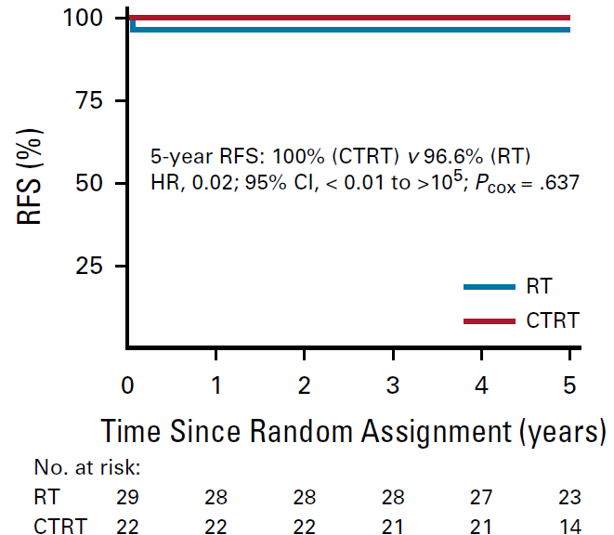 | B) OS for POLEmut EC (5-year follow-up)  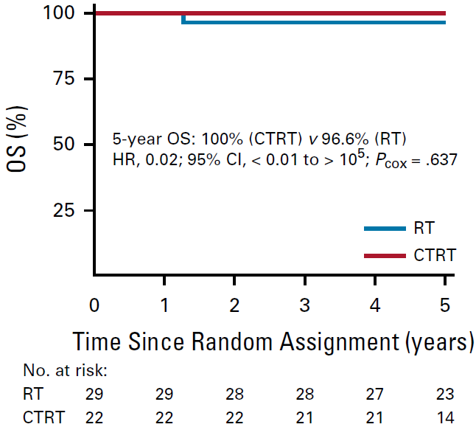
C) RFS for POLEmut EC (10-year follow-up)  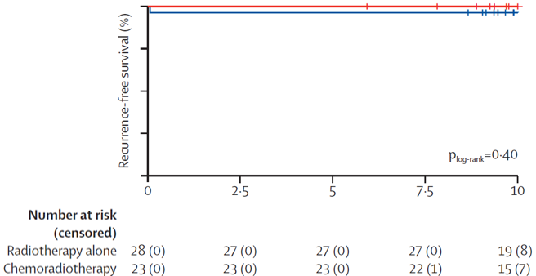 | D) OS for POLEmut EC (10-year follow-up)  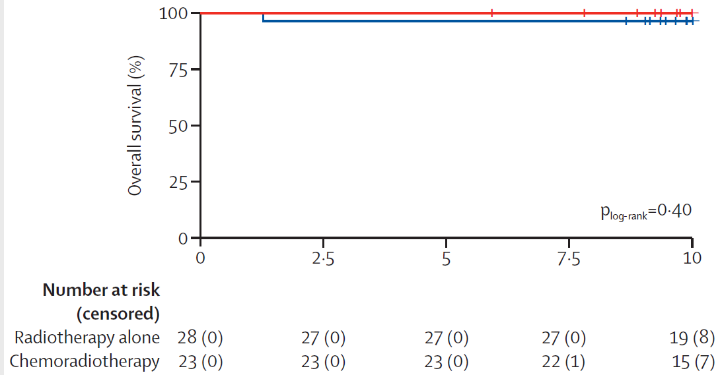
Abbreviations: CI = confidence interval; CTRT = chemoradiation therapy; HR = hazard ratio; OS = overall survival; RFS = recurrence free survival; RT = radiotherapy
Source: León-Castillo, de Boer, et al. (2020) Fig 3 pp 8; Post et al. (2025) Figure 3 pp 8

Clinical claim
The evidence suggests that POLEmut EC is associated with a favourable prognosis compared with other molecular classes, with significantly better OS and RFS.
The evidence suggests that due to the absence of statistically significant differences observed for OS, RFS, PFS and/or DSS, less intensive adjuvant therapy has non-inferior efficacy compared with more intensive regimens in patients with stage I–II POLEmut EC. However, this conclusion is based on low quality evidence. Evidence for patients with stage III–IV POLEmut EC is limited.
The evidence suggests that due to statistically significantly fewer grade 2 AEs and grade 3-4 AEs, less intensive adjuvant therapy likely has superior safety compared to more intensive regimens in patients with POLEmut EC. Overall, POLE genotyping to determine POLE mutation status in EC is likely to lead to superior outcomes in patients with stage I–II POLEmut EC. Evidence for stage III–IV disease is limited.

Economic evaluation
The economic evaluation assessed the cost-effectiveness and cost-utility of POLE genotyping in addition to standard care compared to standard care alone for the management of EC. The objective was to determine whether POLE genotyping is likely to be cost-effective or cost saving, within the context of the Australian healthcare system.
A decision tree model was developed to estimate costs and health outcomes associated with POLE genotyping compared to standard care (MMR, p53, ER assessment) from an Australian healthcare system perspective. The main outcomes of the economic analysis were incremental costs, costs per diagnosis, and cost per patient undergoing adjuvant therapy de-escalation. A Markov model extension was also developed to quantify the incremental costs and incremental QALYs gained through treatment de-escalation among patients with POLEmut EC. When combined with the change in management predictions from the decision tree model, this allowed for estimation of the incremental cost per QALY gained for POLE genotyping compared to standard care.
Model inputs were mostly derived from the published literature and informed assumptions, as evidence from the clinical section was either limited or inapplicable to the Australian setting. Although high diagnostic accuracy was reported for POLE genotyping compared with the respective reference standards in each study, the applicability of these results to the Australian setting was highly uncertain. Local clinician input indicated that NGS is the sole methodology for POLE genotyping in Australia, so the model assumed all POLE genotyping would be performed via NGS. As NGS was defined as the reference standard in the application, NGS results were assumed to reflect the true variant status for the purposes of the economic evaluation, with test accuracy assumed to be 100% (although a test failure rate was incorporated). The clinical section did not identify any direct evidence for management changes resulting from POLE genotyping. In the absence of direct evidence, decisions for adjuvant treatments were modelled based on the ESGO-ESTRO-ESP 2025 guidelines,⁵ which incorporate molecular classification into adjuvant treatment recommendations.
The available evidence suggests equivalent OS, RFS, PFS and/or DSS outcomes irrespective of adjuvant therapy received in stage I–II POLEmut EC, with likely superior safety (see section Comparative effectiveness). Lack of evidence for stage III–IV EC precludes any definitive conclusion in this group. Higher long-term symptom burdens have been reported in association with more intensive adjuvant therapies, including bowel and bladder effects for EBRT and persistent neuropathy after chemoradiation.,, Short- or longer-term reductions in various domains on quality-of-life instruments have also been observed .^{21,22,23} These differences could lead to moderate QALY losses over time.
Two published cost-utility analyses (CUA) were identified assessing the cost-utility of molecular testing (MMR immunohistochemistry, p53 immunohistochemistry and POLE genotyping) versus no molecular testing in EC patient subgroups (stage I and II high-risk EC and stage III EC cohorts)., Despite estimating QALY differences, these studies addressed narrower clinical questions and adjuvant treatment decisions (i.e. CTRT vs RT alone) and could not be replicated easily within the broader decision context of the present analysis.
For the current analysis, a Markov model extension was constructed to quantify the costs and QALY outcomes associated with various potential adjuvant therapy options for patients with POLEmut EC over a 5-year time horizon. Based on the cost and QALY outcomes modelled for each treatment alternative via the Markov modelling, incremental costs and incremental QALYs gained outcomes for each treatment comparison (adjuvant therapy vs VBT; RT alone vs CTRT etc.) were estimated. The treatment comparisons considered comprised the changes in adjuvant therapy/treatment de-escalation options modelled in the CEA.
A brief overview of the model parameters is provided in Table 9.
Table 9 Summary of economic evaluation
Component | Description
Perspective | Healthcare system perspective
Population | Patients diagnosed with endometrial carcinoma (NGOR data 2017–2023: mean age 64.3 years, FIGO stage I 68.9%, II 6.8%, III 13.1%, IV 6.5%, unknown 4.7%)
Prior testing | Pelvic ultrasonography with or without transvaginal ultrasonography to measure endometrial thickness, endometrial biopsy, and/or dilatation and curettage with or without hysteroscopy.
Comparator | No POLE genotyping
Reference standard | NGS
Type(s) of analysis | CEA and CUA
Outcomes | Incremental costs  Incremental cost per diagnosis (patient found to harbour a POLEmut)  Incremental cost per patient undergoing adjuvant therapy de-escalation  Incremental cost per QALY gained
Time horizon | 5 years
Computational method | Decision tree model with Markov model extension
Generation of the base case | Modelled
Health states | Recurrence free, recurred disease, dead
Cycle length | 1 month
Transition probabilities | All transition probabilities directly from published literature, supplemented by assumptions, given the limited clinical evidence.  Prevalence of FIGO stages, molecular biomarkers and grades informed by the published literature.,,  Test accuracy assumed at 100%, as NGS defined as the reference standard for this application. Test failure rate informed by Chen et al. (2024).⁶ Change in management according to ESGO-ESTRO-ESP 2025 guidelines, with the assumption that all patients without metastatic disease (FIGO stage I–IVA) currently receiving adjuvant therapy who are successfully identified as POLEmut would undergo treatment de-escalation.  Risk-based adjuvant treatment options including observation (i.e. no adjuvant therapy), radiation therapy, chemotherapy, chemoradiation therapy and immunotherapy were modelled.  Recurrence-free survival was modelled based on data for the POLEmut cohort irrespective of stage (due to limited data) or adjuvant therapy received (available evidence showed no difference irrespective of adjuvant therapy received).^{,12} Mortality was modelled based on Australian Life Tables and literature-based data for the post-recurrence state.,  Health state utility values were informed by existing cost-utility models, additional literature and Australian population norms.^{25,26,,,,}  The base case assumed 64% of identified POLEmut cases would undergo treatment de-escalation based on the ESGO-ESTRO-ESP 2025 guidelines and noting a recent conference abstract report .
Discount rate | 5% per annum for costs and effects
Software | Tree Age Pro 2023
Abbreviations: CEA = cost-effectiveness analysis; CUA = cost-utility analysis; ESGO = European Society of Gynaecological Oncology; ESP = European Society of Pathology; ESTRO = European Society for Radiotherapy and Oncology; FIGO = International Federation of Gynecology and Obstetrics; NA = not applicable; NGOR = National Gynae-Oncology Registry; NGS = next generation sequencing; POLE = DNA polymerase epsilon, catalytic subunit; POLEmut = DNA polymerase epsilon, catalytic subunit mutation; QALY = quality-adjusted life year.
A stepped analysis was performed for the base-case economic evaluation (Table 10).
Table 10 Results of stepped economic analysis (using the applicant’s higher proposed fee of $497.13 excluding the margin of error)
Step | POLE genotyping | No POLE genotyping | Increment | Incremental costs per effect
Step 1 – Diagnostic accuracy (assumed to be 100%) and test failure rate (assumed to be 4.95%) applied to prevalence of POLEmut in the eligible Australian population
Cost | $497.13 | $0 | $497.13 | $5,105.07
Total correct diagnoses | 0.0974 | 0 | 0.0974 | $5,105.07
Step 2 – Incorporation of change in clinical management (directed by POLE test result)
Cost | $11,052.47 | $11,190.77 | −$138.30 (cost saving) | Dominant  (−$2,219.35)
Appropriate management allocation | 0.0623 | 0 | 0.0623 | Dominant  (−$2,219.35)
Step 3 – Extrapolation over a 5-year time horizon
Cost | NEª | NEª | −$138.30 (cost saving) | NA
Life years gained | NEª | NEª | 0.000 | NA
Step 4 – Translation to QALY outcomes
Cost | NEª | NEª | −$138.30 (cost saving) | POLE genotyping dominant
QALYs gained | NEª | NEª | 0.010 | POLE genotyping dominant
Abbreviations: POLE = DNA polymerase epsilon, catalytic subunit; NA = not applicable; NE = not estimated; POLEmut = DNA polymerase epsilon, catalytic subunit mutation; QALY = quality-adjusted life year.
Notes:
ª Costs and effects associated with various adjuvant therapy alternatives were quantified only among patients with POLEmut EC, to facilitate estimation of the incremental costs and effects associated with treatment de-escalation for patients with POLEmut EC. The overall costs and effects across the general EC test population were not extrapolated over the 5-year period. Incremental treatment and progression-related costs and incremental effects attributable to POLE genotyping for patients without a POLEmut were assumed to be zero. The only incremental cost incurred by these patients is the cost of NGS.
Overall, using the requested fee of $497.13, the model predicted that 9.74% of EC patients would be identified as POLEmut, with an estimated incremental cost of $5,105.07 per POLEmut case identified. This ICER value (cost per measure of diagnostic yield) falls within the range of similar ICERs for other germline genetic tests supported by MSAC (see committee-in-confidence sections for comparisons).
When the model was extended to incorporate change in management outcomes, the proposed intervention (POLE genotyping) became dominant over the comparator (i.e. less costly and more effective). Compared with no POLE genotyping, POLE genotyping was associated with fewer costs and more effectiveness (Table 11 and Table 13). Approximately 6.23% of EC patients were estimated to undergo adjuvant treatment de-escalation, with an average total cost saving of $138.30 per patient tested. Exploratory cost-utility modelling estimated POLE genotyping to be associated with an incremental 0.010 QALYs gained compared to no POLE genotyping over a 5-year time horizon for the overall EC test population, though this figure is highly uncertain and may fall anywhere between 0.0005–0.021 QALYs.
Table 11 Results of cost-effectiveness analysis
Parameter | POLE genotyping | No POLE genotyping | Increment
Diagnostic cost | $497.13 | $0 | $497.13
Total cost | $11,052.47 | $11,190.77 | −$138.30
Diagnosis | 0.0974 | 0 | 0.0974
Treatment de-escalation | 0.0623 | 0 | 0.0623
Incremental diagnostic cost per patient with POLEmut |  |  | $5,105.07
Incremental cost per patient undergoing adjuvant therapy de-escalation |  |  | POLE genotyping dominant
Abbreviations: POLE = DNA polymerase epsilon, catalytic subunit.
Table 12 Results of the extended cost-utility analysis over a 5-year time horizon
Parameter | Incremental costs/effectiveness | Incremental costs per effect
Costs | −$138.30 (cost saving) | NA
Life years | 0.000 | NA
QALYs | 0.010 | POLE genotyping dominant
Abbreviations: NA = not applicable; POLE = DNA polymerase epsilon, catalytic subunit; QALY = quality-adjusted life year
A one-way sensitivity analysis was conducted to assess the impact of parameter uncertainty on disaggregated outcomes. Uncertainty ranges were applied to the following input parameters: probability of POLEmut within specific subgroups, NGS failure rate, proportion receiving no adjuvant therapy among the intermediate- or high–intermediate-risk subgroup, proportion receiving chemotherapy alone in the high-risk group, and proportions of low-grade and oestrogen receptor positive (ER+) tumours, as well as POLE testing costs. For the CUA, uncertainty ranges were applied to all health state utility values as well as the 5-year RFS input.
Subgroup analyses were conducted to explore variations in model outcomes across the 13 patient subgroups classified by molecular classifications and clinicopathological characteristics (e.g. FIGO stage, tumour grade, ER status). Scenario analyses explored uncertainties related to adjuvant therapy costs, the proportion of patients experiencing treatment de-escalation, the composition of the eligible test population entering the model, and the inclusion of potential additional consultation costs.
Key model drivers are summarised in Table 13.
Table 13 Key drivers of model
Description | Method/Value | Impact
Use of first-line immunotherapy in stage III–IV MMRd EC | Patients with stage III–IVA MMRd EC were assumed to receive chemotherapy + immunotherapy + EBRT, in line with ESGO-ESTRO-ESP 2025 guidelines.⁵ For those stage III–IV EC patients with both MMRd and POLEmut, identification of the POLEmut was assumed to result in a de-escalation to EBRT alone, meaning costs for both immunotherapy and chemotherapy were avoided in these patients. The base case assumed dostarlimab for both induction and maintenance immunotherapy. | High, favours the intervention. Immunotherapy costs identified as a key driver of model outcomes, as avoiding immunotherapy (in combination with chemotherapy) in the MMRd stage III–IVA subgroup accounted for nearly all cost savings in the model. The substantial cost of immunotherapy determines that even small changes in use (i.e. this input) have pronounced impact on total incremental costs. Scenario using durvalumab in place of dostarlimab inverted the incremental costs (i.e. reverted the cost saving result, $24.49 vs −$138.30 in the base case).
NGS failure rate | Assumed, based on best available evidence (i.e. failure rates in EC due to insufficient material quantity or quality (Chen et al., 2024)⁶) and varied by ±10% in the OWSA. | Moderate impact on incremental costs and effects; direction of effect (i.e. favouring intervention or comparator) uncertain.
Probability of POLEmut among MMRp and p53wt EC | Base case assumptions based on prevalence data from Talhouk et al. (2017)²⁸ and León-Castillo et al. (2020)²⁹ and varied by ±10% in the OWSA. | Moderate impact on incremental effects; direction of effect (i.e. favouring intervention or comparator) uncertain.
Composition of eligible test population entering the model | Base case included all EC patients, whereas scenario analyses excluded certain subgroups in which a) POLE genotyping not expected to change management, or b) patients would not receive adjuvant therapy regardless of POLE status. | High, favours the comparator. When subgroups unlikely to benefit from POLE genotyping were excluded from the analysis, a slightly lower proportion of patients were identified to harbour a POLEmut. Higher proportion of patients projected to undergo adjuvant treatment de-escalation, resulting in greater cost savings per patient (up to 203.2% higher than base case) and increased incremental QALYs gained.
Proportion of patients with change in management following POLEmut identification | Base case assumed all non-metastatic EC patients receiving adjuvant therapy identified as POLEmut would undergo treatment de-escalation, representing the most optimistic scenario. Given the lack of clear guideline recommendations or clinical evidence for stage III–IVA disease, less optimistic assumptions explored in scenario analyses (stage III–IVA subgroup, varied by 10–90%). | High, favours the intervention. Scenario assuming 50% of stage III–IVA patients changed management due to identification of POLEmut inverted the incremental costs (i.e. reverted the cost saving result). Incremental QALYs gained were reduced by 11.0% under this scenario.
Cost of POLE genotyping | Base case assumptions based on the proposed fee of $497.13 for a new MBS item for POLE genotyping. A sensitivity analysis was conducted using alternative POLE genotyping costs of $550 (to reflect the error of margin) and $397.35 (based on the existing MBS item 73337 for single-gene testing). | Moderate impact on incremental costs; direction of effect (i.e. favouring intervention or comparator) uncertain.
Health state utility values | Health state utility values were informed by various published sources, elicited using a variety of techniques across diverse populations, and focused on cervical cancer-related health states.^{32,33,34} HRQoL data has typically been collected using the EORTC-QLQ-C30 in included RCTs (e.g. PORTEC 2 and 3), requiring mapping to a utility index. This approach was explored in scenario analysis. | High impact on exploratory CUA findings; likely favour intervention.  Health state utility values were key drivers of incremental QALYs, with estimated incremental QALYs varying between 0.0005–0.021 in OWSA. Scenario analysis testing an alternate source of utility values reduced incremental QALYs gained by 76.2%.
Abbreviations: CUA = cost-utility analysis; EC = endometrial cancer; EORTC-QLQ-C30 = European Organisation for Research and Treatment of Cancer – Quality of Life Questionnaire – Core 30; ER = oestrogen receptor; FIGO = International Federation of Gynecology and Obstetrics; HRQoL = health-related quality of life; MMRd = mismatch repair deficient; MMRp = mismatch repair proficient; NGS = next generation sequencing; OWSA = one-way sensitivity analysis; p53abn = abnormal p53 protein expression; p53wt = p53 protein wild type; POLE = DNA polymerase epsilon, catalytic subunit; POLEmut = DNA polymerase epsilon, catalytic subunit mutation; QALY = quality-adjusted life year; RCT = randomised controlled trial.
Key univariate sensitivity analyses and scenario analyses undertaken on the decision tree model are summarised in Table 14.
The assumed proportion of stage III–IVA patients with POLEmut experiencing a change in management as a result of POLE genotyping was identified as a key driver of the incremental cost per patient tested. Scenario analyses demonstrated how the expected cost saving per tested patient decreased as this proportion was reduced. Variations in the prevalence of POLEmut among MMRd patients (±10%) impacted the incremental cost per patient tested by approximately ±33%. The significance of this input was primarily driven by its impact on incremental costs associated with avoided first-line immunotherapy in stage III-IV MMRd EC patients. Three scenarios excluding subgroups unlikely to benefit from POLE genotyping were also conducted. These subgroups include, for example, Subgroup 1: MMRd & FIGO stage IA or IC; Subgroup 7: MMRp & p53wt & low-grade disease & ER+ & FIGO stage IA (Table 14). The average cost savings per patient tested were estimated to increase by 72.3–203.2%, compared with the base case result of $138.30.
Table 14 Sensitivity and scenario analyses
Analysis | Incremental total cost per patient | Incremental proportion POLEmut identified | Incremental proportion of patients undergoing de-escalation
Base case | −$138.30 | 0.0974 | 0.0623
Probability of POLEmut among MMRd EC (base case 5.95%)
5.36% | −$184.67 | 0.0963 | 0.0618
6.55% | −$92.61 | 0.0985 | 0.0629
NGS failure rate (base case 4.95%)
4.45% | −$141.63 | 0.0969 | 0.0620
5.44% | −$135.01 | 0.0979 | 0.0626
Probability of POLEmut among EC with MMRp and p53wt (base case 16.36%)
14.72% | −$153.07 | 0.0896 | 0.0573
18.00% | −$123.53 | 0.1052 | 0.0673
Eligible test population (base case all EC patients)
removing subgroup 7 | −$238.22 | 0.0882 | 0.0721
removing subgroups 1, 4, 7 and 10 | −$369.96 | 0.0925 | 0.0850
removing subgroups 1, 4, 7, 10 and 13 | −$419.28 | 0.0969 | 0.0899
Proportion of FIGO stage III–IVA patients with a change in management following POLEmut identification (base case 100% management change)
90% management change, 10% no change | −$93.93 | 0.0974 | 0.0472
70% management change, 30% no change | −$5.20 | 0.0974 | 0.0505
50% management change, 50% no change | $83.53 | 0.0974 | 0.0539
30% management change, 70% no change | $172.27 | 0.0974 | 0.0573
10% management change, 90% no change | $261.00 | 0.0974 | 0.0606
Abbreviations: EC = endometrial cancer; FIGO = International Federation of Gynecology and Obstetrics; MMRd = mismatch repair deficient; MMRp = mismatch repair proficient; NGS = next generation sequencing; p53wt = p53 protein wild type; POLEmut = DNA polymerase epsilon, catalytic subunit mutation.
Subgroup 1: MMRd & FIGO stage IA or IC
Subgroup 2: MMRd & FIGO stage IB or II
Subgroup 3: MMRd & FIGO stage III–IVA
Subgroup 4: p53abn & FIGO stage IA1 or IC
Subgroup 5: p53abn & FIGO stage IA2, IA3, IB or II
Subgroup 6: p53abn & FIGO stage III or IVA
Subgroup 7: MMRp & p53wt & low-grade disease & ER+ & FIGO stage IA
Subgroup 8: MMRp & p53wt & low-grade disease & ER+ & FIGO stage IB, IC or II
Subgroup 9: MMRp & p53wt & low-grade disease & ER+ & FIGO stage III–IVA
Subgroup 10: MMRp & p53wt & high-grade disease or ER- & FIGO stage IA1 or IC
Subgroup 11: MMRp & p53wt & high-grade disease or ER- & FIGO stage IA2, IA3, IB or II
Subgroup 12: MMRp & p53wt & high-grade disease or ER- & FIGO stage III or IVA
Subgroup 13: FIGO stage IVB or IVC (any molecular classification)
In the cost-utility analysis, POLE genotyping remained dominant in most one-way scenarios tested, apart from those in which 0% of patients with stage III-IVA POLEmut EC were assumed to de-escalate adjuvant therapy and/or immunotherapy was removed as an adjuvant therapy option for patients with stage III-IVA MMRd EC.
Key scenario analyses undertaken on the cost-utility model are presented in Table 15. Across these key scenarios, the incremental QALY outcome for POLE genotyping relative to standard care varied between 0.002–0.018.
Several multivariate analyses were undertaken to explore cost-utility outcomes under more conservative scenarios with respect to treatment de-escalation proportions among patients with stage III-IV POLEmut EC, use of immunotherapy in the absence of POLE genotyping, and health state utility estimates, with or without variations in test population eligibility and/or an extension of the time horizon. Overall, there was considerable variation in the incremental cost-effectiveness ratio (ICER) depending on the assumptions adopted.
Table 15 Key scenario analyses on the cost-utility analysis
 | Analysis | Incremental costs ($) | Incremental QALYs | ICER ($/QALY)
 | Base case | –138.30 | 0.010 | POLE genotyping dominant
1 | 0% of patients with stage III-IVA POLEmut de-escalated | 305.82 | 0.008 | 37,957.88
2 | 50% of patients with stage III-IVA POLEmut de-escalated | 83.76 | 0.009 | 9,107.40
3 | Exclude immunotherapy as therapy option for MMRd stage III-IVA EC | 310.82 | 0.010 | 30,508.91
4 | Exclude no adjuvant therapy as an option for intermediate and high-intermediate risk EC | –154.87 | 0.011 | POLE genotyping dominant
5 | Remove subgroup 7ª from test population | –238.22 | 0.012 | POLE genotyping dominant
6 | Remove subgroups 1^{b}, 4^{c}, 7ª, 10^{d} and 13e from test population | –419.28 | 0.015 | POLE genotyping dominant
7 | Use mapped EORTC-QLQ C30 scores to inform health state utilities | –138.30 | 0.002 | POLE genotyping dominant
8 | Extend time horizon to 10 years | –138.30 | 0.018 | POLE genotyping dominant
 | Multivariate analysis
 | 1 + 3 + 4 | 289.25 | 0.008 | 34,655.77
 | 1 + 4 + 7 + 8 | 289.25 | 0.003 | 112,715.91
 | 2 + 3 + 4 | 291.75 | 0.009 | 30,998.05
 | 2 + 3 + 4 + 7 | 291.75 | 0.002 | 142,836.04
 | 2 + 4 + 7 + 8 | 67.19 | 0.003 | 21,772.78
 | 2 + 6 | –99.03 | 0.013 | POLE genotyping dominant
 | 2 + 6 + 10 + 11 | –99.03 | 0.004 | POLE genotyping dominant
 | 2 + 5 + 10 + 11 | 18.76 | 0.003 | 5,387.71
Abbreviations: EC = endometrial cancer; EORTC-QLQ-C30 = European Organisation for Research and Treatment of Cancer – Quality of Life Questionnaire – Core 30; ICER = incremental cost-effectiveness ratio; POLE = DNA polymerase epsilon, catalytic subunit; QALY = quality-adjusted life year.
Notes:
ª MMRp & p53wt & low-grade disease & ER+ & FIGO stage IA
^{b} MMRd & FIGO stage IA or IC
^{c} p53abn & FIGO stage IA1 or IC
^{d} MMRp & p53wt & high-grade disease or ER- & FIGO stage IA1 or IC
e FIGO stage IVB or IVC (any molecular classification)

Post-ESC work
ESC requested clarification of the utilities for immunotherapy used in the DCAR. Post-ESC, the assessment group clarified that in the base case, utilities for immunotherapy + chemotherapy ± RT were set equal to those for CTRT (0.79), due to the absence of available utility data for immunotherapy in the relevant EC population. The assessment group also stated that a simplifying assumption was used for a scenario analysis (Scenario 7 presented in Table 15), in that the same utilities, using the mapped PORTEC 3 values, were applied to VBT, EBRT, EBRT + VBT and CTRT, chemotherapy alone, immunotherapy + chemotherapy ± RT. The utilities used in the base case and scenario analysis are summarised in Table 16.
Table 16 Summary of utility values for the base case and scenario analysis in the DCAR
Treatment | Base case | Scenario 7 in Table 15
No adjuvant therapy | 0.89 | 0.87  *Set equal to Australian population norm
VBT | 0.89 | *Set equal to EBRT ± VBT
EBRT ± VBT | 0.84 | 0.858–0.870  *Time-dependent
CTRT | 0.79 | 0.830–0.863  *Time-dependent
Chemotherapy alone | 0.83 | *Set equal to CTRT
Immunotherapy + chemotherapy ± RT | 0.79  **set equivalent to CTRT | *Set equal to CTRT
Abbreviations: CTRT = chemoradiation therapy; EBRT = external beam radiation therapy; RT = radiation therapy; VBT = vaginal brachytherapy
Table 17 and Table 18 presents the scenario analyses of subgroups 1 (MMRd & FIGO stage IA or IC) & 7 (MMRp & p53wt & low-grade disease & ER+ & FIGO stage IA) and subgroups 2 (MMRd & FIGO stage IB or II) & 7 requested by ESC.
Table 17 Results of scenario analyses for the cost-effectiveness analysis of subgroups 1&7 and 2&7
 | POLE genotyping | No POLE genotyping | Incremental costs/ effectiveness
Subgroups 1 and 7
Diagnostic costs | $497.13 | $0 | $497.13
Total costs | $497.13 | $0 | $497.13
Diagnosis | 0.1178 | 0 | 0.1178
Treatment de-escalation | 0 | 0 | 0
Incremental diagnostic cost per patient with POLEmut |  |  | $4,221.27
Incremental cost per patient undergoing adjuvant therapy de-escalation |  |  | NAª
Subgroups 2 and 7
Diagnostic costs | $497.13 | $0 | $497.13
Total costs | $1,432.53 | $991.48 | $441.05
Diagnosis | 0.1202 | 0 | 0.1202
Treatment de-escalation | 0.0164 | 0 | 0.0164
Incremental diagnostic cost per patient with POLEmut |  |  | $4,136.03
Incremental cost per patient undergoing adjuvant therapy de-escalation |  |  | $26,930.33
Abbreviations: NA = not applicable; POLE = DNA polymerase epsilon, catalytic subunit
Subgroup 1: MMRd & FIGO stage IA or IC
Subgroup 2: MMRd & FIGO stage IB or II
Subgroup 7: MMRp & p53wt & low-grade disease & ER+ & FIGO stage IA
Note: ª NA indicates that the calculation was not meaningful because the denominator was zero (there was no difference in effectiveness).
MBS test fee of $497.13 used for the results presented in the table.
Table 18 Results of scenario analyses for the cost-utility analysis of subgroups 1&7 and 2&7
Scenario | Incremental cost ($) | Incremental QALYs | ICER ($/QALY)
Base case | –138.30 | 0.010 | POLE genotyping dominant
Test population (base case: all EC patients)
Subgroups 1 and 7 | $497.13 | - | NAª
Subgroups 2 and 7 | $441.05 | 0.001 | $450,125.81
Abbreviations: EC = endometrial cancer; ICER = incremental cost-effectiveness ratio; NA = not applicable; POLE = DNA polymerase epsilon, catalytic subunit; QALY = quality-adjusted life year
Subgroup 1: MMRd & FIGO stage IA or IC
Subgroup 2: MMRd & FIGO stage IB or II
Subgroup 7: MMRp & p53wt & low-grade disease & ER+ & FIGO stage IA
Note: ª Not calculated because there was no difference in effectiveness.
MBS test fee of $497.13 used for the results presented in the table.
Table 19 and Table 20 provides scenario analyses using test fee of $397.35 as advised by ESC
Table 19 Results of scenario analyses for the cost-effectiveness analysis with test fee of $397.35
 | POLE genotyping | No POLE genotyping | Incremental costs/ effectiveness
Proposed fee for POLE test of $397.35
Diagnostic costs | $397.35 | $0 | $397.35
Total costs | $10,952.69 | $11,190.77 | −$238.08 (cost saving)
Diagnosis | 0.0974 | 0 | 0.0974
Treatment de-escalation | 0.0623 | 0 | 0.0623
Incremental diagnostic cost per patient with POLEmut |  |  | $5,105.07
Incremental cost per patient undergoing adjuvant therapy de-escalation |  |  | dominant (−$3,820.54)
Abbreviations: POLE = DNA polymerase epsilon, catalytic subunit
Table 20 Results of scenario analyses for the cost-utility analysis with test fee of $397.35
Scenario | Incremental cost ($) | Incremental QALYs | ICER ($/QALY)
Proposed fee for POLE test (Base case: $497.13)
$397.35 | –238.08 | 0.010 | POLE genotyping dominant
Abbreviations: ICER = incremental cost-effectiveness ratio; POLE = DNA polymerase epsilon, catalytic subunit; QALY = quality-adjusted life year
ESC considered applying a de-escalation rate of ~46% as observed in the PORTEC-4a trial would be more reasonable compared to 64% tested in the base case. Following ESC, the assessment group noted that the proportion of patients undergoing treatment de-escalation was not included as a model input. Therefore, a sensitivity analysis varying the base case estimate from 64% to 46% could not be conducted. Alternatively, the assessment group considered in Table 21, the Scenario presented below (FIGO stage III–IVA: 10% management change, 90% no change) estimated the proportion of patients undergoing de-escalation to be 48.5%, and therefore was relatively close to the 46% reported in the PORTEC-4A results.
Table 21 Results for the cost-effectiveness analysis of FIGO stage III–IVA: 10% management change, 90% no change
 | POLE genotyping | No POLE genotyping | Incremental costs/ effectiveness
Scenario Analysis: FIGO stage III–IVA: 10% management change, 90% no change
Diagnostic costs | $497.13 | $0 | $497.13
Total costs | $11,451.77 | $11,190.77 | $261.00
Diagnosis | 0.0974 | 0 | 0.0974
Treatment de-escalation | 0.0472 | 0 | 0.0472
Incremental diagnostic cost per patient with POLEmut |  |  | $5,105.07
Incremental cost per patient undergoing adjuvant therapy de-escalation |  |  | $5,533.16
Abbreviations: FIGO = International Federation of Gynecology and Obstetrics; POLE = DNA polymerase epsilon, catalytic subunit
Note: MBS test fee of $497.13 used for the results presented in the table.
ESC requested for the base case to be respecified using the following parameters: 46% treatment de-escalation as per PORTEC 4a, use test fee of $397.35 and use mapped utilities informed by PORTEC 3. However, as stated above, the assessment group noted that the 64% treatment de-escalation in the base case is a derived intermediate result generated by the model rather than an input parameter and thus it cannot be adjusted within the model. The assessment group has therefore respecified the base case using the test fee of $397.35 and the mapped utilities. Results derived from the respecified base case are presented in Table 22 to Table 25.
Table 22 Healthcare resource items: disaggregated summary of cost impact per patient in the economic evaluation, respecified base case
Type of resource item | Costs for POLE genotyping | Costs for comparator | Incremental cost
Diagnosis | $397.35 | $0 | $397.35
Treatment de-escalation | $10,555.34 | $11,190.77 | −$635.43
Total | $10,952.69 | $11,190.77 | −$238.08
Table 23 Disaggregated summary of health outcomes per patient included in the economic evaluation, respecified base case
Health outcome | Outcome for POLE genotyping | Outcome for comparator | Incremental outcome
Diagnostic outcomes | 0.0974 | 0 | 0.0974
Treatment de-escalation outcomes | 0.0623 | 0 | 0.0623
QALY outcomes | NE | NE | 0.002
Abbreviations: NE = not estimated; QALY = quality-adjusted life year
Table 24 Costs per effect of POLE genotyping in the economic evaluation, respecified base case
 | POLE genotyping | Comparator | Incremental costs/ effectiveness | Incremental costs per effect
Diagnostic costs | $397.35 | $0 | $397.35 | NA
Total costs | $10,952.69 | $11,190.77 | −$238.08 (cost saving) | NA
Diagnosis | 0.0974 | 0 | 0.0974 | $4,080.42ª
Treatment de-escalation | 0.0623 | 0 | 0.0623 | −$3,820.54^{b}  (dominant)
Abbreviations: NA = not applicable; POLE = DNA polymerase epsilon, catalytic subunit.
ª calculated as incremental diagnostic costs divided by incremental proportion of patients identified to have a POLEmut
^{b} calculated as incremental total costs (i.e. diagnostic + treatment costs) divided by incremental proportion of patients who experience treatment de-escalation
Table 25 Cost per QALY of POLE genotyping in the cost-utility analysis, respecified base case
Component | Incremental costs/effectiveness | Incremental costs per effect
Costs | −$238.08 (cost saving) | NA
Life years | 0.000 | NA
QALYs | 0.002 | POLE genotyping dominant
Abbreviations: NE = not estimated; QALY = quality-adjusted life year
ESC also requested scenario analyses testing for de-escalation in 0% and 50% of people with Stage III-IVA POLEmut using the respecified base case. These are presented in Table 26 and Table 27.
Table 26 Results of scenario analyses for the cost-effectiveness analysis using respecified base case
 | POLE genotyping | No POLE genotyping | Incremental costs/ effectiveness
FIGO stage III–IVA: 0% management change, 100% no change
Diagnostic costs | $397.35 | $0 | $397.35
Total costs | $11,396.35 | $11,190.77 | $205.59
Diagnosis | 0.0974 | 0 | 0.0974
Treatment de-escalation | 0.0455 | 0 | 0.0455
Incremental diagnostic cost per patient with POLEmut |  |  | $4,080.42
Incremental cost per patient undergoing adjuvant therapy de-escalation |  |  | $4,519.64
FIGO stage III–IVA: 50% management change, 50% no change
Diagnostic costs | $397.35 | $0 | $397.35
Total costs | $11,174.52 | $11,190.77 | −$16.25 (cost saving)
Diagnosis | 0.0974 | 0 | 0.0974
Treatment de-escalation | 0.0539 | 0 | 0.0539
Incremental diagnostic cost per patient with POLEmut |  |  | $4,080.42
Incremental cost per patient undergoing adjuvant therapy de-escalation |  |  | dominant (−$301.43)
Abbreviations: FIGO = International Federation of Gynecology and Obstetrics; POLE = DNA polymerase epsilon, catalytic subunit
Table 27 Results of scenario analyses for the cost-utility analysis using the respecified base case
Scenario | Incremental cost ($) | Incremental QALYs | ICER ($/QALY)
Test population (base case: all EC patients)
Subgroups 1 and 7 | 397.35 | - | NAª
Subgroups 2 and 7 | 341.27 | 0.00005 | 6,625,545.96
Proportion with treatment de-escalation in stage III-IVA EC (base case: 100%)
0% of patients with stage III-IVA POLEmut | 206.04 | 0.002 | 129,002.02
50% of patients with stage III-IVA POLEmut | –16.02 | 0.002 | POLE genotyping dominant
Abbreviations: EC = endometrial cancer; ICER = incremental cost-effectiveness ratio; NA = not applicable; POLE = DNA polymerase epsilon, catalytic subunit; QALY = quality-adjusted life year
Note: ª Not calculated because there was no difference in effectiveness.

Financial/budgetary impacts
An epidemiological approach was used to evaluate the overall budget impact of listing POLE genotyping on the MBS by the DCAR. Commencing in 2026, 1,743 patients are expected to receive POLE genotyping. POLE testing is expected to be performed once per primary tumour diagnosis per patient, at the time of initial diagnosis, to inform molecular subtype classification and guide decisions regarding adjuvant therapy. In the absence of a comparator test for which local utilisation data could be sourced, incidence-based estimates were used as the basis for modelling. As per the applicant-submitted PICO, all EC patients were eligible for POLE genotyping. However, in clinical practice, testing is unlikely to be clinically necessary for patients for low-stage, low-grade EC which does not influence the clinical management. There is no alternative MBS item available for POLE genotyping for EC. Thus, the cost of POLE genotyping must be considered as a new addition to the MBS schedule; there would be no substitution of existing items.
The DCAR estimated the total cost to the MBS using the higher proposed fee at 85% benefit ($422.60) is expected to be $736,425 in Year 1 (FY 2026−2027), growing to $1,437,703 in Year 6 (FY 2031−2032) with a total cost of $6,624,406 over 6 years of listing.
Estimates of the net cost to the broader Federal health budget (i.e. MBS and PBS) using the higher proposed fee of $497.13 considered cost offsets for adjuvant therapy avoided. The DCAR estimated these cost offsets based on downstream costs incurred among patients who de-escalated adjuvant therapy as a result of POLE genotyping. The economic model indicated that 6.23% of EC patients may avoid adjuvant therapy such as VBT, EBRT, chemotherapy or combined chemoradiation depending on the stage and grade of disease. The cost of these therapies, plus administration costs, was considered to be the downstream cost. Follow-up specialist consultations depend on the stage and grade of EC rather than treatment type. Subsequent resource use was assumed to be identical for patients who avoid adjuvant therapy and those who receive it. However, a scenario with the cost of specialist consultations was applied within the sensitivity analysis to assess its impact on the financial estimates. Costs of individual items were informed by the MBS and PBS. Treatment items listed on the MBS were costed at 85% of the scheduled fee to reflect Medicare benefit; PBS drugs were costed using their DPMQ price. Estimated cost offsets were $701,051 in Year 1, increasing to $752,755 in Year 6.
Net cost to the Federal health budget is expected to be $35,374 in Year 1 growing to $684,948 in Year 6. This cost reflects the total expenses of the proposed technology, incorporating the difference in downstream costs for patients who avoid adjuvant therapy (excluding immunotherapy).
The financial implications to the MBS resulting using the higher proposed fee of $497.13 for listing of POLE genotyping for EC are summarised in Table 28.
Table 28 Financial implications to the MBS of POLE genotyping for EC (using the applicant’s higher proposed fee of $497.13)
Parameter | 2026–2027 | 2027–2028 | 2028–2029 | 2029–2030 | 2030–2031 | 2031–2032
Estimated use of proposed technology
Number of patients eligible for POLE genotyping | 3,168 | 3,214 | 3,260 | 3,307 | 3,354 | 3,402
Uptake rate | 55% | 65% | 75% | 85% | 95% | 100%
Number of patients who receive POLE genotyping | 1,743 | 2,089 | 2,445 | 2,811 | 3,186 | 3,402
Number of POLEmut positive patients | 309 | 313 | 318 | 322 | 327 | 331
Number of POLEmut patients who avoid adjuvant therapy | 197 | 200 | 203 | 206 | 209 | 212
Estimated cost to MBS of proposed health technology
Total MBS cost at 100% MBS benefit ($497.13) | $866,301 | $1,038,485 | $1,215,427 | $1,397,228 | $1,583,991 | $1,691,258
Total MBS cost at 85% MBS benefit ($422.60) | $736,425 | $882,795 | $1,033,210 | $1,187,755 | $1,346,518 | $1,437,703
Cost offset of proposed health technology
Cost offset to the MBS and PBS at 100% MBS benefit | $803,926 | $815,449 | $827,137 | $838,993 | $851,018 | $863,216
Cost offset to the MBS at 100% MBS benefit | $685,830 | $695,661 | $705,632 | $760,742 | $726,005 | $736,411
Cost offset to the PBS | $118,096 | $119,788 | $121,505 | $123,247 | $125,013 | $126,805
Cost offset to the MBS and PBS at 85% MBS benefit | $701,051 | $711,100 | $721,292 | $731,631 | $742,118 | $752,755
Cost offset to the MBS at 85% MBS benefit | $582,956 | $591,311 | $599,787 | $608,384 | $617,104 | $625,949
Estimated net financial impact to relevant health budgets
Net financial impact to the MBS and PBS at 100% MBS benefit | $62,375 | $223,036 | $388,290 | $558,235 | $732,973 | $828,042
Net financial impact to the MBS at 100% MBS benefit | $180,471 | $342,825 | $509,796 | $636,486 | $857,986 | $954,847
Net financial impact to the MBS and PBS at 85% MBS benefit | $35,374 | $171,695 | $311,918 | $456,124 | $604,400 | $684,948
Net financial impact to the MBS at 85% MBS benefit | $153,469 | $291,484 | $433,423 | $579,371 | $729,414 | $811,754
Abbreviations: EC = endometrial cancer; MBS = Medicare Benefits Schedule; POLE = DNA polymerase epsilon, catalytic subunit
Source: 4.1 POLE Genotyping Budget Impact Model
Sensitivity analyses were included by the assessment group for assumptions relating to the proposed MBS cost (i.e. error margin and variation on uptake rate). Due to the lack of local POLE testing guidelines in Australia, international recommendations were applied to show the impact of testing order and population; as such, sensitivity analyses based on BAGP and ProMisE classification of patients were undertaken. As informed by MSAC (Agenda item 6.4: Application HPP200178 – POLE genotyping for the molecular classification of EC), testing of sub-populations as outlined in the BAGP guidelines (i.e. testing only group 1, group 3 and group 4 patients) and ProMisE protocol (i.e. exclusion of very low risk patients) was conducted.
Across the sensitivity analyses conducted, the BAGP−based classification had the largest impact on anticipated total MBS cost of the proposed listing compared to base case (i.e. FIGO staging). Using the BAGP classification, the total MBS cost was $484,663 in Year 1 (net financial impact: $35,374) increasing to $946,194 in Year 6 (net financial impact: $684,948) at 85% MBS benefits (Table 29).
Table 29 Sensitivity analyses of 6-year budget impact to the MBS of POLE genotyping
Scenario | 2026–2027 | 2027–2028 | 2028–2029 | 2029–2030 | 2030–2031 | 2031–2032
Scenario analyses at 85% benefits
Base case | $736,425 | $882,795 | $1,033,210 | $1,187,755 | $1,346,518 | $1,437,703
One-way deterministic analyses
Proposed MBS cost with error margin ($467.50) | $814,668 | $976,589 | $1,142,985 | $1,313,950 | $1,489,582 | $1,590,455
Alternative MBS cost after duplication removed ($397.95) | $693,470 | $831,302 | $972,943 | $1,118,474 | $1,267,977 | $1,353,834
Existing cost of single gene testing ($337.75) | $588,565 | $705,547 | $825,761 | $949,276 | $1,076,163 | $1,149,040
Scenario analyses
BAGP classification | $484,663 | $580,993 | $679,985 | $781,696 | $886,183 | $946,194
ProMisE classification | $636,271 | $762,735 | $892,693 | $1,026,220 | $1,163,392 | $1,242,176
Scenario analyses at 100% benefits
Base case | $866,301 | $1,038,485 | $1,215,427 | $1,397,228 | $1,583,991 | $1,691,258
One-way deterministic analyses
Proposed MBS cost with error margin ($550.00) | $958,433 | $1,148,929 | $1,344,688 | $1,545,824 | $1,752,449 | $1,871,124
Alternative MBS cost after duplication removed ($468.15) | $815,801 | $977,947 | $1,144,574 | $1,315,777 | $1,491,653 | $1,592,666
Existing cost of single gene testing ($397.35) | $692,424 | $830,049 | $971,476 | $1,116,788 | $1,266,065 | $1,351,802
Scenario analyses
BAGP classification | $570,138 | $683,457 | $799,908 | $919,556 | $1,042,470 | $1,113,066
ProMisE classification | $748,484 | $897,251 | $1,050,129 | $1,207,205 | $1,368,568 | $1,461,247
Abbreviations: BAGP = The British Association of Gynaecological Pathologists; MBS = Medicare Benefits Schedule; POLE = DNA polymerase epsilon, catalytic subunit; ProMisE = proactive molecular risk classifier for endometrial cancer
Source: 4.1 POLE Genotyping Budget Impact Model, ‘Introduction and results sheet’
The assessment group considered several uncertainties were apparent in the current financial estimates due to the lack of trial-based data informing changes in management. The proportions showing changes in management (avoidance of adjuvant therapy) were entirely informed by the economic model (based on treatment guidelines) rather than observed clinical data. Results for possible reductions in adjuvant treatment intensity across various stages of EC are lacking due to the unavailability of trial-based data. As such, costs applied for adjuvant therapy use may not fully capture real-world practice, therefore the results should be interpreted with caution.
Total cost to the MBS of POLE genotyping was largely driven by the way the eligible population is defined. In the base case, all patients with EC were assumed eligible for testing. However, adopting the ProMisE protocol reduced the total MBS cost by 14% compared to the base case; BAGP guidelines reduced the total MBS cost by 34%.
ESC advised for the financials to be updated using the test fee of $397.35. This is presented in Table 30 and Table 31.
Table 30 Financial impact of POLE genotyping with a test fee of $397.35 at 85% MBS benefits excluding immunotherapy costs
Parameter | 2026–2027 | 2027–2028 | 2028–2029 | 2029–2030 | 2030–2031 | 2031–2032
Total MBS cost at 85% MBS benefits | $588,565 | $705,547 | $825,761 | $949,276 | $1,076,163 | $1,149,040
Cost offsets for MBS at 85% MBS benefits | $582,956 | $591,311 | $599,787 | $608,384 | $617,104 | $625,949
Cost offsets for PBS at 85% MBS benefits | $118,096 | $119,788 | $121,505 | $123,247 | $125,013 | $126,805
Net financial impact for MBS at 85% MBS benefits | $5,609 | $114,235 | $225,974 | $340,893 | $459,059 | $523,091
Net financial impact for PBS at 85% MBS benefits | $470,469 | $585,758 | $704,256 | $826,029 | $951,150 | $1,022,235
Net financial impact at 85% MBS benefits | −$112,487 | −$5,553 | $104,469 | $217,646 | $334,046 | $396,286
Abbreviations: MBS = Medicare Benefits Schedule, POLE = DNA polymerase epsilon, catalytic subunit
Table 31 Financial impact of POLE genotyping with a test fee of $397.35 at 85% MBS benefits including immunotherapy costs
Parameter | 2026–2027 | 2027–2028 | 2028–2029 | 2029–2030 | 2030–2031 | 2031–2032
Total MBS cost at 85% MBS benefits | $588,565 | $705,547 | $825,761 | $949,276 | $1,076,163 | $1,149,040
Cost offsets for MBS at 85% MBS benefits | $606,298 | $614,988 | $623,803 | $632,744 | $641,814 | $651,013
Cost offsets for PBS at 85% MBS benefits | $2,428,240 | $2,463,044 | $2,498,348 | $2,534,158 | $2,570,481 | $2,607,324
Net financial impact for MBS at 85% MBS benefits | −$17,733 | $90,558 | $201,958 | $316,532 | $434,349 | $498,027
Net financial impact for PBS at 85% MBS benefits | −$1,839,675 | −$1,757,498 | −$1,672,587 | −$1,584,881 | −$1,494,318 | −$1,458,284
Total net financial impact at 85% MBS benefits | −$2,445,973 | −$2,372,486 | −$2,296,390 | −$2,217,626 | −$2,136,131 | −$2,109,297
Abbreviations: MBS = Medicare Benefits Schedule, POLE = DNA polymerase epsilon, catalytic subunit

Other relevant information
The ESGO-ESHRE-ESGE guidelines indicate that the appropriateness of fertility-sparing treatments in POLEmut EC is unclear. A systematic review in patients with EC and atypical endometrial hyperplasia showed that the POLEmut status did not confer higher success rates in comparison with other molecular classes for complete response to fertility-sparing treatment, supporting the recommendations of the ESGO-ESHRE-ESGE guidelines.
A scoping search found that patients with gynaecological cancers reported concerns relating to fear of cancer spread, worries about the impact on close relatives and need for clear information to support recovery. POLE genotyping may still be advantageous for these patients.

Key issues from ESC to MSAC
Main issues for MSAC consideration
Clinical issues:
- ESC considered that there are no significant clinical issues for this application. POLE testing for endometrial cancer patients is standard of care and testing is conducted by multiple laboratories in Australia. Evidence remains limited for its predictive utility in stage III and IV disease.
- ESC noted discrepancies between the various sources of clinical guidelines and expert opinion regarding targeted versus universal testing. ESC considered it appropriate to test all patients with newly diagnosed endometrial cancer to ensure each tumour is molecularly classified (i.e. universal testing, preferably at the time of diagnosis).
Economic issues:
- ESC noted that the economic model is sensitive to the immunotherapy de-escalation rate, which ESC considered may be too optimistic for the base case; ESC considered that applying a de-escalation rate of ~46% as observed in the PORTEC-4a trial would be more reasonable.
- The exploratory cost-utility modelling provided uncertain QALY gains ranging from 0.0005 to 0.021 over 5 years, which dramatically changed the results. ESC suggested that it may be more appropriate to use the relevant scores from the PORTEC 3 trial mapped onto the EQ-5D-5L utility index as presented in the DCAR’s scenario analysis.
Financial issues:
- ESC advised that the financial impacts with and without immunotherapy should be presented to MSAC, using more conservative estimates regarding the immunotherapy changes.
ESC Discussion
ESC noted that this application from the Royal College of Pathologists of Australasia (RCPA) requested Medicare Benefits Schedule (MBS) listing of DNA polymerase epsilon, catalytic subunit (POLE) genotyping for the molecular classification in patients with endometrial cancer (EC).
ESC noted that EC is increasingly common with an estimated 3,153 Australian cases diagnosed in 2025 (AIHW). ESC also noted that EC has a favourable prognosis with a 5-year survival rate of 84.4%. As a result, adjuvant therapy is often unnecessary following surgical excision; however, accurately identifying which patients require additional treatment is difficult.
ESC noted that there are several subtypes of EC. Endometrioid carcinoma is the most common type, comprising 80–90% of EC cases. Other subtypes include serous, clear cell, undifferentiated/dedifferentiated carcinoma, mixed carcinoma of the uterine corpus and carcinosarcoma of the uterine corpus. Endometrioid carcinoma has also been termed type I (indicating it usually has a better prognosis); whereas all other subtypes have been classified as type II (indicating a poorer prognosis). Type I tumours (endometrioid) are low grade, estrogen related and often relatively indolent. Type II subtypes (non-endometrioid) are usually not driven by estrogen stimulation and are clinically more aggressive than endometrioid carcinomas.
ESC noted that endometrioid carcinomas are graded using the International Federation of Gynaecology and Obstetrics (FIGO) system, with Grade 1 defined as ≤ 5% solid growth, Grade 2 as 6% to 50% solid growth, and Grade 3 as > 50% solid growth. The presence of severe cytological atypia in the majority of cells (>50%) increases the grade by one further level.
ESC noted that grading is primarily applicable to the endometrioid subtype of endometrial carcinoma, because all other subtypes are considered high grade.
ESC noted that new approaches have been developed for the molecular classification of endometrial carcinomas that are histological subtype independent. The molecular classification divides EC into 4 different classes which comprise: POLE-ultramutated (POLEmut) EC, mismatch repair-deficient (MMRd) EC, p53-mutant (p53mut) EC and no specific molecular profile (NSMP) EC. ESC noted that POLEmut EC has an excellent prognosis, MMRd EC is associated with an intermediate prognosis, NSMP ranges from intermediate to good prognosis, and p53mut is linked to poor prognosis.
Although primarily designed to predict the outcome of endometrioid carcinoma, (that is to separate the more common clinically indolent endometroid carcinomas from the more unusual clinically aggressive endometrioid carcinomas) this molecular grading system can be applied to all carcinomas arising in the endometrium. For example, serous carcinomas are consistently aggressive and always harbour p53 variants, so they are always high grade by both molecular classification and by histological classification.
ESC noted the premise of the application was that patients with POLEmut EC have an excellent prognosis and, if they can be identified, clinicians may reduce or omit adjuvant therapy for some of these patients.
ESC noted that immunohistochemistry (IHC) testing for MMR is undertaken as part of standard of care (SoC) for patients with endometrioid cancer (MBS items 72846 and 72847). These MMR test results are considered to be reliable. IHC testing for p53 is also part of SoC (under MBS items 72846 and 72847), but the test results are considered less reliable than molecular testing.
ESC noted and welcomed consultation input received from 10 organisations and 5 individuals prior to the ESC meeting. ESC noted input from the National Gynae-Oncology Registry (NGOR) supported POLE genotyping to be available to all patients with early-stage endometrial cancers irrespective of tumour grade and that, in some instances, POLE genotyping may also be appropriate for patients with late-stage endometrial cancer, if recommended by the patient’s multi-disciplinary team. ESC noted NGOR stated that molecular testing in endometrial cancer, including POLE genotyping, is recommended by the World Health Organisation and should be publicly funded, as its cost limits access and its availability could enhance quality of life of patients. ESC noted that the Human Genetics Society of Australasia (HGSA) argued that POLE genotyping should be publicly funded because only 7-10% of patients with EC will have a POLE variant and having access to testing will increase access to life-improving treatment by avoiding the use of less effective therapies, and will decrease subsequent costs to the healthcare system.
ESC noted the clinical management algorithm. ESC noted that SoC includes IHC testing for MMR and p53 at the time of primary diagnosis as a reflex test. ESC noted that 3–5% of patients will have more than one molecular event in addition to POLEmut – for example, POLEmut and MMRd and/or p53 concurrently – but that these tumours behave in a similar manner to POLEmut tumours. Therefore, ESC considered that all patients should undergo POLE genotyping in addition to IHC testing for MMR and p53 at the time of diagnosis.
ESC noted the FIGO staging of EC recommends molecular classification testing (POLE, MMR and p53) for all EC patients. In contrast, the British Association of Gynaecological Pathologists (BAGP) POLE testing guidelines recommend a selective approach - POLE genotyping should only be undertaken in patients in Group 1 ECs (MMR abnormal and/or p53 abnormal) and Group 3 ECs (selected higher‑risk stage I/II tumours). Patients in Group 4 ECs (stage III/IV/locally advanced) should have POLE genotyping only if recommended by the patient’s multi-disciplinary team.
ESC noted the advice from the applicant in their pre-subcommittee response that the European Society of Gynaecological Oncology (ESGO)-ESTRO-ESP 2025 guidelines are the most up to date international guidelines for EC, and that these guidelines recommend POLE genotyping in all EC patients. ESC therefore agreed with PASC that all patients with EC should have POLE genotyping, as grading and classification of tumours can be subjective and, therefore, universal testing will ensure all tumours will have the opportunity to undergo molecular classification.
ESC noted that, while there was some evidence from a post hoc subgroup analysis of the PORTEC-3 RCT of favourable outcomes for POLEmut EC (and therefore indirectly supporting de-escalation of adjuvant therapy), the majority of participants in PORTEC-3 were stage I-II POLEmut EC (and so only a minority could possibly have supported the need for adjuvant therapy). ESC noted that there is very little evidence to support the other changes to the clinical management included in the economic model. ESC considered although there is sparsity of evidence for any change in management in patients with POLEmut EC by reducing or omitting adjuvant therapy, it is plausible that a POLEmut prognosis of favourable outcomes would persuade decisions not to escalate therapy as defined in the economic model.
ESC noted POLE testing for EC patients already occurs in clinical practice and that testing is conducted by multiple laboratories in Australia. ESC noted that most laboratories in Australia would use next-generation sequencing (NGS) for the proposed test as NGS integrates efficiently with existing laboratory workflows. Additionally, NGS offers the advantage of assessing multiple genes and molecular features, including p53 and microsatellite instability (MSI) status. However, ESC also considered it remains appropriate to use polymerase chain reaction (PCR) or single gene panels for POLE testing as these methods yield similar accuracy of results. Thus, ESC agreed with PASC that the MBS descriptor be method agnostic.
ESC noted that the DCAR used an MBS fee of $497.13, while the department suggested benchmarking the fee against existing MBS single‑gene testing items with a fee of $397.35. ESC considered a fee of $397.35 to be appropriate and consistent with the fees for existing MBS items for single-gene testing.
ESC agreed with PASC that the MBS item should be pathologist determinable, as there would be clear cost and workflow benefits. ESC further noted that the ‘requested by a specialist’ in the item descriptor may be redundant as all of the eligible patients will have been diagnosed following an invasive procedure by a specialist, who would then request the test.
ESC considered it appropriate for the frequency of testing to be once per primary diagnosis given that endometrioid carcinoma may occur at a relatively young age. ESC noted endometrioid carcinoma may be synchronous/metachronous (i.e. arise in ovary as well as endometrium) and it may be challenging to clinically distinguish from where the primary tumour has arisen, resulting in some unavoidable use of testing outside of the intended population.
Table 32 ESC suggested item descriptor for POLE genotyping
Category 6 – Pathology Services
Group P7 – Genetics
MBS item AAAAA

Characterisation of variants in the exonuclease domain (targeting exons 9, 11, 13 and 14 as a minimum) of the POLE gene, requested by a specialist or consultant physician, in a patient diagnosed with endometrial carcinoma.

Applicable once per primary tumour diagnosis.

Fee: $397.35 Benefit: 75% = $298.05 85% = $337.75
Although not supported by any direct evidence, ESC agreed with the plausibility of the clinical claim that POLE genotyping leads to better outcomes in EC because POLEmut ECs are less aggressive and may not require adjuvant therapy, and so it may be appropriate to de-escalate treatment in some patients. ESC considered there are no safety issues associated with this testing, as it could also be performed on archived endometrial tissue that was used to diagnose EC on histopathology, as part of standard care.
ESC noted the economic evaluation was a cost-effectiveness analysis with an exploratory cost-utility analysis. ESC noted the CEA used a decision tree to inform treatment allocation, with a 3-state Markov model extension. ESC considered the time horizon of 5 years was appropriate. ESC noted a probability of receiving or not receiving adjuvant therapy was used according to the classification based on the ESGO-ESTRO-ESP guidelines, with some adjustments made to reflect routine practice and other guidelines. The adjuvant therapy recommendations were only applied to patients with FIGO stages I–IVa EC without any macroscopic residual disease. ESC noted the model assumed that all people identified as POLEmut became low risk and received a recommendation of treatment de-escalation.
ESC noted that modelled treatment de-escalation varied, including from any adjuvant therapy to no adjuvant therapy, from chemotherapy (CT) alone to external beam radiation therapy (EBRT), from CT/radiotherapy (RT) to EBRT, and from CTRT + immunotherapy to EBRT. ESC considered that, given that no clear guideline recommendations or clinical conclusions exist for stage III–IVa patients, the model reflected the most optimistic scenario, with other less-optimistic assumptions explored using scenario analyses. ESC noted in the model patients already receiving no adjuvant therapy (such as the low-risk subgroup) were not considered to be de-escalated. Overall, the model used an assumption that 64% of patients found to have a POLEmut would be de-escalated, which ESC considered may be too high, as recent PORTEC-4a trial data suggested that ~46% may be more reasonable.
ESC noted that the use of immunotherapy in the model was a key driver, with reasonable changes significantly impacting results (e.g., changing the results from being cost-saving/dominant to cost-incurring, with possible implications to the incremental cost-effectiveness ratio (ICER)). The DCAR stated that the probability of receiving CT alone among high-risk patients was 45.36%. However, the DCAR also stated that, for high-risk patients with FIGO IIIM or IVAm MMRd, the adjuvant therapy should be CT plus immunotherapy +/– EBRT (noting that these patients have at least some adjuvant therapy). The model also assumed that those on immunotherapy will de-escalate to EBRT alone. ESC noted that this may not be a reasonable assumption, as immunotherapy may not be ceased in all patients.
ESC noted that the model in the DCAR used a test failure rate (4.95%) that was higher than the applicant’s pre-ESC response which argued that a rate of 1% is seen in clinical practice. However, ESC considered that the published rate of 4.95% [Chen et al. (2024)] is appropriate to use in the economic model.
ESC noted the economic evaluation explored several health outcomes:
- The cost-effectiveness analysis used final molecular classification and de-escalation of adjuvant treatment.
- The diagnostic cost per patient found to have a POLEmut was calculated as the diagnostic-related cost for all patients with EC divided by the number of patients identified with POLEmut.
- The cost per patient undergoing adjuvant therapy de-escalation was calculated as the sum of all costs accrued for the overall population, including diagnosis and treatment costs, divided by the number of patients de-escalated.
- Quality-adjusted life-years (QALYs) associated with adjuvant therapy were estimated.
ESC noted that the utilities used for different treatments in the CUA were inconsistently derived from different sources. ESC noted that the utilities used have overall reasonable face validity, but noted that the use of different sources for the utility weights made a significant difference to the results, making comparisons difficult. ESC noted that the DCAR had tested alternative health state utility values from EORTC-QLQ-C30 scores for the CTRT and RT arms of the PORTEC 3 trial which the DCAR mapped onto the EQ-5D-5L utility index. The overall magnitude of possible QALY gains varied considerably depending on the source of utilities, with the mapped utilities leading to substantively smaller QALY gains. ESC advised that using the consistently derived alternative mapped utilities informed by the PORTEC 3 trial for the base case would be more reliable. There were also no utilities applied to the use of immunotherapy, which ESC considered to be a gap in the model. ESC noted that the model excluded costs of managing adverse events due to adjuvant therapy. Overall, ESC considered that although the CUA was exploratory, it was informative.
Finally, ESC noted that the model used an MBS fee of $497.13, which is higher than the MBS fee recommended by ESC of $397.35. ESC advised that a revised economic analysis using the lower MBS fee would be required for MSAC.
ESC noted that the base case was dominant (cost-saving) when a POLEmut was identified, due to a change in clinical management, which was maintained when extrapolated out to 5 years and when translated to QALY outcomes. ESC noted that the cost savings were largely driven by reductions in immunotherapy, but considered that the base case assumption was too optimistic regarding this point. When reviewing the different patient subgroups, ICERs varied from being dominant up to $123,839 per QALY gained, depending on the nature of the treatment de-escalation.
ESC noted that the presented sensitivity analyses, including multivariate analyses, showed a variety of results, with many no longer being dominant. ESC considered sensitivity analyses of (a) subgroups 1 (MMRd & FIGO stage IA or IC) and 7 (MMRp & p53wt & low-grade disease & ER+ & FIGO stage IA) and (b) subgroups 2 (MMRd & FIGO stage IB or II) and 7 would be informative to further explore conservative and possibly realistic scenarios.
In summary, ESC noted key drivers of the model included:
- use of uncertain utility values for different sources – the variations in utilities applied in the DCAR have a large impact on the results.
- the assumption that all eligible non-metastatic patients will be de-escalated. The PORTEC-4a trial suggests that proportions might be lower than those used in the DCAR.
- the use of immunotherapy, which highly favoured the intervention and may be optimistic because de-escalating immunotherapy treatment in the MMRd stage III–IVA subgroup accounted for nearly all cost savings in the model. The substantial cost of immunotherapy determines that even small changes in use have pronounced impact on total incremental costs. In addition, a scenario using durvalumab in place of dostarlimab changed the base case results from dominant to cost incurring.
- the assumption that all EC patients will undergo POLE testing. Excluding patients (e.g., sensitivity analysis for patients with POLEmut and stage III–IVA disease) for whom de-escalation is not warranted due to the lack of clear guideline recommendations or clinical evidence improved results.
ESC requested for the base case to be respecified using a test fee of $397.35, mapped utilities informed by the PORTEC 3 trial, and treatment de-escalation of 46% as per the PORTEC 4a trial. ESC also requested sensitivity analyses testing for de-escalation in 0% and 50% of people with Stage III-IVA POLEmut using the respecified base case.
ESC noted that the financial analysis used an epidemiological approach, which ESC considered to be appropriate. It assumed that all EC patients would be eligible for POLE genotyping, which is consistent with the earlier advice from PASC. The total cost to the MBS for the proposed item at 85% benefit is expected to be $736,425 in Year 1, increasing to $1,437,703 in Year 6, with a total cost of $6,624,406 over the first 6 years of listing. The net cost to the Federal health budget is expected to be $35,374 in Year 1, increasing to $684,948 in Year 6. This included the reduced adjuvant treatment costs but did not appear to include immunotherapy impacts. ESC noted including immunotherapy costs switched the overall financial impact from costing to a cost saving of more than $1 million each year (when the costs of dostarlimab were used). ESC requested that, consistent with the sensitivity analysis presented in the economic evaluation, the financial impacts with and without immunotherapy should be presented to MSAC. ESC also advised that all the financial estimates for MSAC need to be revised to use the lower MBS fee for POLEmut testing of $397.35. Work requested by ESC is presented in the Post-ESC work section in Economic evaluation and section Financial/budgetary impacts.

Applicant comments on MSAC’s Public Summary Document
The RCPA welcomes MSAC’s support for public funding of POLE genotyping for the molecular classification of endometrial cancer. This decision will improve equitable access to a test that is recommended in international clinical practice guidelines and reduce the need for patients to privately fund testing out of pocket. Importantly, MBS listing will help ensure that all patients with newly diagnosed endometrial cancer can receive comprehensive molecular classification to inform prognosis and guide multidisciplinary treatment planning. For patients with POLE-mutated endometrial cancer, testing can support decisions to safely avoid or reduce unnecessary adjuvant therapy, reducing treatment-related adverse effects without compromising clinical outcomes. This funding decision is an important step toward more precise, equitable and patient-centred cancer care in Australia.

Further information on MSAC
MSAC Terms of Reference and other information are available on the MSAC Website: visit the MSAC website

https://www.aihw.gov.au/reports/cancer/cancer-data-in-australia/contents/cancer-incidence-by-age-visualisation
https://guidelines.esgo.org/media/2025/09/ESGO-ESTRO-ESP-Guidelines-for-EC_-LO-July-2025.pdf
Study Details | NCT05640999 | Adjuvant Therapy in POLE-Mutated and p53-Wildtype/NSMP Early Stage Endometrial Cancer RAINBO BLUE & TAPER | ClinicalTrials.gov
Oaknin et al., 2022, 'Endometrial cancer: ESMO Clinical Practice Guideline for diagnosis, treatment and follow-up', Annals of Oncology, vol. 33, no. 9, pp. 860-77
Concin et al., 2025, 'ESGO&#x2013;ESTRO&#x2013;ESP guidelines for the management of patients with endometrial carcinoma: update 2025', The Lancet Oncology, vol. 26, no. 8, pp. e423-e35.
Chen et al., 2024, 'Evaluation of the Accuracy of a Polymerase Chain Reaction-Based Assay for Polymerase Tifilon Mutation Detection in Endometrial Carcinoma', Arch Pathol Lab Med, vol. 148, no. 8, pp. 945-51.
Van den Heerik et al., 2023, 'QPOLE: A Quick, Simple, and Cheap Alternative for POLE Sequencing in Endometrial Cancer by Multiplex Genotyping Quantitative Polymerase Chain Reaction', JCO Glob Oncol, vol. 9, p. e2200384.
Kim et al., 2022, Clinical evaluation of a droplet digital PCR assay for detecting POLE mutations and molecular classification of endometrial cancer, J Gynecol Oncol, vol. 33, no. 2, p. e15
Talhouk et al., 2016, 'Molecular classification of endometrial carcinoma on diagnostic specimens is highly concordant with final hysterectomy: Earlier prognostic information to guide treatment', Gynecol Oncol, vol. 143, no. 1, pp. 46-53.
León-Castillo et al., 2020, 'Molecular Classification of the PORTEC-3 Trial for High-Risk Endometrial Cancer: Impact on Prognosis and Benefit From Adjuvant Therapy', J Clin Oncol, vol. 38, no. 29, pp. 3388-97.
Post et al., 2025, 'Adjuvant chemoradiotherapy versus radiotherapy alone in women with high-risk endometrial cancer (PORTEC-3): 10-year clinical outcomes and post-hoc analysis by molecular classification from a randomised phase 3 trial', Lancet Oncol.
Church et al., 2015, Prognostic significance of POLE proofreading mutations in endometrial cancer, J Natl Cancer Inst, vol. 107, no. 1, p. 402.
Stelloo et al., 2016, Improved Risk Assessment by Integrating Molecular and Clinicopathological Factors in Early-stage Endometrial Cancer-Combined Analysis of the PORTEC Cohorts, Clin Cancer Res, vol. 22, no. 16, pp. 4215-24.
Horeweg et al., 2023. Molecular Classification Predicts Response to Radiotherapy in the Randomized PORTEC-1 and PORTEC-2 Trials for Early-Stage Endometrioid Endometrial Cancer. J Clin Oncol. 2023 Sep 20;41(27):4369-4380
McAlpine et al., 2021, 'Evaluation of treatment effects in patients with endometrial cancer and POLE mutations: An individual patient data meta-analysis', Cancer, vol. 127, no. 14, pp. 2409-22
Nout et al., 2010. Vaginal brachytherapy versus pelvic external beam radiotherapy for patients with endometrial cancer of high-intermediate risk (PORTEC-2): an open-label, non-inferiority, randomised trial. Lancet. 2010 Mar 6;375(9717):816-23.
Creutzberg et al., 2000. Surgery and postoperative radiotherapy versus surgery alone for patients with stage-1 endometrial carcinoma: multicentre randomised trial. PORTEC Study Group. Post Operative Radiation Therapy in Endometrial Carcinoma. Lancet. 2000 Apr 22;355(9213):1404-11.
https://user-swndwmf.cld.bz/ESTRO-2025-Abstract-Book/4431/ (Accessed 24 November 2025).
NCCN 2025, 'NCCN Clinical Practice Guidelines in Oncology: Uterine Neoplasms, version 3.2025', National Comprehensive Cancer Network.
Ao et al. Efficacy and Toxicity of Adjuvant Therapies for High-Risk Endometrial Cancer in Stage I-III: A Systematic Review and Network Meta-Analysis. Med Sci Monit. 2020 Sep 20;26:e925595. doi: 10.12659/MSM.925595. Erratum in: Med Sci Monit. 2022 Jun 08;28:e937457. doi: 10.12659/MSM.937457.
de Boer et al., 2016, 'Toxicity and quality of life after adjuvant chemoradiotherapy versus radiotherapy alone for women with high-risk endometrial cancer (PORTEC-3): an open-label, multicentre, randomised, phase 3 trial', Lancet Oncol, vol. 17, no. 8, pp. 1114-26
de Boer, SM, et al 2015, 'Long-Term Impact of Endometrial Cancer Diagnosis and Treatment on Health-Related Quality of Life and Cancer Survivorship: Results From the Randomized PORTEC-2 Trial', Int J Radiat Oncol Biol Phys, vol. 93, no. 4, pp. 797-809.
Nout, RA, et al 2011, 'Long-term outcome and quality of life of patients with endometrial carcinoma treated with or without pelvic radiotherapy in the post operative radiation therapy in endometrial carcinoma 1 (PORTEC-1) trial', J Clin Oncol, vol. 29, no. 13, pp. 1692-700.
Post, CCB, et al 2021, 'Long-Term Toxicity and Health-Related Quality of Life After Adjuvant Chemoradiation Therapy or Radiation Therapy Alone for High-Risk Endometrial Cancer in the Randomized PORTEC-3 Trial', Int J Radiat Oncol Biol Phys, vol. 109, no. 4, pp. 975-86.
Orellana, TJ, et al 2022, 'Cost-effectiveness analysis of tumor molecular classification in high-risk early-stage endometrial cancer', Gynecol Oncol, vol. 164, no. 1, pp. 129-35.
Orellana, TJet al 2023, 'Cost-effectiveness analysis of tumor molecular testing in stage III endometrial cancer', Gynecol Oncol, vol. 173, pp. 81-7.
Tsolakidis, D, et al 2024, 'External Validation of the New 2023 International Federation of Gynecology and Obstetrics Staging System in Endometrial Cancer Patients: 12-Year Experience from an European Society of Gynecological Oncology-Accredited Center', Medicina (Kaunas), vol. 60, no. 9.
Talhouk, A, et al 2017, 'Confirmation of ProMisE: A simple, genomics-based clinical classifier for endometrial cancer', Cancer, vol. 123, no. 5, pp. 802-13.
León-Castillo, A, et al 2020, 'Clinicopathological and molecular characterisation of 'multiple-classifier' endometrial carcinomas', J Pathol, vol. 250, no. 3, pp. 312-22.
Australian Government Actuary 2024, Australian Life Tables 2020-22, viewed 9 Dec 2025, <https://aga.gov.au/publications/life-tables/australian-life-tables-2020-22>.
Miller, DS, et al 2020, 'Carboplatin and Paclitaxel for Advanced Endometrial Cancer: Final Overall Survival and Adverse Event Analysis of a Phase III Trial (NRG Oncology/GOG0209)', J Clin Oncol, vol. 38, no. 33, pp. 3841-50.
Jewell, EL, et al 2011, 'Utility scores and treatment preferences for clinical early-stage cervical cancer', Value Health, vol. 14, no. 4, pp. 582-6.
Kwon, JS, et al 2007, 'Cost-effectiveness analysis of treatment strategies for Stage I and II endometrial cancer', J Obstet Gynaecol Can, vol. 29, no. 2, pp. 131-9.
Park, J, Kim, et al 2022, 'Health-Related Quality of Life of Patients with Cervical Cancer According to the Duration of Treatment and Cancer Progression', Asian Pac J Cancer Prev, vol. 23, no. 6, pp. 1945-50.
Redwood, L, et al 2024, 'Australian population norms for health-related quality of life measured using the EQ-5D-5L, and relationships with sociodemographic characteristics', Qual Life Res, vol. 33, no. 3, pp. 721-33.
Olearo, E, et al 2025, 'Beyond POLE: How NGS Impacts On Escalation/De-Escalation Of Adjuvant Therapy Of Endometrial Cancer In Real Life', International Journal of Gynecological Cancer, vol. 35, no. 2
Rodolakis et al., 2023. ESGO/ESHRE/ESGE Guidelines for the fertility-sparing treatment of patients with endometrial carcinoma. Facts Views Vis Obgyn. 2023 Mar;15(1):3-23. doi: 10.52054/FVVO.15.1.065. Epub 2023 Feb 6. PMID: 37010330; PMCID: PMC10392114.
Ferrari et al., 2024. Performance of molecular classification in predicting oncologic outcomes of fertility-sparing treatment for atypical endometrial hyperplasia and endometrial cancer. Int J Gynecol Cancer. 2025 Jan;35(1):100016. doi: 10.1016/j.ijgc.2024.100016. Epub 2024 Dec 18. PMID: 39878274.
Berek, JS, et al 2023, 'FIGO staging of endometrial cancer: 2023', International Journal of Gynecology & Obstetrics, vol. 162, no. 2, pp. 383-94.
Item 72846 | Medicare Benefits Schedule -accessed 18 February 2026
Item 72847 | Medicare Benefits Schedule- accessed 18 February 2026
Singh et al., 2022, BAGP guidance on POLE NGS testing in endometrial carcinoma
ESGO-ESTRO-ESP-Guidelines-for-EC_-LO-July-2025.pdf
van den Heerik et al. (2026). Molecular profile-based adjuvant treatment for women with high-intermediate risk endometrial cancer (PORTEC-4a): results of a randomised, open-label, phase 3, multicentre, non-inferiority trial, The Lancet Oncology, 27(1):23–35.
Chen et al., 2024, 'Evaluation of the Accuracy of a Polymerase Chain Reaction-Based Assay for Polymerase Tifilon Mutation Detection in Endometrial Carcinoma', Arch Pathol Lab Med, vol. 148, no. 8, pp. 945-51.

