MSAC Application 1813
Detection of measurable residual disease in patients with acute myeloid leukaemia
Applicant: The Royal College of Pathologists of Australasia

PICO Confirmation

Summary of PICO/PPICO criteria to define question(s) to be addressed in an Assessment Report to the Medical Services Advisory Committee (MSAC)
Table 1 PICO for detection of measurable residual disease in acute myeloid leukaemia
Component | Description
Population | Patients with acute myeloid leukaemia (AML) undergoing treatment with curative intent
Prior tests | Standard diagnostic assessments for AML, including bone marrow morphology, full blood count, immunophenotyping, cytogenetic studies and molecular studies (MBS items 73445 and 73447).
Intervention | Measurable Residual Disease (MRD) testing using:  - multiparametric flow cytometry (MFC),  - quantitative/digital polymerase chain reaction (q/dPCR), or  - next‑generation sequencing (NGS) assays.  Testing is in addition to morphological assessment with or without cytogenetic analysis.
Comparator | Morphological assessment ± cytogenetic analysis
Reference standard | Long‑term prognostic and predictive health outcomes, including overall survival, event‑free survival, relapse/recurrence rate, and treatment response.
Outcomes | Test performance (for each target tissue and test modality)  - Analytical performance (e.g., detectability, stability over time, variation, signal‑to‑noise ratio)  - Diagnostic accuracy (sensitivity, specificity for detecting MRD positivity)  - Timing -dependent accuracy (how accuracy varies by sampling timepoint)  - Prognostic accuracy (association between MRD positivity/negativity and health outcomes) at each MRD testing timepoint (induction, after therapy completion, during surveillance)  - Predictive accuracy (ability of MRD to predict benefit from specific treatments such as allo‑HSCT, targeted therapy, immunotherapy) at each MRD testing timepoint (induction, after therapy completion, during surveillance)  Management outcomes  - MRD‑directed changes in treatment or management  - Proportion of patients whose management is altered by MRD results  - Rate of re-aspiration/re-biopsy  - Change in the proportion of patients undergoing allogeneic haematopoietic stem cell transplantation (allo‑HSCT)  Health outcomes  - Event‑free survival  - Overall survival  - Relapse‑free survival  - Cumulative incidence of relapse  - Quality of life  - Adverse events arising from testing or MRD‑guided management changes  Economic outcomes  - Cost‑effectiveness  - Budget impact on the MBS and broader healthcare system
Assessment questions | 1. What is the safety, effectiveness, and cost-effectiveness of MRD testing (MFC or molecular methods) in addition to assessment of morphological remission, compared with assessment of morphological remission alone, in patients with AML?  2. What is the analytical and diagnostic accuracy of MRD testing (MFC or molecular methods) in addition to assessment of morphological remission, compared with assessment of morphological remission alone, in patients with AML?  3. What is the incremental prognostic value of MRD testing (MFC or molecular methods), beyond assessment of morphological remission, compared to assessment of morphological remission alone, for predicting health outcomes in AML?  4. What is the incremental predictive value of MRD testing (MFC or molecular methods) in addition to assessment of morphological remission for identifying patients with AML who are more likely to benefit from specific treatment, compared with assessment of morphological remission alone?  5. To what extent does MRD testing (MFC or molecular methods) lead to changes in treatment or management compared with assessment of morphological remission alone?  6. How safe and clinically effective are the MRD-guided management changes identified in question 5?
allo-HSCT = allogenic haematopoietic stem cell transplantation; AML = acute myeloid leukaemia; MBS = Medicare Benefits Schedule; MFS = multiparametric flow cytometry; MRD = measurable residual disease; NGS = next generation sequencing; PCR = polymerase chain reaction;

Purpose of application
An application requesting Medicare Benefits Schedule (MBS) listing of the tests to detect measurable residual disease (MRD) in patients with acute myeloid leukaemia (AML) was received from the Royal College of Pathologists of Australasia (RCPA) by the Department of Health, Disability and Ageing.
The application requested 3 MBS items, one for each method of MRD assessment:
- Next generation sequencing (NGS);
- Quantitative molecular assays, i.e. quantitative/digital polymerase chain reaction (q/dPCR); and
- Multiparametric flow cytometry (MFC).
The applicant claims that the addition of MRD testing is superior to morphological assessment ± cytogenetic testing alone in terms of comparative benefits and harms, as it enables timely, risk-adapted interventions that improve relapse-free survival, with growing evidence for improving overall survival in defined subgroups, and allowing less intensive treatment in those with a good prognosis, reducing adverse events.

PICO criteria

Population
The target population for MRD testing is people with newly diagnosed or relapsed AML. All age groups and subtypes of AML would be eligible for the proposed MRD testing.
AML is a type of aggressive blood cancer caused by rapid proliferation of immature myeloid-derived cells called blasts. These are precursor cells for red blood cells, platelets, and white blood cells (other than B and T cells). The expansion occurs in the bone marrow and peripheral blood. AML may be classified according to its aetiology (e.g., de novo, secondary, or therapy-related) and by prognostic risk categories based on cytogenetic and molecular abnormalities. The majority of de novo cases are due to acquired genetic alterations such as chromosomal abnormalities or isolated gene changes causing clonal expansion of myeloid progenitor cells. In other cases, AML develops secondary to pre-existing myeloid disorders, such as myelodysplastic syndromes or myeloproliferative neoplasms, or occurs following exposure to chemotherapy or radiation therapy (therapy-related AML).
AML develops quickly resulting in the common symptoms of anaemia, recurrent infections and slow healing, easy bruising, petechiae, mucosal bleeding, and bone pain (Leukaemia Foundation, 2026). If left untreated, death usually occurs within months of diagnosis, most often due to infection or bleeding (De Kouchkovsky & Abdul-Hay, 2016). Diagnostic work-up includes complete blood count and differential count, bone marrow aspirate and trephine, immunophenotyping by flow cytometry, cytogenetics, and molecular testing (Döhner et al., 2022; NCCN, 2026).
Diagnosis requires ≥20% myeloid blasts in bone marrow or blood or the presence of specific defining genetic lesions such as t(8;21) or inv(16), regardless of the blasts count. Due to the highly heterogenous nature of AML, individualised cytogenetic and molecular characterisation at diagnosis and at relapse is recommended for all patients (Döhner et al., 2022). Results are used to inform treatment selection and identification of MRD markers used to assess response to treatment. Molecular testing is also used to classify AML into favourable, intermediate, or adverse risk groups according to the 2022 European LeukemiaNet (ELN) risk classification, which guide therapy (Döhner et al., 2022).
AML is the most common acute leukaemia in adults (approximately 80%) but can occur at any age (De Kouchkovsky & Abdul-Hay, 2016; Yamamoto & Goodman, 2008). In 2021, there were 1,174 new cases of AML diagnosed in Australia, with approximately 80% occurring in adults aged 60 years and over (AIHW, 2025). The median age at diagnosis was 71 years, and the age-standardised incidence rate was around 5 cases per 100,000 population. Five-year relative survival remains low at approximately 27%, reflecting the aggressive nature of the disease and its predominance in older populations (AIHW, 2025). Relapse is common occurring in 40-50% of younger patients and in most elderly patients (Thol & Ganser, 2020).
The timing of MRD testing in sub-populations during management as described by ELN-David AML MRD working party (Cloos, et al., 2026) includes:
- Patients with confirmed AML in morphologic remission following intensive chemotherapy (usually after two cycles of induction/consolidation);
- Patients who are potential candidates for further consolidation chemotherapy, allogeneic haematopoietic stem cell transplantation (allo-HSCT), or maintenance therapy;
- Patients in post treatment follow-up or maintenance therapy for whom early identification of molecular or immunophenotypic relapse would inform treatment modification or pre-emptive therapy.
Using the last fully observed AIHW estimate of 1,174 new AML cases in 2021, and assuming a 50% recurrence rate (587 recurrent cases per year), the total annual AML population eligible for MRD testing is approximately 1,761 patients. Applying an estimated MRD uptake rate of 50% (provided in the application PICO set), the number of MRD eligible patients is estimated at approximately 880 per year. The number of MRD tests will be higher, as each eligible patient is expected to undergo multiple assessments (the applicant estimated 12–16 MRD tests per treatment episode, depending on biomarker and technology selection). These represent preliminary estimates, acknowledging expected variation in MRD utilisation across test modalities (MFC, q/dPCR, NGS), as well as differences in utilisation related to AML treatment stage, age and ELN risk category.
PASC noted that the population proposed is all patients diagnosed with AML but questioned if the population should instead be restricted to patients with AML who are suitable for intensive therapy. The applicant confirmed that MRD testing is also applicable to patient who are receiving non-intensive induction therapy and noted the trend towards less intensive treatment. PASC considered the population should be restricted to patients who are undergoing treatment with curative intent. Patients who are unfit for induction therapy or who elect to receive supportive care only (older patients mostly) would be excluded from MRD testing. This group is estimated to be approximately 25% of patients with newly diagnosed AML.

Intervention
The proposed intervention is MRD testing used in addition to morphological assessment (with or without cytogenetic analysis), delivered via one of the following modalities:
- multiparametric flow cytometry (MFC),
- molecular MRD testing using quantitative/digital PCR (q/dPCR), or
- molecular MRD testing using next‑generation sequencing (NGS).
Each MRD modality represents a distinct testing approach with differing analytical characteristics, clinical evidence, and patterns of use across the treatment pathway. MRD testing utilises molecular or immunophenotypic markers that are identified during already funded diagnostic testing at diagnosis or relapse. The frequency and timing of MRD testing may vary by modality and clinical context (e.g. induction, consolidation, remission monitoring).
PASC noted that MRD testing via the three modalities is undertaken at prespecified clinical time points, namely after cycle 2 of induction therapy, end of therapy and during surveillance.
MRD in AML refers to the presence of residual leukaemia cells below the limit of detection by conventional morphological assessment, which defines remission as <5% blasts in bone marrow. MRD therefore captures disease at levels undetectable by morphology alone. International clinical practice guidelines, including the National Comprehensive Cancer Network (NCCN) and ELN, recommend MRD assessment as part of routine AML evaluation and treatment response monitoring (Döhner et al., 2022; NCCN, 2026). In AML, key uses of MRD testing include treatment response assessment (deep remission versus morphological remission), risk stratification and prognosis, relapse detection and to inform treatment decisions.
The applicant notes that in Australia MRD testing in AML has been the standard of care for more than 20 years, however there is currently no dedicated MBS item for it. The applicant also notes that to fund MRD testing hospitals rely on a mix of internal budgets (run at-cost or at a loss) and charitable support. The absence of formal reimbursement mechanisms leads to some centres imposing co-payments for patients, thereby contributing to considerable inequities in access.
MRD testing is performed in addition to morphological assessment (with or without cytogenetic analysis), which is used to determine whether a patient has achieved morphological remission. MRD can be assessed using complementary techniques, including flow cytometry MRD and molecular MRD methods such as q/dPCR and NGS (Croese et al., 2025). Bone marrow aspirate is the preferred specimen, particularly at defined time points such as post-induction, post-consolidation, and pre- or post-transplant. Peripheral blood may be used for surveillance in selected molecular assays after MRD-negative remission by bone marrow is achieved (NCCN, 2026). Strict sample handling, such as prioritising the first marrow pull and ensuring prompt processing, is critical to maintain assay sensitivity and reproducibility. Results are classified as MRD-negative, low-level positive, or MRD-positive according to validated thresholds for each assay. Recommended timepoints for MRD assessment and use in clinical decision making are dependent on the selected MRD markers and the techniques (Figure 1) as recently updated by the ELN-DAVID MRD working party) (Cloos, et al., 2026) The applicant proposes that most patients will require 4 or fewer tests but advises against placing limits on the number of services that each patient can receive due to heterogeneity in AML biology and patient response to treatment.
The MFC detects an aberrant combination of cell-surface markers specific to the individual that make up a leukaemia-associated immunophenotype (LAIP). These are identified using a diagnostic bone marrow sample and are tracked in subsequent assessments (Dix et al., 2020). MFC can alternatively be used for the "different from normal" (DfN) approach, which identifies immunophenotypic deviations from normal haematopoietic maturation, and is particularly useful when diagnostic sample is not available for LAIP (Dix et al., 2020). LAIP and DfN testing approaches are often combined in practice. MFC has a sensitivity of 10⁻³ to 10⁻⁴ (one leukaemic cell out of 1,000-10,000 cells) and can be applied to >90% of patients with AML, as it is not dependent on the presence of specific cytogenetic and molecular aberrations (Döhner et al., 2022). Limitations of MFC-based MRD analyses include the lack of standardisation, the reliance on a high-quality marrow aspirate, and variable sensitivity (Dix et al., 2020).
Real-time quantitative PCR (qPCR) enables highly sensitive detection of AML-associated genetic alterations, with a detection limit of approximately 10^{–4} to 10^{–5}, and is applicable to 40-50% of patients with AML (Croese et al., 2025; Döhner et al., 2022). MRD assessment by qPCR requires at least one specific and stable molecular marker, but some individuals may have two or more trackable targets. Testing can be performed on bone marrow samples or peripheral blood samples, with the latter offering lower sensitivity (Croese et al., 2025). qPCR is the preferred MRD testing method whenever a validated assay exists. Applicable patient groups include those with NPM1 variants, core-binding factor leukaemias displaying either a RUNX1::RUNX1T1 or a CBFB::MYH11 fusion gene, acute promyelocytic leukaemia with a PML::RARA fusion gene, AML with KMT2A::MLLT3 or DEK::NUP214 gene fusions, and in very rare cases, BCR::ABL positive AMLs (Döhner et al., 2022).
Regular NGS has been an integral component of the diagnostic work-up for AML but has limited sensitivity when used for MRD testing (Croese et al., 2025; Döhner et al., 2022). Recently, high sensitivity NGS assays (NGS – MRD) have been developed incorporating error correction methods and achieving better sensitivity, commonly ranging between 10⁻² and 10⁻⁴ depending on the platform, protocol and standardisation (Croese et al., 2025; Nachmias et al., 2025). Its key advantage is broad applicability, as it can theoretically be used in all patients with AML due to its ability to detect any somatic variants. NGS is recommended for MRD detection of FLT3 internal tandem duplications (ITDs) but should not be used as a sole technique due to instability of FLT3-ITD (Croese et al., 2025; Döhner et al., 2022; NCCN, 2026).
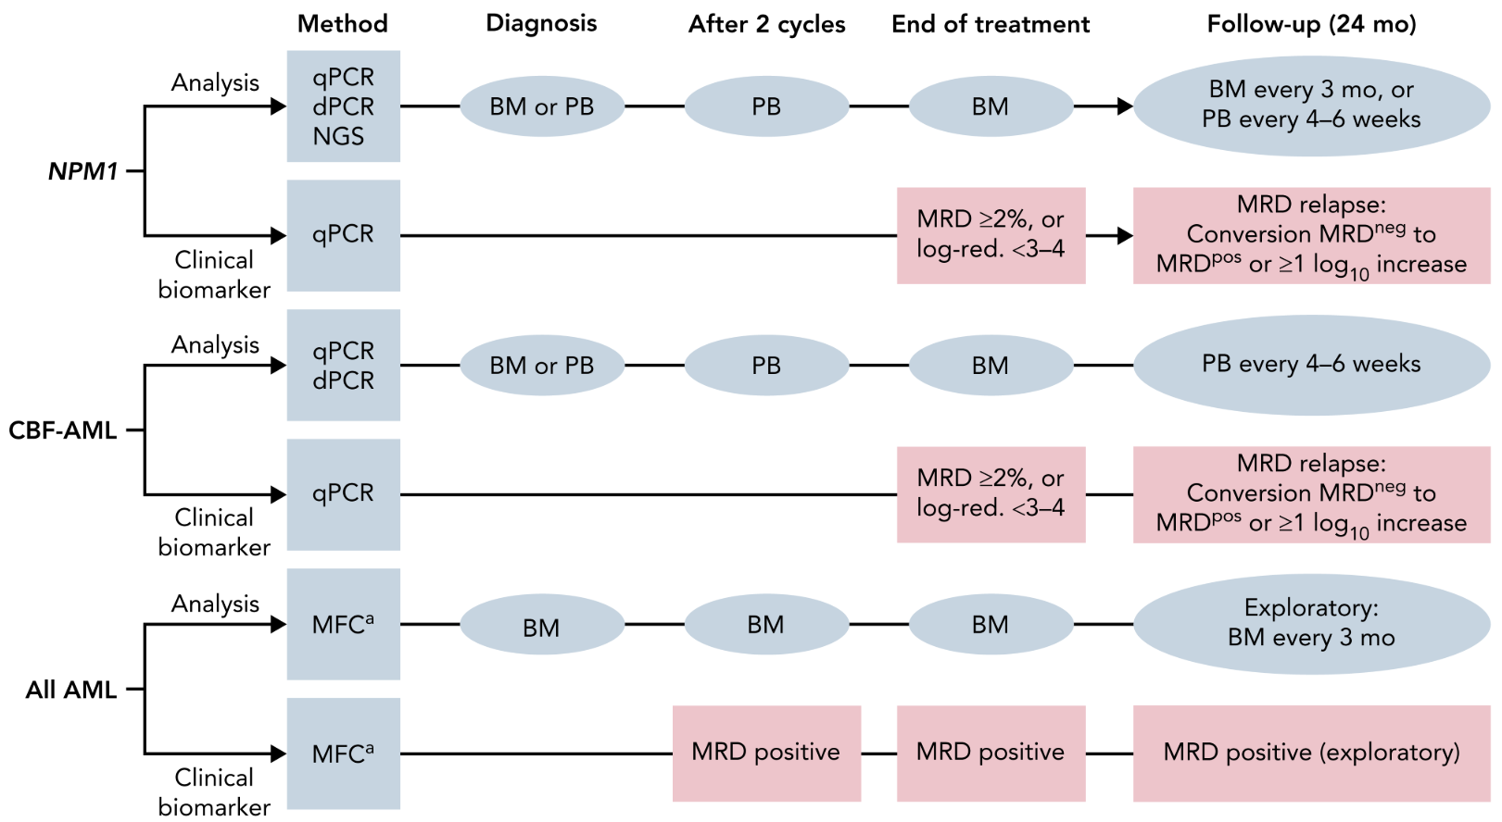
Figure 1 Recommended time points for MRD assessment and clinical decision making for NPM1-mutated, CBF-AML, and AML assessed by MFC
Source: Figure 2 of Döhner et al. 2022
Blue squares indicate timepoints of assessment and source of material; pink squares indicate timepoints for treatment modification based on a clinically relevant biomarker: for example, if the level of molecular MRD as assessed by qPCR is ≥2% or if there is failure to reduce mutant transcript levels by 3 to 4 log after completion of consolidation chemotherapy, treatment modifications (e.g., allogeneic hematopoietic stem cell transplantation) may be considered; similarly, if patients are still MRD positive by MFC after 2 cycles of intensive chemotherapy or at end of treatment. For patients receiving less intensive therapy, timepoints for assessment and clinical decision making are not yet established.
ªMFC as assessed by LAIP or the DfN method.
AML = acute myeloid leukaemia; BM = bone marrow; CBF = core-binding factor; PB = peripheral blood; q/dPCR = quantitative/digital polymerase chain reaction.
PASC queried the availability of a quality assurance program (QAP) for MRD tests. The applicant confirmed that QAPs are in place for many of the markers and that where no external QAP is currently available, laboratories are required to undertake inter‑laboratory sample swapping to ensure compliance with the NATA accreditation framework.
PASC inquired about the selection of bone marrow vs peripheral blood for MRD testing to estimate the frequency at which tests would be used. The applicant explained that bone marrow biopsy is more sensitive for molecular tests hence the recommendation to test peripheral blood at an increased frequency of every 6 weeks when a molecular test is used. The choice of which sample to use is based on clinician discretion. For NGS and MFC bone marrow is the preferred sample.
PASC noted the new classification of low level MRD in recent guidelines. The applicant clarified that this new classification is because some patients may have low level MRD for some time. In most cases, patients subsequently become clearly positive or clearly negative after repeated testing. This scenario is expected to occur in a minority of patients.
PASC considered that for the assessment further clarification and supporting evidence for the frequency of MRD testing during monitoring was required.

Comparator
The proposed comparator is morphological assessment with or without cytogenetic analysis performed on bone marrow samples. Conventional morphological assessment, often supplemented by cytogenetic testing, represents the historical and widely accepted standard for assessing treatment response in haematologic malignancies, including AML. PASC agreed morphological assessment (with or without cytogenetic testing) is the appropriate comparator for the proposed tests.
Molecular diagnostic tests funded under MBS items 73445 and 73447 are undertaken at diagnosis or relapse in both the intervention and comparator pathways as part of standard care. These tests are used for disease characterisation, prognostic risk stratification, and identification of actionable molecular targets. They are not part of the proposed intervention and are assumed to be equally available and utilised in both arms.
Morphological assessment (microscopic examination of bone marrow cells) has a detection limit of approximately 5% blasts, meaning disease can only be identified when there are roughly five myeloblasts per 100 nucleated cells (Song et al., 2025).
Cytogenetic analysis, including karyotyping and fluorescence in situ hybridisation (FISH), is performed on bone marrow aspirates and provides important prognostic and risk‑stratification information. However, cytogenetic analysis does not reliably quantify low‑level disease burden and has a sensitivity similar to, or lower than, that of morphological examination (Song et al., 2025).
MBS items relevant to morphological assessment and cytogenetic analysis are described in Table 2.

Table 2 MBS items for morphological assessment and cytogenetic analysis
MBS items relevant to comparator
MBS item 65087
Bone marrow - examination of aspirated material (including clot sections where necessary), including (if performed): any test described in item 65060, 65066 or 65070
Fee: $83.10 Benefit: 75% = $62.35 85% = $70.65
MBS item 73290
The study of the whole of each chromosome by cytogenetic or other techniques, performed on blood or bone marrow, in the diagnosis and monitoring of haematological malignancy (including a service in items 73287 or 73289, if performed). - 1 or more tests.
Fee: $394.55 Benefit: 75% = $295.95 85% = $335.40
MBS item 73314
Characterisation of gene rearrangement or the identification of mutations within a known gene rearrangement, in the diagnosis and monitoring of patients with laboratory evidence of:
(a) acute myeloid leukaemia; or
(b) acute promyelocytic leukaemia; or
(c) acute lymphoid leukaemia; or
(d) chronic myeloid leukaemia;
Fee: $230.95 Benefit: 75% = $173.25 85% = $196.35
MBS item 73315
A test described in item 73314, if rendered by a receiving APP - 1 or more tests
(Item is subject to rule 18)
Fee: $230.95 Benefit: 75% = $173.25 85% = $196.35
MBS item numbers used for services performed to obtain the bone marrow sample
MBS item 20440
INITIATION OF MANAGEMENT OF ANAESTHESIA for percutaneous bone marrow biopsy of the sternum (4 basic units)
Fee: $82.40 Benefit: 75% = $61.80 85% = $70.05
MBS item 21112
INITIATION OF MANAGEMENT OF ANAESTHESIA for percutaneous bone marrow biopsy of the anterior iliac crest (4 basic units)
Fee: $82.40 Benefit: 75% = $61.80 85% = $70.05
MBS item 21114
INITIATION OF MANAGEMENT OF ANAESTHESIA for percutaneous bone marrow biopsy of the posterior iliac crest (5 basic units)
Fee: $103.00 Benefit: 75% = $77.25 85% = $87.55
MBS item 30081
DIAGNOSTIC BIOPSY OF BONE MARROW by trephine using open approach, where the biopsy specimen is sent for pathological examination
(Anaes.)
Fee: $114.30 Benefit: 75% = $85.75 85% = $97.20
MBS item 30084
DIAGNOSTIC BIOPSY OF BONE MARROW by trephine using percutaneous approach where the biopsy is sent for pathological examination
(Anaes.)
Fee: $61.20 Benefit: 75% = $45.90 85% = $52.05
MBS item 30087
DIAGNOSTIC BIOPSY OF BONE MARROW by aspiration or PUNCH BIOPSY OF SYNOVIAL MEMBRANE, where the biopsy is sent for pathological examination
(Anaes.)
Fee: $30.60 Benefit: 75% = $22.95 85% = $26.05

Reference standard
The prognostic and predictive performance of MRD in AML should be evaluated using clinical outcomes such as overall survival and event‑free survival as the reference standards. Because the clinical significance of MRD in AML varies depending on the individual’s genomic profile status (at diagnostic testing), point in the treatment pathway, analyses of prognostic and predictive accuracy should be stratified by the timing of MRD assessment (e.g. post‑induction, post‑consolidation, or pre‑transplant).This stratification ensures that MRD performance is interpreted within the appropriate clinical and therapeutic context, reflecting its role in AML risk assessment and treatment planning.
PASC agreed with the proposed reference standard.

Outcomes

Test performance (for each target tissue and test modality)

Analytical performance (e.g., detectability, stability over time, variation, signal‑to‑noise ratio)

Diagnostic accuracy (sensitivity, specificity for detecting MRD positivity)

Timing-dependent accuracy (how accuracy varies by sampling timepoint)

Prognostic accuracy (association between MRD positivity/negativity and health outcomes) at each MRD testing timepoint (induction, after therapy completion, during surveillance)

Predictive accuracy (ability of MRD to predict benefit from specific treatments such as allo‑HSCT, targeted therapy, immunotherapy) at each MRD testing timepoint (induction, after therapy completion, during surveillance)

Management outcomes
- MRD‑directed changes in treatment or management
- Number/proportion of patients whose management is altered based on MRD results
- Rate or re-aspiration/re-biopsy

Change in the proportion of patients undergoing allogeneic haematopoietic stem cell transplantation (allo-HSCT) Health outcomes
- Event‑free survival
- Overall survival
- Relapse‑free survival
- Cumulative incidence of relapse
- Quality of life
- Adverse events arising from testing or MRD‑guided management changes

Economic outcomes
- Cost‑effectiveness
- Cost impact on the MBS and broader healthcare system
PASC noted that the proposed outcomes were generally reasonable but suggested that test performance measures should clearly state that all outcomes are to be assessed according to both target tissue and test modality.
PASC also recommended that prognostic and predictive accuracy be evaluated separately at each of the 3 MRD testing timepoints:
- At induction
- After completion of therapy (consolidation ± transplant)
- During surveillance in the first 2 years of maintenance therapy and follow‑up
PASC highlighted that the surveillance timepoint currently has the least supporting evidence and suggested that assessment at each timepoint should include consideration of the number needed to test to meaningfully alter treatment decisions.
In addition, PASC proposed the inclusion of a new outcome:
- Change in the proportion of patients undergoing allogeneic haematopoietic stem cell transplantation (allo‑HSCT) (under Management outcomes)
The applicant stated that the greatest clinical impact of MRD testing is expected in the intermediate-risk patient group, where MRD-negative findings may allow deferral of allo-HSCT in approximately 20–30% of patients.

Assessment framework
The evidence base for MRD in AML is substantial but unevenly distributed across risk groups, clinical settings, and testing modalities. The largest volume of evidence relates to the post-consolidation and first complete remission setting, where multiple studies consistently demonstrate MRD status as a prognostic marker across AML populations. Evidence is also relatively extensive in molecularly defined favourable-risk AML, particularly for PCR-based MRD assessment in subtypes such as NPM1-mutated CBF AML (Nachmias et al., 2025).
In contrast, the evidence base is more limited in intermediate-risk AML and adverse-risk AML, where fewer studies specifically evaluate MRD-guided stratification or management. Across clinical contexts, there is moderate evidence in the post-induction and pre- and post-transplant settings, while evidence in maintenance therapy and MRD relapse settings remains comparatively limited or emerging. By testing modality, flow cytometry-based MRD is supported by a broad evidence base across AML populations and clinical contexts, whereas molecular MRD is supported by a large but subtype-restricted body of evidence. NGS-based MRD is currently supported by a smaller and evolving evidence base (Nachmias et al., 2025). Overall, while MRD has been widely studied in AML, the distribution of evidence is concentrated in specific subgroups and timepoints, with notable gaps in others.
The application PICO set identifies one randomised controlled trial (RCT) that provides direct evidence linking MRD testing to health outcomes in patients with AML (Potter et al., 2025). The study was performed within two large phase 3 trials (AML17 and AML19) which enrolled adults (generally aged 16-60 years) with newly diagnosed AML, a World Health Organisation (WHO) performance status of 0-2, and suitability for intensive chemotherapy. The trial evaluated whether using sequential molecular MRD monitoring using qPCR to guide treatment decisions improves outcomes in this population. MRD‑guided management did not improve overall survival compared with no MRD monitoring, though a pre‑specified subgroup with concurrent NPM1 and FLT3‑ITDs alterations showed a survival benefit.
Scoping searches performed during PICO confirmation did not identify any additional direct evidence evaluating the impact of MRD testing on health outcomes in AML. Given the limited availability of direct test-to-health outcomes evidence, a linked evidence approach will also be required to ensure all eligible populations, clinical settings, MRD technologies and outcomes are comprehensively assessed.
In the PICO set, there are a number of studies listed evaluating the test accuracy, prognostic and predictive value, as well as MRD-guided treatment decisions. However, these studies are predominantly observational, with many employing retrospective designs and the evidence base is broader in populations receiving intensive induction therapy. No cost-effectiveness studies of MRD testing in AML were identified but there are some cost-analysis studies (Tettero et al., 2022).
The assessment framework proposed is shown in Figure 2, and is based on the evidence base identified in the application PICO set and scoping search. Evidence should be assessed separately for flow cytometry-based MRD and molecular-based MRD modalities, reflecting differences in analytical sensitivity, clinical validation, and patterns of use, consistent with prior MSAC considerations (MSAC 1703 and 1707).
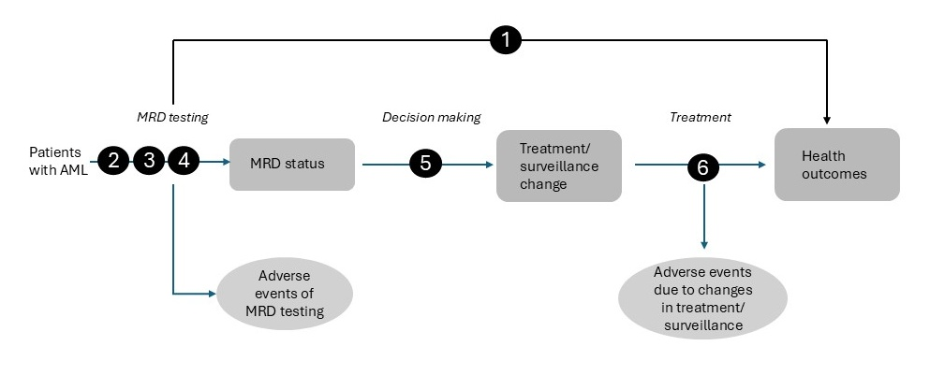
Figure 2 Assessment framework for assessment 1813 showing direct from test to health outcomes evidence and linked evidence from test to health outcomes for assessment
Figure notes: 1: direct from test to health outcomes evidence; 2: analytical and diagnostic accuracy; 3: prognostic accuracy; 4: predictive accuracy; 5: change in treatment/management; 6: influence of the change in management on health outcomes;
The assessment will need to present the clinical evidence according to the specific time points at which MRD testing is conducted, such as highlighting the benefits of testing after induction therapy, separately from testing after consolidation therapy, and before initiating other treatments. Stratification of evidence by ELN risk category, type of AML and intensity of induction treatment may also be necessary.
The questions to be addressed in the assessment report are:
1. What is the safety, effectiveness, and cost-effectiveness of MRD testing (MFC or molecular methods) in addition to assessment of morphological remission, compared with assessment of morphological remission alone, in patients with AML?
2. What is the analytical and diagnostic accuracy of MRD testing (MFC or molecular methods) in addition to assessment of morphological remission, compared with assessment of morphological remission alone, in patients with AML?
3. What is the incremental prognostic value of MRD testing (MFC or molecular methods), beyond assessment of morphological remission, compared to assessment of morphological remission alone, for predicting health outcomes in AML?
4. What is the incremental predictive value of MRD testing (MFC or molecular methods) in addition to assessment of morphological remission for identifying patients with AML who are more likely to benefit from specific treatment, compared with assessment of morphological remission alone?
5. To what extent does MRD testing (MFC or molecular methods) lead to changes in treatment or management compared with assessment of morphological remission alone?
6. How safe and clinically effective are the MRD guided management changes identified in question 5?
Together, these questions distinguish between the clinical value of MRD testing (MFC or molecular methods) as a diagnostic and prognostic tool and the downstream impact of MRD-guided treatment decisions on patient outcomes. The extent to which each question can be addressed will vary by MRD modality, AML subtype, and clinical timepoint, reflecting the distribution of the available evidence.
PASC agreed that a linked evidence approach for the full assessment would be required given the lack of direct health outcomes data. The assessment needs to address whether MRD testing leads to changes in clinical decision making and whether those changes result in improved health outcomes, risks and costs. PASC considered that future RCTs were unlikely given that MRD testing is established as part of standard care.

Clinical management algorithms
The clinical management algorithm without the addition of MRD testing is shown in Figure 3, as provided in the Application 1813 PICO set. Without MRD testing, surveillance relies on full blood examination (FBE) and periodic bone marrow biopsy to detect morphological relapse, which becomes apparent once bone marrow blasts exceed approximately 5%.
Following a confirmed diagnosis of AML, patients are evaluated for suitability for active treatment. Newly diagnosed patients that are suitable will receive intensive chemotherapy as a first-line treatment option, followed by consolidation therapy and consideration of either maintenance therapy or allo-HSCT according to ELN risk and patient fitness (NCCN, 2026). Targeted therapies may also be administered for those that are eligible to receive them. Patients not fit for intensive chemotherapy are recommended lower-intensity treatments (azacitidine + venetoclax), or best supportive care (Blood Cancer Taskforce, 2025).
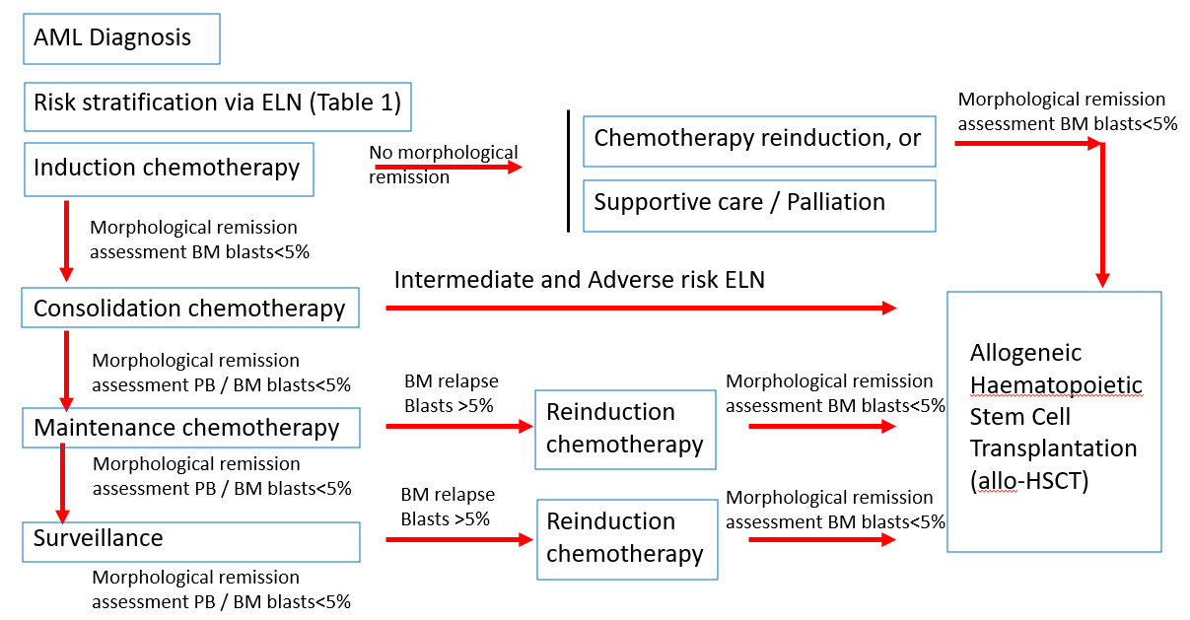
Figure 3 AML clinical management algorithm without the proposed health technology
Source: Application 1813 PICO set
AML = acute myeloid leukaemia; BM = bone marrow; ELN = European LeukemiaNet; PB = peripheral blood.
The clinical management algorithm with the addition of MRD testing is shown in Figure 4. Following diagnosis and induction therapy, patients who achieve complete remission are monitored for relapse risk using MRD. Identification of MRD markers for each patient is achieved at diagnosis. Different MRD makers and technologies may be applied at each timepoint. MRD-negative patients continue standard consolidation and routine blood or marrow surveillance, while MRD-positive patients, who face higher relapse risk, may be considered for allo-HSCT or targeted/clinical trial therapies. MRD testing is most established after intensive induction and consolidation but is also recommended for patients receiving low-intensity therapy (Bazinet et al., 2023; NCCN, 2026).
The applicant noted in the application PICO set that MRD testing is particularly important for patients in the ELN intermediate-risk group. Current international and Australian clinical practice guidelines recommend that fit patients with intermediate- or adverse-risk AML should receive allo-HSCT in first complete remission (Blood Cancer Taskforce, 2025). However, the intermediate-risk group is recognised as highly heterogeneous in terms of clinical outcomes. MRD testing enables more refined risk stratification within this cohort: for example, patients who are MRD-positive may be directed to allo-HSCT, while MRD-negative patients may avoid allo-HSCT.
PBS restrictions for second-line and genetically targeted therapies (including venetoclax, sorafenib, midostaurin, gilteritinib, and gemtuzumab ozogamicin) were reviewed with respect to disease eligibility criteria and biomarker requirements. Across these therapies, access to PBS-funded treatment is determined by clinically defined disease states (e.g., relapsed or refractory acute myeloid leukaemia, or newly diagnosed disease in specific subgroups) in combination with specific biomarker requirements (e.g., FLT3 variation or CD33 expression). PBS eligibility criteria do not incorporate MRD status.
While MRD testing may identify early disease persistence or predict relapse, MRD positivity alone does not meet the clinical definitions of relapsed or refractory disease required for PBS eligibility. Patients who are MRD-positive but remain in morphological remission would therefore not be eligible for PBS-subsidised treatment under current restrictions.
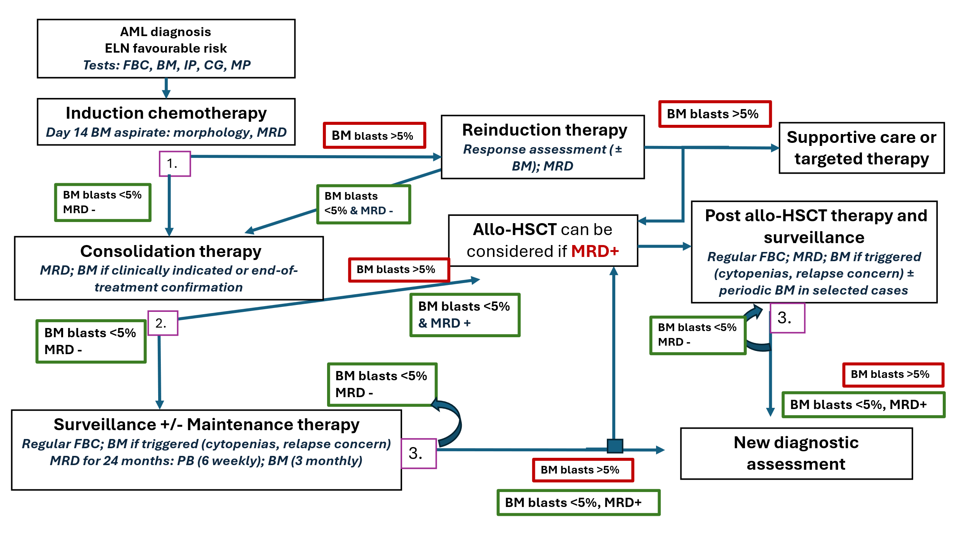
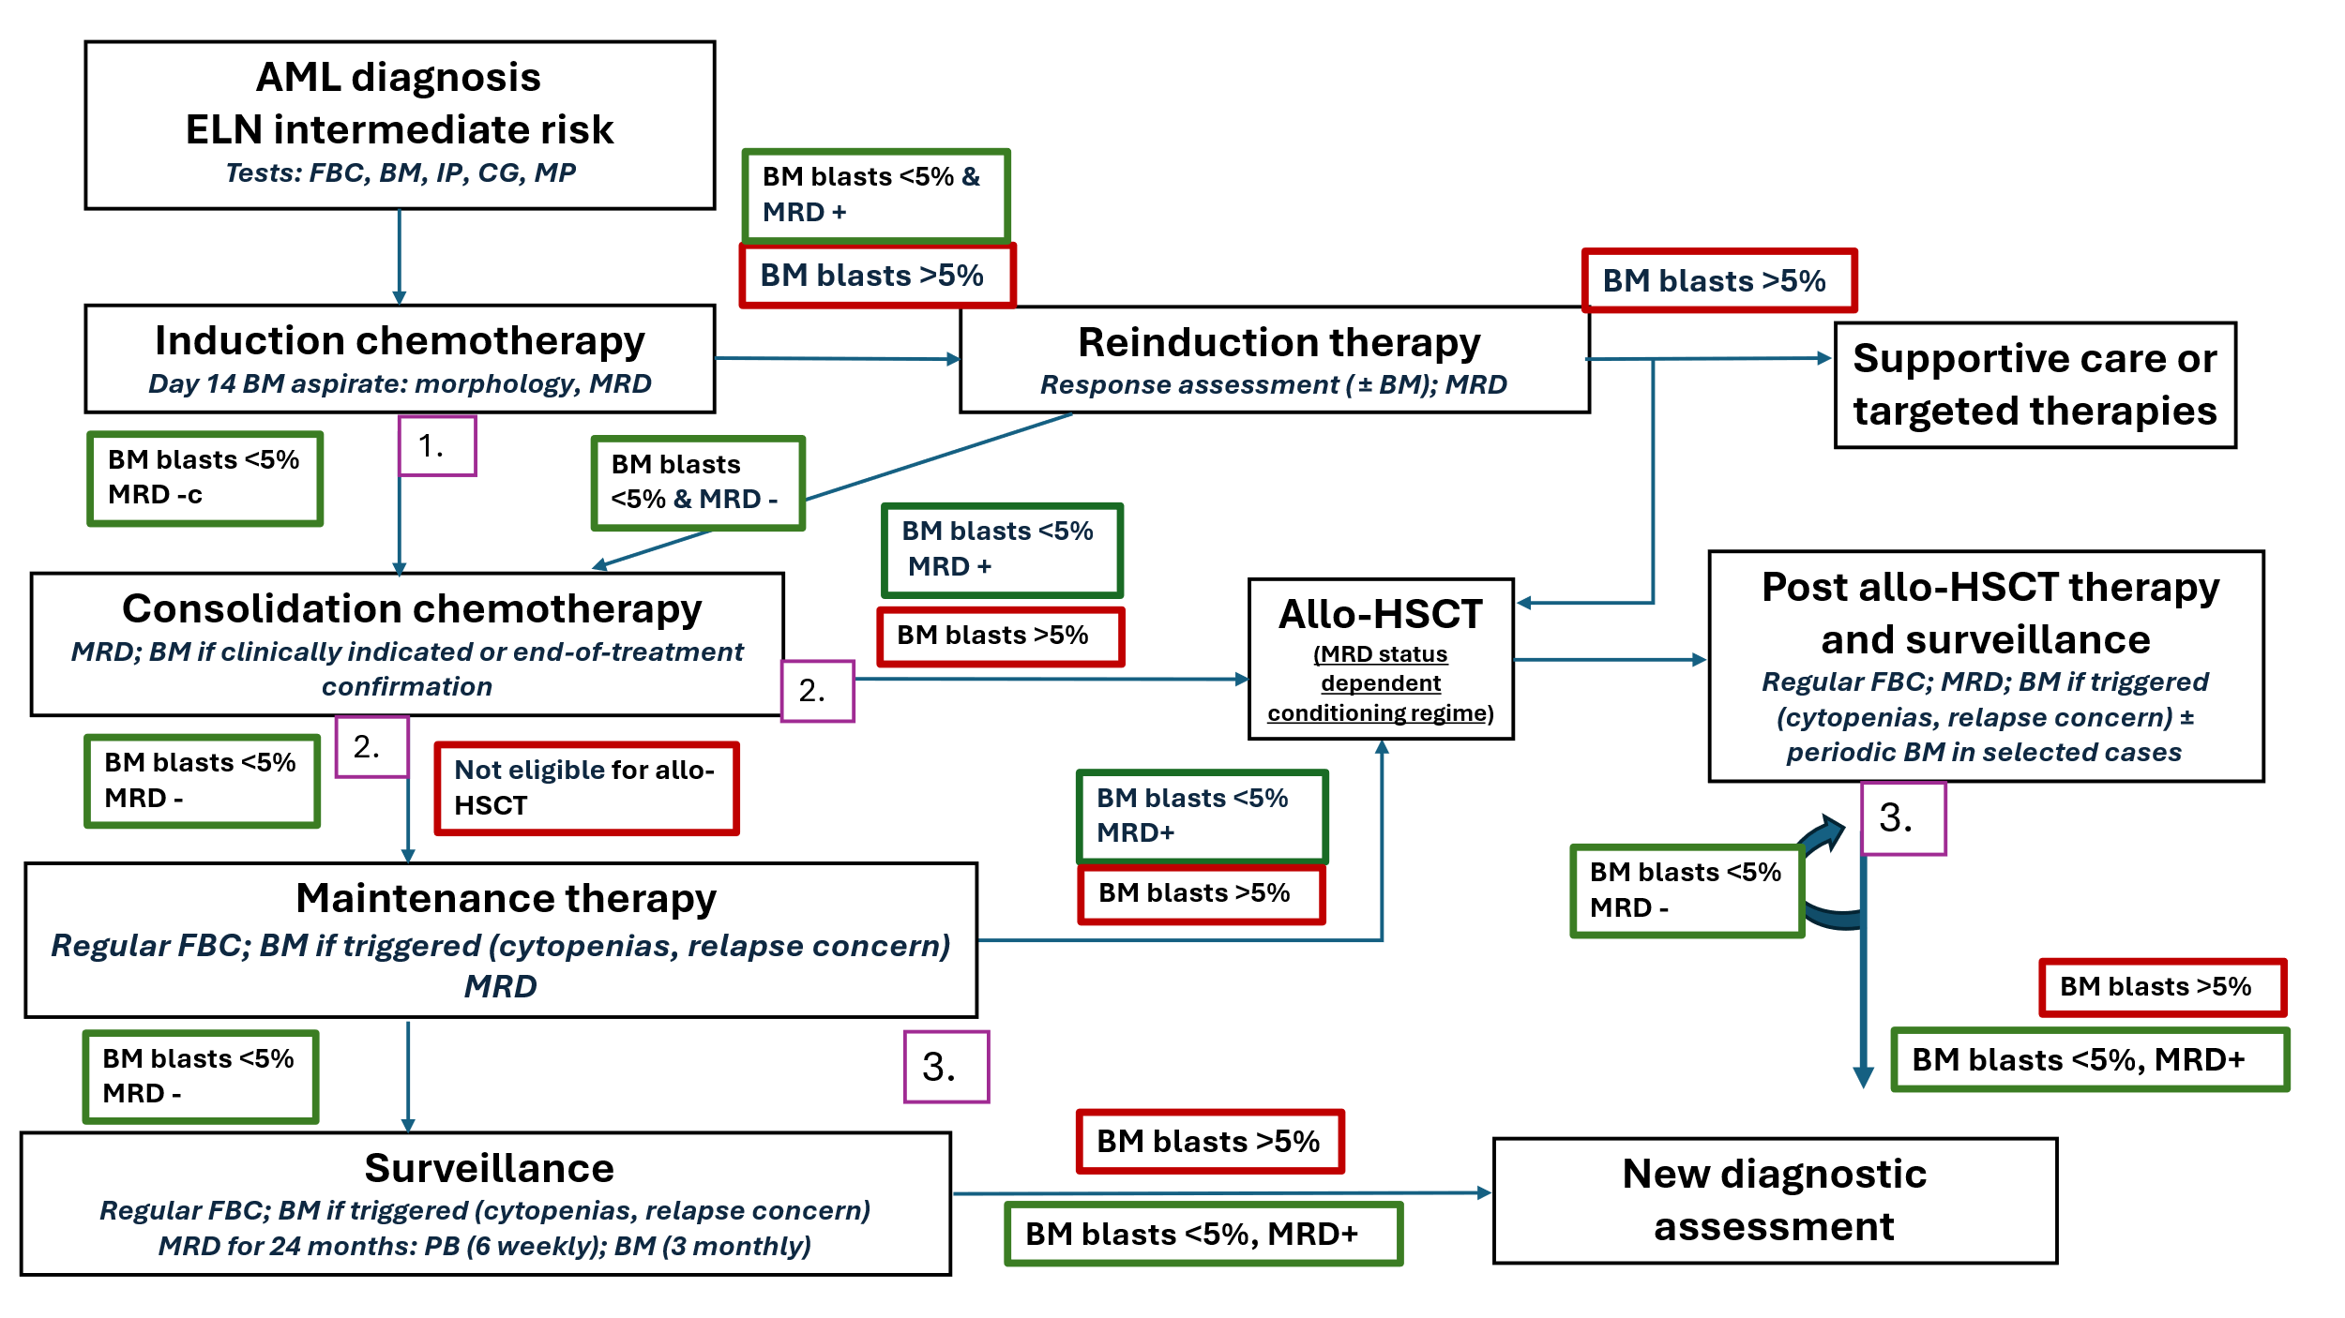
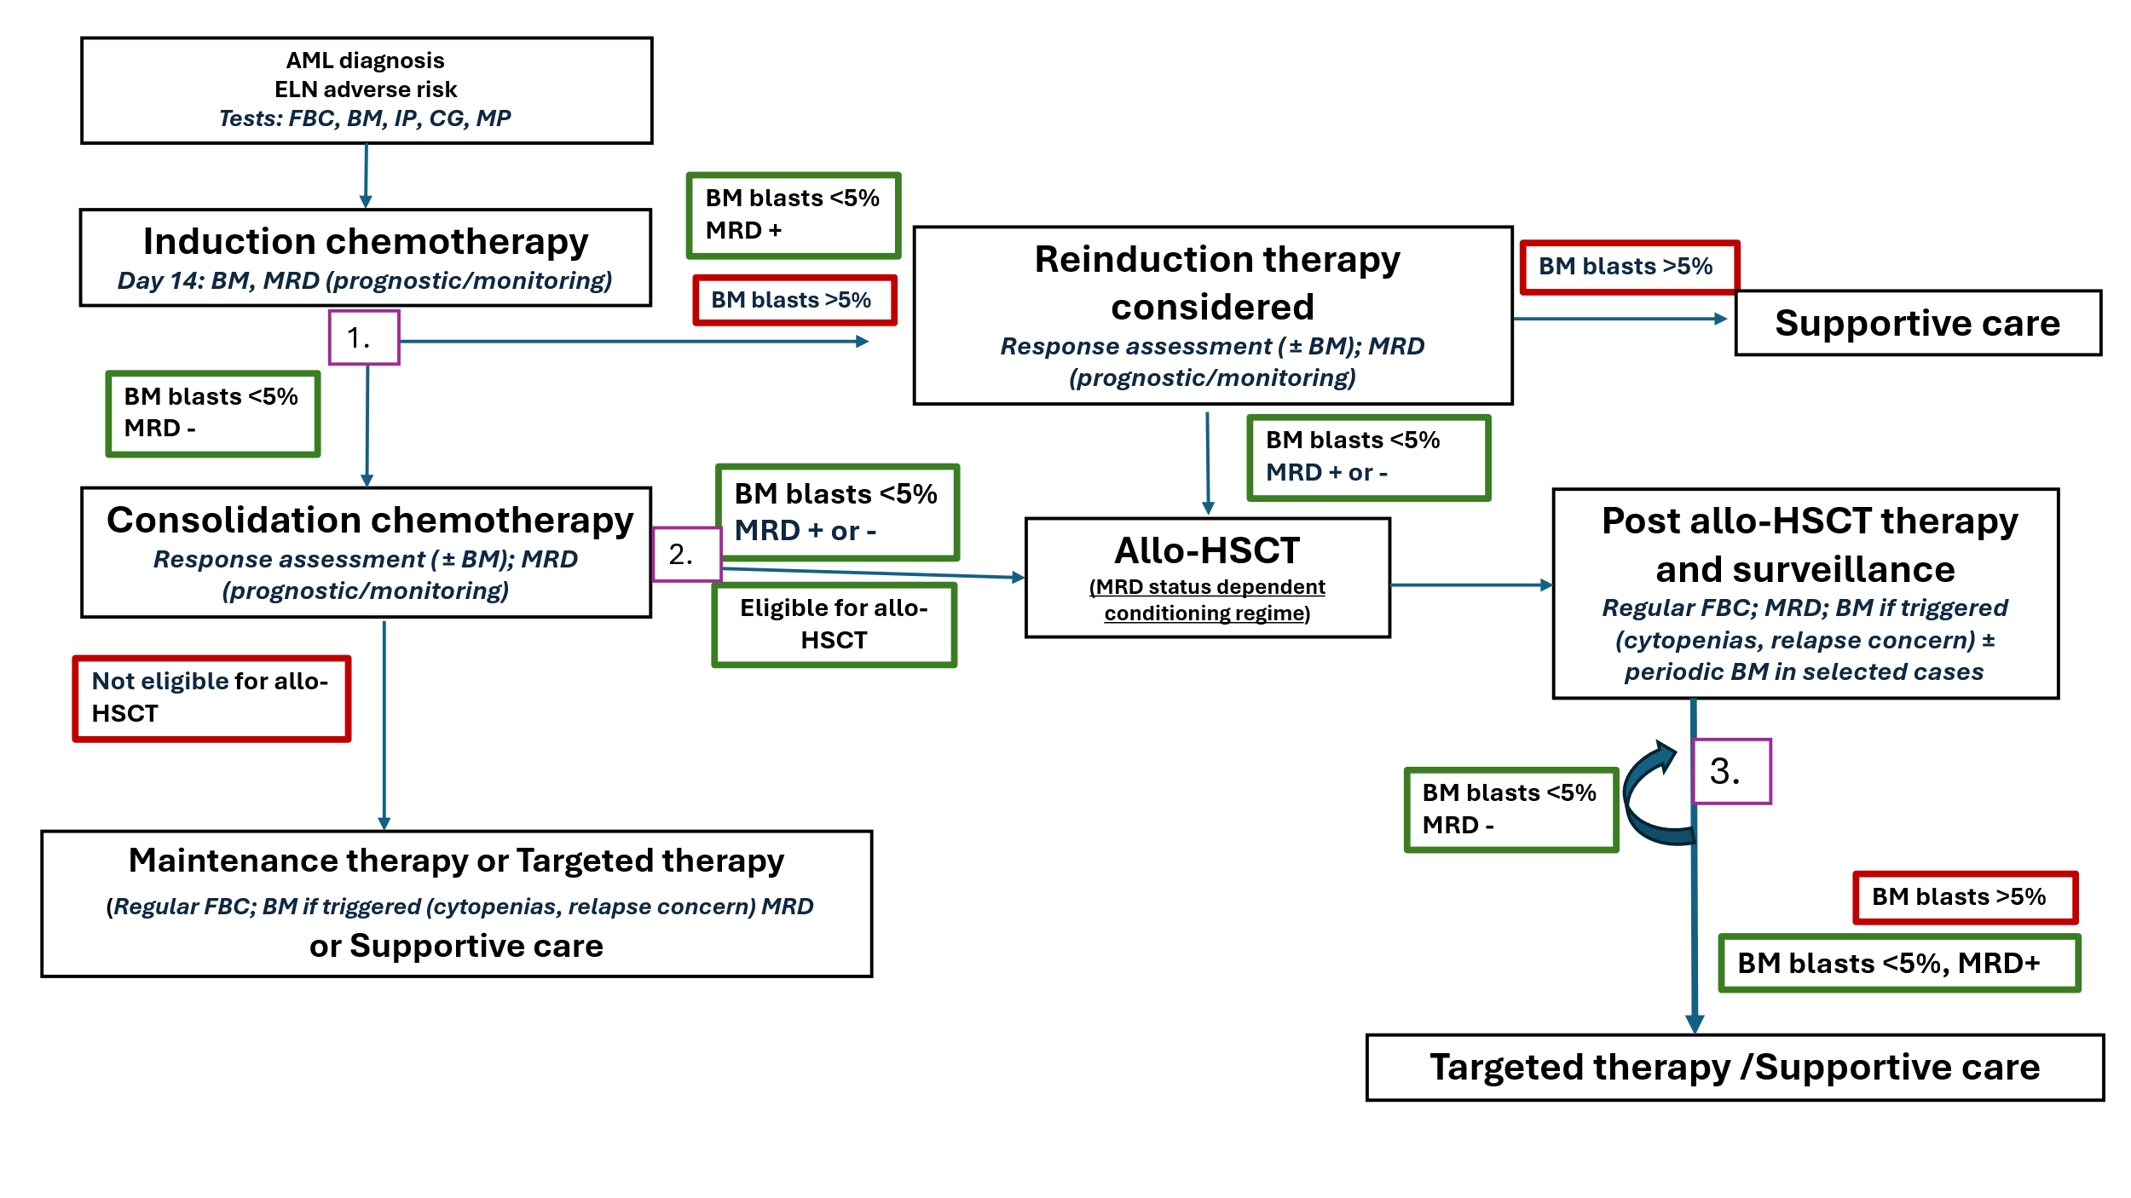
Figure 4 AML clinical management algorithm with the proposed health technology for 3 ELN risk groups
AML = acute myeloid leukaemia; BM = bone marrow; CG, cytogenetics; ELN = European LeukemiaNet; FBC, full blood count; IP, immunophenotyping; PB = peripheral blood; MP, molecular profiling MRD, measurable residual disease. Numbered boxes represent timing of MRD testing during management as described by the ELN-David AML MRD working party.
PASC noted that the clinical management algorithms do not capture the full range of treatment options and outcomes for a highly complex and heterogenous disease such as AML. The existing clinical practice algorithm contains several gaps requiring further clarification, particularly in relation to the management of patients who are unfit for allo‑HSCT, post‑allo‑HSCT clinical management, and treatment pathways for patients who do not achieve remission following re‑induction chemotherapy. In addition, the duration of both the maintenance and surveillance phases is not clearly defined in the current algorithm.
PASC considered the clinical pathway following reinduction therapy remains uncertain when using MRD testing for patients in the favourable and intermediate ELN risk groups. It was unclear whether all patients in the intermediate ELN risk group, irrespective of their MRD status, would be considered for allo-HSCT following re‑induction chemotherapy or only patients in morphological remission but positive via proposed MRD testing methods. PASC suggested that further clarification of the pathways and frequency of testing may be required for the assessment.

Proposed economic evaluation
Relative to disease surveillance with morphological examination with or without cytogenetic testing, MRD testing is claimed to offer superior effectiveness and non-inferior safety, primarily by enabling timely, risk-adapted interventions that improve relapse-free survival, with growing evidence of overall survival benefit in defined subgroups.
Supportive evidence for this claim, as presented in the application PICO set, includes one randomised controlled trial and more than twenty cohort and case‑series studies evaluating the prognostic value, predictive value, and treatment‑management impact of MRD testing.
Given the clinical claim of superior effectiveness and non-inferior safety, the appropriate economic evaluation is a cost‑effectiveness or cost‑utility analysis (Table 3).
Table 3 Classification of comparative effectiveness and safety of the proposed intervention, compared with its main comparator, and guide to the suitable type of economic evaluation
Comparative safety |  | Comparative effectiveness
Comparative safety | Inferior | Uncertainª | Noninferior^{b} | Superior
Inferior | Health forgone: need other supportive factors | Health forgone possible: need other supportive factors | Health forgone: need other supportive factors | ? Likely CUA
Uncertainª | Health forgone possible: need other supportive factors | ? | ? | ? Likely CEA/CUA
Noninferior^{b} | Health forgone: need other supportive factors | ? | CMA | CEA/CUA
Superior | ? Likely CUA | ? Likely CEA/CUA | CEA/CUA | CEA/CUA
CEA=cost-effectiveness analysis; CMA=cost-minimisation analysis; CUA=cost-utility analysis
? = reflect uncertainties and any identified health trade-offs in the economic evaluation, as a minimum in a cost-consequences analysis
ª ‘Uncertainty’ covers concepts such as inadequate minimisation of important sources of bias, lack of statistical significance in an underpowered trial, detecting clinically unimportant therapeutic differences, inconsistent results across trials, and trade-offs within the comparative effectiveness and/or the comparative safety considerations
^{b} An adequate assessment of ‘noninferiority’ is the preferred basis for demonstrating equivalence
PASC noted the applicant’s claim of superior effectiveness with non-inferior safety and agreed that a cost-effectiveness analysis (CEA) or cost-utility analysis (CUA) would be the appropriate economic modelling approach.
PASC noted the potential complexity of the proposed economic model, given that more than 200 MRD targets have been identified in AML. PASC suggested that one way to address this complexity would be to model a representative subtype within each ELN risk subgroup.
PASC further noted that such an approach would require assumptions that MRD testing functions as an adjunct to standard morphological assessment and that MRD test results are treated as binary (MRD positive versus MRD negative). This latter assumption would differ from current ELN guidance, which recognises gradations of MRD levels.

Proposal for public funding
Three new MBS items are proposed, one for each method of MRD testing: for NGS, molecular methods (PCR) and flow cytometry. Proposed item descriptions are provided in Table 4 and the cost breakdown for each technology as provided in the Application is shown in Table 5.
There are no associated applications in progress relating to MRD testing. MSAC has previously considered and supported funding of MRD testing in ALL (applications 1703 and 1707).
Table 4 MBS items proposed in application 1813 PICO set (PASC supported)
Category 6 – Pathology services Group P7 Genetics
MBS item AAAA
Measurable residual disease (MRD) testing by next-generation sequencing, performed on bone marrow (or a peripheral blood sample if bone marrow cannot be collected) from a patient diagnosed with acute myeloid leukaemia receiving treatment with curative intent, requested by a specialist or consultant physician practising as a haematologist or oncologist.
*Greatest Permissible Gap (GPG) applies
A limit of 25 tests per patient, per episode of disease or per clinical relapse applies.
Fee: $950.00 Benefit: 75% = $712.50 85% = $845.50
Category 6 – Pathology services Group P7 Genetics
MBS item BBBB
Measurable residual disease (MRD) testing by a quantitative molecular assay performed on bone marrow or peripheral blood collected from a patient diagnosed with acute myeloid leukaemia receiving treatment with curative intent, requested by a specialist or consultant physician practising as a haematologist or oncologist.
A limit of 25 tests per patient, per episode of disease or per clinical relapse applies.
Fee: $430.00 Benefit: 75%=$322.50 85%=$365.50
Category 6 – Pathology services Group P4 Immunology
MBS item CCCC
Measurable residual disease (MRD) testing by flow cytometry using an assay containing a minimum of 20 antibodies, performed on bone marrow from a patient diagnosed with acute myeloid leukaemia receiving treatment with curative intent, requested by a specialist or consultant physician practising as a haematologist or oncologist.
A limit of 25 tests per patient, per episode of disease or per clinical relapse applies.
Fee: $857.00 Benefit: 75%=$642.75 85%=$752.50*
* Reflects the 1 November 2025 Greatest Permissible Gap (GPG) of $104.50. All out-of-hospital Medicare services which have an MBS fee of $697.00 or more will attract a benefit that is greater than 85% of the MBS fee – being the schedule fee less the GPG amount. The GPG amount is indexed annually on 1 November in line with the Consumer Price Index (CPI) (June quarter).
Table 5 Breakdown of the costs for MRD assessment methods
Cost component | NGS | q/dPCR | MFC
Pre-analytical, post-analytical, and other factors | $50.00 | $50.00 | $50.00
Cell processing and data capture / sample processing | $100.00 | $100.00 | —
Reagents / consumables | $250.00 | $100.00 | $28.00
Scientific labour cost | $250.00 | $150.00 | $218.00
Analytical cost / analysis & reporting | $250.00 | — | $379.00
Antibody panel | NA | NA | $150.00
Bulk lyse MRD labour | — | — | $218.00
QC/QA/maintenance | $50.00 | $30.00 | $32.00
Indirect costs | — | — | —
Total | $950.00 | $430.00 | $857.00
Source: Application 1813 PICO set
q/dPCR = quantitative/digital polymerase chain reaction; MFC = multi-parametric flow cytometry; NGS = next generation sequencing; QA = quality assurance; QC = quality control
During the pre-PASC meeting, the applicant clarified that the fees proposed in the application for MRD testing in AML differ from the current MBS item fees for MRD testing in acute lymphoblastic leukaemia (ALL) due to fundamental differences in the tests and target requirements of the 2 diseases. For the proposed MFC item, the main reason for the higher fee in AML is the highly heterogeneous nature of AML which leads to more complex, labour-intensive and less standardised MFC testing. Testing involves a number of steps within the pathology department listed in the breakdown, including specimen accessioning and assay set up, processing, initial analysis by scientists followed by expert Pathologists, validation and report generation. AML MRD assays typically involve 2-4 tubes with multiple antibodies (typically 24+ antibodies, compared to 12-16 antibodies for B-ALL). Regarding the lower cost for AML NGS MRD as compared to ALL NGS MRD (MBS items 73316 and 73310), this is related to the single genomic target of currently available AML MRD tests and the lack of requirement for proprietary consumables and bioinformatic pipelines.
Table 6 lists the relevant MBS items for MRD testing in ALL.
Table 6 MBS items for MRD testing in patients with ALL
Category 6 – Pathology services Group P7 Genetics
MBS item 73310
Measurable residual disease (MRD) testing by next-generation sequencing, performed on bone marrow (or a peripheral blood sample if bone marrow cannot be collected) from a patient diagnosed with acute lymphoblastic leukaemia, for the purpose of determining baseline MRD, or facilitating the determination of MRD following combination chemotherapy or after salvage therapy, requested by a specialist or consultant physician practising as a haematologist or oncologist
PN.0.35 applies: The number of measurable residual disease (MRD) tests per patient, per episode of disease or per relapse is not expected to exceed 12, inclusive of a baseline assessment.
Fee: $$1,550.00 Benefit: 75% = $1,162.50 85% = $1,445.50*
Category 6 – Pathology services Group P7 Genetics
MBS item 73313
Development of a quantitative patient-specific molecular assay for measurable residual disease (MRD) testing performed on bone marrow (or a peripheral blood sample if bone marrow cannot be collected) from a patient diagnosed with acute lymphoblastic leukaemia treated with combination chemotherapy or after salvage therapy, including the first service described in item 73316 performed on that bone marrow or peripheral blood sample, requested by a specialist or consultant physician practising as a haematologist or oncologist
Applicable once per patient per episode of disease or per relapse
Fee: $3,000.00 Benefit: 75% = $2,250.00 85% = $2,895.50*
Category 6 – Pathology services Group P7 Genetics
MBS item 73316
Measurable residual disease (MRD) testing by a quantitative patient-specific molecular assay performed on bone marrow (or, in a patient with T-cell acute lymphoblastic leukaemia, performed on a peripheral blood sample if bone marrow cannot be collected) from a patient diagnosed with acute lymphoblastic leukaemia treated with combination chemotherapy or after salvage therapy, requested by a specialist or consultant physician practising as a haematologist or oncologist, other than a service associated with a service to which item 73313 applies.
PN.7.20 Applies: The number of measurable residual disease (MRD) tests per patient, per episode of disease or per relapse is not expected to exceed 12, inclusive of a baseline assessment.
Fee: $780.00 Benefit: 75%=$585.00 85%=$675.50*
Category 6 – Pathology services Group P4 Immunology
MBS item 71202
Measurable residual disease (MRD) testing by flow cytometry, performed on bone marrow from a patient diagnosed with acute lymphoblastic leukaemia, for the purpose of determining baseline MRD, or facilitating the determination of MRD following combination chemotherapy or after salvage therapy, requested by a specialist or consultant physician practising as a haematologist or oncologist.
PN.0.35 applies: The number of measurable residual disease (MRD) tests per patient, per episode of disease or per relapse is not expected to exceed 12, inclusive of a baseline assessment.
Fee: $$563.20.00 Benefit: 75%=$422.40 85%=$478.75
* Reflects the 1 November 2025 Greatest Permissible Gap (GPG) of $104.50. All out-of-hospital Medicare services which have an MBS fee of $697.00 or more will attract a benefit that is greater than 85% of the MBS fee – being the schedule fee less the GPG amount. The GPG amount is indexed annually on 1 November in line with the Consumer Price Index (CPI) (June quarter).

PASC agreed with the inclusion of wording in the item descriptors to restrict ordering of the tests to a practising haematologist or oncologist. PASC noted advice from the applicant that identifying well defined markers to follow may require testing with multiple modalities in some instances and therefore the 3 proposed MBS items should not be mutually exclusive.
PASC considered the proposed fees required further consideration and advice from the department to ensure they were appropriate.
PASC acknowledged the applicant’s request to place no limits on the number of claims for each item. However, consultation feedback supported the inclusion of explicit limits on test frequency per patient per disease episode. PASC estimated that an upper limit of approximately 20–25 claims per 2 year period may be appropriate, to accommodate 6 weekly peripheral blood testing or 12weekly bone marrow testing during the 2year surveillance period.
PASC queried the current access to MRD testing via public and private sectors. The applicant clarified that the majority of patients with AML are tested within the public sector; however, access to funding for MRD testing is currently not equitable across jurisdictions and institutions. PASC considered that utilisation of MRD testing items in the private setting may be higher for AML than observed for ALL due to the larger proportion of adult patients.

Summary of public consultation input
PASC noted and welcomed consultation input from 4 organisations and 1 individual health professional. The 4 organisations that submitted input were:
- Australasian Leukaemia & Lymphoma Group (ALLG)
- Australian and New Zealand Children’s Haematology/Oncology Group (ANZCHOG)
- Haematology Society of Australia and New Zealand (HSANZ)
- Public Pathology Australia

Consultation input was supportive of public funding for detection of MRD in patients with AML.
Benefits and Disadvantages
The main benefits of public funding reported in the consultation input included improved risk stratification and more informed clinical decision-making for patients with AML in remission, aligning with contemporary national and international clinical guidelines. Input consistently highlighted that MRD testing supports earlier identification of relapse risk, and enables more personalised treatment planning, including decisions regarding allogeneic stem cell transplantation. ALLG and HSANZ stated that public funding would promote greater consistency of care and formalise access to testing that is already occurring in Australia.
There were no disadvantages of public funding reported in the consultation input.
Population, Comparator (current management) and Delivery
The consultation input agreed with the proposed population, with stakeholders supporting the use of MRD testing in patients with AML who have achieved morphological remission following therapy. HSANZ stated that the population definition is consistent with guidelines, current Australian practice, and achieves an appropriate balance between clinical utility and responsible use of healthcare resources.
The consultation input agreed with the proposed comparator of morphological assessment with or without cytogenetics. ALLG stated that morphological relapse is typically detected weeks to months after sub-morphological / MRD relapse has been established, and that it is a crude endpoint with high variability between observers. HSANZ stated that morphological and cytogenetic evaluation remain the default comparator in many centres because access to MRD testing varies substantially by jurisdiction and institution, and that MRD testing is often used alongside morphological evaluation (rather than as a complete replacement).
MBS Item Descriptor and Fee
The consultation input agreed with the proposed service descriptors, with stakeholders noting that the descriptors appropriately reflected current clinical practice and the intended use of MRD testing in patients with AML. HSANZ supported the use of method-specific descriptors and the inclusion of clear limits on test frequency per disease episode to mitigate the risk of overuse. ALLG considered the restriction of eligible specimen types appropriate.
The consultation input agreed with the proposed service fees, with Public Pathology Australia stating that the proposed fees align with the current testing costs. ALLG noted that the proposed $0 gap was appropriate given that AML patients are often acutely unwell, financially vulnerable, and already managing significant costs associated with their cancer treatment.
Additional Comments
ANZCHOG encouraged MSAC to consider the practical funding and reimbursement implications for children and adolescents, who are usually admitted for bone marrow biopsies to allow the procedure to be conducted under general anaesthesia. ANZCHOG stated it is important that funding settings do not inadvertently disadvantage children and adolescents or restrict equitable access to MRD testing.
PASC noted the positive consultation feedback from Australasian Leukaemia & Lymphoma Group (ALLG), Australian and New Zealand Children’s Haematology/Oncology Group (ANZCHOG), Haematology Society of Australia and New Zealand (HSANZ), Public Pathology Australia and individual specialists.

Next steps
PASC recommended the application be referred to the MSAC Executive for advice on the appropriate pathway for assessment. PASC noted MRD testing was already an established standard of care that has been in place for approximately 10 years and comprehensive assessment would be expected to have a limited impact on clinical practice. In addition, the available evidence base was limited and heterogeneous, particularly across different tests and patient subgroups, increasing the risk that a full HTA would be highly complex, and potentially inconclusive.
Instead, PASC considered a truncated assessment may be an appropriate alternative, focusing on optimising test utilisation by estimating appropriate testing frequency across risk groups and identifying areas of low-value care. For example, this may include consideration of the remission group and the introduction of limits on the number of tests or restrictions on testing beyond a defined time period (e.g. after 2 years).
PASC considered the following needed additional clarification: refinement of clinical indications to better align MBS item eligibility with intended use, additional consideration of appropriate MBS item fees, confirmation of frequency of testing for monitoring and repeat testing, and revisions to the clinical algorithm.

Applicant Comments on Ratified PICO
The RCPA thanks PASC for its detailed and considered review of the PICO Confirmation for MRD testing in this heterogeneous disease. We reiterate the importance of equitable access to MRD testing, given its established role in contemporary AML risk assessment and treatment decision-making.
The RCPA supports the revised indication being restricted to patients undergoing treatment with curative intent, provided this is understood to include patients receiving lower-intensity induction regimens, such as venetoclax–azacitidine, where the therapeutic objective remains remission, relapse prevention and potential cure, and not only patients receiving intensive induction chemotherapy or proceeding directly to allogeneic stem cell transplantation. In practical terms, this restriction should exclude patients receiving best supportive care (either because they are unfit for intensive induction, or by choice), rather than inadvertently excluding patients whose treatment intensity is modified because of age, comorbidity or evolving clinical circumstances.
The proposed testing frequency restriction of 25 tests per patient, per episode of disease or per clinical relapse, appears reasonable to accommodate 6-weekly peripheral blood monitoring or 12-weekly bone marrow monitoring during surveillance as recommended by international clinical practice guidelines.

References
AIHW. (2025). Cancer data in Australia. Retrieved from https://www.aihw.gov.au/reports/cancer/cancer-data-in-australia
Bazinet, A., Kadia, T., Short, N. J., Borthakur, G., Wang, S. A., Wang, W., . . . Ravandi, F. (2023). Undetectable measurable residual disease is associated with improved outcomes in AML irrespective of treatment intensity. Blood Adv, 7(13), 3284-3296. doi:10.1182/bloodadvances.2022009391
Blood Cancer Taskforce, L. F., Haematology Society of Australia and New Zealand,. (2025). Australian treatment guidelines for adults with acute myeloid leukaemia: Clinical guidelines (Version 1.0, February 2025). . Retrieved from
Cloos, J., Valk, P. J. M., Thiede, C., Döhner, K., Roboz, G. J., Wood, B. L., . . . Heuser, M. (2025): Update on MRD in Acute Myeloid Leukemia: A Consensus Document from the ELN-DAVID MRD Working Party. Blood, blood.2025031480. doi: 10.1182/blood.2025031480. PMID: 41397238
Croese, K. J., Cloos, J., & Tettero, J. M. (2025). Measurable residual disease monitoring in acute myeloid leukaemia: Techniques, timing and therapeutic implications. Semin Hematol, 62(3), 167-176. doi:10.1053/j.seminhematol.2025.06.004
De Kouchkovsky, I., & Abdul-Hay, M. (2016). ‘Acute myeloid leukemia: a comprehensive review and 2016 update’. Blood Cancer Journal, 6(7), e441-e441. doi:10.1038/bcj.2016.50
Dix, C., Lo, T. H., Clark, G., & Abadir, E. (2020). Measurable Residual Disease in Acute Myeloid Leukemia Using Flow Cytometry: A Review of Where We Are and Where We Are Going. J Clin Med, 9(6). doi:10.3390/jcm9061714
Döhner, H., Wei, A. H., Appelbaum, F. R., Craddock, C., DiNardo, C. D., Dombret, H., . . . Löwenberg, B. (2022). Diagnosis and management of AML in adults: 2022 recommendations from an international expert panel on behalf of the ELN. Blood, 140(12), 1345-1377. doi:10.1182/blood.2022016867
Leukaemia Foundation. (2026, 23 February 2026). Acute myeloid leukaemia (AML). Retrieved from https://www.leukaemia.org.au/types-of-blood-cancer/leukaemia/acute-myeloid-leukaemia-aml/
Nachmias, B., Haran, A., Yisraeli Salman, M., & Stein, E. M. (2025). Measurable residual disease-guided therapy in acute myeloid leukaemia: Practical insights. Br J Haematol, 207(4), 1192-1212. doi:10.1111/bjh.70038
NCCN. (2026). National Comprehensive Cancer Network (NCCN) Clinical Practice Guidelines in Oncology: Acute Myeloid Leukaemia Version 3.2026. Retrieved from
Potter, N., Jovanovic, J., Ivey, A., Othman, J., Thomas, A., Gilkes, A., . . . Dillon, R. (2025). Molecular monitoring versus standard clinical care in younger adults with acute myeloid leukaemia: results from the UK NCRI AML17 and AML19 randomised, controlled, phase 3 trials. Lancet Haematol, 12(5), e346-e356. doi:10.1016/s2352-3026(25)00037-7
Song, M., Pan, W., Yu, X., Ren, J., Tang, C., Chen, Z., . . . Li, S. (2025). Minimal Residual Disease Detection: Implications for Clinical Diagnosis and Cancer Patient Treatment. MedComm (2020), 6(6), e70193. doi:10.1002/mco2.70193
Tettero, J. M., Al-Badri, W. K. W., Ngai, L. L., Bachas, C., Breems, D. A., van Elssen, C., . . . Cloos, J. (2022). Concordance in measurable residual disease result after first and second induction cycle in acute myeloid leukemia: An outcome- and cost-analysis. Front Oncol, 12, 999822. doi:10.3389/fonc.2022.999822
Thol, F., & Ganser, A. (2020). Treatment of Relapsed Acute Myeloid Leukemia. Curr Treat Options Oncol, 21(8), 66. doi:10.1007/s11864-020-00765-5
Yamamoto, J. F., & Goodman, M. T. (2008). Patterns of leukemia incidence in the United States by subtype and demographic characteristics, 1997-2002. Cancer Causes Control, 19(4), 379-390. doi:10.1007/s10552-007-9097-2

