Models of Care FFP Report – Executive Summary
  - Application No. 1754 – Surgical Procedures for Gender Affirmation in Adults with Gender Incongruence
Applicant: Australian Society of Plastic Surgeons Inc
Date of MSAC consideration: 26-27 November 2026

1. Purpose of assessment
A scoping review was performed to summarise existing models of care for adults with gender incongruence (GI) in Australia and jurisdictions with similar healthcare settings internationally.

2. Background
MSAC is considering Application 1754 (Surgical Procedures for Gender Affirmation in Adults with Gender Incongruence) in two stages. The first stage is to investigate the comparative clinical evidence for effectiveness and safety, and the second stage will consider the economic evaluation and financial analysis. At its April 2025 meeting, MSAC considered the clinical evidence presented by the applicant for MSAC Application 1754. MSAC considered that the Applicant Developed Assessment Report (ADAR) lacked a sufficiently robust literature review and did not adequately assess all relevant clinical evidence in accordance with the MSAC guidelines. MSAC requested that a more comprehensive assessment of the clinical evidence for gender affirming surgery (for adults with GI) was required prior to progressing to the second stage. This report addresses MSAC’s request to assess care pathways, including multidisciplinary team (MDT) involvement, to ensure that patients who have surgery are those most likely to benefit and to attain the best outcomes for the patient.
Consistent with the ADAR that was presented to MSAC in April 2025 (see MSAC 1754 Public Summary Document), the additional assessments requested by MSAC (including this report on the natural history of GI and GD) are restricted to more recent literature from 2010 onwards. GI refers to a marked and persistent incongruence between an individual’s experienced gender and the sex assigned at birth, and may be associated with a desire to live and be recognised as a different gender. A proportion of transgender and gender diverse (TGD) people experience GI in a way that leads them to seek gender-affirming medical and/or surgical care. The services sought vary according to individual needs and preferences and may include one or more surgical procedures, with or without prior or ongoing hormone therapy.
Gender dysphoria (GD) is the distress and/or impairment that can occur when there is an incongruence between a person’s experienced or expressed gender and the sex assigned at birth. People with GI/GD may experience psychosocial challenges linked to stigma and discrimination and have higher reported risks of mental health concerns (e.g., depression/anxiety and suicidality). Management may include psychological support and, for some individuals, gender-affirming medical interventions.
In Australian clinical and policy contexts, the terms “detransition”, “desistance”, and “non‑binary” are used inconsistently, complicating interpretation of the evidence base,. Detransition is variously used to describe stopping gender‑affirming treatment, reversing prior interventions, or changing gender identity, despite these being distinct phenomena; some individuals cease treatment while continuing to identify as trans, while others re‑identify with their birth‑registered sex without regret².
Desistance, largely used in older paediatric literature, refers to children who do not go on to identify as trans later in life; however, the underpinning evidence is methodologically limited and has frequently misclassified individuals lost to follow‑up and those who later identify as non‑binary².
Non‑binary describes gender identities that are not exclusively male or female and represents a distinct gender identity rather than a transitional state.
For clarity, this report defines detransition as re‑identification with birth‑registered sex regardless of treatment history². The term “desistance” is used only to describe pre‑medical changes in gender identification in children, and this is accompanied by explicit acknowledgment of the limits of the available evidence^{2,}. Non‑binary identities are treated as a separate category that should not be misclassified as either desistance or detransition^{4,}.
The term ‘model of care’ is sometimes used to refer to an over-arching approach to care, rather than to a specific care pathway. With respect to models of care for people with gender incongruence, there are two notable instances:
- The ‘gender affirmation’ model of care is where a health care practitioner supports and affirms a person’s gender identity as experienced and expressed by that person, where that gender identity differs from the gender identity assigned to the person at birth.
- The ‘informed consent’ model of care is where a person gains access to gender-affirming treatment (especially hormone therapy from a general practitioner (GP)) solely on the basis of the person’s informed consent, without need for formal psychological assessment.
These models of care can overlap. For example, an informed consent model of care can be part of a broader gender affirmation model of care.
The gender affirmation model of care informed almost all of the care pathways identified in this review, while the informed consent model of care informed many, but not all, care pathways.
The World Professional Association for Transgender Health (WPATH) Standards of Care (Version 7 and 8), which provide clinical guidance, commonly informed the care pathways (Coleman et al. 2012; Coleman et al. 2022).

Findings

Main types of models of care
The review identified more than 30 descriptions of models of care across 7 countries, from 12 peer-reviewed articles and 33 grey literature sources. The characteristics of the models of care that were extracted included: routes of referral, wait periods, assessment, diagnosis, treatment, follow up, healthcare providers involved, and funding. Although identified models of care described a range of care pathways, these could generally be categorised into one of three types of models of care (or some combination of these types). The key types of models of care are listed below and summarised visually via Figures 1-3.
- Specialised gender identity clinics, often geographically dispersed.
- Hub-and-spoke models, where specialised gender identity clinics function as hubs and are supported by a network of spokes. The spokes comprise regular and/or special-interest GPs and specialists.
- Diffuse models, lacking any specialised gender identity clinic. GPs, psychologists and others refer the person directly to surgeons and other specialists.
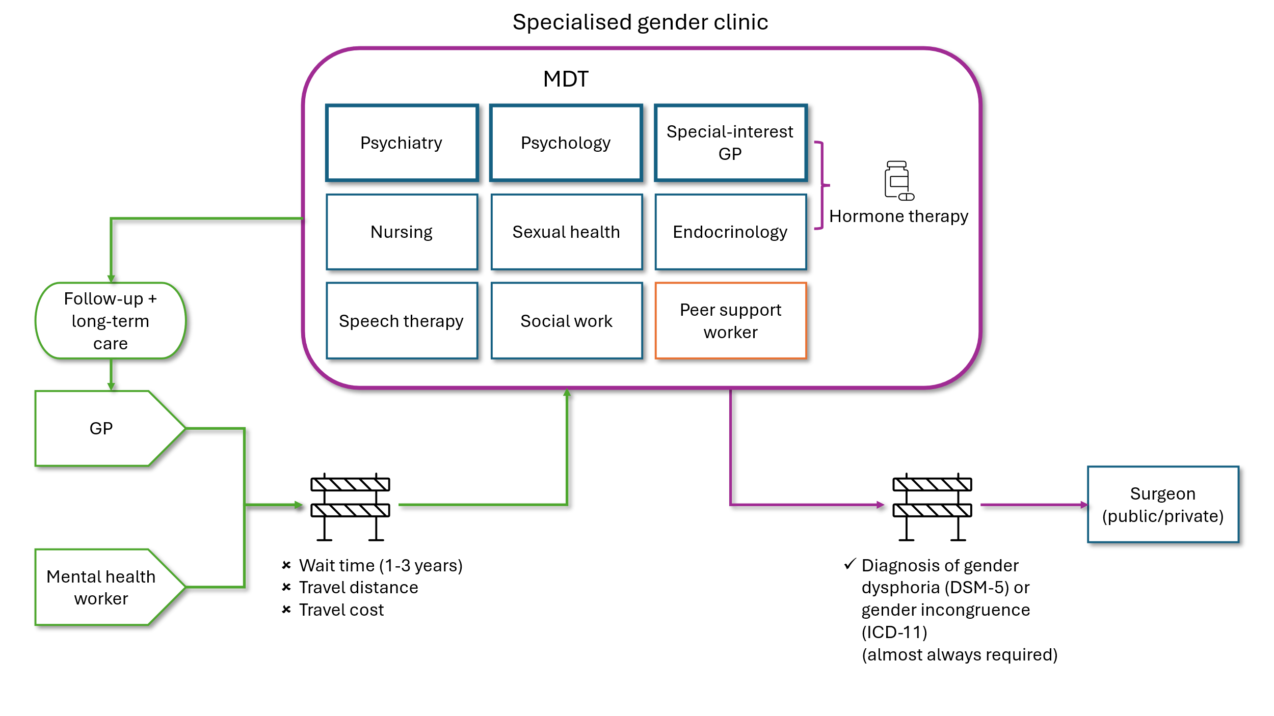
Figure 1 Specialised gender identity clinic model of care
DSM-5 = Diagnostic and Statistical Manual of Mental Disorders, 5th Edition; GP = general practitioner; ICD-11 = International Classification of Diseases 11th revision; MDT = multidisciplinary team
A specialised gender identity clinic is commonly staffed by a mix of practitioners working in MDTs. MDTs sometimes feature clinical leads. The lead is occasionally specified as a psychiatrist or as a psychologist or medical practitioner (e.g., GP) with a special interest and/or WPATH training in gender-affirming care. The number and exact mix of staff in specialised clinics are highly variable. The following disciplines are commonly included: psychiatry, psychology, endocrinology, nursing, speech therapy, social work, sexual health, and general practice (see Figure 1). Gynaecology, urology and surgery are sometimes included, especially as the size or importance of the clinic as a hub increases. More commonly, the specialised gender identity clinic refers the patient on to a surgeon who works outside of the clinic. Hormones are commonly prescribed by a clinic’s GP or (especially for complex cases) endocrinologist. Clinic staff increasingly include a peer-support or lived-experience worker, namely someone with personal experience of gender identity issues who provides support, especially in navigating care pathways. There were frequent recommendations to engage paid or voluntary peer-support workers to help people with care navigation and informal support, especially early in people's engagement with a specialised clinic. People are commonly referred to a specialised clinic by GPs and mental health workers (see Figure 1).
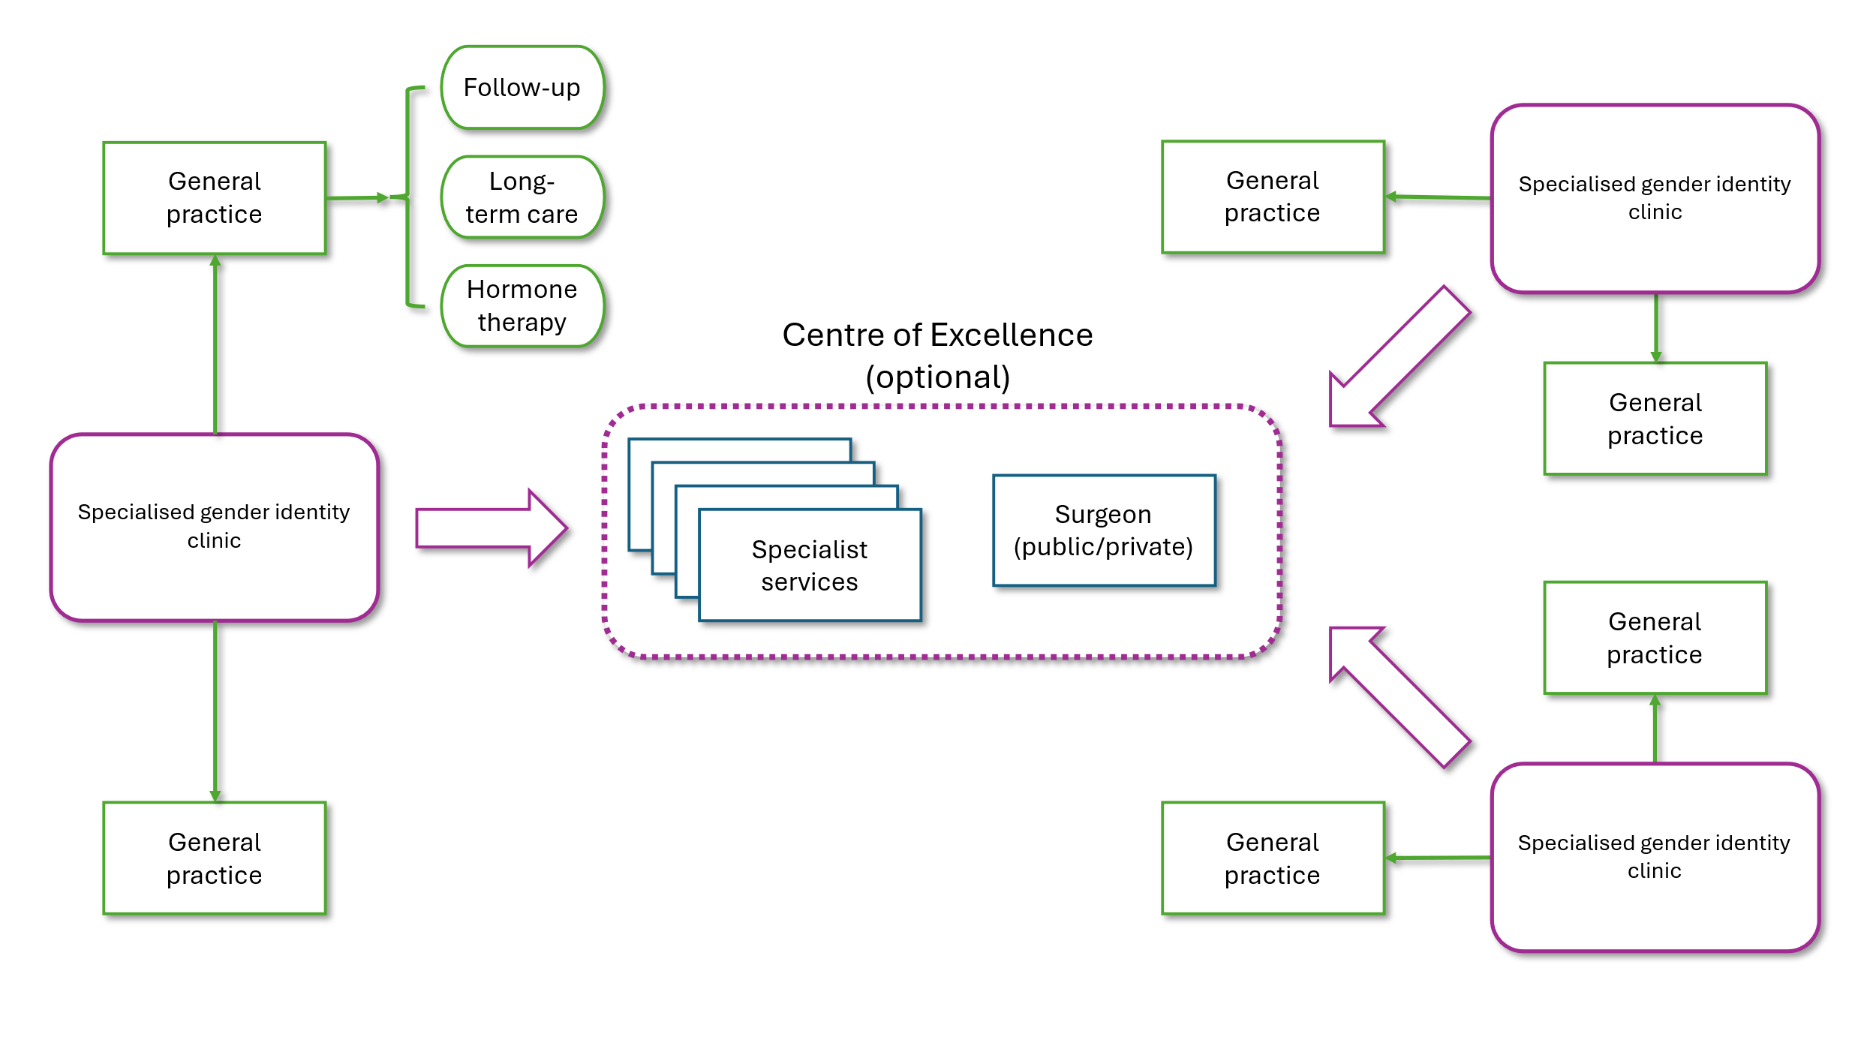
Figure 2 Hub-and-spoke model of care
Related to the specialised clinical model of care is the hub-and-spoke model. In this model, specialised clinics function as hubs that provide support and training to GPs (and others) to provide hormone therapy and other forms of care and support, including psychological counselling. Patient access relies on strong connections and communication between the hub and spokes. A hub-and-spoke model allows for multiple levels, e.g., a Centre of Excellence can function as a hub to multiple specialised gender clinics, which themselves function as hubs to a network of GPs and others (see Figure 2).
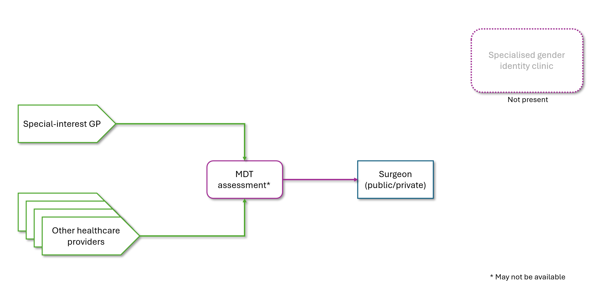
Figure 3 Diffuse model of care
MDT = multidisciplinary team
By contrast, in a diffuse model, a person can self-refer to a health service, where suitably qualified and capable special-interest primary care providers can refer the person directly to a surgeon, including the option for MDT assessment (see Figure 3).
Although models of care differed somewhat in referral pathways and care coordination, it was common for all models of care to rely upon GPs to provide follow up (e.g., 6-12 months after surgery) and long-term care.

Assessments required for access to care
Psychosocial assessment and a formal diagnosis of gender incongruence (International Classification of Diseases 11th revision; ICD-11) or gender dysphoria (Diagnostic and Statistical Manual of Mental Disorders, 5th edition; DSM-5) are sometimes required to access gender-affirming treatment. This was not uniform across identified models of care, nor across the types of care (e.g., hormone therapy or surgery). Assessment and diagnosis are often not required to access hormone therapy (as per the informed consent model of care), but they are almost always required to access gender-affirming surgery.
In models of care that described the use of the informed consent approach, it typically required solely the informed consent of the person for them to access treatment, commonly hormone therapy. This means that the only assessment required would be an assessment of the person’s capacity to provide informed consent. In health care, such assessment is typically informal, though formal assessment sometimes occurs, e.g., where the person’s decision-making capacity is significantly in doubt.
Across the identified models of care, eligibility requirements varied by surgery type. A second psychosocial assessment and 6-12 months of hormone therapy (unless contraindicated) are often required to access surgery. In some jurisdictions and for some surgery types, a diagnosis of gender incongruence is sufficient to access surgery. In other jurisdictions and for other surgery types, a diagnosis of gender dysphoria is required. Genital surgery in particular, can have more stringent requirements than chest surgery. Table 1 provides a snapshot of some of the requirements that were explicitly stated across various sources and countries. Table 1 is not intended to be an exhaustive, systematic report of eligibility requirements of every surgery type across the identified models of care. There are some points of overlap and conflict within Table 1, reflecting the variation in surgical requirements identified.
In response to the requirements for accessing treatment, some people have made criticisms of gatekeeping, namely of undue restrictions on access to treatment behind assessment and diagnosis activities, especially as the burdens of those on the person seeking care increase (see (Gruenewald 2020), for instance).
Table 1 Varying surgical requirements identified
Surgery | Requirements | References
Mastectomy with chest masculinisation  Hysterectomy  Orchiectomy | Gender dysphoria  1 clinical assessment/referral | UK, Alberta Canada, Scotland  (NHS England 2024; Provincial Pathways Unit 2025; Thomson, Baker & Arnot 2018)
“Genital surgery” (not further specified) | Gender dysphoria  6-12 months of hormone therapy  1 year of living in the identity-congruent gender  2 clinical assessments/referrals | UK, Scotland  (NHS England 2022, 2024; Thomson, Baker & Arnot 2018)
Phalloplasty  Metoidioplasty | Gender dysphoria  1 year of hormone therapy  6+ months after hysterectomy  BMI < 40 | Alberta Canada  (Provincial Pathways Unit 2025)
Vaginoplasty | Gender dysphoria  1 year of hormone therapy  BMI < 40  No smoking | Alberta Canada  (Provincial Pathways Unit 2025)
Breast augmentation | Gender dysphoria  1 year of hormone therapy  No or negligible breast development | Alberta Canada  (Provincial Pathways Unit 2025)
Oophorectomy  Orchiectomy | Marked and sustained gender incongruence  Consider 6+ months of hormone therapy | Italy, Nova Scotia Canada (Coleman et al. 2022; Nova Scotia 2023)
BMI = body mass index; UK = United Kingdom

Effectiveness of models of care
Evidence of the benefits of one type of model of care compared with another was not commonly identified during the review. However, the specialised clinic model has occasioned complaints of long wait times (e.g., 1-3 years), too little support while waiting, and burdensome travel distances and travel expenses (see Figure 1). Although it is unclear whether these observations would be generalisable across jurisdictions, or whether they are unavoidably related to a specialised clinic model, they indicate that some decentralisation or diffusion of care, which occurs in both hub-and-spoke models and diffuse models, should be considered.
Only one study was found on the influence of models of care on surgical outcomes. In 2023, a German retrospective cohort study of 45 people compared centralised and decentralised service delivery in terms of the impact on surgical outcomes several years after vaginoplasty (Koehler et al. 2023). Centralised service delivery was defined as all treatment (including surgery) being delivered by one institution, e.g., a specialised clinic. This is consistent with a specialised clinic model of care but where the surgeon consults within, or is closely affiliated with, the specialised clinic (see Figure 1). By contrast, decentralised service delivery involved multiple institutions, as per hub-and-spoke and diffuse models (see Figures 2 and 3). The study found that centralised service delivery was associated with lower psychological distress (on the Female Sexual Distress Scale) and possibly better physical health on the World Health Organization Quality of Life questionnaire (WHOQOL-BREF) (Koehler et al. 2023).
These findings should be scrutinised to identify, if possible, the most likely reasons for the improved outcomes attributable to a specialised service, and whether these characteristics can only be provided in a specialised service or whether they could be implemented in other models of care. The researchers noted that their study was only one retrospective study of one procedure with a small number of participants, so further research is required. However, this finding may indicate that a purely diffuse model of care may not be optimal.
It is not possible to confidently recommend one model type or one model of care over another on the basis of superior surgical outcomes. While in part this may explain the variation in model types observed internationally (see Figure 4) it may also highlight the need for flexibility according to patient experiences and journeys, and that a “one size fits all” model may not be appropriate.

Funding of models of care
Data explicitly specifying funding arrangements (e.g., public vs. private funding) were scarce. The models were not primarily defined by funding source, but by other structural features, e.g., referral paths and the types of healthcare practitioners involved. Although existing funding arrangements necessarily influence the model of care used within a jurisdiction, there did not appear to be any evidence that different models clearly aligned with the source of funding (i.e., public, private or mixed funding). This may also explain the variation in funding sources observed internationally across models of care (see Figure 4).
For example, in England, specialised gender identity clinics are funded publicly, with some movement toward a hub-and-spoke model being evident, as special-interest GPs are contracted by a more local level of government to function as spokes. In Australia, there are examples of specialised gender identity clinics being funded publicly. Monash Health Gender Clinic in Melbourne is funded by the Victorian state government. The South Australian (SA), New South Wales (NSW) and Victorian governments have published and begun to implement plans to publicly fund a specialised gender identity clinic or service on a hub-and-spoke model (see Section 4.2.1 for detail). There are also examples of specialised gender identity clinics receiving mixed funding. Gender Health Australia in Brisbane is funded through a combination of out-of-pocket costs (private funding) and Medicare billing (public funding).
There were few examples of gender-affirming surgery being publicly funded in Australia. In 2018, Monash Health Gender Clinic, funded by the Victorian government, provided discretionary funding to support 18 patients who applied for financial assistance to access surgery (criteria for accessing this assistance were not specified) (Erasmus 2020). The Clinic reported that gender-affirming surgery was otherwise “only available within the private sector”, with out-of-pocket costs ranging “from $10,000 to $40,000” (Erasmus 2020).
Figure 4 maps the surgery funding source and model type mainly used in each of the countries with relevant data.

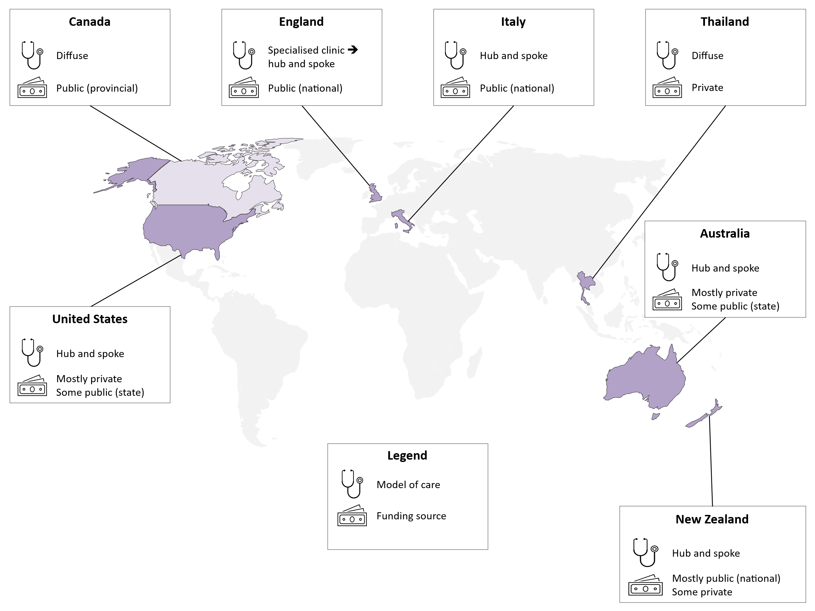
Figure 4 Funding sources and model types for gender-affirming surgery

Models of care in Australia
Any suggestions made or implied in this report regarding possible models of care for gender-affirming surgery are intended merely as points for MSAC consideration. It should also be noted that Australia’s states and territories have oversight of many services, such as any state-funded specialised gender identity clinic or service. States and territories would need to be consulted to ensure that any new funding for gender affirming care (such as MBS items for gender affirming surgery) complements existing or proposed models of care. Literature on Australia’s current models of care mostly describe publicly funded hub-and-spoke models of care.
Given current mechanisms of funding healthcare in Australia, specialised clinics or highly centralised models of care more likely occur in the public sector (funded by state and territory governments). However, if surgery were to be funded via the MBS (i.e., rebated in the private sector and delivered by private healthcare providers), patients seeking gender affirming surgery are more likely to access care within a hub-and-spoke model or diffuse model. Of these two models, hub-and-spoke models may be especially well-suited to addressing individual patient’s needs by enabling access to a range of specialities and health professions. In particular, hub-and-spoke models may better facilitate MDT assessment. The involvement of peer-support workers may support patient journeys and experiences, and it is noted the resourcing of such workers may better suit a hub-and-spoke model where a central provider is taking overall coordination responsibility for the patient. Within a diffuse model, it is possible that a co-ordinating practitioner, such as a GP, could seek assessment from a range of practitioners prior to referring to a surgeon. Within hub-and-spoke models, where some coordinated care is centralised, broader consideration to care models such as telehealth may be needed to address barriers such as wait times and travel distances.
In Australia, gender-affirming care could also operate with a hybrid model (hub-and-spoke plus diffuse). Theoretically, a diffuse model, where a person is referred directly to private surgeons, could be adequate in most cases except where peer support and, in particular, MDT assessments were required. In a hybrid model, people that did require peer support or MDT could access their care needs through a specialised hub. Greater reliance on services delivered through a diffuse model would increase the requirement that care providers and coordinators (often GPs) are appropriately trained and can appropriately identify complex or at-risk cases. In a hub-and-spoke model, complex decision making would tend to be coordinated at the hub rather than at the health practitioner spoke. As the evidence suggests GPs undertake the longer-term care in a hub-and-spoke model, communication regarding the central decisions back to the health professional spoke is vital.
The hybrid approach could result in a hub that, due to reduced demand, does not have long wait times (if adequately resourced). However, it may be that wait times across all models are determined more by resourcing levels than by type of model. Furthermore, the hybrid model could increase travel distances for some people, since there could be fewer hubs than in a dedicated hub-and-spoke model, e.g., where multiple hubs are spread across the country. Therefore, while a hybrid model may result in improved access in rural and regional Australia for less complicated cases, for those who would benefit from greater support only available at a hub, where telehealth services aren’t appropriate, travel may be increased if there is only one hub in the state.
Literature on both specialised clinics and hub-and-spoke models of care describe the involvement of multiple care providers, with some identified models explicitly noting multiple specialties involved in care coordination and decision making. This MDT involvement could be funded through the current MBS items. Primary care practitioners (including GPs), sexual health practitioners, psychologists, and nurse practitioners have attendance items for in-person, video-conferencing and telephone consultations.
MBS item numbers are also available for primary health care (general practitioner) for the management, and preparation of a multidisciplinary care plan, for chronic condition management and for mental health treatment plans. Care should be taken to ensure MBS descriptors adequately capture initial and ongoing management needs of individuals with gender incongruence or gender dysphoria. Other MBS items exist for endocrinologists, psychiatrists, consultant physicians, and allied health practitioners to provide consultations regarding an individual’s health, goals and treatment options, including hormone therapy and surgery.
Personnel who are not covered by current MBS items, but who nonetheless feature in models of care for gender incongruence, include peer-support workers/lived-experience workers. These personnel are not involved in MDT assessment, but they help to co-ordinate care and educate health professionals, e.g., on cultural safety. These workers are currently not able to claim MBS items, unlike social workers or mental health nurses.

Overview of components across models of care
Table 2 provides a snapshot regarding the frequency of model components, irrespective of the model or type of model to which they belong. Table 2 is only a high-level characterisation that has been synthesised and does not reflect the considerable variation existing across many domains. This variation is reflected throughout the report, including in the full data set provided in Table 6 in the Appendix. The categories reflect the frequency that the elements were mentioned, which may reflect variation in the extent of description provided in the model of care, rather than true differences in the way care is provided (e.g. the taking of medical history was only mentioned sometimes, but could be assumed to occur in all settings as part of the standard of care).
Table 2 Components that commonly, sometimes or rarely feature in models of care for adults experiencing gender incongruence
 | Commonly | Sometimes | Rarely
Referral | Self-referral to specialised clinic  Primary care or psychologist referral to specialised clinic  Specialised clinic referral to specialties, including endocrinology and surgery | Primary care or psychologist referral to mental health services and/or peer support  GP or specialised clinic referral to special-interest GP  Psychiatrist referral to surgery | Primary care referral directly to surgery  Specialised clinic referral to major hub, e.g., Centre of Excellence
Wait period | -- | 1-3 years for access to specialised clinic  6-12 months of hormone therapy for access to surgery | --
Assessment for access to treatment | Psychosocial assessment, including to identify any co-occurring mental health conditions | Medical history | Experienced as adversarial or gate-keeping  Readiness assessment
Diagnosis required for treatment | -- | None  OR  Gender incongruence (ICD-11), especially for hormones  OR  Gender dysphoria (DSM-5), especially for surgery | --
Treatment | Hormone therapy  Speech therapy  Mental health support | Social transition support  Surgery – chest  Breast augmentation  Mastectomy with chest masculinisation  Surgery – genital  Hysterectomy  Metoidioplasty  Oophorectomy  Orchiectomy  Phalloplasty  Salpingectomy  Vaginectomy  Vaginoplasty  Surgery – face  Facial feminisation | Fertility preservation  Screening and preventive care  Surgery  Body contouring  Breast reduction  Hair removal  Support for carers and families  Social work
Follow-up | Lifelong hormone monitoring by GP | Hormone monitoring by specialist  Lifelong health monitoring by GP  Surgical follow up with primary surgeon | MDT follow up
Health providers | GP  Special-interest GP  Psychiatrist  Endocrinologist  Speech therapist  Psychologist (clinical or counselling)  Social worker  Peer support worker  Sexual health physician  Nurse (specialist or nurse practitioner)  Surgeon  Gynaecologist  Urologist | Plastic surgeon  Psychotherapist  Counsellor | Ear-nose-and-throat (ENT) surgeon  Dermatologist  Fertility specialist  Neuropsychologist  Dietician  Ethicist  Community health worker  Colorectal surgeon  Optometrist
Requirements of health providers | WPATH training  Expertise and training in gender-affirming care  Training in culturally responsive care | WPATH certification  Masters degree or 2-5+ years’ clinical experience in gender specialised care | Lived experience
Funding | Government funding (state and national) of procedures and specialised clinics  Out-of-pocket costs | Private health insurance | University funding  Grants for research, education and training  Philanthropy
GP = General Practitioner. ICD = International Classification of Diseases. DSM = Diagnostic Statistical Manual of Mental Disorders. WPATH = World Professional Association for Transgender Health.

https://www.msac.gov.au/applications/1754
Transcend Australia; Australian Professional Association for Trans Health (AusPATH). Evidence brief: detransition. Sydney: Transcend Australia; 2024. Available from: https://transcend.org.au/wp-content/uploads/2024/11/Transcend_AusPATH_Detransition-evidence-brief_2024.pdf (accessed 14/04/2026).
Transcend Australia. Detransition: fact sheet. Sydney: Transcend Australia; 2024. Available from: https://transcend.org.au/wp-content/uploads/2024/11/Transcend_AusPATH_Detransition-fact-sheet_2024-1.pdf (accessed 14/04/2026).
Coleman E, Radix AE, Bouman WP, Brown GR, de Vries ALC, Deutsch MB, et al. Standards of care for the health of transgender and gender diverse people, version 8. International Journal of Transgender Health. 2022;23(Suppl 1):S1–S259.
Cass H. Independent review of gender identity services for children and young people: final report. London: NHS England; 2024. Available from: https://archive.org/details/cass-review-final
Australian Professional Association for Trans Health (AusPATH). Position statements and endorsements. Sydney: AusPATH; 2024. Available from: https://auspath.org.au/

