MSAC Application 1629.1

  - Defensive Antibacterial Coating (DAC) with antibiotics for reducing the risk of periprosthetic surgical site infection

  - PICO Set

Population

Describe the population in which the proposed health technology is intended to be used:

Population 1: Patients undergoing elective megaprosthesis or elective major revision for complete joint implants (for knee - TKA or hip - THA) for indications other than periprosthetic infection including total joint revision, tumour removal and reconstruction. Applies only to a cementless or hybrid prosthesis.

Population 2: Patients undergoing surgery for periprosthetic infection for complete joint implants for knee or hip. Applies only to a cementless or hybrid prosthesis.

Specify any characteristics of patients with the medical condition, or suspected of, who are proposed to be eligible for the proposed health technology, describing how a patient would be investigated, managed and referred within the Australian health care system in the lead up to being considered eligible for the technology:
Population 1: Subgroup 1a: Patients with megaprosthesis involve mainly those with cancer. These patients may require prosthetic surgery. There is little evidence relating to these sorts of procedures. Data from the Australian registry relating to distal femoral replacements (Bhanushali 2026) provides data for this population. Subgroup 1b: elective major revision for complete joint implants (for knee or hip) for indications other than periprosthetic infection. These patients are eligible if they require an elective revision without an infection, for total knee or hip where the procedure is cementless or hybrid.
Population 2: elective major revision for complete joint implants (for knee or hip) for periprosthetic infection. These patients are eligible if they require an elective revision with an infection, for total knee or hip where the procedure is cementless or hybrid.

Provide a rationale for the specifics of the eligible population:
Megaprosthesis: Infection remains one of the leading causes of failure following megaprosthesis reconstruction and is associated with substantial reoperation rates (Okafor 2023; Sinagra 2022). Consequently, megaprosthesis patients represent a particularly high-need population in whom effective infection-prevention strategies may provide substantial clinical benefit.
Revisions without periprosthetic infection: Carry a greater risk of infection compared to primary TKA or THA. The risk of infection in patients requiring revision without a periprosthetic infection is higher. The incidence of infection in primary prosthesis in Australia is between 1-3% and more likely to be 2-2.4% in revision surgery, as the infection rates for revision surgery are greater. A recent large-scale international dataset (>1.6 million arthroplasties) reported 1-year prosthetic joint infection (PJI) revision rates of 3.26% for 30 days, 4.83% for 90 days, and 6.51% for 1 year, confirming that revision procedures carry a several-fold greater infection risk than primary arthroplasty (Trudeau 2026).
Cementless or Hybrid: The clinical studies were conducted in procedures using these materials.
Total or Complete procedures: This has been included to restrict the patient population and limit leakage into other lower-risk areas. Patients in the clinical studies also generally had total replacements and therefore this group better aligns with the evidence base.
Private Hospital: Only private hospitals have access to the Prescribed List. Over 60% of revision procedures take place in a private hospital (Lewis PL 2025).
Revisions with periprosthetic infection: This is a high-risk population, and the aim is to reduce the risk of SSI. From Australian data, second revisions were required by 8.4% of knees and 15% of hips (Lewis PL 2025); rates of infection were experienced by 23.9% of hips and 36.6% of knees (Lewis PL 2025).

Intervention

Name of the proposed health technology:
Defensive Antibacterial Coating 5mL Kit (DAC) plus antibiotic.

Describe the key components and clinical steps involved in delivering the proposed health technology:
Defensive Antibacterial Coating (DAC®) 5 mL kit includes the following sterile components: a) a syringe containing 300 mg of dry product (Figure 1), (b) a complete set of DAC parts (connector, backstop and spreader) and (c) an empty graduated 10 ml syringe. The current Application is for the 5 ml kit only. DAC® 5 mL kit is a sterile, single-use Class III medical device designed to create a bioresorbable hydrogel coating on orthopaedic implants to reduce peri-implant infections caused by Gram-positive and Gram-negative aerobic and anaerobic bacteria during and after total joint arthroplasty (TJA). The sponsor is Novagenit Australia Pty Ltd, distributor of Novagenit Italy.
DAC consists of two bioresorbable polymers: hyaluronic acid (HA) and polylactic acid. HA is a naturally occurring polysaccharide found within the extracellular matrix of connective tissue and has been shown to reduce bacterial adhesion and growth on coated surfaces (Zoccali 2021). Polylactic acid is a biodegradable synthetic polymer derived from renewable sources.
The product is supplied as a dry powder that is reconstituted with sterile water immediately before surgery and applied directly to the implant surface. Once applied, DAC forms a temporary physical barrier that inhibits bacterial adhesion and colonisation of the implant surface (Novagenit). The hydrogel is reportedly fully absorbed within 72 hours, minimising the risk of interference with osseointegration or bone healing (https://www.dac-coating.com/ ).

Figure 1: DAC
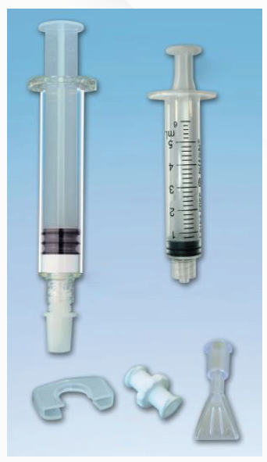

Identify how the proposed technology achieves the intended patient outcomes:
DAC hydrogel is prepared intra-operatively according to the manufacturer’s indications. The hydrogel is directly spread onto the implant, which is then inserted into the body by the surgeons. DAC can be used in a 1-stage approach (1-stage exchange hip or knee procedure) in (Capuano 2018) or a 2-stage approach (2-stage exchange hip procedure) (Zagra 2019). The application of DAC® disrupts the ability of pathogens to bind to the implant surface, inhibiting the initial stages of bacterial colonisation that would then result in biofilm formation (Novagenit). DAC forms a hydrogel that acts as a temporary barrier, providing an effective mechanism for prevention of bacterial infection (see Figure 2). In case of contamination of the implant surface, colonisation by pathogens results in formation of a barrier known as Biofilm. Biofilm is an impervious polymeric matrix, able to make the bacterial colony resistant to antibiotic treatment and the patient’s immune system (Costerton 1978; Gristina 1987; Gristina 1985; Gristina 1988).

Figure 2: Hydrogel defensive mechanism
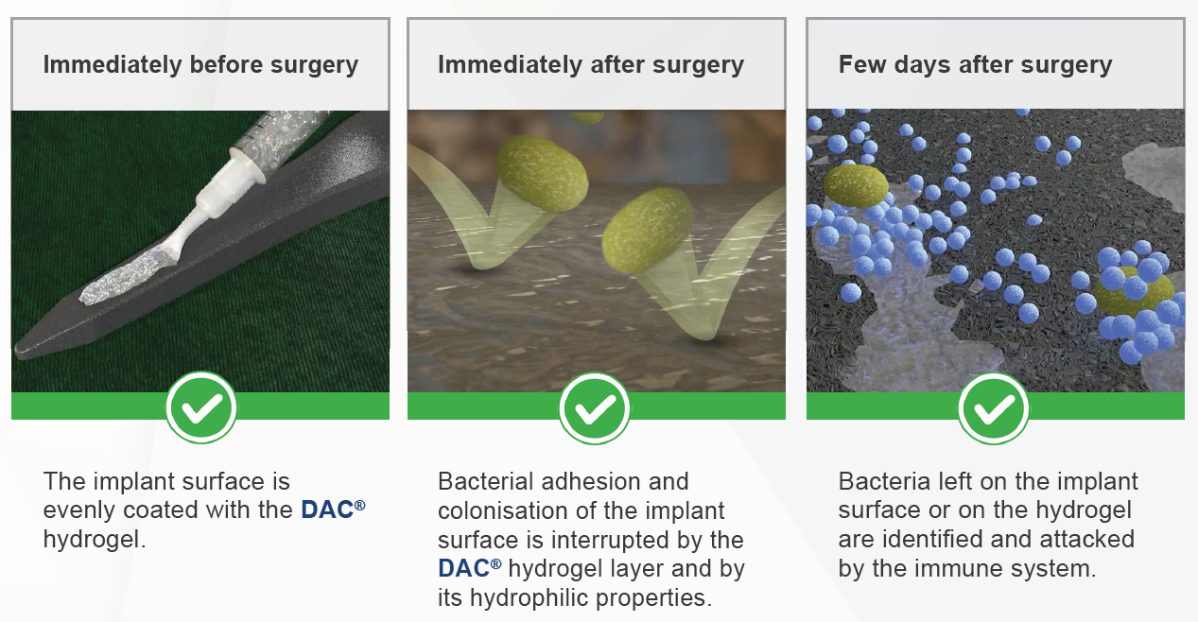

Does the proposed health technology include a registered trademark component with characteristics that distinguishes it from other similar health components?
Yes

Explain whether it is essential to have this trademark component or whether there would be other components that would be suitable:
There is no other device that offers this process.

Are there any proposed limitations on the provision of the proposed health technology delivered to the patient (For example: accessibility, dosage, quantity, duration or frequency):
No

Provide details and explain:
The limitations are imposed by identifying the populations most representative of the study populations. There does not seem to any limitations.

If applicable, advise which health professionals will be needed to provide the proposed health technology:
Orthopaedic Surgeons.

If applicable, advise whether delivery of the proposed health technology can be delegated to another health professional:
The assembly of DAC+antibiotic can be delegated to the surgical team but not the placement of the prosthesis.

If applicable, advise if there are any limitations on which health professionals might provide a referral for the proposed health technology:
None.

Is there specific training or qualifications required to provide or deliver the proposed service, and/or any accreditation requirements to support delivery of the health technology?
No

Provide details and explain:
Provide a response if you answered 'Yes' to the question above

Indicate the proposed setting(s) in which the proposed health technology will be delivered:
Consulting rooms
Day surgery centre
Emergency Department
Inpatient private hospital
Inpatient public hospital
Laboratory
Outpatient clinic
Patient’s home
Point of care testing
Residential aged care facility
Other (please specify)

Specify further details here

Is the proposed health technology intended to be entirely rendered inside Australia?
Yes

Provide additional details on the proposed health technology to be rendered outside of Australia:
Provide a response if you answered 'No' to the question above

Comparator

Nominate the appropriate comparator(s) for the proposed medical service (i.e. how is the proposed population currently managed in the absence of the proposed medical service being available in the Australian health care system). This includes identifying health care resources that are needed to be delivered at the same time as the comparator service:

Provide a name for your comparator:
No DAC

Provide an identifying number for your comparator (if applicable):
Not relevant

Provide a rationale for why this is a comparator:
This has been accepted in the past by PASC. There is no other device that provides this process available.

Pattern of substitution – Will the proposed health technology wholly replace the proposed comparator, partially replace the proposed comparator, displace the proposed comparator or be used in combination with the proposed comparator?
None (used with the comparator)
Displaced (comparator will likely be used following the proposed technology in some patients)
Partial (in some cases, the proposed technology will replace the use of the comparator, but not all)
Full (subjects who receive the proposed intervention will not receive the comparator)

Outline and explain the extent to which the current comparator is expected to be substituted:
The comparator is no DAC so there will be complete substitution in a proportion of patients.

Outcomes
List the key health outcomes (major and minor – prioritising major key health outcomes first) that will need to be measured in assessing the clinical claim for the proposed medical service/technology (versus the comparator):
Health benefits
Health harms
Resources

Outcome description – please include information about whether a change in patient management, or prognosis, occurs as a result of the test information:
 | Types
Health Benefits | SSI incidence  Total complications  Aseptic loosening  Quality of life (QOL): SF-12  Functioning: Harris hip score (HHS), Knee Society Score (KSS)
Health Harm | DAC related Adverse Events  Delayed wound healing
Resources | Time in hospital

Claims
In terms of health outcomes (comparative benefits and harms), is the proposed technology claimed to be superior, non-inferior or inferior to the comparator(s)?
Superior
Non-inferior
Inferior

Please state what the overall claim is, and provide a rationale:
DAC+antibiotic is superior in reducing SSI incidence across Population 1 and 2. The results are based on meta-analyses of the relevant, comparative studies.

Why would the requestor seek to use the proposed investigative technology rather than the comparator(s)?
There currently is no DAC and this was the previously accepted comparator by PASC and the resultant ratified PICO for 1629 (Oct. 2020).

Identify how the proposed technology achieves the intended patient outcomes:
DAC+antibiotic reduces the incidence of SSIs.

For some people, compared with the comparator(s), does the test information result in:
A change in clinical management? Yes
A change in health outcome? Yes
Other benefits? Yes

Provide a rationale, and information on other benefits if relevant:
The reduction in resources used is a consequence of the reduction in the incidence of SSIs.

In terms of the immediate costs of the proposed technology (and immediate cost consequences, such as procedural costs, testing costs etc.), is the proposed technology claimed to be more costly, the same cost or less costly than the comparator?
More costly
Same cost
Less costly

Provide a brief rationale for the claim:
This is a new device used to reduce the rate of infection. It is more costly than not using the device.
If your application is in relation to a specific radiopharmaceutical(s) or a set of radiopharmaceuticals, identify whether your clinical claim is dependent on the evidence base of the radiopharmaceutical(s) for which MBS funding is being requested. If your clinical claim is dependent on the evidence base of another radiopharmaceutical product(s), a claim of clinical noninferiority between the radiopharmaceutical products is also required.
The reduction in resources used a consequence of the reduction in the incidence of SSIs.

Algorithms

PREPARATION FOR USING THE HEALTH TECHNOLOGY

Define and summarise the clinical management algorithm, including any required tests or healthcare resources, before patients would be eligible for the proposed health technology:
Currently, patients undergoing megaprosthesis and revision surgery for hips and knee prosthesis have varying risks of infection. Patients with megaprosthesis and revision surgery without periprosthetic infection carry a similar risk of infection and they form Population 1. DAC + antibiotic will allow for a reduction in the incidence of infections in this population. Patients undergoing revision surgery with an infection are more likely to have a successful revision with the use of DAC + antibiotic and a reduction of re-infections due to the revision.

Is there any expectation that the clinical management algorithm before the health technology is used will change due to the introduction of the proposed health technology?
No

Describe and explain any differences in the clinical management algorithm prior to the use of the proposed health technology vs. the comparator health technology:
Please provide a response if you answered 'Yes' to the question above

USE OF THE HEALTH TECHNOLOGY

Explain what other healthcare resources are used in conjunction with delivering the proposed health technology:
An antibiotic will be used in conjunction with DAC. It is not anticipated that the reconstitution of DAC is especially time consuming.

Explain what other healthcare resources are used in conjunction with the comparator health technology:

The product is supplied as a dry powder that is reconstituted with sterile water immediately before surgery and applied directly to the implant surface

Describe and explain any differences in the healthcare resources used in conjunction with the proposed health technology vs. the comparator health technology:

Sterile water is required to reconstitute the dry powder.

CLINICAL MANAGEMENT AFTER THE USE OF HEALTH TECHNOLOGY

Define and summarise the clinical management algorithm, including any required tests or healthcare resources, after the use of the proposed health technology:
Were DAC to be made available for use with an antibiotic for Populations 1 and 2, this would enable better control of SSIs. The antibiotic could be tailored for the patient’s clinical need. It is not anticipated that there are any substantive costs associated with the use of pr solution and antibiotics but potentially there are large savings in terms of resource use due to SSIs. These are high risk populations and therefore, there are substantial savings expected with the use of DAC+antibiotic.
Define and summarise the clinical management algorithm, including any required tests or healthcare resources, after the use of the comparator health technology:
There are no additional tests required with the use of the technology, indeed a reduction in testing for infection is anticipated. The key resource use that will increase is the use of DAC and the antibiotic that is included.

Describe and explain any differences in the healthcare resources used after the proposed health technology vs. the comparator health technology:
There are no additional tests required with the use of the technology, indeed a reduction in testing for infection is anticipated. The key resource use that will increase is the use of DAC and the antibiotic that is included. It is not anticipated that there are any substantive costs associated with the use of saline solution and antibiotics but potentially there are large savings in terms of resource use due to SSIs.

Insert diagrams demonstrating the clinical management algorithm with and without the proposed health technology:
Note:

(Please ensure that the diagrams provided do not contain information under copyright)

Figure 3: Treatment Algorithm Without DAC
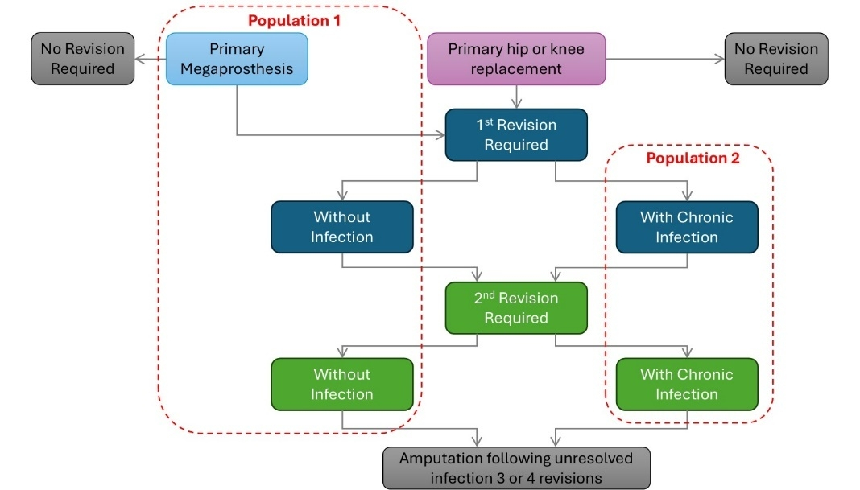
Figure 4: Treatment Algorith with DAC
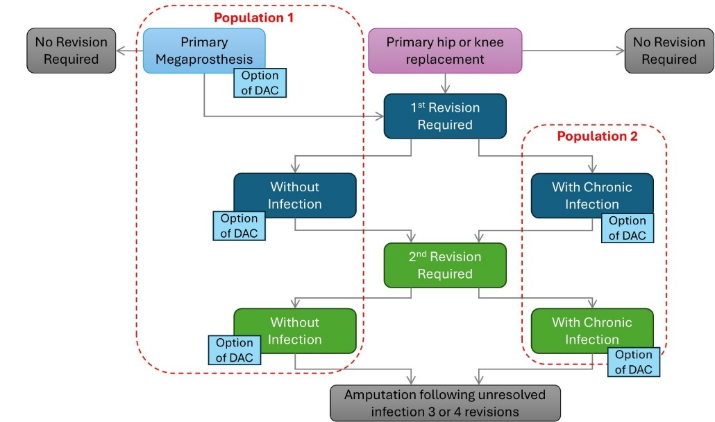

Summary of Evidence

Provide one or more recent (published) high quality clinical studies that support use of the proposed health service/technology. At ‘Application Form lodgement’,

 | Type of study design* | Title of journal article or research project | Short description of research | Website link to journal article or research | Date of publication
 | Population 1 – elective megaprosthesis or elective major revision for complete joint implants (for knee and hip) for indications other than periprosthetic infection
1. | Propensity matched case-control study, observational. | De Meo, D., Calogero, V., Are, L., et al. (2020). Antibiotic-Loaded Hydrogel Coating to Reduce Early Postsurgical Infections in Aseptic Hip Revision Surgery: A Retrospective, Matched Case-Control Study" Microorganisms 8(4) | N=17 DAC+ antibiotic (AB), N=17 no DAC  DAC+AB vs. no DAC (all P>0.05, mean (SD) or %):  Age 74.9 (11.5) vs. 75.9 (9.6) years.  Female 64.7% vs. 58.8%.  BMI 27.1 (5.1) vs. 24.9 (4.9) kg/m²  CCI 4.4 (1.7) vs.4.4 (2.2)  Key results (DAC+AB vs. no DAC; % patients):  SSIs: 0% vs. 35.3% (P=0.0001)  Total complications: 17.6% vs. 64.7% (P=0.0134) | https://pubmed.ncbi.nlm.nih.gov/32326577/ | 2020
2. | Propensity matched case-control study, observational | Zoccali, C., Scoccianti, G., Biagini, R., et al. (2021). Antibacterial hydrogel coating in joint mega-prosthesis: results of a comparative series. European Journal of Orthopaedic Surgery and Traumatology 31(8): 1647–1655. | N=43 DAC+AB, N=43 no DAC, both with 2-stage procedure  DAC+AB vs. no DAC (mean (SD) or %):  Age 45.6 (21.3) vs. 47.4 (19.5) years.  Female 44.2% vs. 44.2%.  BMI 29.5 (6.7) vs. 30.6 (6.8) kg/m²  McPhersons score – compromised host (B+C) 98.7% vs. 98.7%.  Key results (DAC+AB vs. no DAC; % patients):  SSIs: 0% vs. 13.9% (P=0.028)  Total complications: 23.3% vs. 27.9% (P=NR) | https://pubmed.ncbi.nlm.nih.gov/33547509/ | 2021
 | Population 2 – Major revision for complete joint implants (for knee and hip) for periprosthetic infection
3. | Matched case-control study, observational | Capuano, N., et al., One-stage exchange with anti-bacterial hydrogel coated implants provides similar results to two-stage revision, without the coating, for the treatment of peri-prosthetic infection. Knee Surg Sports Traumatol Arthrosc, 2018. 26(11): 3362-3367 | N=22 DAC+AB 1-stage procedure, N=22 no DAC with 2-stage procedure.  DAC+AB vs. no DAC (mean (SD) or %):  Age 71.3 (13.6) vs. 71.9 (8.3) years.  Female 59.1% vs. 59.1%.  McPhersons score – compromised host (B+C) 86.4% vs. 81.8%.  Key results (DAC+AB vs. no DAC; % patients, mean (SD), all P=NS):  SSIs: 9.1% vs. 13.6% (P=NS), demonstrating non-inferiority.  SF-12 total score: 84.4 (7.4) vs. 84.3 (7.4)  Time in hospital 18.9 (2.9) vs. 35.8 (3.4) days (P=0.0001) | https://pubmed.ncbi.nlm.nih.gov/29549387/ | 2018
4. | Matched case-control study, observational | Ding, B.T.K., D'Apolito, R., Sciamanna, L., et al. (2025). Antibacterial hydrogel coating is associated with lower complication risks after complex high-risk primary and cementless hip revision arthroplasty: a retrospective matched cohort study. Bone & Joint Open 6(6 Supple B): 15–23. | N=86 DAC+ AB cases, N=45 matched controls (no DAC); both with 2-stage procedure.  DAC+AB vs. no DAC (mean (SD) or %; all P=NS):  Age 67.2 (11.0) vs. 64.4 (12.2) years.  Female 50% vs. 44.4%.  McPhersons score – compromised host (B+C) 66.3% vs. 66.7%.  Key results (DAC+AB vs. no DAC; % patients):  SSIs: 0% vs. 8.9% (P=0.005)  Total complications: 1.2% vs. 22.2% (P=0.003) | https://pubmed.ncbi.nlm.nih.gov/40449895/ | 2025
5. | Randomised, controlled, trial, multicentre, parallel group | Romano, C.L., et al., Does an antibiotic-loaded hydrogel coating reduce early post-surgical infection after joint arthroplasty? J Bone Jt Infect, 2016. 1: 34-41 | DAC+AB N=54, No DAC N=52 subpopulations, both with 2-stage procedure  Full population DAC+AB vs. no DAC (mean (SD or %):  Age 69 (12.6) vs. 71 (10.6)years.  Female 59.8% vs. 59.8%.  McPhersons score – compromised host (B+C) 76.1% vs. 76.6%.  Key results (DAC+AB vs. no DAC; % patients):  SSIs: 0% vs. 13.4% (P=0.007) | https://pubmed.ncbi.nlm.nih.gov/28529851/ | 2016
6. | Matched case-control study, observational | Zagra, L., et al., Two-stage cementless hip revision for peri-prosthetic infection with an antibacterial hydrogel coating: results of a comparative series. Int Orthop, 2019. 43(1): 111-115 | N=27 DAC+ AB cases, N=27 matched controls (no DAC); both with 2-stage procedure.  DAC+AB vs. no DAC (mean (SD) or %; all P=NS):  Age 63.9 (11.7) vs. 64.8 (10.1) years.  Female 59.3% vs. 48.1%.  McPhersons score – compromised host (B+C) 96.3% vs. 96.3%.  Key results (DAC+AB vs. no DAC; % patients):  SSIs: 0% vs. 8.9% (P=0.005)  Total complications: 0.0% vs. 14.8% (P=0.11) | https://pubmed.ncbi.nlm.nih.gov/30374639/ | 2019
AB: antibiotic; BMI: body mass index; CCI: Charlson Comorbidity Index; HHS: Harris hip score; KSS: Knee Society Score; NR: not reported; NS: non-significant; PJI: periprosthetic joint infection; SD: standard deviation; SF-12: Short-form survey 12; SSI: surgical site infection
Identify yet-to-be-published research that may have results available in the near future (that could be relevant to your application).
Do not attach full text articles; this is just a summary (repeat columns as required).
 | Type of study design* | Title of journal article or research project | Short description of research | Website link to journal article or research | Date of publication
Population 2 – Major revision for complete joint implants (for knee and hip) for periprosthetic infection
1. | Randomised controlled trial, multicentre, parallel group | SINBIOSE-H study  Protocol publication:  Boyer B, Cazorla C, Carricajo A, et al. Single-stage surgery with antibiotic-loaded hydrogel-coated implants versus two-stage surgery for chronic periprosthetic hip joint infection in French tertiary referral hospitals: the SINBIOSE-H non-inferiority, randomised, controlled trial study protocol. BMJ Open. 2025 Feb 25;15(2):e085146. | N=440 will be randomised in 2 groups: DAC+AB with 1-stage procedure vs. no DAC 2-stage procedure in patients with chronic hip PJI.  Primary outcome is a clinically diagnosed infection relapse of the periprosthetic joint, i.e., recurrence of infection by the same organism(s) and/or re-infection with a new organism up to 2 years. | https://pubmed.ncbi.nlm.nih.gov/40000087/ | Currently unknown when study results will be reported.
AB: antibiotic; BMI: body mass index; CCI: Charlson Comorbidity Index; HHS: Harris hip score; KSS: Knee Society Score; NR: not reported; NS: non-significant; PJI: periprosthetic joint infection; SD: standard deviation; SF-12: Short-form survey 12; SSI: surgical site infection

Bhanushali,. 2026. "Exploring the Influence of Surgeon and Hospital Procedural Volume on the Outcomes of Distal Femoral Replacement: An Australian National Joint Replacement Registry Analysis." ANZ J Surg 96 (3): 458–471. https://doi.org/10.1111/ans.70413.
Capuano,. 2018. "One-stage exchange with antibacterial hydrogel coated implants provides similar results to two-stage revision, without the coating, for the treatment of peri-prosthetic infection." Knee surgery, sports traumatology, arthroscopy : official journal of the ESSKA 26 (11): 3362–3367. https://doi.org/https://dx.doi.org/10.1007/s00167-018-4896-4.
Costerton,. 1978. "How bacteria stick." Sci Am 238 (1): 86–95. https://doi.org/10.1038/scientificamerican0178-86.
Gristina. 1987. "Biomaterial-centered infection: microbial adhesion versus tissue integration." Science 237 (4822): 1588–95. https://doi.org/10.1126/science.3629258.
Gristina,. 1985. "Bacterial adherence to biomaterials and tissue. The significance of its role in clinical sepsis." J Bone Joint Surg Am 67 (2): 264–73.
Gristina,. 1988. "Infections from biomaterials and implants: a race for the surface." Med Prog Technol 14 (3-4): 205–24.
Lewis PL,. 2025. Hip, Knee and Shoulder Arthroplat- 2025 Annual Report. AOANJRR (https://aoanjrr.sahmri.com/documents/d/guest/aoa-full-report-2025).
Novagenit. "DAC The hydrogel barrier to infection." Accessed 20 July.
Novagenit. "What is DAC." Accessed 20 July.
Okafor,. 2023. "Is 2-Stage Septic Revision Worth the Money? A Cost-Utility Analysis of a 1-Stage Versus 2-Stage Septic Revision of Total Knee Arthroplasty." J Arthroplasty 38 (2): 347–354. https://doi.org/10.1016/j.arth.2022.09.003.
Sinagra,. 2022. "The accuracy of reporting of periprosthetic joint infection to the Australian Orthopaedic Association National Joint Replacement Registry." Bone & Joint Open 3: 367–374. https://doi.org/10.1302/2633-1462.35.BJO-2022-0011.R1.
Trudeau,. 2026. "Timing and Trends of Periprosthetic Joint Infections Following Over 1,500,000 Primary and Revision Total Knee and Hip Arthroplasty Cases." Arthroplast Today 39: 102031. https://doi.org/10.1016/j.artd.2026.102031.
Zagra,. 2019. "Two-stage cementless hip revision for peri-prosthetic infection with an antibacterial hydrogel coating: results of a comparative series." International Orthopaedics 43 (1): 111–115. https://doi.org/https://dx.doi.org/10.1007/s00264-018-4206-2.
Zoccali,. 2021. "Antibacterial hydrogel coating in joint mega-prosthesis: results of a comparative series." European Journal of Orthopaedic Surgery and Traumatology 31 (8): 1647–1655. https://doi.org/https://dx.doi.org/10.1007/s00590-021-02884-7.

