MSAC Application 1829

  - Anti-Müllerian hormone for identification of Polycystic Ovarian Morphology, to support the diagnosis of Polyendrocrine Metabolic Ovarian Syndrome (PMOS)

  - PICO Set

Population
Describe the population in which the proposed health technology is intended to be used:
Polyendocrine metabolic ovarian syndrome (PMOS, formerly referred to as polycystic ovarian syndrome or PCOS) is a condition which affects approximately 10% of reproductive age women, as noted in the 2023 Australian / International clinical guidelines. PMOS is associated with increased metabolic and cardiovascular risks and with decreased psychological, reproductive, and dermatological health, along with associated reduction in physical and mental wellbeing. Establishing a diagnosis of PMOS is relatively challenging, involving clinical signs, symptoms, and diagnostic tests to establish hyperandrogenism. Following the Australian and Interational Clinical Guidelines, AMH testing can be used to determine polycystic ovarian morphology (PCOM) in adults in whom PMOS is suspected, but do not have irregular menstrual cycles and clinical hyperandrogenism. AMH testing is an alternative to transvaginal ultrasound, which is similarly only recommended to be used to identify polycystic ovarian morphology in patients who do not have irregular menstrual cycles and hyperandrogenism.

Specify any characteristics of patients with, or suspected of having, the medical condition, who are proposed to be eligible for the proposed health technology, describing how a patient would be investigated, managed and referred within the Australian healthcare system in the lead up to being considered eligible for the technology:
Diagnostic work-up of patients suspected of having PMOS is set out in the 2023 Australian / International guidelines. Prior to a clinician considering AMH testing, clinical signs and symptoms would be evaluated by an appropriate clinician (including general practitioners, endocrinologists, and obstetricians / gynaecologists). Biochemical investigations for hyperandrogenism (hormone test) may also be requested. Patients who would be considered eligible for AMH testing, following the Australian guidelines are defined by:
- Adult (noting that AMH testing is most likely to be appropriate for ages 25 to 44, based on evidence for the utility of specific AMH thresholds).
- Do not have other symptoms which would enable a diagnosis of PMOS (do not have irregular menstrual cycles and evidence of hyperandrogenism).
The recommendations for AMH testing in the Guidelines are similar to the recommended use of ultrasound to establish PCOM. In both cases, the Guidelines note that ultrasound or AMH testing is only required when PMOS is being considered as a diagnosis, but there a diagnosis cannot be made on the basis of irregular periods and evidence of hyperandrogenism.
Provide a rationale for the specifics of the eligible population:
This population is derived from the Australian / International Clinical Guidelines for PMOS / PCOS. AMH testing is most likely to be appropriate for patients aged between 25 and 44, based on the outcomes of the APHRODITE and HARMONIA studies. These studies established relevant clinical cutoffs for AMH levels, comparing AMH levels to determination of PCOM based on ultrasound.
Are there any prerequisite tests?
Yes
Are the prerequisite tests MBS funded?
Yes
MBS Item 66695 - Quantitation in blood or urine of hormones and hormone binding proteins (including testosterone)
Provide details to fund the prerequisite tests:
Not applicable

Intervention
Name of the proposed health technology:
Quantification of Anti-Müllerian hormone for identifying Polycystic Ovarian Morphology.
Describe the key components and clinical steps involved in delivering the proposed health technology:
The key components in the diagnosis of PMOS are summarised in Algorithm 1, p. 232 of the Australian / International Clinical Guidelines. The Guidelines note that establishing a diagnosis of PMOS remains complex, and that despite an estimated prevalence of up to 10% of women of reproductive age, patients are likely to remain undiagnosed. The diagnostic algorithm has three key steps:
- Diagnosis of PMOS based on clinical hyperandrogenism and irregular menstrual cycles, after excluding other potential causes.
- For patients with irregular cycles but without clinical hyperandrogenism, investigate biochemical hyperandrogenism.
- For patients who have only irregular cycles or hyperandrogenism (clinical or biochemical), without other explanation, consider ultrasound or AMH testing to identify PCOM.
A positive PCOM investigation, in combination with patient history and excluding other potential causes, can support a clinician to make a diagnosis of PMOS.
Identify how the proposed technology achieves the intended patient outcomes:
AMH is a protein produced by cells in developing ovarian follicles. AMH can be efficiently detected in serum, similarly to other hormones. Although AMH levels can vary substantially with age and environmental factors, the use of AMH levels in serum as part of PMOS diagnosis was considered by a robust independent clinical review process, as part of the guideline development process. Specifically, PCOM is associated with a higher number of small, developing follicles in the ovaries. This means that AMH levels are substantially higher in women with have PMOS, compared to women of a similar age. A systematic literature review related to the use of AMH in PCOM for the purposes of PMOS diagnosis was conducted during the guideline development process, and is available in the published technical report (https://www.monash.edu/__data/assets/pdf_file/0010/3379591/TechnicalReport-2023.pdf)
Does the proposed health technology include a registered trademark component with characteristics that distinguishes it from other similar health components?
No
Explain whether it is essential to have this trademark component or whether there would be other components that would be suitable:
A trademark component is not required. However, AMH testing should only be performed using either an IVD included on the Australian Register of Therapeutic Goods with a published clinical cut-off value relevant for establishing PCOM, or using a laboratory-developed test with an appropriate locally validated clinical cut-off.
Are there any proposed limitations on the provision of the proposed health technology delivered to the patient (For example: accessibility, dosage, quantity, duration or frequency):
Yes, as noted above, testing should only be conducted using a test with appropriate cut-off values. This is achievable due to the availability of commercial IVD assays with appropriate clinical cut-offs included in published instructions for use (IFU).
Provide details and explain:
Not applicable
If applicable, advise which health professionals will be needed to provide the proposed health technology:
Approved pathology providers, in line with existing private (non-MBS funded) AMH testing.
If applicable, advise whether delivery of the proposed health technology can be delegated to another health professional:
Not applicable
If applicable, advise if there are any limitations on which health professionals might provide a referral for the proposed health technology:
Not applicable
Is there specific training or qualifications required to provide or deliver the proposed service, and/or any accreditation requirements to support delivery of the health technology?
Yes
Provide details and explain:
Standard pathology accreditation applies to providing chemical pathology results. The use of AMH testing as part of the diagnosis of PMOS is recommended in the relevant Australian clinical guidelines, developed by Monash University and endorsed by the NHMRC.
Indicate the proposed setting(s) in which the proposed health technology will be delivered:
(Select all relevant settings)
Consulting rooms
Day surgery centre
Emergency Department
Inpatient private hospital
Inpatient public hospital
Laboratory
Outpatient clinic
Patient’s home
Point of care testing
Residential aged care facility
Other (please specify)
Specify further details here
Is the proposed health technology intended to be entirely rendered inside Australia?
Yes
Provide additional details on the proposed health technology to be rendered outside of Australia:
Not applicable

Comparator
Nominate the appropriate comparator(s) for the proposed medical service (i.e., how is the proposed population currently managed in the absence of the proposed medical service being available in the Australian healthcare system). This includes identifying healthcare resources that are needed to be delivered at the same time as the comparator service:
Nomination of comparators for AMH testing for PCOM identification was informed by the recommendations outlined in the 2023 Guidelines. Based on the recommendations made in this clinical practice guidelines the nominated comparator is ultrasound (Table 1).
Ultrasound is the primary imaging modality used to measure these parameters in the diagnosis of polycystic ovary syndrome (PCOS). Diagnostic performance depends on both the imaging approach and the method used to record ovarian morphology:
- Transvaginal ultrasound (TVUS) – Considered the gold-standard approach for ovarian assessment. TVUS provides high-resolution visualization of the ovaries, allowing accurate measurement of FNPO, FNPS, OV, and stromal characteristics. It is recommended where feasible and acceptable to the patient due to its superior diagnostic accuracy.
- Transabdominal ultrasound (TAUS) – Used when TVUS is not feasible or acceptable (e.g., in adolescents or individuals who decline TVUS). TAUS is non-invasive but has lower spatial resolution and reduced sensitivity for follicle detection. As a result, FNPO and OV may be less accurate, and FNPS and OV are more commonly relied upon in these cases.
In conjunction with using one of the above methods, ovarian morphology can be evaluated using several measurements:
- Follicle number per ovary (FNPO) – The total number of small follicles (typically 2–9 mm in diameter) in a single ovary. FNPO provides a comprehensive assessment of polycystic morphology and is preferred when feasible.
- Follicle number per single section (FNPS) – The number of follicles visible in a single cross-section of the ovary. FNPS is often used when full visualization of the ovary is limited.
- Ovarian volume (OV) – The total volume of the ovary, calculated from its dimensions. OV can serve as an alternative measure when follicle counts are difficult to obtain.
These assessments are typically performed by a specialist, such as an obstetrician–gynaecologist, due to the expertise required for accurate measurement and interpretation. Access to specialist-performed ultrasound may be limited in some settings, which can create delays in diagnosis or require patients to travel to larger centres with appropriate expertise.
These assessments are typically performed by a specialist, such as an obstetrician–gynaecologist, due to the expertise required for accurate measurement and interpretation. Access to specialist-performed ultrasound may be limited in some settings, potentially creating delays in diagnosis or requiring patients to travel to larger centres with appropriate expertise. In addition, the accuracy of ultrasound assessment can vary depending on several factors, including the operator’s experience, the ultrasound method used (transvaginal vs. transabdominal), and the type of ovarian measurement captured (FNPO, FNPS, or ovarian volume). These sources of variability can lead to differences in diagnostic performance across settings, which may affect consistency and reliability of PCOM identification.
Table 1: Nominated comparator
Comparator | Recommended Use: Guidelines 2023 | Thresholds
Ultrasound | TVUS is the preferred and most accurate modality for assessing polycystic ovarian morphology (PCOM) when ultrasound is indicated and acceptable to the individual. Enables full visualisation of ovarian morphology. | • Follicle number per ovary (FNPO): ≥ 20 follicles in at least one ovary  • Follicle size: 2–9 mm in diameter  • Ovarian volume (OV): ≥ 10 mL (if FNPO not available)
Source: p. 62 and 63 of the 2023 Guidelines
List any existing MBS item numbers that are relevant for the nominated comparators:
Comparator | MBS item numbers
Pelvic Ultrasound (including transvaginal and transabdominal) | 55065
Complicated Pelvic Ultrasound (including transvaginal and transabdominal) | 55080
Provide a rationale for why this is a comparator:
The selection of comparator is derived from the 2023 Guidelines, which indicate that AMH testing or ultrasound should be used as part of the diagnostic process.
Pattern of substitution – Will the proposed health technology wholly replace the proposed comparator, partially replace the proposed comparator, displace the proposed comparator or be used in combination with the proposed comparator?
(Please select your response)
None (used with the comparator)
Displaced (comparator will likely be used following the proposed technology in some patients)
Partial (in some cases, the proposed technology will replace the use of the comparator, but not all)
Full (subjects who receive the proposed intervention will not receive the comparator)
Outline and explain the extent to which the current comparator is expected to be substituted:
The 2023 Guidelines recommend the use of either AMH testing or ultrasound. AMH testing is most likely to be used where patients prefer a less-invasive test (compared to transvaginal ultrasound), and where there are no other clinical reasons to specifically recommend the use of ultrasound (such as the investigation of other anatomical features or alternative diagnoses which would require imaging investigation). AMH therefore represents an option which may increase access to diagnosis of PMOS. The rate of substitution of AMH testing for ultrasound is unknown, however, it is unlikely to replace all ultrasound. This may be particularly the case for some specialist practitioners (such as obstetricians and gynaecologists) who may be able to offer office-based ultrasound, rather than requesting a diagnostic imaging service from another provider. The rate of substitution will be modelled as part of the proposed assessment process, but is not expected to exceed 50%.

Outcomes
(Please copy the below questions and complete for each outcome)
List the key health outcomes (major and minor – prioritising major key health outcomes first) that will need to be measured in assessing the clinical claim for the proposed medical service/technology (versus the comparator):
(Please select your response)
Health benefits
Health harms
Resources
Value of knowing
Outcome description – include information about whether a change in patient management, or prognosis, occurs as a result of the test information:
Diagnosis of PMOS, leading to improved management of medium to long-term health risks and impacts associated with PMOS. In comparison to ultrasound, AMH testing is likely to deliver non-inferior (equivalent) health outcomes, with potential improvements in health resource utilisation and access to alternative testing options that may be more convenient for patients and with features (such as type of variability or type of clinical cutoffs) that may be preferred by requesting physicians.
The sensitivity and specificity of the proposed technology, in comparison to ultrasound, is summarised briefly in the following table:
Diagnostic Method | Sensitivity | Specificity | Variability / Heterogeneity | Key Sources of Variability
AMH | 0.79 (0.76–0.82) | 0.87 (0.84–0.89) | Relatively stable pooled estimate; | Assay platform (ELISA vs automated vs Elecsys); age; BMI; PCOM inclusion in controls
Ultrasound – Follicle Number per Ovary (FNPO) | 70–94% | 70–100% | Wide range (24% sensitivity spread; 30% specificity spread) | Operator skill; machine resolution; transvaginal vs transabdominal; age; BMI; percentile-based cut-offs
Ultrasound – Follicle Number per Cross-Section (FNPS) | 21–94% | 60–100% | Extremely wide range (73% sensitivity spread) | Plane selection; counting technique; operator variability
Ultrasound – Ovarian Volume | 21–94% | 60–100% | Very wide range (73% sensitivity spread) | Measurement method; ovarian positioning; BMI; age; threshold choice

Proposed MBS items
How is the technology/service funded at present? (e.g., research funding; State-based funding; self-funded by patients; no funding or payments):
Private payment.
Provide at least one proposed item with their descriptor and associated costs, for each Population/Intervention:
(Please copy the below questions and complete for each proposed item)
MBS item number  (where used as a template for the proposed item) | AAAAA
Category number | 6
Category description | Pathology Services
Proposed item descriptor | Quantification of Anti-Mūllerian Hormone to detect polycystic ovarian morphology for the diagnosis of polyendocrine metabolic ovarian syndrome (PMOS).
Proposed MBS fee | $58.50
Indicate the overall cost per patient of providing the proposed health technology | $58.50
Please specify any anticipated out of pocket expenses | Nil
Provide any further details and explain | Recommended associated practice note:  Medicare benefits for AMH testing only apply in cases where reports are provided using a validated age-specific cut-off for determining polycystic ovarian morphology. Eligible patients must be aged >19 years.

Algorithms

PREPARATION FOR USING THE HEALTH TECHNOLOGY
Define and summarise the clinical management algorithm, including any required tests or healthcare resources, before patients would be eligible for the proposed health technology:
The clinical management algorithm is summarised in relevant clinical guidelines (Algorithm 1):
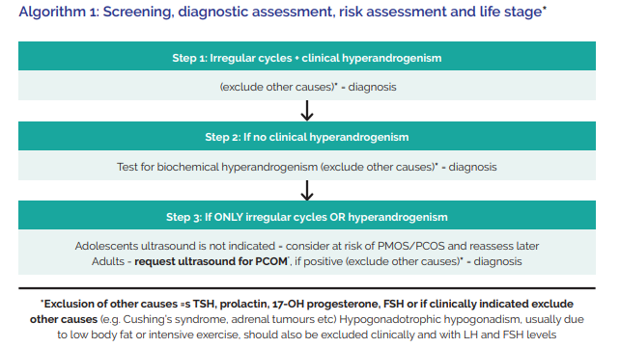
Ultrasound and polycystic ovary morphology
With irregular menstrual cycles and hyperandrogenism, an ovarian ultrasound is not necessary for diagnosis.
In diagnosis, follicle number per ovary is most effective, followed by follicle number per cross-section and ovarian volume as ultrasound markers in adults.
Ultrasound should not be used for PMOS/PCOS diagnosis in adolescents, due to the high incidence of multi-follicular ovaries in this life stage.
Transvaginal ultrasound approach is preferred in diagnosis of PMOS/PCOS, if sexually active or if acceptable to the individual.
Using ultrasound transducers with a frequency bandwidth including 8 MHz, the PCOM threshold is a follicle number per ovary of ≥ 20 and/or an ovarian volume ≥ 10 ml on either ovary, avoiding corpora lutea, cysts or dominant follicles.
Serum AMH could be used for defining PCOM in adults as an alternative to pelvic ultrasound. Either serum AMH OR ultrasound may be used but not both to avoid overdiagnosis.*

Anti-mullerian hormone (AMH) *
Serum AMH could be used for defining PCOM in adults as an alternative to pelvic ultrasound. Either serum AMH OR ultrasound may be used but not both to avoid overdiagnosis.*

Patients would be considered eligible for the proposed AMH test only where biochemical androgen testing is negative or inconclusive, but clinical suspicion of PCOS remains (e.g., persistent ovulatory dysfunction with or without clinical features suggestive of hyperandrogenism). In this context, AMH testing is intended to support the diagnostic assessment by providing evidence of polycystic ovarian morphology, potentially reducing the need for imaging-based investigations (e.g., pelvic ultrasound), particularly in populations where ultrasound is less accessible or acceptable.
Is there any expectation that the clinical management algorithm before the health technology is used will change due to the introduction of the proposed health technology?
No
Describe and explain any differences in the clinical management algorithm prior to the use of the proposed health technology vs. the comparator health technology:
The use of AMH testing is included within the current clinical algorithm, developed as part of the 2023 Australian / International Clinical Guidelines.

USE OF THE HEALTH TECHNOLOGY
Explain what other healthcare resources are used in conjunction with delivering the proposed health technology:
The proposed health technology would be part of the diagnosis of PMOS (as outlined above). This would involve:
- Clinical consultations (attendance items)
- Prior pathology investigations (pathology services to assess hormone levels / biochemical hyperandrogenism)
It is possible that some patients who receive a negative AMH serum result may be referred for an additional ultrasound if there are either suspicions of a false negative or further investigational work-up. AMH testing is likely to be cost-minimising as the proposed scheduled fee is less than the comparator ultrasound item.
Explain what other healthcare resources are used in conjunction with the comparator health technology:
Healthcare resource utilisation is likely to be similar between comparators, with the exception that ultrasound may be delivered in-office by some specialist clinicians.
Describe and explain any differences in the healthcare resources used in conjunction with the proposed health technology vs. the comparator health technology:
In Australia, the use of ultrasound to identify PCOM is relatively resource-intensive and relies on specialised infrastructure and workforce. The pathway typically requires access to an imaging facility, a trained sonographer to perform the scan, and a radiologist or appropriately qualified clinician to interpret and report the findings. It involves capital-intensive equipment (high-resolution ultrasound machines and transvaginal probes), dedicated clinical space, ongoing maintenance, and scheduling of a separate appointment that may introduce waiting times. From the patient perspective, the procedure is more time-consuming and, when performed transvaginally, invasive, which may limit acceptability in some populations. These factors collectively result in higher per-episode resource use and greater system dependency on imaging capacity.
By contrast, AMH testing uses fewer healthcare resources and can be more easily integrated into routine clinical care. The test requires only a standard blood draw by a GP, nurse, with analysis undertaken in an existing pathology laboratory using widely available assay platforms. There is no need for specialised imaging equipment or dedicated procedural rooms, and the patient time burden is minimal. AMH testing can often be ordered and completed within a single primary-care encounter, improving accessibility, particularly in rural or resource-constrained settings. Overall, compared with ultrasound, AMH testing represents a lower-intensity, more scalable use of healthcare resources, with reduced reliance on specialised personnel and infrastructure, albeit with the need for careful clinical interpretation within established diagnostic pathways.

CLINICAL MANAGEMENT AFTER THE USE OF HEALTH TECHNOLOGY
Define and summarise the clinical management algorithm, including any required tests or healthcare resources, after the use of the proposed health technology:
The introduction of AMH testing is not anticipated to change the utilisation of healthcare resources, in comparison to current standard of care. Healthcare resource utilisation after detection of PCOM and confirmation of PMOS diagnosis is dependent on individual patient risk factors and clinical judgement, in line with evidence based recommendations in the Australian clinical guidelines.
Define and summarise the clinical management algorithm, including any required tests or healthcare resources, after the use of the comparator health technology:
Overall clinical management after use of comparator is expected to be identical to after AMH testing.
Describe and explain any differences in the healthcare resources used after the proposed health technology vs. the comparator health technology:
No differences are expected.
Insert diagrams demonstrating the clinical management algorithm with and without the proposed health technology:
PMOS / PCOS diagnosis with AMH testing:
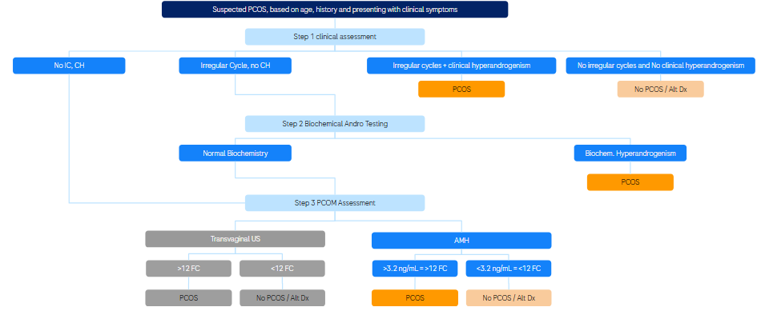
PMOS / PCOS diagnosis without AMH testing:
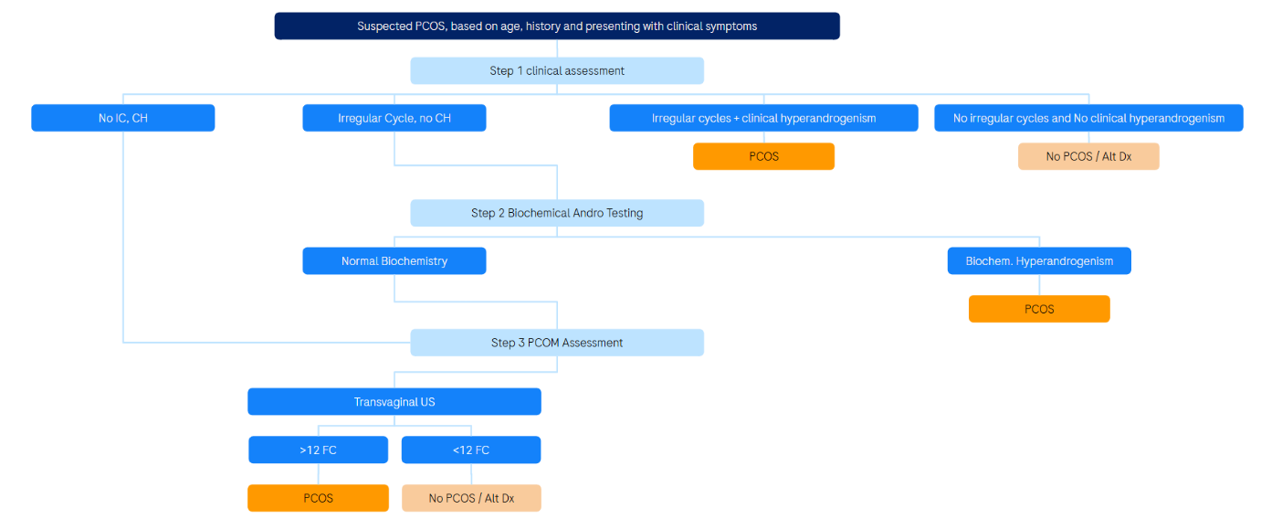

Claims
In terms of health outcomes (comparative benefits and harms), is the proposed technology claimed to be superior, non-inferior or inferior to the comparator(s)?
(Please select your response)
Superior
Non-inferior
Inferior
Please state what the overall claim is, and provide a rationale:
AMH testing is a non-inferior option to establish PCOM in the context of PMOS diagnosis.
Why would the requestor seek to use the proposed investigative technology rather than the comparator(s)?
Serum (blood) tests may be seen as less invasive and less time consuming than a transvaginal ultrasound. Chemical pathology tests are often bulk-billed by providers, and are likely to be a less costly option for patients. Requestors may also prefer AMH testing as it may provide faster test turn-around depending on availability of ultrasound appointments.
Identify how the proposed technology achieves the intended patient outcomes:
In women with suspected PCOS, ovarian morphology is typically assessed using transvaginal or transabdominal ultrasound to determine FNPO and/or ovarian volume. PCOM is characterised by an increased number of small antral follicles (typically 2–9 mm in diameter). These follicles contain granulosa cells, which are the primary source of AMH secretion. Consequently, serum AMH concentration is directly proportional to the number of small growing follicles present in the ovary. Women with PCOM therefore have elevated AMH levels compared with women without PCOM.
Because AMH reflects the same biological substrate measured by ultrasound follicle count, AMH testing can serve as a surrogate marker for FNPO. Higher follicle counts lead to higher circulating AMH concentrations, allowing biochemical identification of PCOM without the need for imaging. This relationship is supported by multiple studies demonstrating strong correlations between AMH levels and ultrasound-derived follicle counts.
For some people, compared with the comparator(s), does the test information result in:
A change in clinical management? No
A change in health outcome? No
Other benefits? Yes
Please provide a rationale, and information on other benefits if relevant:
AMH testing is likely to be lower cost, and offers a less invasive and potentially more accessible option for patients in diagnosing PMOS.
In terms of the immediate costs of the proposed technology (and immediate cost consequences, such as procedural costs, testing costs etc.), is the proposed technology claimed to be more costly, the same cost or less costly than the comparator?
(Please select your response)
More costly
Same cost
Less costly
Provide a brief rationale for the claim:
The proposed scheduled fee has been benchmarked to existing MBS reimbursement for NT-proBNP testing. It is likely that this scheduled fee represents a cost-saving, including considering cases in which a false negative AMH test results in a subsequent referral for ultrasound to further investigate PCOM. It is also likely that AMH testing will represent a substantial saving for patients, as out-of-pocket costs for ultrasound are more common than out-of-pocket costs for pathology services. This will substantially improve access to health-care services for women, and may lead to indirect benefits to the health system more broadly through more effective identification of people at increased risk of long-term metabolic and cardiovascular disease risk (both of which are associated with PMOS, see for example, Gupta et al 2026).
If your application is in relation to a specific radiopharmaceutical(s) or a set of radiopharmaceuticals, identify whether your clinical claim is dependent on the evidence base of the radiopharmaceutical(s) for which MBS funding is being requested. If your clinical claim is dependent on the evidence base of another radiopharmaceutical product(s), a claim of clinical noninferiority between the radiopharmaceutical products is also required.
Not applicable

Summary of Evidence
Provide one or more recent (published) high quality clinical studies that support use of the proposed health service/technology. At ‘Application Form lodgement’,
Do not attach full text articles; just provide a summary (repeat columns as required).
 | Type of study design* | Title of journal article or research project (including any trial identifier or study lead if relevant) | Short description of research (max 50 words)** | Website link to journal article or research (if available) | Date of publication***
1. | Retrospective, multicenter, case-control study | Antimüllerian hormone to determine polycystic ovarian morphology (APHRODITE) | Retrospective multicenter study evaluating serum AMH levels using the Roche Elecsys AMH Plus immunoassay to establish a diagnostic cutoff for identifying polycystic ovarian morphology (PCOM). Compared with transvaginal ultrasound, this study supports AMH as a useful biomarker in PCOS diagnosis. | DOI: 10.1016/j.fertnstert.2021.05.094 | October 2021
2. | Prospective, population-based noninterventional observational study | Prospective validation of anti-Müllerian hormone cutoff to determine polycystic ovarian morphology: HARMONIA study | Large prospective observational study validating a serum AMH cutoff (3.2 ng/mL) for detecting PCOM. Findings show strong correlation with transvaginal ultrasound and support the practical application of AMH testing in routine PCOS diagnostic workup. | https://doi.org/10.1016/j.fertnstert.2025.05.147 | September 2025
3. | Guidelines | International Evidence-based Guideline for the assessment and management of polycystic ovary syndrome 2023 | Comprehensive international guideline providing evidence-based recommendations for PCOS diagnosis, assessment, and management. Includes guidance on the use of serum AMH and imaging criteria for identifying PCOM, as well as treatment strategies for reproductive, metabolic, and psychological aspects of PCOS. | https://www.monash.edu/__data/assets/  pdf_file/0003/3379521/Evidence-Based-Guidelines-2023.pdf | February 2023
4. | Systematic literature review | Polycystic Ovary Syndrome (PCOS)  Technical Reportfor the International Evidence-based Guideline for the assessment  and management of polycystic ovary syndrome 2023 | Evidence summary and GRADE in relation to the use of AMH testing for PMOS diagnosis, prepared by the independent Evidence Team as part of the development of the International Gruidelines (3). | https://www.monash.edu/__data/assets/pdf_file/0010/3379591/TechnicalReport-2023.pdf | 2023
5. | Retrospective cohort study | Atherosclerotic cardiovascular disease risk in polyendocrine metabolic ovarian syndrome: a nationwide, US, claims-based, retrospective, longitudinal, cohort study | [These findings show] that women with PMOS had a higher incidence of ASCVD events than women without PMOS emphasise the need for health-care provider education and PMOS patient awareness of cardiovascular disease risk to improve implementation of early preventive interventions. | https://doi.org/10.1016/S3050-5038(26)00090-7 | 2026

