MSAC Application 1821
Testing for Chromogranin A in patients with neuroendocrine neoplasms (NENs)
Applicant: The Royal College of Pathologists of Australasia

PICO Confirmation

Summary of PICO/PPICO criteria to define question(s) to be addressed in an Assessment Report to the Medical Services Advisory Committee (MSAC)
Table 1 PICO for repeated Chromogranin A (CgA) testing for monitoring of patients with well differentiated advanced/metastatic neuroendocrine neoplasms (NENs): PICO Set 1
Component | Description
Population | Patients with a well differentiated neuroendocrine neoplasm (NEN) who have metastatic (stage IV) and/or locally advanced (stage III) disease.
Prior tests | Diagnostic work up for NEN, this would include anatomical (US, X-ray, CT/MRI) and functional imaging (68Ga-DOTATATE PET/CT, 18F-FDG PET) biopsy and histopathology.
Intervention | Repeated circulating Chromogranin A (CgA) testing for monitoring NEN progression/recurrence using one of several immunoassay platforms (radioimmunoassay (RIA), immunoradiometric assay (IRMA) and enzyme-linked immunosorbent assay (ELISA)) in addition to imaging and clinical review.
Comparator/s | Monitoring for disease progression or recurrence using imaging and clinical review
Reference standard | There is no recognised reference standard for Chromogranin A (CgA) testing, but results of CT/MRI are likely to provide the best reference for progression and recurrence.
Clinical utility standard | The applicant did not propose a clinical utility standard but have suggested that a sustained or clinically meaningful increase in CgA (e.g. ≥50% rise to >100 ng/mL) may prompt escalation to confirmatory testing. This is taken from Meng, et al. (2024) where 8.5 to 10 mL of blood was collected and processed to obtain serum. CgA concentrations were measured using the automated B·R·A·H·M·S CgA II KRYPTOR immunofluorescence assay (KRYPTOR Compact Plus), with samples analysed fresh or after storage at −80°C.
Outcomes | Safety  • Harm associated with absence of testing.  • Harm associated with false positive or false negative results.  Test performance  • Sensitivity.  • Specificity.  • Positive and negative predictive values.  • Correlation of rising CgA with radiological progression.  • Accuracy of CgA in identifying disease progression or recurrence.  Change in clinical management  • Earlier specialist review.  • Earlier CT/MRI or PET imaging.  • Progression/recurrence detection.  • Time to detection of progression compared with routine surveillance.  • Earlier initiation, escalation, or modification of treatment  Clinical Effectiveness Outcomes  • Overall survival.  • Progression-free survival.  • Health-related quality of life.  • Symptom control.  • Avoidance of progression-related complications.  Healthcare resource use  • Number and timing of CT/MRI scans.  • Use of PET imaging.  • Number of specialist consultations.  • Hospitalisations and emergency presentations.  • Costs associated with the intervention.  • Downstream imaging costs.  • Change in therapy and costs  Economic outcomes  • Cost per patient with positive result.  • Incremental cost per management change.  • Incremental cost per quality-adjusted life-year (QALY) gained.
Assessment questions | What is the safety, effectiveness, cost-effectiveness and financial impact of serial CgA testing for monitoring of progression/relapse versus standard practice in patients with a well differentiated NEN who have advanced and/or metastatic disease?

Purpose of application
An application requesting Medicare Benefits Schedule (MBS) listing of Chromogranin A (CgA) testing for monitoring of patients with well differentiated advanced and/or metastatic neuroendocrine neoplasms (NENs) was received from The Royal College of Pathologists of Australasia by the Department of Health, Disability and Ageing.

PICO criteria

Population
The applicant proposed population is patients with well differentiated, locally advanced (stage 3) and/or metastatic (stage 4) NEN who are undergoing ongoing surveillance during treatment or follow-up, where there is a clinical need to monitor for disease progression or recurrence. The Clinical Oncology Society of Australia (COSA) Neuroendocrine Neoplasms (NENs) Consensus Guidelines (consensus guidelines) recommends the use of CgA in a broader patient population:
- patients who have metastatic disease treated, for the evaluation of response or progression, and
- patients with completely resected disease, for relapse monitoring, but this is not requested in this application.
Neuroendocrine neoplasms comprise a diverse group of cancers with widely variable clinical behaviour and outcomes. They include well- and moderately differentiated tumours, as well as poorly differentiated neuroendocrine carcinomas. NENs are generally divided into 3 grades (poorly differentiated NECs are not formally graded but are considered high-grade by definition), based on mitotic rate and Ki-67 index but can vary depending on location of the tumours (Table 2) (Rindi, Mete et al. 2022). These tumours most frequently originate in the gastroenteropancreatic system; particularly the small intestine, rectum, and pancreas, as well as the lungs (Klimstra, Modlin et al. 2010, Maxwell, Yao et al. 2022). Clinically, they may be classified as functional (hormone-secreting) or non-functional (Maxwell, Yao et al. 2022).
Table 2 The World Health Organization (WHO) 2022 Epithelial Neuroendocrine Neoplasms Classification for Different Anatomic Sites (Rindi, Mete et al. 2022).
Neuroendocrine neoplasm | Classification | Diagnostic criteria
Gastrointestinal and pancreatobiliary tract
Well-differentiated neuroendocrine tumour | NET, grade 1 | < 2 mitoses/2 mm² and/or Ki67 < 3%
Well-differentiated neuroendocrine tumour | NET, grade 2 | 2–20 mitoses/2 mm² and/or Ki67 3–20%
Well-differentiated neuroendocrine tumour | NET, grade 3 | > 20 mitoses/2 mm² and/or Ki67 > 20%
Poorly differentiated neuroendocrine carcinoma | Small cell NEC | > 20 mitoses/2 mm² and/or Ki67 > 20% (often > 70%), and small cell cytomorphology
Poorly differentiated neuroendocrine carcinoma | Large cell NEC | > 20 mitoses/2 mm² and/or Ki67 > 20% (often > 70%), and large cell cytomorphology
Upper aerodigestive tract and salivary glands
Well-differentiated neuroendocrine tumour | NET, grade 1 | < 2 mitoses/2 mm² and no necrosis, and Ki67 < 20%
Well-differentiated neuroendocrine tumour | NET, grade 2 | 2–10 mitoses/2 mm² and/or necrosis, and Ki67 < 20%
Well-differentiated neuroendocrine tumour | NET, grade 3 | > 10 mitoses/2 mm² and/or Ki67 > 20%
Poorly differentiated neuroendocrine carcinoma | Small cell NEC | > 10 mitoses/2 mm² and/or Ki67 > 20% (often > 70%) and small cell cytomorphology
Poorly differentiated neuroendocrine carcinoma | Large cell NEC | > 10 mitoses/2 mm² and/or Ki67 > 20% (often > 55%) and large cell cytomorphology
Lung and thymus
Well-differentiated neuroendocrine tumour | Typical carcinoid/NET, grade 1 | < 2 mitoses/2 mm² and no necrosis
Well-differentiated neuroendocrine tumour | Atypical carcinoid/NET, grade 2 | 2–10 mitoses/2 mm² and/or necrosis (usually punctate)
Well-differentiated neuroendocrine tumour | Carcinoids/NETs with elevated mitotic counts and/or Ki67 proliferation index | Atypical carcinoid morphology and a higher (> 10 mitoses per 2 mm²) mitotic count and/or a higher (> 30%) Ki67
Poorly-differentiated neuroendocrine carcinoma | Small cell (lung) carcinoma | > 10 mitoses/2 mm², often necrosis and small cell cytomorphology
Poorly-differentiated neuroendocrine carcinoma | Large cell NEC | > 10 mitoses/2 mm², virtually always necrosis and large cell cytomorphology
Thyroid
Medullary thyroid carcinomas | Low-grade MTC | < 5 mitoses/2 mm² and no necrosis and Ki67 < 5%
Medullary thyroid carcinomas | High-grade MTC | At least one of the following 3 features:  ≥ 5 mitoses/2 mm²  Necrosis  Ki67 ≥ 5%
MTC = Medullary thyroid carcinomas; NEC = neuroendocrine carcinoma; NET = neuroendocrine tumour.
Clinical presentation varies considerably, ranging from symptoms related to tumour bulk (such as abdominal pain, obstruction, bleeding, or respiratory symptoms) to hormone-mediated syndromes, including flushing and diarrhoea in carcinoid syndrome or episodic hypoglycaemia in insulinoma (Maxwell, Yao et al. 2022, Clinical Oncology Society of Australia 2023). Disease course is determined largely by tumour stage and grade. Localised disease is often amendable to total resection and has excellent outcomes (>90% 5-year survival in some gastroenteropancreatic -NEN series), while metastatic and/or high-grade disease has markedly poorer survival, with strong variation by site (e.g. 5-year survival ~88% for rectal NEN vs ~53% for pancreatic NEN) (Wu, He et al. 2023).
Population considerations:
Certain patient populations may be less suitable for CgA testing due to reduced sensitivity, limited clinical utility, or the presence of significant confounding factors.
- CgA concentrations may remain within the normal range in some neuroendocrine tumours (NETs), particularly those with low proliferative potential, including appendiceal NETs, as well as in the majority of insulinomas. Similarly, NETs arising in the lung (typical carcinoids), duodenum and rectum may not consistently produce elevated CgA levels. Rapidly proliferating, poorly differentiated neuroendocrine tumours may also fail to secrete CgA, resulting in false-negative test results.
- In addition, CgA appears to have limited value as a biomarker for monitoring treatment response or disease progression in patients with bronchopulmonary NETs (BPNETs) and other NETs, with evidence indicating that neither absolute CgA levels nor changes in CgA over time reliably reflect somatostatin analogue treatment efficacy or disease progression (Matar, Malczewska et al. 2020).
- Furthermore, CgA is a non-specific neuroendocrine secretory protein and can be elevated in the absence of tumour activity due to a range of common factors, including proton pump inhibitor use, gastritis, renal or hepatic impairment, inflammatory bowel disease, glucocorticoid therapy, and the presence of rheumatoid factor. In these patients, CgA results may be difficult to interpret and should be assessed in the context of relevant medications and comorbidities, with reversible confounders addressed where possible and serial measurements interpreted cautiously using a consistent assay platform (Marotta, Zatelli et al. 2018, Cancer Council Australia 2023).
Historical data indicate the incidence of NENs is increasing (Figure 1). The most recent age-standardised incidence rate reported by the Australian Institute of Health and Welfare (AIHW) was around 19 per 100,000 in 2021 (21.4 per 100,000 in males and 17.4 per 100,000 in females), noting that the eligible population is a subset of these (AIHW 2025). The prevalence of NENs is high as many are indolent and chronic, contributing to a substantial survivorship population, as at end of 2021 there were 14,091 who were alive and had been diagnosed with NEN between 2017 and 2021. Based on a US study, NENs are typically diagnosed in later life, with a median age at diagnosis of 57, and the majority are diagnosed with localised cancer (53.3%) (Wu, He et al. 2023). This equates to an incident population of patients with metastatic NEN at approximately 9 per 100,000 (50.3% regional and 49.7% distant metastasis) (Wu, He et al. 2023, AIHW 2025). An older study from Queensland on small intestinal neuroendocrine tumours, demonstrated that the ileum was the most common primary tumour site, accounting for 49.1% of cases, and 84.2% of tumours exhibited carcinoid morphology (Wyld, Moore et al. 2021). Disease stage at diagnosis was available for 91.7% of patients, of whom 28.3% presented with regional disease and 23.9% had distant metastatic disease a similar rate to the US study of 52.2% of patients being eligible (Wyld, Moore et al. 2021).
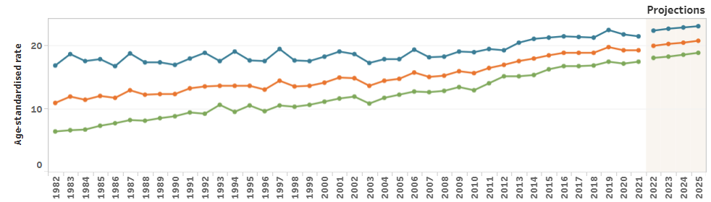
Figure 1 Age-standardised (2025 Australian population) incidence rate for NENs by sex, 1982 to 2025 (AIHW 2025)

PASC noted the substantial heterogeneity of neuroendocrine neoplasms and that some neuroendocrine tumours do not produce or secrete sufficient CgA to result in elevated blood concentrations. PASC also noted that for some subtypes (e.g. BPNETS) there is published evidence that serum CgA monitoring is of limited value. However, PASC noted that the proposed population did not specify patients must have an elevated baseline CgA. PASC questioned the clinical utility of serial monitoring in patients whose tumours do not produce elevated serum CgA and considered that the population description should be clear that a baseline CgA measurement should be undertaken to establish that CgA is elevated before commencing serial monitoring.
PASC queried the justification for the proposed population, noting that it did not directly align with the population described in the COSA consensus statement, did not exclude subtypes where CgA monitoring is known to be of limited value and was broader than the more selected populations evaluated in the available evidence. The applicant explained that the proposed focus on patients with advanced disease reflected the view that these patients are more likely to have elevated CgA and that false-positive elevations are less likely to be clinically significant where CgA levels are substantially elevated. The applicant also considered that serial CgA monitoring may be most useful in selected patients with more indolent disease.
PASC noted that the available evidence did not clearly establish which patient subgroups would benefit from serial CgA monitoring. PASC noted the key study (CASPAR) included patients with advanced differentiated gastroenteropancreatic neuroendocrine tumours and excluded patients with conditions or medications that could cause false-positive CgA results. PASC also noted that while the COSA consensus statement described populations that may benefit from CgA monitoring, this was based on expert opinions and was not underpinned by a systematic review of the evidence to demonstrate that CgA monitoring in the proposed populations led to improved patient outcomes. PASC acknowledged the challenges when there is limited evidence for best practice management of patients with a rare disease. However, PASC noted that the MSAC process is a technical evidenced based process where expert opinion is insufficient. As such, the COSA consensus statements are not fit for purpose for defining an evidenced-based proposed population for CgA monitoring for MBS funding.
PASC considered that the proposed population required further refinement and justification, including clearer definition of the patient subgroup for whom there is evidence that serial CgA monitoring would be clinically useful and lead to improved patient outcomes.

Intervention
The intervention is serial serum Chromogranin A (CgA) testing, in addition to imaging and clinical review, for monitoring for patients with well-differentiated NENs. The CgA test is used as part of ongoing surveillance and treatment monitoring, with repeated blood measurements performed over time to track disease activity, assess treatment response, and detect recurrence or progression. There are variations on how CgA is measured, but based on the study by Meng, et al. (2024) blood is collected and processed to obtain serum. CgA concentrations are measured using the automated immunofluorescence assays, with samples analysed fresh or after storage at −80°C [10].
CgA would be collected and analysed more frequently than routine imaging, there is currently no recognised standard frequency of monitoring, rather the frequency would be determined by the clinician based on the individual patient. A sustained rise in CgA would potentially prompt earlier clinical assessment and cross-sectional imaging, followed by specialist review and confirmatory imaging if needed. The intervention is intended to complement, rather than replace, routine monitoring with clinical review and radiological investigations. Clinicians may decide, on an individual patient bases, to reduce the frequency of imaging if they were comfortable with the CgA and clinical assessment.
Routine surveillance of metastatic NENs would continue to rely on scheduled imaging, regardless of whether serial CgA monitoring is performed. Although CgA may provide supplementary information and may occasionally trigger earlier clinical review or imaging when results change significantly, it is not considered sufficiently accurate to replace or reduce the frequency of standard radiological assessment. Consequently, the use of CgA monitoring is generally expected to be additive to, rather than a substitute for, routine imaging surveillance.
The proposed intervention is closely aligned with COSA consensus guidelines, which state that Chromogranin A (CgA) measurement may be useful for evaluating treatment response and for detecting disease progression or recurrence, particularly in patients with elevated baseline levels (Clinical Oncology Society of Australia 2023).
The intervention also reflects guideline recommendations that CgA should be used as an adjunct rather than a standalone test. In the proposed pathway, serial CgA results are interpreted alongside clinical review and imaging, with rising CgA levels prompting earlier confirmatory investigations such as CT, MRI, or somatostatin receptor PET imaging. This approach mirrors guideline recommendations that biomarker results should be considered in conjunction with radiological and clinical findings.
There are some key considerations with the testing of CgA:
- Different laboratory methodologies radioimmunoassay (RIA), immunoradiometric assay (IRMA), and enzyme-linked immunosorbent assay (ELISA) and other platforms) can produce different results, and there is no universally accepted standard assay. This limits comparability across laboratories and reinforces the need for consistent testing using same assay format within the same laboratory.
- CgA is a non-specific neuroendocrine secretory protein, it can also be elevated by common non-tumour factors including proton pump inhibitor use, gastritis, renal or hepatic impairment, inflammatory bowel disease, glucocorticoid therapy, and rheumatoid factor (Cancer Council Australia 2023, Koffas, Giakoustidis et al. 2023). As a result, CgA results should be interpreted within the broader clinical context and monitored using a consistent assay where possible. Clinicians should consider potential confounders and address reversible causes before attributing changes in CgA levels to tumour progression.
- Interpretation of serial CgA results is complicated by the absence of a universally accepted threshold for indicating disease progression. Different studies have proposed different definitions of a clinically meaningful change. For example, Tsai et al. (2021) found that a ≥40% increase in CgA during follow-up was associated with a significantly higher likelihood of tumour progression or recurrence, whereas the prospective CASPAR study defined a positive result as a ≥50% increase from the previous measurement reaching an absolute concentration >100 ng/mL.(Tsai, Hsiao et al. 2021). The use of different thresholds across studies highlights the lack of consensus regarding the magnitude of CgA change that should trigger further investigation or management modification (Tsai, Hsiao et al. 2021, Meng, Halfdanarson et al. 2024).
- Uncertainty also exists regarding the optimal frequency and duration of CgA monitoring. While some guidelines recommend monitoring every 3–12 months depending on tumour type, stage, treatment status, and disease stability, these recommendations are largely consensus-based and supported by limited prospective evidence (Clinical Oncology Society of Australia 2023). The CASPAR investigators noted that current guideline recommendations encompass a broad range of imaging and follow-up intervals, reflecting the lack of robust evidence informing surveillance schedules. For well-differentiated neuroendocrine neoplasms (NENs), follow-up is generally long-term and often lifelong, reflecting the typically indolent disease course and the possibility of late recurrence or progression (Tareco Bucho, Pascucci et al. 2025). Furthermore, a comprehensive review by Marotta et al. (2018) concluded that the role of serial CgA measurements in follow-up remains controversial, citing assay variability, lack of standardisation, and insufficient prospective evidence linking biomarker changes with clinically meaningful outcomes (Marotta, Zatelli et al. 2018).
CgA is of limited utility and not intended as a diagnostic biomarker. CgA lacks both sensitivity and specificity; levels may remain normal in several NET subtypes, resulting in false-negative results, while numerous non-tumour conditions and medications can cause elevated CgA concentrations, leading to false-positive findings and reducing its diagnostic accuracy (Baekdal, Krogh et al. 2020).
PASC queried the challenges associated with interpreting serial CgA measurements given intra-assay variability, inter-assay variability between the three available antibody-based assays and variability between laboratories. PASC noted that serial CgA monitoring would require consistent use of the same assay for an individual patient because results obtained using different assays are not directly comparable. PASC also noted that even when using the same assay, the COSA guidelines note inter-assay variability can be up to ±20%. PASC noted the suggestion that one way to address this was that laboratories should provide confidence intervals and interpatient variation in duplicate samples. The applicant’s clinical expert advised that one assay is currently used by most Australian laboratories and that the RCPA Quality Assurance Program provides a mechanism for ensuring that assay performance is assessed in laboratories, regardless of the assay used.
PASC also questioned how an actionable change in CgA would be defined. PASC noted that thresholds used in the available evidence varied. For example, one Australian retrospective study (Nguyen et al 2022) used an increase of 25% as the threshold, while the CASPAR study considered an increase ≥50% above the prior CgA concentration to a value >100 ng/mL in the following CgA concentration as positive. PASC noted the applicant’s pre-PASC response was open to using the CASPAR threshold for the assessment but did not support applying the use of a universal clinical decision rule. The applicant’s clinical experts advised that interpretation would depend on the magnitude and rate of change in CgA, together with symptoms, radiological findings and other clinical risk factors. PASC considered the lack of an evidence base for an actionable change in CgA levels problematic, and that the applicant would need to clearly specify how an actionable change in CgA would be defined and applied in clinical practice based on evidence before a Health Technology Assessment can be undertaken to evaluate how CgA monitoring leads to a change in patient management and improved patient outcomes.
PASC also noted that CgA results may be affected by comorbidities and medications that can cause false-positive elevations, further complicating the interpretation of serial measurements. The applicant’s clinical experts acknowledged the importance of considering these factors when interpreting results and advised that where a significant rise in CgA was not supported by imaging findings, CgA may subsequently be considered less useful for monitoring in that individual patient. PASC considered that the proposed monitoring strategy should clarify how potentially false-positive or discordant CgA results would be managed.
PASC considered that the frequency and duration of CgA monitoring also required specification. Without a defined testing interval/schedule for CgA monitoring and how this compares with current monitoring, the assessment would not be able to evaluate the benefit of CgA monitoring. The applicant’s clinical expert considered that testing up to four times per year may be appropriate, with 3- to 6-monthly testing sufficient for many patients and less frequent testing potentially appropriate for patients with more indolent disease. PASC noted that the applicant was not aware of prospective evidence evaluating CgA monitoring at standardised intervals and how the results subsequently informed changes in clinical management.
PASC sought clarification regarding the clinical place of CgA monitoring, particularly whether it was intended solely as an adjunct to scheduled imaging or whether it could be used to reduce or defer imaging in selected patients. The applicant’s clinical experts advised that CgA should not be used in isolation to determine a change in treatment, as imaging remains necessary to confirm disease progression and inform treatment selection. However, in selected patients with stable or indolent disease and an elevated baseline CgA that is considered informative, the applicant’s clinical experts considered that CgA monitoring could potentially be used to reduce the frequency of scheduled imaging or prompt earlier imaging where a significant rise occurs. PASC noted that the applicant’s experts advice that CgA monitoring could reduce imaging frequency in some instances (i.e. CgA monitoring could possibly replace imaging in some instances), appeared to contradict what was formally put forward as part of the application. That is, the applicant’s pre-PASC response stated that CgA monitoring is not intended for replacement of imaging, it is additive to scheduled clinical review and imaging, and that reduction in imaging should not be treated as a defining clinical claim or assumption in the economic model. PASC considered that the intended role and clinical place of CgA in relation to imaging and subsequent clinical management needed to be clearly and consistently defined and supported by evidence.
Overall, PASC considered that the proposed serial CgA monitoring strategy required further clarification, particularly regarding the definition of an actionable change, management of potentially false-positive or discordant results, testing frequency and duration, and the intended role and place of CgA in relation to imaging and subsequent clinical management.

Comparator(s)
The comparator is current practice without serial Chromogranin A (CgA) monitoring. In this pathway, patients with metastatic well-differentiated NENs are monitored through routine specialist review, symptom assessment, physical examination, and scheduled imaging (typically CT or MRI), with functional imaging such as ⁶⁸Ga-DOTATATE PET/CT used selectively when progression is suspected or imaging findings are inconclusive.
The COSA Guidelines recommend that response assessment and follow-up in patients with NENs should be based on a combination of clinical evaluation, quality-of-life measures, biochemical markers (this depends on tumour site but can include: urine 5-hydroxyindoleacetic acid, blood glucose, C-peptide, Pro-insulin, Serum acid phosphatase, urinary serotonin and many more), and imaging findings, with the surveillance strategy individualised according to patient and disease characteristics (Cancer Council Australia 2023). Radiological imaging and molecular PET/CT imaging are considered complementary modalities and should be used as appropriate based on the clinical context. The recommended frequency of follow-up and choice of imaging modality should take into account factors such as tumour grade, disease extent, growth kinetics, baseline imaging characteristics, anticipated treatment response, and the patient's overall health status (Cancer Council Australia 2023). The applicant stated that computed tomography (CT) or magnetic resonance imaging (MRI) is typically performed at predefined intervals, commonly every 3 to 12 months depending on tumour grade, primary site, disease burden, and treatment strategy, to determine whether disease remains stable or has progressed. In general, the COSA guidelines recommend less intensive surveillance for patients with localised or low-grade disease, whereas more frequent monitoring may be appropriate for patients with higher-grade NENs, FDG-avid metastatic disease, substantial tumour burden, aggressive tumour behaviour, severe hormone-related symptoms, or elevated CgA concentrations (Cancer Council Australia 2023). Where conventional imaging findings are equivocal, there is clinical suspicion of progression, or imaging results are likely to influence management decisions, functional imaging may also be employed. This may include somatostatin receptor imaging with ⁶⁸Ga-DOTA-peptide PET/CT and, in selected patients with higher-grade disease, ¹⁸F-FDG PET imaging. There may be a tendency amongst some clinicians to move straight to functional imaging and skip cross sectional imaging.
Disease progression is therefore identified primarily through clinical assessment and imaging rather than longitudinal biomarker testing.

Clinical criteria suggestive of progression
Suspicion of progression may arise from the development of new symptoms or worsening existing symptoms, including carcinoid syndrome manifestations, pain, weight loss, declining performance status, bowel obstruction, ascites, or other tumour-related complications (Lamarca, Bartsch et al. 2024).

Imaging criteria suggestive of progression
On CT or MRI, progression is typically assessed using RECIST 1.1 criteria and may be defined by (Tareco Bucho, Pascucci et al. 2025):
- A ≥20% increase in the sum of diameters of target lesions (with a minimum absolute increase of 5 mm).
- The appearance of one or more new lesions.
- Unequivocal progression of non-target lesions.

Functional imaging criteria suggestive of progression (Tareco Bucho, Pascucci et al. 2025):
- Functional imaging may be performed when conventional imaging is equivocal or when there is clinical suspicion of progression. Findings suggestive of progression include:
- New somatostatin receptor-positive lesions on SSTR PET/CT.
- Increased extent of disease demonstrated on SSTR PET/CT.
- New or increased ^18F-FDG uptake, particularly in higher-grade disease, which may indicate more aggressive tumour biology or dedifferentiation.
PASC considered that the proposed comparator of monitoring without CgA was appropriate in principle but required further specification. PASC considered that the comparator should reflect current standard of care, comprising clinical review and imaging, without serial CgA monitoring. PASC noted that CT and MRI form part of routine monitoring, with further imaging undertaken where clinically indicated.
PASC noted that the proposed comparator did not specify the frequency or modality of routine monitoring. PASC considered that these should be defined to establish the standard-care monitoring pathway against which serial CgA monitoring would be compared.
Overall, PASC considered that the comparator should be more clearly defined, particularly regarding the frequency and modality of standard-care monitoring.

Reference standard (for investigative technologies only)
The reference standard was radiologically confirmed disease status, primarily determined using CT and/or MRI (often according to Response Evaluation Criteria in Solid Tumors (RECIST) criteria), supplemented by functional imaging and clinical assessment where appropriate.
PASC noted that there was no recognised reference standard for evaluating serial CgA monitoring. The application proposed CT or MRI as possible reference standards. PASC noted that CT and MRI form part of the current standard of care and queried whether Ga-68 DOTATATE PET/CT may be a more appropriate reference standard for confirming suspected disease progression or recurrence.
PASC considered that the reference standard used to assess the test performance of serial CgA monitoring should be clearly defined, including the imaging modality against which changes in CgA would be assessed. No single reference standard was agreed at the PASC meeting.

Clinical utility standard (for codependent investigative technologies only)
The applicant did not propose a clinical utility standard but have suggested that a sustained or clinically meaningful increase in CgA (e.g. ≥50% rise to >100 ng/mL) may prompt escalation to confirmatory testing. This is taken from Meng, et al. (2024) where 8.5 to 10 mL of blood was collected and processed to obtain serum. CgA concentrations were measured using the automated B·R·A·H·M·S CgA II KRYPTOR immunofluorescence assay (KRYPTOR Compact Plus), with samples analysed fresh or after storage at −80°C [10].
Different laboratory methodologies including radioimmunoassay (RIA), immunoradiometric assay (IRMA), and enzyme-linked immunosorbent assay (ELISA) and other platforms can produce different results, and there is no universally accepted standard assay. This limits comparability across laboratories and reinforces the need for consistent testing using the same assay format within the same laboratory.
PASC noted that no clinical utility standard was identified for serial CgA monitoring. The available studies did not evaluate a defined CgA test and method of interpretation that was used to allocate patients to alternative management options and demonstrate subsequent health outcome gains.
PASC noted that the CASPAR study provided information on the test performance of serial CgA monitoring using a predefined change in CgA but did not provide direct evidence that changes in patient management based on CgA results improved patient health outcomes. PASC therefore considered that CASPAR did not establish a clinical utility standard for the proposed use of serial CgA monitoring.

Outcomes
The PICO set proposes relevant outcomes across the domains of health benefits, health harms, resource use, and value of knowing, with a particular focus on the ability of serial CgA monitoring to detect disease progression and inform clinical management. However, as there is no direct evidence linking CgA testing to patient health outcomes, a linked-evidence approach will be required to demonstrate clinical utility. This approach will assess the relationship between test performance, the impact of CgA results on clinical decision-making and management, and subsequent effects on patient health outcomes across the domains specified in the PICO framework.
Safety
- Harm associated with absence of testing.
- Harm associated with false positive or false negative results.
Test accuracy
- Sensitivity.
- Specificity.
- Positive and negative predictive values.
- Ability of rising CgA to predict radiological progression.
- Accuracy of CgA in identifying disease progression or recurrence.
Change in clinical management
- Earlier specialist review.
- Earlier CT/MRI or PET imaging.
- Progression/recurrence detection.
- Time to detection of progression compared with routine surveillance.
- Earlier initiation, escalation, or modification of treatment.
- Reduction in imaging.
Health outcomes resulting from change in management
- Overall survival.
- Progression-free survival.
- Health-related quality of life.
- Symptom control.
- Avoidance of progression-related complications.
Healthcare resource use
- Number and timing of CT/MRI scans.
- Use of PET imaging.
- Number of specialist consultations.
- Hospitalisations and emergency presentations.
- Costs associated with the intervention including cost of appointments, cost of test processing and out-of-pocket costs.
- Downstream imaging costs.
- Change in therapy and costs
Economic outcomes
- Cost per patient with positive result.
- Incremental cost per management change.
- Incremental cost per quality-adjusted life-year (QALY) gained.

PASC considered that the proposed patient-relevant outcomes, including survival, disease control and quality of life, were appropriate. PASC noted, however, that the evidence presented in the PICO primarily related to test performance and did not demonstrate how serial CgA monitoring would lead to changes in clinical management and subsequent patient health outcomes. PASC noted that the CASPAR study provided test-performance data but did not evaluate downstream health outcomes.
PASC considered that change-in-management outcomes such as earlier specialist review, earlier imaging or earlier treatment would need to be linked to patient-relevant outcomes to establish the clinical utility of serial CgA monitoring. PASC queried whether there was evidence from longitudinal studies in which CgA was measured at defined intervals and changes in CgA informed subsequent clinical management and patient outcomes. The applicant’s clinical expert advised that they were not aware of prospective evidence addressing this question.
PASC also noted consultation feedback highlighting the potential value of knowing a patient’s CgA result. PASC noted that this may represent a patient-relevant benefit distinct from changes in health outcomes and considered that, if included as an outcome in the assessment, the value of knowing should be clearly defined and distinguished from outcomes such as health-related quality of life.
Overall, PASC considered that the proposed outcomes were appropriate but noted that there is likely insufficient evidence to assess the outcomes, in particular changes in clinical management and patient-relevant health outcomes.

Assessment framework (for investigative technologies)
The evidence supporting serial CgA monitoring in patients with NENs appears limited and is largely confined to test performance rather than clinical utility. Preliminary literature searches have identified studies evaluating the diagnostic and prognostic performance of CgA, but these studies also highlight important limitations in sensitivity and specificity.
Importantly, there appears to be little direct evidence demonstrating that serial CgA monitoring leads to changes in clinical management that improve patient outcomes or leads to change in management. While CgA results may influence decisions regarding further investigation or follow-up, preliminary searches have not identified robust evidence showing that routine CgA monitoring improves the detection of progression, alters treatment decisions, or leads to better patient outcomes compared with standard surveillance based on clinical assessment and imaging. Consequently, the evidence base is likely to support test performance outcomes but provide limited evidence for downstream outcomes such as change in management, health outcomes, or resource use. A linked-evidence approach will therefore be required to assess the clinical utility of serial CgA monitoring.
Figure 2 provides the assessment framework for serial serum CgA monitoring for patients with well-differentiated NENs and advanced or metastatic disease. The direct evidence pathway has been included for completeness.
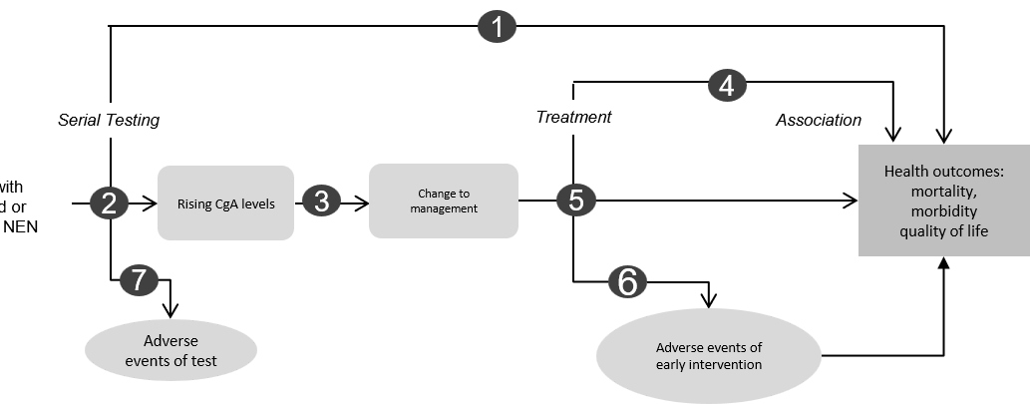
Figure 2 Assessment framework showing the links from the test population to health outcomes
Figure notes: 1: direct from test to health outcomes evidence; 2: test accuracy; 3: change in diagnosis/treatment/management; 4: influence of the change in management on health outcomes; 5: influence of the change in management on intermediate outcomes; 6: adverse events due to treatment; 7: adverse events due to testing;
Assessment questions mapped to the assessment framework:
Direct Evidence
- What is the comparative safety and effectiveness of serial serum CgA versus no serial serum CgA in patients with well-differentiated NENs?
Indirect Evidence
- What is the diagnostic yield of serial serum CgA in patients with well-differentiated NENs? What CgA threshold (absolute concentration or change from baseline) provides the optimal balance of sensitivity and specificity for predicting disease progression and prompting further investigation with imaging? What is the test accuracy of the proposed test in predicting progression of well-differentiated NENs?
- Can the use of serial CgA monitoring, compared with standard monitoring without serial CgA testing, be used to safely reduce the frequency of functional imaging (e.g. ⁶⁸Ga-DOTA-peptide PET/CT or ¹⁸F-FDG PET)? How do the proposed results affect downstream clinical treatment/management (e.g., treatment/investigative escalation) and what is the evidence base of the impact?
- What is the impact of the change in therapy vs no change in therapy on health outcomes such as mortality, morbidity, underlying condition control, and quality of life?
- What are the effects on safety and efficacy in escalating therapy where appropriate regarding drug adverse events?
- How do adverse events of treatment impact on health outcomes (e.g., morbidity, mortality, quality of life)?
- What is the comparative safety of serial serum CgA vs no serial serum CgA including but not limited to e.g., impact of false negative results and potential delay in commencing?
PASC noted that no direct evidence was cited linking serial CgA monitoring to patient health outcomes. PASC considered that the assessment would rely on a linked-evidence approach examining the test performance of serial CgA monitoring, whether the information provided by CgA leads to a change in clinical management, and whether any change in management leads to patient-relevant health outcomes. PASC considered the assessment questions should reflect the intended clinical place of serial CgA monitoring relative to the comparator but that there remains uncertainty whether CgA monitoring is used in addition to standard-care monitoring or partially substitutes for scheduled imaging in selected patients. PASC considered that relevant changes in management should include changes in the timing or frequency of specialist review and imaging arising from CgA results. The assessment should also capture any adverse consequences arising from CgA testing or subsequent changes in management. Noting the variability in the assays, PASC considered that the available CgA assay methodologies should be compared in the evaluation as well.

Clinical management algorithms
Figure 3 illustrates the current clinical management for monitoring patients with NENs, where in the absence of routine publicly funded CgA monitoring, patients would commence additional treatment when indicated by routine surveillance methods (Figure 3).

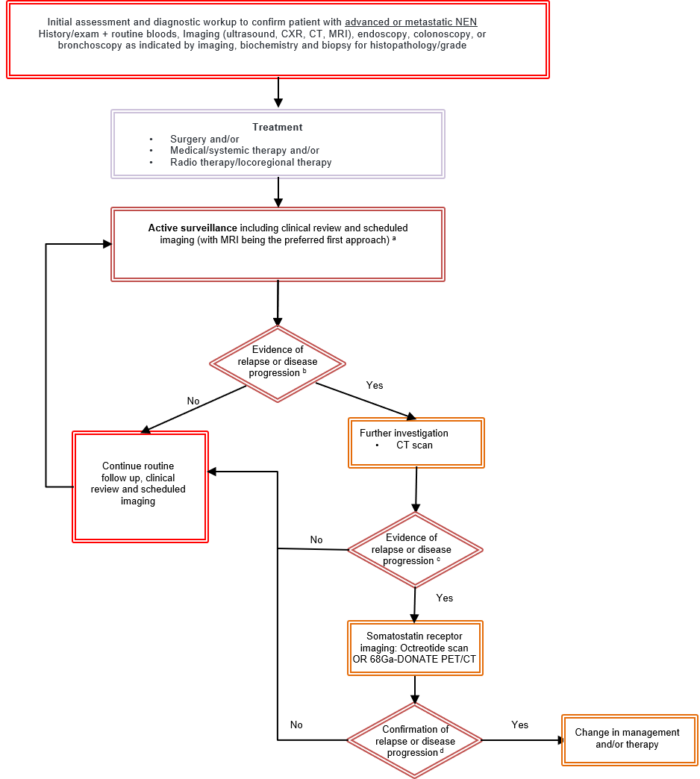
Figure 3 Current clinical management algorithm of patients with metastatic or advanced NEN, without CgA monitoring as proposed by the applicant and modified by PASC. (Cancer Council Victoria and Commonwealth Government 2022)
CT = computed tomography; CXR = chest X-ray; MIRI = magnetic resonance imaging; NEN = neuroendocrine neoplasm; PET = positron emission tomography.
ª On CT or MRI, progression is typically assessed using RECIST 1.1 criteria and may be defined by (Tareco Bucho, Pascucci et al. 2025):
- A ≥20% increase in the sum of diameters of target lesions (with a minimum absolute increase of 5 mm).
- The appearance of one or more new lesions.
Unequivocal progression of non-target lesions
^{b} suspicion of progression may arise from the development of new symptoms or worsening existing symptoms, including carcinoid syndrome manifestations, pain, weight loss, declining performance status, bowel obstruction, ascites, or other tumour-related complications.
^{c} on CT or MRI, disease progression is typically assessed using RECIST 1.1 criteria and is defined by a ≥20% increase in the sum of target lesion diameters (with a minimum absolute increase of 5 mm), the appearance of one or more new lesions, or unequivocal progression of non-target lesions.
^{d} progression suggested by the appearance of new somatostatin receptor-positive lesions, an increased extent of disease on somatostatin receptor (SSTR) PET/CT, or new or increased 18F-FDG uptake, particularly in higher-grade tumours where this may indicate more aggressive tumour biology or dedifferentiation.
Figure 4 illustrates the proposed clinical management algorithm for monitoring patients with NENs when incorporating CgA monitoring. All patients diagnosed with metastatic or advanced NEN would undergo serial serum CgA surveillance. For patients with a rising CgA (50% above baseline) they would be considered to have evidence of relapse or progression and advance to more intensive investigation and treatment.
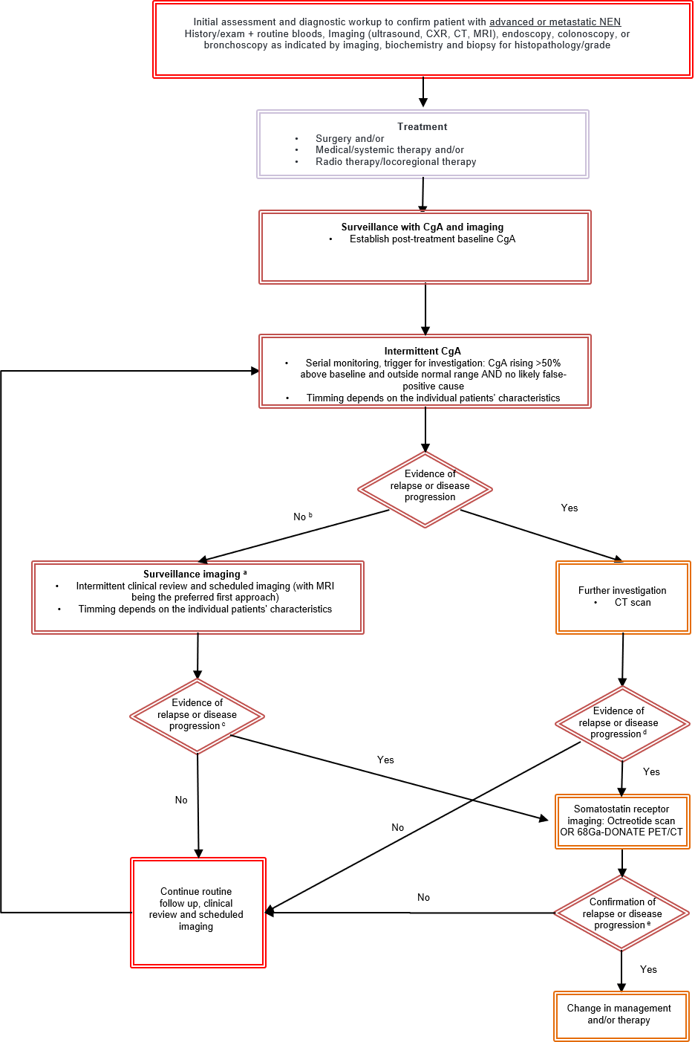
Figure 4 Proposed clinical management algorithm of patients with metastatic or advanced NEN, with CgA monitoring as proposed by the applicant and modified by PASC. [7]
CgA = Chromogranin A; CT = computed tomography; CXR = chest X-ray; MIRI = magnetic resonance imaging; NEN = neuroendocrine neoplasm; PET = positron emission tomography.
ª On CT or MRI, progression is typically assessed using RECIST 1.1 criteria and may be defined by (Tareco Bucho, Pascucci et al. 2025):
- A ≥20% increase in the sum of diameters of target lesions (with a minimum absolute increase of 5 mm).
- The appearance of one or more new lesions.
Unequivocal progression of non-target lesions.
^{b} Whether imaging is triggered or not depends on individual patient characteristics
^{c} suspicion of progression may arise from the development of new symptoms or worsening existing symptoms, including carcinoid syndrome manifestations, pain, weight loss, declining performance status, bowel obstruction, ascites, or other tumour-related complications.
^{d} on CT or MRI, disease progression is typically assessed using RECIST 1.1 criteria and is defined by a ≥20% increase in the sum of target lesion diameters (with a minimum absolute increase of 5 mm), the appearance of one or more new lesions, or unequivocal progression of non-target lesions.
^{e} progression suggested by the appearance of new somatostatin receptor-positive lesions, an increased extent of disease on somatostatin receptor (SSTR) PET/CT, or new or increased ¹⁸F-FDG uptake, particularly in higher-grade tumours where this may indicate more aggressive tumour biology or dedifferentiation.
PASC considered that the proposed clinical management algorithm required further clarification to show how serial CgA monitoring would be incorporated into the current standard-care monitoring pathway.
PASC considered that the proposed clinical management algorithm should be revised to clearly demonstrate how CgA results would inform clinical management decisions, and that this would need to occur subsequent to resolution of issues regarding the population, intervention, comparator and clinical place of CgA monitoring (discussed earlier). PASC considered that the revised clinical management algorithm should:
- clearly distinguish the current and proposed pathways
- reflect the intended role of CgA monitoring in relation to specialist review, scheduled imaging and further investigation (i.e. where it is in addition to and/or replaces/reduces imaging)
- depict how CgA monitoring results lead to changes in patient management
- address discordant results.

Proposed economic evaluation
The application claimed that serial CgA monitoring is superior to routine surveillance without CgA monitoring because it provides an additional longitudinal marker of disease activity that can identify progression or recurrence earlier and lead to earlier clinical intervention.
The evidence supporting serial CgA monitoring in patients with NENs is limited and is predominantly restricted to studies of biomarker performance rather than studies demonstrating clinical utility. Preliminary literature searches have identified evidence evaluating the diagnostic and prognostic characteristics of CgA; however, these studies also report significant limitations in sensitivity and specificity, with performance varying across tumour subtypes and clinical settings.
Importantly, there is a notable lack of direct evidence demonstrating that routine serial CgA monitoring leads to meaningful changes in clinical management or improvements in patient outcomes. Although CgA results may be used in practice to prompt additional investigations or closer follow-up, preliminary searches have not identified robust evidence showing that serial CgA monitoring improves the detection of disease progression, influences treatment decisions, reduces the need for imaging, or improves survival, quality of life, or other patient-relevant outcomes compared with standard surveillance based on clinical assessment and imaging.
There also appears to be limited evidence regarding the impact of serial CgA monitoring on healthcare resource use and costs. In particular, preliminary searches have not identified studies demonstrating that CgA-guided monitoring safely reduces the frequency of imaging, avoids other healthcare interventions, or represents a cost-effective alternative to existing surveillance strategies. As a result, there is currently little direct evidence to support an economic evaluation based on observed differences in resource utilisation or health outcomes.
Consequently, while some evidence is available to inform the assessment of test performance, there appears to be little evidence addressing the critical downstream links between testing, changes in management, patient health outcomes, and resource use. The evidence base for serial CgA monitoring is therefore characterised by substantial uncertainty regarding its clinical utility and cost-effectiveness, and a linked-evidence approach will be required to evaluate whether any observed test performance translates into meaningful clinical and economic benefits.
The clinical claim in the application leads to a cost-effectiveness analysis (CEA) or a cost-utility analysis (CUA) for the economic evaluation (Table 2).
Table 3 Classification of comparative effectiveness and safety of the proposed intervention, compared with its main comparator, and guide to the suitable type of economic evaluation
Comparative safety |  | Comparative effectiveness
Comparative safety | Inferior | Uncertainª | Noninferior^{b} | Superior
Inferior | Health forgone: need other supportive factors | Health forgone possible: need other supportive factors | Health forgone: need other supportive factors | ? Likely CUA
Uncertainª | Health forgone possible: need other supportive factors | ? | ? | ? Likely CEA/CUA
Noninferior^{b} | Health forgone: need other supportive factors | ? | CMA | CEA/CUA
Superior | ? Likely CUA | ? Likely CEA/CUA | CEA/CUA | CEA/CUA
CEA=cost-effectiveness analysis; CMA=cost-minimisation analysis; CUA=cost-utility analysis
? = reflect uncertainties and any identified health trade-offs in the economic evaluation, as a minimum in a cost-consequences analysis
ª ‘Uncertainty’ covers concepts such as inadequate minimisation of important sources of bias, lack of statistical significance in an underpowered trial, detecting clinically unimportant therapeutic differences, inconsistent results across trials, and trade-offs within the comparative effectiveness and/or the comparative safety considerations
^{b} An adequate assessment of ‘noninferiority’ is the preferred basis for demonstrating equivalence

Based on the applicant’s claim of superior effectiveness and non-inferior safety for serial CgA monitoring compared with standard care without CgA monitoring, PASC considered that a cost-utility analysis would be an appropriate form of economic evaluation.
However, PASC noted that the evidence presented primarily addressed test performance and that limited evidence was identified to quantify the relationship between changes in CgA, subsequent changes in management and patient health outcomes. PASC considered that this may limit the ability to populate the proposed economic model.
PASC noted that the economic evaluation would need to reflect the intended clinical place of CgA monitoring relative to the comparator and that the modelling approach will likely depend on information from the applicant addressing PASC concerns regarding the population, intervention, comparator and clinical place of CgA monitoring (discussed earlier). For example, whether the model should account for CgA monitoring in addition to standard-care monitoring or as a partial substitute for scheduled imaging in selected patients, as these uses may have different effects on healthcare resource use and costs.
PASC considered that the economic evaluation should capture the costs of serial CgA testing and any changes in healthcare resource use arising from testing, including changes in the timing or frequency of specialist review, CT, MRI and functional imaging. PASC also noted that an elevated CgA result may lead to additional imaging under existing MBS arrangements and considered that any resulting costs to the MBS should be captured.
Overall, PASC considered that the economic evaluation should reflect the agreed clinical pathway and account for uncertainty in the extent to which CgA monitoring changes subsequent management, healthcare resource use and patient health outcomes.

Proposal for public funding
The application proposed a new MBS item for serial serum CgA for serial monitoring in patients with well differentiated NEN, with a fee of $65 (see Table 5 further below). The application included clinical notes to be included in the item descriptor.
The application proposed item descriptor, is broad enough to cover all populations identified in the COSA guidelines and could lead to use beyond the proposed population of this application. Particularly, the application is limited to patients with well differentiated, locally advanced (stage 3) and/or metastatic (stage 4) NEN, whereas the current proposed wording opens the population up to lower stages of NEN. In addition, the restriction enables CgA to be used in NENs where changes in CgA may not be evident (e.g., neuroendocrine tumours with low proliferative potential). The PICO set included justification for a fee of $65. The application based this fee on the average publicly available cost of CgA testing across five Australian providers (approximately $53) and used this value to inflate the fee to $65 based on preventing an out-of-pocket cost for bulk billing (i.e. 85% of $65 would cover an 85% rebate of $55.25, which is greater than the average price). This seems inappropriate and the proposed fee should be the 100% value of $53, based on average pricing. PASC may also wish to consider if a lower fee of $45 would be appropriate, as this is the lowest price for conducting CgA testing.
Table 4 The average publicly available cost of CgA testing across five Australian providers
Provider | Price | Notes
SA Pathology  (Adelaide PHN) | $45 | No longer ELISA -> automated immunofluorescence analyser Kryptor Gold; twice weekly; Updated as of 2024
PathWest  (Fiona Stanley) | $50.75 | Updated as of 2021
Syd Path  (St Vincent’s Pathology) | $45 | Updated as of 2024
Peter Mac  (Austin Pathology, Royal Children's Hospital Melbourne and Royal Melbourne) | $52 | Weekly batched  Updated as of 2024
Clinpath -> SNP | $70 | Daily testing  Updated as of 2023
Source: PICO set document ‘CgA fee justification.docx”
Given the above issues, during the PICO development the following changes were proposed to the item descriptor (blue text).
Table 5 Applicant proposed MBS item with edits suggested by the assessment group in blue text
Category 2 – Pathology Services; Group P2 – Chemical
MBS item *XXXX
Quantitation of chromogranin A (CgA) performed: to establish a baseline, or for serial monitoring to assist in managing a patient, where: the patient has a well differentiated advanced or metastatic neuroendocrine tumour, and the service is requested by a specialist or consultant physician.
for a patient with a well differentiated neuroendocrine tumour, performed to establish a baseline and for serial monitoring of disease activity, to assist in identifying relapse/progression and in assessing response to treatment, where the patient has known metastatic disease, and the service is requested by a specialist or consultant physician.
Maximum 4 tests per year.
Fee: $65.00 Benefit: 75%=$48.75 85%=$55.25 $53.00 Benefit: 75%=$39.75 85%=$45.05
Notes:
CgA is not a measure of tumour bulk for gastrinomas, therefore other hormonal markers need to be measured. It is also not a useful measure for patients on proton pump inhibitors, and if appropriate, attempts should not be made to measured it where when this drug therapy is being used. can be interrupted.
CgA should not be measured in patient populations with reduced sensitivity particularly neuroendocrine tumours with low proliferative potential.
Antibody-derived assays are variable and hence patient’s samples should be measured in the same lab consistently.

PASC noted that the proposed fee for CgA testing was substantially higher than the fee for existing tumour marker testing under MBS item 66500, which was cited as approximately $24. PASC considered that the proposed fee required further justification, including consideration of relevant existing MBS items and the costs associated with providing the service.
PASC noted the proposed item descriptor, but considered that the proposed MBS items could not be refined further due to the lack of agreed definitions for testing populations, CgA levels, frequency and other key elements.

Summary of public consultation input
PASC noted and welcomed consultation input from 7 organisations and no individual input was received. The 7 organisations that submitted input were:
- Australasian Association for Clinical Biochemistry and Laboratory Medicine (AACB)
- Endocrine Society of Australia (ESA)
- NeuroEndocrine Cancer Australia (NECA)
- Pancare Foundation (Pancare)
- Peter MacCallum Cancer Centre European Neuroendocrine Tumour Society Centre of Excellence (Peter MacCallum ENETS)
- Public Pathology Australia (PPA)
- The Australian and New Zealand Society of Nuclear Medicine (ANZSNM).
Consultation input was all supportive of public funding for CgA testing in patients with NENs. The consultation input raised a number of concerns, predominately in relation to using CgA test results in isolation without consideration of other clinical information and imaging.
Consumer Experience
NECA and Pancare highlighted the significant physical, emotional and financial impact of neuroendocrine tumours on patients, families and carers. Patients may experience ongoing symptoms, repeated testing, imaging and specialist appointments over many years, contributing to anxiety, uncertainty and financial burden. Both organisations emphasised that out-of-pocket costs for regular CgA testing can accumulate over time and may create barriers to ongoing monitoring, particularly for people living in regional and rural areas.
Benefits and Disadvantages
The main benefits of public funding reported included improved access to an established monitoring test, reduced out-of-pocket costs and improved equity of access for patients with NENs, particularly those requiring long-term surveillance. Benefits also included that serum CgA testing is easier to access at local pathology centres and is less invasive than specialised nuclear medicine scans. CgA testing provides patient reassurance and supports more targeted use of imaging resources by helping identify patients who may require further clinical review or investigation.
The main disadvantages of public funding was that CgA testing is not appropriate for all NEN subtypes and that results may be influenced by factors such as medication use and comorbidities, which could lead to false positive results. ANZSNM input stated that due to inter-assay variability, a patient’s serial CgA testing should be performed in the same laboratory.
Population, Comparator (current management) and Delivery
The consultation input agreed with the proposed population, stating that restricting funding to patients with well-differentiated metastatic NENs where CgA levels are clinically trackable captured the population most likely to benefit.
The consultation input agreed with the proposed comparator of current practice, involving specialist review, imaging, pathology testing and multidisciplinary care. ANZSNM stated that CgA testing is available in Australia, with some patients accessing testing through self-funding or local institutional arrangements.
Other services identified as being needed before or after the intervention included specialist clinical review, imaging services (including CT, MRI and somatostatin receptor PET/CT), pathology testing and multidisciplinary care. Consultation input emphasised that CgA testing is most appropriately used in conjunction with clinical assessment and imaging as part of ongoing monitoring.
MBS Item Descriptor and Fee
The consultation input agreed with the proposed service descriptor, including a frequency of 4 times per year. ANZSNM suggested the descriptor could more explicitly recognise the use of serial monitoring in patients with trackable baseline CgA levels.
The consultation input partly agreed with the proposed fee. The majority of consultation input stated that CgA testing costs ranged from $30 to $80, and that the fee should be set at up to $80.
PASC noted that consultation input was supportive of public funding for serial CgA testing and that patient advocacy organisations highlighted the out-of-pocket costs associated with repeated testing.
PASC noted that consultation feedback also highlighted the potential value of knowing a patient's CgA result and the potential equity benefits of improving access to testing, particularly for patients living in regional areas who may otherwise need to travel significant distances for specialist review or imaging.
PASC noted that consultation feedback supported the use of CgA as an adjunct to standard care rather than as a substitute for imaging.

Next steps
PASC considered that the application could not progress in its current form. PASC noted that key elements of the PICO for CgA monitoring in patients with NENs remained insufficiently defined, including the target population, testing frequency and duration, definition of an actionable change in CgA, the clinical place (i.e. adjunct vs replacement to imaging) and the change in clinical management arising from a change in CgA. PASC also noted that the evidence presented did not demonstrate that serial CgA monitoring resulted in changes in clinical management that led to improved patient health outcomes.
PASC suggested that the applicant engage further with relevant clinical groups to clarify the clinical place of serial CgA monitoring and the evidence to support this. PASC noted that the applicant may return with a revised application (i.e. reapplication) and any further relevant evidence that becomes available or was not identified in the current application. PASC also noted the applicant may wish to seek a pre-application meeting with the department before submitting a reapplication.

Applicant Comments on Ratified PICO
We thank PASC for its careful deliberation. This application addresses inequitable access to CgA monitoring, particularly for regional, rural and remote patients facing substantial travel burdens and out-of-pocket costs. CgA is an established blood test supported by clinical and consumer organisations, with prospective evidence supporting its use alongside clinical assessment and imaging in selected patients with elevated, trackable baseline results. MBS funding will improve access to testing already incorporated into some public hospital pathways. We acknowledge that the population, testing schedule, interpretation and resulting management decisions require clearer definition, and that test performance alone does not establish improved patient outcomes. We will work with clinical groups to refine the pathway and review evidence linking testing to management, outcomes and access benefits before considering a revised application.

References
AIHW (2025). "Cancer data in Australia, Cancer summary data visualisation." Australian Institute of Health and Welfare.
Baekdal, J., J. Krogh, M. Klose, P. Holmager, S. W. Langer, P. Oturai, A. Kjaer, B. Federspiel, L. Hilsted, J. F. Rehfeld, U. Knigge and M. Andreassen (2020). "Limited Diagnostic Utility of Chromogranin A Measurements in Workup of Neuroendocrine Tumors." Diagnostics (Basel) 10(11).
Cancer Council Australia. (2023). "COSA Neuroendocrine Neoplasms (NENs) Guidelines." Retrieved 14 July 2025, from https://app.magicapp.org/#/guideline/jlAbxL.
Cancer Council Victoria and Commonwealth Government (2022). Optimal care pathway for people with neuroendocrine tumours. Cancer Council Victoria, Melbourne. 1st edn.
Clinical Oncology Society of Australia (2023). "Neuroendocrine Neoplasms (NENs) Clinical Guidelines." Cancer Council Australia.
Klimstra, D. S., I. R. Modlin, D. Coppola, R. V. Lloyd and S. Suster (2010). "The pathologic classification of neuroendocrine tumors: a review of nomenclature, grading, and staging systems." Pancreas 39(6): 707-712.
Koffas, A., A. Giakoustidis, A. Papaefthymiou, P. Bangeas, D. Giakoustidis, V. N. Papadopoulos and C. Toumpanakis (2023). "Diagnostic work-up and advancement in the diagnosis of gastroenteropancreatic neuroendocrine neoplasms." Front Surg 10: 1064145.
Lamarca, A., D. K. Bartsch, M. Caplin, B. Kos-Kudla, A. Kjaer, S. Partelli, A. Rinke, E. T. Janson, C. Thirlwell, M.-L. F. van Velthuysen, M.-P. Vullierme and M. Pavel (2024). "ENETS clinical guidance on the management of neuroendocrine neoplasms (NENs)." Journal of Neuroendocrinology 36(9): e13423.
Marotta, V., M. C. Zatelli, C. Sciammarella, M. R. Ambrosio, M. Bondanelli, A. Colao and A. Faggiano (2018). "Chromogranin A as circulating marker for diagnosis and management of neuroendocrine neoplasms: more flaws than fame." Endocrine-Related Cancer 25(1): R11-R29.
Matar, S., A. Malczewska, K. Oberg, L. Bodei, H. Aslanian, A. Lewczuk-Myślicka, P. L. Filosso, A. L. Suarez, A. Kolasińska-Ćwikła, M. Roffinella, B. Kos-Kudła, J. B. Ćwikła, I. A. Drozdov, M. Kidd and I. M. Modlin (2020). "Blood Chromogranin A Is Not Effective as a Biomarker for Diagnosis or Management of Bronchopulmonary Neuroendocrine Tumors/Neoplasms." Neuroendocrinology 110(3-4): 185-197.
Maxwell, J. E., J. C. Yao and D. M. Halperin (2022). Neuroendocrine Tumors. The MD Anderson Manual of Medical Oncology, 4e. H. M. Kantarjian, R. A. Wolff and A. G. Rieber. New York, NY, McGraw Hill Education.
Meng, Q. H., T. R. Halfdanarson, J. A. Bornhorst, H. Jann, S. Shaheen, R. Z. Shi, A. Schwabe, K. Stade and D. M. Halperin (2024). "Circulating Chromogranin A as a Surveillance Biomarker in Patients with Carcinoids—The CASPAR Study." Clinical Cancer Research 30(24): 5559-5567.
Rindi, G., O. Mete, S. Uccella, O. Basturk, S. La Rosa, L. A. A. Brosens, S. Ezzat, W. W. de Herder, D. S. Klimstra, M. Papotti and S. L. Asa (2022). "Overview of the 2022 WHO Classification of Neuroendocrine Neoplasms." Endocr Pathol 33(1): 115-154.
Tareco Bucho, T. M., L. Pascucci, G. Mancò, A. Taraschi, M. C. Macchia, N. Tinari, D. Brocco, R. G. H. Beets-Tan, A. D. Pizzi and S. Trebeschi (2025). "RECIST progression: Patterns among target, non-target, non-measurable and new lesions progression." European Journal of Radiology 186.
Tsai, H.-J., C.-F. Hsiao, J. S. Chang, L.-T. Chen, Y.-J. Chao, C.-J. Yen and Y.-S. Shan (2021). "The Prognostic and Predictive Role of Chromogranin A in Gastroenteropancreatic Neuroendocrine Tumors – A Single-Center Experience." Frontiers in Oncology Volume 11 - 2021.
Wu, P., D. He, H. Chang and X. Zhang (2023). "Epidemiologic trends of and factors associated with overall survival in patients with neuroendocrine tumors over the last two decades in the USA." Endocr Connect 12(12).
Wyld, D., J. Moore, N. Tran and P. Youl (2021). "Incidence, survival and stage at diagnosis of small intestinal neuroendocrine tumours in Queensland, Australia, 2001-2015." Asia-Pacific Journal of Clinical Oncology 17(4): 350-358.

Neuroendocrine Neoplasms (NENs) Consensus Guidelines | Cancer Council Australia

