MSAC Application 1822
F-18 Fluorodeoxyglucose (FDG) positron emission tomography (PET) for evaluation of complex infection
Applicant: Queensland X-Ray Pty Ltd

PICO Confirmation

Summary of PPICO criteria to define questions to be addressed in an Assessment Report to the Medical Services Advisory Committee (MSAC)
Table 1 PPICO for F-18 FDG PET in patients with complex infection: PICO Set 1
Component | Description
Population | Patients with suspected deep-seated or complex infection, in whom standard initial clinical evaluation consisting of clinical history, physical examination, laboratory tests and targeted imaging has not provided a definitive diagnosis. Subgroups to be considered include:  - spinal infections (e.g. vertebral osteomyelitis, discitis, or epidural abscess)  - osteomyelitis in cases of a known soft tissue infection (including diabetic foot ulcers), fracture-related osteomyelitis, and potential dissemination of infection to other skeletal sites or organs  - bone and joint infections in children  - prosthetic joint infection or other orthopaedic hardware infection, if more than 2 years post-surgery  - infective endocarditis, including following congenital heart disease, or due to prosthetic valve infection, cardiac implantable electronic device (CIED) infection or septic emboli  - extrapulmonary non-tuberculous mycobacterial (EPNTM) infection  - suspected metastatic infection secondary to bacteraemia (for example Staphylococcus aureus or other pathogens with a high risk of metastatic infection)
Prior tests | Vary by subgroup but may include:  - laboratory tests (e.g. full blood count (FBC), C-reactive protein (CRP), erythrocyte sedimentation rate (ESR), electrolytes, urea, and creatinine (EUC), liver function test (LFT))  - microscopy, culture and sensitivity of blood or other body fluid or tissue  - biopsy/histology  - electrocardiogram (ECG) where endocarditis is a possibility  - targeted imaging (X-ray, magnetic resonance imaging (MRI), computed tomography (CT), ultrasound)  - nuclear imaging (bone scan, labelled white blood cell (WBC) scan)
Intervention | FDG PET/CT
Comparator/s | Either:  - repeat targeted imaging (MRI, CT), and/or  - nuclear imaging (bone scan, WBC scan), and/or  - gallium-67 citrate (Ga-67) scintigraphy.
Reference standard | Clinical diagnosis at final follow-up incorporating all available clinical information
Outcomes | Safety outcomes  - Harms from the test procedure (e.g. radiation exposure, exposure to contrast agent and/or radiotracers, requirements for sedation/anaesthesia)  - Harms from false positive (FP) and false negative (FN) results  - Harms from subsequent focal investigations e.g. biopsy or from follow up of incidental findings  Clinical effectiveness outcomes  Test performance  - Diagnostic accuracy (sensitivity, specificity, additional true positive (TP) and additional true negative (TN))  - Diagnostic yield (where there are insufficient findings arising from diagnostic accuracy studies or it provides additional information due to the heterogenous diagnostic outcomes arising from the proposed technology)  - Rate of failed and/or inconclusive tests resulting in no change to management  Change in management outcomes  - Change in procedures (e.g. biopsies, surgeries, investigations)  - Change in treatment (e.g. treatment ceased, initiated, avoided, de-escalated, targeted)  - Time to correct diagnosis/treatment  Patient health outcomes  - Disease-specific mortality  - Morbidity  - Health-related quality of life  Health care resources  - Cost of testing  - Cost of treatment  - Cost of adverse events  Cost-effectiveness  - Incremental cost per QALY gained  Total Australian Government health care costs
Assessment questions | - What is the safety, effectiveness, cost-effectiveness and financial impact of FDG PET/CT versus other forms of targeted imaging in patients with suspected deep-seated or complex infection, in whom standard initial clinical evaluation has not provided a definitive diagnosis?
Table 2 PPICO for F-18 FDG PET in patients with fever of unknown origin: PICO Set 2
Component | Description
Population | Patients with persistent or recurrent fever in whom baseline investigations have not identified the cause of fever or there is significant concern for additional undetected infections (e.g. fungal infection) or concern for undetected nidus of infection of a known pathogen (for instance, bacteraemia with concern for deep seated infection). Subgroups to be considered include:  - patients with persistent fever/pyrexia of unknown origin (FUO/PUO) defined as:  - documented fever ≥38.3 °C on multiple occasions; and  - duration of fever ≥3 weeks  or  - patients with persistent or recurrent high-risk neutropenic fever defined as:  - absolute neutrophil count <0.5 X 10⁹/L  - persistent fever: fever ≥38.0 °C daily for 3 days or more; or  - recurrent fever: documented fever ≥38.0 °C which has recurred during same neutropenic episode after an initial episode of neutropenic fever (temperature ≥38.0 °C sustained over 1 hour).
Prior tests | Subgroup 1: FUO/PUO  - detailed clinical history  - laboratory tests (e.g. full blood count (FBC), C-reactive protein (CRP), erythrocyte sedimentation rate (ESR), electrolytes, urea, and creatinine (EUC), liver function test (LFT), antinuclear antibody (ANA), rheumatoid factor, thyroid function test (TFT))  - sputum culture  - mid-stream urine (MSU) microscopy, culture and susceptibility testing (MCS)  - human immunodeficiency virus (HIV) serology  - chest X-ray  - echocardiogram (where indicated i.e. heart murmur)  Subgroup 2: Persistent or recurrent high-risk neutropenic fever  - blood cultures (2 or more)  - other cultures based on clinical suspicion (e.g. urine, stool, sputum)  - laboratory tests (e.g. FBC, EUC, LFT, CRP)  - chest X-ray  - targeted imaging based on clinical suspicion (e.g. brain (magnetic resonance imaging) MRI computed tomography (CT) sinuses, high-resolution chest CT)
Intervention | F-18 fluorodeoxyglucose positron emission tomography (FDG PET) /CT
Comparator/s | Subgroup 1: FUO/PUO  - contrast enhanced CT of the chest, abdomen, and pelvis, and/or  - gallium-67 citrate ⁽Ga-67) scintigraphy, and/or  - white blood cell (WBC) scan.  Subgroup 2: Persistent or recurrent high-risk neutropenic fever  - high-resolution CT (chest +/- brain, sinus, abdomen, pelvis), and/or  - WBC scan.
Reference standard | Diagnosis at final follow-up incorporating all available clinical information
Outcomes | Safety outcomes  - Harms from the test procedure (radiation exposure, exposure to contrast agent and/or radiotracers)  - Harms from false positive (FP) and false negative (FN) results  - Harms from subsequent focal investigations e.g. biopsy  Clinical effectiveness outcomes  Test performance  - Diagnostic accuracy (sensitivity, specificity, additional true positive (TP) and additional true negative (TN))  - Diagnostic yield of confirmed deep-seated or complex infection (where there are insufficient findings arising from diagnostic accuracy studies or it provides additional information due to the heterogenous diagnostic outcomes arising from the proposed technology)  - Rate of failed and/or inconclusive tests  Change in management outcomes  - Change in procedures (e.g. biopsies, surgeries, investigations)  - Change in treatment (e.g. treatment ceased, initiated, avoided, de-escalated, targeted)  - Time to correct diagnosis  - Time to appropriate treatment  Patient health outcomes  - Disease-specific mortality  - Morbidity  - Time to clinical response to therapy  - Health-related quality of life  Health care resources  - Cost of testing  - Cost of treatment  - Cost of adverse events  Cost-effectiveness  - Incremental cost per QALY gained  Total Australian Government health care costs
Assessment questions | - What is the safety, effectiveness and cost-effectiveness of FDG PET/CT versus contrast enhanced CT, Ga-67 scintigraphy or WBC scan in patients with FUO/PUO in whom baseline investigations have not identified the cause of fever or there is significant concern for additional undetected infections?  - What is the safety, effectiveness and cost-effectiveness of FDG PET/CT versus high-resolution CT or WBC scan in patients with persistent or recurrent neutropenic fever in whom baseline investigations have not identified the cause of fever or there is significant concern for additional undetected infections or an undetected nidus of infection from a known pathogen?

Purpose of application
An application requesting Medicare Benefits Schedule (MBS) listing of F-18 fluorodeoxyglucose positron emission tomography (FDG PET) for the evaluation of complex infection was received from Queensland X-Ray Pty Limited by the Department of Health, Disability and Ageing (the department).
The clinical claim is that FDG PET/CT imaging is superior to other second-line advanced imaging techniques for patients with complex infection, resulting in a quicker, more informed diagnosis, and lowered healthcare burden.

PICO criteria

Population
The application includes 2 PICO sets with multiple subgroups.
PICO Set 1: patients with deep seated, complex, or rare infection, in whom standard initial clinical evaluation consisting of clinical history, physical examination, laboratory tests and targeted imaging (unless contraindicated) has not provided a definitive diagnosis and where treatment decisions depend on accurate and timely identification of the infection sites.
Subgroups to be considered include:
- spinal infections (vertebral osteomyelitis, discitis, or epidural abscess)
- osteomyelitis in cases of a known soft tissue infection (including diabetic foot ulcers), fracture related osteomyelitis, and to assess for dissemination of infection to other skeletal sites or organs
- bone and joint infections in children
- prosthetic joint infection or other orthopaedic hardware infection, if more than 2 years post-surgery
- infective endocarditis, including following congenital heart disease, or due to prosthetic valve infection, cardiac implantable electronic device (CIED) infection or septic emboli
- extrapulmonary non-tuberculous mycobacterial (EPNTM) infection
- suspected metastatic infection secondary to bacteraemia (for example Staphylococcus aureus or other pathogens with a high risk of metastatic infection)
PICO Set 2: patients with persistent fever of unknown origin or persistent or recurrent neutropenic fever consists of two subgroups:
- patients with persistent fever/pyrexia of unknown origin (FUO/PUO) with absence of diagnosis or resolution despite initial investigations. FUO/PUO, defined as:
  - documented fever ≥38.3 °C on at least two occasions; and
  - duration of fever ≥3 weeks
or
- patients with persistent or recurrent high-risk neutropenic fever defined as:
  - persistent fever: absolute neutrophil count <0.5 X 10⁹/L and documented fever ≥38.0 °C daily for at least 3 days; or
  - recurrent fever: documented fever ≥38.0 °C which has recurred during same neutropenic episode after an initial episode of neutropenic fever (temperature ≥38.0 °C sustained over 1 hour during absolute neutrophil count <0.5 X 10⁹/L) in whom baseline investigations have not identified the cause of fever, or there is significant concern for additional undetected infections (e.g. fungal infection) or concern for undetected nidus of infection of a known pathogen (e.g. bacteraemia with concern for deep seated infection).

The indications in the application are all diagnostically challenging with no single routine test available with high diagnostic accuracy. Diagnosis is usually made with a combination of clinical, laboratory, microbiological and imaging tests, and these can be determined based on clinical presentation, personal experience, test availability, institutional experience, and financial considerations. These testing strategies each have their limitations (Glaudemans et al. 2019). The gold standard for many indications is histopathological examination of tissue sample obtained by biopsy and microbiological culture of the infected site; however, this requires prior identification of the site, may require image guidance and can be invasive.

PICO Set 1: complex infection
There are 8 subgroups of complex infection to be considered; however, across all subgroups, the eligible patients are those who have already undergone standard initial investigations. These differ for different subgroups but include laboratory tests, plain X-ray, cultures, and biopsy. They are high-yield and low-cost tests and can identify the source of infection in most cases. Therefore, the proposed population is patients where there remains diagnostic uncertainty following initial investigations and patients remain clinically unwell. Noting that there is heterogeneity in clinical pathways, a summary of the prior and comparator tests for each subgroup is presented in Table 3, noting the atypical or uncommon subgroup is not included in the table due to the heterogeneity within this population group.
The subgroups are not mutually exclusive; for example, bacteraemia can lead to osteomyelitis and/or infective endocarditis. Furthermore, there are more granular indications within subgroups; for example, prosthetic joint infections at different sites (hip, knee, shoulder etc.), fracture-related osteomyelitis, and endocarditis of prosthetic valves, native valves, cardiac implantable electronic devices (CIEDs) and ventricular assist devices (VADs).
Table 3 Summary of prior tests and comparator tests for each sub-group of PICO Set 1
 | Spinal infections |  | Osteo-myelitis |  | Paediatric bone & joint infections |  | Prosthetic joint infections |  | Infective endocarditis |  | EPNTM infections |  | Bacteraemia with high risk of metastatic infection
Prior tests
Laboratory tests | FBC, CRP, ESR |  | FBC, ESR, CRP, EUC, LFT |  | FBC, CRP (+/-ESR) |  | FBC, ESR, CRP, EUC, LFT |  | FBC, CRP or ESR |  |  |  | FBC, CRP or ESR, LFT, EUC, lactate
X-ray |  |  | ü |  | ü |  | ü
Culture |  |  | ü |  | ü |  | ü |  | ü |  | ü |  | ü
Biopsy and/or histology |  |  | ü |  |  |  | ü |  |  |  | ü
Urine MCS |  |  |  |  |  |  |  |  | ü
ECG |  |  |  |  |  |  |  |  | ü |  |  |  | ü
Targeted imaging | CE-MRI |  | CT and/or MRI |  | Targeted MRI |  | CT and/or MRI |  | TTE |  | CT and/or MRI |  | CT and/or MRI
Nuclear medicine | Bone scan |  | Bone scan |  |  |  | Bone scan |  |  |  |  |  | Bone scan
Comparator tests
MRI | ü |  | ü |  | ü |  | ü |  | ü |  | ü |  | ü
CT | ü |  | ü |  |  |  | ü |  | ü |  | ü |  | ü
Ga-67 scintigraphy | ü |  | ü |  |  |  | ü |  | ü |  | ü |  | ü
3-phase bone scan | ü |  | ü |  |  |  | ü |  |  |  | ü |  | ü
WBC scan | ü |  | ü |  |  |  | ü |  | ü |  | ü |  | ü
CE = contrast enhanced; CRP = c-reactive protein; CT = computed tomography; ECG = echocardiogram; EPNTM = extrapulmonary non-tuberculous mycobacterial; ESR = erythrocyte sedimentation rate; EUC = electrolytes, urea, creatinine; FBC = full blood count; Ga-67 = gallium-67 citrate; LFT = liver function test; MCS = microscopy, culture, and sensitivity; MRI = magnetic resonance imaging; TTE = transthoracic echocardiogram; WBC = white blood cell

Spinal infection
Spinal infections are a spectrum of infectious diseases that can affect the vertebral body (vertebral osteomyelitis), intervertebral discs (discitis), endplates (spondylitis), facet joints (septic arthritis) and adjacent tissues (soft tissue epidural abscess). Infections are usually diffuse and affect multiple structures and are referred to broadly as spondylodiscitis. Primary spinal infections originate from a distant site (e.g. genitourinary, gastrointestinal, respiratory tract, oral cavity) and reach the spinal structures by hematogenous spread whereas secondary infections originate via direct contamination through interventions, surgery, or trauma. In nearly 50% of cases the original source of infection remains unidentified (Muharremi et al. 2025).
Spinal infections can occur at any age but are most common in adults aged 50 to 70 years or in people who are immunosuppressed, are intravenous drug users or have surgical implants. Patients commonly present with pain with or without fever (absent in up to half of cases). Neurological symptoms can occur in more advanced infections. Clinical presentation can be insidious, nonspecific and progressive; an average delay in diagnosis of 2 to 4 months is reported (Laur et al. 2024).
Initial investigations are laboratory tests (e.g. white blood cell (WBC) count and differential, c-reactive protein (CRP) and erythrocyte sedimentation rate (ESR) tests) that can help to differentiate infection from chronic degenerative back pain. Plain X-rays are commonly performed as part of the initial clinical pathway, although they have limited sensitivity and specificity in the early stages of infection before bone destruction, and are not recommended for suspected spinal infection. They are therefore not considered a component of the clinical pathway. Where spinal infection is suspected, MRI is recommended first-line imaging test.
Where spinal infection remains suspected based on clinical presentation, history and laboratory findings, contrast-enhanced MRI is the recommended first-line imaging approach (Lazzeri et al. 2019).It has high sensitivity for both soft tissue and bone marrow abnormalities, no ionising radiation and can detect infection earlier than other modalities.
Antibiotic therapy is the mainstay of treatment; however, surgical intervention may be required if conservative treatment fails, or there is spinal instability or neurologic deficit (Laur et al. 2024).

Osteomyelitis
Osteomyelitis refers to a primary infection of the bone marrow with subsequent involvement of the cortical bone. The term osteomyelitis is often used interchangeably with osteitis, which is a superficial infection of the bone and surrounding soft tissue. Although spinal infections are a type of osteomyelitis, peripheral osteomyelitis behaves differently and therefore there are some differences in diagnostic approach. There are also differences in aetiology and clinical characteristics in children compared to adults (for both spinal and peripheral osteomyelitis) (Glaudemans et al. 2019).
Osteomyelitis can be seeded from haematogenous spread, which is most common in children (and in the spine) or secondary to a contiguous focus of infection in adjacent soft tissue, which is the most common form in adults. This includes surgical site infections and, more commonly, infections in patients with diabetes due to neuropathy and peripheral vascular disease. Staphylococcus aureus is the most common organism causing osteomyelitis accounting for, alone or in combination with another pathogen, for around 50% of all infections (Arnold et al. 2026). Incidence is highest in adults aged 60 or more and is higher in people who are immunocompromised or have peripheral vascular disease.
Patients will typically present with fever, pain, swelling, inflammation and reduced function (e.g. limp or refusal to bear weight); however, osteomyelitis associated with pressure ulcers or diabetic foot wounds often do not present with pain as underlying conditions may lead to loss of sensation (Arnold et al. 2026).
Initial investigations are clinical assessment and laboratory testing for systemic inflammation (e.g. full blood count (FBC), ESR, CRP); however, their specificity in differentiating osteomyelitis from other clinical conditions is low. This is usually followed by plain X-ray with bone changes usually seen 7 to 10 days from symptom onset, although in anatomically complex locations CT may replace radiographs. Blood cultures may be taken and aid diagnosis when positive, but findings are frequently negative (Glaudemans et al. 2019). In suspected diabetic foot infections, a probe-to-bone test may also be undertaken.
Initial tests may be sufficient for diagnosis and treatment; however, advanced imaging may be required where diagnostic uncertainty remains, there is a lack of response to therapy, or there is a need for surgical planning. Non-contrast enhanced MRI is the preferred imaging approach due to its high resolution for marrow and soft tissue, test availability, and lack of radiation burden. It may be contraindicated in patients with an implanted prosthesis. Nuclear imaging is then used if further imaging is required, most commonly bone scanning, which has high sensitivity but lacks specificity, particularly post-surgery or trauma (Glaudemans et al. 2019). In a patient with a suspected diabetic foot infection, a WBC scan is recommended (Yin et al. 2026).
Osteomyelitis can become chronic and treatment challenging. The principles of management are confirmation of diagnosis, debridement of non-viable tissue, systemic and/or local antibiotics and preservation of function. Coordinated, multidisciplinary care may be required including general medicine, infectious diseases, orthopaedic surgery, radiology, physical therapy, nutrition, plastic and vascular surgery and others (Arnold et al. 2026).

Paediatric bone and joint infections
Osteomyelitis and septic arthritis in children are associated with serious morbidity and can cause permanent disability; therefore, they require prompt and effective treatment. Most paediatric cases are due to haematogenous spread in healthy individuals although repeated infection should prompt consideration of inborn errors of immunity (Orange et al. 2026). In osteomyelitis the most common sites affected are the femur and tibia and in septic arthritis the most common sites affected are the hip and knee joints. The inflammatory response leads to rapid joint destruction (Iliadis and Ramachandran 2017).
Children may present with fever, pain, and limited use of the affected limb or joint. Fever and systemic symptoms are less common in osteomyelitis than septic arthritis. Initial tests are the same as those in adults, namely laboratory tests (FBC, ESR, CRP), blood culture and X-ray, and if a diagnosis is made on this basis, then the patient is initiated on antibiotics and, for septic arthritis, referred urgently to orthopaedics for consideration of arthrotomy, irrigation and debridement. If further imaging is required, the preferred test is contrast enhanced MRI for osteomyelitis. Ultrasound can be used to identify joint effusions.
In paediatric patients, MRI is the preferred imaging modality, particularly in localised cases. However, for whole-body imaging, MRI frequently requires general anaesthesia whereas FDG PET/CT does not. There are significant practical and clinical advantages associated with avoiding general anaesthesia including resource implications, procedural risk and delays. Therefore, in some cases FDG PET/CT will be the preferred imaging technique, for example, in neonates and young infants with a prolonged fever without localisation despite investigation where localisation is challenging or there is a suspected multifocal infection. There is no MBS listed item for whole-body MRI for this purpose, which means that access may be restricted where patients need to pay privately for the scan or rely on public hospital arrangements. There is one MBS item (63304), which allows for a scan of the musculoskeletal system for infection arising in bone or musculoskeletal system, however this is for a regional scan rather than whole-body.

Prosthetic joint infections
Prosthetic joint infections can occur early (within the first 3 months after surgery), delayed (up to 2 years post-surgery) or late (more than 2 years after surgery). Early or delayed infections will be more easily recognised and likely to have reached the prosthesis at the time of surgery. These patients are referred to the orthopaedic surgeon. The proposed population is patients with late prosthetic joint infections.
Late prosthetic joint infections are more likely to be caused by haematogenous spread and present with local symptoms such as pain, swelling and reduced function. Symptoms are not specific for infection and so differential diagnosis with aseptic loosening is required. Initial tests are the same as for osteomyelitis; laboratory tests (e.g. FBC, ESR, CRP, electrolytes, urea, creatinine (EUC), liver function test (LFT)), plain X-ray and blood culture; however, a negative result in some or all of these does not exclude prosthetic joint infection.
The next investigation may be a biopsy of the infected site, under image guidance or further imaging. MRI can be complicated by the implant but may no longer be a contraindication due to MRI compatible prostheses and improved MRI sequences (Signore et al. 2019). CT can also be used for diagnosis. Additional imaging can include a bone scan, a WBC scan or FDG PET/CT, with clinical guidelines recommending bone scanning or FDG PET/CT as an initial nuclear medicine approach in suspected prosthetic joint infections more than 2 years after implant. However, they also recommend a follow-up a WBC scan where the bone scan or FDG PET/CT test is positive due to the low specificity of both (Signore et al. 2019).

Infective endocarditis
Infective endocarditis has high mortality rates and severe complications, so early identification and treatment are essential. Those most at risk are patients with prosthetic valves, a previous episode of endocarditis or congenital heart disease (Habib et al. 2015). Clinical presentation can vary but commonly includes fever and heart murmurs. The distal effects of emboli are a common presenting feature.
International guidelines provide clear diagnostic criteria for infective endocarditis. The first investigation, before empiric antibiotic therapy, is blood culture. While this is a key investigation, they are negative in almost a third of cases (Habib et al. 2015). The initial imaging test is echocardiography, which again can be normal or inconclusive in up to 30% of cases. Therefore, if suspicion remains following these tests, then FDG PET/CT or a WBC scan are recommended, particularly where patients have a prosthetic valve. A positive FDG PET/CT finding is recognised as one of the ten major criteria for diagnosis of infective endocarditis (Fowler et al. 2023).

Extrapulmonary non-tuberculous mycobacterial (EPNTM) infection
Non-tuberculous mycobacteria (NTM) are a diverse group of Mycobacteria representing over 200 species that are ubiquitous in the environment, including soil, dust, and natural and drinking water sources. It excludes Mycobacterium tuberculosis and Mycobacterium leprae. Infection is more likely in immunocompromised individuals and occurs via inhalation, ingestion or inoculation of a wound through injury or surgery (Rath et al. 2025). The most common clinical presentation is with pulmonary disease, although extrapulmonary disease contributes 20-30% of cases.
EPNTM infections can involve the skin and soft tissue, lymph nodes, bones and joints, urinary tract, and blood. Clinical presentation is variable and depends on the site(s) of infection. Diagnosis is complex and relies on culture, histopathology and molecular studies (such as nucleic acid amplification tests to detect NTM) when available. These may be sufficient for diagnosis and treatment planning. However, for suspected infections involving bone or dissemination, imaging may be required and could involve CT, MRI or ultrasound. As a whole-body functional imaging approach, FDG PET/CT is proposed to document the extent of dissemination and to guide treatment where required.

Bacteraemia
Bacteraemia refers to viable bacteria in the blood. While often transient and clinically benign, it can lead to clinically relevant bloodstream infection and progress to sepsis. Clinical presentation can be overt, with fever, rigors, hypotension and systemic inflammatory response, or more subtle, with features such as delirium, malaise or unexplained deterioration. Infection can result in serious complications such as infective endocarditis and metastatic deep tissue infection leading to increased mortality. Blood culture is the key first-line investigation along with other laboratory tests. Further investigations depend on clinical signs and symptoms and aim to determine the source and extent of infection, including any metastatic sites of infection. Echocardiogram is recommended in all patients to rule out infective endocarditis.
Further imaging is targeted based on signs and symptoms but may include MRI or a WBC scan where there is back, joint or bone pain, or an ultrasound looking for joint swelling. FDG PET/CT is proposed as an additional tool for the detection of metastatic foci. Up to a third of complicating infectious foci do not have localising symptoms and signs, but their identification leads to important management changes such as prolonged antibiotic treatment or site-specific treatments such as drainage (Vos et al. 2010).

Estimated population size for PICO set 1
The application estimated the size of the population using a market-share approach. MBS claims for comparator metabolic imaging technologies over the period 2022-23 to 2024-25 are not specific for complex infection, but infection is assumed to account for 75% with the remainder being other conditions such as inflammation. The total number of claims in 2024/25 was 4,182; therefore, the estimated patient population is 3,137. The application estimates that 25% would not have ready access to PET due to geographical constraints and therefore the total uptake would be 2,352 patients.
MBS item 61527 currently provides access to FDG PET as an alternative to Ga-67 scintigraphy where Ga-67 is unavailable. It was introduced in 2022 and has seen increasing claims each year reaching 2,539 in 2024-25 (Figure 1). Therefore, based on current MBS claims, a substantial impact of funding the proposed intervention would be a shift in claims from an existing FDG PET MBS item, with no defined a specific clinical indication, to the proposed indication-specific MBS items. Claims for Ga-67 scintigraphy have declined substantially over the past 10 years, but other nuclear metabolic imaging claims have been more stable (Figure 1).
Figure 1 MBS claims for comparator metabolic imaging, 2010/11 to 2023/24
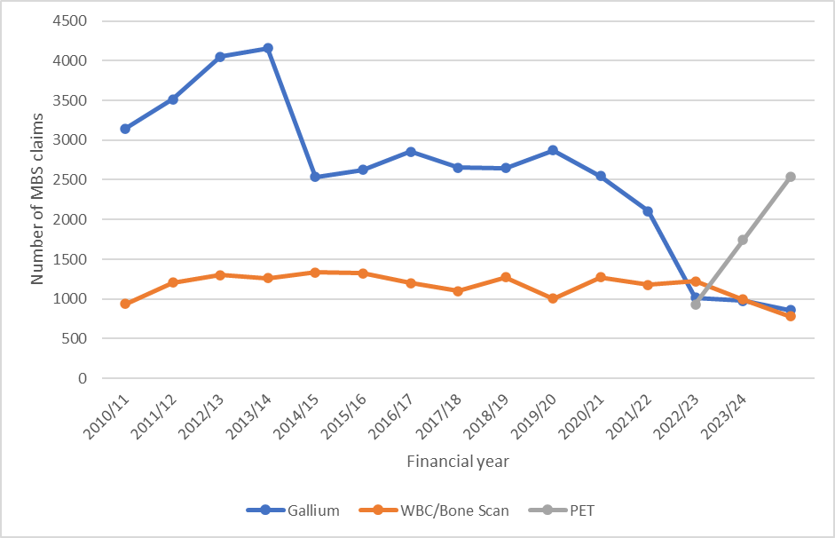
Data are from Medicare Item Reports. MBS item numbers included for Ga-67 scintigraphy are 61429, 61430, 61450, 61442, 61453. Items included for WBC/bone scanning are 61433, 61457, 61454, 61434. PET MBS item 61527 was introduced in August 2022 and is for whole body PET where Ga-67 is unavailable.
An alternative approach might be to use the total number of oncology PET claims and identify the market share that infection would assume. In England, non-oncology indications – which are broader than the requested indications - are allowed up to a threshold equal to 10% of oncology activity suggesting an upper limit to any estimates

PICO Set 2: persistent or recurrent fever
There are two subgroups to be considered for PICO Set 2: fever/pyrexia of unknown origin (FUO/PUO) and neutropenic FUO. Neutropenic fever is clinically distinct as it occurs in patients who are already immunologically compromised and require urgent treatment. For this reason, the place of FDG PET/CT in the diagnostic pathway differs for the neutropenic fever subpopulation, with fewer prior tests required before the proposed intervention (Table 4). The population in PICO Set 2 may also overlap with that of PICO Set 1 with the identification of potential sites of infection moving the patient from FUO to one of the suspected diagnoses described in PICO Set 1.
Table 4 Summary of prior tests and comparator tests for each sub-group of PICO Set 2
 | Fever of unknown origin | Recurrent high-risk neutropenic fever
Prior tests
Laboratory tests | FBC, ESR, CRP, EUC, LFT, ANA, rheumatoid factor, TFT, HIV serology | EUC, LFT, CRP
X-ray | Chest | Chest
Culture | ü | ü
Biopsy and/or histology
Urine MCS | ü
ECG | If heart murmur present
Targeted imaging |  | MRI and/or CT
Nuclear medicine
Comparator tests
MRI
CT | contrast enhanced | high resolution
Ga-67 scintigraphy | ü
3-phase bone scan
WBC scan | ü | ü
ANA = antinuclear antibody; CRP = c-reactive protein; CT = computed tomography; ECG = electrocardiogram; ESR = erythrocyte sedimentation rate; EUC = electrolytes, urea, creatinine; FBC = full blood count; Ga-67 = gallium-67 citrate; HIV = human immunodeficiency virus; LFT = liver function test; MCS = microscopy, culture, and sensitivity; MRI = magnetic resonance imaging; TFT = thyroid function test; WBC = white blood cell.

Persistent fever of unknown origin
FUO/PUO is defined as:
- documented fever ≥38.3 °C on at least two occasions; and
- duration of fever ≥3 weeks
- failure to reach a diagnosis despite investigations.
FUO is, by definition, a collection of multiple, disparate diseases that are diagnostically challenging. Nevertheless, they can be grouped into categories: infection, neoplasm, inflammation, miscellaneous and undiagnosed. The proportion of each varies according to time period, geography and patient cohort.
The diagnosis begins with a thorough patient history, emphasising travel, occupational, zoonotic and environmental exposures, followed by a systematic physical examination. Baseline investigations include a broad range of laboratory markers, cultures (urine, blood and sputum in adults) and a chest X-ray. An echocardiogram should be undertaken if there is a risk of endocarditis.
Where these tests fail to diagnose a condition, patients may be referred to hospital-based services and undergo further evaluation. This may include CT or nuclear imaging, expanded autoimmune and microbiological testing, and tissue or bone marrow biopsy if indicated. FDG PET/CT is proposed to be used within this second-line setting because it is a whole-body test and can detect both neoplastic and infectious disease. Tumour markers are unreliable as a screening test for occult malignancy, and therefore the use of FDG PET/CT enables identification of lesions and areas of interest for further evaluation via biopsy or fine needle aspiration.

Persistent or recurrent neutropenic fever
Neutropenia is defined as an absolute neutrophil count (ANC) of <0.5 x10⁹/L with profound neutropenia sometimes described as an ANC < 0.1 x10⁹/L (Freifeld et al. 2011). It is a common side effect of intensive chemotherapy and/or bone marrow transplant. Patients with persistent (3 or more days) or recurrent neutropenic fever will usually be inpatients in a haematology ward of a tertiary centre already under close observation, for example, outpatients receiving chemotherapy. Fever in these patients is a clinical emergency but not always related to infection; however standard of care is treatment with broad-spectrum antibiotics. There is often a lack of focal signs or symptoms to localise infection and, being heavily immunocompromised, there is a greater risk of multiple infective and non-infective causes of fever simultaneously.
The initial investigations are blood cultures, including from any central line if applicable, inflammatory markers (EUC, LFT, CRP) and chest X-ray as lungs are common sites of infection. This is usually followed by targeted imaging based on clinical suspicion using MRI or CT; for example, MRI of the brain if CNS infection is suspected or CT of sinuses if there is a concern for fungal sinusitis.
FDG PET/CT is proposed to be used where the cause of fever remains unclear following these investigations (pathogen and/or sites of infection), or where there is significant concern for additional undetected infections, or sites of infection. The use of FDG PET/CT in this setting is proposed to guide treatment; in particular, it has been proposed as a mechanism of safely de-escalating or ceasing antibiotic treatment as management is switched from an empiric to targeted approach (Douglas et al. 2022).

Estimated population size
The application did not estimate a population size for PICO Set 2, noting potential overlap with the in PICO Set 1 population because patients may subsequently meet a PICO Set 1 indication once further investigation identifies a suspected infection site. However, the extent of this overlap was not quantified.
PASC noted that the subpopulations specified in PICO Set 1 were heterogenous and that it was unclear which subpopulations would be most likely to benefit from FDG PET/CT through changes in clinical management leading to better health outcomes and are supported by sufficient evidence to support evaluation.
PASC noted that the proposed population spans a diverse range of clinical presentations and considered that defining the clinical trigger for testing may be more informative than defining eligibility solely by disease subgroup. PASC further noted that while a broader population may be appropriate, FDG PET/CT is intended for a subset of patients at a defined point in the diagnostic pathway and not for all patients with suspected infection. PASC considered that further refinement of the population is required, including consideration of the clinical circumstances or point in the diagnostic pathway where FDG PET/CT adds value, supported by an appropriate evidence base
PASC questioned whether the proposed populations were more likely to be in the acute or chronic phase of illness . The applicant clarified that many of the indications, particularly those within PICO Set 1, relate to occult infections that are difficult to detect. Patients may be clinically stable at presentation but remain at risk of significant long-term complications if the infection is not identified and appropriately managed. Examples of subpopulations where patients may present with an indolent infection include diabetic foot infections, subacute infective endocarditis, Q fever and EPNTM infections. PASC considered that atypical and uncommon infectious disease should be removed as a subgroup and noted that a clinical trigger or a clinical context would be needed to define which patients with chronic infections would require a FDG PET/CT.
PASC noted that patients with neutropenic fever are largely managed at tertiary centres, where FDG PET/CT may already be available as part of hospital-based care. PASC considered that further refinement was needed of the population most likely to be eligible for the service if MBS listed, including a clearer definition of the clinical circumstances, thresholds, and diagnostic uncertainty that would support use of FDG PET/CT across all populations.
For PICO Set 1, PASC noted the Australasian Association of Nuclear Medicine Specialists (AANMS) concerns regarding the availability of evidence for many of the subpopulations and considered that infective endocarditis and bacteraemia with suspected metastatic infection appeared to have the strongest supporting evidence base. PASC also considered that the role of FDG PET/CT within the diagnostic pathway remained unclear for several of the proposed subpopulations. When asked to justify the proposed subpopulations, the applicant advised that they were proposed by a group of infectious diseases physicians coordinated by the Australasian Society for Infectious Diseases. The applicant further noted that the application was informed by the European Association of Nuclear Medicine (EANM) guidelines (Hess et al. 2024). The applicant acknowledged that the evidence base is relatively strong for bacteraemia and endocarditis, whereas for other indications, such as osteomyelitis, FDG PET/CT and WBC scans may have similar diagnostic performance and test selection may be influenced by clinical utility and practical considerations. PASC advised that proposed subpopulations will require an appropriate evidence base to support evaluation and where this was not available, inclusion of the particular subpopulation(s) should be reconsidered.
For PICO Set 2, the applicant’s clinical expert advised that for FUO, there are few international guideline recommendations. However, a recent international Delphi consensus statement concluded that CT would usually be the first-line investigation, with FDG PET/CT considered subsequently where CT findings are inconclusive or fail to identify a cause.
In neutropenic fever, the applicant’s clinical expert stated that the Australasian practice guidelines have been published and recommend FDG PET/CT, where accessible, or CT in patients with persistent fever (at least 72 hours) with no evidence on culture or basic imaging (e.g. chest x-ray) of infection source (Douglas et al. 2025). In this population, FDG PET/CT is proposed as a replacement test; however, if the patient is critically unwell, a CT scan or no imaging may be preferred. A positive FDG PET/CT is likely to identify a source but targeted investigation, such as a bronchoscopy, may be required to reach a final diagnosis.
PASC considered that the populations within PICO Set 2 appeared comparatively better established than those proposed in PICO Set 1. PASC noted the potential overlap between the two PICO sets, as patients presenting with fever of unknown origin or neutropenic fever may meet a PICO Set 1 indication once a site or source of infection is identified. Therefore, PASC advised that further population refinement is required.

Intervention
The intervention is FDG PET/CT. PET is a minimally invasive nuclear imaging technique that uses short-lived radiopharmaceuticals, the most common of which is F-18 FDG, a radioactive analogue of glucose. FDG is taken up by cells via cell membrane glucose transporters, with areas of higher uptake indicating higher metabolic activity. While predominately used for oncological indications, FDG PET is also well suited to detecting sites of infection and inflammation due to the glycolytic activity of the cells involved in the inflammatory response, particularly neutrophils and the monocyte/macrophage family (Treglia 2019).
PET is performed with a low-dose CT scan for attenuation correction and anatomical localisation. When clinically indicated, a diagnostic-quality CT may be performed concurrently, often with oral and/or intravenous contrast. Stand-alone PET is no longer performed, and studies of PET imaging performed without an integrated CT scanner should not be included in the assessment.
FDG PET/CT is widely established in Australia. It first underwent HTA assessment in 1990 and has since been assessed on numerous occasions by MSAC. It is currently publicly funded for a broad range of oncology indications, for the evaluation of refractory epilepsy and for the diagnosis of Alzheimer’s disease. There are over 100 PET units established in Australia, primarily in major cities. Between 2012-13 to 2022-23, a large increase in number of PET services was observed from 45,000 to 203,000, and total Medicare benefits paid increased from $48 million to $189 million.
The proposed service requires an on-site cyclotron and radiopharmacy production capacity or access to commercial supplies. It is provided by a nuclear medicine specialist or consultant physician upon receipt of a written referral from a medical specialist, most likely an infectious disease specialist for these indications. Equipment handling and radiopharmaceutical administration are performed by trained and registered nuclear medicine technologists.
Specific patient considerations apply to imaging for suspected infective endocarditis due to the uptake of glucose by the normal myocardium, and specific protocols are used to minimise physiological uptake in the heart. Current recommendations suggest a prolonged fasting period of at least 12 hours preceded by a high fat-low/no carbohydrate-diet for 24-48 hours, with or without the administration of intravenous heparin (50 IU/kg) 15 min before tracer injection (Abikhzer et al. 2025).
Blood glucose levels should also be monitored in patients with diabetes as high levels can potentially interfere with radiotracer uptake in target sites. It is also recommended that FDG PET/CT be undertaken before any antibiotic or glucocorticoid treatment as these can decrease signal (Abikhzer et al. 2025). Undertaking PET/CT scans on critically ill patients presents both logistical and technical challenges and is a consideration for some populations in the application. Similarly, paediatric patients will require specific considerations including dose adjustment, specialist paediatric consultation and consideration of sedation.
PET/CT scans are typically acquired from the base of the skull to the upper thighs or toes but can be localised to specific areas of clinical concern where appropriate.
In oncology semi-quantitative analysis is often used; however, this has not been validated in infection and qualitative visual analysis is recommended (Abikhzer et al. 2025) based on the intensity and pattern of uptake and correlation with location and morphologic data from the CT.
For an average 75 kg individual, typical radioactivity ranges from 180 to 260 megabecquerels (MBq), and dosage is generally calculated at approximately 3-5 MBq per kilogram of body weight, with the Australian Radiation Protection and Nuclear Safety Agency (ARPANSA) recommending 3.5 MBq/kg. Estimated effective doses for patients receiving between 150 and 450 MBq of FDG are 3-9 millisievert (mSv). The CT generally adds 4-5mSv radiation dose depending on arm position and length of scan.
The application is for a single diagnostic FDG PET/CT; however, it is noted that patients may experience infections multiple times in a lifetime, particularly patients at higher risk (e.g. immunocompromised patients, injecting drug users) and therefore may have multiple scans over time. FDG PET/CT can also be used to monitor treatment response, but monitoring applications are not part of this application.
PASC noted that increased metabolic activity detected on FDG PET/CT is not specific to infection and could also indicate inflammation or malignancy. PASC also noted that there can be challenges in performing FDG PET/CT in some of the proposed subgroups (critically ill, high glucose etc.). These considerations contributed to PASC’s view that the population in PICO Set 1 required further consideration, with a view to clinical subpopulations where FDG PET/CT is able to direct a change in clinical management and outcomes supported by an appropriate evidence base
PASC noted that PET units are primarily located in major cities and questioned whether public funding would improve access for rural and remote patients. The applicant suggested that public funding may improve access for these patients by enabling greater use of PET in private centres in regional areas and reduce out-of-pocket costs for patients who would otherwise need to travel to public PET centres in metropolitan areas. The applicant further indicated that patients with complex infections are often managed in regional hospitals, where infectious diseases specialists are commonly available and that some relevant infections, such as Q fever, are more prevalent in regional and remote areas.
PASC considered that clinical evidence using stand-alone FDG PET is not applicable because the intervention comprises combined FDG PET and CT.
PASC noted that the proposed role of FDG PET/CT is to support diagnosis, rather than monitoring response to treatment. The applicant clarified that a follow-up FDG PET/CT may be clinically indicated in limited circumstances, such as prolonged antimicrobial therapy for invasive fungal infection in neutropenic patients or in Q fever, particularly where there are prosthetic devices in situ.

Comparator(s)
Comparators for PICO Set 1 (Table 3) and 2 (Table 4) include (repeat) MRI and/or CT, Ga-67 scintigraphy, labelled WBC scanning and 3-phase bone scanning.

Anatomical imaging
Depending on the clinical context, MRI is the suggested initial imaging test because it can evaluate both bone and soft tissue and entails no radiation exposure. Furthermore, although metallic implants were historically considered a contraindication to MRI, advances in implant design and MRI technology have made this considerably less common (Glaudemans et al. 2019). For all subgroups in PICO Set 1, the diagnostic pathway assumes patients have already had targeted CT or MRI or for suspected IE, transthoracic echocardiogram (TTE) . Therefore, MRI and/or CT are prior tests for most subgroups rather than comparators. However, where these tests are repeated with higher resolution or the addition of contrast, or image a different anatomical site they are comparators to FDG PET/CT, which is proposed to replace either repeat testing or follow-up CT testing after non-diagnostic MRI (or the reverse).
However, for PICO Set 2, MRI and CT have not been routinely included as prior tests unless there is clinical suspicion that directs focal imaging. FDG PET/CT is proposed to be used in the diagnostic pathway as an alternative to high-resolution or contrast enhanced CT and is proposed to replace or displace CT in this diagnostic pathway. Where it displaces CT, FDG PET/CT findings would direct subsequent focal imaging by CT. However this will be dependent on local availability of FDG PET/CT compared with CT.
The application states the advantages of FDG PET/CT over MRI and CT are that it provides both functional and anatomic imaging, is able to provide whole body imaging and has higher specificity than anatomical imaging alone. However, FDG PET/CT is more costly, involves radiotracer production and handling, has a longer scan acquisition time and is not as readily available than MRI or CT, particularly in regional and rural areas.
An additional advantage of FDG PET/CT over MRI is proposed in paediatric bone and joint infections where sedation or anaesthesia is commonly required for MRI but can be omitted in FDG PET/CT. Therefore, for this subpopulation, the practical advantages of the proposed intervention over MRI are greater and it is anticipated that FDG PET/CT could replace MRI in many cases, depending on machine availability, rather than be undertaken following negative MRI.

Nuclear imaging
Where anatomical imaging fails to lead to diagnosis or is insufficient to direct treatment, nuclear imaging is used. There are 3 tests relevant to the assessment: Ga-67 scintigraphy; 3-phase bone scanning; and WBC scanning (Table 5). All can be combined with single photon emission computed tomography (SPECT) or SPECT/CT to improve anatomic localisation. Not all are relevant to each subgroup, but they are all proposed as direct comparators to FDG PET/CT and are proposed to be replaced by the introduction of the proposed intervention. However, replacement may only be partial as in some cases one of the existing tests may be preferred, such as where a patient has had recent surgery or fracture that may show high FDG uptake due to inflammation. Furthermore, because of the limitations of individual nuclear imaging tests, patients who are diagnostically challenging may have more than one nuclear imaging test.
Table 5 Summary of comparator nuclear imaging tests and their key advantages and disadvantages compared to FDG PET/CT
Item | Ga-67 scintigraphy | 3-phase bone scan | WBC scan | FDG PET/CT
Tracer | Ga-67 citrate | Technetium-99m methylene diphosphonate (MDP) | technetium-99m stannous colloidª | F-18 fluorodeoxyglucose
Scan duration (from injection) | up to 72 hours | 2 – 4 hours | 4 – 24 hours | 1 – 2 hours
Advantages | Whole body | Specific for bone pathology  Low cost | Whole body  Most specific for infection | Whole body  Fast with only 1 timestamp  Better anatomical image resolution
Disadvantages | Close contact restrictions/ higher radiation dose  Long duration  Tracer availability maybe limited | Not applicable for non-bone sites | Requires blood handling/ labour-intensive | Uptake not specific to infection, also due to inflammation, malignancy
MBS items | 61429, 61430, 61442, 61450 or 61453. | 61446, 61499 | 61433, 61434, 61454, 61457 | -
MBS fee | $1,763.20 | $496.05 | $540.40 | -
CT = computed tomography; FDG = F-18 fluorodeoxyglucose; Ga-67 = gallium-67 citrate; MBS = Medicare Benefits Schedule; PET = positron emission tomography; WBC = white blood cell.
a. In the literature, WBC scanning frequently uses indium-111 or technetium-99m labelled-hexamethylpropyleneamine oxime (HMPAO), but MSAC Application 1056 indicates that technetium-99m stannous colloid is the most common tracer used in Australia.
Of the nuclear imaging comparators, Ga-67 scintigraphy is the most likely to be wholly replaced by FDG PET/CT. This is due to the higher radiation burden, longer scan time and poorer image quality of Ga-67 scintigraphy, without any specific advantages over FDG PET/CT.
However, both bone scanning and WBC scanning have advantages and disadvantages compared to FDG PET/CT depending on the clinical indication and may only be partially replaced. For WBC scanning, a sample of the patient’s blood is collected, labelled ex vivo and then reinjected, which poses risks to patients, clinicians and technicians. However, it is more specific to infection and therefore might be preferred where the pre-test probability is higher (Signore et al. 2018). In addition to autologous WBC scanning, commercially available antibody-based kits are available that negate the need for ex vivo labelling. For example, LeukoScan is MBS-listed (MBS item 61650, MSAC application 1056), although it is restricted to patients who do not have access to ex vivo WBC scanning and for imaging only the long bones and feet, including in patients with diabetic ulcers.
PASC considered that the role of FDG PET/CT within the diagnostic pathway remained unclear for several proposed indications. PASC noted that the proposed indications encompass diverse clinical scenarios and acknowledged that clarification of the role of FDG PET/CT would inform the selection of comparators, including whether FDG PET/CT should be characterised as a replacement or add-on test.
PASC sought clarification on the comparators, particularly the extent to which FDG PET/CT would replace them or be an add-on test. This is particularly important for PICO2 where FDG PET/CT may not be readily available and CT is, and noting the international guidelines recommending CT as the initial test
For PICO Set 1, the applicant’s clinical expert gave the example of Q fever. In this situation, it would be common to do a transthoracic echocardiogram, a transesophageal echocardiogram, vascular imaging, and an MRI of the spine. The applicant’s clinical expert stated that all these investigations could be replaced by FDG PET/CT.
For PICO Set 2, the applicant’s clinical expert confirmed that Ga-67 scintigraphy is not a comparator for neutropenic fever and stated that WBC scans are of limited use in these patients because they have low WBCs.
The applicant discussed the practical difficulties associated with the nuclear imaging comparators, including limited availability, long acquisition times and workforce or supply constraints. For Ga-67 scintigraphy, the cost of obtaining the Ga-67 is higher than the rebate and there is often a wait of 3 weeks to obtain it. Similarly, for WBC scans there is a shortage of the radiopharmaceutical to undertake the test. Furthermore, both tests are slower to perform than FDG PET/CT. Ga-67 scintigraphy is a 2-to-3-day scan and so may not be suitable for patients who are sick or need to travel to access the test. WBC scans take approximately 8 hours compared to 1.5 to 2 hours for FDG PET/CT. Furthermore, PET is a modality that is expanding and there is a resulting lack of investment in the comparators, particularly in regional areas. The applicant indicated that these factors may influence the role of comparator tests in clinical practice and their likelihood of being replaced by FDG PET/CT.
PASC concluded that refinement of the target population would inform the selection of appropriate comparators. PASC also noted that whether FDG PET/CT is best characterised as an add-on or a replacement test will depend on the clinical context.

Reference standard
The best way to determine the presence of infection is generally microbiological culture or biopsy with histological examination.; however, these procedures are invasive and are therefore not always undertaken, particularly in patients with negative imaging findings or low clinical suspicion of infection. Therefore, the proposed reference standard is diagnosis at final follow-up incorporating all available clinical information. However, given the diversity of clinical indications and comparators, alternative reference standards should also be considered for inclusion in the assessment.
Further complicating the assessment of diagnostic accuracy is that a positive FDG PET/CT scan, particularly in FUO, may not lead to a diagnosis of infection, but rather malignancy or an inflammatory disease. Therefore, diagnostic yield may also be relevant to the assessment.

Outcomes
The outcomes are the same for both PICO sets and all subgroups, except for the requirement for sedation and/or anaesthesia, which is proposed to be a unique advantage of FDG PET/CT compared to MRI in the paediatric population. The outcomes are summarised in Table 6. No intermediate or surrogate outcomes are proposed, as all outcomes are classified as test performance, change-in-management or patient health outcomes.
Table 6 Outcomes relevant to the assessment of FDG PET/CT testing for diagnosis in complex infection
Outcome type | Outcome
Safety | Harms from the test procedure (radiation exposure, exposure to contrast agent and/or radiotracers, requirements for sedation/anaesthesia)  Harms from FP and FN results  Harms from subsequent focal investigations e.g. biopsy
Efficacy/effectiveness – primary health outcomes | Disease-specific mortality  Morbidity  Time to clinical response to therapy  Health related quality of life
Additional outcomes using a linked evidence approach | Test performance  Diagnostic accuracy (sensitivity, specificity, additional TP and additional TN)  Diagnostic yield  Rate of failed and/or inconclusive tests  Change in management outcomes  Change in procedures (biopsies, surgeries, investigations)  Change in treatment (treatment ceased, initiated, avoided, de-escalated, targeted)  Time to correct diagnosis  Time to appropriate treatment
Health care resources (including patient out-of-pocket costs) | Cost of testing  Cost of treatment  Cost of adverse events
Cost-effectiveness | Incremental cost per QALY gained
Total Australian Government health care costs | Total cost to the MBS  Total cost to the PBS
FN = false negative; FP = false positive; MBS = Medicare Benefits Schedule; PBS = Pharmaceutical Benefits Scheme; QALY = quality adjusted life years; TN = true negative; TP = true positive.
PASC considered the proposed outcomes and noted that the use of FDG PET/CT could lead to additional investigations as well as reduce the need for further testing for incidental/additional findings that are unrelated to the test indication. Consequently, PASC considered that the change in management outcomes should capture both increases and decreases in subsequent investigations.
PASC noted uncertainty around the inclusion of ‘other changes occurring in ≥10% of patients’ in the proposed outcomes and stated that ’requirements for sedation/anaesthesia’ was only relevant if the paediatric subgroup was retained. PASC stated that ’harms from subsequent focal investigations’ should be included as an outcome.
PASC considered that the outcome ‘cost per correct diagnosis’ is unlikely to be an informative measure of cost-effectiveness and agreed that a cost-utility assessment was the appropriate measure of cost-effectiveness.

Assessment framework
The application has made a claim of superior health outcomes for FDG PET/CT. As limited direct evidence is anticipated, a linked evidence approach is necessary. This will require each step of the assessment framework (Figure 2) to be addressed individually.
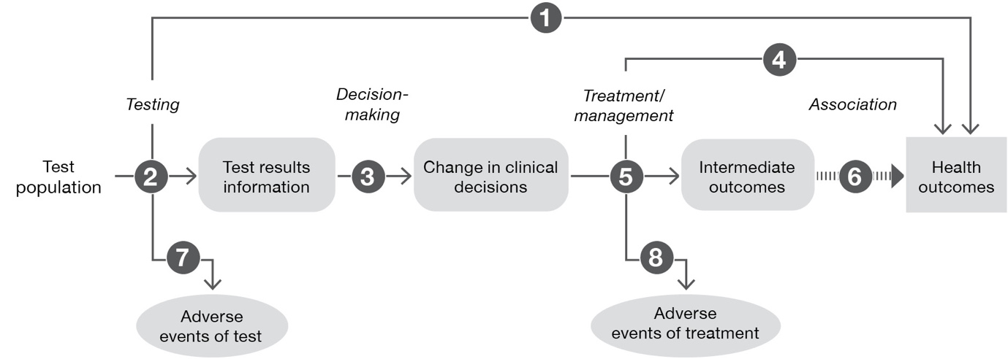
Figure 2 Generic assessment framework showing the links from the test population to health outcomes
Figure notes: 1: direct from test to health outcomes evidence; 2: test accuracy; 3: change in diagnosis/treatment/management; 4: influence of the change in management on health outcomes; 5: influence of the change in management on intermediate outcomes; 6: association of intermediate outcomes with health outcomes; 7: adverse events due to testing; 8: adverse events due to treatment
The questions to be addressed for each step of the assessment framework are listed below.
Direct evidence
1. Does the use of FDG PET/CT in place of the comparator tests result in superior health outcomes (mortality, morbidity, time to clinical response, health-related quality of life)?
Linked evidence
2. How does the information from the proposed test differ from that of the comparators? What is the accuracy of FDG PET/CT compared to the comparator tests?
3. Does the information from FDG PET/CT lead to a change in management compared to the information gained from the comparator tests?
4. Do the differences in management derived from FDG PET/CT, relative to the comparator tests, result in the claimed health outcomes?
5. Not applicable as no surrogate outcomes are proposed in the assessment.
7. What are the adverse events associated with FDG PET/CT compared to those associated with the comparator tests (radiation exposure, sedation/aesthesia, biopsy etc.)?
8. What are the adverse events associated with the change in treatments/interventions that arise from management decisions altered by the use of FDG PET/CT?
PASC considered that direct evidence may not be available and a linked evidence approach will likely be required.

Clinical management algorithms

PICO Set 1
In current practice, patients who present with signs of complex infection will undergo first-line investigations tailored to their clinical history and symptoms. These typically include laboratory markers of infection (e.g. CRP, ESR), with additional laboratory testing performed according to the suspected diagnosis. Investigations may include plain X-rays where bone involvement is suspected, blood cultures in many subgroups, and microbiological culture of any relevant discharge or aspirated fluid. A probe-to-bone test is recommended in patients with diabetic ulcers. Patients may be initiated on empiric antibiotic therapy depending on the level of suspicion and their clinical stability.
If further diagnosis is required, either due to ongoing uncertainty or requirement for biopsy localisation or surgical planning, then targeted imaging is usually the next investigation. MRI is recommended in suspected spinal infection and paediatric bone and joint infections and TTE in suspected infective endocarditis. CT or MRI are suitable for other indications depending on the suspected location of infection. For many patients, these investigations are sufficient to establish the diagnosis or to identify a suitable site for targeted biopsy or aspiration, enabling confirmation of the diagnosis and guiding subsequent treatment, which may include antibiotics, surgery, or both. However, for some patients, first-line testing is equivocal or insufficient to localise sites of infection for ongoing management decisions, or there are contraindications to baseline testing (e.g. the requirement for anaesthesia in paediatric patients) and diagnostic uncertainty remains. These patients would be referred to an infectious diseases service.
If infective endocarditis remains a concern and TTE is equivocal, a transesophageal echocardiogram (TOE) is recommended. For suspected bone infections, a bone scan is a likely next step. Beyond this, further advanced imaging is utilised and differs with each indication but may include anatomical imaging (CT, MRI and sometimes ultrasound) and, if required, metabolic imaging (3-phase bone scanning, labelled WBC scanning, Ga-67 scintigraphy). In current practice, FDG PET/CT may be used as an alternative to GA-67 scintigraphy under MBS item 61527; however, this existing use is not shown in the clinical management algorithm. Although there are guidelines for some indications, the diagnostic pathway varies according to local availability and clinical expertise. If uncertainty remains following one of more of these advanced imaging investigations, options may include repeat imaging after a period of close clinical monitoring, invasive biopsy, or empirical broad-spectrum antimicrobial therapy.
The current clinical management algorithm is presented in Figure 3.
The addition of FDG PET/CT provides an additional advanced imaging option and would replace many, but not all, tests at this point in the diagnostic pathway. It is proposed to enable a quicker diagnosis and reduced likelihood of requiring further or repeat imaging (where it has higher sensitivity than the comparators). Where it has equivalent sensitivity, FDG PET/CT is proposed to retain advantages over the comparators as it is simpler to administer and has a shorter scan acquisition time. It also has a high negative predictive value and provides whole body imaging. Therefore, a negative scan is more likely to lead to cessation of further investigations and a conservative ongoing approach.
The proposed clinical management algorithm is presented in Figure 4
Figure 3 Current clinical management algorithm for PICO Set 1
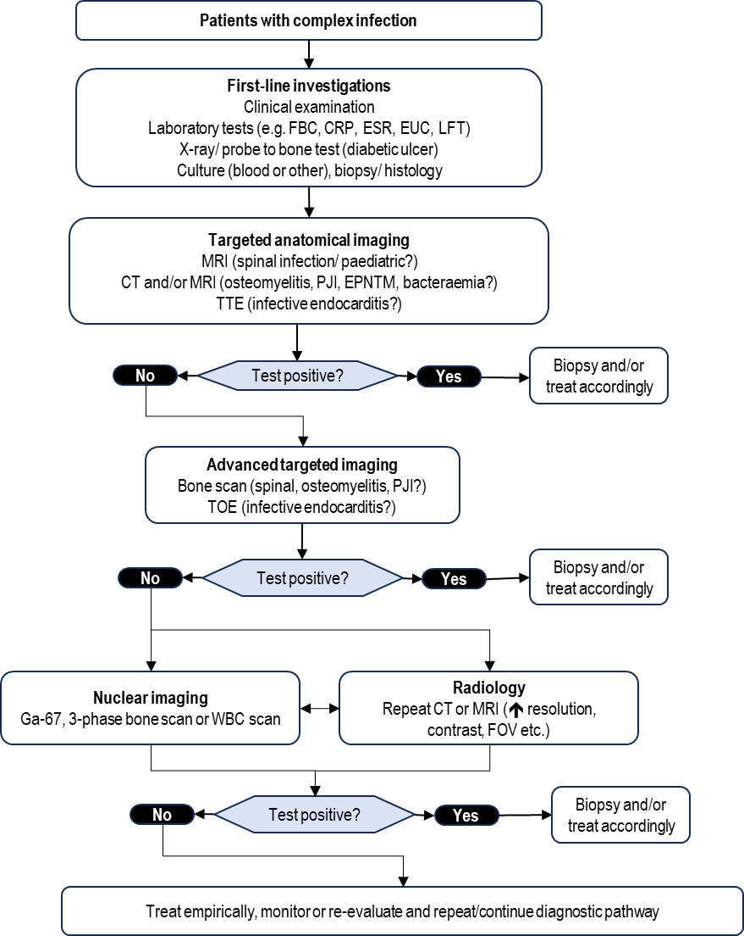
CRP = c-reactive protein; CT = computed tomography; EPNTM = extrapulmonary non-tuberculous mycobacterial; ESR = erythrocyte sedimentation rate; EUC = electrolytes, urea, creatinine; FBC = full blood count; FOV = field of view; Ga-67 = gallium-67 citrate; LFT = liver function test; MRI = magnetic resonance imaging; PJI = prosthetic joint infection; TOE = transesophageal echocardiogram; TTE = transthoracic echocardiogram; WBC = white blood cell.

Figure 4 Proposed clinical management algorithm for PICO Set 1
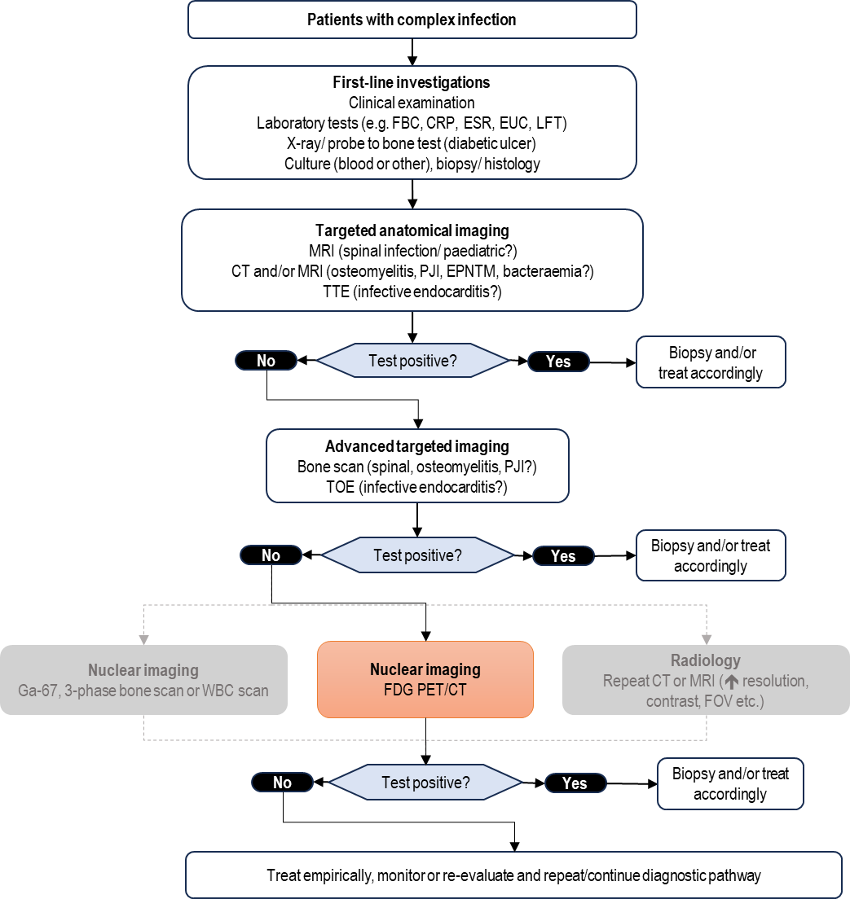
CRP = c-reactive protein; CT = computed tomography; EPNTM = extrapulmonary non-tuberculous mycobacterial; ESR = erythrocyte sedimentation rate; EUC = electrolytes, urea, creatinine; FBC = full blood count; FDG = F-18 fluorodeoxyglucose; FOV = field of view; Ga-67 = gallium-67 citrate; LFT = liver function test; MRI = magnetic resonance imaging; PET = positron emission tomography; PJI = prosthetic joint infection; TOE = transesophageal echocardiogram; TTE = transthoracic echocardiogram; WBC = white blood cell.

PICO Set 2
The clinical management pathways differ initially between the two PICO Set 2 subgroups. For patients who present with fever of unknown origin (not neutropenic), undergo a detailed history and physical assessment, wide-ranging laboratory tests, microbiological cultures, chest X-ray and, if there is a heart murmur or other risks for infective endocarditis, an echocardiogram. If these tests fail to yield a diagnosis and fever has not resolved, they will be referred to hospital-based general specialists or infectious disease services and progress to targeted imaging.
For patients with persistent or recurrent neutropenic fever, are likely to be hospitalised already, or will be hospitalised on presentation, and there is greater urgency in diagnosis, due to the risk of rapid onset of sepsis. The initial investigations are 2 sets of blood cultures and laboratory markers for infection. Further cultures and/or a chest X-ray may be undertaken depending on clinical suspicion.
For both presentations, these initial investigations would be followed by targeted imaging, mostly likely CT. In many cases, this would identify an abnormality that would then direct further diagnostics (e.g. image-guided biopsy, aspiration and culture, tumour markers) and/or appropriate referral and treatment (e.g. oncology, orthopaedic surgery, rheumatology). However, if CT is negative, further imaging using functional markers may be required, either labelled WBC scanning or Ga-67 scintigraphy plus additional diagnostic approaches depending on clinical suspicion. In current practice, FDG PET/CT may be used as an alternative to GA-67 scintigraphy under MBS item 61527; however, this existing use is not shown in the clinical management algorithm.
FDG PET/CT is proposed to replace alternative functional imaging approaches in this pathway and may partially replace CT. Although specificity is low because FDG PET/CT does not differentiate between malignancy, infection and inflammation, a positive scan can focus further tests such as image-guide biopsy, leading to appropriate diagnosis and referral. Conversely, the high negative predive value of FDG PET/CT can reduce ongoing testing and enable a conservative management approach.
The current clinical management algorithm is presented in Figure 5 and the proposed clinical management algorithm is presented in Figure 6.
PASC considered the clinical management algorithms and noted that for PICO Set 1, patients may undergo nuclear imaging and radiology (i.e. CT or MRI) sequentially and this relationship should be reflected in the current clinical management algorithm (Figure 3). Furthermore, PASC was concerned that the proposed clinical management algorithms (Figures 4 and 6) showed that the results from FDG PET/CT resulted in a diagnostic outcome (diagnosis or no diagnosis), whereas a positive FDG PET/CT may be more likely to inform further targeted investigations (e.g. biopsy an area of increased uptake or targeted anatomical imaging) than result in a definitive diagnosis. PASC noted that the clinical algorithms will need to be revised depending on the final populations.
Figure 5 Current clinical management algorithm for PICO Set 2

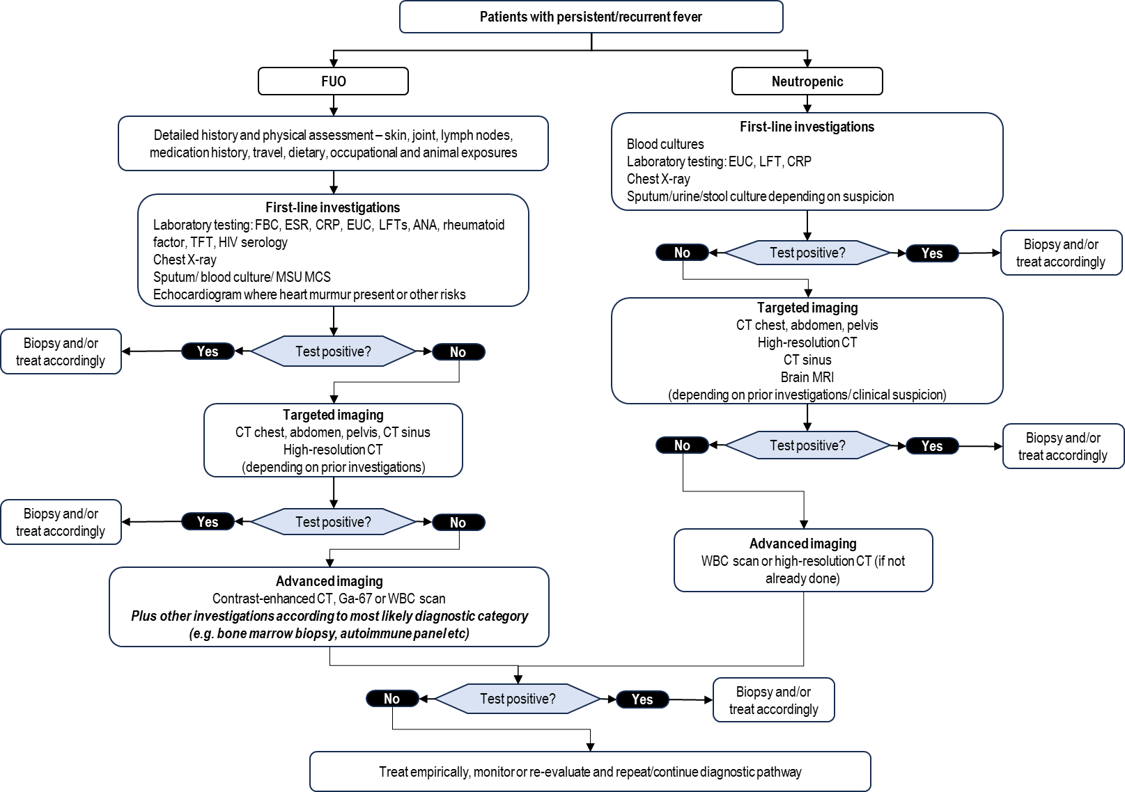

ANA = antinuclear antibody; CRP = c-reactive protein; CT = computed tomography; ESR = erythrocyte sedimentation rate; EUC = electrolytes, urea, creatinine; FBC = full blood count; FDG = F-18 fluorodeoxyglucose; FUO = fever of unknown origin; Ga-67 = gallium-67 citrate; HIV = human immunodeficiency virus; LFT = liver function test; MCS = microscopy, culture, and sensitivity; MRI = magnetic resonance imaging; MSU = mid-stream urine; PET = positron emission tomography; TFT = thyroid function test; WBC = white blood cell.
Figure 6 Proposed clinical management algorithm for PICO Set 2
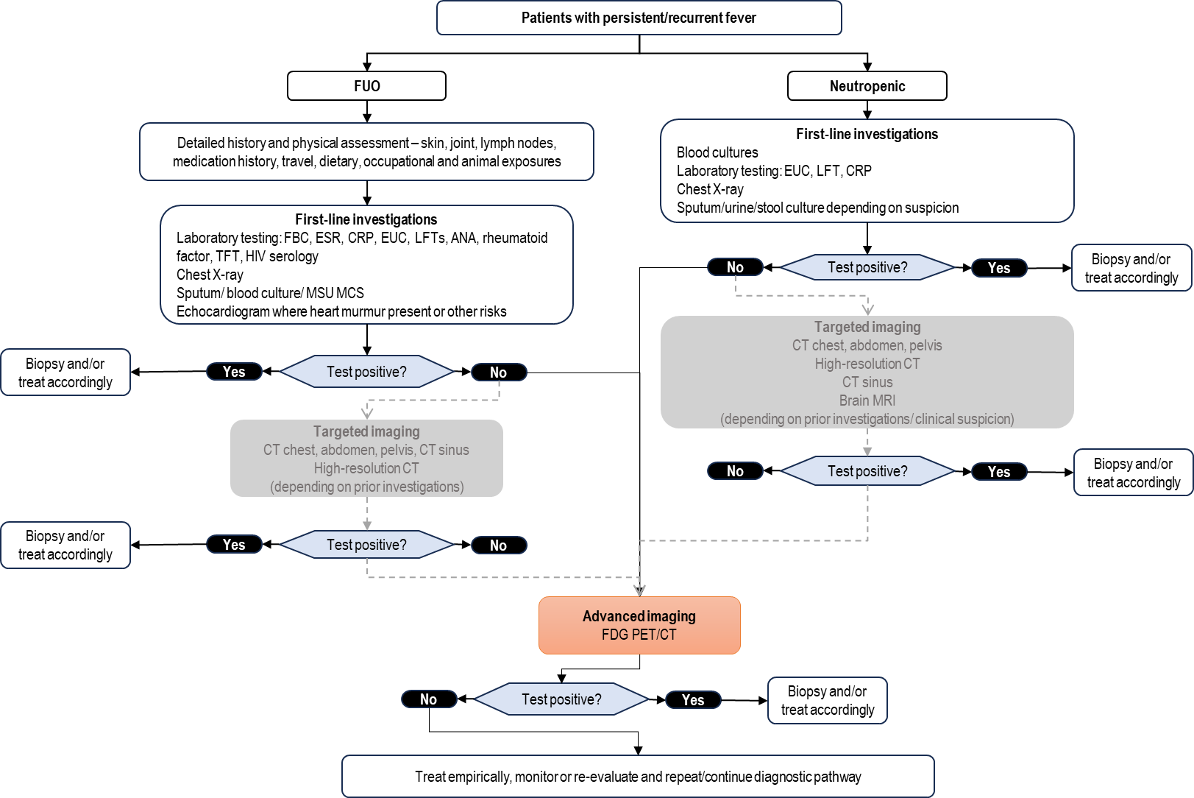
ANA = antinuclear Antibody; CRP = c-reactive protein; CT = computed tomography; ESR = erythrocyte sedimentation rate; EUC = electrolytes, urea, creatinine; FDG = F-18 fluorodeoxyglucose; FBC = full blood count; Ga-67 = gallium-67 citrate; HIV = human immunodeficiency virus; LFT = liver function test; MCS = microscopy, culture, and sensitivity; MSU = mid-stream urine; PET = positron emission tomography; TFT = thyroid function test; UEC = urea, electrolytes, and creatinine; WBC = white blood cell.

Proposed economic evaluation
The applicant has claimed that FDG PET/CT results in superior health outcomes compared to the comparator tests. The test is proposed to be more accurate and safer (compared to other nuclear imaging tests), although the relative additional value for each varies by indication. On the basis of these clinical claims, the appropriate economic evaluation is a cost-effectiveness analysis or a cost-utility analysis (Table 7).
Table 7 Classification of comparative effectiveness and safety of the proposed intervention, compared with its main comparator, and guide to the suitable type of economic evaluation
Comparative safety |  | Comparative effectiveness
Comparative safety | Inferior | Uncertainª | Noninferior^{b} | Superior
Inferior | Health forgone: need other supportive factors | Health forgone possible: need other supportive factors | Health forgone: need other supportive factors | ? Likely CUA
Uncertainª | Health forgone possible: need other supportive factors | ? | ? | ? Likely CEA/CUA
Noninferior^{b} | Health forgone: need other supportive factors | ? | CMA | CEA/CUA
Superior | ? Likely CUA | ? Likely CEA/CUA | CEA/CUA | CEA/CUA
CEA=cost-effectiveness analysis; CMA=cost-minimisation analysis; CUA=cost-utility analysis
? = reflect uncertainties and any identified health trade-offs in the economic evaluation, as a minimum in a cost-consequences analysis
ª ‘Uncertainty’ covers concepts such as inadequate minimisation of important sources of bias, lack of statistical significance in an underpowered trial, detecting clinically unimportant therapeutic differences, inconsistent results across trials, and trade-offs within the comparative effectiveness and/or the comparative safety considerations
^{b} An adequate assessment of ‘noninferiority’ is the preferred basis for demonstrating equivalence
FDG PET/CT is an established technology that is widely used in oncology and a large volume of evidence for its use in infection is available. The joint European Association of Nuclear Medicine (EANM) and Society of Nuclear Medicine and Molecular Imaging (SNMMI) guideline (Abikhzer et al. 2025) recently summarised this evidence, including all systematic reviews and metanalyses published in the 10 years to January 2023. Similarly, the EANM summarised the evidence on the use of FDG PET/CT in FUO in 2024, including 9 systematic reviews and 49 primary studies (Hess et al. 2024). In 2019, a comprehensive report conducted under the UK Health Technology Assessment (HTA) Programme of the National Institute for Health Research evaluated imaging tests for osteomyelitis and included 81 studies (Llewellyn et al. 2019).
An RCT (PIPPIN NCT03429387) comparing FDG PET/CT with CT for persistent or recurrent neutropenic fever was published in 2022, but does not provide direct evidence as the primary endpoint was a composite of starting, stopping, or changing the spectrum (broadening or narrowing) of antimicrobial therapy (referred to as antimicrobial rationalisation), which is a change in management outcome and not a clinical outcome (Douglas et al. 2022). Nevertheless, it was conducted in Australia and provides a level of evidence rarely available for change of management outcomes. An economic evaluation of the PIPPIN clinical trial reported dominance of FDG PET/CT over CT (Tew et al. 2023).
The complexity of the PICOs, with their multiple subpopulations and comparators alongside variable clinical pathways dependent on a mixture of clinical presentation, test availability and provider expertise, will present a challenge for the clinical assessment and the economic evaluation. A pragmatic approach utilising existing systematic reviews might be considered for the clinical assessment. A 2-stage assessment could be used to confirm the clinical assessment and guide subsequent requirements for economic and financial analysis.
MSAC guidelines describe an exemplar/facilitated assessment that is intended to simplify assessment specifically of gene related technologies, however it has been used in imaging assessments such as Application 1702, albeit for a population with a genetic condition. The comparator tests are largely not restricted to defined clinical indications but have generic listings.
The clinical evidence is sparse for the role of FDG PET/CT in paediatric patients. The assessment may need to justify the claim made in the application that in this population, FDG PET/CT is preferred over MRI due to a reduced requirement for sedation and/or anaesthesia, as this does not appear to be clearly supported in the literature (Oztek et al. 2026). Existing FDG PET/CT MBS items are not restricted to adults.
Inflammatory conditions are also an indication for FDG PET/CT and are frequently considered alongside infection in the relevant literature (Abikhzer et al. 2025; Hess et al. 2024). In this application, inflammatory conditions may be identified as an underlying cause in patients meeting the FUO/PUO criteria but are not proposed as an additional population outside those criteria.
PASC discussed the economic evaluation and stated that a cost-utility analysis was the most appropriate approach. PASC did not consider an exemplar approach to be suitable based on this application and had a preference to refine the population to the groups where FDG PET/CT would be of most value, enabling conduct of an economic analysis.

Proposal for public funding
The application proposed the creation of 2 new MBS items to support the use of FDG PET/CT in the diagnosis of complex infections, FUO/PUO and recurrent or persistent neutropenic fever populations (Table 8). The proposed fee is the same as existing FDG PET MBS items. The CT component of the scan is claimed with the existing MBS item 61505, which is for anatomic localisation and/or attenuation correction with PET or SPECT and attracts a fee of $100. If a diagnostic-quality CT is also undertaken, it would be claimed as a separate MBS item and frequently undertaken in a separate session.
Although there are 2 PICOs, they could be combined into a single MBS item. No restriction on the number of times the item can be claimed has been proposed, which may risk expansion of use beyond diagnostic purposes (i.e. for monitoring treatment response). It is relevant to note that patients with neutropenic fever are often cancer patients and malignancy is a differential diagnosis in FUO; therefore, FDG PET may be available for some of the proposed population under existing MBS items.
First-line investigations (prior tests) have not been specified however the PICO states ‘standard initial clinical evaluation consisting of clinical history, physical examination, laboratory tests and targeted imaging (unless contraindicated) has not provided a definitive diagnosis and where treatment decisions depend on accurate and timely identification of the infection sites’ for the complex infection populations and this wording may be more suitable for the MBS item descriptor.
Similarly, the atypical or uncommon infectious disease subpopulation states ‘where FDG PET is expected to inform a significant change in patient management.’ This could be defined in greater detail, for example, ‘where FDG PET is expected to inform appropriate antimicrobial prescribing, surgical planning or further targeted investigations including biopsy and imaging.’ The paediatric subpopulation has not been included in the proposed MBS item descriptor as existing MBS items for PET do not specify age limits and therefore, paediatric patients would be eligible under ‘suspected osteomyelitis.’
Table 8 Proposed new MBS items
Category 5 – DIAGNOSTIC IMAGING SERVICES
MBS item AAAA

Whole body FDG PET study for the evaluation of suspected deep seated, complex, or rare infection in patients in whom first-line investigations were equivocal or contraindicated, including one or more of:
- Suspected spinal infection (vertebral osteomyelitis, discitis or epidural abscess); or
- Suspected osteomyelitis in cases of a known soft tissue infection (including diabetic foot ulcers), fracture related osteomyelitis, and to assess for dissemination of infection to other skeletal sites or organs
- Suspected prosthetic joint infection or other orthopaedic hardware infection, if more than 2 years post-surgery
- Suspected infective endocarditis, including following congenital heart disease, or due to prosthetic valve infection, cardiac implantable electronic device infection and septic emboli
- High-risk bacteraemia (for example Staphylococcus aureus or other pathogens with a high risk of metastatic infection) where metastatic infection is suspected
- Extrapulmonary non-tuberculous mycobacterial (EPNTM) infection with suspected disseminated infection

Fee: $953.00 Benefit: 75% = $714.75 85% = $848.50*
MBS item BBBB
Whole body FDG PET study for the evaluation of fever/pyrexia of unknown origin (FUO/PUO), or persistent or recurrent high-risk neutropenic fever, where there is clinical concern for an underlying infective, inflammatory, or malignant cause, where an appropriately detailed initial evaluation has not established a diagnosis, and the patient has persistent symptoms.

Fee: $953.00 Benefit: 75% = $714.75 85% = $848.50*
* 85% benefit reflects the 1 November 2025 Greatest Permissible Gap (GPG) of $104.50. All out-of-hospital Medicare services that have an MBS fee of $697.00 or more will attract a benefit that is greater than 85% of the MBS fee – being the schedule fee less the GPG amount. The GPG amount is indexed annually on 1 November in line with the Consumer Price Index (CPI) (June quarter).
PASC acknowledged that targeting specific indications may not future proof the item(s) and risks 'over specifying’ clinical use. PASC further noted that the comparator items do not specify clinical indications, particularly in the context of complex infection. PASC considered that a focus on individual indications could exclude patients who would benefit from FDG PET/CT and considered whether a broader listing approach may be appropriate. However, PASC considered that the proposed service may need to be restricted to clearly define the clinical circumstances to ensure that FDG PET/CT is used in the intended patient population and at the appropriate point in the diagnostic pathway.
PASC considered the MBS item descriptors proposed in the application and an alternative proposed by the department that combined both PICO Sets into a single MBS item. PASC supported a single MBS item and the phrase ‘one scan per course of illness’ to distinguish the proposed use for investigation and diagnosis rather than monitoring and to ensure that patients remain eligible for testing if they have experienced subsequent infections requiring investigation.
PASC reiterated the need to refine the populations specified in PICO Set 1 as this would be reflected in the proposed MBS item. PASC considered the revised MBS item descriptor should define eligibility for the item based on the features of a patient's presentation and clinical parameters, rather than a list of suspected clinical conditions. The item descriptor should also include the indication that initial investigations were equivocal or insufficient for a definitive diagnosis , with the purpose of imaging being to inform ongoing management decisions which will influence treatment. PASC considered this may require prior tests to be specified, and expected change in management included within the item descriptor. PASC was concerned about use outside of the proposed population and considered that the descriptor should clearly identify the clinical circumstance in which FDG PET/CT would be used, noting that it is not intended as a baseline test for patients with suspected infection.
PASC noted stakeholder inputs that the proposed fee may be inadequate because imaging to investigate infection may require a larger field than many oncology indications, as imaging may extend from vertex to toes rather than vertex to thighs. Stakeholders proposed fees of $999 (consistent with MBS items 61533 and 61640) and $1,053. PASC also noted that the current fee for MBS item 61527 is $752.35 (PET scan due to unavailability of Ga-67) which is lower than the proposed fee. PASC considered that further work was required to determine the appropriate fee.

Summary of public consultation input
PASC noted and welcomed consultation input from 5 organisations and no individual input was received. The 5 organisations that submitted input were:
- Australasian Association of Nuclear Medicine Specialists (AANMS)
- Australian Diagnostic Imaging Association (ADIA)
- Cyclotek
- The Australian and New Zealand Society of Nuclear Medicine (ANZSNM)
- The Royal Australian and New Zealand College of Radiologists (RANZCR).
Consultation input was supportive of public funding for FDG PET/CT for evaluation of complex infection.
Benefits and Disadvantages
The main benefits of public funding reported in the consultation input included improved access to FDG PET/CT for evaluation of complex infection, earlier and more accurate diagnosis, more timely clinical decision-making and improved treatment guidance. AANMS stated that the conditions outlined in the application can disproportionally affect vulnerable populations, including First Nations peoples, who are unable to self-fund imaging and that public funding would improve equitable access. Consultation input also highlighted the potential to reduce hospital length of stay, reduce reliance on comparator investigations and support more efficient use of healthcare resources. AANMS stated that FDG PET/CT delivers a whole-body study in a single attendance unlike labelled WBC scanning and Ga-67 scintigraphy which require sequential imaging over consecutive days.
The main disadvantages of public funding reported in the consultation input related to uncertainty regarding the strength of evidence and clinical utility across proposed subpopulations.
Population, Comparator (current management) and Delivery
The consultation input partly agreed with the proposed population. ANZSNM considered the proposed population closely aligned with the European Association of Nuclear Medicine Guideline for FDG PET/CT in infection and inflammation in adults. AANMS considered the proposed eligibility criteria too broad and highlighted that the populations of PUO/FUO, high-risk neutropenic fever, infective endocarditis, and bacteraemia with suspected metastatic infection were most likely to benefit. RANZCR proposed broadening the population to include inflammation in addition to complex infection and Cyclotek suggested alignment with existing gallium infection imaging indications.
The consultation input agreed with the proposed comparator and considered it reflective of current Australian clinical practice. AANMS, Cyclotek and RANZCR stated that WBC kits for labelled WBC scanning and gallium-67 for Ga-67 scintigraphy are produced overseas and are subject to supply issues and increasing costs. AANMS considered that conventional imaging investigations would continue to play an important role in the diagnostic pathway and that FDG PET/CT is most appropriately used as an adjunct to existing first-line investigations.
Other services identified in the consultation input as being needed before or after the intervention included conventional imaging investigations, specialist clinical assessment and multidisciplinary management.
MBS Item Descriptor and Fee
The consultation input mostly disagreed with the proposed item descriptors. AANMS considered the proposed indications too broad and should be restricted to certain clinical indications following appropriate first-line investigations that have failed to establish a diagnosis. RANZCR recommended defining equivocal first-line tests as “non-diagnostic or technically limited work up, contraindication to first line imaging, or persistent inability to localise the clinical problem despite baseline assessment”. ANZSNM and AANMS advised that the item should be restricted to once per discrete episode, whereas Cyclotek advised that the item frequency should be left to clinician discretion.
The consultation input ranged from agreeing to disagreeing with the proposed MBS item fee. AANMS supported the proposed fee. ANZSNM, ADIA and Cyclotek considered a higher fee ranging from $999 to $1053 was appropriate to cover vertex to toes scanning for infection assessment, rather than the proposed fee that corresponds to vertex to thighs scanning.
Additional Comments
Consultation input noted that FDG PET/CT is already routinely used in clinical practice for evaluation of complex infection and that existing PET infrastructure and workforce capability would support implementation of the proposed service.
PASC noted the public consultation feedback, particularly that provided by the AANMS who considered the criteria too broad and that the proposed population included patients who were unlikely to benefit from FDG PET/CT. The AANMS commented that clear thresholds for clinical suspicion should be established and the stage of illness at which the scan is indicated requires definition. AANMS raised the concern that clinical benefit was most likely for PICO Set 2 in patients where there are no localising signs of infection. In this case, FDG PET/CT would be a first-line investigation. For PICO Set 1, infective endocarditis and bacteraemia with suspected metastatic infection would be the most likely subpopulations to benefit and FDG PET/CT should complement rather than replace other imaging.
AANMS stated that FDG PET/CT has advantages over other nuclear imaging options in certain circumstances but recognised the limited specificity of the test. Nevertheless, the high negative predictive value was recognised for the potential to avoid unnecessary investigations or treatment.
Feedback was also received from the Royal Australian and New Zealand College of Radiologists (RANZCR) who requested clarification of the terms ‘equivocal or contraindicated’ within the proposed item descriptor.

Next steps
PASC considered that the proposed population requires further refinement, including clearer definition of the clinical circumstances, clinical thresholds and level of diagnostic uncertainty that would support use of FDG PET/CT, and that proposed subpopulations will require an appropriate evidence basis to facilitate evaluation via a HTA pathway PASC advised that further consultation between the applicant, clinical experts, and the department is required to refine the proposed population before the application returns to PASC for further consideration.

Applicant Comments on Ratified PICO
We welcome PASC’s recognition that an overly prescriptive list of conditions could exclude patients who would benefit from FDG PET/CT. Additionally, we support further defining the clinical circumstances in which FDG PET/CT would inform management. We request that the proposed subgroups remain under consideration while criteria and supporting evidence are reviewed with clinical experts.

References
Abikhzer G, Treglia G, Pelletier-Galarneau M, Buscombe J, Chiti A, Dibble EH, Glaudemans AWJM, Palestro CJ, Sathekge M, Signore A, Jamar F, Israel O and Gheysens O (2025) ‘EANM/SNMMI guideline/procedure standard for [18F]FDG hybrid PET use in infection and inflammation in adults v2.0’, European Journal of Nuclear Medicine and Molecular Imaging, 52(2):510–538, doi:10.1007/s00259-024-06915-3.
Arnold SR, Giordano V, Obremskey WT, Schwarz EM, Smeltzer MS, Veis DJ and Cassat JE (2026) ‘Osteomyelitis’, Nature Reviews Disease Primers, 12(1):33, doi:10.1038/s41572-026-00707-9.
Douglas AP, McMullan B, Yap N, Bajel A, Alcorn K, Cooley L, Kinsella P, Laundy N, Bupha‐Intr O, Legg A, Roberts J, Trubiano JA, Sasadeusz J, Conyers R, Thursky KA, and the Australasian Neutropenic Fever Guidelines Steering Committee (2025) ‘Consensus guidelines for the subsequent management of neutropenic fever after empiric therapy’, Internal Medicine Journal, 55(S7):68–94, doi:10.1111/imj.70249.
Douglas A, Thursky K, Spelman T, Szer J, Bajel A, Harrison S, Tio SY, Bupha-Intr O, Tew M, Worth L, Teh B, Chee L, Ng A, Carney D, Khot A, Haeusler G, Yong M, Trubiano J, Chen S, Hicks R, Ritchie D and Slavin M (2022) ‘[18F]FDG-PET-CT compared with CT for persistent or recurrent neutropenic fever in high-risk patients (PIPPIN): a multicentre, open-label, phase 3, randomised, controlled trial’, The Lancet Haematology, 9(8):e573–e584, doi:10.1016/S2352-3026(22)00166-1.
Fowler VG, Durack DT, Selton-Suty C, Athan E, Bayer AS, Chamis AL, Dahl A, DiBernardo L, Durante-Mangoni E, Duval X, Fortes CQ, Fosbøl E, Hannan MM, Hasse B, Hoen B, Karchmer AW, Mestres CA, Petti CA, Pizzi MN, Preston SD, Roque A, Vandenesch F, Van Der Meer JTM, Van Der Vaart TW and Miro JM (2023) ‘The 2023 Duke-International Society for Cardiovascular Infectious Diseases Criteria for Infective Endocarditis: Updating the Modified Duke Criteria’, Clinical Infectious Diseases, 77(4):518–526, doi:10.1093/cid/ciad271.
Freifeld AG, Bow EJ, Sepkowitz KA, Boeckh MJ, Ito JI, Mullen CA, Raad II, Rolston KV, Young J-AH and Wingard JR (2011) ‘Clinical Practice Guideline for the Use of Antimicrobial Agents in Neutropenic Patients with Cancer: 2010 Update by the Infectious Diseases Society of America’, Clinical Infectious Diseases, 52(4):e56–e93, doi:10.1093/cid/cir073.
Glaudemans AWJM, Jutte PC, Cataldo MA, Cassar-Pullicino V, Gheysens O, Borens O, Trampuz A, Wörtler K, Petrosillo N, Winkler H, Signore A and Sconfienza LM (2019) ‘Consensus document for the diagnosis of peripheral bone infection in adults: a joint paper by the EANM, EBJIS, and ESR (with ESCMID endorsement)’, European Journal of Nuclear Medicine and Molecular Imaging, 46(4):957–970, doi:10.1007/s00259-019-4262-x.
Habib G, Lancellotti P, Antunes MJ, Bongiorni MG, Casalta J-P, Del Zotti F, Dulgheru R, El Khoury G, Erba PA, Iung B, Miro JM, Mulder BJ, Plonska-Gosciniak E, Price S, Roos-Hesselink J, Snygg-Martin U, Thuny F, Tornos Mas P, Vilacosta I and Zamorano JL (2015) ‘2015 ESC Guidelines for the management of infective endocarditis: The Task Force for the Management of Infective Endocarditis of the European Society of Cardiology (ESC)Endorsed by: European Association for Cardio-Thoracic Surgery (EACTS), the European Association of Nuclear Medicine (EANM)’, European Heart Journal, 36(44):3075–3128, doi:10.1093/eurheartj/ehv319.
Haidar G and Singh N (2022) ‘Fever of Unknown Origin’, New England Journal of Medicine, 386(5):463–477, doi:10.1056/NEJMra2111003.
Hess S, Noriega-Álvarez E, Leccisotti L, Treglia G, Albano D, Roivainen A, Glaudemans AWJM and Gheysens O (2024) ‘EANM consensus document on the use of [18F]FDG PET/CT in fever and inflammation of unknown origin’, European Journal of Nuclear Medicine and Molecular Imaging, 51(9):2597–2613, doi:10.1007/s00259-024-06732-8.
Iliadis AD and Ramachandran M (2017) ‘Paediatric bone and joint infection’, EFORT Open Reviews, 2(1):7–12, doi:10.1302/2058-5241.2.160027.
Kouijzer IJE, Kampschreur LM, Wever PC, Hoekstra C, Van Kasteren MEE, De Jager-Leclercq MGL, Nabuurs-Franssen MH, Wegdam-Blans MCA, Ammerlaan HSM, Buijs J, Geus-Oei L-FD, Oyen WJG and Bleeker-Rovers CP (2018) ‘The Value of¹⁸ F-FDG PET/CT in Diagnosis and During Follow-up in 273 Patients with Chronic Q Fever’, Journal of Nuclear Medicine, 59(1):127–133, doi:10.2967/jnumed.117.192492.
Laur O, Schonberger A, Gunio D, Minkowitz S, Salama G, Burke CJ and Bartolotta RJ (2024) ‘Imaging assessment of spine infection’, Skeletal Radiology, 53(10):2067–2079, doi:10.1007/s00256-023-04558-3.
Lazzeri E, Bozzao A, Cataldo MA, Petrosillo N, Manfrè L, Trampuz A, Signore A and Muto M (2019) ‘Joint EANM/ESNR and ESCMID-endorsed consensus document for the diagnosis of spine infection (spondylodiscitis) in adults’, European Journal of Nuclear Medicine and Molecular Imaging, 46(12):2464–2487, doi:10.1007/s00259-019-04393-6.
Llewellyn A, Jones-Diette J, Kraft J, Holton C, Harden M and Simmonds M (2019) ‘Imaging tests for the detection of osteomyelitis: a systematic review’, Health Technology Assessment, 23(61):1–128, doi:10.3310/hta23610.
Muharremi E, Demiraj F, Babici D, Shaban A, Kutuk T and Nath S (2025) ‘Acute Spinal Infections: A Modern Narrative Review With Evidence Through 2024’, Clinical Infection and Immunity, 10(3):41–50, doi:10.14740/cii509.
Orange JS, Chinen J, Horner CC, Kobrynski LJ, Ballow M, Butte MJ, Chandrakasan S, Chinn IK, Satter LF, Freeman AF, Heimall JR, Knight V, Lawrence MG, Lehman HK, Maglione PJ, Perez EE, Risma KA, Walter JE, Abraham RS, Barmettler S, Broderick L, Chang CC, Chan AY, Chen K, Connelly J, Danziger-Isakov LA, De la Morena MT, DiGiacomo D, Dimitriades VR, Dorsey MJ, Dulek DE, Dutmer CM, Dvorak CC, Farmer JR, Frazer-Abel A, Joshi AY, Keller MD, Khan YW, Kitcharoensakkul M, Leiding JW, Myers KC, Nandakumar V, Platt CD, Pai SY, Patel NC, Pozos TC, Puck JM, Rider NL, Sacco KA, Williams KW, Lieberman JA, Rank MA, Shaker MS, Abrams EM, Bernstein JA, Chu DK, Ellis AK, Golden DBK, Greenhawt M, Ledford DK, Mosnaim G, Wang J (2026) ‘2025 Inborn errors of immunity practice parameter: Guidance from the Joint Task Force on Practice Parameters, the American Academy of Allergy, Asthma & Immunology (AAAAI), the American College of Allergy, Asthma and Immunology (ACAAI) and the Clinical Immunology Society (CIS)’, Annals of Allergy, Asthma and Immunology, 136(4):426-493, doi: 10.1016/j.anai.2025.10.026.
Oztek MA, Shulkin BL and Parisi MT (2026) ‘Pediatric infection imaging focusing on FDG PET/CT: Techniques, safety, and indications’, Seminars in Nuclear Medicine, 56(3):511–527, doi:10.1053/j.semnuclmed.2026.03.011.
Rath S, Firdaus S, Nayak G and Mohanty M (2025) ‘Extrapulmonary Nontuberculous Mycobacteria Infection: The New-Age Neglected Infectious Disease’, Cureus, doi:10.7759/cureus.81017.
Signore A, Jamar F, Israel O, Buscombe J, Martin-Comin J and Lazzeri E (2018) ‘Clinical indications, image acquisition and data interpretation for white blood cells and anti-granulocyte monoclonal antibody scintigraphy: an EANM procedural guideline’, European Journal of Nuclear Medicine and Molecular Imaging, 45(10):1816–1831, doi:10.1007/s00259-018-4052-x.
Signore A, Sconfienza LM, Borens O, Glaudemans AWJM, Cassar-Pullicino V, Trampuz A, Winkler H, Gheysens O, Vanhoenacker FMHM, Petrosillo N and Jutte PC (2019) ‘Consensus document for the diagnosis of prosthetic joint infections: a joint paper by the EANM, EBJIS, and ESR (with ESCMID endorsement)’, European Journal of Nuclear Medicine and Molecular Imaging, 46(4):971–988, doi:10.1007/s00259-019-4263-9.
Tew M, Douglas AP, Szer J, Bajel A, Harrison SJ, Tio SY, Worth LJ, Hicks RJ, Ritchie D, Slavin MA, Thursky KA and Dalziel K (2023) ‘Evaluating the cost-effectiveness of [18F] FDG-PET/CT for investigation of persistent or recurrent neutropenic fever in high-risk haematology patients’, Cancer Imaging, 23(1):119, doi:10.1186/s40644-023-00647-7.
Treglia G (2019) ‘Diagnostic Performance of¹⁸ F-FDG PET/CT in Infectious and Inflammatory Diseases according to Published Meta-Analyses’, Contrast Media & Molecular Imaging, 2019:1–12, doi:10.1155/2019/3018349.
Vos FJ, Bleeker-Rovers CP, Sturm PD, Krabbe PFM, Van Dijk APJ, Cuijpers MLH, Adang EMM, Wanten GJA, Kullberg B-J and Oyen WJG (2010) ‘¹⁸ F-FDG PET/CT for Detection of Metastatic Infection in Gram-Positive Bacteremia’, Journal of Nuclear Medicine, 51(8):1234–1240, doi:10.2967/jnumed.109.072371.
Yin P, Sherwood A, Castellino LM, Crisologo PA, Israel O, Öz OK and Abikhzer G (2026) ‘Imaging trends in diabetic foot infections’, Seminars in Nuclear Medicine, 56(3):430–441, doi:10.1053/j.semnuclmed.2026.03.012.

The Royal Children’s Hospital Melbourne, Clinical Practice Guidelines, Bone and Joint Infection.
Advice provided by applicant’s clinical paediatric infectious disease specialists via written response.
Staphylococcus aureus Bacteraemia (SAB) Management Clinical Guideline, Version 2.0 27 February 2023, SA Health.
NHS England, Clinical Commissioning Policy Statement: Positron Emission Tomography-Computed Tomography (PET-CT) Guidelines (all ages)
Originally defined as failure to reach a diagnosis despite 1 week of inpatient investigations and subsequently shortened to 3 inpatient days or 3 outpatient visits (Haidar and Singh 2022)
Pyrexia of unknown origin, Metro North Health, Queensland Government.
Pyrexia of unknown origin, Royal College of Pathologists of Australasia
Positron emission tomography, National Health Technology Advisory Panel (1990)
Department of Health, Disability and Ageing, PET units in Australia
AIHW (Australian Institute of Health and Welfare) (2024) Pathology, imaging and other diagnostic services, AIHW, Australian Government, accessed 6 July 2026.
Credentialled under the Joint Nuclear Medicine Specialist Credentialling Program for the Recognition of the Credentials of Nuclear Medicine Specialists for PET overseen by the Joint Nuclear Medicine Credentialling and Accreditation Committee of the Royal Australasian College of Physicians (RACP) and Royal Australian and New Zealand College of Radiologists (RANZCR). Alternatively, it can be performed by a practitioner who is a Fellow of either RACP or RANZCR, and who, prior to 1 November 2011, reported 400 or more studies forming part of PET services for which a Medicare benefit was payable, and who holds a current licence from the relevant State radiation licensing body to prescribe and administer the intended PET radiopharmaceuticals to humans.
Australian national diagnostic reference levels for nuclear medicine and PET

