MSAC Application 1826
N-Terminal-pro Brain Natriuretic Peptide (NT-proBNP) testing to support management of patients with heart failure
Applicant: Roche Diagnostics Australia Pty Ltd

PICO Confirmation

Summary of PPICO criteria to define question(s) to be addressed in an Assessment Report to the Medical Services Advisory Committee (MSAC)
Table 1 PPICO for NT-proBNP testing to support management of patients with heart failure
Component | Description
Population | Patients in the immediate post-discharge phase following hospitalisation for treatment of heart failure (HF) with reduced ejection fraction (EF) who:  - are intended to be treated or managed with guideline directed medical therapy (GDMT), from at least 3 of the 4 of the following classes:  - angiotensin-converting enzyme inhibitor (ACEi)/ angiotensin receptor neprilysin inhibitor (ARNI)/ angiotensin receptor blocker (ARB)  - beta blocker  - mineralocorticoid receptor antagonist (MRA), and/or  - sodium-glucose cotransporter 2 (SGLT2) inhibitor  - are not currently treated with >50% of maximum doses of GDMT, and  - had an elevated NT-proBNP measurement during or immediately prior to hospitalisation.
Prior tests | Baseline NT-proBNP test (during or immediately prior to hospitalisation)
Intervention | NT-proBNP testing in addition to current standard medical management as an aid to the titration of GDMT post-hospitalisation for HF. Testing to be undertaken up to 5 times in the post-discharge period (noting this is typically defined as the 6-week period post-hospitalisation, but testing will be permitted in the 3 month period post-hospitalisation to account for potential delays in accessing follow up healthcare in the shorter timeframe).
Comparator/s | Current standard medical management consisting of clinical observations and standard laboratory measurements without NT-proBNP testing
Reference standard | The health outcome being considered (mortality, HF related rehospitalisation)
Outcomes | Safety  - Adverse events due to testing  - Harms associated with change of management  Efficacy/effectiveness  Primary health outcomes  - Mortality  - Repeat HF hospitalisation  - Functional status  - Quality of life using disease specific and generic tools  Intermediate/surrogate outcomes  - Time to optimal dose/proportion on optimal dose  - Left ventricular ejection fraction (LVEF)  Additional outcomes using linked evidence approach  Change in management  - Dose(s) of medication(s) up-titrated/down-titrated  - Medication(s) initiated, ceased etc.  - Number of post-discharge visits (specialist, GP etc.)  - Other changes (additional/reduced imaging/laboratory tests etc.)  Test performance/Analytical validity  - Prognostic and predictive value  - Responsiveness  - Reproducibility, reliability, acceptability  Health care resources (including patient out-of-pocket costs)  - Cost of NT-proBNP testing  - Cost of post-discharge care including NT-proBNP testing  - Costs associated with change in management (additional visits, medication changes)  Cost-effectiveness  Total Australian Government health care costs  - Total cost to the Medicare Benefits Schedule (MBS)  - Total cost to the Pharmaceutical Benefits Schedule (PBS)
Assessment questions | What is the safety, effectiveness and cost-effectiveness of NT-proBNP testing in addition to standard medical management as an aid to rapid optimisation of GDMT versus standard medical management alone in patients in the immediate post-discharge period following hospitalisation for acute HF?

Purpose of application
An application requesting Medicare Benefits Schedule (MBS) listing of N-terminal-pro brain natriuretic peptide (NT-proBNP) testing as an aid for the management of patients with heart failure (HF) was received from Roche Diagnostics Australia Pty Limited by the Department of Health, Disability and Ageing (the department).
The application is for the use of NT-proBNP testing to be used in the period post-discharge from a hospitalisation for HF to enable more rapid dose escalation of guideline-directed medical therapy (GDMT). The test is proposed to be used up to 5 times within 6 weeks of the index hospitalisation. The use of the proposed technology is claimed to result in superior health outcomes compared to standard practice.
NT-proBNP (or brain natriuretic peptide [BNP]) testing has been considered by the Medical Services Advisory Committee (MSAC) on 4 previous occasions (Table 2), 2 of which relate to HF. One of these, 1087, considered monitoring of HF. MSAC concluded that there was insufficient evidence of effectiveness and cost-effectiveness for the use of BNP assays in monitoring the progress of patients with HF. Numerous trials of NT-proBNP monitoring in HF have since been conducted; however, the current application is restricted to the use of NT-proBNP in the immediate post-discharge period to guide treatment optimisation and not for more general monitoring.
Table 2 Prior MSAC application for NT-proBNP testing
Application No. | Title of application | MSAC Meeting date | Outcome
1087 | Brain natriuretic peptide assays in the diagnosis and monitoring of heart failure | 15 November 2006  6-7 April 2017 (report to MSAC on the predicted versus actual impacts following its support of the application) | Supported – hospital emergency setting  Not Supported – non-hospital setting
1689 | Quantification of NT-proBNP in patients with systemic sclerosis, and in patients with diagnosed pulmonary arterial hypertension | 28–29 July 2022 | Supported – diagnosis  Not Supported - monitoring
1689.1 | Quantification of NT-proBNP in patients with diagnosed pulmonary arterial hypertension for ongoing risk assessment (i.e. monitoring population not supported in 1689) | 27–28 July 2023 | Supported
1740 | N-Terminal-pro Brain Natriuretic Peptide (NT-proBNP) to aid in the diagnosis of patients with suspected heart failure in a non-hospital setting | 23–24 November 2023 | Supported
MSAC = Medical Services Advisory Committee; NT-proBNP = N-Terminal-pro Brain Natriuretic Peptide.

PICO criteria

Population
The proposed population is patients in the immediate post-discharge phase following hospitalisation for treatment of HF who:
- are intended to be treated or managed with at least 3 of the 4 classes of GDMT, consisting of:
  - angiotensin-converting enzyme (ACE) inhibitor/ angiotensin receptor neprilysin inhibitor (ARNI)/ angiotensin receptor blocker (ARB)
  - beta blocker
  - mineralocorticoid receptor antagonist (MRA), and/or
  - sodium-glucose cotransporter 2 (SGLT2) inhibitor
- are not currently treated with >50% of maximum doses of GDMT, and
- had an NT-proBNP measurement during or immediately prior to hospitalisation of >2,500 pg/mL.
These criteria have been proposed as they align with the population studied in the pivotal trial referred to as STRONG-HF (Mebazaa et al. 2022; NCT03412201 Table 3). This trial was designed to compare usual care with ‘high-intensity care.’ In the high-intensity care arm, rapid up-titration of GDMT is facilitated by the assessment of routine laboratory measures and biomarkers, including NT-proBNP, and frequent post-discharge visits.
The STRONG-HF randomised controlled trial (RCT) was enriched for sicker patients due to the requirement for a high NT-proBNP level at baseline. In an emergency department setting, the diagnostic cut-off for acute HF is an NT-proBNP level of >900 pg/mL (age 50-75 years); however, the applicant’s clinical expert estimated that >85% of presenting patients had a level >2,500 pg/mL. The current MBS item for HF diagnosis in the emergency setting (MBS item 66830, the baseline test) is for both BNP and NT-proBNP testing and could restrict access where BNP was the initial test, most likely in rural and remote locations.
At the time of the trial, SGLT2 was not established as GDMT and therefore did not form part of the trial inclusion criteria and few patients in the trial were prescribed SGLT2 inhibitors (10% in the intervention arm). SGLT2 is now recommended as part of GDMT in an Australian consensus statement (Sindone et al. 2022) and is PBS-listed for HF.
In comparison with the proposed PICO population, the RCT did not enrol patients older than 85 years, nor those with a range of comorbidities and clinical characteristics all of which are likely to be common in a hospitalised HF cohort. Sub-optimal GDMT is not as tightly defined in the proposed PICO population as it was in the trial.
Table 3 Key inclusion and exclusion criteria for the STRONG-HF RCT
Inclusion criteria | Exclusion criteria
- SBP ≥100 mmHg and HR ≥ 60 bpm  - K+ ≤ 5.0 mmol/L  - NT-proBNP  - >2,500 pg/mL at screening  - >1, 500 pg/mL at randomisation (1-2 days before discharge) & decreased >10% from screening  - Either:  - ≤ 50% recommended dose of ACE inhibitor/ARB/ARNI, no beta blocker and ≤50% recommended dose of MRA prescribed, or  - No ACE inhibitor/ARB/ARNI, ≤50% recommended dose of beta blocker prescribed and ≤50% recommended dose of MRA prescribed | - Age <18 or >85 years  - Intolerance to high doses of beta blocker or ACE inhibitors and ARB  - Significant pulmonary disease  - Myocardial infarction, unstable angina or cardiac surgery within 3 months, or cardiac resynchronization therapy device implantation within 3 months, or percutaneous transluminal coronary intervention, within 1 month prior to screening.  - Index admission triggered by correctable etiology (atrial fibrillation, tachycardia, infection, anaemia etc.)  - Renal disease or eGFR <30 mL/min/1.73 m²  - Discharge estimated to be >14 days from admission or to a long-term care facility  - Inability to comply with all study requirements due to major co-morbidities, social or financial issues or a history of noncompliance with medical regimens
ACE = angiotensin-converting enzyme; ARB = angiotensin receptor blocker; ARNI = angiotensin receptor neprilysin inhibitor; bpm = beats per minute; eGFR = estimated glomerular filtration rate; HR = heart rate; K+ = potassium; min = minute; mL = millilitres; mmHg = milligrams of mercury; MRA = mineralocorticoid receptor antagonist; NT-proBNP = N-Terminal-pro Brain Natriuretic Peptide; pg = picograms; RCT = randomised controlled trial; SBP = systolic blood pressure.
Source: Supplementary Table 2 of Kimmoun et al. (2019)

Heart Failure
HF is a complex clinical syndrome with typical symptoms and signs that generally occur on exertion but can also occur at rest (particularly when recumbent). It is secondary to an abnormality of cardiac structure or function that impairs the ability of the heart to fill with blood at normal pressure or eject blood sufficient to fulfil the needs of the metabolising organs (Atherton et al. 2018).
HF is primarily classified with reference to the percentage of blood ejected from the left ventricle in each cardiac contraction measured using echocardiography. The lower limit of normal is a left ventricular ejection fraction (LVEF) of 50-55% and on this basis, HF is classified into 2 main types, with reduced ejection fraction (HFrEF) or with preserved ejection fraction (HFpEF). In Australian guidelines HFrEF is <50% (Atherton et al. 2018); however, variable cut-offs are used in HF studies.
HF symptoms impact on daily activities which can be assessed using the New York Heart Association (NYHA) severity scale, ranging from Class I, no limitation of ordinary physical activity, to Class IV, where patients experience symptoms on any physical activity or at rest.
Acute HF can refer to either an acute onset or significant worsening of symptoms in a patient with chronic HF that is sufficient to warrant treatment (acute-on-chronic). Most patients present with the latter. The proposed population includes both presentations provided they have had an unplanned and immediate admission to hospital for treatment of HF. When hospitalised, as part of individual patient treatment decisions, patients are likely to be initiated on medication or have doses of current medications adjusted in line with clinical guidelines for the management of HF.
HF is associated with both increasing age and comorbidity. In a study of consecutive patients admitted to hospital with acute HF as part of the Victorian Cardiac Outcomes Registry (VCOR), the mean age was 77 years and there were high rates of comorbidity including hypertension (75%), chronic renal disease (64%), atrial fibrillation (55%), diabetes (44%) and chronic obstructive pulmonary disease (COPD) (32%) (Driscoll et al. 2020). For comparison, in an Australian general practice cohort with HF the mean age was 70 years, 41% had hypertension, 25% had COPD and 6.4% had severe renal impairment (Sindone et al. 2021).

Pharmacological management of HF
The aim of medication in treating HF is to improve cardiac output and reduce biomechanical stress within the heart. This reduces the risk of mortality and improves everyday quality of life through restoring the heart’s capacity to meet every day metabolic demands. Australian GDMT is detailed in the 2018 Cardiac Society of Australia and New Zealand (CSANZ) Guidelines (Atherton et al. 2018) and a consensus statement (Sindone et al. 2022) that updates the guideline recommendations based on more recent evidence.
All patients with HFrEF are recommended to commence on 4 destination therapies:
- ARNI or ACE inhibitor; and
- HF specific beta blocker; and
- MRA; and
- SGLT2 inhibitor (Figure 1).
The consensus statement differs from the 2018 Guidelines in recommending ARNI in preference to ACE inhibitors and broadening the use of SGLT2 inhibitors (previously only for patients with Type 2 diabetes). Further, the consensus statement specifically notes that the therapies should be up-titrated to the maximum tolerated dose (Table 4) and should be commenced together (not in a stepwise manner) before full titration of individual medications.
Figure 1 HFrEF medication management algorithm updated in consensus statement (Sindone et al. 2022) from the original 2018 National Heart Foundation of Australia (NHFA) and Cardiac Society of Australia and New Zealand (CSANZ) heart failure guidelines
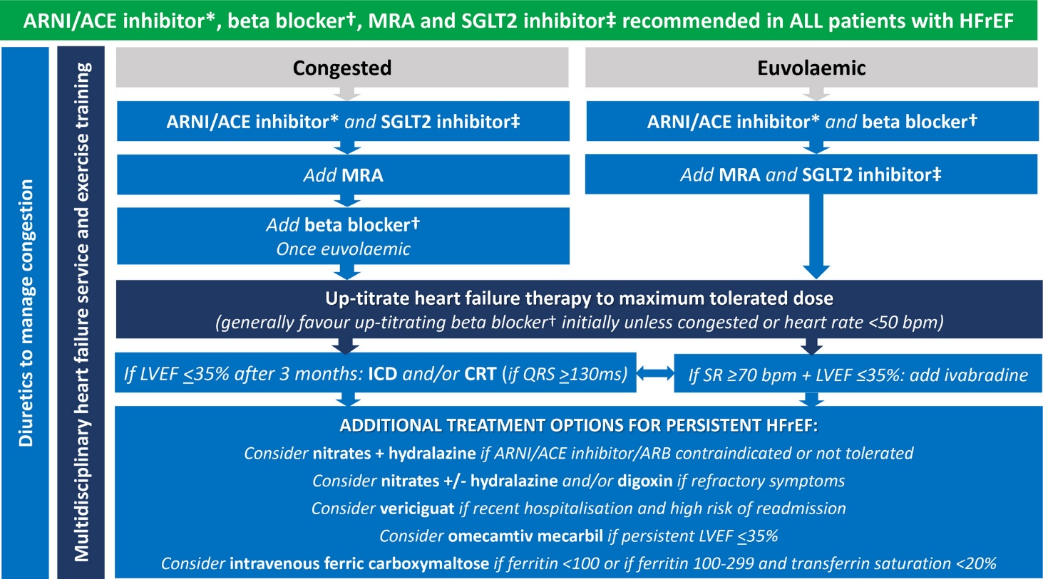
ACE = angiotensin-converting enzyme; ARB= angiotensin receptor blocker, ARNI = angiotensin receptor neprilysin inhibitor; bpm = beats per minute; CRT = cardiac resynchronisation therapy; HFrEF = heart failure with reduced ejection fraction; ICD = implantable cardioverter defibrillator; LVEF = left ventricular ejection fraction; MRA = mineralocorticoid receptor antagonist; ms = milliseconds; QRS = QRS complex (electrocardiogram); SGLT2 = sodium–glucose cotransporter 2; SR = sinus rhythm.
The key overarching theme (green background) is to commence all patients on the 4 destination therapies of ARNI/ACE inhibitor*, beta blocker†, MRA and SGLT2 inhibitor‡ as soon as clinically possible, given their early morbidity and mortality benefit. * ARNI preferred. ACE inhibitor can be considered as an alternative if problematic hypotension, and consider switching to ARNI later. † Use beta blocker with outcome trial proven HFrEF efficacy (i.e., carvedilol, bisoprolol, metoprolol succinate or nebivolol). ‡ Use SGLT2 inhibitor with outcome trial proven HFrEF efficacy (i.e., dapagliflozin or empagliflozin).
Source: Box 4 of Sindone et al. (2022) licenced under CC BY-NC 4.0
Table 4 Minimum and maximum dose for GDMT
Class | Drug | Minimum dose | Maximum dose
ACE inhibitor | captopril | 6.25 mg td | 50 mg td
 | enalapril | 2.5 mg bd | 10 – 20 mg bd
 | lisinopril | 2.5 - 5 mg daily | 20 – 35 mg daily
 | ramipril | 2.5 mg bd | 5 mg bd
 | trandolapril | 0.5 mg daily | 4 mg daily
ARNI | sacubitril/valsartan | 24/ 26 mg bd | 97/ 103 mg bd
HF specific beta blocker | carvedilol | 6.25 mg bd | 25 mg bd
 | bisoprolol | 1.2 mg daily | 10 mg daily
 | metoprolol succinate | 23.75 mg daily | 190 mg daily
 | nebivolol | 1.2 mg daily | 10 mg daily
MRA | spironolactone/ eplerenone | 12.5 mg daily | 25 – 50 mg daily
SGLT2 inhibitor | dapagliflozin or empagliflozin | 10 mg daily | N/A
ACE = angiotensin-converting enzyme; ARNI = angiotensin receptor neprilysin inhibitor; bd = twice daily; GDMT = guideline directed medical therapy; HF = heart failure; mg = milligrams; MRA = mineralocorticoid receptor antagonist; N/A = not applicable; SGLT2 = sodium-glucose cotransporter 2; td = three times daily
Source: Sindone et al. (2006) and McDonagh (2021)
Specific benefits of medical therapy have not been demonstrated in patients with HFpEF with the exception of SGLT2 inhibitors. Therefore, the consensus statement recommends an SGLT2 inhibitor be considered in these patients, but no recommendations are made regarding other HF medications (Sindone et al. 2022). However, a more recent Australian consensus statement (Sindone et al. 2026) defines GDMT in HFpEF as including both SGLT2 inhibitor and MRA (finerenone) on the basis of the FINEARTS-HF trial (Solomon et al. 2024). Patients were included in the STRONG-HF trial regardless of baseline LVEF, and no interaction between baseline LVEF and the trial outcomes was observed. Patients with LVEF ≥50% comprised 15% (163/1,075) of the STRONG-HF trial population and were up-titrated to all 3 classes of GDMT at the same rate as patients with HFrEF (Pagnesi et al. 2023). This is despite the lack of evidence, and guideline recommendations, for the use of these medications in HFpEF.
Several medicines are restricted to HF patients under the Pharmaceutical Benefits Scheme (PBS) (Table 5) and a condition of subsidy for these medicines includes prior or concomitant use with optimal standard chronic HF treatment unless contraindicated or not tolerated, usually an ACE inhibitor/ARB and/or a beta-blocker. PBS restrictions do not necessarily align with GDMT as defined in the application; for example, PBS-subsidised ARNI and the MRA eplerenone are restricted to patients with LVEF ≤40% and require prior use of an ACE inhibitor/ARB. Other HF medications listed on the PBS have an unrestricted benefit including ACE inhibitors, ARBs, non-selective beta blockers, diuretics and the MRA spironolactone.
Table 5 PBS-listed medicines for HF with restricted benefit/authority required
Class | Medicine | PBS item code | PBS List date | PBS restriction
Beta blockers | Bisoprolol (as fumarate) | 8604W; 8605X; 8606Y | August 2002 | Moderate to severe HF  Must be stabilised on conventional therapy, which must include an ACE inhibitor or ARB, if tolerated
 | Carvedilol | 8255L; 8256M; 8257N; 8258P | May 1998 | Moderate to severe HF  Must be stabilised on conventional therapy, which must include an ACE inhibitor or ARB, if tolerated.
 | Metoprolol (as succinate) | 8732N; 8733P; 8734Q; 8735R | May 2004 | Moderate to severe HF  Must be stabilised on conventional therapy, which must include an ACE inhibitor or ARB, if tolerated.
 | Nebivolol | 9316H; 9311C; 9312D | March 2010 | Moderate to severe HF  Must be stabilised on conventional therapy, which must include an ACE inhibitor or ARB, if tolerated.
ARNI | Sacubitril+Valsartan | 11123K; 11131W; 11122J; | June 2017 | Symptomatic chronic HF (NYHA classes II to IV)  LVEF ≤40%  Must receive concomitant optimal standard chronic HF treatment, which must include a beta-blocker, unless at least one of the following is present in relation to the beta-blocker: (i) a contraindication listed in the PI, (ii) an existing/expected intolerance, AND  Must have been stabilised on an ACE inhibitor or ARB at the time of initiation with this drug, unless such treatment is contraindicated according to the TGA-approved PI or cannot be tolerated, AND  The treatment must not be co-administered with an ACE inhibitor or an ARB.
MRA | Eplerenone | 8879H; 8880J | February 2006 | Symptomatic chronic HF (NYHA classes II to IV)  LVEF ≤40%  Must receive concomitant optimal standard chronic HF treatment, which must include a beta-blocker, unless at least one of the following is present in relation to the beta-blocker: (i) a contraindication listed in the PI, (ii) an existing/expected intolerance, AND  Must have been stabilised on an ACE inhibitor or ARB at the time of initiation with this drug unless such treatment is contraindicated according to the TGA-approved PI or cannot be tolerated.
SGLT2 inhibitors | Dapagliflozin | 12823X | January 2022 | Symptomatic chronic HF (NYHA classes II to IV)  LVEF ≤40%  Treatment must be an add-on therapy to optimal standard chronic HF treatment, which must include a beta-blocker, unless contraindicated according to the TGA-approved PI or cannot be tolerated, AND  Treatment must be an add-on therapy to optimal standard chronic HF treatment, which must include an ACE inhibitor or ARB or ARNI, unless contraindicated according to the TGA-approved PI or cannot be tolerated; AND  Must not be receiving treatment with another SGLT2 inhibitor.
 | Empagliflozin | 12918X | April 2022 | Symptomatic chronic HF (NYHA classes II to IV)  LVEF ≤40%  Treatment must be an add-on therapy to optimal standard chronic HF treatment, which must include a beta-blocker, unless contraindicated according to the TGA-approved PI or cannot be tolerated, AND  Treatment must be an add-on therapy to optimal standard chronic HF treatment, which must include an ACE inhibitor or ARB or ARNI, unless contraindicated according to the TGA-approved PI or cannot be tolerated; AND  Must not be receiving treatment with another SGLT2 inhibitor.
HCN channel blocker | Ivabradine | 10012Y; 2960T | December 2013 | Symptomatic chronic HF (NYHA classes II or III)  Must be in sinus rhythm  Must have documented LVEF ≤35%  Must have resting HR ≥77 bpm  Must receive concomitant optimal standard chronic HF treatment, which must include the maximum tolerated dose of a beta-blocker, unless contraindicated or not tolerated.
sGC stimulator | Vericiguat | 13181R; 13178N; 13186B; 13189E; 13193J; 13192H | December 2022 | Symptomatic chronic HF (NYHA classes II to IV)  LVEF ≤45%  The condition must be stabilised following a decompensation event that required at least one of: (i) hospitalisation in the past 6 months, (ii) intravenous diuretic therapy in the past three months.  Not have clinical signs of fluid overload in the previous 24 hours.  Systolic BP <100 mmHg  Treatment must be an add-on therapy to optimal chronic HF treatment, which must include a beta-blocker, unless contraindicated according to the TGA-approved PI or cannot be tolerated, AND  Treatment must be an add-on therapy to optimal standard chronic heart failure treatment, which must include an ACE inhibitor or ARB or ARNI, unless contraindicated according to the TGA-approved PI or cannot be tolerated.
ACE = angiotensin-converting enzyme; ARB = angiotensin receptor blocker; ARNI = angiotensin receptor neprilysin inhibitor; BP = blood pressure; bpm = beats per minute; HCN = hyperpolarization-activated cyclic nucleotide-gated; HF = heart failure; HR = heart rate; LVEF = left ventricular ejection fraction; MRA = mineralocorticoid receptor antagonist; NYHA = New York Heart Association; PBS = Pharmaceutical Benefits Scheme; PI = Product Information; sGC = soluble guanylate cyclase; SGLT2 = sodium–glucose cotransporter 2; TGA = therapeutic goods authority.
Italics indicate HF medications that are not part of GDMT as specified for the proposed population
Source: Adapted from Table 1 of Gadzhanova and Roughead (2024)
Use of GDMT in Australia has been reported as sub-optimal. In the HF prevalent population in June 2023, based on PBS data:
- 22% of patients were receiving monotherapy (most commonly beta blocker, followed by ARNI),
- 34% of patients were receiving dual therapy (most commonly beta blocker + ACE inhibitor or beta blocker + ARB),
- 28% of patients were receiving triple therapy (most commonly beta blocker + ACE inhibitor + loop diuretic or beta blocker + ARB + loop diuretic); and,
- 17% of patients were receiving 4 or more therapies (Gadzhanova and Roughead 2024).
The analysis found that the proportion of the population receiving standard of care was higher in people aged 64 to 84 years (37%) than those aged 85 or over (25%) and noted the challenges of managing competing health risks with increasing age and frailty. A consensus statement on HF and frailty notes there is an evidence gap due to the routine exclusion of older adults who are frail from clinical trials. The statement further notes that there are risks to polypharmacy in these patients including falls, delirium and incontinence and that older age is associated with lower medication adherence and higher rates of discontinuation (McDonagh et al. 2025). The STRONG-HF trial excluded patients >85 years and required patients to be hemodynamically stable – the trial population had a mean age of 63 years (Mebazaa et al. 2022). Therefore, the trial population may be younger, less comorbid and less frail than the population hospitalised with acute HF generally.
Studies of international cohorts also show low rates of both uptake and appropriate titration of GDMT (Malgie et al. 2023) and have identified a range of barriers at the patient, local and healthcare system levels (Table 6).
Table 6 Barriers to GDMT implementation
Patient | Local hospital/ clinician | Health care system
Old age/frailty  Comorbidities  Psychological factors  Poor health literacy  Allergy  Intolerance/ side effects  Socio-cultural factors  Cost  Patient preference | Differences in clinician’s risk assessment of side-effects as they relate to individual patient factors  Guideline complexity and perceived lack of guideline applicability  Risk treatment paradox  Clinical inertia  Time pressures  Therapeutic relationship  Resistance to change (status quo bias) | Health care costs  Government policies  Access to healthcare  Health care provider education  Funding  Staffing
GDMT = guideline directed medical therapy
Source Adapted from Figure 3 of Malgie et al. (2023) and Figure 1 of Freedman et al. (2025)

Non-pharmacological management of heart failure
Effective long-term management of HF is not only pharmacological, but it also requires addressing comorbidity and polypharmacy and supporting self-management. Guidelines recommend regular moderate intensity continuous exercise to improve physical functioning and quality of life, and decrease hospitalisation (Atherton et al. 2018). Fluid management, dietary approaches and risk factors are also discussed. Recommendations are also made regarding devices, surgery and percutaneous procedures.

Post-discharge care
The post-discharge period is a critical period due to an increased risk of mortality and rehospitalisation and has been referred to as the vulnerable phase (Greene et al. 2015). The exact duration of this period is unclear, but it is suggested to last 2-3 months. Mortality and rehospitalisation occur for many different reasons, both cardiac and noncardiac; however, a large subset of patients are rehospitalised due to short-term worsening of haemodynamics, particularly increased left ventricular filling pressures (Greene et al. 2015).
The Australian Clinical Practice guidelines acknowledge this as a vulnerable period and state that ideally patients should be reviewed within the first 7-14 days of discharge from hospital; however, no formal recommendation was made. Two related strong recommendations were made:
- referral to a multidisciplinary HF disease-management program is recommended in patients with HF associated with high-risk features to decrease mortality and rehospitalisation, and
- nurse-led medication titration is recommended in patients with HFrEF who have not achieved maximum tolerated doses of ACE inhibitors, ARBs, ARNIs, beta blockers or MRAs, to decrease hospitalisation (Atherton et al. 2018).
Remote nurse-led titration of medication has been demonstrated to improve GDMT in the Australian context (Freedman et al. 2025).
In the VCOR study (Victorian public and private hospitals), in-hospital mortality was 5.1% and 30-day mortality 9%. The readmission rate within 30 days was 24.4% (Driscoll et al. 2020). In this cohort, 62.5% of patients were referred to an outpatient clinic post discharge, and at 30 days post discharge, 25.7% of these patients were waiting for an appointment date (the average time to an outpatient clinical visit was 27 days). A third of patients were referred to a HF disease management program (34.4%); of these, 54% received a home visit within 30 days of discharge and the average time to review was 21 days. An outpatient appointment within 30 days of discharge reduced the risk of mortality by 81% (OR 0.19, 95% CI 0.09–0.43).
An analysis by the Australian Institute of Health and Welfare (AIHW) reported on patients who were hospitalised for HF in 2019 and the post-discharge care they received; 61% of the cohort visited a general practitioner (GP) within one week of discharge from the index hospitalisation and 38% visited a GP more than twice a month (on average) following their index hospitalisation. In the year following hospitalisation, 77% of the cohort saw a specialist of any type, 48% saw a cardiologist and 22% accessed residential aged care. Fewer than 4% accessed a nurse practitioner during the 1-year post-index hospitalisation period.

GDMT in the STRONG-HF trial
Following randomisation into the intervention arm of STRONG-HF, patients were prescribed medical therapy with beta-blockers, ACE inhibitor (or ARB if intolerant to ACE inhibitor) or ARNI, and MRA adjusted to at least half the optimal dose. Dose increases were recommended in hemodynamically stable patients, ideally in the same day, but if needed, over the two days before discharge.
The study team assessed safety and tolerability at 1, 2, 3 and 6 weeks by a full physical examination and laboratory assessments of NT-proBNP, growth differentiation factor 15 (GDNT-15), sodium, potassium, glucose, kidney function, and haemoglobin measures. Two weeks following randomisation, up-titration to full optimal doses was anticipated given adequate safety. Guidance for delaying up titrations was:
- ACE inhibitor/ARB/ARNI and/or MRAs will not be up-titrated if systolic blood pressure is <95 mmHg, serum potassium >5.0 mmol/L, or estimated glomerular filtration rate (eGFR) is <30 mL/min/1.73 m².
- If eGFR alone is <30 mL/min/1.73 m², investigators are encouraged to reduce the dose of diuretics, if those are deemed high or have been recently up titrated.
- Beta blockers will not be up-titrated if heart rate <55 bpm or systolic blood pressure is <95 mmHg. If the NT-proBNP level is >10% higher than the pre-discharge level, physicians should consider not
up-titrating BBs and consider increasing diuretics.
- If GDF-15 >2500 pg/mL, the investigator will consider correcting comorbidities, including diabetes or hypertension for instance, if needed.
- At each visit more than 1 week following randomization, if the patient was not on maximally tolerated doses of Beta blockers and/or ACE inhibitors/ARBs/ARNI and based on the above criteria it is deemed safe to up-titrate these medications, further up-titrations were encouraged (Kimmoun et a. 2019).

Estimated size of the eligible population
The application estimated the size of the eligible population using AIHW data. The cohort included 71,494 Australians who had an acute care index admission to hospital with a diagnosis (principal or additional) of HF. HF was identified according to ICD-10 diagnostic classifications. The application considered that only patients diagnosed with congestive HF, left ventricular failure and ‘HF, unspecified’ would form the eligible population (Table 7). This excluded patients with cardiomyopathies, hypertensive HF and neonatal cardiac failure. The most likely population is those patients admitted for a first HF hospitalisation and a principal diagnosis of HF as they are most likely to be initiated on HF-specific treatment. This constituted 13,633 patients in 2019.
Table 7 Heart Failure classification at index hospitalisation - AIHW cohort hospitalised with HF in 2019
Description | ICD-10-AM | Prior HF hospitalisation |  |  | First HF hospitalisation
 |  | Principal diagnosis | Additional diagnosis only | Total | Principal diagnosis | Additional diagnosis only | Total
Congestive heart failure | I50.0 | 10,907 | 12,000 | 23,082 | 10,967 | 15,111 | 26,471
Left ventricular failure | I50.1 | 924 | 1,697 | 2,673 | 1,716 | 5,928 | 7,853
Heart failure, unspecified | I50.9 | 505 | 832 | 1,402 | 950 | 2,262 | 3,378
Total |  | 12,336 | 14,529 | 27,157 | 13,633 | 23,301 | 37,702
HF = heart failure; ICD-10-AM International Statistical Classification of Diseases and Related Health Problems, Tenth Revision, Australian Modification.
Source: Adapted from Table S2.2 of AIHW (Australian Institute of Health and Welfare) (2025) Hospital to community: How Australians with heart failure receive health care, AIHW, Australian Government, accessed 17 June 2026.
The application considers that the sum of all HF hospitalisations, 64,859 patients, would be an upper bound of the eligible population as many patients are not on optimal treatment and may need titration of medication even where it is not a first admission.
The number of BNP/NT-proBNP diagnostic services may also be indicative of the population size. The annual number of BNP/NT-proBNP test services for HF diagnosis in a hospital emergency department, MBS item 66830, has increased over time and reached 43,628 in 2024/25 (Figure 2). Baseline or diagnostic NT-proBNP is a prerequisite test for the proposed service, however most patients are likely to present to public emergency departments where the service is not billed to the MBS. MBS item 66829 for diagnosis in the non-hospital setting was more recently added to the MBS; there were 58,815 services for this item in 2024/25, its first year of listing. This exceeds the number of in-hospital diagnostic services for that period, which did not decline from prior years (Figure 2). The observed high utilisation of out-of-hospital diagnostic services may be indicative of potentially high utilisation of an out-of-hospital monitoring NT-proBNP test, especially where the population definition is broad and the time frame for testing is extended.
Figure 2 Number of MBS item 66830 services for NT-proBNP tests for HF diagnosis in a hospital emergency department from 2015/16 to 2024/25
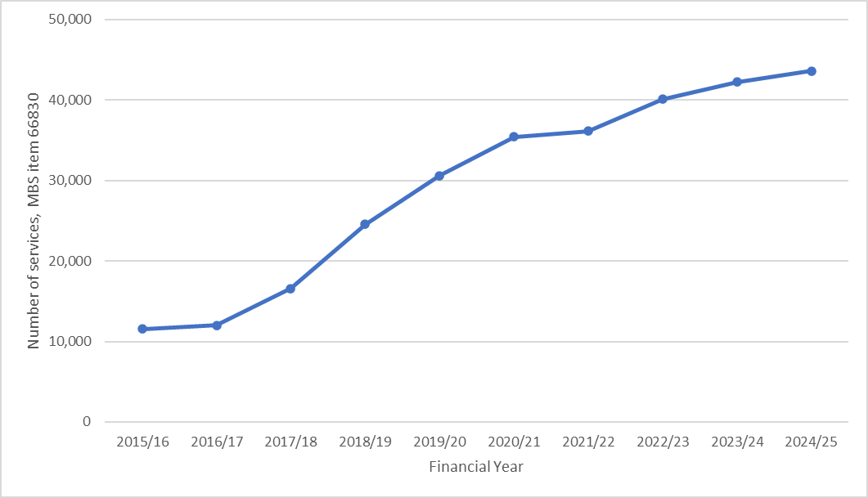
MBS = Medicare Benefits Schedule

PASC discussed the STRONG HF trial as the primary evidence base for the application. PASC noted that:
- The trial was conducted predominately in healthcare settings with more limited access to care than Australia. PASC considered that the trial – and specifically the standard of care comparator – may therefore have limited applicability to the Australian context.
- It is difficult to assess the relative impact of each individual aspect of the intervention used in the trial given that it consisted of multiple components including frequent clinical review, medication up-titration and biomarker-guided management. Therefore, it is difficult to determine what contribution the proposed intervention alone (i.e. NT-proBNP testing) made to final health outcomes.
- The trial was conducted prior to the widespread adoption of SGLT2 inhibitors, which are now part of GDMT and do not require up-titration.
PASC considered that the proposed population was somewhat reflective of the population enrolled in the STRONG HF trial noting that the trial had an upper age limit.
PASC discussed the inclusion of patients with HFpEF in the population, noting that only a small proportion of the trial population had HFpEF and that treatment strategies for this population are different and not focussed on GDMT, compared to those for HFrEF. The applicant stated that they preferred the application to focus on a population that requires therapy optimisation across multiple drug classes rather than defining the population according to LVEF cut-off. PASC advised the assessment should specifically consider HF with reduced and moderately reduced EF as the sub-populations of primary interest; PASC advised that given the application will proceed as an applicant-developed assessment report (ADAR), the inclusion of patients with HFpEF was at the applicant’s discretion.
PASC discussed the NT-proBNP thresholds that were applied in the intervention arm of STRONG HF, noting that a NT-proBNP threshold of >2,500 pg/mL is relatively high and could exclude some patients with clinically significant HF. PASC considered that this threshold was overly prescriptive for the proposed population. PASC also noted that in the STRONG HF trial patients were required to demonstrate a >10% reduction in NT-proBNP levels between screening and randomisation (i.e. within 2 days before discharge) while maintaining a level above 1,500 pg/mL. PASC discussed whether this criterion should form part of the population but ultimately decided that it should be at the discretion of the treating clinician.
PASC noted the applicant’s clarification that although patients with reversible causes of HF were excluded from the STRONG HF trial, they would not be excluded from the proposed population.

Intervention
The proposed intervention is NT-proBNP testing in addition to standard medical management (i.e. a management strategy that incorporates the test). NT-proBNP is proposed to provide additional information for clinical decision-making during the vulnerable phase of HF following hospitalisation. This information is proposed to support the rapid up-titration of medication to achieve GDMT more quickly than would be achieved under standard medical management. GDMT involves achieving 100% maximal/optimal doses of all relevant therapies.
NT-proBNP is a biomarker for HF associated with cardiac pathophysiology. BNP is produced predominately by cardiac myocytes in response to ventricular dilation and pressure overload. It is synthesised as a precursor protein (preproBNP) that undergoes enzymatic cleavage to produce a biologically active C-terminal fragment (BNP) and an inactive cleavage product (NT-proBNP). BNP has counter-regulatory effects on the renin–angiotensin–aldosterone system, induces diuresis, natriuresis and systemic vasodilation and has an antifibrotic role. In HFrEF, elevated BNP/NT-proBNP reflects intracardiac pressures and wall stress and strongly predicts adverse outcomes (Panneflek et al. 2025). In HFpEF, levels are often elevated but may be attenuated by smaller ventricular volumes and obesity-related deficiency (Panneflek et al. 2025).
Levels of both BNP and NT-proBNP can be measured in plasma, however BNP has a much shorter half-life (~20 minutes) than NT-proBNP. This is because BNP levels are regulated by enzymatic degradation, including by neprilysin, and receptor-mediated clearance. In contrast, NT-proBNP is cleared by the kidneys, leading to a longer half-life but also elevation with impaired renal function. Although either test is available for diagnosis of HF (MBS item 66830 and 66829), the current application is for the use of NT-proBNP testing only. MSAC Application 1689.1 (Quantification of NT-proBNP in patients with systemic sclerosis, and in patients with diagnosed pulmonary arterial hypertension) was also for NT-proBNP testing only. However, to maintain patient access the resulting MBS item number (MBS item 66586) includes both BNP and NT-proBNP testings because, although NT-proBNP is the more common laboratory measure, some laboratories could only provide BNP on-site. In addition to its role as a biomarker, BNP has been tested as a therapeutic intervention and although BNP infusion has not been shown to improve HF outcomes, the inhibition of neprilysin (ARNI) is effective and forms part of GDMT (Panneflek et al. 2025). In patients initiated on ARNI, levels of BNP increase before stabilising after the ARNI reduces myocardial wall stress. Levels of NT-proBNP are more stable as they are not degraded by neprilysin. However, many BNP assays cross-react with NT-proBNP (Nishikimi and Nakagawa 2022). An Australian consensus statement on optimisation of post-discharge HF patient care notes that in patients treated with ARNI, NT-proBNP is the preferred biomarker (Sindone et al. 2026).
BNP and NT-proBNP levels can be elevated by factors other than HF including acute coronary syndrome, pulmonary embolism, shock, atrial arrhythmia, severe pneumonia and renal disease. They are also higher in women than men, increase with age and have an inverse relationship with body mass index (BMI, lower in obesity). For this reason, age dependent cut-off values are used for the diagnosis of HF. Similarly, the intervention does not rely on a specific NT-proBNP value but on detecting an increase or decrease from pre-discharge concentrations. The application states that an increase of more than 10% from pre-discharge may prompt treatment modifications, particularly not up-titrating beta blockers and, where clinically appropriate, up-titrating diuretics. Conversely, reduced levels may provide reassurance that up-titration of GDMT is safe, particularly beta-blockers.
The applicant’s proposal is that up to 5 NT-proBNP monitoring tests are conducted following a hospital admission (not including any diagnostic or baseline tests done at admission). The number of tests is consistent with the STRONG-HF trial where patients in the intervention arm had a screening (baseline) and randomisation (pre-discharge) NT-proBNP test. NT-proBNP was subsequently measured at follow-up visits at 1, 2, 3, and 6 weeks after randomisation, totalling 5 tests for the purpose of medical management. The frequency of early post-discharge appointments in the STRONG-HF trial might be difficult to replicate in current practice; the applicant stated that 3-months might be a suitable period for monitoring and treatment optimisation to enable some flexibility regarding appointment scheduling. The applicant’s proposed MBS item was for 5 tests within 12 months (Table 11).
Patients are not expected to require repeat testing if they are subsequently rehospitalised unless they have ceased treatment with GDMT or are on lower doses of GDMT and therefore require a second titration. The application states that these would be exceptional cases, but has proposed that the annual limit would facilitate access where this occurs.
No specific model of care or schedule of post-admission outpatient visits are specified in the application. However, the application states that a cardiologist, who will have overall responsibility, would recommend the use of NT-pro BNP testing as part of GDMT titration, while GPs and nurse practitioners may be involved in the care of the patient under a collaborative model. The application states that consideration could be given to allowing GPs to request NT-proBNP tests for patients who are under the care of a cardiologist to support shared care models and/or telehealth. The current MBS item for NT-proBNP diagnosis of HF in a non-hospital setting can be requested by GPs (MBS item 66829).
PASC considered whether the application should include BNP or remain restricted to NT-proBNP. PASC noted that in past assessments, BNP had been included due to equity concerns, particularly to support access in rural areas where access to NT-proBNP was previously limited. However, PASC noted that this is less likely to be a concern as NT-proBNP has become more widely available and is now the most commonly used measure. The applicant advised that NT-proBNP is broadly available in both public and private laboratories and is usually bulk billed. The applicant’s clinical expert advised that NT-proBNP is the preferred biomarker compared to BNP, due to the increase in BNP levels as a response to ARNI initiation. PASC agreed that the application should be restricted to NT-proBNP.
PASC discussed equity and workforce issues and noted that access to post-discharge HF care is often more readily available in public settings compared to private settings. PASC considered that improving access to structured post-discharge care may have a greater impact on patients’ outcomes than improving access to NT-proBNP testing. The applicant’s clinical expert stated that access to NT-proBNP can facilitate models of post-discharge care, including providing clinical information to guide management, particularly when undertaking telehealth consultations.

Comparator(s)
The comparator is standard medical management, which consists of clinical observations and standard laboratory measurements, excluding NT-proBNP measurement, to guide medication up-titration in the post-discharge period and is based on the CSANZ Heart Failure Guidelines (Table 8) (Atherton et al. 2018). Based on this schedule, patients should be offered 4 outpatient visits, and these would be completed within 12 weeks at the earliest. The application states that in usual care, full dose titration to achieve GDMT can take more than 6 months post discharge. Blood pressure, blood biochemistry and clinical evaluation can be undertaken by a GP or specialist under existing MBS items.
Table 8 Practice advice on medication titration in Australian clinical practice guidelines
Medication class | Titration schedule | Patient review | Tests | Management
ACE inhibitors  ARB  ARNI | Usually started at low doses and up-titrated by doubling the dose every 2 weeks, aiming for target doses or maximum tolerated doses. Faster up-titration may occur with close monitoring (e.g. in an inpatient setting) | Following initiation and each dose escalation (1-2 weeks) | Blood pressure  Blood biochemistry (renal function, potassium) | If symptomatic hypotension, eGFR decreases >30%, or the serum potassium rises >5.5 mmol/L, assess volume status and the need for other drugs that lower blood pressure or impact on renal function and potassium (e.g. calcium channel blockers, nitrates, NSAIDs, diuretics and potassium supplements). ACE inhibitor/ARB/ARNI may need to be decreased (or ceased).  If angioedema, cease ACE inhibitor/ ARNI.  If cough, consider if due to pulmonary congestion or lung disease. If related to ACE inhibitor, change to ARB.
Beta blockers | Usually started at low doses and gradually up-titrated by doubling the dose every 2–4 weeks, aiming for target doses or maximum tolerated doses | Following initiation and each dose escalation (1-2 weeks) | Heart rate  Blood pressure  Clinical evaluation | If symptomatic bradycardia (<50 bpm), arrange ECG and review the need for other drugs that lower heart rate (e.g. digoxin and amiodarone). Beta blocker dose may need to be decreased and specialist advice sought.  If symptomatic hypotension, assess volume status and review the need for other drugs that lower blood pressure (e.g. calcium channel blockers, nitrates, and diuretics). Beta blocker dose may need to be decreased and specialist advice sought.  If increasing congestion, increase the diuretic dose, occasionally may require a reduction in beta blocker dose.
MRAs | Low doses initially and up-titrating in 4–8 weeks | Following initiation and each dose escalation (1-2 weeks, then every 4 weeks for 12 weeks, and at 6 months) | Blood pressure  Blood biochemistry (renal function, potassium) | If eGFR decreases >30% or serum potassium rises >5.5 mmol/L, assess volume status and review the need for other drugs that affect renal function and potassium (e.g. NSAIDs and potassium supplements). If not successful, MRAs should be reduced. If serum potassium rises >6.0 mmol/L, cease MRA and seek specialist advice.
Diuretics | Start at low dose and treatment adjusted according to clinical response | 1-2 weeks | Volume status  Blood biochemistry (renal function, sodium, potassium) | Patients may also be educated to adjust the dose of diuretic.
ACE = angiotensin-converting enzyme; ARB = angiotensin receptor blocker; ARNI = angiotensin receptor neprilysin inhibitor; bpm = beats per minute; ECG = electrocardiogram; eGFR = estimated glomerular filtration rate; MRA = mineralocorticoid receptor antagonist; NSAIDs = nonsteroidal anti-inflammatory drugs
Source: Adapted from Atherton et al. (2018)
There are numerous resources available to guide medication up-titration and ongoing management for both health care workers and patients and their careers, for example:
- Pharmacist quick reference guide to: four pillars for the treatment of heart failure with reduced ejection fraction (Medicines Advice Initiative Australia/ Pharmaceutical Society of Australia)
- Medicines for patients with heart failure and reduced ejection fraction (Medicines Advice initiative Australia)
- Medications to manage heart failure (Queensland Health)
- Heart online – titrating medications in heart failure (Queensland Health/ National Heart Foundation of Australia).
PASC agreed that the comparator, standard medical management without NT-proBNP measurement, is appropriate.
PASC discussed the applicability of the comparator arm of STRONG HF to the Australian setting. PASC noted that the mean number of healthcare visits in the standard care arm of the trial was suboptimal by Australian standards and that rates of optimisation of GDMT were also substantially lower than anticipated in the Australian setting. PASC therefore considered that the comparator arm may not adequately reflect current Australian standards of care. PASC stated that the assessment will need to include supportive evidence from Australia regarding current post-discharge standard of care.

Reference standard
The proposed intervention is incorporation of NT-proBNP testing into post-discharge management to guide medication titration. There is no cut-off value for making management changes, rather medication titration is dependent on trending values between measurements. Therefore, the assessment should be of the longitudinal accuracy of the test, considering the clinical utility of NT-proBNP-guided post-discharge management compared with standard clinical management and medication optimisation in terms of patient-relevant outcomes such as mortality, HF rehospitalisation, and functional or quality-of-life outcomes. MSAC guidelines (Technical Guidance 2.4) state ‘if the purpose of the test is to predict a future health outcome, the reference standard is likely to be the health outcome.’ Therefore, the reference standard is the health outcomes being considered: mortality and HF hospitalisation.
PASC agreed that the reference standard is appropriate.

Outcomes
The outcomes relevant to the assessment of NT-proBNP testing for post-discharge patient management are summarised in Table 9.
Table 9 Outcomes relevant to the assessment of NT-proBNP testing for patient management
Outcome type | Outcome
Safety | Adverse events due to testing  Harms associated with change of management
Efficacy/effectiveness – primary health outcomes | Primary health outcomes  Mortality  Repeat HF hospitalisation  Functional status  Quality of life using disease specific and generic tools  Intermediate/ surrogate outcomes  Time to optimal dose/ proportion on optimal dose  LVEF
Additional outcomes using a linked evidence approach | Change in management  Dose up-titrated/down-titrated  Medication initiated, ceased etc.  Number of post-discharge visits (specialist, GP etc.)  Other changes (additional/reduced imaging/laboratory tests etc.)  Test performance/Analytical validity  Prognostic and predictive value  Responsiveness  Reproducibility, reliability, acceptability
Health care resources (including patient out-of-pocket costs) | Cost of NT-proBNP testing  Cost of post-discharge care including NT-proBNP testing  Costs associated with change in management (additional visits, medication changes)
Cost effectiveness | Incremental cost per QALY gained
Total Australian Government health care costs | Total cost to the MBS  Total cost to the PBS
GP = general practitioner; HF = heart failure; LVEF = left ventricular ejection fraction; MBS = Medicare Benefits Schedule; NT-proBNP = N-Terminal-pro Brain Natriuretic Peptide; PBS = Pharmaceutical Benefits Scheme; QALY = quality adjusted life year
The primary outcome in the STRONG-HF trial was 180-day HF readmission or all-cause death and the secondary endpoints were change in quality of life measured by the EQ-5D visual analogue scale (VAS), 180-day all-cause death, and 90-day HF readmission or all-cause mortality (Mebazaa et al. 2022).
The application did not include symptom resolution, functional status, or disease specific quality of life measures as outcomes. Functional status using the NYHA severity scale was collected in the STRONG-HF trial. Trials of HF medication reviewed by PBAC tend to report mortality and hospitalisation as primary outcomes and not to report symptom status or functional outcomes. However, they do use a disease-specific quality-of-life tool (e.g. Kansas City Cardiomyopathy Questionnaire [KCCQ]).
The application presents the STRONG-HF trial as direct evidence; however, additional linked evidence will likely be required to demonstrate that the effect of the STRONG-HF trial is due to NT-proBNP testing independently of intensification of post-discharge care. In particular, as the test is proposed to be undertaken on an approximately weekly basis to inform up and down titration of medication, evidence regarding test responsiveness (signal to noise ratio) over this timeframe will be required and change in management evidence as a result of the test should also be presented.
As NT-proBNP levels are influenced by numerous patient-specific factors, no threshold is available to define a positive test and interpretation for medication titration is based on trends over time with the application noting that a greater than 10% increase from pre-discharge concentrations may prompt treatment modification, including consideration of not up-titrating beta blockers and, where clinically appropriate, up-titrating diuretics. Conversely, a reduction in NT-proBNP levels may provide reassurance to support the safe up-titration of GDMT, including beta blockers. Given this, the assessment should demonstrate that a 10% change in NT-proBNP levels is clinically significant and above the level of variability in test results due to random variation.
PASC requested that functional status and quality of life be included as outcome measures, as they are standard and clinically important outcomes used to assess therapy for HF.

Assessment framework
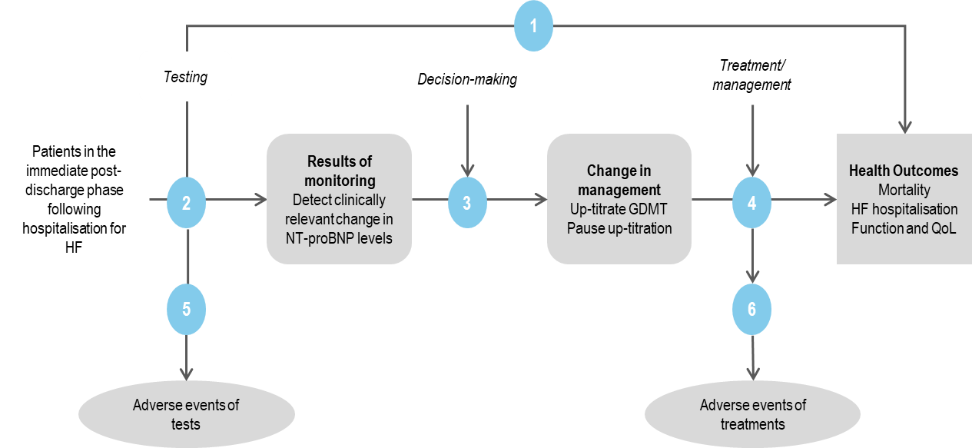
Figure 3 Assessment framework showing the links from the test population to health outcomes
Figure notes: 1: direct from test to health outcomes evidence; 2: longitudinal accuracy; 3: change in management; 4: influence of the change in management on health outcomes; 5: adverse events due to testing; 6: adverse events due to treatment
Abbreviations: GDMT = guideline directed medical therapy; HF= heart failure; NT-proBNP = N-Terminal-pro Brain Natriuretic Peptide; QoL = quality of life
The assessment questions related to the assessment framework are listed below.
Direct evidence
- In patients in the immediate post-discharge phase following hospitalisation for the treatment of HF, does the addition of NT-proBNP testing to standard management improve health outcomes compared to standard management alone?
Indirect evidence
- In patients in the immediate post-discharge phase following hospitalisation for the treatment of HF, how does the additional information from NT-proBNP testing differ from the information obtained without NT-proBNP testing?
- What is the prognostic value of a decline and/or increase in NT-proBNP for predicting mortality and rehospitalisation in the immediate post-discharge period?
- How responsive is NT-proBNP to pathophysiological changes associated with HF (e.g. fluid overload) that are affected by GDMT titration?
- Does the information from NT-proBNP testing lead to a change of management of the patient compared to no NT-proBNP testing?
- Do the differences in management (e.g. up-titration of GDMT, pause in up-titration of GDMT) derived from the NT-proBNP test lead to improved health outcomes compared to treatment based on symptoms alone?
- What are the (direct) adverse events associated with NT-proBNP testing in addition to standard medical management for monitoring and standard medical management alone?
- What are the adverse events associated with the treatments/ interventions that lead from the management decisions informed by the NT-proBNP testing in addition to standard medical management and by the standard medical management alone?
PASC confirmed that the assessment framework is appropriate.
PASC considered that the additional questions within the linked evidence framework need to be addressed, particularly questions regarding prognosis and responsiveness (question 2) as this information is not available within the STRONG HF trial.
PASC noted that failure to up-titrate beta-blockers, based on NT-proBNP levels, is a potential adverse event associated with the intervention (question 6).

Clinical management algorithms
There are Australian clinical practice guidelines that describe GDMT (Atherton et al. 2018); however, as new trials are published and additional medications added to the PBS, medical therapy has evolved and guidance has been updated with a clinical consensus statement (Sindone et al. 2022). Figure 1 shows the updated clinical algorithm for the management of HFrEF from the consensus statement; however, the guidelines are less directive regarding the model of care for implementing medication in HF and ongoing monitoring. The majority of patients with HF present at hospital emergency departments, estimated at 90 to 95%, most of which are at public hospitals. Post-discharge, the majority are referred to an outpatient clinic, although around a quarter remain waiting for an appointment 1 month after discharge (Driscoll et al. 2020). In a separate analysis, more than half of patients saw a GP within a week of discharge but fewer than 20% saw a cardiologist within 30 days and fewer than half within 6 months⁸. No specific schedule of visits or type of health care provider is specified in the guidelines although they note that patients should be reviewed following initiation and each dose escalation with monitoring of blood pressure and blood biochemistry (renal function, potassium) at 1-2 weeks. There is a strong recommendation for nurse-led medication titration. The guidelines state that faster up-titration may occur with close monitoring (e.g. in an inpatient setting) (Atherton et al. 2018).
The application states that up-titration can be completed within 12 weeks at the earliest based on the 2018 guidelines and frequently takes more than 6 months post-discharge. The current clinical management algorithm (Figure 4) shows the type of information that is considered for managing medication up-titration but cannot specify the number, frequency or type of post-discharge visits. Similarly, the proposed clinical management algorithm (Figure 5) shows how the addition of NT-proBNP tests are intended to contribute to decisions regarding medication titration and facilitate more rapid up-titration, but the specifics of post-discharge care are not defined.
It is anticipated that there would be substantial variation in practice when patients are discharged from hospital following acute HF and that care may be overseen by a range of clinical specialities that could include geriatricians and discharge into aged care.
PASC noted that BNP and NT-proBNP are not necessary to establish a diagnosis of HF, however, PASC accepted the proposed clinical management algorithms.

Figure 4 Current clinical management algorithm
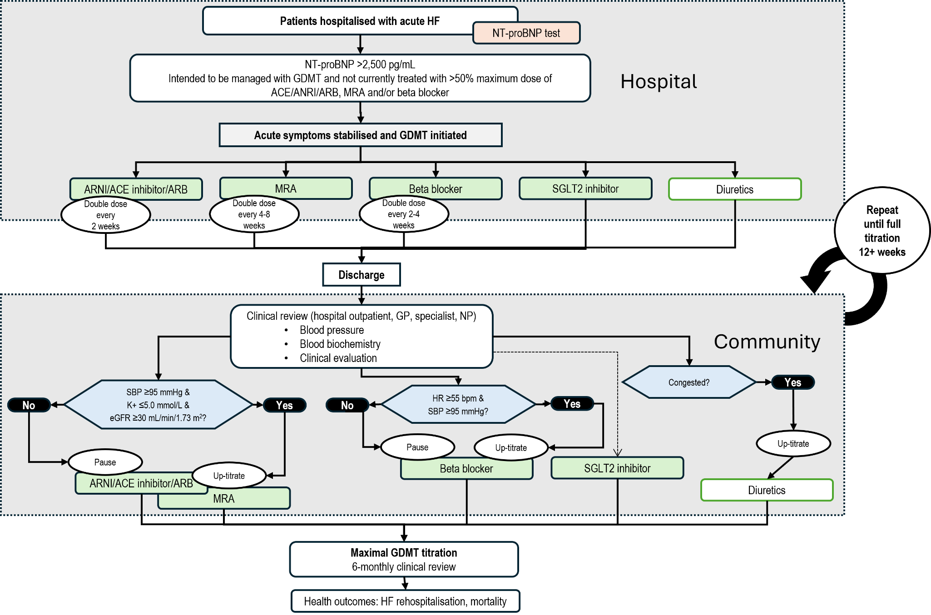
ACE = angiotensin-converting enzyme; ARB = angiotensin receptor blocker; ARNI = angiotensin receptor neprilysin inhibitor; eGFR = estimated glomerular filtration rate; GDMT = guideline directed medical therapy; GP= general practitioner; HF= heart failure; HR = heart rate; K+ = potassium; min = minute; mL = millilitres; mmHg = milligrams of mercury; MRA= mineralocorticoid receptor antagonist; NP = nurse practitioner; NT-proBNP = N-Terminal-pro Brain Natriuretic Peptide; pg = picograms; SBP = systolic blood pressure; SGLT2 = Sodium-glucose cotransporter 2
Source: adapted from Figures 1, 2 and 3 of application PICO Set
Figure 5 Proposed clinical management algorithm
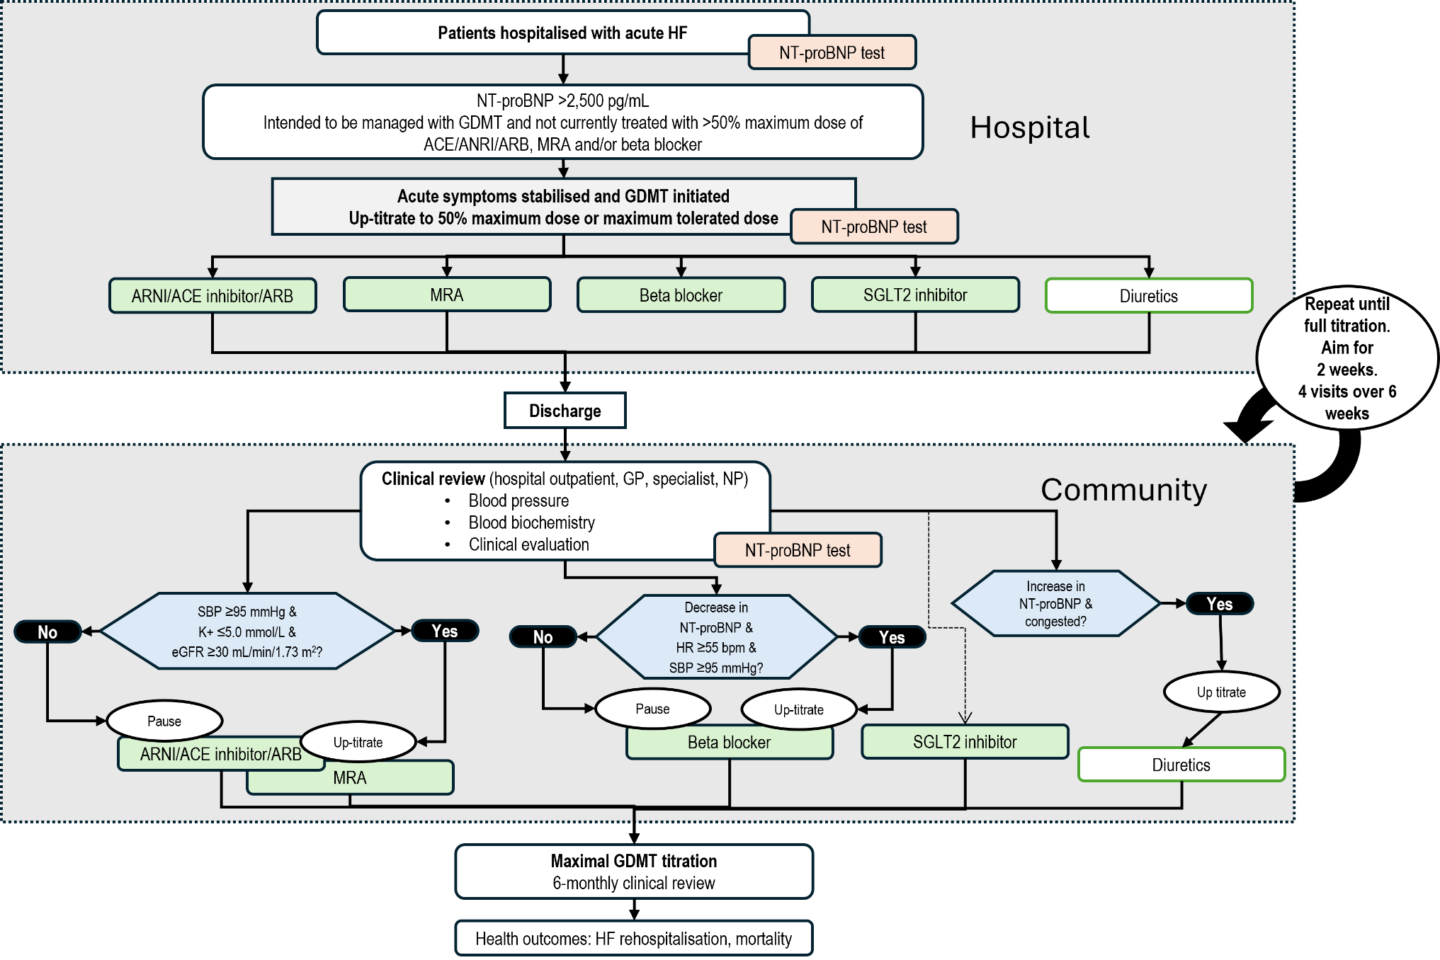
ACE = angiotensin-converting enzyme; ARB = angiotensin receptor blocker; ARNI = angiotensin receptor neprilysin inhibitor; eGFR = estimated glomerular filtration rate; GDMT = guideline directed medical therapy; GP= general practitioner; HF= heart failure; HR = heart rate; K+ = potassium; min = minute; mL = millilitres; mmHg = milligrams of mercury; MRA= mineralocorticoid receptor antagonist; NP = nurse practitioner; NT-proBNP = N-Terminal-pro Brain Natriuretic Peptide; pg = picograms; SBP = systolic blood pressure; SGLT2 = Sodium-glucose cotransporter 2Source: adapted from Figures 1, 2 and 3 of MSAC application PICO Set
Source: adapted from Figures 1, 2 and 3 of application PICO Set

Proposed economic evaluation
The application proposed a superior clinical claim stating that NT-proBNP testing will lead to optimised GDMT, reduced readmission and better survival outcomes. The applicant clarified pre-PASC that the application also intended to claim non-inferior safety. On the basis of these clinical claims, the appropriate economic evaluation is a cost-effectiveness analysis or a cost-utility analysis (Table 10).
Table 10 Classification of comparative effectiveness and safety of the proposed intervention, compared with its main comparator, and guide to the suitable type of economic evaluation
Comparative safety |  | Comparative effectiveness
Comparative safety | Inferior | Uncertainª | Noninferior^{b} | Superior
Inferior | Health forgone: need other supportive factors | Health forgone possible: need other supportive factors | Health forgone: need other supportive factors | ? Likely CUA
Uncertainª | Health forgone possible: need other supportive factors | ? | ? | ? Likely CEA/CUA
Noninferior^{b} | Health forgone: need other supportive factors | ? | CMA | CEA/CUA
Superior | ? Likely CUA | ? Likely CEA/CUA | CEA/CUA | CEA/CUA
CEA=cost-effectiveness analysis; CMA=cost-minimisation analysis; CUA=cost-utility analysis
? = reflect uncertainties and any identified health trade-offs in the economic evaluation, as a minimum in a cost-consequences analysis
ª ‘Uncertainty’ covers concepts such as inadequate minimisation of important sources of bias, lack of statistical significance in an underpowered trial, detecting clinically unimportant therapeutic differences, inconsistent results across trials, and trade-offs within the comparative effectiveness and/or the comparative safety considerations
^{b} An adequate assessment of ‘noninferiority’ is the preferred basis for demonstrating equivalence
There have been numerous trials of BNP/NT-proBNP directed treatment for HF with mixed results leading to uncertain conclusions regarding the clinical effectiveness of the approach (McLellan et al. 2016). The application is restricted to post-discharge treatment optimisation and the pivotal evidence is the STRONG-HF trial. However, the STRONG-HF trial compared high-intensity care, which included NT-proBNP measurement, to usual care. The usual care arm of the trial had a mean of 1 follow-up visit in the first 90-days of the study. The assessment will need to consider the applicability of the comparator arm of the trial to usual care in Australia and the impact of NT-proBNP testing independently of intensified post-discharge follow-up.
An economic analysis of the STRONG-HF trial from a United States healthcare perspective has been published (Dixit et al. 2023). The authors reported that an intensive GDMT optimisation program was extremely cost-effective with incremental cost-effectiveness ratios <$10,000 per QALY. The analysis considered the impact of intensive GDMT optimisation and not the impact of repeat NT-proBNP testing.
PASC agreed that a cost-utility analysis is appropriate, based on the applicant’s claim of superior effectiveness and non-inferior safety.

Proposal for public funding
The applicant’s proposed new MBS item is presented in Table 11. The proposed fee and benefit are the same as existing MBS items for BNP/NT-proBNP testing. The proposed item descriptor is broader than the population defined in the application, as it does not define optimal treatment and the tests are able to be used over a 12-month period. Although the application is for use in the immediate post-discharge period, defined as 6 weeks, the application states that, due to anticipated delays in accessing follow-up care, the extended testing period permitted in the proposed item descriptor is justified; however, this risks the item being available for more general monitoring beyond the intent of the application.
The proposed practice note is intended to allow access by a general practitioner; however, this is required to be undertaken in consultation with a specialist.
Table 11 MBS item proposed in the application (with PASC suggested changes)
Category 6 - Pathology Services
MBS item AAAA

Quantitation of NT-proBNP levels in patients with heart failure with reduced ejection fraction to guide the optimisation of heart failure therapy if:

- the patient has been hospitalised with heart failure within the previous 3 months; and
- where a the patient has had an elevated NT-proBNP level during or immediately prior to the initial hospitalisation of greater 2,500 pg/ml; and
- patients the patient is not currently on optimal treatment; and
- to guide the optimisation of heart failure therapy.

Applicable to a maximum of 5 tests per patient in any 312-month period.
Fee: $58.50 Benefit: 75% = $43.90 85% = $49.75
PN.X.X
Where MBS item AAAA is requested by a medical practitioner (other than a specialist or consultant physician), the request should be made in consultation with a specialist or consultant physician who manages the treatment of the patient.
Suggested amendments from PASC are shown in strikethrough and blue text.
PASC agreed that the proposed MBS item requires substantial modification.
PASC discussed the proposed 12-month applicability period for the proposed item and noted that, in the STRONG HF trial, biomarker testing was undertaken over a 6-week period post-discharge and that there were almost no changes to medication after 2 weeks. The applicant stated that the proposed 12-month period was intended to focus the item on therapy optimisation following an index HF hospitalisation rather than its use following repeat hospitalisation. The applicant also stated that the longer timeframe was intended to account for potential delays in accessing follow-up care. However, PASC considered that a 12-month applicability period would present a significant risk of use outside the intended population. PASC considered that 3 months is a more suitable period, while still allowing some flexibility for patients to access follow-up care.
PASC did not consider that the level of NT-proBNP needed to be specified in the item descriptor and that the wording ‘elevated’ is sufficient, with further decision-making to be at clinicians’ discretion. PASC agreed that the MBS item should be limited to NT-proBNP.
PASC noted that the population in the item descriptor could be restricted to patients with HFrEF depending on the outcomes of the assessment.
PASC noted that Australian patients are commonly reviewed by their GP following hospitalisation for HF, and that GPs can manage these patients and up-titrate therapy. PASC therefore raised concerns about the proposed restriction to specialists and considered it would be beneficial if GPs involved in post-discharge management and optimisation of care were also able to request the item.
PASC considered whether GDMT within the item descriptor should be described but considered this may be too complex.
PASC agreed with the proposed fee.

Summary of public consultation input
PASC noted and welcomed consultation input from 5 organisations and no individual input was received. The 5 organisations that submitted input were:
- Arrhythmia Alliance
- Heart Foundation
- Hearts4heart
- Public Pathology Australia (PPA)
- The Royal Australian College of General Practitioners (RACGP)
Consultation input was partly supportive of public funding for NT-proBNP testing to support management of patients with heart failure (the Heart Foundation and the RACGP were uncertain of their support, while the remaining organisations were supportive, although the Arrythmia Alliance included some caveats). Consultation input raised concerns regarding the evidence that serial NT-proBNP testing alone provides benefits in the absence of a coordinated care model.
Consumer Experience
The Arrhythmia Alliance and Hearts4heart provided consultation input stating that people with heart failure often experience breathlessness, fatigue, oedema, reduced exercise tolerance, sleep disturbance, dizziness and weakness. These effects of heart failure can significantly impact work, driving, social activities, independence, mental wellbeing and daily living. Consultation input included that patients and carers are affected by the effects of heart failure which can include recurrent hospital admissions that may disrupt employment and family life. Ongoing management of medicines, symptoms and appointments can place a substantial emotional, physical, and financial burden on patients and carers.
Benefits and Disadvantages
The main benefits of public funding reported in the consultation input included earlier optimisation of guideline-directed medical therapy, reduced heart failure readmissions and improved patient outcomes. Consultation input also highlighted the potential for improved treatment monitoring, quality of life and more structured post-discharge management for people living with heart failure.
The main disadvantages of public funding reported in the consultation input related to the uncertainty regarding the role of NT-proBNP testing within the supporting evidence. The Heart Foundation and the Arrhythmia Alliance considered that the benefits reported in the evidence were attributable to the broader high-intensity care pathway rather than NT-proBNP testing alone. The Arrhythmia Alliance also stated that using NT-proBNP alone may place an overemphasis on achieving nominal target doses of medication rather than maximum tolerated, patient-centred treatment, noting that rapid medication optimisation can cause hypotension, renal impairment, hyperkalaemia, bradycardia and other adverse effects.
Population, Comparator (current management) and Delivery
The consultation input largely agreed with the proposed population focusing on patients in the immediate post-hospitalisation period. The Arrhythmia Alliance and the Heart Foundation recommended closer alignment with the STRONG-HF trial and a clearer definition of patients most likely to benefit from the proposed pathway. Consultation input noted that patients on or near maximum tolerated GDMT are unlikely to benefit and that a requirement that every patient be intended for at least three of four medication classes may not be appropriate across all ejection-fraction phenotypes.
The organisations that provided consultation input generally disagreed with the proposed comparator of biochemistry tests, vital signs, and clinical observations alone. The Heart Foundation considered that the correct comparator is high-intensity up-titration care pathway without NT-proBNP. The Arrhythmia Alliance stated that contemporary recommendations also recognise the preventive role of SGLT2 inhibitors in selected.
Other services identified in the consultation input as being needed before or after the intervention included specialist and primary care follow-up, medication optimisation, renal function and electrolyte monitoring, heart failure nursing support, pharmacy services and multidisciplinary care. Arrhythmia Alliance and the Heart Foundation highlighted that NT-proBNP testing should be delivered as part of a structured post-discharge treatment optimisation pathway with appropriate clinical review and follow-up.
MBS Item Descriptor and Fee
Organisations that provided consultation input on the proposed item descriptor generally agreed with the proposed item descriptor. The Heart Foundation considered that the descriptor should better reflect the role of NT-proBNP testing within a structured post-discharge treatment optimisation pathway and specify the clinical context and timing of testing. The RACGP considered that the proposed specialist consultation requirement may create barriers to timely access and recommended that GPs be able to request testing as the titration of treatments for CCF falls well into the scope of practice for GPs.
Organisations that provided consultation input agreed with the proposed service fee and considered it should be benchmarked against existing natriuretic peptide pathology items.
PASC noted that feedback received during public consultation was mixed. The Heart Foundation and RACGP both responded to the question regarding whether they support public funding for the application as it is currently proposed as ‘unsure/other’. The Heart Foundation expressed concerns about the validity of the STRONG HF trial as the primary evidence base and noted that current treatment limitations in HF care in Australia are more closely related to access to clinical services than to access to biomarker testing. The Arrythmia Alliance was supportive with caveats, stating that public funding should support the entire package of care and the test needed to be part of a multidisciplinary approach. Hearts4heart and Public Pathology Australia were supportive.

Next steps
The applicant confirmed that an ADAR will be submitted.

Applicant Comments on Ratified PICO
Roche Diagnostics Australia thanks PASC for the feedback provided and the ratified PICO. RDA confirms that it is likely that the Applicant Developed Assessment Report (ADAR) will include heart failure patients across the full spectrum of left ventricular ejection fraction (LVEF), noting that PASC left this to the applicant’s discretion. In relation to the intervention described in the PICO, RDA clarifies that the second NT-proBNP test may take place in the hospital setting prior to discharge, but agrees with PASC that the benefits from the intervention are observed in the post-discharge period and that the proposed PICO is appropriate for the assessment process.

References
Atherton JJ, Sindone A, De Pasquale CG, Driscoll A, MacDonald PS, Hopper I, Kistler P, Briffa TG, Wong J, Abhayaratna WP, Thomas L, Audehm R, Newton PJ, OˈLoughlin J, Connell C and Branagan M (2018) ‘National Heart Foundation of Australia and Cardiac Society of Australia and New Zealand: Australian clinical guidelines for the management of heart failure 2018’, Medical Journal of Australia, 209(8):363–369, doi:10.5694/mja18.00647.
Dixit NM, Parikh NU, Ziaeian B and Fonarow GC (2023) ‘Economic Modeling Analysis of an Intensive GDMT Optimization Program in Hospitalized Heart Failure Patients’, Circulation: Heart Failure, 16(12), doi:10.1161/CIRCHEARTFAILURE.123.011218.
Driscoll A, Dinh D, Prior D, Kaye D, Hare D, Neil C, Lockwood S, Brennan A, Lefkovits J, Carruthers H, Amerena J, Cooke JC, Vaddadi G, Nadurata V and Reid CM (2020) ‘The Effect of Transitional Care on 30-Day Outcomes in Patients Hospitalised With Acute Heart Failure’, Heart, Lung and Circulation, 29(9):1347–1355, doi:10.1016/j.hlc.2020.03.004.
Freedman G, Watt R, Chowdhury EK, Quinlan K, Eccleston D, Driscoll A, Theuerle J and Kearney L (2025) ‘Nurse-Led, Remote Optimisation of Guideline-Directed Medical Therapy in Patients with Heart Failure and Reduced Ejection Fraction Across Australia’, Journal of Clinical Medicine, 14(15):5371, doi:10.3390/jcm14155371.
Gadzhanova S and Roughead L (2024) Utilisation analysis of PBS-listed medicines for heart failure, University of South Australia, https://pbs.gov.au/reviews/utilisation-analysis-of-pbs-listed-medicines-for-heart-failure, accessed 19 June 2026.
Greene SJ, Fonarow GC, Vaduganathan M, Khan SS, Butler J and Gheorghiade M (2015) ‘The vulnerable phase after hospitalization for heart failure’, Nature Reviews Cardiology, 12(4):220–229, doi:10.1038/nrcardio.2015.14.
Kimmoun A, Cotter G, Davison B, Takagi K, Addad F, Celutkiene J, Chioncel O, Solal AC, Diaz R, Damasceno A, Duengen H-D, Filippatos G, Goncalvesova E, Merai I, Metra M, Ponikowski P, Privalov D, Sliwa K, Sani MU, Voors AA, Shogenov Z and Mebazaa A (2019) ‘Safety, Tolerability and Efficacy of Rapid Optimization, Helped by NT-proBNP and GDF-15, of Heart Failure Therapies (STRONG-HF): Rationale and Design for a Multicentre, Randomized, Parallel-Group Study’, European Journal of Heart Failure, 21(11):1459–1467, doi:10.1002/ejhf.1575.
Malgie J, Clephas PRD, Brunner-La Rocca H-P, de Boer RA and Brugts JJ (2023) ‘Guideline-directed medical therapy for HFrEF: sequencing strategies and barriers for life-saving drug therapy’, Heart Failure Reviews, 28(5):1221–1234, doi:10.1007/s10741-023-10325-2.
McDonagh J, Ferguson C, Hilmer SN, Hubbard RE, Lindley RI, Driscoll A, Maiorana A, Wu L, Atherton JJ, Bajorek BV, Carr B, Delbaere K, Dent E, Duong MH, Hickman LD, Hopper I, Huynh Q, Jha SR, Keech A, Sim M, Singh GK, Villani A, Shang C, Hsu M, Vandenberg J, Davidson PM and Macdonald PS (2025) ‘An Expert Opinion on the Management of Frailty in Heart Failure from the Australian Cardiovascular Alliance National Taskforce’, Heart, Lung and Circulation, 34(7):693–703, doi:10.1016/j.hlc.2025.01.012.
McDonagh TA, Metra M, Adamo M, Gardner RS, Baumbach A, Böhm M, Burri H, Butler J, Čelutkienė J, Chioncel O, Cleland JGF, Coats AJS, Crespo-Leiro MG, Farmakis D, Gilard M, Heymans S, Hoes AW, Jaarsma T, Jankowska EA, Lainscak M, Lam CSP, Lyon AR, McMurray JJV, Mebazaa A, Mindham R, Muneretto C, Francesco Piepoli M, Price S, Rosano GMC, Ruschitzka F, Kathrine Skibelund A, ESC Scientific Document Group, De Boer RA, Christian Schulze P, Abdelhamid M, Aboyans V, Adamopoulos S, Anker SD, Arbelo E, Asteggiano R, Bauersachs J, Bayes-Genis A, Borger MA, Budts W, Cikes M, Damman K, Delgado V, Dendale P, Dilaveris P, Drexel H, Ezekowitz J, Falk V, Fauchier L, Filippatos G, Fraser A, Frey N, Gale CP, Gustafsson F, Harris J, Iung B, Janssens S, Jessup M, Konradi A, Kotecha D, Lambrinou E, Lancellotti P, Landmesser U, Leclercq C, Lewis BS, Leyva F, Linhart A, Løchen M-L, Lund LH, Mancini D, Masip J, Milicic D, Mueller C, Nef H, Nielsen J-C, Neubeck L, Noutsias M, Petersen SE, Sonia Petronio A, Ponikowski P, Prescott E, Rakisheva A, Richter DJ, Schlyakhto E, Seferovic P, Senni M, Sitges M, Sousa-Uva M, Tocchetti CG, Touyz RM, Tschoepe C, Waltenberger J, Adamo M, Baumbach A, Böhm M, Burri H, Čelutkienė J, Chioncel O, Cleland JGF, Coats AJS, Crespo-Leiro MG, Farmakis D, Gardner RS, Gilard M, Heymans S, Hoes AW, Jaarsma T, Jankowska EA, Lainscak M, Lam CSP, Lyon AR, McMurray JJV, Mebazaa A, Mindham R, Muneretto C, Piepoli MF, Price S, Rosano GMC, Ruschitzka F and Skibelund AK (2021) ‘2021 ESC Guidelines for the diagnosis and treatment of acute and chronic heart failure’, European Heart Journal, 42(36):3599–3726, doi:10.1093/eurheartj/ehab368.
McLellan J, Heneghan CJ, Perera R, Clements AM, Glasziou PP, Kearley KE, Pidduck N, Roberts NW, Tyndel S, Wright FL and Bankhead C (2016) ‘B-type natriuretic peptide-guided treatment for heart failure’, Cochrane Database of Systematic Reviews, 2016(12), doi:10.1002/14651858.CD008966.pub2.
Mebazaa A, Davison B, Chioncel O, Cohen-Solal A, Diaz R, Filippatos G, Metra M, Ponikowski P, Sliwa K, Voors AA, Edwards C, Novosadova M, Takagi K, Damasceno A, Saidu H, Gayat E, Pang PS, Celutkiene J and Cotter G (2022) ‘Safety, tolerability and efficacy of up-titration of guideline-directed medical therapies for acute heart failure (STRONG-HF): a multinational, open-label, randomised, trial’, The Lancet, 400(10367):1938–1952, doi:10.1016/S0140-6736(22)02076-1.
Nishikimi T and Nakagawa Y (2022) ‘B-Type Natriuretic Peptide (BNP) Revisited—Is BNP Still a Biomarker for Heart Failure in the Angiotensin Receptor/Neprilysin Inhibitor Era?’, Biology, 11(7):1034, doi:10.3390/biology11071034.
Pagnesi M, Metra M, Cohen-Solal A, Edwards C, Adamo M, Tomasoni D, Lam CSP, Chioncel O, Diaz R, Filippatos G, Ponikowski P, Sliwa K, Voors AA, Kimmoun A, Novosadova M, Takagi K, Barros M, Damasceno A, Saidu H, Gayat E, Pang PS, Celutkiene J, Cotter G, Mebazaa A and Davison B (2023) ‘Uptitrating Treatment After Heart Failure Hospitalization Across the Spectrum of Left Ventricular Ejection Fraction’, Journal of the American College of Cardiology, 81(22):2131–2144, doi:10.1016/j.jacc.2023.03.426.
Panneflek J, Barbarawi M, Kakarlapudi Y, Barbarawi Z, Lauzea B and Meraz-Torres M (2025) ‘Natriuretic Peptides as Multisystem Regulators: From Clinical Biomarkers to Therapeutic Targets in Cardio-immunology’, Cardiovascular Drugs and Therapy, doi:10.1007/s10557-025-07821-y.
Sindone AP, Amerena J, De Pasquale CG, Chan AWP, Gan GCH, Rao SD, Burdeniuk C, Shah A and Atherton JJ (2026) ‘Consensus Statement on Optimisation of Patient Care After Hospitalisation for Acute Heart Failure’, Heart, Lung and Circulation, 35(2):157–170, doi:10.1016/j.hlc.2025.09.019.
Sindone AP, De Pasquale C, Amerena J, Burdeniuk C, Chan A, Coats A, Hare DL, Macdonald P, Sverdlov A and Atherton JJ (2022) ‘Consensus statement on the current pharmacological prevention and management of heart failure’, Medical Journal of Australia, 217(4):212–217, doi:10.5694/mja2.51656.
Sindone AP, Haikerwal D, Audehm RG, Neville AM, Lim K, Parsons RW, Piazza P and Liew D (2021) ‘Clinical Characteristics of People with Heart Failure in Australian General Practice: Results from a Retrospective Cohort Study’, ESC Heart Failure, 8(6):4497–4505, doi:10.1002/ehf2.13661.
Solomon SD, McMurray JJV, Vaduganathan M, Claggett B, Jhund PS, Desai AS, Henderson AD, Lam CSP, Pitt B, Senni M, Shah SJ, Voors AA, Zannad F, Abidin IZ, Alcocer-Gamba MA, Atherton JJ, Bauersachs J, Chang-Sheng M, Chiang C-E, Chioncel O, Chopra V, Comin-Colet J, Filippatos G, Fonseca C, Gajos G, Goland S, Goncalvesova E, Kang S, Katova T, Kosiborod MN, Latkovskis G, Lee AP-W, Linssen GCM, Llamas-Esperón G, Mareev V, Martinez FA, Melenovský V, Merkely B, Nodari S, Petrie MC, Saldarriaga CI, Saraiva JFK, Sato N, Schou M, Sharma K, Troughton R, Udell JA, Ukkonen H, Vardeny O, Verma S, Lewinski D von, Voronkov L, Yilmaz MB, Zieroth S, Lay-Flurrie J, Gameren I van, Amarante F, Kolkhof P and Viswanathan P (2024) ‘Finerenone in Heart Failure with Mildly Reduced or Preserved Ejection Fraction’, New England Journal of Medicine, 391(16):1475–1485, doi:10.1056/NEJMoa2407107.

Originally isolated from porcine brain tissue, NT-proBNP is now more frequently referred to as N-terminal pro-B-type natriuretic peptide.
Information supplied by the applicant during the pre-PASC meeting, 15 June 2026.
ARB can be used if intolerant to ARNI and ACE inhibitor.
Finerenone is currently restricted on the PBS to patients with chronic kidney disease with Type 2 diabetes
Differs to GDMT as defined in the population. PBAC has noted that restrictions may need to be revised to align with clinical guidelines (September 2024 PBAC outcomes.)
PBAC did not support an application to expand access to ARNI to LVEF 41 to ≤50% or for first-line use (i.e., to replace ACE/ARBs) Sacubitril with valsartan – November 2020 Public Summary Document
Note that standard of care in the analysis consisted of ACE inhibitor/ARB/ARNI + heart specific beta blocker +/- MRA +/- SGLT2 inhibitor and was therefore a less stringent definition than GDMT as defined in the proposed population.
AIHW (Australian Institute of Health and Welfare) (2025) Hospital to community: How Australians with heart failure receive health care, AIHW, Australian Government, accessed 17 June 2026.
RCPA Manual – NT pro B-Natriuretic peptide
Information supplied by the applicant during the pre-PASC meeting, 15 June 2026.
For example Empagliflozin Public Summary Document (November 2021) and Dapagliflozin Public Summary Document (July 2021)
Application 1087 Predicted versus actual utilization - Public Summary Document (April 2017) and information supplied by the applicant during the pre-PASC meeting, 15 June 2026.

