MSAC Application 1827
Testing for hepatitis B virus (HBV) and hepatitis B virus surface antigen (HBsAg) to support the use of bepirovirsen in people with chronic hepatitis B (CHB)
Applicant: GlaxoSmithKline Australia

PICO Confirmation

Summary of PPICO criteria to define question(s) to be addressed in an Assessment Report to the Medical Services Advisory Committee (MSAC)
Table 1 PPICO for testing algorithm to support bepirovirsen treatment initiation and response monitoring in patients with chronic hepatitis B: PICO Set 1
Component | Description
Population | People diagnosed with chronic hepatitis B (CHB) on stable nucleos(t)ide analogue (NA) therapyª who are being assessed for treatment with bepirovirsen or being treated with bepirovirsen.
Prior tests | Diagnosis of infection with Hepatitis B virus (HBV) by qualitative hepatitis B surface antigen (HBsAg) assay ± antibody to hepatitis B core antigen (anti-HBc) and antibody to hepatitis B surface antigen (anti-HBs)
Intervention | New CHB testing algorithm that includes both quantitative HBsAg (qHBsAg) and qualitative HBsAg tests and HBV DNA testing for purposes of selecting patients for bepirovirsen treatment, treatment monitoring, NA discontinuation and functional cure assessment.
Comparator/s | Current standard of care (SOC) laboratory testing algorithm for CHB patients on stable NA therapy: HBV DNA testing (up to 4 times per year using current MBS items).
Reference standard | Outcome-based clinical utility standard anchored to the B-Well trial eligibility, testing schedule, and functional cure criteria.
Clinical utility standard | Roche Elecsys HBsAg II quant II immunoassay and HBV DNA lower limit of quantification (LLOQ) is defined as being <20 IU/mL, per B-Well trial protocol.
Outcomes | Safety  - Patient burden and anxiety  - Misclassification harm  - Procedural risk (minor)  Efficacy/effectiveness  - Analytical and diagnostic performance of quantitative HBsAg assays  - Concordance with the clinical utility standard  - Accuracy of baseline qHBsAg for predicting response to bepirovirsen  - Signal-to-noise / distinguishing true response from background variation  - Bepirovirsen initiation  - Treatment response at Week 12  - NA discontinuation at Week 48  - Functional cure rate at Week 72 (sustained HBsAg loss + HBV DNA <LLOQ at 24 weeks off-treatment)  Healthcare resources  - Comparative test utilisation impact  Cost-effectiveness  - Cost-effectiveness/ cost -utility analysis  Total Australian Government health care costs  - Healthcare costs and budget impact
Assessment questions | What is the safety, effectiveness and cost-effectiveness of the proposed CHB testing algorithm versus current standard-of-care testing algorithm in patients with CHB being considered for or receiving bepirovirsen treatment?
ª “Stable nucleos(t)ide analogue (NA) therapy” is defined as NA treatment for at least 6 months before screening, including at least 3 months on the current regimen if a switch has occurred for reasons other than loss of viral suppression or treatment failure, with no planned treatment changes.
Table 2 PPICO for post-treatment monitoring of functionally cured CHB patients: PICO Set 2
Component | Description
Population | People with CHB who achieve functional cure (defined as sustained HBsAg loss and HBV DNA below the lower limit of quantification for at least 24 weeks) following completion of a 24-week course of bepirovirsen therapy and have ceased NA therapy.
Prior tests | Confirmation of functional cure status, defined as HBsAg loss and HBV DNA <LLOQ, sustained over 24 weeks off-treatment.
Intervention | Ongoing tapered monitoring of HBsAg and HBV DNA. HBV DNA testing only if HBsAg test result is positive.
Comparator/s | Current EASL guideline-recommended monitoring after confirmed HBsAg loss/functional cure on NA therapy (Year 1: 4x HBV DNA; Year 2+: 1-2x HBV DNA)
Reference standard | Longitudinal follow-up assessing maintenance or loss of functional cure, based on HBsAg and HBV DNA results and their consequences for clinical management.
Clinical utility standard | Per B-Well 1/2 trial protocol, Roche Elecsys HBsAg II Quant II immunoassay and HBV DNA LLOQ <20 IU/mL. Evidence of functional cure durability following bepirovirsen treatment is not yet mature.
Outcomes | Safety  - Safety of the proposed tapered monitoring schedule  - Safety of NA therapy reinitiation when triggered by monitoring results  Efficacy/effectiveness  - Suitability for monitoring/ signal-to-noise, particularly at the lowest testing frequency (Year 3+)  - Detection of virological/serological relapse  - Reinitiation of NA therapy if relapse detected  - Durability of functional cure  Healthcare resources  - Downstream resource use associated with monitoring and any subsequent retreatment  Cost-effectiveness  - Cost-effectiveness/cost-utility analysis  Total Australian Government health care costs  - Healthcare costs and budget impact
Assessment questions | What is the comparative safety, effectiveness and cost-effectiveness of the proposed post-functional cure monitoring algorithm versus current post-treatment monitoring in patients with CHB who have achieved functional cure following bepirovirsen treatment?

Purpose of application
An application requesting a change to the Medicare Benefits Schedule (MBS) items and/or listing of new MBS items to support a Pharmaceutical Benefits Schedule (PBS)-subsidised bepirovirsen treatment pathway for patients with chronic hepatitis B (CHB) was received from GlaxoSmithKline Australia by the Department of Health, Disability and Ageing.
Bepirovirsen is not currently listed on the PBS. The applicant advises that a submission to the Pharmaceutical Benefits Advisory Committee (PBAC) is planned for late 2026. The proposed testing algorithm is intended to support patient selection, treatment monitoring, and assessment of functional cure associated with bepirovirsen treatment. Without access to bepirovirsen, there is limited clinical need for the proposed testing pathway. In turn, the proposed bepirovirsen treatment pathway relies on access to the relevant biomarker testing to determine treatment eligibility, monitor treatment response and assess functional cure.

PICO criteria

Population
Hepatitis B (HBV) is an infection of the liver caused by the hepatitis B virus. The infection can be acute or chronic. The virus is most commonly transmitted from mother to child, typically during childbirth, or in early childhood. Transmission can also occur through contact with infected blood or other body fluids. HBV infection in adulthood leads to chronic hepatitis B (CHB) in less than 5% of cases, whereas infection in infancy and early childhood leads to CHB in about 95% of cases. CHB predisposes a patient to the development of portal hypertension, cirrhosis, and its complications or hepatocellular carcinoma (HCC). CHB is associated with substantial morbidity and mortality due to cirrhosis, liver failure and HCC (CDC, 2025; WHO, 2026; WHO Europe, 2021).
Hepatitis B is a nationally notifiable disease in Australia (AIHW, 2025). In 2023, there were an estimated 219,800 people living with CHB in Australia, but only around 67% of those are estimated to have been diagnosed. Approximately one quarter receive ongoing monitoring, and approximately half of these individuals are accessing treatment (MacLachlan et al., 2025). Among all Australians living with CHB the majority were born overseas, particularly in China and Vietnam. Other priority populations include Aboriginal and Torres Strait Islander peoples, people who inject drugs, and men who have sex with men.
Prevention of HBV infection relies primarily on vaccination, which is included in the Australian National Immunisation Program Schedule. Additional measures include prevention of mother-to-child transmission through antenatal screening and appropriate management of pregnant women with HBV infection, safe injection and infection-control practices, blood donor screening, safer-sex practices and harm-reduction strategies for people who inject drugs. Collectively, these measures have substantially reduced the incidence of HBV infection and the subsequent burden of CHB (Lubel et al., 2022; WHO, 2026).
Current HBV infection is established by detecting hepatitis B surface antigen (HBsAg), most commonly using a qualitative enzyme immunoassay to determine whether HBsAg is present. Additional serological markers, including hepatitis B core antibody (anti-HBc) and hepatitis B surface antibody (anti-HBs), are generally used to support diagnosis and characterise infection status. Quantitative HBsAg (qHBsAg) testing can also be performed to measure the concentration of HBsAg and has an emerging role in treatment decision-making and assessment of functional cure. A summary of different HBV markers, their intended use and interpretation of results is shown in Table 3.
Differentiation between acute and chronic HBV infections generally requires evidence of persistent HBsAg positivity for ≥6 months. In clinical practice, however, the distinction can often be made earlier through consideration of patient history and interpretation of additional serological markers, including immunoglobulin (IgM) anti-HBc assay results(Lubel et al., 2022; Towell & Cowie, 2012). Chronic HBV infection typically produces no symptoms until advanced liver disease (cirrhosis, decompensation) has developed. Individuals with CHB are typically diagnosed incidentally through routine blood screening, blood donation, or investigation of an unrelated abnormal liver function test (Tang et al., 2018). Diagnosis of CHB is complex, requiring a combination of laboratory testing, clinical history, and in some cases, repeated assessment over time. Chronic HBV infection is understood as a dynamic disease progressing through phases, including immune-tolerant, hepatitis B e-antigen (HBeAg)-positive immune active, HBeAg-negative immune active, and inactive. According to the AASLD-IDSA Practice Guideline, a substantial proportion of patients (up to 40%) fall into an "indeterminate" phase not meeting strict criteria for any of these categories (Ghany et al., 2026).
Table 3 Hepatitis B serological and virological markers
HBV marker | Full name | When used | What it indicates
HBsAg | Hepatitis B surface antigen (qualitative) | Initial screening and diagnosis; Confirmation of chronic status. | Presence of current HBV infection. Persistence for at least 6 months defines CHB.
qHBsAg | Quantitative HBsAg | Monitoring treatment response; predicting NA-discontinuation suitability and bepirovirsen eligibility (this application) | Level (IU/mL) of circulating surface antigen; declining levels associated with likelihood of treatment response and approaching functional cure
Anti-HBs | Antibody to HBsAg (HBsAb) | Screening (with HBsAg, anti-HBc) to determine immune status; monitoring for seroconversion after functional cure | Immunity, either from resolved infection or vaccination. Levels ≥10 IU/L generally considered protective/immune.
IgM anti-HBc | Immunoglobulin M antibody to hepatitis B core antigen | Distinguishing acute from chronic infection where the 6-month HBsAg persistence criterion hasn't yet been met | Marker of recent/acute infection (or occasionally reactivation/flare in chronic infection); typically wanes within months
IgG anti-HBc | Immunoglobulin G antibody to hepatitis B core antigen | Confirming prior HBV exposure; combined with HBsAg/anti-HBs to classify infection status (current, resolved, or occult) | Marker of past exposure to HBV (persists long-term); present in both chronic infection and resolved infection. Does not by itself indicate immunity
HBeAg | Hepatitis B e-antigen | Phase determination (immunotolerant vs immunoactive); monitoring for HBeAg seroconversion during treatment | Marker of active viral replication and high infectivity; typically associated with high HBV DNA level
Anti-HBe | Antibody to HBeAg (HBeAb) | Phase determination; assessing treatment response in HBeAg-positive patients | Usually indicates reduced viral replication following HBeAg loss ("HBeAg seroconversion")
HBV DNA (quantitative PCR) | Hepatitis B viral load | Phase determination; monitoring on-treatment suppression; confirming functional cure (combined with HBsAg loss); relapse detection | Direct measure of viral replication; used to define disease phase, treatment eligibility, and treatment response/suppression
Abbreviations: Anti-HBe, Antibody to hepatitis B e-antigen (HBeAb); Anti-HBs, Antibody to HBsAg(HBsAb); CHB, chronic hepatitis B; HBeAg, Hepatitis B e-antigen; HBsAg, Hepatitis B surface antigen (qualitative); HBV, Hepatitis B virus; HBV DNA (quantitative PCR), Hepatitis B viral load; IgG anti-HBc, Immunoglobulin G antibody to hepatitis B core antigen; IgM anti-HBc, Immunoglobulin M antibody to hepatitis B core antigen; qHBsAg, quantitative hepatitis B surface antigen
Once a definitive diagnosis of CHB has been established, clinical management continues within a mixed general practice and specialist setting (hepatology, gastroenterology, infectious diseases). Recommended regular laboratory assessments conducted in this setting include HBV viral load, which is measured using a quantitative real time polymerase chain reaction (PCR) DNA assay, qualitative HBeAg status, qualitative HBsAg testing, standard liver function tests including alanine aminotransferase (ALT) and aspartate transaminase (AST), full blood examination, HCC surveillance, and periodic (non-invasive) assessment of fibrosis and cirrhosis (Lubel et al., 2022).
Antiviral treatment is recommended for a subset of patients with CHB, generally reserved for patients who have evidence of active viral replication, liver inflammation, fibrosis, or other factors that increase the risk of disease progression (Lubel et al., 2022). The main contemporary pharmacological management options are nucleos(t)ide analogues (NAs), including entecavir and tenofovir disoproxil or alafenamide (preferred) as well as lamivudine, adefovir and telbivudine (alternative). Pegylated interferon is another option in some cases but has been largely superseded as a frontline treatment in most developed country settings and is no longer reliably available in Australia.
Current NA therapies effectively suppress HBV replication but rarely achieve functional cure (3% to 5%), defined by sustained loss of HBsAg (Marrapu et al., 2025). As a result, many patients require prolonged or lifelong treatment and monitoring to reduce the risk of cirrhosis, liver failure and HCC. The development of therapies capable of achieving functional cure has therefore become an important goal in CHB management.
It should be recognised that functional cure does not represent eradiation of HBV infection. Even when functional cure is achieved, viral HBV DNA persists within hepatocytes as integrated HBV DNA and as covalently closed circular DNA (cccDNA). These viral reservoirs can continue to serve as a transcriptional template despite the absence of detectable HBsAg or HBV DNA in serum. As a result, HBV reactivation remains possible, particularly in the setting of immunosuppression.
The population relevant to this application comprises patients with CHB receiving consistent NA regimen for at last 6 months, who may be eligible for a finite course of treatment with bepirovirsen (or other curative therapy), as well as those requiring follow-up after achieving functional cure. The target populations are stratified into two groups reflecting distinct clinical phases and testing objectives.

PICO 1
The proposed population for PICO 1 set includes people diagnosed with CHB on stable NA therapy. Stable NA therapy is defined as treatment for at least 6 months before screening, including at least 3 months on the current regimen if a switch has occurred for reasons other than loss of viral suppression or treatment failure, with no planned treatment changes. These patients are assessed for bepirovirsen treatment. Within this population, successive testing and treatment points occur at baseline where treatment eligibility is determined, followed by progressive narrowing of the population at each subsequent assessment point: Week 12, to patients demonstrating a treatment response; Week 48, to patients eligible for NA discontinuation; and Week 72, to patients achieving functional cure.
The proposed indication for bepirovirsen is likely to involve patients with:
- Confirmed CHB (based on laboratory assessment of HBsAg, anti-HBc and anti-HBc)
- Stable NA therapy (≥6 months)
- qHBsAg ≤3,000 IU/mL
- HBV DNA <90 IU/mL
- ALT ≤2× upper limit normal (ULN)
- Management under specialist care
The applicant has indicated that the initially proposed Therapeutic Goods Administration (TGA) indication and PBS restriction for bepirovirsen will likely be for finite treatment of CHB (24 weeks) in patients already on stable NA therapy, with HBsAg levels ≤ 3,000 IU/mL. The proposed population for PICO set 1 includes patients with HBsAg level ≤3,000 IU/mL. Existing guidance from the AASLD-IDSA Practice Guidelines considers qHBsAg <100 IU/mL as a reasonable threshold for considering NA discontinuation without additional therapy (Ghany et al., 2026).
The threshold of ≤3,000 IU/mL was derived from receiver-operating-characteristic (ROC) analysis of the B-Clear data and subsequently adopted as an eligibility criterion in the pivotal phase 3 B-Well 1/2 trials (Yuen et al., 2022). The now-published B-Well 1/2 phase 3 results demonstrated clinically meaningful functional cure rates of 19% to 20% vs 0% placebo) in this biomarker-selected population (Hou et al., 2026).
The assessment group considers the population reasonably appropriate for the applicant's stated purpose but notes that alignment with existing guidelines is partial. The broad entry population (stable, long-term NA therapy) corresponds to a group already recognised in AASLD-IDSA Practice Guideline (Ghany et al., 2026) and EASL 2025 guidance on NA discontinuation (Cornberg et al., 2025). However, the specific HBsAg eligibility threshold (≤3,000 IU/mL) used to further restrict this population is not derived from these guidelines. Rather, this eligibility criterion for bepirovirsen treatment is based on a post-hoc ROC analysis in a single phase 2b trial. The population-narrowing structure at Weeks 12, 48 and 72 also reflects the trial's visit schedule rather than an independently established Australian clinical practice pathway.
PASC considered the separation of the two PICO populations appropriate, as each reflects a distinct testing purpose.
For PICO 1, PASC noted the difference between the HBsAg eligibility thresholds used in the B-Well trials and those proposed for reimbursement. Trial eligibility required baseline HBsAg levels between 100 and 3,000 IU/mL, whereas the proposed reimbursement population may include patients with HBsAg levels below 3,000 IU/mL (which includes levels below 100 IU/ml), consistent with the proposed TGA indication. The applicant clarified in its pre-PASC response that patients with baseline HBsAg levels below 100 IU/mL were excluded from the B-Well trials because of their higher likelihood of spontaneous HBsAg loss, however, these patients are expected to be eligible for bepirovirsen treatment in clinical practice. PASC considered that the broader population is pragmatically appropriate and noted the rationale of the difference from the trial population and the proposed population.

PICO 2
Population relevant to PICO set 2 includes patients who have achieved functional cure defined as sustained HBsAg loss and HBV DNA below the lower limit of quantification for at least 24 weeks following completion of a finite course of therapy. Testing is used to monitor durability of response and detect relapse over time.
In the B-Well trials, functional cure was defined as sustained HBsAg loss and HBV DNA below the lower limit of quantification for at least 24 weeks following completion of a finite course of therapy. This is broadly consistent with contemporary guideline definitions of functional cure, which generally require HBsAg loss and sustained suppression of HBV DNA following treatment cessation (Cornberg et al., 2025; Ghany et al., 2026; Lubel et al., 2022).
The assessment group considers the proposed population to be reasonably appropriate for this application, primarily because it is more closely aligned with contemporary clinical guidelines than the population proposed for PICO set 1. The EASL 2025 Clinical Practice Guidelines explicitly recommend monitoring of HBV DNA and ALT, rather than HBsAg, at 3-monthly intervals during the first year following confirmed functional cure (defined as HBsAg loss on two occasions 6 months apart with HBV DNA below the limit of quantification) and NA cessation. Monitoring is then reduced to 6- to 12-monthly intervals thereafter (Cornberg et al., 2025). The AASLD-IDSA Practice Guideline addresses a related but distinct population, namely patients stopping NA before achieving HBsAg loss (HBsAg <100 IU/mL, HBV DNA undetectable ≥2 years) recommending a more intensive testing schedule for HBV DNA and ALT (Ghany et al., 2026).
PASC considered the definition of the PICO 2 population appropriate but noted the limited availability of guidelines, including consensus guidance, for this population.
PASC noted that patients with cirrhosis were excluded from the B-Well trial and that no direct efficacy or safety evidence is currently available in this population. PASC considered that the generalisability of the evidence to patients with cirrhosis remains uncertain and the applicant’s clinical expert commented that clinicians would likely exercise caution in prescribing bepirovirsen for this population given the potential risk of treatment-related flares in ALT.
PASC noted estimates that approximately 240,000 Australians have CHB, with around 36,000 currently receiving NA therapy and approximately 30,000 potentially meeting bepirovirsen treatment eligibility criteria, noting this number is uncertain as there is minimal data on the prevalence of those with CHB and the specific quantitative sAg thresholds for treatment. PASC noted that the uptake of bepirovirsen is expected to occur gradually through specialist centres during the initial implementation period.

Intervention

PICO 1
The proposed intervention is a laboratory testing algorithm for CHB used to identify patients eligible for a finite 24-week course of bepirovirsen, monitor treatment response, support treatment discontinuation decisions, and assess functional cure status.
The proposed testing schedule as described by the applicant is summarised in Table 4. qHBsAg and HBV DNA testing at Week 0 are required to determine eligibility for initiation of bepirovirsen treatment. qHBsAg testing at Week 12 is proposed as an early response assessment with patients who do not achieve qHBsAg < 1 IU/ml discontinuing bepirovirsen treatment. At Week 48, HBsAg, HBV DNA and HBeAg testing are proposed to assess treatment response and determine suitability for NA cessation (undetectable HBsAg and HBV DNA and HBeAg negative status). Functional cure status is proposed to be assessed at Week 72 using HBsAg and HBV DNA results in those patients who discontinue NA therapy at Week 48. The HBsAg testing at Week 48 and 72 following commencement of bepirovirsen treatment is proposed to be qualitative.
Under the proposed testing algorithm, both HBsAg and HBV DNA testing are required at Weeks 0, 48 and 72. Testing both markers ensures the functional cure definition can be appropriately verified at each assessment point. It is important to note that under current MBS item restrictions, HBV DNA testing (items 69482 and 69483) is conditional on HBsAg positive status.
In the B-Well trials, HBsAg and HBV DNA were tested weekly from baseline to Week 26 and continued frequent ongoing monitoring through Week 72. HBeAg testing was conducted approximately every 6 weeks during the first 48 weeks and every 4 weeks thereafter. This is considerably more frequently than the proposed testing schedule, which includes 4 testing timepoints (Weeks 0, 12, 48, and 72).
Table 4 The proposed testing schedule for PICO set 1
Phase / Timepoint | Purpose of testing |  | HBsAg | HBeAg | HBV DNA
Eligibility
Week 0 | Assessment of eligibility for bepirovirsen treatment |  | Required (Quantitative)  Threshold: ≤3,000 IU/mL | Not required | Required  Threshold: <90 IU/mL
On-treatment monitoring
Week 12 | Assessment of treatment response |  | Required (Quantitative)  Threshold: < 1 IU/mL | Not required | Not required
Week 48 | Assessment of treatment response and suitability for NA cessation |  | Required (Qualitative)  Threshold: Undetectable | Required (Qualitative)  Threshold: Negative | Required  Threshold: LLOQ
Week 72 | Functional cure assessment |  | Required (Qualitative)  Threshold: Undetectable | Not required | Required  Threshold: LLOQ
Abbreviations: HBsAg, hepatitis B surface antigen; HBeAg, hepatitis B e-antigen; HBV DNA, hepatitis B viral DNA; LLOQ, lower limit of quantification; NA, nucleos(t)ide analogue
PASC considered the proposed testing schedules for both PICOs broadly acceptable. PASC noted that qHBsAg testing is already available in Australian laboratories but not routinely reported.
PASC questioned whether the proposed testing schedule for PICO 1 was too narrow compared with the intensive monitoring used in the clinical trial. The applicant noted that the timing of testing within the proposed schedule focuses on key treatment decision points rather than intensive information gathering and that additional safety monitoring would still occur in practice, including liver function tests, blood counts, and renal function tests. PASC concluded that PICO 1 intervention may require further refinement to better reflect realistic clinical practice, including consideration of additional testing for safety monitoring and the appropriate timing and frequency of testing.
PASC noted the applicant’s pre-PASC advice that the Week 12 early response testing would most likely be explored in a sensitivity or scenario analysis rather than included in the base case and considered that this approach may be appropriate.

PICO 2
The proposed intervention is a laboratory testing algorithm for long-term monitoring of patients with CHB who achieve a functional cure following completion of a finite course of bepirovirsen treatment. The purpose of monitoring is to detect relapse and inform subsequent clinical management.
The proposed testing schedule as described by the applicant is summarised in Table 5. Qualitative HBsAg testing would be undertaken to monitor that patients are maintaining functional cure status, with the frequency of testing decreasing over time and being most intensive during the first year of follow-up. HBV DNA testing would be performed only when HBsAg positivity is detected, suggesting a potential relapse.
In the B-Well trials, participants who achieved functional cure at Week 72 underwent HBsAg and HBV DNA testing every four weeks during the subsequent 24-week follow-up period. Long-term follow-up is ongoing and published evidence describing monitoring beyond this period is currently limited.
The applicant provided clinical algorithm implies that monitoring would likely be indefinite. Monitoring is intended to ensure relapse can be quickly and appropriately managed however no further detail on what appropriate management would involve was provided.
Current clinical guidelines provide limited direction regarding management of patient who achieve functional cure. The 2022 GESA guidelines recommend ongoing monitoring following cessation of NA therapy but do not specify the frequency of monitoring, the combination of markers to be assessed, the duration of follow-up, or thresholds for re-treatment (Lubel et al., 2022). The 2025 EASL Clinical Practice Guidelines recommends monitoring HBV DNA and ALT every 3 months during the first year following NA cessation and every 6 to 12-month thereafter, with monitoring individualised according to patient risk factors (Cornberg et al., 2025). Similarly, the AASLD-IDSA Practice Guideline does not provide detailed recommendations regarding long-term monitoring after achievement of functional cure or HBsAg loss(Ghany et al., 2026).
Some guidelines, including the EASL Clinical Practice Guidelines (Cornberg et al., 2025), and the AASLD-ISDA Practice Guideline (Ghany et al., 2026), provide recommendations regarding re-initiation of treatment in patients who discontinue NA therapy before achieving HBsAg loss. These recommendations generally include patient preference, the development of extrahepatic manifestations of HBV infection, or re-emergence of treatment indications such as HBV DNA ≥2,000 IU/mL together with ALT ≥2× the upper limit of normal. Whether these criteria are applicable to patients who have achieved functional cure remains uncertain.
Overall, current hepatitis B guidelines support ongoing monitoring following treatment cessation; however, a specific clinical management pathway for patients achieving functional cure has not been established. The proposed testing schedule therefore appears to be derived from the B-clear and B-well clinical development programs and expert clinical opinion rather than a guideline-endorsed monitoring algorithm.
The proposed algorithm demonstrates co-dependent use of biomarkers. During the post-treatment phase, HBV DNA testing is conditional on HBsAg positivity, such that HBsAg functions as a trigger for additional virological assessment. This represents a sequential testing strategy in which monitoring decisions depend on the results of preceding tests.
Table 5 The proposed testing schedule for PICO set 2
Phase / Timepoint | HBsAg | HBeAg | HBV DNA
Year 1 | Required (Qualitative) *  Frequency: Weeks 4, 12, 24, 36, 48 | Not required | Only if HBsAg becomes positive
Year 2 | Required (Qualitative) *  Frequency: Weeks 72, 96 | Not required | Only if HBsAg becomes positive
Year 3+ | Required (Qualitative) *  Frequency: yearly | Not required | Only if HBsAg becomes positive
Abbreviations: HBsAg, hepatitis B surface antigen; HBeAg, hepatitis B e-antigen; HBV DNA, hepatitis B viral DNA;
* Testing frequency in the post-treatment phase (e.g. 5 tests in Year 1, 2 tests in Year 2, then annually) is proposed by the applicant.
PASC considered that the indefinite annual testing proposed for PICO 2 after 3 years was reasonable, noting that long-term evidence is currently unavailable.
PASC noted the importance of equitable access to testing and treatment pathways, particularly for Aboriginal and Torres Strait Islander peoples, migrant communities, and people living in rural and remote areas. Existing viral hepatitis testing pathways may facilitate access, however PASC noted the initial introduction of bepirovirsen through specialist centres may create practical access challenges during the early stages of rollout.

Comparator(s)

PICO 1
As bepirovirsen is an investigational therapy and is not currently incorporated into Australian or international hepatitis B management guidelines, no established comparator pathway exists for patients receiving bepirovirsen in combination with NA therapy. The most relevant comparator is current guideline-based management of patients receiving NA therapy alone, which represents the standard of care for patients with CHB. The proposed intervention population represents a subset of this broader NA-treated population.
Patients receiving NA therapy undergo ongoing monitoring including HBV DNA testing liver function tests (particularly ALT) and hepatitis B serology, as clinically indicated (Lubel et al., 2022). The frequency of monitoring is individualised according to disease activity, treatment status and risk of disease progression (Table 6). Under the current MBS, HBV DNA testing for patients receiving antiviral therapy is reimbursed up to four times within a 12-month period (MBS item 69483). Monitoring is generally undertaken within a specialist-led model of care and is informed by disease activity, treatment status and risk of progression.
Quantitative HBsAg (qHBsAg) has not been incorporated into routine treatment algorithms for NA therapy because HBV DNA is a more direct measure of active viral replication and is the preferred biomarker for determining treatment eligibility and monitoring virological response. In contrast, qHBsAg provides complementary information regarding disease phase, prognosis and the likelihood of achieving HBsAg loss, making it increasingly relevant for finite treatment directed at achieving functional cure (Cornberg et al., 2025). The proposed use of bepirovirsen therefore represents a departure from current practice, as treatment eligibility would depend on predefined qHBsAg and HBV DNA thresholds, introducing a biomarker-guided treatment strategy that is not currently used for approved antiviral therapies.

PICO 2
Currently, no cure-directed therapies are approved for CHB, and consequently, there is no established monitoring pathway for patients achieving functional cure. The closest available comparator evidence relates to monitoring following HBsAg loss after treatment cessation, which overlaps substantially with, but is not necessarily identical to, the functionally cured population proposed in PICO set 2. The closest comparator is therefore monitoring following NA cessation. Among major clinical guidelines, the 2025 EASL Clinical Practice Guideline provide the most detailed recommendations, suggesting monitoring of HBV DNA and ALT every three months during the first year following NA cessation and every six to twelve months thereafter (Cornberg et al., 2025).
Table 6 Testing recommendations in current CHB guidelines
Marker | GESA 2022 (Lubel et al., 2022) | EASL 2025 (Cornberg et al., 2025) | AASLD 2025 (Ghany et al., 2026)
NA therapy
ALT | Every 3 to 6 months (individualised) | Every 3 to 6 months | Every 3 to 6 months
HBV DNA | Every 3 to 6 months | Every 3 to 6 months | Every 3 to 6 months
HBsAg | Not routinely recommended for monitoring; may be assessed to evaluate treatment response or HBsAg loss | qHBsAg recommended for disease characterisation and to guide management in selected settings | HBsAg loss assessed during therapy; no recommendation for routine serial qHBsAg monitoring
HBeAg* | Not addressed | Not addressed | Not addressed
Post HBsAg loss
ALT | No specific schedule after HBsAg loss; ongoing clinical monitoring recommended | Year 1: ~ every 3 months; after every 6 to 12 months | Not addressed
HBV DNA | No specific schedule after HBsAg loss; following NA cessation, ongoing monitoring is recommended but frequency not specified | Year 1: ~ every 3 months; after every 6 to 12 months | Not addressed
HBsAg | Not addressed | Not addressed | Not addressed
Abbreviations: ALT, alanine aminotransferase; CHB, chronic hepatitis B; HBeAg, hepatitis B e-antigen; HBsAg, hepatitis B surface antigen; HBV DNA, hepatitis B viral DNA; NA, nucleos(t)ide analogue; qHBsAg, quantitative hepatitis B surface antigen
* If a patient is HBeAg-negative at baseline, routine repeat HBeAg testing is generally not recommended.
PASC considered that the proposed comparators were appropriate.

Reference standard

PICO 1
The proposed testing algorithm is being used to identify eligibility for bepirovirsen, monitor response, determine suitability for NA cessation, and assess functional cure. As such it is closer to a predictive/treatment-selection algorithm than a conventional diagnostic test. Consistent with MSAC guidelines TG2.4, the algorithm is therefore more appropriately characterised as a predictive or treatment selection strategy, than a conventional diagnostic test.
As no independent reference standard exists separate from the biomarker-defined treatment pathway the appropriate reference standard would therefore be the pivotal B-Well 1/2 trials criteria used to define bepirovirsen eligibility, response, NA-discontinuation eligibility, and functional cure, including the assay/platform and lower limit of quantification assumptions used in those trials. In this context, the reference standard for the whole algorithm is best understood as an outcome-based clinical utility standard, rather than an independent diagnostic gold standard.

PICO 2
For patients who have achieved functional cure following bepirovirsen treatment, the condition of interest is maintenance of functional cure versus reactivation of CHB. No independent diagnostic gold standard appears to exist for maintenance or loss of functional cure separate from the biomarkers used to define the state. The most appropriate reference standard is therefore a longitudinal clinical utility standard based on persistence or loss of functional cure over follow-up, assessed using HBsAg and HBV DNA results and their consequences for clinical management.
PASC agreed that the clinical utility standard was an appropriate reference standard for both PICO sets.

Clinical utility standard

PICO 1
Per B-Well 1/2 trial protocol, Roche Elecsys HBsAg II Quant II immunoassay and HBV DNA LLOQ <20 IU/mL. Eligibility threshold (HBsAg >100 to 3,000 IU/mL) derived from ROC analysis of B-Clear phase 2b data. Functional cure at week 72 confirmed in approximately 20% of bepirovirsen-treated patients versus 0% placebo (Hou et al., 2026).

PICO 2
Per B-Well 1/2 trial protocol, Roche Elecsys HBsAg II Quant II immunoassay and HBV DNA LLOQ <20 IU/mL. Evidence of functional cure durability following bepirovirsen treatment is not yet mature. The B-Well 1/2 trials include a planned durability-of-response assessment up to Week 96 in patients who achieved functional cure and discontinued NA therapy, but these results are not yet available (Hou et al., 2026). Longer term durability is also being evaluated in the ongoing B-Sure long-term extension study (NCT04954859), although results are not yet published.
PASC considered the outcome-based clinical utility standard, anchored to the pivotal B-Well trial protocol, to be appropriate and sufficient. PASC noted that further consideration of qHBsAg testing may be required given its role in treatment selection and the use of a specific assay platform in the B-Well trials. PASC noted the applicant's advice that an ultrasensitive HBV DNA assay (LLOQ <20 IU/mL) was incorporated into the B-Well protocol in 2024 and that the lower limit of quantification used in practice will depend on the assay employed.

Outcomes

PICO 1
Safety
- Patient burden and anxiety
- Misclassification harm
- Procedural risk (minor)
Efficacy/ effectiveness
- Analytical and diagnostic performance of quantitative HBsAg assays
- Concordance with the clinical utility standard
- Accuracy of baseline qHBsAg for predicting response to bepirovirsen
- Signal-to-noise / distinguishing true response from background variation
- Bepirovirsen initiation
- Treatment response at Week 12
- NA discontinuation at Week 48
- Functional cure rate at Week 72 (sustained HBsAg loss + HBV DNA <LLOQ at 24 weeks off-treatment)
Healthcare resources
- Comparative test utilisation impact
Cost-effectiveness
- Cost-effectiveness/ cost-utility analysis
Total Australian Government health care costs
- Healthcare costs and budget impact

PICO 2
Safety
- Safety of the proposed tapered monitoring schedule
- Safety of NA therapy reinitiation when triggered by monitoring results
Efficacy/effectiveness
- Suitability for monitoring / signal-to-noise, particularly at the lowest testing frequency (Year 3+)
- Detection of virological/serological relapse
- Reinitiation of NA therapy if relapse detected
- Durability of functional cure
Healthcare resources
- Downstream resource use associated with monitoring and any subsequent retreatment
Cost-effectiveness
- Cost-effectiveness/ cost-utility analysis
Total Australian Government health care costs
- Healthcare costs and budget impact
PASC considered the listed outcomes appropriate for both PICO sets. PASC agreed that the conventional definition of functional cure was appropriate for the assessment.

Assessment framework
For a claim of superiority, the assessment would need to show an improvement in health outcomes. The new testing algorithm for CHB would inform treatment decisions (enable access to bepirovirsen treatment), and the change in treatment would result in health outcome changes to a patient.
If direct evidence is not available (a study comparing the proposed new CHB testing algorithm with the current standard-of-care testing algorithm), linked evidence should be presented for each separate step. Assessment frameworks for PICO 1 and PICO 2 are shown in Figure 1 and Figure 2, respectively.
For PICO 1, there are four distinct testing and decision points: (a) baseline assessment of eligibility for bepirovirsen treatment, (b) Week 12 response assessment, (c) Week 48 assessment of eligibility for NA-discontinuation, and (d) Week 72 confirmation of functional cure.
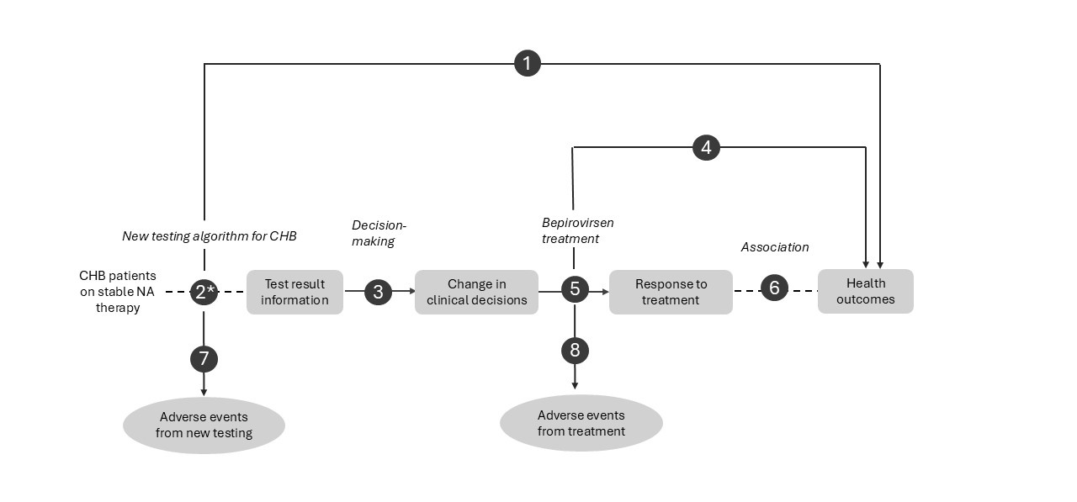
Figure 1 Assessment framework showing the links from the test population to health outcomes (PICO 1)
Abbreviations: CHB, chronic hepatitis B; NA, nucleos(t)ide analogue
Figure notes: 1: direct from test to health outcomes evidence; 2: test accuracy; 3: change in diagnosis/treatment/management; 4: influence of the change in management on health outcomes; 5: influence of the change in management on intermediate outcomes; 6: association of intermediate outcomes with health outcomes; 7: adverse events due to testing; 8: adverse events due to treatment
* PASC's guidance is sought on the applicant's position that accuracy evaluation is not required, given the intervention is a change in testing pattern/frequency of established, ARTG-listed tests rather than a new test technology
Assessment questions:

PICO 1 – CHB testing algorithm for bepirovirsen selection and assessment
- What is the comparative safety, effectiveness and cost-effectiveness of the proposed CHB testing algorithm versus current standard-of-care testing algorithm in patients with CHB being considered for or receiving bepirovirsen treatment?
- What evidence supports the use of baseline qHBsAg and HBV DNA measurements, and the associated eligibility criteria, for identifying patients who derive benefit from bepirovirsen treatment?
- Do the test results generated by the proposed algorithm appropriately inform each clinical decision in the pathway: bepirovirsen eligibility, Week 12 treatment response, Week 48 NA-discontinuation eligibility, and Week 72 functional cure assessment?
- Is there existing evidence, to be evaluated separately by PBAC that the management pathway enabled by the bepirovirsen treatment improves long-term health outcomes compared with the standard CHB management?
- Compared with the standard CHB management, how does the management pathway enabled by the proposed testing algorithm impact intermediate outcomes, including HBsAg and HBV DNA levels?
- Is achievement of functional cure (sustained HBsAg loss and HBV DNA suppression), with and without NA cessation, associated with improved long-term health outcomes?
- What is the comparative safety of the proposed CHB testing algorithm versus standard of care testing algorithm?
- What is the comparative safety of bepirovirsen treatment in patients selected using the proposed testing algorithm versus patients selected using standard of care testing algorithm?
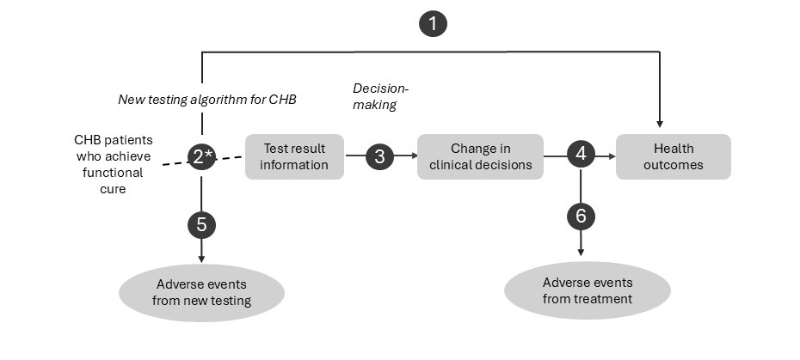
Figure 2 Assessment framework showing the links from the test population to health outcomes (PICO 2)
Abbreviations: CHB, chronic hepatitis B; NA, nucleos(t)ide analogue
Figure notes: 1: direct from test to health outcomes evidence; 2: test accuracy; 3: change in diagnosis/treatment/management; 4: influence of the change in management on health outcomes; 5: adverse events due to testing; 6: adverse events due to treatment

PICO 2 – Post functional cure monitoring following NA cessation
- What is the comparative safety, effectiveness and cost-effectiveness of the proposed post-functional cure monitoring algorithm versus current post-treatment monitoring in patients with CHB who have achieved functional cure following bepirovirsen treatment?
- What evidence supports the proposed monitoring frequency and duration following functional cure?
- Compared with current monitoring approaches, does the proposed monitoring algorithm, including the HBsAg-led strategy whereby HBV DNA testing is triggered by HBsAg positivity, adequately detect loss of functional cure and inform reinitiation of NA therapy, compared with current monitoring approaches?
- Is earlier detection of relapse and subsequent timely reinitiation of NA therapy associated with improved long-term health outcomes, including avoidance of hepatic flare, decompensation and HCC?
- What is the comparative safety of the proposed post functional cure monitoring algorithm versus current monitoring approaches?
- What is the comparative safety of NA therapy re-initiation triggered by the proposed monitoring algorithm versus current monitoring approaches?
PASC agreed with the proposed assessment frameworks, noting that assessment of diagnostic accuracy would not be required for established tests, but further consideration of diagnostic accuracy regarding quantitative HBsAg testing is required given that it is not routinely used in clinical practice currently and its role in treatment selection within the proposed algorithm.
PASC agreed that the application met the definition of a co-dependent technology, as testing is required to inform treatment decisions regarding bepirovirsen use.

Clinical management algorithms

Current clinical management

PICO 1
The current clinical management pathway for patients with CHB receiving NA therapy is presented in Figure 3.
Patients with CHB receiving NA therapy are managed with long-term antiviral treatment and regular monitoring. Current Australian consensus recommendations (GESA 2022) and international guidelines, including the 2025 EASL Clinical Practice Guidelines and the AASLD-IDSA Practice Guideline, support regular monitoring including HBV DNA, ALT, and hepatitis B serological markers, with the frequency and selection of tests guided by disease activity, treatment status, and individual patient factors. Emerging guidance, particularly from EASL, also recognises an increasing role for qHBsAg in patient stratification, treatment decision-making and assessment of functional cure.
Loss of HBsAg may occur during long-term treatment, however this outcome is rare with currently approved antiviral therapies. Therefore, treatment is often continued for many years and may be lifelong for some patients. Patients who achieve HBsAg loss may be considered for treatment cessation, with ongoing monitoring performed following discontinuation of therapy.
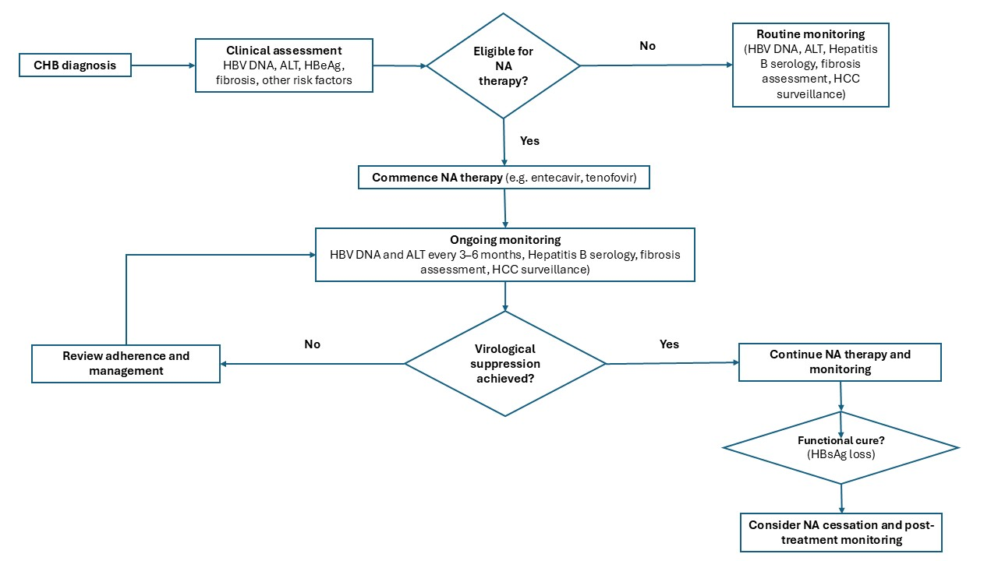
Figure 3 Current clinical management algorithm for CHB in patients receiving NA therapy (PICO 1)
Abbreviations: ALT, alanine aminotransferase; CHB, chronic hepatitis B; HBeAg, hepatitis B e-antigen; HBsAg, hepatitis B surface antigen; HCC, hepatocellular carcinoma; HBV DNA; hepatis B viral DNA; NA, nucleos(t)ide analogue;
Source: Generated for the PICO based on CHB clinical practice guidelines (GESA 2022, EASL 2025, AASLD 2025)

PICO 2
The current clinical management pathway for patients with CHB who achieve a functional cure is presented in Figure 4.
Guidance regarding monitoring and management following functional cure is limited. The 2025 EASL Clinical Practice Guidelines(Cornberg et al., 2025) include an explicit statement regarding monitoring after confirmed HBsAg loss on NA therapy: “Data on long-term outcomes following HBsAg loss with antiviral therapy are limited. Therefore, regular monitoring of HBV DNA and ALT levels at 3-month intervals is recommended during the first year after discontinuing NA therapy. Subsequently, monitoring should be adjusted to 6-12-month intervals, considering factors such as comorbidities, age, sex, and the degree of liver fibrosis, particularly given the risk of developing HCC.” However, no specific recommendations regarding monitoring after confirmed HBsAg loss were identified in other CHB guidelines, including GESA consensus recommendations (Lubel et al., 2022) and the AASLD-IDSA Practice Guideline (Ghany et al., 2026).
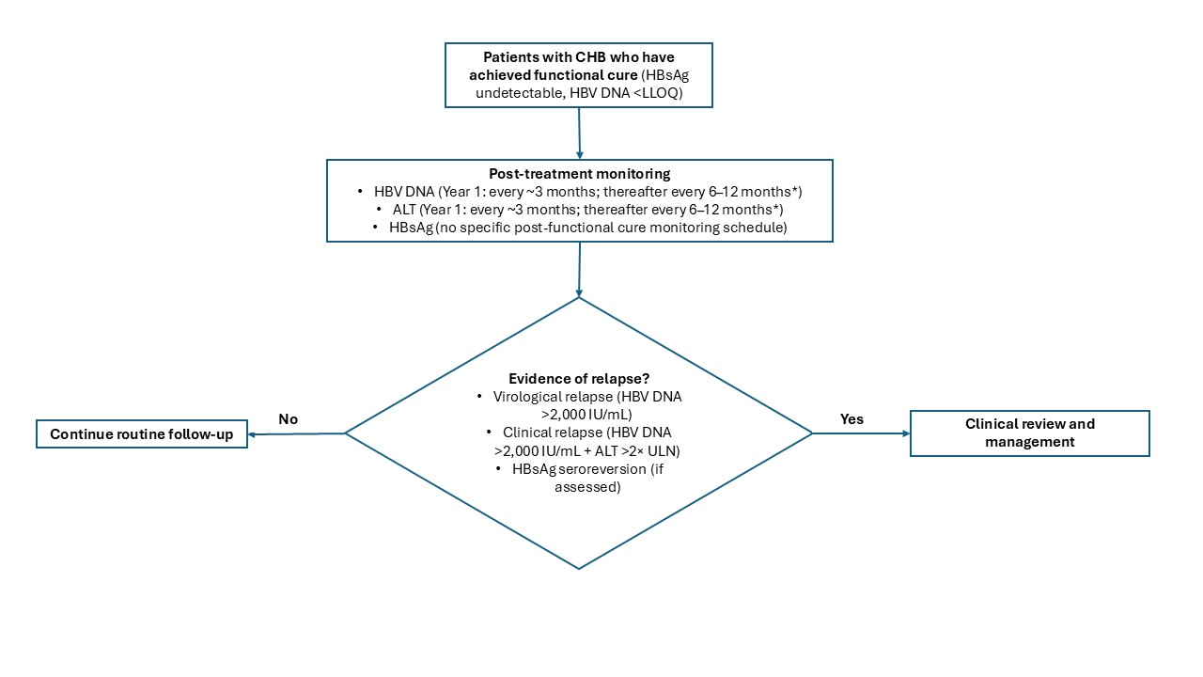
Figure 4 Current clinical management algorithm for CHB in patients who achieve functional cure (PICO 2)
Abbreviations: ALT, alanine aminotransferase; CHB, chronic hepatitis B; HBsAg, hepatitis B surface antigen; HBV DNA; hepatis B viral DNA; LLOQ, lower level of quantification; NA, nucleos(t)ide analogue; ULN, upper limit normal
* Based on EASL recommendations following HBsAg loss

Proposed clinical management pathway

PICO 1
The proposed clinical management pathway for patients with CHB receiving NA therapy is presented in Figure 5.
Under the proposed pathway, patients with CHB receiving stable NA therapy (defined as treatment for at least 6 months before screening, including at least 3 months on the current regimen if a switch has occurred for reasons other than loss of viral suppression or treatment failure, with no planned treatment changes) are assessed for eligibility to receive bepirovirsen using qHBsAg, HBV DNA and other clinical parameters. Eligible patients (qHBsAg ≤3,000 IU/mL, HBV DNA <90 IU/mL, ALT ≤2× ULN) commence a finite 24-week course of bepirovirsen in addition to ongoing NA therapy.
During treatment, patients undergo additional biomarker testing to assess virological response and treatment effectiveness. The applicant has proposed an assessment point at Week 12 with only patients who have qHBsAg < 1 IU/ml continuing bepirovirsen treatment. Patients complete bepirovirsen treatment at Week 24 but continue to receive NA therapy for a further 24 weeks. At Week 48, undetectable HBsAg and HBV DNA and HBeAg negative status (applicant estimates that 99% expected to be negative for HBeAg) are all required to determine if NA can be ceased. Functional cure status is assessed approximately 6 months later (Week 72). Patients who achieve functional cure may discontinue NA therapy and enter a structured monitoring program.
The proposed pathway includes several decision points that determine whether patients progress to the next stage of treatment. For example, patients found ineligible for bepirovirsen at Week 0, non-responders at Week 12, patients not eligible for NA discontinuation at Week 48, and patients who discontinue NA but do not achieve confirmed functional cure at Week 72. These patients are expected to continue on standard NA therapy under existing monitoring arrangements, rather than exiting clinical care altogether.

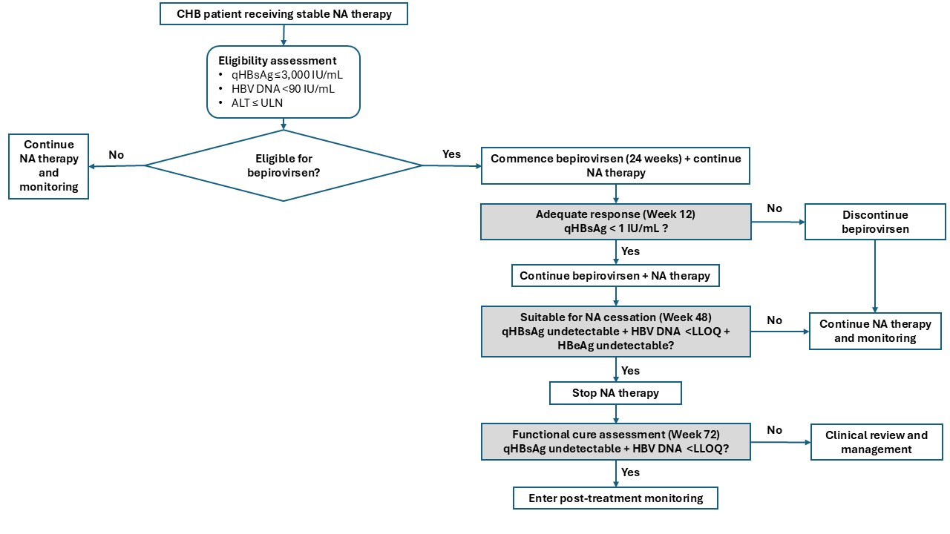
Figure 5 Proposed clinical management algorithm for CHB with new testing algorithm and bepirovirsen treatment (PICO 1)
Abbreviations: ALT, alanine aminotransferase; CHB, chronic hepatitis B; HBeAg, hepatitis B e-antigen; HBsAg, hepatitis B surface antigen; HBV DNA; hepatitis B viral DNA; LLOQ, lower level of quantification; NA, nucleos(t)ide analogue; qHBsAg, quantitative hepatitis B surface antigen; NA, nucleos(t)ide analogue; ULN, upper limit of normal
Source: Generated for the PICO based on CHB clinical practice guidelines (GESA 2022, EASL 2025, AASLD 2025)

PICO 2
The current clinical management pathway for patients with CHB who achieve a functional cure is presented Figure 6.
The proposed post-treatment monitoring primarily involves repeated HBsAg testing to assess durability of response and detect relapse. HBV DNA testing is performed if HBsAg becomes detectable, resulting in a reflexive testing strategy in which subsequent testing is determined by preceding test results.
Although several elements of the proposed clinical pathway are consistent with contemporary hepatitis B management principles, the specific testing schedules, conditional testing strategies and long-term monitoring arrangements proposed in this application are not currently standardised in clinical practice or explicitly recommended in clinical practice guidelines. These aspects appear to be derived from clinical trial protocols and emerging concepts of finite therapy and functional cure.
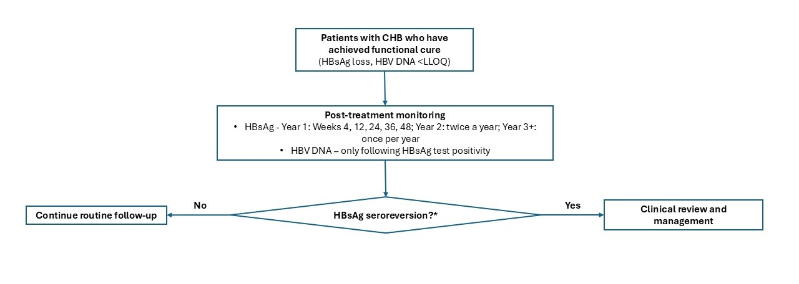
Figure 6 Proposed clinical management algorithm for CHB in patients that achieve functional cure (PICO 2)
Abbreviations: CHB, chronic hepatitis B; HBsAg, hepatitis B surface antigen; HBV DNA; hepatis B viral DNA; LLOQ, lower level of quantification;
* The applicant has not specified the criteria for defining HBsAg seroreversion (including whether confirmatory testing is required), the HBV DNA threshold for virological relapse, or the clinical management pathway following relapse. Current international guidelines do not provide specific recommendations for monitoring or management after relapse following cure-directed therapy.
* Testing in Year 2 is proposed to be conducted at weeks 72 and 96.
PASC agreed with the current and proposed clinical management algorithms.
PASC noted that transient fluctuations (“blips”) in biomarker levels around clinically relevant testing thresholds were observed in the key clinical trial. PASC noted the applicant’s explanation that these “blips” were more likely to be observed in the clinical trials due to more intensive testing schedules and may be less frequently detected in routine clinical practice, where testing is less frequent. The applicant’s clinical expert advised that unexpected results would generally be confirmed through repeat testing before treatment decisions are modified.
PASC noted the applicant's clarification that patients would be eligible for only one course of bepirovirsen treatment during their lifetime and, therefore, would not require reassessment of treatment eligibility following completion of therapy, regardless of clinical outcome.
PASC noted the applicant’s rationale for the proposed HBsAg-led monitoring pathway for PICO set 2, whereby HBV DNA testing is triggered by HBsAg positivity. PASC also noted the limited evidence and guidance available regarding post-functional cure monitoring.

Proposed economic evaluation
The overall claim by the applicant is that the proposed testing algorithm for patients with CHB receiving stable NA therapy will be superior in terms of downstream health outcomes when compared with current SOC testing, in that it will facilitate treatment with bepirovirsen, and ideally other functionally curative treatment options for CHB. The applicant is asked to clarify the safety claim.
Based on the clinical claim proposed by the applicant, and noting that the intervention comprises established pathology testing used in a different testing algorithm and frequency rather than a new testing technology, a cost-effectiveness/ cost-utility analysis is the most appropriate economic evaluation (Table 7). The assessment group considers an assumption of non-inferior safety to be reasonable as no obvious reason to expect materially different test-related safety outcomes compared with the comparator has been identified.
Table 7 Classification of comparative effectiveness and safety of the proposed intervention, compared with its main comparator, and guide to the suitable type of economic evaluation
Comparative safety |  | Comparative effectiveness
Comparative safety | Inferior | Uncertainª | Noninferior^{b} | Superior
Inferior | Health forgone: need other supportive factors | Health forgone possible: need other supportive factors | Health forgone: need other supportive factors | ? Likely CUA
Uncertainª | Health forgone possible: need other supportive factors | ? | ? | ? Likely CEA/CUA
Noninferior^{b} | Health forgone: need other supportive factors | ? | CMA | CEA/CUA
Superior | ? Likely CUA | ? Likely CEA/CUA | CEA/CUA | CEA/CUA
Abbreviations: CEA, cost-effectiveness analysis; CMA. cost-minimisation analysis; CUA, cost-utility analysis;
? = reflect uncertainties and any identified health trade-offs in the economic evaluation, as a minimum in a cost-consequences analysis
a ‘Uncertainty’ covers concepts such as inadequate minimisation of important sources of bias, lack of statistical significance in an underpowered trial, detecting clinically unimportant therapeutic differences, inconsistent results across trials, and trade-offs within the comparative effectiveness and/or the comparative safety considerations
b An adequate assessment of ‘noninferiority’ is the preferred basis for demonstrating equivalence
PASC agreed that either a cost-effectiveness or cost-utility analysis would be appropriate for the economic evaluation. PASC noted that any additional safety monitoring arising from the proposed clinical management algorithms should be captured within the economic model.

Proposal for public funding
The applicant has not clearly specified whether the proposed testing algorithm would be supported through amendment of existing MBS items or the creation of new item(s).
Preliminary assessment suggested that while existing items may capture some components (e.g. HBV DNA in patients who are HBsAg positive), it is unclear whether current item descriptors adequately support the repeated HBsAg testing and the proposed monitoring frequency (Table 8).
A detailed review of current item descriptors and restrictions identifies several potential gaps:
- MBS Item 69481 requires 3 tests for hepatitis antibodies/antigens and may not apply to standalone HBsAg tests ordered at discrete intervention timepoints (e.g., Week 0, Week 24, Week 48, Week 72) and it appears intended for the diagnostic investigation of suspected hepatitis;
- MBS Items 69482 and 69483 (for HBV DNA testing) require patients to be HBsAg positive, which may exclude HBV DNA testing performed after HBsAg turns negative but before functional cure is confirmed at 24 weeks off-treatment;
- MBS Items 69475 and 69478 (for hepatitis antigen/antibody testing) appear intended for post-exposure/vaccination immune status determination and may not be applicable to an already diagnosed CHB population.
The primary issue is that the current MBS does not appear to contain an item for routine serial HBsAg/qHBsAg monitoring in patients with CHB, either for treatment selection or for ongoing assessment of functional cure. Under current clinical practice, HBsAg testing is generally used for diagnosis and disease classification rather than repeated longitudinal monitoring. This issue becomes particularly relevant under the proposed testing algorithm, where repeated HBsAg measurements are required to determine eligibility for bepirovirsen treatment, assess treatment response, support NA cessation decisions and confirm maintenance of functional cure. The proposed pathway therefore introduces a new use-case for HBsAg testing that is not explicitly accommodated by existing MBS arrangements.
Another issue relates to HBV DNA testing. Current HBV DNA testing items (69482 and 69483) require patient to be HBsAg positive. Under the proposed pathway, however, patients who achieve functional cure are expected to become HBsAg negative, yet ongoing HBV DNA testing may still be clinically relevant to confirm maintenance of functional cure and detect relapse. Consequently, patients may no longer satisfy the eligibility requirements for HBV DNA testing at the same point that ongoing virological monitoring becomes most relevant.
The proposed testing pathway therefore highlights two potential funding gaps: (i) the absence of an MBS-supported mechanism for routine serial HBsAg monitoring in established CHB, and (ii) the potential loss of eligibility for HBV DNA testing under existing MBS items following HBsAg loss. Guidance is sought on whether these issues should be addressed through amendment of existing HBV DNA item descriptors, creation of new HBsAg monitoring items, or a combination of both approaches.
The applicant's proposed algorithm also includes HBeAg assessment at Week 48, however no MBS item specifically supporting HBeAg testing has been identified.
Table 8 Summary of currently funded MBS items relevant to CHB and applicability to the current assessment
MBS Item | MBS Descriptor | MBS Schedule Fee (as of 02 July 2026) | MBS Restrictions | Applicability to Current Assessment
69475 or 69478 | One test for item 69475 / two tests for item 69478  for hepatitis antigen or antibodies to determine immune status or viral carriage following exposure or vaccination to Hepatitis A, Hepatitis B, Hepatitis C or Hepatitis D | $15.65 or  $29.25 | Items subject to rule 11 (a Medicare benefit is not payable in respect of more than one of items 69475, 69478 and 69481 in a patient episode.) | Item 69475 or 69478 is not applicable in patients already diagnosed with Hepatitis B.
69481 | Investigation of infectious causes of acute or chronic hepatitis - 3 tests for hepatitis antibodies or antigens | $40.55 | Item subject to rule 11 (a Medicare benefit is not payable in respect of more than one of items 69475, 69478 and 69481 in a patient episode) | This item requires 3 tests, which means if the only test(s) ordered is qHBsAg or HBeAg this item is not applicable.  The item is intended for diagnostic investigation of suspected hepatitis, not routine monitoring of a patient with previously diagnosed, stable CHB.
69482 | Quantitation of Hepatitis B viral DNA in patients who are Hepatitis B surface antigen positive and have chronic hepatitis B, but are not receiving antiviral therapy - 1 test | $152.10 | Item subject to rule 25 (Once in a 12 month period) | HBV DNA viral load is not rebatable in patients who are HBsAg negative.
69483 | Quantitation of Hepatitis B viral DNA in patients who are Hepatitis B surface antigen positive and who have chronic hepatitis B and are receiving antiviral therapy - 1 test | $152.10 | Item subject to rule 25 (4 times in a 12 month period) | HBV DNA viral load is not rebatable in patients who are HBsAg negative.
69484 | Supplementary testing for Hepatitis B surface antigen or Hepatitis C antibody using a different assay on the specimen which yielded a reactive result on initial testing | $17.10 | Item subject to rule 18 (episode coning) | Patients who no longer test positive to HBsAg would be excluded from this item.
Abbreviations: HBsAg, hepatitis B surface antigen; HBV DNA, hepatitis B viral DNA; MBS, Medicare Benefits Schedule
If the proposed testing algorithm cannot be adequately supported through amendments of existing MBS item, the creation of three new, dedicated MBS items (see Table 9 and Table 10 for proposed item descriptors) would be required to support the proposed algorithm.
Table 9 Proposed item descriptors for HBV Antigen/ Antibody testing for the assessment or monitoring of patients with CHB, updated to reflect PASC advice
Category 6 - PATHOLOGY SERVICES – Group P3 - Microbiology
MBS item AAAA
One test for hepatitis B antigen or antibody for the assessment or monitoring of a patient who has established chronic hepatitis B
Fee: $15.65 Benefit: 75% = $11.75 85% = $13.35
MBS item BBBB
2 tests described in AAAA for two different hepatitis B antigens or antibodies
Fee: $29.25 Benefit: 75% = $21.95 85% = $24.90

Table 10 Proposed item descriptor for HBV DNA monitoring of CHB patients, updated to reflect PASC advice
Category 6 - PATHOLOGY SERVICES – Group P3 - Microbiology
MBS item CCCC
Quantitation of hepatitis B virus DNA in a patient who has established chronic hepatitis B (CHB) and who has become hepatitis B surface antigen negative following treatment with a functionally curative therapy for CHB under the Pharmaceutical Benefits Scheme (PBS)
Applicable not more than 4 times in 12 months
Fee: $152.10 Benefit: 75% = $114.10 85% = $129.30

PASC agreed that new MBS items are required as existing arrangements may not adequately support serial quantitative HBsAg testing and HBV DNA monitoring in patients with CHB and/or following functional cure. PASC emphasised that any new items should be future-proofed, where possible, to accommodate for potential new hepatitis B curative therapies. PASC noted that the department proposed some amendments to the three new MBS items but considered that further consideration would be required regarding the final item descriptors and appropriate fees for quantitative HBsAg testing.

Summary of public consultation input
PASC noted and welcomed consultation input from 5 organisations and 2 individuals, both of whom were health professionals. The 5 organisations that submitted input were:
- Australasian Society for Infectious Diseases (ASID)
- Australasian Society for HIV, Viral Hepatitis and Sexual Health Medicine (ASHM)
- Hepatitis B Voices Australia
- Public Pathology Australia (PPA)
- Royal College of Pathologists of Australasia (RCPA)
Consultation input was largely supportive of public funding for HBV and HBsAg testing to support the use of PBS-subsidised bepirovirsen in people with CHB. Consultation input raised that the population for HBV monitoring should be broadened to include all people with CHB.
Consumer Experience
Hepatitis B Voices Australia highlighted the significant physical, emotional and social impacts of CHB, including stigma and discrimination, barriers in obtaining visas, and being disallowed employment in the armed forces, police, and other professions. Hepatitis B Voices Australia stated that the majority of people living with HBV in Australia are not linked to care. Consultation input advised that current management with long-term antiviral therapy is linked to several challenges including side effects from antiviral therapy (bone density loss and kidney damage), financial costs for clinical consults with specialists and lab tests, and time toxicity attending appointments and pharmacy visits to pick up medicines. Public funding of HBV testing was considered important to support access to emerging therapies and reduce the long-term burden of living with CHB.
Benefits and Disadvantages
The main benefits of public funding reported in the consultation input included access to HBV and HBsAg testing to support treatment eligibility, monitoring and access to emerging therapies for a functional cure for CHB. Consultation input also highlighted that a functional cure is associated with a reduced risk of cirrhosis liver failure and liver cancer, eliminates the risk of transmission, and can reduce the stigma associated with living with HBV.
The main disadvantages of public funding reported in the consultation input included concerns regarding the scope of the proposed testing pathway. Consultation input stated that the proposed amended and new HBV testing items do not support guideline-based monitoring for all people living with CHB, particularly those not receiving antiviral therapy.
Population, Comparator (current management) and Delivery
The consultation input generally agreed that the proposed population was consistent with the phase 3 registration trials but input recommended that the population should be broadened beyond those intended for treatment with bepirovirsen. Consultation input from individual health professionals stated that the population captured those that would benefit including minority groups in Australia. Hepatitis B Voices Australia considered the population may be too narrow and that people with low HBsAg may be more likely to respond to both existing options e.g. interferon alpha and upcoming therapeutic strategies such as bepirovirsen.
The consultation input agreed with the proposed comparator of standard of care, noting that existing HBV monitoring arrangements may not adequately support all people living with CHB.
MBS Item Descriptor and Fee
The consultation input largely agreed with the proposed item descriptors. The health professionals advised that new MBS items should be created to reflect quantitative testing for HBsAg and the increased frequency for HBV DNA testing. The RCPA stated that the proposed frequency of HBV DNA testing post-treatment should be justified against the expected timing and incidence of virological relapse in patients treated with bepirovirsen.
Consultation input broadly agreed with the proposed MBS item fees. One health professional noted the current quantitative HBsAg assays usually have an upper limit of detection requiring repeat testing of a diluted sample and that it was unsustainable for laboratories to continue to cover the cost for repeat tests.
Additional Comments
ASID, ASHM and the RCPA considered that broader amendments to HBV testing are more equitable, administratively simpler and more consistent with Australia’s hepatitis B elimination strategy than a narrow, medicine-specific funding pathway. Consultation input advised that regular HBV DNA monitoring is required in other populations including people with CHB who are not receiving antiviral therapy, are receiving immunosuppressive therapies or are pregnant. More frequent monitoring in these populations was used to identify changing disease activity, reassess eligibility for treatment, distinguish sustained inactive infection from fluctuating viraemia, and detect reactivation. Consultation input stated that the current annual restriction on HBV DNA testing contributes to patients forgoing HBV monitoring in primary care, resulting in unnecessary referral to hospital-based services, fragmented care, and reduced access for people in regional, rural and remote settings.
PASC noted that stakeholder feedback was supportive of the application. Stakeholders highlighted the importance of the proposed testing algorithm to support access to subsidised quantitative HBsAg and HBV DNA monitoring for patients receiving bepirovirsen and highlighted the need for appropriate MBS funding arrangements to support ongoing access to HBV DNA and quantitative HBsAg testing in line with current and emerging hepatitis B management guidelines.

Next steps
PASC advised that the application meets the definition of a co-dependent technology and should be evaluated through the already established parallel evaluation process via PBAC and MSAC. The assessment of diagnostic accuracy would not be required for established tests used in current clinical practice (such as qualitative HBsAg and HBV DNA) but should be assessed for quantitative HBsAg testing.
PASC considered that the intervention may need refinement to reflect realistic clinical practice and additional safety monitoring via more comprehensive testing, and that further consideration is required regarding the proposed MBS items to ensure future-proofing and establish appropriate fees.

Applicant Comments on Ratified PICO
GSK acknowledges the ratified PICO for the testing for hepatitis B virus (HBV) and hepatitis B virus surface antigen (HBsAg) to support the use of bepirovirsen in people with chronic hepatitis B (CHB). GSK notes that HBsAG testing (quantitative, qualitative) and HBV DNA are available on the MBS schedule, though the introduction of bepirovirsen will require new or amended items. While the ratified PICO has requested the diagnostic accuracy of HBsAg testing be evaluated, GSK notes that associated test performance would not change should Bepirovirsen be funded. In addition, with updates to treatment and monitoring guidelines for CHB, further steps can be taken to simplify MBS items to enable recommended HBV DNA monitoring across CHB populations.

References
CDC. (2025). Clinical Overview of Hepatitis B Retrieved 08 Jul from https://www.cdc.gov/hepatitis-b/hcp/clinical-overview/index.html
Cornberg, M., Sandmann, L., Jaroszewicz, J., Kennedy, P., Lampertico, P., Lemoine, M., Lens, S., Testoni, B., Lai-Hung Wong, G., & Russo, F. P. (2025). EASL Clinical Practice Guidelines on the management of hepatitis B virus infection. Journal of Hepatology, 83(2), 502-583. https://doi.org/10.1016/j.jhep.2025.03.018
Ghany, M. G., Pan, C. Q., Lok, A. S., Feld, J. J., Lim, J. K., Wang, S. H., Kim, A. Y., Tang, A. S., Nguyen, M. H., Naggie, S., Sulkowski, M. S., Norberto, R. B., Chen, J., Murad, M. H., Mohammad, K. S., & Terrault, N. A. (2026). AASLD ISDA Practice Guideline on treatment of chronic hepatitis B. Hepatology, 83(4), 974-997. https://doi.org/10.1097/HEP.0000000000001549
Hou, J., Lim, S.-G., Buti, M., Yuen, M.-F., Gane, E., Lampertico, P., Terrault, N., Nguyen, H., Yim Hyung, J., Xie, Q., Lin, J., Qiu, Y., Jeng, W.-J., Heo, J., Peng, C.-Y., Chen, C.-H., Chuang, W.-L., Xie, Y., Hlebowicz, M., . . . Elston, R. (2026). Phase 3 Results of Bepirovirsen Treatment for Chronic Hepatitis B Virus Infection. New England Journal of Medicine, 394(24), 2395-2406. https://doi.org/10.1056/NEJMoa2515131
Lubel, J. S., Strasser, S. I., Thompson, A. J., Cowie, B. C., MacLachlan, J., Allard, N. L., Holmes, J., Kemp, W. W., Majumdar, A., Iser, D., Howell, J., & Matthews, G. V. (2022). Australian consensus recommendations for the management of hepatitis B. Med J Aust, 216(9), 478-486. https://doi.org/10.5694/mja2.51430
MacLachlan, J. H., Mondel, A., Purcell, I., & Cowie, B. (2025). Viral Hepatitis Mapping Project: Hepatitis B National Report 2023.
Marrapu, S., Soni, J. R., Kamal, K., & Kumar, R. (2025). Hepatitis B functional cure: Current and future perspective. World J Hepatol, 17(10), 110107. https://doi.org/10.4254/wjh.v17.i10.110107
Tang, L. S. Y., Covert, E., Wilson, E., & Kottilil, S. (2018). Chronic Hepatitis B Infection: A Review. JAMA, 319(17), 1802-1813. https://doi.org/10.1001/jama.2018.3795
Towell, V., & Cowie, B. (2012). Hepatitis B serology. Aust Fam Physician, 41(4), 212-214. https://www.ncbi.nlm.nih.gov/pubmed/22472681
WHO. (2026, June 2026). Hepatitis B Fact Sheet. Retrieved 08 Jul from https://www.who.int/news-room/fact-sheets/detail/hepatitis-b
WHO Europe. (2021). Hepatitis B Fact Sheet In.
Yuen, M. F., Lim, S. G., Plesniak, R., Tsuji, K., Janssen, H. L. A., Pojoga, C., Gadano, A., Popescu, C. P., Stepanova, T., Asselah, T., Diaconescu, G., Yim, H. J., Heo, J., Janczewska, E., Wong, A., Idriz, N., Imamura, M., Rizzardini, G., Takaguchi, K., . . . Theodore, D. (2022). Efficacy and Safety of Bepirovirsen in Chronic Hepatitis B Infection. N Engl J Med, 387(21), 1957-1968. https://doi.org/10.1056/NEJMoa2210027

Qualitative HBsAg testing determines whether HBsAg is present or absent. Quantitative HBsAg (qHBsAg) testing measures the amount of HBsAg in serum and reports the result as a concentration (IU/mL).
B-well is a phase 2b trial on bepirovirsen conducted prior to B-well trial

