MSAC Application 1836

Ciltacabtagene autoleucel therapy to treat patients with refractory or relapsed multiple myeloma after at least 1 prior therapy

  - PICO Set

Population
Describe the population in which the proposed health technology is intended to be used:
Multiple myeloma (MM) is a cytogenetically heterogeneous clonal plasma cell proliferative disorder characterised by an abnormal serum and/or urine immunoglobulin (known as M protein). As MM progresses and patients relapse following initial treatment, the presence of sub-clonal populations of malignant plasma cells becomes increasingly prevalent. Typical clinical features include bone disease (and bone loss) with skeletal pain, impaired renal function, anaemia, fatigue, hypercalcaemia, recurrent and/or persistent bacterial infection, and/or hyperviscosity of the blood (Quach et al 2019). Together, these symptoms are associated with significant morbidity and can result in death in patients who are unable to receive or no longer responsive to available therapies.
MM follows a relapsing and remitting course as patients receive multiple lines of therapy. Although current standard treatments for MM may result in remission, most patients will relapse as there is no cure for the disease. The duration of response and remission typically gets shorter with each line of therapy, and is the result of plasma cell clonal evolution, acquiring mutations that can confer high risk features and resistance to standard therapy. Furthermore, there is significant patient attrition at each line, as patients become unsuitable for further therapy and succumb to the disease (Zhao et al 2019).
This application focuses on relapsed or refractory MM after at least one prior line of therapy (i.e. second line plus), including a proteasome inhibitor (PI) and immunomodulatory agent (IMiD). Further, the proposed technology, ciltacabtagene autoleucel (cilta-cel) was studied in a lenalidomide refractory population. Lenalidomide refractory MM is defined as failure to achieve minimal response or progression on or within 60 days of completing lenalidomide therapy. Thus, as lenalidomide is a treat-to-progression therapy, and most patients in Australia receive lenalidomide as their first-line treatment, this means that most patients in Australia with relapsed or refractory MM are typically refractory to lenalidomide.
This is particularly important because patients with lenalidomide-refractory MM experience worse clinical outcomes than other MM patients, including increased risk of disease progression and death as reported in the literature (Dhakal B et al 2024; Dhakal B et al 2025; Hartley-Brown M et al 2024; Yong K et al 2025), and most Australians receive lenalidomide as first-line myeloma therapy. Hartley-Brown M et al 2024 presented a systematic literature review across 24 clinical trials published between January 2008 and October 2023 which reported lenalidomide‑refractory patients had shorter population-weighted mean of median PFS (8.8 months) and OS (21.7 months) than the intent‑to‑treat populations (mPFS: 13.8 months, mOS: 35.9 months); clearly demonstrating the poorer prognosis of patients with lenalidomide refractory disease. Furthermore, these publications have consistently noted that survival outcomes in lenalidomide-refractory patients have also shown little improvement even with recent advances in treatments. This highlights a significant clinical unmet need for new and effective innovative therapies, such as cilta-cel, for the relevant population considered within this application.
Specify any characteristics of patients with the medical condition, or suspected of, who are proposed to be eligible for the proposed health technology, describing how a patient would be investigated, managed and referred within the Australian health care system in the lead up to being considered eligible for the technology:
Table 1 below presents the proposed eligibility criteria for cilta-cel for 2L+ MM. Patient selection and referral decisions will be determined by institution, state and National Multi-Disciplinary Teams (MDTs), as appropriate, which will ensure eligible and suitable patients are identified and prioritised for cilta-cel treatment. Refer to ‘Intervention’ and ‘Algorithms’ sections for further details around the health technology, medical condition, and those eligible for cilta-cel.
Table 1: Proposed eligibility criteria for cilta-cel for 2L+ MM treatment under NHRA
Treatment criteria | Patient must be treated in a tertiary public hospital with appropriate credentials  AND  Patient must be treated by a haematologist working in a multi-disciplinary team specialising in the provision of CAR-T cell therapy
Clinical criteria | The condition (MM) must be confirmed by a histological diagnosis.  AND  Patient must have progressive disease after at least one prior line of therapy  AND  Patient must have previously had treatment with a proteasome inhibitor, and an immunomodulatory (IMiD) drug  AND  Patient must be refractory to lenalidomide  AND  Patient must not have previously received treatment with another B-cell maturation antigen (BCMA) directed therapy for this condition  AND  Patient must not be receiving concomitant PBS-subsidised MM therapies  AND  Patient must have an ECOG score of 0 or 1  AND  Patient must have a creatinine clearance of 40 mL/min or greater  AND  Patient must have a liver function (AST and ALT) of 3.0 x upper limit of normal or less  AND  Patient must not have received successful treatment with cilta-cel before, (i.e. treatment is limited to one successful infusion per lifetime)

Provide a rationale for the specifics of the eligible population:
The eligibility criteria proposed for cilta-cel for 2L+ MM is aligned to the population enrolled in the clinical trial relevant to this application (CARTITUDE-4 [NCT04181827]) and specific elements of the criteria supported by MSAC for cilta-cel for treating 5L+ MM that remain relevant (i.e., those related to creatinine clearance, liver function, and one successful infusion per lifetime). Further details related to the specifics of the eligible population will be provided in the submission (i.e., ADAR).

Intervention
Name of the proposed health technology:
Ciltacabtagene autoleucel (cilta-cel, CARVYKTI®).
Describe the key components and clinical steps involved in delivering the proposed health technology:
The CAR-T process for cilta-cel in 2L+ MM is consistent with that considered by MSAC for cilta-cel in 5L+ MM, which is now NHRA funded. The diagram presented in Figure 1 below summarises the steps involved in the proposed medical service. Most of the medical service will be rendered in Australia. The exception is the manufacturing of the cilta-cel CAR-T product which occurs in the Janssen manufacturing centre in Raritan (NJ, USA). The main steps involved and resources used at each step are similar for cilta-cel at 5L+ MM.
Referral: Patient eligibility for CAR-T will be discussed at Standard Tumour Stream multidisciplinary team (MDT) meetings. Prior to being discussed at an MDT meeting, the patient will have a consent to their referral for CAR-T being discussed at the meeting. These consultations with the patient are generally conducted on an outpatient basis or via Telehealth; and will consider whether the patient social context and whether any assistance is required for interstate travel. Further, the patient’s medical history will be discussed and whether there is a need for any specialist pathology tests ahead of the MDT meeting. After local MDT meetings, some sites may discuss individual CAR-T cases at a national CAR-T patient meeting. These national meetings may include CAR-T specialists (including tumour stream leads), treating and referring centre clinical representatives, CAR-T fellows, CART nurse consultants, research nurses, apheresis nurses, cell logistics project managers and the CAR-T program managers.
Apheresis: Once a patient is considered suitable they will be enrolled for cilta-cel through CQUENCE, the Johnson & Johnson digital ordering platform. Patients will then undergo a standard apheresis process to collect white blood cells (WBC). The T cells (a type of WBC) from apheresis will be collected for transduction and undergo expansion to manufacture cilta-cel. Apheresis is performed according to institutional standards, with a collection target of 9.0 ± 3.0 × 10⁹ WBC. A minimum of ≥ 1.0 × 10⁹ WBC is required. Various specialised apheresis systems are available for this process. The apheresis machine is a multi-use consumable. Single-use consumables include tubing, sets, bowls, anticoagulant and replacement fluids.
In the current process, fresh cell collection from apheresis is shipped to Cell Therapies Pty Ltd, in Melbourne for cryopreservation. From Cell Therapies, cryopreserved cells will be cold chain transported to the Janssen manufacturing centre in Raritan (New Jersey, USA). It is anticipated that the related clinical and logistical implications of the cilta-cel program on cell collection costings for 2L+ MM are expected to be minimal given the current state of preparedness for existing standard of care CAR-T therapies in Australia, including cilta-cel for 5L+ MM.
Bridging therapy: Most patients receive bridging therapy as per clinical indication to maintain disease stability during the period of production of cilta-cel. Following cell collection, a patient’s status must be maintained until the cells are manufactured and delivered back to the treatment site by bridging therapy. The clinical goal of bridging therapy is to achieve disease control of the myeloma ahead of CAR-T infusion (i.e., prevent disease progression during the manufacturing process). This is an important step in the process, as effective bridging therapy reduces the potential for CAR-T related toxicities and supports the achievement of optimal long-term outcomes.
In the CARTITUDE-4 study, the median number of cycles of bridging therapy was 2 cycles. This is expected to be consistent with the average duration of bridging therapy required for each patient receiving cilta-cel in Australian clinical practice based on local expert clinical advice. While bridging requirements may change and/or be jurisdiction specific (e.g. in part dependent on what is approved by the PBS in Australia), patients are most likely to be treated with an agent they have not previously received (when possible).
Manufacture of cilta-cel: The WBC are enriched for T-cells and genetically modified ex vivo by transduction with a replication incompetent lentiviral vector to express a chimeric antigen receptor (CAR) comprising an anti-BCMA targeting domain. The transduced anti-BCMA CAR T-cells are expanded in cell culture, washed, formulated into a suspension and cryopreserved. The product must pass a sterility test before release for shipping as a frozen suspension in a patient-specific infusion bag. The drug product infusion bag is individually packed in an aluminium cryo cassette prior to cryopreservation. Currently, once the CAR-T product is manufactured, it will undergo full QA release at Raritan, then cold chain transported directly to the applicable treatment centre in Australia.
Conditioning (lymphodepletion): Approximately redacted after apheresis, after the completion of manufacture and quality testing of cilta-cel, the patients are subjected to a conditioning regimen of IV cyclophosphamide 300 mg/m² and fludarabine 30 mg/m² at three daily doses. The conditioning regimen will lead to lymphodepletion and help promote cilta-cel cell expansion in the patients. Cyclophosphamide 300 mg/m2 and fludarabine 30 mg/m² before cilta-cel infusion in the 2L+ setting is consistent with cilta-cel in the 5L+ MM setting, and the lymphodepletion regimen used in the other marketed CAR-T products in Australia (for example, Kymriah and Yescarta). The dose of fludarabine should be reduced to 24 mg/m² for patients with an eGFR of 30 to 70 mL/min/1.73m².
Standard single-use consumables for an IV infusion include sterile alcohol wipes, plastic wrap, film dressing, gauze wipes, tubing adhesive tape, spill kit, preparation mats, labels, transport bag, and latex gloves.
Cilta-cel infusion: Cilta-cel is a single infusion product. Cilta-cel will be administered 5 to 7 days in the after start of the conditioning regimen at a public hospital (i.e., at the CAR-T treatment centre). The recommended dose is 0.5-1.0×10⁶ CAR-positive viable T-cells per kg of body weight, with a maximum dose of 1×10⁸ CAR-positive viable T-cells per single infusion. Treatment will be prescribed and monitored by an experienced haematologist working in a multidisciplinary team specialising in the provision of CAR-T cell therapy and who have undergone appropriate accreditation and training.
Pre-infusion medications are administered to all patients (30 to 60 minutes) prior to cilta-cel infusion which include antipyretics and an antihistamine. Further, before the infusion and during the recovery period, tocilizumab (for managing cytokine release syndrome [CRS]) and emergency equipment will need to be available for use if needed.
The patient’s identity with the patient identifiers on the infusion bag need to be confirmed before infusion. Cilta-cel should not be infused if the information on the patient-specific label does not match the intended patient.
Once thawed, the entire contents of the cilta-cel bag must be administered by IV infusion within 2.5 hours using infusion sets fitted with an in-line filter and not a leukodepleting filter. The contents of the bag should be gently mixed during cilta-cel infusion to disperse cell clumps. After the entire content of the product bag is infused, the administration line inclusive of the in-line filter should be flushed, with sodium chloride 9 mg/mL (0.9%) solution (normal saline) to ensure all product is delivered.
The patients will be evaluated for safety on the day of cilta-cel infusion. Infusion of cilta-cel will be delayed:
- If there are any signs of infection (patients requiring anti-microbial treatment, or with temperature ≥ 38.0 Celsius within 48 hours before infusion of cilta-cel.
- In case of Grade ≥3 non-hematologic toxicities of cyclophosphamide and fludarabine conditioning (except for Grade 3 nausea, vomiting, diarrhea, or constipation) occurs.
Monitoring after infusion: Following the infusion, there will be a period of monitoring required. The approved TGA Product Information recommends that patients are monitored daily for 14 days after the infusion at a certified healthcare facility and then periodically for an additional two weeks after infusion for signs and symptoms of cytokine release syndrome (CRS), neurologic events and other toxicities. Thus, the monitoring requirements for cilta-cel for 2L+ MM are consistent with those required for NHRA funded cilta-cel for 5L+ MM.
The setting of post infusion care for cilta-cel can vary by patient, by site and by the experience and capacity of the treating clinician and team. As such, patients are managed in both the inpatient and outpatient settings, consistent with cilta-cel in 5L+ MM, and other CAR-Ts currently funded in Australia.
Some patients may require a short inpatient admission as a consequence of cytokine release syndrome (CRS) onset and CAR-T neurotoxicities. Typically, these toxicities may take up to 7 days to onset. Tocilizumab or methylprednisolone may be administered via IV infusion for the management of CRS or ICANS. Furthermore, a low rate of ICU is expected given most patients are monitored as an inpatient for some of the period to avoid ICU admissions. Redacted.
Long term patient assessment: Previous CAR-T therapies recommended by MSAC have required assessment of long-term patient outcomes, including cilta-cel for 5L+ MM, to support both their respective pay-for-performance (PfP) arrangements, and registry data collection. Any timeframe in a PfP should not be overly onerous to the healthcare system, the treatment and referring centres and clinicians. Data on the use of CAR-T therapies in Australia is currently recorded by the Australian and New Zealand Transplant and Cellular Therapies Registry (ANZTCT), with the cost of data collection met by the sponsor.

Figure 1 Clinical steps involved with the delivery of cilta-cel – Figure redacted

Identify how the proposed technology achieves the intended patient outcomes:
Cilta-cel consists of autologous CAR-T cells designed to target the biomarker, B cell maturation antigen (BCMA) which is a type III membrane protein and a part of the tumour necrosis receptor superfamily. BCMA is stably expressed in malignant multiple myeloma plasma cells in almost all patients with MM. Expression of BCMA in non-malignant cells is minimal and limited to plasma cells and a small subset of B cells. BCMA also facilitates MM plasma cell survival.
Mechanism of cilta-cel
Cilta-cel is prepared from the patient’s peripheral blood mononuclear cells obtained via a leukapheresis. The mononuclear cells are enriched for T-cells and genetically modified ex vivo by transduction with a replication incompetent lentiviral vector to express a chimeric antigen receptor (CAR) comprising an anti-BCMA targeting domain. The transduced anti-BCMA CAR T-cells are then expanded and infused and formulated into a suspension prior to infusion back into the patient, where the anti-BCMA CAR T-cells can recognise and eliminate BCMA expressing target cells.
The therapy includes two variable heavy homodimer (VHH) domains that are directed against two distinct BCMA epitopes. These domains enable high-avidity binding of cilta-cel to BCMA. This is an important distinction of cilta-cel from other CAR T cell therapies, which only have one BCMA binding domain, such as idecabtagene vicleucel (ide-cel).
Figure 2 Composition of cilta-cel
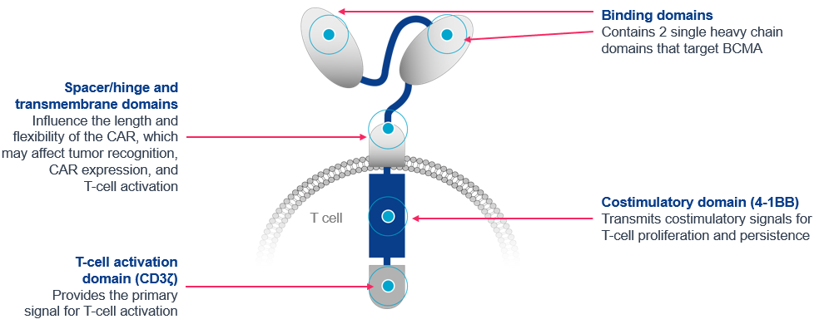
Abbreviations: BCMA = B-cell maturation antigen; CAR = chimeric antigen receptor.
Refer to the above for the clinical steps involved with delivering cilta-cel.
Does the proposed health technology include a registered trademark component with characteristics that distinguishes it from other similar health components?
Yes
Explain whether it is essential to have this trademark component or whether there would be other components that would be suitable:
Ciltacabtagene autoleucel will be supplied as a trademarked class 4 biological product; CARVYKTI®.
This is consistent with NHRA funded cilta-cel for 5L+ MM.
Are there any proposed limitations on the provision of the proposed health technology delivered to the patient (For example: accessibility, dosage, quantity, duration or frequency):
Yes
Provide details and explain:
The following limitations are applied to the proposed medical service:
Dosing: Cilta-cel is to be administered as a single dose for infusion per patient containing a suspension of chimeric antigen receptor (CAR)-positive viable T-cells. The dose is 0.5-1.0×10⁶ CAR-positive viable T-cells per kg of body weight, with a maximum dose of 1×10⁸ CAR-positive viable T-cells per single infusion. The infusion should be given 5 to 7 days after the start of the lymphodepleting regimen. The dosing for cilta-cel in 2L+ MM is consistent with the dosing of cilta-cel for 5L+ MM.
Number of CAR-T treatments in a lifetime: Consistent with the MSAC recommendation for cilta-cel for 5L+ MM (November 2024), and the current NHRA funding of cilta-cel for 5L+ MM, it is proposed that 2L+ MM patients would be limited to one successful CAR-T infusion per lifetime. A successful infusion is when the patient with RRMM has been infused with the optimal cilta-cel dosage as per the recommend dose above.
Prescriber: Treatment will be prescribed and monitored by an experienced haematologist working in a multidisciplinary team specialising in the provision of CAR-T cell therapy.
Treatment centre: Treatment with cilta-cel is limited to specialist public hospital centres across the Australian states and territories that have been accredited as CARVYKTI Certified Healthcare Facilities.
If applicable, advise which health professionals will be needed to provide the proposed health technology:
Infusion of cilta-cel will be delivered by an appropriately trained and qualified nurse and supervised by a haematologist in an accredited hospital setting. This is consistent with the administration of the NHRA funded cilta-cel for 5L+ MM.
If applicable, advise whether delivery of the proposed health technology can be delegated to another health professional:
It is not appropriate for this medical service to be delegated to another health professional for delivery.
If applicable, advise if there are any limitations on which health professionals might provide a referral for the proposed health technology:
Cilta-cel for 2L+ MM will be referred by specialised haematologists to accredited treatment centres, consistent with how people with MM in Australia are referred for cilta-cel for 5L+ MM which is NHRA funded.
Is there specific training or qualifications required to provide or deliver the proposed service, and/or any accreditation requirements to support delivery of the health technology?
Yes
Provide details and explain:
Treatment with cilta-cel is limited to key specialist public hospital centres across the Australian states and territories. Several hospitals have experience with cilta-cel through the CARTITUDE clinical trial program, and through the delivery of cilta-cel in the 5L+ MM setting under the current NHRA funding arrangement. Thus, several sites in Australia have relevant clinical experience and protocols in place for delivering this medical service.
Cilta-cel treatment centres need to be approved by State/Territory governments and accredited by Janssen with supply and quality agreements in place. As part of Janssen accreditation process, the treatment centres will need to be trained in accordance with the TGA approve Risk Management Plan that includes, among other things, the important identified risks of cytokine release syndrome (CRS) and neurotoxicity and availability of tocilizumab to manage CRS. Redacted.
Once the site has been qualified as a certified healthcare facility, patient enrolment can occur.
Full site re-accreditation by Janssen will occur every redacted which is inclusive of on-site audits to ensure compliance with set-up, processes, and training.
CAR-T site HCP education and patient education materials have been developed and include:
Redacted
Furthermore, sites are nominated by State and territory governments—working in collaboration with the Commonwealth—and base their site selection on the following criteria:
- Multidisciplinary Infrastructure: Sites must be equipped with specialist cell therapy handling, stem cell processing laboratories, and intensive care units to manage severe side effects.
- Specialised Workforce: Hospitals must have trained haematologists, oncologists, and specialised nursing and scientific staff.
- Logistics and Regulation: Facilities must satisfy rigorous chain-of-custody and cold-chain logistics to safely handle patient immune cells being shipped to and from pharmaceutical labs.
- Funding Approval: Centres are designated under the Highly Specialised Therapies Program and the National Health Reform Agreement
Indicate the proposed setting(s) in which the proposed health technology will be delivered:
Consulting rooms
Day surgery centre
Emergency Department
Inpatient private hospital
Inpatient public hospital
Laboratory
Outpatient clinic
Patient’s home
Point of care testing
Residential aged care facility
Other (please specify)
Patients may be admitted as an inpatient for the following steps of the cilta-cel medical service: delivery of the infusion and potentially a period of monitoring. This post infusion monitoring is standard practice and is consistent with NHRA funded cilta-cel for 5L+ MM.
Patients would be seen in an outpatient setting for other steps of the cilta-cel medical service including: apheresis, bridging therapy and conditioning, routine follow-up once monitoring after discharge from inpatient infusion.
As treatment experience increases with CAR-T product delivery globally, and within Australia, familiarity with the technology and optimal management has also increased. This is evidenced by the publication of multiple consensus guidelines, and evolving models of care, which has also led to CAR-T centres managing a patient as an outpatient following the infusion. Further information and detail of this will be provided in the sponsors ADAR.
Is the proposed health technology intended to be entirely rendered inside Australia?
No
Provide additional details on the proposed health technology to be rendered outside of Australia:
Most of the medical service will be rendered in Australia. The exception Is the manufacturing of cilta-cel CAR-T product which occurs in the Janssen manufacturing centre in Raritan (NJ, USA). For further details, refer to response to “Describe the key components and clinical steps involved in delivering the proposed health technology” question above, and ‘Manufacture of cilta-cel’ subsection.

Comparator
Nominate the appropriate comparator(s) for the proposed medical service (i.e. how is the proposed population currently managed in the absence of the proposed medical service being available in the Australian health care system). This includes identifying health care resources that are needed to be delivered at the same time as the comparator service:
Provide a name for your comparator:
The nominated comparators for cilta-cel (CARTITUDE-4) include:
- Pomalidomide plus bortezomib and dexamethasone for 2L+ MM (PBS listed)
- Carfilzomib plus dexamethasone for 2L+ MM (PBS listed)
- Daratumumab plus bortezomib and dexamethasone for 2L only MM (PBS listed)
- Belantamab mafodotin plus bortezomib and dexamethasone for 2L+ MM (near market comparator).
Provide an identifying number for your comparator (if applicable):
Table 1: Summary of PBS item codes for nominated comparator
Comparator | PBS item code
Pomalidomide (plus bortezomib and dexamethasone) [PBd] | 12661J, 12665N, 12666P, 12668R, 13794B, 13812Y, 13813B, 13815D
Carfilzomib (plus dexamethasone) [Cd] | 11229B, 11230C, 12243J, 12244K
Daratumumab (plus bortezomib and dexamethasone) [DBd] | 12220E, 12225K, 12226L, 12228N, 12230Q, 12231R, 12682L, 12683M, 12725R, 12745T, 12746W, 12755H
Provide a rationale for why this is a comparator:
Current PBS practice for 2L+ MM
As noted earlier in the ‘Population’ section, the proposed indication for cilta-cel is for the treatment of patients with RRMM after at least one prior line of therapy including a PI and an IMiD, and who are lenalidomide-refractory. Thus, the earliest patients can receive cilta-cel will be as a second line MM treatment. Further, as described in ‘Algorithms’ section, almost all patients with newly diagnosed MM receive a lenalidomide-based regimen as their first-line treatment, and as lenalidomide is given until disease progression, patients will also be refractory to lenalidomide in the second-line setting.
An analysis of the PBS 10% sample based on the number of unique patients on each molecule between 2021 and 2026 on second-line, third-line and fourth-line treatments are presented in Figure 3 (includes lenalidomide containing regimens) and Table 2 (excludes lenalidomide containing regimens). The analysis excluding lenalidomide containing regimens is presented because this application for cilta-cel is requesting funding in a population who are refractory to lenalidomide. Thus, lenalidomide containing regimens will not be prescribed in the requested population, and are not relevant comparators for cilta-cel for 2L+ MM.
The PBS 10% sample data demonstrates that the proportion of patients who receive a lenalidomide-based regimen for RRMM has substantially reduced over the last 5 years (from approximately 30% to 15%; refer to Figure 3). The significant majority of patients are now receiving a non-lenalidomide based therapy for RRMM in Australia, and this is continuing to decline considerably over time. This is not surprising given that almost all patients are now receiving a lenalidomide-based regimen as part of their first treatment regimen following the PBS listings of various lenalidomide regimens, including:
- Lenalidomide plus dexamethasone for transplant ineligible newly diagnosed MM (February 2017)
- Lenalidomide maintenance therapy post transplant (April 2020)
- Lenalidomide, bortezomib and dexamethasone for all newly diagnosed MM (June 2020)
- Daratumumab, lenalidomide and dexamethasone for transplant ineligible newly diagnosed MM (November 2025).
Figure 3: Uptake of medicines on the PBS for 2L+ MM (based on patient initiations)

Source: Analysis of 10% PBS data. Unique patients per year. 24 April 2026.
The PBS 10% sample data demonstrates that the most commonly utilised medicines for RRMM across the second-line, third--line and fourth-line settings are daratumumab, carfilzomib and pomalidomide (Table 2). Daratumumab was listed on the PBS in January 2021 as an option for second-line MM, in combination with bortezomib and dexamethasone. Carfilzomib was PBS listed in combination with dexamethasone in February 2021, and was subsequently listed in combination with lenalidomide and dexamethasone in October 2023. Both regimens are available under a broad PBS listing for RRMM. Pomalidomide in combination with dexamethasone was PBS listed in October 2021, and was subsequently listed in combination with bortezomib in January 2024.
While the use of bortezomib appears high, this medicine is being used in combination with either daratumumab (DBd), or pomalidomide (PBd), rather than as a monotherapy. This is because these combination regimens result in superior efficacy relative to bortezomib monotherapy.
Table 2: Uptake of medicines on the PBS for 2L+ MM excluding lenalidomide (based on patient initiations)
Medicine | 2021 | 2022 | 2023 | 2024 | 2025 | 2026
Daratumumab | 23.8% | 33.1% | 37.3% | 44.3% | 43.0% | 58.9%
Bortezomib | 31.7% | 31.4% | 31.5% | 27.7% | 28.0% | 17.2%
Carfilzomib | 23.8% | 17.4% | 15.7% | 14.8% | 14.2% | 13.9%
Pomalidomide | 16.8% | 14.7% | 11.4% | 11.6% | 11.4% | 8.1%
Selinexor | 0.0% | 0.2% | 1.3% | 0.2% | 1.8% | 1.4%
Thalidomide | 3.8% | 3.1% | 2.8% | 1.3% | 1.6% | 0.5%
Total | 100.0% | 100.0% | 100.0% | 100.0% | 100.0% | 100.0%
Source: Analysis of 10% PBS data. Unique patients per year. 24 April 2026.
The results of the above analyses are consistent with the PBAC consideration of belantamab mafodotin in November 2025. The PBAC advised that if the sponsor of belanatamab mafodotin were to consider a broader RRMM (2L+) listing, a mixed comparator that consisted of daratumumab, carfilzomib, pomalidomide, selinexor and elotuzumab would be reasonable (paragraph 7.3, belantamab Public Summary Document, November 2025). Please note that elotuzumab was excluded from the PBS10% analysis. This is because as of 1 December 2024, initial treatment with elotuzumab as triple therapy is no longer PBS-subsidised (that is new patients cannot initial elotuzumab therapy anymore). Continuing treatment with elotuzumab as triple therapy remains on the PBS to ensure continuity of the treatment for existing patients who are receiving benefit. Thus, elotuzumab is not a relevant comparator for cilta-cel for 2L+ MM as its use in Australian clinical practice is only in historical patients and will decline to zero in the future. This data point from the PBAC in November 2025 supports that the proposed comparators for cilta-cel for 2L+ MM in this application are appropriate and reflective of Australian clinical practice.
Future PBS practice for 2L+ MM
Belantamab mafodotin plus bortezomib and dexamethasone is considered as a near market comparator for RRMM after at least one prior therapy (i.e., second-line plus). Belantamab was not recommended by the PBAC in November 2025 for second-line only MM, but is being reconsidered by the PBAC in July 2026 for RRMM after at least one prior therapy. At the time of this application, the PBAC outcome was not known. Similar, to cilta-cel, belantamab is a BCMA directed therapy.
Pattern of substitution – Will the proposed health technology wholly replace the proposed comparator, partially replace the proposed comparator, displace the proposed comparator or be used in combination with the proposed comparator?
None (used with the comparator)
Displaced (comparator will likely be used following the proposed technology in some patients)
Partial (in some cases, the proposed technology will replace the use of the comparator, but not all)
Full (subjects who receive the proposed intervention will not receive the comparator)
Outline and explain the extent to which the current comparator is expected to be substituted:
As cilta-cel is a one-off, safe and superior in efficacy therapy relative to standard of care for 2L+ MM, clinicians will want to use it at the earliest opportunity. Despite high efficacy of cilta-cel for 2L+ MM as shown in CARTITUDE-4, not all patients will be eligible or be able to tolerate cilta-cel, so it will only partially replace the nominated comparators. Suitability and uptake of cilta-cel will also be moderated by the fact that:
- Only patients who have received a PI and IMiD, and lenalidomide refractory can receive cilta-cel as per the CARTITUDE-4 population. However, this is expected to be most, if not all, patients at 2L+ MM in Australia due to current PBS clinical practice.
- Cilta-cel for 2L+ MM is proposed to be used in patients who are naïve to a BCMA directed therapy as aligned to the CARTITUDE-4 population. However, there are no BCMA directed therapies currently reimbursed in 2L or 3L MM in Australia, so the impact of this criteria will be limited based on currently available therapies.
- Only a portion of patients will be able to tolerate or be fit enough for treatment and can travel to the treatment site which may be interstate. However, as the requested population in this application is 2L+MM, the proportion of patients who will be able to tolerate cilta-cel therapy will be higher relative to the previous application for cilta-cel, which was in a late-line 5L+ MM setting.
- As several CARTs are now funded by the NHRA, and this application is for a 2L+ MM, it will mean that the use of cilta-cel in this setting will also be influenced by the capacity of accredited sites who can deliver highly specialised therapies (HSTs). However, it is expected that the number of accredited sites will continue to increase over time. Thus, increasing overall capacity to treatment patients with CAR-T, including cilta-cel in the proposed population.
Partial replace of 2L daratumumab
If a 2L MM patient is treated with cilta-cel, clinicians and patients will not be able to access daratumumab on the PBS if their MM progresses. This is because daratumumab is not available for 3L+ MM on the PBS (refer to ‘Algorithm’ section for further details). However, as outlined in the above, not all 2L MM patients will be eligible or be able to tolerate CAR-T therapy, which means that there will still be some patients who will access daratumumab at 2L on the PBS if cilta-cel is funded for 2L+ MM.
Partial replacement of pomalidomide / carfilzomib
Outside of the factors noted above, patients are also likely to be treated with either pomalidomide or carfilzomib on the PBS as 3L or 4L therapy if their MM progresses after cilta-cel at 2L or 3L therapy, respectively. However, there are also patients who may not require any subsequent treatment following cilta-cel because their MM has not progressed. Thus, highlighting that pomalidomide and carfilzomib will only be partially replaced in clinical practice by cilta-cel.

Outcomes
List the key health outcomes (major and minor – prioritising major key health outcomes first) that will need to be measured in assessing the clinical claim for the proposed medical service/technology (versus the comparator):
Health benefits
Health harms
Resources
Clinical Effectiveness Outcomes: Complete response/stringent complete response (CR/sCR), overall response rate (ORR), duration of response, time to response, minimal residual disease (MRD) negativity, progression free survival (PFS), overall survival (OS), health-related quality of life.
Safety Outcomes: Rate of adverse events (AE) and serious adverse events (SAE), incidence of AEs of special interest, incidence of CRS, incidence of neurological toxicity- CAR-T cell-related neurotoxicity (ICANS) and other neurological toxicities, incidence of tumour lysis syndrome, incidence of cytopenia.
Outcome description – please include information about whether a change in patient management, or prognosis, occurs as a result of the test information:
Cilta-cel is not a test. As described earlier, it is a highly specialised therapy (HST), that results in deep and durable responses that translate into significantly better long-term outcomes (e.g., PFS, OS). Refer to ‘Intervention’ section above and ‘Claims’ section below.

Claims
In terms of health outcomes (comparative benefits and harms), is the proposed technology claimed to be superior, non-inferior or inferior to the comparator(s)?
(Please select your response)
Superior
Non-inferior
Inferior
Please state what the overall claim is, and provide a rationale:
Cilta-cel is superior in efficacy to current PBS standard of care for 2L+ MM, for the outcomes of response, PFS and OS. This superiority claim is informed by the pivotal CARTITUDE-4 trial (NCT04181827).
CARTITUDE-4 is an open-label, multicentre, randomised, phase 3 trial at 81 hospital sites in the USA, Europe, Asia, and Australia. Eligible patients were adults (aged >18 years) with lenalidomide-refractory multiple myeloma, with one to three previous treatment lines, including a proteasome inhibitor and an immunomodulatory drug, and an Eastern Cooperative Oncology Group performance status of 0 or 1.
Patients were randomly assigned (1:1) via a computerised algorithm and balanced with permuted blocks, with stratification by physician’s choice of pomalidomide–bortezomib–dexamethasone (PBd) versus daratumumab–pomalidomide–dexamethasone (DPd), International Staging System stage, and number of previous treatment lines. Patients were assigned to cilta-cel (apheresis, bridging therapy [at least one PBd or DPd cycle], lymphodepletion, then ciltacel infusion [0·75 × 10⁶ CAR T cells per kg]) or standard of care (PBd or DPd). PBd is routinely used on the PBS for 2L+ MM. The primary endpoint was progression-free survival. Figure 4 presents the CARTITUDE-4 schematic.
Figure 4: Overview of CARTITUDE-4 trial design
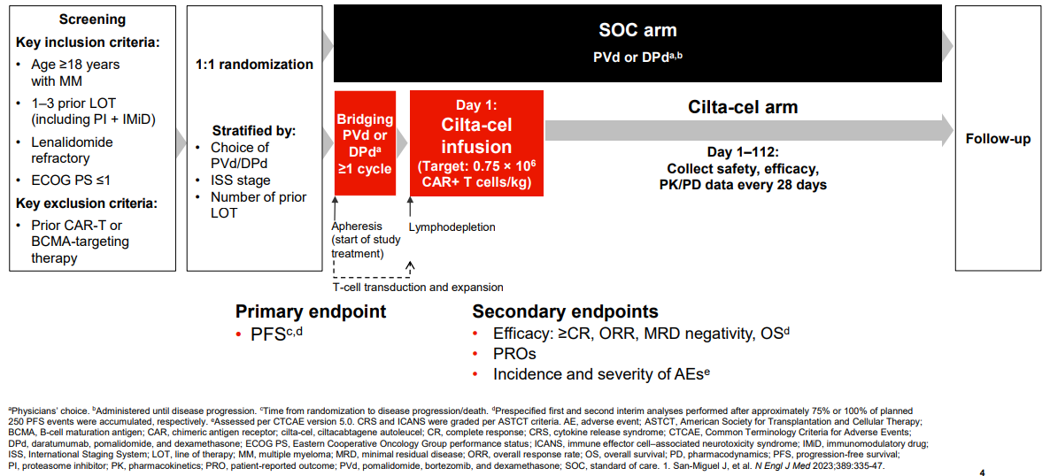
Overall, 419 patients were randomised into CARTITUDE-4 (standard of care arm: 211 patients; cilta-cel arm: 208 patients) and comprised the ITT analysis set. Of these, 416 patients received any part of study treatment (standard of care arm: 208 patients; cilta-cel arm: 208 patients) and comprised the safety analysis set. Three patients were randomised to the standard of care arm but not treated. Of 208 patients in the cilta-cel arm, 176 patients received cilta-cel infusion as study treatment, while 32 patients discontinued study treatment during apheresis and/or bridging therapy before receiving cilta-cel infusion. Of these 32 patients, 2 patients died and 30 had disease progression.
At a median follow-up of 33·6 months (IQR 20·3–35·0), median PFS was not reached (95% CI 34·5 months–not evaluable) in the cilta-cel group versus 11·8 months (9·7–14·0) in the standard-of-care group. Treatment with cilta-cel significantly reduced the risk of disease progression or death compared with the standard of care arm by 71% (HR 0·29 [95% CI 0·22–0·39]). After 30 months, more than double the proportion of patients remained alive and progression free after treatment with cilta-cel compared with the standard of care arm.
Median OS was not reached (95% CI not evaluable) with cilta-cel versus not reached (37·7 months–not evaluable) with standard of care. Treatment with cilta-cel significantly reduced the risk of death from any cause compared with the standard of care arm by 45% (HR 0·55 [95% CI 0·39–0·79]; p=0·0009). After 30 months, an additional 12% of patients remained alive after treatment with cilta-cel compared with the standard of care arm.
The PFS and OS KM graphs are presented below in Figures 5 and 6.
Figure 5: Progression-free survival (CARTITUDE-4)
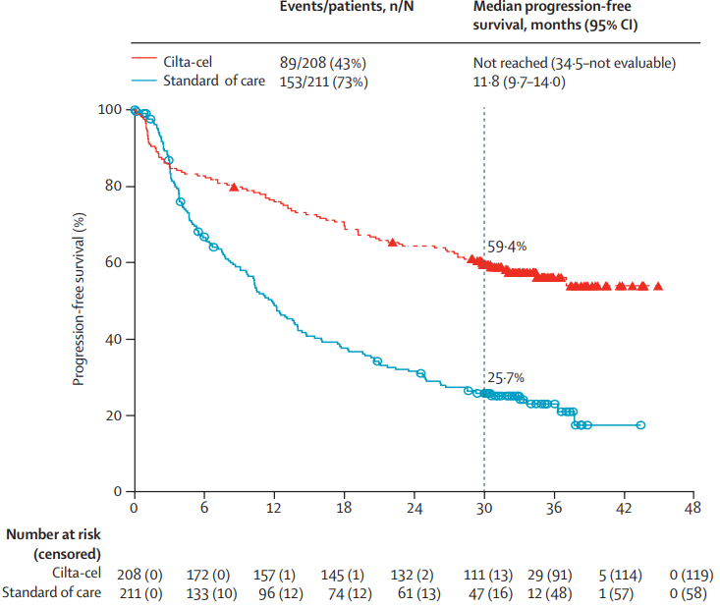
Source: Einsele H et al. 2026. Lancet Oncol.
Figure 6: Overall survival (CARTITUDE-4)
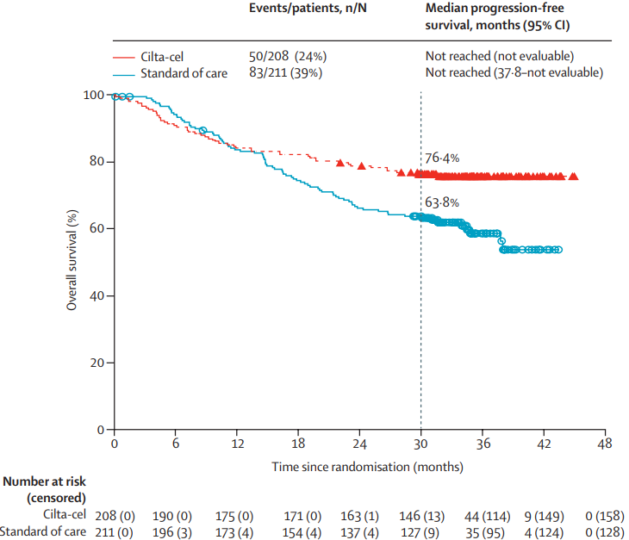
Source: Einsele H et al. 2026. Lancet Oncol.
CARTITUDE-4 also demonstrated that cilta-cel has a manageable safety profile (see Table 3). All patients in the safety analysis set experienced at least 1 TEAE (Table 3). Serious TEAEs were reported for 47.1% of patients in both arms (serious TEAEs related to any part of study treatment: 32.2% and 26.0%, for cilta-cel and standard of care, respectively). In the cilta-cel arm, redacted% of patients experienced at least 1 serious TEAE considered related to cilta cel. Maximum severity Grade 3 or 4 TEAEs were reported for 89.4% and 92.8% of patients in the cilta-cel arm and standard of care arm, respectively. Nine patients (4.3%) in standard of care arm and 15 patients (7.2%) in cilta-cel arm experienced a TEAE with an outcome of death.
Table 3: Overall Summary of Treatment-emergent Adverse Events; Safety Analysis Set
Analysis set: Safety | Cilta-cel (n=208) | Standard of care (n=208)
Any TEAE | 208 (100.0%) | 208 (100.0%)
Redacted | Redacted | Redacted
Redacted | Redacted | Redacted
Any serious TEAE | 98 (47.1%) | 98 (47.1%)
At least one relatedª | 67 (32.2%) | 54 (26.0%)
Redacted | Redacted | Redacted
Maximum severity of any TEAE
Redacted | Redacted | Redacted
Redacted | Redacted | Redacted
Grade 3 | 30 (14.4%) | 77 (37.0%)
Grade 4 | 156 (75.0%) | 116 (55.8%)
Grade 5 | 15 (7.2%) | 9 (4.3%)
Source: CARTITUDE-4 CSR IA2.
Key: TEAE = treatment-emergent adverse event.
Redacted
Data from the CARTITUDE-4 trial shows a significantly lower rate of neurotoxicity relative to the CARTITUDE-1 trial when using cilta-cel (refer to Table 4). This reduction is primarily attributed to earlier intervention and modified patient management protocols. As CARTITUDE-4 evaluated cilta-cel in earlier lines of therapy (1–3 prior lines) versus CARTITUDE-1 (4 or more prior lines), patients had a lower baseline tumour burden. Furthermore, clinicians implemented proactive mitigation strategies, including more robust bridging therapies to control disease before infusion and aggressive, early management of CRS and ICANS. Thus, as clinical experience has increased with CAR-T therapy, and specifically cilta-cel, the management of neurotoxicities has improved considerably (Cohen et al. 2022).
Table 4: Comparison of neurotoxicity in CARTITUDE-4 and CARTITUDE-1
CART-associated AEs¹ | Grade 1 or 2 |  | Grade 3 or 4 |  | Grade 5
CART-associated AEs¹ | CART-4 | CART-1 | CART-4 | CART-1 | CART-4 | CART-1
Cytokine release syndrome | 134 (76%) | 87 (90%) | 2 (1%) | 4 (4%) | 0 (0%) | 1 (1%)
Neurotoxicity² | 36 (21%) | 10 (11%) | 5 (3%) | 11 (11%) | 0 (0%) | 1 (1%)
Immune effector cell-associated neurotoxicity syndrome | 8 (5%) | 14 (15%) | 0 (0%) | 2 (2%) | 0 (0%) | 0 (0%)
Other³ | 30 (17%) | 3 (3%) | 4 (2%) | 10 (10%) | 0 (%) | 1 (1%)
Parkinsonism | 1 (1%) | 2 (2%) | 0 (0%) | 4 (4%) | 0 (%) | 0 (0%
Sources: Einsele H, San-Miguel J, Dhakal B et al. Cilta-cel in lenalidomide-refractory multiple myeloma (CARTITUDE-4): an updated analysis including overall survival from an open-label, multicentre, randomised, phase 3 trial. The Lancet Oncology, 2026; 27, 254-268. Usmani, S. Phase 1b/2 study of ciltacabtagene autoleucel, a BCMA-directed CAR-T cell therapy, in patients with relapsed/refractory multiple myeloma (CARTITUDE-1): Two years post-LPI. Abstract #8028 [Poster]. Presented at the 2022 American Society of Clinical Oncology Annual Meeting.
1 Analysed in the patients who received cilta-cel study treatment in CART-1 (n=97) and analysed in the ITT analysis set for CART-4 (n=208). 2 There were no fatal neurotoxicities. 3 Included in the category of other CAR T-associated events were those that were not classified as immune effector cell-associated neurotoxicity syndrome or its associated symptoms. Other neurotoxic events included (but were not limited to) parkinsonism, cranial nerve palsy, and peripheral neuropathy.
Further supporting evidence for the clinical claim will be provided in the ADAR.
Why would the requestor seek to use the proposed investigative technology rather than the comparator(s)?
Cilta-cel results in superior clinical outcomes (i.e., response, PFS, OS) to all available therapies for 2L+ MM on the PBS. Furthermore, cilta-cel therapy is a one-off therapy, and provides a significant treatment-free interval. This means that patient receiving cilta-cel do not need continuous treatment which is what current options on the PBS require to manage 2L+ MM. This is important as patients will no longer be subject to cumulative toxicity from ongoing continuous treatment which will improve a patients quality of life. This also means reduced monitoring and time spent in the hospital after the infusion relative to current practice.
Australian haematologists have experience with cilta-cel from the CARTITUDE clinical trial program, and also from using cilta-cel for 5L+ MM which was NHRA funded from redacted. This means that there is significant experience with using this technology already in Australian clinical practice, and there is significant desire for its availability on the NHRA earlier in the treatment algorithm, as this is where maximum patient benefit and long term outcomes are achieved.
Identify how the proposed technology achieves the intended patient outcomes:
Refer to the ‘Intervention’ section above.
For some people, compared with the comparator(s), does the test information result in:
A change in clinical management? Yes
A change in health outcome? Yes
Other benefits? Yes
Provide a rationale, and information on other benefits if relevant:
Cilta-cel is not a test. Cilta-cel is a HST, while the comparators are medicines listed on the PBS. Compared with the comparators, cilta-cel results in superior efficacy (i.e., PFS, OS), and is also delivered as a one-off therapy instead of continuous therapy. Refer to above subsection in the ‘Claims’ section for more information on these elements.
In terms of the immediate costs of the proposed technology (and immediate cost consequences, such as procedural costs, testing costs etc.), is the proposed technology claimed to be more costly, the same cost or less costly than the comparator?
More costly
Same cost
Less costly
Provide a brief rationale for the claim:
Cilta-cel qualifies as a high cost, HST. Cilta-cel is a TGA approved therapy that will be delivered in public hospitals where the therapy and its conditions of use are recommended by MSAC.
Janssen’s Global Headquarters has not yet established the price of cilta-cel for 2L+ MM, but the average annual treatment cost at the commencement of funding will exceed AU$200,000 per patient (including supportive care, ancillary services, infusion, toxicity management and logistics), which is the threshold as described in the Addendum for a high cost, specialised therapy. Given the proposed higher cost, and superior clinical benefits, a cost-effectiveness analysis will be provided in the sponsors ADAR. Further information regarding costs will be provided in the submission.

Algorithms

PREPARATION FOR USING THE HEALTH TECHNOLOGY
Define and summarise the clinical management algorithm, including any required tests or healthcare resources, before patients would be eligible for the proposed health technology:
The management of patients with MM is individualised and many factors are considered when making treatment decisions, including age, comorbidities, frailty, treatment history and disability. Currently available myeloma therapies in Australia include– proteosome inhibitors (PI [e.g. bortezomib, carfilzomib]), immunomodulator drugs (IMiDs [e.g. thalidomide, lenalidomide, pomalidomide]), anti-CD38 monoclonal antibodies (e.g. daratumumab), selective inhibitor of nuclear export (SINE [e.g. selinexor]), BCMA targeted bispecific antibodies (e.g. elranatamab) and CART therapy (e.g. cilta-cel [in 5L+ MM]).
A treatment algorithm is presented below in Figure 7 that is informed by the Australian MSAG guideline, the PBS restrictions for currently available MM therapies, NHRA funded therapies, and recent PBAC considerations for MM therapies (i.e., medicines considered by the PBAC but not currently PBS listed).
First line treatment and determining eligibility for transplant
At diagnosis, patients with MM have historically been classified as either autologous stem cell transplant eligible (TE) or transplant ineligible (TI). Eligibility for ASCT is assessed on various factors including age, presence of comorbidities and functional status. As such, patients with TE MM are younger and fitter than patients with TI MM who are generally older and more frail.
In July 2025, MM clinicians highlighted to the PBAC that the PBS restriction requirement to classify newly diagnosed multiple myeloma (NDMM) as autologous stem cell transplant (ASCT) ineligible or eligible is a historic and arbitrary distinction and emphasised that transplantation remains the most cost-effective method of managing myeloma for eligible patients (MM stakeholder meeting, July 2025).
Irrespective of whether ASCT is incorporated as part of initial treatment, the aim of first-line MM treatment is to induce a maximal depth of response, ideally complete response (CR) or better, without unacceptable toxicities. CR or better is associated with significant prolongation of PFS and OS in both the TE and TI setting (H. Quach, 2022), and in both young and elderly patients.
Treatment of TE NDMM
The combination of bortezomib, lenalidomide plus dexamethasone (BLd) is PBS listed for newly diagnosed multiple myeloma irrespective of transplant eligibility; and lenalidomide maintenance post ASCT is also available on the PBS. Most transplant eligible patients will receive BLd and go on to receive lenalidomide maintenance after transplantation. Other options on the PBS for TE patients include bortezomib and dexamethasone (Bd) or bortezomib, cyclophosphamide and dexamethasone (BCd), but these are not commonly used given TE patients are generally young and sufficiently fit to receive BLd. Thus, most TE patients will have received both a PI and IMiD (i.e., lenalidomide) as part of their first line treatment.
Treatment of TI NDMM
In November 2025, daratumumab in combination with lenalidomide and dexamethasone (DLd) was PBS listed for TI NDMM. DLd will be used by most TI NDMM patients due to its superior efficacy relative to all other available treatment options. As such, people with TI NDMM will now be exposed to both a IMiD and an anti-CD38 therapy in their first line of treatment.
Other treatments available for TI NDMM, include BLd, lenalidomide and dexamethasone (Ld) and Bd. The use of bortezomib as part of a BLd regimen is associated with known tolerability challenges and Australian real-world evidence has shown that BLd has not delivered improved clinical outcomes in the TI NDMM setting. Thus, most TI patients will have received a IMiD (i.e., lenalidomide) as part of their first line treatment, and some TI patients will have received a PI.
Treatment of RRMM
The type of prior therapy received, response and associated toxicities with prior therapy are important factors which determine treatment of relapsed/refractory patients in the second line setting and beyond. The aim of treatment is not only to prolong survival, but to also treat or prevent development of myeloma related end organ damage. Treatments currently PBS listed for patients in the early-line RRMM setting include daratumumab, lenalidomide, bortezomib, carfilzomib, pomalidomide, and selinexor. These treatments may or may not be used in combination with chemotherapies and/or corticosteroids (most commonly dexamethasone). Elotuzumab was PBS listed for RRMM but the initial PBS subsidy for elotuzumab for multiple myeloma was delisted as of December 1, 2024, for new patients.
Daratumumab, bortezomib and dexamethasone (DBd) is only listed on the PBS in the RRMM setting for second-line MM only (i.e. not a line agnostic PBS listing). Furthermore, patients eligible for DBd must not have received prior daratumumab in the first line setting (i.e., DLd). Whereas lenalidomide, bortezomib, carfilzomib, pomalidomide, and selinexor all have line agnostic PBS listings in the RRMM setting.
Belantamab mafodotin, an antibody-drug conjugate targeting BCMA for RRMM, was not recommended in combination with bortezomib and dexamethasone (BmBd) by the PBAC in November 2025 for 2L only MM. The PBAC noted that the requested positioning did not align with the clinical trial (i.e., a large proportion had received more than one prior line of therapy), or with how clinicians would like to use MM therapies as described at the July 2025 stakeholder meeting (described above). The PBAC considered a broad RRMM listing would be more appropriate to allow clinician and patient discretion about when and how it can be used. BmBd is now being reconsidered by the PBAC in July 2026 for a broad RRMM listing, but is not currently available on the PBS.
There is no single best treatment sequence defined for RRMM. Generally it is recommended to switch drug class at each relapse, especially if remission to prior medicines was short or a patient had concerning associated toxicity. Furthermore, response to previous therapies and prior treatment history received plays a major role in treatment selection and this has historically led to heterogeneity in treatment sequences in clinical practice. As the presented in Figure 3 the use of lenalidomide in the RRMM setting (i.e., 2 to 4L MM) has substantially reduced from 2021 as it became available across multiple PBS listings, and across broad NDMM settings, and thus most patients have previously received this medicine once they relapse, and have typically become refractory to it. Publications have consistently noted that survival outcomes in lenalidomide-refractory patients have also shown little improvement even with recent advances (Dhakal B et al 2024; Dhakal B et al 2025; Hartley-Brown M et al 2024; Yong K et al 2025). This highlights a significant clinical unmet need for new and effective innovative therapies, such as cilta-cel, for the relevant population considered within this application.
Access and choice in the RRMM setting may also be determined by the PBS restrictions. For example, access to daratumumab (i.e., anti-CD38 monoclonal antibody) is restricted to once per lifetime use, and can either be used as DLd in the TI NDMM setting, or as DBd in the second line MM setting. This means that if a person with MM received DLd in the first-line setting, they cannot receive daratumumab again, so the patient would receive either carfilzomib in combination with dexamethasone (Cd), or pomalidomide in combination with bortezomib and dexamethasone (PBd) in the RRMM setting. If a person with MM did not receive daratumumab in the first-line setting, especially those with TE NDMM in which daratumumab is not currently available, the person with MM would likely receive BLd and then most likely receive DBd for second-line MM.
Until recently, there were a limited number of therapies with different, or new, mechanisms of action on the PBS or NHRA for heavily pretreated RRMM. Most patients have received the 3 classes of MM drugs by the time they reach the 3L MM setting (i.e., PI, IMiD and anti-CD38 monoclonal antibody). These patients are referred to as triple class exposed (i.e., TCE). On 1 April 2026, elranatamab, a BCMA targeted bispecific antibody was listed on the PBS for people with MM after at least three prior lines of therapy (i.e., 4L+) including a PI, IMiD and an anti-CD38 (i.e., TCE). Teclistamab, which is also a BCMA targeted bispecific antibody, was recommended by the PBAC in March 2026, for the same population as elranatamab. Patients can only receive one of belantamab, elranatamab or teclistamab on the PBS (if listed) as the PBAC have recommended that the clinical criteria for BCMA therapies include that “patients must not have previously received treatment with another B-cell maturation antigen (BCMA) directed therapy for this condition”. One-off cilta-cel CAR-T therapy (i.e., the intervention of interest for this application) was NHRA funded from redacted for the treatment of adult patients with RRMM who have received at least 4 prior lines of therapy (i.e., 5L+) including a PI, IMiD and an anti-CD38, after MSAC supported its funding in November 2024.
Is there any expectation that the clinical management algorithm before the health technology is used will change due to the introduction of the proposed health technology?
No
Describe and explain any differences in the clinical management algorithm prior to the use of the proposed health technology vs. the comparator health technology:
N/A. People with MM will continue to be prescribed the same therapies for 1L MM. Most patients in Australian clinical practice receive a lenalidomide based regimen for their 1L treatment.

USE OF THE HEALTH TECHNOLOGY
Explain what other healthcare resources are used in conjunction with delivering the proposed health technology:
As noted in previous sections, treatment with cilta-cel is limited to key specialist public hospital centres across the Australian states and territories. Several hospitals have experience with cilta-cel through the CARTITUDE clinical trial program, and through the delivery of cilta-cel in the 5L+ MM setting under the current NHRA funding arrangement. Thus, several sites in Australia have relevant clinical experience and protocols in place for delivering this medical service.
Cilta-cel treatment centres need to be approved by State/Territory governments and accredited by Janssen with supply and quality agreements in place. As part of Janssen accreditation process, the treatment centres will need to be trained in accordance with the TGA approve Risk Management Plan that includes, among other things, the important identified risks of cytokine release syndrome (CRS) and neurotoxicity and availability of tocilizumab to manage CRS. The accreditation process also redacted.
Once the site has been qualified as a certified healthcare facility, patient enrolment can occur.
Full site re-accreditation by Janssen will occur every redacted which is inclusive of on-site audits to ensure compliance with set-up, processes, and training.
Furthermore, patient selection and referral decisions will be determined by institution, state and National Multi Disciplinary Teams (MDT) which will ensure eligible and suitable patients who can tolerate CAR-T therapy are identified and prioritised for treatment. This level of decision making and consideration by MDTs will lead to better patient selection and achievement of optimal patient outcomes aligned to those seen in CARTITUDE-4.
Consistent with other CAR-Ts considered by MSAC, including cilta-cel for 5L+, it is proposed that the use of cilta-cel for 2L+, will be limited to one successful infusion per lifetime (a successful infusion is when the patient with 2L+ MM has been infused with the optimal cilta-cel dosage as per the TGA recommend dose).
Also refer to response to ‘Describe the key components and clinical steps involved in delivering the proposed health technology’ in the Intervention section of this application for further information on other healthcare resources used in the delivery of cilta-cel therapy.
Explain what other healthcare resources are used in conjunction with the comparator health technology:
Not relevant.
Describe and explain any differences in the healthcare resources used in conjunction with the proposed health technology vs. the comparator health technology:
Refer to the ‘Intervention’ section of this application.

CLINICAL MANAGEMENT AFTER THE USE OF HEALTH TECHNOLOGY
Define and summarise the clinical management algorithm, including any required tests or healthcare resources, after the use of the proposed health technology:
Following one-off cilta-cel in the 2L+ MM setting, outside of the routine visits to assess their MM, redacted. Furthermore, two key differences in the clinical management algorithm after a person with MM receives cilta-cel at 2L+ compared to current practice, is that they would no longer be eligible for any BCMA directed therapy (e.g., elranatamab, teclistamab, belantamab) on the PBS, or (should the 2L+ cilta-cel treatment be considered a successful infusion), patients will not be eligible for treatment with another CART therapy or cilta-cel in the 5L+ MM setting. Refer to Table 4 for further details.
Define and summarise the clinical management algorithm, including any required tests or healthcare resources, after the use of the comparator health technology:
Refer to the ‘Algorithm’ section of this application, and Table 4 below, for further details.
Describe and explain any differences in the healthcare resources used after the proposed health technology vs. the comparator health technology:
Table 5 presents a comparison of the differences in healthcare resources used after the proposed health technology (i.e., cilta-cel) compared to the comparators.
Table 5: Comparison of the current and proposed clinical management algorithms (after cilta-cel and comparators)
Factor relating to subsequent therapy | Proposed (with cilta-cel at 2L to 4L MM) | Current (without cilta-cel at 2L to 4L MM) | Rationale
Delivery of healthcare technology | One-off therapy | Medicines provided as continuous therapy until disease progression, or unacceptable toxicity | Cilta-cel is a HST, comparators are medicines. Likely to require more hospital visits for comparators in long-term due to nature of delivery.
Timing of subsequent therapy | Longer relative to current therapy | Upon relapse | As cilta-cel is superior in efficacy to current standard of care, this will delay, and potentially reduce, the need for subsequent therapy
Option to use a BCMA directed therapy upon relapse | Not eligible for any BCMA directed therapy | Eligible for a BCMA directed therapy | Restriction proposed for cilta-cel for 2L+ (CART-4) to include criteria that patient must not have previously received BCMA directed therapy as aligned to CARTITUDE-4 evidence/population & current PBS restrictions
Option to use a CART therapy upon relapse | Not eligible for cilta-cel or other CART therapy | Remain eligible for cilta-cel at 5L+ | Treatment limited to one successful infusion per lifetime CART therapy
Option to use an IMiD or PI upon relapse | No difference (unchanged) |  | Treatment will depend on multiple factors, including treatment history (type, response, toxicity). Refer to ‘Algorithm’ section.
Insert diagrams demonstrating the clinical management algorithm with and without the proposed health technology:
Refer to ‘Algorithm’ section above for descriptive detail on current and proposed algorithm. The current algorithm is provided pictorially in Figure 7 below, and has included near-market comparators (i.e., belantamab mafodotin, and teclistamab, which have been recommended by the PBAC but are not yet PBS listed). Furthermore, on the PBS, a patient is only able to access an anti-CD38 therapy (e.g., daratumumab) and a BCMA directed therapy (e.g., cilta-cel, teclistamab, elranatamab, belantamab mafodotin) once.

Figure 7: Current treatment algorithm
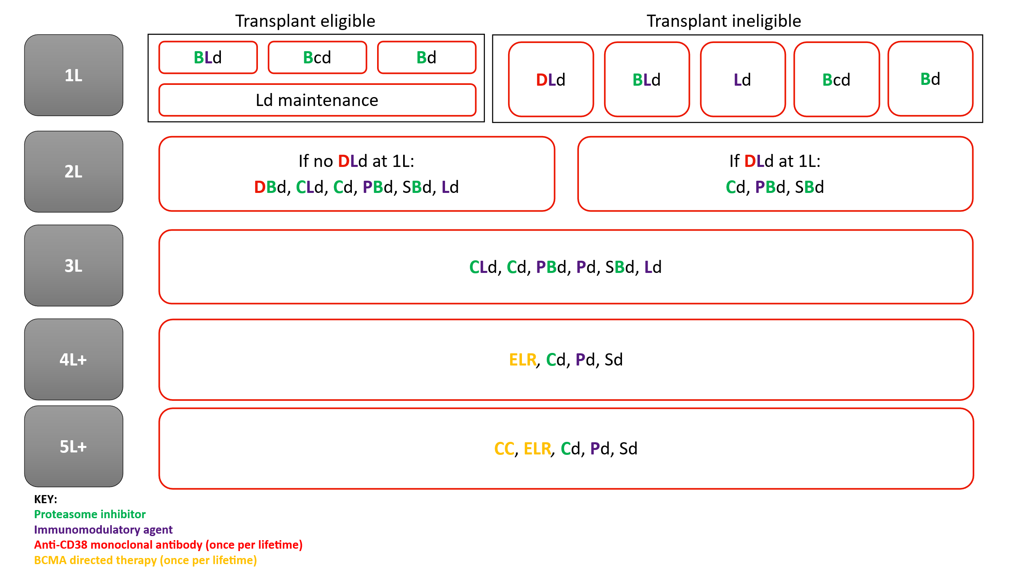
Note: Near market comparators BmBd and TEC are excluded as they are not currently listed on the PBS.
Abbreviations: Bd, bortezomib and dexamethasone; BLd, bortezomib with lenalidomide and dexamethasone; Bcd, bortezomib with cyclophosphamide and dexamethasone; BmBd, belantamab mafodotin; CC, cilta-cel; Cd, carfilzomib and dexamethasone; CLd, carfilzomib with lenalidomide and dexamethasone; DBd, daratumumab with bortezomib and dexamethasone; DLd, daratumumab with lenalidomide and dexamethasone; ELR, elranatamab; Ld, lenalidomide and dexamethasone; Pd, pomalidomide and dexamethasone; PBd, pomalidomide with bortezomib and dexamethasone; Sd, selinexor and dexamethasone; SBd, selinexor with bortezomib and dexamethasone; TEC, teclistamab.
Figure 8: Proposed treatment algorithm with cilta-cel NHRA funded for 5L+ MM
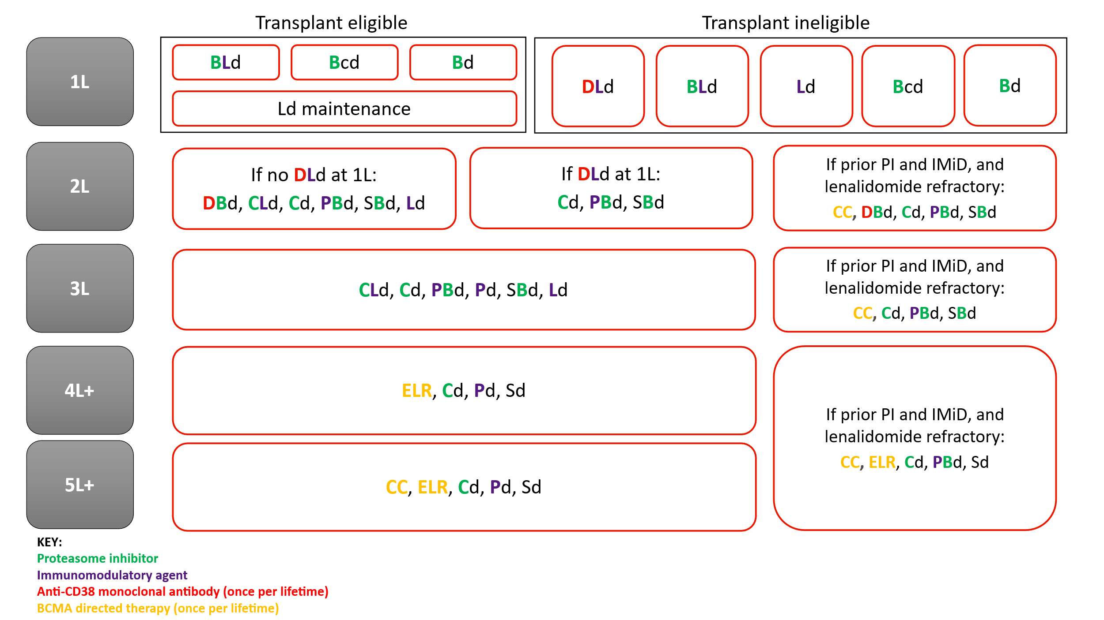
Note: Near market comparators BmBd and TEC are excluded as they are not currently listed on the PBS.
Abbreviations: Bd, bortezomib and dexamethasone; BLd, bortezomib with lenalidomide and dexamethasone; Bcd, bortezomib with cyclophosphamide and dexamethasone; BmBd, belantamab mafodotin; CC, cilta-cel; Cd, carfilzomib and dexamethasone; CLd, carfilzomib with lenalidomide and dexamethasone; DBd, daratumumab with bortezomib and dexamethasone; DLd, daratumumab with lenalidomide and dexamethasone; ELR, elranatamab; Ld, lenalidomide and dexamethasone; Pd, pomalidomide and dexamethasone; PBd, pomalidomide with bortezomib and dexamethasone; Sd, selinexor and dexamethasone; SBd, selinexor with bortezomib and dexamethasone; TEC, teclistamab.

Summary of Evidence
Provide one or more recent (published) high quality clinical studies that support use of the proposed health service/technology. At ‘Application Form lodgement’,
 | Type of study design* | Title of journal article or research project | Short description of research (max 50 words)** | Website link to journal article or research | Date of publication***
1. | PIVOTAL STUDY  Phase III, randomised, open-label, multi-centre study in patients with lenalidomide-refractory multiple myeloma who have received 1-3 previous lines of treatment (including a proteasome inhibitor and an immunomodulatory drug) | CARTITUDE-4  Clinical trial identifier:  NCT04181827  San-Miguel, J. et al. (2023). Cilta-cel or Standard Care in Lenalidomide-Refractory Multiple Myeloma. N Engl J Med 2023;389:335-347 | Evaluation of efficacy and safety of cilta-cel (N=208) vs physician’s choice (N=211) of effective standard care (pomalidomide, bortezomib, and dexamethasone [PVd] or daratumumab, pomalidomide, and dexamethasone [DPd]) in patients with lenalidomide-refractory MM.  Primary endpoint: progression-free survival  Median follow-up was 15.9 months in primary analysis (San-Miguel J et al. 2023). Median follow-up in updated analysis was 33.6 months (Einsele H et al. 2026). | Primary Publication (interim analysis 1 [IA1])  https://www.nejm.org/doi/full/10.1056/NEJMoa2303379 | 5 June 2023
2. |  | Mina, R. et al. (2025). Patient-reported outcomes following ciltacabtagene autoleucel or standard of care in patients with lenalidomide-refractory multiple myeloma (CARTITUDE-4): results from a randomised, open-label, phase 3 trial. The Lancet Haematology, Volume 12, Issue 1, e45 - e56 |  | https://www.thelancet.com/journals/lanhae/article/PIIS2352-3026(24)00320-X/abstract | January 2025
3. |  | Einsele H, et al. (2026). Cilta-cel in lenalidomide-refractory multiple myeloma (CARTITUDE-4): an updated analysis including overall survival from an open-label, multicentre, randomised, phase 3 trial. Lancet Oncol 2026 Feb;27(2):254-268 |  | Updated analysis (IA2): https://www.thelancet.com/journals/lanonc/article/PIIS1470-2045(25)00653-9/fulltext | February 2026
4. |  | Dhakal, B. et al. (2023). First phase 3 results from CARTITUDE-4: Cilta-cel versus standard of care (PVd or DPd) in lenalidomide-refractory multiple myeloma. ASCO 2023 conference |  | Conference abstract  https://ascopubs.org/doi/10.1200/JCO.2023.41.17_suppl.LBA106 | 7 June 2023
* Categorise study design, for example meta-analysis, randomised trials, non-randomised trial or observational study, study of diagnostic accuracy, etc.
**Provide high level information including population numbers and whether patients are being recruited or in post-recruitment, including providing the trial registration number to allow for tracking purposes. For yet to be published research, provide high level information including population numbers and whether patients are being recruited or in post-recruitment.
*** If the publication is a follow-up to an initial publication, please advise. For yet to be published research, include the date of when results will be made available (to the best of your knowledge).

References
Cohen AD et al. (2022). Incidence and management of CAR-T neurotoxicity in patients with multiple myeloma treated with ciltacabtagene autoleucel in CARTITUDE studies. Blood Cancer Journal volume 12, Article number: 32 (2022).
Dhakal B, Einsele H, Schecter J, Deraedt W, Lendvai N et al. (2024). Real-world treatment patterns and outcomes in relapsed/refractory multiple myeloma (1-3 prior lines): Flatiron database. Blood Adv. 2024 Oct 8;8(19):5062-5071.
Dhakal, et al (2025). Real-World Treatment Patterns and Outcomes in Patients With Lenalidomide-Refractory Multiple Myeloma With 1 to 3 Prior Lines: SEER-Medicare Database. Clin Lymphoma Myeloma Leuk. 2025 Jun;25(6):e394-e403.
Einsele H et al. Cilta-cel in lenalidomide-refractory multiple myeloma (CARTITUDE-4): an updated analysis including overall survival from an open-label, multicentre, randomised, phase 3 trial. Lancet Oncol 2026; 27: 254–68
Hartley-Brown MA, et al. (2024). Multiple myeloma refractory to lenalidomide. A systematic literature review of trials and real-world evidence. Br J Haematol. 2024;00:1–18.
Multiple Myeloma Stakeholder Meeting. Outcome Statement. Friday 25 July 2025. PBAC. Link: https://pbs.gov.au/industry/listing/elements/pbac-meetings/pbac-stakeholder-meetings/Multiple-Myeloma-Meeting-Outcome-Statement.pdf
Quach H. and Prince H.M. on behalf of MSAG 2019. Clinical Practice Guideline. Multiple Myeloma. Updated 2019 https://myeloma.org.au/wp-content/uploads/2019/10/myeloma_clinical_practice_guideline_oct19.
Zhao J et al. Real-world treatment patterns in relapsed/refractory multiple myeloma in Australia: results from the Myeloma and Related Diseases Registry. Abstract presented (O051) at Blood 2019 on 21/10/2019, Perth Convention & Exhibition Centre, 20 - 23 October 2019. Link: https://www.hsanz.org.au/resources/Documents/Blood%20Abstract%20Supplement/Blood%202019%20abstract%20supplement.pdf
Yong K, Einsele H, Schecter J, Roccia T, Deraedt W et al. (2025). Characteristics and outcomes in patients with lenalidomide refractory multiple myeloma treated with 1-3 prior lines of therapy: analysis of individual patient-level data from daratumumab clinical trials. European Journal of Cancer Volume 215, 17 January 2025, 115157.

